How To Receive a One-time Physical Item in Alma Acquisitions

Notes:
- Make sure your location is set to the necessary site for receiving.
  - If that location is not already displaying, open the drop-down list to see the available locations.
- The Receive operation might be immediately available among the Recent Pages
- If it’s not, selection Acquisitions in the top menu bar.
  - Under Receiving and Invoicing, select Receive

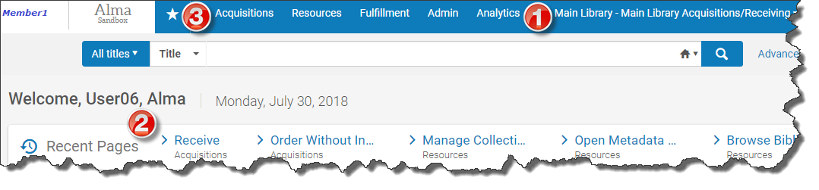

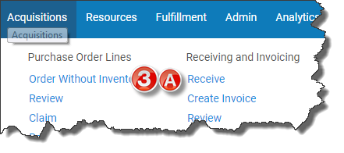

On the Receive New Material screen, be sure you are on the One Time tab.

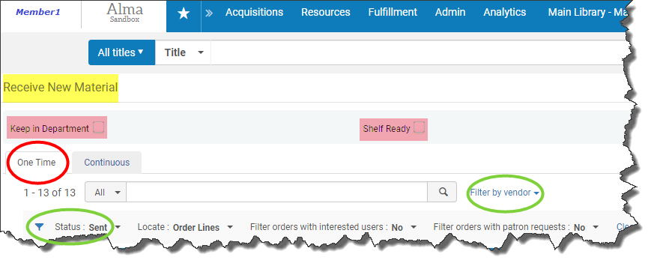

Use the checkboxes as necessary.
Check Keep in Department to select the next stage in the processing (e.g., Copy Cataloging, Original Cataloging, or Physical Processing according to the locations your library has identified).
Check Shelf Ready if that is how the item was ordered and received. Locate the item by its barcode.
- You do not have to use either box. If you do not select either checkbox, when the item is indicated as received in Alma, it will simply show as In Transit until its barcode is scanned at the circulation desk of its final location.

All items with a status of Sent will be displayed by default.
Locate the item in hand by any number of methods
- scrolling if the list is short
- filtering by vendor (or other limiters)
- searching
  - identify the field to be searched using the drop-down list
  - search by Standard number and scan in an ISBN, e.g.
To indicate items as received in Alma, check the relevant box(es) in the list and click Receive.

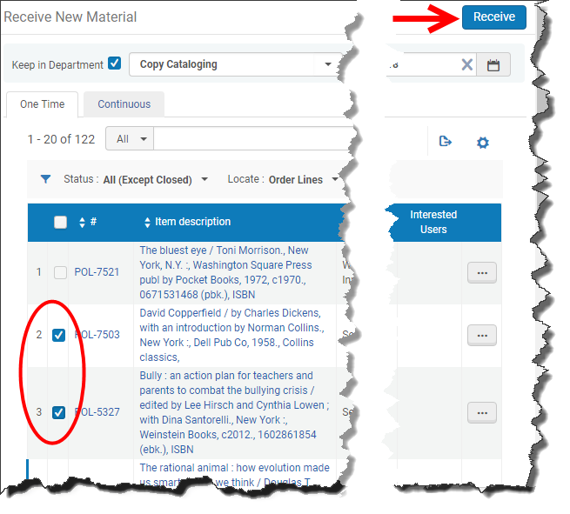

Alternatively, click on the ellipses next to the relevant title and either Receive or select Manage Items to have the options of editing the item record (to add its barcode, e.g.).

