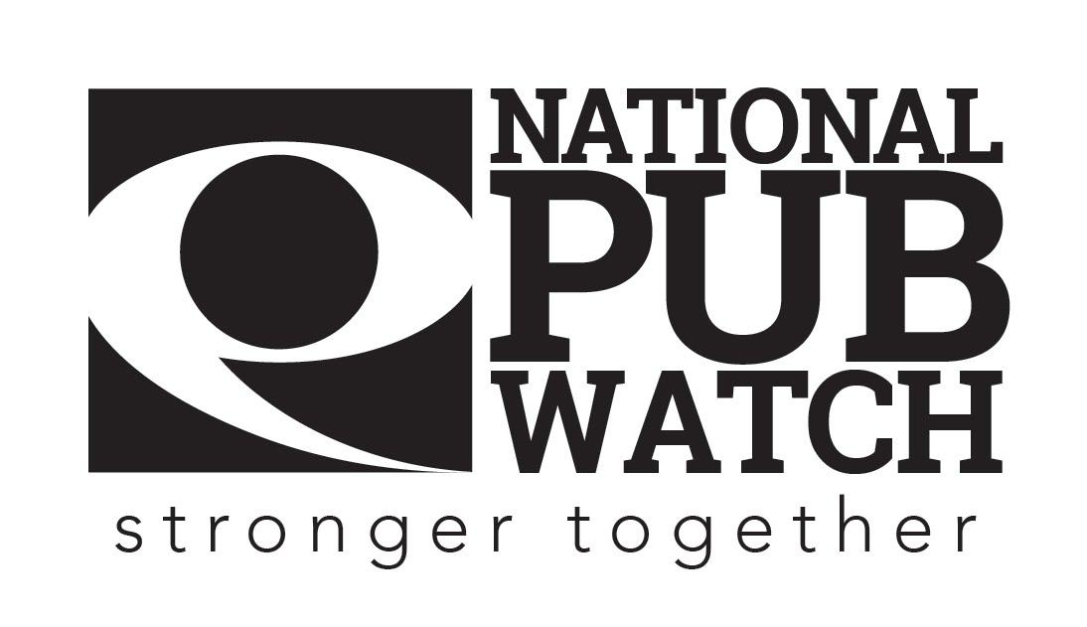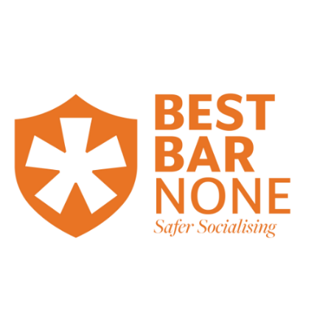

**Conflict Management Policy**

**Date Created:**

**Date of last review: NB Policies should be reviewed annually.**

**Expected Standards**

There are 4 licensing objectives of equal importance:

* The prevention of crime and disorder
* Public safety
* The prevention of public nuisance
* The protection of children from harm

**Conflict management** is the process of reducing the instances of threatening behaviour, aggression, harassment and violence through a combination of effective workplace systems, design of the working environment and training to enable employees to act proactively, but not put themselves in a position of danger. Conflict resolution can be used to lessen the impact of conflict when escalation occurs.

We [insert name of premises] take our legal responsibilities to protect the health, safety and welfare of our employees, under the Health and Safety at Work Act 1974, very seriously. This duty of care includes all forms of work-related violence, which HSE defines as: ‘Any incident in which a person is abused, threatened or assaulted in circumstances relating to their work’. This means:

* Physical violence – including kicking, spitting, hitting or pushing, as well as more extreme violence with weapons.
* Verbal abuse – including shouting, swearing or insults, racial or sexual abuse.
* Threats and intimidation

Tackling the risk of violence is the same as dealing with any other possible cause of harm in the workplace, such as slips and trips and lifting heavy loads.

We need to ensure that our customers enjoy using our facilities without behaving in a way that is offensive to others or that breaks the law. Therefore, it is important that you know how to deal with conflict, should it arise.

**What to look out for**

The main causes of violence in pubs/clubs include:

* Disagreements between customers
* Customers being drunk.
* Refusing a sale or asking someone to leave the premises.
* Poor or slow service
* Customers who have used illegal drugs.
* Overcrowding and discomfort

**Ways to avoid and reduce conflict.**

**[edit to suit your premises)**

* Looking out for early signs, such as raised voices and agitation through body language.
* Provide a high standard of service with efficiency and politeness.
* Getting to know the customers and their needs.
* Being attentive and observant to the customers
* De-personalising refusal by mentioning your legal responsibilities.
* Display signage reminding customers that the venue will not permit or tolerate physical or verbal abuse against employees.
* [managers, door supervisors] should wear a body camera at all times.

**When to step in and what to do**

* Do not take personally what customers say whilst they are frustrated or angry with the situation.
* Never lose your temper, as this causes more problems rather than solving anything.
* Think carefully before you speak or react and keep calm and polite at all times.
* Call for help/assistance from your [manager, door staff, colleagues] if the customer becomes aggressive.
* [Managers, door supervisors, supervisors] must seek to address the situation, where possible, without putting themselves at risk of personal attack, [remain behind the bar or keep a safe distance].
* When you feel the situation is getting out of control, call the police for assistance.
* Where customers demonstrate abusive or violent behaviour, the [manager, supervisor, door staff] will contact the police.
* Details of violent or aggressive customers or people attempting to enter the building, will be provided to the police, together with witness statements and footage from [CCTV and body camera systems] which may have captured any incident.
* [Managers, door staff] will be required to log all incidents in the [incident book, log] and this will be reviewed by the [manager].
* The venue will participate in local police schemes and initiatives such as [Pubwatch and Best Bar None, DISC app] where available, and will communicate with staff and other venues and ban known troublemakers or convicted offenders.
* Wherever possible managers will attend local Pubwatch meetings.

**Incident logbook**

Remember to record the incident in the incident log book. The log is kept [insert location]. You must log the date and time, what happened, any witness details plus any other details that may be useful to others in future, such as a description of the person(s).

**Please sign this document to acknowledge that you have understood your responsibilities in regard to conflict management.**

Date: …………………………………………………………………

Trainer’s Name: ……………………………………………... Trainer’s Signature: …………………………………….

Trainee’s Name: …………………………………………….. Trainee’s Signature: ……………………………………