Curriculum Information
- Training Credit: 3.5 hours
- Trainers should give participants one 15-minute break during the training.
- This curriculum was developed by the State of Tennessee Office of Training and Professional Development.
- Staff may receive T4T credit for this course by:
- Attending the course T4T offering -- OR --
- Attending an offering of the course taught by another trainer & debriefing with that trainer.

This curriculum was developed by the Tennessee Department of Children’s Services with federal funds. It is available to use in part or in whole free of charge. Suggested citation:
OTPD. (2021). Reaction Awareness: How to Show Up During Conflict. Tennessee Department of Children’s Services.

Learning Objectives
- Participants will understand the process of the Conflict Cycle
- Participants will understand how our own emotions and behavior contribute to the Conflict Cycle
- Participants will develop an understanding of the role of Understanding, Expecting Change, and Avoidance during conflict
- Participants will understand how to form a Balanced Response to achieve improved outcomes to conflict situations
- Participants will understand the importance of self-awareness in providing balanced responses

Materials Checklist
  - Facilitator Guide
  - Power Point
  - Participant Journal
  - VIDEO: Josh Shipp: “Be the Difference”
  - (not for group 4) VIDEO: “Children Need Parents Who Get Along”

Annotated Agenda
Agenda Item | Time | Learning Objectives | Resources
Unit 1: The Foundation | 45 min | Participants will be introduced to the process of the Conflict Cycle | Video: Josh Shipp: Be the Difference
Lesson 1.1 Welcome and Introductions | 45 min
Unit 2: The Driving Forces | 50 min | Participants will understand how our own emotions and behavior contribute to the Conflict Cycle | Video: Children Need Parents Who Get Along
Lesson 2.1 Emotional Regulation | 40 min
Lesson 2.2 Emotional Co-Regulation | 10 min
Unit 3: Exploring Resources | 65 min | Participants will develop and understanding of the role of Understanding, Expecting Change, and Avoidance during conflict  Participants will understand how to form a Balanced Response to achieve improved outcomes to conflict situations
Lesson 3.1: Exploring Responses | 40 min
Lesson 3.2: The Balancing Act | 25 min
Unit 4: Increasing Self-Awareness | 30 min | Participants will understand the importance of self-awareness in providing balanced responses.
Lesson 4.1 The Reinforced Response | 15 min | .
Lesson 4.2 Putting it all together | 15 min
Unit 5: Wrap Up | 10 min |  | What I know, What I want to know, What I learned Slide from Unit 1  Course Evaluation
Lesson 5.1: Wrap Up | 10 min

Unit 1: The Foundation

Unit Time: 45 minutes

Learning Objectives:
- Participants will be introduced to the process of the Conflict Cycle

Supporting Materials:
- PowerPoint
- Video: Josh Shipp: Be the Difference
- Resource: Participant Journal

Lesson 1.1: Welcome and Introductions
Lesson Time: 45 minutes
Key Teaching Points / Instructions
- EXPLAIN conflict occurs in life regularly both personally and professionally. During this course we will explore conflict and our response to it. Since we have all experienced conflict at one time, or another this course is highly interactive and relies on participants sharing their experience with conflict. STATE we will begin the session with an activity to help us think about what we hope to learn during our time together.
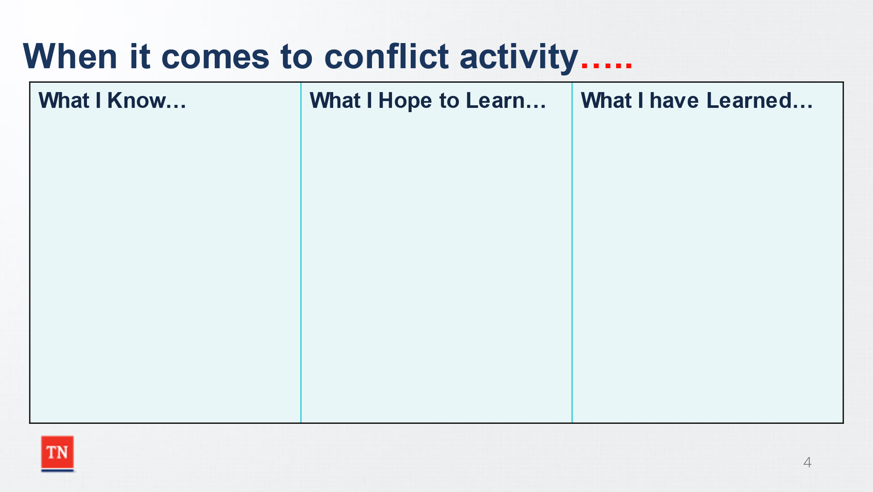
- SHARE the slide “When it comes to conflict…”
- ASK participants to share what they already know about conflict and what they hope to learn. RECORD the responses on the slide or invite participants to annotate on the slide (ensure annotation priviledges are given). EMPHASIZE they can share as much or as little as they are comfortable with; do not place any parameters on whether this is regarding conflict at work or in their personal lives.
- ENSURE that each participant shares at least one item for each column. The facilitators should also contribute one item for each column.
- CREATE a positive learning environment by affirming responses and relating responses to the curriculum if possible.
- EXPLAIN the last column will be filled out at the end of the training day, but participants are encouraged to make notes for themselves as they learn and master new concepts throughout the training.
- Trainer Note: The facilitators should display humility, vulnerability, and accept responsibility of past mistakes throughout the training to model these behaviors for the participants. It is essential to do this early in the training, as this helps participants to connect with the material and training experience. Creating a safe space beginning with introductions and the development of comfort rules is paramount.
- SHARE that this training is based on the Counter Response training developed by Vanderbilt, and the concepts of the REStArt approach.
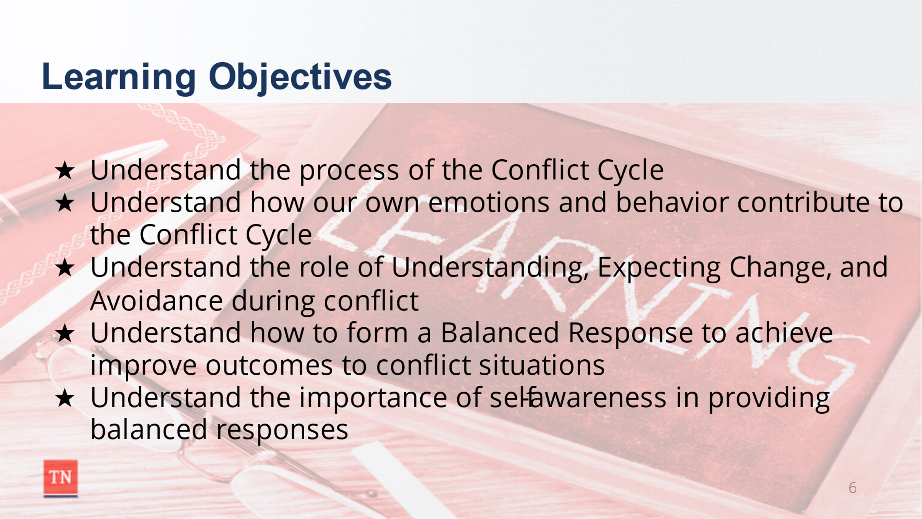
- REVIEW the Learning Objectives Slide:
- Participants will understand the process of the Conflict Cycle
- Participants will understand how our own emotions and behavior contribute to the Conflict Cycle
- Participants will develop an understanding of the role of Understanding, Expecting Change, and Avoidance during conflict
- Participants will understand how to form a Balanced Response to achieve improved outcomes to conflict situations
- Participants will understand the importance of self-awareness in providing balanced responses

- INTRODUCE the course journal that has been provided and explain it will be used throughout the training. SHARE participants are encouraged to continue using the journals after the class to capture their progress with Counter Response skills.
- STATE we will start the training by watching a video of Josh Shipp, a former foster care youth, whose life was changed by caring adults who helped him break out of his destructive Conflict Cycle.
- SHOW (or drop the video link into the chat box) the Josh Shipp video “Be the Difference” (5:36): https://www.youtube.com/watch?v=FrV9oO0BOtk&t=1s
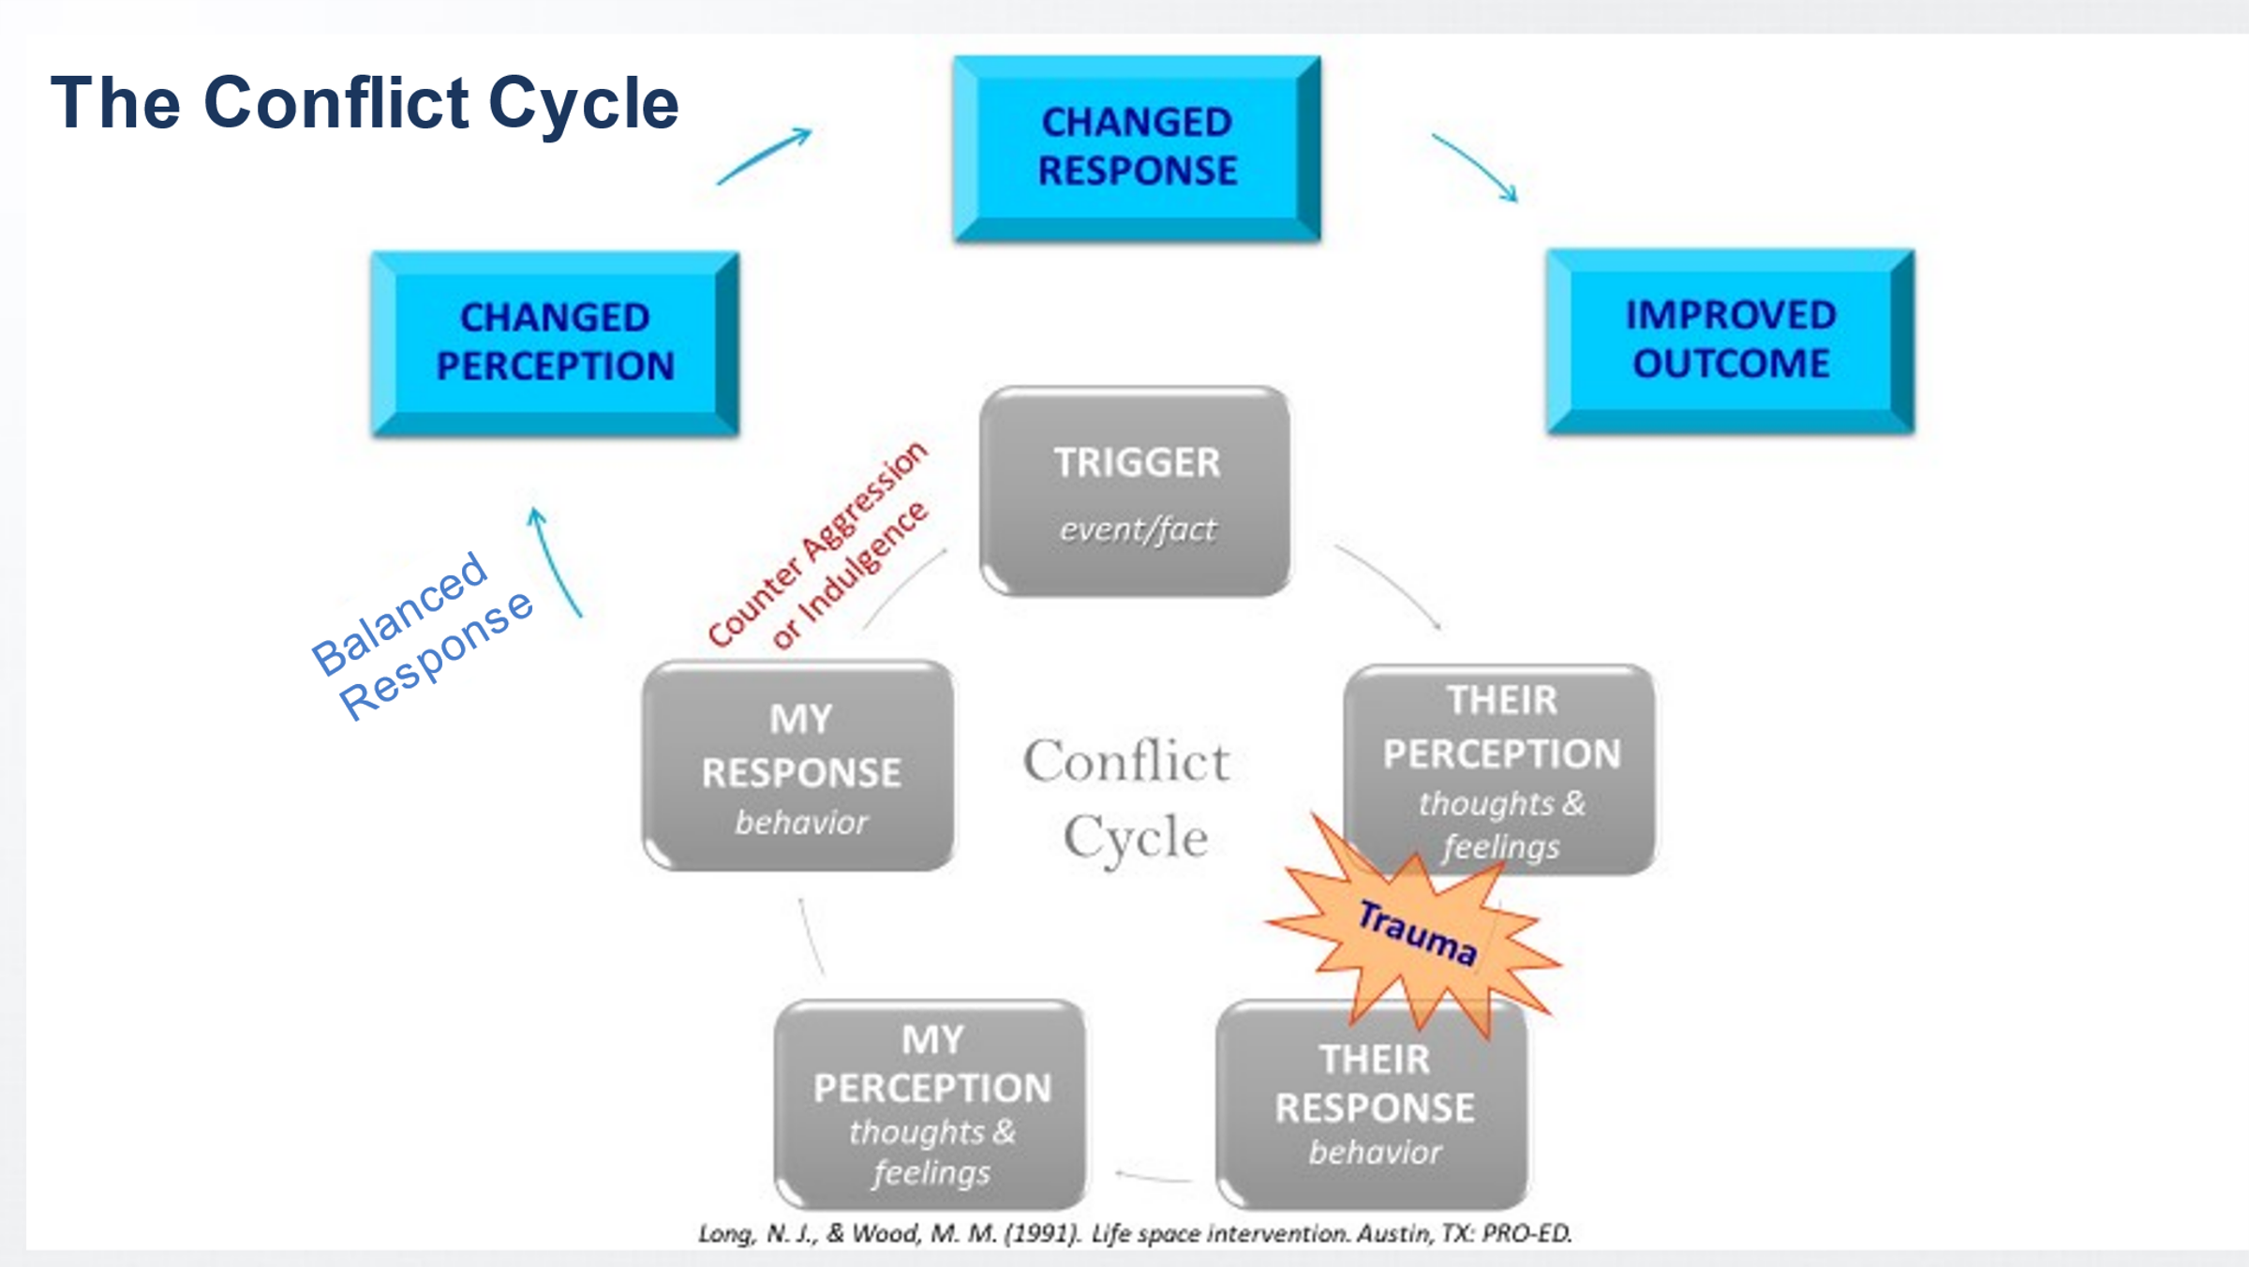
- DEBRIEF the video by asking participants to share their reactions to Josh’s story. EXPLAIN this training is designed to teach staff how to work with individuals who have experienced trauma, are ambivalent about change, and how to capitalize on the opportunities present within conflict situations. The training provides participants with unique opportunities to examine how traumatic experiences and ambivalence regarding change affect their own reactions when responding to conflict situations in their professional and personal lives.
- BRIEFLY introduce the Conflict Cycle and inform participants the diagram can be found in their journal.
Trainer Note: Upload a copy of the Conflict Cycle on a separate tab in WebEx for easy reference throughout the training.
- EXPLAIN within the Conflict Cycle, events trigger feelings based on perception (both conscious and unconscious). In turn, these feelings manifest in behaviors which then trigger our own feelings based on our perception. A history of complex trauma, past unresolved conflicts, and ambivalence to change may all contribute to our reactions during this process.
- SHARE our feelings are then expressed through our behavioral response to the others involved in the conflict, further feeding, and perpetuating the cycle.
- STATE through self-awareness and better understanding of conflict patterns, we can use various tools and techniques to respond more effectively during these situations and therefore break the unproductive cycle. Breaking the cycle increases the chance of successful resolution and creates more opportunities for repair, leading to better outcomes.
- ACTIVITY: Applying the Conflict Cycle to Josh Shipp’s story.
- SHARE with participants we will now apply the conflict cycle to Josh Shipp’s story. The facilitator/co-facilitator will annotate participant responses on the Conflict Cycle slide on a separate PowerPoint tab for easy reference.
- BEGIN the activity by sharing the conflict the group will be focusing on is the Trigger: Josh getting arrested and calling Rodney for help.
  - Their Perception: ASK participants what do you think Josh was thinking and feeling when he called Rodney? Possible responses: Scared, he is going to have me moved, this is it.
  - ASK participants how to do you think Josh’s trauma history impacted his thoughts and feelings and in turn his behavior? Possible response: He wanted to have a relationship with the foster parents, but he also wanted to push them away before they pushed him away.
  - Their Response: ASK participants how do you think Josh responded when he called Rodney? Possible response: He knew Rodney was the only person he could call, but he was also hesitant to ask for help.
  - My Perception: ASK participants what do you think Rodney’s thoughts and feelings were when Josh called him? Possible responses: Hope he is okay. Not this again, I can’t believe he messed up. Worry, irritation, frustration, helpless.
  - My Response: SHARE we will explore Rodney’s responses as we move throughout the training.
- TRANSITION to Unit 2 by SHARING we will not explore the foundation of how we relate to others and what drives our behavioral responses.

Unit 2: The Driving Forces

Unit Time: 40 minutes

Learning Objectives:
- Participants will understand how our own emotions and behavior contribute to the Conflict Cycle

Supporting Materials:
- PowerPoint
- VIDEO: “Children Need Parents Who Get Along”
- RESOURCE: Journal

Lesson 2.1: Emotional Regulation
Lesson Time: 30 minutes
Key Teaching Points / Instructions
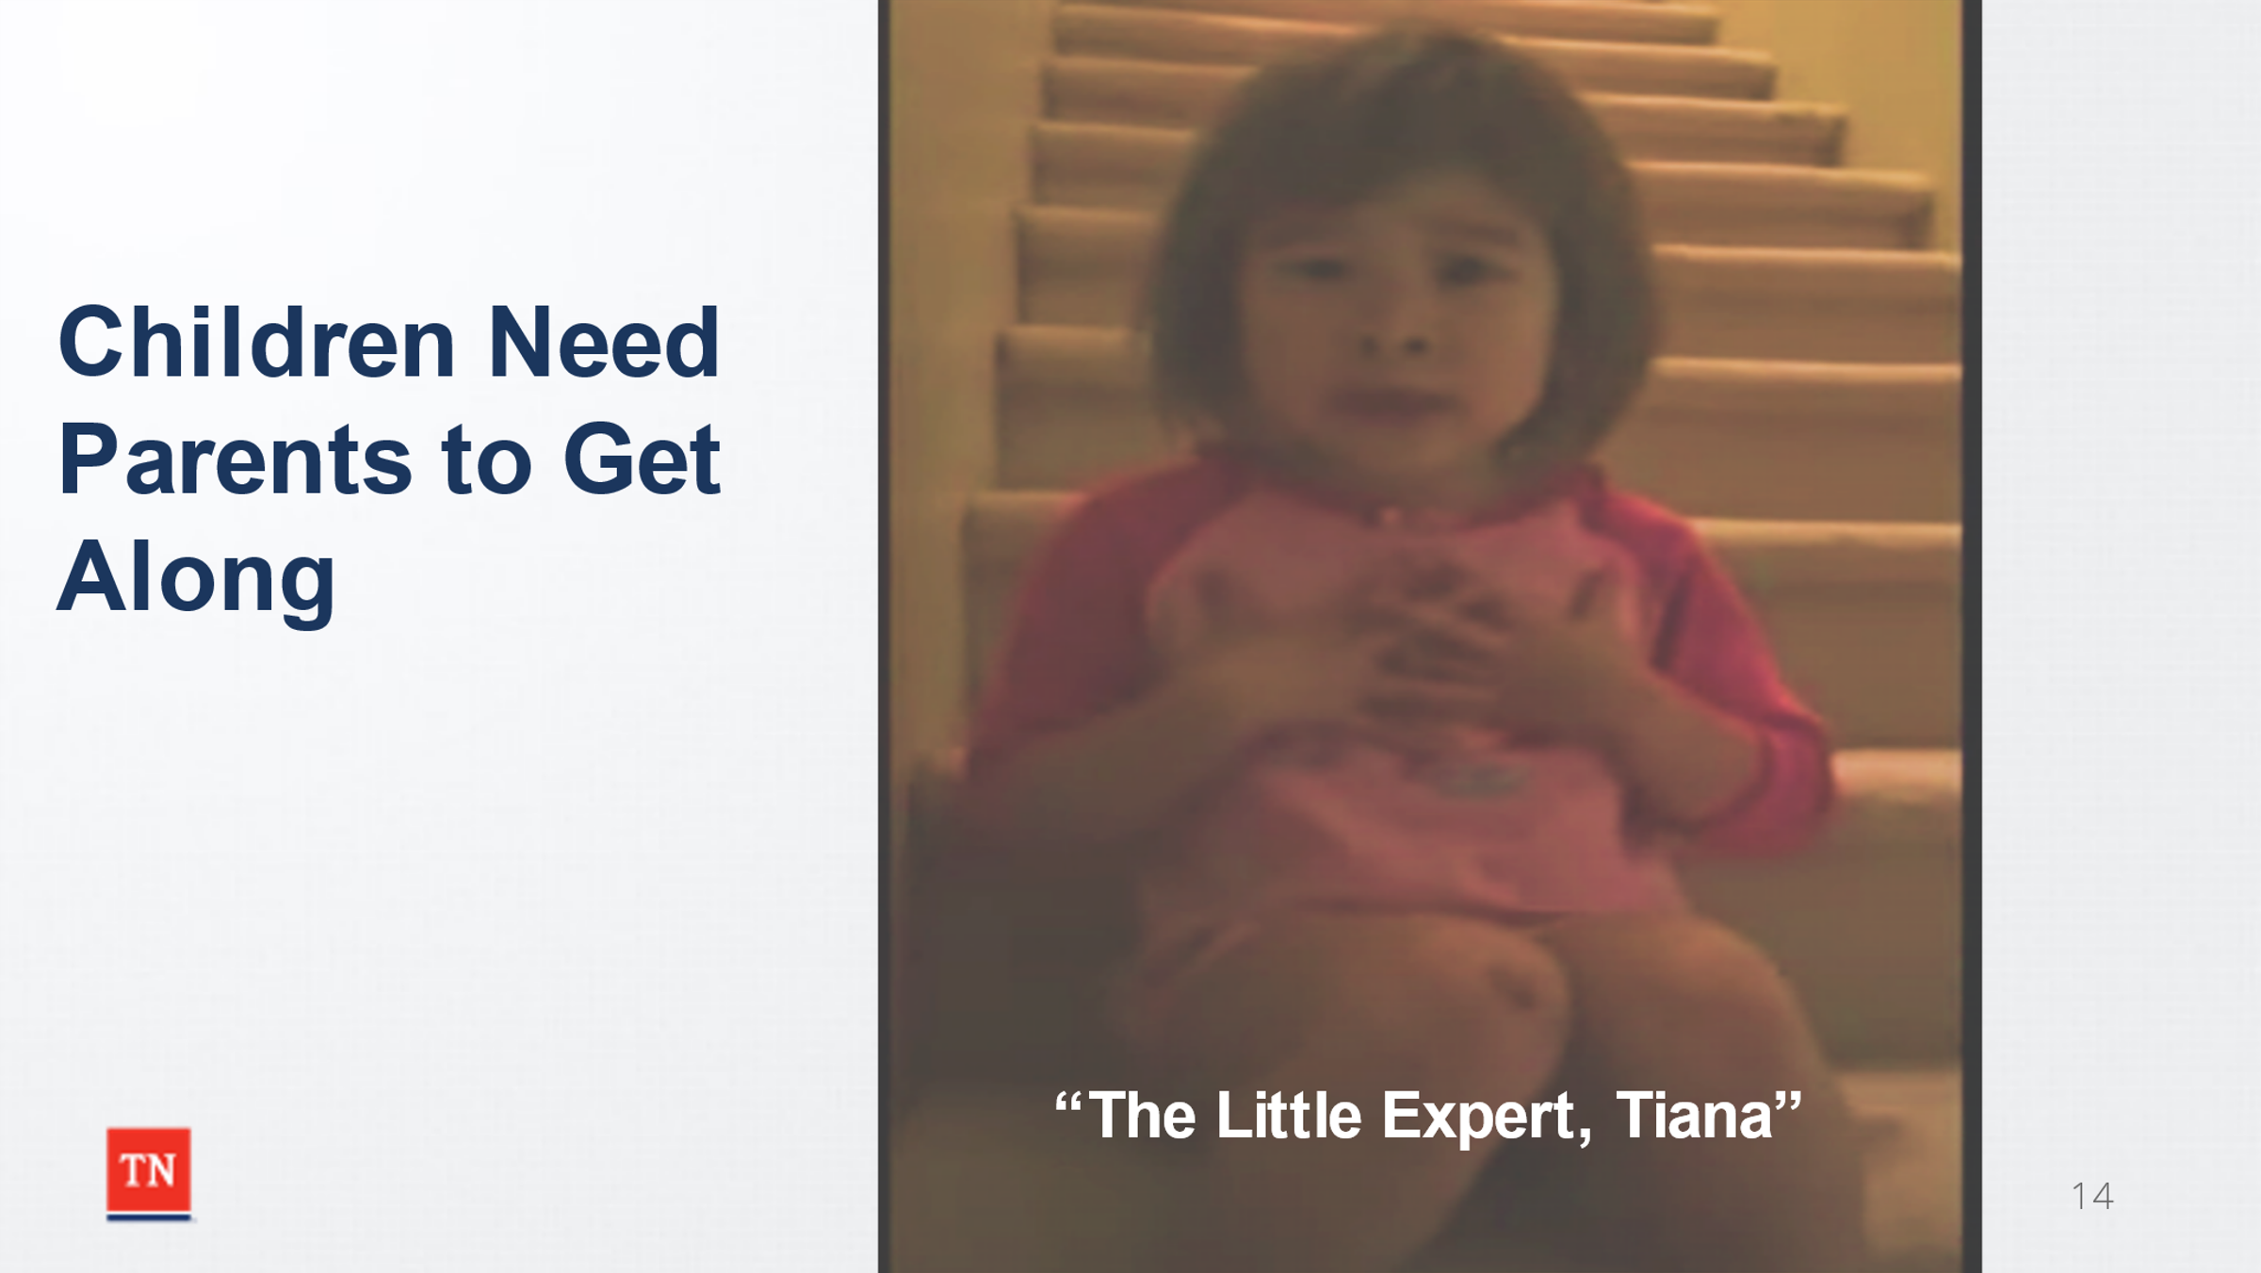
- INFORM the participants we will begin our discussion around emotion regulation by watching a brief video from an expert. In this video the “Little Expert” (Tiana) is talking to her divorced parents about a fight they just had.
- SHOW or drop link in chat box for the video “Children Need Parents to Get Along”: https://www.youtube.com/watch?v=IMjpCQBH8zU SHARE with participants to stop the video at 2:43.
- DEBRIEF the video using the terms used by the Little Expert including “mean heights” and “be steady”. RELATE the Little Expert’s terms to the Window of Tolerance on the next slide.
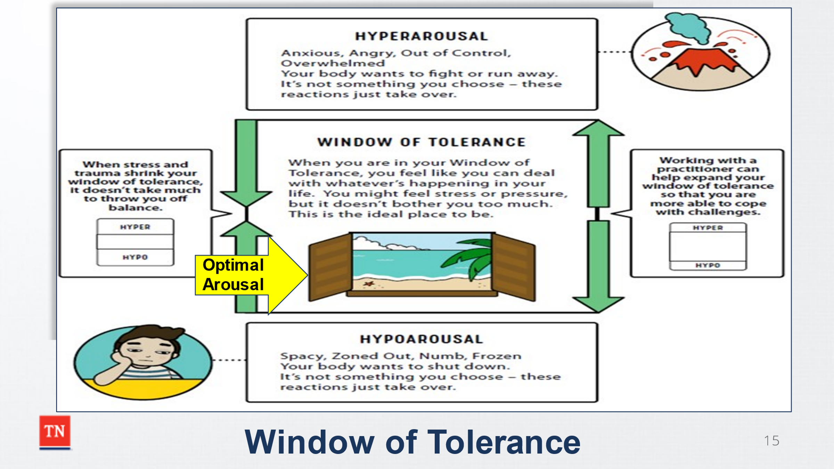
- EXPLAIN the Optimal Arousal Zone is where we are able to effectively regulate our emotions and travel the full path from stimulus to behavior. When we are more emotionally regulated, we are more likely to stay curious, asking questions and being open to cultivating dialogue during conflict. In the optimal zone or window of tolerance, one is more likely to listen deeply and question their own thoughts/perceptions and behavior/reactions. Being the optimal arousal zone allows for increase self-awareness understanding, and how my thoughts and feelings impact my behaviors hence leading to more balanced responses for optimal outcomes during conflict.
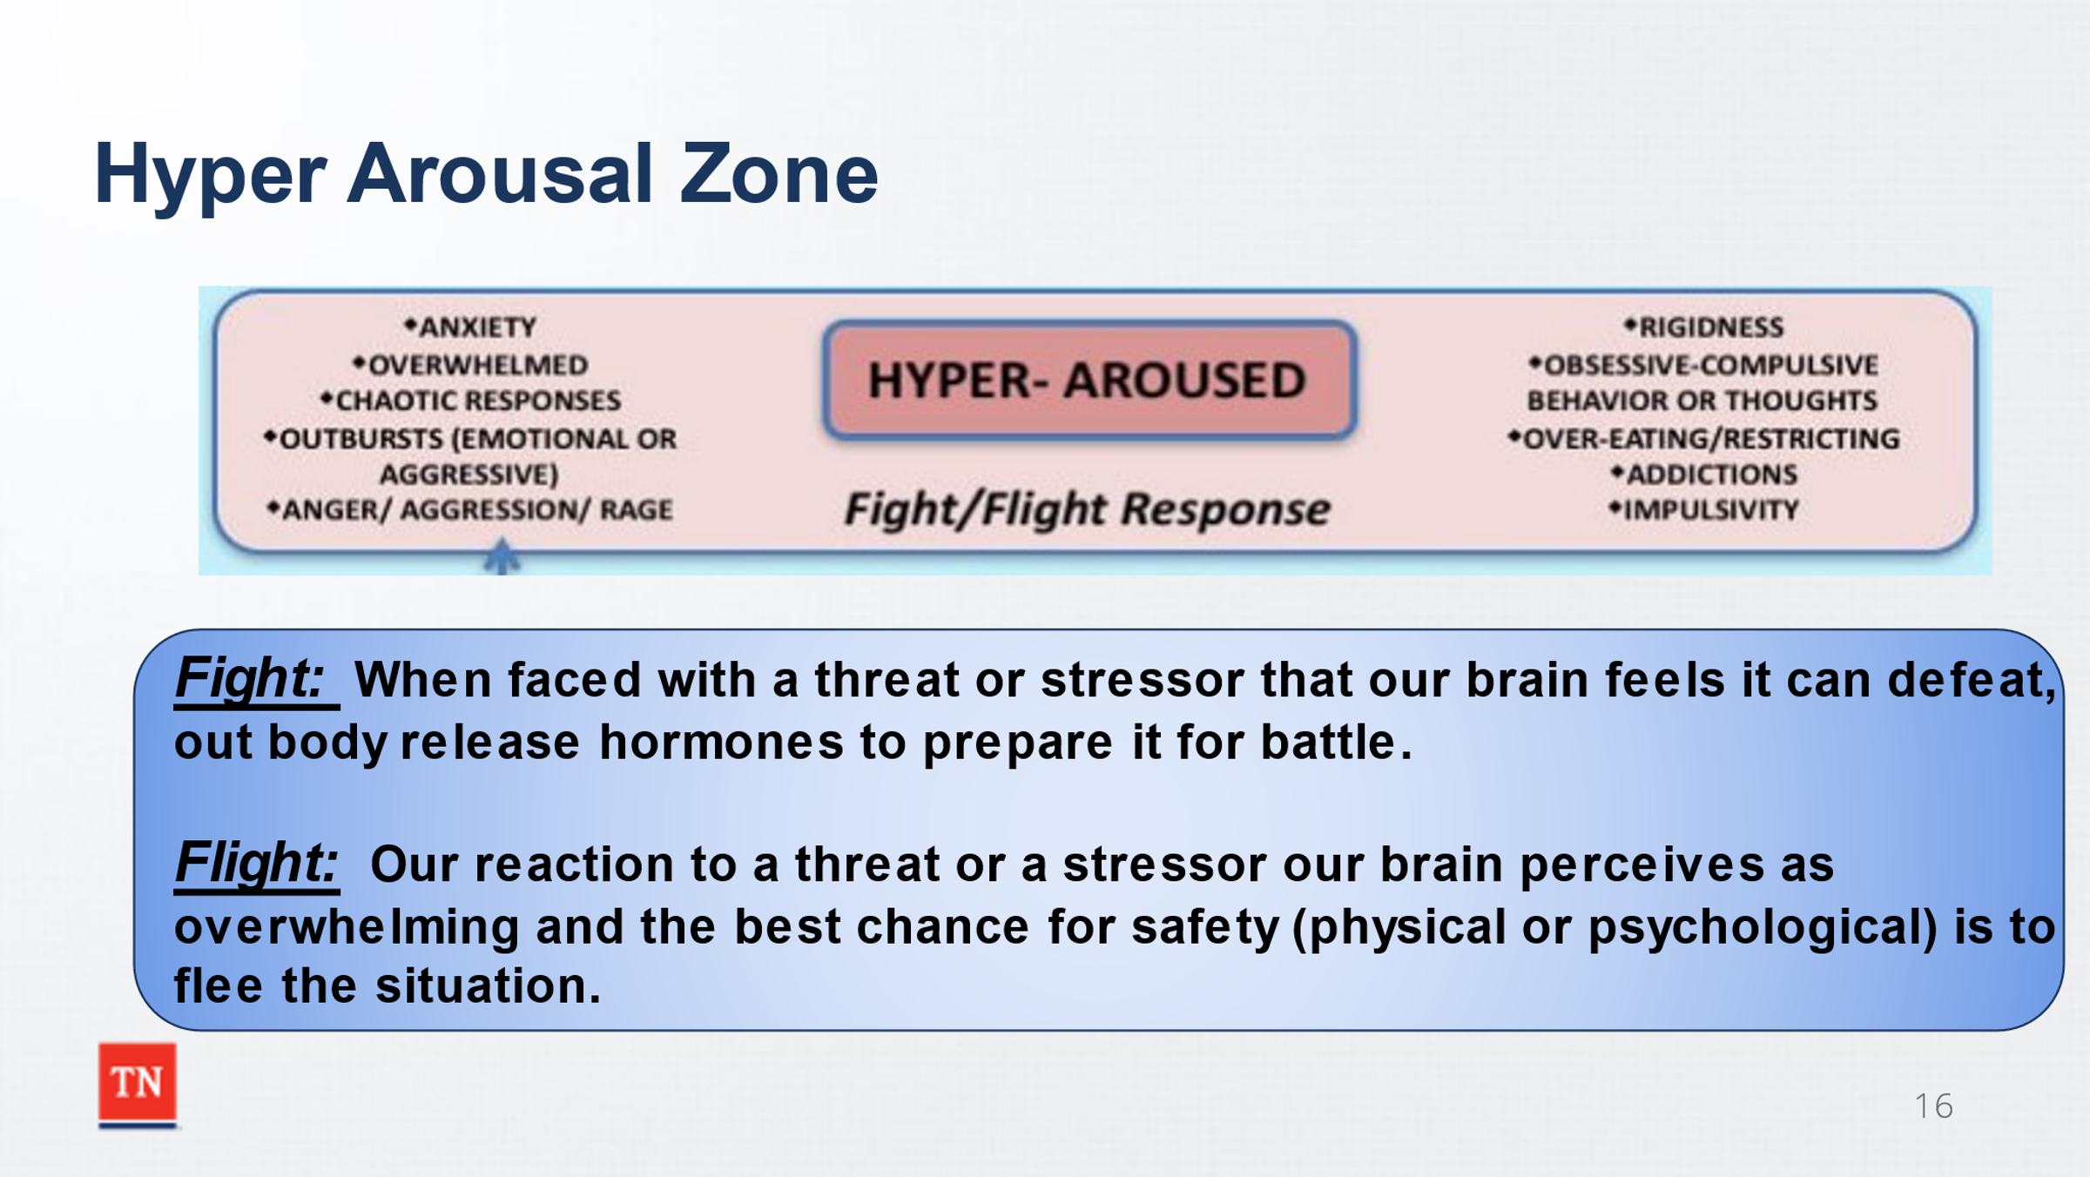
- EXPLAIN that once the Sympathetic Nervous System is engaged, we become Hyper Arousal Zone and go into Flight, Fight mode. REITERATE that the Fight, Flight, Freeze response is automatic, activated by the alarm of threat, and vital to our survival. Unfortunately, it can malfunction due to misinterpretation of stimuli that can falsely trigger the alarm.
  - Fight: When faced with a threat or stressor that our brain feels it can defeat our body (through the ANS) releases hormones which prepare it for battle. Our muscles tense, we sweat, our heartrate increases, and we act impulsively to preserve and defend our safety.
  - Flight: Flight is our reaction to a threat or a stressor our brain perceives as overwhelming and the best chance for safety (physical or psychological) is to flee the situation. The body responds by increasing blood pressure, blood sugar levels, and adrenaline. Physically fleeing a situation means running from danger, hiding, or seeking cover. Psychologically fleeing includes shutting down during an argument, walking away, or protective body language such as crossing our arms in front of us to cover our body (and thereby hide our vulnerabilities).
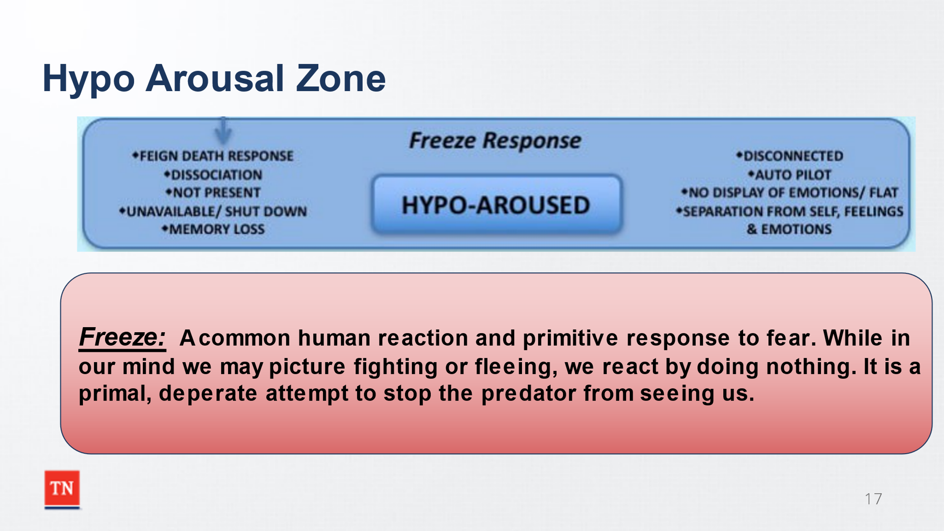
- EXPLAIN that the Hypo Arousal Zone is the Freeze response of doing nothing out of hopelessness.
  - Freeze: Freezing is a very common human reaction and a primitive response to fear. While in our mind we may be picturing fighting or fleeing, we react by doing nothing. Freezing is a primal, desperate attempt to stop the predator from seeing us. Because the body has responded by diverting blood from the brain, thinking becomes incredibly difficult.
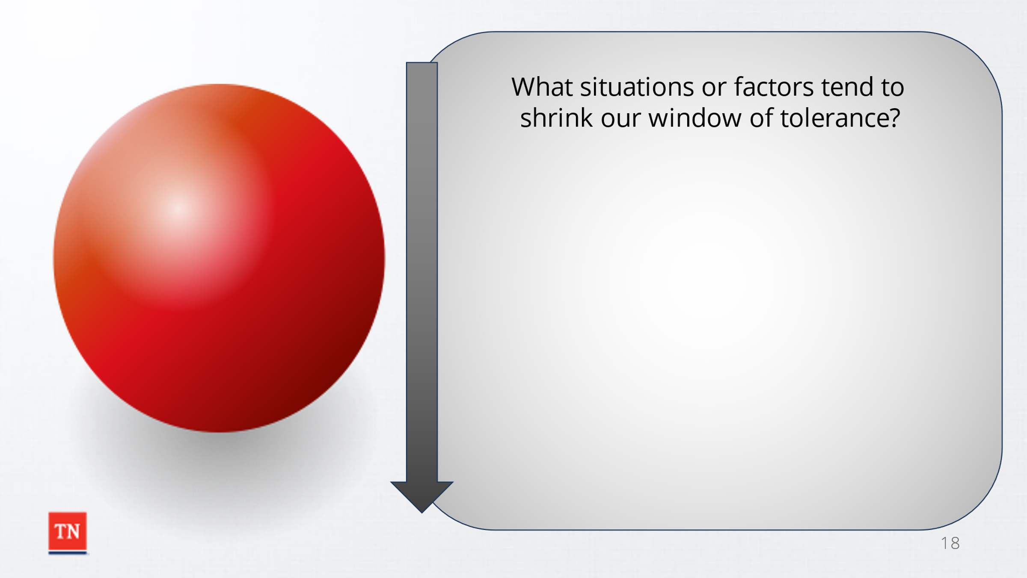
- STATE self-awareness is essential as we continue to explore our window of tolerance and its effect on the conflict cycle. We have to be aware of when our “red ball” is raised so we can respond more effectively.
- SHARE a whiteboard entitled “what situations or factors tend to shrink our window of tolerance?” Possible Responses include:
  - Finances
  - Illness/ Pain
  - Hunger
  - History of abuse
  - Tired
- EXPLAIN that the most effective way to remain in the Window of Tolerance during times of conflict is by slowing the cycle down, being aware of our own emotions, and how our reaction contributes to situations with those around us. There are practices that can adapt to help expand our window of tolerance during conflict.
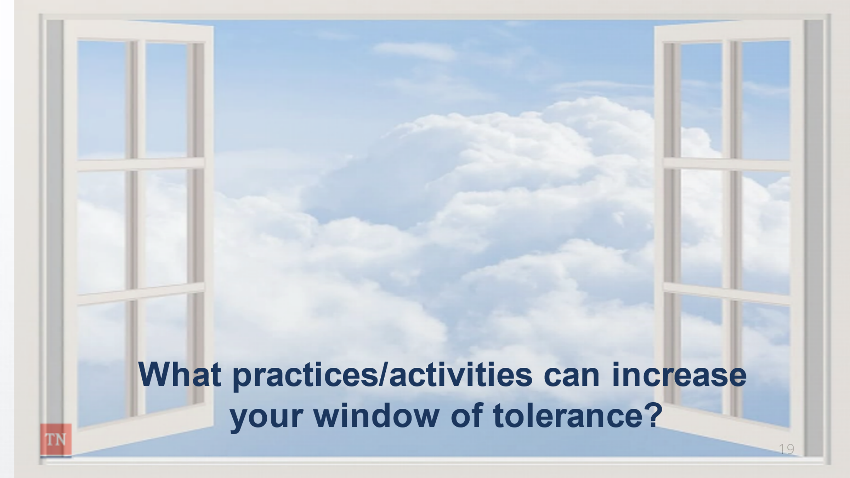
- ASK the group how they think prior trauma affects a person’s window of tolerance.
- INFORM participants that previous experiences and trauma histories can cause us to experience “false alarms” where our bodies begin to respond to stressors that are not actual present thus causing our window of tolerance to decrease.
- SHARE a whiteboard entitled “What practices/ activities can increase your window of tolerance?” Possible responses include:
  - Taking a break
  - Mindfulness breathing (4- Squared breathing)
  - Eating a snack or meal
- TRANSITION to Lesson 2.2 by sharing while using these emotional regulation techniques are effective, there are times when we are unable to regulate our own emotions and must seek help from others to help regulate.
Lesson 2.2: Emotional Co-regulation
Lesson Time: 10 minutes
Key Teaching Points / Instructions

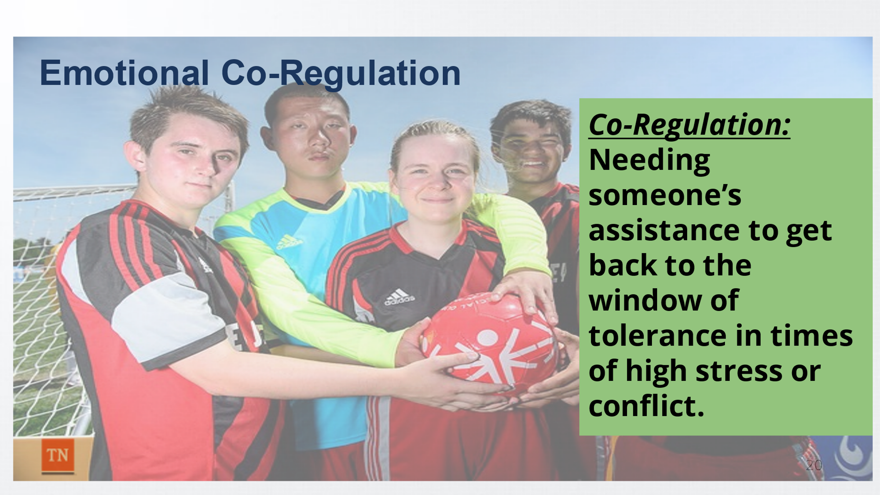
- ASK participants for examples of situations where it is challenging to self-regulate their emotions? Possible responses include:
  - Heated CFTMs
  - Arguments with significant others
  - Times of loss
- STATE during these times of high stress or conflict (hyperarousal) we may have difficulty putting our learned emotion regulation skills to practice and require someone else’s assistance to get back to the window of tolerance. This is called co-regulation.
- ASK participants to recall an instance when they became upset and had difficulty self-regulating until someone else helped them co-regulate by processing the upsetting situation/ trigger.
- ASK for examples of what that person did to assist them to regain focus? Possible responses include:
  - Rubbing their back
  - Reassuring them of a positive outcome
  - Putting the situation into perspective
- POINT OUT that as child welfare workers, we frequently participate in this process during CFTMs, removals, after court hearings, and in many other situations. During those times we are trying to help the other person restore emotional balance, so they can react appropriately within the situation.
- ASK participants if they have ever found themselves seeking validation or a reason to stay in conflict. STATE at times we can be prone to seek individuals who are more validating to our emotional imbalances and “fuel the fire” when it comes to the conflict.
- STATE, therefore, who we choose to rely on for co-regulation is crucial. It is important to seek out those individuals in our support system that will have a calming, reasoning effect on us.
- ASK participants, to think about people they tend to turn to for emotional co-regulation and identify who assist them in regaining emotional regulation verses who tends to validate you being dis-regulated?
- INFORM participants the same person can respond differently depending on the topic/ situation. In some situations, they might provide emotional regulation while in others they might validate dis-regulation.
- TRANSITION to Unit 3 by stating now that we have explored factors that impacts our perceptions/thoughts/feelings in the conflict cycle, we are going to continue exploring the cycle by looking at our responses.

Unit 3: Exploring Responses

Unit Time: 65 minutes

Learning Objectives:
- Participants will develop an understanding of the role of Understanding, Expecting Change, and Avoidance during conflict
- Participants will understand how to form a Balanced Response to achieve improved outcomes to conflict situations

Supporting Materials:
- PowerPoint
- Participant Journal

Lesson 3.1: Exploring Responses
Lesson Time: 40 minutes
Key Teaching Points / Instructions
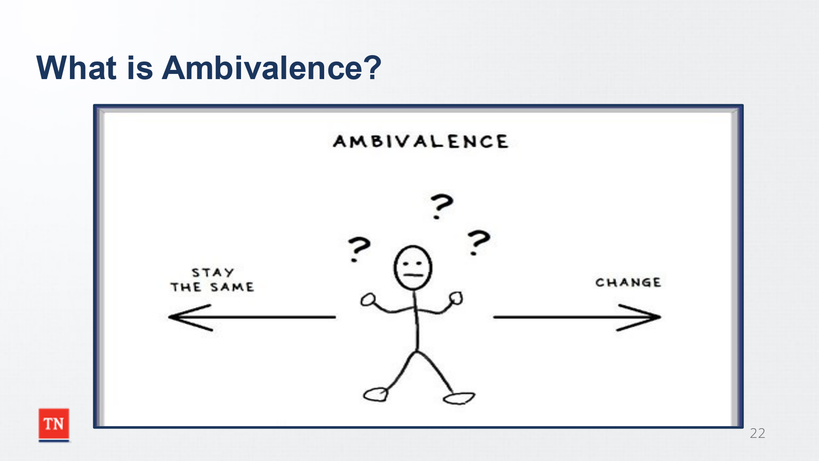
- INFORM participants that in this unit we will explore different types of responses to conflict and work toward gaining a deeper understanding of feelings/emotions and perceptions that drive each one.
- ASK the participants to share their definition of “ambivalence”.
- STATE ambivalence is defined as simultaneously having positive and negative feelings regarding a situation. Recognizing ambivalence as an integral part of the change process is a key component of Motivational Interviewing.
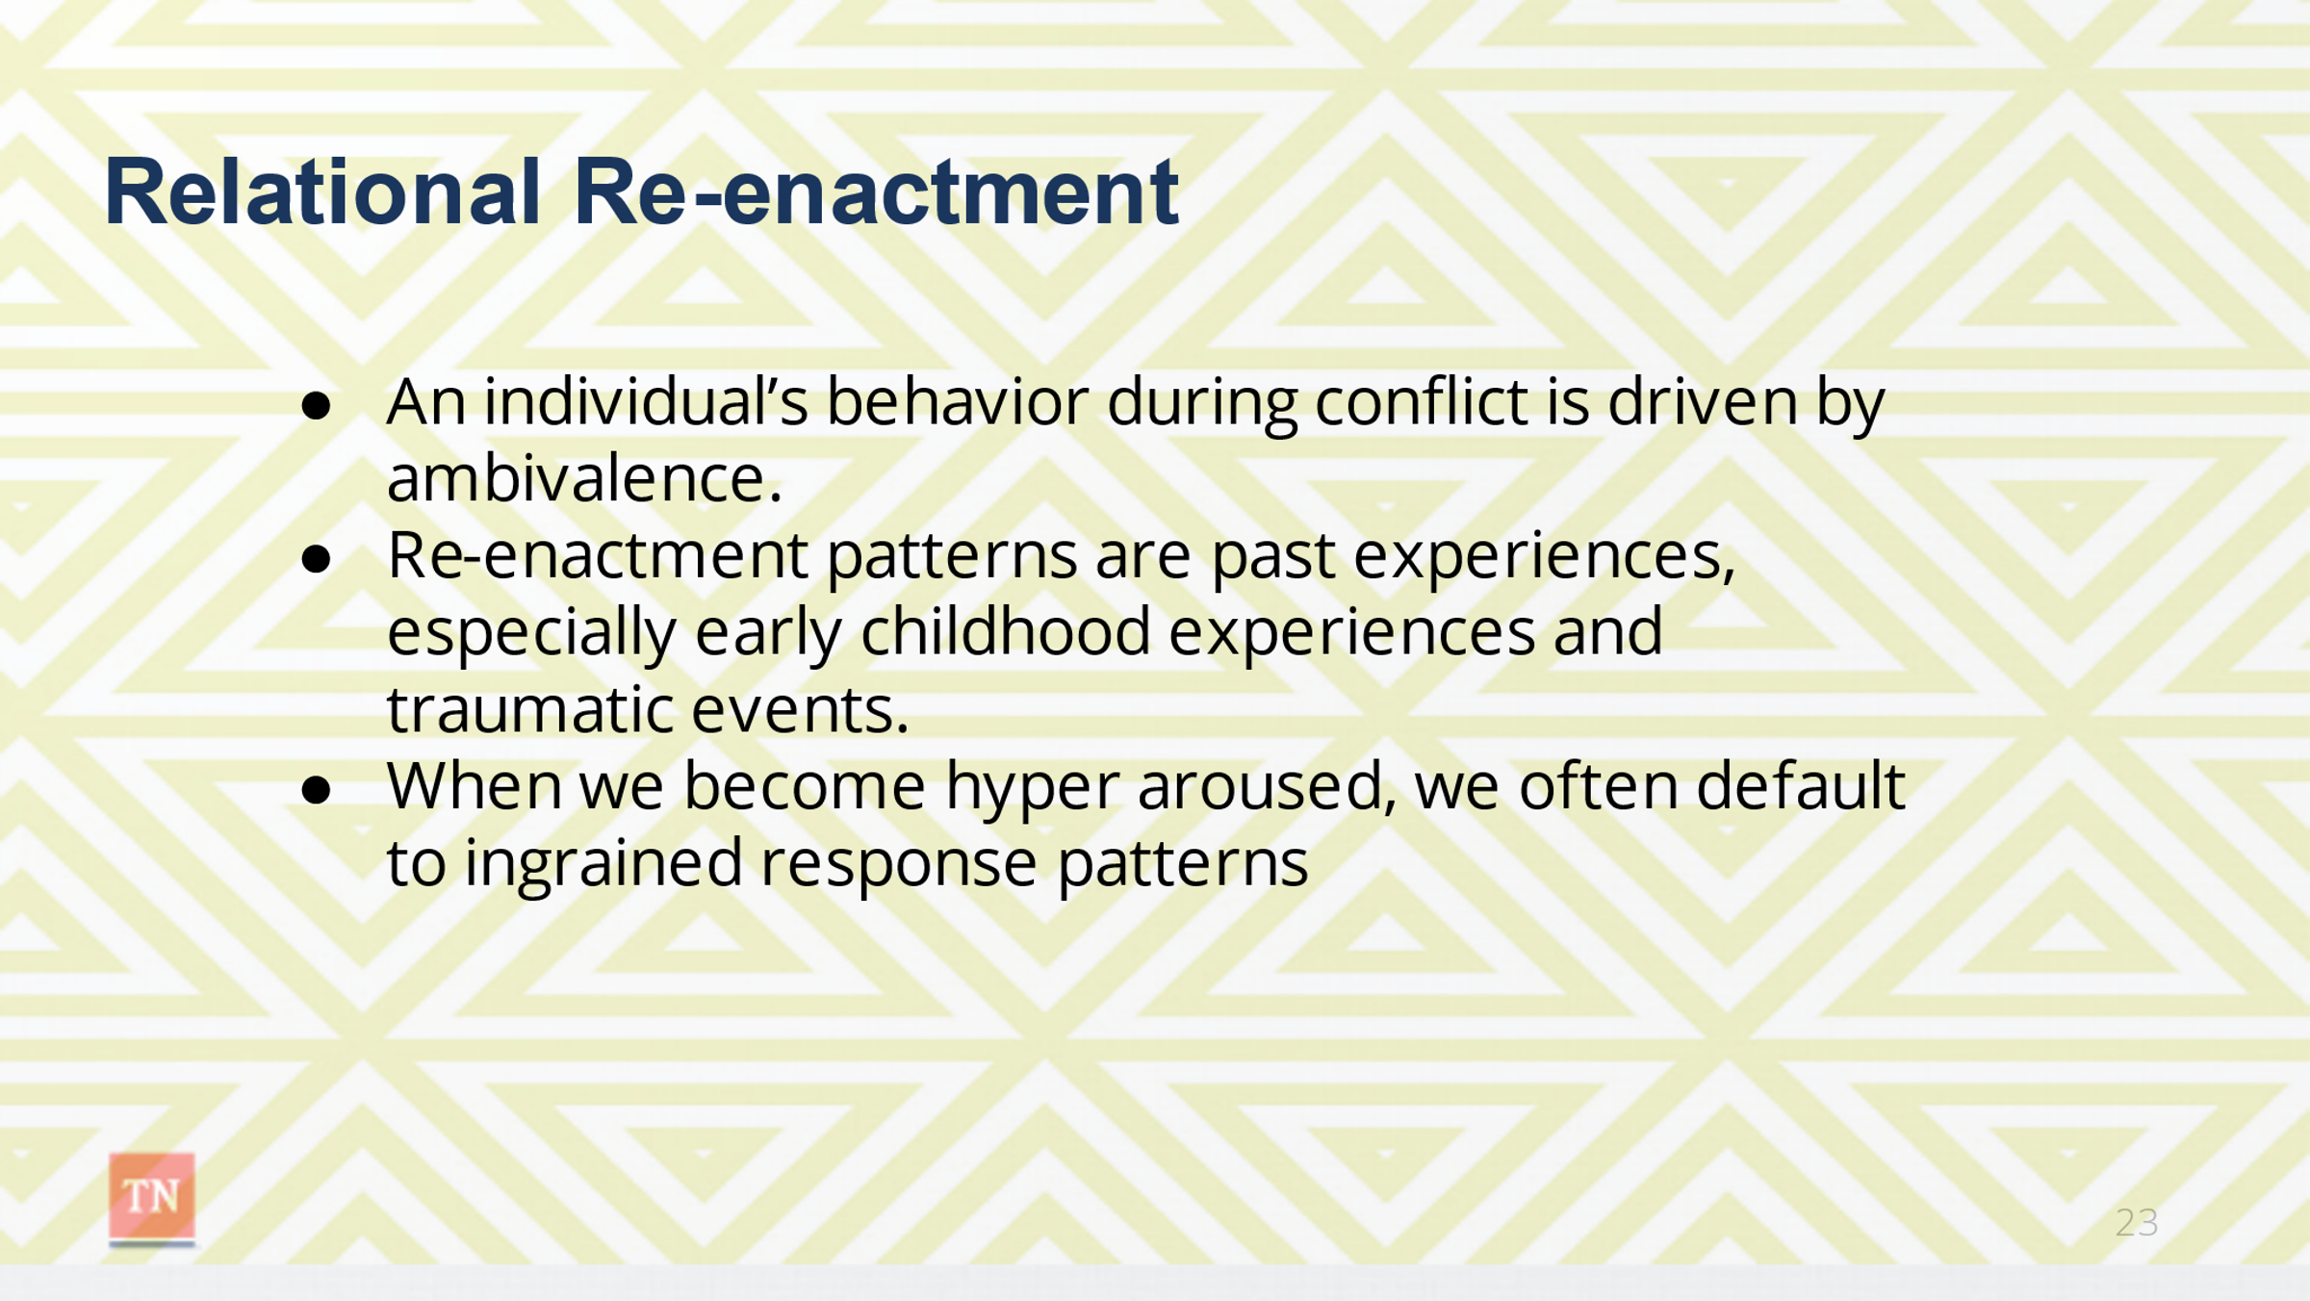
- SHARE in the context of client families, caregivers may have an unsafe parenting style that they learned from their own parents or a lengthy history of active addiction. These long-term, challenging behavior patterns are not easily reversed. These clients know they need to change, maybe even want to change, but that is often easier said than done.
- EXPLAIN that it is imperative to understand that an individual’s behavior during a conflict situation (the Relational Re-enactment) is driven by ambivalence.
- REMIND the group of the Relational Re-enactment concept and the fact that these re-enactment patterns are subconscious and stem from past experiences, especially early childhood experiences and traumatic events. When we become hyper aroused during conflict, we often default to ingrained response patterns (like Josh pushing people away through negative behaviors).
- Josh was ambivalent about developing a close relationship with his foster parents: on the one hand he wanted a close, loving relationship with his caregivers but on the other hand he was afraid that he would be hurt or rejected by them if he allowed himself to become vulnerable. Josh talks about giving youth the time and space to resolve their own ambivalence regarding change by allowing them to “sit” in their positive or negative choice without jumping in to emotionally rescue them.
- REINFORCE that ambivalence (internal conflicts) can externally present as challenging behaviors, much like Josh Shipp’s behaviors from the video. We all struggle with ambivalence regarding change. We recognize that change needs to occur given the circumstances, but we also are comfortable with the way things are.
- Within our work as child welfare professionals, we often struggle as we try to balance the desire to be helpful and patient while feeling pressured to meet demands, deadlines, policy requirements, and to achieve permanency in a timely manner.
- STATE it can often be challenging to provide a balanced response.
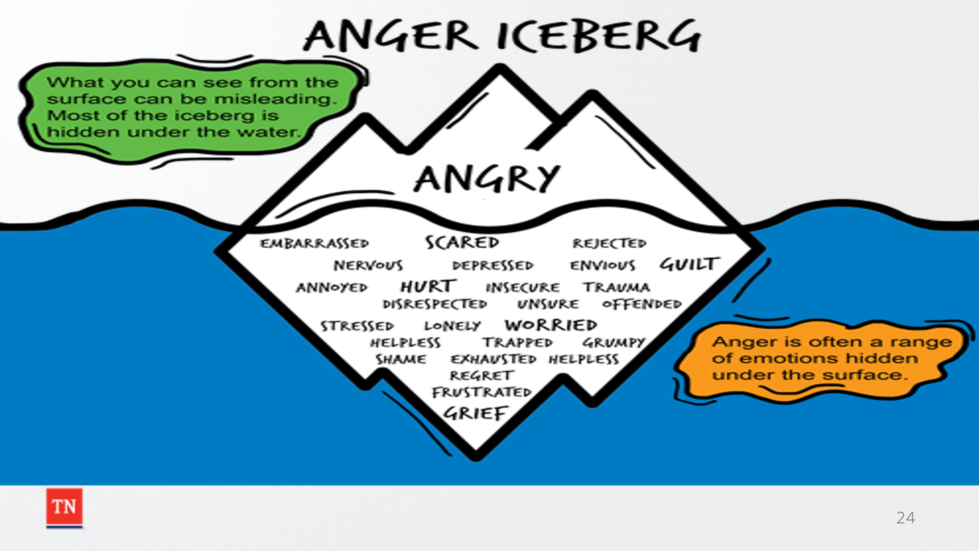
- ASK participants if they have been involved in a conflict situation in their personal or professional lives and “lost it” (reacted in an overly harsh. Aggressive manner)?
- STATE often during a conflict the easiest feeling to express is anger That is because anger is one of the safest feelings to express because it limits vulnerability; however, we need to be mindful of what is driving the anger by looking below the surface at what could be motivation the response.
- ASK participants if there was a time when they “gave in” (were overly lenient/ accommodating)?
- EXPLORE what motivated the responses. Possible responses include:
  - Fear or frustration
  - Effort to de-escalate a tense/ explosive situation
  - Desire to be the “good guy”
  - Attempt to end unproductive conflict
- EXPLAIN we are now going to look at the possible ways we can respond during a conflict which is referred to as our counter response.
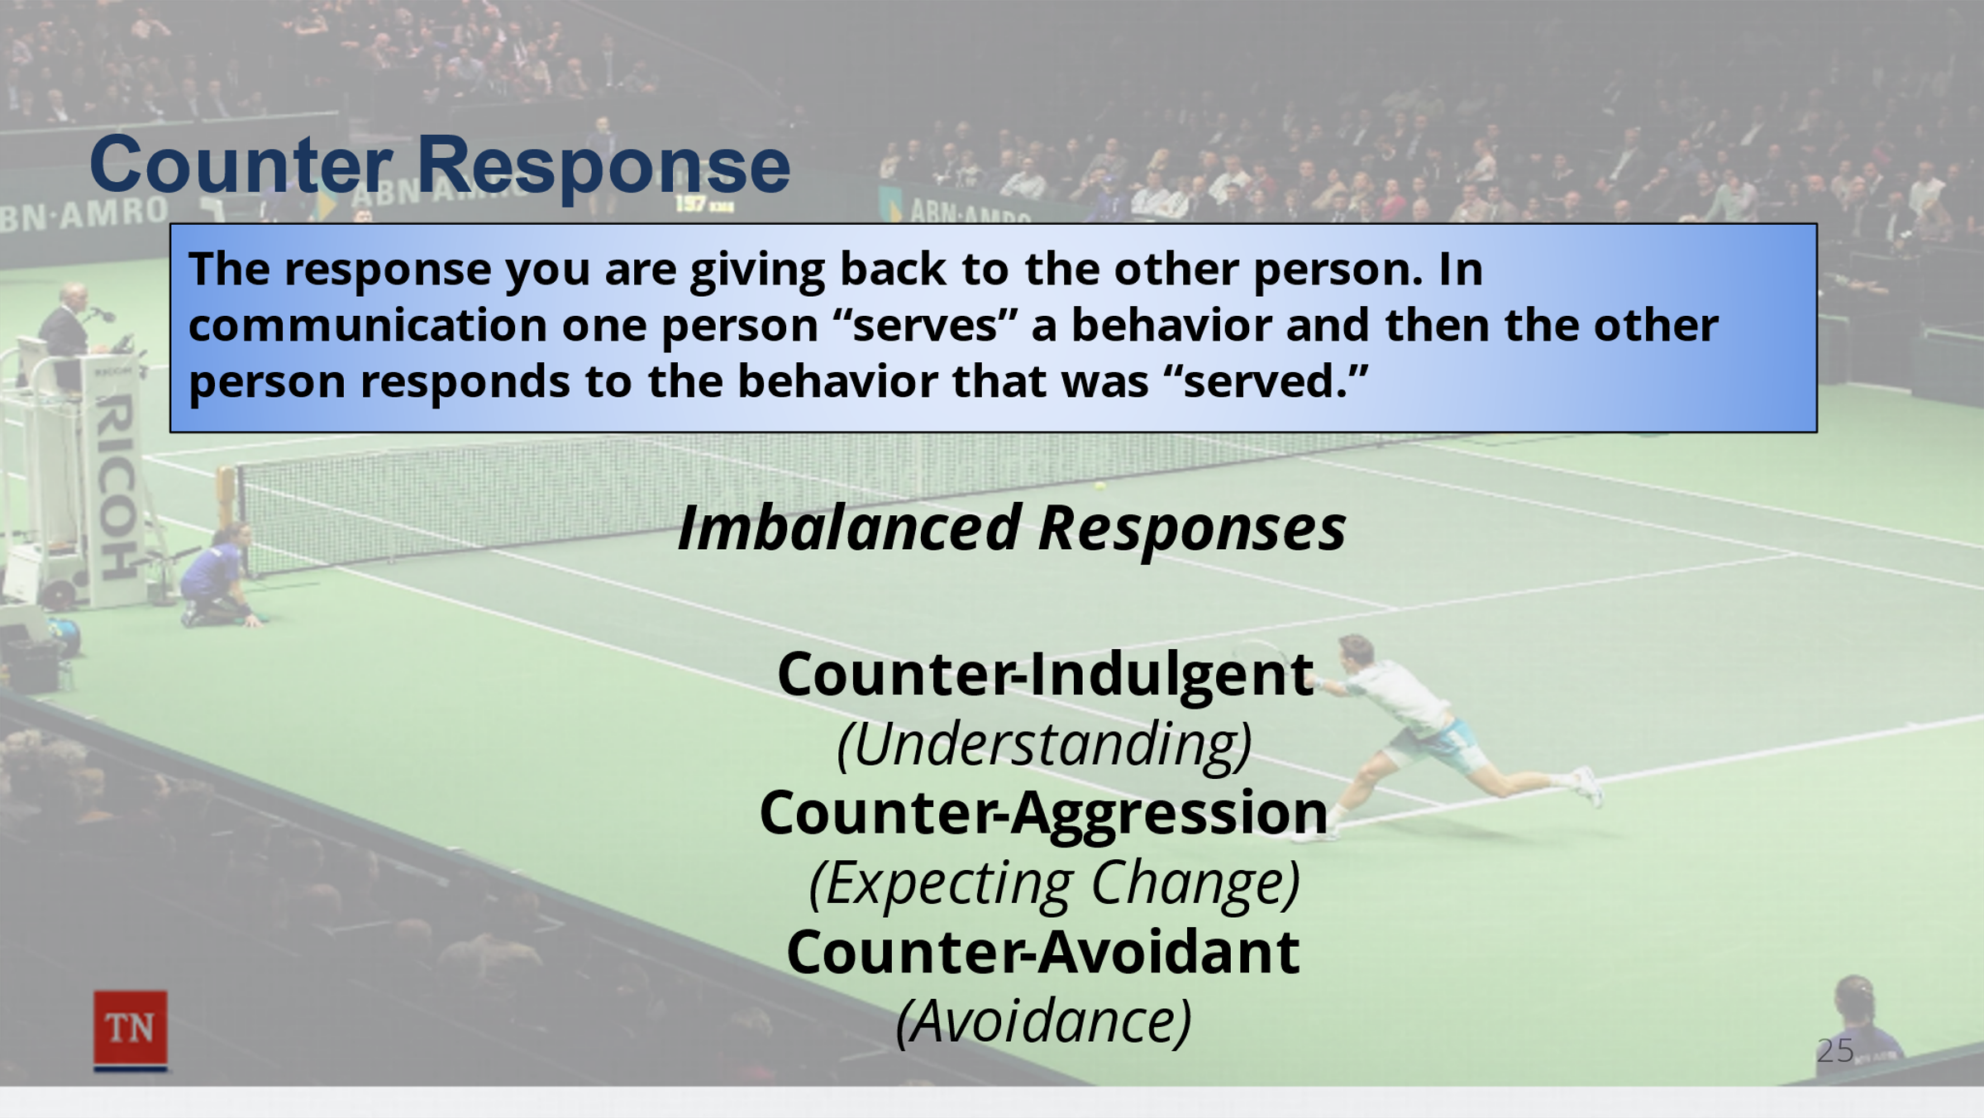
- STATE the term counter response refers to the response that you are giving the other person during an exchange. Think of it like a tennis match. The first player serves the ball and then second player then returns the ball. In order for the game to continue, each player must respond to the other player’s action. This is a counter response. In communication, one person “serves” a behavior and then other person responds to the behavior “served”.
- EXPLAIN behaviors such as “losing it” or “giving in” are what we refer to as imbalanced responses and they fall into three main categories:
  - Counter-Indulgent/ Understanding
  - Counter-Aggressive/ Expecting Change
  - Counter-Avoidant/ Avoidance
- STATE we will explore how to provide a balance response later in the class.
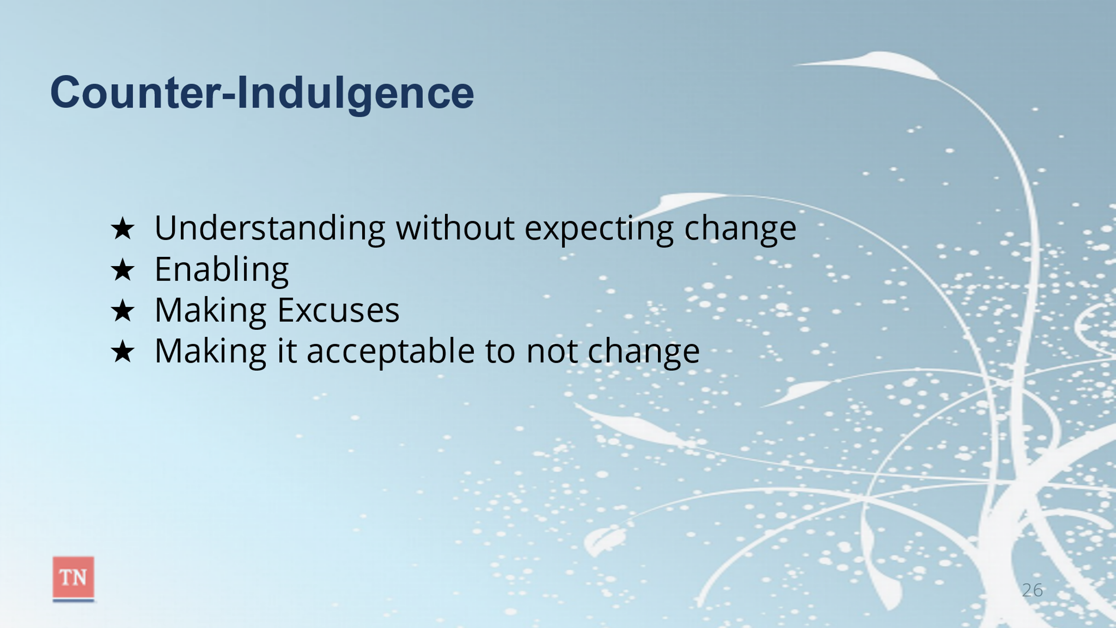
- EXPLAIN counter-indulgence can be defined as understanding without expecting change, enabling, making excuses, making it acceptable to not change.
- ASK participants to think back to Josh Shipp’s story and share an example of how Rodney could have responded to Josh in a counter-indulgent manner. (Place the conflict cycle with notes on the screen).
  - Rodney responds with empathy, understanding, and aligns with Josh’s position. He does not hold Josh accountable for his inappropriate behavior and does not communicate any expectation of change.
  - Rodney recognizes that Josh has a significant trauma history and desires a stable relationship, so he immediately bails Josh out and takes him to a restaurant for a meal in order to soothe him from the ordeal of the arrest and incarceration. He attributes his negative behavior to his past trauma and the need for love and does not communicate any expectation for Josh to take responsibility for his actions.
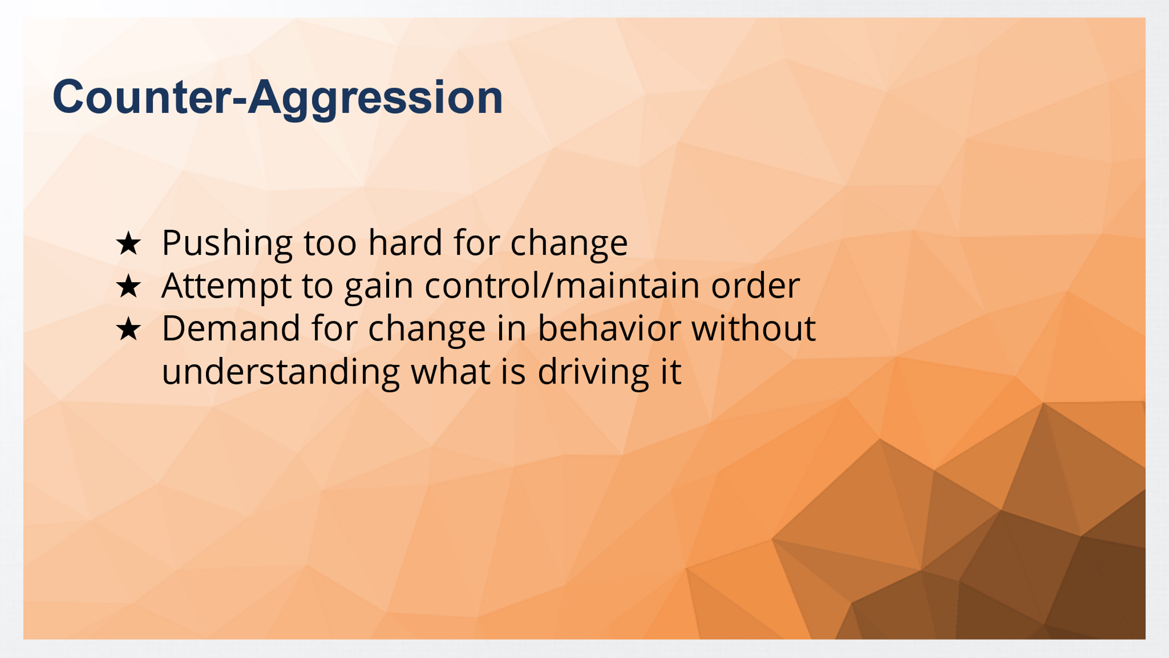
- EXPLAIN counter-aggression can be defined as pushing too hard for change without allowing the person to resolve their own internal ambivalence. This response is often an attempt to gain control and maintain law and order in a conflict situation. There is a demand for change in behavior without understanding what is driving it.
- ASK participants how might have Rodney responded to Josh in a counter-aggressive manner?
  - Rodney is angry and frustrated and makes demands for Josh to change his inappropriate behavior without seeking to understand what is driving his actions.
  - Rodney experiences resentment due to his failed efforts to steer Josh in the right direction and is frustrated by his delinquent behavior. When Josh asks Rodney to bail him out of jail, Rodney says, “What were you thinking? I am so frustrated with you! You did this to yourself and have to suffer the consequences. There is nothing I can do for you.” Then without giving Josh the opportunity to respond, Rodney hangs up the phone.
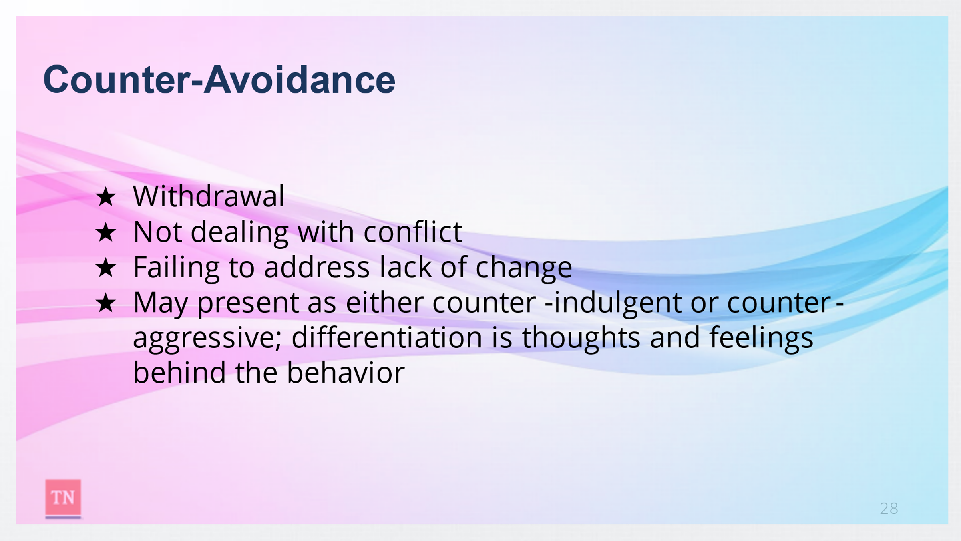
- EXPLAIN counter-avoidance can be defined as withdrawal, not dealing with the conflict, failing to address the lack of change. Counter-Avoidance may present as either a counter indulgent or counter aggressive response, depending on situation; the differentiation is in the feelings and thoughts behind the behavior. This response may take many forms including ignoring the situation altogether, shutting down, and pretending the conflict does not exist.
- ASK participants how might have Rodney responded to Josh in a counter-aggressive manner?
  - Rodney is so tired of continually dealing with Josh’s behavior, so he decides to withdraw from the conflict. He goes to the jail and picks Josh up but makes no mention of the situation.
  - Rodney and his wife have been trying to make a difference in Josh’s life for years, yet they feel they are failing. Since Josh has not returned in time for curfew, Rodney assumes he has gotten into trouble again and does not answer the phone that night, no matter how many times Josh tries to call him from jail.
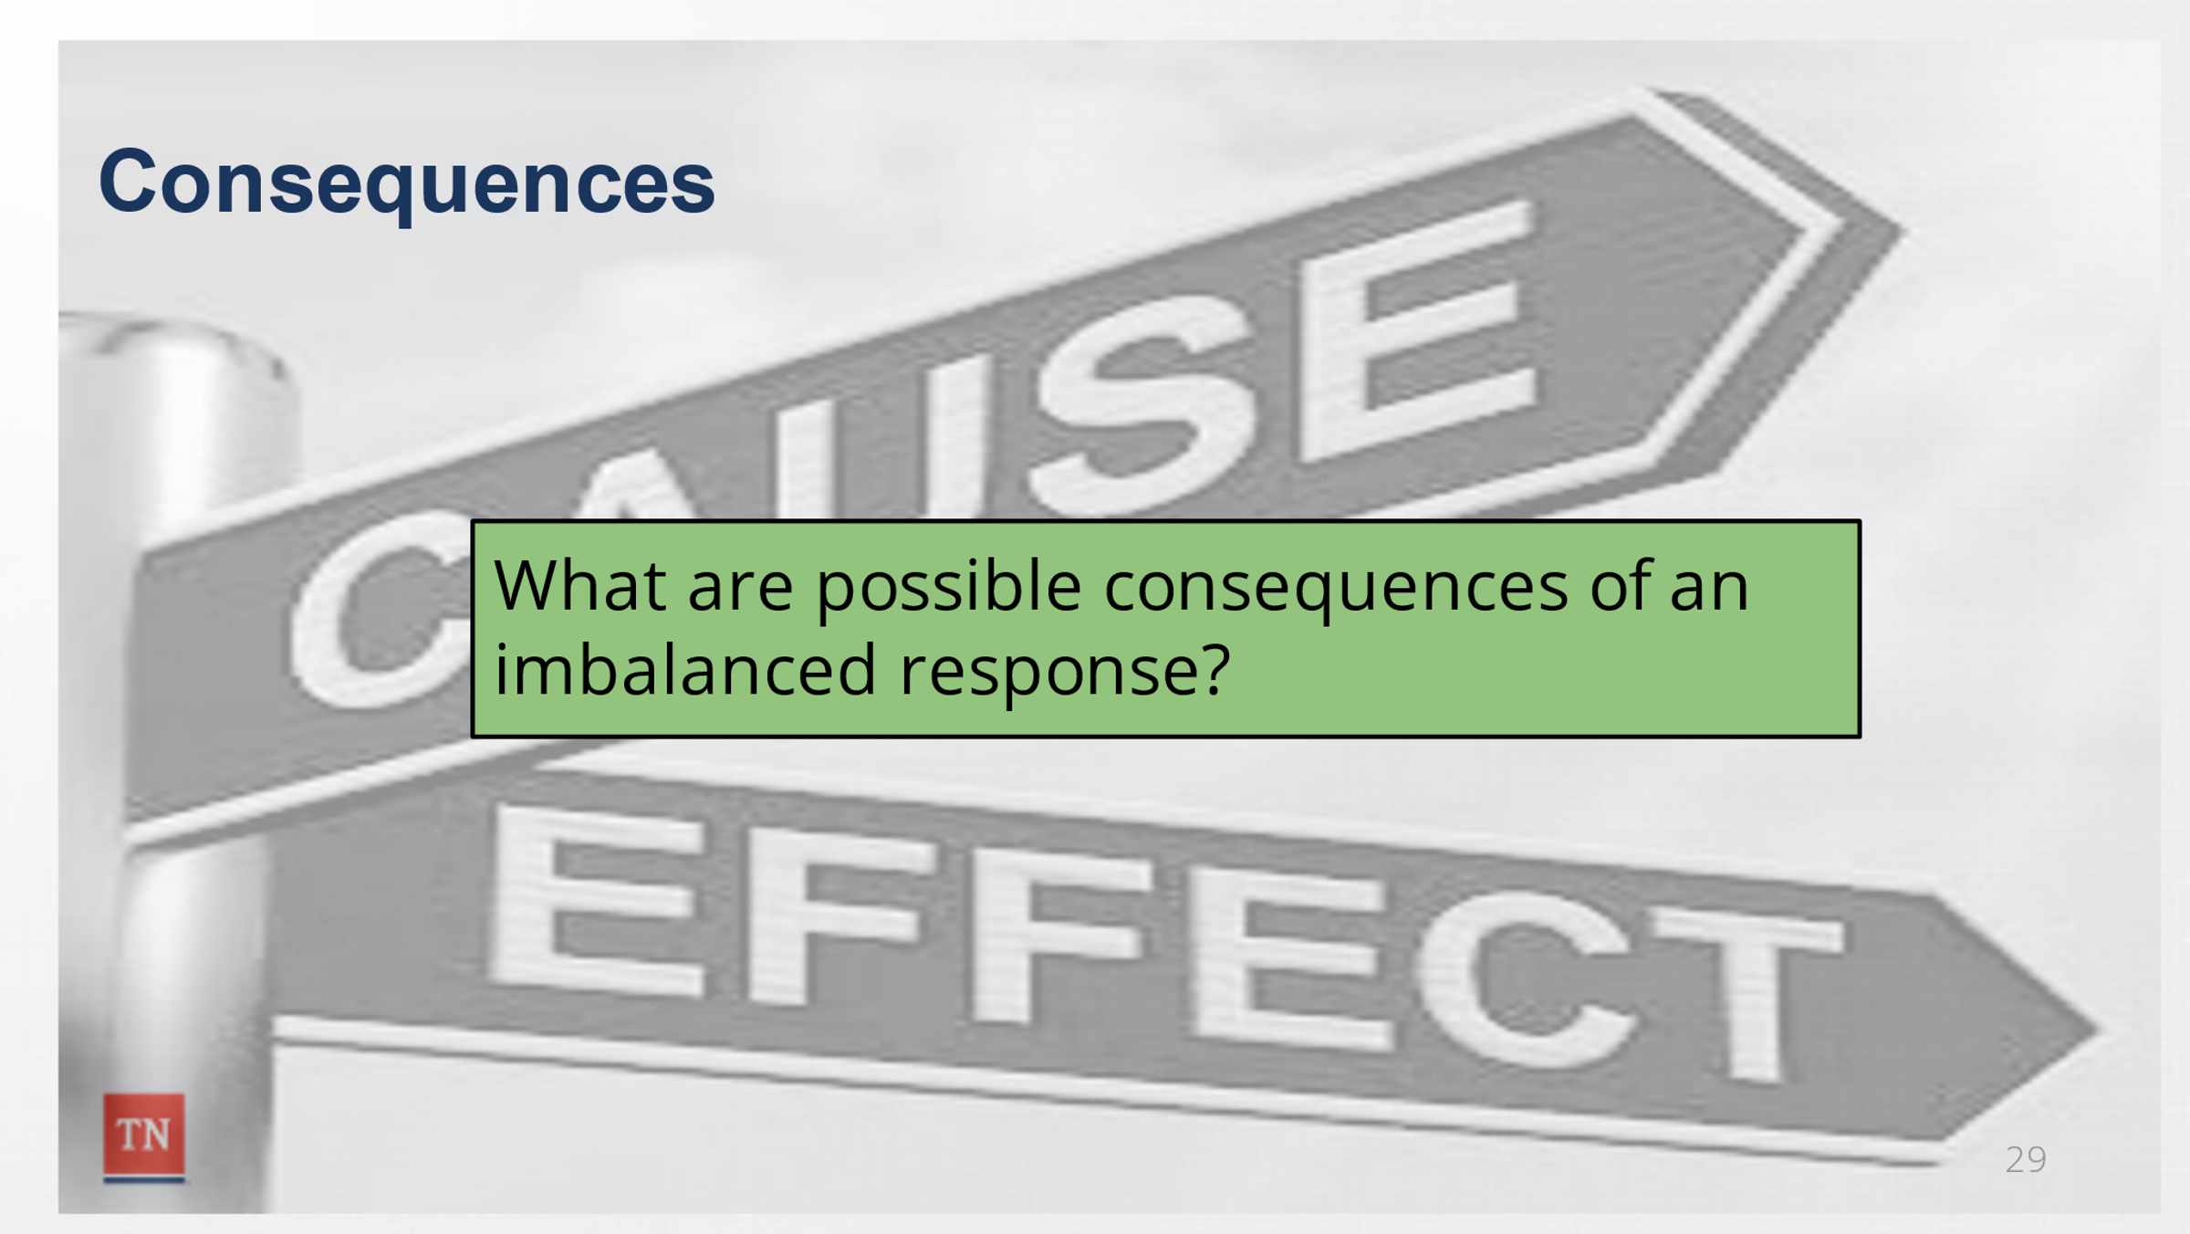
- STRESS to the group that the Counter-Indulgence (Understanding) is NOT THE SAME as social work best practice. Both Counter-Indulgent and Counter-Aggressive responses have negative consequences and perpetuate the Conflict Cycle as opposed to resolving the conflict.
- ASK participants to share some possible consequences of each of the three types of imbalanced responses. Possible responses include:
  - Counter-indulgent: continuing the negative behavior and blaming it on the underlying concerns and never taking accountability for the actions. Continually making excuses and even acting out to get your way since you have not been held accountable for actions in the past.
  - Counter-Aggressive: the “my way, or no way” response could create additional conflict and push back. People don’t like to be told what to do and if they are not bought into the situation, they are more likely to express negative emotions and behaviors; thus, causing additional conflict.
  - Counter-Avoidance: The situation continues to build up causing resentment and discord. No change occurs since the situation is being ignored.
- REITERATE all three of these are imbalanced responses to conflict and ultimately lead to the conflict continuing, change not occurring, and not reaching a positive outcome. In the moment, it may be easier to respond in one of these ways; however, the conflict is not being resolved in a positive manner.
- TRANSITION to Lesson 3.2 by stating now that have that we know that imbalanced responses look like and how it impacts the conflict cycle. Let’s look at imbalanced responses within ourselves.

Lesson 3.2: The Balancing Act
Lesson Time: 25 minutes
Key Teaching Points / Instructions
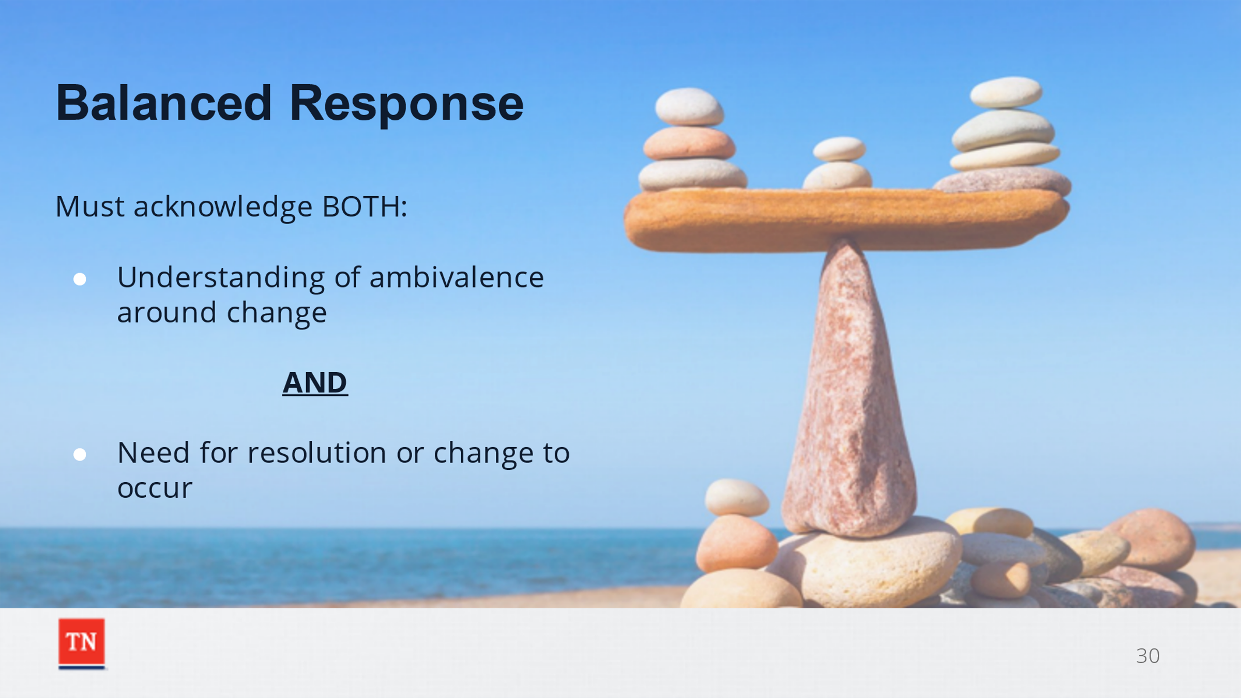
- INFORM the participants that in this lesson we will explore skills we can use to react with a Balanced Response in conflict situations.
- BEGIN the discussion by asking the group what comes to mind when they hear the word “balance” in the context of responding within the Conflict Cycle.
- EXPLAIN that the best response during a conflict situation is one that acknowledges BOTH the understanding of the presence of ambiguity around change and the need for a resolution or change to occur. This creates a balanced environment in which the individual can resolve their own ambivalence, therefore becomes genuinely and internally committed to the change.
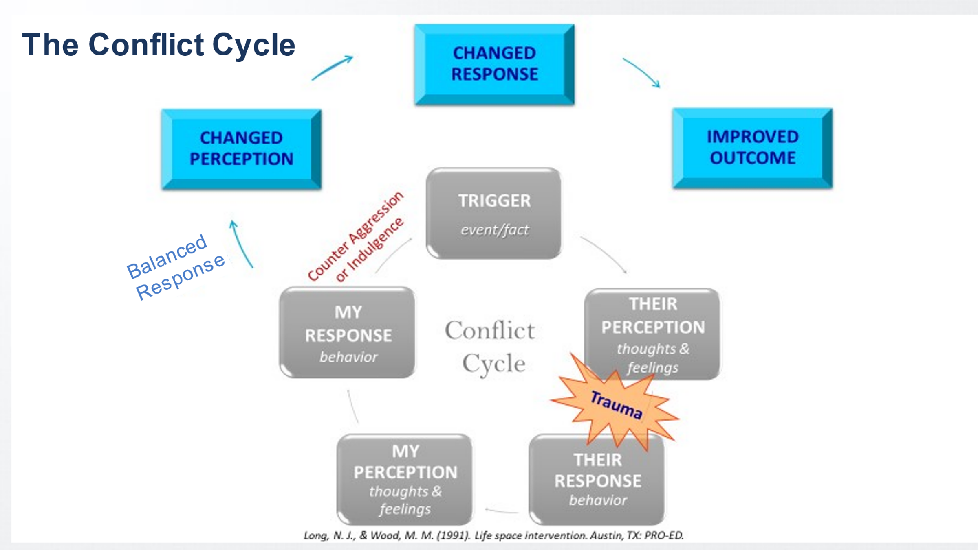
- REFER to the conflict cycle and ASK participants which part of the cycle we have control over. The answer is our response. EMPHASIZE it is a normal human response to conflict to have negative thoughts and feelings during a conflictual situation. What we must focus on, is how we choses to respond to the other person/ people in the situation to lead to a positive outcome. We cannot let our initial thoughts and feeling control our behavior.
- STATE, at times, conflict is caused by misperceptions. People tend to make assumptions about others intent and define meaning to their behaviors without seeking to fully understand them. It is important for us to make generous assumptions about others when navigating the conflict cycle. If we assume that people are doing the best they can in the situation, we are more likely to be empathetic with them.
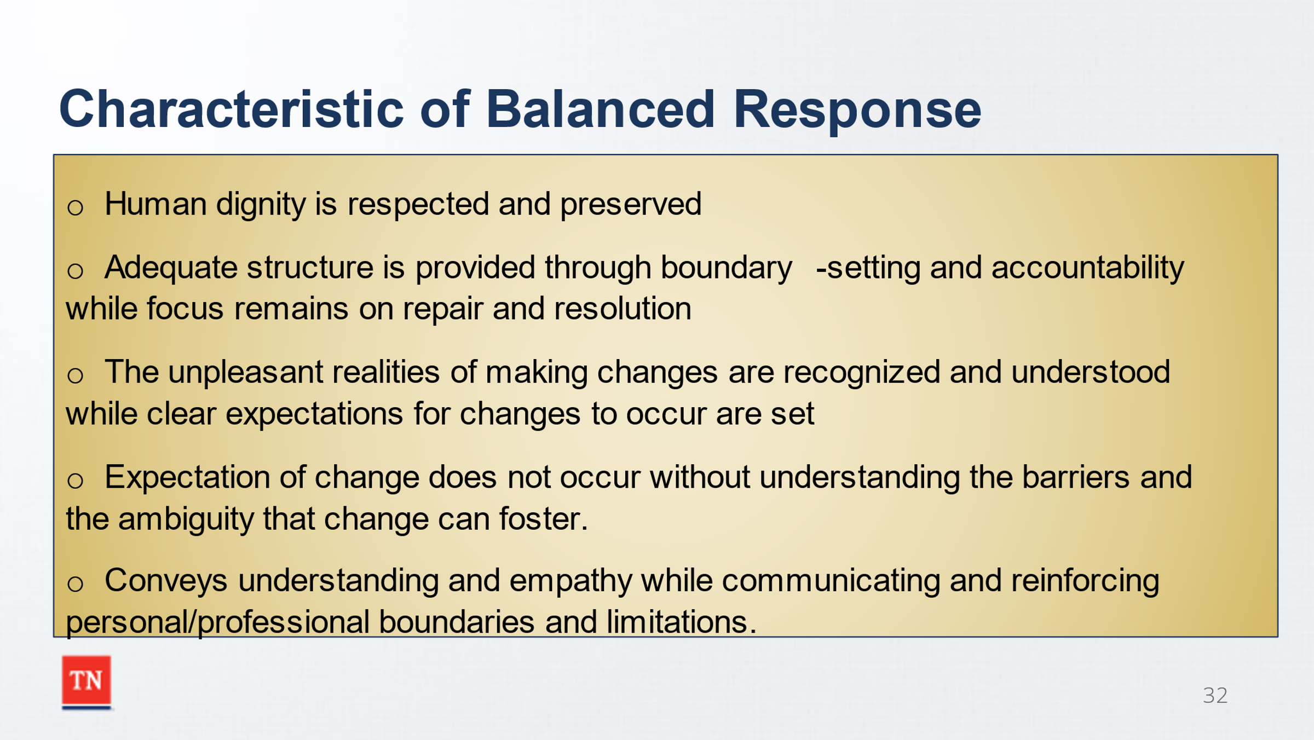
- INFORM participant that some characteristics of balanced responses include:
- Human dignity is respected and preserved
- Adequate structure is provided through boundary-setting and accountability while focus remains on repair and resolution
- The unpleasant realities of making changes are recognized and understood while clear expectations for changes to occur are set
- Expectation of change does not occur without understanding the barriers and the ambiguity that change can foster.
- Conveys understanding and empathy while communicating and reinforcing personal/professional boundaries and limitations.
- SHARE that in a balanced response we want to convey empathy, understanding the challenges that comes with change. Yet be sure to communicate personal and/or professional boundaries and limitations. Clear communication of personal boundaries are essential in healthy personal and work relationships.
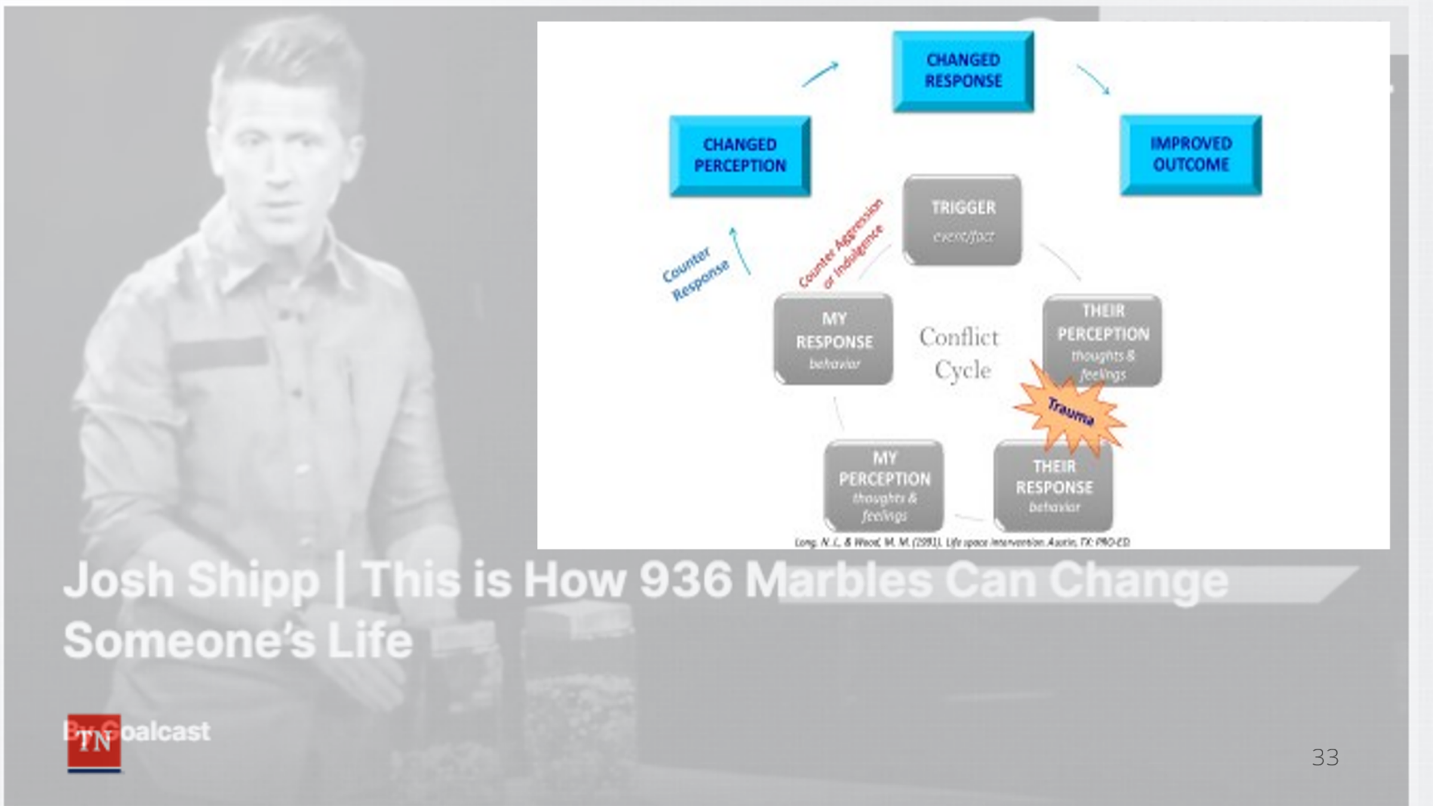
- REVISIT Josh Shipp’s situation. ASK participants for examples of how Rodney respond to Josh in a balanced way when he called from jail. Possible Responses: He waited until the next day to allow himself to have a time to cool down and gain control of his emotions. He understood why Josh was afraid of developing a relationship with him while holding him responsible for his actions.
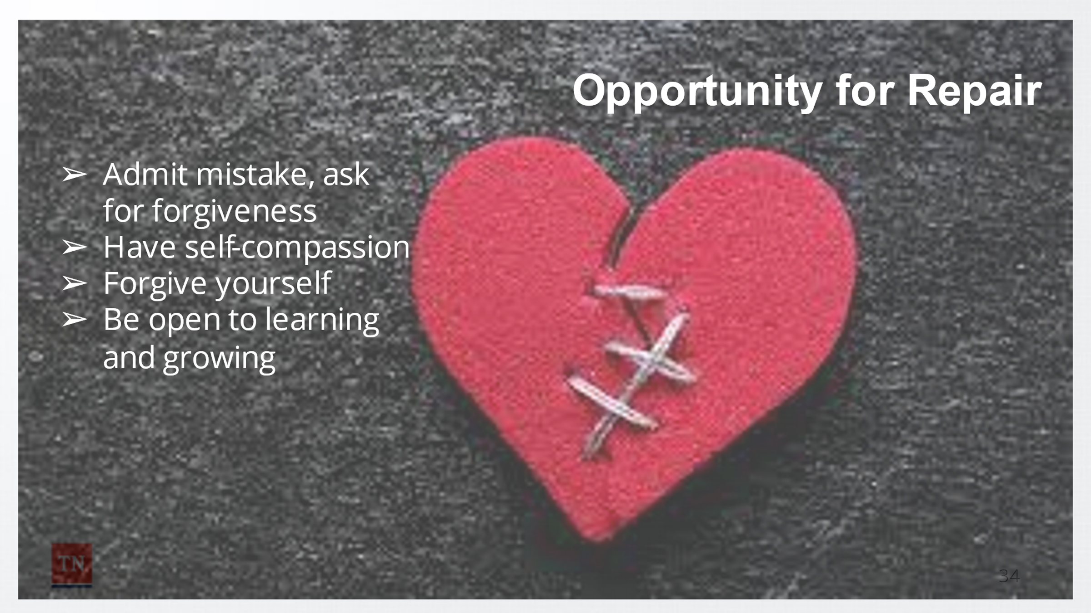
- EXPLAIN the concept of a balanced response is simple, but the challenge is applying the skills during heated interactions and not allowing our emotions to take over.
- EMPHASIZE to the group that we are human and do not always navigate conflict in the best manner. However, we can consistently learn from our prior experiences, even our mistakes. This leads to the opportunity for repair.
- SHARE we are consistently modeling behavior for others (our children, significant others, children and families we serve). When times arise that we make mistakes, it is important for us to admit the mistake and ask for forgiveness. This shows that we are all human and it is acceptable to make mistakes and take responsibility for our actions. These times tend to build and strengthen the relationship so you can have more meaningful interactions in the future.
- STATE it is not always possible for us to repair the relationship depending on the circumstances. For example, you may not even know the person you were in conflict with since they were just at a restaurant or store, but we can continue to learn from our interactions and grow.
- SHARE internal repair refers to self-compassion and forgiving ourselves for times when we have not responded to conflict in a productive way. We can often be our own worst critic; therefore, it is important to understand what contributed to our reaction and strive for improved outcomes in the future. TRANSITION to Unit 4 Increasing Self-Awareness.

Unit 4: Increasing Self-Awareness

Unit Time: 30 minutes
Learning Objectives:
- Participants will understand the importance of self-awareness in providing balanced responses.

Supporting Materials:
- PowerPoint
- Journal
Lesson 4.1: The Reinforced Response Lesson Time: 15 minutes
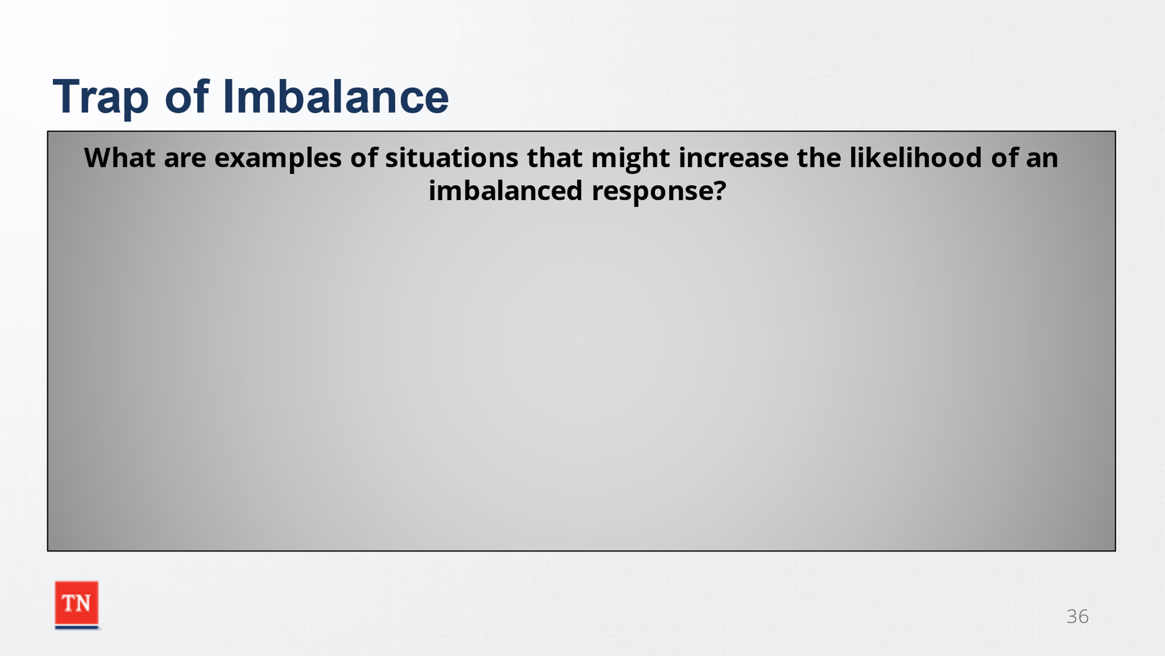
Key Teaching Points / Instructions
- EXPLAIN providing a balanced response begins with self-awareness and understanding. We must be aware of our own imbalanced response tendencies and identify our triggers and intentions in these reactions.
- STATE the unpleasant realities of working in child welfare can often push us into a trap of Imbalanced Responses.
- ASK participants for some examples of situations they might experience that would increase the likelihood of them providing an imbalanced response. Possible responses include:
  - heightened concern regarding imminent risk to a child
  - staff that are burned out or feeling compassion fatigue
  - Court or policy dictating that if change does not occur, alternate action should be taken within certain timeframes
  - families that continue to display the same unsafe or unhealthy behaviors despite expressing commitment to change
  - a cooperative/compliant client backslides
  - a previously obstinate client starts crying or expressing remorse
  - a client with a history of violence gets upset or angry
  - clients that are persistently argumentative or difficult to work with
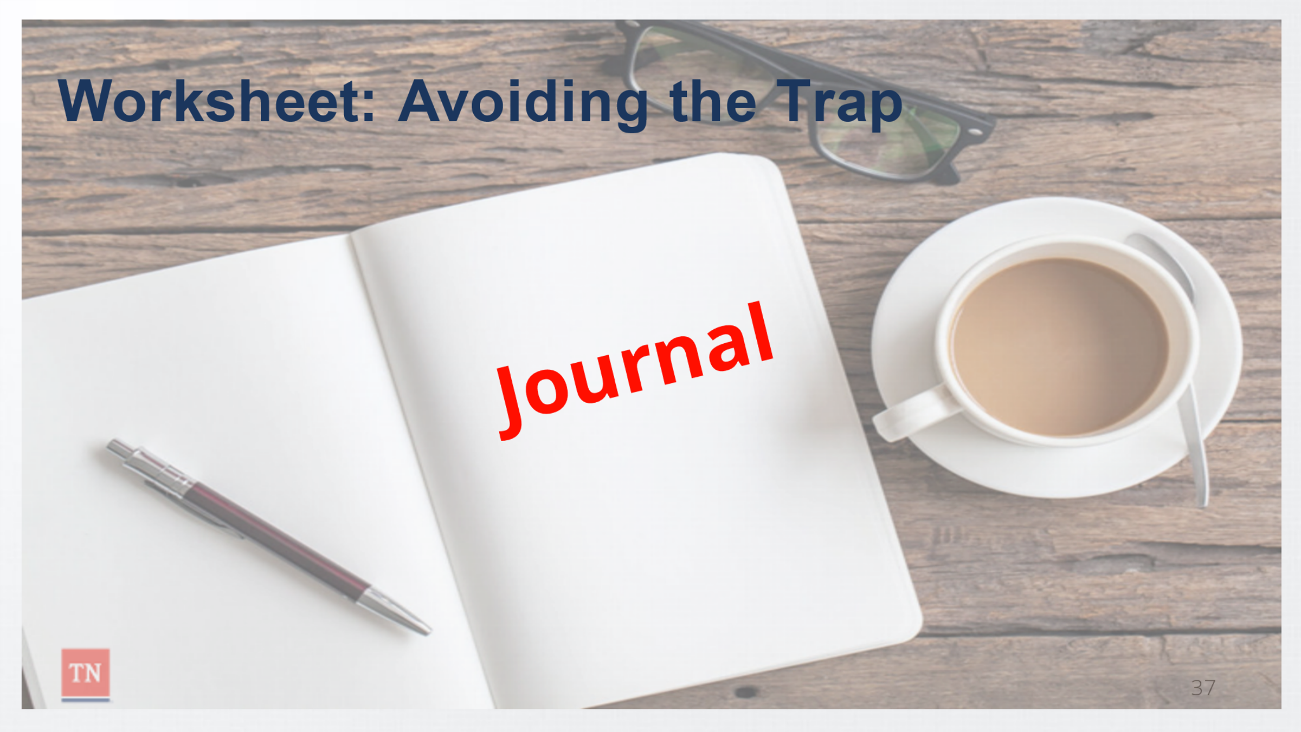
- OPTIONAL ACTIVITY: Avoiding the Trap Worksheet
  - REFER participants to the worksheet entitled Avoiding the Trap in their journal. ALLOW participants 5 to 10 minutes to respond to the questions.
    - I am likely to response in an imbalanced way when….
    - When my response is imbalanced, I often…
    - I am most likely to respond with imbalance again when…
    - The next time I find myself falling into the trap of imbalance I can….
- DEBRIEF the activity by asking why it is important that we become more aware of when we tend to respond in an imbalanced way. ASK what strategies participants plan to use to be more balanced in their responses? Responses may include:
  - Prepare for meetings/ encounters by planning for difficult conversations
  - Consult with a supervisor, co-worker, or friend (depending on the situation) regarding personal feelings prior to further interactions to ensure neutrality; seek supervision.
  - Explore the ambivalence underlying the conflict
  - Recognize and praise progress
- TRANSITION to Lesson 4.2 Putting it All Together

Lesson 4.2: Putting it All Together
Lesson Time: 15 minutes
Key Teaching Points / Instructions
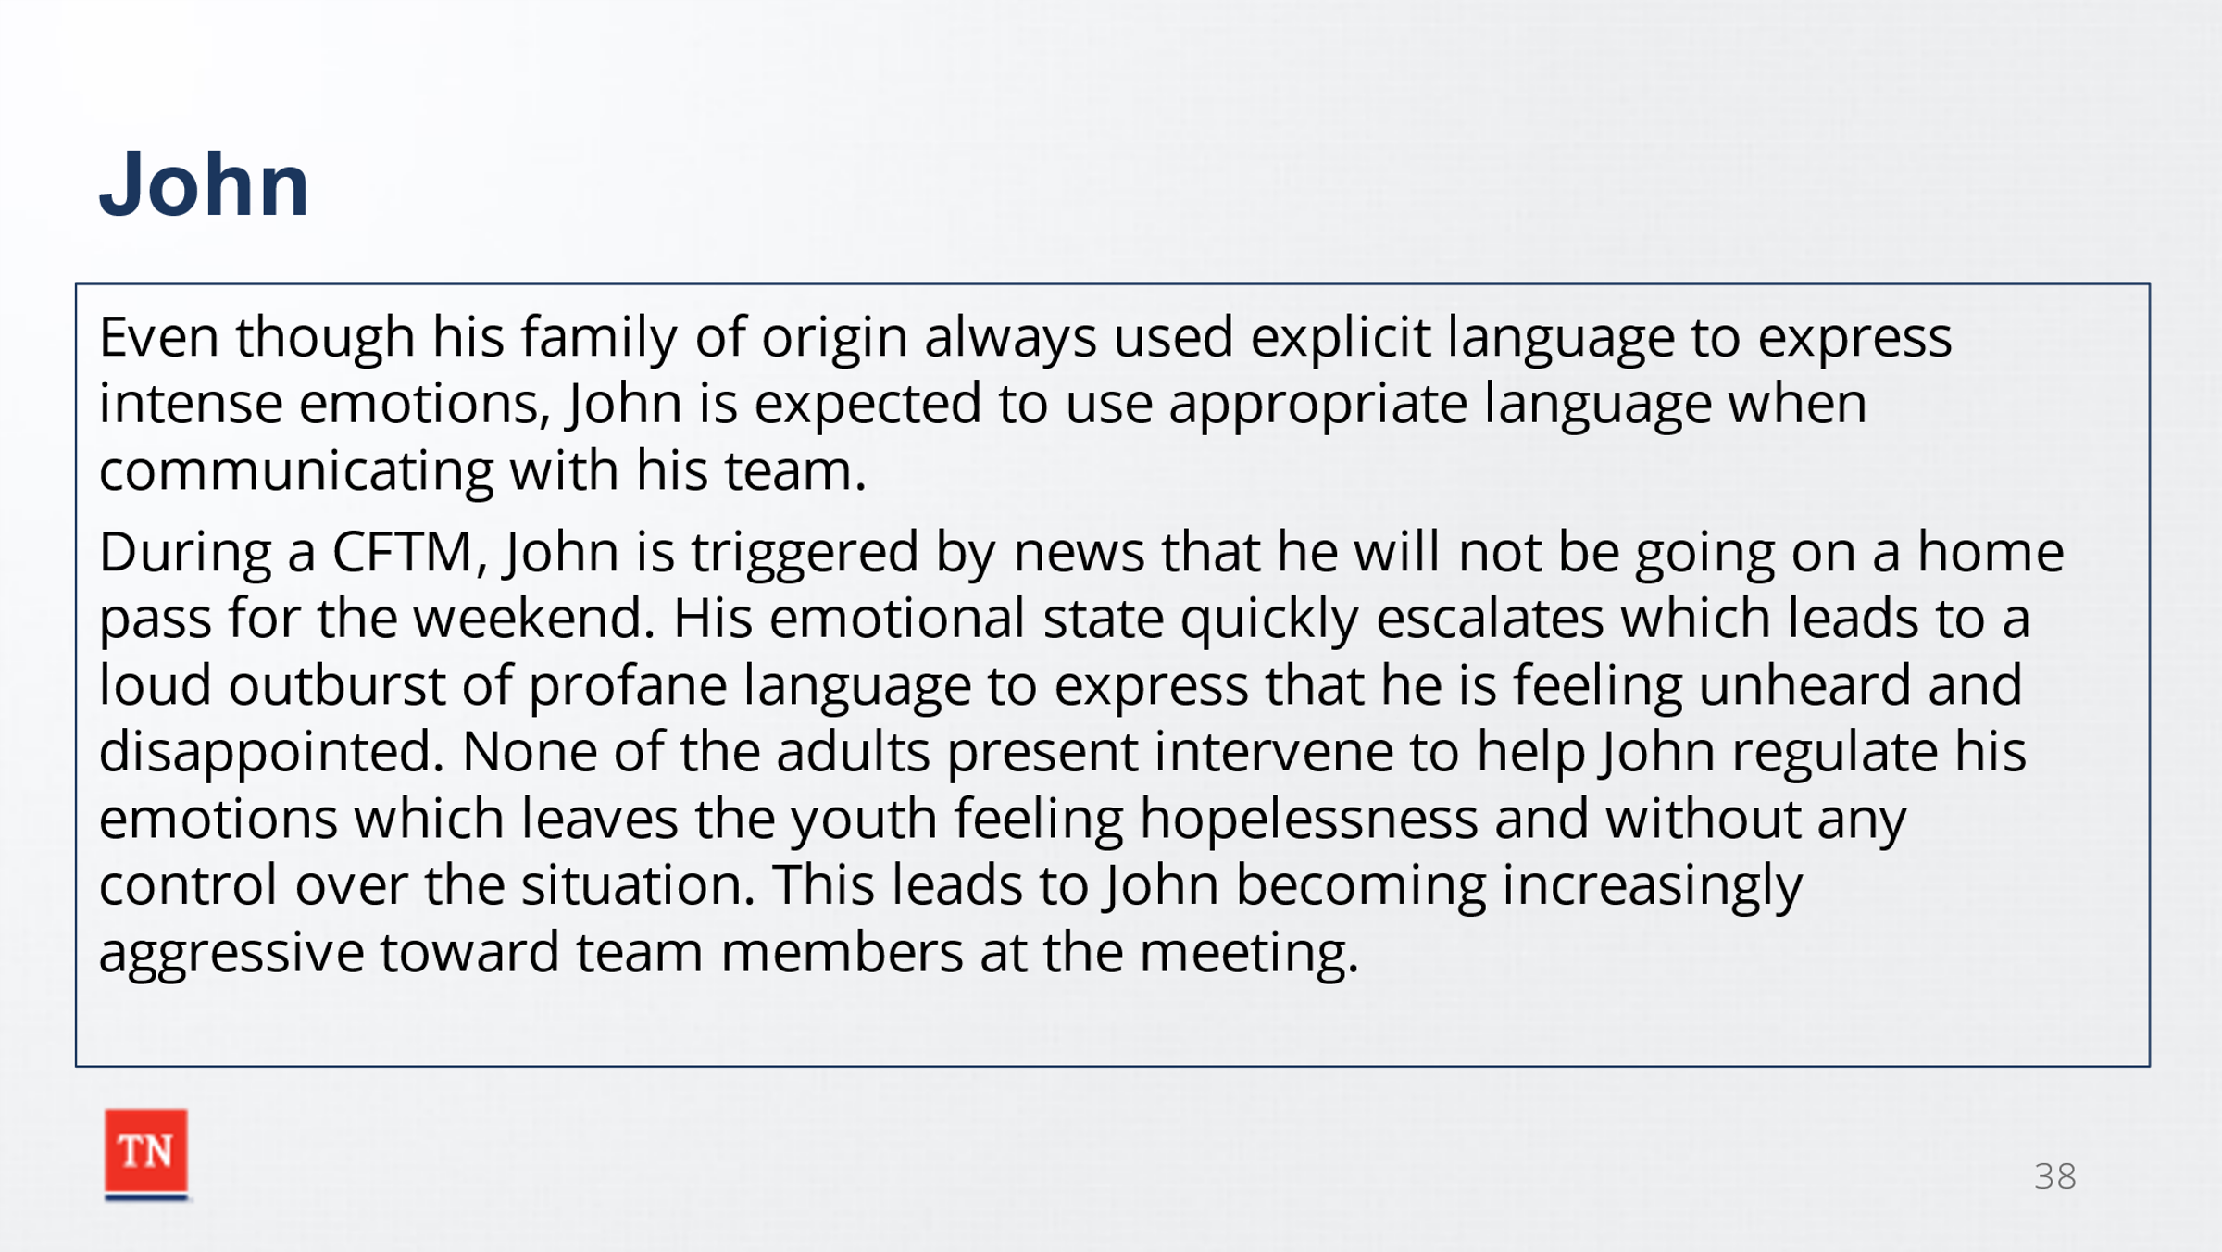
- DISPLAY the conflict cycle on a slide and FACILITATE a discussion applying the following scenario to the conflict cycle and identifying possible responses the case manage may give help reinforce understanding of imbalanced responses.
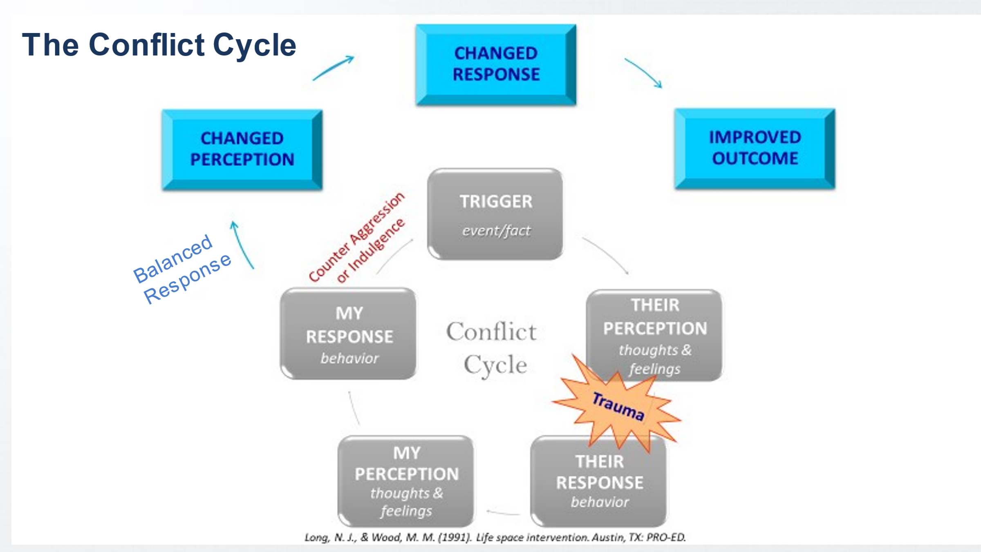
  - Even though his family of origin always used explicit language to express intense emotions, John is expected to use appropriate language when communicating with his team. During a CFTM, John is triggered by news that he will not be going on a home pass for the weekend. His emotional state quickly escalates which leads to a loud outburst of profane language to express that he is feeling unheard and disappointed. None of the adults present intervene to help John regulate his emotions which leaves the youth feeling hopelessness and without any control over the situation. This leads to John becoming increasingly aggressive toward team members at the meeting.
- ASK participants to APPLY this scenario to the conflict cycle while annotating participants responses on the slide. Responses may include:
  - Trigger: not receiving a home pass
  - John’s Perception: Upset, disappointed, unheard
  - John’s Response: Outburst of profane language and aggression
  - My perception: (Ask participants their thoughts and feelings if they were on John’s team): Disappointment for him not getting a home pass, frustration that he is behaving this way, tired, stressed
  - My Response: ASK participants examples of each imbalanced response.
    - Counter-Indulgent: State that John’s reaction is understandable. He has been working hard on getting a home pass and has every right to be angry. It is okay that he used bad language, his parents talk way worse than that to me.
    - Counter-Aggressive: Informing John that he will stop using that language immediately or he will be asked to leave the meeting, or you will be forced to call law enforcement. Expecting him to sit down and be quite without acknowledging why he is upset about this situation.
    - Counter-Avoidance: change the subject of the meeting and keep moving forward without acknowledging John’s outburst. Asking John to sit in the lobby for the rest of the meeting so you don’t have to deal with him.
    - Balanced Response: Allow John to vent for a few minutes, tell him it is understandable that he is frustrated about not getting a home pass. Ask his understanding of why he might not have gotten the home pass and explore how he could obtain one in the future. Explore ways for him to express his frustrations without yelling and using profanity.
- THANK participants for their responses and ask if there are any questions. TRANSITION to Unit 5 Wrapping Up.

Unit 5: Wrap Up
Unit Time: 10 minutes

Supporting Materials:
- PowerPoint
- What I Know/ Want to Know/ What I Learned slide from Unit 1

Lesson 5.1: Wrap Up
Lesson Time: 10 minutes
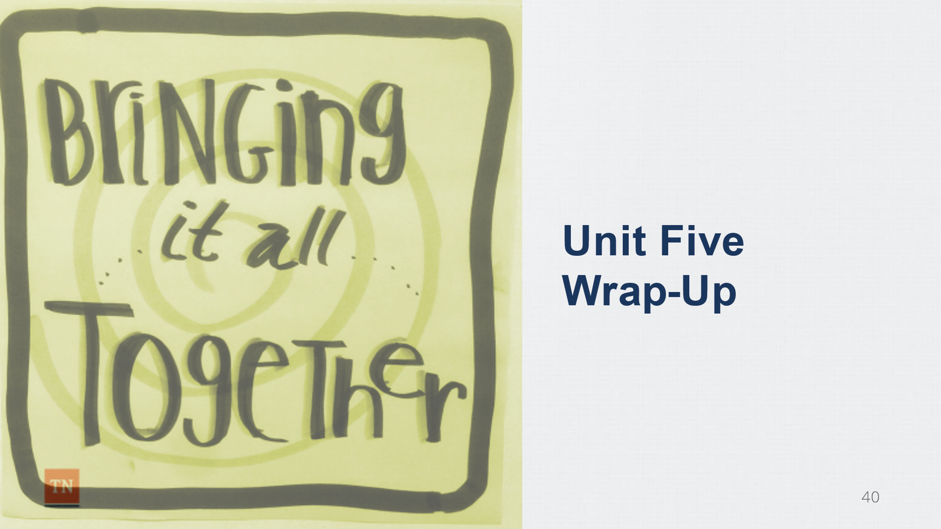
Key Teaching Points / Instructions
- REVISIT the K/W/L slide and ASK participants to share what they have learned about conflict and what is one thing that they commit to doing moving forward as a result of this training.
- THANK participants for their time and their commitment to gain knowledge and understanding around reaction awareness and how to navigate conflict in a meaningful way.
- REQUEST participants to complete the course reaction survey at: https://www.teamtn.gov/dcs/divisions/training/t/cai/dcstrainingevaluation.html.

References
Crittenden, P.M. (1988), Relationships at Risk. J. Belsky & T. Nezworski (Eds.), The Clinical Implications of Attachment (pp. 136-174). Hillsdale, NJ: Lawrence Erlbaum.

CDC Morbidity & Mortality Weekly Report, Vol 57, No. 13, pp 336-339 http://www.cdc.gov/mmwr/preview/mmwrhtml/mm5713a2.htm.
Boris NW, Wheeler, EE, Heller SS, Zeanah CH (2000). Attachment and Developmental Psychopathology. Psychiatry. 2000; 63: 75-84.
Keeping the Promise: The Critical Need for Post-Adoption Services to Enable Children and Families to Succeed. October 2010. The Evan B. Donaldson Adoption Institute.
https://www.allendale4kids.org/subpages/REStArTPrinciples5-2-12.pdf
http://www.attachmenttraumanetwork.org/attachment-trauma/trauma-disrupts-attachment/
http://www.attachmenttraumanetwork.org/understanding-attachment/
http://www.attachmenttraumanetwork.org/attachment-trauma/
http://www.attachmenttraumanetwork.org/myths/
http://disinhibitedsocialengagementdisorder.com/controversies-regarding-reactive-attachment-disorder
- https://www.ncbi.nlm.nih.gov/pmc/articles/PMC3396357/
- https://myshrink.com/making-the-same-relationship-mistakes/
- http://www.cirp.org/library/psych/vanderkolk/

