The Child Welfare Trauma Training Toolkit

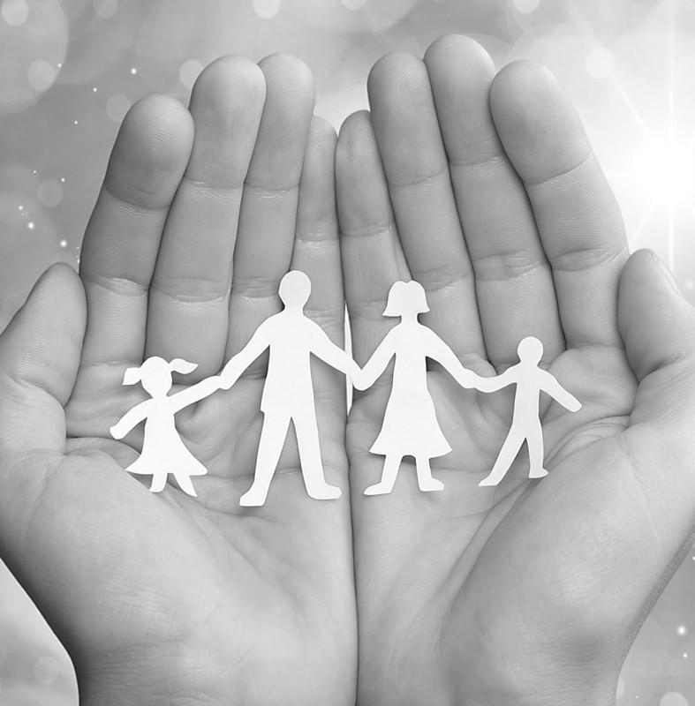

The Child Welfare Trauma Training Toolkit

The Child Welfare Trauma Training Toolkit (CWTTT), 3rd edition, is a comprehensive training series that consists of classroom training targeted toward various levels and roles within the child welfare workforce as well as follow-up consultation for supervisors.

This Toolkit consists of:
- Trauma 101 Facilitator Guide, Participant Manual, and Slides

It is publically available if you register for free at https://learn.nctsn.org/ and visit the section for the Child Welfare Trauma Training Toolkit on the Service System Page.
The National Child Traumatic Stress Network
Established by Congress in 2000, the National Child Traumatic Stress Network (NCTSN) brings a singular and comprehensive focus to childhood trauma. NCTSN’s collaboration of frontline providers, researchers, and families is committed to raising the standard of care while increasing access to services. Combining knowledge of child development, expertise in the full range of child traumatic experiences, and dedication to evidence-based practices, the NCTSN changes the course of children’s lives by changing the course of their care.
The Center for Child Welfare Trauma-Informed Policies, Programs, and Practices (TIPs Center)
The TIPs Center is located at Chadwick Center for Children and Families at Rady Children's Hospital-San Diego and is funded by the Substance Abuse and Mental Health Services Administration (SAMHSA) as a Category 2 Center of
NCTSN. The focus of the TIPs Center is to provide training and technical assistance on trauma-informed policies, programs, and practices to child welfare systems. The CWTTT 3rd Edition was authored by the staff of the TIPs Center in collaboration with the NCTSN.
Financial Support
This project was funded by SAMHSA, US Department of Health and Human Services (HHS). The views, policies, and opinions expressed are those of the authors and do not necessarily reflect those of SAMHSA or HHS.
Citation
Walsh, C., Pauter, S., & Hendricks, A. (2020). Child Welfare Trauma Training Toolkit (3rd ed.). Los Angeles, CA, and Durham, NC: National Center for Child Traumatic Stress.
Copyright © 2020 UCLA-Duke University National Center for Child Traumatic Stress, on behalf of Cambria Walsh, Sarah Pauter, Alison Hendricks, the Chadwick Center for Families at Rady Children’s Hospital-San Diego, and the National Child Traumatic Stress Network. All rights reserved. You are welcome to copy or redistribute the Child Welfare Trauma Training Toolkit in print or electronic form, provided the citation above is used, and no fee is charged for copies beyond actual publication copying costs.
General requests or inquiries relating to the CWTTT 3rd Edition should be directed to the TIPS Center at info@tipscenter.org with "CWTTT" in the Subject Line.
General inquiries relating to products produced by the NCTSN can be directed to the NCTSN National Resource Center at info@nctsn.org. Other NCTSN products can be viewed on its website at www.NCTSN.org, as well as the Learning Center for Child and Adolescent Trauma at http://learn.nctsn.org.
Acknowledgements
The CWTTT 3rd Edition was adapted by Cambria Rose Walsh, LCSW, Sarah Pauter, MPAA, and Alison Hendricks, LCSW, with design and editing assistance provided by Megan Platt, Jennifer Demaree, and Deanna Griffin. Additional assistance was provided by Dr. Andrea Hazen who ran the evaluation and assisted in collecting data from the two pilots of the CWTTT 3rd Edition which informed this final version.
It was adapted from the two previous versions which Alison Hendricks, Peter Dahlin, Mary Garrison, and Miriam Wolf created from materials developed by the NCTSN and California Social Work Social Work Education Center (CalSWEC). It was originally part of a larger project, the Trauma-Informed Child Welfare Training Project, a collaboration with the Child and Family Policy Institute of California (CFPIC) and the California Institute for Mental Health (CIMH).
The most recent edition project was supported by a National Advisory Committee:
Karen Baylor, Bonnie Beneke, Marcy Hara, Katharine Briar Lawson, Laurie Fortin, Kim Giardina, Jane Halladay Goldman, Alison Hendricks, Teresa Huizar, Al Killen-Harvey, Keva Miller, Donna Pence, Carl Price, Maegen Rides At the Door, Greg Rose, Leslie Rozeff, Virginia Strand, and Pam Toohey
The project was also supported by the Child Welfare Trauma Training Toolkit Subcommittee of the National Child Traumatic Stress Network’s Child Welfare Collaborative Group.
Others who provided guidance and assistance on this project include:
Jen Agosti, Melissa Bernstein, Linda Billman, Connie Black Pond, Kimberly Blackshear, Angela Breidenstine, Adam Brown, Emma Cardeli, Rocio Chang-Angulo, Anne Comstock, Lisa Conradi, Mary Crane, Raven Cueller, Haydée Cuza, Lacy Dicharry, Zuleika Dixon, Mary Eason, Rebecca N. Ezechukwu, Jennifer First, Patricia Fisher, Heather Forkey, Karen Hangartner, Jeremy Harvey, Jason HeavyRunner, Vanessa Hernandez, Katie Morris Henson, Marla Himmeger, Melissa Hoffman, Jennifer Hossler, Tammy Hurley, Lauren Kelso, Russell Jones, Vonda Jump, Laurel Kiser, Cassie Kisiel, Julie Larrieu, Rene Ledford, Brandy Liles, Kansas “Lizzie” Loveless, Saprina Matheny, Francoise Mathieu, Jenifer Maze, Shelby McDaniel, Alisa Miller, Brian Miller, Darice Orobitg, Carmen Rosa Norona, Alan O’Malley Laursen, Rene Ledford, Kate Murray, Andrea Ocampo, Baldivenia Perez, Isaiah Pickens, Mark Rains, Libby Ralston, Jeff Rowe, Cathy Sears, Eda Spielman, Ginny Sprang, Brianna Stichter, Chaney Stokes, Moira Szilagyi, Rachel Szymarek, Mandy Taylor, Elizabeth Thompson, Ashley Trautman, Rochelle Trochtenberg, Erika Tullberg, Steven Wells, Charles Wilson, and Kietha Wilson
Participants in the Pilot Trainings that were conducted in San Diego, California, in the fall of 2018 and in Tennessee in the spring of 2019 also provided valuable feedback on the CWTTT, 3rd Ed.
We appreciate the following organizations which allowed us to use their videos, or excerpts from them, in the Child Welfare Trauma Training Toolkit, 3rd ed.:

IDEO.org
  - Brainstorm Rules – November 22, 2016 https://vimeo.com/192704550
  - How Might We – August 8, 2014 https://vimeo.com/102964749

Karyn Purvis Institute of Child Development at Texas Christian University
  - Children from Hard Places and the Brain: Chapter 1– January 13, 2016 https://www.youtube.com/watch?v=ak6z3pqNqFU&t=471s

KPJR FILMS LLC
  - ACES Primer – September 21, 2015 https://vimeo.com/139998006

Matanick, Nathanael
  - ReMoved – March 11, 2014 https://youtu.be/lOeQUwdAjE0
  - Remember My Story - ReMoved Part 2 – June 13, 2015 https://youtu.be/I1fGmEa6WnY

Mercury News
  - Drugging Our Kids – April 17, 2018 https://youtu.be/L7lHeosq-FY?t=1301

On Our Own of Maryland, Inc.
  - Recovery Stories: Tonier– August 8, 2013 https://www.youtube.com/watch?v=mFPAq7Bszac

Palix Foundation
  - Brains: Journey to Resilience – November 30, 2017 https://vimeo.com/245310333

Sentis
  - Neuroplasticity - November 6, 2012 https://www.youtube.com/watch?v=ELpfYCZa87g

Texas Department of Family and Protective Services
  - Help and Hope Testimonial – Angelique – June 28, 2012 https://www.youtube.com/watch?v=ZAzWeK4N5sc&feature=youtu.be
  - Help and Hope Testimonial - Jannette – June 28, 2012 https://www.youtube.com/watch?v=5Qsi8pUl_to&feature=youtu.be
  - Help and Hope Testimonial – Traci – June 28, 2012 https://www.youtube.com/watch?v=GGRaEzS7-1I

U.S. Department of Health and Human Services, Administration for Children and Families, Children’s Bureau, Center for States
  - Biological Mother Visit – August 24, 2017 https://www.youtube.com/watch?v=R0-61Cu3ylk&feature=youtu.be,
  - Maryann’s Story – March 20, 2019 https://www.youtube.com/watch?time_continue=9&v=WsLshhETnYk
  - Young Adult, Formerly in Congregate Care: Treat Me Like a Normal Child – July 7, 2016 https://youtu.be/km0GILVLOB8

This page is intentionally left blank.

The Child Welfare Trauma Training Toolkit

Trauma 101 Training

To download the entire Child Welfare Trauma Training Toolkit (CWTTT, 3rd ed.), please visit https:// learn.nctsn.org/, and find the Child Welfare Trauma Training Toolkit under the Service Systems link. Note that you will need to register for a free account to access the downloadable materials.

This page is intentionally left blank.

Table of Contents

Trauma 101 Introduction (5 minutes)
- Instructions

Trauma 101 Google Classroom (1 Hour)
- Learning Objectives
- Before We Get Started
- Trauma Exposed Workplaces

Trauma Definitions and Types
- What is Trauma?
- Types of Trauma
- System Induced Trauma and Traumatization

Trauma and Memory
- Children from Hard Places and the Brain
- Trauma and the Brain
- Activity: Grounding Exercise
- Long Term Effects of Childhood Trauma
- Epigenetics and Trauma
- ACE Study -Adverse Childhood Experiences

Trauma 101 Virtual Classroom (40 minutes)
- Welcome and Introductions
- Learning Objectives
- Activity: Commonalities
- Before We Get Started
- You Make a Difference
- Culture, Race, and Trauma
- Activity: Differences

Impact of Trauma (45 minutes)
- Neural Connections
- Trauma and the Brin
- Preparing for Action
- Caregivers as Mediators of Trauma Response

Development and Trauma (20 minutes)
- Developmental Stages and Trauma
- Activity: The Impact of Trauma at Different Developmental Stages

Resilience (55 minutes)
- Neuroplasticity
- Defining Resilience
- Internal and External Protective Factors
- Tipping the Scale
- How Can the Child Welfare Workforce Influence Resilience?

Wrap-up and Closure (5 minutes)

This page is intentionally left blank.
TRAUMA 101
This is the Trauma 101 training, which is the first part of the larger Child Welfare Trauma Training Toolkit (CWTTT).

Training Materials that Need to be Prepared in Advance

All Materials Needed at the Training Session
- Facilitator’s Guide
- Participant Guide
- Power Point

Trauma 101
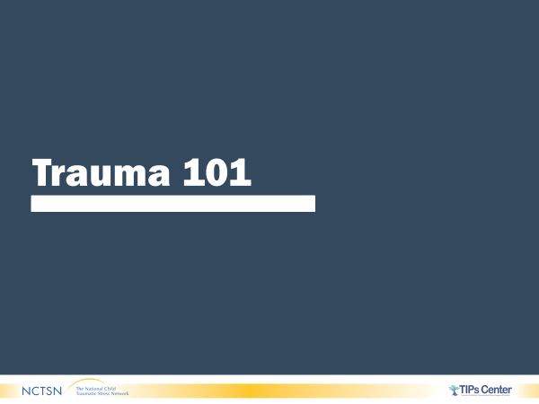
- WELCOME participants to Trauma 101. SHARE training is divided into two sections, the first section is Sway Presentation in Google Classroom, and the second section is in Web Ex with the trainers. STATE participants will have one hour to view the Sway and take a break. ADVISE participants to return to Web Ex to complete the rest of the training. SHARE Web Ex will remain open, and trainers will remain present in case difficulties arise.
- PROVIDE participants with the following link to the Sway: https://sway.office.com/XzUEbebABXNjyCvx?ref=email

- TRAINER NOTE: This curriculum provides the information participants will view in the Sway. The next section: Virtual Classroom begins the curriculum for the Web Ex portion.

Trauma 101 Google Classroom

- Welcome to the first section of Trauma 101. This training is divided into two sections.
- The first part of this course will take place in Google Classroom. The second part will be completed with the trainers and the training group via Web Ex.
- This training is designed for everyone working in this child
welfare organization and focuses on providing a basic understanding of trauma and its impacts.
This training provides an overview of trauma.

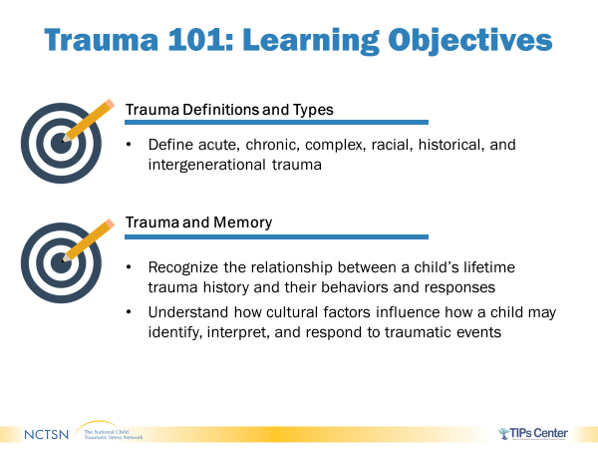
  - This training will be divided into Trauma Definitions and Types and Trauma and Memory.

- This training covers some intense material. For some of you this may be the first time you are hearing information about trauma, for others it may trigger memories from your professional or your personal lives.

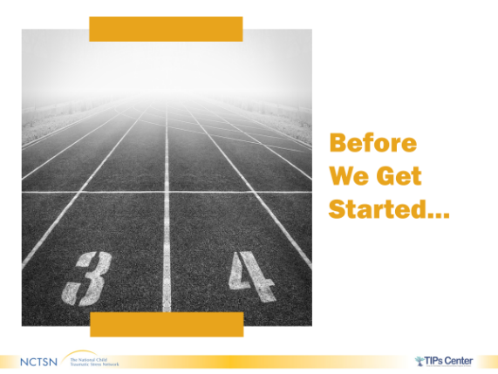
- It is very important that you take care of yourself. Please take breaks when you need to, check-in with each other as needed and think about what works for you in terms of debriefing, de-stressing, and getting support both during this training and in your day-to-day work. Please contact a trainer, your Professional Development Coach, or your Supervisor for additional support.

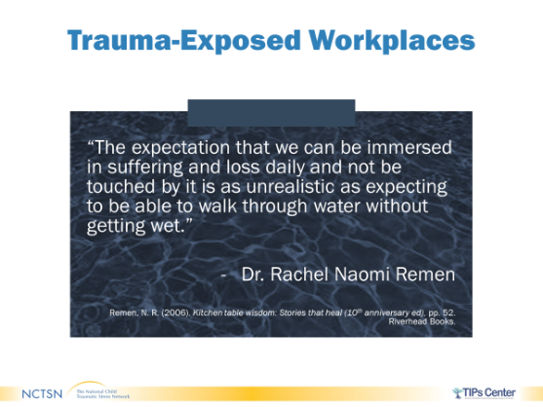
- The work that each of you do is not easy. You may be exposed to trauma both through hearing about it and seeing its impacts daily. On occasion, you may be in situations where you are directly exposed to trauma.

- This quote by Rachel Naomi Remen, who spent many years as a doctor working with cancer patients, truly captures how working around trauma has an impact on each of us.

“The expectation that we can be immersed in suffering and loss daily and not be touched by it is as unrealistic as expecting to be able to walk through water without getting wet.”

- Because it is common, and actually expected that exposure to traumatic material will have an impact on each of you, it is important that you look at individual ways to address your own traumatic stress reactions. It is also critical to look at the impacts of working in a trauma-exposed workplace from an overall organizational perspective to ensure that there is support for everyone in the workforce including those who may not have direct contact with the families you serve. It is very difficult to do the best for the children and families if you are not at your best!

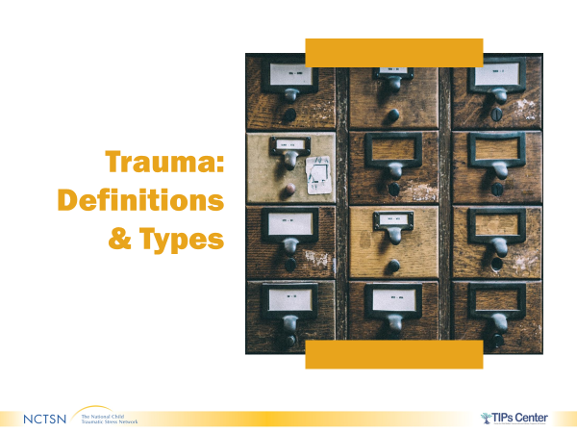
- Now we will move into looking at the different types of trauma. For some of you, this may be new material while for others it may be a refresher, but it is important that everyone understands what trauma is and what forms it can take.
- This is helpful to understand before talking about the impact of trauma on individuals.

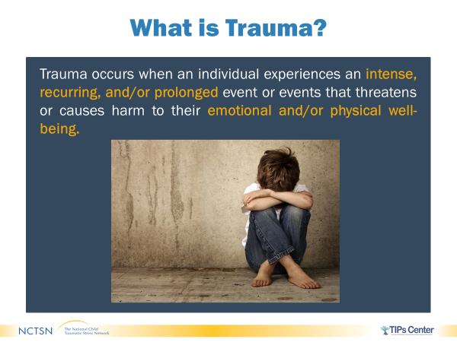
- Trauma occurs when an individual experiences an intense, recurring, and/or prolonged event (or events) that threatens or causes harm to their emotional and/or physical well-being.

- An event that threatens or causes harm to another, including a loved one or someone close to the child, is also a trauma.

- Let’s differentiate stressful experiences from traumatic ones. For instance, playing in the big football game when a college
scout is watching you can be stressful, but that stress might actually be positive in that it makes you play a great game. Or having to get up and present at a conference may be stressful but knowing that sharing that information is important and will be done within an hour makes that stress tolerable. In neither of these situations do you perceive that your life or someone else’s is in danger. In other words, they are stressful, but not traumatic.
These are examples of traumatic events:
Being in a car accident
Witnessing someone being seriously hurt or killed
Being abused
Being kidnapped
Experiencing a natural disaster

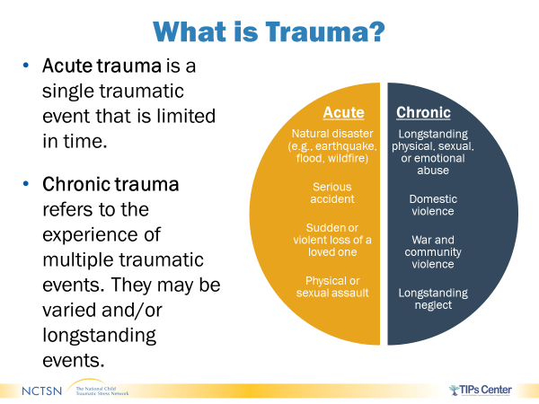
- To understand the impact of trauma on children, youth, and families, it can be helpful to think about trauma as acute or chronic.

- Acute trauma is a single traumatic event that is limited in time. Examples include: a natural disaster, a serious accident, sudden or violent loss of a loved one, and a physical or sexual assault. This is not to say that the impact of an acute traumatic event is short- lived. It may take months or even years for a person to recover from an acute trauma.

- Chronic trauma refers to repeated assaults on a person’s body and/or mind. They may be varied and/or longstanding events. For instance, experiencing or witnessing domestic violence, being in a war zone, living in a neighborhood with frequent violence, longstanding emotional or physical neglect, or sexual, physical, or emotional abuse that is ongoing.

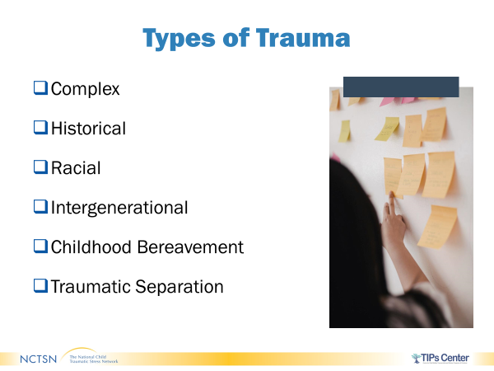
- We will now review the types of trauma beginning with Complex Trauma.

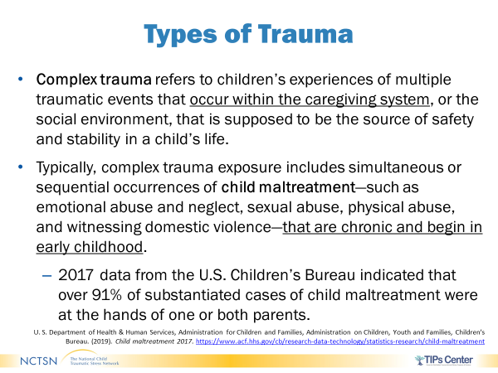
- Complex trauma refers to children’s experiences of multiple traumatic events that occur within the caregiving system, or the social environment, that is supposed to be the source of safety and stability in a child’s life.

- Complex trauma can occur simultaneously or sequentially and is often perpetrated by one or more primary caregivers.
Child maltreatment, including neglect and physical, emotional, or psychological abuse, at the hands of a parent or other trusted
adult is a fundamental breach of the child’s most important relationship.

- It is so traumatizing that, if severe, ongoing, or frequent, can affect a child in a multitude of ways, including forming healthy attachments, regulating emotions, and focusing.

- Many children involved in child welfare have complex trauma histories stemming from child maltreatment.
A Children’s Bureau report on child maltreatment that occurred across the U.S. in 2017 indicated that over 91% of substantiated cases of child maltreatment were at the hands of one or both parents.
Exposure to complex trauma can act as a catalyst for subsequent traumatic experiences or events if the child is not removed from the unsafe environment and provided with adequate protective factors and supports.

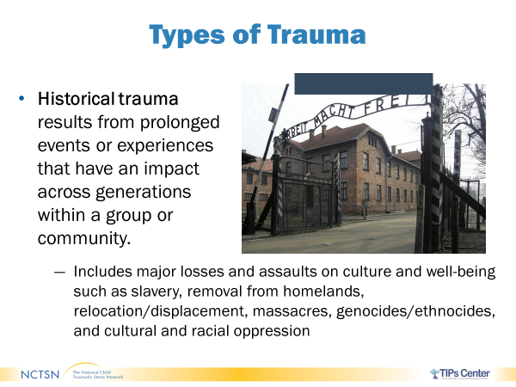
- Historical trauma results from prolonged events or experiences that have an impact across generations within a group or community.

- An example of historical trauma in the U.S. is the former use of American Indian Boarding Schools where native children were forcibly removed from their families to be “civilized” into Euro-American culture. The children were stripped of their culture, including their food, clothing, rituals, and language while being physically disconnected Children of historical trauma survivors can experience symptoms similar to their parents despite having never been directly exposed to the traumatic experiences or events. Studies of the children of Holocaust survivors and descendants of Japanese Americans interned during World War II indicate that historical trauma may negatively impact confidence, self-esteem, assertiveness, shame, and family communication, while also increasing the likelihood of experiencing subsequent trauma.

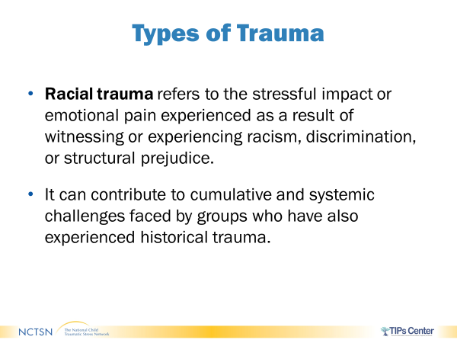
- Racial Trauma refers to the stressful impact or emotional pain experienced as a result of witnessing or experiencing racism, discrimination, or structural prejudice

- It can contribute to cumulative and systemic challenges faced by groups who have also experienced historical trauma.

- There are a lot of subtle, and not so subtle, ways in which discrimination is practiced. Sometimes it is so ingrained in a person, they may not even recognize that they are behaving in ways or have beliefs that influence their behavior toward people of certain races, religions, ethnicities, national origins, cultures, etc.

- Microaggressions are one form of racism and discrimination. They are the everyday verbal, nonverbal, and environmental slights, snubs, or insults (whether intentional or unintentional) that target individuals of marginalized groups.
For instance, being asked “What are you?” regarding your race, ethnicity, or nationality can be a microaggression. Although it seems benign, questions like this are a form of microaggressions and can cause a person to question their sense of identity and belonging.

- It is important to keep in mind that both historical trauma and racial trauma may be experienced not only by the children and families you work with, but also by you and your own family, friends, colleagues, and community. Your own experiences or the experiences of those around you may impact your perception of other’s experiences.

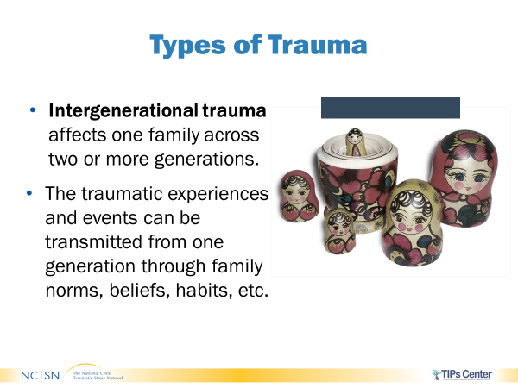

- Though sometimes used interchangeably with historical trauma, intergenerational trauma typically affects one family (vs. a group or community) across multiple generations.

- Trauma experienced in childhood or adulthood can have an impact on an individual’s parenting and can be transmitted through things like family norms, beliefs, habits, and socioeconomic status.

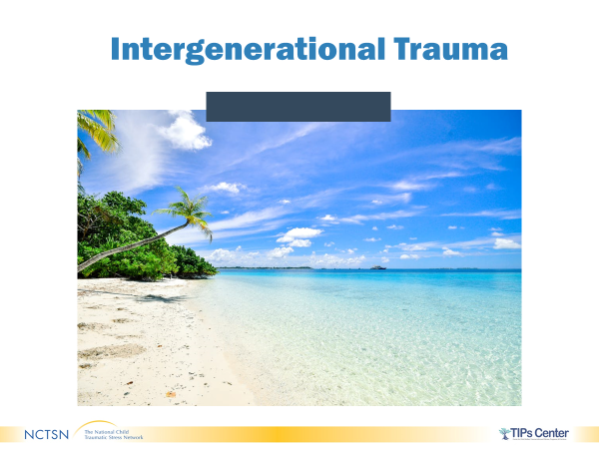
- As you look at this image, what thoughts or feelings come to mind?

- You may be thinking and feeling about peace, serenity, relaxation, how the sand feels between your toes.

- Now, what if I told you that before I was born, my mom survived a tsunami, but lost the home she grew up in and many of her friends and family members died.

- How do you think I feel when looking at the same image above?
I could be feeling scared, triggered, anxious

- It is entirely feasible that my mother would have instilled fear in me about water due to her own experiences. While I did not witness the tsunami, I came to have a negative perception of water, the ocean, and beaches. This is an example of how trauma can be passed on intergenerationally through family beliefs, norms, and habits.

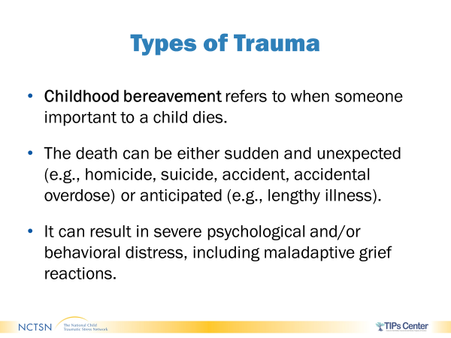
- Childhood bereavement is one of the most common, and most stressful, types of trauma in childhood and adolescence.

- Childhood bereavement refers to when someone important to a child dies. The death of an important person to that child may be either sudden or unexpected and can impair a child’s ability to grieve.

- For instance, the child may view the deceased as all good or all bad and may have difficulty reflecting on memories of the individual. It can result in severe psychological and/or behavioral distress, including maladaptive grief reactions.

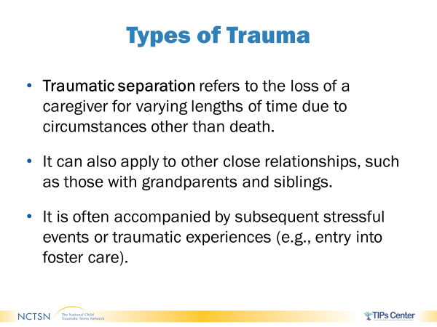
- Traumatic separation refers to the loss of a caregiver for varying lengths of time due to circumstances other than death.

- Traumatic separations can be sudden, unexpected, and prolonged. They can be accompanied by additional stressful events. For children and youth involved in child welfare, their removal from the home or their parent’s removal, incarceration, deportation, or termination of rights are some of the situations in which traumatic separation may occur.

- Traumatic separation can also apply to other relationships, such as those with grandparents and siblings. Traumatic separation may have an impact on parents and caregivers as well.

- Though similar in nature, traumatic separation differs from childhood bereavement in that the child may spend a great deal of time hoping for reunification, even if it cannot occur for years, if at all. This can impede the child’s ability to cope effectively.

- Despite the system’s best intentions, being involved in child welfare can expose children to system-induced trauma and re-traumatization.

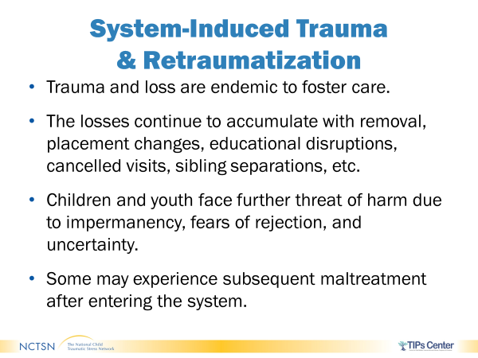
- System-Induced Trauma and Retraumatization- Trauma and loss are endemic to foster care.

- In the event a child has experienced multiple traumas, their ability to overcome future trauma is compromised, creating a cycle of loss. This reinforces a child’s beliefs that they are worthless, that people are untrustworthy, and that the world is unpredictable and hostile.

- The losses continue to accumulate with removal, placement changes, educational disruptions, canceled visits, sibling separations, etc. Children and youth face further threat of harm due to impermanency, fears of rejection, and uncertainty.

- Some studies have shown that up to 30% of youth in foster care experience additional maltreatment while a dependent or ward of the court.

- Some racial and cultural minority groups may experience trauma at higher rates due to exposure to violence, mental health disparities, and substance use issues.

- It is important to realize that how you approach a case and what you communicate to a child, resource parent, or other caregiver can have either a positive or negative impact for that child and family.
There are many circumstances that are out of your control, but if each one of you approaches the children and families that you work with in a trauma-informed way, you can make a difference.

- https://www.bookwidgets.com/play/4B2R74G?teacher_id=4822104473075712

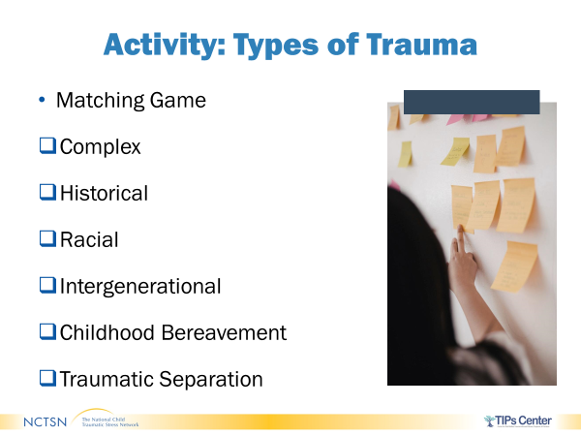
- In this activity, you will match the type of trauma with the correct definition.

Trauma and Memory

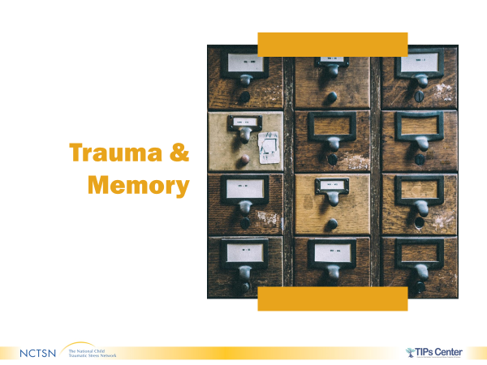
- We will now look at Trauma and Memory.

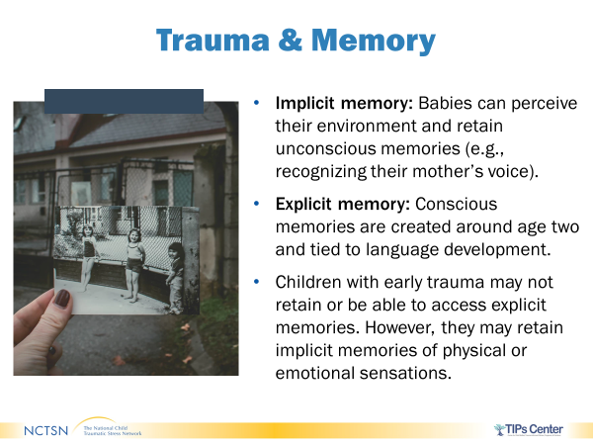
- In the past, it was thought that young children were not impacted by trauma.

- What experts now know is that implicit memories are those that are unconscious and can be formed at a very early age.

- Explicit memories are conscious memories and can be formed as language develops, typically around age 2.

- Young children who have been abused or suffered other forms of trauma may not retain or be able to access explicit memories of their traumatic experiences. However, they may retain implicit memories of the physical or emotional sensations.

- Think of a one-year-old who was repeatedly exposed to domestic violence that involved yelling by her father as he hurt her mother. The infant now cries every time she hears a loud male voice. The male voice brings the implicit memory back and is a trauma reminder for her. The loud male voice causes feelings of fear even though she cannot identify the specific memory of her father; she still retains and reacts to this memory.

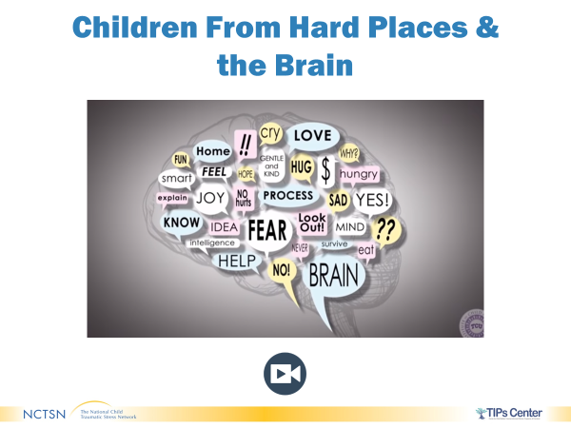

- The following video provides information on the impact of trauma on the brain. In the video, they refer to the upstairs and downstairs brain as the brain builds from the bottom up. The downstairs brain is the brainstem and the upstairs brain is the prefrontal cortex.

https://www.youtube.com/watch?v=ak6z3pqNqFU&t=282s

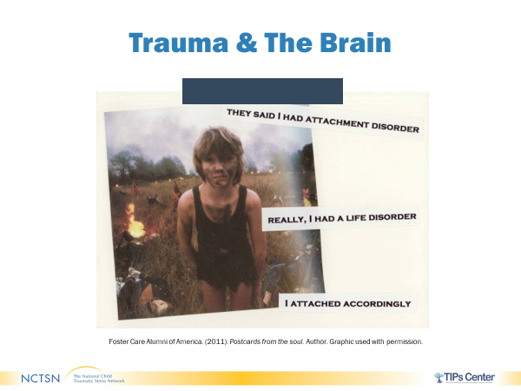
- The long-term results of changes to the brainstem, the prefrontal cortex, and other brain structures can have an influence on the reactions people have to stress throughout life.
- As you see noted on this postcard, which was developed by a child who was in foster care about their experience, psychopathology or mental health challenges may emerge due to the mismatch between the world the brain was modified to survive in and the world it finds itself in during subsequent developmental stages.

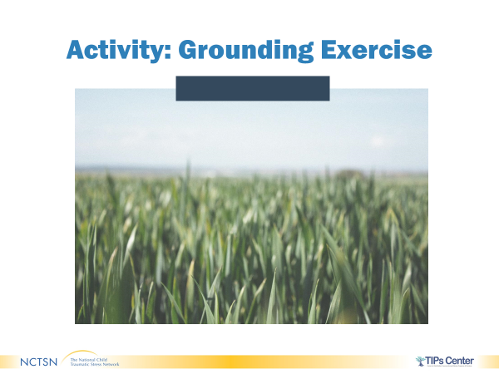
- Three-minute video in short progressive muscle relaxation exercise. https://www.youtube.com/watch?v=ClqPtWzozXs

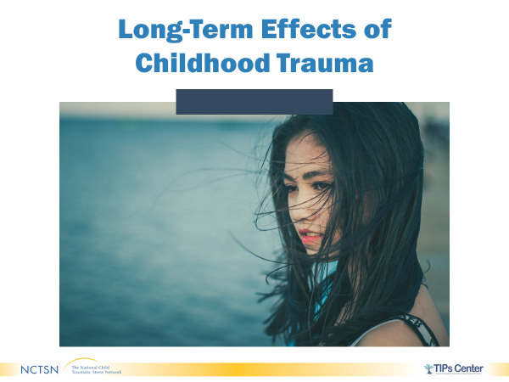
- Next let’s look at the potential long-term effects of childhood trauma.

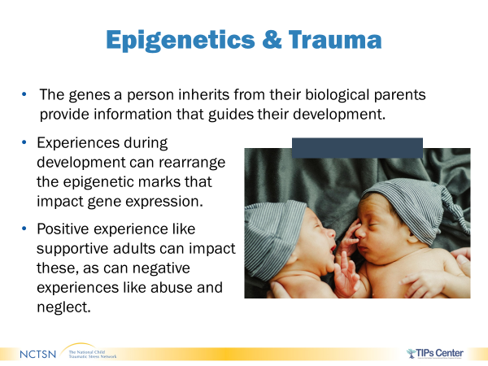
- One-way experts are now able to understand the long-term impacts of trauma is to look at the emerging area of Epigenetics. This is an area of scientific research that shows how experiences affect the expression of genes.

- Epigenetics explains why genetically identical twins can exhibit different behaviors, skills, health, and achievement.

- The genes you inherit from your biological parents provide information that guides your development.
Genes might influence height, temperament, or disease.

- Experiences during development can rearrange the epigenetic marks that impact gene expression. They can change whether and how genes release the information they carry.

- Having a supportive adult, healthy home environment, etc., can positively impact genetic expression. Whereas experiences like abuse and neglect can negatively impact genetic expression. For instance, the negative experiences may activate genes that cause disease.

- Recent research demonstrates that there may be ways to reverse certain negative changes to gene expression and restore healthy functioning.

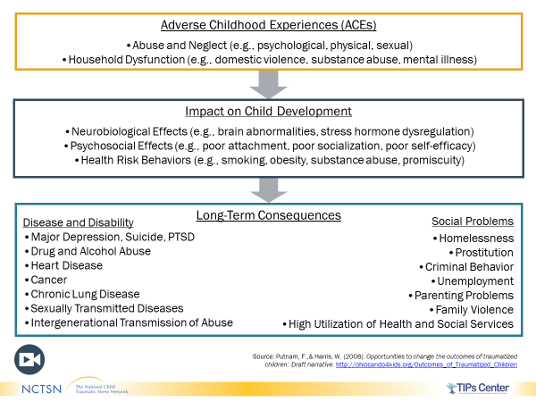
- Another way to understand some of the long- term impacts of trauma is by looking at data from the Adverse Childhood Experiences or ACE study. The ACE Study looked at adverse childhood experiences and long-term health outcomes and found many consequences related to disease as well as to social problems.

- ACES Primer video (length 4:59) in the chat box. Watch the 5:00 min video.
https://vimeo.com/139998006

- To emphasize what was said in the video: “What is predictable is preventable. ACES are not destiny; they are a tool for helping and understanding the impacts of adversity.” We will be talking a bit more about resilience later today and ways that you can help prevent and mitigate the impacts of childhood adversity.

- This portion of Trauma 101 is now complete. You will complete the remainder of this course through Web Ex with your trainers and group.

Virtual Classroom

Welcome & Introductions

About this Section

Timing:
- 40 minutes in length

Materials

Pages in Participant Manual:
- Overview of the CWTTT

Icon Reminders
For Your Eyes Only
What to Say and Do Discussion

Welcome & Introductions
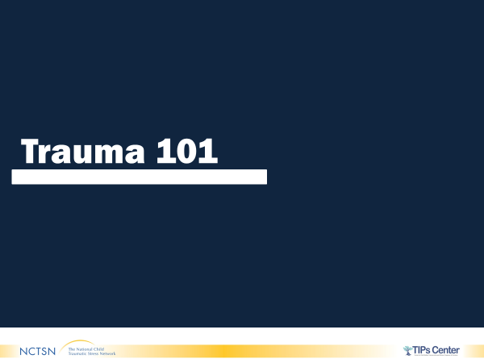

- Welcome participants to the second part of Trauma 101.
- Thank participants for attending the training.
- Introduce yourself and provide a brief synopsis of your
Training background and your background in Child Welfare.
Repeat if there is a co-trainer.

- Introduce what can be found in the Participant Manual
(copy of the slides, places to take notes, worksheets,
Information sheets, and sources of information.

- ASK participants to include in the chat box what stood out
for them from the Google portion of the training. ASK
participants if there were any questions from that part of the training.

- Encourage participants to note any questions they have related
To child trauma throughout this training in the chat box.

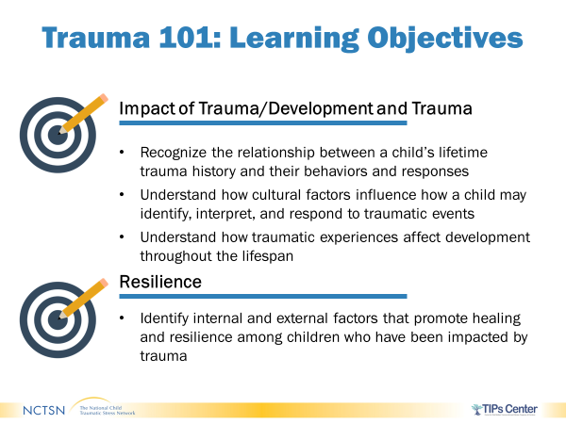
- This portion of the training will be divided into these sections:
- Commonalities
- You Make a Difference
- Culture, Race, and Trauma
- Differences
- Impact of Trauma
- Intergenerational Parenting
- Caregivers as Mediators
- Development and Trauma
- Resilience

- Review the learning objectives on the slide.

Activity Commonalities

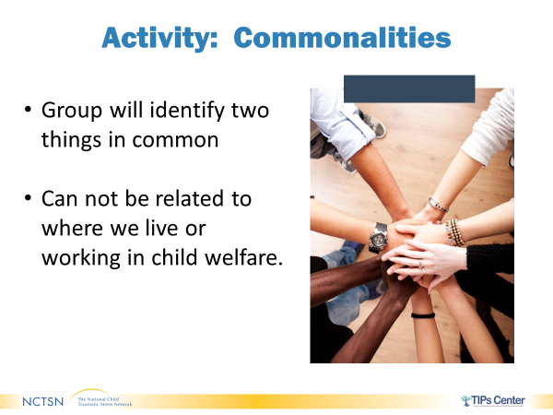
- Trainer will present the slide on commonalities and
differences.
Group will identify two similarities (things in common)
they have which are not related to their work in child
welfare. Trainer will ask participants to identify things in the chat box or on a white board such as their likes, interests, talents, family compositions. Trainer will engage participants to assess commonalities of the group.

- Trainer will debrief the activity and the level of
difficulty. What did it take for the group to succeed?

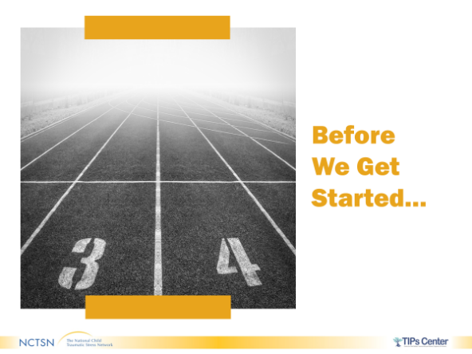
Before We Get Started…
- This training covers some intense material. For some of you this may be the first time you are hearing information about trauma, for others it may trigger memories from your professional or your personal lives. Revisit the Comfort Rules developed earlier with the group. ASK if any changes need to be made and if everyone can agree to support the rules.
- It is very important that you take care of yourself. Please take breaks when you need to, check-in with each other as needed and think about what works for you in terms of debriefing, de-stressing, and getting support both during this training and in your day to day work. STATE participants can use the chat box to send any specific messages to just the trainer or the panelist.

It is critical that you, as the facilitators, are keeping the pulse of the audience. If you sense someone is really struggling, look at how you can support them during a break.
If you feel like you need to have the participants take a stretch break at any time or do a quick grounding or mindfulness exercise beyond what is already in the curriculum, feel free to do that.

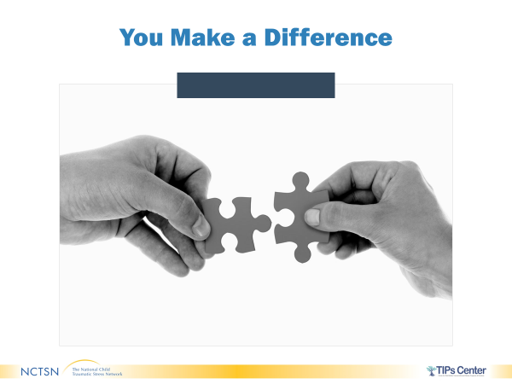
- The work that you do every day with children and families makes a difference. Your work often doesn’t receive a thank you, nor do you always get to see the positive outcomes, but what you do matters and can make an impact on how children and families heal from trauma.
- ASK Why is it important to understand trauma? Gather 2-3 quick responses from the participants. Limit to 2 minutes.
- Responses may include:
- Trauma impacts all of them
- Trauma impacts their agencies
- Trauma impacts their relationships with each other
- Trauma impacts how they function
- Throughout the training, we will be looking at concrete skills and strategies to be more trauma-informed and increase your effectiveness in working with children and families, whether you work with them directly, answer phones or file paperwork, provide transportation, or supervise others.
- Individually, what you do matters; and, collectively, you can make an even bigger difference.

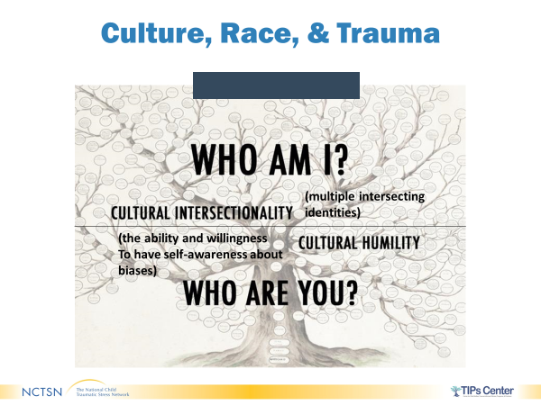
- This is not a training about race or culture but understanding an individual’s unique life history is a critical part of being trauma- informed. Concepts related to culture and to race will be discussed throughout the training series. It is important to be aware of how they intersect with trauma.
- Race is defined in the dictionary as “common ancestry, distinguished from others by physical characteristics, such as hair type, color of eyes and skin, stature.”
- Culture is defined in the dictionary as, “the customs, arts, social institutions, and achievements of a particular nation, people, or other social group.” This encompasses many aspects of one’s identity including religion, sexual orientation, gender identity, being a foster child, a member of the military, etc.

- There are 2 concepts that serve as a foundation for understanding culture.
- Cultural intersectionality or the idea of multiple intersecting identities.
- Add an example here that is relevant to you or use the ideas below to help illustrate this point:
  - Native American lesbian who is a mother of two
  - Latino former foster youth serving in the military
  - Catholic white foster parent
- These multiple identities can put a person at risk for discrimination, exposure to violence, social marginalization, and other negative consequences.
- Cultural humility pertains to the ability and willingness of a person to have self- awareness about biases and to embrace the notion that one is never done learning about culture.
- Much like being trauma-informed, cultural humility is an ongoing journey, not a checklist that you can complete.
- Understanding the dynamics between culture, race, and trauma will help you tailor the way you engage and interact with the populations you serve.
- Consider that children and families involved in Child Welfare may be from groups that may be vulnerable to both explicit and implicit biases – discrimination, stereotyping, poverty, exposure to violence, and social marginalization – which may lead to circumstances that put them at risk for trauma, more severe symptomatology, and/or longer duration of symptoms.
- Culture and race are also strengths and can bring positives to the table for an individual, such as the support and the nurturance they receive from their community, traditions, etc.

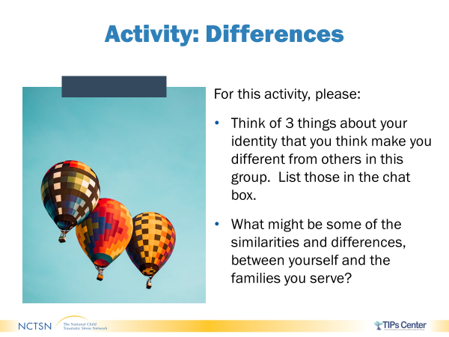
Total Time for Differences Activity: 5 minutes
- Think of three things about your identity that you think make you different from others in the group. List them in the chat box.

- Let’s think about the activity we completed earlier on our commonalities. As you looked for things in common, did you also find that there were differences?

- ASK participants to share any thoughts about commonalities and differences between themselves and the families they service in the large group. Debrief discussion.

- Now that some background information has been covered, let’s move into more details about trauma.

Impact of Trauma

About this Section

Timing:
  - 45 minutes in length

Materials:
  - Children from Hard Places and the Brain video [Excerpt from video]

Pages in Participant Manual:
  - Effects of Trauma on the Brain
information sheet
  - What is Epigenetics? infographic

Icon Reminders
What to Say and Do Discussion
Video

Impact of Trauma
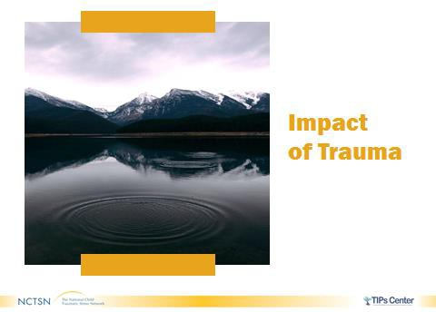
- Now that you have a greater understanding of what trauma is, we are going to talk about how it impacts children and adolescents, starting with the brain.

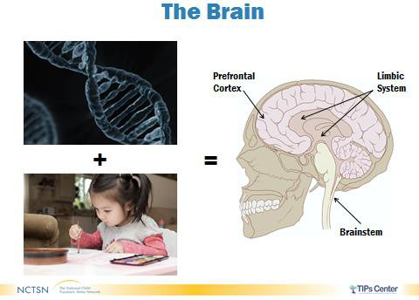
- Let’s start with a very brief overview of brain development in general.

- In very simple terms, as you can see illustrated on this slide, the interaction of genes and experiences shapes the brain.
- In thinking about experiences, remember that children develop within an environment of relationships. A substantial proportion of the brain is built in the early years of life, but the brain continues to build over time.

Neural Connections
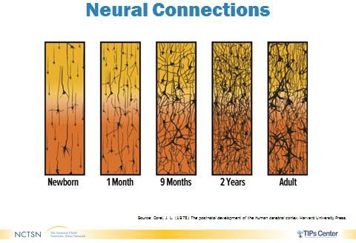
- Between birth and age 3, more than a million neural connections are made each second.

- These neural connections or structures are called synapses and they allow nerve cells to communicate with other cells.
- Learning requires forming new synapses as well as strengthening and discarding existing ones.
- Early synapses are weak and need repeated exposure to strengthen. Simply meaning that
people learn from repetition. Therefore, you have to repeat yourself over and over and over to very young children.
- The brain adapts to one’s environment. This can be either positive or negative depending on the environment.
- If you are in an environment that is characterized by violence or neglect, then the synapses that are strengthened may be those that help you identify danger instead of those conducive to learning and meeting early milestones like walking and talking.

Corel, J. L. (1975). The postnatal development of the human cerebral cortex. Harvard University Press.
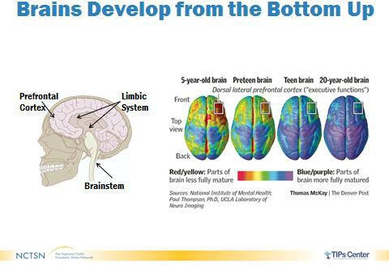
- It has been observed that the brain develops from the bottom up:

  - Starting with the primitive brain – think basic survival – which is the brainstem. After the primitive brain, more complex parts of the brain develop – think rational thought, planning, abstract thinking – which is the prefrontal cortex.
  - The first 3 years of life are a busy time for brain development, but it
continues to develop throughout childhood and into adulthood.
- This graphic shows us the images of brains from age 5 to 20 illustrating the maturation of the different parts of the brain over time.
- The last part to mature is the prefrontal cortex which impacts skills related to self- regulation and decision-making. This happens in a person’s mid-20s.

Trauma & the Brain
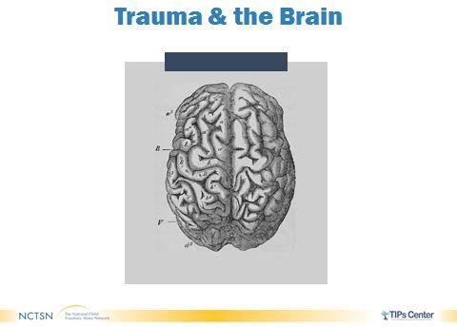
- Now that you hopefully have a basic understanding of how brains develop, let’s look at how trauma impacts the brain.

Thompson, P., & McKay, T. (n.d.). [Image of brain development and executive function]. Laboratory of Neuro Imaging & Denver Post.
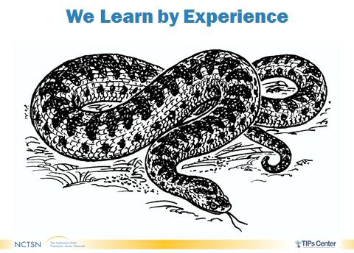

- It is also known that people learn by experience. So how does a traumatic experience impact a person?
- Imagine that you are taking a walk at the park near your home and suddenly in front of you is a huge snake.
- How might you react?
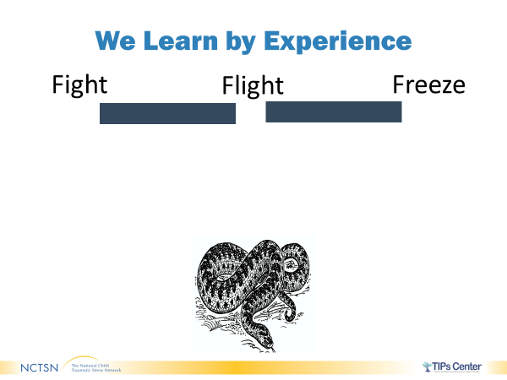
- Using the prepared slide with Fight, Flight, or
Freeze, instruct participants to use the pointer
to indicate how they would respond.
- Trainers can also ask participants to include responses in
Chat box to indicate whether seeing the snake would
Result in the response of fight, flight, or freeze.

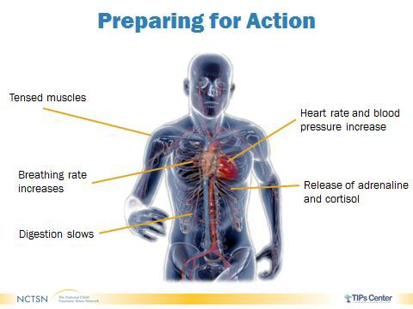
Preparing for Action

- Let’s review one of the most important body responses that happens when a person feels threatened: the fight, flee, or freeze response.
- This response refers to an activation of a part of the nervous system known as the sympathetic nervous system. The sympathetic nervous system prepares a person to deal with a threat. When activated, it initiates their fight, flight (or flee), or freeze response, also known as the stress response.
- It’s responsible for an increase in heart rate, blood pressure, and breathing rate. Blood rushes to the muscles while digestion shuts down and the immune system is weakened.
- The sympathetic nervous system is linked to the endocrine system which is responsible for secretion of stress hormones such as adrenaline and cortisol. This further fuels our fight, flight or freeze stress response.

- It’s important to note that this response is normal and is an automatic biological response everyone has when they believe a threat is present or feeling stressed.

- When someone is overwhelmed by the threat or stress, this response can look like someone physically hitting someone or yelling, running away, or shutting down and not responding to anything around them.

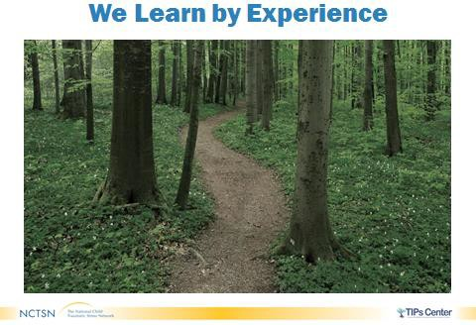
- Now imagine you are walking through that same park a couple days later. How might you feel about walking there again?

o Invite participants to respond in the chat box. Highlight a few responses.
- More than likely you would be watching the ground carefully for snakes!

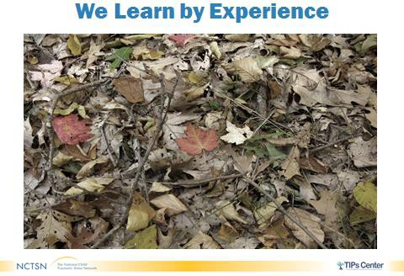

- Now let’s say you see a stick on the path. You are likely to startle even before the thought, “Argh, snake!” is in your conscious awareness.
- Even if you had been in the park many times before without seeing a snake, seeing a snake changes your perception of the park and makes you expect danger.
- That’s because it is a lot more dangerous to mistake a snake for a stick than to see a snake in every stick. Brains are wired this
way to generalize in the direction of looking out for danger for protective reasons.

Marrow, M., Benamati, J., Decker, K., Griffin, D., & Lott, D. A. (2012). Think trauma: A training for staff in juvenile justice residential settings. Los Angeles, CA, and Durham, NC: National Center for Child Traumatic Stress.
Grillo, C. A., Lott, D. A., & Foster Care Subcommittee of the Child Welfare Committee, National Child Traumatic Stress Network. (2010). Caring for children who have experienced trauma: A workshop for resource parents. Los Angeles, CA and Durham, NC: National Center for Child Traumatic Stress.
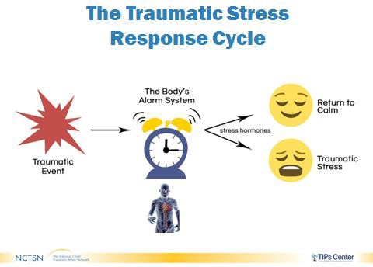
- Let’s use the snake as an example of a traumatic experience to illustrate the traumatic response cycle or what happens in your brain and body when you are exposed to something traumatic.

- As mentioned before, when faced with a threat or traumatic event like the snake, the body has an automatic response, the fight, flight or freeze response which is the body’s alarm system.
- The area of the brain that prompts the
response is the primitive brain (which remember is the survival part of the brain and is the earliest to develop).
- More advanced centers of the brain, like the prefrontal cortex, are responsible for thinking, reasoning, and consciously processing the information. As these develop, they help to analyze the threat and signal the primitive brain to stop pumping out stress hormones so the body’s system can return to normal. When you realize that you’re looking at a stick and not a snake and you feel yourself relax, these higher centers have done their job and helped you to return to calm!
- Exposure to chronic trauma tends to cause people to overreact to perceived threats and be on constant alert for danger. The emergency response system can get stuck in the “on position” for traumatic stress.

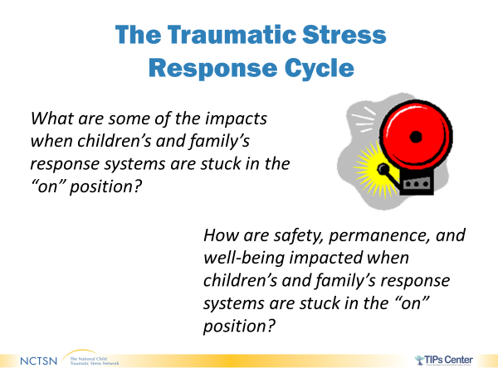
  - What are some of the impacts when children’s and family’s response systems are stuck in the “on” position?
  - Possible responses:
    - Stress hormones can keep flowing and make it harder for the prefrontal part of the brain to think and plan and work efficiently
    - Stress hormones, and related brain chemical that are generated, get in the way of rational thinking
    - Increased aggressiveness
    - Numb to danger
    - Fearful
    - Difficulty concentrating

  - How are safety, permanence, and well-being impacted when children’s and family’s response systems are stuck in the “on” position?

Georgetown University Center for Child & Human Development. (n.d.). Stress and the developing brain: The stress response. http://www.ecmhc.org/tutorials/trauma/mod2_1.html
Grillo, C. A., Lott, D. A., & Foster Care Subcommittee of the Child Welfare Committee, National Child Traumatic Stress Network. (2010). Caring for children who have experienced trauma: A workshop for resource parents. Los Angeles, CA and Durham, NC: National Center for Child Traumatic Stress.

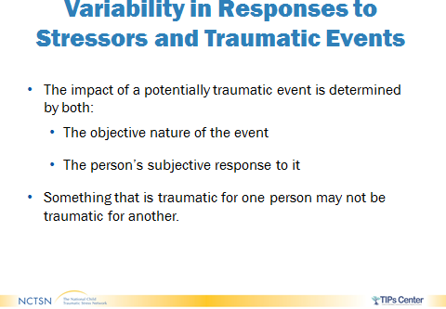
- It is important to understand that trauma reactions are not the same for all children or adults. You need to look at each person as a unique individual with unique experiences.

- Don’t assume that a youth is traumatized simply because they were a part of an event that was traumatic. You need to rely on mental health screening and/or assessment and the youth or caregiver report about how they are functioning.
- It is also important to note that it is easier to identify when a youth is traumatized when their response is acting out with overt behaviors; however, some youth tend to internalize their symptoms and they may be overlooked because they are described as a quiet or compliant child.

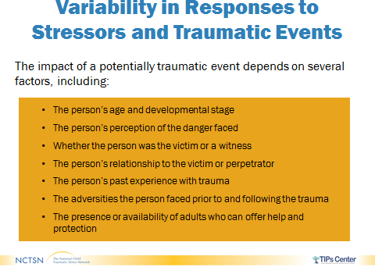
- Think of how many different combinations there are with all these factors. It is easy to see how there may be many different responses to a similar traumatic event. This sometimes plays out within families when siblings are all exposed to the same trauma but have differing reactions.

- Remember the earlier conversation today about cultural intersectionality? A person’s racial and cultural background influence how trauma is defined, their response to a traumatic event, and how trauma is treated.
- Historical and intergenerational trauma are also important here in terms of how a caretaker or a community responds to trauma.

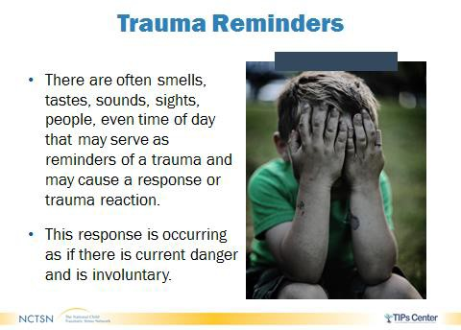
- When traumatic stress responses, sometimes they can be triggered even if there is no current danger.

- Trauma reminders are the ways that human bodies encode trauma into memory. These memories can be triggered by any of the five senses.
- In our snake example, the stick was clearly a trauma reminder. In that scenario, there may have been others, like the strong smell of pine in the forest, which can bring back the
same feeling of fear and a similar flight-fight-freeze response without a snake ever being present.
- Think about these involuntary responses and what behaviors might then happen. If a person is in flight or freezing, they may act out aggressively or feel numb (like not letting feelings out or interacting with others) in self-protection. These behaviors are a result of the earlier trauma. Therefore, having a trauma-informed lens allows you to focus on asking “What happened to you?” versus “What is wrong with you?”

Intergenerational/Parent Trauma

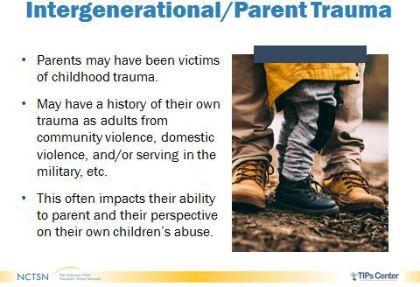
- To talk about children, you must talk about parents. Think about a newborn baby. They are completely dependent on an adult to meet their basic needs and help them learn and grow. Children continue to need support from adults as they grow. Because of this, you must think about these adults as a key part of the environment.

- Adults who have had their own traumatic experiences, whether in the past or present may have more difficulty being present and tuned into their environments.
- It is important to remember that parents may have been victims of childhood trauma, and/or may have current trauma exposure that may impact their perspective on their own children’s abuse (e.g., they may not even recognize it as abuse). Share that this may look like a caregiver in a domestic abuse relationship who minimizes the impact of the abuse on themselves and/or the children in the home.
- Keep in mind that parent trauma may also stem from historical trauma, as well as intergenerational trauma.

Caregivers as Mediators of Trauma Response

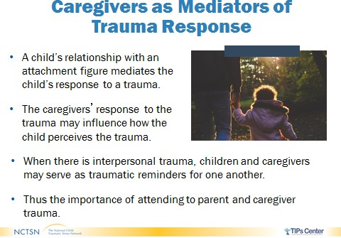
- Much of what infants and toddlers learn is from their caretakers.

- Older children often take cues from their caretakers as well.
- How these caretakers react to the trauma has an impact on a child’s perception and reaction to the trauma.
- For young children whose brains are still developing, it is also important to remember, that having a supportive caregiver help them to return to calm may be critical as they may
not yet have the brain function to do so themselves.
- Seeing the caretaker may be a trauma reminder for a child. The child may also be a trauma reminder for the parent. These are important dynamics to understand and to make sure are being addressed appropriately.
- More will be covered on parent and caregiver trauma later in the training series. Here the focus is on emphasizing the importance of the relationship in development, especially during the early years, but throughout childhood as well.

Applegate, J. S., & Shapiro, J. R. (2005). Neurobiology for clinical social work theory and practice. W.W. Norton & Company.

Development & Trauma

About this Section

Timing:
  - 20 minutes in length

Pages in Participant Manual:
  - Early Childhood Development Milestones o
  - School-Age Developmental Milestones
  - Adolescent Development Milestones
  - Developmental Tasks for Transitional Age Youth (TAY)
  - Impact on Development Activity
worksheet

Icon Reminders
What to Say and Do

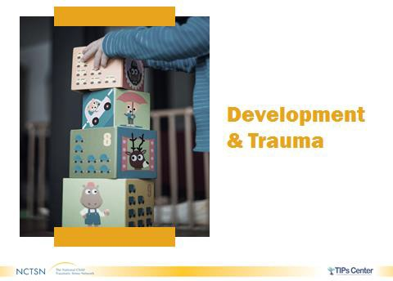

Development & Trauma
- Now that you have a greater understanding of what trauma is, we are going to talk about how it impacts children and adolescents, starting with the brain.
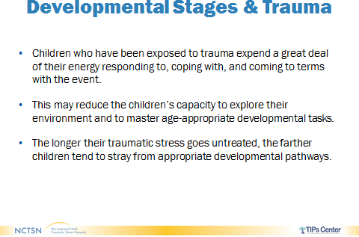

- A child who has experienced a traumatic event tends to expend a lot of energy responding to, coping with, and coming to terms with the event.
- This may interfere with their capacity to explore their environment and master developmental tasks.
- The longer the traumatic stress goes unaddressed, the farther the child may stray from appropriate developmental trajectories.

Activity: The Impact of Trauma at Different Developmental Stages

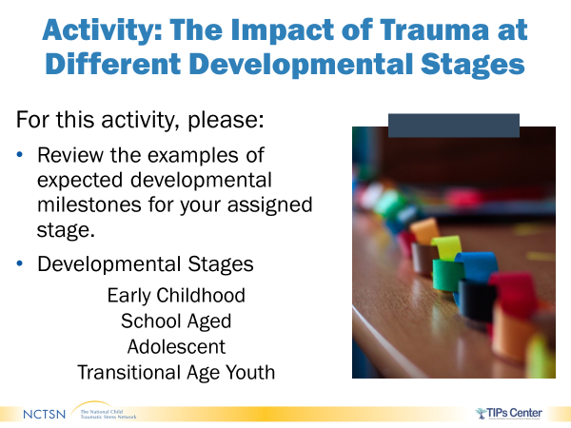
Trainer Note: The resource in the participant guide is only meant as a resource. This activity should be brief and take no more than 20 minutes.
Option 1: 20 minutes
- You are now going to do an activity to look at the impact of trauma at different developmental stages.
- Assign one developmental stage to no more than five participants.
  - Early Childhood
  - School Aged
  - Adolescent
  - Transitional Age Youth
- Allow participants three minutes to review examples of developmental milestones for their assigned stage in the Participant Manual.
- Instruct Participants to use the internet to find an image that best represents their assigned stage and determine what impact trauma exposure would have on the developmental milestones for the stage they were assigned.
- Once completed, ask for volunteers to share their image and give their response for each stage. (Trainer can make the participant a presenter).
- Trainer can also use the prepared Jam Board to have participant copy and paste images that reflect their assigned developmental stage. Participants will then use the sticky notes to determine what exposure trauma would have on their assigned developmental stage.
- Trauma 101- Milestones Jam Board; https://jamboard.google.com/d/1wTrETiZqM0YI2sXrRAjmPUjPEqO9W97OB465bj8zM-o/viewer?f=0
- Debrief activity by reviewing responses on the jam board frames

Option 2: 15-16 minutes
- Using the white board feature in WebEx or the prepared Power Point Resource with each developmental stage(Early Childhood, School Aged, Adolescent, Transitional Age Youth).
- Allow participants 5 mins to review examples of developmental milestones in the participant manual.
- Invite participants to share how trauma exposure would impact achievement of developmental milestones at each developmental stage.

Option 3: 12 minutes
- REFER participants to the Participant Guide. ASK participants to identify the developmental stage they would like to gain experience working with. Allow three minutes for participants to review the developmental milestones for the stage they have selected.
- Drop the link to the google form in the chat box. Allow participants no more than 8 minutes to complete the google form.

- https://docs.google.com/forms/d/e/1FAIpQLSeJ7ot9UlBAgTSRy9RVq1RD7r3Mvs8hC3ppJl6GuPbA0QwWAQ/viewform

- DEBRIEF by highlighting a few responses from participants for each developmental stage.

Resilience

About this Section

Timing:
- 55 minutes in length

Materials:
- Internet access that is hard wired or has a strong Wi-Fi signal
- Neuroplasticity video (link embedded in the video icon on the slide)
- Brains: Journey to Resilience video (link embedded in the video icon on the slide)

Pages in Participant Manual:
- How Can the Child Welfare Workforce Influence Resilience?

Icon Reminders
What to Say and Do Discussion
Video

Resilience
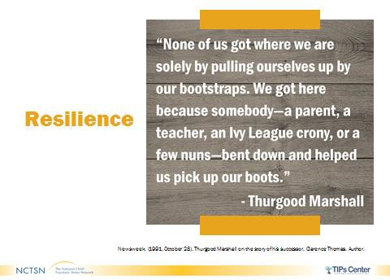
- It is important to understand that with all of trauma’s impacts, there are ways that you can help foster healing.

- Read the Thurgood Marshall (Associate Justice of the Supreme Court of the United States) quote on the slide or ask for a volunteer to do so.
- As the Thurgood Marshall quote indicates, the process of recovering from trauma and developing resilience is largely dependent on supportive and enduring relationships.
- Think back on a time that you went through some tough challenges. What helped you get through?
o Gather 2-3 quick responses from the participants. Limit to 1 minute.
Newsweek. (1991, October 28). Thurgood Marshall on the story of his successor, Clarence Thomas. Author.

- Before talking about resilience, let’s spend some
time exploring Neuroplasticity.
- Neuroplasticity is the brain’s ability to adapt to
new ways of thinking, feeling, and doing.
- A great example of this comes from
Dr. Michael Merzenich (One of the foremost researchers on neuroplasticity)-
  - He wrote: “Each time we learn a new dance step, it reflects a change in our physical brains: new wires (neural pathways) that give instructions to our bodies on how to perform each step. Each time we forget someone’s name, it also reflects a brain change- “wires” that once connected to the memory have been degraded or even severed.” As these examples show, changes in the brain can result in improved skills or weakening of skills.
- Over time and with repetition, neural pathways can be forged or refined, and long-lasting functional changes in the brain can occur. Has anyone here ever learned a new language or skill later in life or changed a habit? Participants may respond in the chat box.
- Review comments and transition to Neuroplasticity Video.
o The video you are about to watch demonstrates how pathways in the brain can be strengthened or weakened over time so people can learn to speak French or dance Samba.
o Drop the link for the Neuroplasticity video (length=2:03) in the chat box. https://youtu.be/ELpfYCZa87g

Icon Reminders: What to Say and Do Discussion Video

Quotation Source: “On the brain" with Dr. Michael Merzenich. (2019). About brain plasticity. https://www.onthebrain.com/brain-plasticity/
Sentis Pty Limited. (2012) Neuroplasticity [Video]. https://youtu.be/ELpfYCZa87g

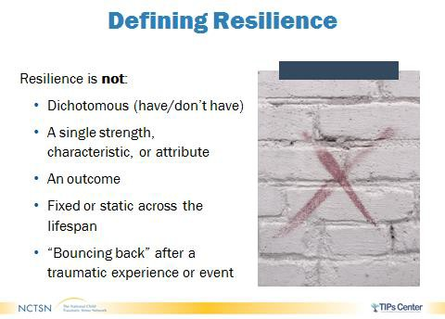

.
- Because of neuroplasticity, experts now know that human brains aren’t, in fact, set
in stone like it was once believed. There is a lot a person can do to change their brain functioning, and, in turn, the way they think, feel, and behave. This is particularly important to understand when talking about resilience.
- Figuring out what resilience is and how to define it is challenging. Social scientists have explored the phenomena of resilience for nearly 50 years and with a
variety of populations, including refugees, cancer patients, and even Fortune 500 companies. You can imagine how different resilience might look for Microsoft than it would for a child or youth in foster care.
- Before delving into the definition of resilience, let’s spend some time addressing common misconceptions.
- First, resilience is not something someone does or does not have. It is not a single strength, characteristic, or attribute. Instead, it is a culmination of factors, both internal and external (we’ll touch more on that later).
- Additionally, resilience is not an outcome. It ebbs and flows across the lifespan. In fact, someone who demonstrates resilience today may not in 5 or 10 years, and vice versa.
- Lastly, it is unrealistic to think children and youth can bounce right back when faced with serious life challenges and hardships. More often, suffering and struggle are experienced in forging resilience, so it should not be mischaracterized as breezing through trauma unscathed or bouncing back to the original state before the trauma occurred.

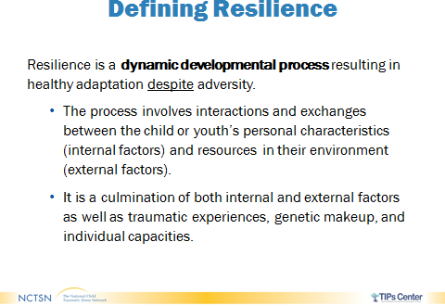
- Resilience is a dynamic developmental process that occurs over time, resulting from a culmination of both internal and external influences, as well as past trauma, genetic makeup, and individual capacities.

- These factors enable people to positively adapt and function despite facing acute or chronic trauma.
- Positive adaptation has been defined differently over the years, but there is
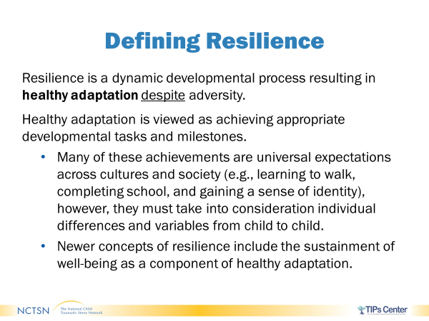
growing consensus that it is marked by the achievement of age-appropriate developmental milestones. For younger children, this could include learning to walk and talk while for older adolescents it may be completing school and engaging in a romantic relationship.
- To understand how multidimensional resilience can be, consider two children who’ve experienced the same trauma.
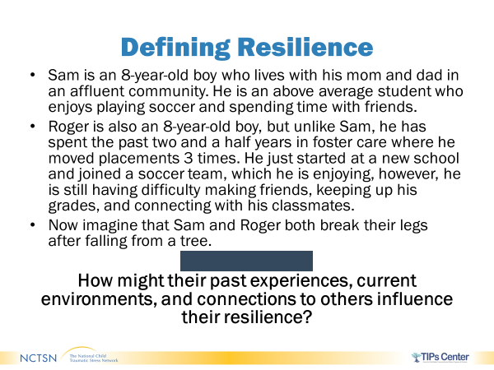
- Sam is an 8-year-old boy who lives with his mom and dad in an affluent community. He is an above average student who enjoys playing soccer and spending time with friends.
- Roger is also an 8-year-old boy, but unlike Sam, he has spent the past two and a half years in foster care where he moved placements 3 times. He just started at a new school and joined a soccer team, which he is enjoying, however, he is still having difficulty making friends, keeping up his grades, and connecting with his classmates.
- Now imagine that Sam and Roger both break their legs after falling from a tree.
- How might their past experiences, current environments, and connections to others influence their resilience?
o Gather 2-3 quick responses from the participants. They can either shout them out or raise their hands. Limit to 3 minutes.

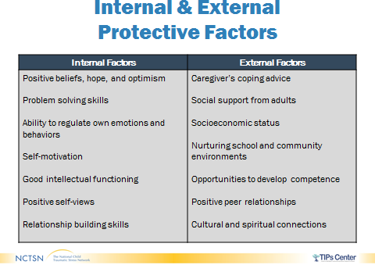

- All people have protective factors that help them overcome and respond to traumatic
events. They can come from internal and external factors that aid in coping and processing stressful or traumatic events. Internal factors include problem-solving skills, hope, and the ability to regulate their emotions. External factors can include support from a network of family, friends, and the community.
- There is no formula or one-size-fits-all combination of factors that can guarantee
healthy adaptation. However, these are some of the internal and external factors or influences known to aid in coping with trauma and developing or strengthening resilience.
- Internal protective factors include personal strengths and characteristics that influence a person’s behavior. While many of them may sound like biologically determined traits that one either has or does not have, research now indicates they can be learned.
- For instance, research shows that individuals who have a deeper sense of gratitude have a higher likelihood of demonstrating resilience since it helps develop and maintain relationships. However, it’s the act of saying “thank you” to someone who has done something kind, rather than an actual deep or genuine feeling of thankfulness, that helps you have positive social interactions.
- Review the slide on the Internal Factors.
- External factors are the resources and supports that are present in the child or youth’s life and range from intimate family relationships to the broader environment, like school and the community. Young children are especially dependent on external protective factors as they continue to develop internal abilities like problem-solving skills and self- regulation.
- Read the slide on the External Factors.
- No single internal or external factor can yield resilience on its own. The interaction among the different factors, and the degree to which they are present, are critical in understanding someone’s response and recovery after trauma.
- It’s important to note that some factors have a larger impact on positive adaptation and healing. Research has demonstrated that a stable relationship with a caring and supportive adult is one of the greatest indicators of a child or youth’s recovery following a traumatic event.
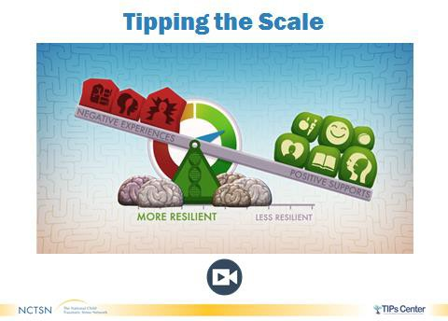
o OPTIONAL ACTIVITY: The video you are about to watch illustrates the idea of how resilience can be formed

and changes over time.
- Drop the link to the video in the chat box: Brains: Journey to Resilience video (length=7:44) in the chat box. https://vimeo.com/245310333
o Facilitate a large group discussion by having participants list key words or descriptors that help to conceptualize or define resilience in the chat box. Allow up to 3 minutes for participants to answer.

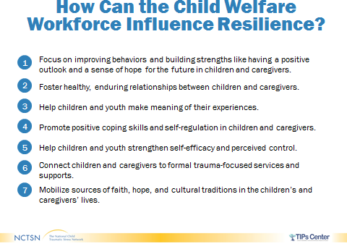
- You can’t make the bad things that happened to a young person go away, but there are things that you can do to help them make sense of what happened. In fact, you may already be engaging in a variety of resilience-building activities that help children, youth, and families tip their scales towards positive outcomes.

- Trainer will review strategies listed on Page 43 of the Participant Manual with the group.
  - 1. Focus on improving behaviors and building strengths like having a positive outlook and a sense of hope for the future in children and caregivers.
  - 2. Foster healthy, enduring relationships between children and caregivers.
  - 3. Help children and youth make meaning of their experiences.
  - 4. Promote positive coping skills and self-regulation in children and caregivers.
  - 5. Help children and youth strengthen self-efficacy and perceived control.
  - 6. Connect children and caregivers to formal trauma-focused services and supports.

  - 7. Mobilize sources of faith, hope, and cultural traditions in the children’s and caregivers’ lives.

- Trainer will ask the group to identify activities they, as the case manager, can use to promote these strategies to influence resilience in children and families.
- Examples can include: Returning phone calls within 24 hours, recognizing emotional responses, conveying genuineness, empathy, and respect, ensuring visitation is timely, thorough assessments to identify underlying needs, family centered practice (inclusion in service planning), etc.

Wrap-Up & Closure

About this Section

Timing:
- 5 minutes in lecture

Wrap-Up & Closure

- This brings us to the end of the Trauma 101 training. We hope that wrapping up with resilience will keep you believing that you can make a difference in the forefront of your mind!
- We appreciate all of you taking the time to participate.
- There are other trainings on trauma available such as Trauma- Informed Child Welfare 101 training. This information will also be used throughout your Pre-Service Training.
- We appreciate your participation.
- SHARE with participants we will now wrap-up the week of Core Foundations.

