Curriculum Information
Background from Capacity Building Center for States
In September 2014, the Preventing Sex Trafficking and Strengthening Families Act, Public Law (P.L.) 113–183 was enacted. As one of several Federal laws passed to address trafficking, P.L. 113–183 presents specific requirements for child welfare agencies. Certain provisions require agencies to develop and implement policies and procedures—including caseworker training— for identifying, reporting, and determining services for children and youth who are victims, or at risk of becoming victims, of sex trafficking. The law also requires protocols and procedures to locate and provide services to children who run away from foster care.
Given the intersection between child welfare and sex trafficking, child welfare professionals can play a critical role in identifying and reporting victims, determining appropriate services and placement options for victims, and helping to prevent future victimization of youth currently in care. Child welfare professionals, however, cannot address trafficking alone.
Multidisciplinary, collaborative responses are needed, with child welfare professionals working closely with law enforcement, juvenile justice, runaway and homeless youth services, victim service providers, mental health professionals, and others.
This training will provide child welfare professionals with knowledge and skills that support effective implementation of P.L. 113–183. Version 16.6.2 of this curriculum was adapted from: Capacity Building Center for States. (2015). Child welfare response to child & youth sex trafficking: Caseworker’s curriculum. Washington, DC.
Additional resources include examples of screening tools, recorded webinars, tip sheets, and digital stories with facilitator guides. These resources are available through the Capacity Building Center for States and can be found at:
- “At Risk for Sex Trafficking: Youth Who Run Away from Foster Care” – PDF (Child Welfare Capacity Building Center for States, 2015).
- “Resources to Support Implementation of the Sex Trafficking Provision of P.L. 113–183” – PDF (Child Welfare Capacity Building Collaborative, 2015).
- List of “Related Organizations: Sex Trafficking Prevention and Intervention” (Child Welfare Information Gateway, 2015).
- Resources and information about additional training specific to sex trafficking in Native communities can be found at “At Risk for Sex Trafficking: Youth Who Run Away From Foster Care” – PDF (Child Welfare Capacity Building Center for States, At Risk for Sex Trafficking: Youth who Run away from Foster Care, 2015).
This curriculum was developed by the Tennessee Department of Children’s Services with federal funds. It is available to use in part or in whole free of charge. Suggested citation:
Nash, A. (2019). TN-KEY (Knowledge Empowers You) Training. Tennessee Department of Children’s Services
- For more information: Please visit the Capacity Building Center for States’ website at https://capacity.childwelfare.gov/states.

Competencies
- Participants will understand the laws and policies related to protecting children and youth at risk of CSEM.
- Participants will demonstrate how to apply the definition of CSEM to determine if trafficking is occurring.
- Participants will recognize the indicators and risk factors of CSEM and the dynamics of sex trafficking relationships.
- Participants will understand DCS policy for identification, intervention, and reporting of CSEM and case manager tasks.
- Participants will understand the challenges of engaging with trafficked youth and how to use effective strategies.
- Participants will be aware of the impact of CSEM and needs of CSEM survivors.
- Participants will recognize the immediate and long-term health care needs of trafficked youth and be aware of local and statewide resources.

Materials Checklist

Materials needed for this curriculum:
- Video links
- Visual Aids
- Etc.

Annotated Agenda
4.0 Hour Training
Agenda Item | Time | Learning Objectives | Activities
- Unit 1: Commercial Sexual Exploitation of Minors | - 40 min | - Understand the laws and policies related to protecting children and youth at risk of CSEM | - Changing the Language
- Unit 2: Identifying CSEM | - 50 min | - Demonstrate how to apply the definition of CSEM to determine if trafficking is occurring | - Trafficking or Not
- Unit 3: Risk Factors and Characteristics of CSEM | - 45 min | - Recognize the indicators and risk factors of CSEM and the dynamics of sex trafficking relationships
- Unit 4: CSEM Identification and Assessment | - 25 min | - Understand DCS policy for identification, intervention, and reporting of CSEM and case manager tasks
- Unit 5: Trauma Informed Practice and Engaging Trafficked Youth | - 20 min | - Understand the challenges of engaging with trafficked youth and how to use effective strategies
- Unit 6: The Impact of CSEM and the Needs of Survivors | - 45 min | - Be aware of the impact of CSEM and needs of CSEM survivors  - Recognize the immediate and long-term health care needs of trafficked youth and be aware of local and statewide resources | - Health Needs and Risks of CSEM Victims Activity
- Unit 7: Close | - 15 min

Unit 1: Commercial Sexual Exploitation of Minors
Time: 40 Minutes
Learning Objectives:
Participants will:
- understand the laws and policies related to protecting children and youth at risk of CSEM
Supporting Materials:
- Power Point

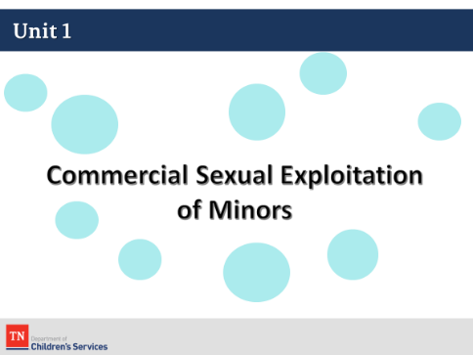
Lesson 1.1: Welcome & Introductions
Time: 10 minutes
Key Teaching Points / Instructions:
- WELCOME participants to training and conduct any necessary housekeeping activities.
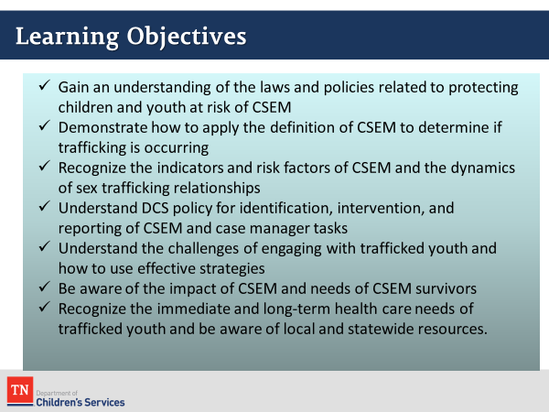
- REVIEW the objectives for the day.
- The overall goal of this training is for participants to understand and describe effective identification, documentation, reporting, and service delivery for children and youth under DCS care and supervision who are victims of, or at risk of sex trafficking.
Lesson 1.2: Changing the Language
Time: 20 minutes
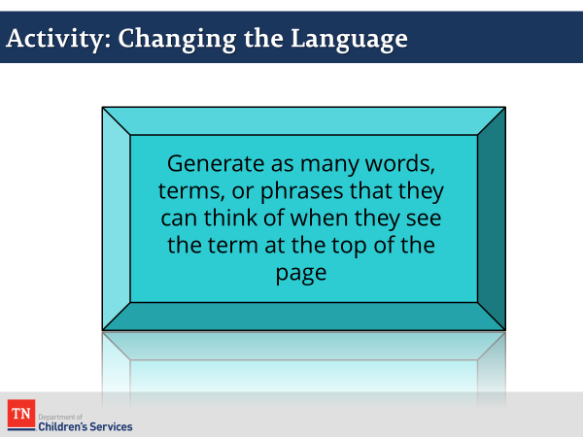
Key Teaching Points / Instructions:
- EXPLAIN that language and the words we use are essential to framing an issue. They communicate how we feel about, value, or interpret a concept, idea, or issue.
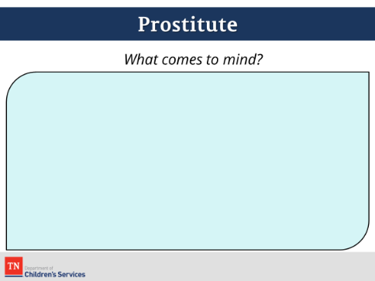
- ASK the participants to generate as many words, terms, or phrases that they can think of when they see the term at the top of the page. They should list any words that come to mind, even if they seem “politically incorrect” or are not words that participants would say themselves. They should think about what images come to mind, such as how the person is dressed, how they are acting, etc.
- ASK the participants to generate as many terms as they can for the term “Prostitute” by writing those down on post it notes. ASK participants to bring the post it notes to the Power Point to stick them under the terms. If the participants seem to be stuck, it may be helpful to provide a couple of terms to get them started, such as “cheap,” “hooker”, etc., prompt the large group to give you some. Once this has been done, ask the following questions:
  - What ideas, images or concepts do these terms communicate?
  - How is this person dressed? How is he/she acting?
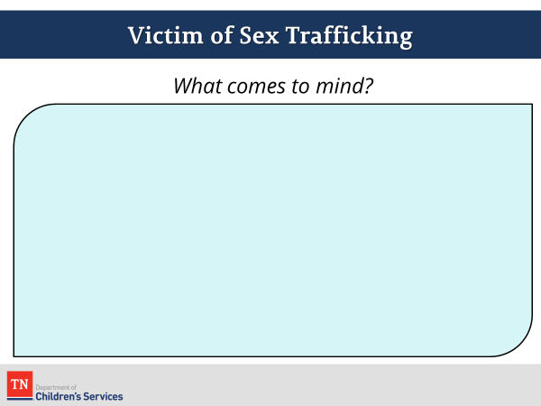
- After 2-3 minutes ask participants to move on to the next page and do the same process (NOTE: remove the first post-it notes from the screen) for “Victim of Sex Trafficking.” Once this has been done, ask the following questions:
  - What ideas, images, or concepts do these terms communicate?
  - How is this person dressed? How is he/she acting?
  - Repeat the previous step for the “Victim of Sex Trafficking” terms.
- TRANSITION the discussion to “Child/Teen Prostitutes” vs. “Victim of Child Sex Trafficking” and briefly discuss with the group whether they believe that adding minors to the terms makes a difference in how we view them. Coach the group to recognize that if we indeed view “teen prostitutes” differently, this has been a recent change in attitude.
- ASK the following questions:
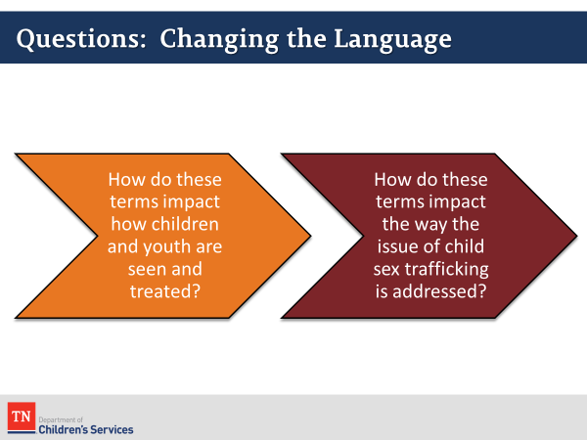
  - How do these terms impact how children/youth are seen and treated?
  - How do these terms impact the way the issue of CSEM is addressed?
- COACH participants to point out the distinctions. You may use the next two slides as a guide, if needed, for each after participants give their own ideas.
- SHOW the trauma insensitive term “Teen/Child Prostitute” slide:
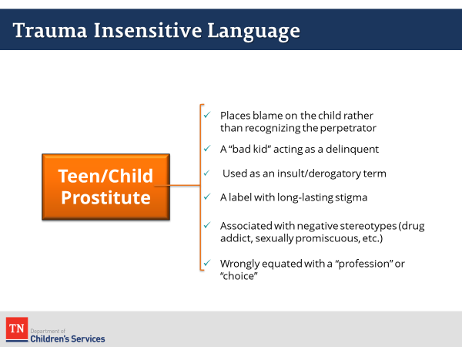
  - Places blame on the child rather than recognizing the perpetrator
  - A “bad kid” acting as a delinquent
  - Used as an insult/derogatory term
  - A label with long-lasting stigma
  - Associated with negative stereotypes (drug addict, sexually promiscuous, etc.)
  - Wrongly equated with a “profession” or “choice”
- DISPLAY the trauma sensitive term ”Child Sex Trafficking Victim” slide:
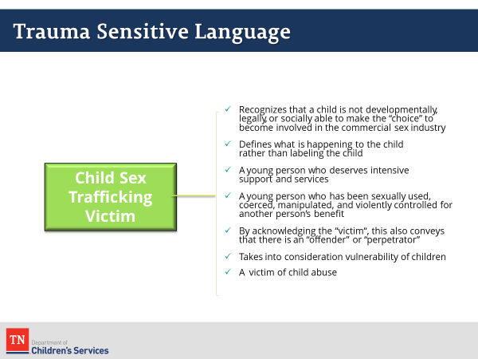
  - Recognizes that a child is not developmentally, legally, or socially able to make the “choice” to become involved in the commercial sex industry
  - Defines what is happening to the child rather than labeling the child
  - A young person who deserves intensive support and services
  - A young person who has been sexually used, coerced, manipulated, and violently controlled for another person’s benefit
  - By acknowledging the “victim”, this also conveys that there is an “offender” or “perpetrator”
  - Takes into consideration the vulnerability of children
  - A victim of child abuse
- CLOSE the activity by highlighting how the use of trauma insensitive versus trauma sensitive terms makes a difference in how we view, identify, and respond to the issue of child sex trafficking.
- It has only been in the past few years that we have stopped viewing teenage prostitution as criminal behavior.
- During the debrief, NOTE that Tennessee law now stipulates that a minor cannot be considered a “prostitute.”
- REFER participants to “Language as an Indicator”(PG 5). This page provides a list of basic terms that are often taught to youth while they are under the control of a trafficker.
- Because we are talking about language, it is important to familiarize ourselves with pimping/prostitution terminology which may be helpful as we work with CSEM survivors.
- Give participants a moment to look at the list and ask if there are any terms that particularly stand out to them or that they have heard / seen before.
Lesson 1.3: Prevalence of CSEM
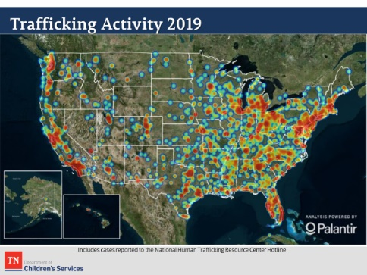
Time: 10 minutes
Key Teaching Points / Instructions:
- DISPLAY the slide “Trafficking Activity 2019”. The statistics on these slides come from the National Human Trafficking Resource Center (NHTRC), a national anti-trafficking hotline and resource center serving victims and survivors of human trafficking and the anti-trafficking community in the United States, and from the National Center for Missing & Exploited Children (NCMEC), the congressionally authorized national clearinghouse on missing and exploited children.
- ASK participants their thoughts? What sticks out noting the redder the color, the more trafficking activity?
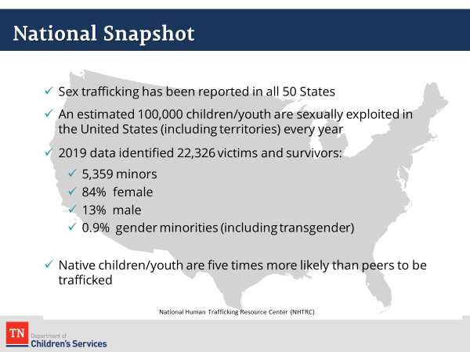
- NHTRC has received reports of CSEM in all 50 States. We know that numbers differ depending on where they came from and what constitutes CSEM in the statistics. For example, the 100,000 children sexually exploited in the US every year includes all forms of sexual exploitation. This slide shows the States where CSEM was reported in 2019 and only shows confirmed incidents.
- Reports of human trafficking are increasing each year which may also be related to increased awareness of the issue and available support for victims of trafficking.
- During 2019, National Human Trafficking Resource Center received 22,326 reports of potential sex trafficking. Minors accounted for 5,359 of the victim total (24%). According to NHTRC’s website, 68% of the victims were female, 13% were male, and 0.006% were gender minorities, including transgender and intersex (gender was not reported in all cases which was 18%).
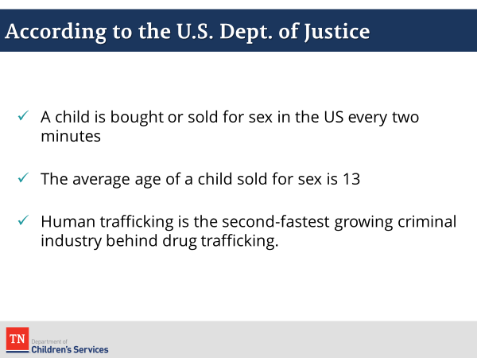
- However, we know that boys and LGBTQ youth are vastly under-represented in these numbers. We return to this concern below:
  - According to the US Justice Department:
    - A child is bought or sold for sex in the US every two minutes
    - The average age of a child sold for sex is 13
    - Human Trafficking is the second-fastest growing criminal industry behind drug trafficking
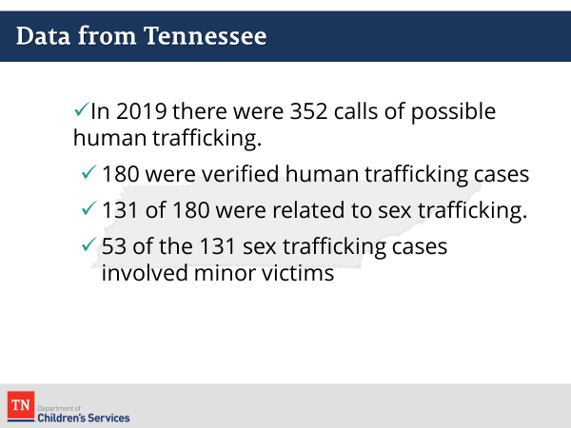
- DISPLAY slide “Data from Tennessee”. In 2019, data from National Human Trafficking Resource Center revealed that Tennessee had 352 calls of possible human trafficking. 180 of those were verified as human trafficking cases. Sex trafficking accounted for 131 of the 180 cases. In the 131 cases of sex trafficking, 53 of the cases involved victimization of minors. The two most notable venues/industries for sex trafficking were residential-based commercial sex and pornography. Online ads are frequently placed on Craigslist and in the deep web.
- A popular misconception is that CSEM only happens in the urban counties of Tennessee. But the reality is that CSEM is as much a rural as an urban problem in our state. In 2011, the TBI conducted a survey of law enforcement across the state requesting information related to sex trafficking. Nearly 40% of respondents from rural counties were aware of sex trafficking cases in their jurisdiction.
- INFORM participants we are now going to briefly look at the law which was developed to combat trafficking.
Lesson 1.4: Overview of Public Law
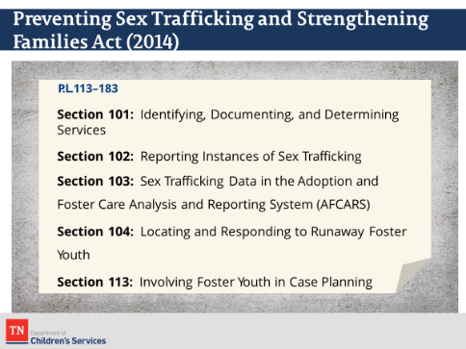
Time: 5 minutes
Key Teaching Points / Instructions:
- SHOW the slide “Preventing Sex Trafficking and Strengthening Families Act”. States began to implement the requirements of this law in September 2016.
- Only requirements of the law that are pertinent to child welfare practice will be explored in this training and we will cover DCS requirements more thoroughly as the training progresses. For example, Section 103 regarding data was discussed in the previous slides.
- REFER participants to “P.L. 113–183 Child Welfare Provisions Desk Reference” and ask if there are any questions (PG 7).
Unit 2: Identifying CSEM
Time: 50 Minutes
Learning Objectives:
Participants will:
- demonstrate how to apply the definition of CSEM to determine if trafficking is occurring
Supporting Materials:
- Power Point
- “Hidden America: Chilling New Look at Sex Trafficking in the US” https://www.youtube.com/watch?v=gSgTmcq-bBkVideo: Link
- Trafficking or Not Scenarios

Lesson 2.1: Identifying CSEM
Time: 25 minutes
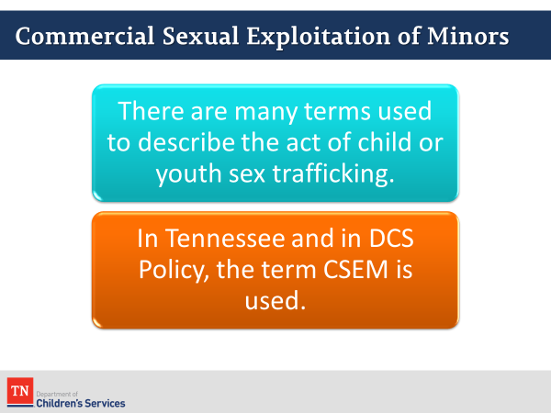
Key Teaching Points / Instructions:
- While there are many ways to refer to child sex trafficking, Tennessee and DCS will use the term Commercial Exploitation of Minors (CSEM).
- The primary aim of the Preventing Sex Trafficking law is to identify and provide services to as many victims of CSEM as possible. The federal definition of child sex trafficking (which we will cover momentarily) is very broad and this presents some dilemmas for the typical criteria for CPS involvement. SHARE the three basic criteria for a CPS investigation (some will also list location).
  - Child
  - Caregiver
  - Allegation of Harm
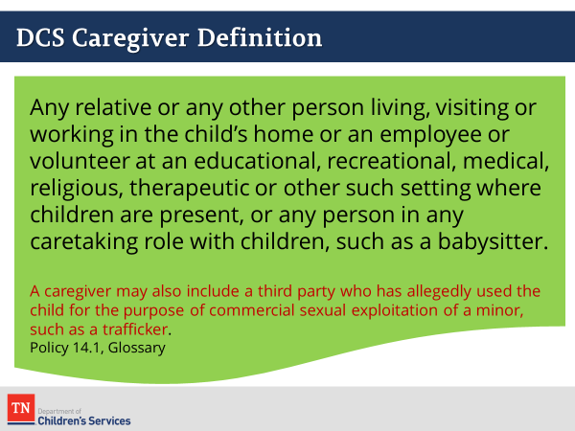
- ASK which of these criteria is most likely to be unmet in allegations of CSEM (caregiver).
- In order to allow DCS to provide services to victims of CSEM in cases where the caregiver criteria may not be met, the legislature has expanded the definition of caregiver to include a trafficker. A caregiver may also include a third party who has allegedly used the child for the purpose of commercial sexual exploitation of a minor, such as a trafficker.
- REFER participants to the glossary in Policy 14.1.
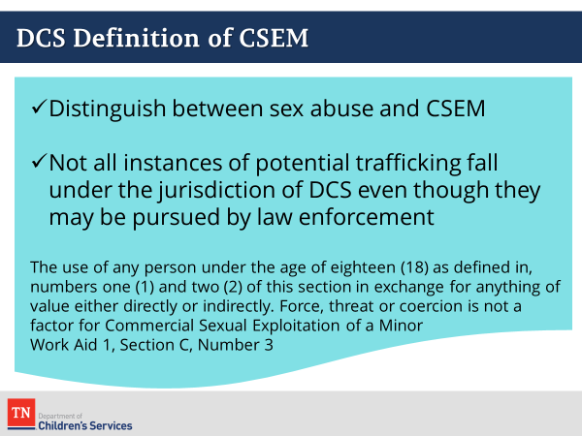
- CSEM is considered a sub-category of sex abuse. In order to accept CSEM cases with victims over the age of 13, Policy 14.1 also adds item 3b (page 3 of the policy), allowing the victim of CSEM to be between 13 ang 17 years old and meeting the definition of caregiver (as above).
- Additionally, DCS wants to differentiate between cases of sexual abuse and sex trafficking. There are some instances which DCS would classify as sex abuse but would not classify as CSEM. In order to make this distinction, the DCS definition of CSEM required a third party (in addition to the minor victim and the person engaged in sex with the minor) who acts as a broker. The third party may be a parent or other caretaker. Click the slide again for the DCS Definition of CSEM. Refer participants to Work Aid 1, CPS Categories and Definitions of Abuse/Neglect, Section C, Sex Abuse, Number 3, where the definition is found (page 5). Note that Section C, items 1 &2 refer to the criteria for an allegation of sexual abuse. The definition of CSEM has been added in item 3:
  - The use of any person under the age of eighteen (18) as defined in, numbers one (1) and two (2) of this section in exchange for anything of value either directly or indirectly. Force, threat or coercion is not a factor for Commercial Sexual Exploitation of a Minor (CSEM).
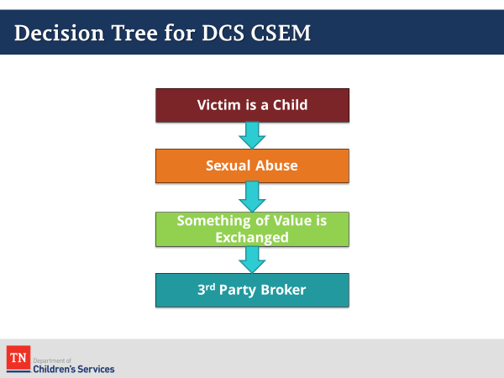
- DISPLAY slide and REFER participants to the Case Manager Decision Tree to Determining Commercial Sexual Exploitation of a Minor (PG 10). To clarify our understanding of which cases meet the DCS criteria for CSEM, the Office of Child Safety has produced a decision tree. Briefly walk participants through the tree highlighting the four basic criteria noted on the slide.
  - The Victim is a Child or Youth under the age of 18
  - There is an allegation of sexual abuse meeting the definition in CPS Work Aid 1, Section C, Sex Abuse.
  - Something of value is exchanged
  - There is a 3rd party acting as a broker
- REFER participants to the Child Abuse Hotline Cue Questions (PG 11). As calls are received by the Child Abuse Hotline and the allegation of harm includes sexual abuse or potential CSEM, Hotline staff will ask the following cue questions:
  - Has the child been made available by the alleged perpetrator to others for purposes of sexual gratification or prostitution?
  - Has the victim, the caretaker or any third party (friend, relative, etc.) received money, items or services in exchange for access or sex with the victim?
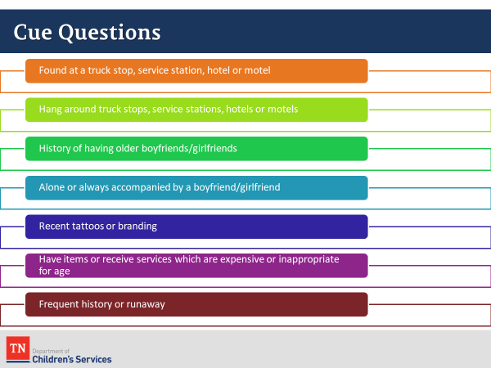
- If the answer to either question is YES or there are indications that it is happening, PROCEED TO CUE QUESTIONS for Commercial Exploitation of a Minor.
  - If the child is a runaway, was the child found at a truck stop, service station, hotel or motel?
  - Does the child hang around or spend time at truck stops, service stations, hotels or motels?
  - Does the child have a history of having older boyfriends?
  - Is the child ever alone or is he/she always accompanied by the boyfriend?
  - Does the child have recent tattoos or brandings? Bar codes and gang tattoos are the most common.
  - Does the child have items or receive services that are expensive or inappropriate for his/her age (expensive hair styles, manicures/pedicures, provocative clothes, expensive jewelry, purses or clothing)?
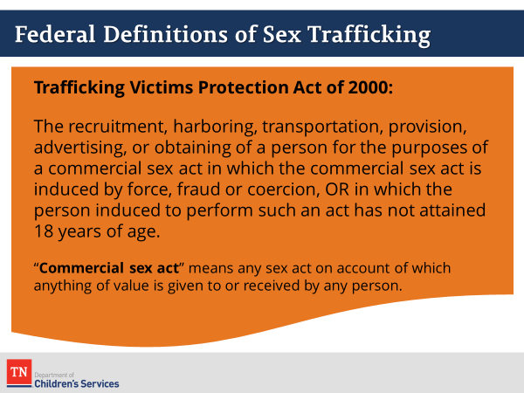
  - Does the child have a history of frequent runaway?
- INFORM participants the federal definition of CSEM is broader than that used by DCS:
  - The recruitment, harboring, transportation, provision, advertising, or obtaining of a person for the purposes of a commercial sex act in which the commercial sex act is induced by force, fraud or coercion, OR in which the person induced to perform such an act has not attained 18 years of age.
- HIGHLIGHT the difference in the definition of trafficking for minors. For children under 18 years of age, the definition clearly states that ANY child exploited through commercial sex is a victim. The use of force, fraud, or coercion is not included in the definition of CHILD sex trafficking since minors are not able to give “consent” to be exploited.
- A “Commercial sex act” means any sex act on account of which anything of value is given to or received by any person.
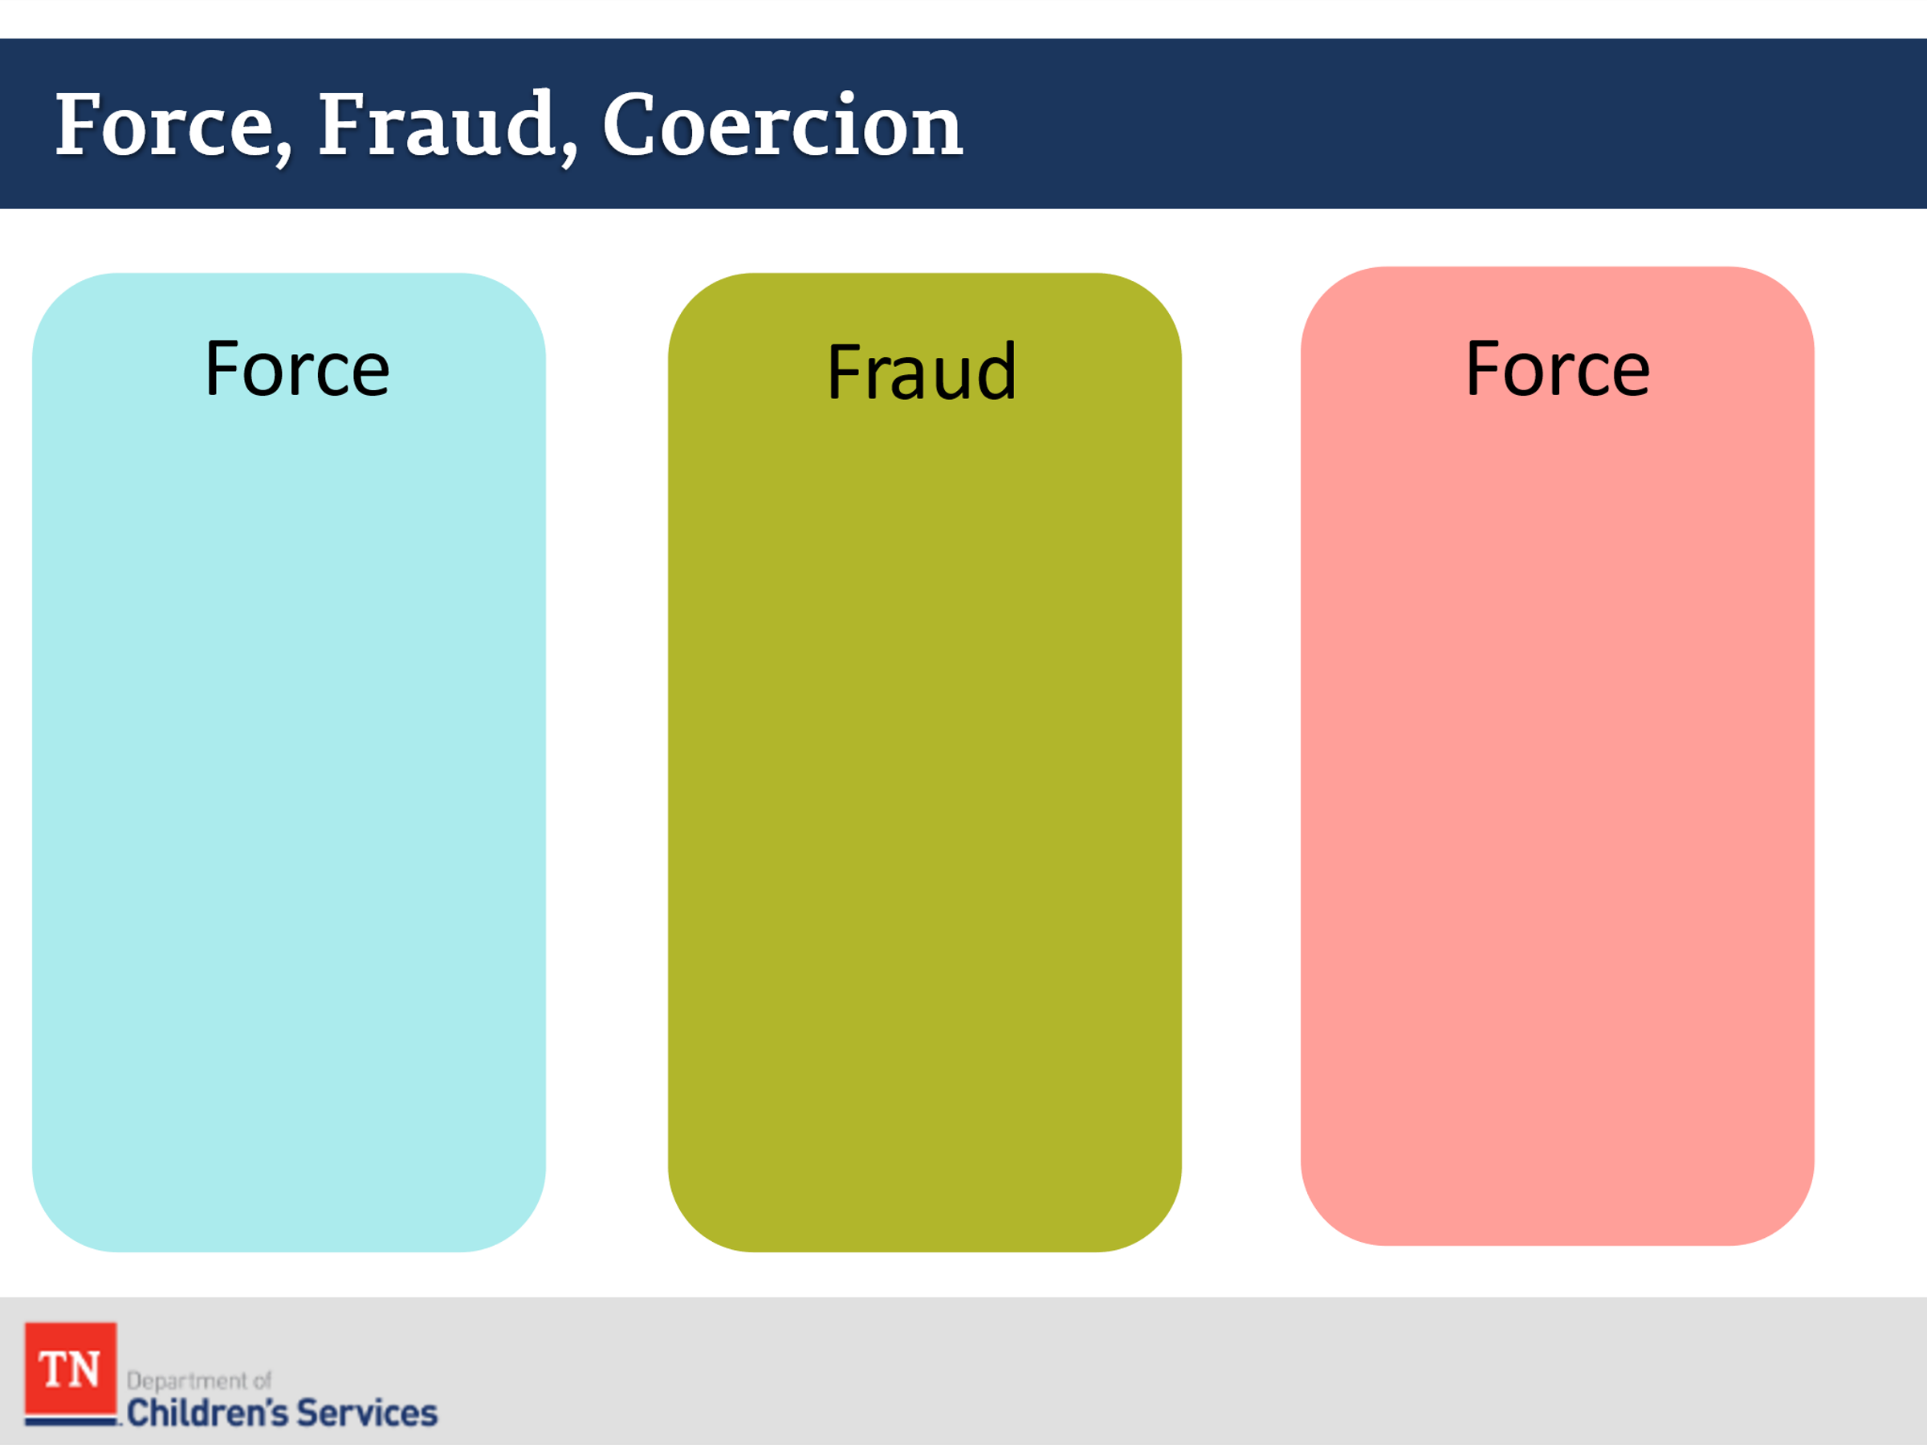
- For adults 18 years of age or older, the law requires proof of force, fraud, or coercion. This can occur in a variety of ways, and the recognition of psychological coercion as a component of control and exploitation is significant.
- ASK participants to brainstorm some examples of each: force, fraud, and coercion. Highlight the fact that the exchange of something of value (could be an example of coercion or fraud) includes food, shelter, clothing, money, etc. According to the law, the exchange can be “given to or received by anyone”, including the youth.
- The definition also includes youth, 17 years of age or younger, who are not under the control of a trafficker. This is commonly referred to as “survival sex”.
- As noted previously, the DCS definition of CSEM narrows the number of cases that are considered CSEM. DCS needs to draw a distinction between CSEM and sex abuse. At the same time, federal law might classify that same instance as CSEM. Additionally, not all potential cases of CSEM fall within the jurisdiction of DCS. In these cases, law enforcement may choose to pursue criminal charges outside the involvement of DCS.
- It should also be noted some cases which meet the federal definition of CSEM, but not the DCS definition of CSEM may still become DCS cases on other allegations of harm. For example, a minor involved in survival sex may receive DCS services due to neglect or abuse.
- Law enforcement, including the TBI will use the federal definition as they have jurisdiction over a wider span of cases.
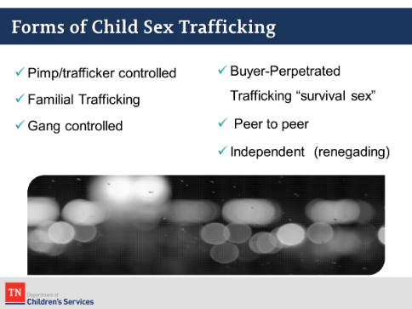
- As noted in the Child Sex Trafficking CBT, there are six primary forms of sex trafficking. We will cover them briefly.
  - The first form is Pimp/Trafficker Controlled commercial sex. The terms pimp and trafficker are synonymous and can be used interchangeably. While “trafficker” is the legally correct term, “pimp” is a slang term that is more commonly heard in pop culture.
  - Sex trafficking also occurs within families (Familial Trafficking) where biological parents, family members, and foster or adoptive parents exploit youth and young adults through commercial sex. This is a recognizable trend noted by child welfare practitioners. ASK participants what they believe are some contributing factors that may influence a family’s decision to involve their child or youth in sex trafficking? Possible responses include:
    - extreme poverty,
    - substance abuse/addiction
    - gang involvement
    - domestic violence
  - Gangs are quickly expanding their criminal activity to include sex trafficking. Sadly, gangs see sex trafficking as a way to significantly increase their profit, since a human being can be sold over and over again.
  - For youth 17 years of age and younger, the federal definition of child sex trafficking does not require the presence of a third-party controller (i.e., a trafficker or pimp). Any minor exploited/involved in commercial sex (Buyer-Perpetrated Trafficking “Survival Sex”) is a victim of sex trafficking. It is important for individuals to understand that youth and young people often transition in and out of different forms of CSEM. It is not unusual for a survivor to have experienced multiple forms of sex trafficking.
  - For example, a youth may run away from home, get introduced to commercial sex by a peer (Peer to Peer), and first start off in sex trafficking. However, traffickers often look for these opportunities to offer youth “protection” and to meet other basic needs in exchange for their money. Once under the control of a trafficker, a youth may escape or be recovered by law enforcement but may not get the services he/she needs.
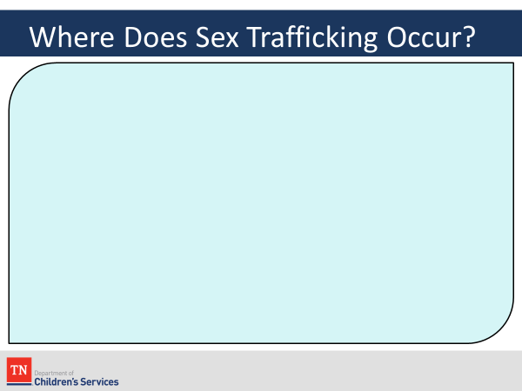
  - The youth may then end up back on the streets and back in commercial sex as a minor or an adult. This would be considered Independent/Renegading—when an individual adult or minor is involved in commercial sex without a trafficker/pimp.
- ASK participants where sex trafficking occurs. WRITE their answers on the slide.
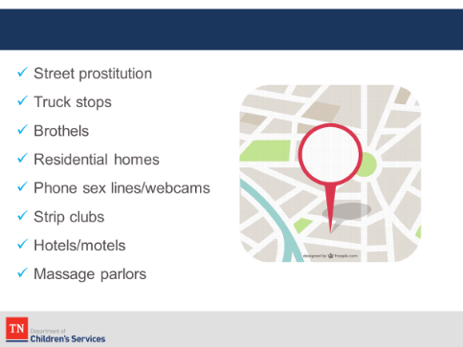
- After gathering a few responses, BRIEFLY review the list of places where trafficking can occur. Trafficking can occur in a variety of locations and especially flourishes in or around sexually oriented businesses such as strip clubs, phone sex lines, and areas of town known for prostitution-related activity. However, CSEM is not limited to these areas. Sex trafficking activity has been identified in numerous higher-end hotels and suburban communities.
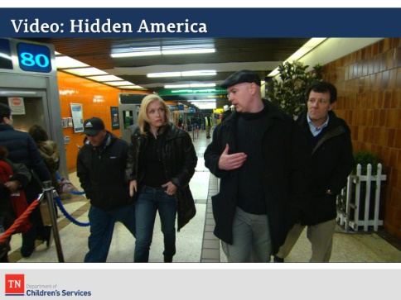
- INFORM participants we will now watch a video (12 minutes) in which Diane Sawyer reports on the dangers of vulnerable youth falling victim to sex trafficking. This clip is part of a documentary called “A Path Appears” where women and young girls share their stories of being trafficked. Note that some of the footage is filmed in Nashville highlighting that this is a local and National issue.
- SHOW the video “Hidden America: Chilling New Look at Sex Trafficking in the US” https://www.youtube.com/watch?v=gSgTmcq-bBk
- DEBRIEF the video by asking the group for their thoughts and what stood out for them.
Lesson 2.2: Trafficking or Not
Time: 25 minutes
Key Teaching Points / Instructions:
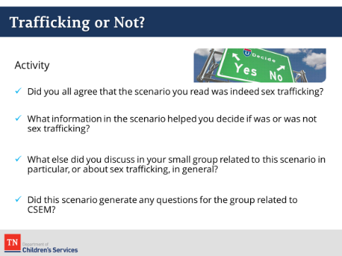
- DIVIDE participants into 2-3 groups or complete as a large group. Each group should be given one or two scenarios to discuss, depending on class size and time.
- Each group should read their assigned scenario and use the questions at the bottom of the scenario to guide a brief discussion about the scenario. Give 10 minutes for the activity. ( PG 15)
- DEBRIEF by having each group or a volunteer report out to large group. Read the scenario and have a volunteer summarize their group discussion, if applicable. Use the questions below to guide your discussion.
  - Did you all agree on whether the scenario constituted CSEM?
  - What information in the scenario helped you decide if it was or was not CSEM?
  - What else did you discuss in your small group related to this scenario in particular or about CSEM in general?
  - Did this scenario generate any questions for the group related to CSEM?
Trafficking or Not? Facilitator Version
Scenario 1
Jamil is 14 years old and lives with his mother in an apartment. Even though she works two jobs, his mother struggles to make ends meet. Jamil spends a lot of time home alone, and the landlord started asking Jamil to help him with some projects around the building to keep him busy. For the last 3 months, while they are hanging out, the landlord makes Jamil perform oral sex and sometimes takes pictures of him during the sex acts. The landlord told Jamil and his mother that he would not evict them as long as Jamil keeps hanging out with him.
Does this case fit the DCS definition of CSEM?
- It depends on whether or not it is determined that the mother is aware of the situation. Clearly, the mother is aware that she is receiving free rent, and the landlord has told her that the reason for the free rent is because Jamil is “hanging out” with him. However, it’s unclear whether she has direct knowledge about the abuse. Strong cases can be made on both sides, especially depending on how caseworkers, law enforcement, teachers, and others handle the situation if Jamil discloses or shows signs of the abuse. Another consideration is whether his mother is directly or indirectly operating as a trafficker.
- This case is clearly sex abuse and also fits the federal definition of sex trafficking and should be referred to law enforcement even if the DCS case is unfounded.
If yes, what components of the scenario align with the DCS definition? If no, what components are missing?
- Jamil is a minor.
- Something of value (a place to live) is being provided in exchange for a sex act (oral sex), but the third-party broker is unclear.
Facilitator question for trainees: In the context of whether this scenario meets the definition of sex trafficking, does the fact that the landlord is taking photos make a difference?
  - No. While the photos can be considered child pornography and used as possible evidence, the documentation of the sexual abuse is not required and does not impact whether this is considered child sex trafficking.
Scenario 2
Ashley is 15 years old. She lives with her 84-year-old grandmother, who also takes care of her four younger siblings. The week before her first day of school, Ashley realizes the family doesn’t have enough money to buy her school uniform and supplies. One of her friends suggests she go down to the local gas station and “stand on the corner” to make money. Within 15 minutes of standing on the corner, a man offers Ashley $50 for an oral sex act. Ashley agrees because $50 will pay for her school uniform.
Does this case fit the DCS definition of CSEM?
- No, because there is no third-party acting as a trafficker.
- Again, this case fits the federal definition of trafficking and should be referred for other services.
If yes, what components of the scenario align with the DCS definition? If no, what components are missing?
- Ashley is a minor.
- Something of value ($50) is being provided in exchange for a sex act (oral sex), but there is no third-party broker.
Scenario 3
Vanessa just turned 15 years old and is on the run from her foster home when she meets an older girl who says she can get her a job as a stripper. The girl introduces Vanessa to her boyfriend, Ricky, who says he’ll operate as her manager. Vanessa gets a job at the club without even interviewing. She’s super excited, but at the end of her first night of dancing, Ricky tells her he needs all of her money to cover rent and her dance outfits. When she hands him $300, he says it’s not enough and tells her he needs her to work “overtime” in the back rooms. She feels like she does not have a choice if she wants a place to sleep that night, so she goes in the back and engages in sex acts to earn another $300 for Ricky.
Does this case fit the DCS definition of CSEM?
- Yes, there is a third party involved as a trafficker.
If yes, what components of the scenario align with the DCS definition? If no, what components are missing?
- Vanessa is a minor.
- Something of value (money) is being provided in exchange for a sex act (stripping/sexually explicit performance and sex acts).
Scenario 4
An officer in your local law enforcement Vice Unit has contacted you at 11 p.m., following a sting operation where they located a missing 15-year-old youth from another state. The officer found the youth after responding to an online classified ad posted on websites like Backpage.com and Myproviderguide.com. The child told the police officer that she met “Cream” outside of her group home about a month ago. She keeps referring to “Cream” as her boyfriend and says that they have been on the road, moving from hotel to hotel for about 3 weeks. She’s really worried about whether he is in trouble and keeps asking when she will get to see him. Law enforcement is asking for someone to come and take her to a placement for the evening.
What are some of the risk factors and red flags in the scenario related to potential child sex trafficking?
- 15-year-old youth from another State
- Online classified advertisement on websites known for commercial sex and sex trafficking (Backpage.com and Myproviderguide.com)
- Living in a group home/in State care
- References to a “boyfriend” named Cream (bonus points for someone in the group who knows what CREAM stands for: Cash Rules Everything Around Me)
- Living hotel to hotel
Does this case fit the DCS definition of CSEM?
- Unknown, but highly likely because of all the indicators present. Further investigation should seek to determine if sex is being exchanged for anything of value.
If yes, what components of the scenario align with the DCS definition? If no, what components are missing?
- Same as above.
Scenario 5
You receive a case from the court regarding 16-year-old Maria, whose mother has filed an unruly petition. The mom says she can’t control Maria. In the past month, Maria has run away three times, and when she does come home, it’s hardly ever before midnight. The mom says she received a call from the school counselor saying Maria is sleeping through most of her classes. The mom is suspicious that Maria might be getting into drug dealing because she returned from her last run with her nails done and had upgraded her phone, which she’s always using. When you sit down to talk with Maria, you notice that she has a notepad from the Red Roof Inn in her purse and several condoms.
Does this case fit the DCS definition of CSEM?
- Unknown, but likely. If it is determined that trafficking is present, this case would fit the DCS definition.
If yes, what components of the scenario align with the DCS definition? If no, what components are missing?
- Maria is a minor.
- Indicators of grooming for child sex trafficking and of exploitation are present but unconfirmed.
What are some of the risk factors and red flags in the scenario related to potential child sex trafficking?
- Chronic Runaway
- Sleeping during the day
- Returning from running away with hair/nails done and upgraded phone
- Hotel notepad and condoms in her purse
Scenario 6
Liz, who is 17 years old, runs away from her foster home because she hates the other kids placed there. While sitting outside of a local mall she gets a message on a social networking app from Mike, a cute older “boy” (33 years old) who hit her up a few weeks ago and said he thought she was pretty. They’ve been communicating for weeks and he always contacts her when she’s having a rough day. He seems so sweet and asks her about her life and promises to help her achieve her hopes and dreams. Liz quickly falls for him, and when he hears she ran away, he says she can stay at his place. She thinks they are in love. After spending what she considers an amazing month together, he tells her that she is costing him too much money and must earn her keep. When she says she does not want to prostitute, Mike says, “Your uncle has been taking it for free for years, it’s about time you got something for it.” So Liz agrees because she wants to prove her love for him. Mike takes a couple photos and posts her escort ad online. Within minutes, the first text responses come in, asking to coordinate a location and time for a date, and within the hour, she’s already made $100 for Mike.
Does this case fit the DCS definition of CSEM?
- Yes.
If yes, what components of the scenario align with the DCS definition? If no, what components are missing?
- Liz is a minor.
- Mike is the trafficker/pimp and is advertising her on escort sites online and taking the money. Something of value (money) is exchanged for sex acts.
Facilitator question for trainees: How do you think Liz feels about the $100 she made in an hour?
- Excited. $100 is a lot of money and she earned it in an hour. Proud of making Mike happy and helping them out financially. Dirty and embarrassed. Confused. If Mike loves her, how could he allow another guy to touch her?

Unit 3: Risk Factors and Characteristics of CSEM
Time: 45 Minutes
Learning Objectives:
Participants will:
- recognize the indicators and risk factors of CSEM and the dynamics of sex trafficking relationships
Supporting Materials:
- Power Point
- https://youtu.be/cGJoi3h2rvs
Lesson 3.1: Risk Factors of CSEM
Time: 15 minutes
Key Teaching Points / Instructions:
- This section engages participants in the exploration of risk factors related to CSEM.
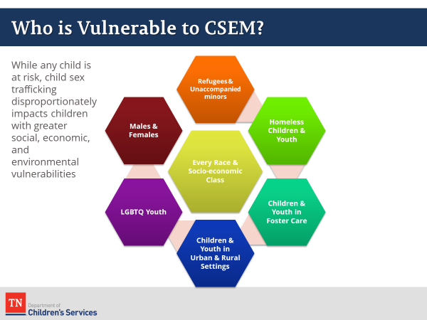
- DISPLAY Who Is Vulnerable to CSEM slide. Ask participants who they think (what population) is most vulnerable to CSEM? There is no single profile for trafficking victims. The slide demonstrates that victims of trafficking have diverse socioeconomic backgrounds and varied levels of education.
- Widespread lack of awareness and understanding of CSEM leads to low levels of victim identification by the people who most often encounter them. Trafficking victims have been identified in urban, suburban, and rural areas in all 50 States and in Washington DC.
- While trafficking crosses all demographics, several factors and circumstances increase the risk and vulnerability to victimization and trafficking. While not inclusive of all vulnerabilities, the slide highlights several populations at greater risk of CSEM.
- As discussed, runaway and homeless youth are vulnerable to trafficking. A study in Chicago found that 56% of prostituted women initially were runaway youth, and similar numbers have been identified for male populations. Runaway and homeless youth lack a strong supportive network and those who run away to unfamiliar environments particularly are at risk of trafficking. Traffickers often approach runaway youth at transportation hubs, shelters, or other public spaces. These traffickers pretend to be a boyfriend or significant other, using feigned affection and manipulation to elicit commercial sex or services from the victim (Trafficking Resource Center, 2015).
- While no single profile for victims of CSEM exists, it is important to recognize that certain populations merit special consideration due to particular vulnerabilities.
- As mentioned earlier in the training day, little effort has been made to collect comprehensive data on the scope of this issue, but it is clear that many minors who are trafficked interact with the child welfare system.
- Certain groups of children and youth are particularly vulnerable to CSEM. Traffickers prey on children and youth with low self-esteem and minimal social support. These traits are highly prevalent among children and youth experiencing homelessness and among those with histories of abuse, neglect, or other forms of trauma.
- Child Welfare agencies are in the forefront of the response to CSEM for a number of reasons:
  - A significant number of CSEM cases will inherently come to the attention of CPS as a result of sex abuse investigations.
  - Children and youth with a history of abuse and neglect are a greater risk for CSEM.
  - Youth who run away from care are particularly vulnerable to CSEM.
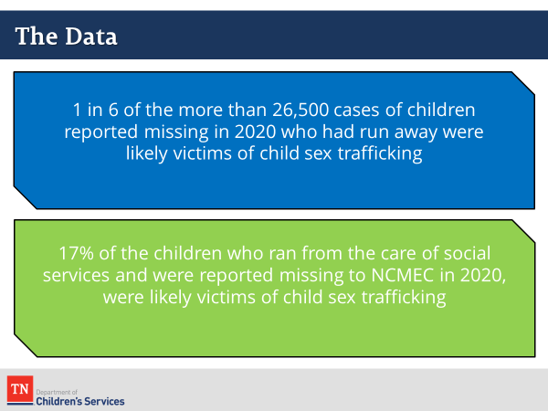
- As noted, runaway youth are at particular risk for CSEM. According to NCMEC:
  - 1 in 6 of the more than 26,500 cases of children reported missing in 2020 who had run away were likely victims of child sex trafficking.
  - 17% of the children who ran from the care of social services and were reported missing to NCMEC in 2020, were likely victims of child sex trafficking
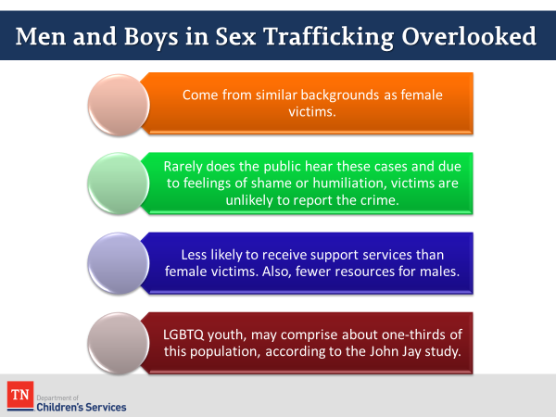
- More is known about the sex trafficking of young girls than about sex trafficking of boys. It is believed that boys are under-identified within this population. REFER participants to Men & Boys Sex Trafficking for more information.
  - Male victims come from similar backgrounds as female victims.
  - Rarely does the public hear about cases of male sex trafficking and due to feelings of shame or humiliation, victims are unlikely to report the crime.
  - Male victims of sex trafficking are less likely to receive support services than female victims.
  - LGBTQ youth, who are more likely to be kicked out of their homes due to their sexual orientation or gender identity, may comprise about one-third of this population, according to the John Jay Study.
- Other key facts for trainer knowledge:
  - At least 1 in 6 men have been sexually abused or assaulted
  - Men sexually abused in childhood typically disclose, on average, 22 years after the assault –this is 10 years later than the average time it takes women to disclose childhood sexual abuse.
  - 16% of males are sexually abused by the age of 18
  - 26% of sexual assault victims under the age of 12 are boys.
  - Only 16% of men with documented histories of sexual abuse considered themselves to have been sexually abused, compared to 64% of women with documented histories in the same study.
- Male victims may be under identified because they are less likely to be screened for CSEM and may be less likely to report CSEM if they are asked. There is often an assumption that male victims of CSEM are gay, but this is not necessarily the case.(PG 18).
- As mentioned, on the slide, LGBTQ youth are particularly vulnerable to being homeless due to rejection by their families. They are more than seven times more likely to experience acts of sexual violence than their heterosexual peers. And they are three to seven times more likely to engage in survival sex to meet basic needs. Refer participants to the Polaris Fact Sheet on Sex Trafficking and LGBTQ Youth. (PG 20)
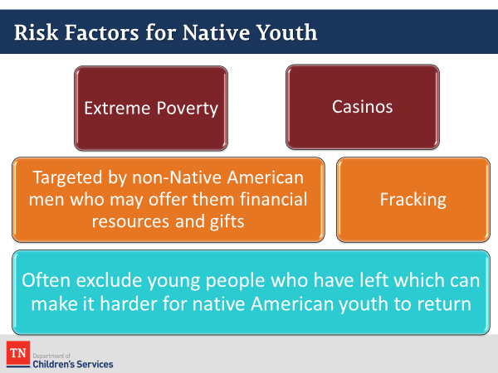
- Recent exploratory studies indicate that traffickers are targeting Native American children and youth who have trauma-related risk factors. While more data is needed to understand the extent of Native youth’s vulnerability, these early studies indicate need for concern. The findings from these studies are in line with results from the National Survey of Adolescents, which indicated that Native youth are disproportionately victimized by some type of sexual assault (U.S. Department of Health and Human Services Administration on Children, Youth and Families, 2014). Some reasons for this could be the prevalence of extreme poverty in the Native American population living on reservations. Young people are often targeted by non-Native American men who may offer them financial resources and gifts. There are also casinos located on reservations which provide opportunities for trafficking. Native American communities will often exclude young people who have left which can make it harder for native American youth to return after being trafficked.
- The proliferation of the Fracking (the drilling of oil/gas wells) industry also contributed to a rise in sex trafficking of Native girls and women as “man camps” were established in remote areas of Minnesota, North and South Dakota creating a high demand for sex in an environment where drugs and alcohol were prevalent.
- Tribal Nations have begun implementing anti-trafficking laws, raising awareness in their communities and training initiatives. The US government has increased funding, collaborated with Tribal Nations on training programs and increased efforts to identify victims. Human Trafficking training will be conducted at all National Indian Gaming Conventions and increased resources, and technical assistance will be offered by the Department of Health and Human Services.
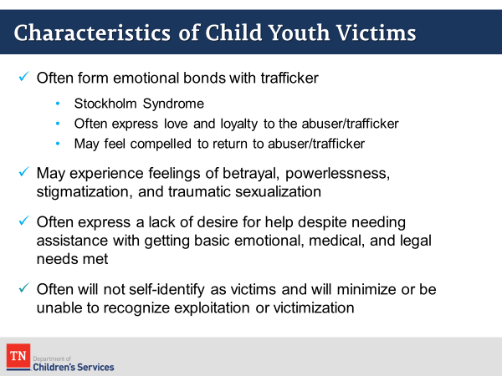
- In addition, to having histories of abuse and trauma, trafficked children and youth often form emotional bonds with their trafficker. This dynamic makes it very difficult to realize that they are being exploited. When children that have developed positive feelings toward their trafficker/abuser (Stockholm Syndrome), this behavior is seen as a coping mechanism for those who are unable to process the trauma they have experienced.
- Children and youth who experience abuse, neglect, and/or trauma may develop feelings of betrayal, powerlessness, stigmatization, and may exhibit sexualized behavior. These feelings often lead to more significant mental health issues including depression, anxiety, and disassociation.
- Sometimes, trafficked children and youth come from broken families and are desperate to get their basic needs met. Traffickers prey on their vulnerabilities by offering affection, a connection to someone/something, and by promising to help meet their daily needs. The vulnerabilities that existed in a child’s life prior to victimization through sex trafficking, coupled with strategic grooming, manipulation, and exploitation through sex trafficking, is powerful and confusing to the youth. As a result, youth are often reluctant or unable to self-identify as victims. This resistance or inability to see themselves as victims or view their abuser as an exploiter can become a barrier for connecting or engaging youth in services.
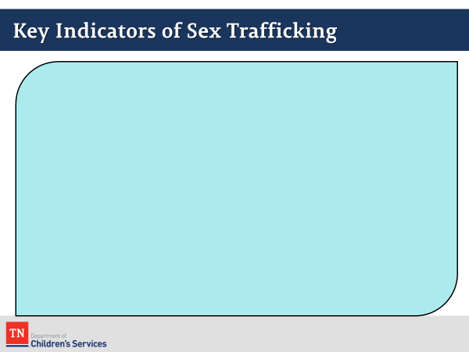
- Sex trafficking is said to be a crime that “happens in plain sight”. Children and youth rarely disclose that they have been sexually exploited. Trafficked youth and children often suffer from depression, hostility, stress, anxiety, posttraumatic stress disorder (PTSD), fear of authority, and fear of those who are exploiting them. Outward signs may simply appear as difficult behavior or resistance to assistance but could also take on more extreme characteristics.
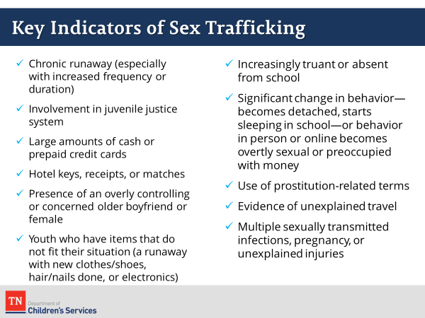
- ASK participants to SHARE indicators of sex trafficking and NOTE on the slide.
- After allowing time for responses, show slide Key Indicators of Sex Trafficking and cover any indicators missed in the previous list.
- It should also be noted that these indicators may be caused by a number of factors and are not, in themselves, evidence of CSEM. They should be considered red flags for the case manager to assess for further information.
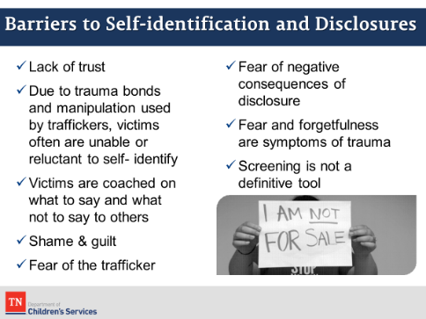
- It is important for caseworkers to be prepared for the numerous challenges and barriers that they will likely face when attempting to screen for CSEM. Being aware of the various reasons why youth are reluctant to disclose can help us be more sensitive and patient with youth during this process. Ask participants why victims of CSEM might be reluctant to disclose this information. Ensure the list below is covered.
  - Due to trauma bonds and manipulation used by traffickers, victims often are unable or reluctant to self-identify
  - Lack of trust
  - Victims are coached on what to say and what not to say to others
  - Shame and guilt
  - Fear of the trafficker
  - Fear of negative consequences of disclosure
  - Fear and forgetfulness are symptoms of trauma
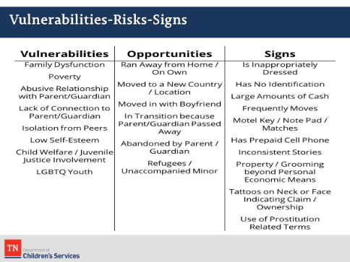
  - Screening is not a definitive tool
- REVIEW Vulnerabilities –Risks – Signs slide. Remind participants that the resource section of the participant guide contains a number of valuable references that they may find helpful as they work with CSEM. Draw participant’s attention to the Human Trafficking and Child Welfare: A Guide for Caseworkers handout in the Participant Guide (PG 26) which summarizes many of the key points from this training.
Lesson 3.2: The Process of Pimp Control
Time: 30 minutes
Key Teaching Points / Instructions:
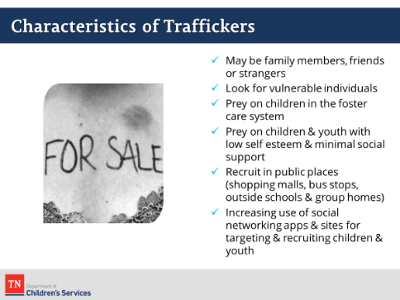
- Traffickers may be family members or friends, or they may have been strangers to the trafficked child/youth. Reports indicate that traffickers recruit children and youth near group homes, malls, bus stops, truck stops, and other public places where young people congregate.
- Additionally, access to technology has significantly changed the way traffickers target and recruit youth. Through their cell phones, tablets, gaming devices, and other internet-accessible devices, youth are available to individuals on nearly a 24/7 basis.
- Youth put a lot of personal information in online social media accounts, and traffickers can use this information to their advantage as they look for vulnerabilities and opportunities to build trust through shared likes and activities.
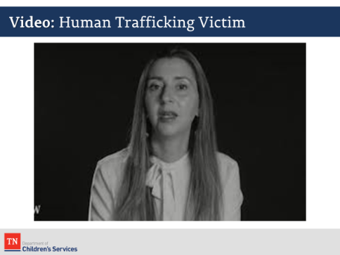
- Rather than increasing their risk through visibility, traffickers can remain anonymous as they communicate with multiple youth while remaining hidden. As we’ve discussed, traffickers seek to take advantage of a child/youth’s low self- esteem and vulnerabilities and work hard to make trafficking seem appealing.
- INFORM participants that they are going to watch a 13-minute video. In this video, Rachael Lloyd, the creator of GEMS (Girls Education and Mentoring) will share her story. https://youtu.be/cGJoi3h2rvs
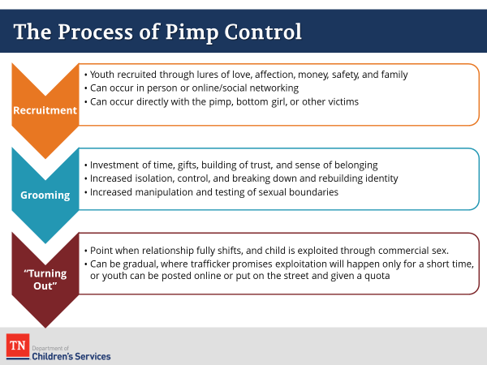
- DEBRIEF the video by asking participants to share their thoughts and if they have had any experiences with similar cases.
- DISPLAY “The Process of Pimp Control”. (PG 40) Ask participants to note any parallels that they saw in the GEMS video and the information on this slide.
- The process that traffickers/pimps use to target, recruit, groom, and exploit is extremely intentional and strategic. Sadly, numerous books written by known pimps/traffickers, explain how to use a mix of manipulation, coercion, and violence to bind a victim to loyalty and silence.
- Recruitment can occur in a variety of ways and does not always include the pimp directly recruiting. All individuals under the control of a trafficker/pimp are required to recruit.
- The grooming phase is rife with investments of time, care, gifts, and the building of a seemingly caring relationship. This is also why survivors often will identify the trafficker/pimp as a “boyfriend” instead of an exploiter. There are pimps called “gorilla pimps” who immediately resort to threats and violence and do not use these less coercive types of grooming tactics.
- The “Turning Out” step occurs when the youth is required to first engage in commercial sex.
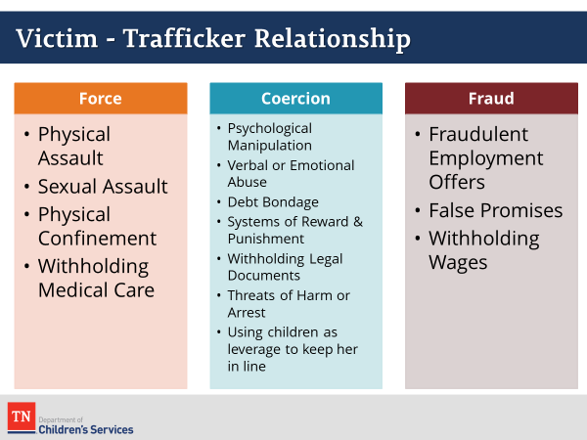
- DISPLAY slide “Inside the Mind of a Pimp” Explain that this is a quote from the book, The Pimp Game: An Instruction Manual, written by Mickey Royal. The quote highlights the very strategic steps a trafficker/pimp takes in breaking down the victim to develop him/her into a product for sale. Invite participants to share their reactions to this quote. Allow a moment or two for discussion.
- DISPLAY slide “Victim-Trafficker Relationship”. Note that while force, coercion, and fraud are not necessary to the definition of CSEM, they are frequently present. Cover the points in the slide related to forms of force, coercion and fraud. Participants may wish to add additional points.
- REFER participants to “Human Trafficking Power and Control Wheel” (PG 41). Many participants will recognize the Power and Control Wheel often used in discussion of domestic violence. Sex trafficking is one form of human trafficking and many consider it to be “modern-day slavery.” The dynamics of trafficking, regardless of the form/type, are the same and traffickers subject their victims to the same types of behaviors. Traffickers will use a number of different tactics to keep their victims under control.
- GIVE participants a few minutes to review the wheel and ask if anything stands out to them. Provide an example of your own, if necessary. Allow a few minutes to process. Ask participants how they might use this tool in their casework. (e.g., share it with potential victims and discuss the implications).

Unit 4: CSEM Identification and Assessment
Time: 25 Minutes
Learning Objectives:
Participants will:
- understand DCS policy for identification, intervention, and reporting of CSEM and case manager tasks
Supporting Materials:
- Power Point
- Policy 14.1, Policy 14.7, Work Aid 1, Work Aid 9, Policy 31.2, Policy 31.10, Policy 16.46, Policy 16.8

Lesson 4.1: CSEM Identification and Screening
Time: 10 minutes
Key Teaching Points / Instructions:
- This section will provide participants with best practices for identiﬁcation, screening, and assessment of CSEM victims and introduce trauma informed, culturally appropriate engagement strategies when interviewing children and youth who are victims of CSEM. These strategies will be explored in more detail later in the training.
- As we discussed earlier today, there are many benefits of including identification of CSEM in our procedures in the child welfare field.
- Several different factors lead to children and youth becoming victims of CSEM. We talked a bit about the characteristics of the victims and so we know that victims may have difficulty articulating their experiences due to fear and anxiety related to the exploitation they have endured. Youth may also not identify themselves as victims of CSEM. Because of this, screening and assessment must be conducted in a way that is mindful and respectful of the trauma they have experienced and sensitive to how they view their experience.
- Establishing rapport with the child/youth is important and may take time. This is fundamental to engaging victims of CSEM because they had their trust violated by others. Being able to establish rapport will help ensure a successful interview.
- Aside from identifying CSEM at the Hotline, the two primary ways that the Preventing Sex Trafficking Act will impact case managers is through CPS Investigations into CSEM and in responding to incidents of runaways.
- When there is an assessment for CSEM, as with all sex abuse situations, a forensic interview will be necessary. Therefore, caution should be used in interviewing the victim, especially in the initial phases of the allegation, to gather only minimal facts and to let the forensic interviewer conduct the CSEM assessment.
Lesson 4.2: DCS Policy
Time: 15 minutes
Key Teaching Points / Instructions:
- REVIEW policies related to CSEM. REMIND participants policies are always being updated and to ensure they are reviewing the most recently updated CSEM policy.
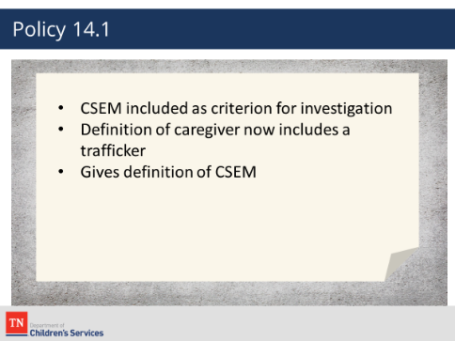
CPS
Policy 14.1
  - CSEM is included as a criterion for investigation in Policy 14.1
  - Item 3b to section E, Criteria for CPS Involvement, notes TFACTS indicator
  - Definition of caregiver now includes a traﬃcker
  - Definition of CSEM given
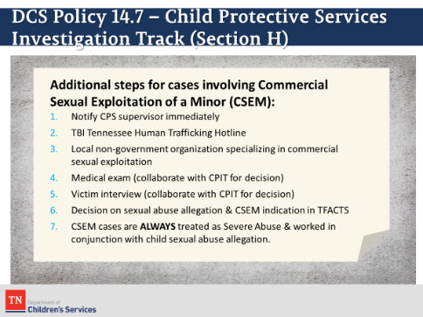
Policy 14.7
  - Gives additional investigative tasks
    - Immediately notify supervisor
    - Reports to TBI within 24 hours
    - Contacts NGO within 24 hours
    - Notifies CPIT
      - Determine lead investigator
      - Determine need for medical examine
      - Determine need for victim interview
    - Adds CSEM indicator in TFACTS to open cases when warranted
    - Always treated as severe abuse and works in conjunction with a child sex abuse allegation
    - Refers to Safety Notice: Creating Safe Environments for Youth Survivors of Exploitation
Work Aid 1
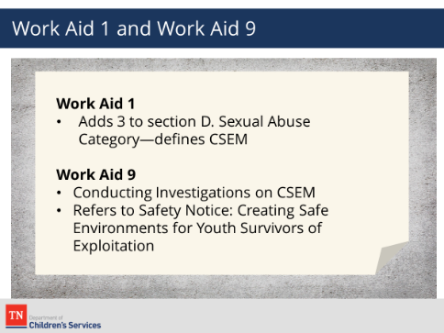
  - Adds 3 to section D. Sexual Abuse Category—defines CSEM
Work Aid 9
  - Work Aid: Conducting Investigations on CSEM
  - Refers to Safety Notice: Creating Safe Environments for Youth Survivors of Exploitation
- SHARE the following information with participants:
  - These policies were developed to ensure that CPS cases are properly classified. It regulates the use of empirical processes and classification criteria to influence fair and consistent decisions for referred cases.
  - Section H, along with Work Aid 9 (Cases Involving Commercial Sexual Exploitation of a Minor) of the policy gives additional investigative tasks associated with child sexual abuse allegations.
  - The Safety Notice highlights the need for prompt medical care, safety planning, support and services.
- ENSURE that CPS participants understand their notification responsibilities. Highlight the circumstances when immediate notification of TBI or NGOs might be warranted and ensure they understand the role of the CPIT in CSEM.
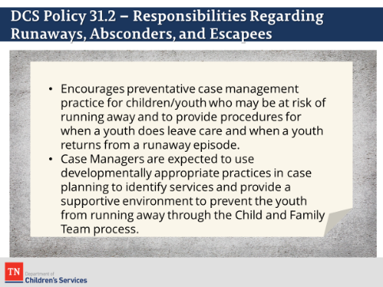
CUSTODIAL AND NON-CUSTODIAL
Policy 31.2
  - CFT works to locate child/youth
  - CFT determines primary factors contributing to running away
  - Determine youth’s experience while gone
  - Prevents runaway incidents through communication & appropriate supervision practices
  - Recognizes the vulnerability of youth who are on runaway
  - Immediate notification of local law enforcement
  - Immediate report to NCMEC
  - Serious Incident Report
  - Email the Absconder Unit at EI_DCS.AbsconderUnit@tn.gov to report the youth has run away within 24 hours
  - Send Form CS-0705, Notification Checklist for Absconders/Runaways/Escapees – Part A including social media usernames; A current photograph of the youth, a color photo is preferred and Proof of LE notification by providing the NCIC number.
  - Upon return from runaway, FSW coordinates with CFT, LE, placement & service providers to determine needs & needed services
- Immediate safe placement
- Primary factors contributing to runaway
- Immediate medical evaluation and trauma informed care if CSEM if indicated
- Notification of regional health rep
- Notification the regional Absconder Recovery Program Representative –Complete DCS Form CS-0705, Notification Checklist for Absconders/Runaways/Escapees – Part B.
- An Inter periodic EPSDT if gone more than 24 hours if there are no suspected injury or sexual assault. The youth will need to be taken to an emergency medical care center/hospital ER or Sexual Assault Center if sexual assault or injury occurred or suspected to have occurred during absconder episode. Protocol Medical Evaluations for Runaways and/or Commercial Sexual Exploitation of a Minor https://files.dcs.tn.gov/policies/chap20/ProtocolMedEvalRunawayCSEM.pdf
- Ensure participants are aware that youth on runaway status are a much greater risk of CSEM and that policy changes reflect this awareness.

- The purpose of DCS Policy 31.2 is to encourage preventative case management practices for children/youth that may be at risk of running away and to provide procedures for when a youth does leave care and when a youth returns from a runaway episode.
- Case Managers are expected to use developmentally appropriate practices in case planning to identify services and provide a supportive environment to prevent the youth from running away through the Child and Family Team process.

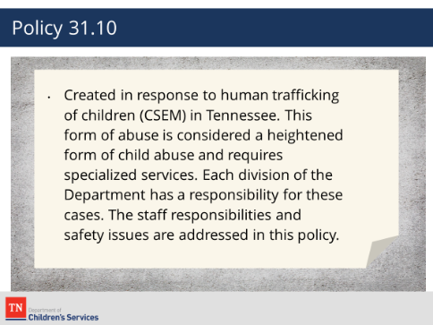
Policy 31.10
  - This policy was created in response to human trafficking of children (CSEM) in Tennessee. This form of abuse is considered a heightened form of child abuse and requires specialized services. Each division of the Department has a responsibility for these cases. The staff responsibilities and safety issues are addressed in this policy.
Policy 16.46
- Refers to Safety Notice: Creating Safe Environments for Youth Survivors of Exploitation which requires:
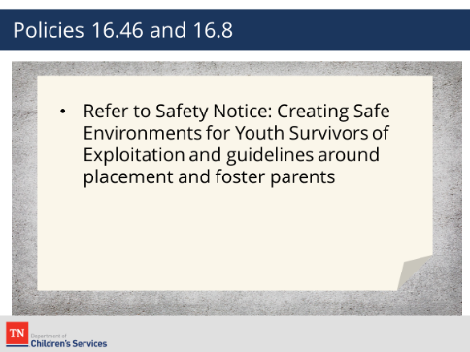
  - Avoiding placing custodial youth in areas where they have been exploited or in the presence of their trafficker.
  - Engaging foster parents in Safety Planning
  - Planning ahead for the possibility of sexually reactive behaviors
  - Being certain of a person’s identity before giving information about the youth
Policy 16.8
- Refers to Safety Notice: Creating Safe Environments for Youth Survivors of Exploitation which requires:
- Foster parents to be mindful of the unique needs of children/youth who have experienced severe trauma, such as child exploitation.

- INFORM participants that when planning and completing casework activities they should incorporate good practice associated with quality contacts and documentation. This will include planning for visits and engagement with the child and family, formal and informal assessment of safety, need and progress towards case goals and comprehensive, quality documentation. The checklists should be used as a reference for casework tasks that need to be completed. The associated casework activities and contacts should be documented as face-to-face contacts or as part of the monthly summary and should reflect concerted efforts made to engage with the child and family, progress the case goals and ensure safety.
- ALLOW participants a few moments at the end of this section to review the policies and ask if there are any questions.

Unit 5: Trauma Informed Practice and Engaging Trafficked Youth
Time: 20 Minutes
Learning Objectives:
Participants will:
- understand the challenges of engaging with trafficked youth and how to use effective strategies
Supporting Materials:
- Power Point
Lesson 5.1: Trauma Informed Practice
Time: 10 minutes
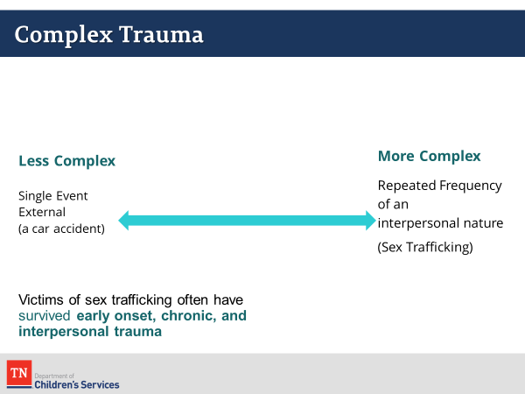
Key Teaching Points / Instructions:
- DISPLAY slide “Complex Trauma” and refer participants to “Complex Trauma” (PG 44). Explore the continuum of trauma experienced by survivors of CSEM and how their life experience often fits the criteria for complex trauma.
- Complex trauma occurs when individuals experience multiple traumatic events. Events that have an early onset, are chronic, and / or are interpersonal are more traumatic. For example, in general, a single incident typically produces a less severe and shorter-term reaction than repeated trauma that occurs at the hands of a caregiver. Ongoing and chronic trauma such as poverty and racism are more likely to produce complex trauma than single “act of God” occurrences such as a tornado or a fire.
- Depending on their age, children respond to traumatic stress in different ways. Many children show signs of intense distress—disturbed sleep, difficulty paying attention and concentrating, anger and irritability, withdrawal, repeated and intrusive thoughts, and extreme distress—when confronted by anything that reminds them of their traumatic experiences. Some children develop psychiatric conditions, such as PTSD, depression, anxiety, and a variety of behavioral disorders (National Child Traumatic Stress Network, 2015).
- While some children "bounce back" after adversity, traumatic experiences can result in a significant disruption of child or adolescent development and can have profound long-term consequences. Repeated exposure to traumatic events can affect the child's brain and nervous system and increase the risk of low academic performance, engagement in high-risk behaviors, and difficulties in peer and family relationships. Traumatic stress can cause increased use of health and mental health services and increased involvement with the child welfare and juvenile justice systems.
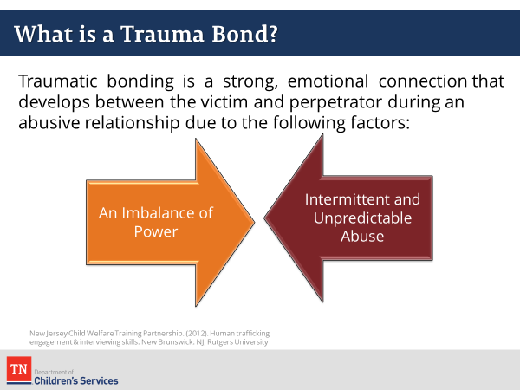
- Begin by asking participants what a trauma bond is and allow a few moments for responses. In general, the term “trauma bond” is used to describe strong, emotional connections that develop between a victim and the perpetrator during an abusive relationship due to the following factors:
  - An imbalance of power in which the victims lose confidence in themselves or their ability to care for themselves, leading them to become more reliant on the perpetrator
  - Intermittent and unpredictable abuse, which is combined with equally intermittent or unpredictable reward or positive affirmation (New Jersey Child Welfare Training Partnership, 2015).
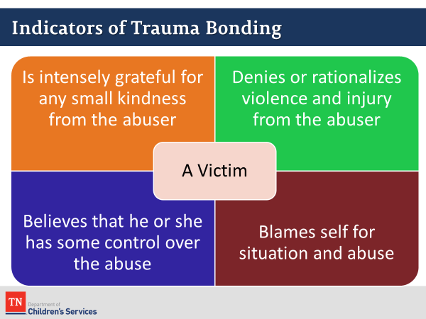
- DISPLAY slide “Indicators of Trauma Bonding”. During this training we’ve discussed the level of exploitation, manipulation, and violence survivors of CSEM have experienced. Recognizing this level of exploitation as a complete violation of human dignity, it seems reasonable to expect that once survivors escape, are recovered by law enforcement, or interact with individuals who can help them get out or stay out of this situation, they would embrace this assistance.
- Unfortunately, this is often not the case, and preparing expectations is important so that workers do not become easily frustrated or discouraged by survivors who respond differently.
- REFER participants to the Understanding Victim Mindsets handout in their participant guide which outlines some common barriers as to why trafficked persons cannot or will not leave a trafficking situation.
- DCS is diligently working to ensure our practices are trauma informed. As case workers, viewing and responding to survivors from a trauma informed perspective is crucial to engaging the young person and empowering them to make informed decisions in their lives. Review the key elements of Trauma Informed Practice.
Lesson 5.2: Principles of Engagement and the Relationship Building Process
Time: 10 minutes
Key Teaching Points / Instructions:
- The effectiveness of our engagement with trafficked youth can affect their ability to recognize the trauma they have experienced and access support and services to meet their needs and increase their safety.
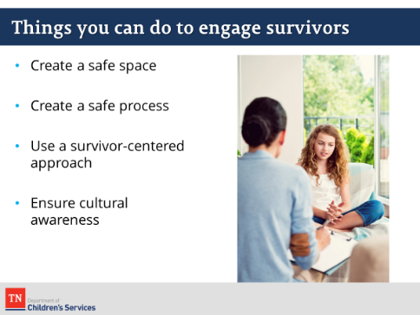
- Understanding the unique ways individuals respond to events in their lives will inform how we work with them. We need to ensure that our approach engages and does not traumatize or further isolate the individual we are working with.
- REVIEW the Things You Can do to Engage Survivors slide.
- Creating a trusting relationship with the young person is central to effective engagement. Relationships are built over time and can only occur if trust is present.
- Utilizing the Principles of Engagement, we reviewed earlier will enable us to begin the process of building trust and take the first steps towards creating a meaningful relationship with the young person.
- REMIND participants that this may be a slow process but one that can create lasting, long term change. The slide illustrates that relationship building is on a continuum. Rapport building is the first stage, progressing to trust building, relationship building and support system building. This process will take time and will look different with each young person. As Leslie Briner, MSW states in Responding to Sexual Exploitation and Trafficking of Youth, “Relationship is the intervention”.
- REFER participants to the Things You Can Do to Engage Survivors handout (PG 47) in the participant guide and review the Power Point slide. BRIEFLY review each of the points on the handout and draw participant’s attention to the specific suggestions for engaging LGBTQ and Native American youth.
- ASK if there are any questions about engaging survivors of CSEM. STATE we will now move into talking about the impact of CSEM and the needs of survivors.

Unit 6: The Impact of CSEM and the Needs of Survivors
Time: 45 Minutes
Learning Objectives:
Participants will:
- be aware of the impact of CSEM and needs of CSEM survivors
- recognize the immediate and long-term health care needs of trafficked youth and be aware of local and statewide resources
Supporting Materials:
- Power Point
Lesson 6.1: The Impact of CSEM
Time: 30 minutes
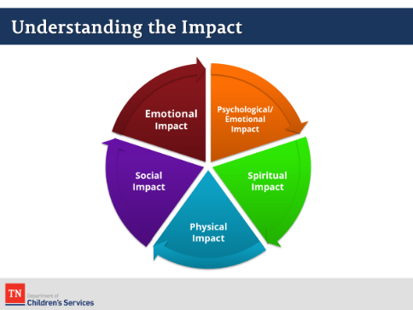
Key Teaching Points / Instructions:
- DISPLAY slide “Understanding the Impact” (PG 46) and refer participants to “Understanding the Impacts of Child Sex Trafficking”.
- Regardless of whether a survivor has been victimized for 24 hours or 2 years he/she will have experienced significant psychological, emotional, social, spiritual, and physical impact as a result of exploitation. Each survivor will process and deal with exploitation differently, and it’s important that the treatment plan, approach, and engagement be individualized. Additionally, as survivors begin to experience increased safety, stability, and support, they will also recognize different levels of impact throughout the healing process.
- REVIEW the physical and mental impacts trafficking can have on a survivor:
  - Physical
    - Lack of care for physical and mental health, vision and dental needs
    - Pregnancy
    - Sexually Transmitted Infections (STI’s)
    - Chronic reproductive health issues
    - Malnutrition
    - Current or historic physical injuries, often left untreated
  - Mental Health
    - Post-Traumatic Stress Disorder (PTSD)
    - Disturbances of self or identity
    - Decreased self-esteem and self-efficacy
    - Shame, guilt and isolation
    - Aggression and anti-social behaviors
    - High risk sexual behaviors
- While basic needs (especially shelter) are often the priority, it’s important for those responsible for developing the youth’s continuum of care to also consider how to address the risk factors that created the vulnerability and to establish opportunities for support.
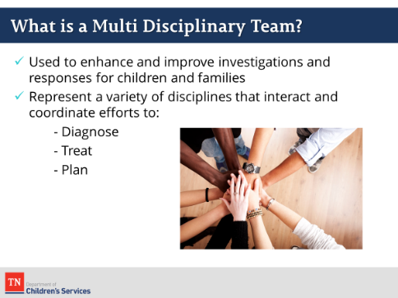
- Meeting the needs for CSEMS victims require cross-systems partnerships. To be effective, interventions and services must be trauma-informed, survivor- centered, strengths-based, and culturally sensitive. To reach positive outcomes for survivors, we must work collaboratively with other systems and service providers.
- RECALL from earlier in the day, one of the recommendations of the Preventing Sex Trafficking Act was the use of Multi-Disciplinary Teams. Due to the complex nature of child abuse/neglect investigations and family assessments, MDTs are often used to enhance and improve investigations and responses for children and families. MDTs represent a variety of disciplines that interact and coordinate their efforts to diagnose, treat, and plan for children and families receiving child welfare services.
- An essential part of the MDT is health service providers. Their effectiveness in providing strength-based, trauma-informed, and culturally sensitive interventions is essential to the victims’ immediate-long-term healing and success.
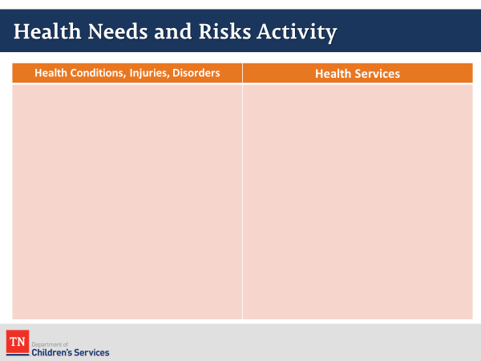
- ACTIVITY: Health needs and risks of CSEM victims. REFER participants to the case studies in their participant guides (PG 50). Select a scenario and review it as a whole group. Using a whiteboard/slide, ASK the group to brainstorm and develop a list of health conditions, injuries, and disorders that the identified victim in their scenarios may have experienced or may be at risk. Have participants write directly on the whiteboard, via the annotation feature.
- Possible answers may include:
  - Exposure to STDs
  - Unwanted pregnancies
  - Exposure to unsafe abortions
  - Blood borne pathogens
  - Self-injurious behavior
  - Physical problems associated with beatings
  - Untreated medical conditions
  - Mental health issues
  - Somatic complaints
  - Malnutrition
  - Lack of dental care and cosmetic dental issues
  - Substance abuse
- REVIEW information on slides and highlight any points not covered in the activity.
- ASK the groups to now complete the Health Services column by developing a list of health services that are essential to meeting the victim’s immediate and long-term health needs.
- ASK the groups to share their responses and facilitate a brief discussion.
- Possible answers could include:
  - Sex and reproductive (assessment, education, and treatment)
  - Physical trauma (treatment for physical injuries)
  - Dental (assessment, treatment, cosmetic procedures)
  - Mental (Assessments, treatment planning, substance abuse treatment, group therapy, etc.)
  - Urgent medical care and evaluation
  - STD testing
  - Prophylactic treatment for STDs and HIV
- DEBRIEF the activity by reviewing the lists developed and highlighting the range of health needs trafficked youth may have with participants that children and youth who have been intravenous drug users may also have health needs in relation to treatment for STDs and birth control and prophylactic treatment would be an appropriate in this situation.
- DIRECT participants to the Health Services for Trafficked Youth handout (PG 54) in their participant guide. Share with them that this handout was created by Patricia Slade MSN MBA RN, Director of Nursing, DCS to increase awareness of the range of health needs CSEM survivors may have and the treatment options. This document was created in response to the unmet health needs identified in the case studies during the Safety Analysis.
- TRANSITION by stating that we are now going to look at health services and resources for CSEMs victims.
Lesson 6.2: Health Services/Resources for Trafficked Youth
Time: 15 minutes
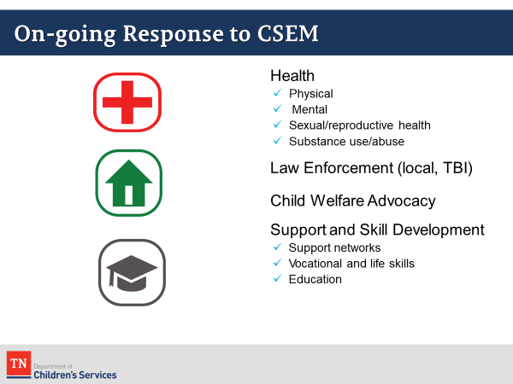
Key Teaching Points / Instructions:
- ASK participants, what factors should be considered when managing or choosing health service providers for CSEMs victims.
  - Possible responses: Insurance and procurement processes, travel and transportation, availability for appointments, the providers understanding of the victim, the victim’s comfort with the service provider (Ex: gender preferences).
- INFORM participants that case managers are required to engage victims into Non- Government Organizations (NGOs) who specifically provide services to victims of sex trafficking. Refer participants to “Non-Governmental Organizations for CSEM” with contact information for each of these agencies in the PG (PG 59).
- EXPLAIN that the NGOs mentioned provide a wide range of services and partner with many community agencies for the purpose of prevention and awareness of sex trafficking, meeting the needs of survivors, and assisting in survivors immediate and long-term healing.
- INFORM participants that some of the services the listed NGOs includes but are not limited to:
  - Housing,
  - Trauma-Informed Counseling Services,
  - Immediate and Long-term safety planning for victims and survivors,
  - Group Support Services (Long-term),
  - Drug and Alcohol Treatment,
  - Medical/Reproductive/Dental health care,
  - Legal aid (criminal, child custody, immigration legal aid),
  - Social Support Services (education, job search assistance, community advocacy, etc.)
- ASK if there are any questions about the health services and needs for survivors of trafficking before moving into the last unit.

Unit 7: Close
Time: 15 Minutes
Supporting Materials:
- Power Point
Lesson 7.1: Closing
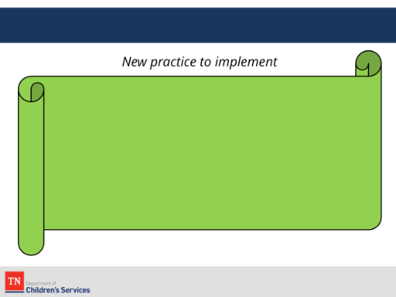
Time: 15 minutes
Key Teaching Points / Instructions:
- CONCLUDE by asking participants to name one new thing they will implement in their practice as a result of what they have learned about CSEM.
- THANK participants for attending the training and for their participation.

References
Briner, L. (2017). Responding to the Sexual Exploitation and Trafficking of Youth. YouthCare

Child Welfare Capacity Building Center for States. (2015). At risk for sex trafficking: Youth who run away from foster care.

Child Welfare Capacity Building Center for States. (2015). Collaborating with youth serving agencies to respond to and prevent sex trafficking of youth. Retrieved from https://www.childwelfare.gov/topics/systemwide/trafficking/convening

Child Welfare Capacity Building Collaborative. (2015). Resources to support implementation of the sex trafficking provision of P.L. 113-183. Retrieved from https://library.childwelfare.gov/cwig/ws/library/docs/gateway/Blob/99378.pdf?w=NATIVE% 28%27

Child Welfare Information Gateway. (2015). Related organizations: Sex trafficking prevention and intervention. Retrieved from https://www.childwelfare.gov/organizations/?CWIGFunctionsaction=rols:main.dspROL&rolTy pe= Custom&RS_ID=57

Children’s Defense Fund, Child Welfare League of America, First Focus, Generations United, Foster Family-based Treatment Association, & Voice for Adoption. (2015). Implementing the preventing sex trafficking and strengthening families act to benefit child and youth. Retrieved from http://www.childrensdefense.org/library/data/implementing-the-preventing.pdf

Commercial Sexual Exploitation of Minors: A Safety Systems Analysis of Selected Cases (2016).
Tennessee Department of Children’s Services

Mathur, G. &. (2014). Child Sex Trafficking and the Child Welfare System. Washington, D.C.: The First Focus State Policy Advocacy and Reform Center (SPARC).

National Center for Missing and Exploited Children. (2015). Missing children, state care, and child sex trafficking: Engaging the judiciary in building a collaborative response. Retrieved from http://www.missingkids.com/Publications/cst

National Center for Trauma-Informed Care. (2015). Trauma-informed approach trauma-informed interventions. Retrieved from http://www.samhsa.gov/nctic/trauma-interventions

National Child Traumatic Stress Network. (2015). Defining trauma and traumatic stress. Retrieved from http://nctsn.org/content/defining-trauma-and-child-traumatic-stress
National Human Trafficking Resource Center. (2015). Human trafficking. Retrieved from www.traffickingresourcecenter.org

New Jersey Child Welfare Training Partnership. (2015). Human trafficking: Engagement and interviewing skills. Trenton, New Jersey: New Jersey Department of Children and Families Training Academy.

Preventing Sex Trafficking and Strengthening Families Act, Pub. L. No. 113-183, § 128 Stat. 1919 (2014). (n.d.).

U.S. Department of Health and Human Services Administration on Children, Youth and Families. (2014). Guidance to states on addressing human trafficking of children and youth in the U.S. Washington, D.C.: Author.

U.S. Department of Health and Human Services, Administration for Children & Families. (2015). Human Trafficking Fact Sheet. Retrieved from http://www.acf.hhs.gov/programs/orr/resource/fact-sheet- human-trafficking

Wilson, C. E. (2013, Winter). The emergence of trauma-informed child welfare systems. CW360: A Comprehensive Look at a Prevalent Child Welfare Issue, pp. 12-13.

