CFTM Facilitation for the Case Manager
Facilitator Guide
In-Person Delivery
03.02.2023
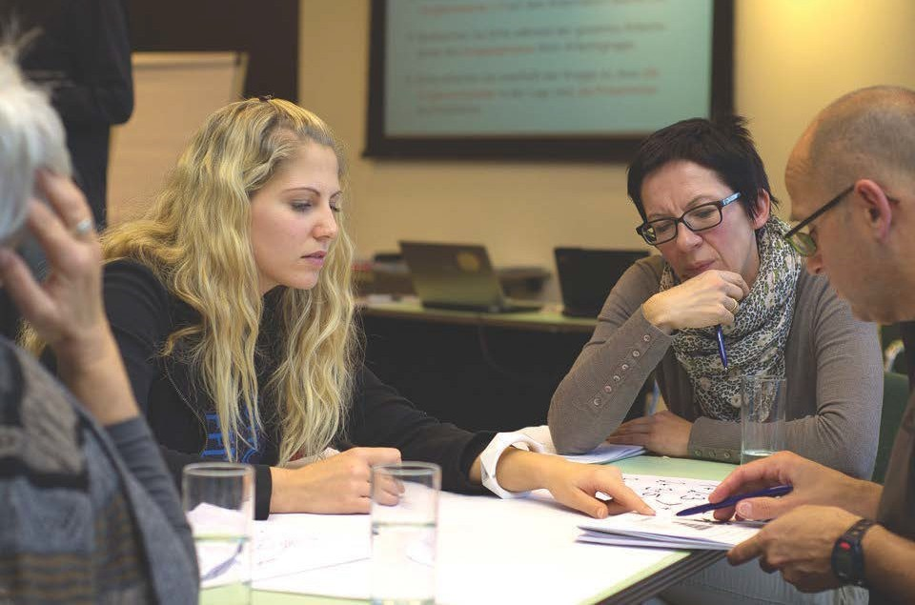

CFTM Facilitation for the Case Manager

Competencies
- Participants will have a greater understanding of Comfort Rules and how to reach consensus in a CFTM.
- Participants will have a greater understanding of the history of the CFTM Process used in Tennessee.
- Participants will receive an overview of the CFTM Guide.
- Participants will have a greater understanding of how CFTMs relate to CFSR and best practice.
- Participants will understand the Stages of the CFTM including the Preparation Stage prior to the formal meeting.
- Participants will learn the role of the facilitator in a CFTM.
- Participants will learn engagement strategies to implement when the role is both case manager and facilitator.
- Participants will have a better understanding of the importance of communication skills in a CFTM.
- Participants will receive strategies and have a greater understanding of dealing with challenging behaviors in a CFTM.
- Participants will be able to demonstrate and model effective teaming using formal and informal resources.
- Participants will identify how to assess if the CFTM was quality.
- Participants will identify how to transfer information into field practice.

Materials Checklist
Materials needed for this curriculum:
- Facilitator Guide
- Power Point
- Child and Family Team Guide
- Adoption and Safe Families Act (1997)
- Lessons Learned from Child Welfare Class Action Litigation: A Case Study of Tennessee’s Reform from the Center for the Study of Social Policy
- Questions to Elicit Strengths Handout
- Communication Skills Handout
- Facilitating Challenging Behaviors Handout
- Remembrances of Childhood Part 1 and Part 2 Handouts
- Work Aid: Child and Family Team Meeting Preparation Tool-How DCS Workers Can Help Prepare the Families for the Meeting
- Work Aid: Child and Family Team Meeting Tool-Preparing the Facilitator for the Meeting
- Genogram (CS-0774)
- Family Eco-map (CS-0782)

Agenda
0.0 Hour Training
Agenda Item | Time | Resources | Activities
- Unit 1: Welcome, Introductions, and Building Consensus | - 35 minutes | - Child and Family Team Guide | - Knowledge Scaling  - Comfort Rules
Lesson 1.1 Welcome and Introductions | - 15 minutes
Lesson 1.2  Comfort Rules and Building Consensus | - 20 minutes
- Unit 2: The Why Behind the CFTM Process | - 30 minutes | - Adoption and Safe Families Act (1997)  - Lessons Learned from Child Welfare Class Action Litigation: A Case Study of Tennessee’s Reform from the Center for the Study of Social Policy  - Child and Family Team Guide | - Review of CFTM Guide Sections: Introductions, Deciding Who to Invite, Involvement of Children, Parent’s Involvement, Supervisor’s Participation
Lesson 2.1  The Why Behind CFTMs | - 10 minutes
Lesson 2.2  What’s in the Guide? | - 20 minutes
- Unit 3: The Stages of the CFTM | - 45 minutes | - Child and Family Team Guide  - Work Aid: Child and Family Team Meeting Preparation Tool-How DCS Workers Can Help Prepare Families for the Meeting  - Work Aid: Child and Family Team Meeting Tool-Preparing the Facilitator for the Meeting  - Question to Elicit Strengths Handout | - Review of the Stages of a CFTM
Lesson 3.1  The “Preparation Stage” of the CFTM | - 15 minutes
Lesson 3.2  Stages of the CFTM | - 30 minutes
- Unit 4: Facilitation Skills | - 55 minutes | - Communication Skills Handout  - Dealing with Challenging Behaviors Handout | - Process vs. Content  - Challenging Behaviors
Lesson 4.1
Role of the Facilitator
Lesson 4.2
Facilitator vs. Case Manager Role
Lesson 4.3
Communication Skills
Lesson 4.4
Managing Challenging Behaviors
- Unit 5: The Practice Wheel | - 35 minutes | - Remembrances from Childhood, Part 1 and Part 2 Handouts  - Genogram (CS-0774)  - Family Eco-map (CS-0782)  - Child and Family Team Meeting Guide | - Empathy Orientation  - Types of CFTMs
Lesson 5.1  Engagement | - 15 minutes
Lesson 5.2  Team Building | - 10 minutes
Lesson 5.3  Assessment and Planning | - 10 minutes
- Unit 6: Quality CFTMs and Closing | - 15 minutes | - Continuum of Knowledge Scaling from Unit 1  - Training Evaluation | - Knowledge Scaling
Lesson 6.1  Quality CFTMs | - 10 minutes
Lesson 6.2  Closing/Summary | - 5 minutes

Unit 1: Welcome, Introductions, and Building Consensus
Time: 35 Minutes
Learning Objectives:
- Participants will have a greater understanding of Comfort Rules and how to reach consensus in a CFTM.
Supporting Materials:
- The Child and Family Team Guide

Lesson 1.1 Welcome and Introductions
Lesson Time: 15 minutes
Key Teaching Points / Instructions:

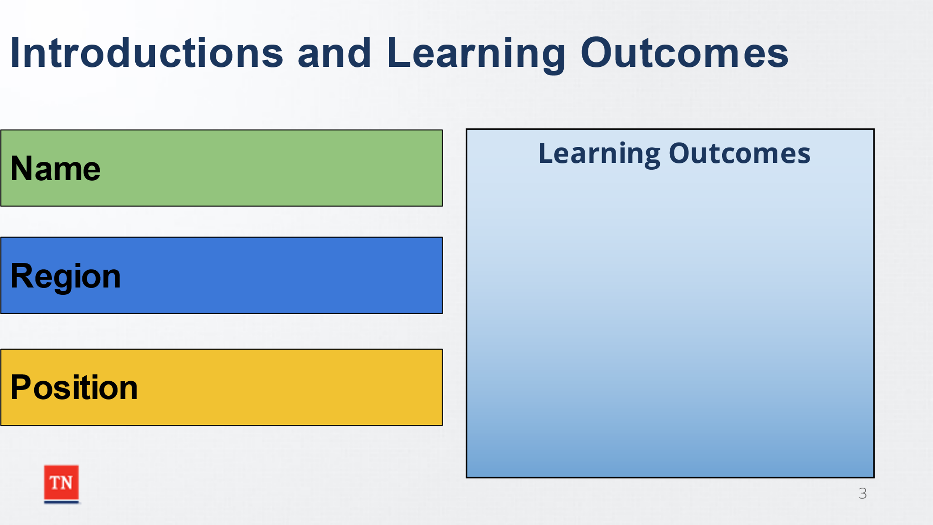
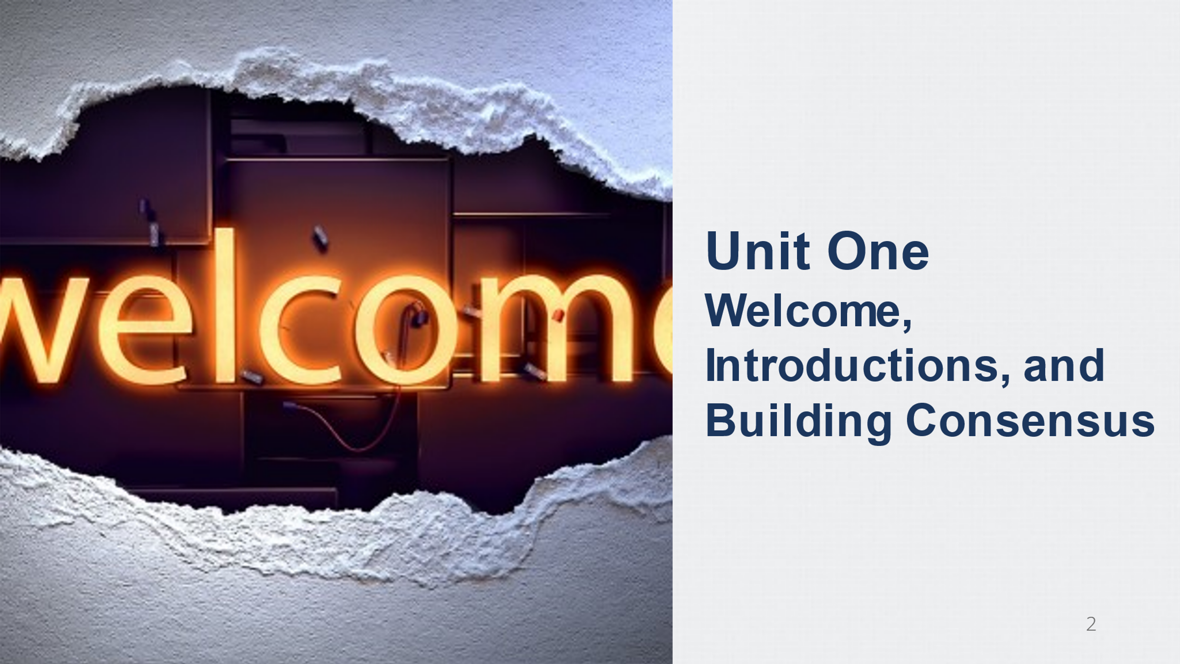
- WELCOME participants to the training. BEGIN on time and SHARE Housekeeping information. STATE activities and breaks have been included to help with this training. Trainers will introduce themselves and highlight their past child welfare experiences detailing any work with Child and Family Team Meetings.
- ASK participants introduce themselves by sharing their Name, Region, Position, and at least one learning outcome for the day. Trainer will document learning outcome on a flip chart.
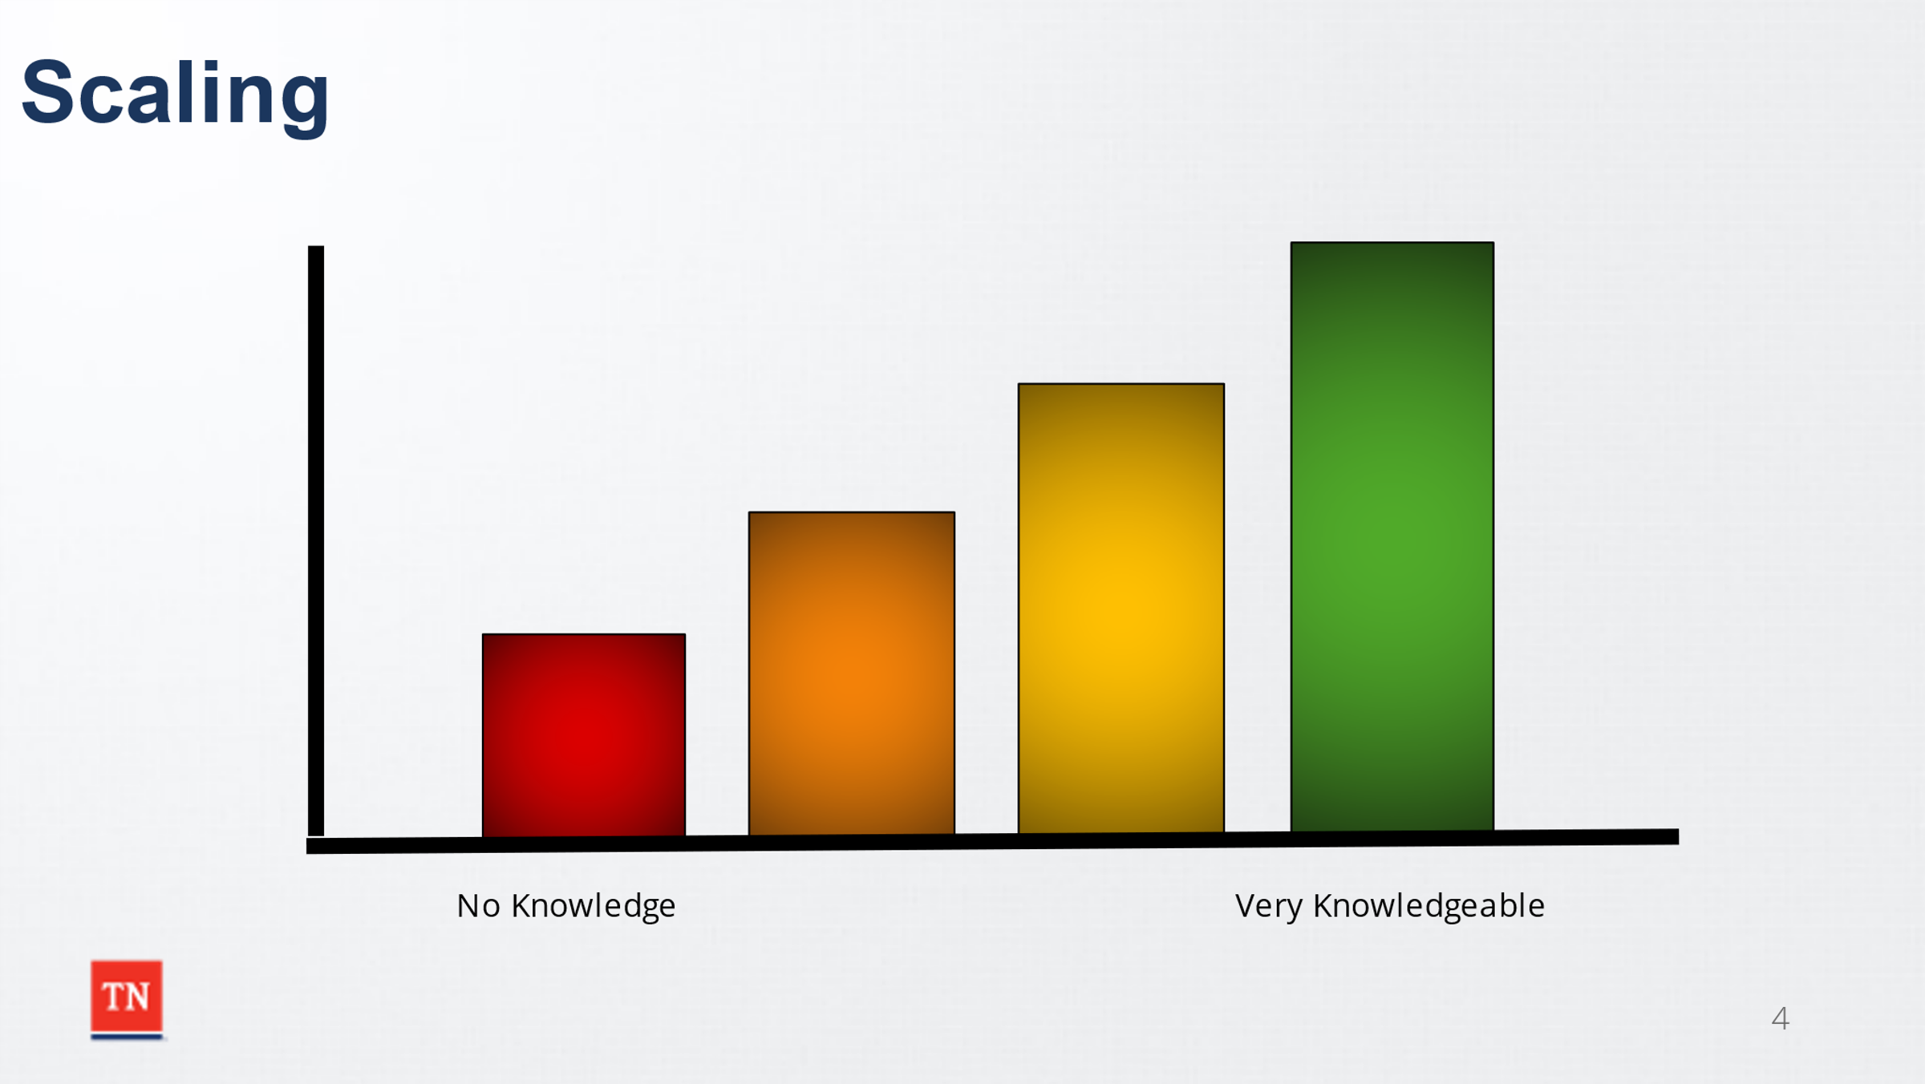
- ASK participants to scale their knowledge of Child and Family Team Meetings (Red-zero knowledge, Green-very knowledgeable). NOTE a flip chart of this graph can be posted and staff or trainer may document responses to refer back to at the conclusion of class.
- MODEL Motivational Interviewing by asking participants what brings them to the current rating, and what would be needed to move up the scale. DEBRIEF.
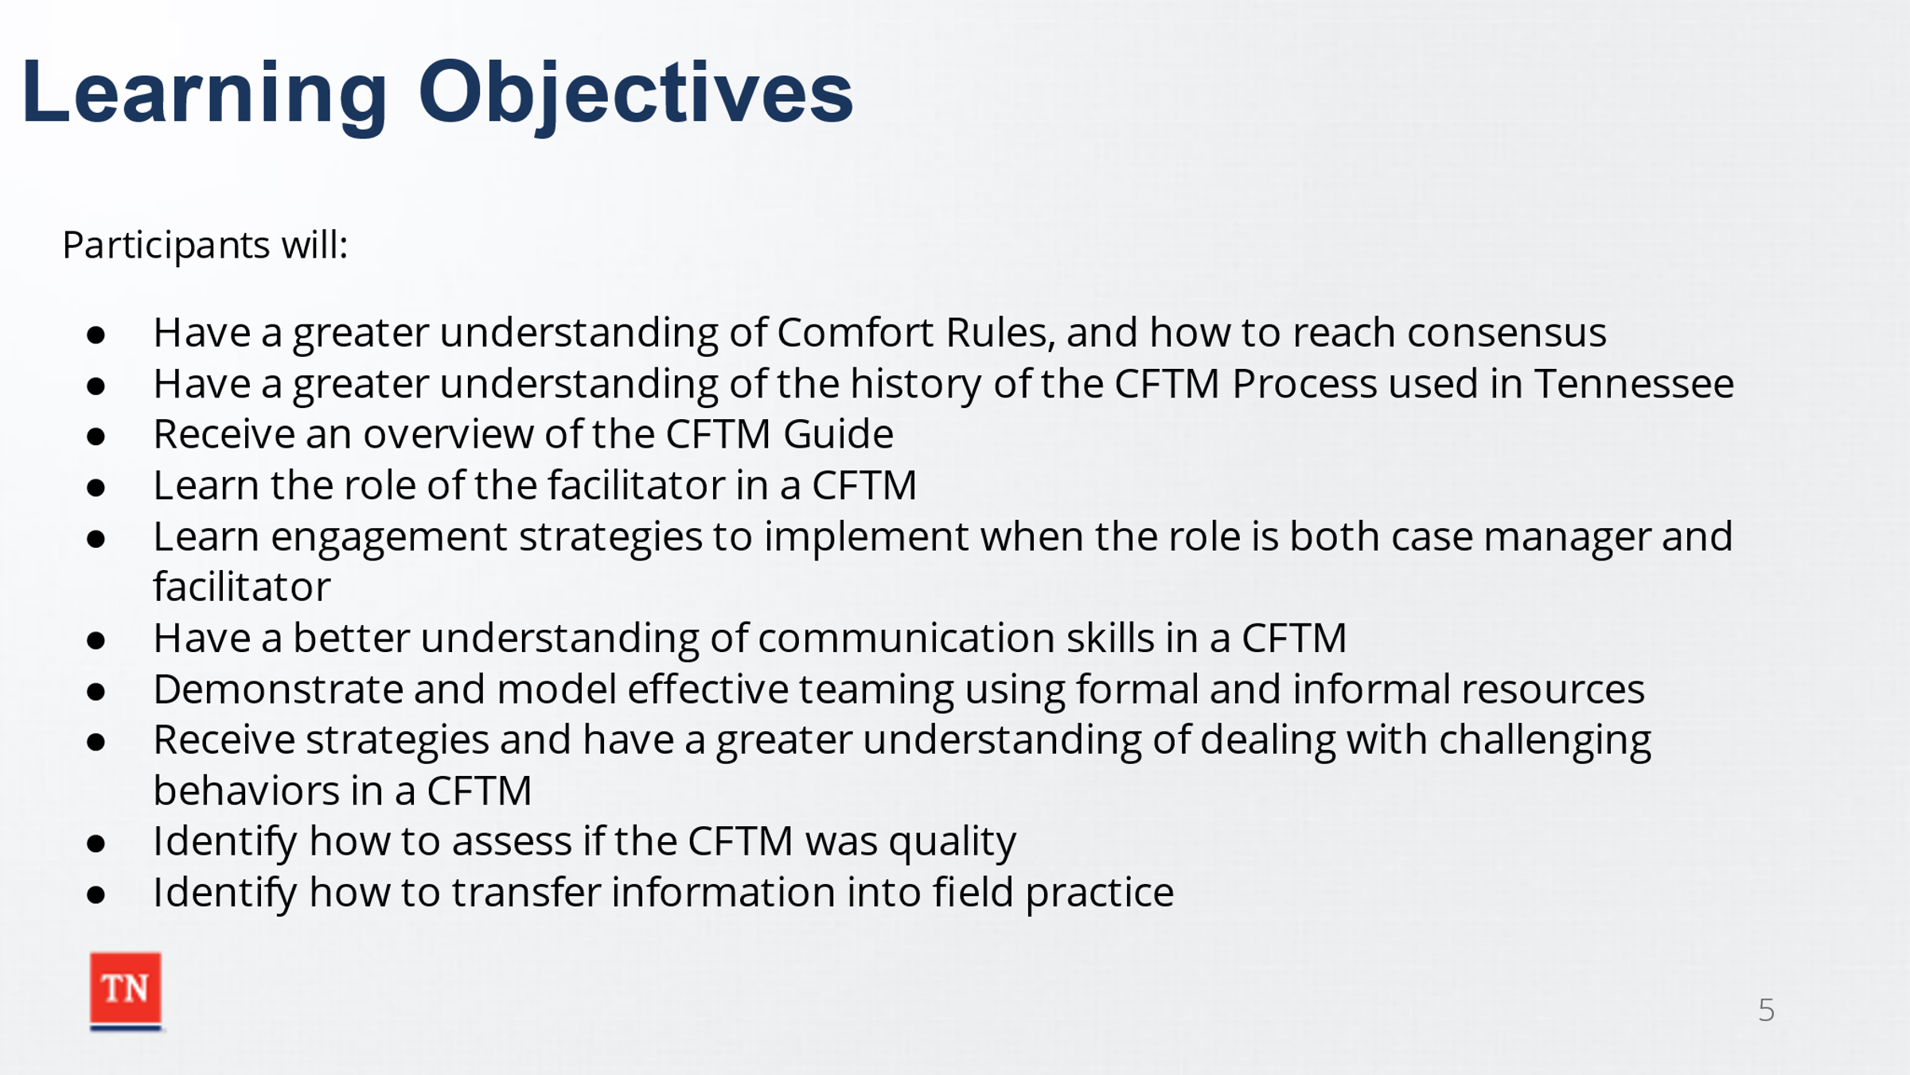
- SHARE the Learning Objectives:
  - Participants will have a greater understanding of Comfort Rules and how to reach consensus in a CFTM.
  - Participants will have a greater understanding of the history of the CFTM Process used in Tennessee.
  - Participants will receive an overview of the CFTM Guide.
  - Participants will have a greater understanding of how CFTMs relate to CFSR and best practice.
  - Participants will learn the role of the facilitator in a CFTM.
  - Participants will learn engagement strategies to implement when the role is both case manager and facilitator.
  - Participants will have a better understanding of the importance of communication skills in a CFTM.
  - Participants will be able to demonstrate and model effective teaming using formal and informal resources.
  - Participants will receive strategies and have a greater understanding of dealing with challenging behaviors in a CFTM.
  - Participants will identify how to assess if the CFTM was quality.
  - Participants will identify how to transfer information into field practice.
- TRANSITION to Lesson 1.2 Comfort Rules and Consensus Building.

Lesson 1.2 Comfort Rules and Consensus Building
Lesson Time: 20 minutes
Key Teaching Points / Instructions:

- STATE while we are together, we would like for the group to be comfortable, productive, and collaborative.
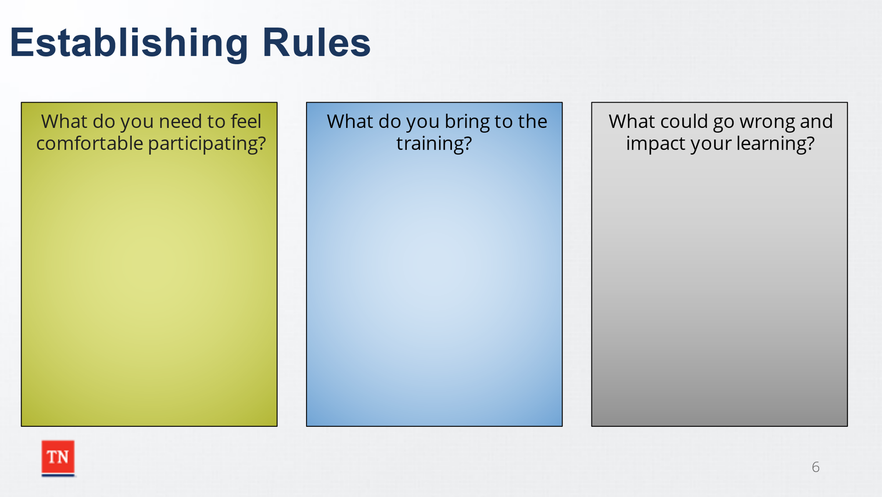
- ENGAGE the group in a discussion around Comfort Rules. ASK participants the following questions and ANNOTATE responses on the Power Point Slide or CAPTURE their responses on a flip chart.
  - What do you need to feel comfortable participating in training? What does Do No Harm look like in the training environment?
  - What do you bring to the training?
  - What could go wrong and impact your learning?
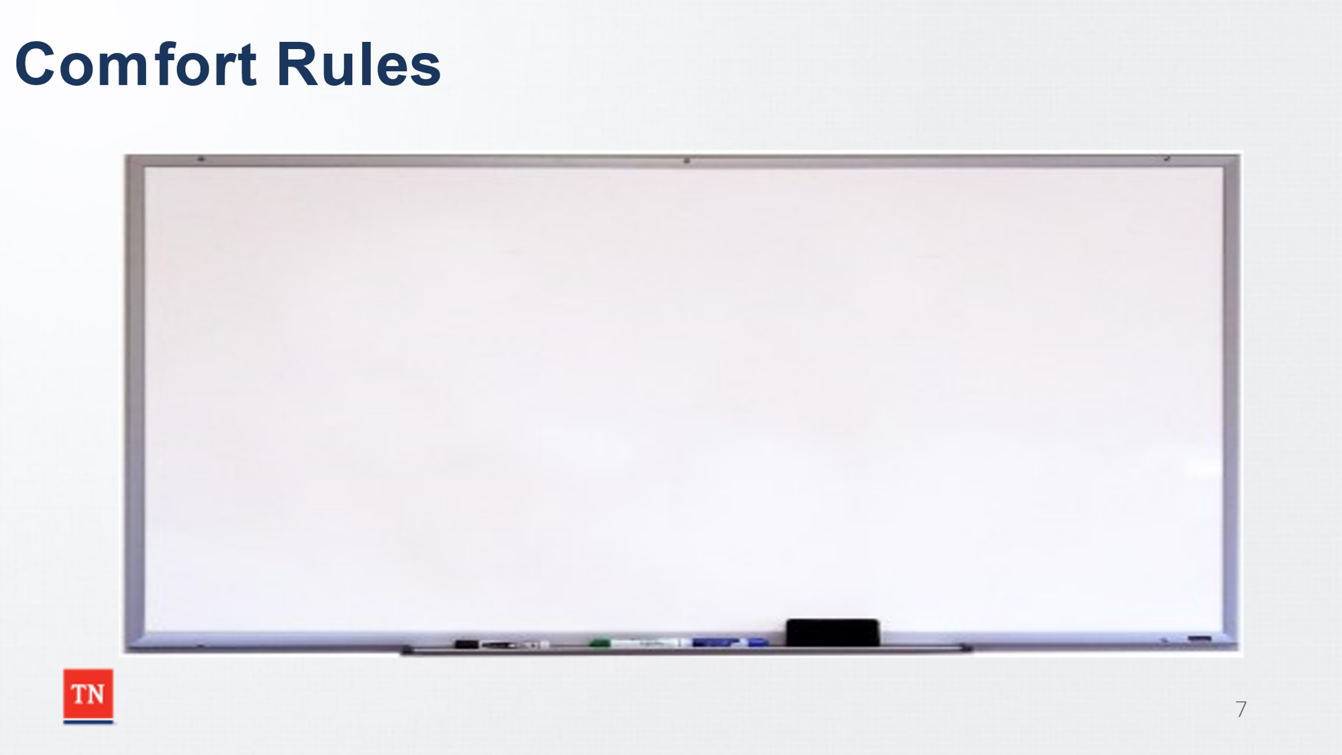
- STATE we will now take what you bring to the training, what you need to feel comfortable participating to create rules to address what could go wrong. ASK participants what rules or guidelines will ensure we can be productive and learn. NOTE rules on the prepared flip chart paper. ASK participants if they can agree to support these rules.
- ASK the following:
  - What did the group just accomplish?
  - How did it feel to be asked for input on how we will work together?
  - What if the rules would have been created by trainers without your input? How would this experience have been different?
  - How does this parallel to the CFTM process?
- EMPHASIZE as facilitators of some of their own meetings, case managers will model engagement of the family through the mutual development of the Comfort Rules.
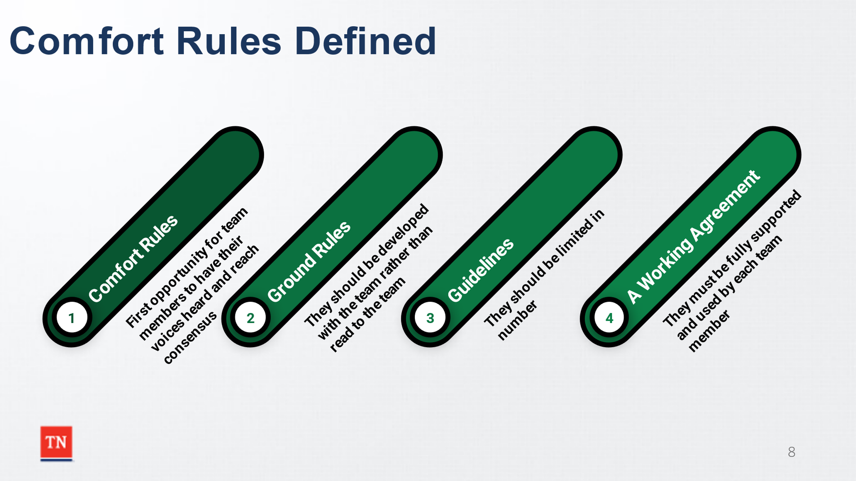
- SHARE these rules may be listed as Comfort Rules, Ground Rules, Guidelines, a Working Agreement, or etc. The Child and Family Team Guide uses the term “Comfort Rules.” STATE the development of these rules is the first opportunity for the team members to have their voices heard and reach consensus. They should be developed with the team rather than read to the team. They should be limited in number. SHARE finally the comfort rules must be fully supported and used by each team member. STATE by asking the team if they agree to support the rules, you are leading the team in building consensus. SHARE consensus is not about total agreement; it is about being heard and supporting the decision of the group even if they do not agree. PARALLEL consensus building to asking this group if they can agree to support the comfort rules for the day. ASK if there are any question and TRANSITION to Unit 2: The Why behind Child and Family Team Meetings.

Unit 2: The Why Behind the CFTM Process
Time: 30 Minutes
Learning Objectives:
- Participants will have a greater understanding of the history of the CFTM Process used in Tennessee.
- Participants will receive an overview of the CFTM Guide.
- Participants will have a greater understanding of how CFTMs relate to CFSR and best practice.
Supporting Materials:
- Adoption and Safe Families Act (1997)
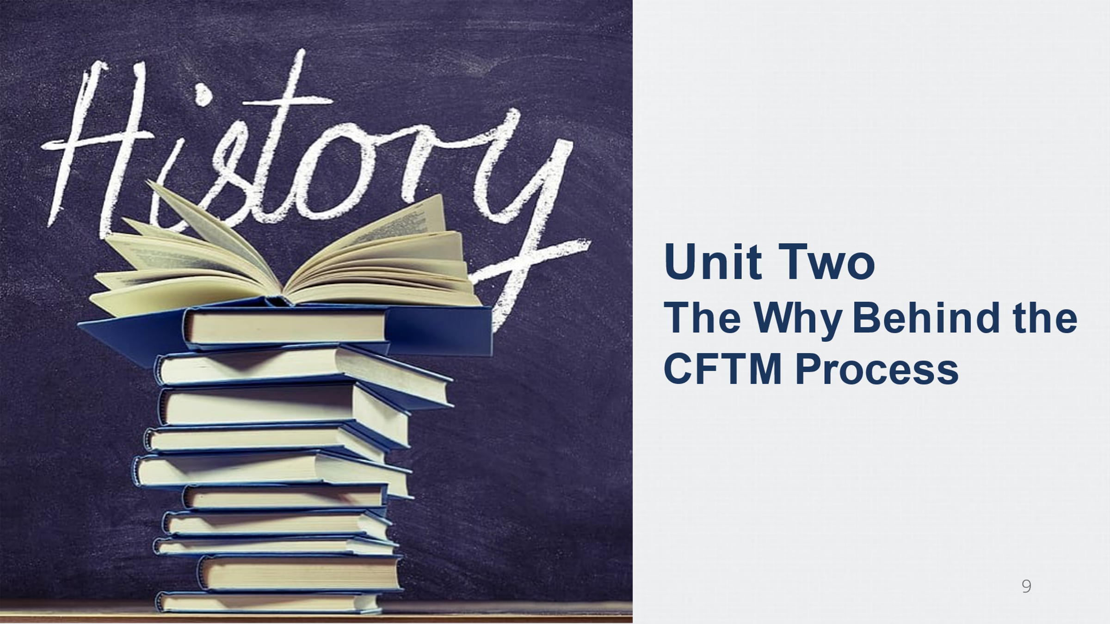
- Lessons Learned from Child Welfare Class Action Litigation: A Case Study of Tennessee’s Reform from the Center for the Study of Social Policy

Lesson 2.1 The Why Behind CFTMs
Lesson Time: 10 minutes
Key Teaching Points / Instructions:

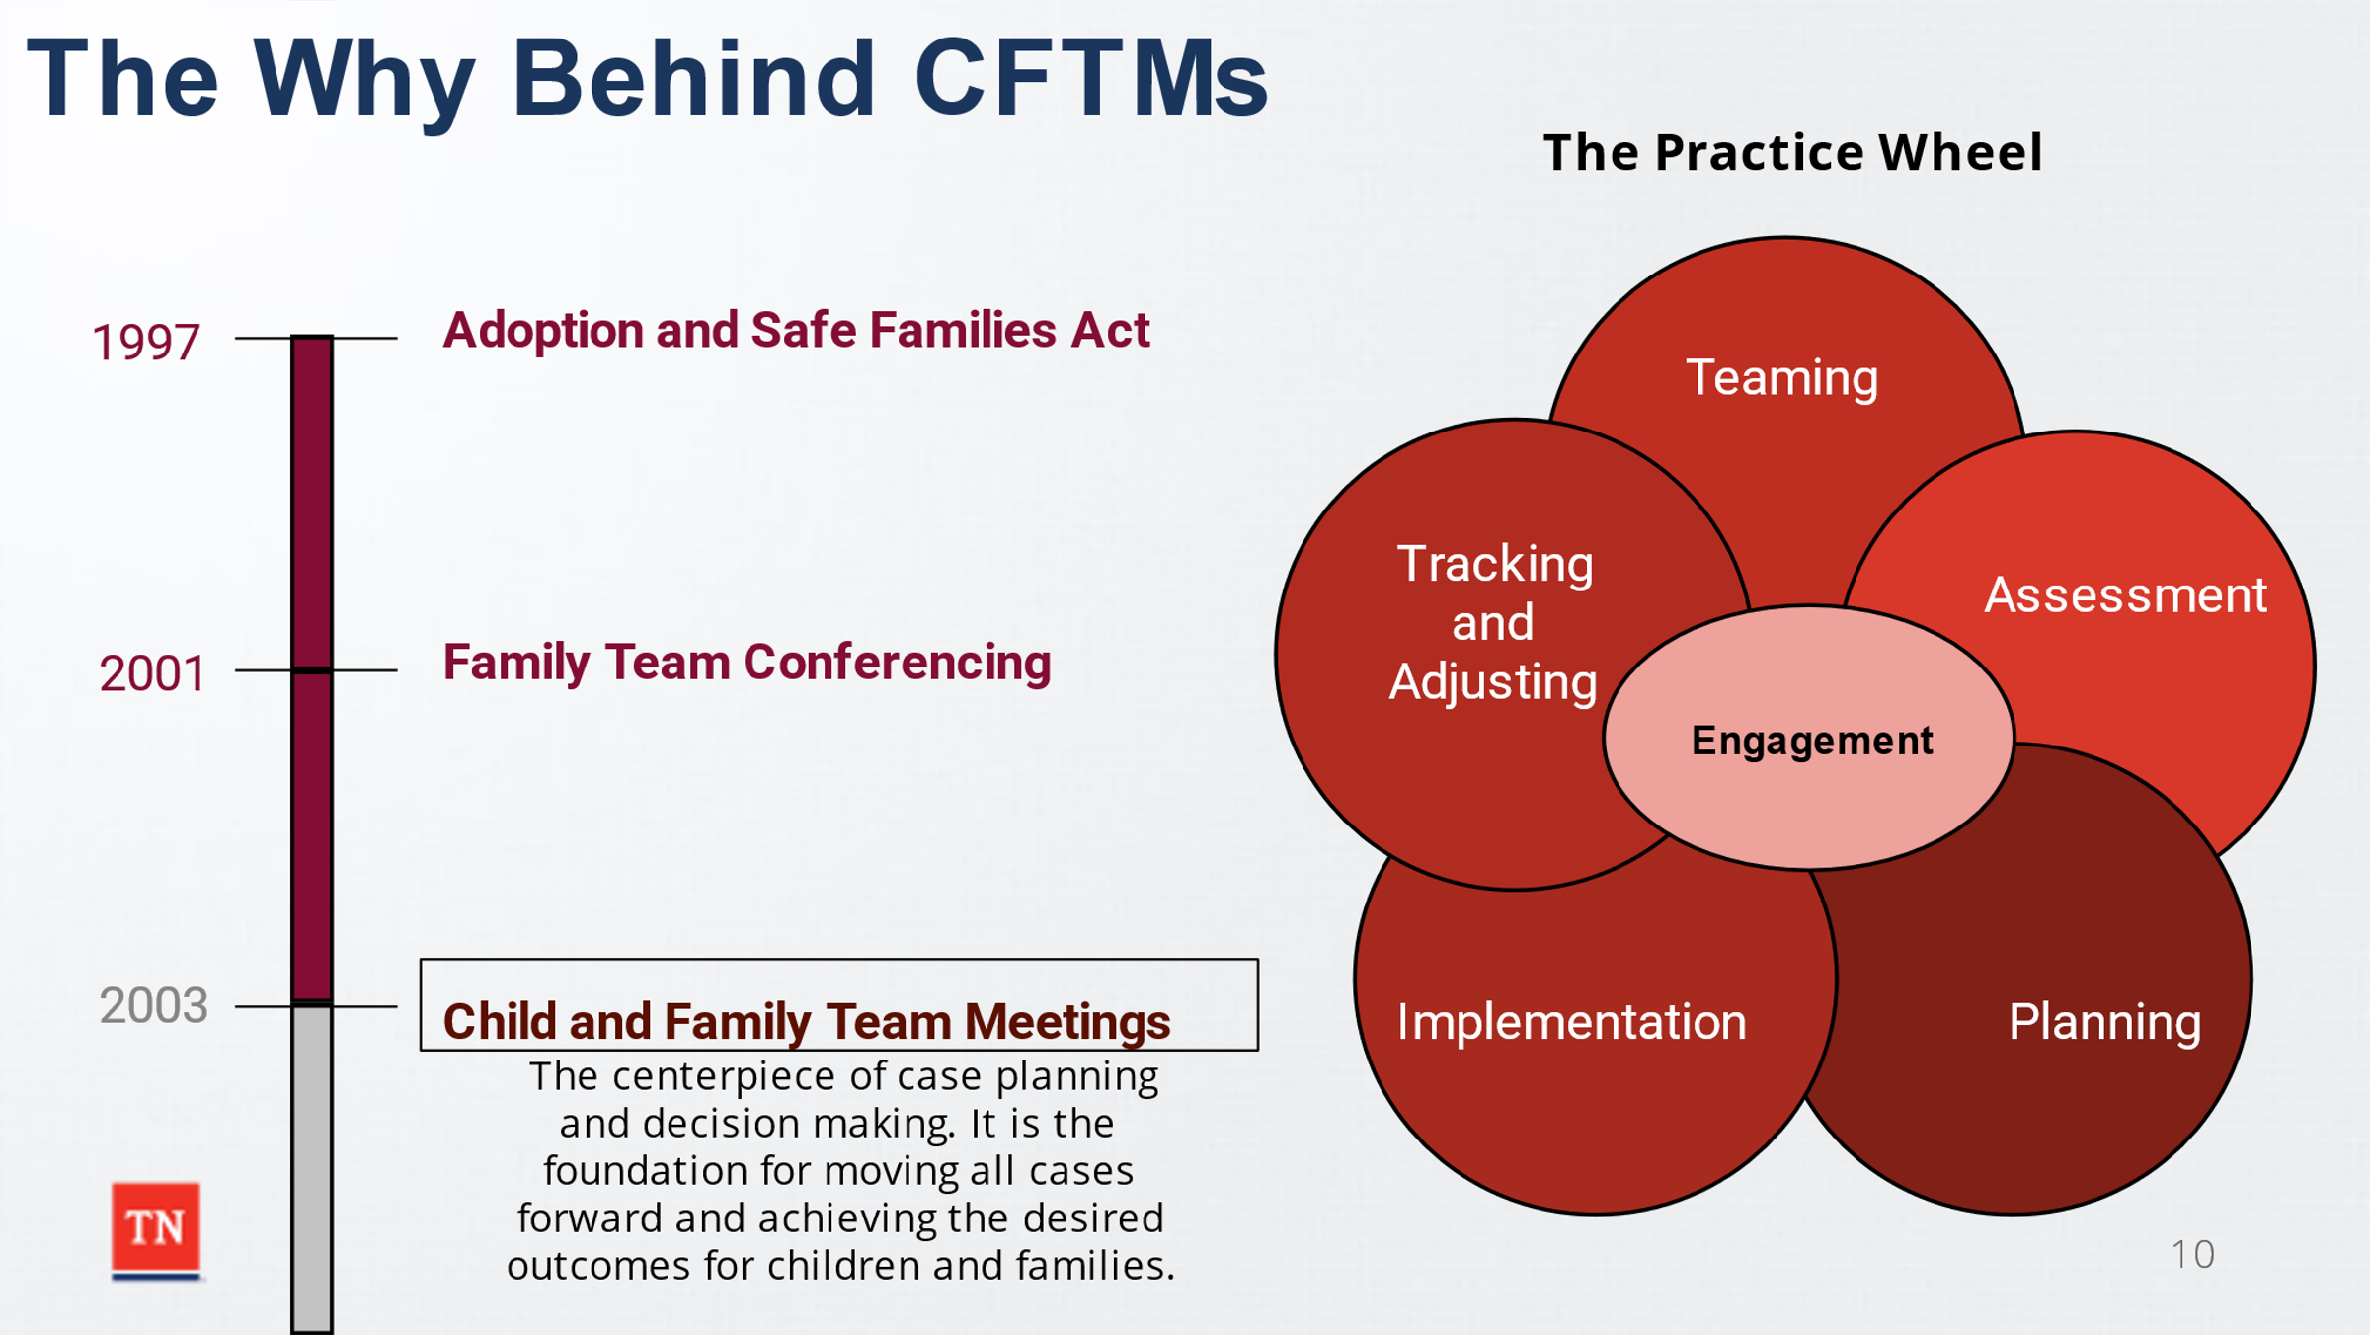
- SHARE we will now look at the why behind CFTM practice in Tennessee. SHARE the late 1990’s early 2000’s was a time of change in child welfare including the Department of Children’s Services. DISCUSS the enactment of the Adoption and Safe Family Act in 1997 and how federal lawsuits shifted child welfare practice for the better.
Trainer Note: Points for Discussion were obtained from Lessons Learned from Child Welfare Class Action Litigation: A Case Study of Tennessee’s Reform from the Center for the Study of Social Policy.
- SHARE from 2001-2004 the Department began to innovate with casework models including piloting the use of family team conferencing by implementing “Family to Family.” Eventually these efforts would be fully embedded into quality case practice through the Child and Family Team process and case practice model.
- STATE DCS adopted a core set of policies and procedures for working with children and families. At the center of the practice model was the Child and Family Team (CFTM) process which was built around the six core activities often referred to as the Practice Wheel (Engagement, Teaming, Assessment, Planning, Implementation, and Tracking and Adjusting). DCS believed a focus on improving these six core activities, if done well, would lead to improvement in all of the many benchmarks set out. SHARE DCS first piloted the family team conference model in 2001 and the CFTM model we utilize in practice today was fully implemented in 2003. The CFTM process became the centerpiece of case planning and decision making. The CFT process was the foundation for moving all cases forward and achieving the desired outcomes for children and families.
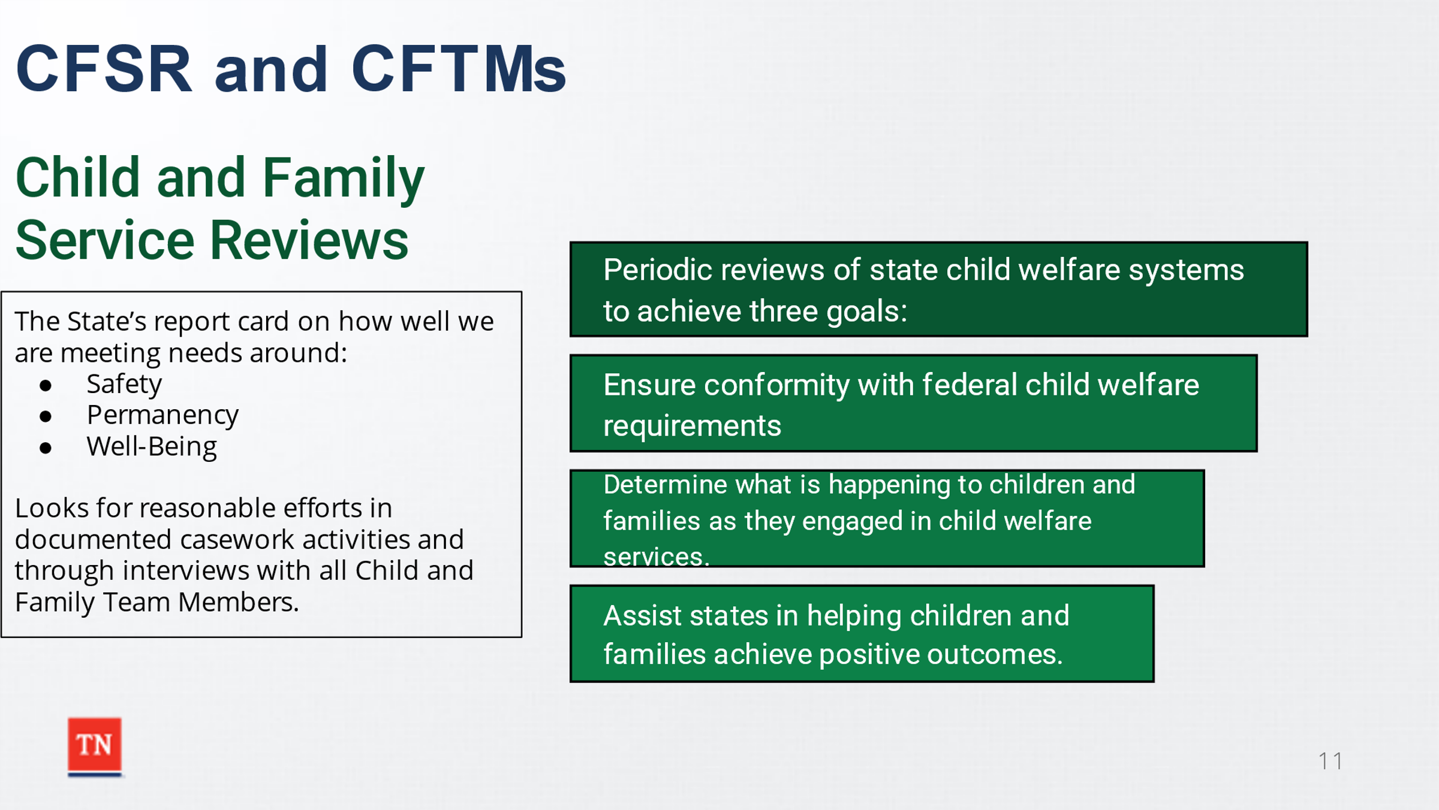
- STATE DCS continues to use the CFTM process to move cases forward. ADVISE the Children’s Bureau defines (Child and Family Services Reviews) as periodic reviews of state child welfare systems to achieve three goals.
  - Ensure conformity with federal child welfare requirements.
  - Determine what is happening to children and families as they are engaged in child welfare services.
  - Assist states in helping children and families achieve positive outcomes. After a CFSR is completed, States develop a Performance Improvement Plan (PIP) to address areas in their child welfare services that need improvement.
- EXPLAIN CFSR is basically the State’s report card on how well we are meeting needs around Safety, Permanency, and Well-being.
- SHARE CFSR looks for evidence of concerted (reasonable) efforts in documented casework activities and through interviews with all CFT (Child and Family Team) members to assess the quality of contacts. CFSR also looks for consistency and a shared vision/understanding of the family plan and its implementation. Permanency Plans should be developed with the family in the context of a CFTM.
Trainer Note: Make sure to make connection of CFTMs and Teaming to Quality Contacts and achieving desired outcomes. You may ask the class how the two correlates?
- TRANSITION to Lesson 2.2 What’s in the Guide?

Lesson 2.2 What’s in the Guide?
Lesson Time: 20 minutes
Key Teaching Points / Instructions:

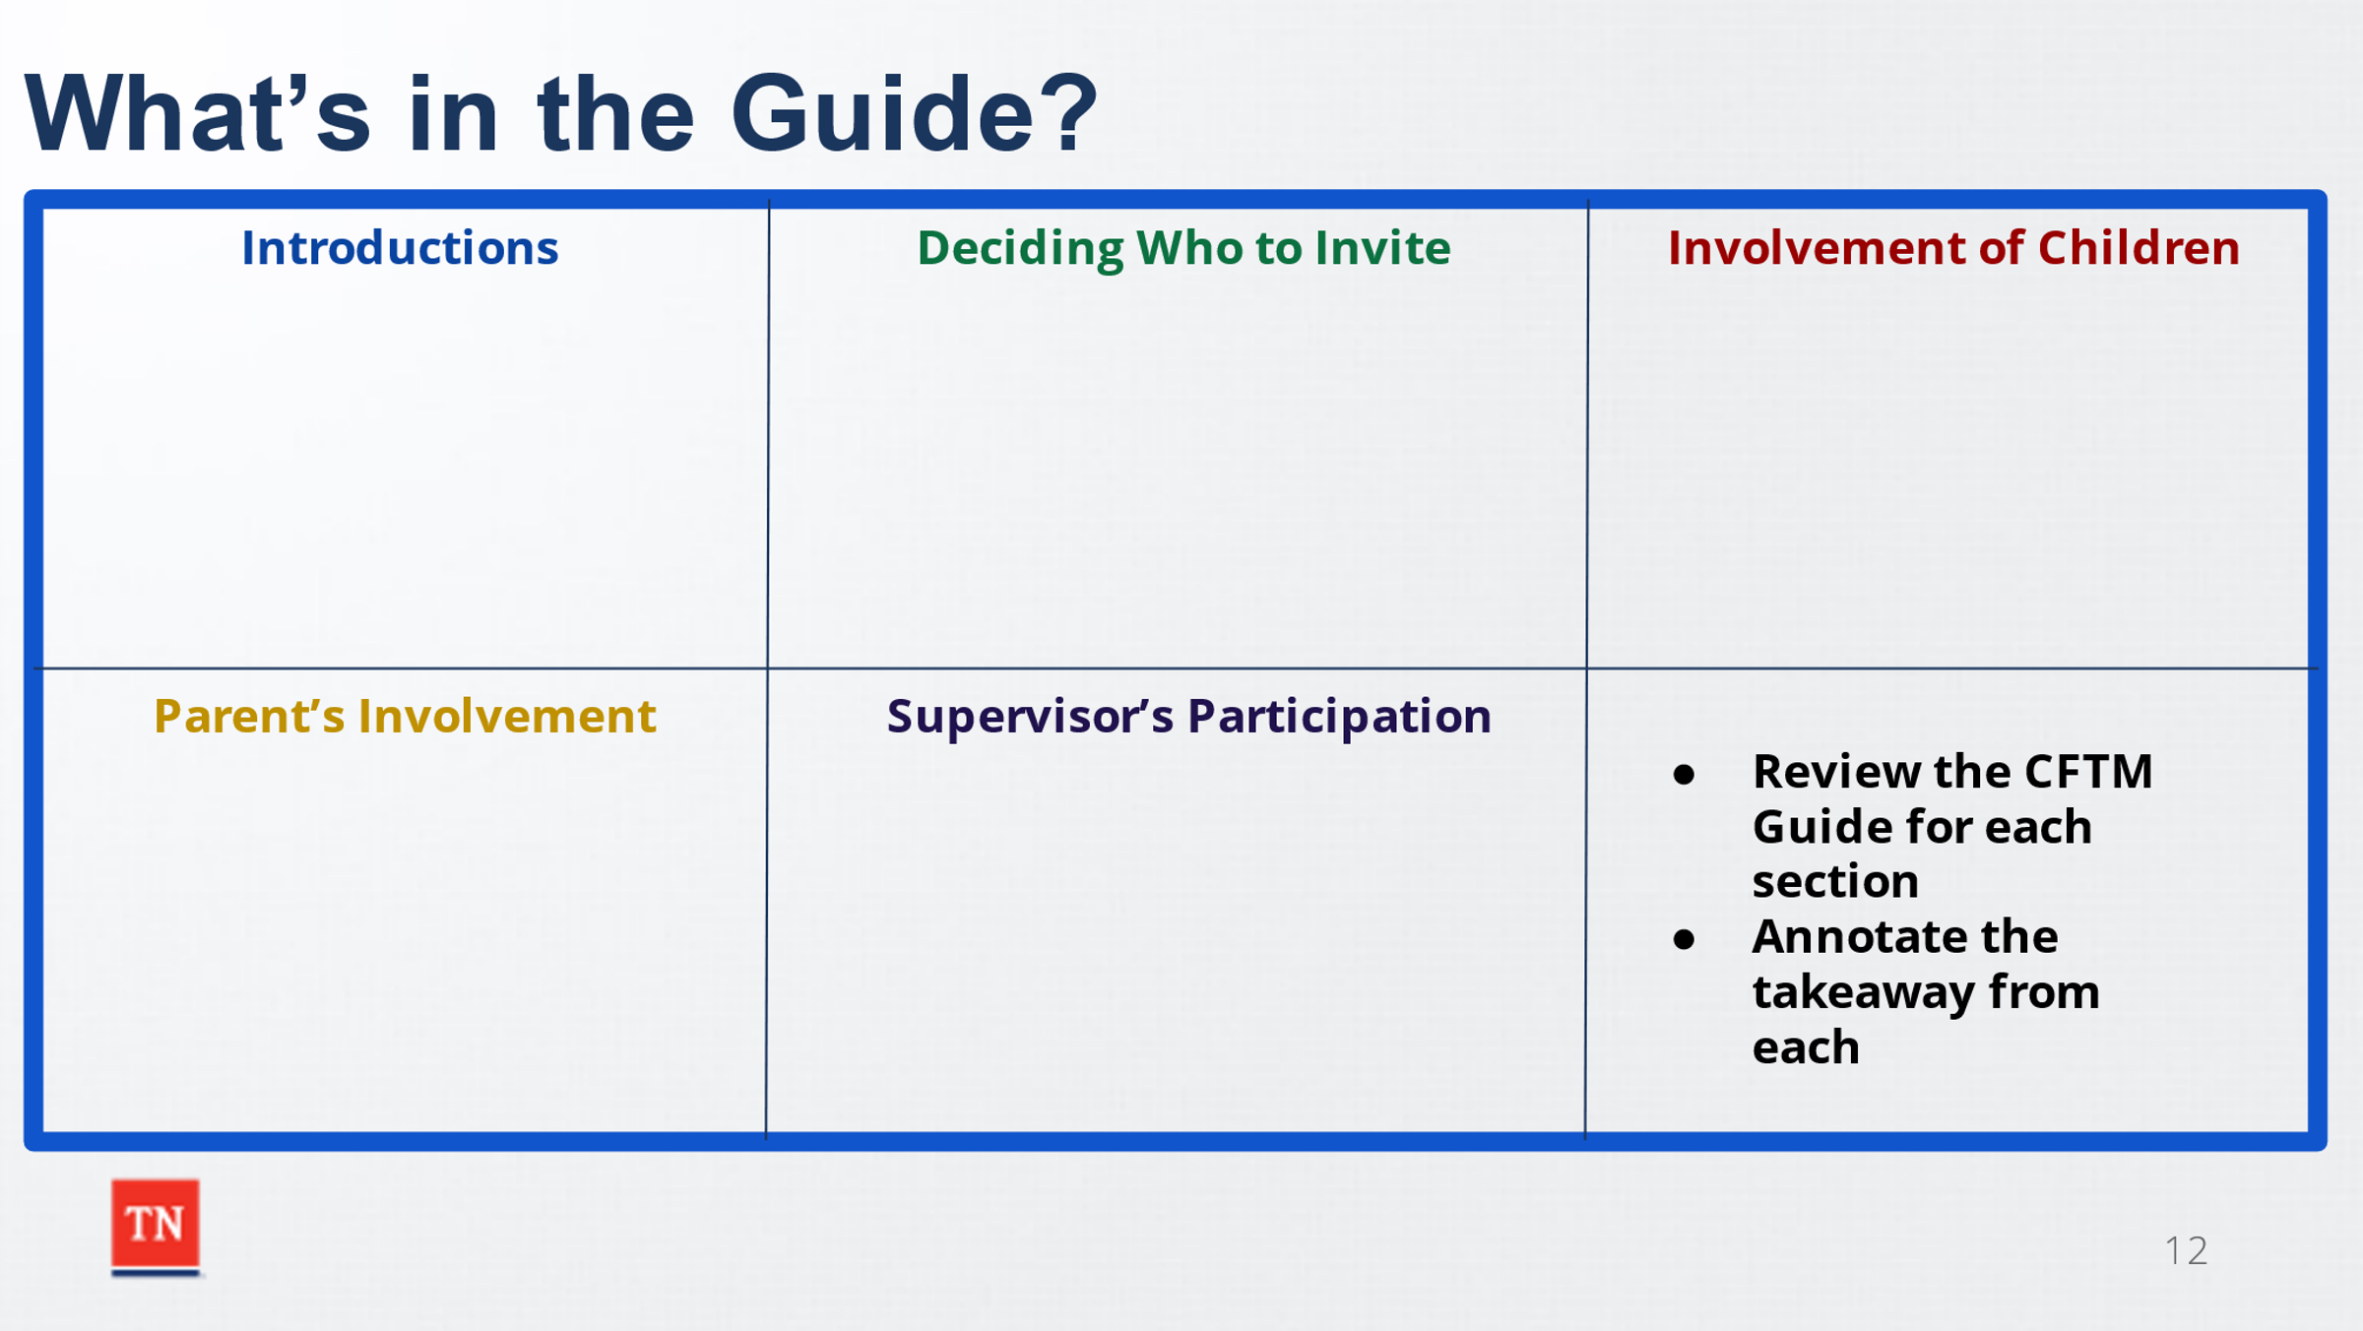
- STRESS to the class being familiar with the CFTM Guide is crucial to being successful at engagement and teaming with the family along with facilitating meetings which do not require a Skilled Certified Facilitator.
- ASK participants how familiar they are with the guide. SHARE participants will now review the following parts of the guide. ADVISE participants they will have 10 minutes to review each of the following sections.
  - Introductions
  - Deciding Who to Invite
  - Involvement of Children
  - Parent’s Involvement
  - Supervisor’s Participation
- Trainer will ANNOTATE information for each section on the Power Point slide or Prepared Flip Chart as discussion occurs.
- ASK if there are any questions and TRANSITION to Unit 3 The Stages of the CFTM.

Unit 3: The Stages of the CFTM
Time: 45 Minutes
Learning Objectives:
- Participants will understand the Stages of the CFTM including the Preparation Stage prior to the formal meeting.
Supporting Materials:
- Child and Family Team Guide
- Work Aid: Child and Family Team Meeting Preparation Tool-How DCS Workers Can Help Prepare Families for the Meeting
- Work Aid: Child and Family Team Meeting Tool-Preparing the Facilitator for the Meeting
- Child and Family Team Meeting Flyer
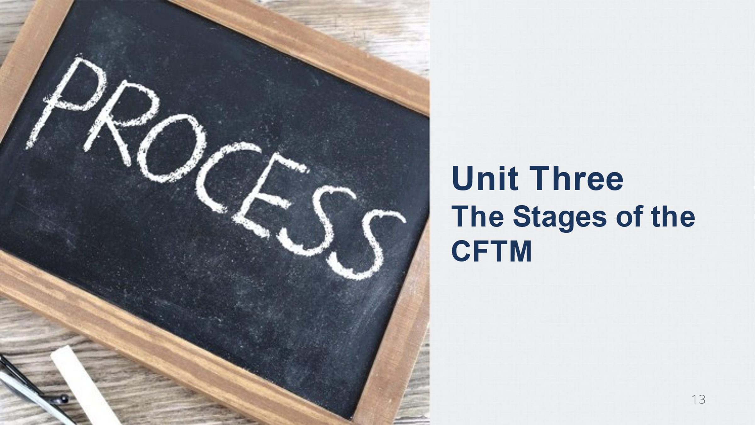
- What Youth Should Know About a CFTM
- Question to Elicit Strengths Handout

Lesson 3.1: The “Preparation Stage” of the CFTM
Lesson Time: 15 minutes
Key Teaching Points / Instructions:

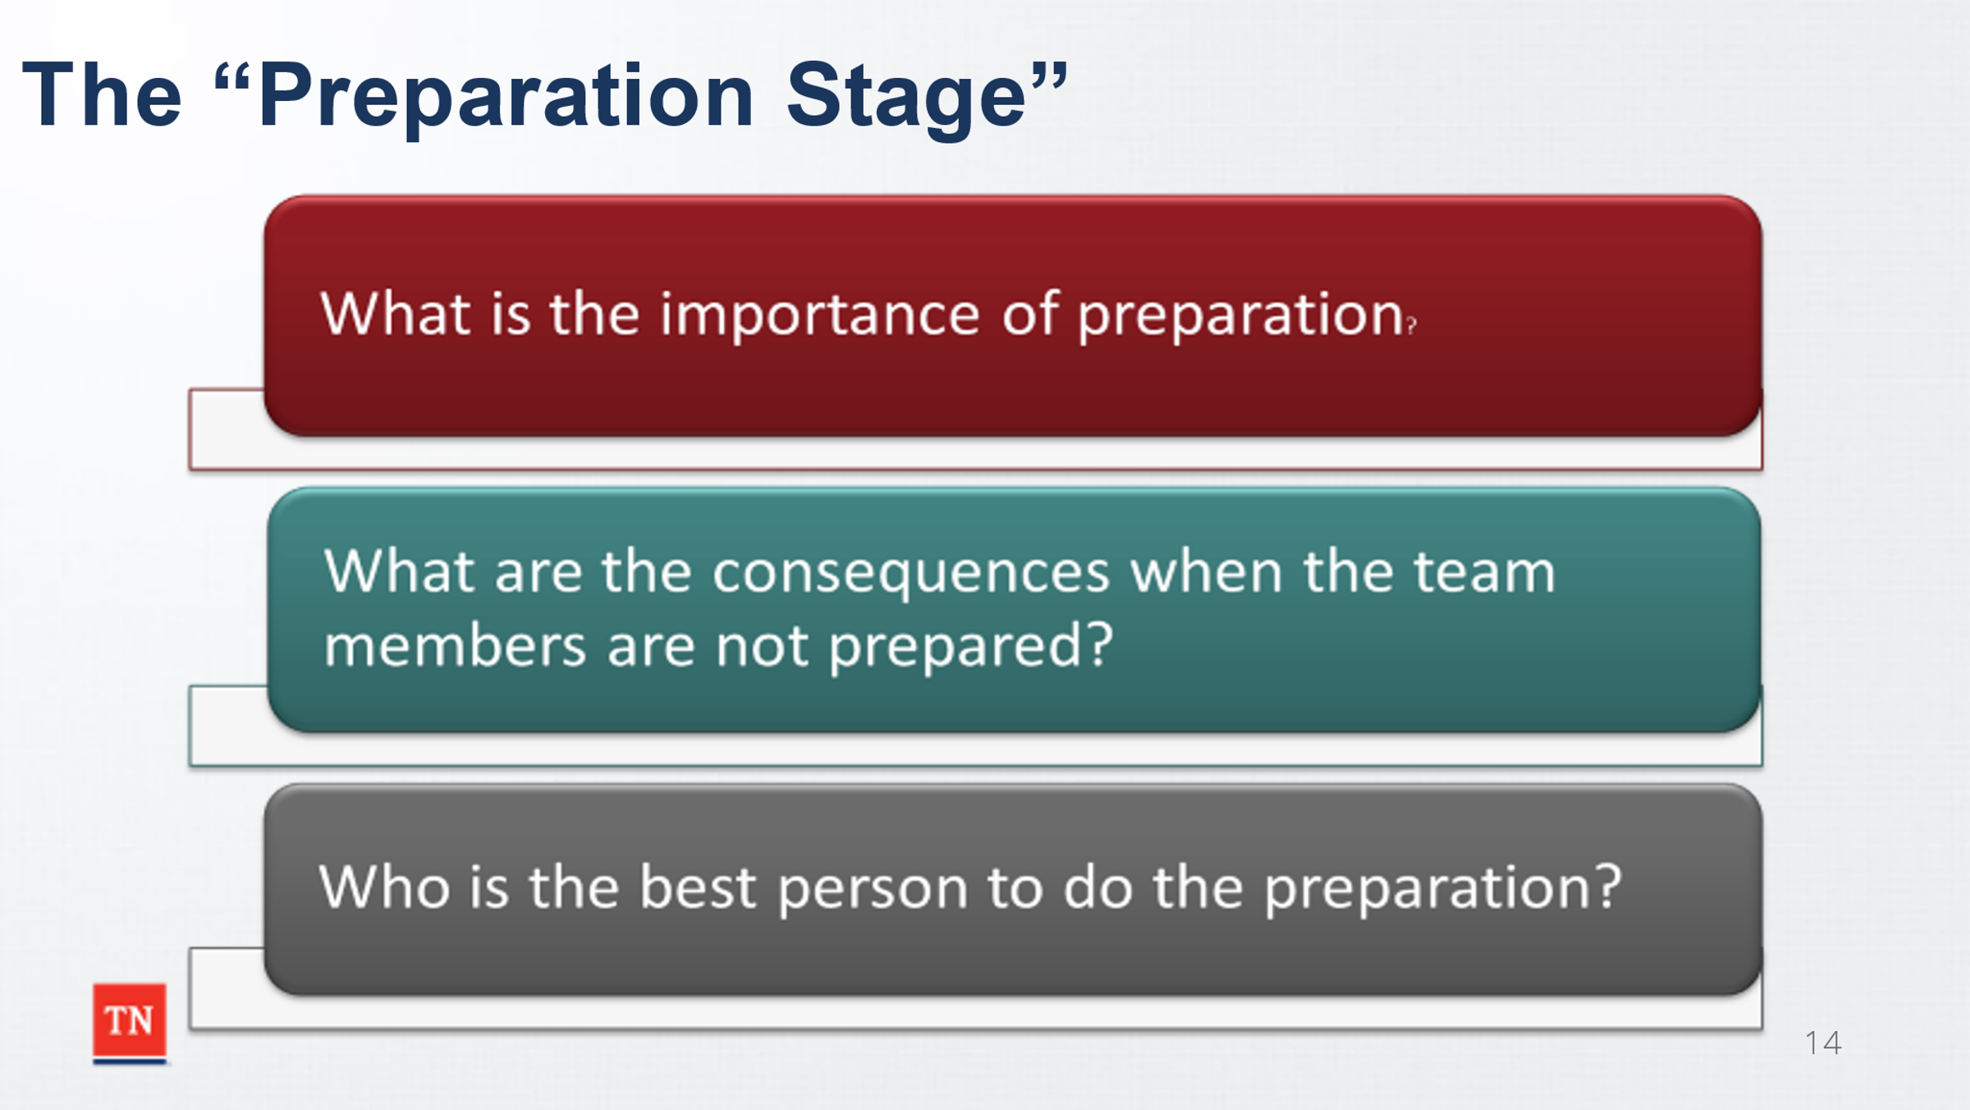
- EXPLAIN to the class Preparation is the first stage of the CFTM. Preparation of the ENTIRE team is key to a successful CFTM. ASK the following questions:
  - What is the importance of preparation?
  - What are the consequences when people are not prepared?
  - Who is the best person to prepare the team?
- SHARE benefits of quality preparation include:
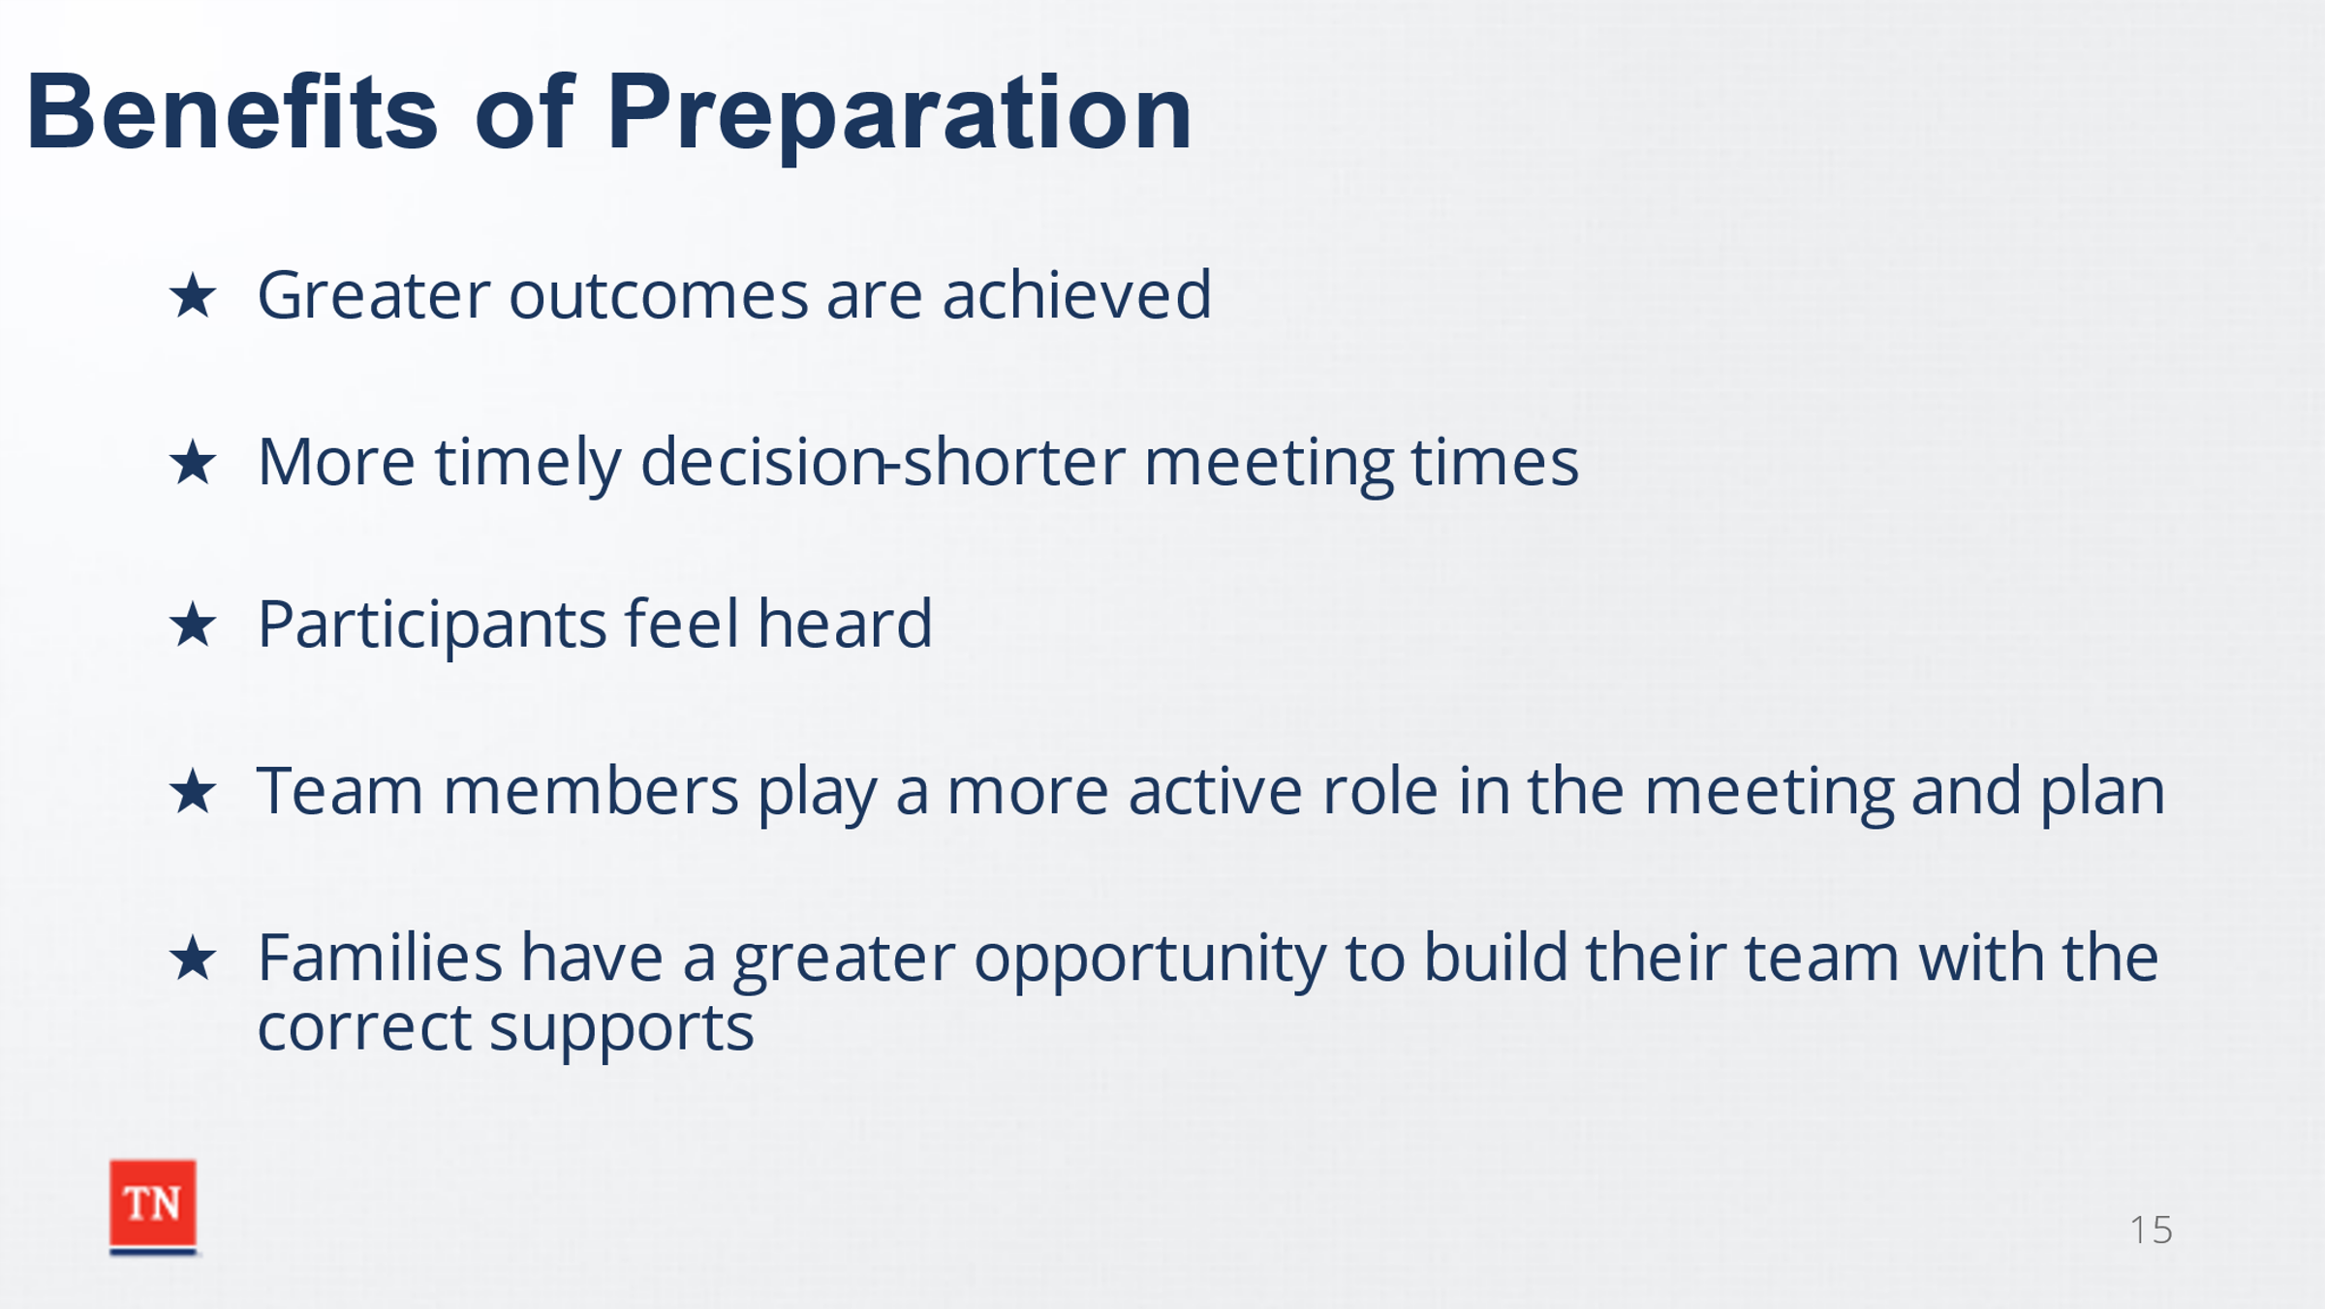
  - Greater outcomes are achieved
  - More timely decision/shorter meeting times
  - Participants feel heard
  - Team members play a more active role in the meeting and plan
  - Families have a greater opportunity to build their team with the correct supports
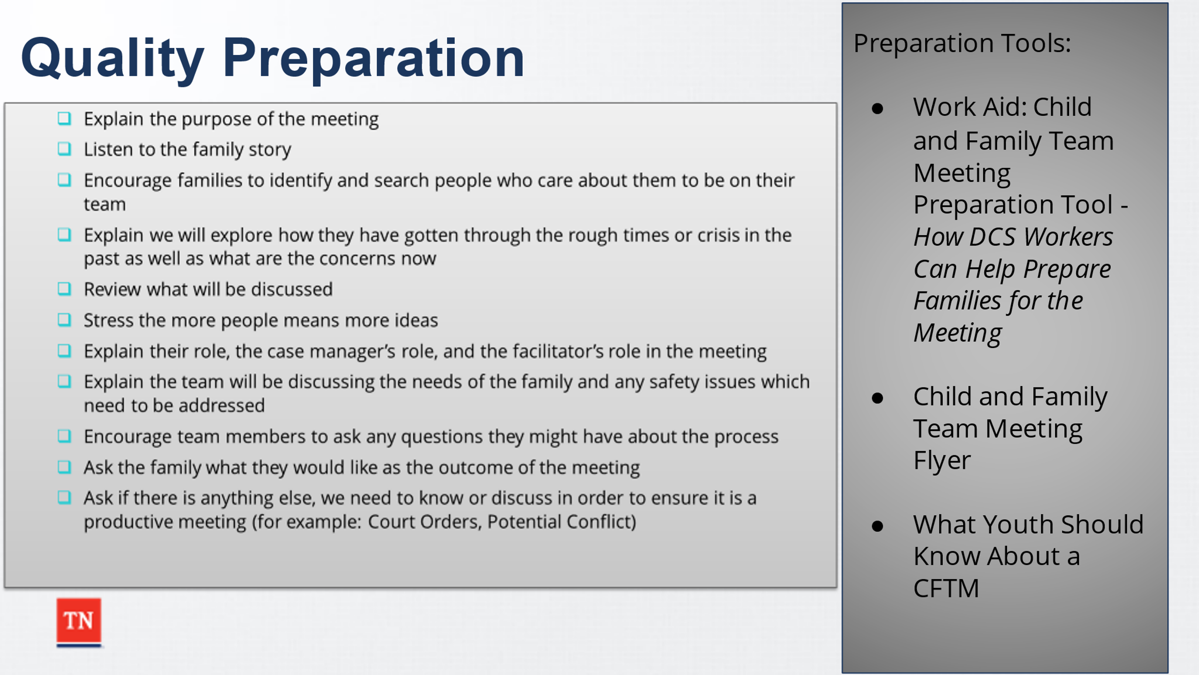
- REFER participants to the following Work Aids and REVIEW key parts of quality preparation interviews/contacts: Work Aid: Child and Family Team Meeting Preparation Tool-How DCS Workers Can Help Prepare Families for the Meeting. SHARE the following flyers are also available to give to children and families as preparation resources: Child and Family Team Meeting Flyer and What Youth Should Know About a CFTM.
  - Explain the purpose of the meeting
  - Listen to the family story
  - Encourage families to identify and search people who care about them to be on their team
  - Explain we will explore how they have gotten through the rough times or crisis in the past as well as what are the concerns now
  - Review what will be discussed, including: Confidentiality and any circumstances that cannot be changed in the meeting such as Court Orders, State Law, and DCS Policies that related to the safety and well- being of children and youth.
  - Stress the more people means more ideas
  - Explain their role, the case manager’s role, and the facilitator’s role in the meeting
  - Explain the team will be discussing the needs of the family and any safety issues which need to be addressed
  - Encourage team members to ask any questions they might have about the process
  - Ask the family what they would like as the outcome of the meeting
  - Ask if there is anything else, we need to know or discuss in order to ensure it is a productive meeting (for example: Court Orders, Potential Conflict)
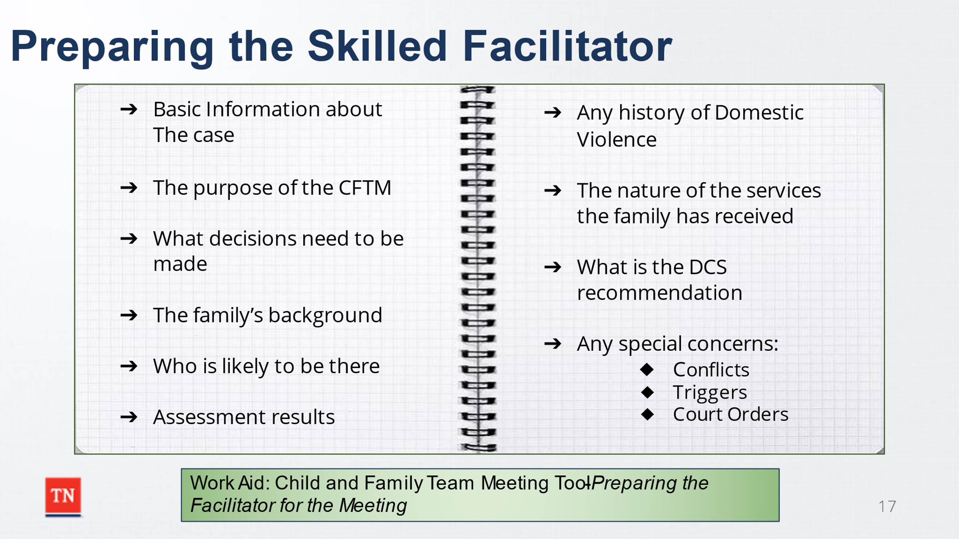
- SHARE it is also important for a Skilled Certified Facilitator to be prepared before the CFTM. SHARE the following Work Aid with participants: Work Aid: Child and Family Team Meeting Tool-Preparing the Facilitator for the Meeting.
- ADVISE regions have a process of requesting a Skilled Facilitator and some have their own request form.
- REVIEW the following key takeaways of preparing the Skilled Facilitator:
  - Basic information about the case
  - The purpose of the CFTM-what decisions need to be made?
  - The family’s background
  - Who is likely to be there?
  - Assessment Results
  - The nature of the services the family has received
  - The DCS Recommendation
  - Special concerns-Conflict, Triggers, Court Orders
- ASK if there are any questions around preparation and TRANSITION to Lesson 3.2 Stages of a CFTM.

Lesson 3.2 Stages of a CFTM
Lesson Time: 30 minutes
Key Teaching Points / Instructions:

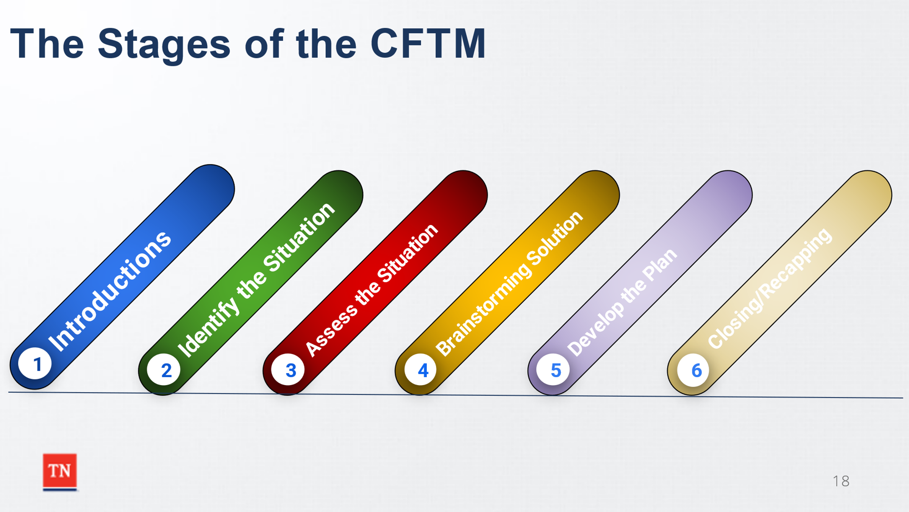
- ASK participants how many stages are in a CFTM? Answer: 6 INFORM participants the Stages of the CFTM can be found on pages 15-18 of the Child and Family Team Meeting Guide. DISCUSS while these stages are linear, they can be interchangeable throughout the meeting other than the Introduction, Identify the Situation, and Summary. The goal is to ensure all information in each section is discussed.
- ASK participants to REVIEW each Stage briefly. REFER participants to the Child and Family Team Meeting Guide. Participants will review the Stage and annotate on the prepared flip chart papers of each stage what is essential with each stage.
Trainer Note: This activity can be a walk-about or if the group is large enough, the group can be divided into six groups and each group is assigned a stage to review.
- ENSURE the following points are discussed:
- 1. Introduction
  - Introductions: Team members identify who they are and how they are connected to the family.
  - Brief Purpose of the Meeting (such as to discuss Placement Stability or to Prevent the child(ren) from entering DCS Custody)
  - Develop Comfort Rules
  - Discuss and review Confidentiality. ADVISE it is important to document how confidentiality is discussed with the group. DISCUSS what should take place if a member of the team does not agree to maintain confidentiality.
  - Circumstances that cannot be changed in the meeting such as Court Orders, State Laws, or DCS Policies related to the safety and well-being of the youth will be discussed in the beginning of the meeting, as the facilitator helps the group define the scope and limits of the groups’ decision making.

- 2. Identify the Situation-The Family Story
  - The child and/or family can be invited to share their understanding of this first, or the case manager can present this information if the family is uncomfortable beginning. If the case manager presents the situation first, the family will be invited to clarify or comment on anything the case manager presented before moving on. o Families should be allowed to tell their story uninterrupted, as this is not the time for fact checking but a mechanism to ensure the family is heard and their point of view is considered.
  - SHARE it is very important to discuss while the family is sharing their story, it is imperative the only questions asked are to gain clarity by using reflective listening. STRESS this is not the time to ask questions to gather additional information.
  - The family’s story may be different than that of DCS’ understanding or perspective.
  - Each member of the family team will be given the opportunity to share information on the current situation.
  - The Family Story Stage for a Prevention, Initial, or Initial Permanency Plan may take a longer amount of time. For other meetings, the story should consist of sharing information which has happened between meetings.
  - The case manager/facilitator can identify Strengths and Needs based off the Family’s Story.
  - The strengths identified may be used to transition into the next stage.
  - The family story should be documented in the language used by the family. It should not be summarized or abbreviated.

- 3. Assess the Situation (Identify Strengths and Needs/Concerns)
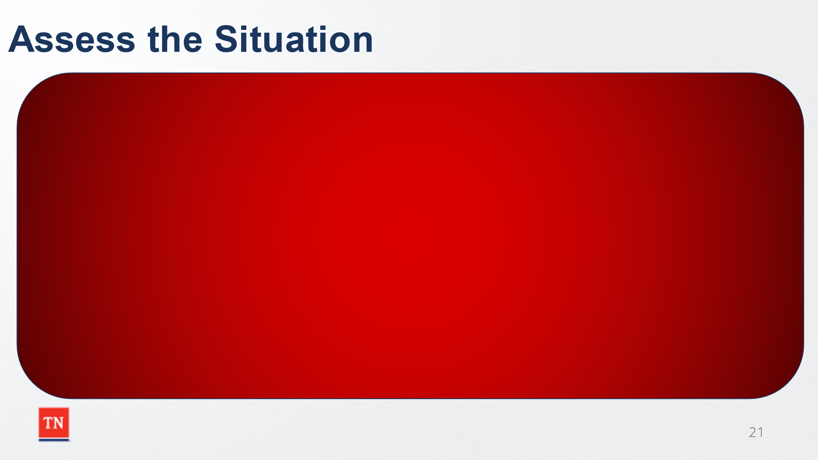
  - Identifying Strengths and Supports. This can be a good way to transition from the family story. Be mindful of asking specific people what the strengths are of another person. Discuss the difficulties teams may have in identifying strengths. Present other options to help identify strengths.
    - What is working well for your family? What has worked well in the past? What activities does your family enjoy doing together?
    - Utilize the Eco-Map and Genogram to help identify strengths
  - SHARE the handout Questions to Elicit Strengths with the group-NOTE how the questions are open-ended and help gather more of the family’s story.
  - Identify risks/safety concerns. Be mindful of helping the team identify underlying needs when possible.
  - Services involved presently and services utilized in the past o Past Successes and Past history/stressors
  - Worker recommendations

- 4. Brainstorming Solutions
  - Brainstorm ideas to address concern and provide safety and protection.
  - Ideas are usually in 3 categories:
    - Placement/Custody
    - Services to reduce risk
    - Action to provide safety

- 5. Develop Plan/Reach a Decision
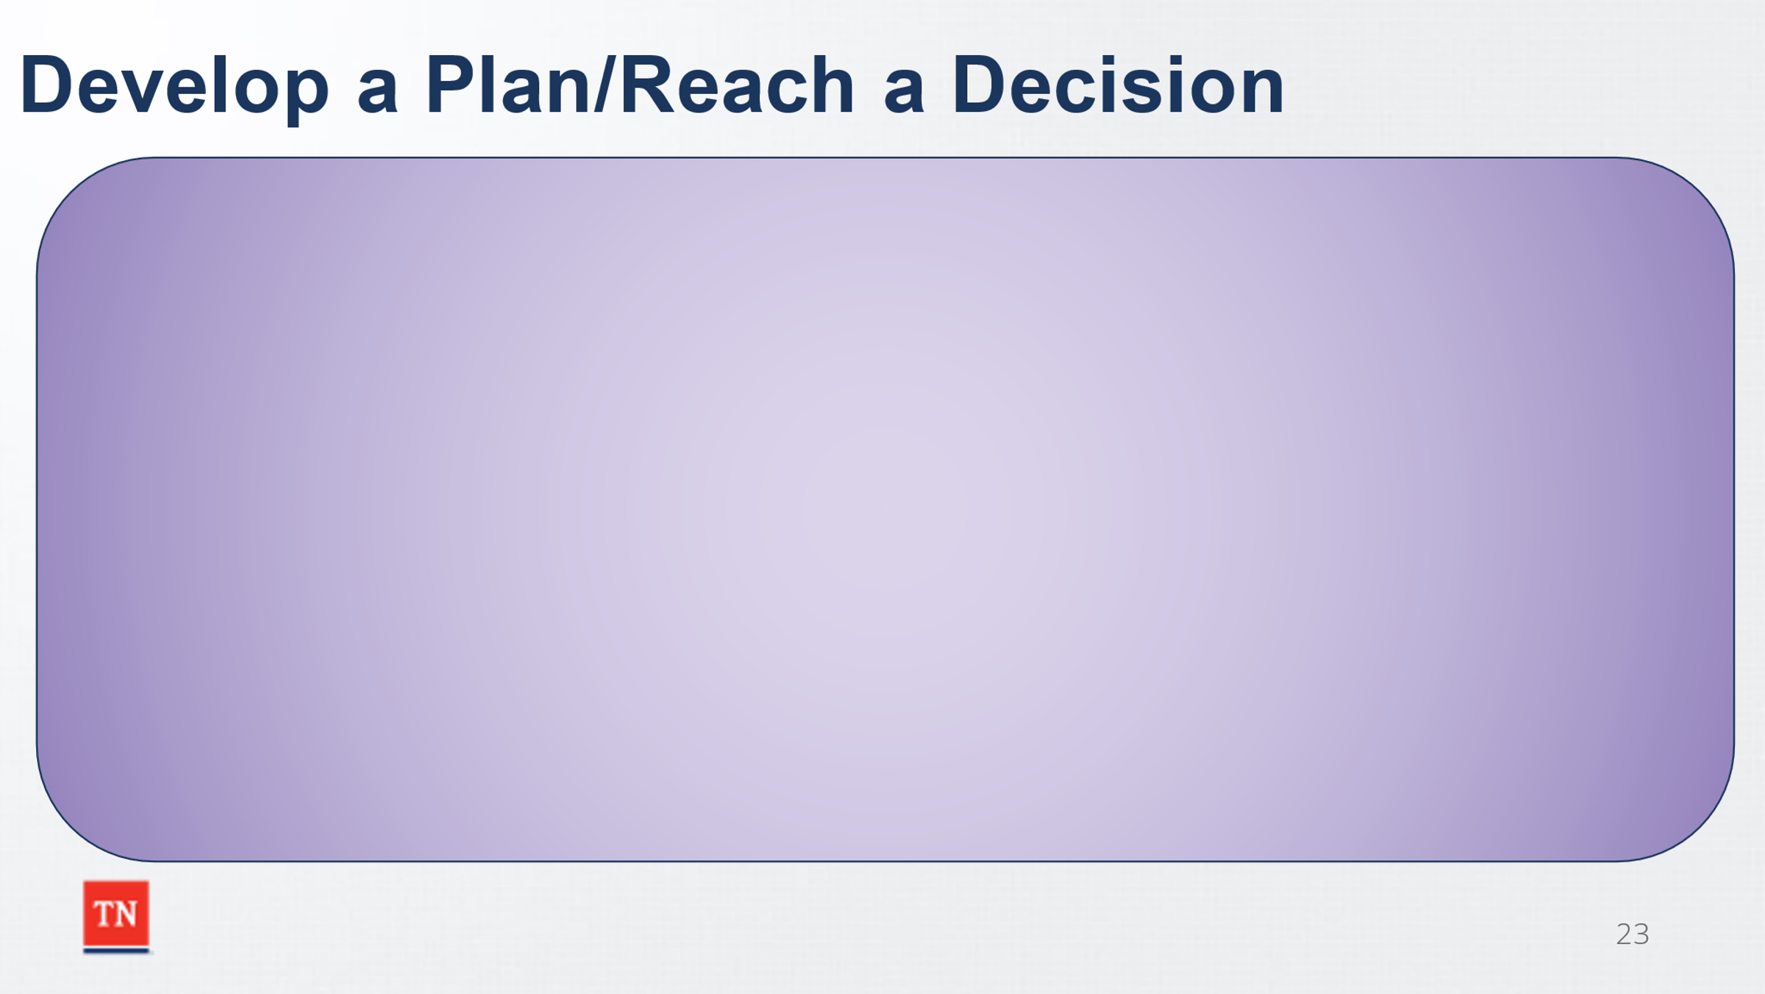
  - Plan will address all safety risks
  - The Child and Family Team will create an action plan which addresses the desired outcome. o Family will play a role in creating the plan while the Department ensures Safety, Permanency, and Well Being. o Plan will address all needs identified.
  - Utilize SMART (Specific, Measurable, Attainable, Realistic, Timely) to define action steps. o Contingency Plan will be discussed.

- 6. Closing/Recapping the Meeting/Summary
  - Review decision made, action steps, responsible persons, and timeframes.
  - Answer any remaining questions.
  - Schedule any follow up meetings needed. o Acknowledge and thank everyone for participating.
  - The participating team members at the close of the meeting sign the plan or the summary, which is copied and distributed to the meeting participants. If copying is not an option, the assigned worker distributes copies or scanned documents to members of the team within five (5) business days.
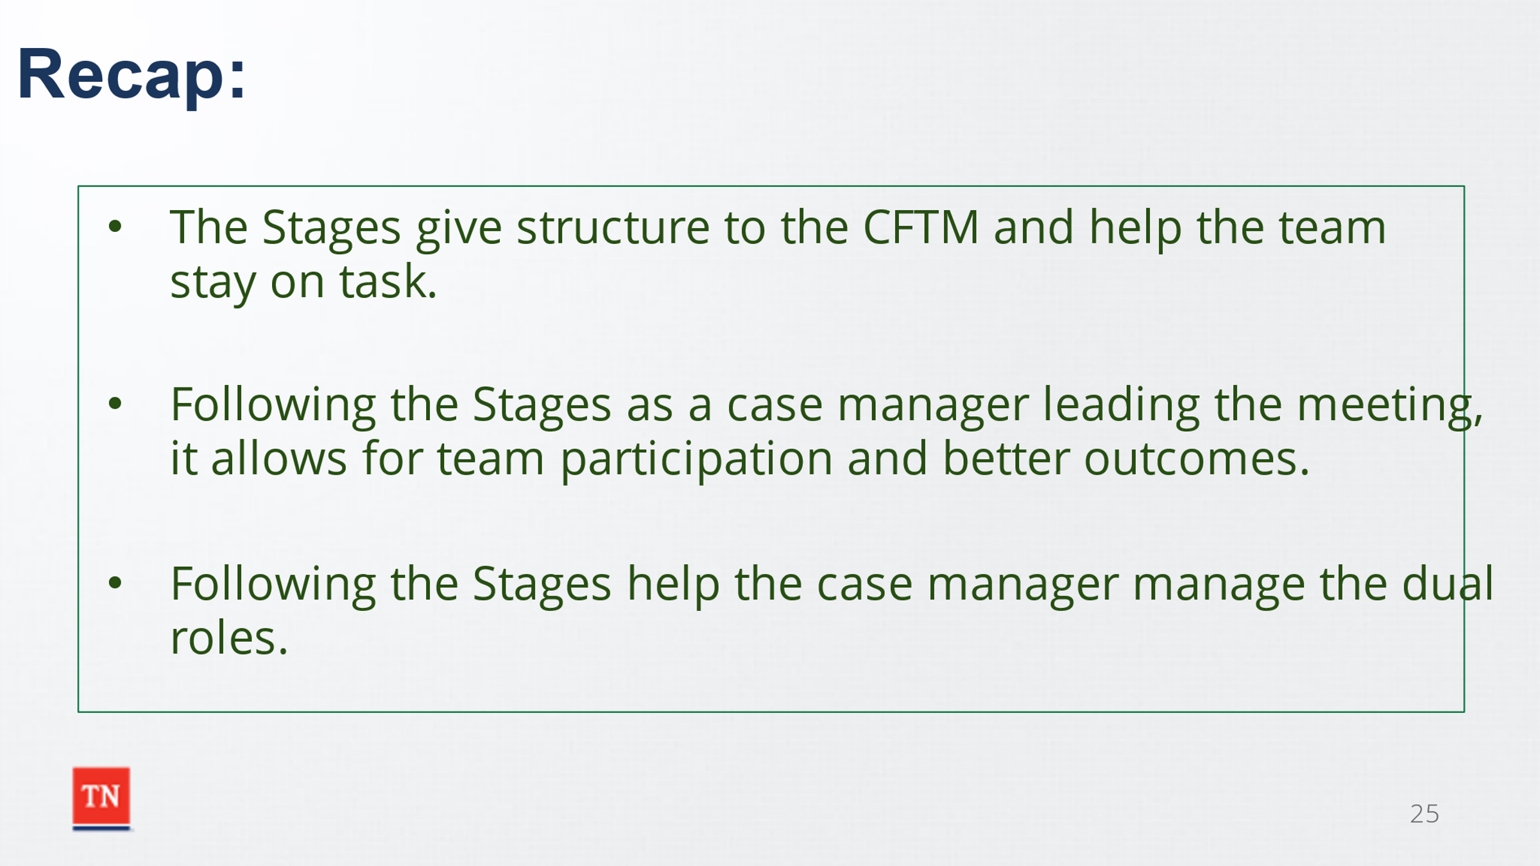
- RECAP by sharing the Stages give structure to the CFTM and help the team stay on task. SHARE by following the Stages as a case manager leading the meeting, it allows for team participation and better outcomes for children and families. SHARE it also helps as the case manager manages dual roles.
- ASK if there are any question regarding preparation or the Stages of the CFTM and TRANSITION into Unit 4: The Role of the Facilitator.

Unit 4: Facilitation Skills
Time: 25 Minutes
Learning Objectives:
Participants will:
- Participants will learn the role of the facilitator in a CFTM.
- Participants will learn engagement strategies to implement when the role is both case manager and facilitator.
- Participants will have a better understanding of the importance of communication skills in a CFTM.
- Participants will receive strategies and have a greater understanding of dealing with challenging behaviors in a CFTM.
Supporting Materials:
- Communication Skills Handout
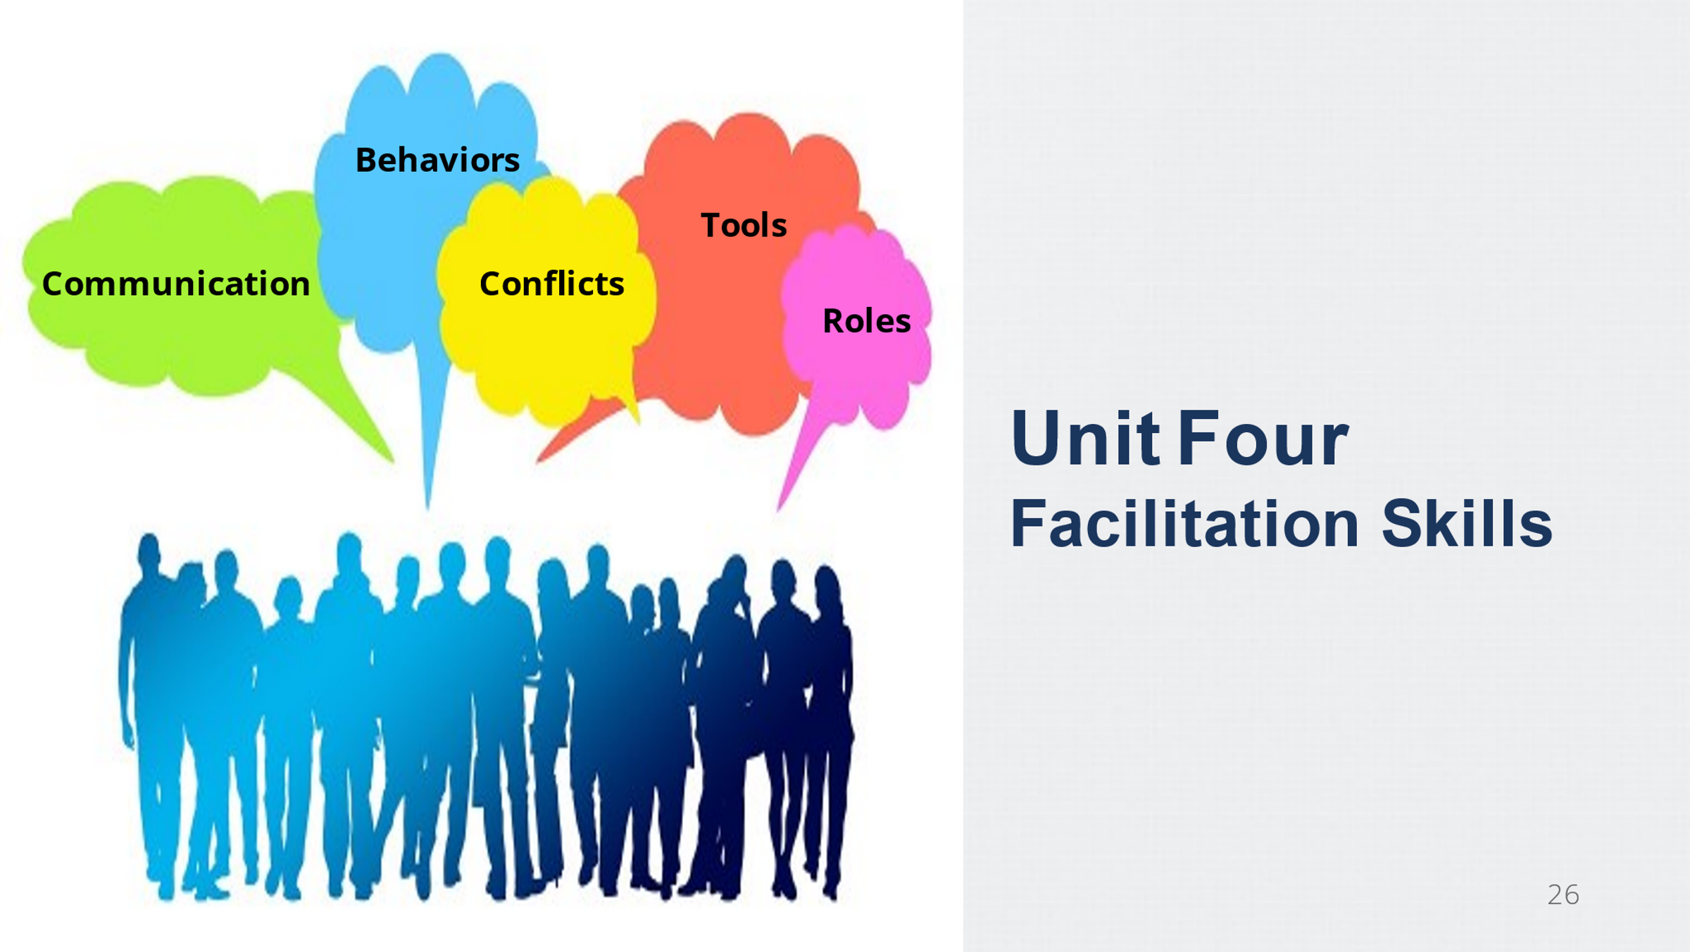
- Dealing with Challenging Behaviors Handout

Lesson 4.1 The Role of the Facilitator
Lesson Time: 10 minutes
Key Teaching Points / Instructions:

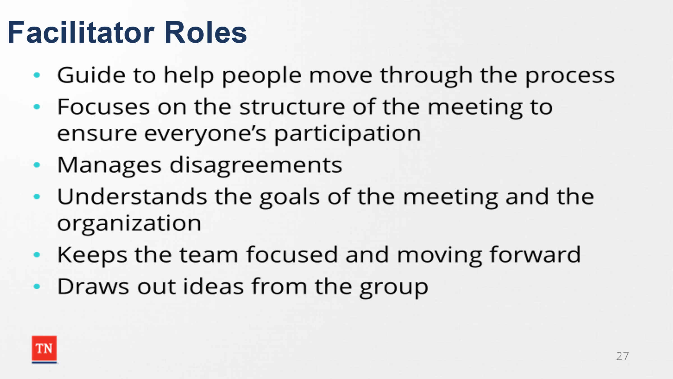
- INFORM participants we will now discuss the role the facilitator plays, and the skills needed to facilitate Child and Family Team Meetings.
- SHARE the roles of an effective facilitator includes:
  - A facilitator is a guide to help team members move through a process together and is not the seat of wisdom and knowledge.
  - A facilitator draws out opinions and ideas of team members and ensures decisions are made democratically.
  - A facilitator is generally objective about the content of the meeting.
  - A facilitator makes sure important decisions are discussed, made, and actions steps are ready to be taken.
  - A facilitator focuses on how the meeting is structured to make sure everyone can participate.
  - A facilitator creates an atmosphere which allows for everyone to feel comfortable sharing their ideas in the meeting, while drawing out quiet participants and managing domineering participants.
  - A facilitator ensures the team feels the ideas and decisions are theirs and not just one-sided.
  - A facilitator does not allow any member of the team to be criticized for their ideas when there are disagreements.
  - A facilitator has a good understanding of the goals of the meeting and the organization.
  - A facilitator keeps the team focused on the agenda and moving forward.
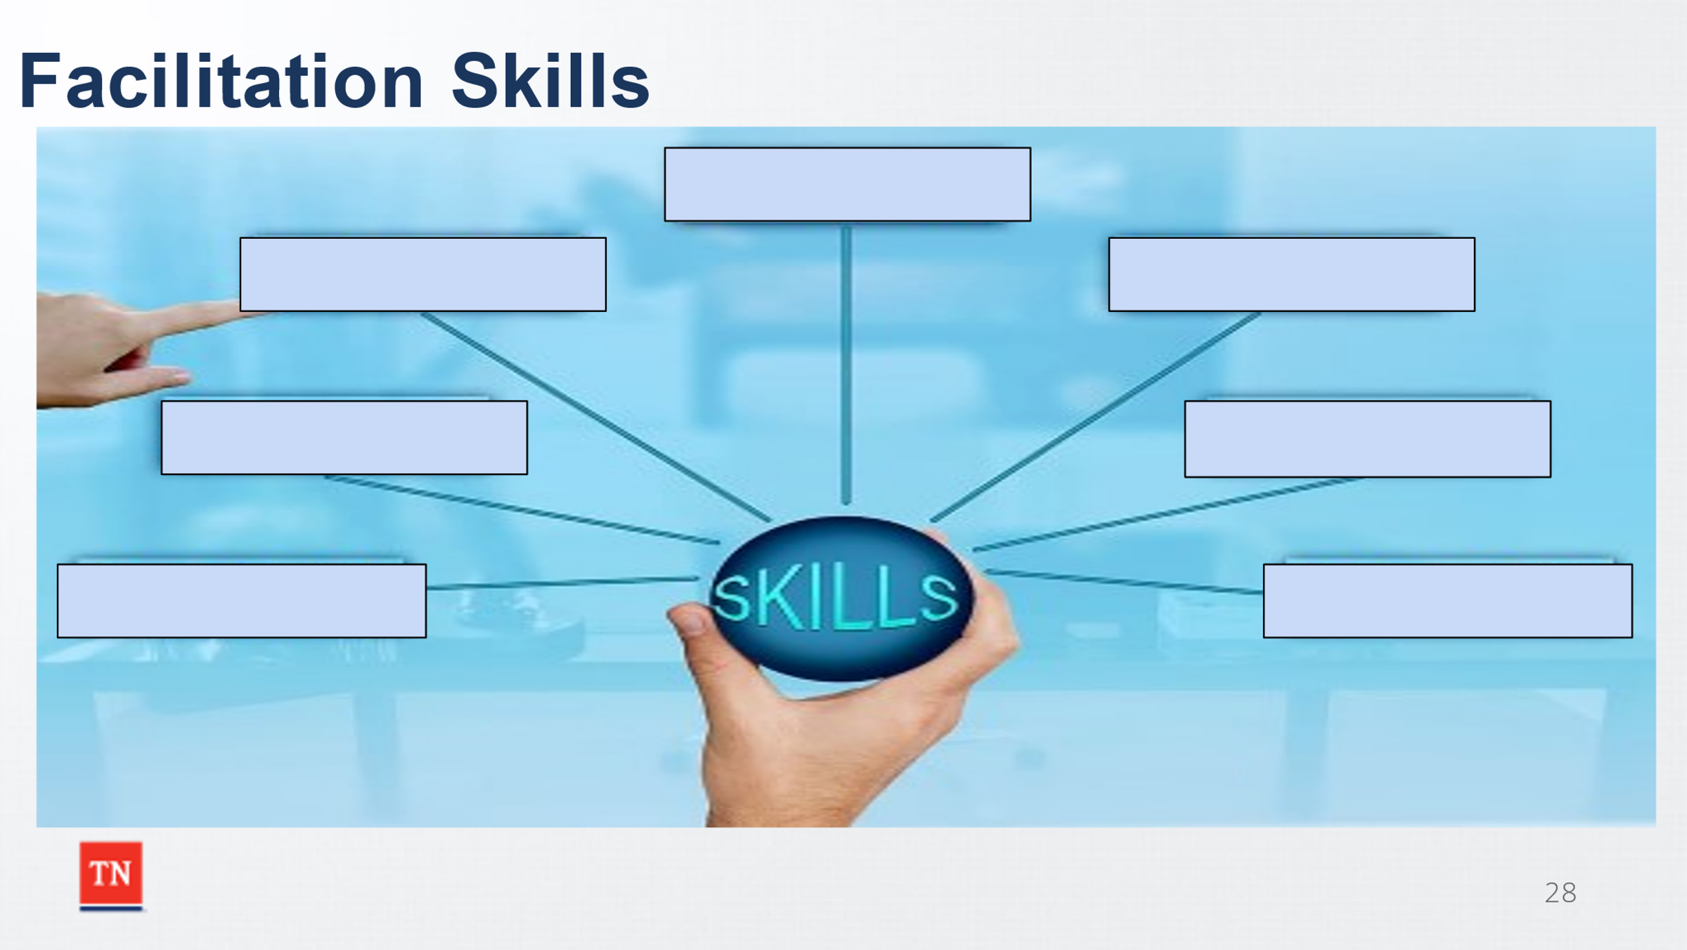
- ASK participants to share skills needed to effectively facilitate by annotating on the slide or prepared flip chart. ENSURE the following are mentioned:
  - Ask open-ended questions
  - Speak in a clear, concise manner using an even tone
  - Use wording all participants understand
  - Be respectful of all team members, always, even when it is necessary to redirect
  - Avoid labels such as abuser, mom, dad, kid (ask for preferred name or title)
  - Be aware of culture and potential biases both personally and from other team members
- SHARE at times the role of the facilitator and the case manager is played by the same person. TRANSITION into Lesson 4.2 Facilitator vs. Case Manager Roles.

Lesson 4.2 Facilitator vs. Case Manager Roles
Lesson Time: 15 minutes
Key Teaching Points / Instructions:

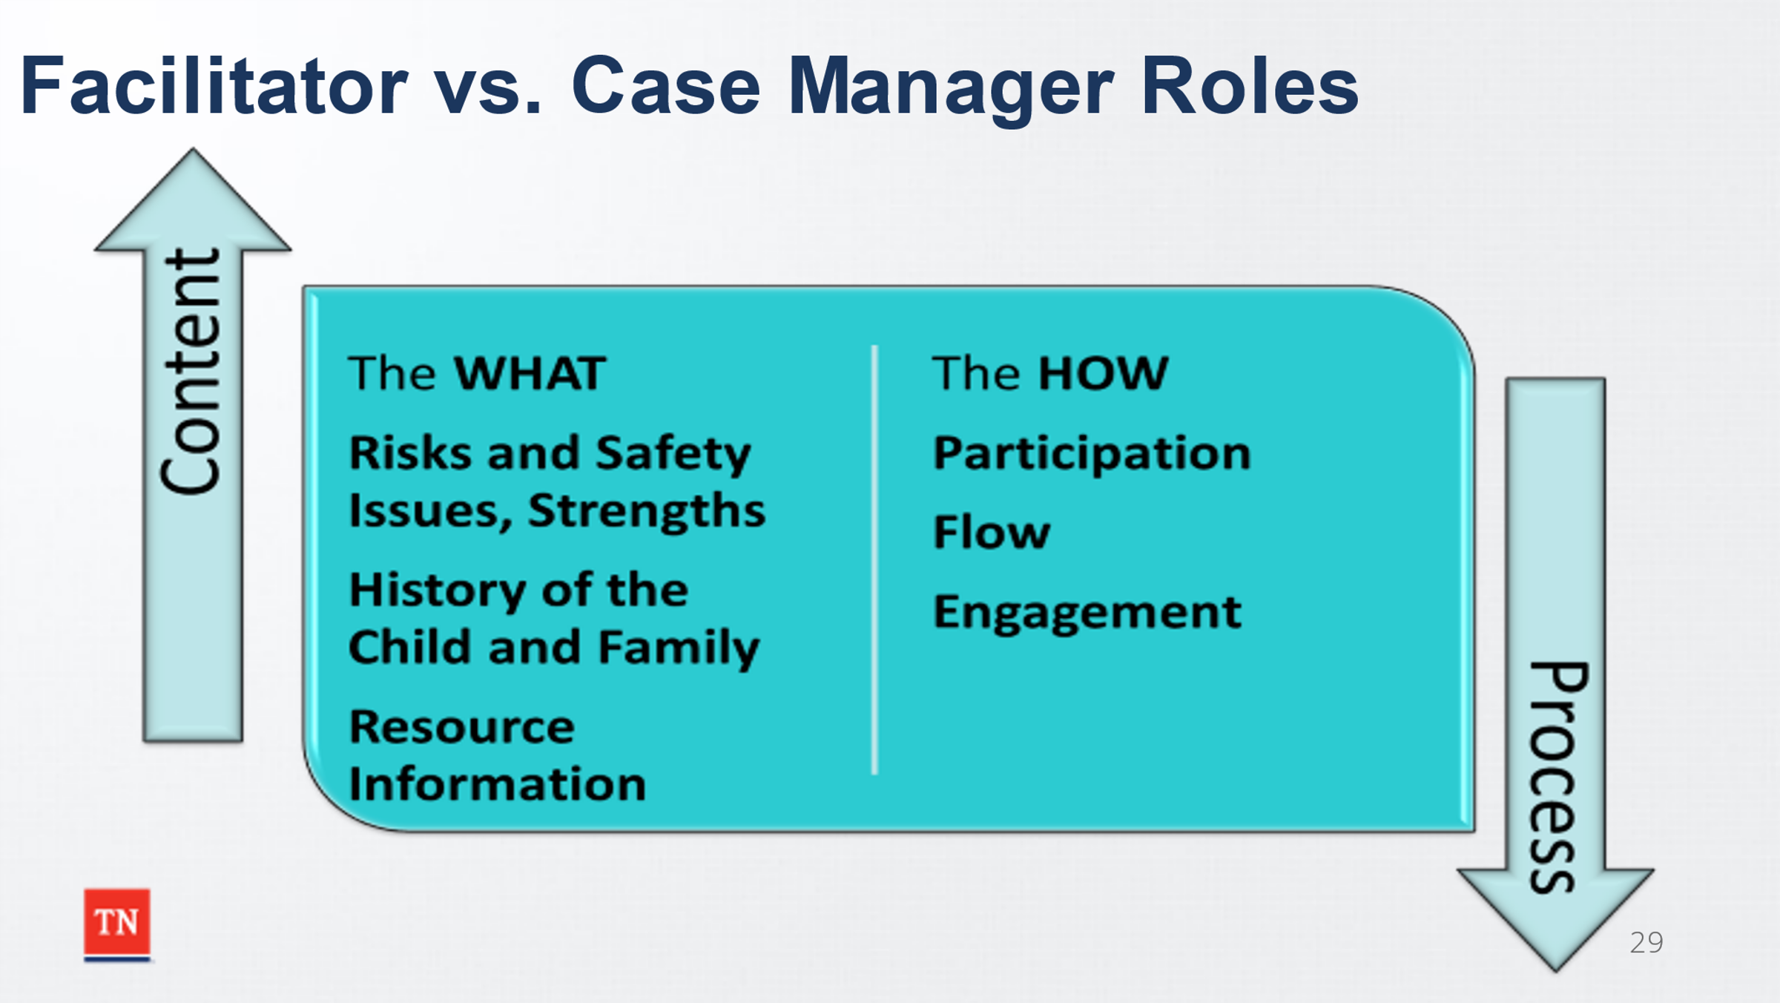
- DISCUSS the difference between content provided in a CFTM and the process of how a meeting is conducted.
- EXPLAIN the following:
  - CONTENT: WHAT the team is discussing
    - Risk and safety issues
    - History of the child and family
    - Strengths of the child and family
    - Assessment information
    - Information on Resources
    - Generally, the role of the Case Manager
  - PROCESS: HOW the team is discussing it
    - Participation
    - Flow
    - Engagement
    - Generally, the role of the Skilled Facilitator
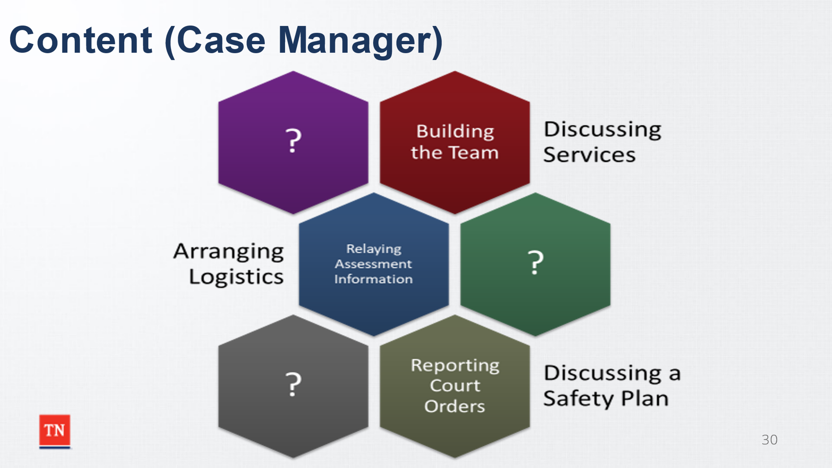
- SHARE the following examples of Content and Process. ASK the group to discuss what are other examples of Content and Process.
  - Content:
    - Building the Team
    - Discussing Services
    - Arranging Logistics
    - Relaying Assessment Information
    - Reporting Court Orders
    - Discussing a Safety Plan
  - Process:
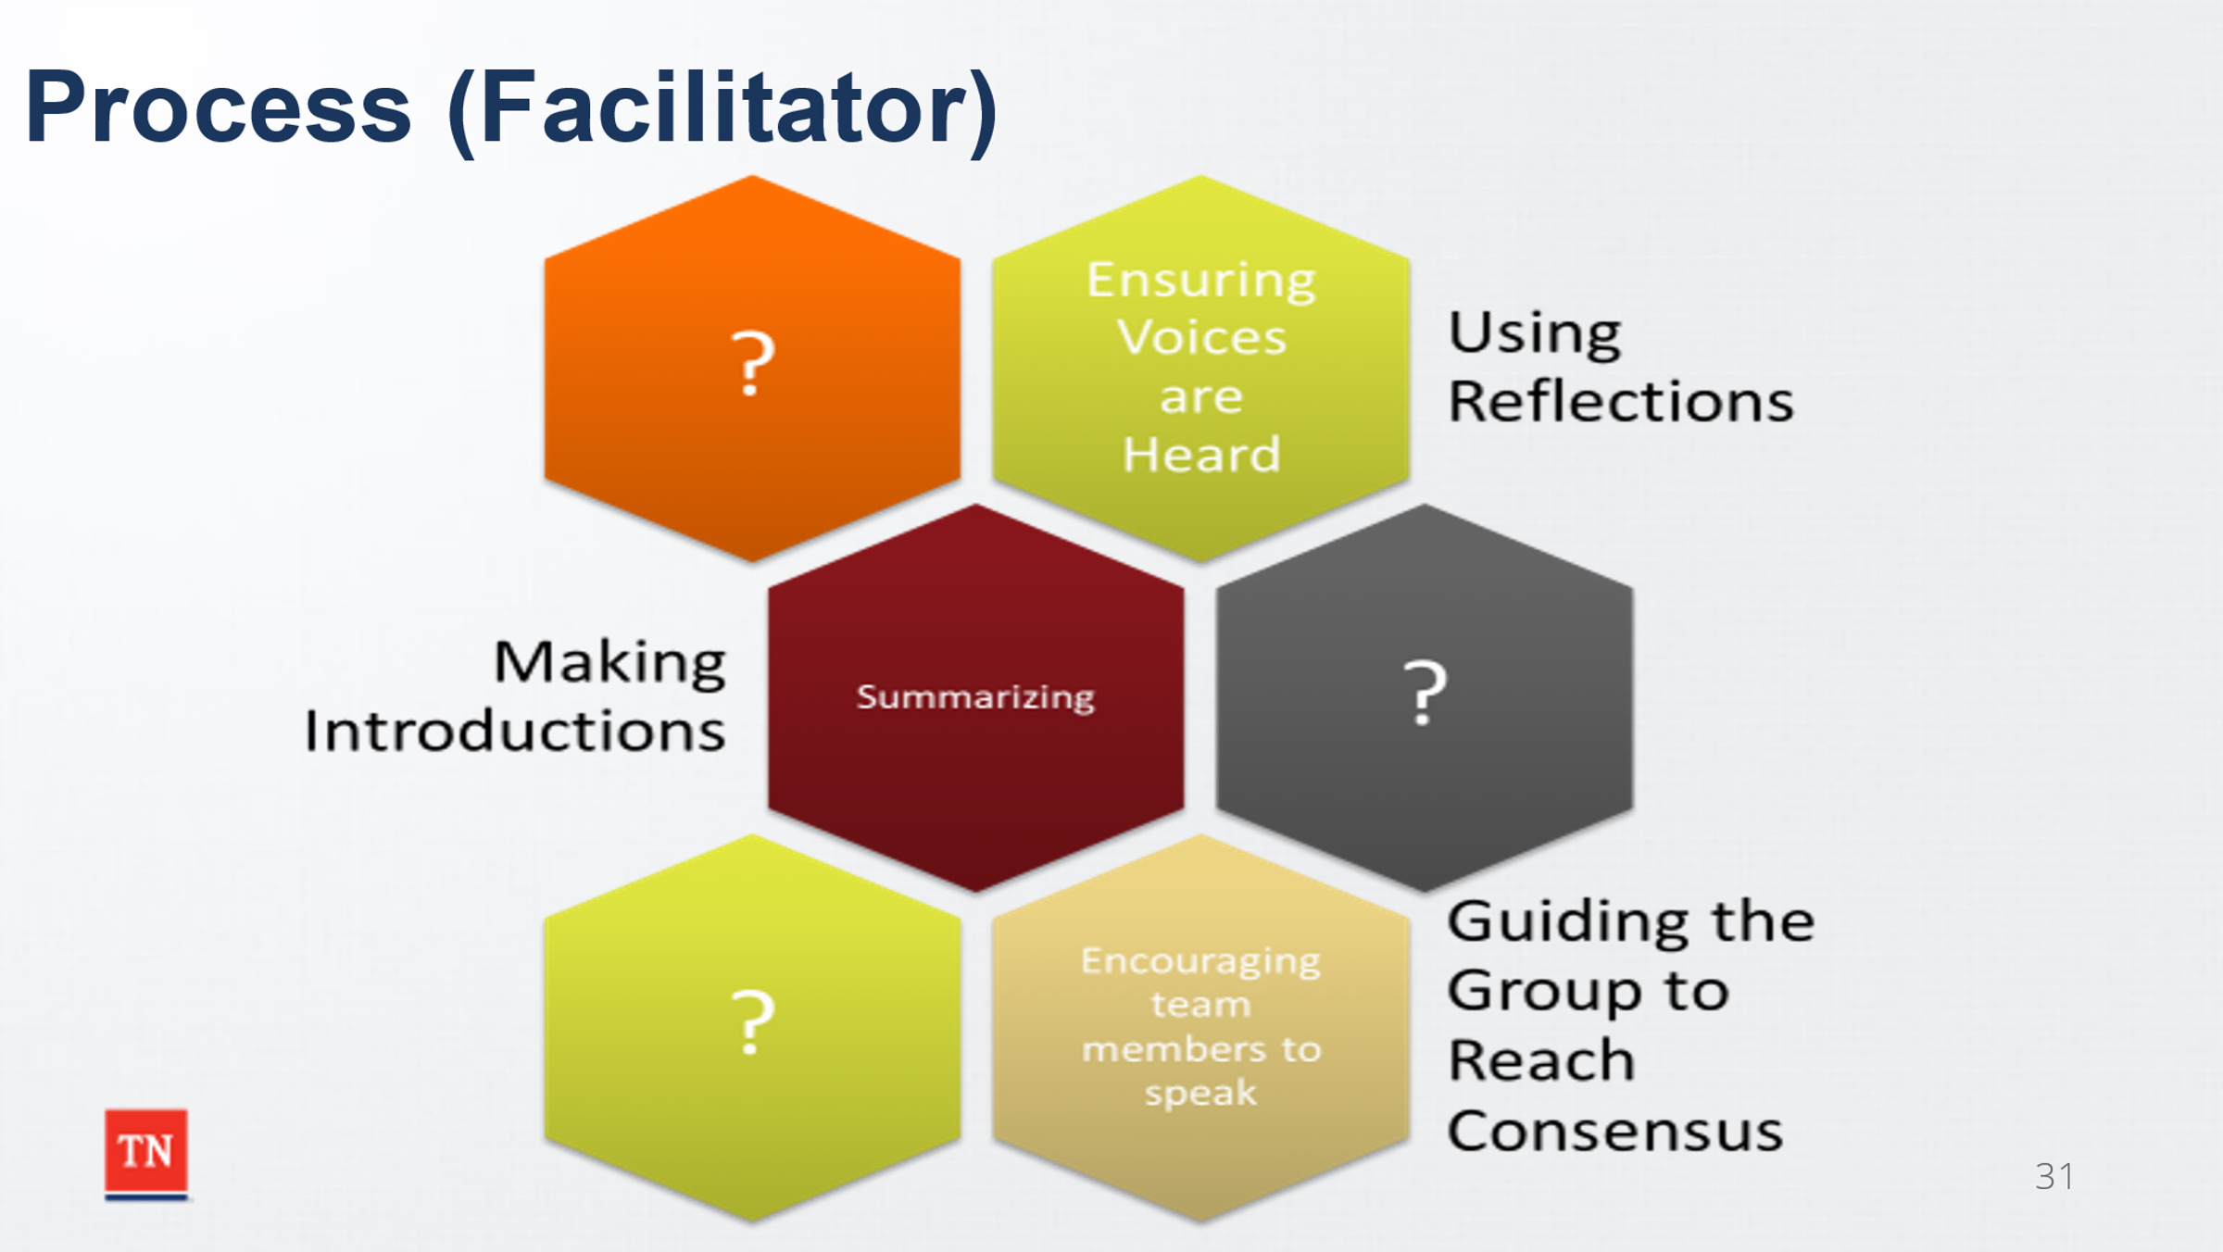
    - Ensuring Voices are Heard
    - Using Reflections
    - Making Introductions
    - Summarizing
    - Encouraging Team Members to Speak
    - Guiding the Group to Reach Consensus
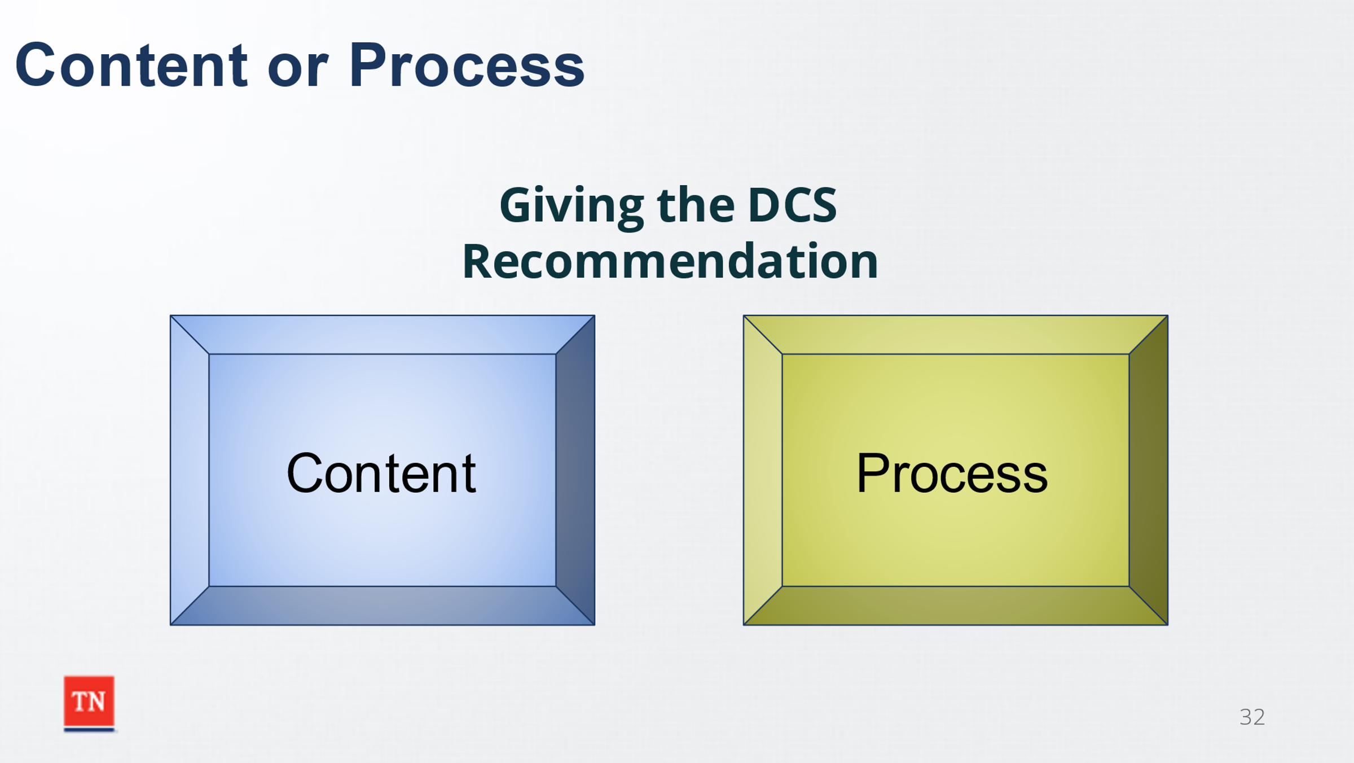
- ACTIVITY: LEAD the group through identifying if the statement on the slide is a part of content (case manager) or process (facilitator) during the CFTM.
Trainer Note: The purpose of this activity is for the group to discuss the actions and if it is that of content or process. This is not about right wrong.
  - Giving the DCS Recommendation (Content)
  - Leading the development of Comfort Rules (Process)
  - Being Objective (Process)
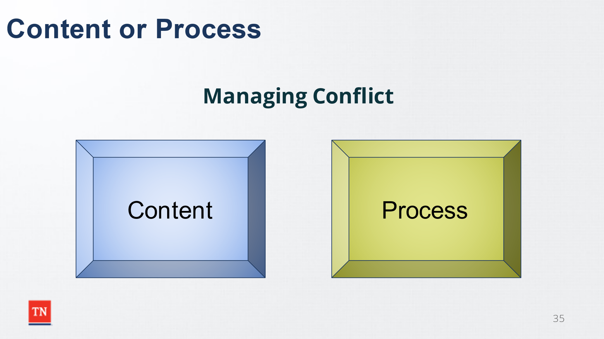
  - Managing Conflict (Can be both-Process)
    - SHARE although Managing Conflict is the primary responsibility of the facilitator, there may be times that other team members such as the Case Manager or Team Leader can help manage conflict.
    - ASK participants for other examples of when the roles overlap.
- SHARE the following examples:
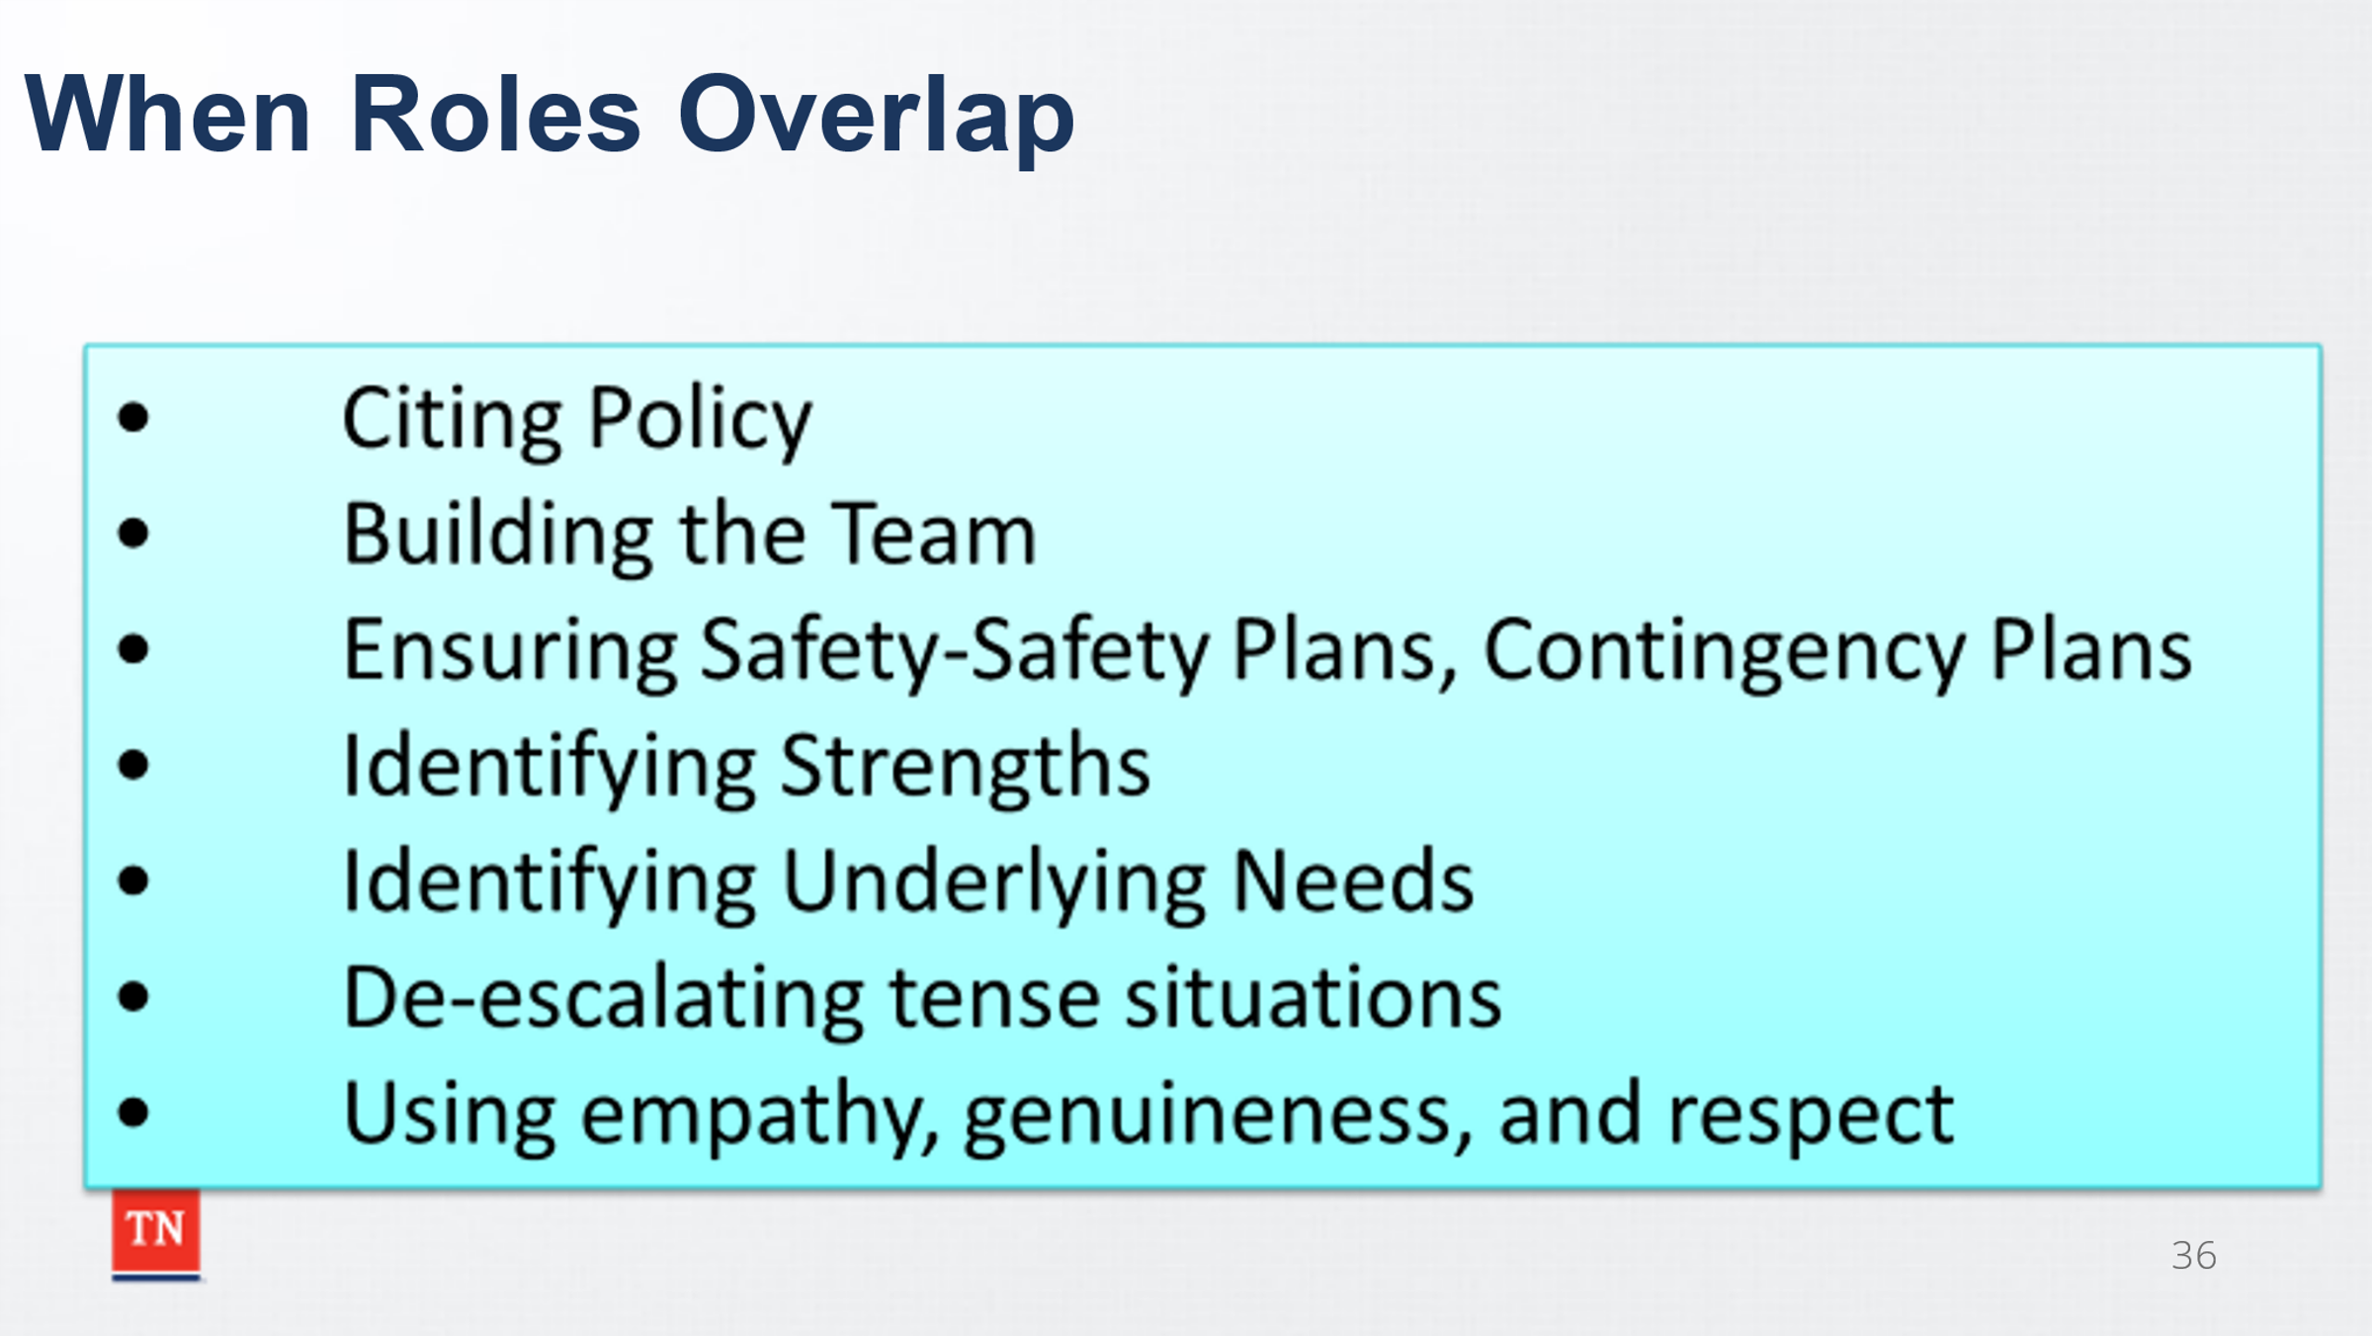
  - Both ensure crucial information is being covered.
  - Both ensure the correct paperwork is being submitted.
  - Both ensure policy is being following
  - Both ensure the plan addresses any safety issues.
  - Both are responsible for helping build the team.
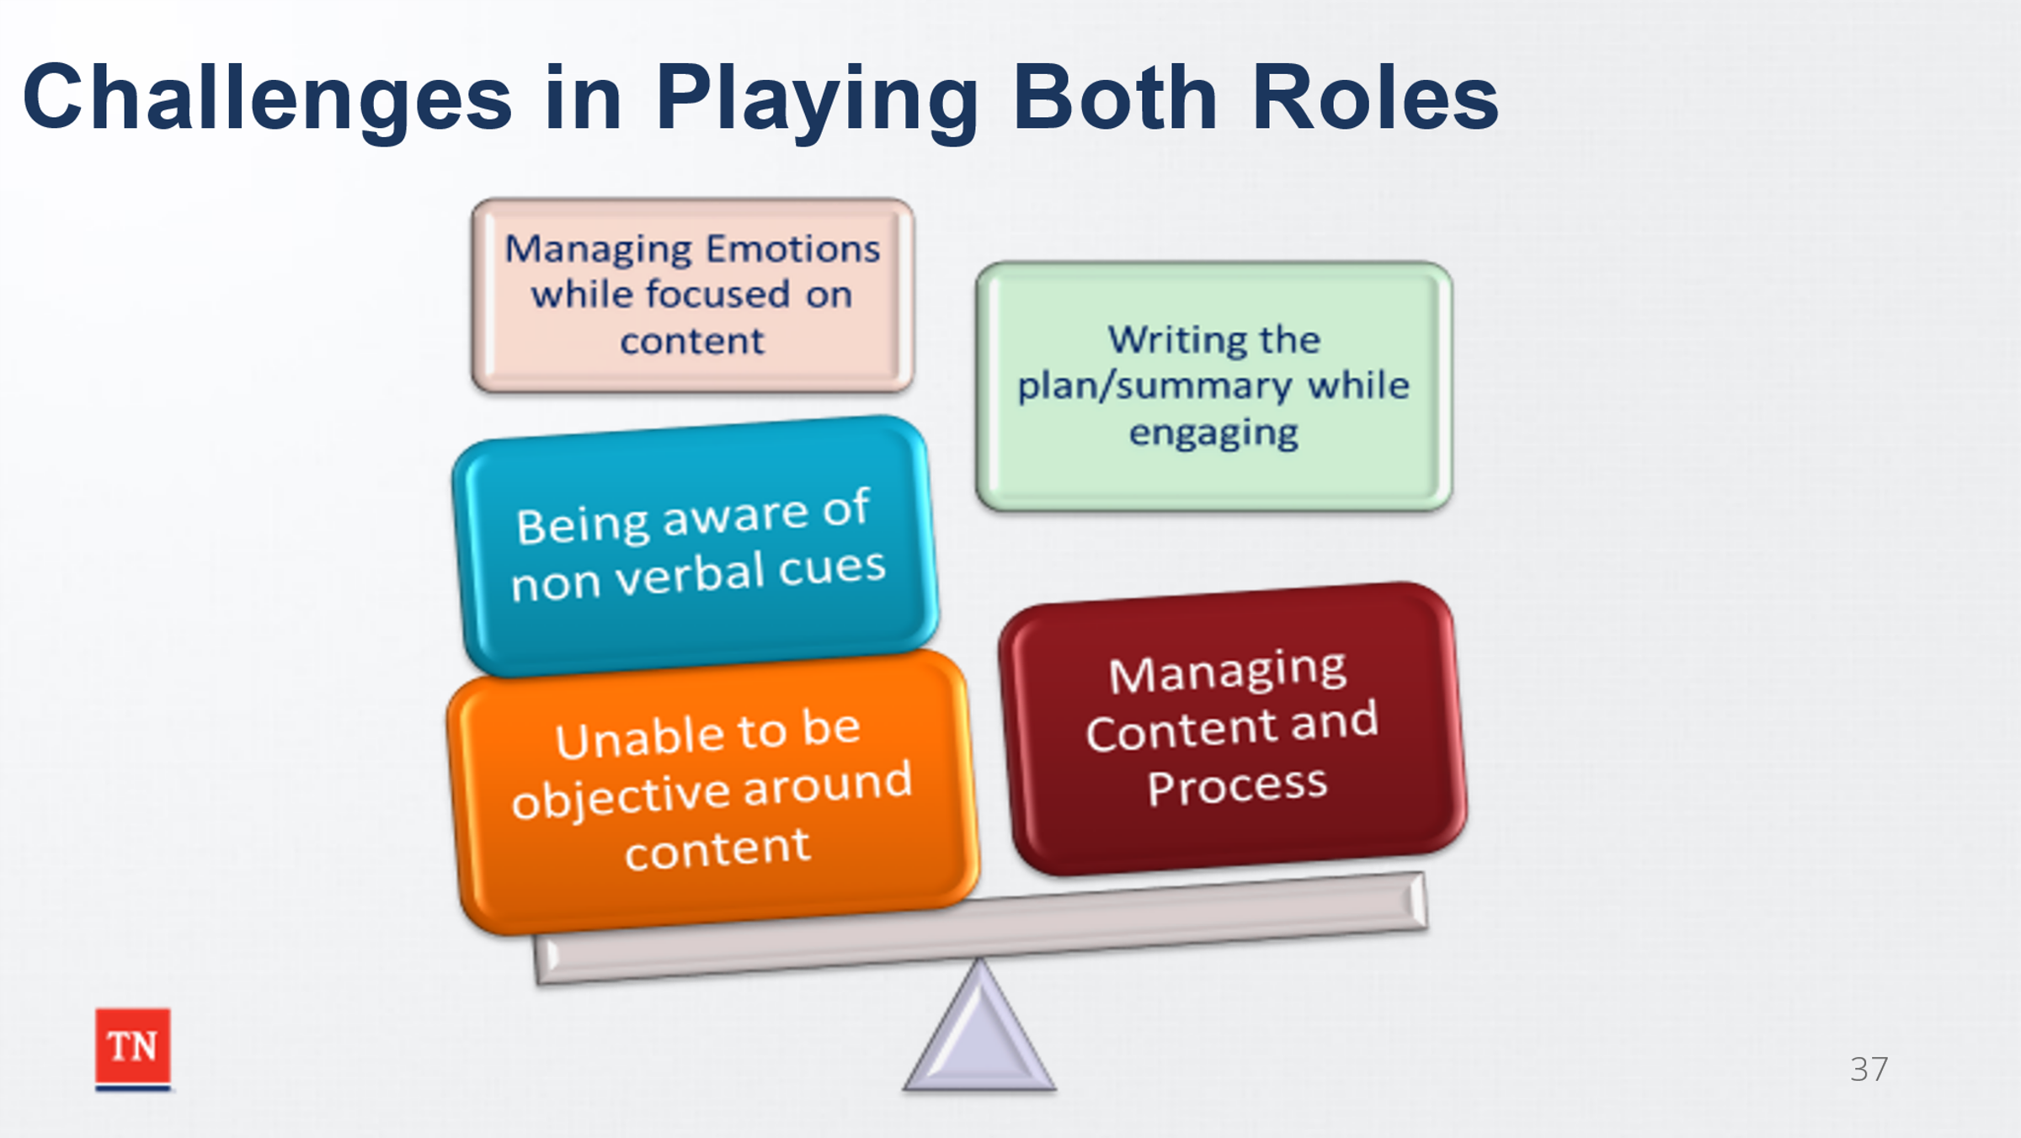
- ASK the group to share possible challenges of playing both roles. REVIEW the following:
  - Managing emotions while focusing on content.
  - Difficulty in remaining objective regarding content
  - Writing the plan and CFTM Summary while engaging the team
  - Keeping biases in check
  - Sharing content while using content
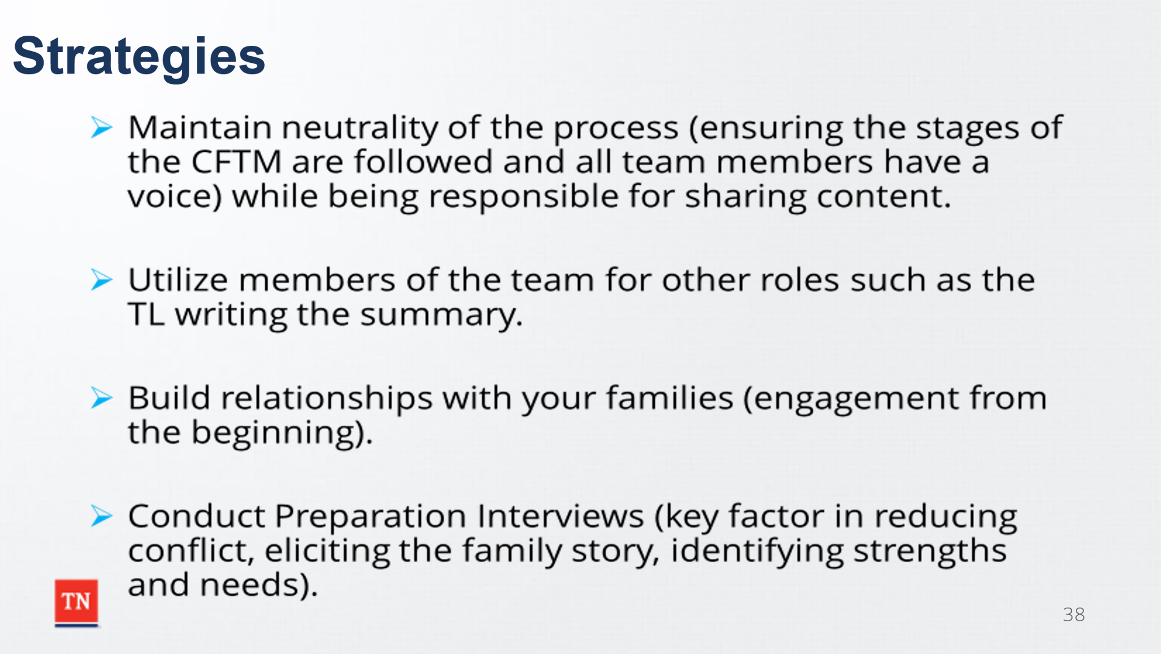
- DISCUSS strategies to manage the challenges of playing both roles. Strategies could include:
  - Maintain objectivity of the process (ensure the Stages of the CFTM are following and all team members have voice) while sharing content as the case manager.
  - Utilize members of the team for other tasks such as a Team Leader writing the summary.
  - Build relationships with your families-engage from the beginning.
  - Ensure preparation is completed-preparation interviews are a key factor in reducing conflict, eliciting the family story, and identifying strengths and needs.
  - Acknowledge the feelings of the team members.
  - Be open-minded, plan for the unexpected.
  - Ask for a team leader or another case manager to co-facilitate.
  - Formatting
- RE-EMPHASIZE content is WHAT we are talking about versus process being HOW we talk about it. REITERATE content is generally the role of the case manager and process is typically the role of the facilitator.
- TRANSITION into Lesson 4.3 Communication Skills.

Lesson 4.3 Communication Skills
Lesson Time: 10 minutes
Key Teaching Points / Instructions:

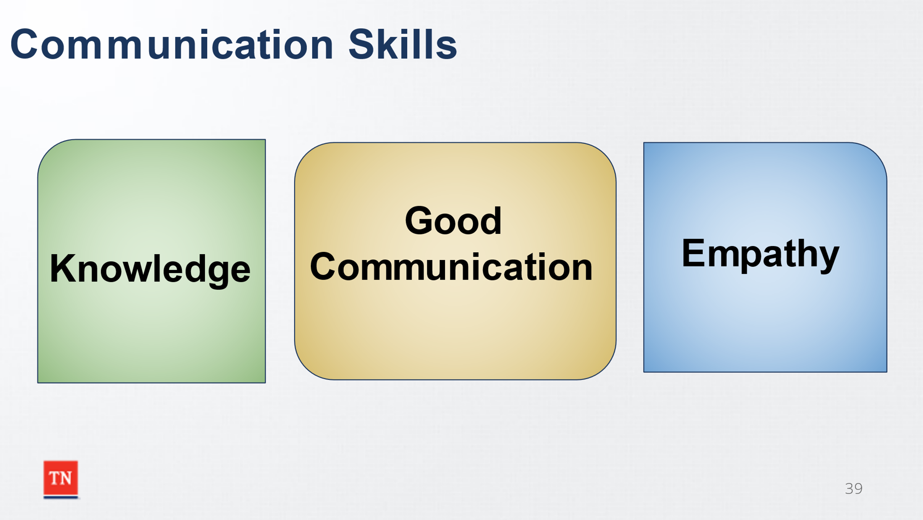
- BEGIN by ASKING participants which of the following is most important: Knowledge, Empathy, or Good Communication. STATE empathy and knowledge are critical, but if you cannot communicate, what good is it to have empathy or knowledge.
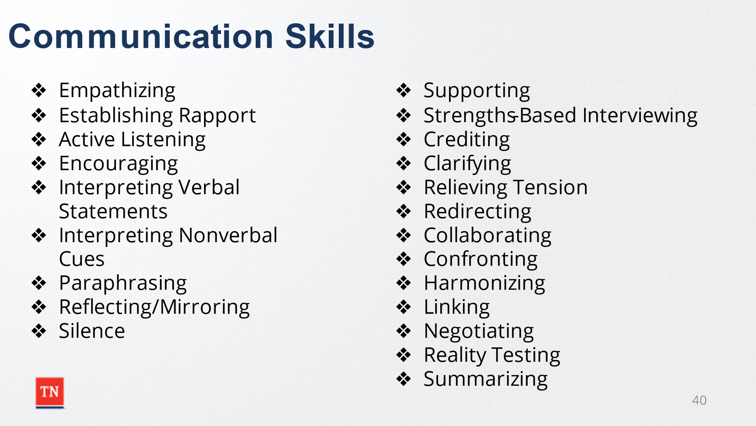
- SHARE communication skills in a CFTM are important to have as the facilitator. SHOW the handout, Communication Skills, which can also be found in the Participant Guide. ASK participants what skills stand out to them. DEBRIEF noted responses.
  - Empathizing: Entering the feelings or ideas of another, putting oneself in another person’s shoes.
  - Establishing Rapport: Developing a relationship or connection with another person. Showing others, you are interested in them and willing to listen. Inviting them to say what’s on their mind and using the person’s name.
  - Active Listening: Trying to see the problem the way the speaker sees it. Requires entering actively and imaginatively into the other person’s situation and trying to understand a frame of reference different than your own. (Reflective Listening)
  - Encouraging: Friendly, warm, and responsive to others; accepts others; Asks for responses, ideas, and feelings of all participants. Examples
    - “Tell us more…”
    - “You were saying…”
    - “Describe…”
    - “Is there other viewpoints on this subject?”
    - “Is there something we haven’t though of?”
    - “Anything else?”
  - Interpreting Verbal Statements: Exploring and clarifying statements so the meaning is understood.
  - Interpreting Nonverbal Cues: Translating the non-spoken messages, provided by body language and paralanguage—the inflections and other vocal and gestural nuances added to language to convey meaning. Body language includes facial expressions; eye contact and movement; head, arm, and hand movements; and body postures and shifts. Whether automatic or learned, body language can corroborate or contradict what a person says or doesn’t say in words.
  - Paraphrasing: To check communication accuracy between speaker and listener. Saying back to the speaker, in your own words, your understanding of what the person has said, to make sure you understand the content and meaning of the message you hear. “If I understand correctly, you are saying…”
  - Reflecting/Mirroring: To share or repeat what you heard or saw. From time to time, the facilitator comments on either the content or the process of the meeting and asks the group to respond. “I notice we’re only talking about foster care placement, is there any other option?” (Content-focused) or “We agreed to hear everyone out, and there seems to be a lot of interrupting going on? How is this affecting participation?” (Process-focused)
  - Silence: Being powerfully quiet. Ask a question, pause, wait, say nothing.
  - Supporting: Assisting or aiding either verbally and/or non-verbally, nodding head, saying “Okay,”” Thanks,” “That’s a great idea,” etc.
  - Strengths-Based Interviewing: Respectfully questioning to allow families to recognize and to be recognized for their strengths. Involves listening, observing, complimenting, encouraging, asking, and talking about successes.
  - Crediting: Recognizing the contribution and efforts of a person. It is giving credit where credit is due and remembering to do it.
  - Clarifying: Interprets ideas or suggestions; Clears up confusion; Defines and explains terms, jargon, acronyms; Indicates alternatives and issues confronting the group. Example: “I don’t understand, did you say…”
  - Relieving Tension: Alleviating or lessening the level of emotional stress or anxiety. Example: “There are a lot of strong feelings being expressed. Maybe we all need to take a deep breath for just a moment.”
  - Redirecting: Recognizing when the group is getting off-track and bringing them back to focus on the best interest of the child and the purpose of this CFTM. This may be done directly, as in “I think we’ve gotten off on a tangent..” to less directly, as in “I heard you say earlier Ms. Jones, you’ve been worried about Johnny for a while. Can you tell us a little more about what was worrying you?”
  - Collaborating: Working together; assisting; “Let’s see if we can work on this together.”
  - Confronting: To push others to acknowledge problems, feelings, or behaviors when other less directive interventions has failed to do so. It may increase resistance if not successful, difficult to use without an established and supportive relationship.
  - Harmonizing: Attempts to reconcile disagreements and find areas of commonality; Gets people to explore their differences. “Sounds as if you have the same goal, but different ideas how to get there…”
  - Linking: Joining parts together to assist in making connections and build understanding. “Sounds like your though/ideas are similar to what X had to say.”
  - Negotiating: Discussing to build agreement, asking for what you want and listening to the other person. Secret of successful negotiating is listening.
  - Reality Testing: Checking if the idea is sound and can be implemented. Is it viable?
  - Summarizing: Pulls together related ideas; May assist with keeping discussion on track. Helps to concisely organize information. Restates suggestions or ideas after the group has discussed them. Example— “Let me see if I understand you correctly. So far, you said…”
- SHARE communication skills are important in all CFTMs. TRANSITION to Lesson 4.4 Challenging Behaviors in CFTMs.

Lesson 4.4 Challenging Behaviors in CFTMs
Lesson Time: 20 minutes
Key Teaching Points / Instructions:

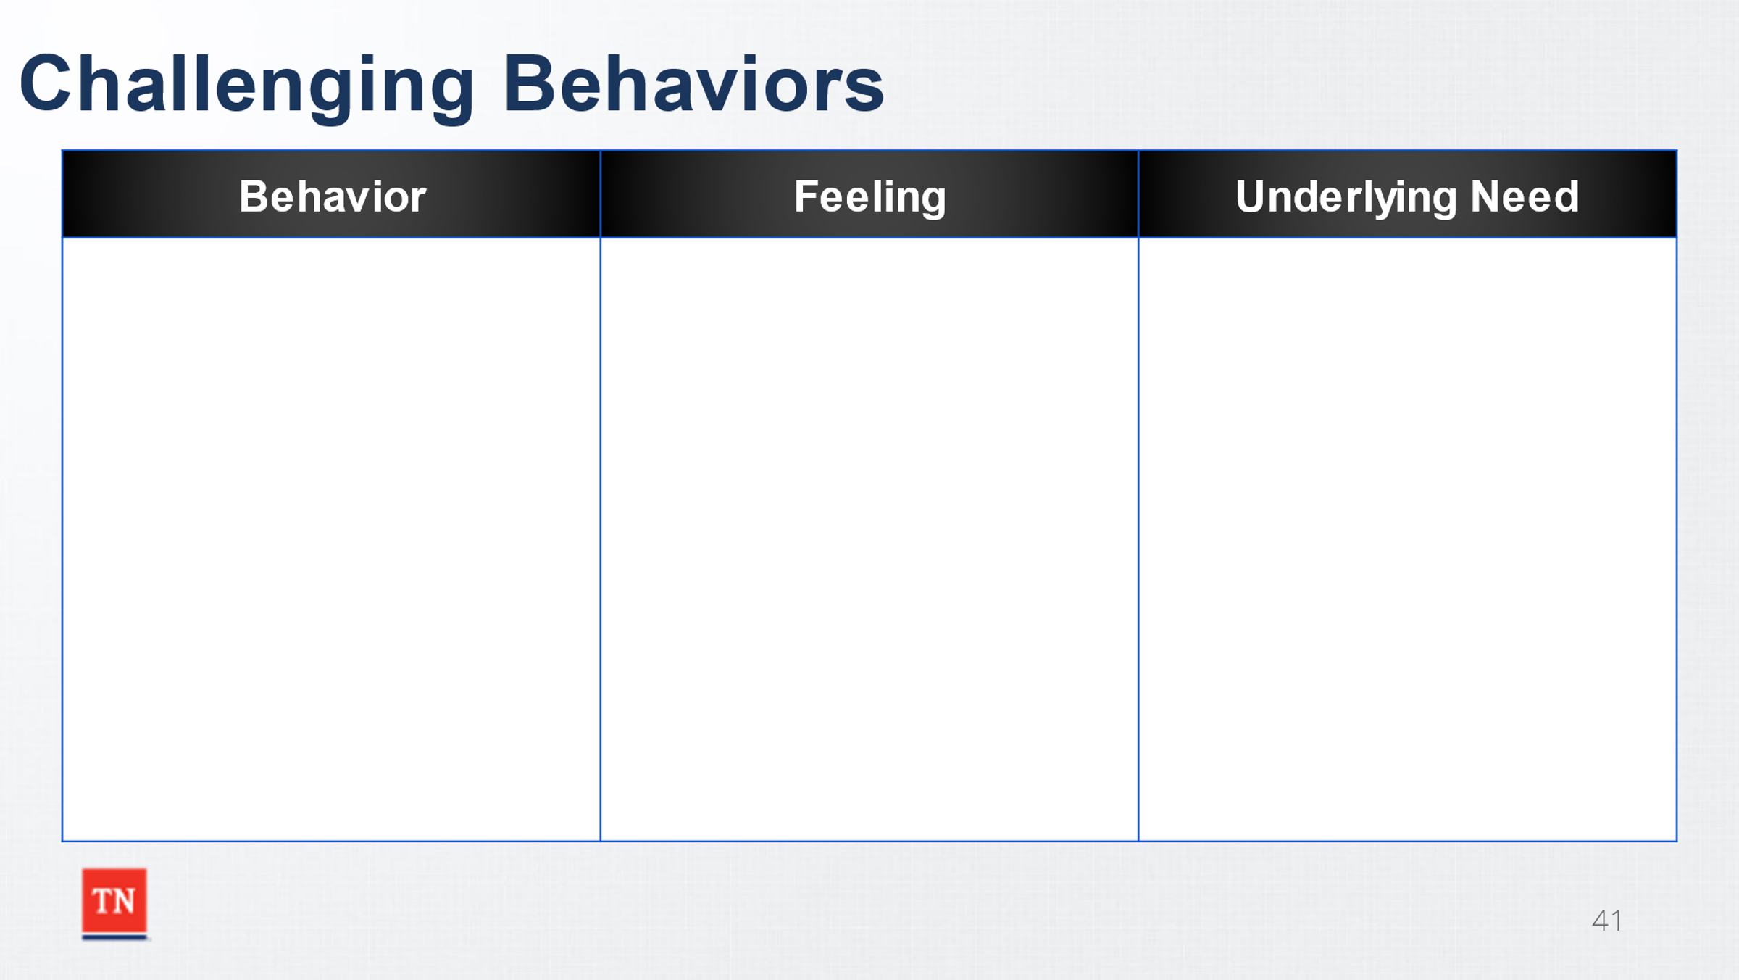
- SHARE it is important to recognize challenging behaviors in CFTMs, and it is best if they are prevented from escalating. STATE behavior is the expression of a need, even in a CFTM. If we can’t meet the need, it must at least be acknowledged.
- STATE addressing the behavior without recognizing the underlying needs does not improve the behavior. The behavior will continue, escalate, or even produce a new behavior.
- ASK “What are some challenging behaviors in CFTMs?” Examples may include name calling, profanity, etc. DOCUMENT the challenging behaviors on the slide or prepared flip chart. Next, LEAD, the group into discussing/identifying feelings behind the behaviors. DOCUMENT the feelings on the slide or flip chart. Lastly, LEAD, the group to identify possible underlying needs or what could be driving the behaviors and feelings. DOCUMENT on the slide or flipchart. SHOW the handout, Dealing with Challenging Behaviors, to the group and REVIEW strategies for a few of the behaviors identified. STATE this handout can be useful to take to CFTMs to help give options as you facilitate your own meetings.
- ASK if there are any questions, and TRANSITION to Unit 6, The Practice Wheel.

Unit 5: The Practice Wheel
Time: 35 minutes
Learning Objectives:
- Review the Core Conditions which lead to successful engagement.
- Discuss the importance of hearing the Family Story.
- Learn ways to elicit the Family Story during the CFTM.
- Understand the importance of stacking for success when helping the family build their team.
- Review the meaning of formal and informal supports.
Supporting Materials:
- Remembrances from Childhood, Part 1 and Part 2 Handouts
- Genogram (CS-0774)
- Family Eco-map (CS-0782)
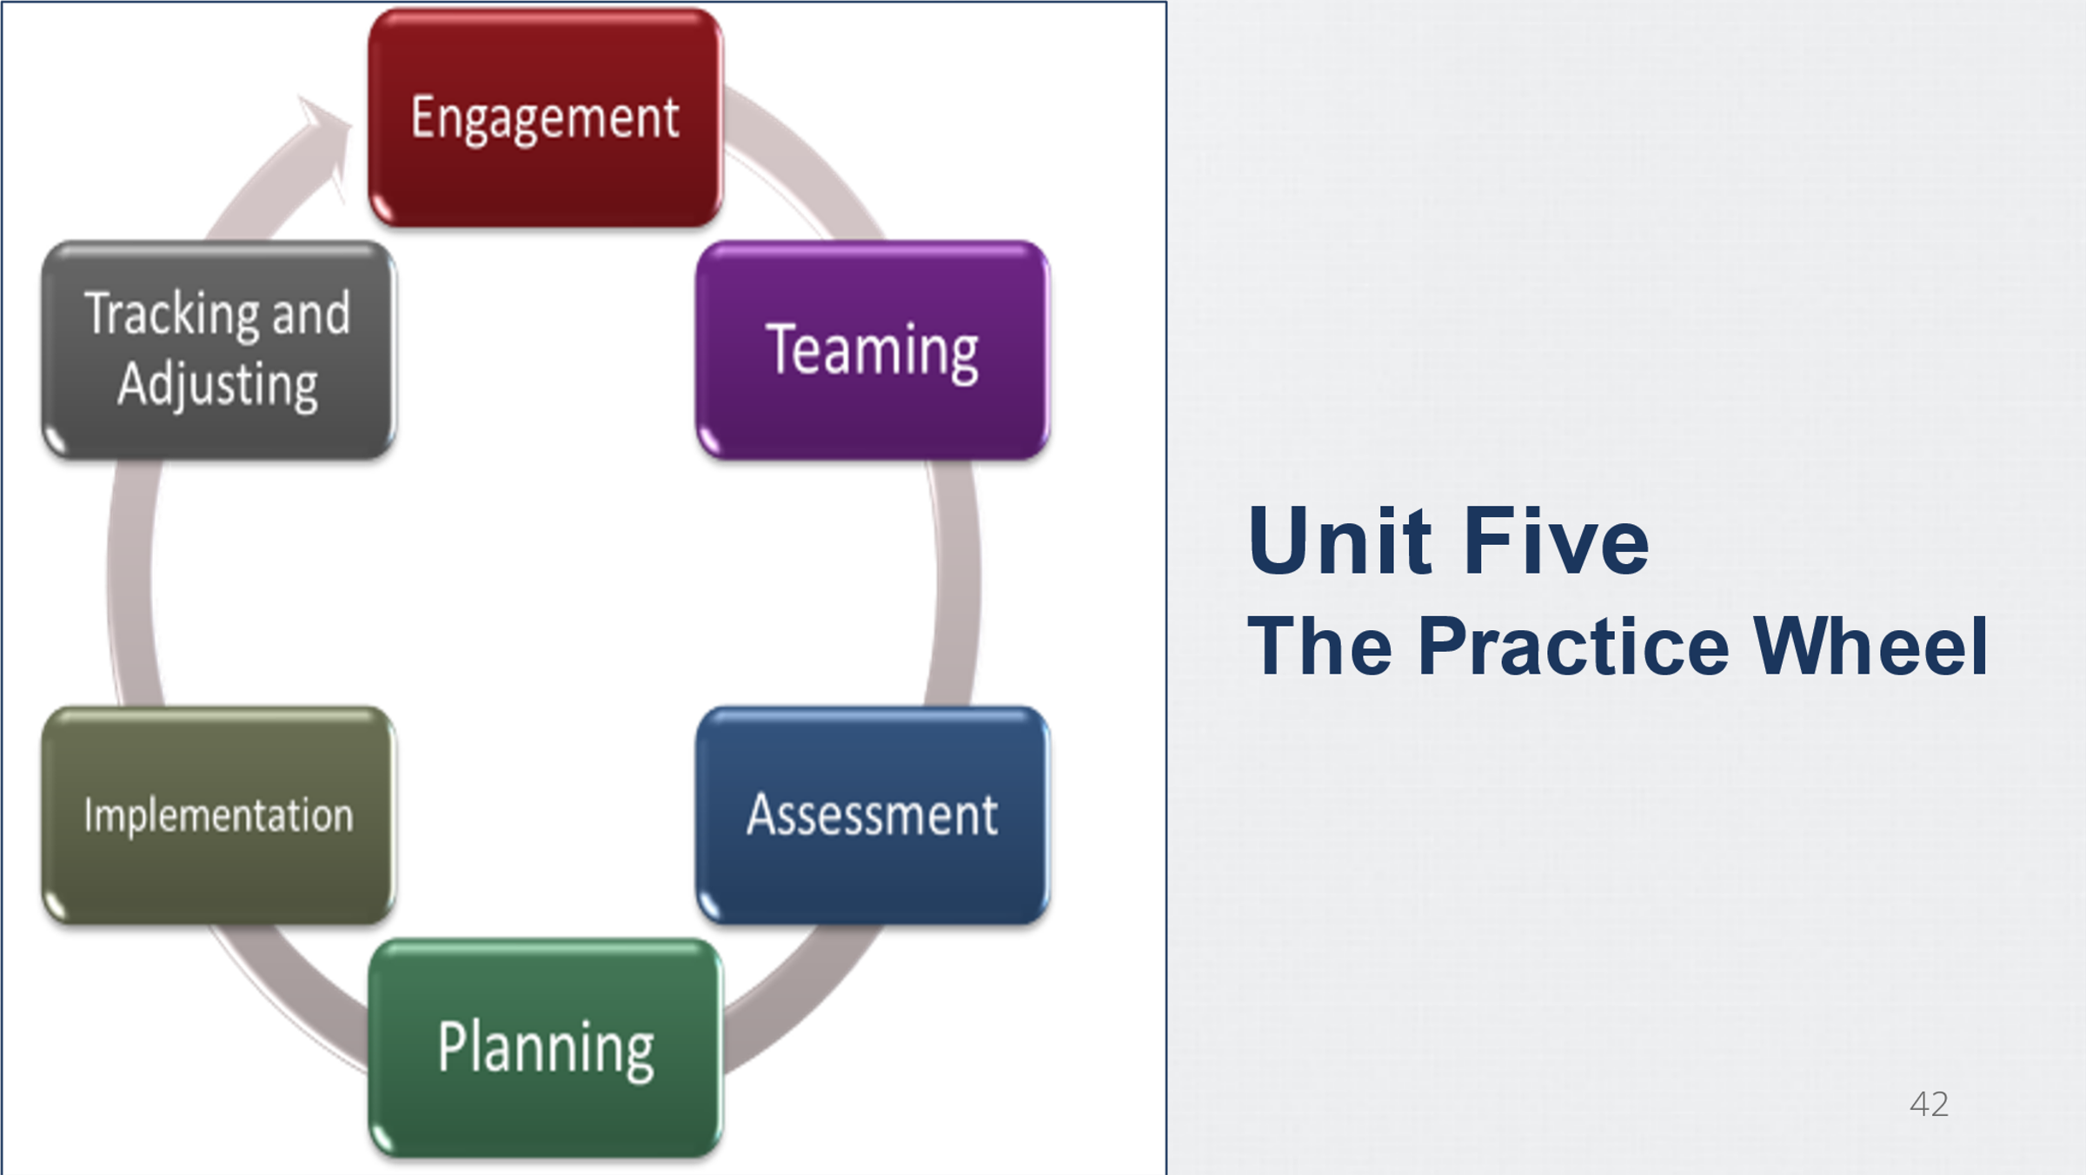
- Child and Family Team Meeting Guide

Lesson 5.1 Engagement
Lesson Time: 15 minutes
Key Teaching Points / Instructions:

Trainer Note: The Empathy Orientation Handouts could trigger emotional responses from participants. ENCOURAGE participants to take a break if they need to take a moment or reach out to a trainer through the chat box.
- BEGIN by asking What is Empathy?
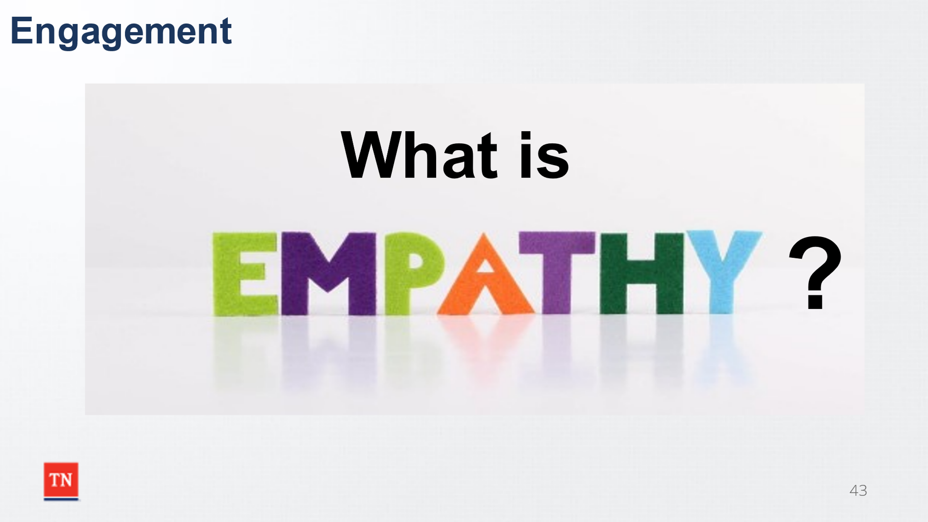
- EXPLORE empathy, and how you know when empathy is needed in a CFTM. SHARE empathy is where you can hear other people’s perspectives from their frame of reference while being present. Empathy is the capacity to understand or feel what another person is experiencing from within their frame of reference, that is, the capacity to place oneself in another person’s position. Empathy is NOT feeling sorry for the other person. It is listening and trying to understand the situation. It is NOT “fixing” an issue or taking action.
- ACTIVITY (Empathy Orientation): Remembrances of Childhood, Part 1
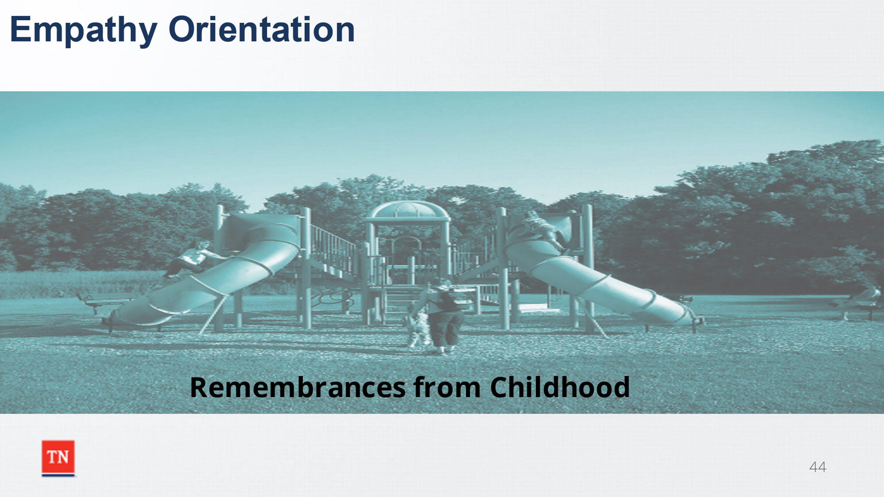
- DISPLAY “Remembrances from Childhood, Part 1” Handout. ASK participants to take 3 minutes to read the questions.
- ASK the group for volunteers to share memories. NOTE Not all questions need answered.
- DEBRIEF by asking:
  - What was it like to share personal information with the group?
  - What was your comfort level?
  - What increases/decreased your comfort level?
- ACTIVITY: Remembrances of Childhood, Part 2.
- DISPLAY Remembrances of Childhood, Part 2. ADVISE participants they will not be asked to share information from the questions. ALLOW three minutes to review.
- DEBRIEF by asking how they would have felt if asked to share these events which may have been painful or possibly family secrets.
- ASK how this compares with how we work with families. ASK if anyone would have shared but edited their information. STATE when families edit information in a CFTM, how do we characterize them? Responses could include: Lying, Fibbing, Withholding, Not Sharing, Being Deceitful.
- EMPHASIZE this is why engagement is important from the beginning of a case. SHARE we are dealing with information which is very personal and may be painful. STATE we want to start building rapport from the very first contact.
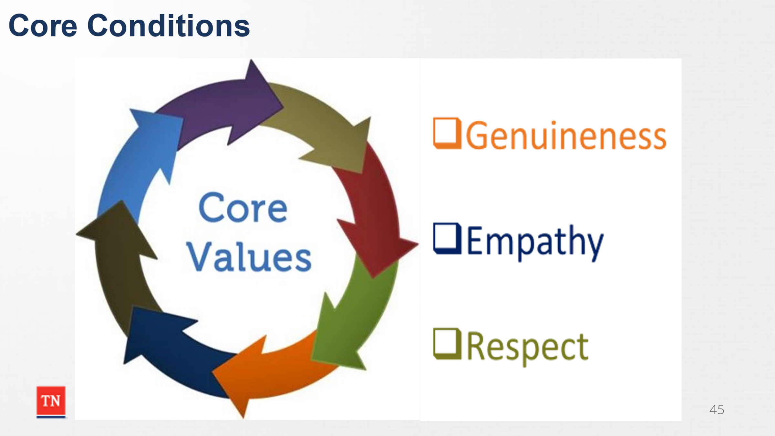
- MOVE into the discussion on the Core Conditions of Engagement. ASK participants how we help families share these potentially painful events during a CFTM. DEBRIEF responses. STATE for families to trust enough to share these events and their family story, we must be able to engage using the Core Conditions.
- STATE the case manager demonstrates respect, genuineness, and empathy for all family members. ASK how each of the Core Conditions lead to hearing the family’s story.
  - Genuineness: Being real, verbal, and spontaneous. Listening first and being non-defensive.
  - Empathy: As discussed, communicating understanding, connecting with feelings, recognizing non-verbal cues, discussing what is important to the child and family, and showing a desire to understand their feelings.
  - Respect: Showing commitment, communicating warmth, suspending critical judgement, and applauding the child and family’s resiliency.
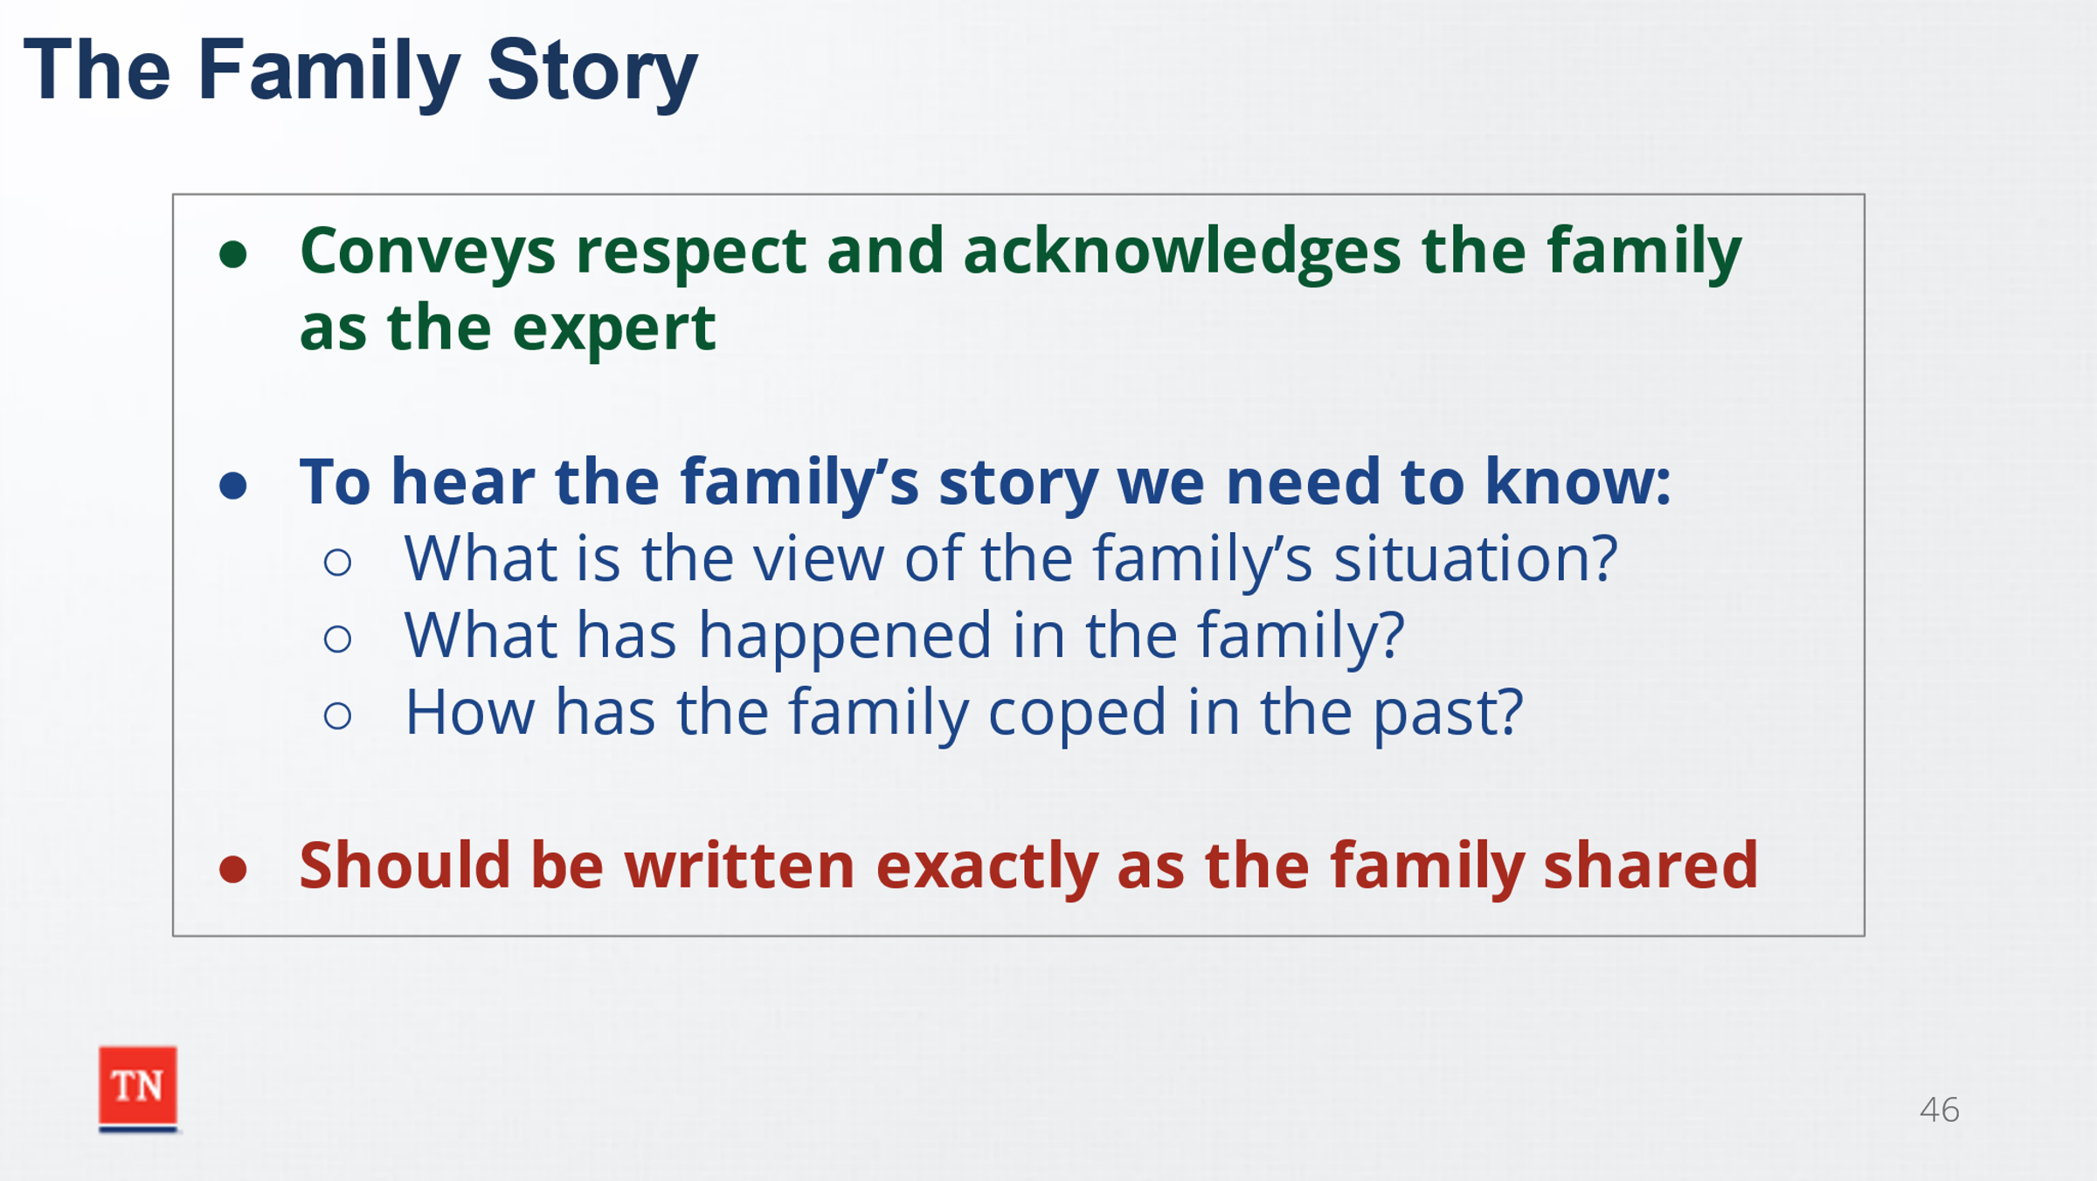
- STATE one of the best ways to show respect to a family is by listening to their story and acknowledging the family as the expert. SHARE to hear the family story we need to know:
  - What is the view of the family’s situation/problem?
  - What has happened in the family?
  - How has the family coped in the past?
- SHARE the family story should be written exactly as the family shares it. REITERATE again this is not the perspective of DCS, but the perspective from the family. When the family is sharing their story, the only interruption should be to clarify what is being said. Questions to gather more information should only be asked when the story is finished. STATE developing a helping relationship with children, youth, and their family to hear their story is critical to help the family change the conditions and patterns of behavior which cause DCS to intervene. REMIND participants relationship building begins with the very first contact with the child, youth, and their families.
- ASK if there are any questions, TRANSITION to Lesson 5.2 Team Building.

Lesson 5.2 Teaming
Lesson Time: 10 minutes
Key Teaching Points / Instructions:

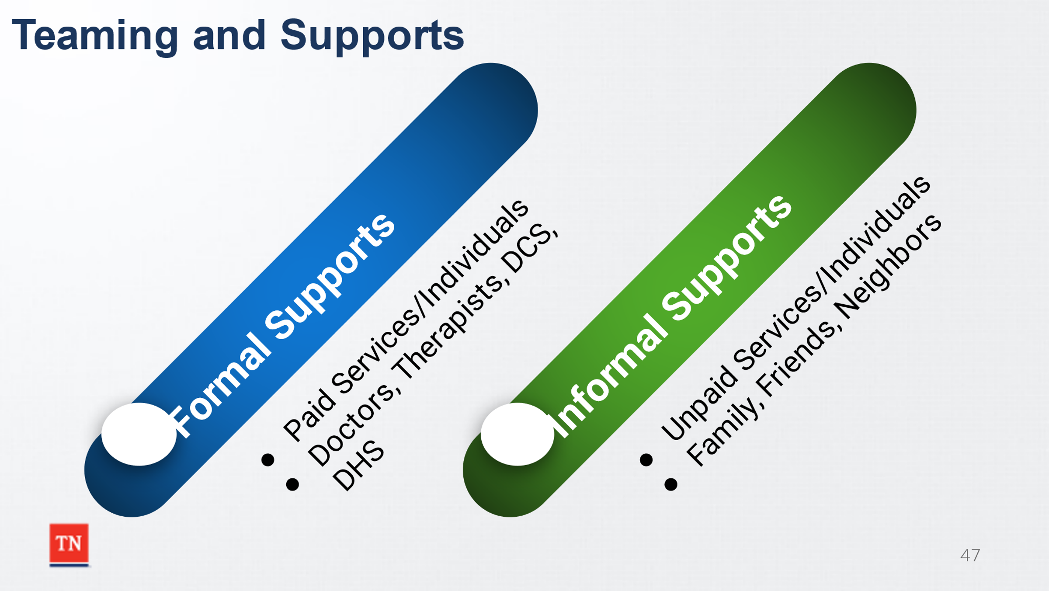
- BEGIN by asking what are formal and informal supports? SHARE formal supports are paid services or individuals such as doctor’s, therapists, DCS, DHS, etc. while informal supports are unpaid services or individuals such as family, friends, neighbors, etc.
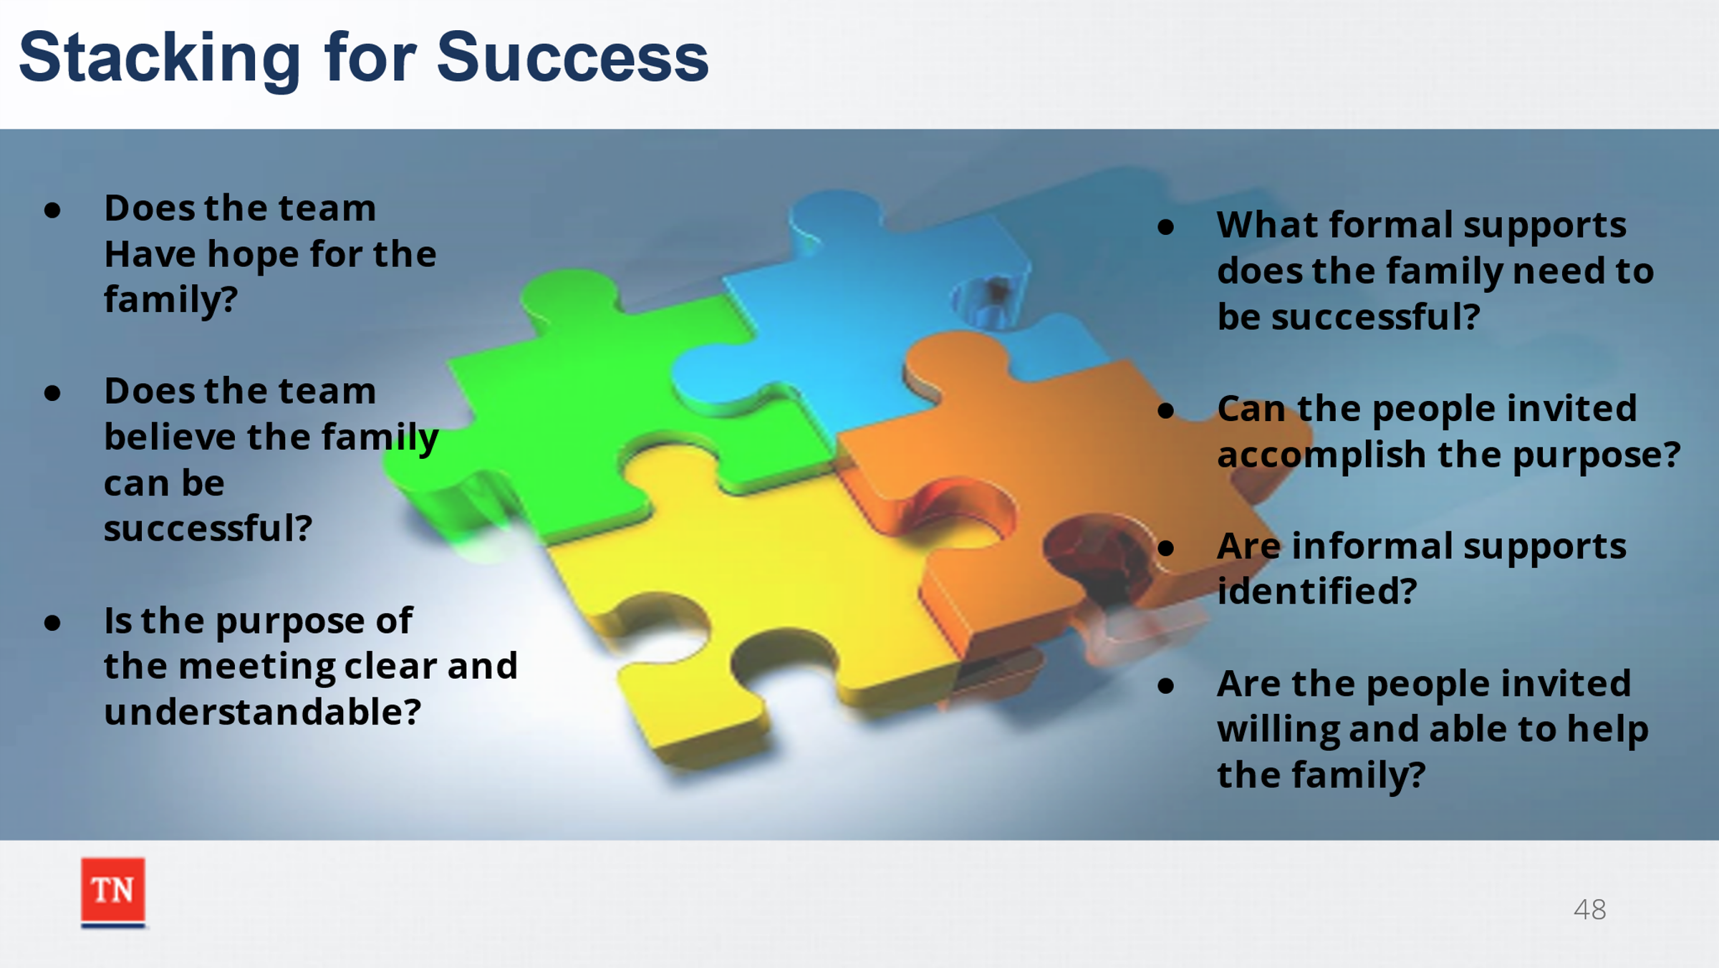
- SHARE families are engaged to determine who they would like to invite to the CFTM including their own support system. STATE if family finds it difficult to identify potential team members, the case manager can ask questions such as:
  - Who do you spend the holidays with?
  - Who cares about what happens to your family?
  - Who do you talk to or text each day?
  - Who attends your child’s birthday parties?
  - Who is on your child’s emergency contact list at school?
- STATE the “Stacking for Success” model provides an example of how the case manager can assess the composition of the family team. SHARE the following questions can help assess the team and ensure it is “stacked for success”:
  - Does the team member have hope for the family?
  - Does the team believe the family can come together and be successful in creating a family plan?
  - Is the purpose of the meeting clear and understandable?
  - What formal support systems resources are necessary for the family to be successful?
  - Can the people invited accomplish the purpose?
  - Does the family have a support network that can help them through the change process?
  - Are there informal supports identified by the family willing to attend the meeting and participate in the planning process? If unable to attend, how can their input and support be obtained?
  - Are the people invited willing and able to help the family achieve the goals?
- SUMMARIZE by sharing when the team is truly committed to the family, the chances for success and change are much greater.
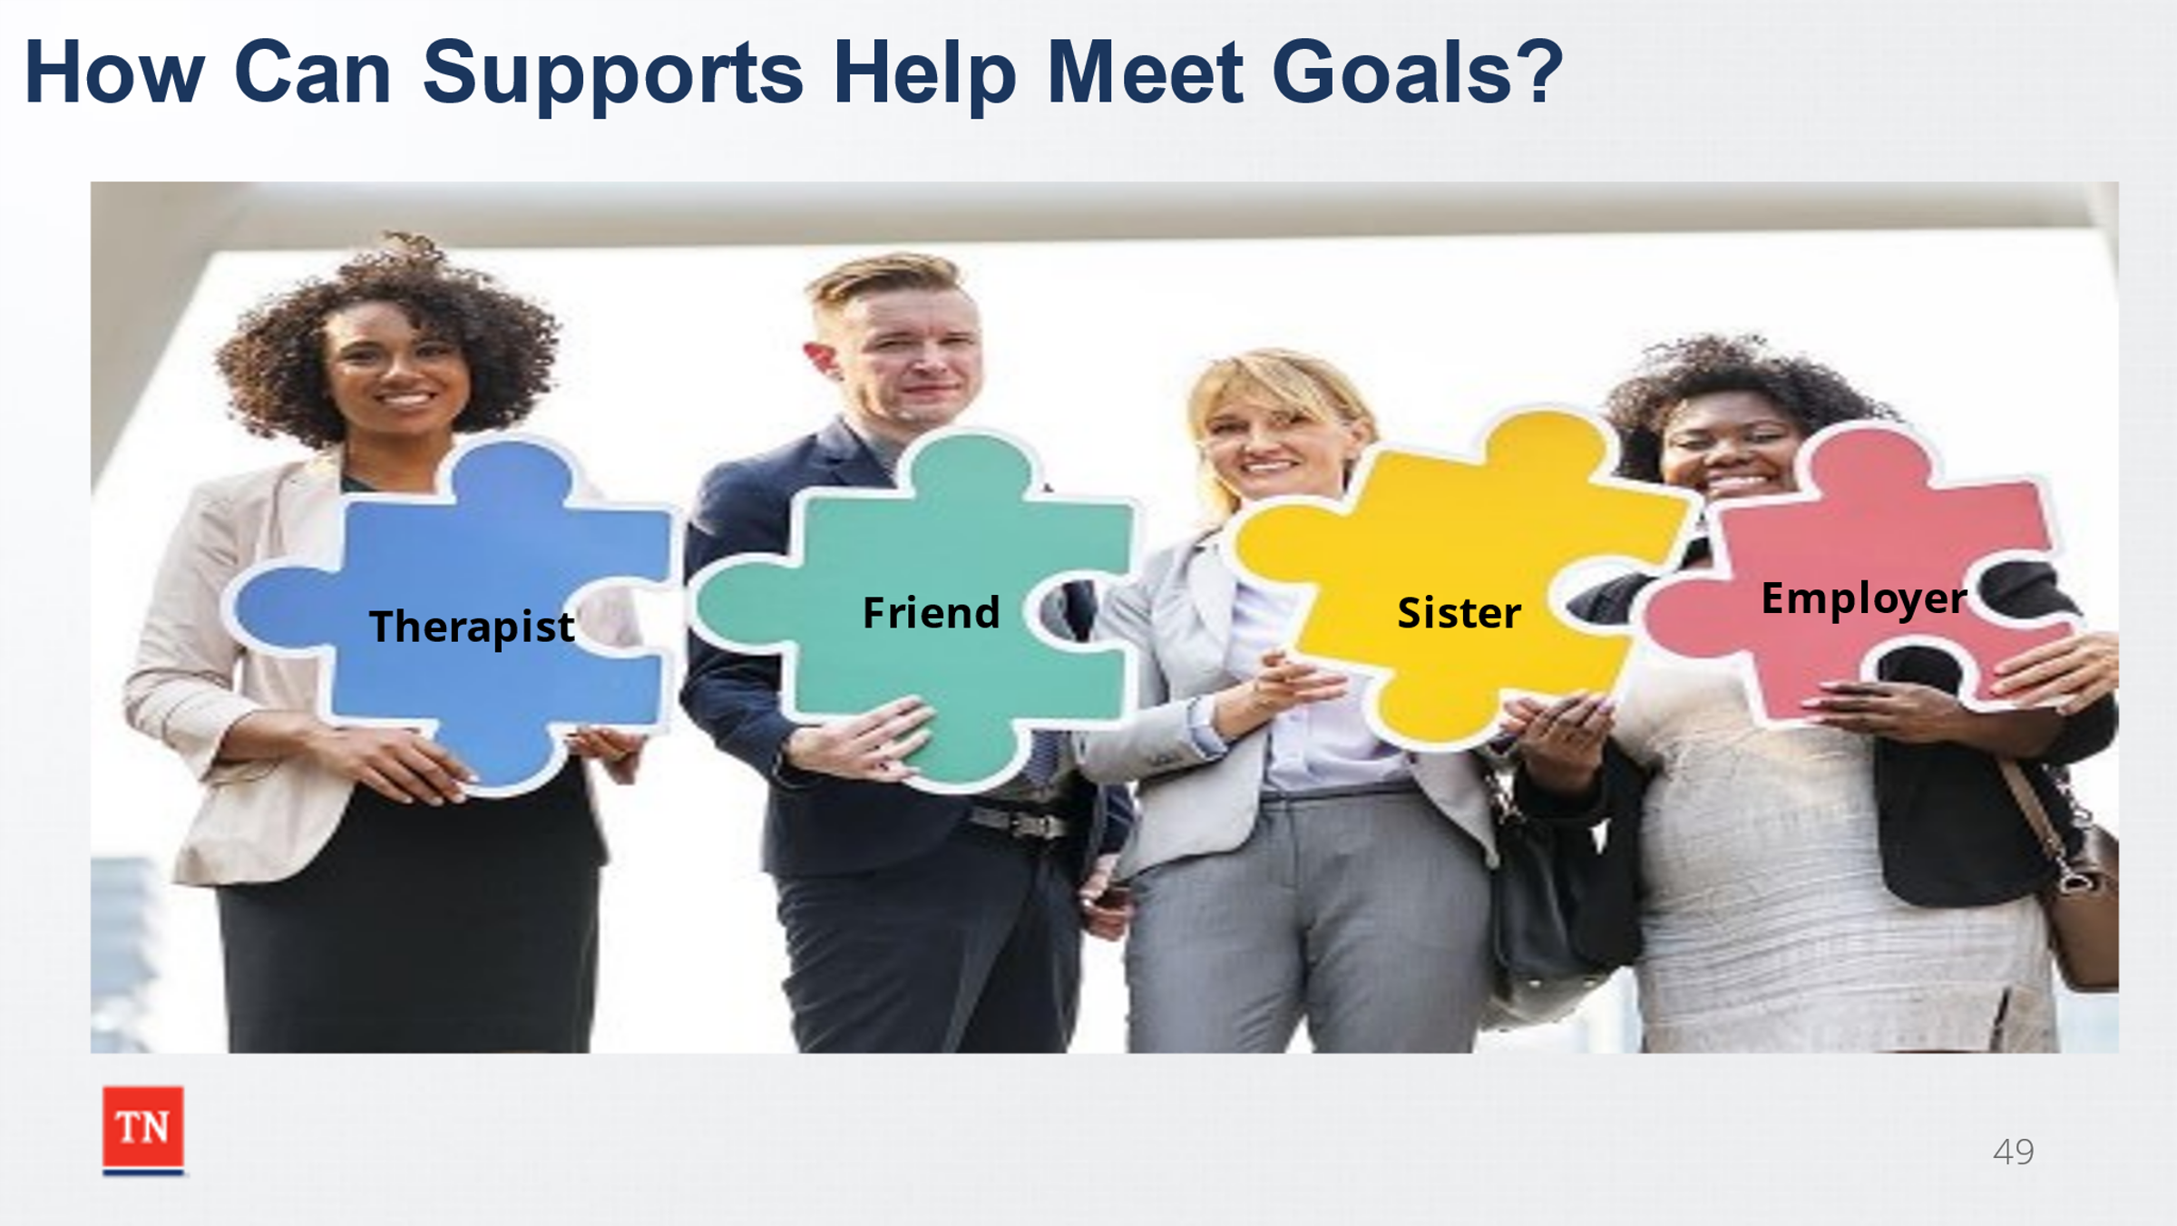
- ASK what is the importance of finding and involving family and kin? Possible answers: Helps the family meet the goals, possible placements for the children, possible permanent homes, a long-term support
- DISPLAY the slide of a puzzle with identified supports. Trainer will identify one support listed on the puzzle, for example-employer. ASK to share how the support identified can assist the family in completing the goals. SHARE assistance from supports can include completing tasks, making connections, providing support or expertise. ASK what is the importance of helping the family identify numerous supports? STATE if members of the team have no role to play, they will often stop attending CFTMs and providing support to the family. ADVISE it is critical for each team member to have action steps at the end of the meeting on what they can do, even if something minor, to support the family.
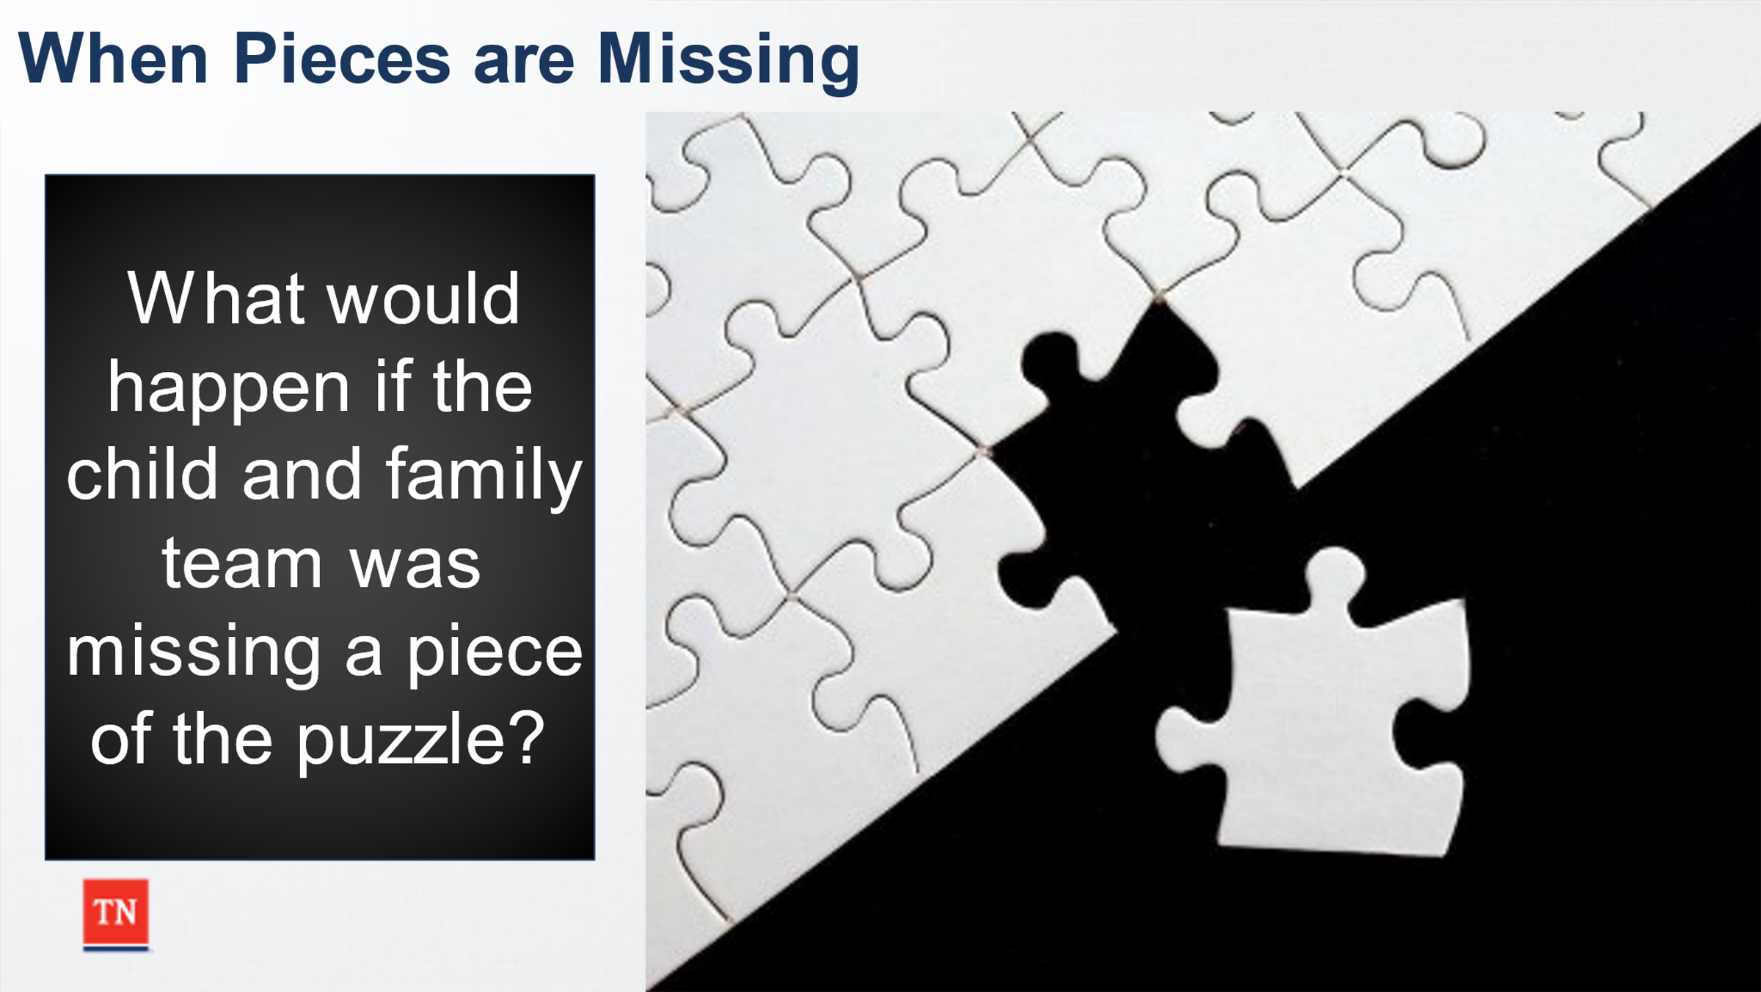
- ASK what would happen if the child and family team was missing a piece of the puzzle? Responses could include longer time involved with DCS, increased trauma, loss of family/cultural connections, etc.
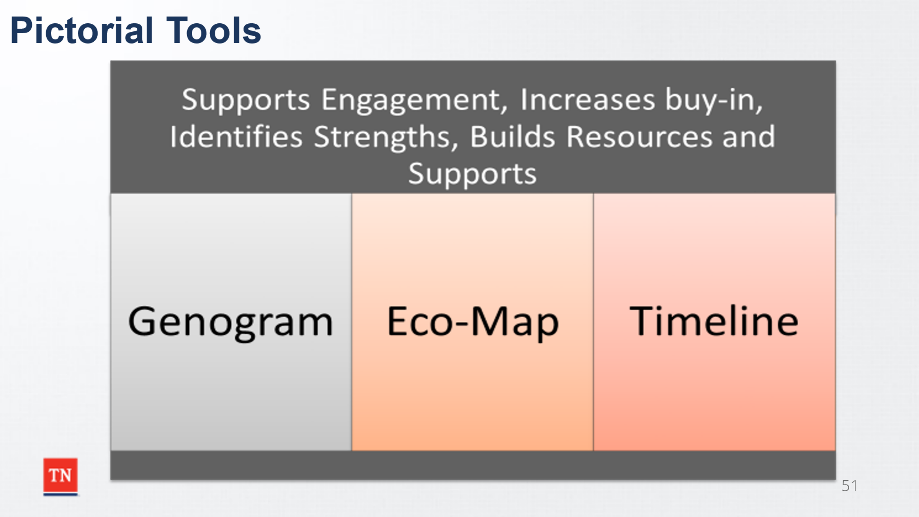
- STATE the search for the family’s supports begins with the first contact and continues throughout the life of the case. EMPHASIZE the importance of periodically checking with family regarding new team members. ASK what pictorial tools are available to engage the family around building their team. CONFIRM tools such as the Genogram (required by policy), the Family Eco-Map, and Timelines can be used to help identify supports for the family. SHARE they can also be used to engage the family to provide a more detailed picture of the family, family members, as well as resources and possible team members. STATE details captured should include information such as the location, involvement level, age, history, etc. STATE these tools are not solely used for collecting information. The process of partnering with the family to complete the tool can help build rapport, trust, and relationships with the family.

Lesson 5.3 Assessment and Planning
Lesson Time: 10 minutes
Key Teaching Points / Instructions:

- ASK what the importance of tracking and adjusting is during each CFTM.
- STATE goals and progress must be reviewed to adequately track and adjust. SHARE the following:
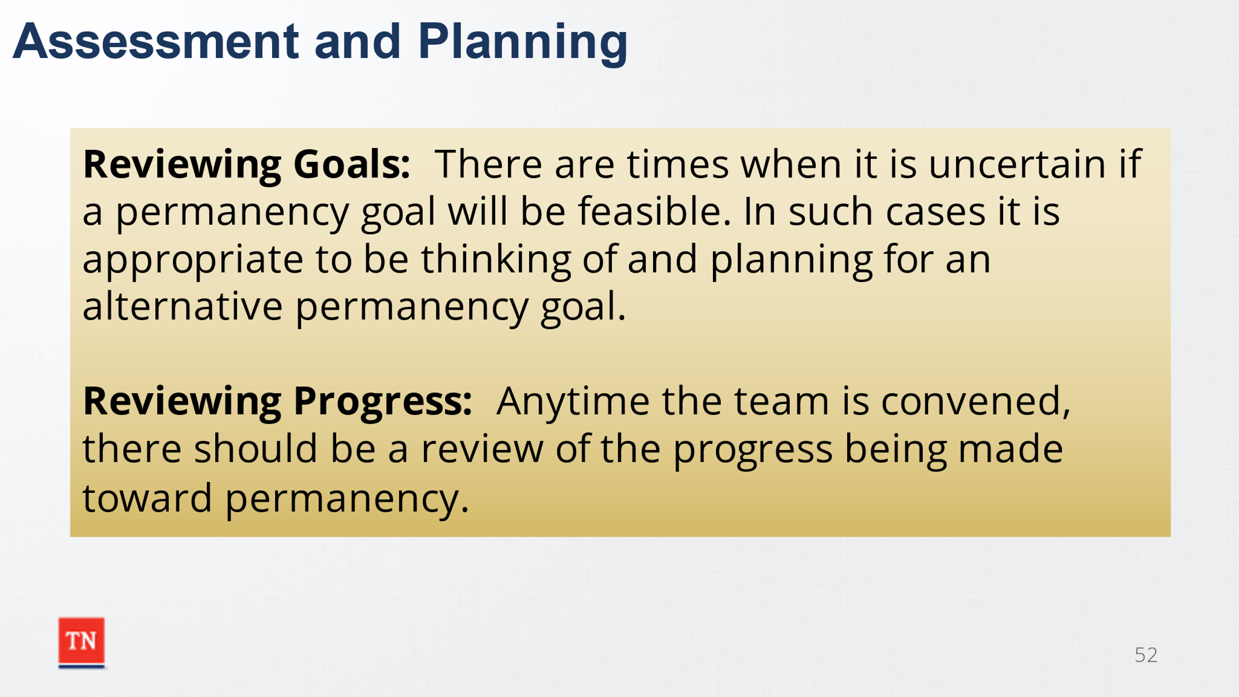
  - Reviewing Goals: There are times when it is uncertain if a permanency goal will be feasible. In such cases it is appropriate to be thinking of and planning for an alternative permanency goal which also will be in the best interests of the child if the primary goal cannot be realized.
  - Reviewing Progress: Anytime the team is convened, there should be a review of the progress being made toward achieving permanency. A review of services being provided, if they are effective and are all responsible parties doing what they agreed to on the plan. Identify the remaining barriers to permanency and develop plans to remove those barriers. Assess the effectiveness of services and whether revisions to the plan or additional action steps are needed.
- SHARE one important aspect and role of the members of the child and family team is to discuss services the child and family may need based off the assessment information included in the CANS and FAST assessments as well as information obtained from the family story. SHARE services should be discussed ongoing during the case at ALL CFTMs as well as any barriers in both obtaining services as well as progress being made. For example, if a child needs an orthopedic appointment- it should be discussed and documented. During the next CFTM the results of the appointment and any next steps to be taken should be discussed as well as any positives or barriers in the recommendations.
- NOTE the CFTM Guide discusses service implementation under How the CFTM Promotes Best Practices Aligned with the Practice Wheel-Tracking and Adaptation.
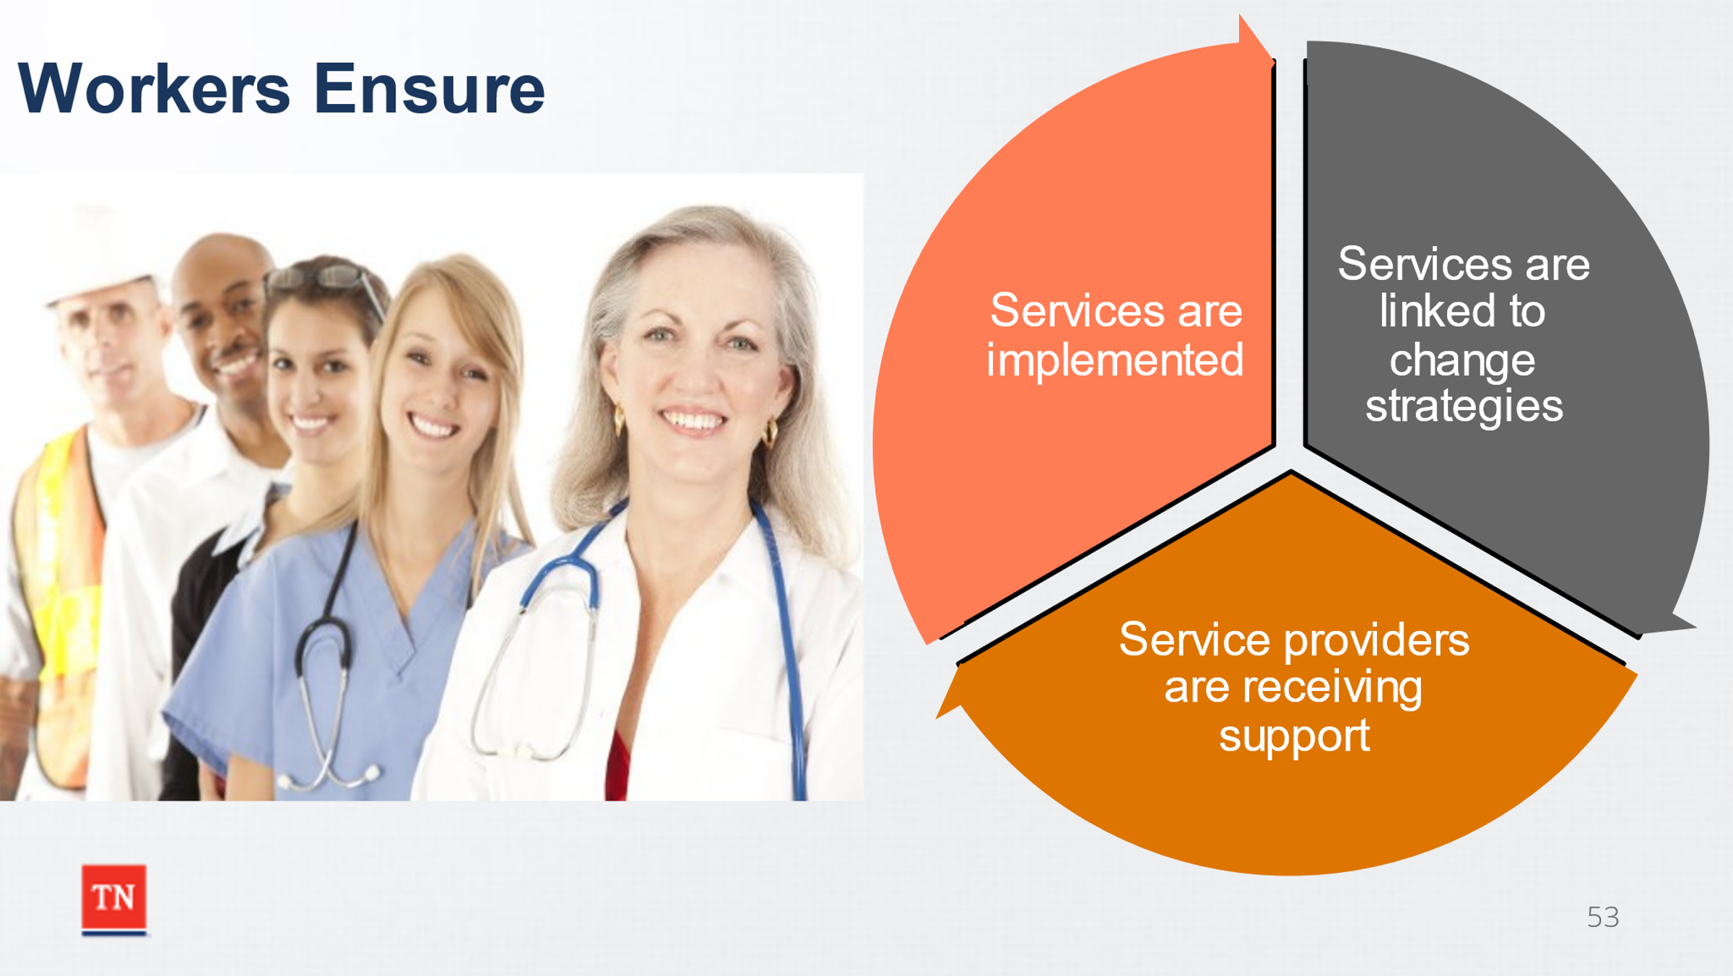
  - The DCS worker is responsible for following up on referrals and tasks assigned to the members of the team to ensure that the services and strategies developed in the plan are being executed in a timely and competent manner. This requires coordination and resource management to ensure that progress is being made. The DCS worker maintains regular contact with the family and team to ensure that:
    - a) The strategies, actions, and services planned for the parent/family and child/youth are being implemented in a timely, competent, and dependable manner, consistent with family-centered practice and with necessary cultural accommodations.
    - b) Actions, supports, and services linked to change strategies are being provided at a level of intensity and continuity necessary to meet priority needs, reduce risks, facilitate successful transitions, and achieve adequate daily functioning for the parent and child/youth.
    - c) Service providers (e.g., social workers, care staff, teachers, therapists, tutors, mentors) are receiving support and supervision necessary for adequate role performance in conducting the planned change strategies for the parent and child/youth.
- ASK participants what are possible barriers to obtaining services? Answers could include transportation, lack of insurance, lack of provider for the service in the area, lack of willingness to participate.
- SHARE during the CFTM the team members are empowered to discuss services and barriers. REMIND participants of the Stages of the CFTM. ASK which Stages are essential to discussing needed services, progress of services being provided, and any barriers to services. Answer: Assess the Situation, Brainstorming, and Planning. STRESS the importance of documenting this discussion on the CFTM Summary. SHARE as discussed in Unit 5, it is essential to help the family identify team members who will be able to help the family be successful. The Child and Family Team Guide discusses other participants who may be involved including specialized DCS staff, therapist, contract agency staff, community partners, or service providers.
- ADVISE the role of the skilled facilitator is to ensure services are discussed (process) while the case manager ensures specifics around services are discussed including how the family is working with services, strengths, and concerns.
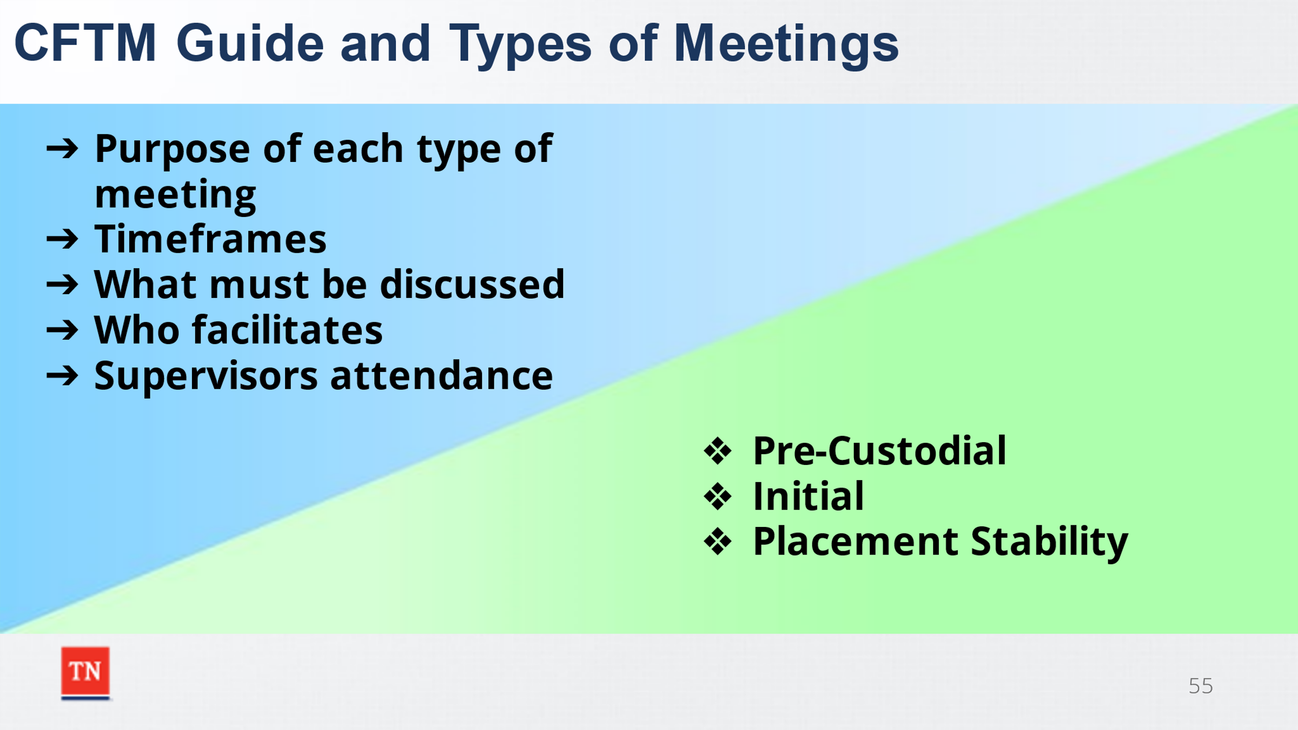
- STATE the Child and Family Team Guide gives direction on the purpose of each type of meeting, as well, as the timeframes, and what must be discussed. CFTM Descriptions begin on Page 26 of the guide.
- SHOW participants the CFTM Guide section with the different types of meetings. Briefly, REVIEW the following types of meetings: Pre-Custodial, Initial, and Placement Stability or ASK participants to review the information for these types and report back on what stands out about each.
Trainer Note: If time allows, participants can be divided into three groups to review each type of CFTM. Pre-Custodial group should include non-custodial workers such as CPS, FSS; while the Initial and Placement Stability group should include custodial workers with Foster Care and Juvenile Justice.

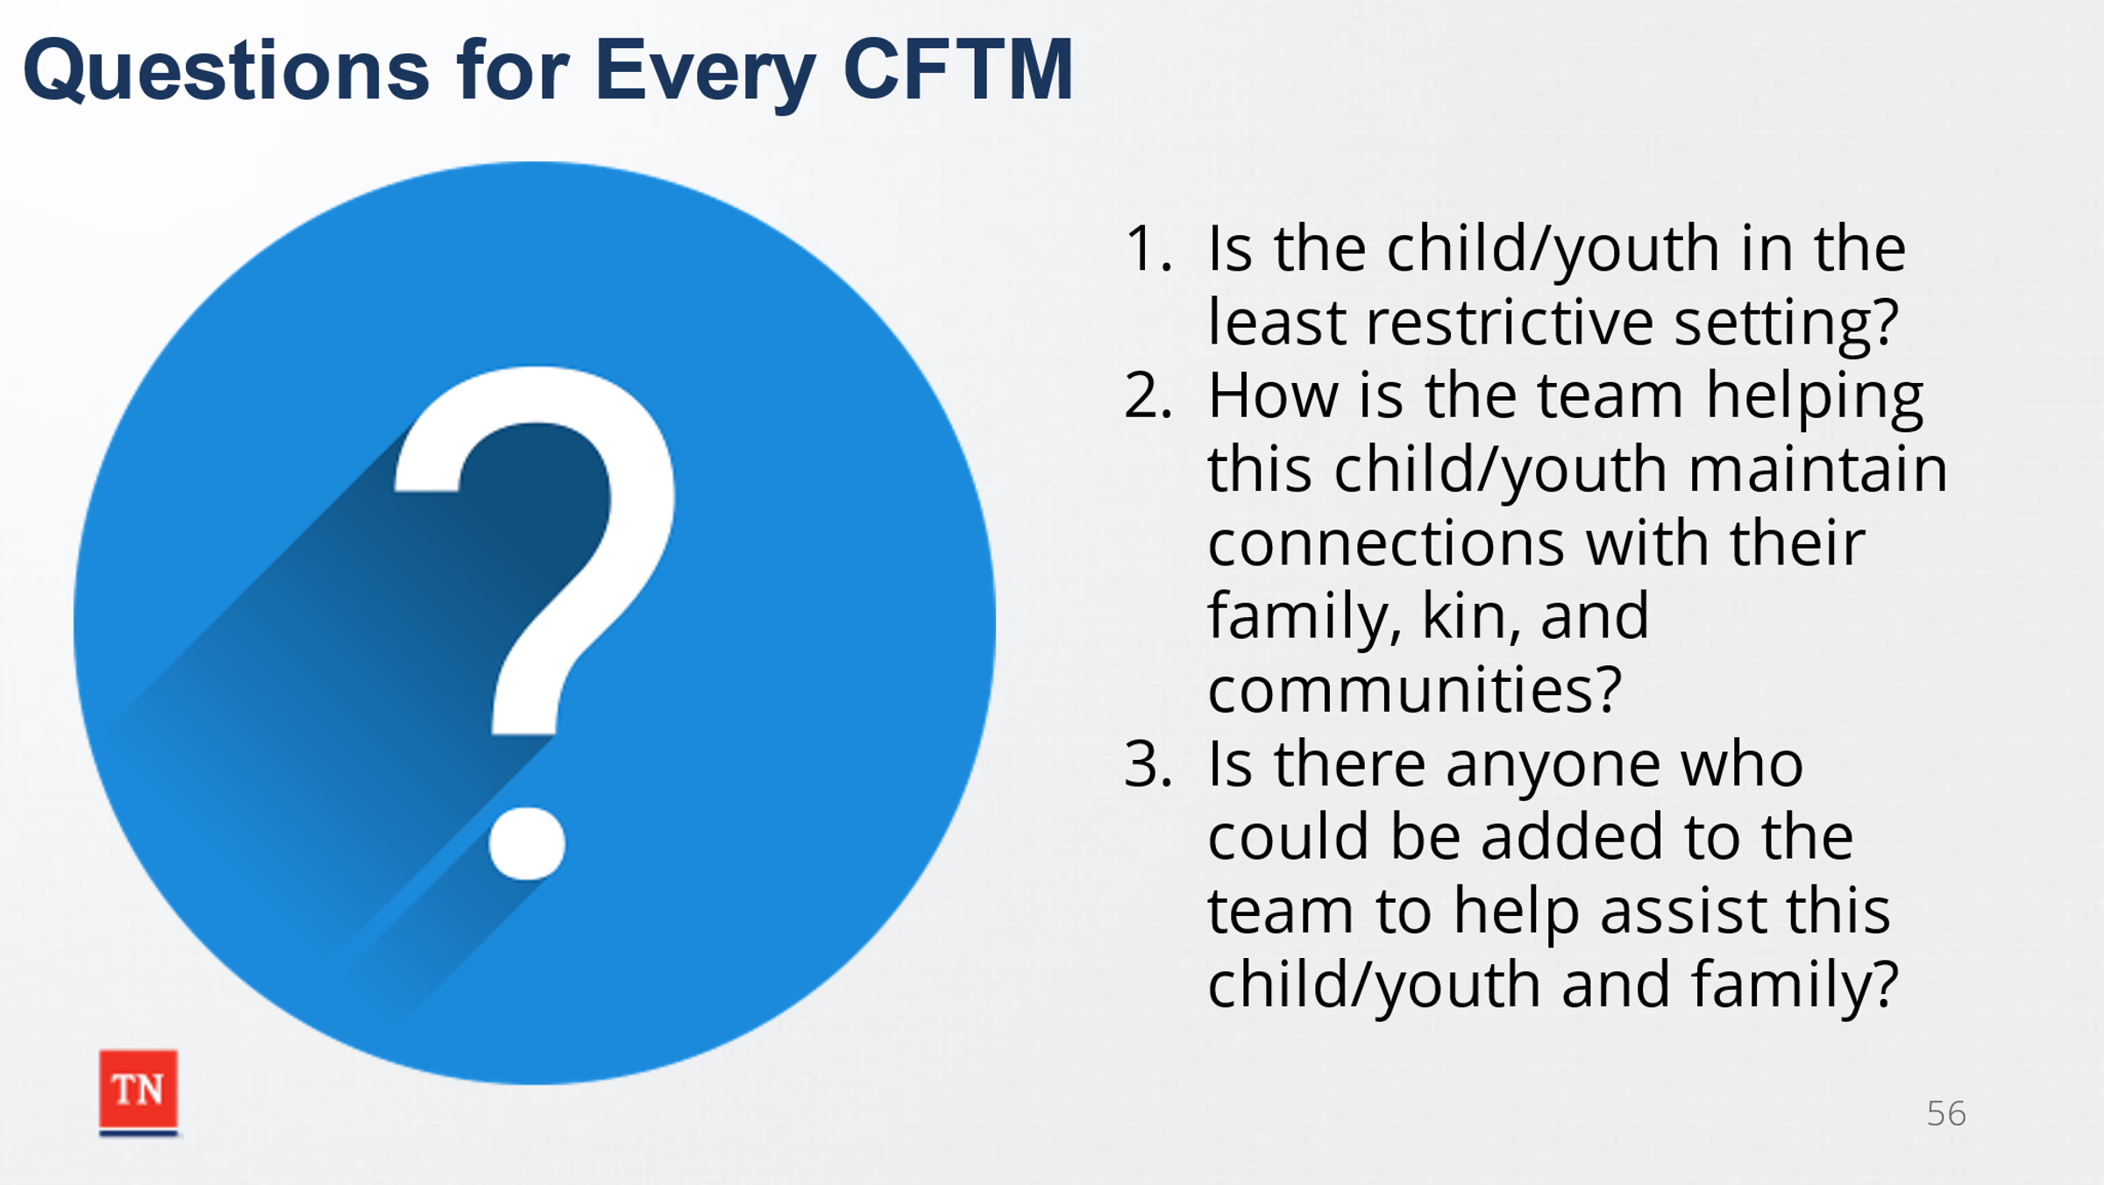
- SUMMARIZE by sharing there are questions that should be answered at every CFTM including:
  - Is the child/youth in the least restrictive setting?
  - How is the team helping this child/youth maintain connections with their family, kin, and communities?
  - Is there anyone who could be added to the team to help assist this child/youth and family?
- ASK if there are any questions. TRANSITION to Unit 6 Quality CFTMs and Closing.

Unit 6: Quality CFTMs and Closing
Time: 15 minutes
Learning Objectives:
- Participants will identify how to assess if the CFTM was quality.
- Participants will identify how to transfer information into field practice.
Supporting Materials:
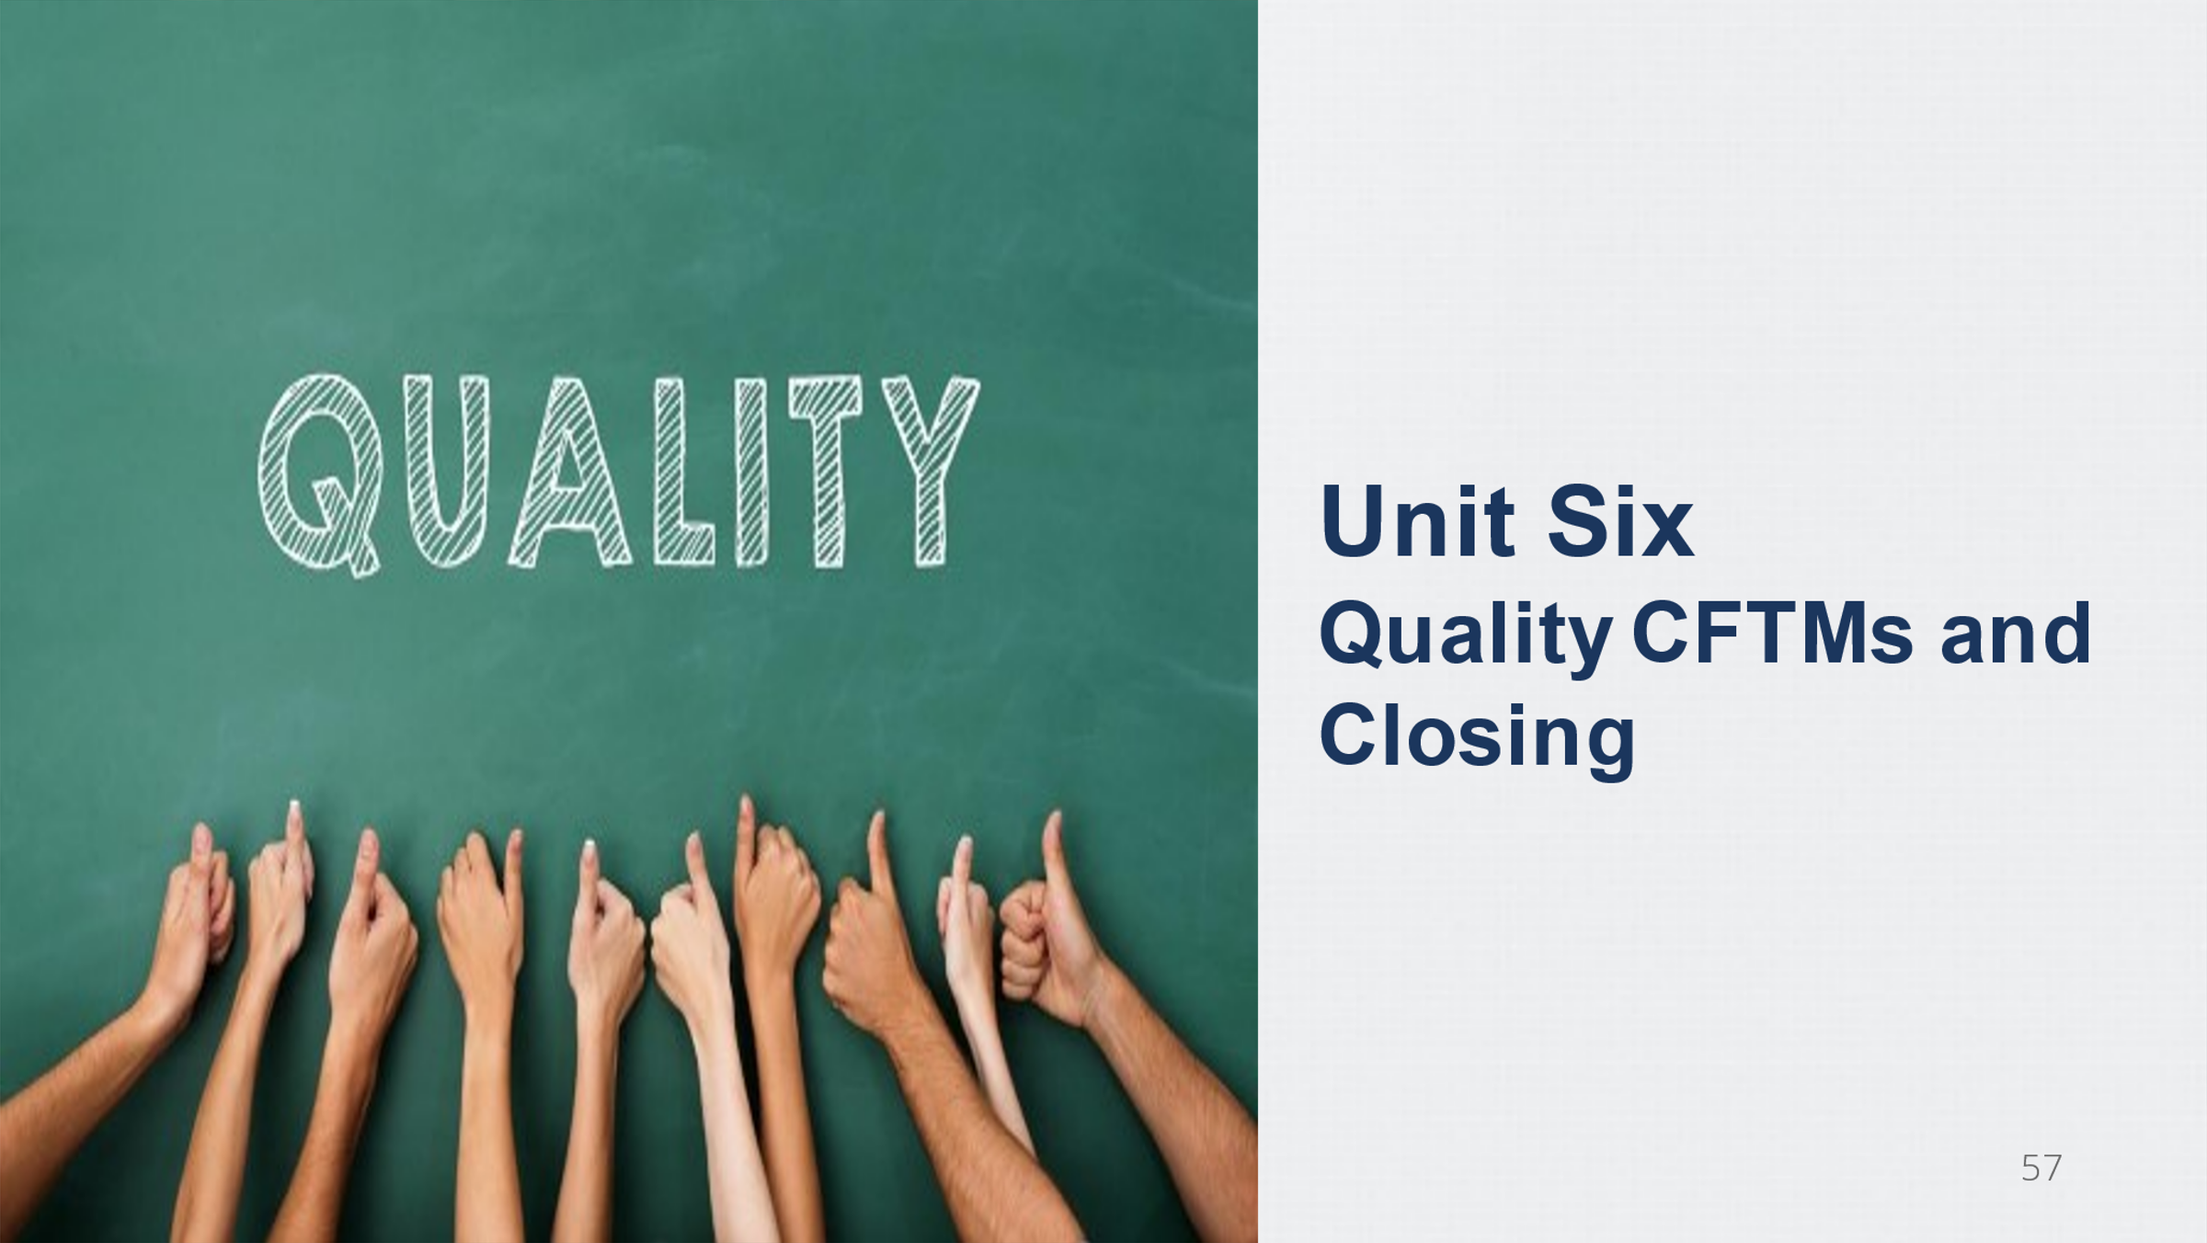
- Continuum of Knowledge Scaling from Unit 1
- Training Evaluation

Lesson 6.1 Quality CFTMs
Lesson Time: 10 minutes
Key Teaching Points / Instructions:

- ASK participants how to assess if it was a Quality CFTM?
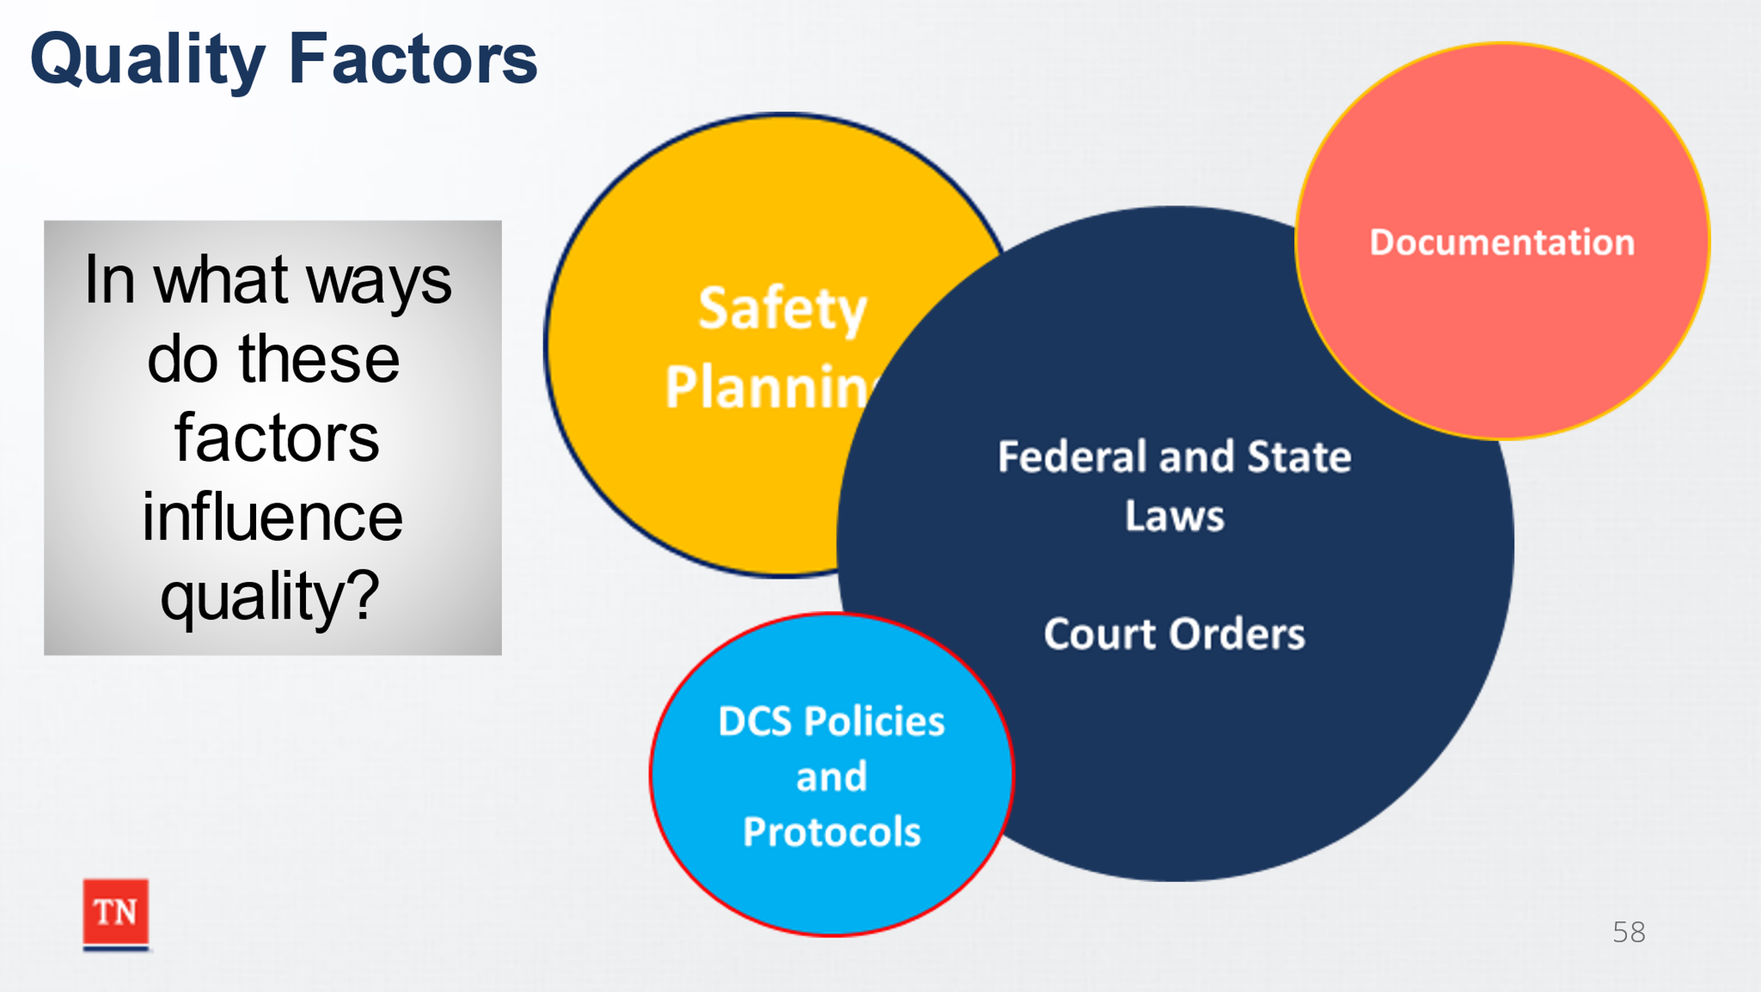
- STATE the following factors impact the quality of the CFTM:
  - Child Safety
  - Policy
  - Laws
  - Court Orders
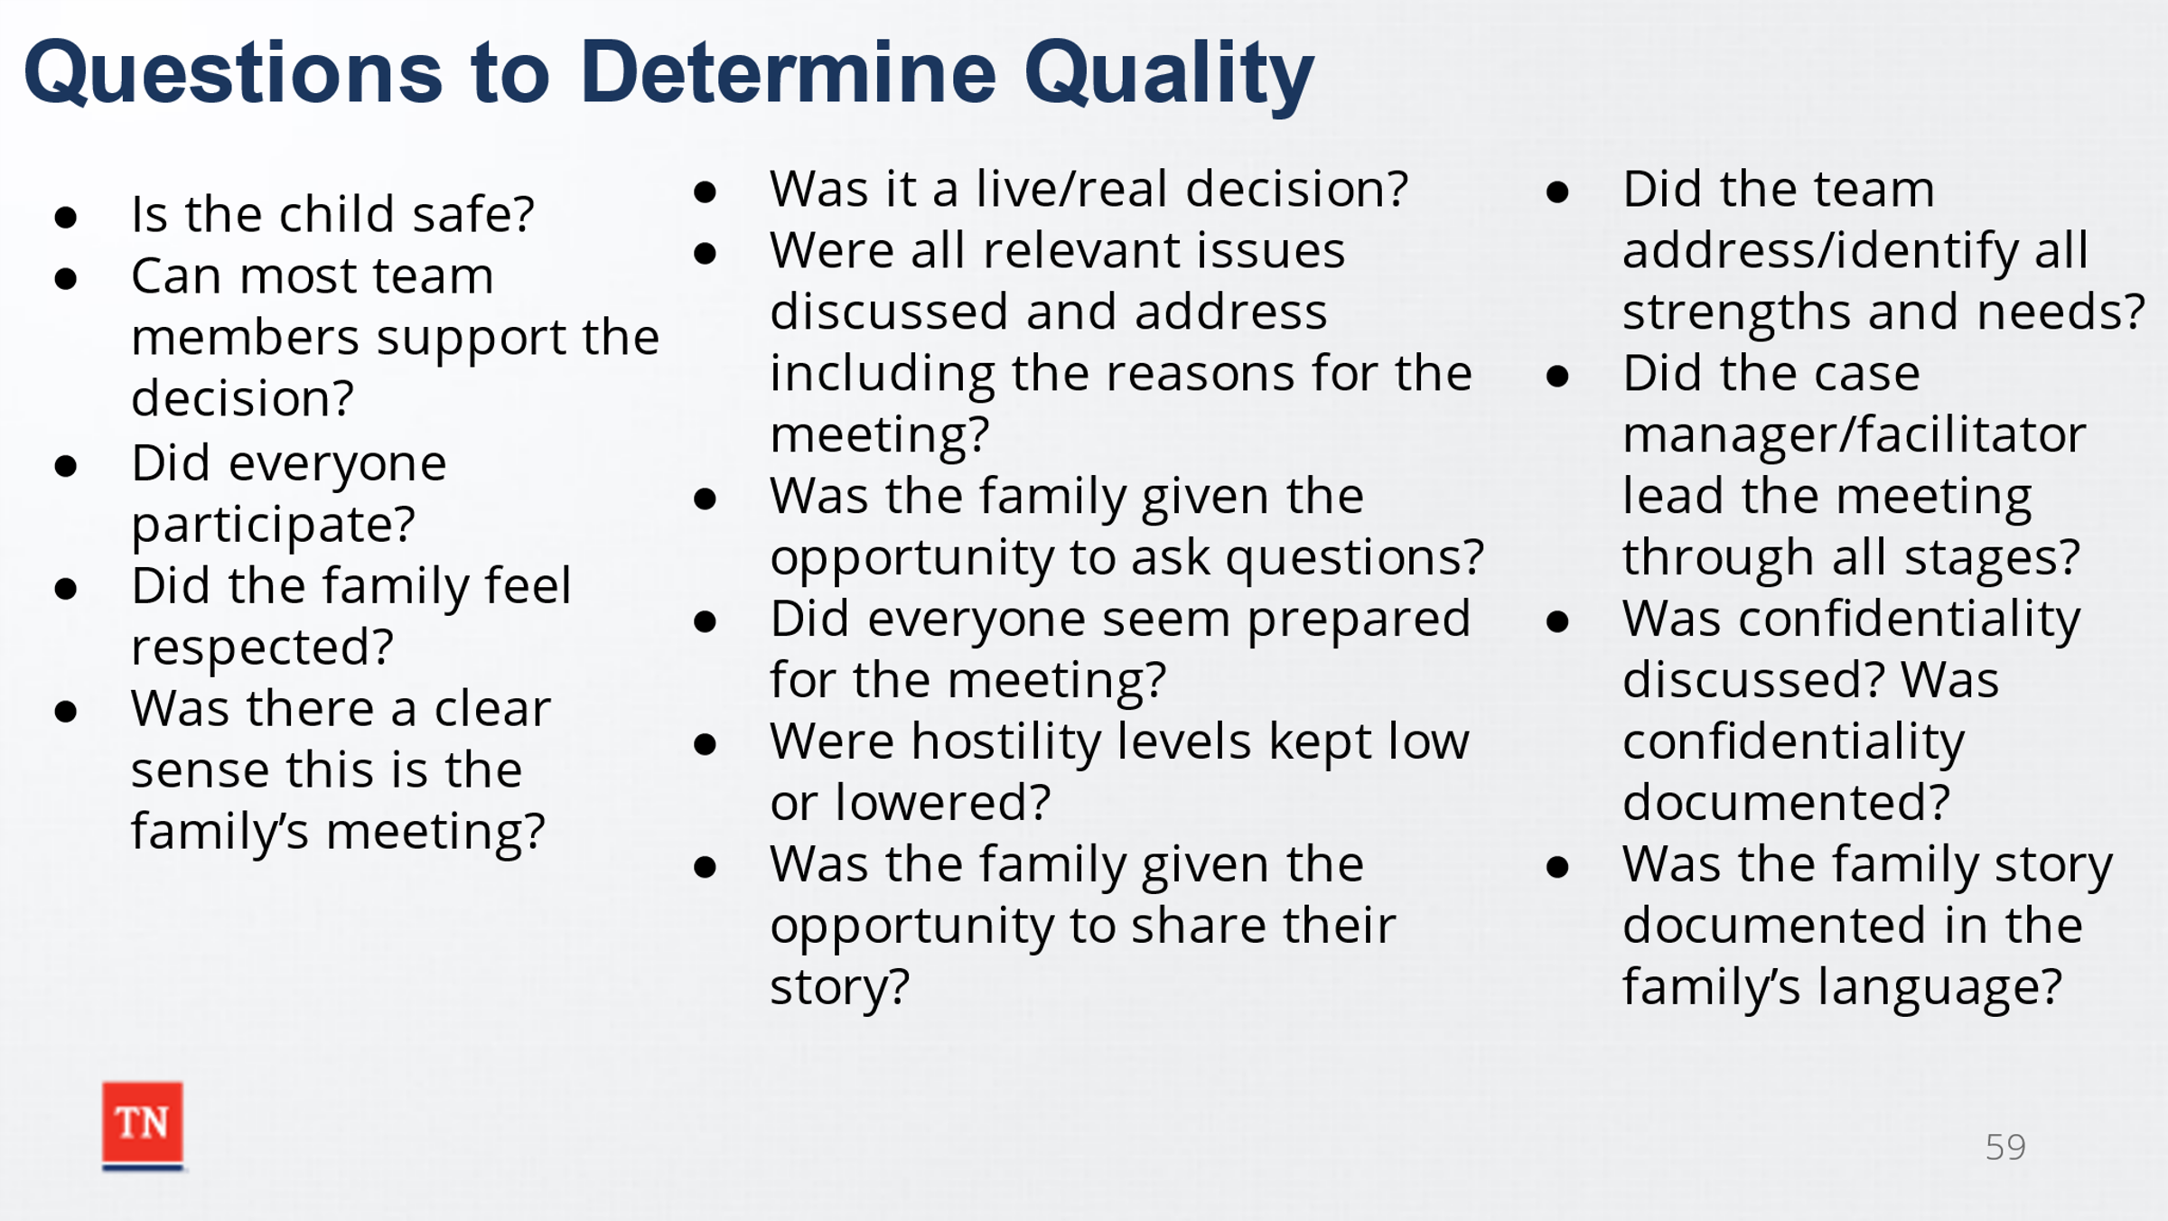
- ASK in what ways do these factors influence quality. DEBRIEF.
- STATE there are questions that can be asked at the end/throughout the CFTM to help determine if it is quality.
- ASK participants to SHARE which they feel is most important regarding quality. DISCUSS the selections.
- STATE each question is important to answer to assess for quality. TRANSITION to Lesson 6.2 Closing.

Lesson 6.2 Closing/Summary
Lesson Time: 5 minutes
Key Teaching Points / Instructions:

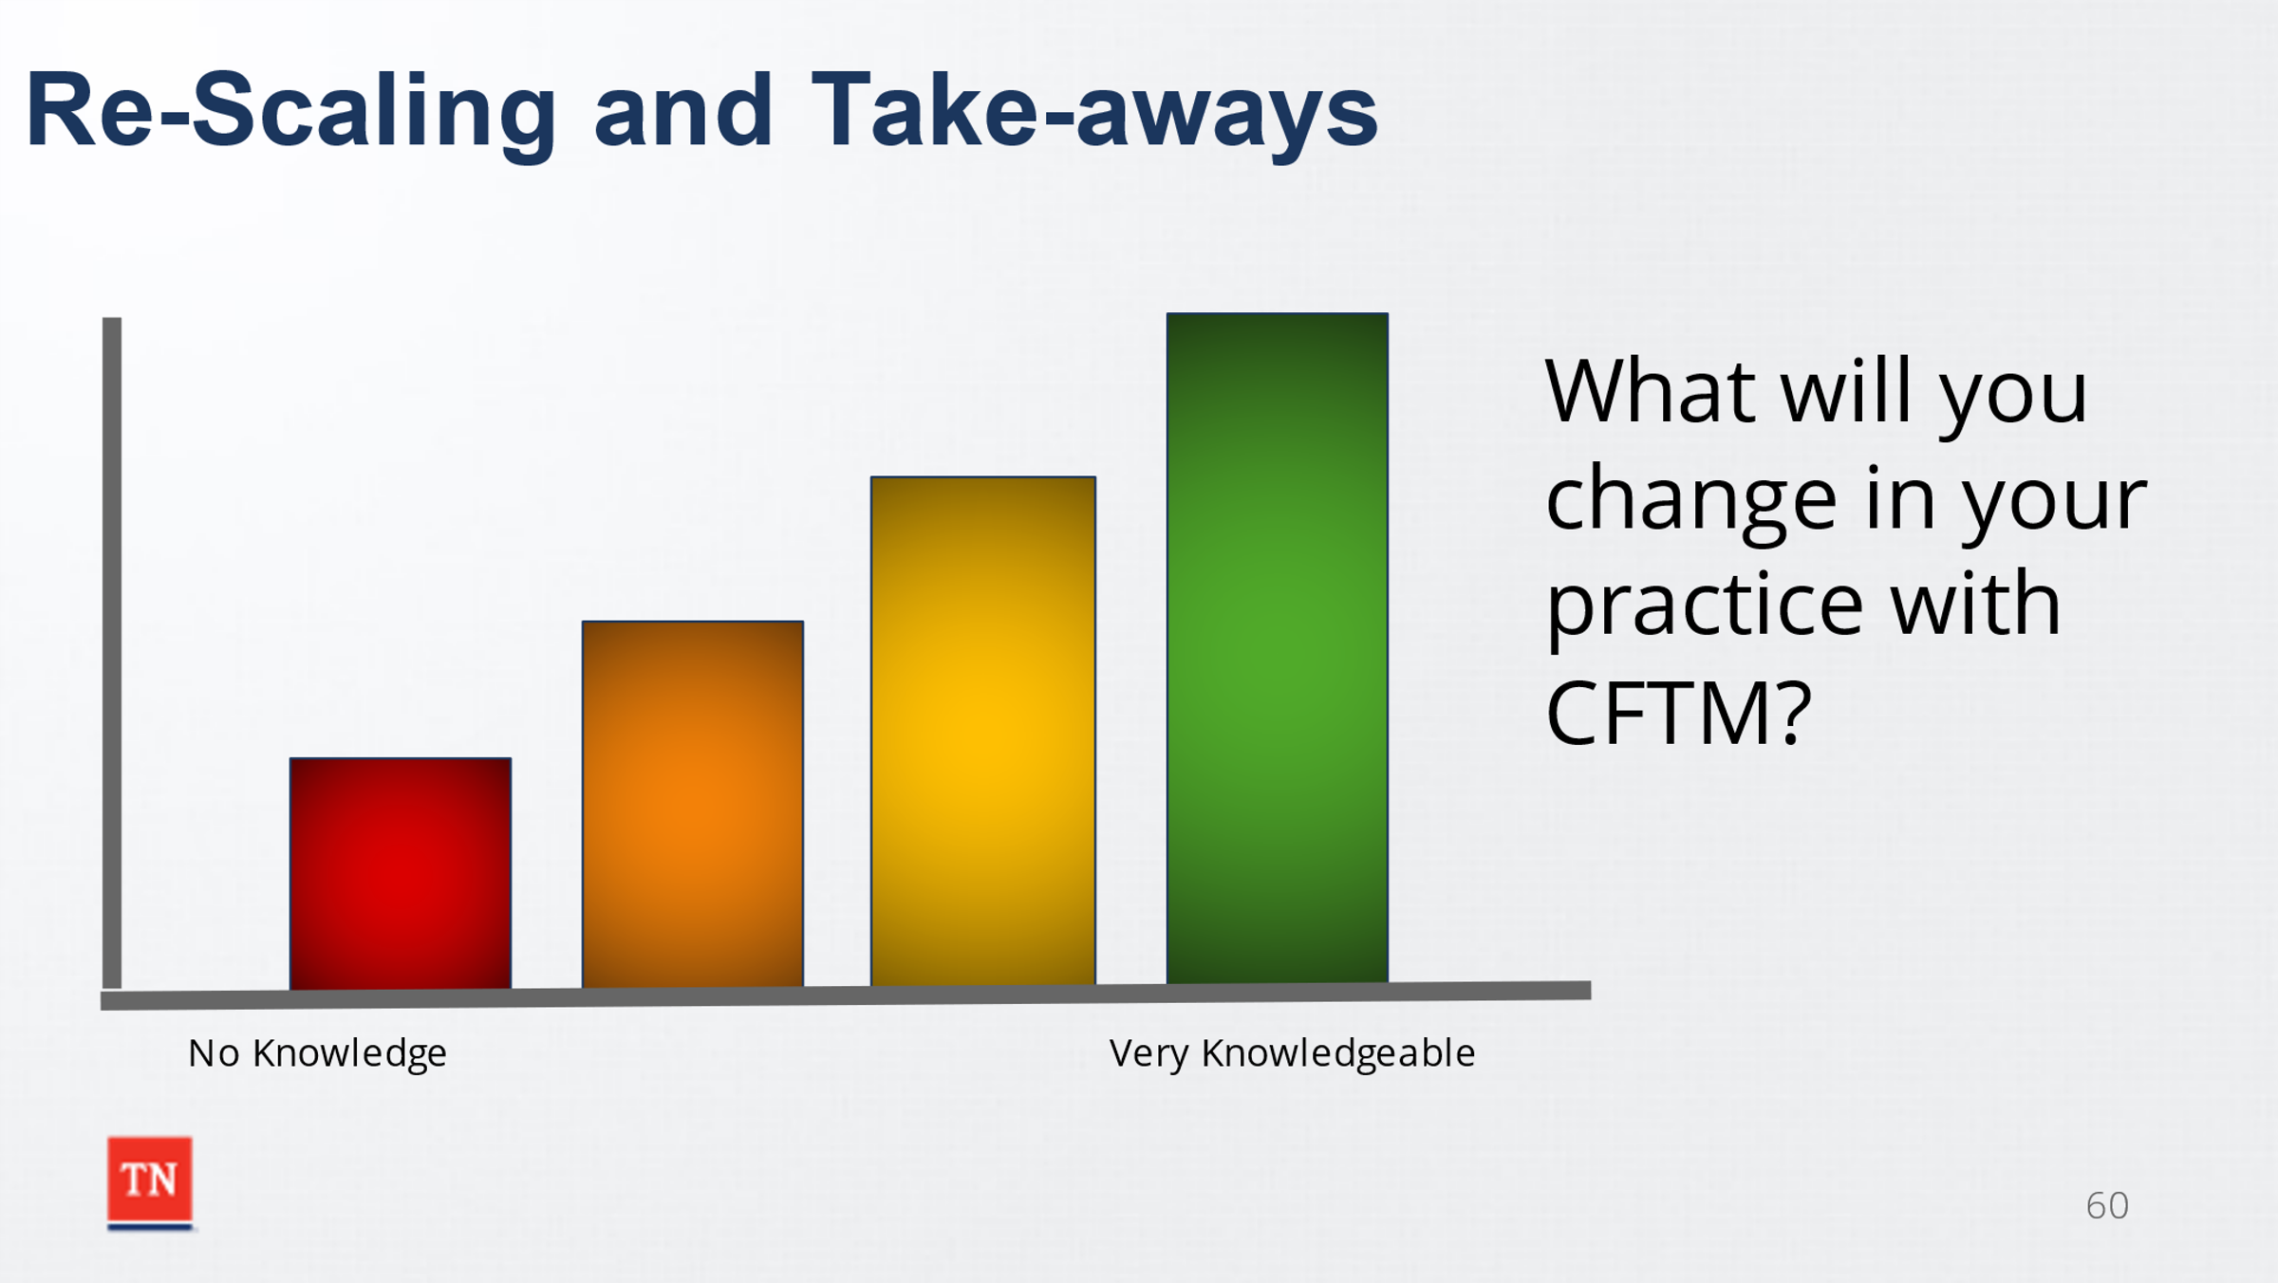
- REVIEW the Continuum of Knowledge with CFTM. ASK each participant to re-scale their knowledge of CFTMs. MODEL Motivational Interviewing again by asking them to share what has helped them increase their knowledge and what takeaways they have from the course. ASK participants what they will change in their practice with CFTMs.
- ASK the group if there are any questions.
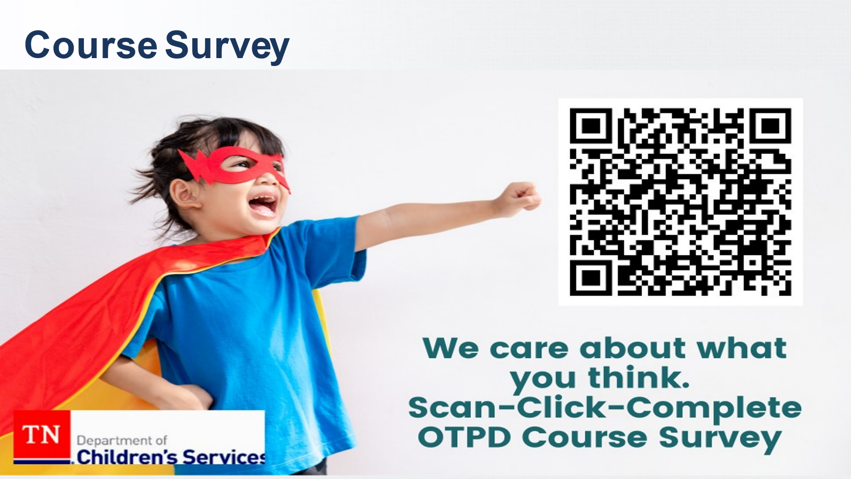
- REMIND participants of the handouts and information included in the Participant Guide as well as the Child and Family Team Guide.
- ASK the class complete training evaluation by scanning the QR Code.
- THANK the class for their participation and wish them success in facilitating Child and Family Team Meetings.

References

- Center for the Study of Social Policy. (2019, February). Lesson Learned from Child Welfare Class Action Litigation: A Case Study of Tennessee’s Reform. Retrieved from https://cssp.org/wp-content/uploads/2019/02/Tennessee-Case-Study-FINAL.pdf

