Time Management
Facilitator Guide
TN Department of Children’s Services| CHDE4043| Ver. 23.03.03

Curriculum Information
- This training is intended to provide 2.0 hours training credit
- Staff may receive T4T credit for this course by:
- Attending the course T4T offering -- OR --
- Attending an offering of the course taught by another trainer and debriefing with that trainer.

This curriculum was developed by the Tennessee Department of Children’s Services with federal funds. It is available to use in part or in whole free of charge.

OTPD. (2023). Time Management. Tennessee Department of Children’s Services.

Supporting Materials:
Materials needed for this curriculum
- Course Power Point
- Course Facilitator Guide
- Personal Productivity Style
- Your personal energy cycle (2:08)
- Covey’s Time Management Matrix

Agenda
Unit | Title | Duration | Resources
Unit 1 | Aspects of Time Management | 40 minutes | - Participant Guide
1.1 | What is Time Management? | 10 minutes
1.2 | Benefits and Myths | 10 minutes
1.3 | Being “Busy” and Barriers to Productivity | 20 minutes
Unit 2 | Time Management Strategies | 50 minutes | - Personal Productivity Style
2.1 | Not Just About the Tools | 20 minutes
2.2 | Evaluating How You Manage Time | 30 minutes
Unit 3 | Prioritizing and Scheduling | 80 minutes | - Your personal energy cycle (2:08)  - Covey’s Time Management Matrix  - Maximizing Your Time Infographic
3.1 | Energy Cycles | 30 minutes
3.2 | Maximizing Your Time | 40 minutes
3.3 | Wrap-Up | 10 minutes

Unit 1: Aspects of Time Management

Unit Time: 40 minutes

Resources:
- Facilitator Guide and PowerPoint

Learning Competencies
- Participants will have a greater understanding of time management in child welfare.
- Participants will understand the benefits along with internal and external barriers.

Lesson 1.1: What is Time Management?

Lesson Time: 10 minutes

Key Teaching Points / Instructions

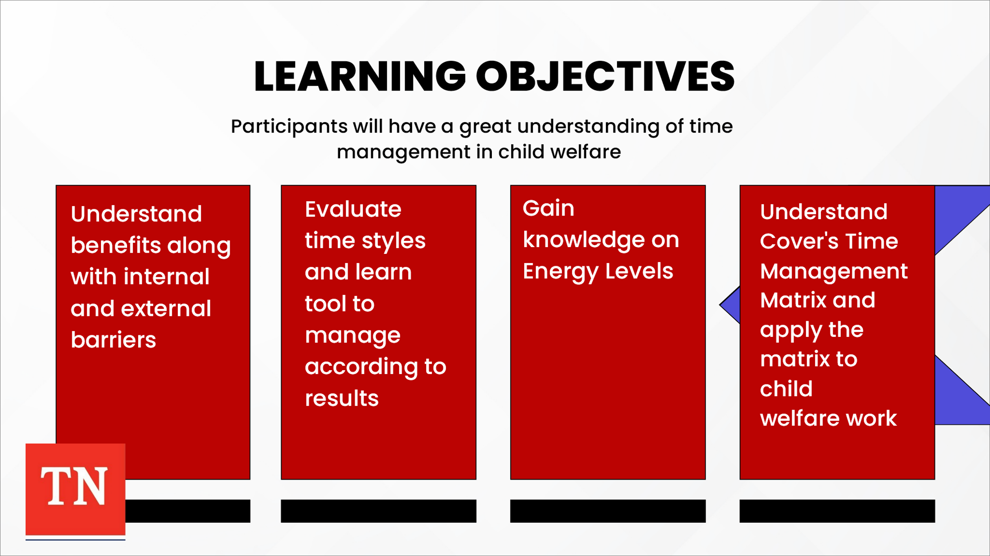
- SHARE for child welfare professionals, the ability to make effective use of limited time is critical. As new staff you are receiving training on tasks and responsibilities you will have when working with families. STATE it is also important for you to receive training and coaching on how to best prioritize tasks, plan your day, meet required timeframes, organize files, adapt to emergencies, and communicate efficiently. ADVISE use of time management measures will help new staff develop greater self-awareness about your strengths and limitations.
- SHARE the following Learning Objectives:
  - Participants will have a greater understanding of time management in child welfare.
  - Participants will understand the benefits along with internal and external barriers.
  - Participants will evaluate their own time styles and learn tools to assist with how to manage according to their results.
  - Participants will gain knowledge on Energy Levels.
  - Participants will gain knowledge on Covey’s Time Management Matrix and be able to apply the matrix to child welfare work.
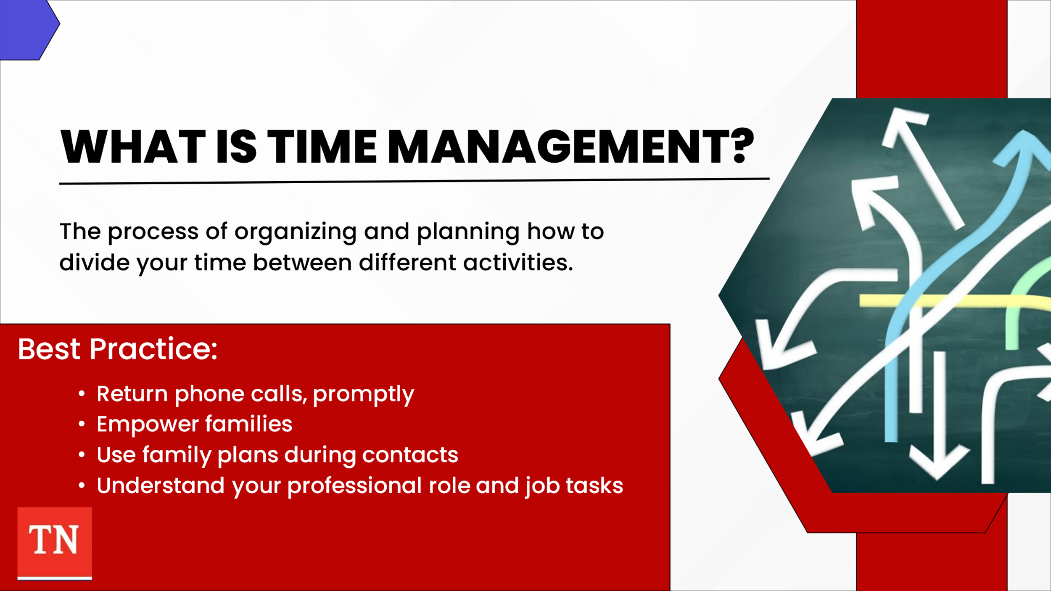
- ASK participants What is Time Management? SHARE time management is the process of organizing and planning how to divide your time between different activities. STATE if we get it right, we end up working smarter, not harder. SHARE the highest achievers manage their time exceptionally well.
- STATE as a child welfare worker, it will feel like you are being pulled in many different directions at once. There are a lot of high priority tasks so knowing how to work efficiently and manage time can make or break your ability to stay on top of your cases and help families with safety, permanency, and well-being.
- SHARE efficiency and effective time management should not mean leaving a job half-finished or cutting corners especially in a field as important as child welfare. Instead, whether you are working independently or as a part of a team, your time management strategies should maximize the limited time and resources you do have to ensure your most pressing and priority tasks always get completed.
- SHARE before we move on to assess our time styles and discuss strategies, it is important to keep in mind best practices:
  - Return phone calls promptly.
  - Empower families. When they do more for themselves, they rely on you less.
  - Use family permanency plans during quality contacts. This keeps everyone focused on the common goal and assessing progress along the way. It also ensures time is used efficiently.
  - Understand your professional role and tasks you must complete. Once you have this understanding, you can more easily prioritize and schedule.
- STATE we will now discuss some benefits and myths of time management. TRANSITION to Lesson 1.2.

Lesson 1.2: Benefits and Myths

Lesson Time: 10 minutes

Key Teaching Points / Instructions

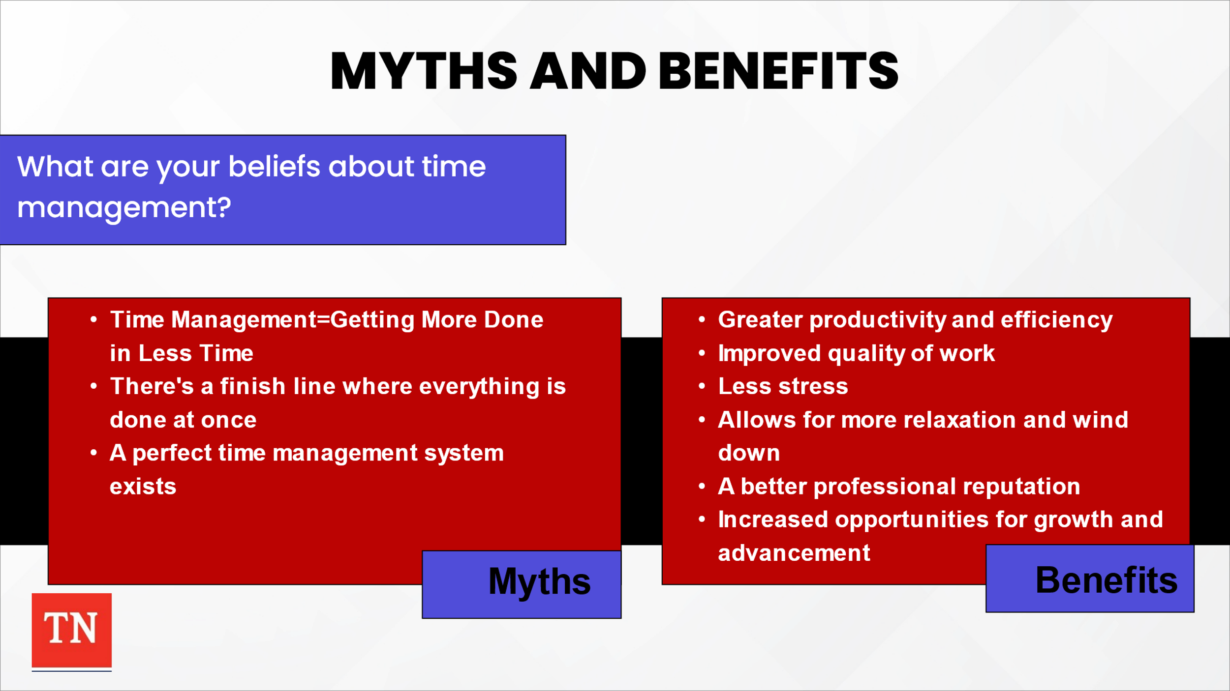
- ASK participants to share their beliefs about time management. DISCUSS the following myths:
  - Time Management=Getting More Done in Less Time
  - There’s a finish line where everything is done at once
  - A perfect time management system exists
- STATE we cannot manage time, nor can we save it. Time ticks away relentlessly, despite, our efforts to control it. SHARE when we can manage our productivity, there are numerous benefits.
- ASK the group to share benefits to effectively using your time. STATE when you know how to manage your time effectively, you can unlock many benefits. REVIEW any benefits not shared:
  - Greater productive and efficiency
  - Improved quality of work
  - Less stress
  - Allows for more relaxation and wind down
  - A better professional reputation
  - Increase opportunities for growth and advancement
  - More opportunities to achieve your life and career goals
- ADVISE overall, you start to feel more in control with confidence to choose how to best use your time. Ultimately feeling happier, more relaxed, better able to think, and more in control leads you to a great place to help children and families reach their target too.
- STATE we are provided 24 hours of time each day to use as we like. The key is in how we use that time. We can use it wisely, we can waste it, but we can never save it. At the end of the day, it is gone. What we can manage is productivity. We will discuss what being busy versus being productive looks like next. TRANSITION to Lesson 1.3 Being “Busy” and Barriers to Productivity.

Lesson 1.3 Being “Busy” and Barriers to Productivity

Lesson Time: 20 minutes

Key Teaching Points / Instructions

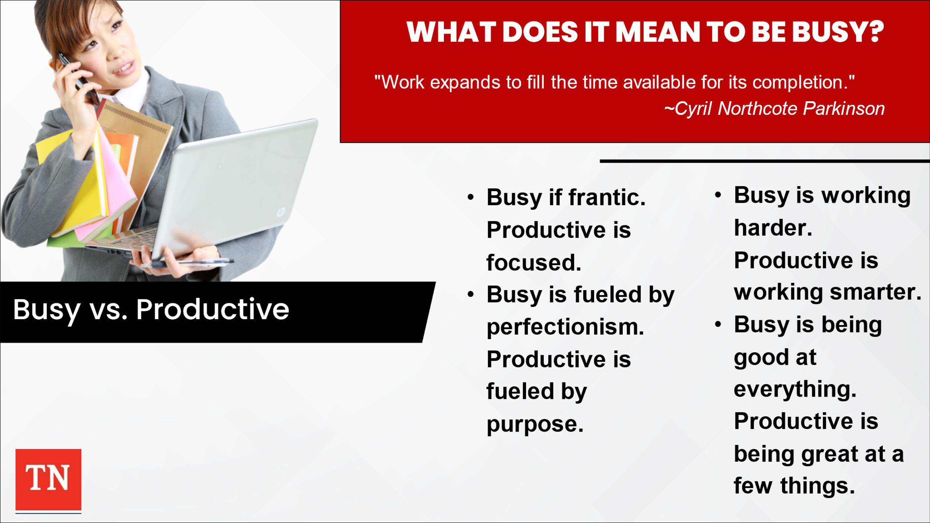
- ASK what does it mean to be busy? STATE in our “always-on” world, there is a constant demand to be busy, to be seen as busy, responding to everything immediately and getting tasks done quickly. This can lead to feelings of being overwhelmed and overworked.
- SHARE economist Cyril Northcote Parkinson once wrote that “Work expands to fill the time available for its completion.” ASK for thoughts on the quote.
- STATE John Spencer, editor of Pop Culture and Society has four rules for understanding the difference between being busy and being productive:
  - Being busy is frantic, while being productive is focused.
  - Being busy is fueled by perfectionism while being productive is fueled by purpose.
  - Being busy is about working harder while being productive is about working smarter.
  - Being busy is about being good at everything while being productive is about being great at a few important things.
- SHARE being busy means having a great deal to do. You constantly feel as though you have a lot going on, and you are trying to accomplish many task at the same time. However, in reality, you are really accomplishing very little. By overloading yourself sometimes because you feel you have to or possibly because of the work in child welfare, you are actually impacting your ability to complete tasks in the long term and within your role. Your personal credibility may suffer as your tasks are not completed and goals are not met.
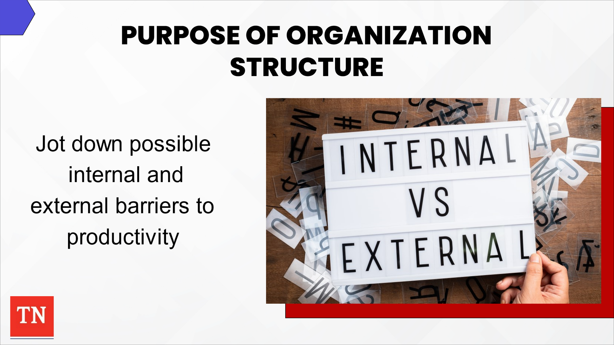
- STATE being “busy” isn’t the only obstacle in productivity in child welfare. SHARE we each have both internal and external barriers.
- ASK participants to take 2-3 minutes to use a post-it note to jot down possible internal and external barriers. ASK for participants to share. The following are possible examples:
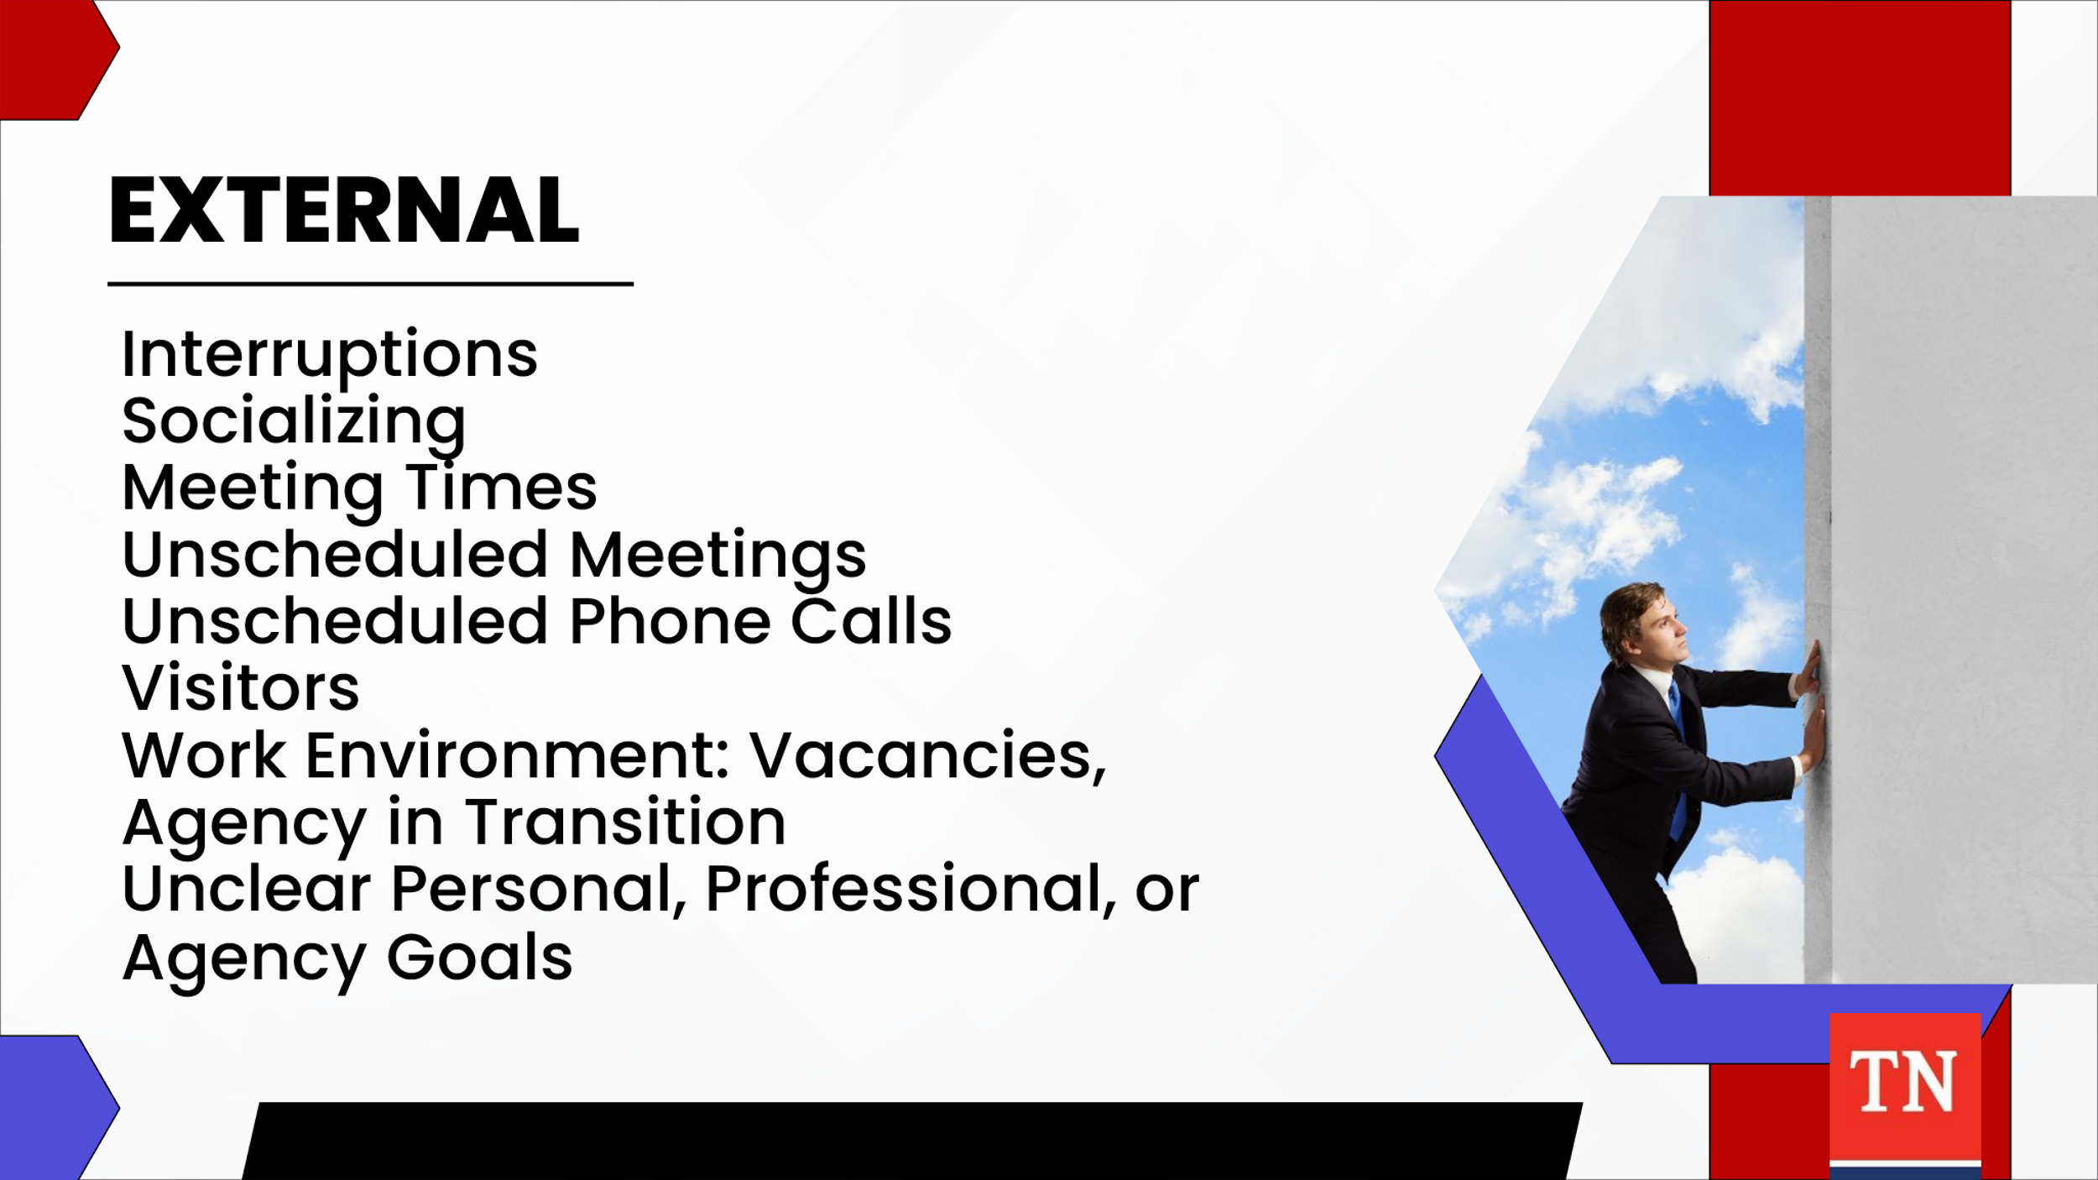
  - External: interruptions, socializing, meeting and unscheduled meetings, unscheduled phone calls or visitors, work environments (vacancies, agency in transition), unclear personal, professional, or agency goals
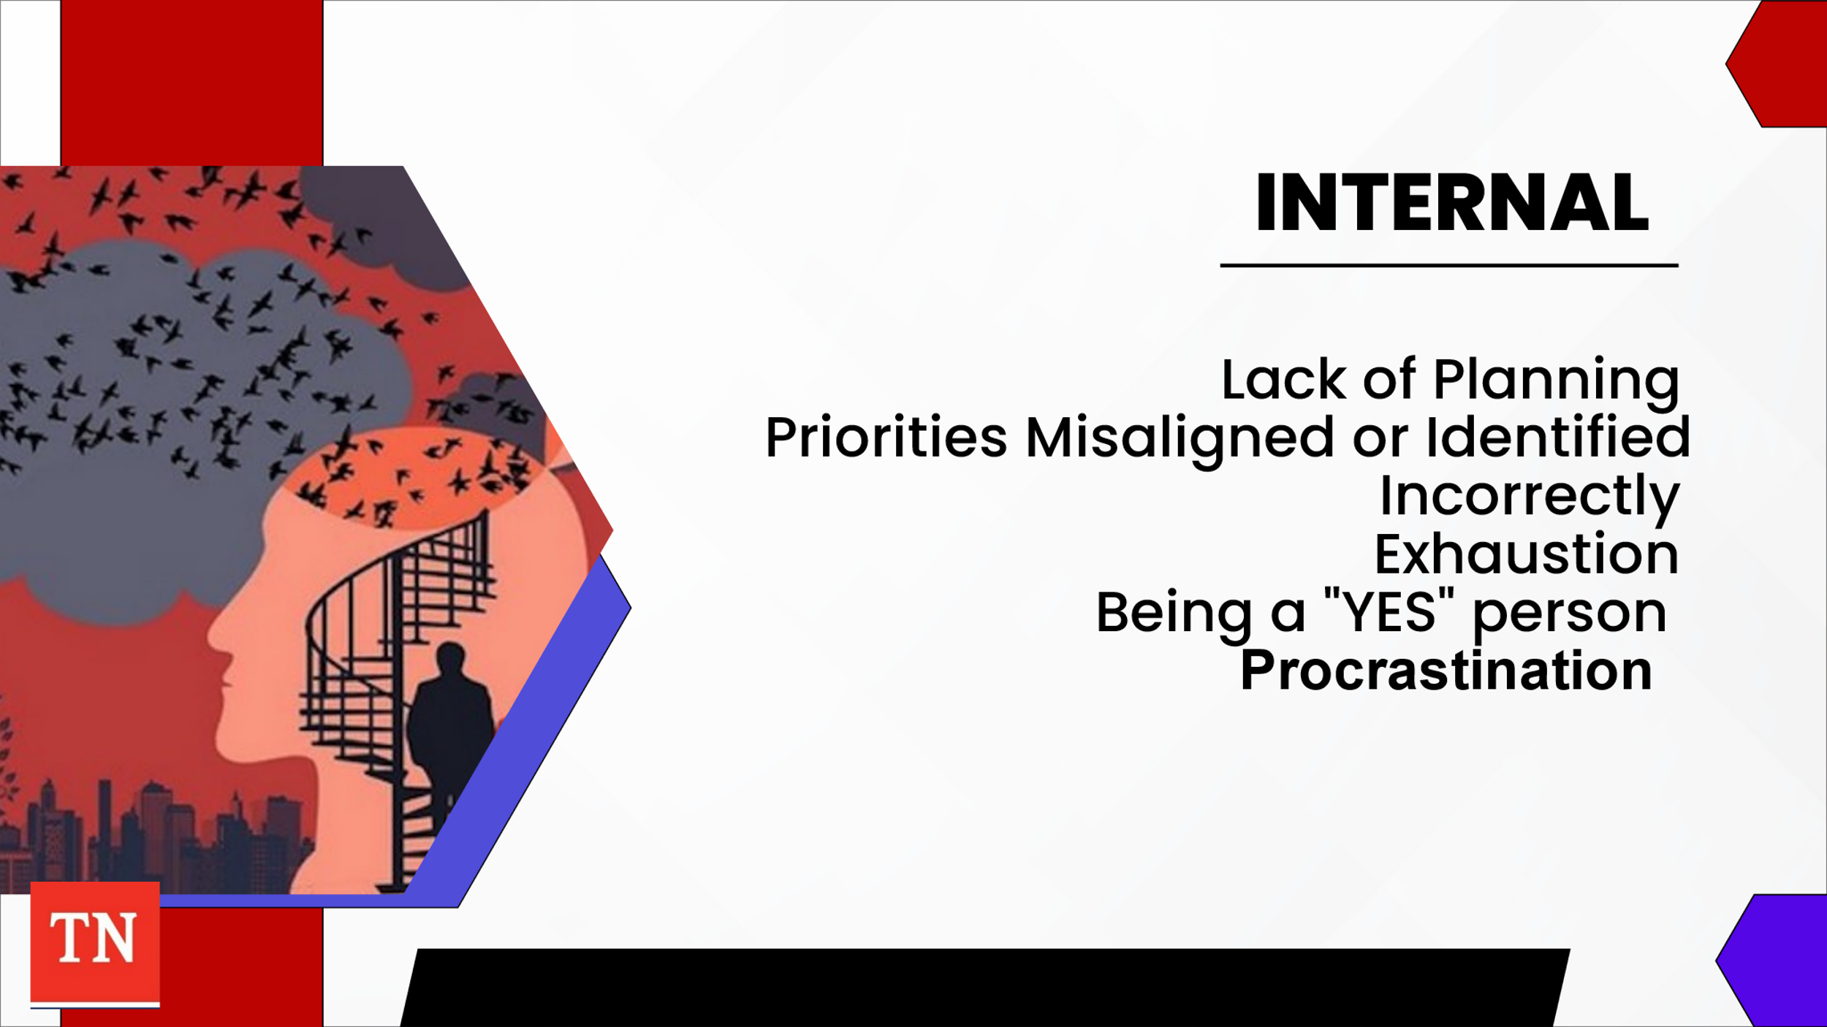
  - Internal: lack of planning, priorities misaligned, or identified incorrectly, exhaustion, being a “Yes” person, and procrastination
- SHARE we will now discuss procrastination more in depth.
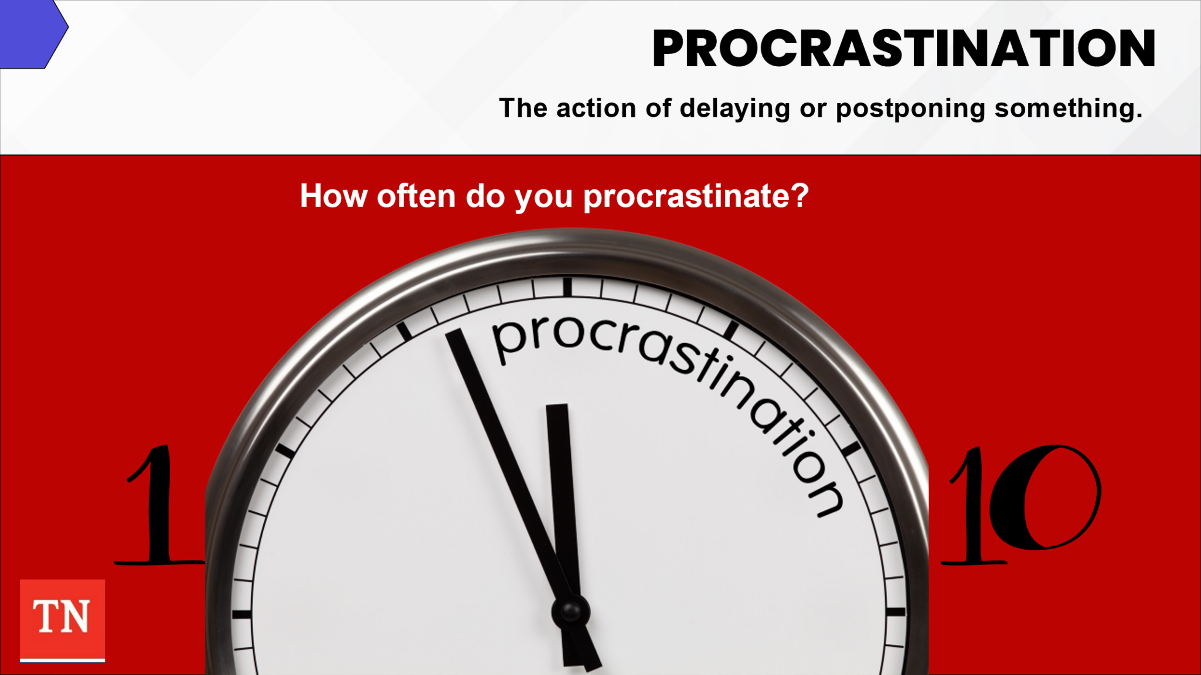
- STATE procrastination is defined as by the Oxford Dictionary as: The action of delaying or postponing something.
- ASK participants to rate how often they procrastinate when having an important task with a timeframe with 1 being always and 10 being never. ASK for a volunteer and use Motivational Interviewing Skills to ask the following: Why you chose the number you are at? What reason are you not at a lower number? What would you need to do in order to move down the scale toward always?
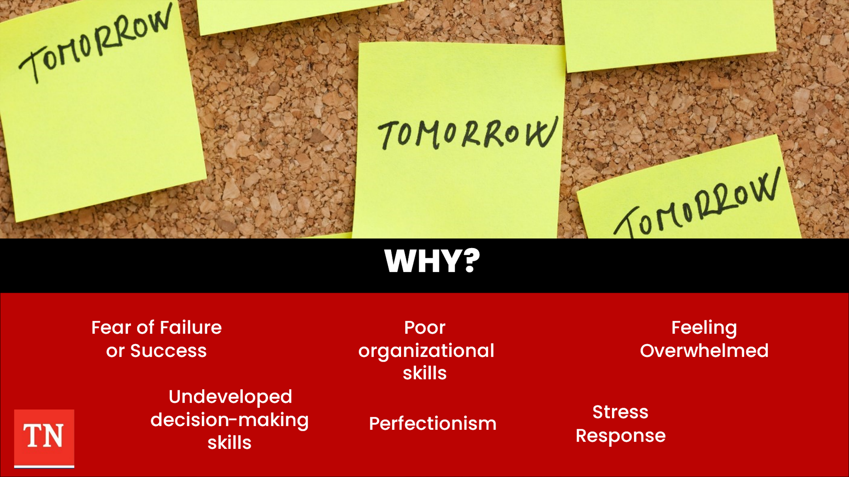
- STATE we procrastinate as we often wait for the right mood or time to complete a task. We may fear failure or even at times success. We sometimes have undeveloped decision-making skills and/or poor organizational skills or may want everything to be perfect. Sometimes procrastination can be due to feeling overwhelmed where our stress response (or fight, flight, or freeze) is activated.
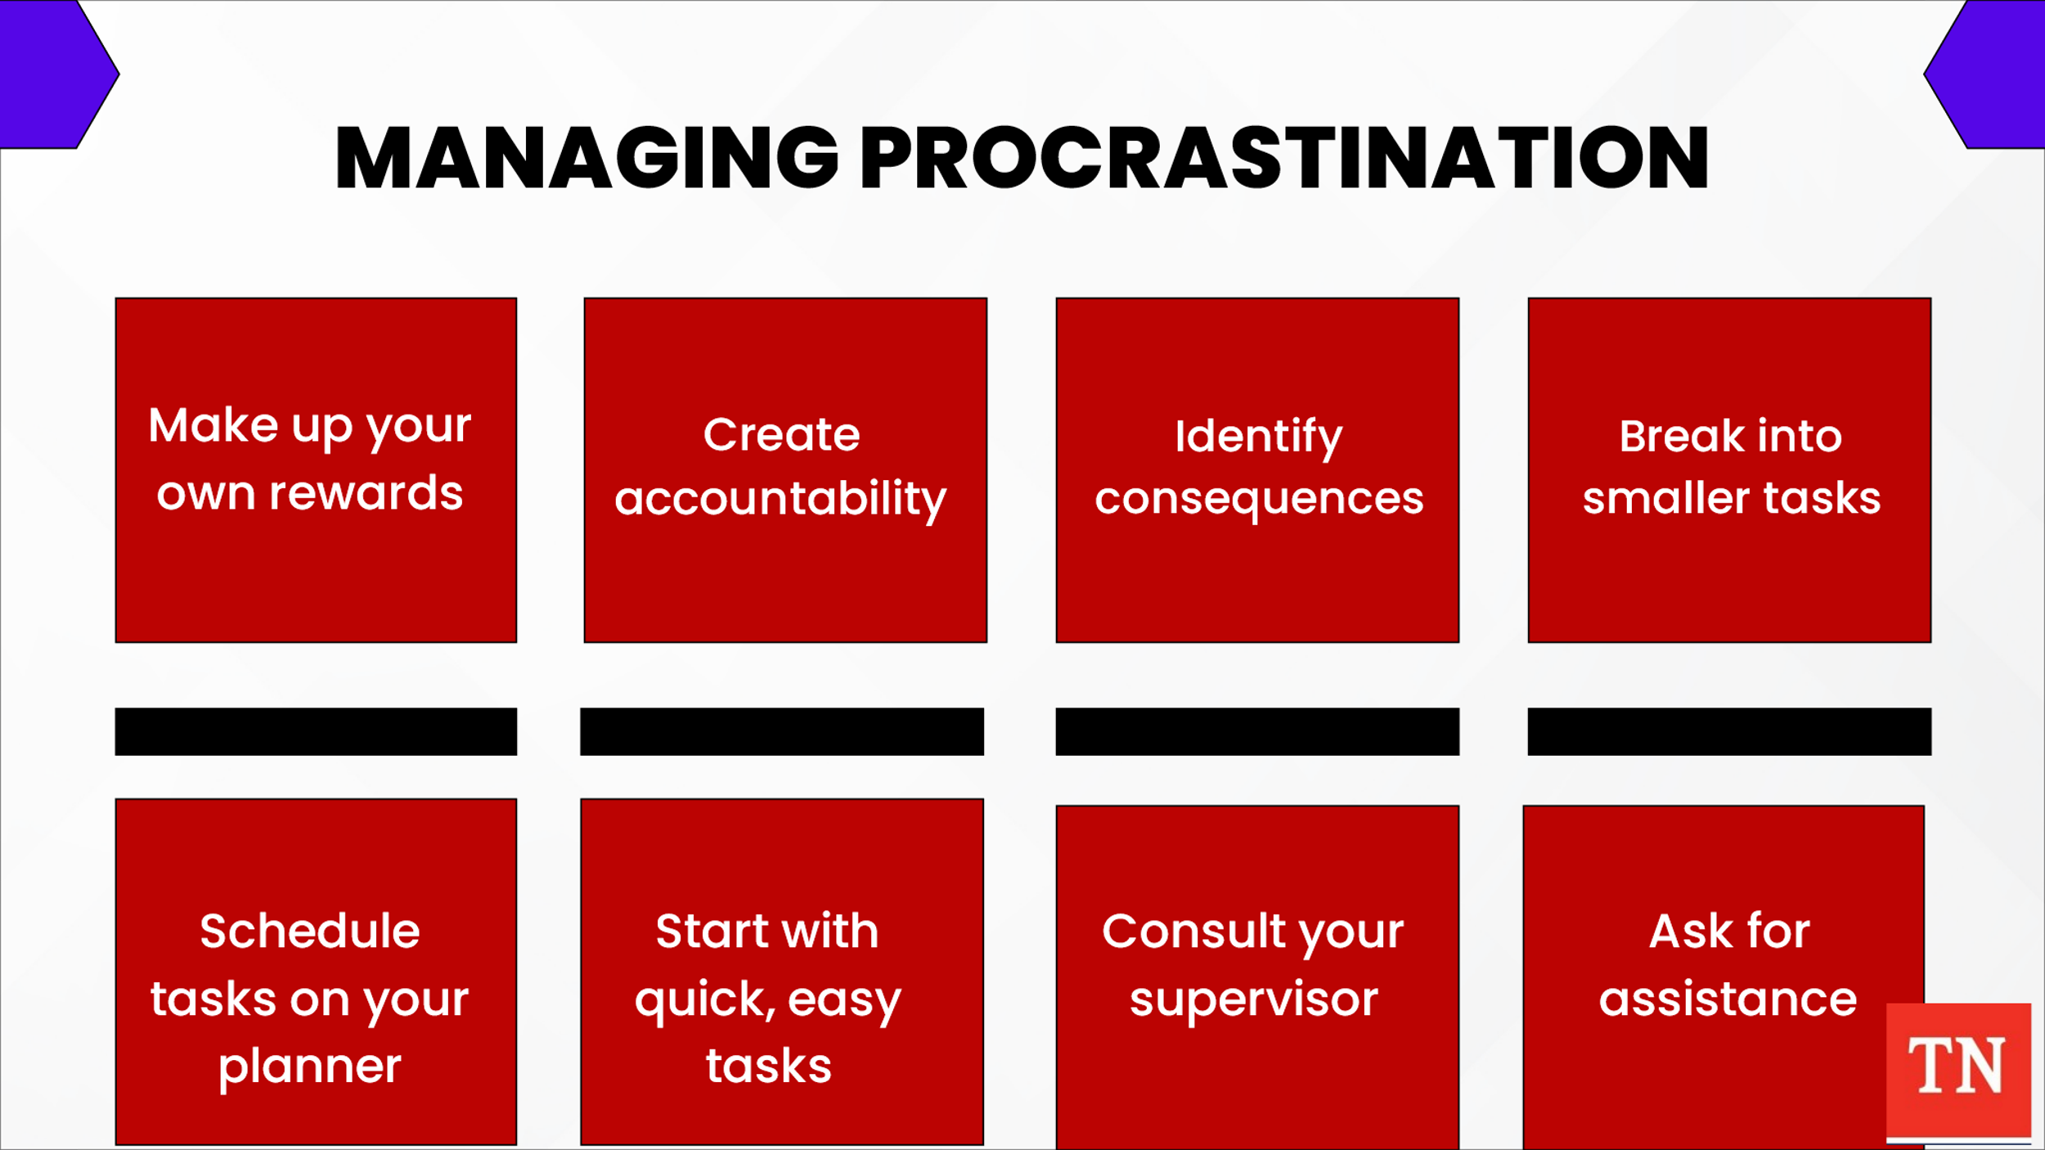
- EMPHASIZE the key to overcoming procrastination is to recognize you ARE procrastinating and figure out WHY then make a plan. ASK for the group to share strategies to manage the tendency to procrastinate.
- SHARE the following: make up your own rewards, ask someone to check on you (creating accountability), identify consequences of NOT completing the tasks, break the project into smaller, manageable tasks and schedule them on your calendar/planner, start with quick, easy tasks, consult with your supervisor, and ask for assistance.
- STATE managing procrastination is only one area of time management. SHARE we will next discuss Time Management Strategies. TRANSITION to Unit 2.

Unit 2: Time Management Strategies

Unit Time: 50 minutes

Resources:
- Facilitator Guide and PowerPoint
- Personal Productivity Style

Learning Objectives:
- Participants will evaluate their own time styles and learn tools to assist with how to manage according to their results.

Lesson 2.1 Not just about Tools

Lesson Time: 20 minutes

Key Teaching Points / Instructions
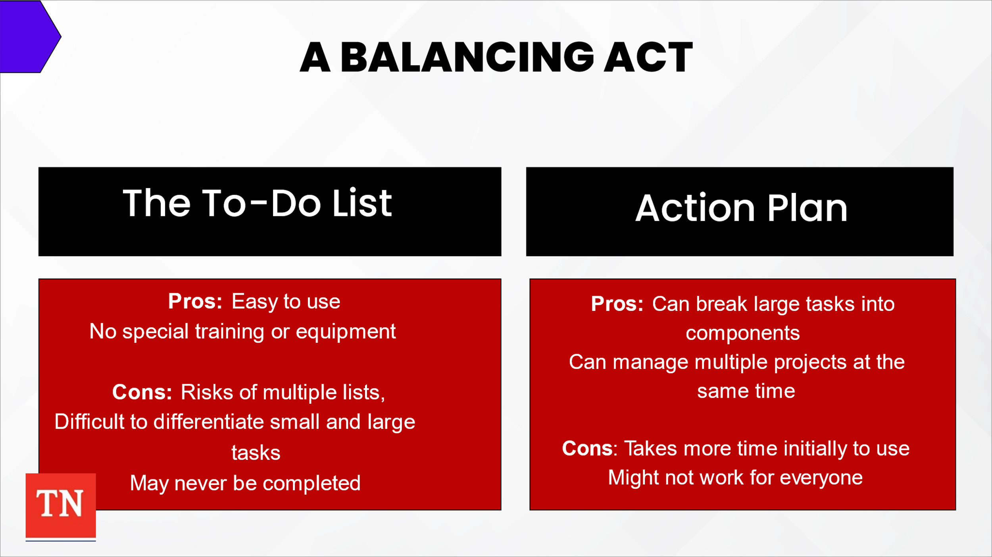
- BEGIN by STATING time management can be tricky for child welfare workers. You are balancing tasks such as providing services with administrative duties all the while being available for the children and families we serve. STATE it may feel as though you are available each hour of the day with social media, emails, cell phone, etc. So how do you juggle all your professional responsibilities as a case manager? ADVISE you must use your assessment skills to decide what has the highest priority, and what tasks can wait.
- SHARE there are many time management tools and strategies. Two of the most common are to-do lists and action plans. Each of these have pros and cons.
  - The To-Do List:
    - Pros: Easy to use, no special training or equipment required
    - Cons: Risks of multiple list, Difficult to differentiate small and large tasks, may never be completed
  - Action Plan:
    - Pros: Can break large tasks into components, Can manage multiple projects at a time
    - Cons: Takes more time initially to use, might not work for everyone
- ASK participants who uses either of these tools? ASK how they work for you? STATE there are other strategies which may be more helpful in child welfare.
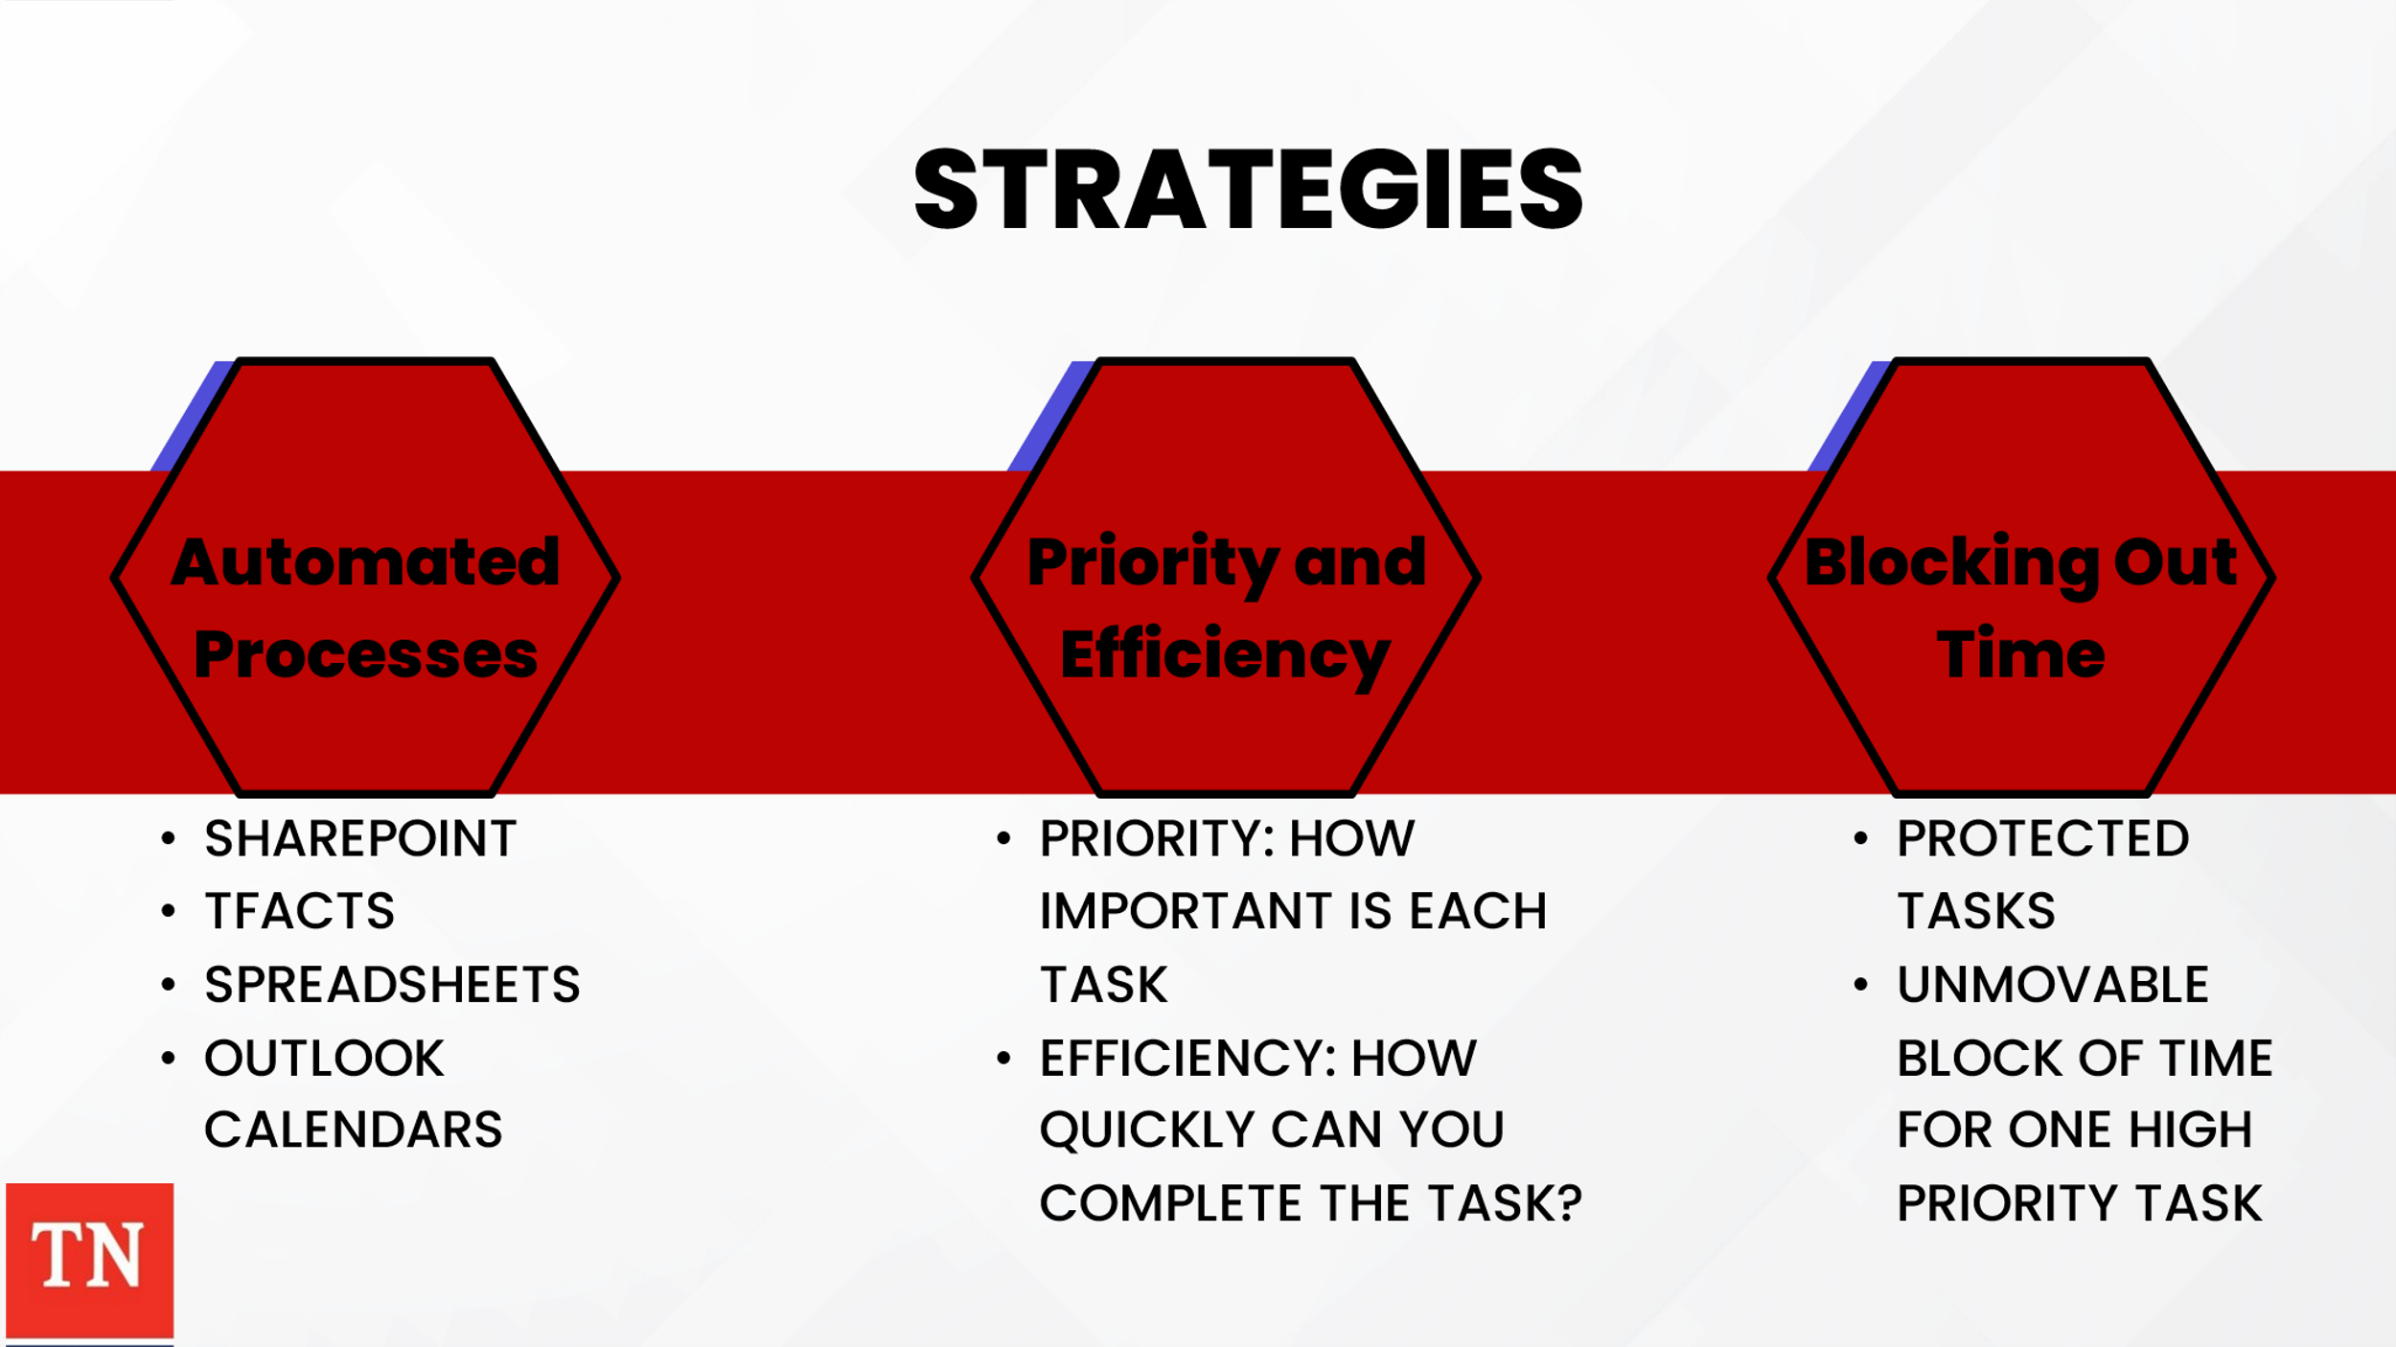
- SHARE the first is Automated Tools. It may feel like you have to do everything manually to manage your case correctly, however, a way to save time and reduce overall workload is to rely on automated processes. Within DCS we have many tools to help manage cases and data. SharePoint, TFACTS Alerts, Spreadsheets and Outlook Calendars may help keep due dates and timeframes in check.
- Second organize the task based on Priority and Efficiency. How you manage your daily tasks is essential to how well you maximize your time. It is easy to routinely tackle tasks as they come up or even when they are added to your list; however, these strategies can leave you putting out fires and delaying important cases. It is important to take a moment to assess your current list of task and organize by two factors: priority and efficiency.
  - Priority: How important is each task. It may be influenced by time sensitivity (i.e., an Initial Permanency Plan CFTM or Face-to-face contacts). It can also be influenced by urgency and overall importance. As we know emergencies do come up and the task list should give allowance to prioritize them as necessary. Tasks that need to be complete at some point but are not of immediate concern or importance are considered low priority while those with an immediate deadline requiring urgent action are high priority.
  - Efficiency: How quickly can you complete the task? Sometimes small task can get pushed off and actually create a significant time deficiency later on. When you finish your high priority tasks, you can knock out several quick tasks at once. Do so can give you a boost as a seemingly insurmountable task list can be overwhelming.
- STATE another helpful strategy when assessing priority and efficiency is to color code tasks. This approach can help organize your daily schedule at a glance.
- Third strategy is blocking out time. You should assess your to-do list for tasks based on how quickly you can complete them. Blocking out time is especially important for meetings with families and teams. Also consider choosing a “protected” task each day. It may be normal to rearrange your schedule as other assignments come up; however, look at your list to choose one high-priority assignment that will be an unmovable block of time to complete.

Lesson 2.2 Evaluating How You Manage Time

Lesson Time: 30 minutes

Key Teaching Points / Instructions

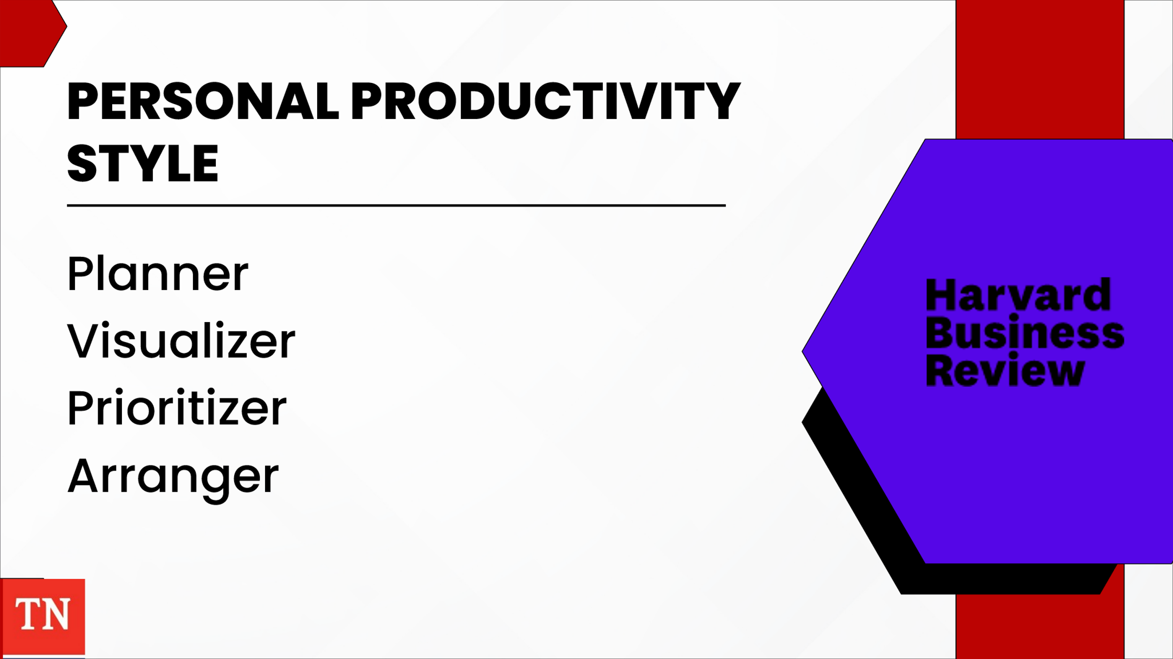
- SHARE when it comes to personal productivity advice, one size does not fit all. STATE the way a person prefers to perceive and process information can have a dramatic impact on the success or failure of time management techniques and performance enhancement strategies. This assessment is designed to help you understand your own style—how you think, learn, and communicate best—and guide you toward productivity tips that have been found to be effective.
- SHARE the following website and ASK participants to complete the Personal Productivity Style from the Harvard Business Review. https://hbr.org/2015/01/assessment-whats-your-personal-productivity-style
- Results could include:
  - Planner: Prefers organized sequential, and detailed thinking. They create to-do lists, set aside time for task, an prepare thorough and accurate project plans. They don’t waste time on anything unproductive or unimportant. They comply with laws, policies, regulations, and quality criteria. They frequently complete work ahead of deadlines.
    - Productivity tools that appeal: Agendas, IPad apps, label makers, file folders, filing cabinets, drawer organizers, and pen holders.
  - Visualizer: Prefers holistic, intuitive, integrative thinking. They manage and juggle multiple tasks while still seeing the big picture. They are known for creativity and innovation. They think strategically about projects and work quickly to execute tasks. They tend to maintain visual list often using color.
    - Productivity tools: Digital whiteboard apps, Sketchbook Pro (captures ideas with digital sketching and painting tools), Apps to save receipts, Multi-colored post-it notes, folders, notebooks, and pen; large whiteboards, baskets, bags, and clipboards.
  - Prioritizer: Prefer logical, analytical, fact based, critical, and realistic thinking. They use time effectively and focus on the highest-value tasks, accurately completing significant amounts of work. They analyze project goals and strive to achieve the desired outcomes.
    - Productivity tools: iPads, Digital Notebooks, Legal Pads, Label Makers
  - Arranger: Prefer supportive, expressive, and emotional thinking. They encourage teamwork to maximize output, and they make decisions intuitively as events unfold. They block off time to complete work but excel at partnering with others to get it done. They communicate effectively, which helps them build and lead project teams. They tend to maintain visual lists, often using color.
    - Productivity tools: Dictation Apps, WebEx, Teams, Zooms, aesthetically pleasing office supplies such as notebooks, unlined pages, pens in variety of ink colors.
- DEBRIEF results. ASK do you feel like the results match the worker you have been in the past? Has your previous way of doing things worked for you, or do you think it’s time to change?
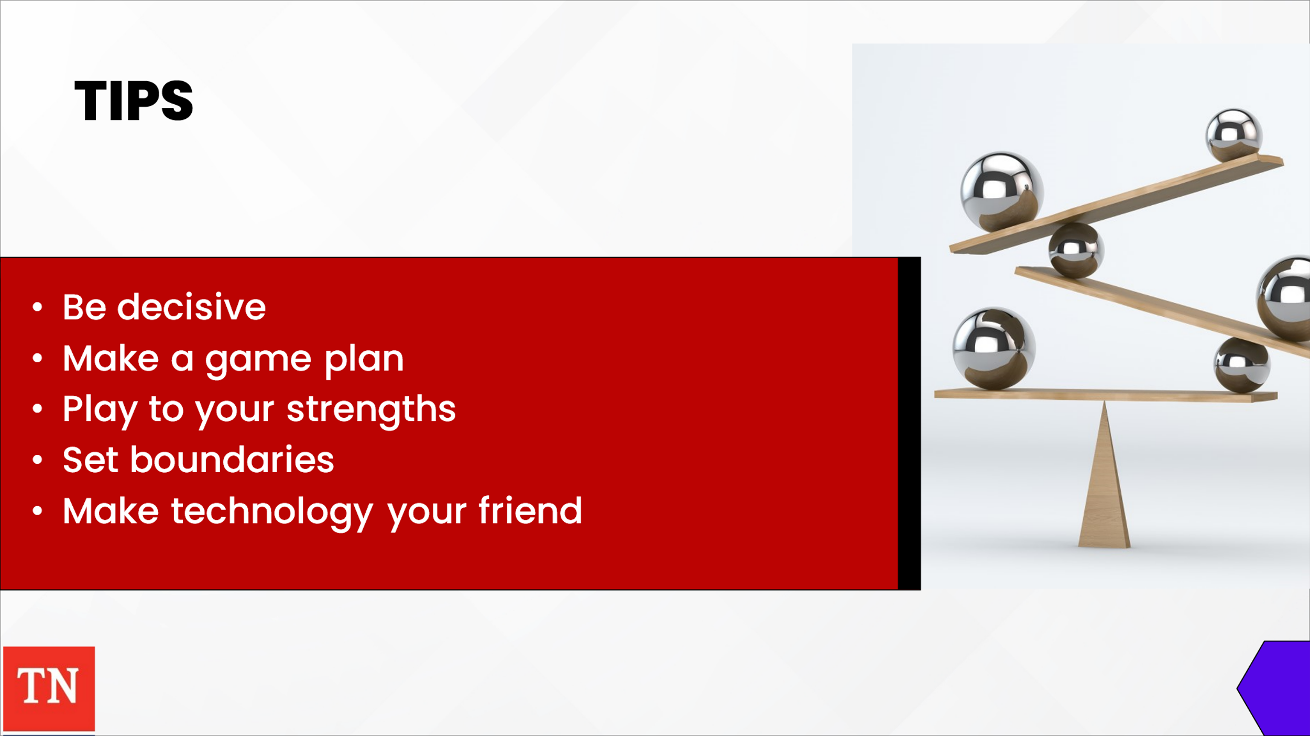
- STATE deliberate, quick, and thoughtful case management is essential to children and families and staying on top of your workload is essential to managing your own stress levels and ability to plan. The following tips can assist.
  - Be decisive. Making decisions every day can be overwhelming and can zap your energy. If you aren’t great at making decisions, use tricks like flipping a coin or setting a timer for decisions that aren’t significant. Follow your intuition. If two competing tasks need your time and are equally important, divide and conquer. Alternate an hour on each task then set it aside rotating back and forth until both are complete or until one takes priority over the other
  - Make a game plan. Take a few minutes each morning to complete the priority list for the day. Do the little things as you go. If it takes less than five minutes, do it at that time. This will prevent the smaller pieces from piling up.
  - Play to your strengths. Whether you perform better in the morning or at night, plan to complete your bigger, more demanding tasks during the time of day you are most productive with the least distractions.
  - Set boundaries. Child welfare is a profession in which self-awareness is key. Feelings will come up and it isn’t easy to “leave it at the office.” Setting boundaries is essential. You may set a firm timeframe for a client who likes to monopolize your time or let your colleagues and supervisor know when you are and aren’t available. Decide how much of your day you can or are willing to give to others. Consult with your supervisor on your daily schedule/itinerary.
  - Make technology your friend. Getting bombarded with email throughout the day can be extremely distracting and cause anxiety but can come in handy and give you an assist. For clients, choose one means of contact to use for emergencies or crisis calls. For non-crisis accounts, silence alerts during all non-office hours. Consider checking emails/messages at designated times. Use the Outlook Calendar to keep track of meetings and appointments and block out sufficient hours to allow yourself time.
- STATE these tips can help, but you will have to experiment to find what works and what doesn’t for you. Balancing all aspects of your job as a child welfare workers is crucial. Not only will it help you avoid burnout, but it can also help keeping your satisfied and sane. It will also help families reach positive outcomes.
- TRANSITION to Unit 3 Prioritizing and Scheduling

Unit 3: Prioritizing and Scheduling

Unit Time: 80 minutes

Resources:
- Facilitator Guide and PowerPoint
- Your personal energy cycle (2:08)
- Covey’s Time Management Matrix
- Maximizing Your Time Infographic

Learning Objectives:
- Participants will gain knowledge on Energy Levels.
- Participants will gain knowledge on Covey’s Time Management Matrix and be able to apply the matrix to child welfare work.

Lesson 3.1 Energy Cycles

Lesson Time: 30 minutes

Key Teaching Points / Instructions

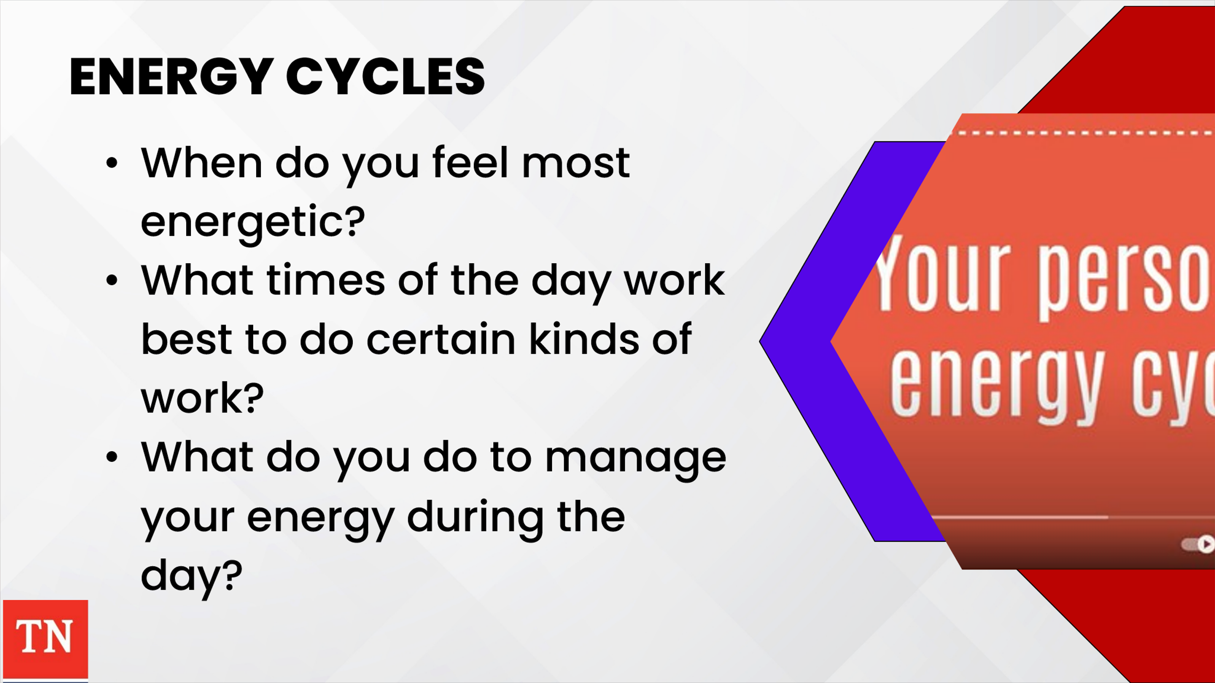
- SHARE we have been discussing a lot of information regarding the management of time, but ultimately, time is not what needs to be managed. No matter what you choose to do during the day, the time will inevitably pass. Every hour is not created equal. Throughout the day, you have natural energy levels that cycle up and down. These natural rhythms during the day are called Energy Cycle.
- STATE the goal is to work with your natural energy cycle versus against it. SHOW the following video: Your personal energy cycle (2:08)
https://www.youtube.com/watch?v=IU35rj1sAis
- DEBRIEF by asking the following:
  - When do you feel most energetic?
  - What times of the day work best to do certain kinds of work?
  - What do you do to manage your energy during the day?
- STATE there is nothing abnormal about the changes we all have in energy during the day; however, we sometime categorize the downswing in energy as a problem to fix. We often try to get done more by resting less. We may use large doses of sugar and caffeine while others even turn to abusing prescription or illegal drugs.
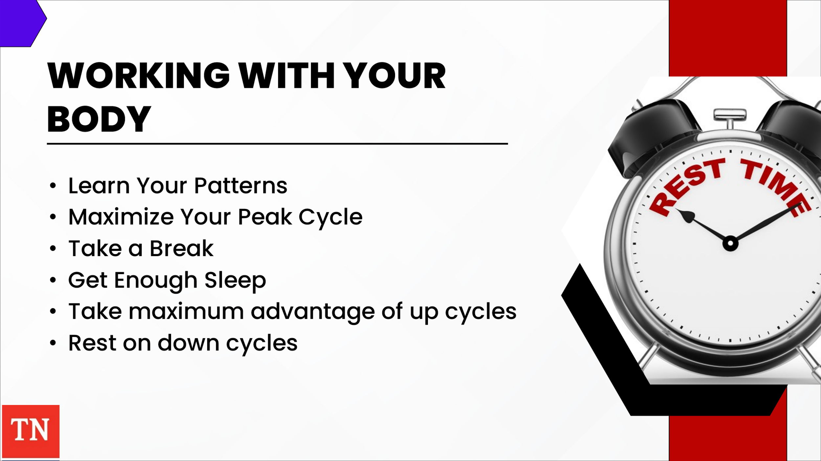
- STRESS humans need to rest and recover for peak performance. Resting isn’t a sign of laziness or weakness. It is recognizing an essential human need. We must pay attention to our natural energy cycles to help consistently perform our bests over long periods of time. Here are some ways to work with our bodies instead of against them.
  - Learn Your Patterns: use a notebook or calendar to track how much energy you are having during different parts of the day as well as what you are eating and drinking. If you do this for a few days, you’ll notice patterns in how your energy flows allowing you to plan accordingly.
  - Maximize Your Peak Cycle: When you are in an up cycle, you can get a lot accomplished, so plan your day to take advantage of that energy.
  - Take a Break: When you are in a down cycle, it’s better to rest than attempt to power through it. Rest and recovery are not optional. If you do not rest, your body will force you to rest later. During a down cycle, go for a walk, meditate, take a twenty-minute nap.
  - Get Enough Sleep: Sleep deprivation results in a prolonged down cycle which gets in the way of getting things accomplished.
- SHARE paying attention to your Energy Cycles during the day will help you get the most out of the time you have available. Take maximum advantage of your up cycles and rest on down cycles. You will find you are accomplishing more in the day.
- TRANSITION to Lesson 3.2 Maximizing Your Time.

Lesson 3.2 Maximizing Your Time

Lesson Time: 40 minutes

Key Teaching Points / Instructions
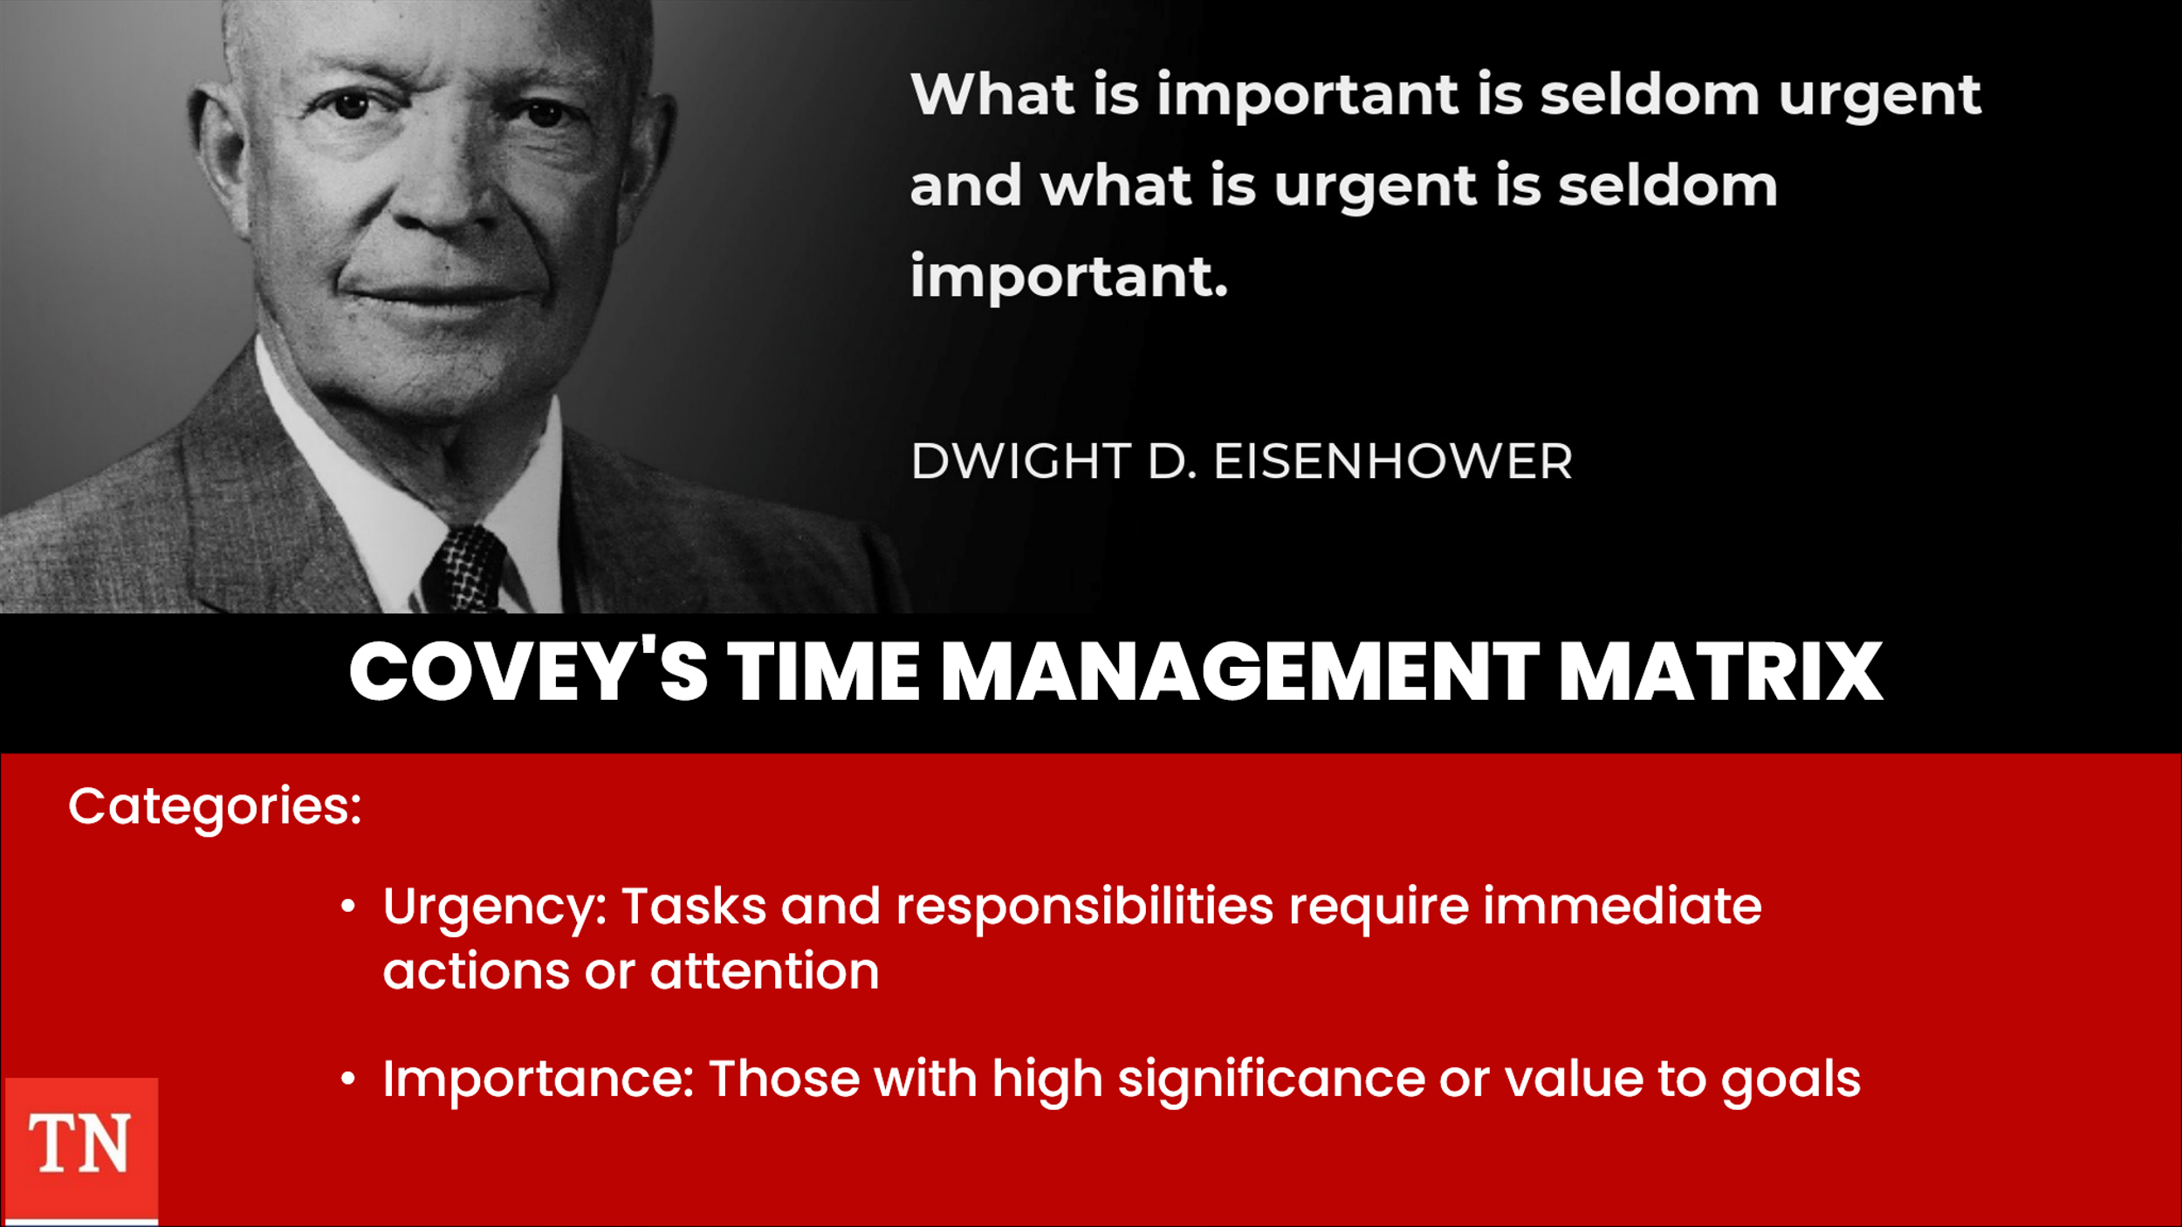
- SHARE Dwight D. Eisenhower, former general and former president of the United States devised “the Eisenhower Decision Matrix.” He said,
What is important is seldom urgent, and what is urgent is seldom important.”
- ADVISE most people fall into the category of believing all urgent activities are also important. In his book, the 7 Habits of Highly Effective People, Steven Covey refined Eisenhower’s Decision Matrix into four quadrants. This four-quadrant system helps you to categorize each task and responsibility based on urgencies and importance.
  - Urgency: Tasks and responsibilities require immediate action or attention
  - Importance: Those with high significance or value to goals
- STATE the objective of using this method is to focus on improving both personal and professional relationships as well as promoting growth and accomplishment.
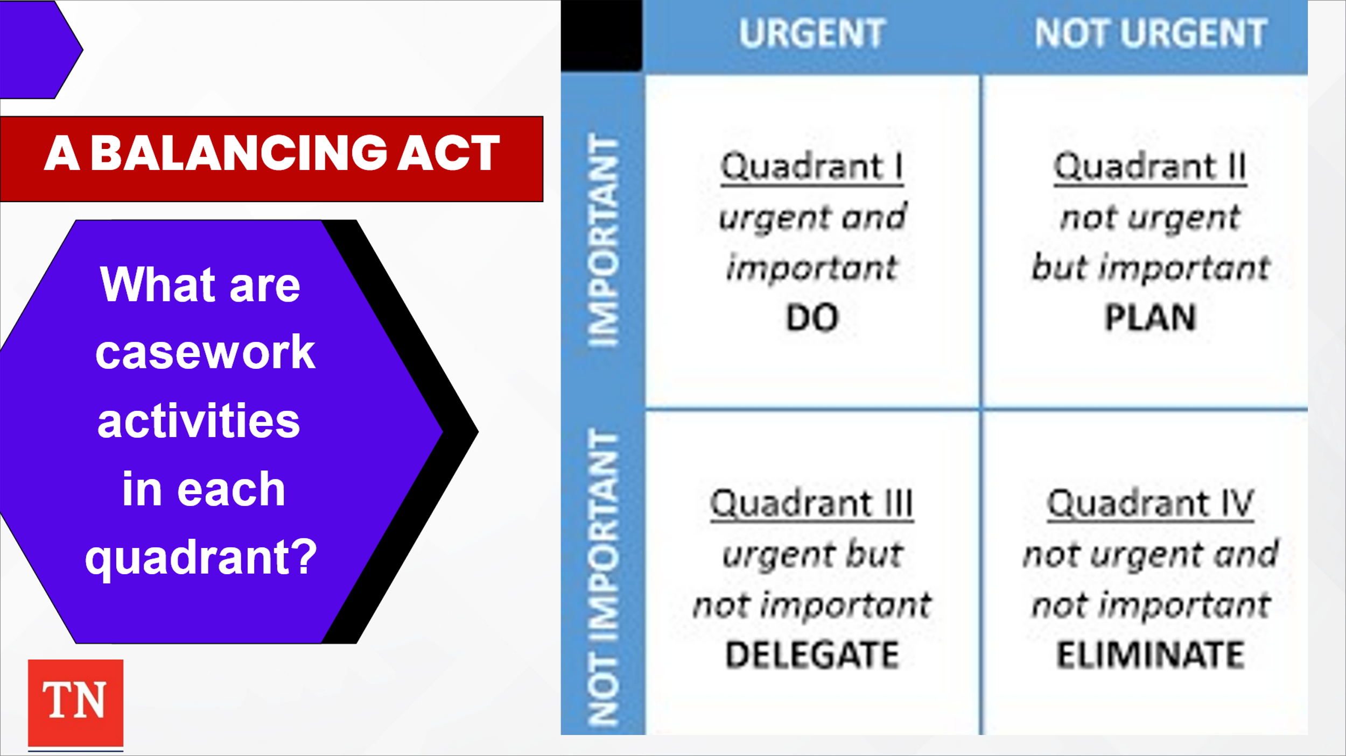
- SHARE the matrix symbolizes your time. So, its size cannot be modified, but the size of each quadrant may be changed based on how much time you spend in it.
- REVIEW the following information about each quadrant.
  - Quadrant 1: Urgent and Important
    - Involves responsibilities or tasks related to critical results and requires urgent attention. These items may also be stressors due to their urgency and importance, so being aware of these tasks and categorizing them accordingly can ensure you focus the necessary time and effort on them. Items in Q1 have the following qualities
      - Impending deadlines
      - Direct relation to time-sensitive goals
      - Involves alleviating immediate risk
- ASK what may be case work activities in Q1?
  - Quadrant 2: Not urgent but important
    - Involves focusing on activities to develop a sense of discipline and commitment, as well as identifying and working on things you can control. Items may have the following qualities:
      - Require planning or additional steps
      - Direct relation to overall goals
- ASK what may be case work activities for Q2?
  - Quadrant 3: Urgent but not important
    - Activities in Q3 are urgent and assume some form of importance in the moment. These are likely items that can be reduced or removed from your workflow. They likely have some of the following qualities:
      - Result of poor planning of items in Q1 and Q2
      - Interrupting productivity
      - Distraction
- ASK what may be case work activities for Q3?
  - Quadrant 4: Not urgent and not important
    - Tasks in Q4 are more likely able to be removed completely or reduced. It is important to identify which items belong in this quadrant, so you know which tasks to classify as lowest priority. These items typically have the following qualities:
      - Cause the least amount of stress
      - Not directly related to overall or time-sensitive goals
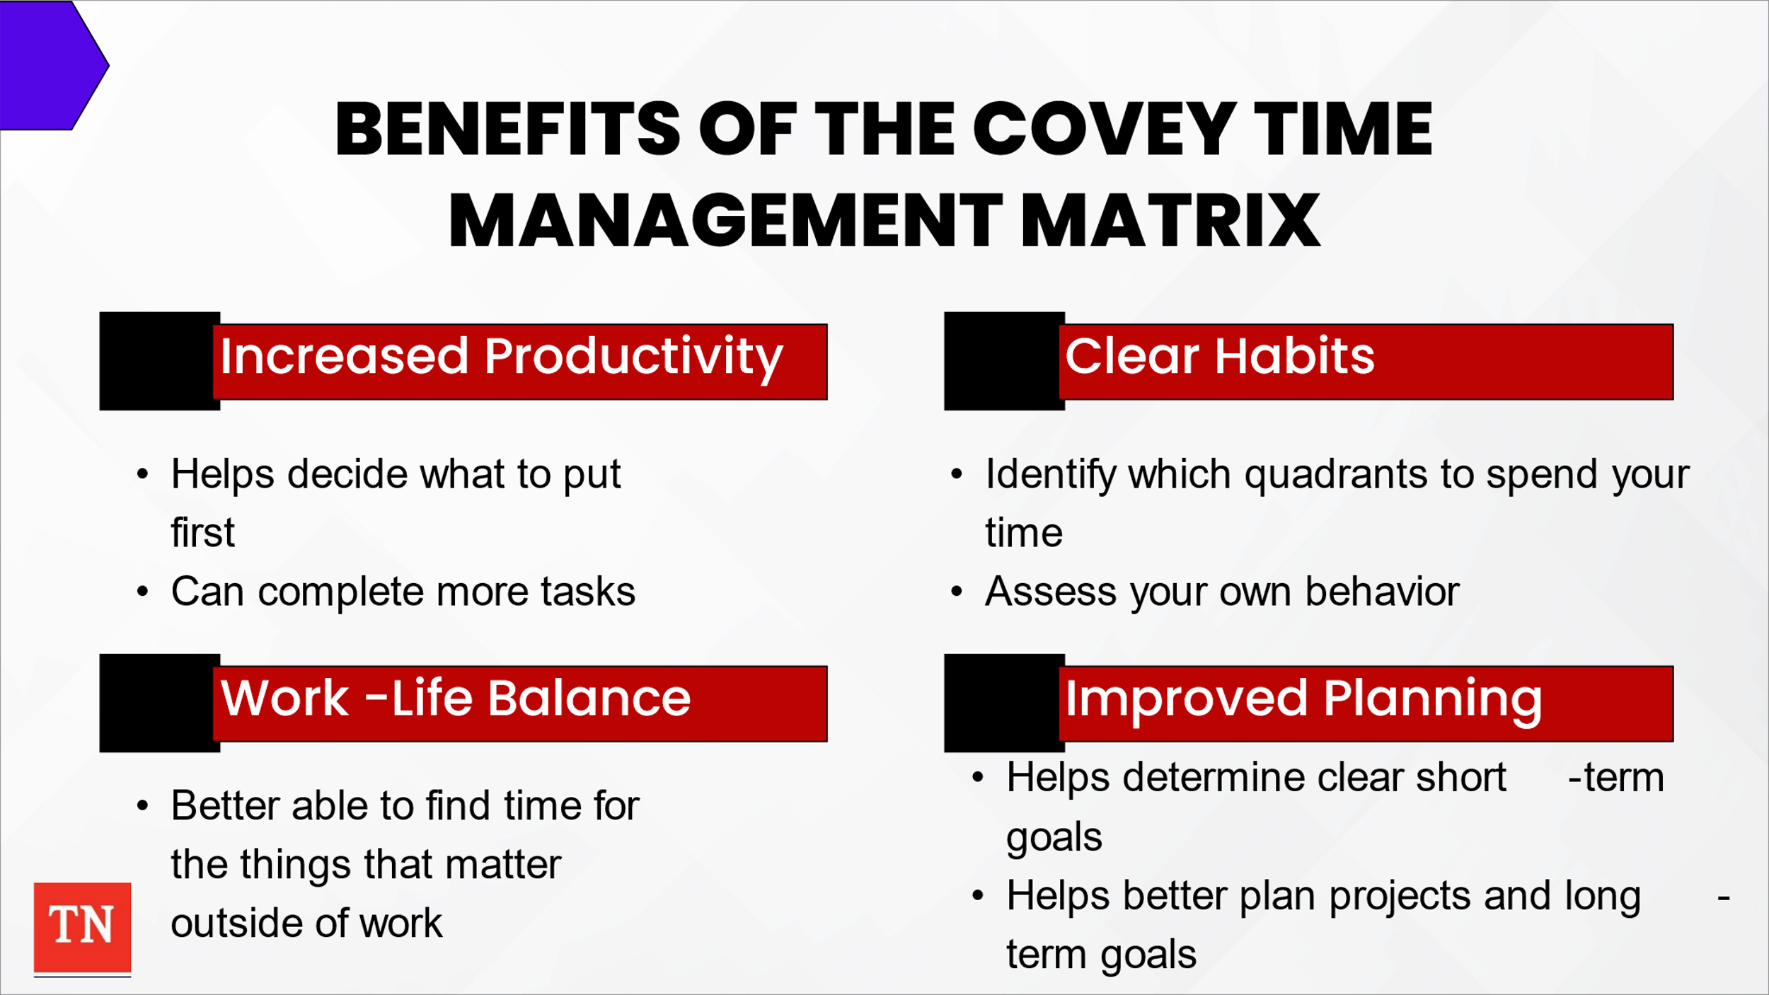
- SHARE using the Covey Time Management Matrix can have many benefits in the workplace, including:
  - Increased productivity: The order of this method can help you decide what to put first in your life and how to efficiently approach these tasks. Having an organized and prioritized list of tasks can help you complete more and the most vital tasks in the same amount of time.
  - Clear habits: Using this matrix can help you identify which quadrants you spend most of your time in and assess your own behavior. You can then develop new habits of focusing only on Q1 and Q2 items.
  - Work-life balance: With more productive habits at work, you are better able to find time for the things that matter most to you outside of work as well.
  - Improved planning skills: Prioritizing tasks appropriately with this matrix can also help you determine clear short-term goals that can be completed within certain timeframes. This can help you better plan projects and long-term goals.
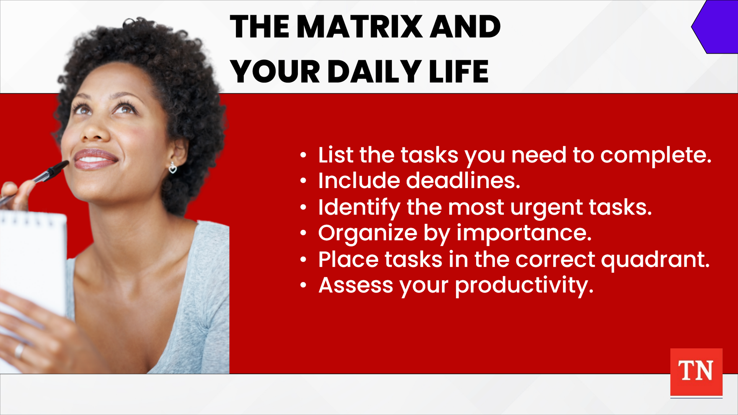
- STATE applying this matrix to your daily life and routine involves self-assessment and specificity. Here are some steps that may help you navigate this technique:
  - 1. List the tasks you need to complete. Whether prioritizing tasks for the day or for the month, it’s important to write out every task you have yet to complete. These tasks should be brief and clear statements.
  - 2. Include deadlines.
After you’ve clearly listed each task, include their deadlines. Knowing when things need to be completed can help you prioritize what needs to come first and what can wait until later. Make note of the deadlines that are quickly approaching to help determine the urgency of your tasks in the next step.
  - 3. Identify the most urgent tasks.
Indicate which listed deadlines are closest to determine which are most urgent. This allows you to put your tasks into perspective when it comes to prioritization. It also provides a clear view of what your responsibilities are collectively and may give you an idea of which tasks should be completed first and last.
  - 4. Organize by importance.
After determining how urgent each task is to your schedule, order your tasks according to their importance. This will allow you to fully realize which tasks are tentative and which tasks can wait at the moment. It can also assist with creating a schedule to get these urgent tasks completed according to their importance.
  - 5. Place tasks in the correct quadrant
Examine each task to determine how urgent and/or important it is for your agenda, then organize them into groups in your list. Once you have assessed which tasks are urgent, important, both or neither, place them in their corresponding quadrant. You can begin using this organization of the matrix to complete tasks throughout your day, week or month.
  - 6. Assess your productivity.
Repeat this process for your daily and weekly activities. After using the method for a few weeks or months, reflect upon your performance. Determine how completing tasks in order of their location in the matrix improved your efficiency, workflow and stress management. You can use your findings to figure out how best to adjust your schedule to accommodate your needs or assess if certain items in your matrix need to be moved to a different quadrant. If you discover some items are not as important as others, consider re-organizing your matrix, schedule, or work methods to put more meaningful tasks first.
- ASK if there are any questions. PROVIDE participants the following link to the Infographic: Maximizing Your Time https://public.3.basecamp.com/p/VKggVJCYidqFhGPtF4GXNGpW
- STATE we have discussed numerous aspects to time management. TRANSITION to Lesson 3.3 Wrap-Up.

Lesson 3.3 Wrap-Up

Lesson Time: 10 minutes

Talking Points and Instructions:

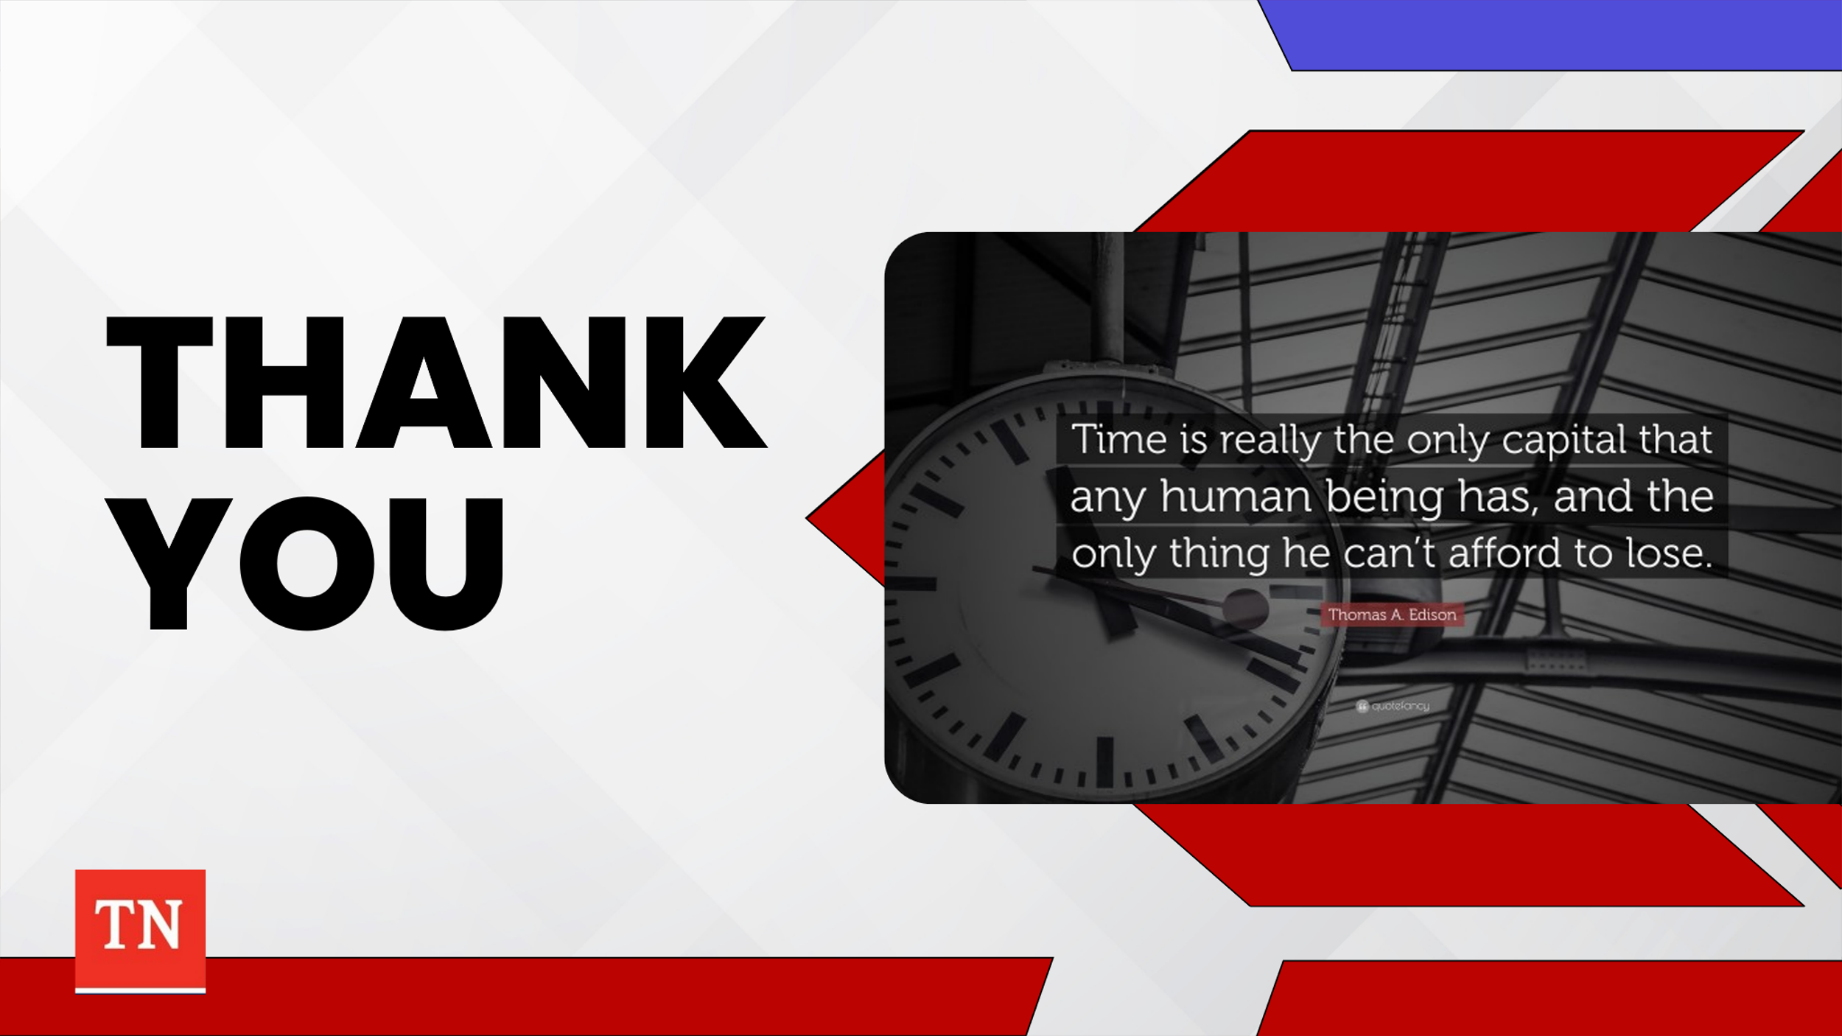
- ASK the group for any final thoughts or questions.
- ASK participants to SHARE at least one change they will implement into their daily routine practice going forward. GIVE affirmations to the selections.
- SHARE the following quote by reading it or asking a participant to read it:
- “Time is really the only capital every human has, and the only thing he can’t afford to lose.” ~Albert Einstein
- THANK participants for their participation.

References:
- What is Time Management:
https://www.mindtools.com/arb6j5a/what-is-time-management
- Time Management for Child Welfare Social Workers (Trudi Frazel, MSW)
https://slideplayer.com/slide/12533321/
- The Personal MBA (Josh Kaufman)
https://personalmba.com/energy-cycles/
- The Difference Between Being Busy and Being Productive
https://digitalmarketinginstitute.com/resources/lessons/personal-skills_the-difference-between-being-busy-and-being-productive_fmwq#:~:text=Being%20busy%20is%20frantic%2C%20while,productive%20is%20about%20working%20smarter.
- Increasing Efficiency: Time Management for Social Workers
https://astronsolutions.net/time-management-for-social-workers/
- 5 tips for social workers:
https://gssw.touro.edu/news/stories/5-time-management-tips-for-social-workers.php#:~:text=Not%20only%20will%20it%20help,hard%20work%20you're%20doing

- 10 Reason Time Management is important: https://www.brainbridge.be/en/news/10-reasons-why-time-management-is-important

- 10 Lessons from 10 Years on the Frontline: 7, Effective social work depends on effective time management
https://richarddevinesocialwork.com/2020/09/08/10-lessons-from-10-years-on-the-frontline-7-effective-social-work-depends-on-effective-time-management/
- Your Personal Energy Cycle:
https://www.youtube.com/watch?v=IU35rj1sAis

