Juvenile Justice Quality Contacts Desk Reference Guide
Documentation Directions
Each month the Caseworker will document the following case activity and contacts must be a separate case recording in TFACTS:
- Face to Face Visits with Child/Youth
- Worker/Parent contacts
- Parent Child Visitations
- Home/Placement Visit (may be included in another type of case recording, but location must be “family home”;
- Child and Family Team Meeting (CFTM);
Caseworkers will also provide additional documentation within the Monthly Case Summary contact type due along with other documentation requirements each month. This note is a “catchall” location for staff to capture all other notes in one place that do not require a compliance count like those listed above. Topics covered here include:
  - Contacts with “other” case participants and service providers;
  - Service referral information and quality contacts with service providers;
  - Notations;
  - Emails, phone call, fax and text correspondence;
  - Notifications such as to the Juvenile Court, District Attorney or etc.;
  - Legal consultations –no details needed.
  - Anything else pertinent
Monthly Quality Practice and Documentation Expectations
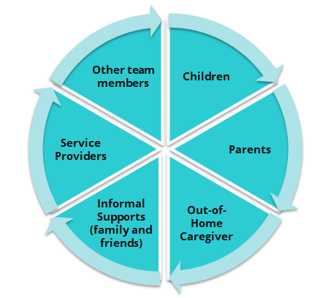
Who?
Each month the caseworker needs to ensure a comprehensive quality contact with each case member including, but not limited to:
Each child – including a private contact
- Each biological and legal parent or caregiver
- Relatives and kin- informal supports
- Out-of-home caregivers – safety placement caregivers, kinship caregivers and foster parents
- Service Providers including those arranged by DCS and those pre-existing
- Other team members – attorneys, CASA, church members, teachers, mentors, etc.
How?
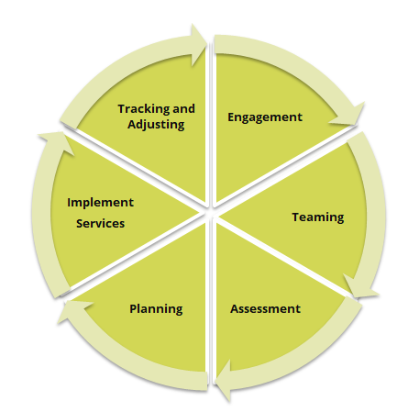
Each month the caseworker needs to ensure their efforts to implement all components of the practice wheel occur and are reflected in their documentation.
How the worker ENGAGES each case member (above) to:
- Share their story;
- Provide an update on how things are going;
- Participate in assessing what’s working and what’s not working;
- Developing ideas for solutions to problems;
- Contribute to decision making;
How the worker develops a TEAM to ensure case members will be:
- Invited and their schedule considered for attendance at CFTMs;
- Prepared by the worker for teaming touch points such as CFTMs, FCRBs, Court, etc.;
- Engaged in sharing their story, views and ideas for solutions in meetings during meetings;
How the worker ASSESSES to ensure:
- Discussion at every contact with each case participant to gather global assessment;
- Use of Motivational Interviewing skills to elicit global assessment;
- Global Assessment is used to complete the CANS or FAST;
- Other formal assessments, such as psychological and parenting assessments are collected.
How the worker PLANS with the team to:
- Develop formal plans that address the depth of need identified in global assessment (this may not happen monthly).
- Information outlined in formal assessments such as CANS, FAST, psychological, parenting, etc. are addressed and recommendations are implemented.
- Develop informal plans to ensure case progress continues.
How the worker IMPLEMENTS to ensure:
- Services are put in place that will address areas of concern uncovered by global assessment.
- Communication with service providers ensure shared assessment and progress updates
The worker TRACKS AND ADJUSTS to ensure:
- The team works to address areas that are not improving, services that are not working to develop new plans
- Progress made, areas of stability, or areas of lack of progress on areas identified in assessments are updated monthly.
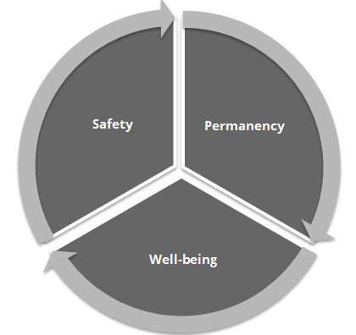
What?
Safety:
- Safety/Risk Concerns- document supervision level and justification
- Home environment- include safety of all children in the home
- Domestic Violence
- Foster family environment/ group or residential environment
- Risk factors contributing to probation involvement or entering custody
- Runaway risk/ history
- Gang involvement; sexual exploitation
Permanency:
- New Assessments, gathering information both formal and informal
  - Case manager observations of progress of assessment recommendations
  - CANS
  - Mental Health assessments (psychological, psychiatric, etc.)
  - Alcohol and Drug/ Sex Offender
  - Others assessments/evaluations as plan requires
- Parents, Child progress on Permanency Plan Goals
  - Efforts to engage the youth and family in completing recommended assessments and services
  - Ensuring the quality of the services are assessed and the service meets the needs of the family
- Visitation Plan and Progress
  - Efforts to engage the youth and family in quality visitation this month
    - preparing them for the visits, debriefing after the visits
    - observations by the worker, agency worker, foster family or kinship family
  - If visits did not occur this month what were the barriers

- Barrier to worker visit with parent
- Sibling Visits –sibling separation and why
- Appropriateness of placement- if placement changes, why? Efforts made to stabilize placement? If temporary placement efforts made to identify permanent placement?
- CFTM’s that occurred during the month including decisions made
- On-going diligent search efforts
- Other contacts
- Legal Updates - THV status; changes in youth legal status/ new charges etc.
Well-being:
- Youth Medical Health (if in home assess all children in home)
- Counseling or therapeutic progress
- Dental
- Youth’s Education (if in home assess all children in home)
- Independent living skills; self-esteem and coping skills progress/needs
- Additional information, collateral contacts, records received etc.
***
In addition to monthly documentation, the following open and closing summary documentation are needed at the beginning and the end of the case.
Opening Summary
- Case open reason (include charges current and pending; risk factors contributing to custody)
- Prior history of the family (transient, parent mental health, substance abuse, domestic violence)
- Cultural diversity of the family
- Efforts to engage the family
- Initial Diligent Search
- Placement information
- Document supervision level and justification
The opening summary should be submitted to the immediate supervisor for review and approval
Closing Summary:
- Reason for opening/involvement with the family include charges current and pending
- Current status of youth and family including safety status of youth include supervision level
- Justification for case closure which should include behaviorally specific description of how the youth and family has stabilized and achieved the goals in the original or updated case plan
- Family reaction to termination of services
- Community referrals made by worker to support family after case closure
- Any ongoing provider aftercare services the family will be receiving (e.g., continued counseling, med management).
- Discharge CANS and CFTM
- For all youth exiting care to independence, an identified plan for self-sufficiency which addresses the nine domains of independent living. Documentation of when the Exit Packet and the Exit Verification letter were provided to the youth is included in the narrative.
The closing summary should be submitted to the immediate supervisor for review and approval
Supervision
Each month, supervisors should select two-three case to coach and mentor their staff on for the month. The same case should be reviewed at least 2-3 consecutive months to review for improvements are made.

Quick Documentation Desk Reference Guide Checklist
Activity | Child | Child | Child | Mother | Father | Relative/Foster/Other Caregiver | Other family and friend supports | Service Providers | Other professional team members
PRACTICE (How?)
Avoid Buzzwords and use behaviorally descriptive language
Engagement
Share their story;
Provide an update on how things are going;
Participate in assessing what’s working and what’s not working;
Developing ideas for solutions to problems;
Contribute to decision making;
Teaming
Invited and their schedule considered for attendance at CFTMs;
Prepared by the worker for teaming such as CFTMs, FCRBs, Court, etc.;
Engaged in sharing story, views and ideas for solutions during meetings;
Assessment (Integrated)
Use of Motivational Interviewing skills to elicit global assessment;
Global Assessment is used to complete the CANS or FAST;
Other formal assessments, such as psychological and parenting assessments are collected.
Planning
Develop formal plans that address the depth of need identified in global assessment (this may not happen monthly).
Information outlined in formal assessments such as CANS, FAST, psychological, parenting, etc. are addressed and recommendations are implemented.
Develop informal plans to ensure case progress continues.
Implementation
Services are put in place that will address areas of concern uncovered by global assessment.
Communication with service providers ensure shared assessment and progress updates
Tracking and Adjusting
Team works to address areas that are not improving, services that are not working to develop new plans
Progress made, areas of stability, or areas of lack of progress on areas identified in assessments are updated monthly.
GLOBAL ASSESSMENT (What?)
Safety/Risk Concerns- document supervision level and justification
Domestic Violence
Home environment- include safety of all children in the home
Foster family environment/ group or residential environment
Risk factors contributing to probation involvement or entering custody
Runaway risk/ history
Gang involvement; sexual exploitation
Permanency
New Assessments, gathering information both formal and informal
Case manager observations of progress of assessment recommendations
CANS Summary
Mental Health assessments (psychological, psychiatric, etc.)
Alcohol and Drug/ Sex Offender
Others assessments/evaluations as plan requires
Parents, Child progress on Permanency Plan Goals
Efforts to engage the youth and family in completing recommended assessments and services
Ensuring the quality of the services are assessed and the service meets the needs of the family
Visitation Plan and Progress
Efforts to engage the youth and family in quality visitation
Preparing them for the visits, debriefing after the visits
Observations by the person supervising the visit
If visits did not occur this month what were the barriers
Barrier to worker visit with parent
Sibling Visits –sibling separation and why
Appropriateness of placement- if placement changes, why? Efforts made to stabilize placement? If temporary placement efforts made to identify permanent placement?
CFTM’s that occurred during the month including decisions made
On-going diligent search efforts
Other contacts
Legal Updates - THV status; changes in youth legal status/ new charges etc.
Well-being
Youth Medical Health (if in home assess all children in home)
Counseling or therapeutic progress
Dental
Youth’s Education (if in home assess all children in home)
Informal supports, extracurricular activities, hobbies, etc.
Independent living skills; self-esteem and coping skills progress/needs
Additional information, collateral contacts, records received etc.

