Non-Custodial Quality Contacts Desk Reference Guide
Documentation Directions
Each month the Caseworker will document the following case activity and contacts must be a separate case recording in TFACTS:
- Face to Face Visits with Child/Youth
- Worker/Parent contacts
- Parent Child Visitations
- Home/Placement Visit (may be included in another type of case recording, but location must be “family home”;
- Child and Family Team Meeting (CFTM);
Caseworkers will also provide additional documentation within the Monthly Case Summary contact type due along with other documentation requirements each month. This note is a “catchall” location for staff to capture all other notes in one place that do not require a compliance count like those listed above. Topics covered here include:
  - Contacts with “other” case participants and service providers;
  - Service referral information and quality contacts with service providers;
  - Notations;
  - Emails, phone call, fax and text correspondence;
  - Notifications such as to the Juvenile Court, District Attorney or etc.;
  - Legal consultations –no details needed.
  - Anything else pertinent
Monthly Quality Practice and Documentation Expectations
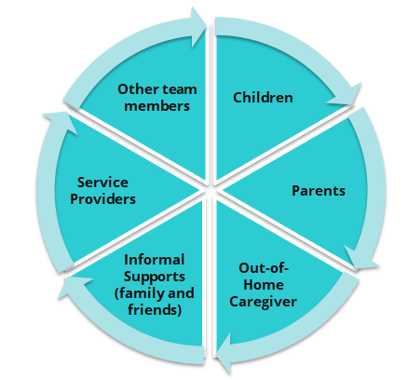
Who?
Each month the caseworker needs to ensure a comprehensive quality contact with each case member including, but not limited to:
- Each child – including a private contact
- Each biological and legal parent or caregiver
- Relatives and kin- informal supports
- Out-of-home caregivers – safety placement caregivers, kinship caregivers and foster parents
- Service Providers including those arranged by DCS and those pre-existing
- Other team members – attorneys, CASA, church members, teachers, mentors, etc.
How?
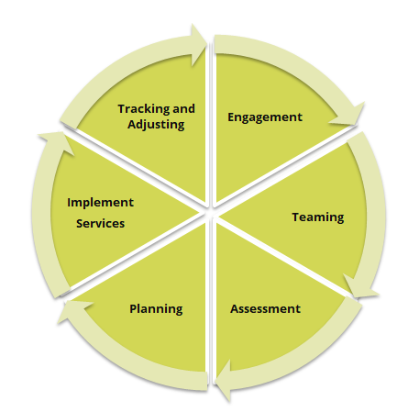
Each month the caseworker needs to ensure their efforts to implement all components of the practice wheel occur and are reflected in their documentation.
How the worker ENGAGES each case member (above) to:
- Share their story;
- Provide an update on how things are going;
- Participate in assessing what’s working and what’s not working;
- Developing ideas for solutions to problems;
- Contribute to decision making;
How the worker develops a TEAM to ensure case members will be:
- Invited and their schedule considered for attendance at CFTMs;
- Prepared by the worker for teaming touch points such as CFTMs, FCRBs, Court, etc.;
- Engaged in sharing their story, views and ideas for solutions in meetings during meetings;
How the worker ASSESSES to ensure:
- Discussion at every contact with each case participant to gather global assessment;
- Use of Motivational Interviewing skills to elicit global assessment;
- Global Assessment is used to complete the CANS or FAST;
- Other formal assessments, such as psychological and parenting assessments are collected.
How the worker PLANS with the team to:
- Develop formal plans that address the depth of need identified in global assessment (this may not happen monthly).
- Information outlined in formal assessments such as CANS, FAST, psychological, parenting, etc. are addressed and recommendations are implemented.
- Develop informal plans to ensure case progress continues.
How the worker IMPLEMENTS to ensure:
- Services are put in place that will address areas of concern uncovered by global assessment.
- Communication with service providers ensure shared assessment and progress updates
The worker TRACKS AND ADJUSTS to ensure:
- The team works to address areas that are not improving, services that are not working to develop new plans
- Progress made, areas of stability, or areas of lack of progress on areas identified in assessments are updated monthly.
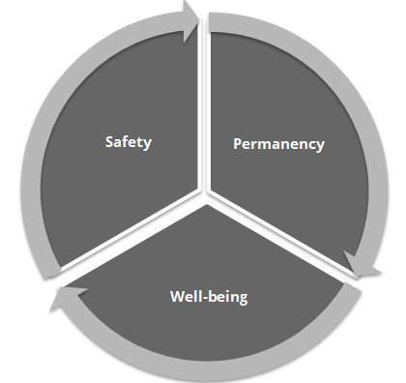
What?
Safety:
- Home environment
- Parenting ability
- Domestic Violence
- Physical, mental, emotional safety for each adult and child living in the home (all household members)
- Safety of all children in the home or children having access to the alleged perpetrator
- Alcohol and/or drug concerns
- Case Worker’s informal assessment, (observations of signs of safety, risk, concerns)
Permanency:
- Assessments, gathering information both formal and informal
  - FAST
  - Observations (including informal assessment by the worker and others involved).
  - Mental Health assessments
  - Alcohol& Drug assessments, recommendations, and drug screen results
  - Others assessments/evaluations as plan requires
- Parents, Child progress on Permanency Plan Goals
  - Efforts to engage the child and family in completing recommended assessments and services (Different efforts to engage the family must occur each month until the parent/youth is engaged in assessment, planning and services)
  - Diligent search efforts to find absent parents and family members.
  - Ensuring that we assess the quality of the services and is the service (paid services and community services) meeting the needs of the family
- Engagement of child and family in quality visitation when the child is placed outside the home:
  - Preparing them for the visits
  - Debriefing after the visits
  - Observations by the worker, agency worker, foster family, birth family or kinship family
- Worker visit with parent
- Type of Placement and why (if child is in residential treatment)
- If CFTM was held during the current month, report on any key decisions that were made in context of CFTM
- On- going diligent search efforts for absent parents
- Other contacts-This could include phone contacts or other types of contacts not referenced earlier excluding face to face contacts.
Well-being:
- Child’s Medical Health
- Child’s Dental
- Child’s Education
- Counseling progress
- Additional information, collateral contacts, records received etc.
In addition to monthly documentation, the following open and closing summary documentation are needed at the beginning and the end of the case.
Opening Summary
- Case Open Reason
- Prior History of the family
- Cultural diversity of the family
- Efforts to engage the family
- Identify the needs of the family
- Initial Diligent Search
- Household composition, include every child in the home
- If the siblings are separated please explain why and where they are
The opening summary should be submitted to the immediate supervisor for review and approval
Closing Summary:
- Reason for opening the case
- Current status of child and family including safety status of child
- Justification for case closure which should include behaviorally specific description of how the family has stabilized and achieved the goals in the original or updated case plan
- Family reaction to termination of services
- Community referrals made by worker to support family after case closure
- Discharge FAST and CFTM
- Legal status at closure (i.e. who has custody, any no contact orders, etc.)
The closing summary should be submitted to the immediate supervisor for review and approval
Supervision
Each month, supervisors should select one case to coach and mentor their staff on for the month. The same case should be reviewed at least 2-3 consecutive months to review for improvements are made.

Quick Documentation Desk Reference Guide Checklist
Activity | Child | Child | Child | Mother | Father | Relative/Foster/Other Caregiver | Other family and friend supports | Service Providers | Other professional team members
PRACTICE (How?)
Avoid Buzzwords and use behaviorally descriptive language
Engagement
Share their story;
Provide an update on how things are going;
Participate in assessing what’s working and what’s not working;
Developing ideas for solutions to problems;
Contribute to decision making;
Teaming
Invited and their schedule considered for attendance at CFTMs;
Prepared for teaming such as CFTMs, FCRBs, Court, etc.;
Engaged in sharing story, views and ideas for solutions during meetings;
Assessment (Integrated)
Use of Motivational Interviewing skills to elicit global assessment;
Global Assessment is used to complete the CANS or FAST;
Other formal assessments, such as psychological and parenting assessments are collected.
Planning
Develop formal plans that address the depth of need identified in global assessment (this may not happen monthly).
Information outlined in formal assessments such as CANS, FAST, psychological, parenting, etc. are addressed and recommendations are implemented.
Develop informal plans to ensure case progress continues.
Implementation
Services are put in place that will address areas of concern uncovered by global assessment.
Communication with service providers ensure shared assessment and progress updates
Tracking and Adjusting
Team works to address areas that are not improving, services that are not working to develop new plans
Progress made, areas of stability, or areas of lack of progress on areas identified in assessments are updated monthly.
GLOBAL ASSESSMENT (What?)
Safety Concerns
Home environment
Foster Family environment
Domestic Violence
Group or Residential home environment
Case Worker’s informal assessment, (observations of signs of safety, risk, concerns)
Permanency
Assessments, gathering information both formal and informal (only if there has been update in the month)
CANS
Case Worker Observations, progress in assessments
New or follow-up on Mental Health Assessments/Recommendations for parents and children
Alcohol and Drug
Others assessments/evaluations as plan requires
Parents, Child progress on Permanency Plan Goals
Family participation in services
Quality of services and needed tracking and adjusting
Visitation Plan and Progress that occurred during the month
Preparing them for the visits
Debriefing after the visits
Observations by person supervising the visit
If visits didn’t occur, explain why
Sibling Visits –Sibling Separation and why
Describe efforts to locate and engage parents for the month
Appropriateness of placement
CFTM’s that occurred during the month
On- going diligent search efforts
Other contacts
Legal Updates -TPR Status-THV status
Well-being
Child’s Medical Health and counseling progress
Dental
Child’s Education
Informal supports, extracurricular activities, hobbies, etc.
Independent Living/Self Esteem/Coping Skills
Additional info, collateral contacts, records received etc.

