Foster Care Specialty
Week 1
Facilitator Guide for In-person Delivery
Tennessee Department of Children’s Services | Ver. 23.06.15

Curriculum Information

- Training Credit: 23 hours
- Trainers should give participants one 15-minute break in the morning and on 15-minute break in the afternoon for full day classes.
- This curriculum was developed by the State of Tennessee Office of Training and Professional Development.
- Staff may receive T4T credit for this course by:
  - Attending the course T4T offering -- OR --
  - Attending an offering of the course taught by another trainer & debriefing with that trainer.

This curriculum was developed by the Tennessee Department of Children’s Services with federal funds. It is
available to use in part or in whole free of charge. Suggested citation:
OTPD. (2023). Permanency Specialty. Tennessee Department of Children’s Services.

Learning Objectives

- Participants will gain knowledge of the foster care casework process.
- Participants will have a greater understanding of how engaging families leads to quality contacts and assisting families during the custodial episode.
- Participants will team with the family to identify informal and formal supports to assist the family through the custodial episode.
- Participants will demonstrate assessment skills by using the CANS to assess the strengths and needs of the family.
- Participants will learn and demonstrate how to plan with the family to implement action steps which will help the family reach positive outcomes.
- Participants will become knowledgeable in ongoing tracking and adjusting in casework.
- Participants will apply knowledge learned from the foster care casework process.

Materials Checklist

Materials needed for this curriculum:
- Curriculum Facilitator Guide
- Curriculum Power Point
- Pathways to Permanence Video
- Flip Chart Paper
- Tape
- Projector
- Markers (flipchart/whiteboard)
- Handouts (located in Google Classroom and/or Basecamp):
  - New Hire Guide
  - Interviewing Techniques
  - Assessing Potential Relative Placements
  - Developmentally Related Visitation Activities
  - Guidelines for Arranging Family Visitation
  - Parenting a Child who has experience Trauma
  - How to Prepare Families and Children for Placement
  - Types of Placements
  - A Guide for Using CANS with Child, Caregivers, and their families: A Tip Sheet
  - How to have the Permanency Conversation with Youth

- Guiding Question for Youth

- Case Calendar

- Forms Link: https://www.teamtn.gov/dcs/forms-and-documents.html
- Policies:
  - Policy Page Link: https://www.tn.gov/dcs/program-areas/qi/policies-reports- manuals/policiesprocedures.html
  - CPS: Work Aid 1
- 15.7 Consent to Adoption of Child Fourteen (14) Years of Age and Older
- 15.11 Adoption Assistance
- 15.15 Subsidized Permanent Guardianship
- 15.16 Subsidized Permanent Guardianship Case File Contents
- 16.2 Multi Ethnic Placement Act
- 16.24 Children of Native American Heritage
- 16.3 Desired Characteristics of Foster Parents
- 16.31 Permanency Planning for Children/Youth in the Department of Children’s Services Custody
- 16.4 Foster Home Selection and Approval
- 16.8 Responsibilities of Approved Foster Homes
- 16.8 Attachment 3 Guidelines for Life Story Books
- 16.20 Expedited Custodial Placements
- 16.29 Foster Home Board Rates
- 16.32 Foster Care Review and Progress Reports
- 16.38 Face-to-Face Visitation with Dependent/Neglected/Unruly Children in DCS Custody
- Visitation Guide
- 16.43 Supervised/Unsupervised Visitation between Child-Youth, Family, and Siblings
- 16.46 Child/Youth Referral and Placement
- 16.51 Independent Living and Transition Planning
- 16.52 Extension or Re-establishment of Foster Care for Young Adults
- 16.53 Eligibility for Independent Living Services
- 16.59 Disclosure of Permanency Options and Available Services for Relative or Kin Caregivers
- 20.7 Early Periodic Screening Diagnosis & Treatment Standards (EPSDT)
- 20.7 Attachment Protocol for Early Periodic Screening, Diagnosis and Treatment Standards
- 20.12 Dental Services
- 21.9 Educational Passport
- 31.1 Family Permanency Plans
- 31.8 Parent/Caregiver Engagement and Support
- 31.8 Supplement Parent Engagement and Support Work Aid
- 31.9 Conducting Diligent Searches
- Independent Living Handbook
- Child and Family Team Meeting Guide
- Protocol for Court Preparation and Attendance by Foster Care Staff
- Life Skills Assessment Storyboard
- Identifying and Accessing Independent Living Services Manual

Annotated Agenda

Unit 1: Introduction to Casework Process

Unit Time: 80 minutes

Learning Objectives:
- Participants will gain knowledge of the foster care casework process.

Supporting Materials:
- PowerPoint
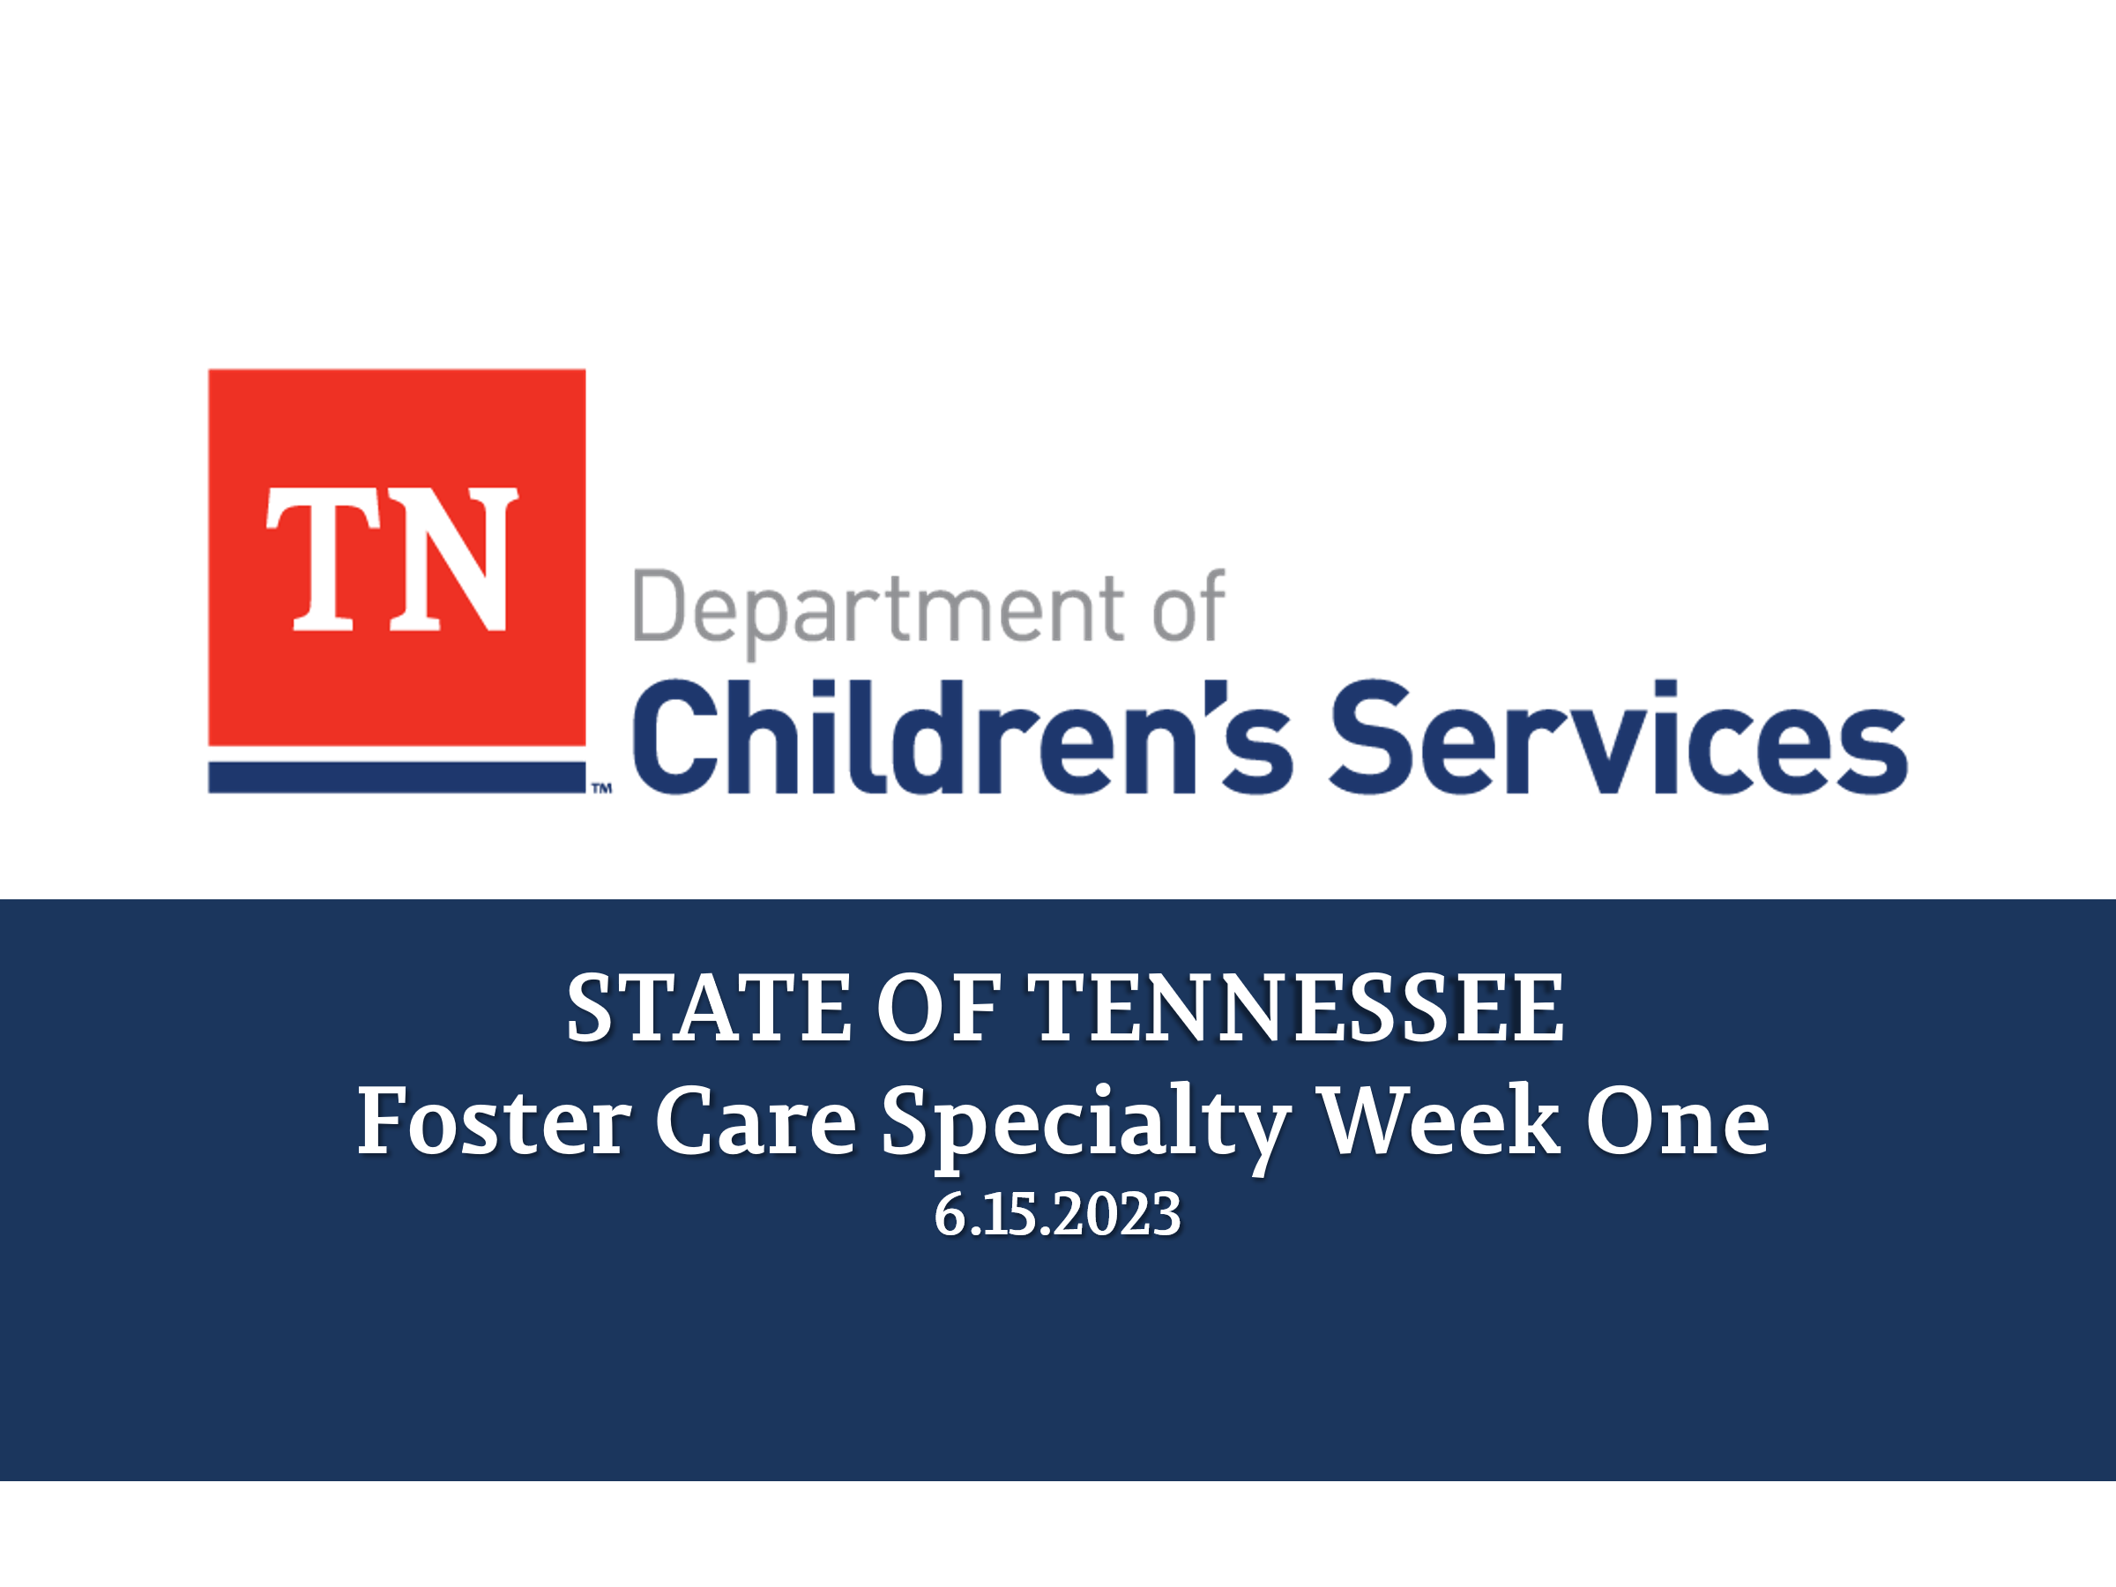
- Desired Outcome Flip Chart
- Comfort Rules from Core
- Practice Wheel Handout
- Policies/Guides:
  - Policy link
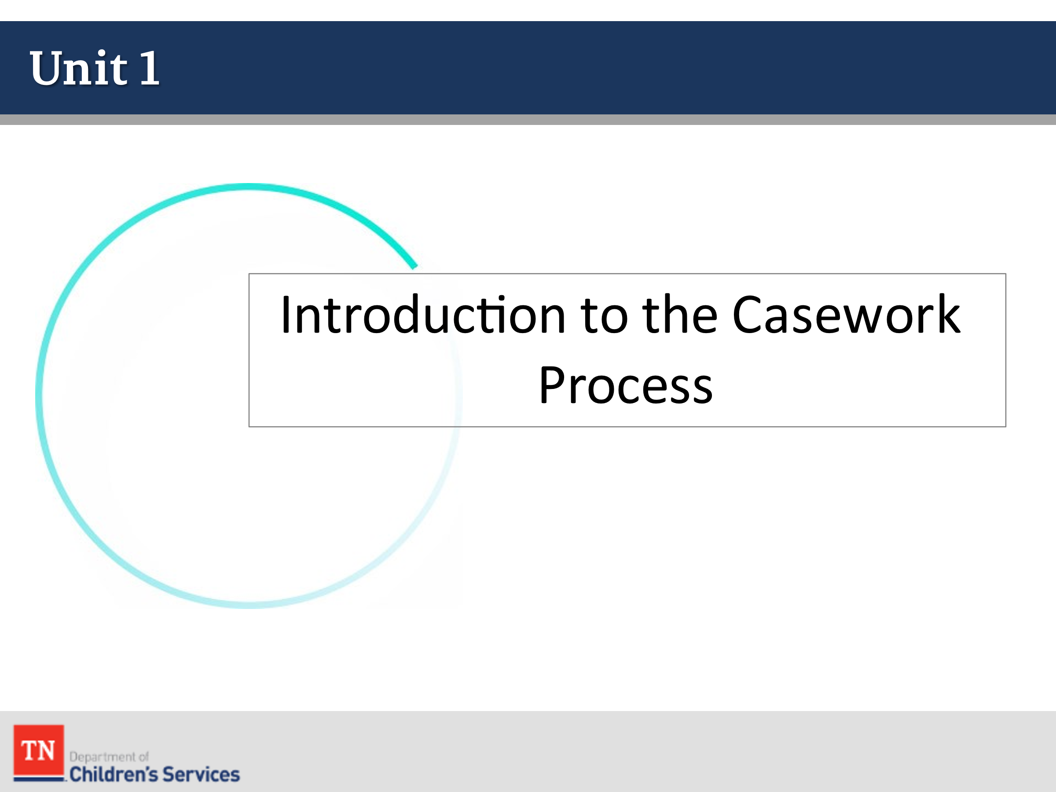
  - New Hire Guide
  - CFTM Guide
  - Visitation Guide
  - Work Aid 1

Lesson 1.1: Welcome/Introductions

Lesson Time: 20 minutes
Key Teaching Points / Instructions

- WELCOME participants to Foster Care Specialty training. INTRODUCE yourself, briefly, to the group and share information about your previous experiences working with children and families from the child welfare system.
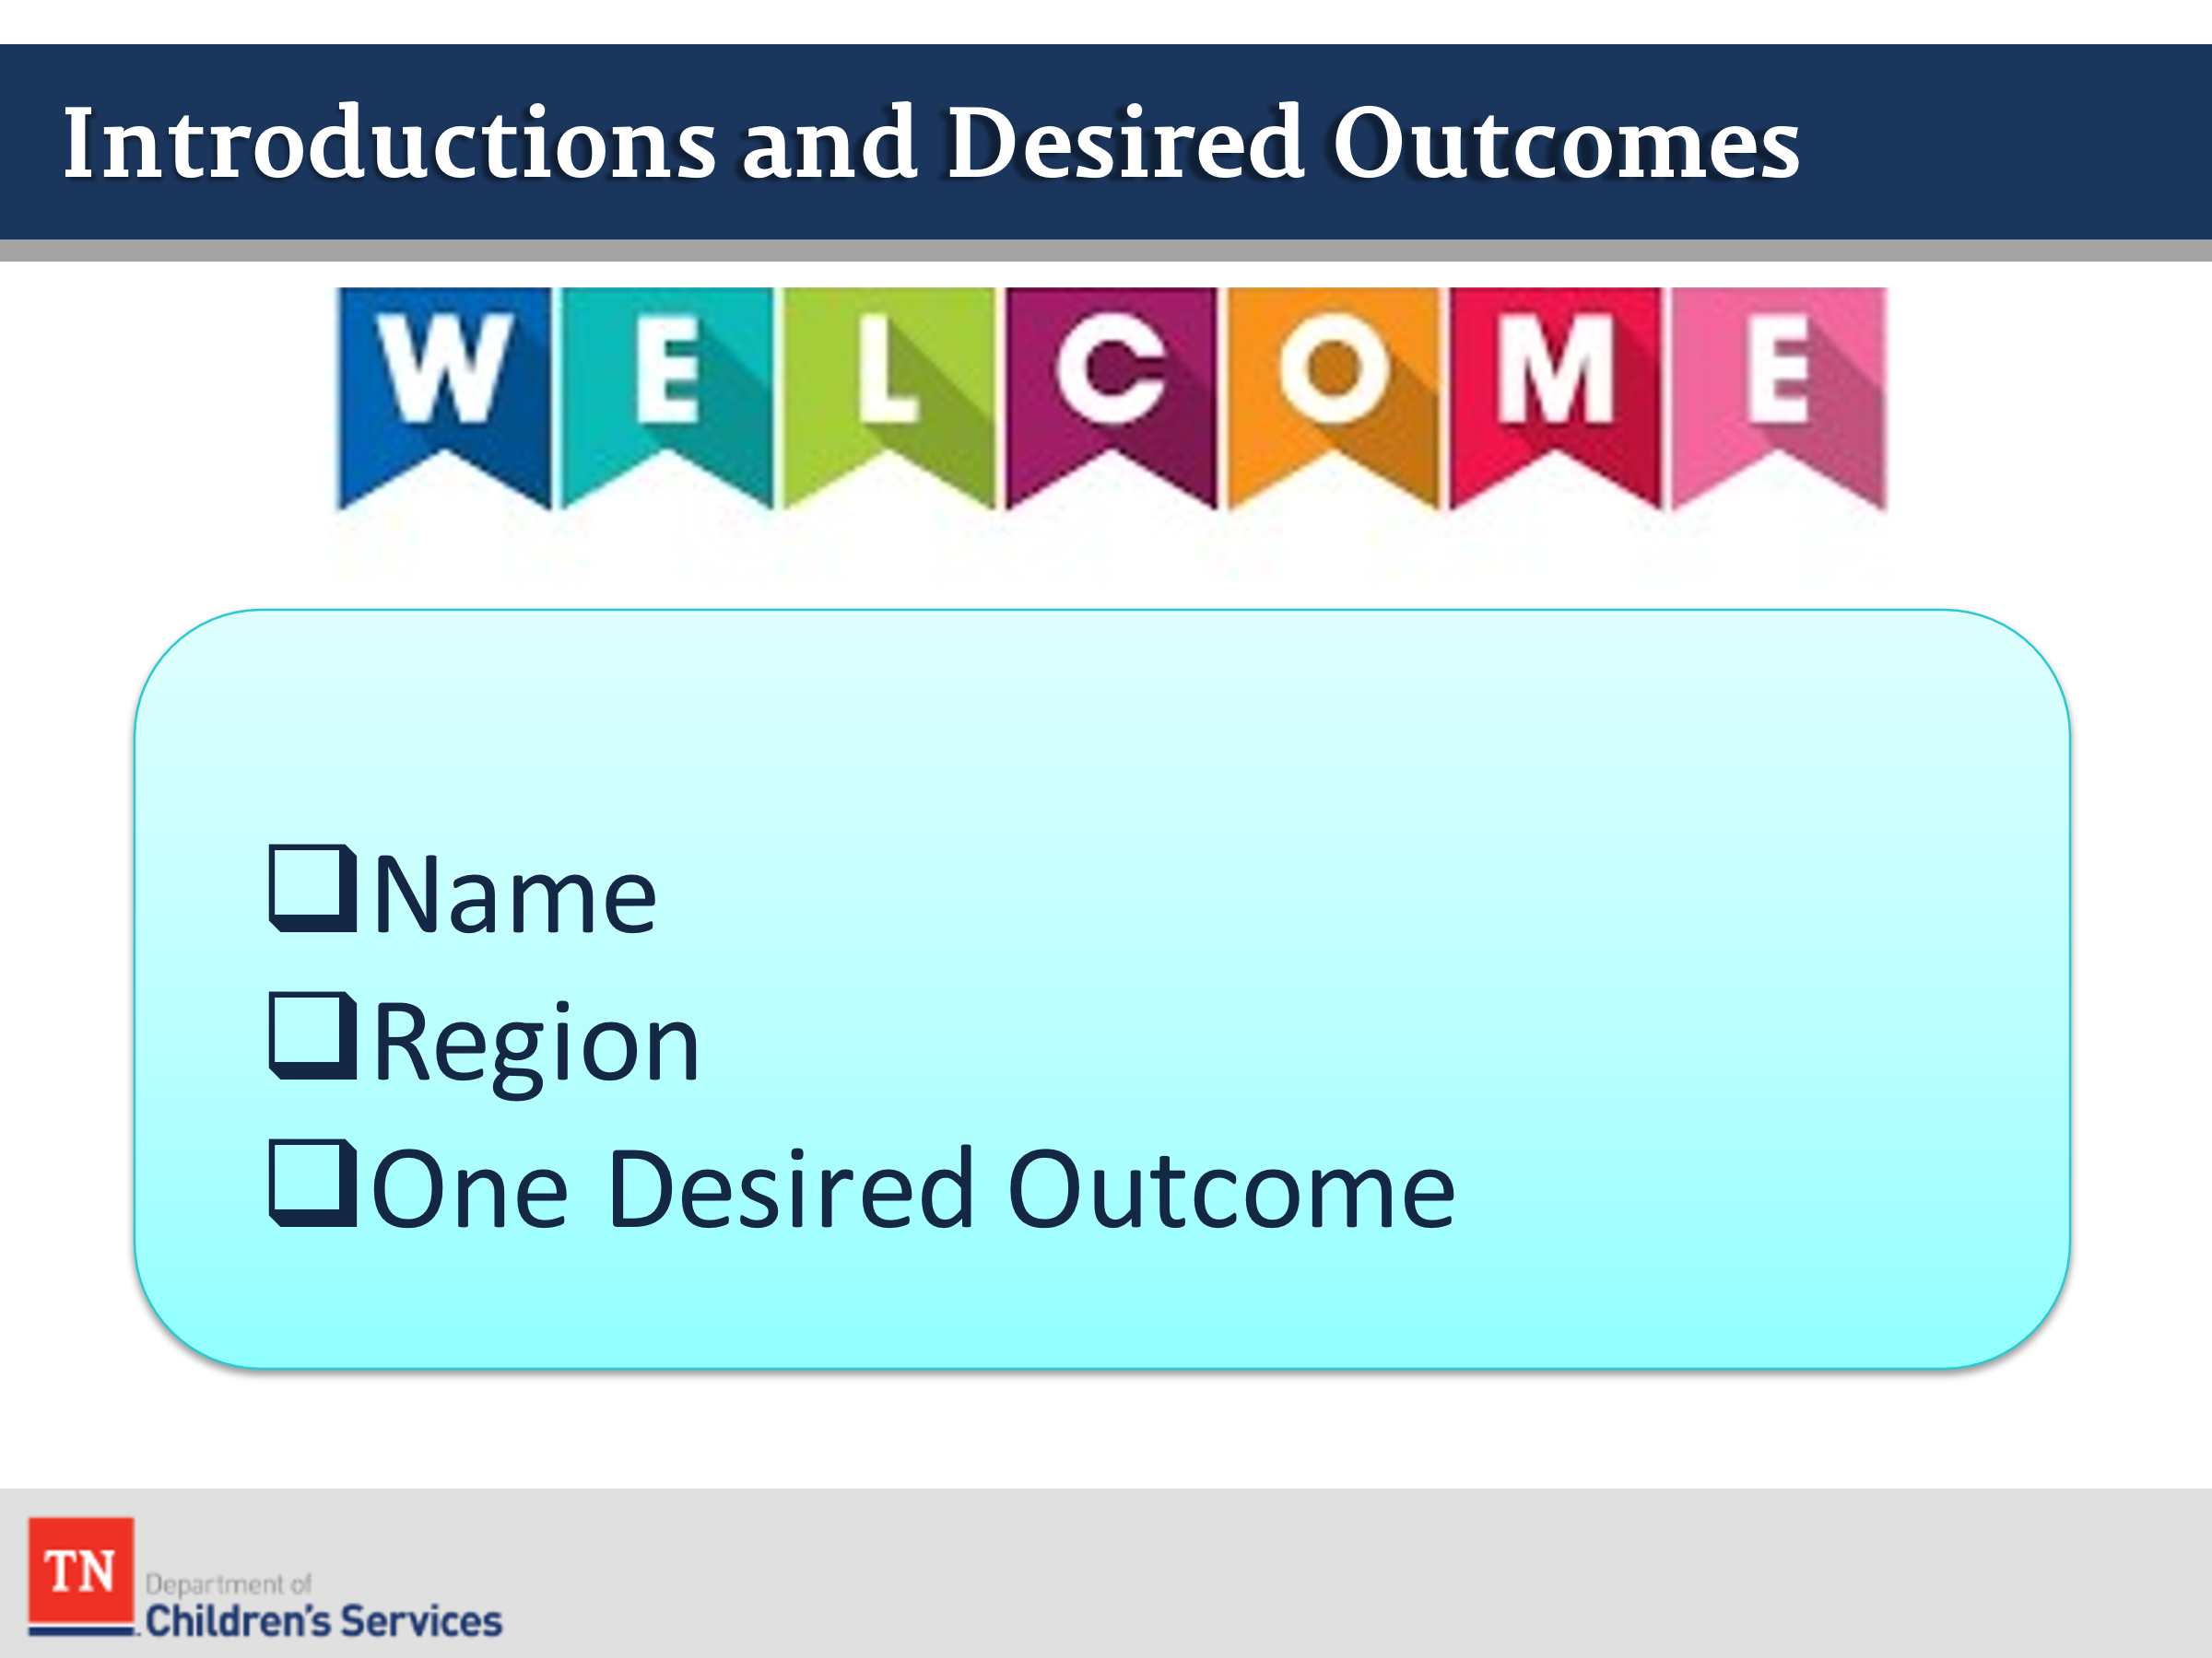
- DISCUSS with participants the purpose of this course is to provide knowledge of permanency concepts that will pertain to their cases worked in the foster care specialty. EXPLAIN the classroom training is only a portion of the process. EMPHASIZE the importance of OJT and learning in the field.
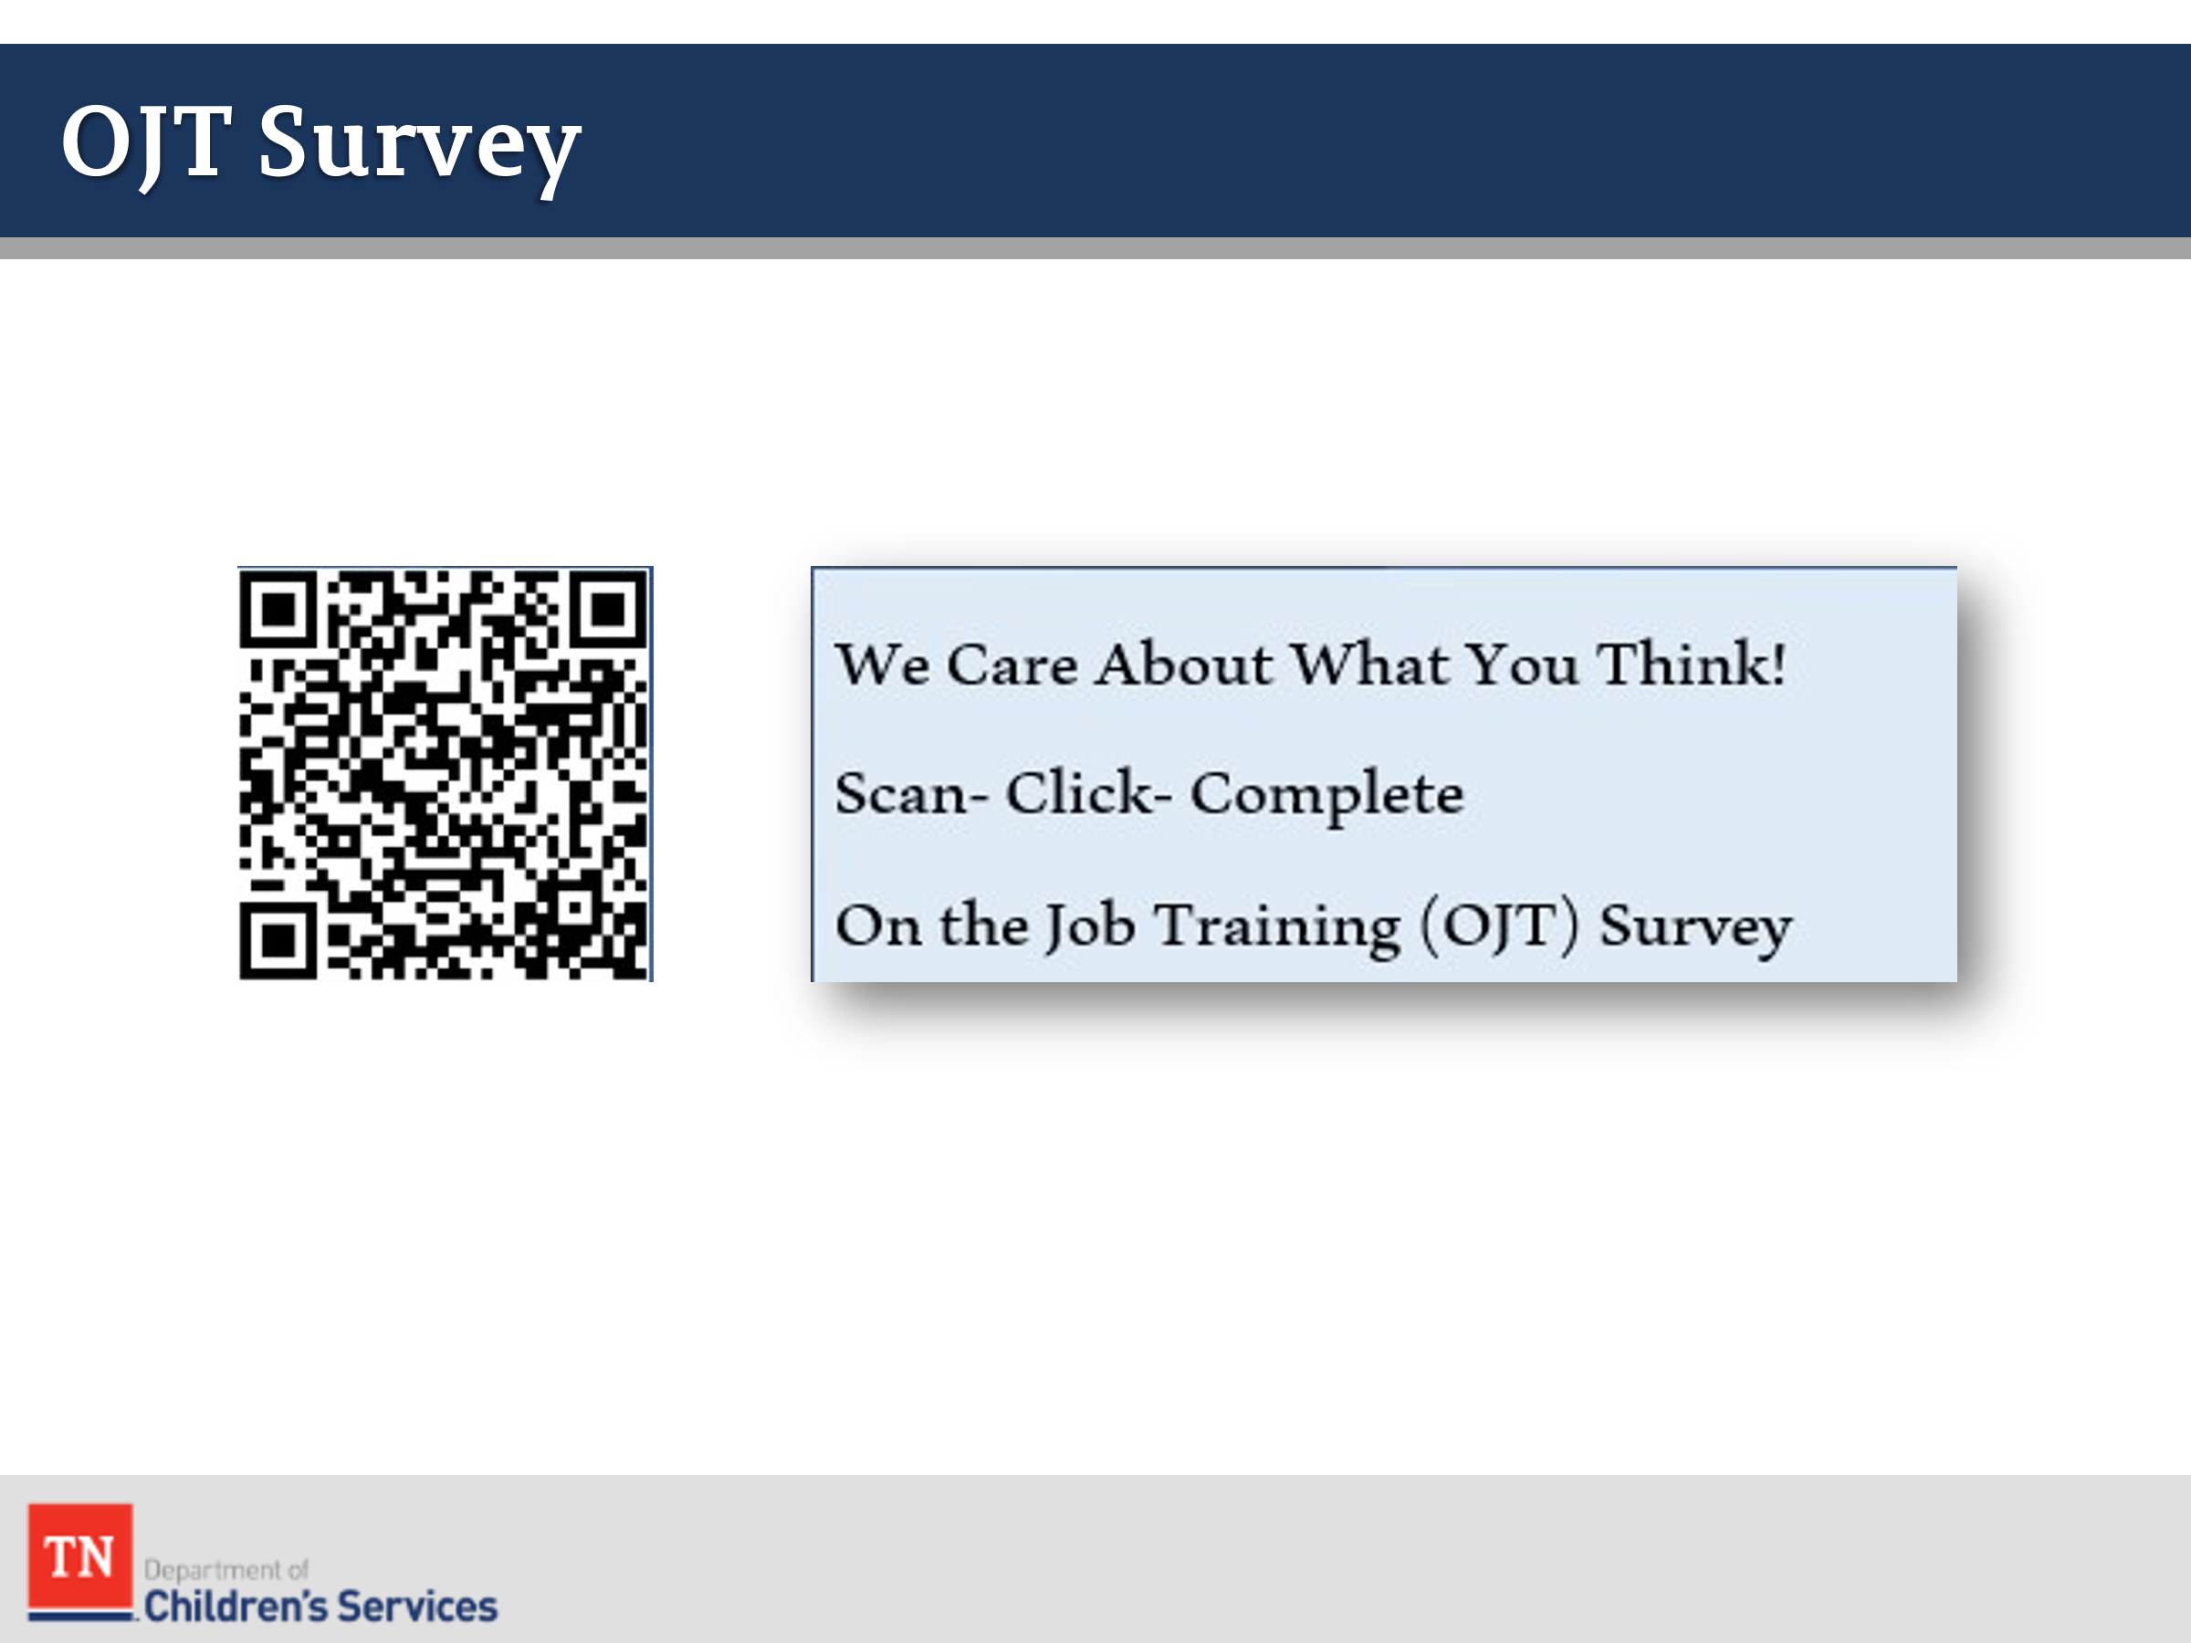
- ASK participants to introduce themselves by sharing their name and region and share one desired outcome for the training. Trainer will document the desired outcomes on a prepared flipchart in order to revisit on the last day of training.
- BEFORE moving forward ASK participants to complete the OJT Survey by scanning the QR Code. REITERATE the importance of providing feedback.
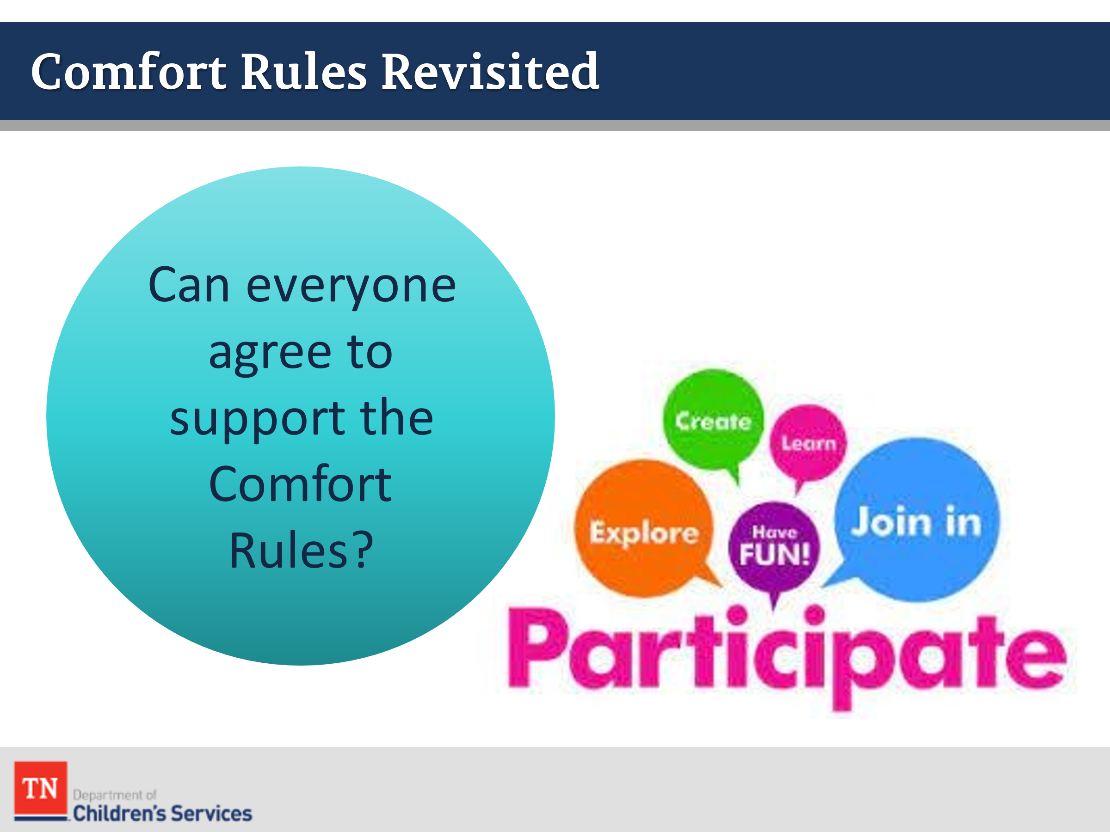
- REVIEW comfort rules developed from Core Training. If there are new participants in this group, acknowledge they did not have input into developing the agreement and ask them, specifically, if they see anything they have questions about or if they would like to add anything to the rules.
- ASK if the participants can continue to agree to support the rules or if any additions/changes need to be made. REVISIT the comfort rules as needed throughout the training.
- EMPHASIZE the importance of respect at the beginning of the class. REITERATE the DCS values of empathy, genuineness, and respect. DEBRIEF and ASK if there are any questions.
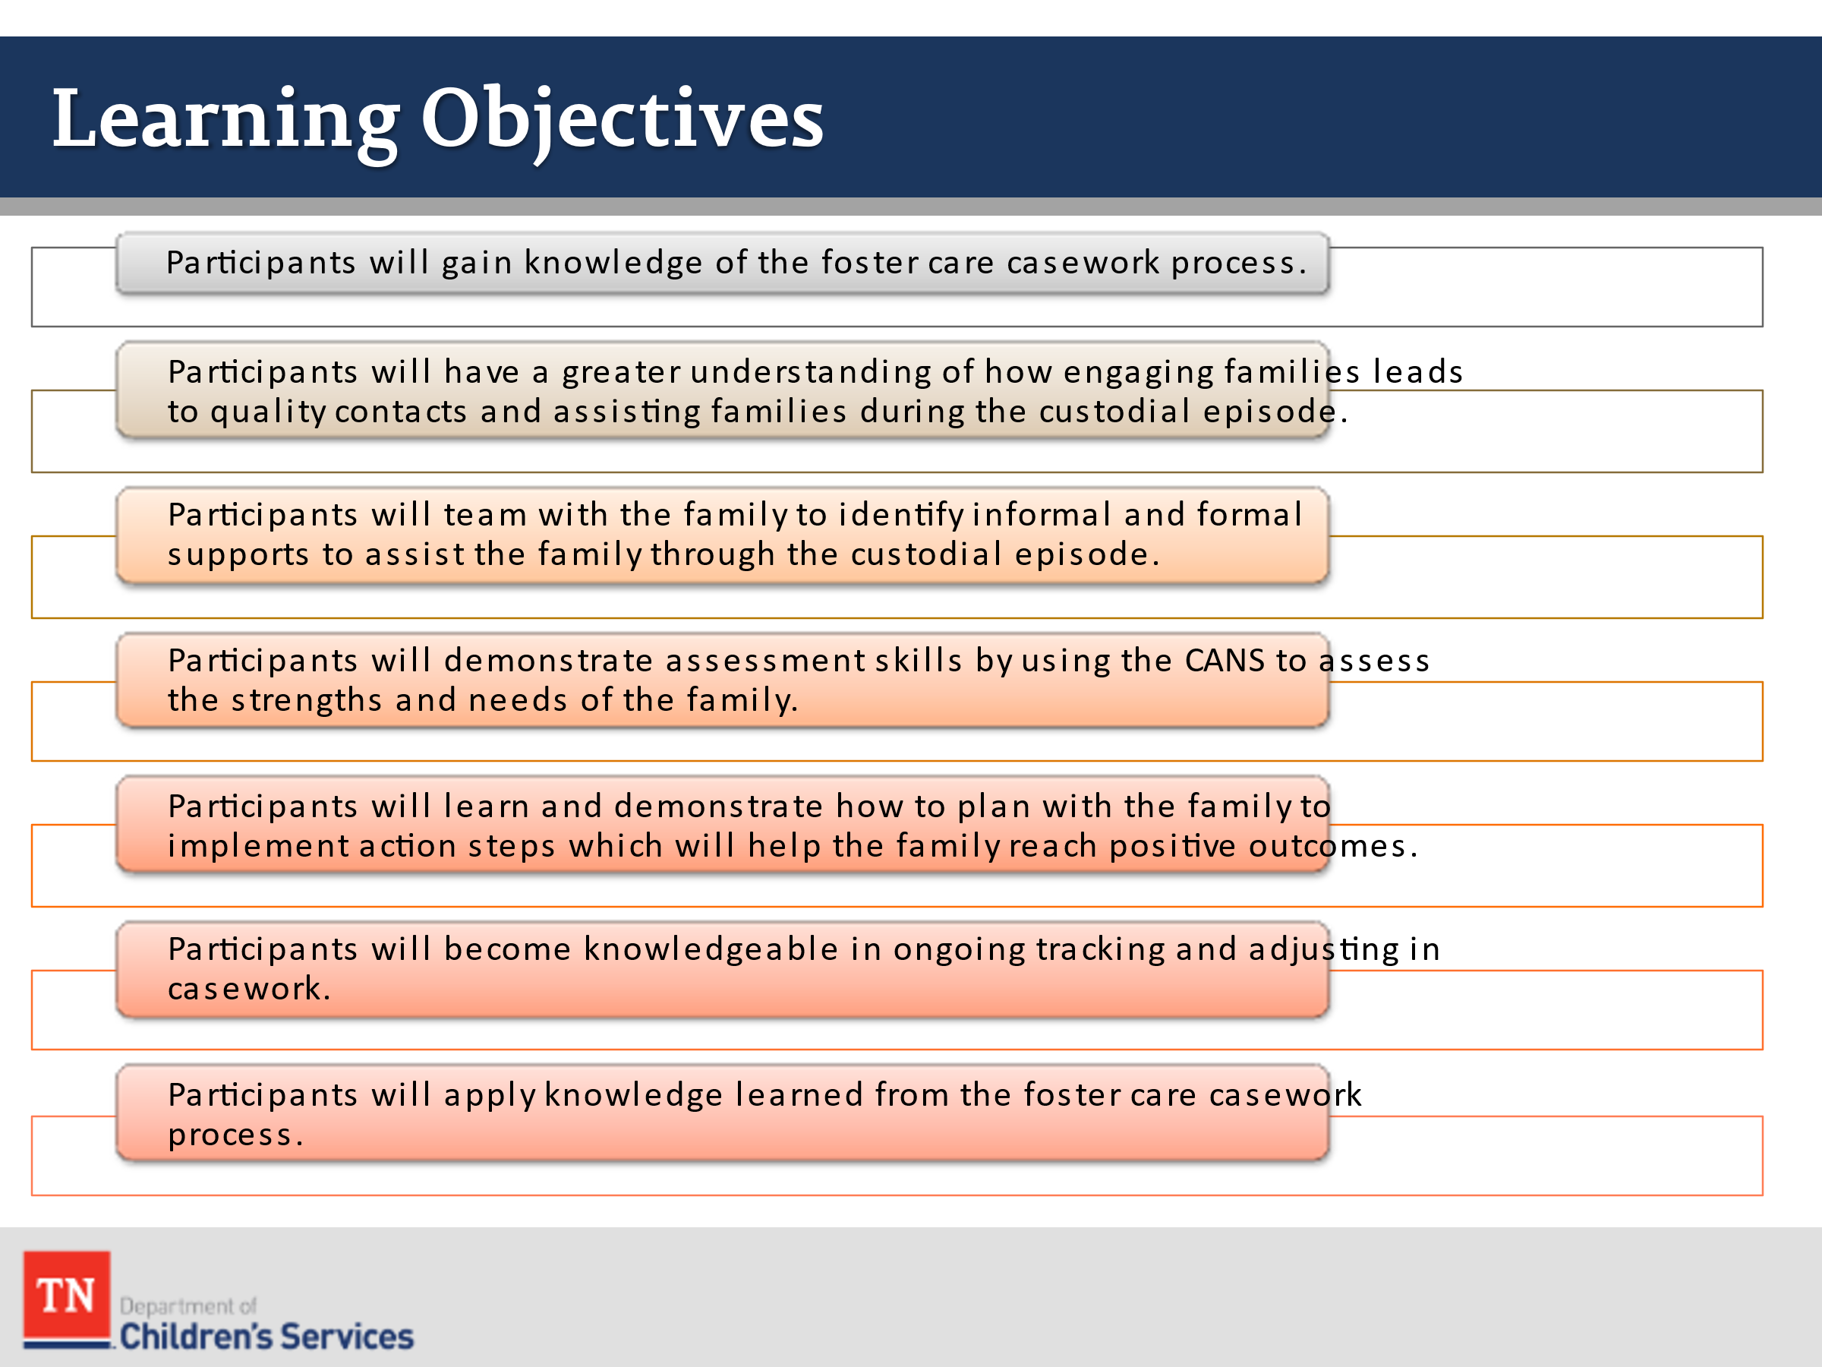
- REVIEW the Learning Objectives:
- Participants will gain knowledge of the foster care casework process.
- Participants will have a greater understanding of how engaging families leads to quality contacts and assisting families during the custodial episode.
- Participants will team with the family to identify informal and formal supports to assist the family through the custodial episode.
- Participants will demonstrate assessment skills by using the CANS to assess the strengths and needs of the family.
- Participants will learn and demonstrate how to plan with the family to implement action steps which will help the family reach positive outcomes.
- Participants will become knowledgeable in ongoing tracking and adjusting in casework.
- Participants will apply knowledge learned from the foster care casework process.
- TRANSITION to Lesson 1.2 Setting the Stage.

Lesson 1.2: Setting the Stage

Lesson Time: 40 minutes
Key Teaching Points / Instructions

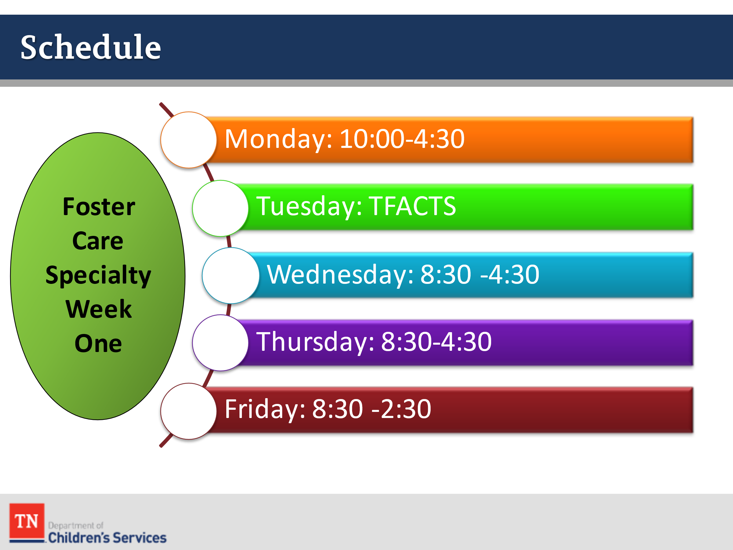
- SHARE Foster Care Specialty will be two weeks with information provided regarding policies, best practice, and opportunities to practice case work activities with a case family.
- Monday 10-4:30 pm (5.25)
- Tuesday TFACTS
- Wednesday 8:30-4:30 pm (6.5)
- Thursday 8:30-4:30 pm (6.5)
- Friday 8:30-2:30 pm (4.75)
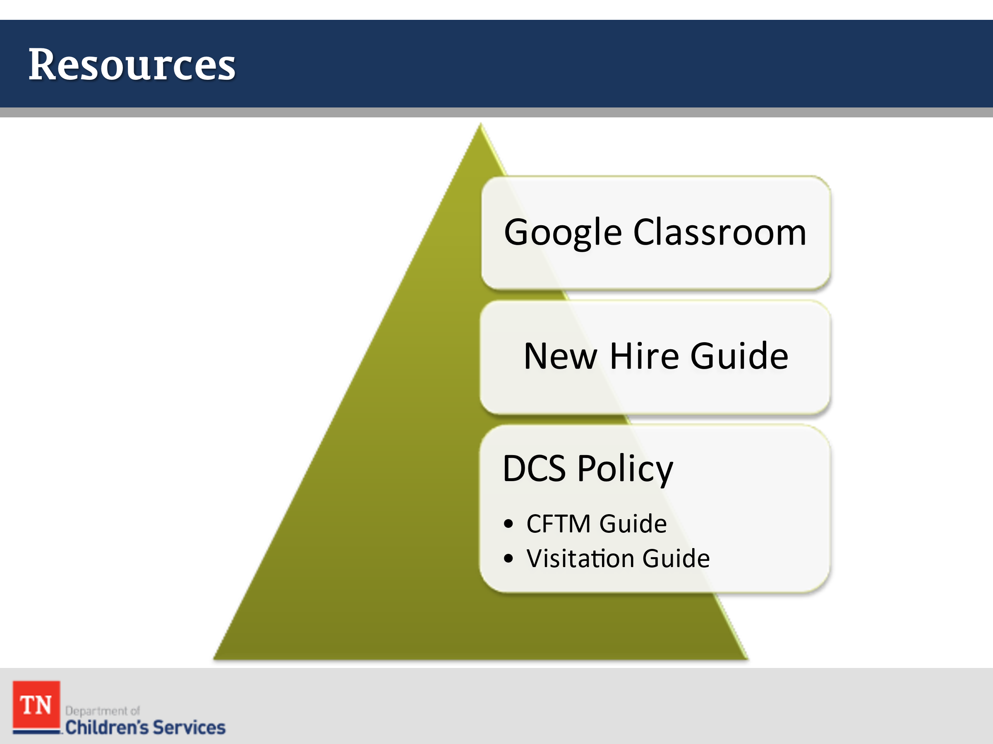
- REVIEW the Foundations of Professional Development: Foster Care New Hire Guide, Child and Family Team Meeting Guide, and the Visitation Guide. SHARE supplemental resources can be found in Google classroom. EXPLAIN to participants how to access these supporting documents. STATE these resources and policies will be revisited throughout the two weeks of training. SHARE these documents will assist with casework practice and help with a visual timeline of responsibilities.
  - New Hire Guide:
    - This guide was developed to use as a base for case tasks and responsibilities throughout the life of a case.
  - CFTM Guide
  - Visitation Guide
- INFORM participants these documents explain many of the important tasks involved in effectively working a custodial case from start to finish. Other activities, forms, and policies will be discussed in this training as well. RECOMMEND participants take notes throughout the training about resources shared in training or questions they will need to ask their Team Leader or Mentor for team/region specifics.
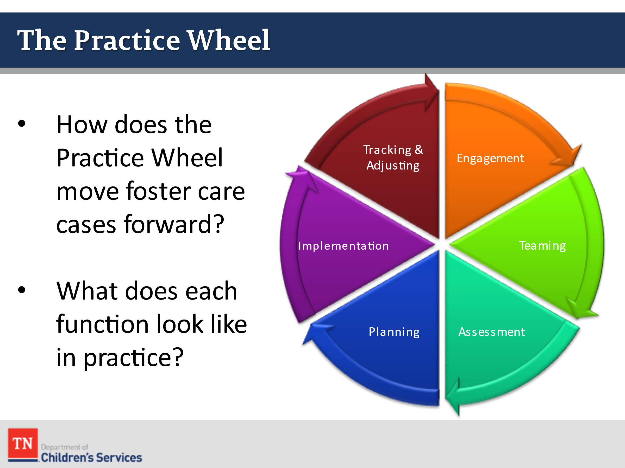
- REMIND participants of the DCS Practice Wheel and the importance of the function of each of the elements of the wheel. REFERENCE the following Practice Wheel Handout in Google Classroom. ASK how the Practice Wheel helps to move foster care cases forward. ASK what each function of the Practice Wheel looks like in practice.
  - The Core Functions of Practice include:
    - What does Engagement look like?
      - Listening carefully to the child and family (hearing their story)
      - Reaching out to other family and team members
      - Remaining non-judgmental and open to the family’s culture, values, and priorities
      - Treating clients and colleagues with genuineness, empathy, and respect
      - Being available to families
      - Following up on services to ensure families are benefiting
      - Maintaining a hopeful focus on positive outcomes
      - Creating a climate where families clearly understand the issues and the responsibility for change
    - What does Team Formation look like?
      - Helping the family to identify team members
      - Supporting the team in developing the goals that will result in the outcomes of safety, permanency, and well-being of the children
      - Preparing all team members prior to CFTMs to discuss what their role is and what they can offer the team
      - Preparing to present the case information the team needs to make a decision and to make a recommendation for the outcome to be successful
      - Ensuring team meetings are held as needed and are family-driven
      - Coordinating the tasks assigned and follow-up on action steps with team members between CFTMs
      - Ensuring CFTMs are scheduled in advance whenever possible and at the family’s convenience
      - Maintaining documentation demonstrating this work in case recordings
    - What does Assessment look like?
      - Listening carefully to what the family and team members say about the family needs
      - Making every effort to engage youth to share their feelings and needs
      - Interviewing all team members and collateral contacts to make a full assessment of the family’s strengths and needs
      - Updating the CANS according to policy and as needed when new information emerges
      - Helping the family to identify their functional strengths and challenges
      - Keep an open mind and refrain from rushing to judgment about any youth or family’s needs or issues
      - Demonstrating professional curiosity about the child and family’s feeling about DCS interventions
    - What does Planning and Implementation look like?
      - Plans are behaviorally specific and spell our what can and cannot be done
      - Goals are clear and agreed to be supported by the team
      - Action steps are clearly stated with target dates and desired outcomes specified
      - Plans are developed with the family and team in a Child and Family Team Meeting
      - Plans are individualized to fit the family
      - Plans are written in compliance with the law and DCS requirements
      - Plans build on family’s strengths which are supplemented with other resources
      - Plans clearly address the underlying needs of the child and family
      - Plans clearly address all of the safety risks and issues that brought the children into foster care
      - Plans reflect strengths, need, and resources identified in the CANS
      - Outcomes are specified with services that are thoughtfully considered and clearly related to the needs being addressed
      - Plans reflect a long-term view for the child and family’s success
    - What does Tracking and Adjusting look like?
      - Maintain contact with families and team members to assess the progress or lack of progress, and document this information
      - Monitor the effectiveness of services being provided
      - Contact service providers for reports and updates
      - Discuss progress with families during family contacts
      - Ensure Progress Review CFTMs are taking place with the appropriate team members present
      - Maintain contact with foster parents and providers to assess how the child is progressing or adjusting to the placement
- TRANSITION into Lesson 1.3 What is Permanency?

Lesson 1.3: What is Permanency?

Lesson Time: 20 minutes
Key Teaching Points / Instructions

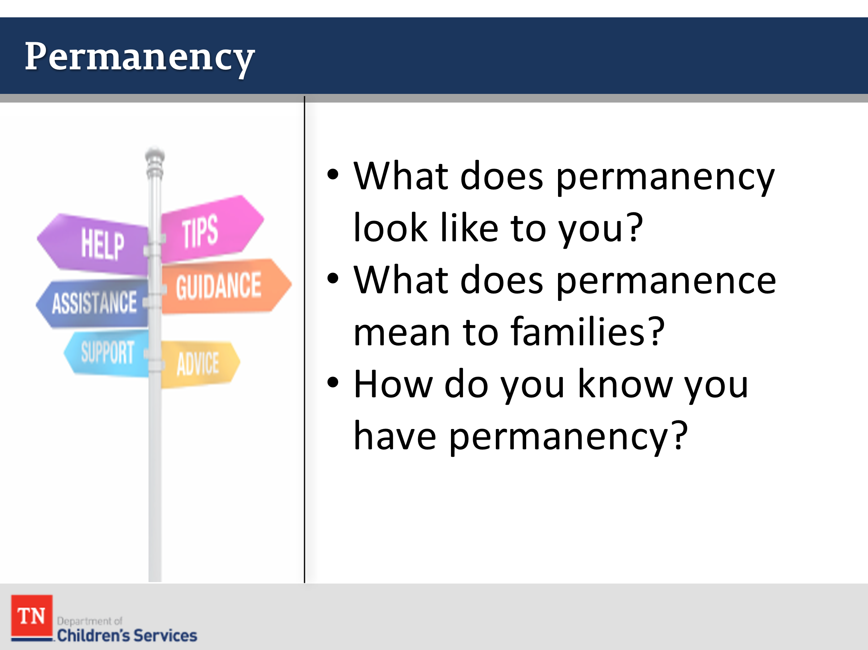
- ASK the group what does permanency look like to them. GUIDE the discussion around the concept of permanency (i.e., loving relationships, family stability, and emotional support) by asking participants:
  - What does permanence mean to families?
  - Why is it important and what does lack of it mean for children?
  - How do you know you have permanence?
  - How would you rate the permanence in your life right now?
  - How did it develop for you?
  - How important are relationships in creating permanence?
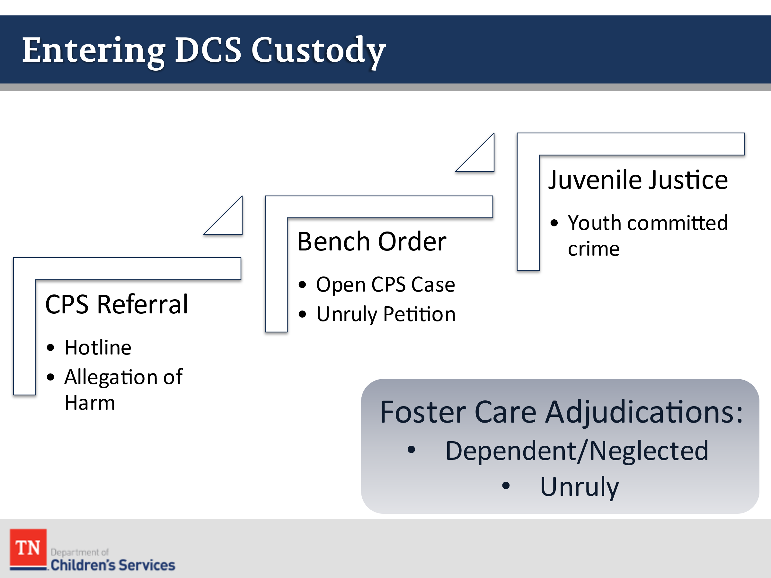
- SHARE with participants the different ways children and youth come into foster care:
- CPS Referral
- Bench Order (Open CPS or FSS Case or Unruly petition)
- EXPLAIN a child who enters foster care will be adjudicated either Dependent/Neglected or Unruly. If the child is adjudicated as Dependent/Neglected, there must be an Allegation of Harm. If the child is adjudicated as Unruly, the child must have received a charge that only a juvenile could commit such as truancy or runaway. SHARE there may be situations when a youth who is in custody adjudicated as Juvenile Justice may change to a Dependent/Neglect Adjudication or a youth who is adjudicated as Dependent/Neglect may incur charges which would change the adjudication of Juvenile Justice. STATE we will now BRIEFLY review the Allegations of Harm.
- ASK participants why it is important as a Foster Care Case Manager to know the different allegations (Work Aid 1) and how children enter care.
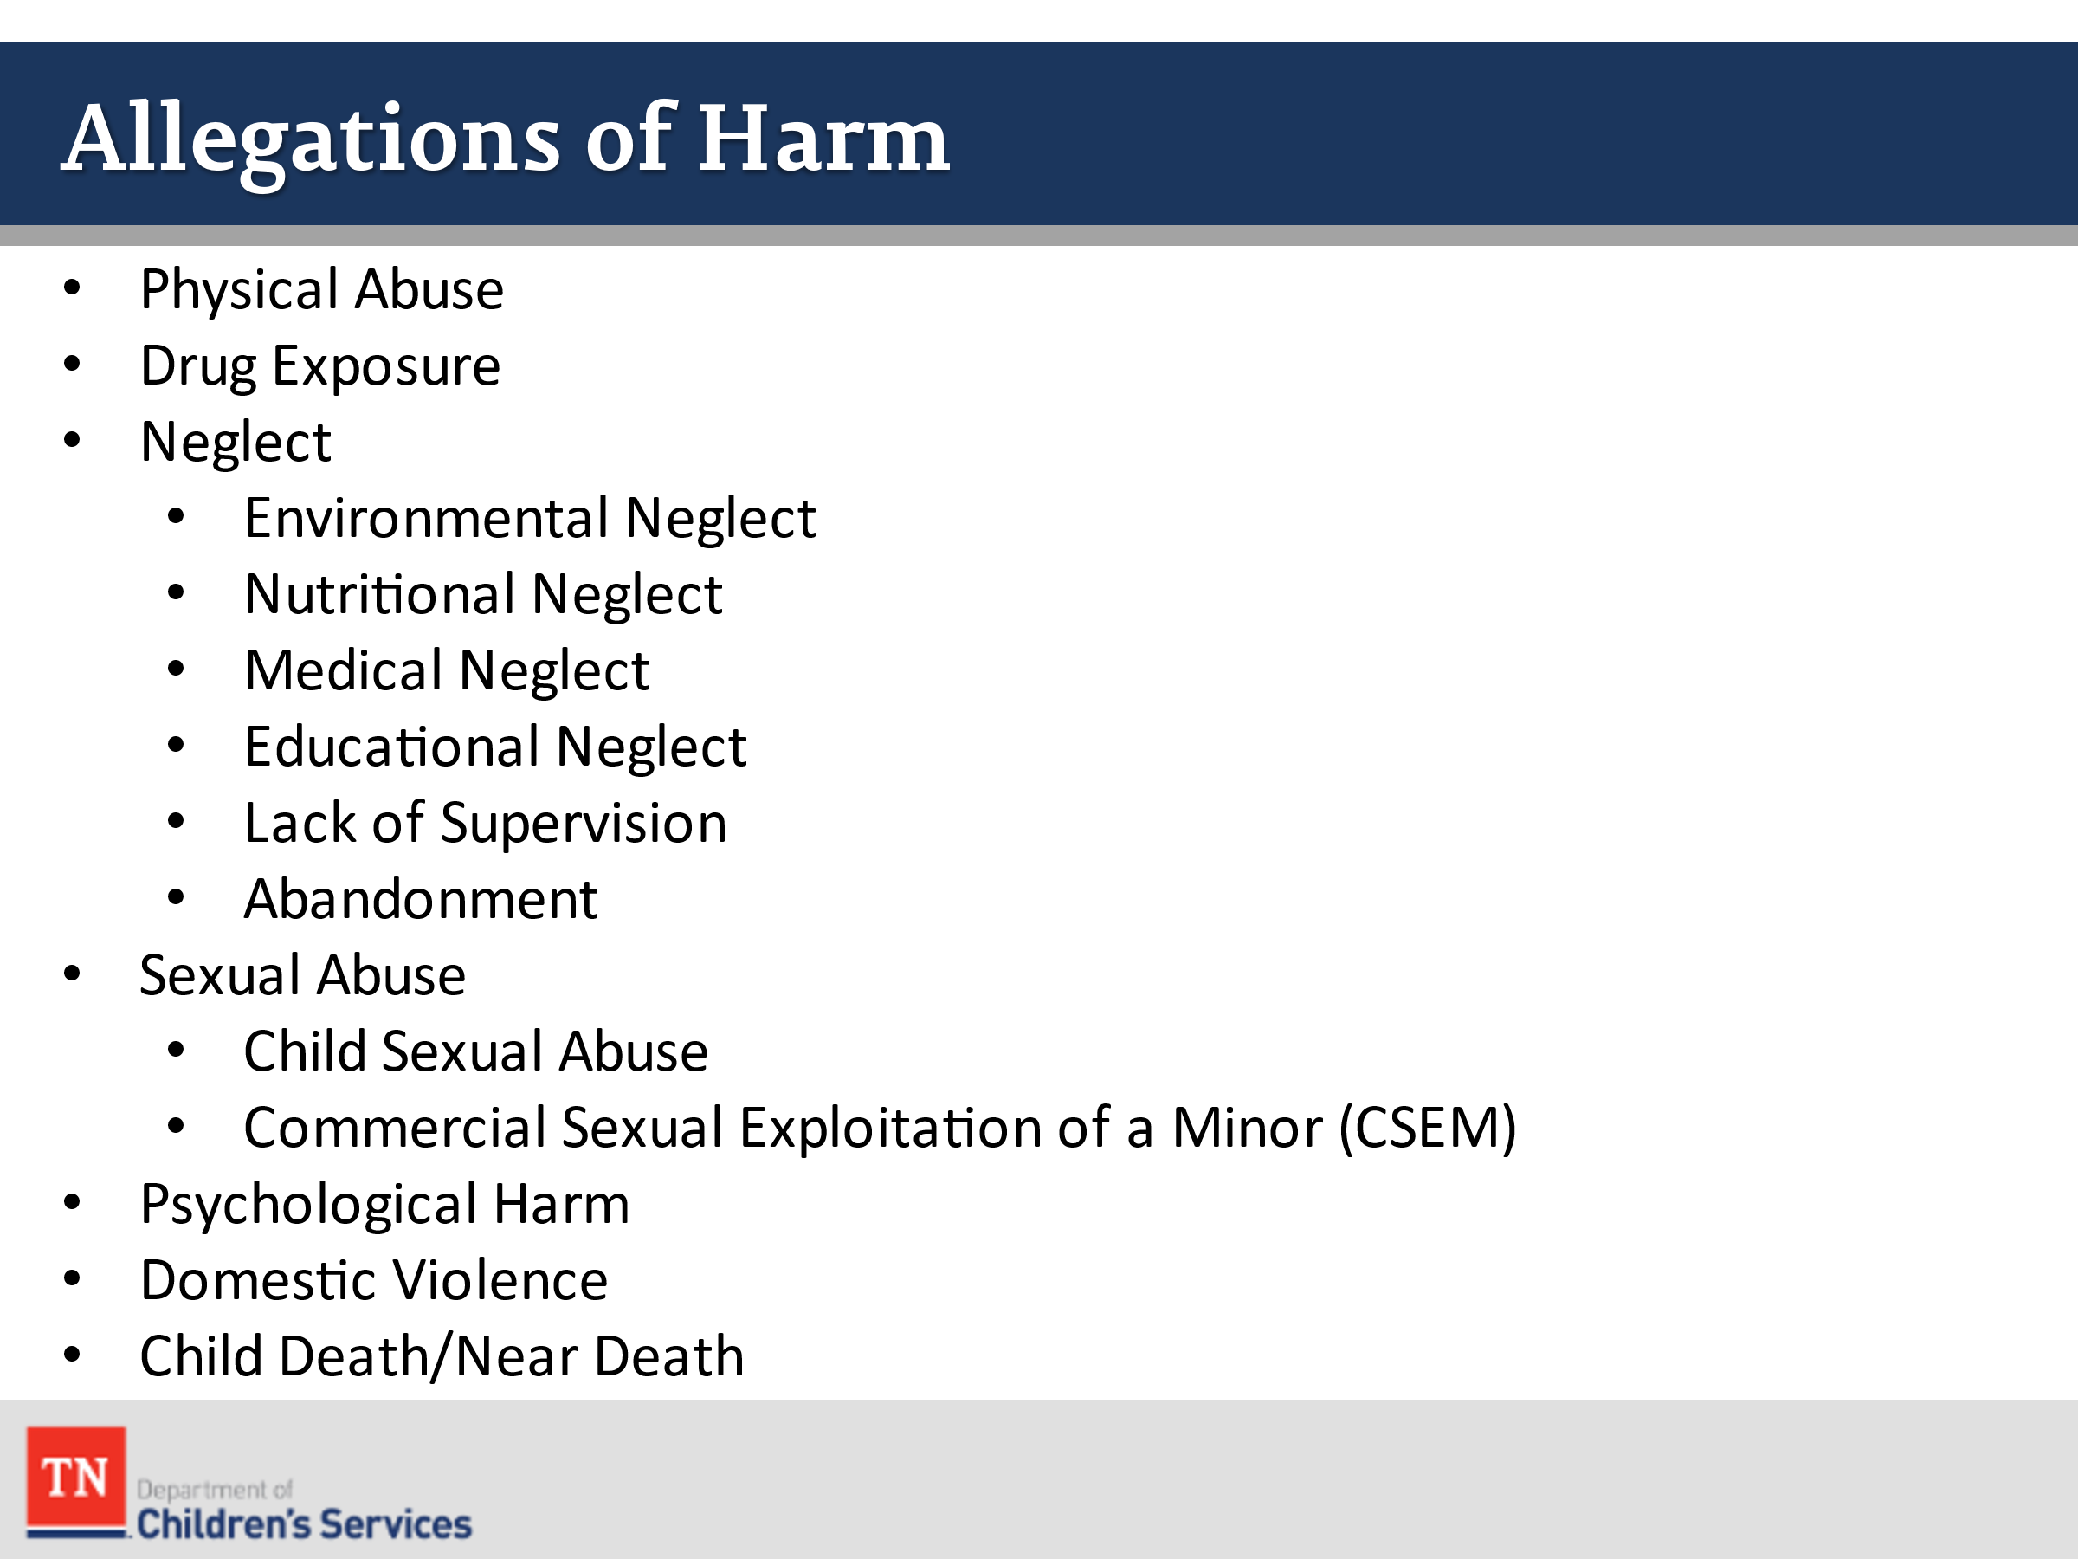
- REMIND participants of the following Allegations of Harm (discussed in more detail in Core week 1):
- Physical Abuse
- Drug Exposure
- Neglect
  - Environmental Neglect
  - Nutritional Neglect
  - Medical Neglect
  - Educational Neglect
  - Lack of Supervision
  - Abandonment
- Sexual Abuse
  - Child Sexual Abuse
  - Commercial Sexual Exploitation of a Minor (CSEM)
- Psychological Harm
- Domestic Violence
- Child Death/Near Death
- EXPLAIN foster care case managers will be assessing for safety, permanency, and well-being throughout the custodial episode in all environments, i.e., in foster home, schools, at appointments, etc.
- STATE during Introduction and the Core weeks, you received a lot of information about the Steward Case. SHARE during normal practice, it would not be typical to have that much time/information prior to engaging the family. NOTE during this class, we will be focusing on the Practice Wheel using another case family, the Williams. Participants will revisit the Steward family during Foster Care Specialty, Week Two.
- TRANSITION to Unit 2 by stating the first step in the case work process is Engagement.

