Unit 2: Engagement

Unit Time: 6 Hours, 30 Minutes

Learning Objectives:
- Participants will have a greater understanding of how engaging families leads to quality contacts and assisting families during the custodial episode.

Supporting Materials:
- PowerPoint
- Interviewing Techniques Handout
- Stages of Change Worksheet
- Flipchart: Behaviors, Feelings, Underlying Needs
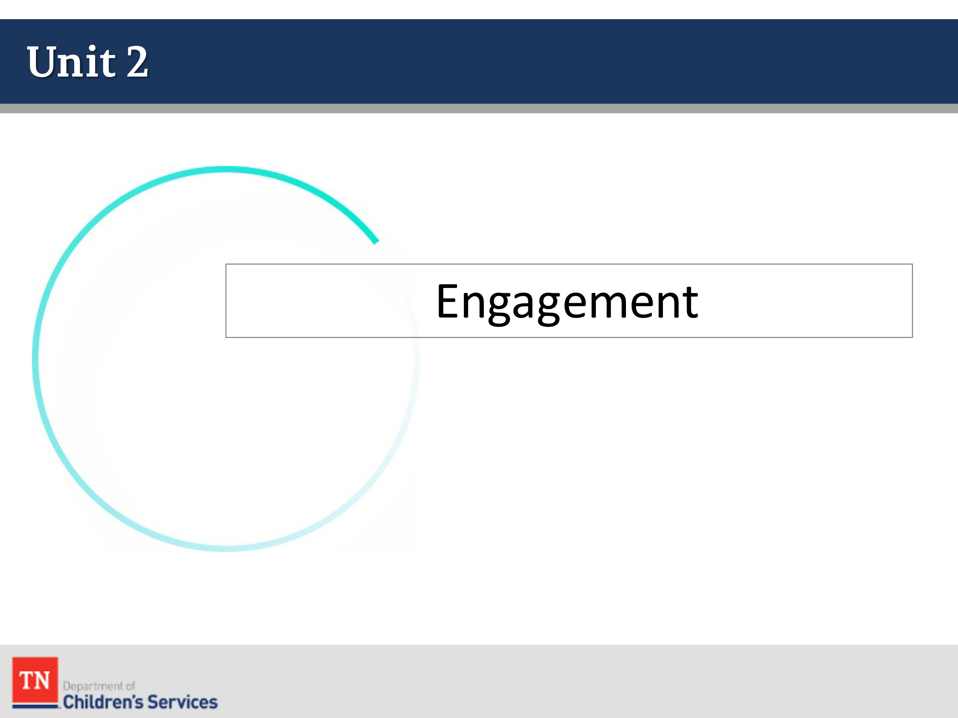
- Flipchart: Williams Strengths
- Flipchart: Williams Needs
- New Hire Guide
- Visitation Guide
- Policy 21.19 Education Passport
- CS-0657 Education Passport
- Family Assessment Worksheet

Lesson 2.1: Working with Families

Lesson Time: 20 minutes
Talking Points / Trainer Instructions:
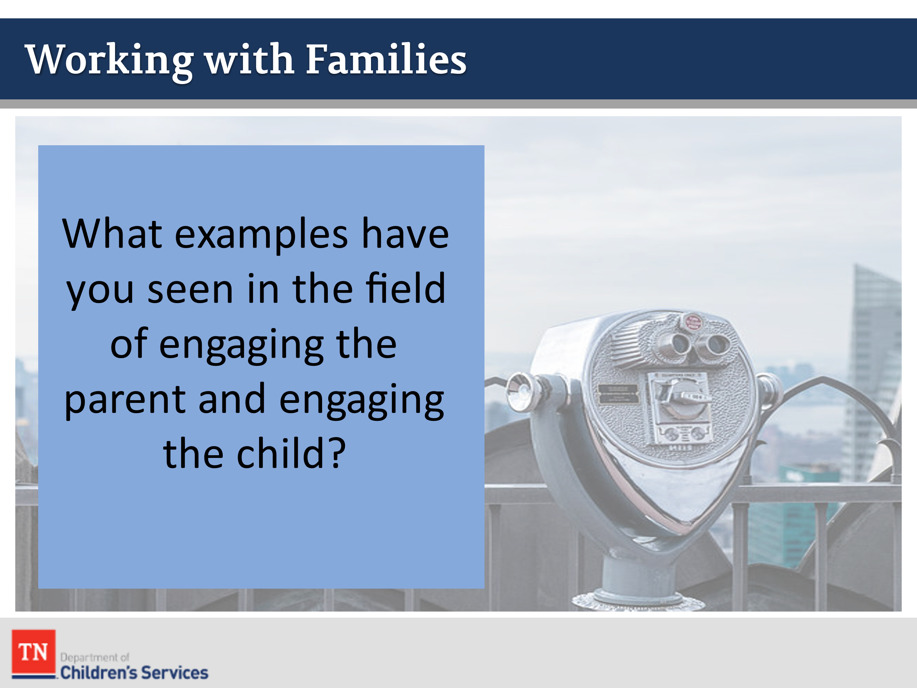
- INTRODUCE the following discussion by explaining the importance of engagement in any of the work we do, whether we are first meeting a family trying to establish rapport, in the early and middle stages when we are working with the family to move the case along, or at the end, when we hope the progress of our work together will continue after the case closes. ASK what are examples you have seen in the field of engaging the parent and engaging the child?
- ENGAGE the group in a discussion centered around below:
- The parent is sharing or providing more information to the Case Manager than just what was asked for.
- The Case Manager encouraging the parent to talk about him/herself or talk about the family, what it is like, how they interact.
- The Case Manager might ask the child about what they like to do in their free time, about school, or about their favorite toys. The Case Manager would know the child is engaged by open body language, the child interacting with the worker, possibly showing the worker the child’s toys or room, etc.
- INFORM the group the remainder of the lesson we will be looking at some of the skills and elements of engagement, and how these can benefit us when working with parents who are resistant.
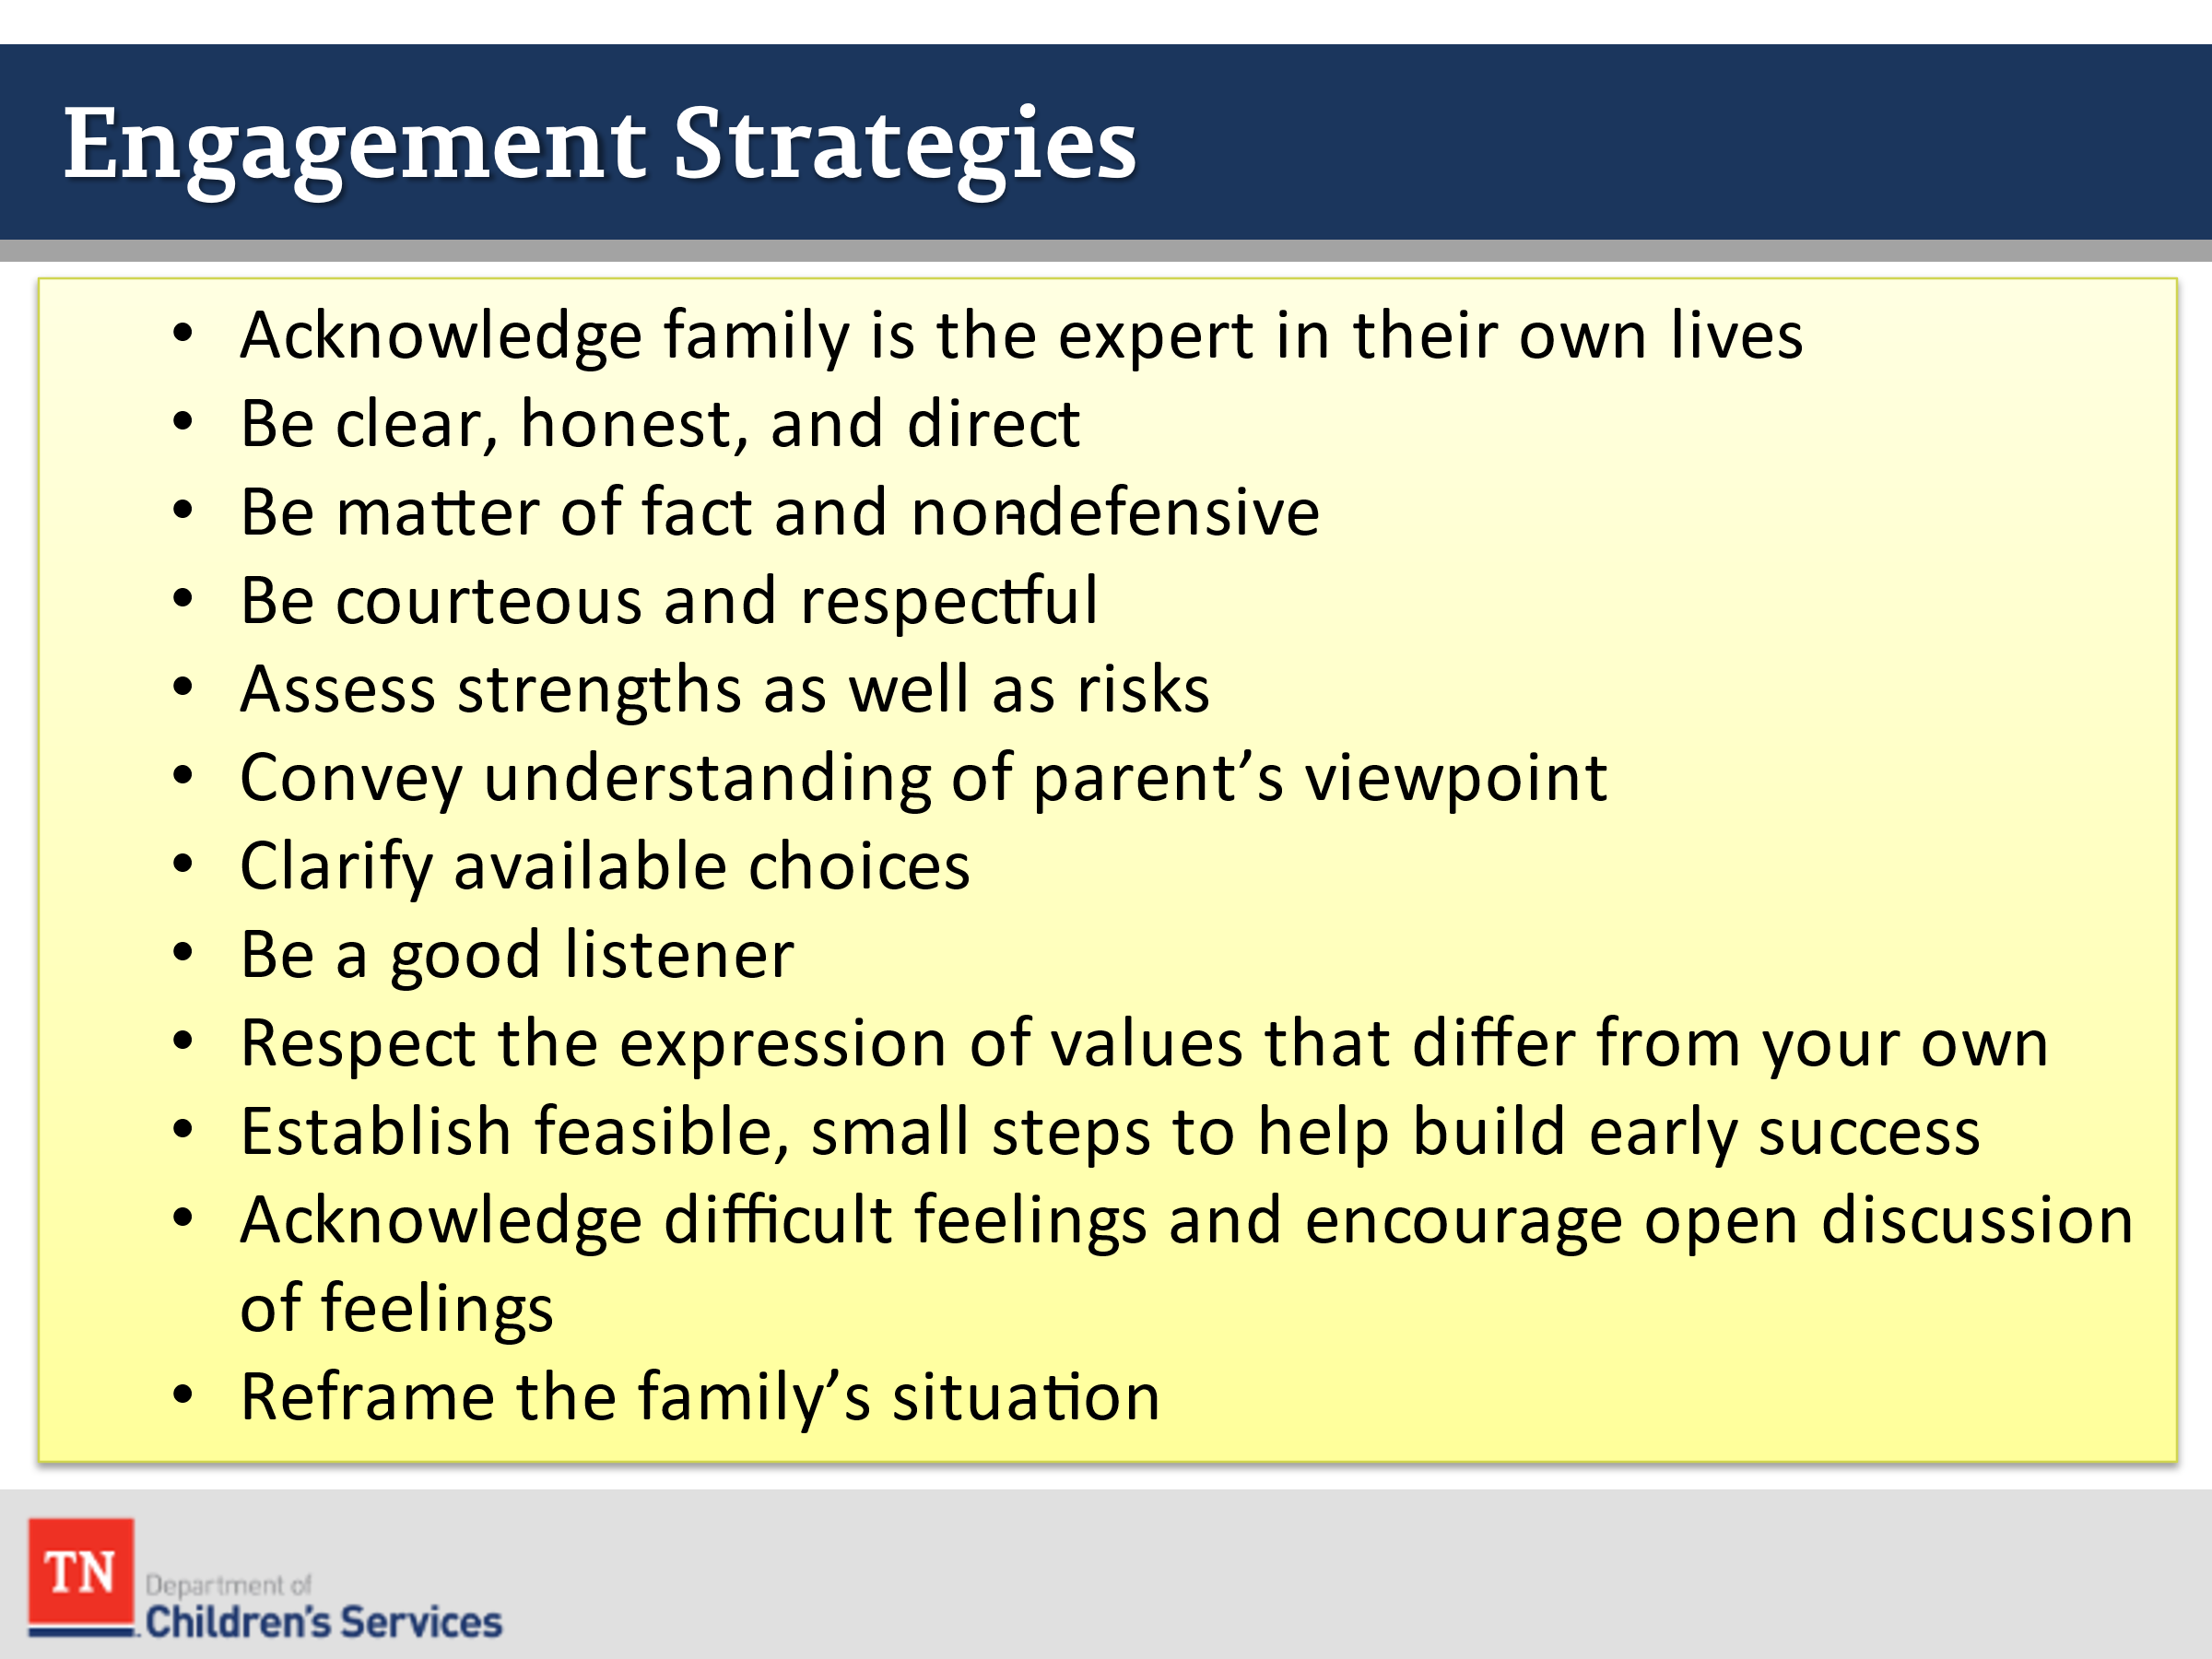
- SHARE there are many skills we can use to engage families including:
- Acknowledge family is the expert in their own lives
- Be clear, honest, and direct
- Be matter of fact and non-defensive
- Be courteous and respectful
- Assess strengths as well as risks
- Convey understanding of parent’s viewpoint
- Clarify available choices
- Be a good listener
- Respect the expression of values that differ from your own
- Establish feasible, small steps to help build early success
- Acknowledge difficult feelings and encourage open discussion of feelings
- Reframe the family’s situation
- SEGUE into resistance by ASKING participants if it is possible that a parent or caregiver may resist engagement efforts by DCS. ASK how likely it will be for them to encounter a resistant parent. TRANSITION to Lesson 2.2 Engagement, Trauma and Change.

Lesson 2.2: Engagement, Trauma, and Change

Lesson Time: 80 minutes
Talking Points / Trainer Instructions:

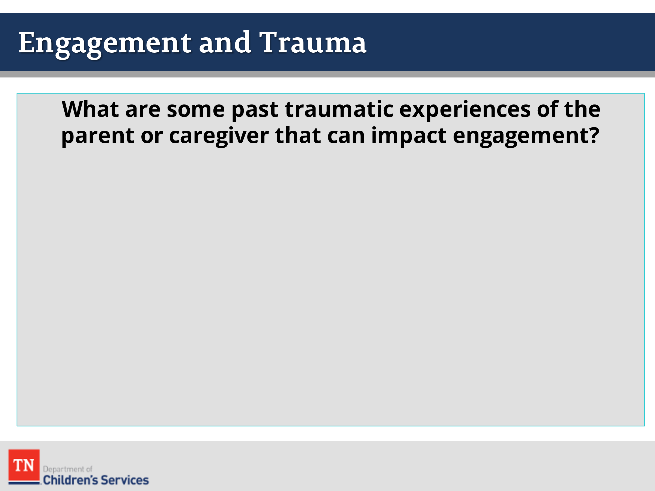
- STATE traumatic experiences can happen over generations, resulting in abuse or neglect cycles if intervention and resiliency development doesn’t happen. Now let’s consider how these same factors can impact parent or caregiver’s ability to engage in receiving intervention and support to develop resiliency and begin to end those harmful cycles.
- ASK participants what possible traumatic experiences a parent or caregiver may have in their past that can impact our ability to engage them. Responses could include:
  - Past abuse
  - Past neglect
  - In custody as a child
  - Death of a parent or loved one
  - Death of a child
  - Loss of a job
  - Loss of a home
  - Mistrust of government/mistrust of DCS
  - Fearful children will be removed
  - Powerless within societal structure
  - Immigration status
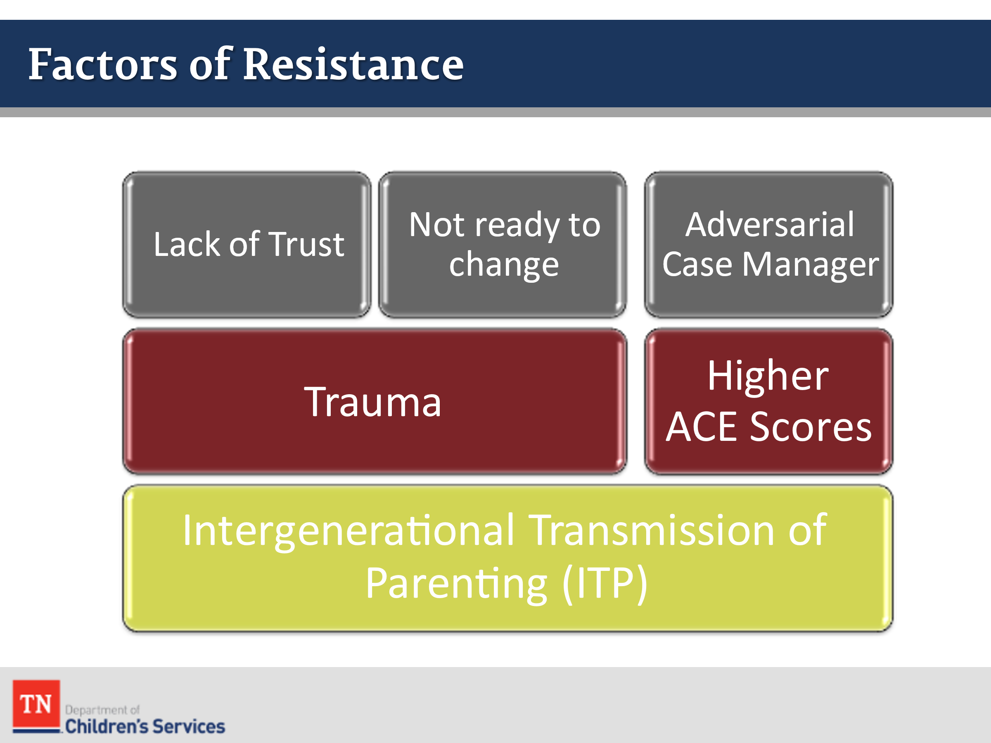
- ENGAGE the group in a discussion about some of the additional reasons a parent/family might be resistant including:
- Higher ACE scores
- Fear
- Lack of trust
- Adversarial Case Manager
- Mistrust of government/mistrust of DCS
- Fearful children will be removed
- Powerless within societal structure
- Immigration status
- Intergenerational Transmission of Parenting (ITP): Intergenerational Transmission of Parenting is defined as the process through which, purposefully or unintentionally, an earlier generation psychologically influences parenting attitudes and behavior of the next generation.
- Not ready to change
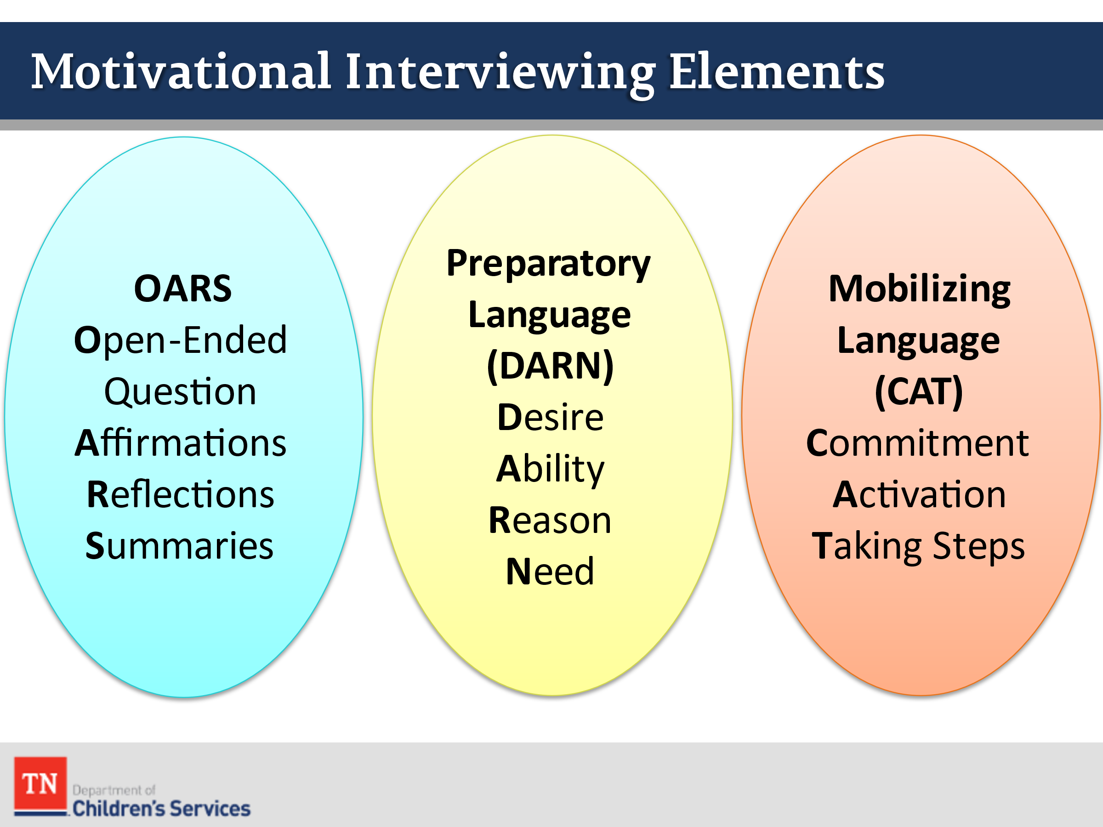
- ENSURE the group identifies the Parent/Caregiver may not be ready to change as a possible reason for resistance. ASK participants what they remember from Introduction and CORE Training weeks about Motivational Interviewing. SHARE we are now going to cover additional elements of Motivational Interviewing as it pertains to working with families whose children are in foster care. INFORM participants it is important to understand we are constantly engaging throughout the entire case. It is not just at the beginning of a case. It is important for us to understand the change process early on, so we recognize the signs and use our skills to help families progress through the cycle.
- STATE we can use Motivational Interviewing OAR skills to help elicit Preparatory (DARN) and Mobilizing Language (CAT) with youth and parents to help determine whether they are in the change process and to help challenge them to move forward.
- REMIND participants preparatory change (DARN) is when a person expresses motivations for change without stating or implying specific intent or commitment to do it. ASK the group if they can think of some examples:
  - Desire to change
  - Ability to change
  - Reasons to change
  - Need to change
- TELL participants being able to recognize preparatory language is important when working with families. It shows that the family is at least thinking about changing a behavior or habit. We must be listening for the change talk to follow up with the family and guide them toward a commitment of change. ASK where most families will be in the change cycle once they receive a new case in foster care.
- INFORM participants mobilizing language (CAT) is when the person expresses or implies action to change. We are listening for:
  - Commitment statements
  - Activation statements
  - Taking steps statements
- ASK participants, “Why being able to recognize mobilizing language is important with working with families.” Possible responses include: the person is trying to change, taking steps to address the issue, etc.
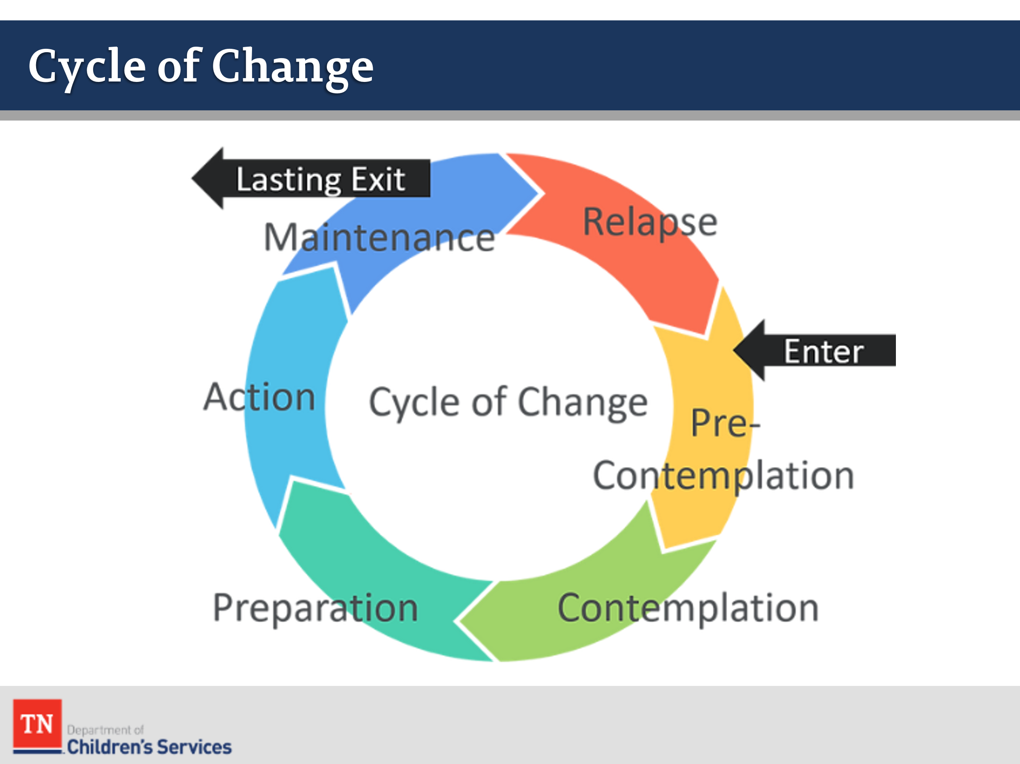
- SEGUE into discussing the Stages of Change. STATE as you meet families for the first time, it is important to know where they are in the process of change. If we understand where they are in the change process, we can use our engagement skills to gather information and potentially help them move through the stages. The stages of change are:
  - Pre-contemplation-the person has no intentions of change.
  - Contemplation-the person is ambivalent about change and sees both the pros and cons to the behavior.
  - Decision-making –this typically is a brief stage as the person resolves ambivalence and decides to make a change.
  - Action- the person takes some action toward resolution of the problem behavior.
  - Maintenance-for a year after the change has been successfully made, relapse is a possibility and a proactive plan developed.
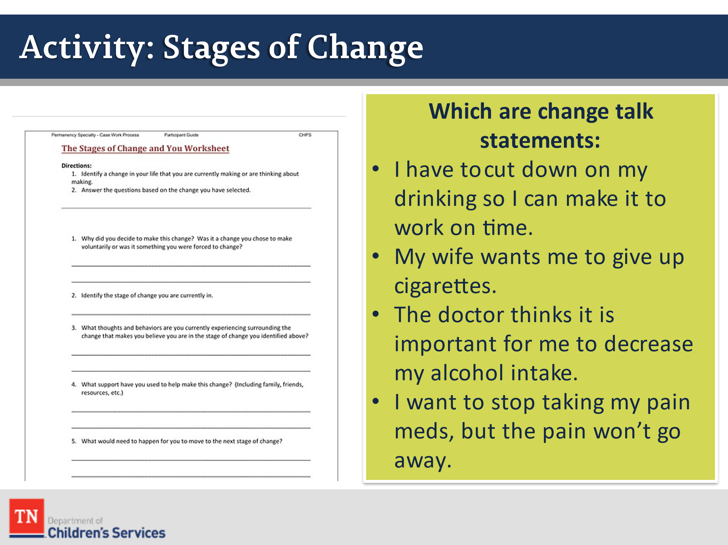
- CONDUCT ACTIVITY: Stages of Change Worksheet
  - GIVE participants 5 minutes to complete the Stages of Change worksheet.
- DEBRIEF the activity with the group and process how hard change can be and how we are asking parents to make changes so quickly. Empathy is important through this process and understanding change talk will help facilitate change.
- SHARE families may not believe that their behavior is a problem or that it will negatively affect them, or they may be resigned to their unhealthy behavior because of previous failed efforts and no longer believe that they have control.
- ASK participants to identify which statements are change talk statements:
  - I have to cut down on my drinking so I can make it to work on time. (Change)
  - My wife wants me to give up cigarettes. (Sustain)
  - The doctor thinks it is important for me to decrease my alcohol intake. (Sustain)
  - I want to stop taking my pain meds, but the pain won’t go away. (Change)
- STATE the goal of Motivational Interviewing is to form a partnership with the person. We are not pushing the person through the stages. We are just helping to guide the person through the process. The goals of every interaction where we use our Motivational Interviewing skills is to help the person move one step towards their goal, “not to fix the problem.”
- STATE it is a common response to want to “make things right” when we see a problem. Motivational interviewing does not try to make things right. We do not persuade, cajole, inform, prod, or in any way try to change their behavior.
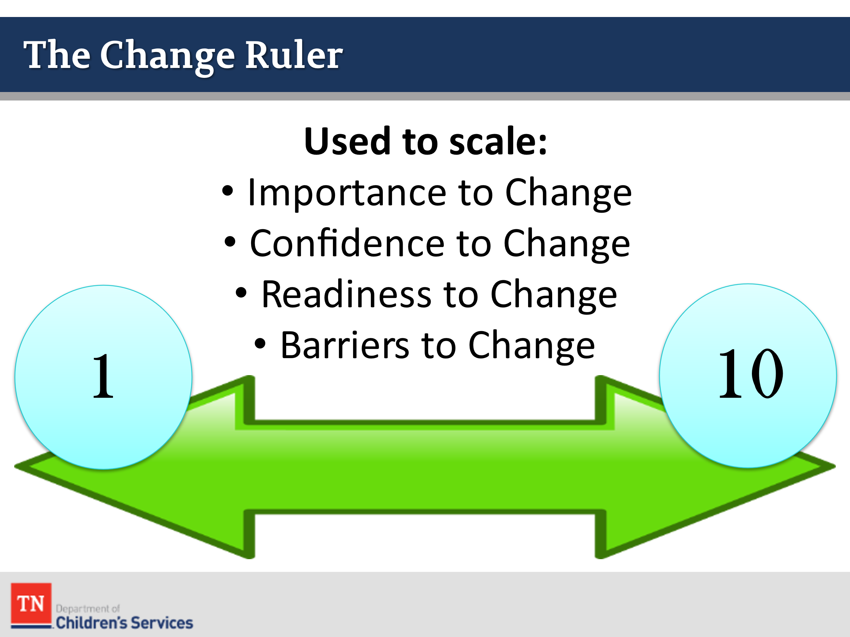
- SHARE a practical tool to support the use of MI is utilizing a Change Ruler to help guide conversations about personal change. The Change Ruler is a simple, straight line drawn on a paper that represents a continuum from the left to the right usually a scale of 1-10. We can scale many things including importance to change, confidence to change, or readiness to change.
- EXPLAIN the three most important elements in changing a behavior including:
  - Readiness to change: Do you have the resources and knowledge to make a lasting change successful?
  - Barriers to change: Is there anything preventing you from changing?
  - Likelihood of relapse: What might trigger a return to a former behavior?
- ENSURE participants understand the importance of asking these questions to help assess the change process in order to move toward the planning process with families.
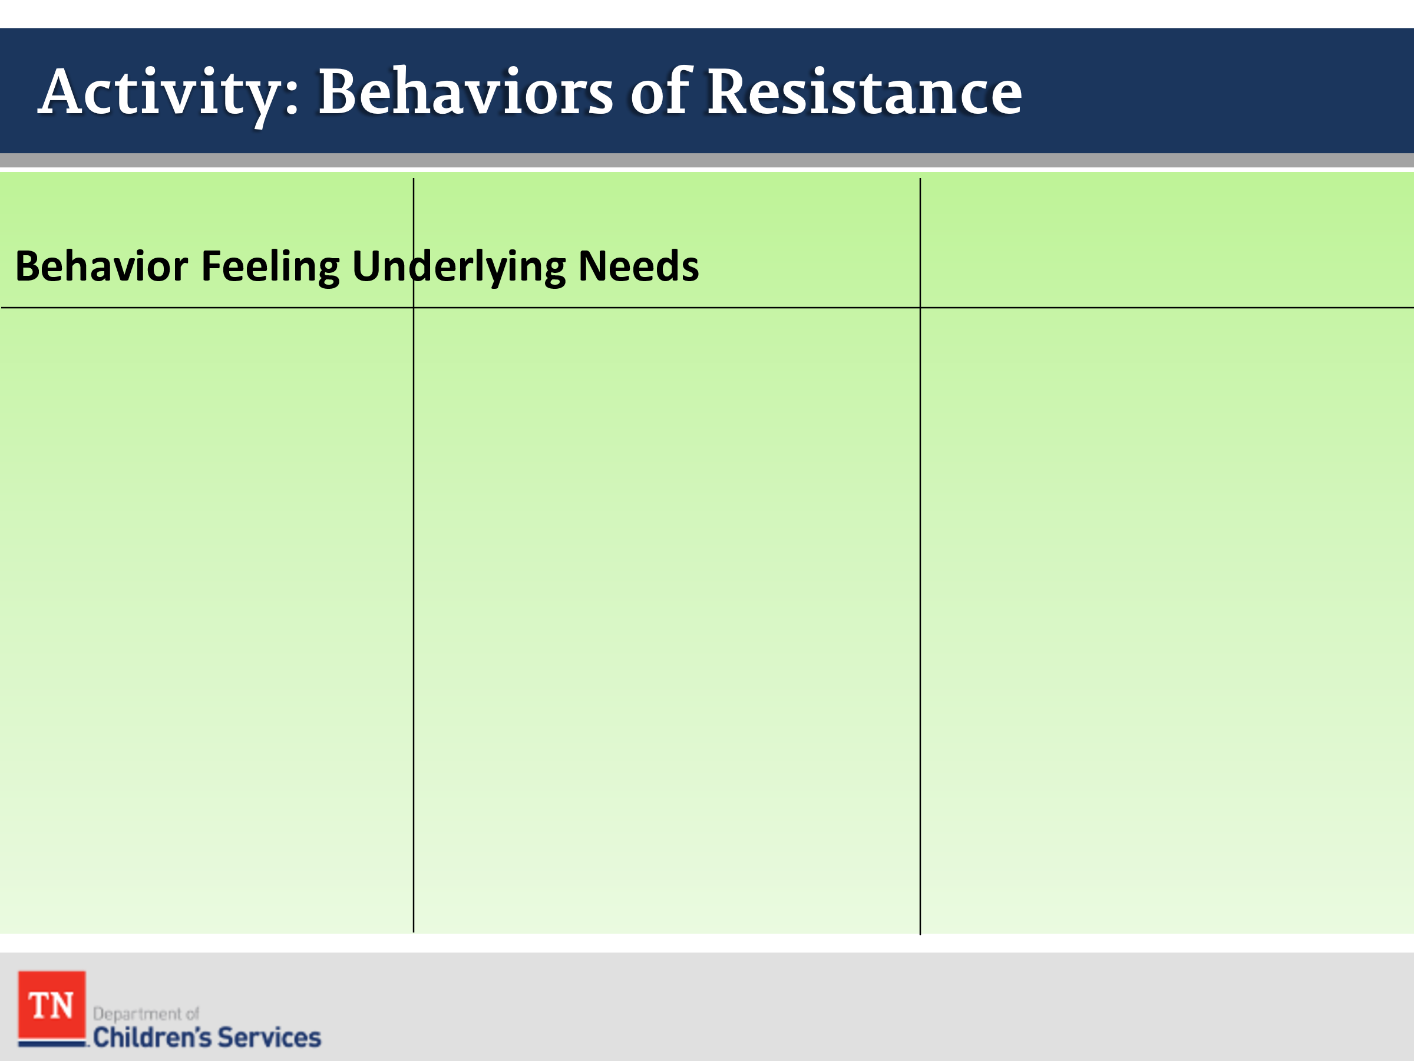
- CONDUCT ACTIVITY: Behaviors of Resistance
- DRAW grid on flipchart paper including “Behaviors, Feelings, and Underlying Needs.” Have the group list some of the behaviors exhibiting resistance and ask participants to identify what feelings that person may be experiencing which may be causing the behaviors we see.
- Then ASK participants to identify the underlying needs or what might be driving the behaviors and causing the feelings.
- STATE some of our most challenging cases are often the ones where the highest levels of trauma are present, and therefore the ones that most rely on us to be competent and compassionate.
  - Culturally competent case managers take a family’s personal history and demographics into account when working with families.
  - Culturally competent, trauma-informed case managers are aware of the underlying issues that a family is facing and assists them without judgement or bias.
- INFORM participants it is not uncommon for us to experience resistance in families. In fact, we will see resistance on a regular basis as it’s a normal reaction to this type of work.
- ASK the group if they could cause some resistance in the relationship with parents and caregivers? In what ways?
- ASK the group to brainstorm strategies that can reduce resistance that can be used with children, youth, and adults.
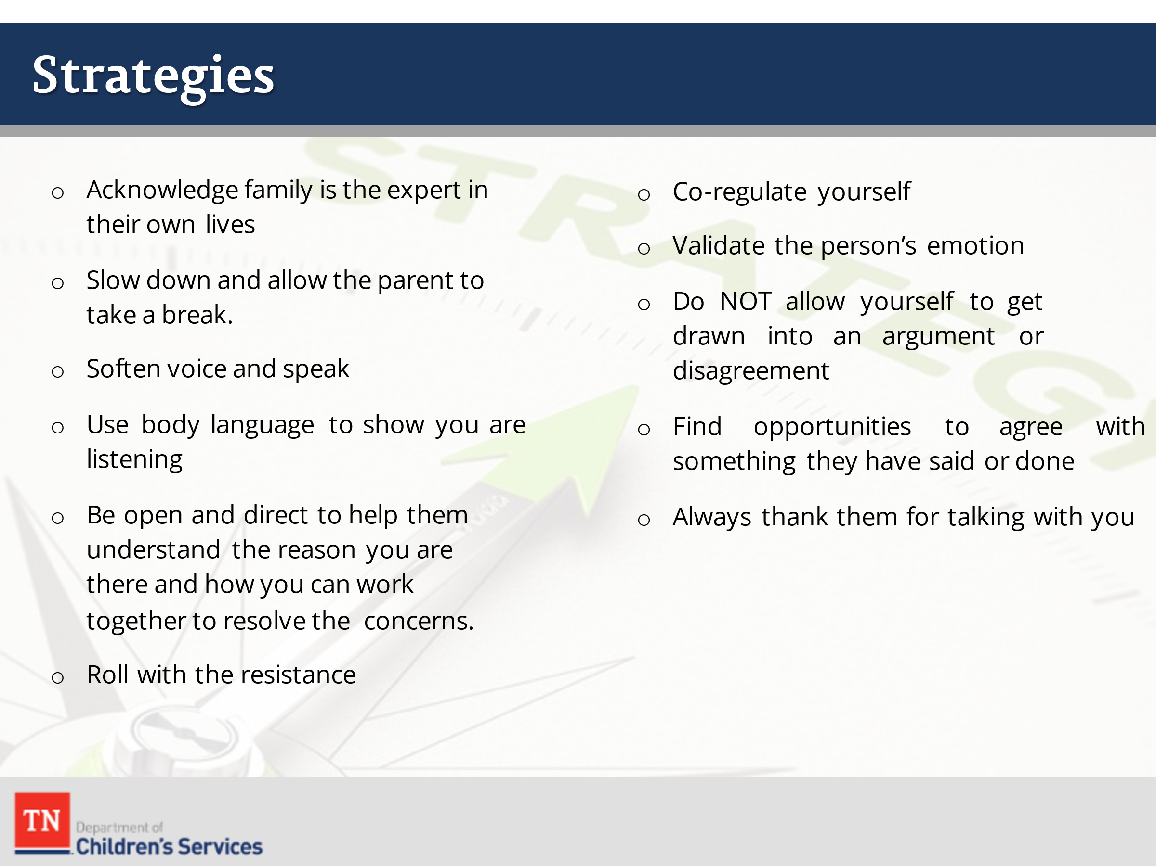
- ENGAGE the group in a discussion about their strategies. ENSURE the following are discussed:
  - Acknowledge family is the expert in their own lives
  - Slow down and allow the parent to take a break. Remember you may be talking about some sensitive topics, and they may not trust you or be ready to open to you
  - Soften voice and speak calmly-If a parent begins to raise their voice, don’t go with them, lower your voice, and remain calm
  - Use “Yes, and” (explain the “Yes, and” approach to the new hires)
  - Use body language to show you are listening attentively and to align yourself
  - Be open and direct to help them understand the reason you are there and how you can work together to resolve the concerns.
  - Roll with the resistance
  - Co-regulate yourself (maybe combine this with below “to avoid and argument…)
  - Validate the person’s emotion (anger, fear, sadness, etc.) and emphasize with what they are feeling (you do not have to agree with the actions or behavior in order to express empathy)
  - Do NOT allow yourself to get drawn into an argument or disagreement
  - Find opportunities to agree with something they have said or done
  - Always thank them for talking with you
- EXPLAIN to the group they will review some possible statements of resistance and discuss what strategies could be used to facilitate engagement.
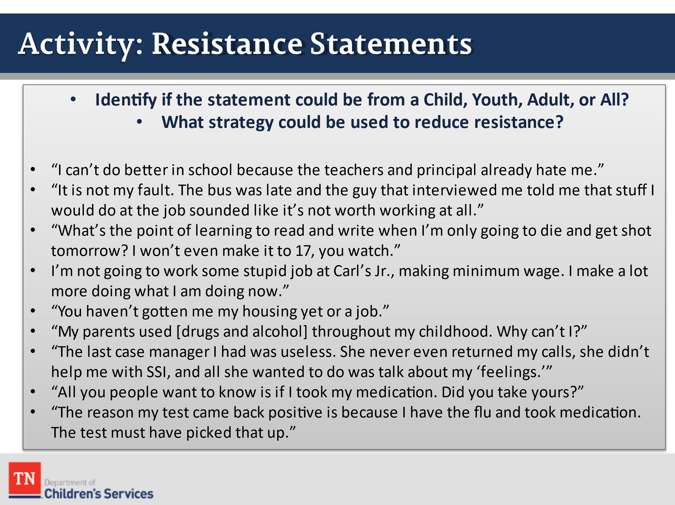
- CONDUCT ACTIVITY: Statements of Resistance
- The Trainer will select and READ some resistant statements aloud based on time and group size.
- After each statement is read ASK the group if this statement could be from a child, youth, adult or all the above and what stage of change the person could potentially be in.
- Once it has been decided ASK the group what strategies could be used to engage the person. ENCOURAGE all the participants to offer suggestions.
- Statements of Resistance
- “I can’t do better in school because the teachers and principal already hate me.”
- “It is not my fault. The bus was late and the guy that interviewed me told me that stuff I would do at the job sounded like it’s not worth working at all.”
- “What’s the point of learning to read and write when I’m only going to die and get shot tomorrow? I won’t even make it to 17, you watch.”
- “I’m not going to work some stupid job at Carl’s Jr., making minimum wage. I make a lot more doing what I am doing now.”
- “You haven’t gotten me my housing yet or a job.”
- “My parents used [drugs and alcohol] throughout my childhood. Why can’t I?”
- “The last case manager I had was useless. She never even returned my calls, she didn’t help me with SSI, and all she wanted to do was talk about my ‘feelings.’”
- “All you people want to know is if I took my medication. Did you take yours?”
- “The reason my test came back positive was because I had the flu and took flu medication. The test must have picked that up by accident.”
- Strategies
- Listen to the family and their concerns. Sometimes the most challenging clients are only expressing frustration because they feel like they are not being heard. Let the family know you hear their concerns.
- Ask for more detail about something the client says. When you ask someone for more information or to explain something to you it often de-escalates the situation and causes the client to calm down.
- Point out the client’s strengths or something they are doing well. For example, “I can really see how much you care about your child” or “I can see that you must be really strong to have gone through so much”
- Ask the client what they would like to see happen or what their ideal situation would look like.
- DEBRIEF the activity by reemphasizing to the class they do not want to get drawn into an argument or disagreement with the family.
- TELL the participants they are the professionals. Don’t allow an argument or disagreement to become personal. It is important to stress that in most cases a parent’s anger is about the situation and has little to do with the case manager.
- TRANSITION by sharing we are going to practice some skills that you can take with you into every home.

Lesson 2.3: The Questions You Ask

Lesson Time: 30 minutes
Talking Points / Trainer Instructions

- STATE in addition to being aware of our style and how this can produce resistance, now let’s consider the questions we use. ENGAGE the group in a discussion by asking the following question and exploring their answers:
  - “How does the type of questions used make a difference when engaging a family?”
  - ENSURE open-ended questions are included in the discussion.
- SHARE we are now going to practice our use of open-ended questions.
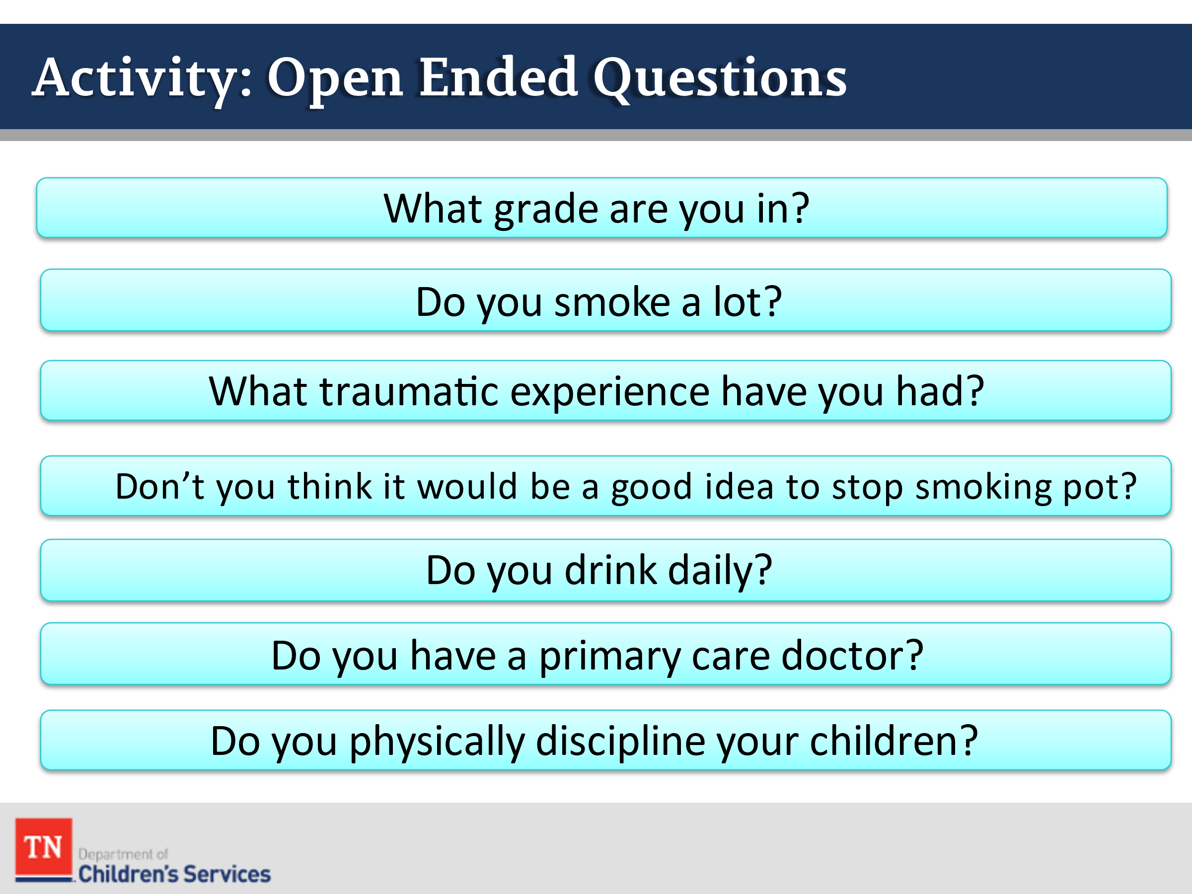
- CONDUCT ACTIVITY: Open-Ended Questions
- SELECT 2-3 questions from the list below and INSTRUCT participants to take out a piece of paper and to convert the closed ended questions into open ended questions (Trainer may refer to open-ended version suggestions in debrief). ENCOURAGE creativity in engagement.
- “Which grade are you in?”
- Open-Ended Version: “Tell me about the last grade in school that you were able to complete.”
- “Do you smoke a lot?”
- Open-Ended Version: ‘Tell me about your cigarette use.”
- “What traumatic experience have you had?”
- Open-Ended Version: “What would you say has been the most difficult for you in your life?”
- “Don’t you think it would be a good idea to stop smoking pot?”
- Open-Ended Version: “What would be the benefits of not smoking pot?”
- “Do you drink daily?”
- Open-Ended Version: “Tell me about your alcohol use.”
- “Did anyone in your family have mental illness growing up?”
- Open-Ended Version: “How did your family handle stress when you were growing up?”
- “Do you have a primary doctor?”
- Open-Ended Version: “Tell me about what happens when you and your family get sick?”
- “Do you physically discipline your child?”
- Open-Ended Version: “How do you discipline your child?”
- “Have you ever witnessed or experienced a life-threatening accident?”
- Open-Ended Version: “What is the scariest thing you have ever seen or experienced in your life?”
- “Have you ever been incarcerated?”
- Open-Ended Version: “What has been your experience with law enforcement?”
- “Have you felt sad, lifeless, or exhausted most of the day every day for the last two weeks?”
- Open-Ended Version “What emotions have made daily life difficult in the last few days? How have they made life difficult?”
- “Do you carry a gun or a knife on you?”
- Open-Ended Version: “What are your feelings on personal protection?” or, “What are your thoughts about carrying weapons?”
- “Have you paid your rent this month?”
- Open-Ended Version: “Can you tell me about a time when you have had a hard time paying your bills?”
- “Do you have access to food?”
- Open-Ended Version: “If I could help you with anything right now, what would that be?”
- “Are you thinking about harming yourself or others?”
- Open-Ended Version: “How do you manage stress? What does that look like?” or “How do you deal with issues you may have with others?”
- DEBRIEF the activity by asking how participants can continue to practice using open-ended questions with children, youth, and families.
- SHARE a good way to ensure open ended questions is starting with “tell me about…….” “What are your thoughts on ”
- SHARE with the group there are many interviewing techniques that the pros use, however, we wanted to share some that can be used easily and right away. REFER participants to the resource in Google Classroom: Interviewing Techniques.
- TRANSITION to Lesson 2.4: Transitioning Cases to the FSW.

Lesson 2.4: Transitioning Cases to the FSW

Lesson Time: 30 minutes
Key Teaching Points / Instructions

- INTRODUCE the lesson by stating we will now focus on how to ensure a smooth case transition from CPS to Foster Care and review the tasks required for FSWs to successfully prepare for the initial contact with the family after a child enters custody. It is imperative to gather as much detail as possible in preparation for the initial visit with the family.
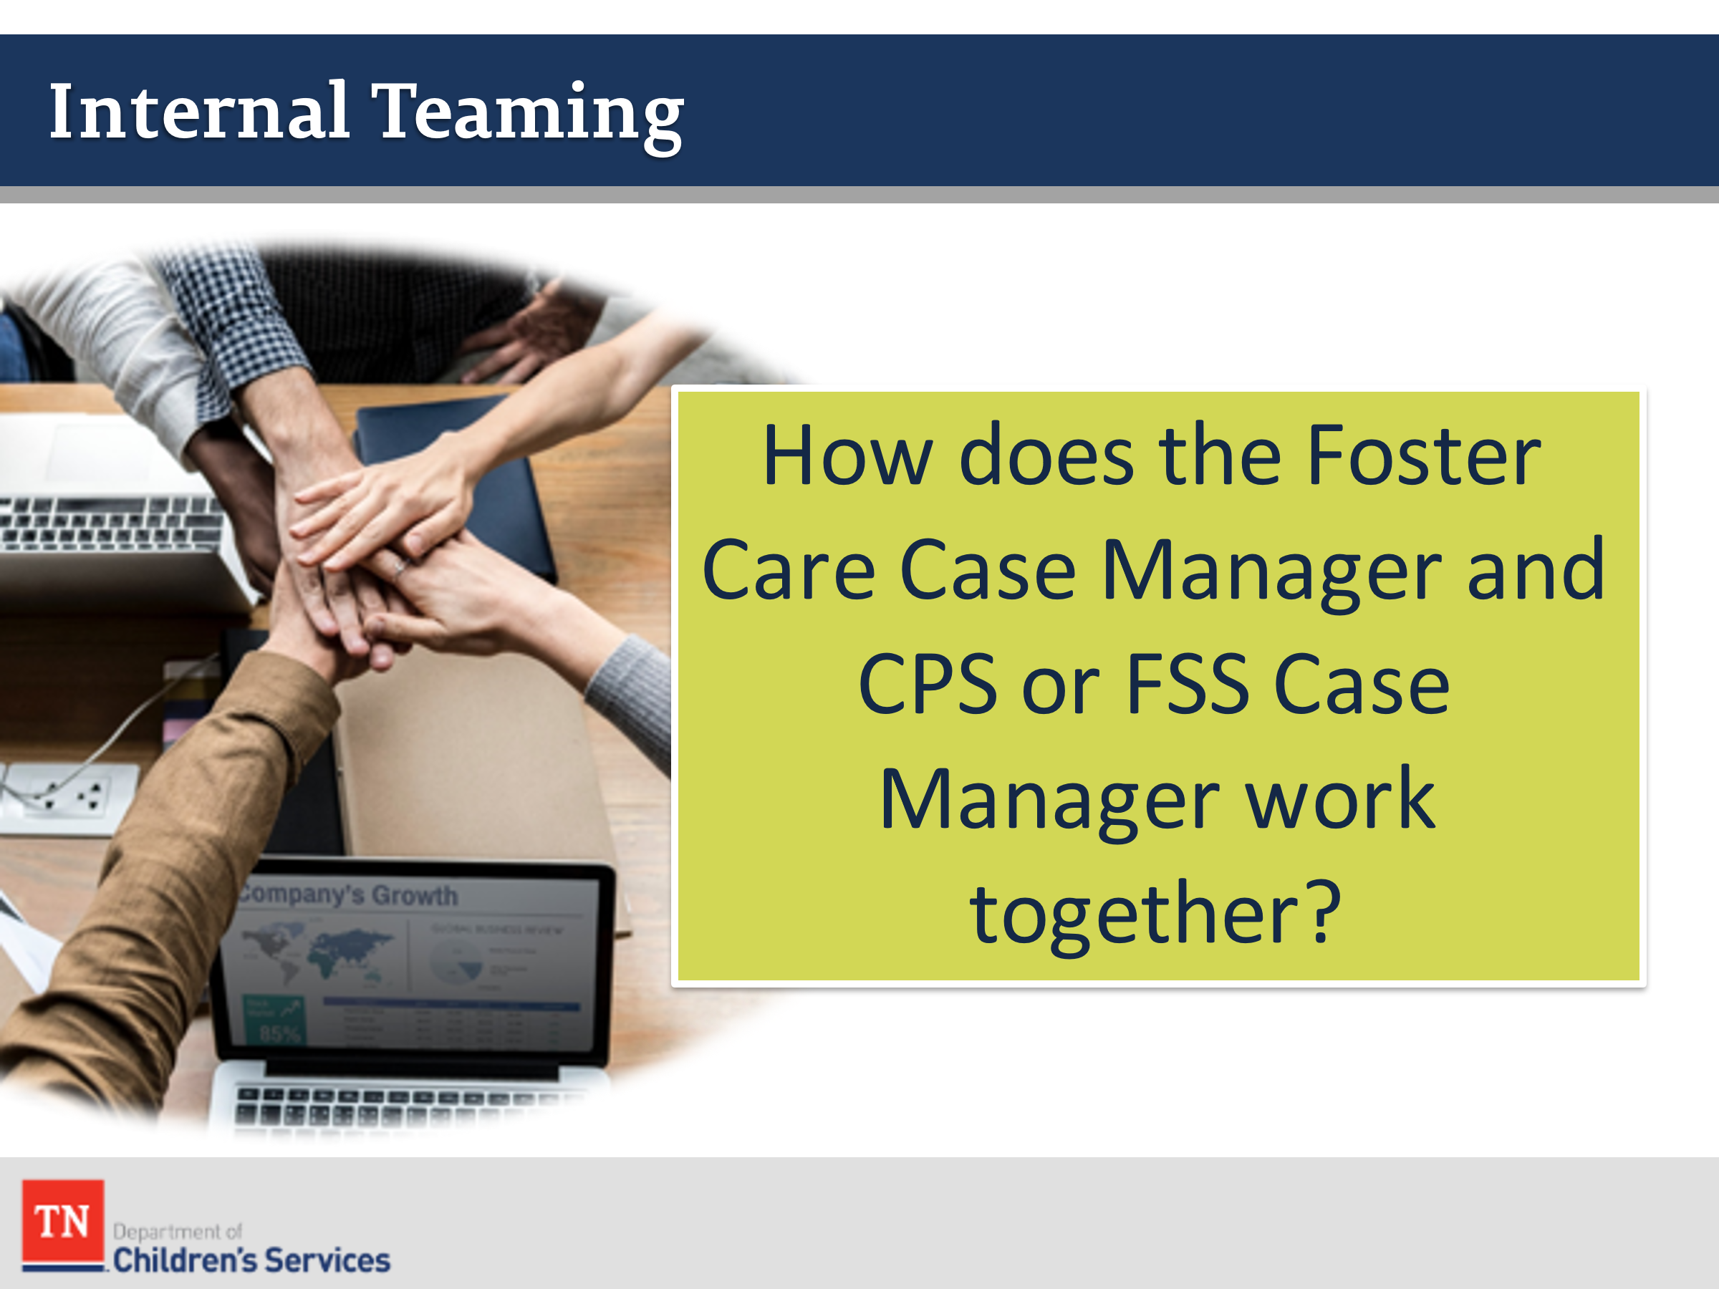
- EMPHASIZE the importance of internal teaming within DCS program areas. ASK how the Foster Care Case Manager and the CPS or FSS Case Manager work together. SHARE the following and NOTE regions may have various procedures for case assignment and completing first case steps:
- FOSTER CARE CASE MANAGER:
- Assigned case after a child/youth is placed into custody and date/time of Initial CFTM, plus additional information. Assist in waiting with child on placement, collecting personal items, completing genogram, etc.
- Contact foster parent or provider to check on the youth/child and assist with trauma reduction. Schedule first contact with foster parent, child, parents, collateral contacts
- Gather copies of CPS file, Records, Assessments, etc.
- Attend Initial CFTM, if held by CPS; schedule/attend Initial CFTM if not completed by CPS/FSS
- Attend Preliminary Hearing noting any court orders, next hearing, etc.
- Follow-up on any severe abuse cases, CPIT and any possible court hearings on case.
- CPS/FSS Case Manager:
- Transports child/youth to initial placement, alerts custodial case manager to any urgent information including picking child up from school, additional clothing, medication needs, etc.
- Distributes copies of all CPS documentation/paperwork
- Attends Preliminary Hearing
- Contacts Foster Care case manager to inform of any substantiated Severe Abuse cases, CPIT review, any criminal court hearing, etc.
- REFER participants to the New Hire Guide for steps to take when children enter custody.
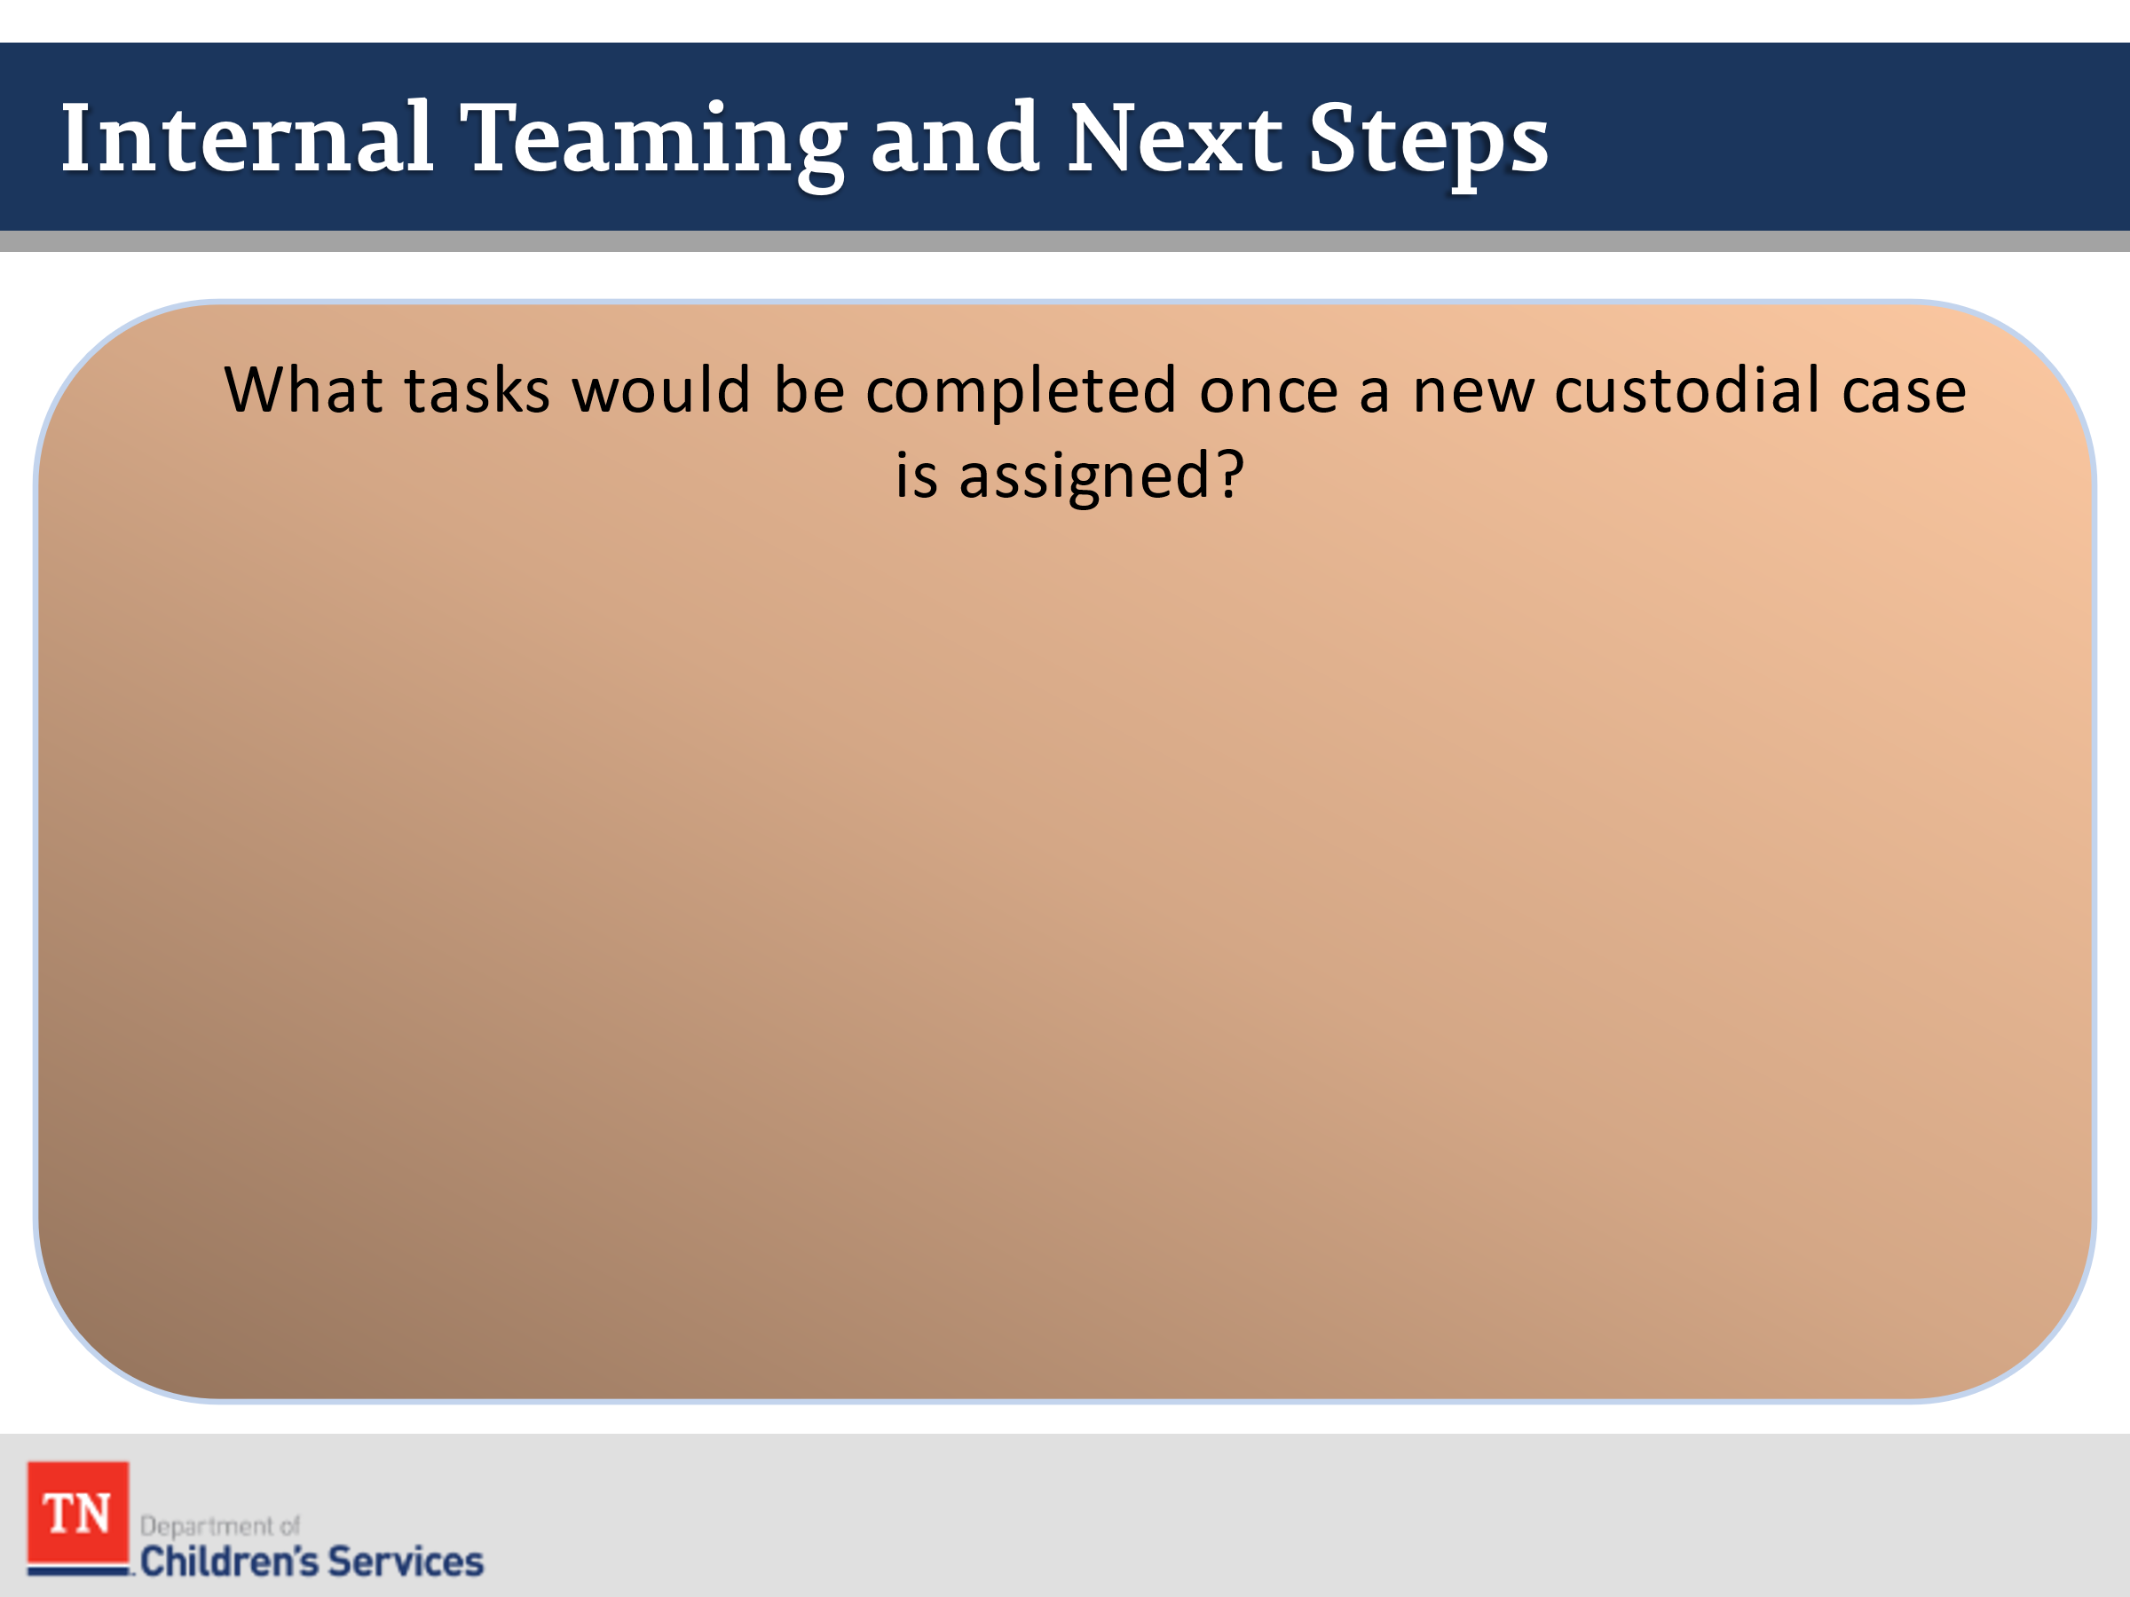
- ASK participants to share what task would be completed once a new custodial case is assigned. Answers should include:
  - Schedule EPSD&T and dental
  - Obtain photograph
  - Educational Passport/School enrollment. REFER to Policy 21.19 Educational Passport to provide additional information. PROVIDE information regarding Form CS-0657 and STATE the Education Passport is a compilation of the following: Completed Education Passport Face Sheet with completed demographic information, additional school enrollment information, a list of recent schools attended and the following documents: Immunization records, Most recent grade card with attendance records, current transcript for High School students, and as applicable, special education, student plans under Section 504 of the Rehabilitation Act, or TEIS records. SHARE the compilation of the Education Passport begins once the child/youth enter DCS custody.
  - Clothing allotment
  - Obtaining records
  - Face to Face with children/youth/parents
  - Schedule visitation with parent and child(ren)
  - Visit the placement
  - Schedule Initial Child and Family Team Meeting
  - Attend Preliminary Hearing
  - Documentation (within 30 days of contact and on-going)
- ASK if there are any questions and TRANSITION to Lesson 2.5 The Initial Contact.

Lesson 2.5: The Initial Contact

Lesson Time: 80 minutes
Key Teaching Points / Instructions

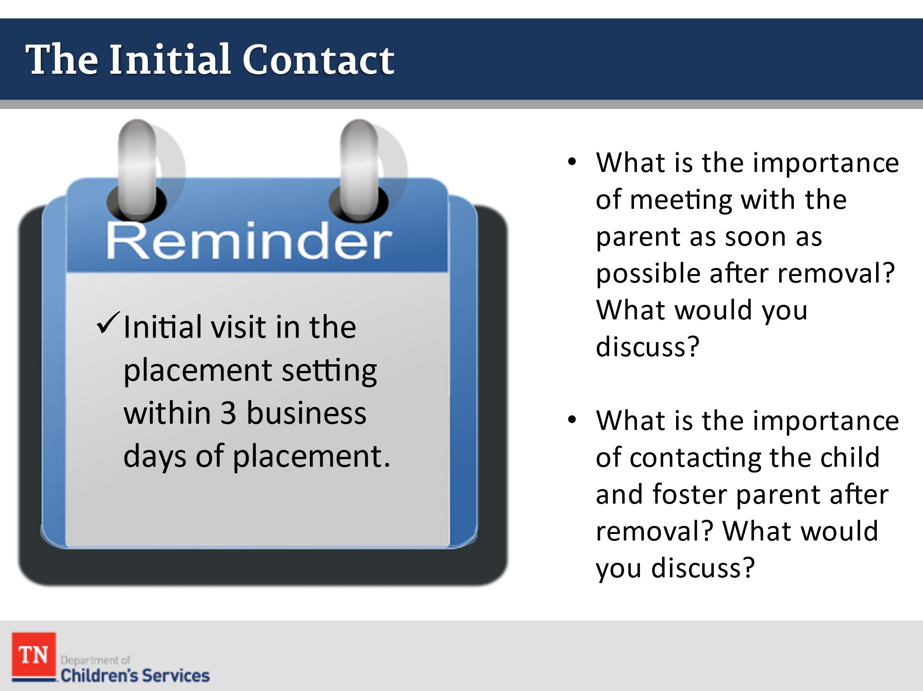
- STATE one of the most important case tasks after receiving a new custodial case is conducting the initial face to face contact with the child and parents. STATE this contact may be completed by CPS or the FSW; however, the FSW will conduct the initial visit with the child in the placement setting within 3 business days of any new placement.
- INFORM participants all face to face contacts with children in the home will be documented within 10 business days.
- ASK participants what you would need to know before the Intial Contact and where you would collect this information.
- ASK participants the following questions:
  - What is the importance of meeting with the parent as soon as possible after removal? What would you discuss?
  - What is the importance of contacting the child and foster parent after removal? What would you discuss?
- REFER participants to the Visitation Guide for face-to-face quality contacts and review the Quick Reference Table on page 3 and DISCUSS the visitation requirements of a new custodial episode for children and parents.
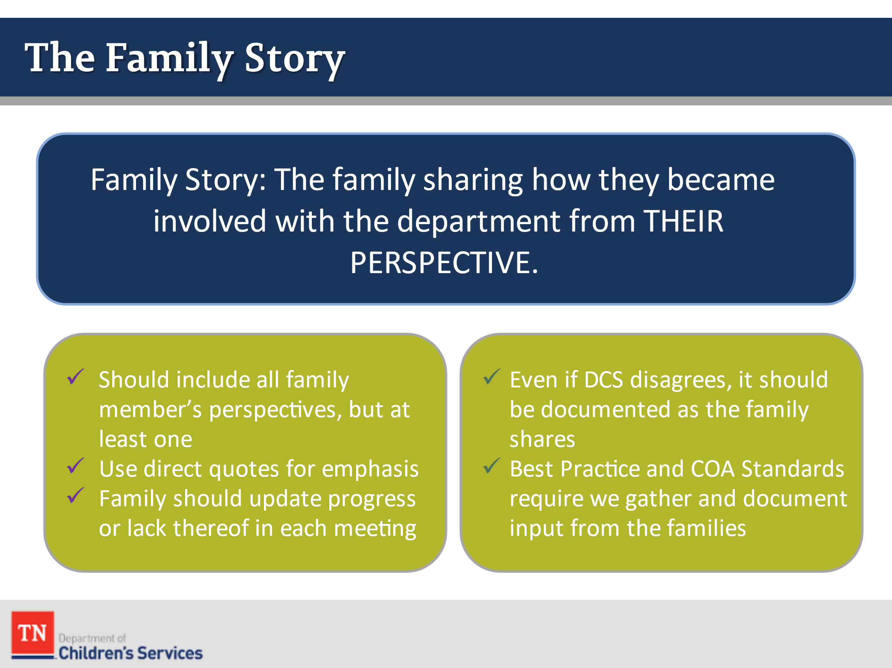
- STATE the purpose of the initial contact with the parent is to meet the family and hear the family story from their point of view. It is also the time to begin building the Child and Family Team and prepare the family for the upcoming Initial Child and Family Team Meeting.
- TELL participants that gathering the family story is an opportunity for the worker to engage the family in sharing how they came to be involved with the department from their perspective.
  - When the story is captured in documentation it should reflect a narrative version of the family’s view, interpretation and account of their situation, progress, and involvement with the department.
  - This might only be the perspective of one family member or multiple, depending on the case situation.
  - It is good to use quotes from family members whenever possible.
  - If it is being updated after the initial meeting, be sure to note the family’s own progress, or lack thereof, towards permanency.
  - It is important to remember that even if you, as the worker, disagree with the family’s perspective, the family story should still be documented as the family stated it. We can note that this is the family’s perception of the events and not the perception of DCS.
  - Best practice and COA standards require that we gather and document input from the families we work with.
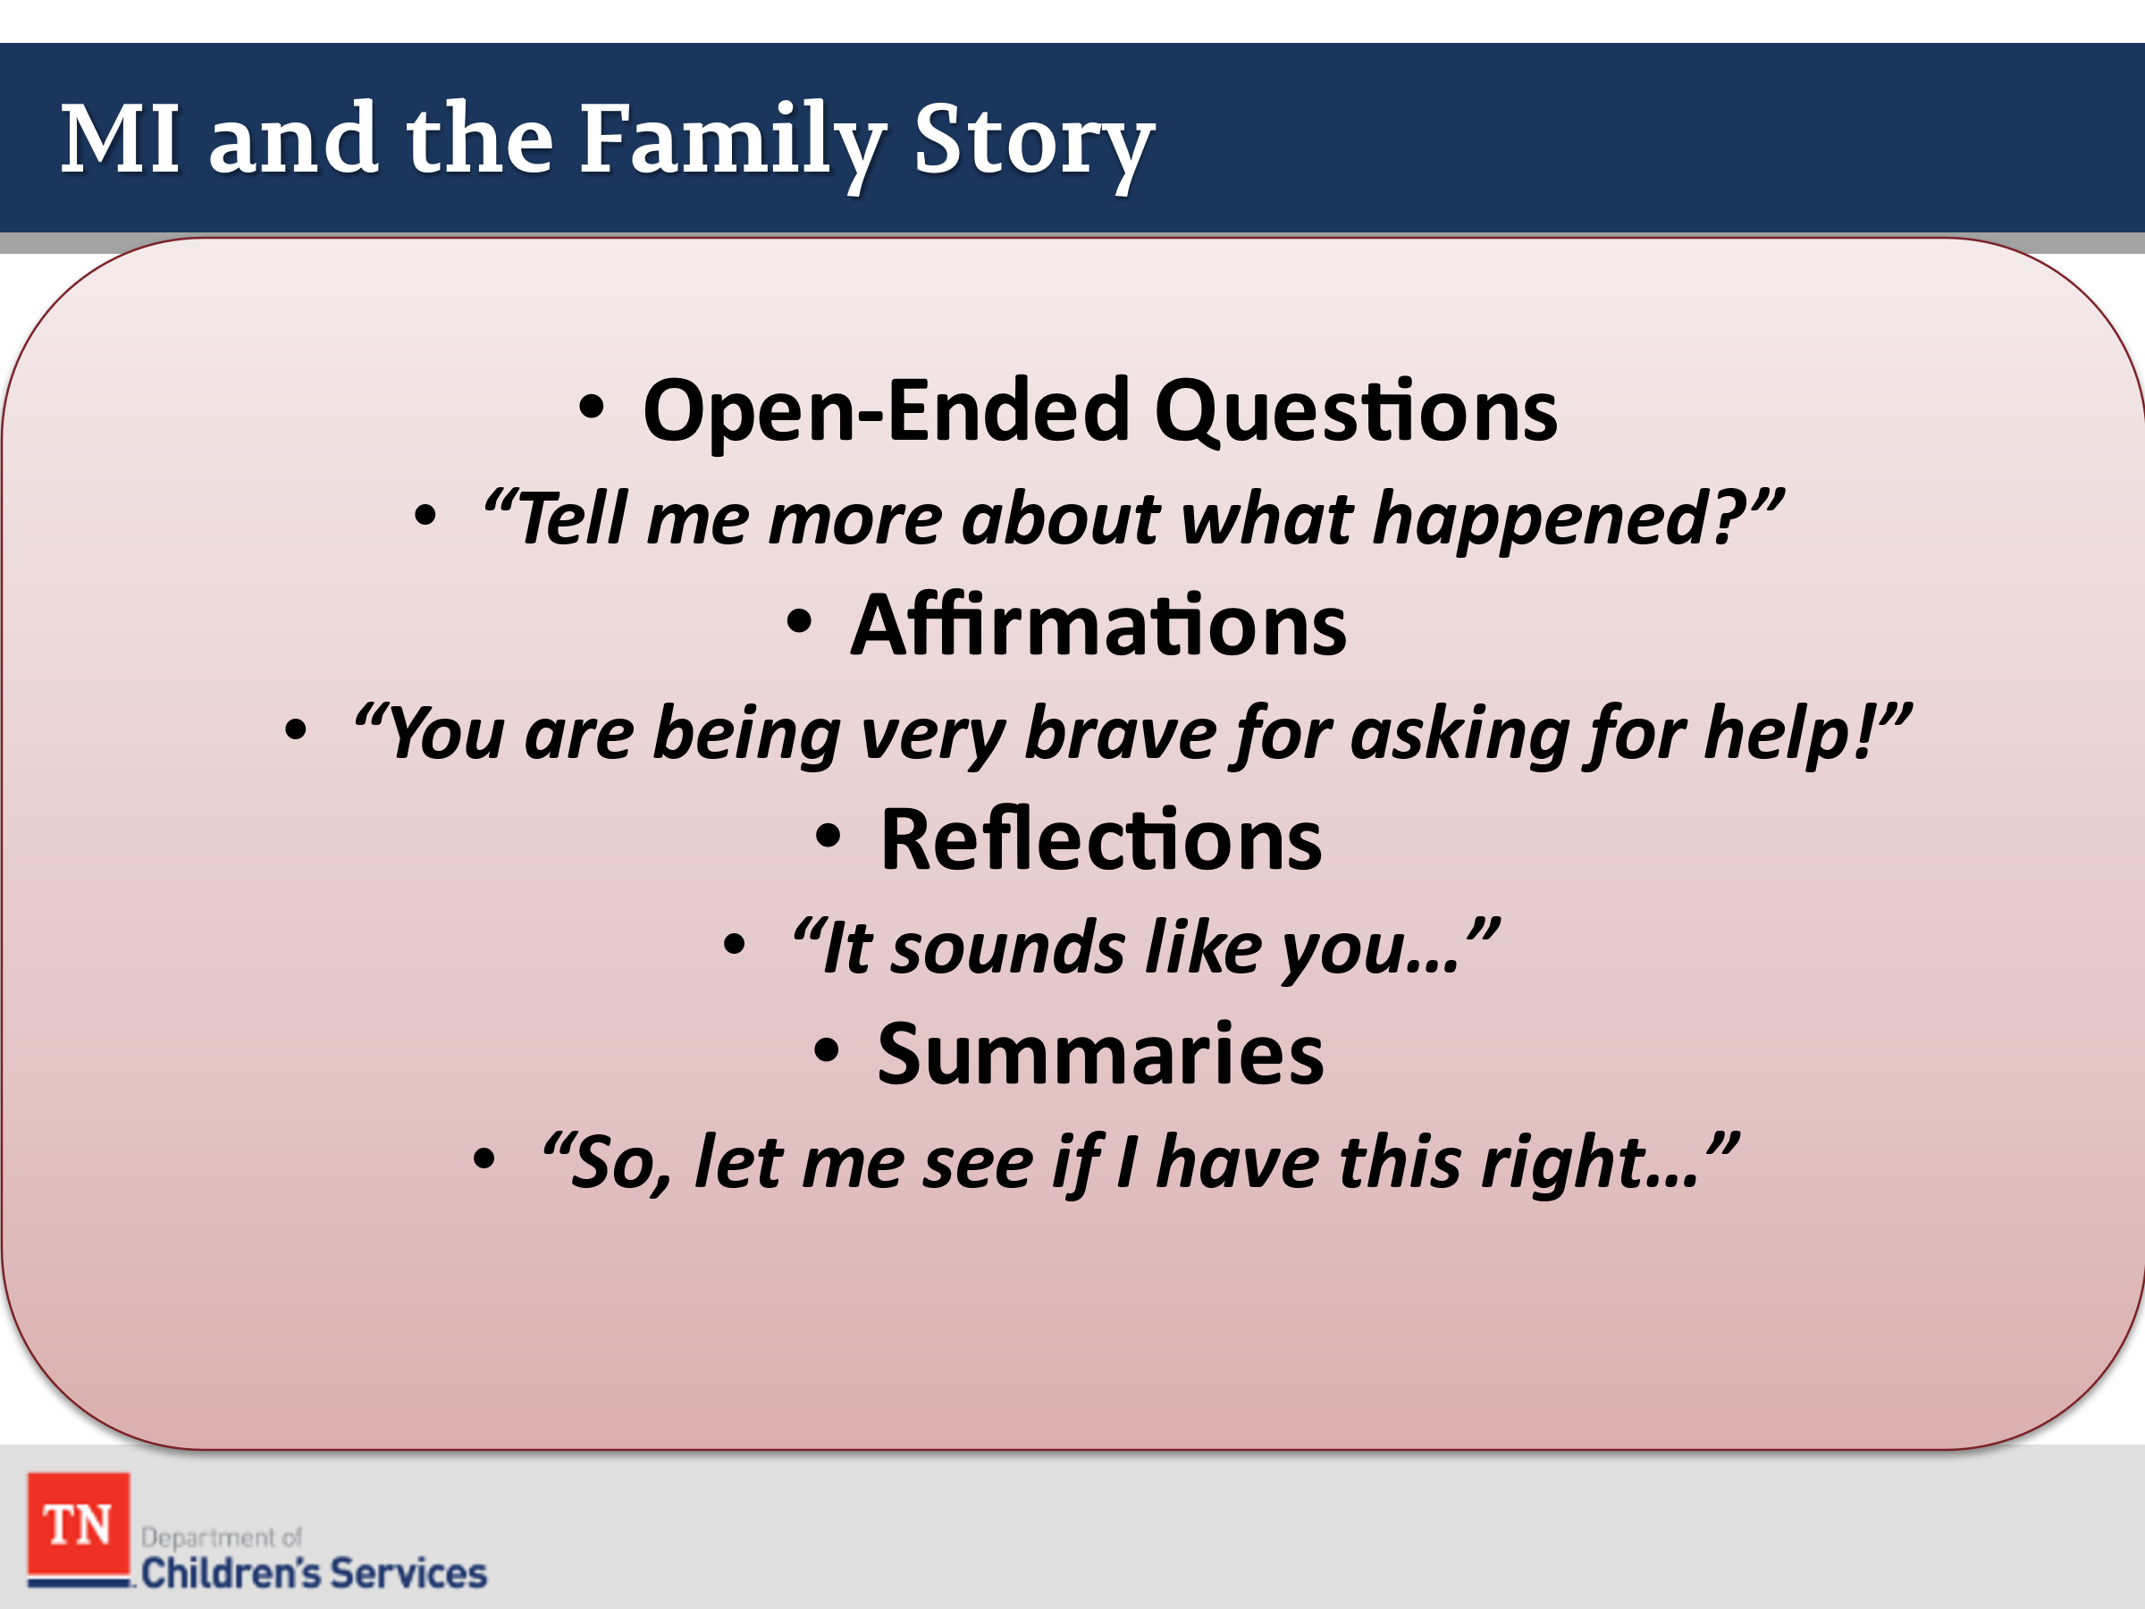
- REMIND participants of the information learned in Introduction and CORE weeks around Motivational Interviewing by STATING Motivational Interviewing is a client-centered approach for enhancing intrinsic motivation to change behavior by exploring and resolving ambivalence. ASK how OARS (Open-Ended Question, Affirmations, Reflections, and Summaries) could be used in hearing the family story.
O | Open-ended Questions | Example: Tell me more about what happened?
A | Affirmations | Example: You are being very brave for asking for help!
R | Reflections | Example: It sounds like you…
S | Summaries | Example: So, let me see if I got this right…

- Open Ended Question: Elicits descriptive information, requires more of a response than a simple yes or no, encourages the family to do most of the talking, helps us avoid premature judgement, and keeps communication moving forward.
- Affirmations: Must be done sincerely, supports and promotes self-efficacy, acknowledges the difficulties the person has experienced, validates the person’s experience and feelings, and emphasizes past experiences that demonstrate strengths and success to prevent discouragement.
- Reflective Listening: Is a way of checking rather than assuming that you know what is meant, shows that you have an interest in and respect for what the family has to say, demonstrates that you have accurately heard and understood the person’s problems and feelings.
- Summarize: Reinforces what has been said, shows that you have been listening carefully, prepares the person for transition, allows you to be strategic in what to include reinforcing talk that is in the direction of change, and can underscore feelings of ambivalence and promote perception of discrepancy.
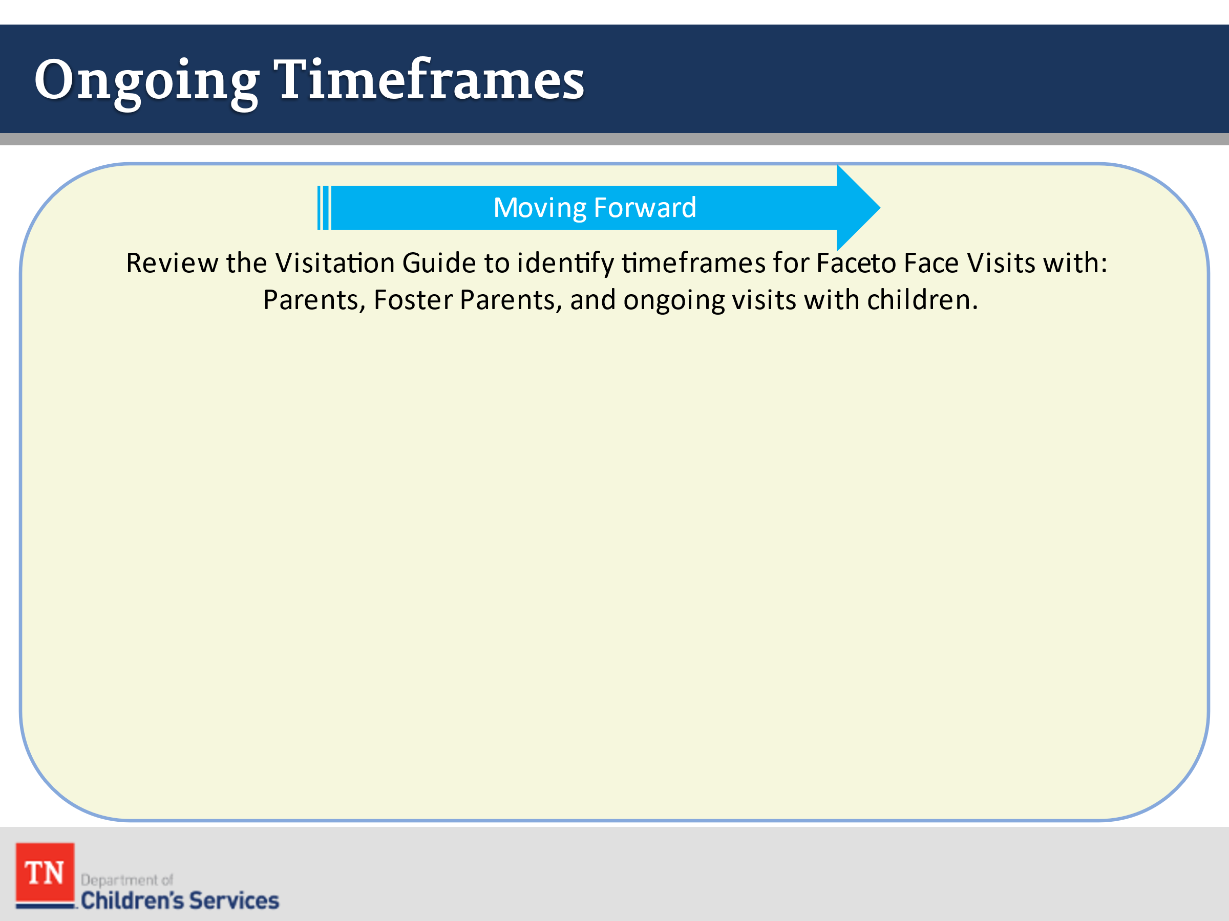
- ASK participants to identify the timeframes for ongoing face-to-face visits with parents, foster parents, and with children on their caseloads by REFERRING participants to the Visitation Guide.
- ACKNOWLEDGE the tasks of the FSW may vary according to the specifics of a case situation. EMPHASIZE communication between the FSW and CPS is critical for a smooth transition and to ensure compliance with DCS policies and state and federal laws.
- ACKNOWLEDGE there may be regional/county differences in the assignment of initial tasks and remind participants they will be able to learn this process as a part of their OJT Checklist. ENCOURAGE participants to speak with their Supervisor and Mentor about specifics in this area.
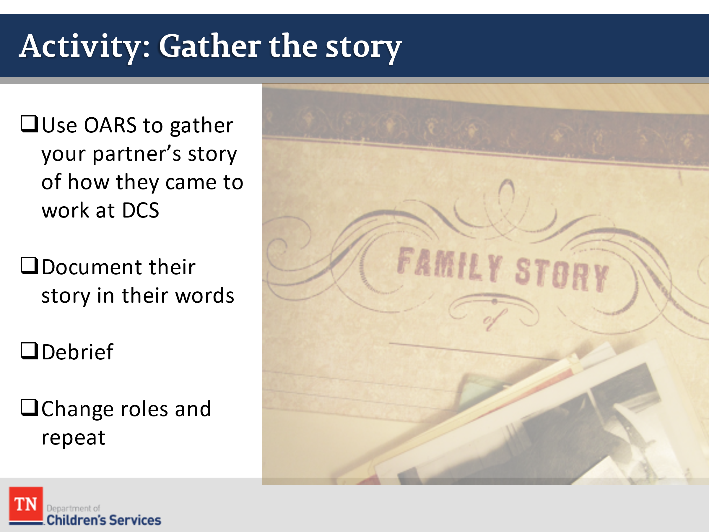
- CONDUCT ACTIVITY: Gather the story
- DIVIDE participants into groups of 2. One person will be interviewed on their “story” of coming to work at DCS. The “interviewer” will use OARS to gather the story and will document their story using the person’s own words.
- After 5-7 minutes, the group will DEBRIEF together. The person interviewed will read their story and identify how accurate the information was documented.
- CHANGE positions and repeat interview and DEBRIEF.
- DEBRIEF as a large group by asking:
  - How did the interviewer use OARS to gather the story?
  - How accurate was the story documented?
- TRANSITION to Lesson 2.6 Meet the Family by SHARING we will now be introduced to the case family we will use to learn and practice case work around the Practice Wheel.

Lesson 2.6: Meet the Family

Lesson Time: 150 minutes
Key Teaching Points / Instructions

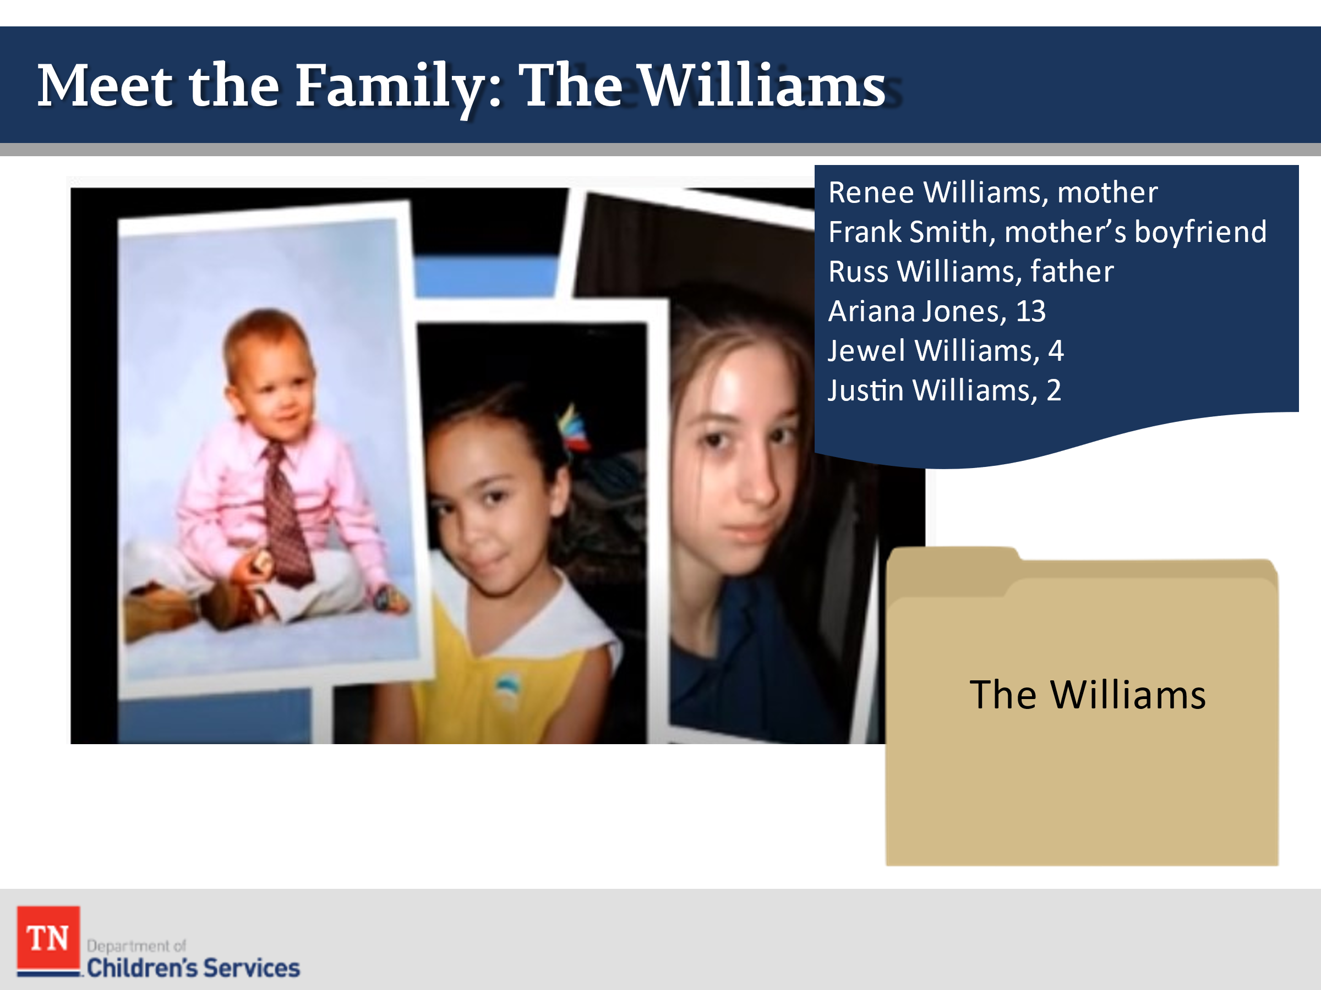
- INFORM the participants we are going to meet the Williams family for the first time. SHARE we will follow the family from the day the children are removed until permanency is achieved.
- REFER and ASK participants to review the Williams family case file pages. AFTER participants have reviewed those pages, ASK what allegations are involved in the case, and what brought the children into custody.
- ASK participants to share what tasks would be completed once a new custodial case is assigned. Answers should include:
- Schedule EPSD&T and dental
- Obtain photograph
- Educational Passport/School enrollment
- Clothing Allotment
- Obtaining records
- Face to Face with children/youth/parents
- Visit the placement
- Schedule Initial Child and Family Team Meeting
- Attend Preliminary Hearing
- Documentation (within 30 days of contact and on-going)
- SHARE we will watch the initial face to face contact with the mother, Renee Williams. REMIND participants the purpose of the initial contact is to meet the family, hear the family story from their point of view, and begin building the team. ASK participants to refer to the Family Assessment Worksheet in Google Classroom or Trainer may provide a handout of the Worksheet. DETAIL participants will use this worksheet throughout the week as we process through the Williams Case. NOTE the worksheet will be updated throughout the week the same as it was used in Introduction and Core Weeks with the Steward Family.
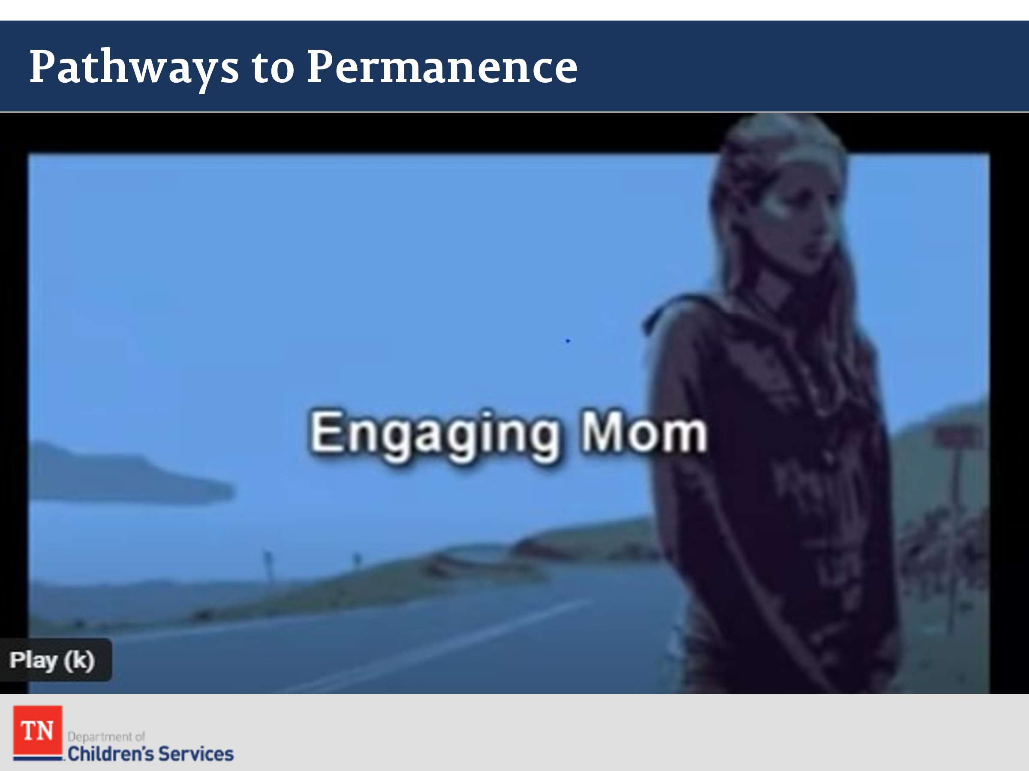
- INTRODUCE the activity by explaining participants will view Scene 1—Engaging Mom of the Pathways to Permanence DVD. TELL participants in this scene the case manager will meet Renee/Mom for the initial contact following the CPS worker placing Renee’s children in foster care the previous night. EXPLAIN participants will document the contact in a Case Recording as a practice opportunity after they view the scene. Instructions will be given after the video is viewed. ASK participants to watch closely and take notes on specific details of the contact using the Family Assessment Worksheet.
- SHOW Pathways to Permanence Scene 1 Engaging Mom from DVD or Link: https://www.youtube.com/watch?v=IQusnk6fN4M&feature=youtu.be&t=10Approximately 19:13 minutes. The following occurs in this scene:
- The narrator provides some background information regarding Renee Williams and how her children came to be placed in emergency care the previous night.
- The narrator sets up the first scene by explaining that Sandra, the FSW, is visiting Renee to discuss the reasons for the children’s removal, to begin her assessment of the family, to schedule a CFTM as soon as possible, and to prepare Renee for what will happen in that meeting.
- The initial visit between Sandra and Renee begins, and Sandra attempts to engage Renee in a trusting, cooperative relationship.
- Sandra explains workers’ roles, informs Renee of her children’s whereabouts, and encourages Renee to talk about herself and her family by exploring the family’s past and current situations.
- Sandra also describes the CFTM process and purpose and assists Renee in identifying people to invite to the CFTM who can support Renee and her family.
- Throughout the scene, Sandra identifies Renee’s strengths, acknowledges her expertise as the mother of her children, and makes note of the family’s resources.
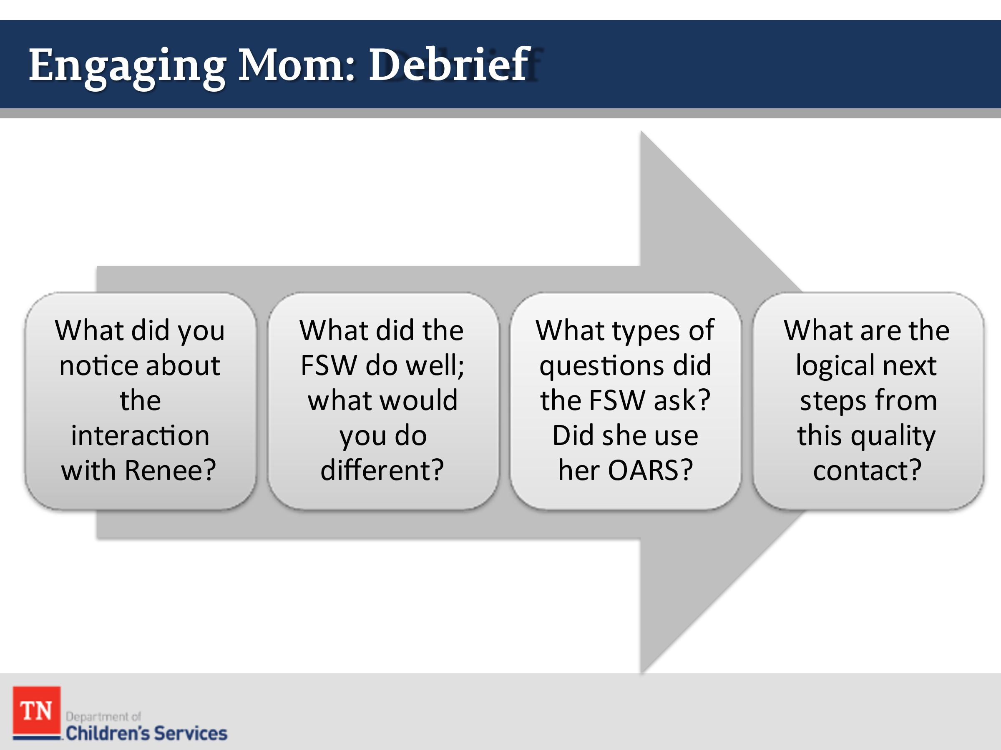
- DEBRIEF the Pathways to Permanence Engaging Mom video. ASK participants the following questions:
  - What did you notice about the interaction with Renee?
  - What did the FSW do well, what would you different?
  - How did Sandra use OARS in engaging Renee?
  - What are the logical next steps from this quality contact? The next steps are things the case worker will follow-up on from the contact. The following are possible responses from the Williams family contact:
    - Death certificate
    - Contacting Grandma Rose and Mr. Williams
    - Follow-up with Pastor Tom
    - Schedule CFTM
    - Complete drug screens
    - Gather records (criminal, education, medical, etc.)
    - Educational passport (REFER participants to Policy 21.19)
    - Diligent search efforts
    - Genogram/Ecomap
    - Collateral contacts
- STRESS it is important during quality contacts with families to begin capturing strengths/protective factors and additional needs/risks/concerns. These can be discussed at the Initial Child and Family Team Meeting and used as part of the Permanency Plan.
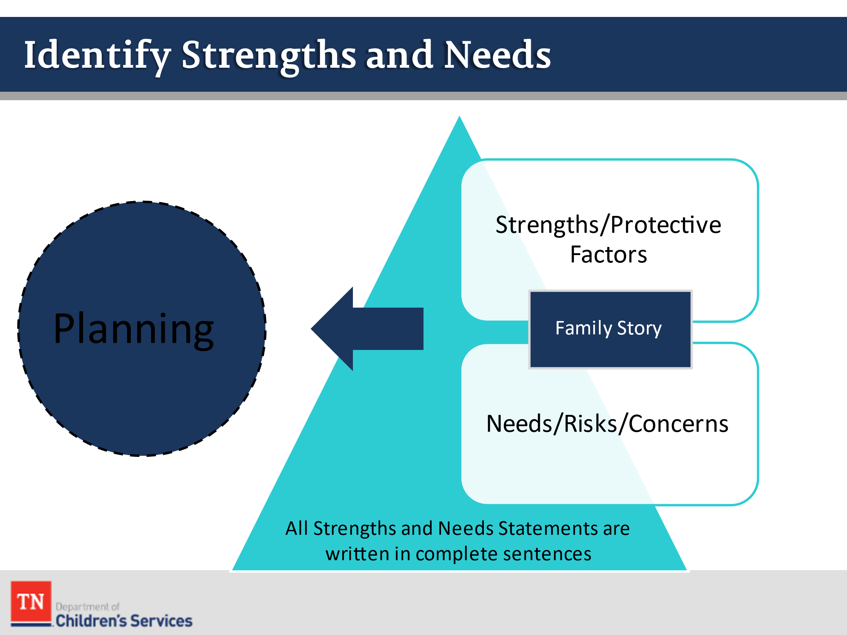
- CONDUCT ACTIVITY: Williams Strengths and Needs
- EXPLORE with participants and CAPTURE strengths/protective factors and needs/risks/concerns of the Williams family on a flipchart.
- TRAINER NOTE: Model writing these in complete sentences and ensure balance of strengths and needs (we want more strengths than needs and we do not want to give a strength and take it away with a need. Example: Strength: Renee left an abusive relationship in the past and sought help. Need: Renee is currently in a possible domestic violence relationship. Also, attorney’s look at strengths and can argue if the family has this strength, there is no need for intervention. Possible responses include:
- Strengths/Protective Factors
    - Renee left an abusive relationship in the past and sought help.
    - Renee is knowledgeable about her children and their well-being.
    - Renee is concerned about her children’s needs.
    - Renee is outspoken and asks questions.
    - Ariana is a caregiver for her siblings and is protective of them.
    - Renee has identified supports she has relied on in the past including a pastor and paternal grandmother.
    - The family has clean housing.
    - Mr. Williams has a good relationship with his children when he is around.
- Needs/Risks/Concerns
    - Renee was arrested for possession of cocaine and marijuana.
    - Renee has abused drugs and shares she uses “recreationally.”
    - The family has limited informal and formal supports.
    - Frank is using substances around the children.
    - Frank helps pay the rent.
    - Mr. Williams is currently in jail.
    - The children do not feel safe in the home and are afraid of Frank.
- CHECK for thoughts or questions about engagement thus far and INFORM participants we will see engagement threaded through the remainder of the course as it is the key to success in the implementation of the rest of the practice wheel components.
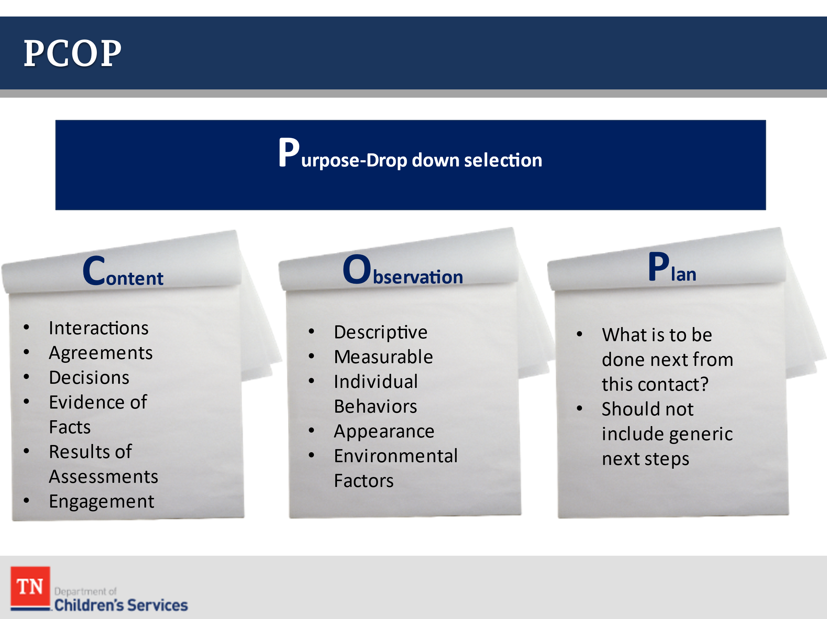
- EXPLAIN to participants they will now practice writing case documentation. REFER participants to DCS Policy 31.14 Documentation of TFACTS Case Recordings sections A, B, C, and D. SHARE PCOP with the group. They will begin the documentation with the Purpose of the Contact, share Observations, and end with Plan or logical next steps from the contact.
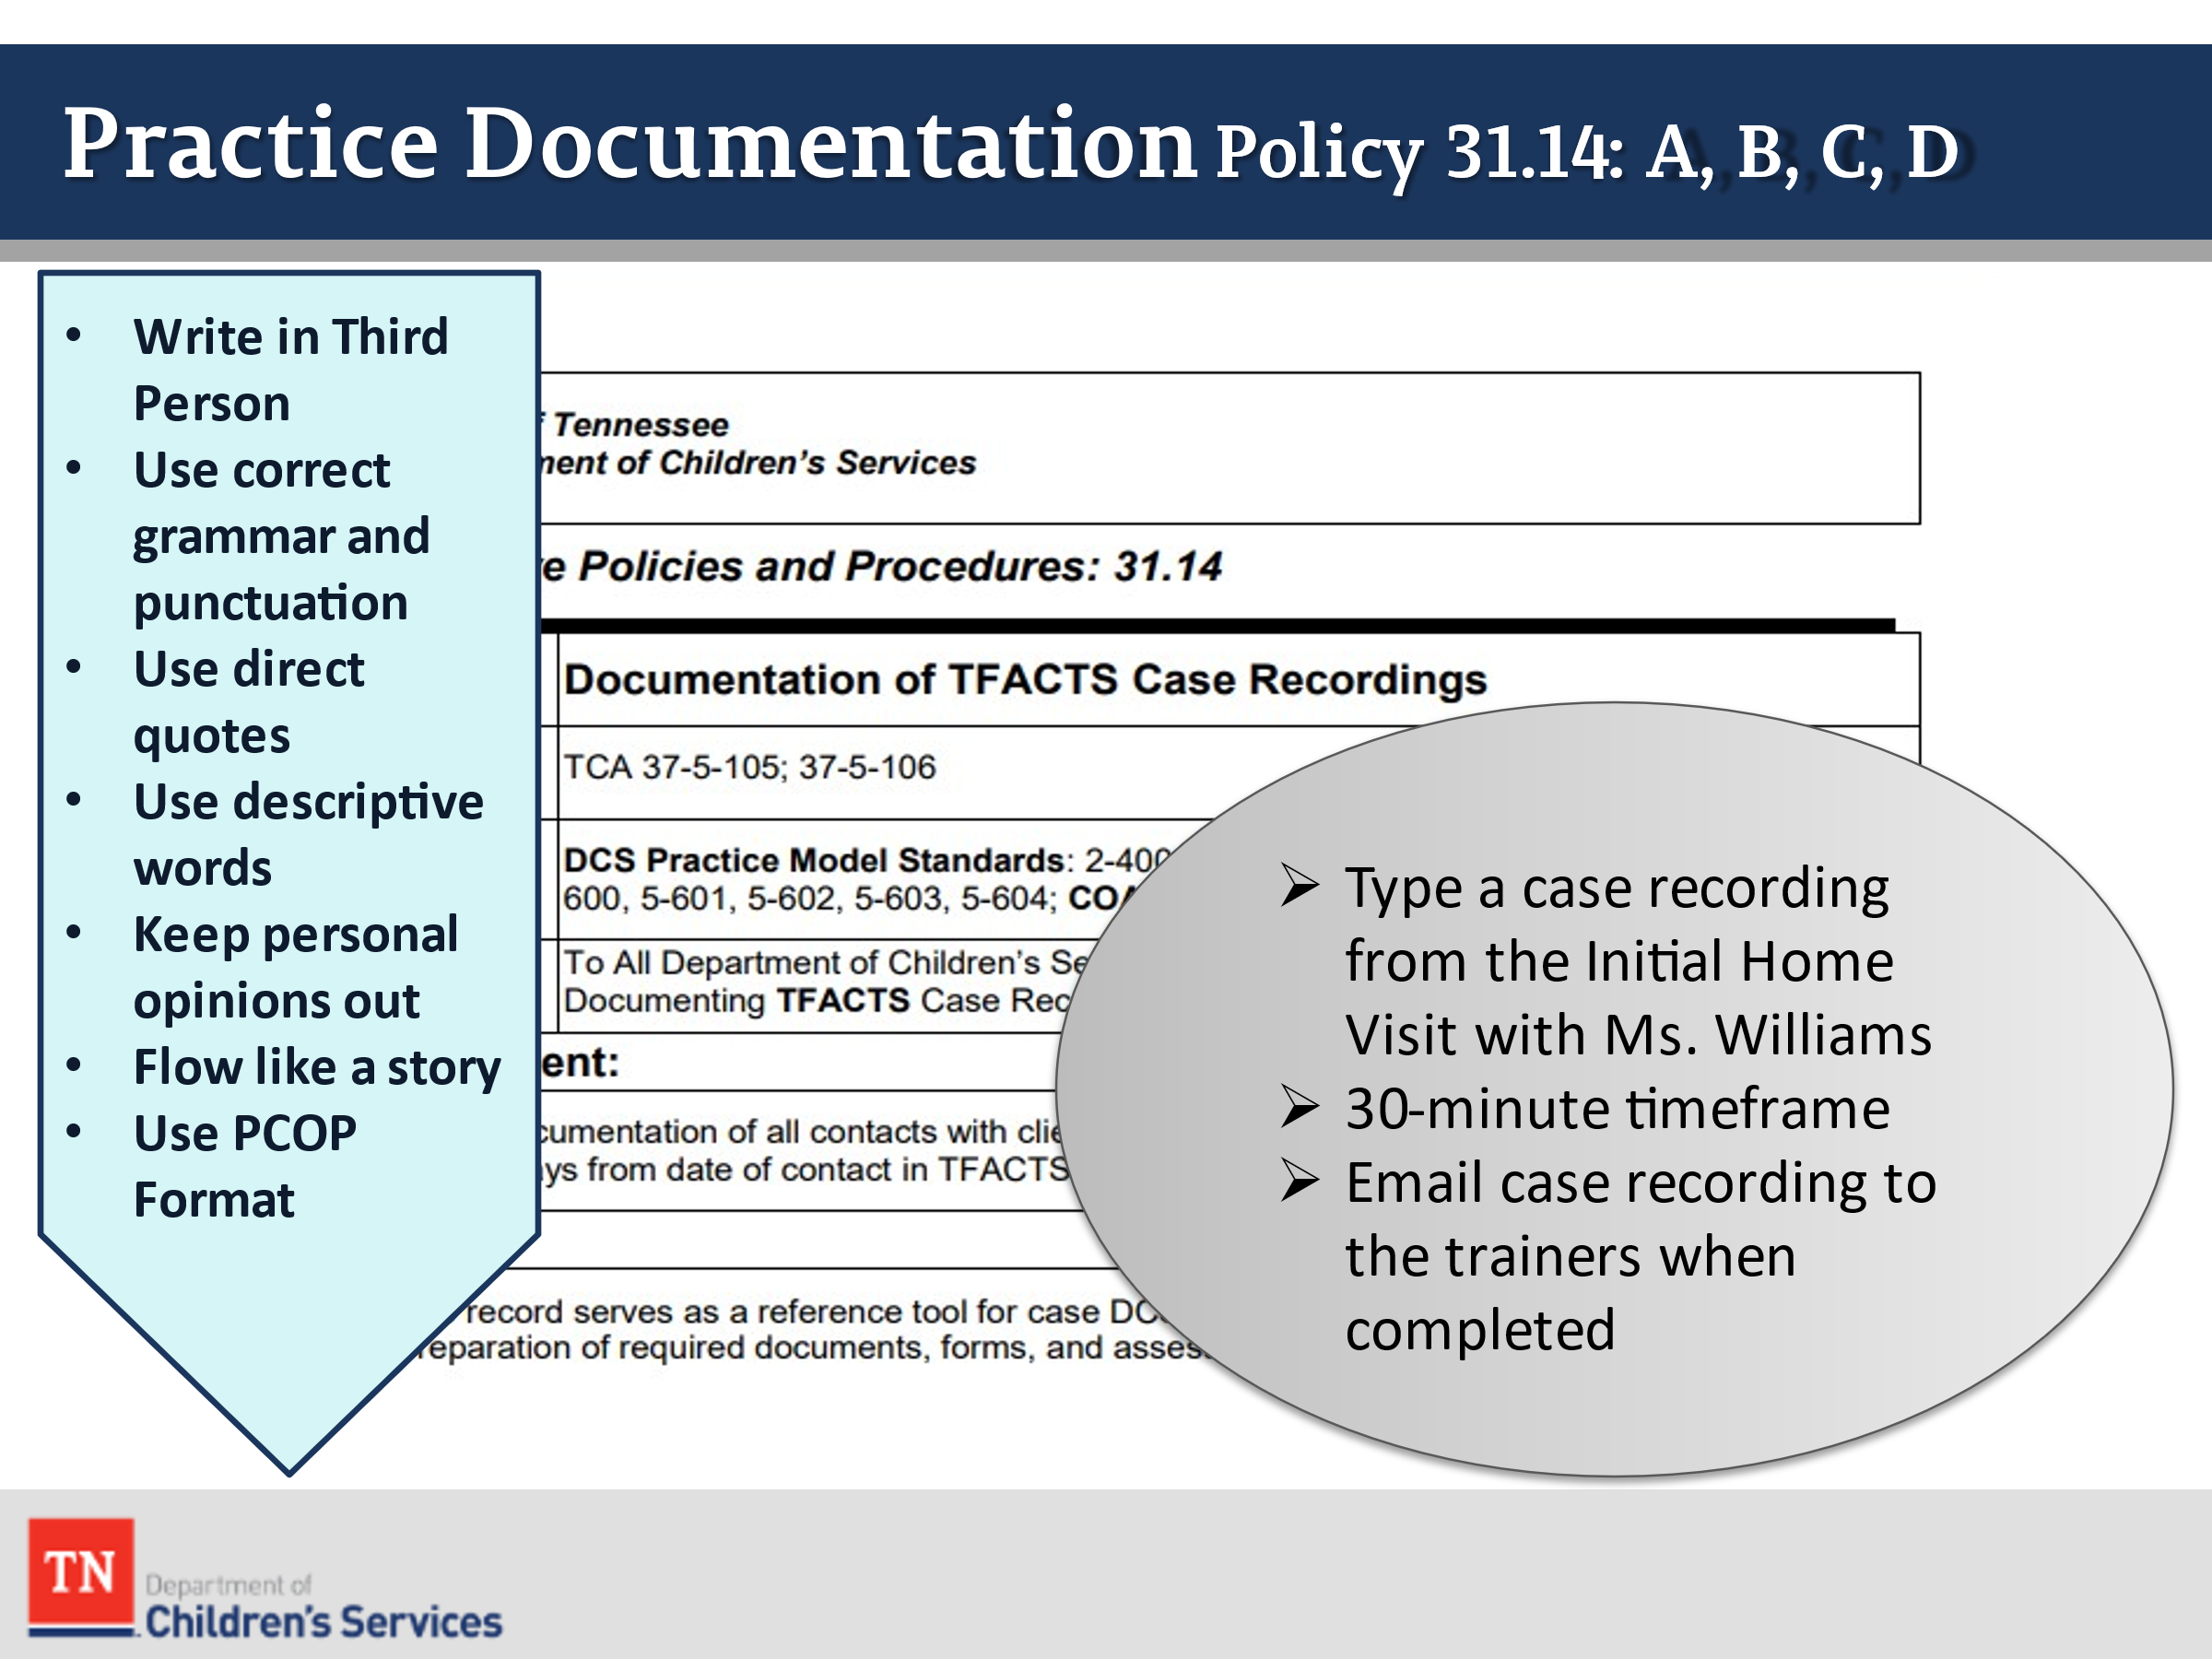
- CONDUCT ACTIVITY: Williams Case Recording
  - INSTRUCT participants they will type a case recording of the Williams case using the following tips:
  - Write in third person
  - Use correct grammar and punctuation
  - Use direct quotes from the family
  - Keep personal opinions out
  - Use descriptive words to describe what they see and hear
  - Flow like a story
  - Use PC-COP format (content, observation, and plan must be included)
- SHARE with participants they have approximately 30 minutes to type and submit their case note to the trainers by email. ENSURE the trainer emails are posted in the room. INFORM participants to capture as much of the family story as possible.
- RECONVENE the group after 30 minutes and SHARE the trainers will be providing feedback to the participants on their case recordings before the end of the class week.
- STATE one case work aspect missing in the video is Drug Screening. ASK participants who has observed Drug Screens being completed in the field. STATE when assessing for substance use, Drug Screens are only one formal tool of assessment. SHARE we will further discuss assessment throughout the training.
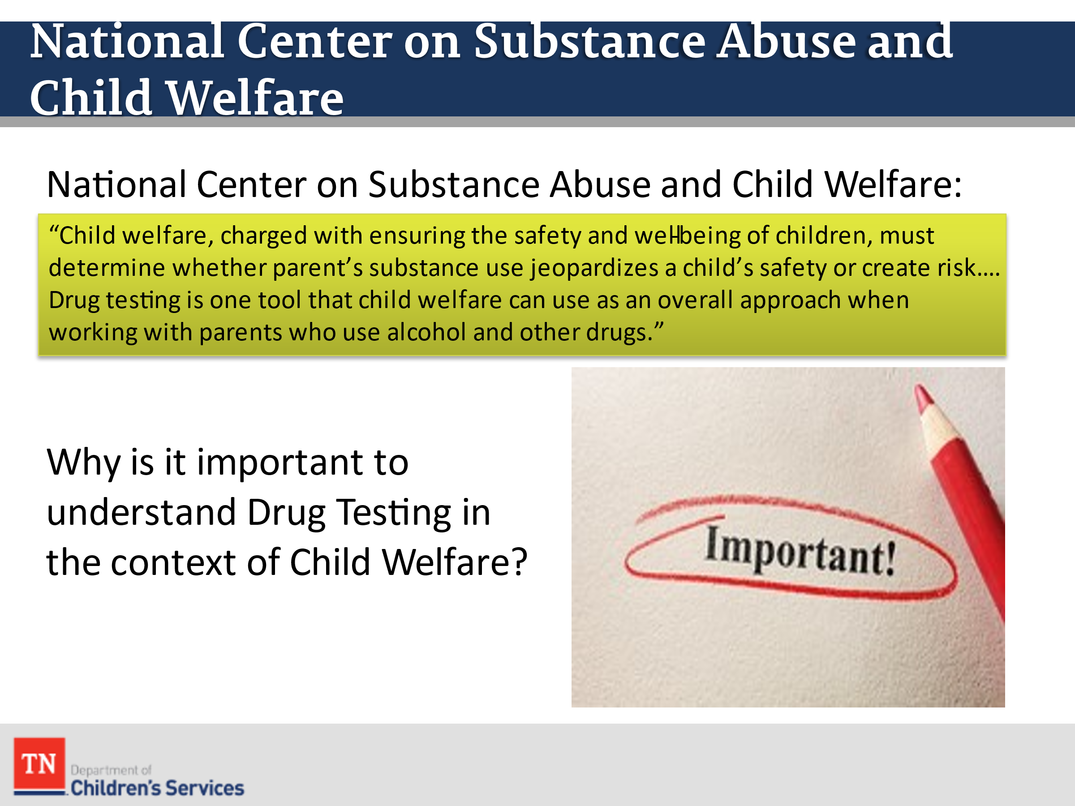
- SHARE the following article information from the National Center on Substance Abuse and Child Welfare.
  - Purpose: “Child welfare, charged with ensuring the safety and well-being of children, must determine whether parents’ substance use jeopardizes a child’s safety or creates risk. Child welfare professionals face the difficult task of collecting adequate information about families, making insightful decisions based on this information, and taking timely and appropriate action to safeguard children. Drug testing is one tool that child welfare can use as an overall approach when working with parents who use alcohol and other drugs.”
  - Why is it important to understand Drug Testing in the context of Child Welfare?
    - Drug testing is costly and limited in terms of determining child risk and safety.
    - Agencies risk relying too much on drug test results to inform decisions on child removal, parent-child family time, reunification, and termination of parental rights.
    - When administered inappropriately or inconsistently (e.g., punitively), drug tests can perpetuate stigma or create bias based on race, ethnicity, or socioeconomic status.
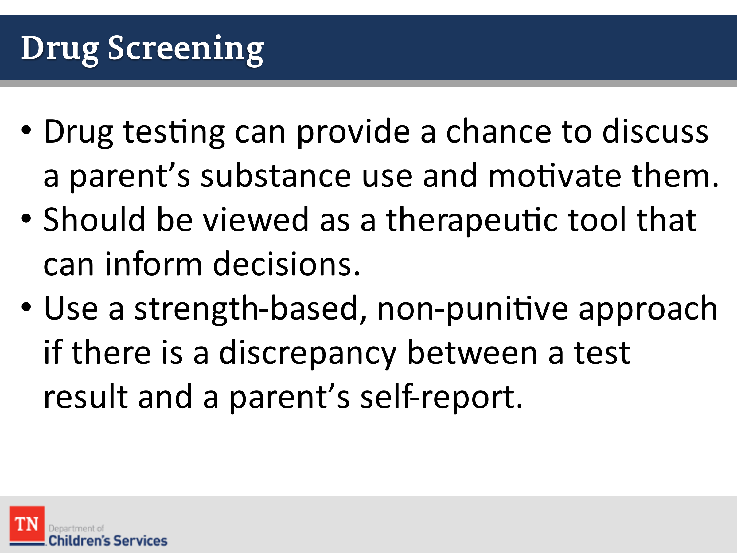
- SHARE “Drug testing can provide a chance to discuss a parent’s substance use and motivate them to follow their case plans and engage in treatment. Test results provide an opportunity for child welfare workers and court professionals to engage parents and families in the treatment and recovery process. Sharing results provides an opportunity to have a conversation with parents that reduces overall shame and stigma. During this conversation, it is important to use “person-first” language and avoid labels.”
- SHARE drug testing should be viewed as a therapeutic tool that can inform decisions, help parents recognize the need for treatment, and/or promote discussions about what is and is not currently working for them to support recovery. Substance misuse often stems from trauma and acts as a coping mechanism.
- SHARE child welfare workers can use a strength-based, non-punitive approach with parents if there is a discrepancy between a test result and a parent’s self-report. Start by asking the parent what they think would happen if the drug test was accurate in detecting a substance. Based on the parent’s response, help them understand why there may be errors in their thought process. Stress that child welfare is there to support them and ensure their family receives the help and support they need. Using an empathetic approach of, “I am worried about you, how can I help?” may allow the parent to feel safe enough to confide.
- ASK participants about drug testing in the Williams case. Who would have tested Renee. DISCUSS the ideas from the group. STATE typically CPS would drug screen at removal.
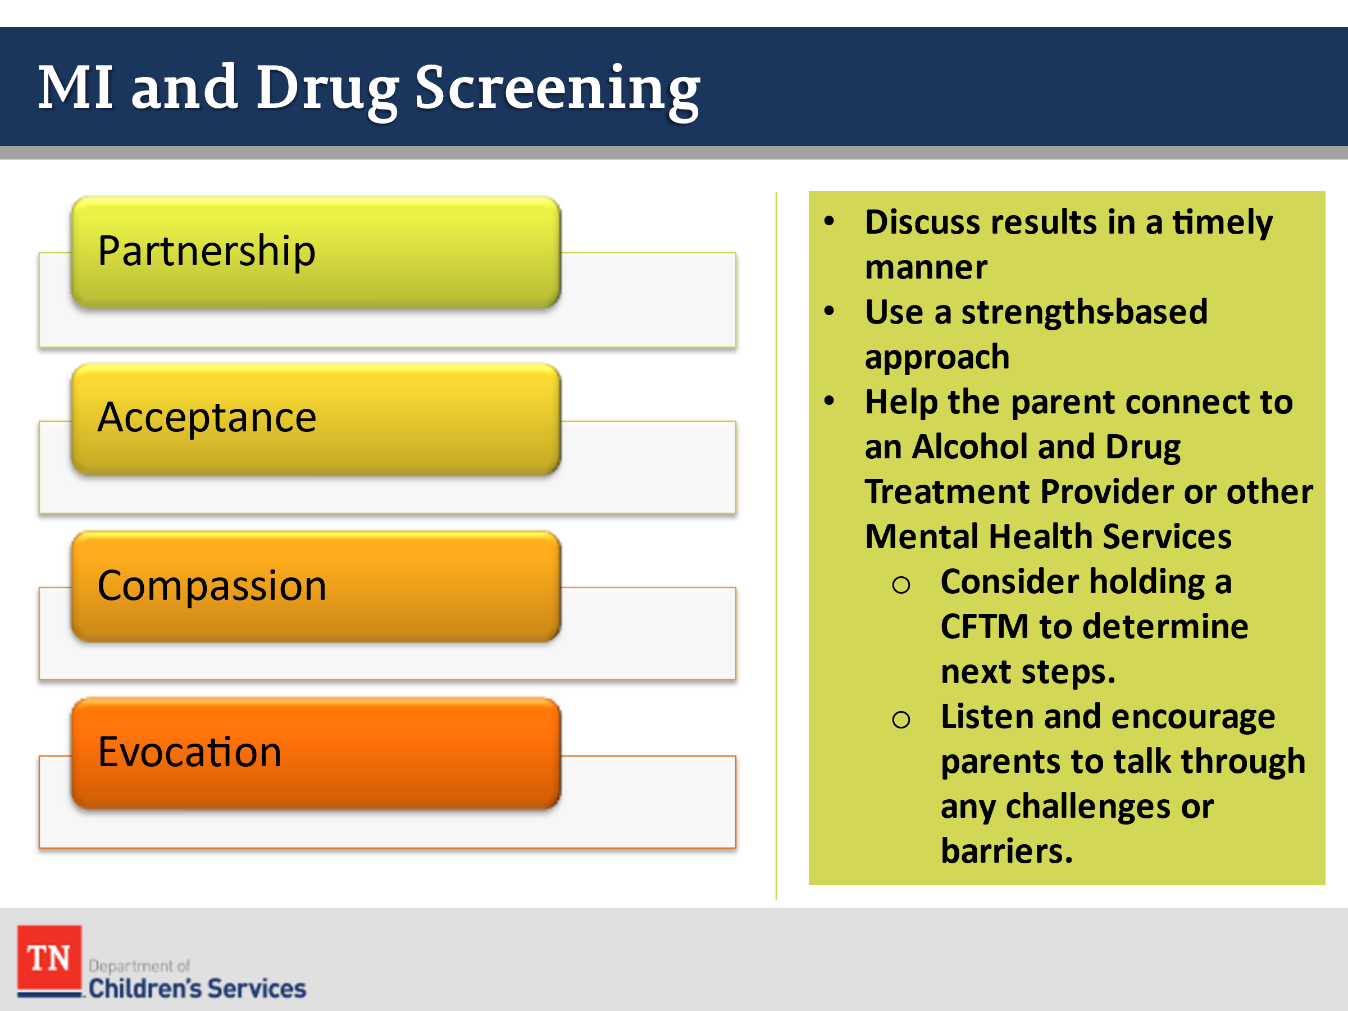
- STATE Motivational Interviewing can help in engaging the parent. REMIND participants the Spirit of Motivational Interviewing is comprised of:
  - Partnership-Collaboration between you and the client. A client is more willing to express concerns when you are empathetic and show genuine curiosity about the client’s perspective. In this partnership you are influential, but the client drives the conversation.
  - Acceptance-refers to your respect for and approval of the client. This doesn’t mean agreeing with everything the client says, it’s a demonstration of your intention to understand the client’s point of view and concerns.
  - Compassion-refers to your active promotion of the client’s welfare and prioritization of client needs.
  - Evocation-Elicits and explores motivations, values, strengths, and resources the client already has.
- PROVIDE the following approach when discussing drug testing:
  - Discuss the results with parents in a timely manner to assess the child’s safety and risk. Results are only one indicator of potential safety and risk concerns. Determine the child’s location when the parent engaged in substance use, if the parent used the existing safety plan to protect the child, and what protective factors are present that can mitigate any potential safety/risk concerns.
  - Use a strength-based approach to provide the parent an opportunity to discuss the results, either admitting to substance use, or challenging the results, in which case, a lab would need to confirm. Provide responses geared toward motivating the parent to engage or re-engage with treatment and recovery supportive services. If a parent is attending a recovery support group (e.g., Alcoholics Anonymous, Narcotics Anonymous, Celebrate Recovery, etc.), encourage them to attend a meeting that day. If the parent currently receives treatment, ask their provider to discuss the drug test results and treatment progress. Explore how to develop a shared and consistent response that supports both child safety and parent recovery, and if the parent should be reassessed for a higher level of care.
  - Help the parent connect to an A&D treatment provider for an assessment if they are not currently engaged in treatment services using motivational strategies. Consider holding a CFTM to determine next steps. Help the parent by listening and encouraging them to talk through any challenges or anticipated barriers. A lapse can ideally provide the parent with a chance to learn from the experience. It is a potential time for a parent to figure out what helps or hinders their recovery efforts while they still have a supportive network.
- ASK if there are any questions. TRANSITION into Unit 3 Teaming.

