Lesson 5.7: The Role of the Court and Legal Considerations

Lesson Time: 115 minutes
Key Teaching Points / Instructions

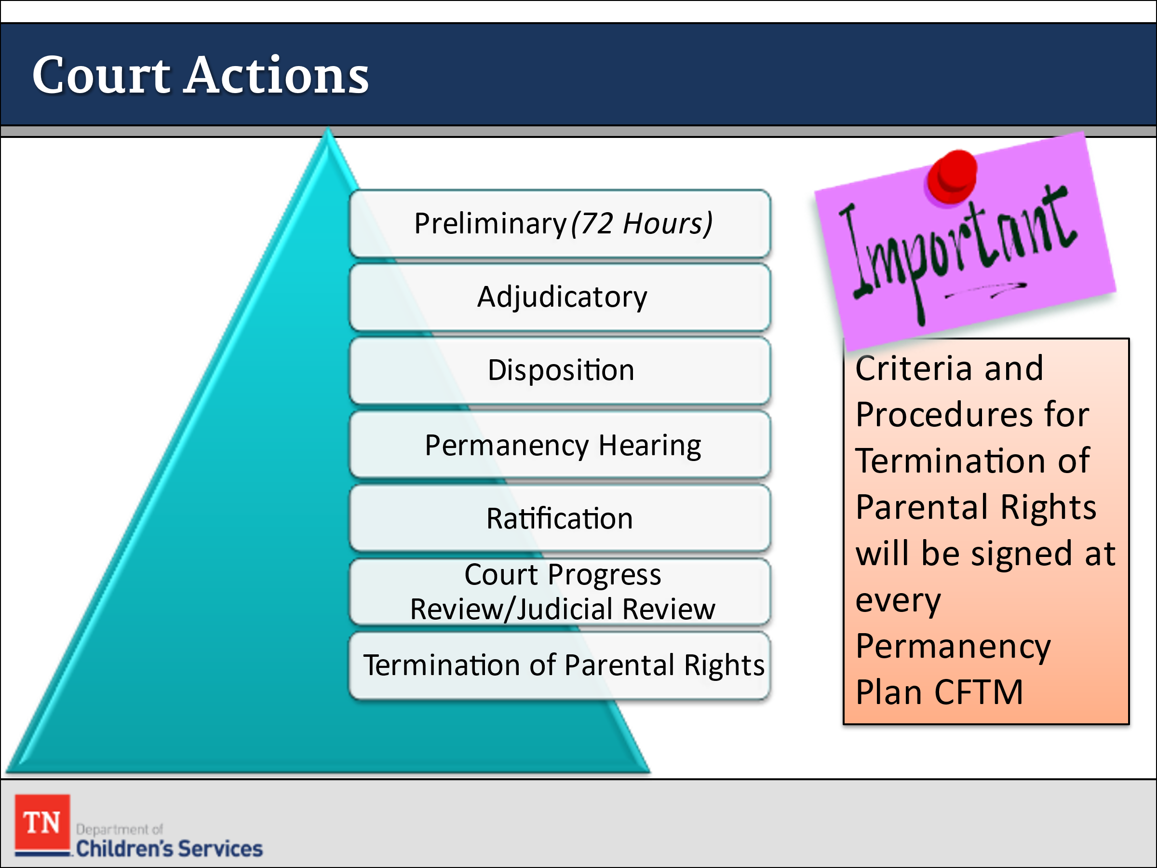
- ASK: “What is the role of the court in making decisions about case progress?”
- PROVIDE a brief overview of types of hearings in removal cases.
  - Preliminary
    - After an emergency removal, a preliminary hearing on the removal must be held within 72 hours. The standard, or burden of proof, at a preliminary hearing is probable cause, which roughly means that there are reasonable grounds to believe that the emergency removal of the child was justified. The evidentiary standard at this hearing is somewhat relaxed in that reliable hearsay is admissible. For example, if the child were removed due to physical abuse, the CPS worker would submit the child’s emergency room record to the court and would repeat what the doctor, the police officer, or the schoolteacher said without needing any of those people present to testify. However, those people will be asked to testify, either at court or in a pre- hearing deposition, at the adjudicatory hearing.
  - Adjudicatory
    - At the adjudicatory hearing, the court (the judge) determines whether the factual allegations of the petition are true and whether the evidence supports a finding that the child is dependent and neglected. The standard of proof for the adjudicatory hearing is clear and convincing. This is an intermediate standard of proof—higher than the typical civil standard of preponderance of the evidence but lower than the criminal standard of beyond a reasonable doubt.
  - Disposition
    - If, at the adjudication stage, the court finds dependent and neglect, it may proceed directly to the disposition, or it can conduct the disposition hearing within 15 days. The disposition hearing is supposed to design an appropriate plan to meet the needs of the child. Often, the disposition follows the adjudication directly. While the rules of evidence still apply in the dispositional phase, reliable hearsay, such as reports of DCS, as well as other professionals, is admissible.
  - Permanency Hearing
- REFER participants to Policy 16.31 Sections K, L, M for information on Permanency Hearing. STATE following the ratification of the Permanency Plan, the court will hold a permanency hearing within twelve (12) months of the date of a child’s placement in state custody and every twelve (12) months thereafter until permanency is achieved or until the child reaches the age of majority. Trainer Note: Per Policy 16.31 Family Permanency Plans are updated before the goal achievement date expires, so in most cases this would be at least every six (6) months.
  - Ratification
- STATE one of the biggest responsibilities of the Juvenile court in a custodial case is presiding over permanency plans ratification hearings. This process is how we ratify the permanency plan, making them a legal document. The CFT presents the plan to the court and at that time the court decides if the plan is an efficient plan to reach permanency for the child (ren). The court hears from everyone on the team before making a decision.
- Court Progress Review/Judicial Review
  - The Department submits regular progress reports to the Court and the Court should review the progress made on the permanency plan at least every six (6) months. The six (6) months review can be held by the Court or the FCRB. Court expectations can vary, and staff will follow each Court’s requirements for reviews.
  - Termination of Parental Rights (TPR)
- A formal proceeding usually sought by a state agency at the conclusion of dependency proceedings in which severance of all legal ties between parent and child is sought against the will of one or both parents, and in which the burden of proof must be by clear and convincing evidence. (www.tncourts.gov)
- REVIEW the Criteria and Procedures for Termination of Parental Rights document. EXPLAIN this document is to be reviewed with the family at every CFTM in which a Permanency Plan is written or revised. This form is to be read to the parents, not summarized and if the parents have any questions they are to be directed to their attorneys.
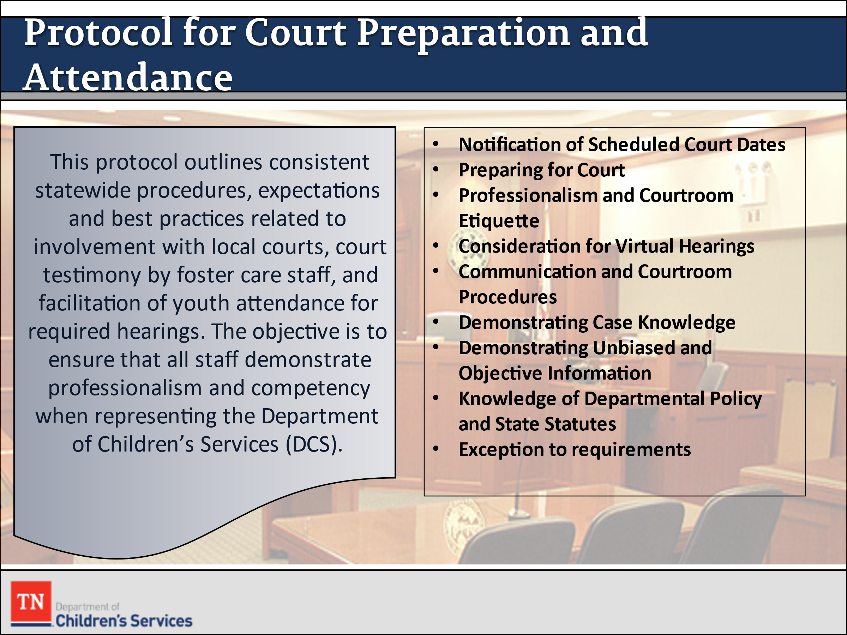
- SHARE as the case manager represent the Department of Children’s Services, it is important to present in a professional manner in court, always. STATE the Protocol for Court Preparation and Attendance by Foster Care Staff outlines consistent statewide procedures, expectations, and best practices related to involvement with local courts, court testimony by foster care staff, and facilitation of youth attendance for required hearings. The objective is to ensure that all staff demonstrate professionalism and competency when representing the Department of Children’s Services (DCS). BRIEFLY review the components of the protocol by sharing your screen. STATE legal will provide additional training in later weeks. ASK if there are any questions.
- STATE one of the biggest responsibilities of the Juvenile court in custodial cases is presiding over permanency plan ratification hearings. This process is how we ratify the permanency plan, making it a legal document. ASK what are the other roles of the Court?
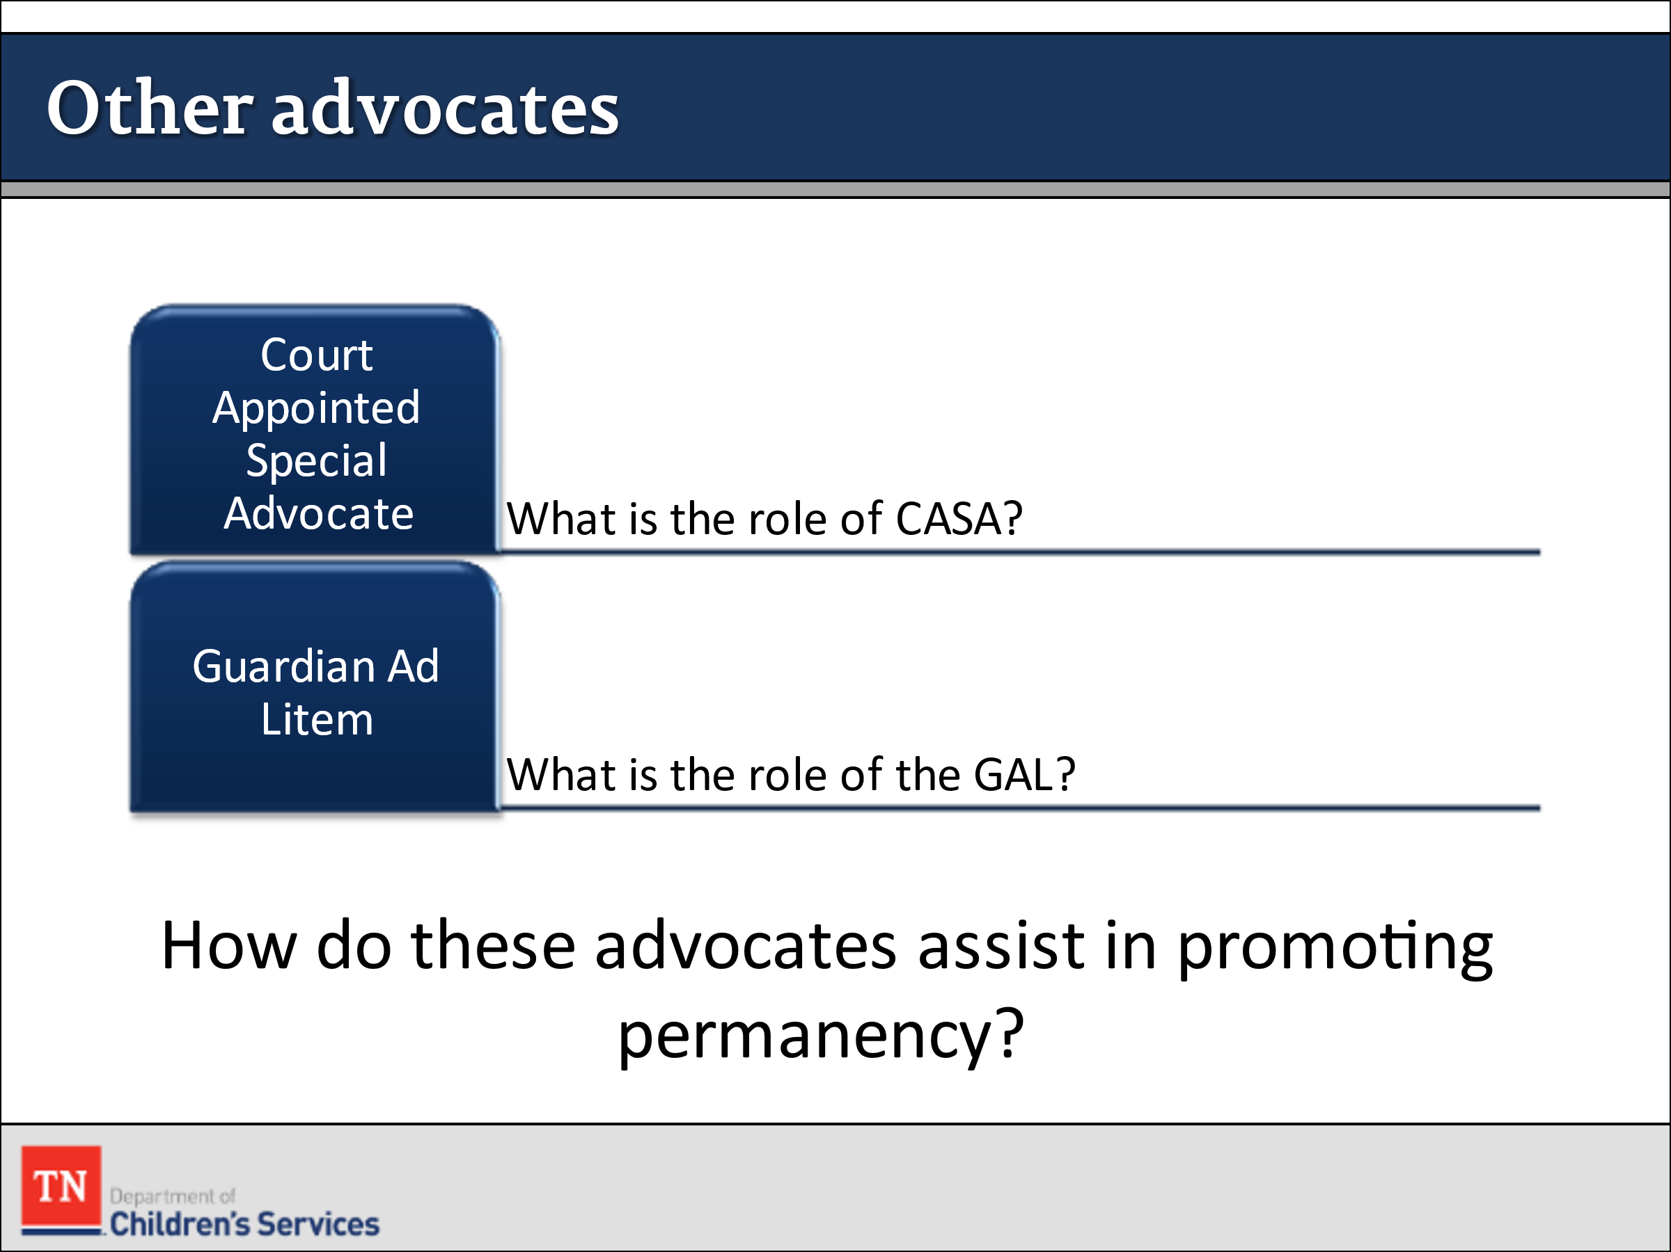
- STATE there are other advocates for the child or youth who monitor the family’s progress toward permanence and report their findings to the Foster Care Review Board (FCRB) and court. ASK the following questions:
  - What is the role of the court-appointed special advocate (CASA)? The CASA website can be found here: https://nationalcasagal.org.
  - What is the role of a guardian ad litem (GAL)?
  - How do these advocates assist in promoting permanency?
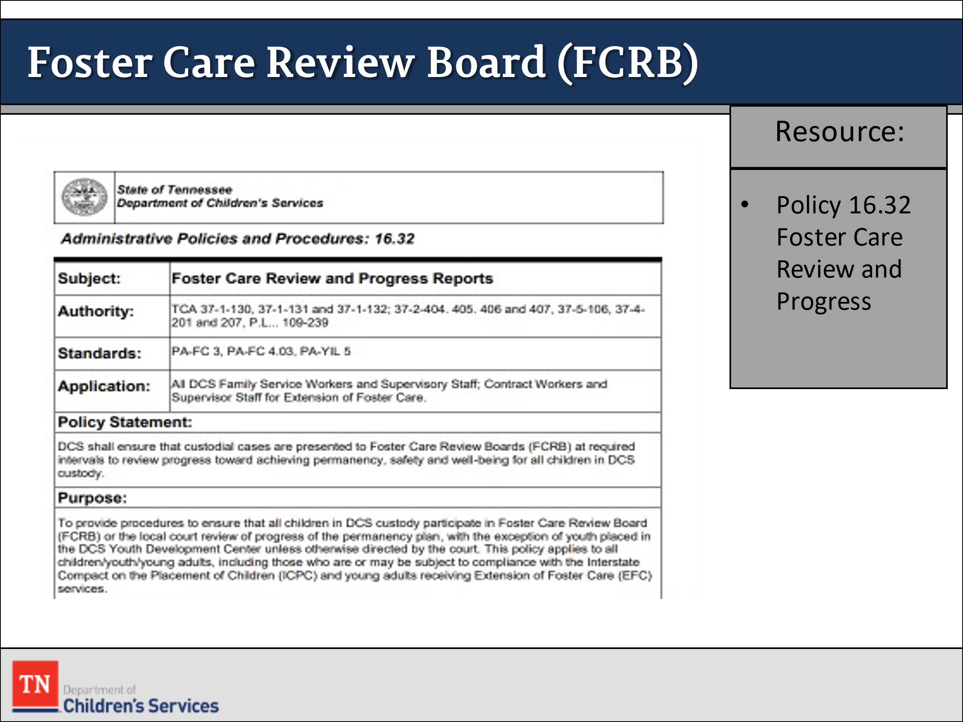
- REFER participants to DCS Policy 16.32: Foster Care Review and Progress Reports. If no participants have had a chance to attend a FCRB, give them a brief explanation of what the purpose is and what to expect. Briefly REVIEW Progress Report on Child in State Custody to familiarize participants with the form. ASK the following questions about FCRB:
  - What participants know about FCRBs and progress reports?
  - How many participants have had the opportunity to observe a FCRB?
  - Who was present and what was the role of the FSW?
  - What happened if the FSW did not know the answer to a question raised by the FCRB?
  - What was the process of the meeting?
  - What kinds of recommendations were made by the board?
  - What were your observations?
- STRESS the importance of observing a FCRB during OJT for those that have not had a chance to attend.
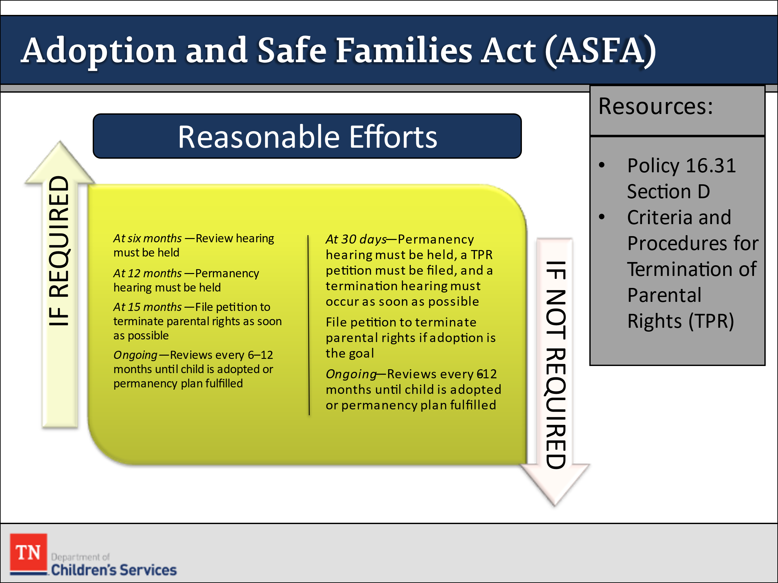
- ASSESS participant’s understanding of the Adoption and Safe Families Act (ASFA) that governs permanency planning. STRESS it includes the primary elements that affect permanency planning when a child has been in care for nine months or more.
- POINT OUT many of the tenets of ASFA are incorporated into the DCS Policy 16.31 Section D.
- LEAD the group in a discussion about the following:
- ASFA Guidelines and Timelines
- Paths toward permanency: The Adoption and Safe Families Act (ASFA) establishes two possible paths toward permanency depending on the court’s decision about reasonable efforts:
- If the court requires reasonable efforts:
- At six months—Review hearing must be held
- At 12 months—Permanency hearing must be held
- At 15 months—File petition to terminate parental rights as soon as possible
- Ongoing—Reviews every 6–12 months until child adopted or permanency plan fulfilled
- If the court does not require reasonable efforts:
    - At 30 days—Permanency hearing must be held, a TPR petition must be filed, and a termination hearing must occur as soon as possible
    - File petition to terminate parental rights if adoption is the goal
    - Ongoing—Reviews every 6-12 months until child adopted, or permanency plan fulfilled
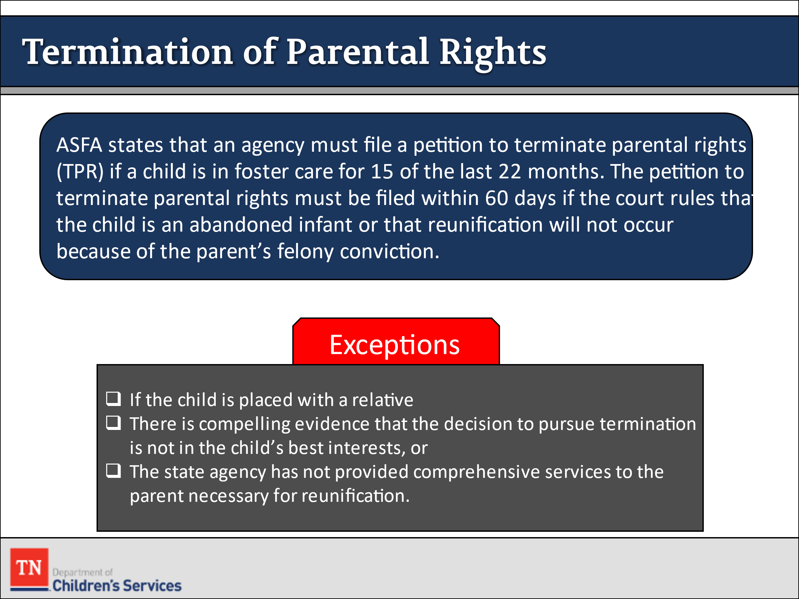
- Terminating Parental Rights
  - ASFA also established conditions under which a state should terminate parental rights and seek permanent placement for a child in state custody. ASFA states that an agency must file a petition to terminate parental rights (TPR) if a child is in foster care for 15 of the last 22 months. The petition to terminate parental rights must be filed within 60 days if the court rules that the child is an abandoned infant or that reunification will not occur because of the parent’s felony conviction.
- There are a few exceptions. These include:
    - if the child is placed with a relative,
    - there is compelling evidence that the decision to pursue termination is not in the child’s best interests, or
    - the state agency has not provided comprehensive services to the parent necessary for reunification.
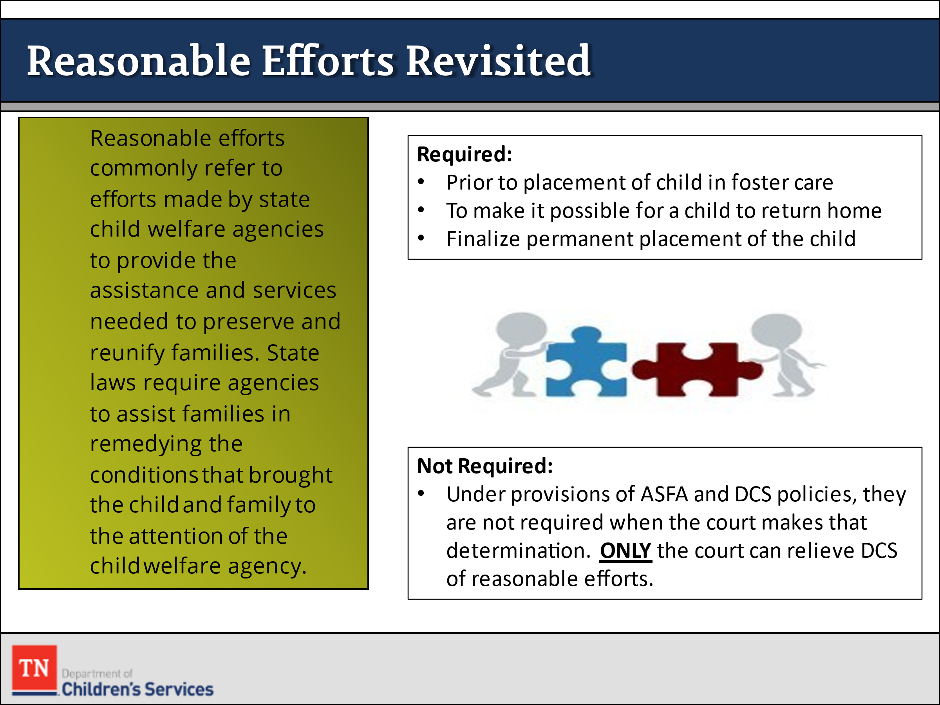
- REVIEW the definition of reasonable efforts with the group:
- Reasonable efforts commonly refer to efforts made by state child welfare agencies to provide the assistance and services needed to preserve and reunify families. State laws require agencies to assist families in remedying the conditions that brought the child and family to the attention of the child welfare agency. In Tennessee, TCA 37-1-166 is the basis for determining whether or not DCS has exercised reasonable efforts. According to this statute, reasonable efforts mean the exercise of reasonable care and diligence by the department to provide services related to meeting the needs of the child and the family.
- The child’s health and safety are the primary concerns in determining reasonable efforts.
- When reasonable efforts are required:
- Reasonable efforts are required to preserve and reunify families
      - prior to the placement of a child in foster care, to prevent or eliminate the need for removing the child from the child’s home; and to make it possible for a child to safely return to the home.
      - If continuation of reasonable efforts is determined to be inconsistent with the permanency plan for the child, reasonable efforts shall be made to place the child in a timely manner in accordance with the permanency plan and to complete whatever steps are necessary to finalize the permanent placement of the child.
- When reasonable efforts are not required:
- Under the provisions of ASFA and DCS Policies, reasonable efforts to preserve or reunify the family are not required when the court has determined that:
    - The parent has committed certain defined felonies against the child or any sibling or half-sibling or any other child residing temporarily or permanently in the home. TCA 37-1-166 lists those felonies as
      - murder;
      - voluntary manslaughter;
      - aided or abetted, attempted, conspired, or solicited to commit such a murder or voluntary manslaughter; or
      - felony assault that results in serious bodily injury to the child or any sibling or half-sibling or any other child residing in the home.
    - parental rights of the parent to a sibling or half-sibling have been terminated involuntarily.
    - The parent has subjected the child or any sibling or half-sibling or any other child residing temporarily or permanently in the home to aggravated circumstances defined in TCA 36-1-102(9) including abandonment, abandonment of an infant, aggravated assault, aggravated kidnapping, especially aggravated kidnapping, aggravated child/youth abuse and neglect, aggravated sexual exploitation of a minor, especially aggravated sexual exploitation of a minor, aggravated rape, rape, rape of a child/youth, incest, or severe child abuse.
- EMPHASIZE the importance of consulting with DCS legal staff (and supervisors) and gaining court approval whenever it is believed that reasonable efforts might not apply. Only after the court has relieved us of these reasonable efforts, are we allowed to discontinue them.
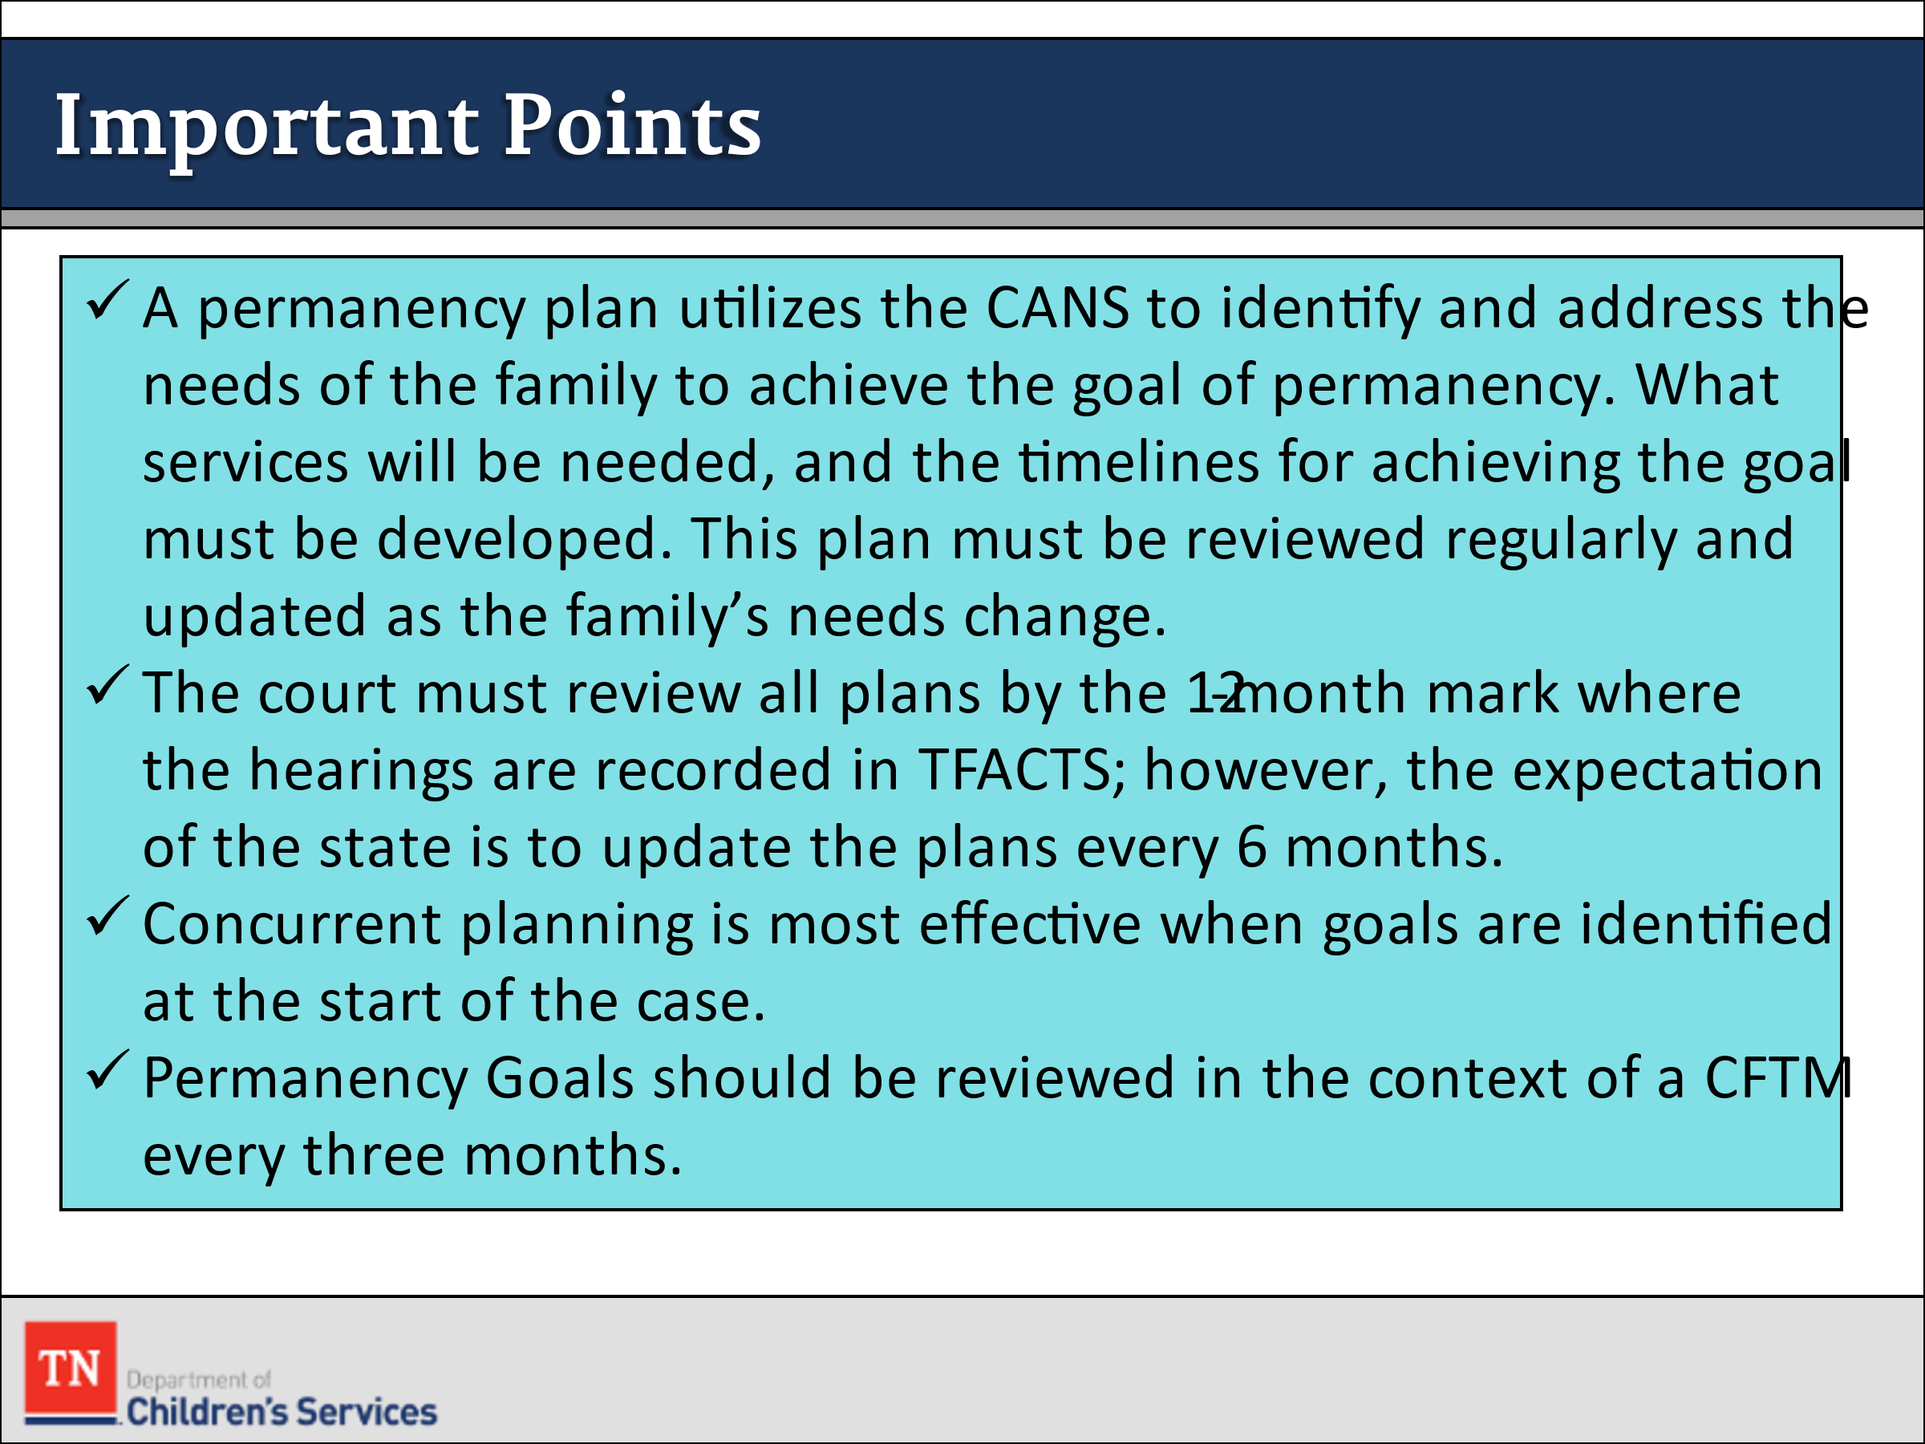
- ASSESS participants level of knowledge about DCS policies and practices pertaining to permanency planning at this stage in the life of a case. ENCOURAGE them to identify and discuss the following important points:
  - A permanency plan that utilizes the CANS to identify and address the needs of the family to achieve the goal of permanency. What services will be needed, and the timelines for achieving the goal must be developed. This plan must be reviewed regularly and updated as the family’s needs change.
  - Concurrent planning is most effective when the appropriate goals and needs are identified at the start of the case.
  - The court must review all plans by the 12-month anniversary of the child’s entry into state custody, and these permanency review hearings must be recorded in TFACTS, but it is an expectation of the state to update the plan every 6 months.
  - Permanency plan goals should be reviewed in the context of a CFTM every three months and by the Foster Care Review Board (FCRB) at a minimum of every six months. These are also recorded in TFACTS.
Trainer Note: Every court has different expectations of when the FSW or Legal should file the Permanency Plan with the court to allow the Judge appropriate time to review the plan, Progress Review Summary, affidavits, etc.
  - DCS must discuss with the family the progress that has been made toward the goals of the permanency plan and explore barriers to permanency, safety, or well-being. The team’s goal is to work together to address the needs, by reviewing the plan during quarterly progress review CFTM’s along with using the CANS we can address barriers as they come up.
- TRANSITION to Lesson 5.8 The Revised Permanency Plan.

Lesson 5.8: The Revised Permanency Plan

Lesson Time: 70 minutes
Key Teaching Points / Instructions

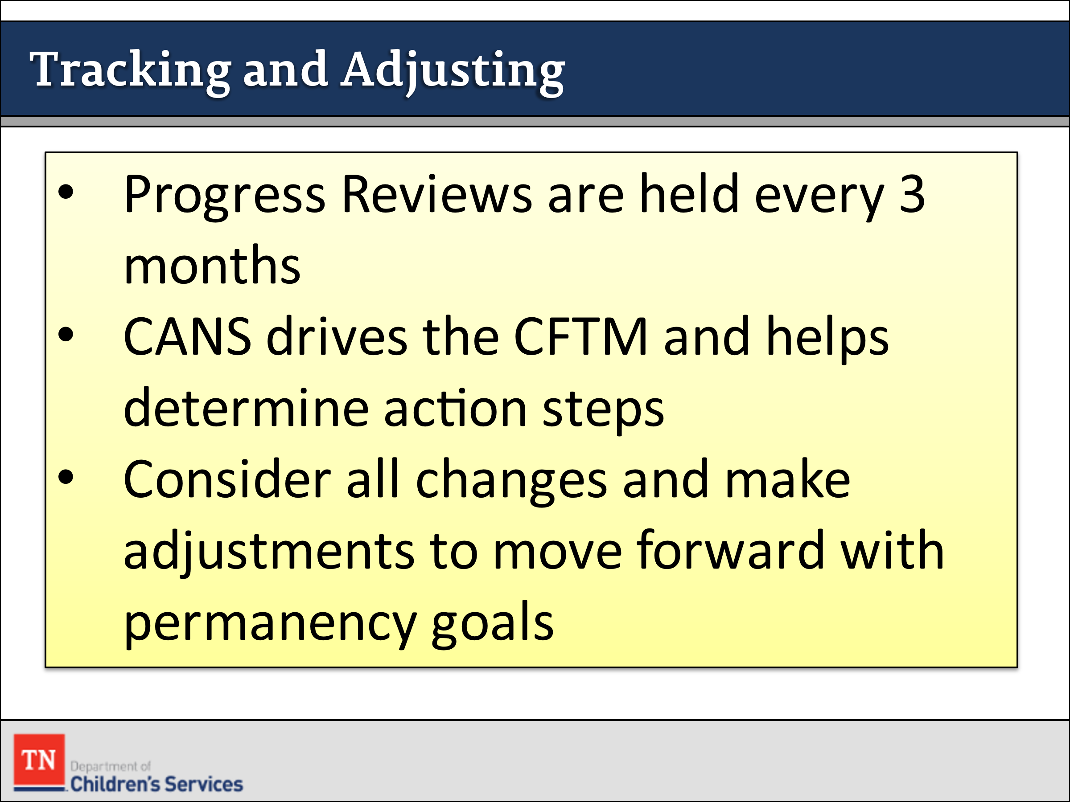
- TRANSITION we have reached a point where revising the permanency plan and concurrent planning is necessary for Renee and her family.
- SHARE with participants we will soon view the Pathways to Permanence Scene 5 - Tracking to Permanence. In this scene, participants will see a portion of a Revised Permanency Plan CFTM and learn how to prepare families for this meeting, explore barriers to permanency, and assess and address the case family’s needs. The case family and team evaluate progress on the permanency plan and discuss other options to ensure the best permanency decision for the children.
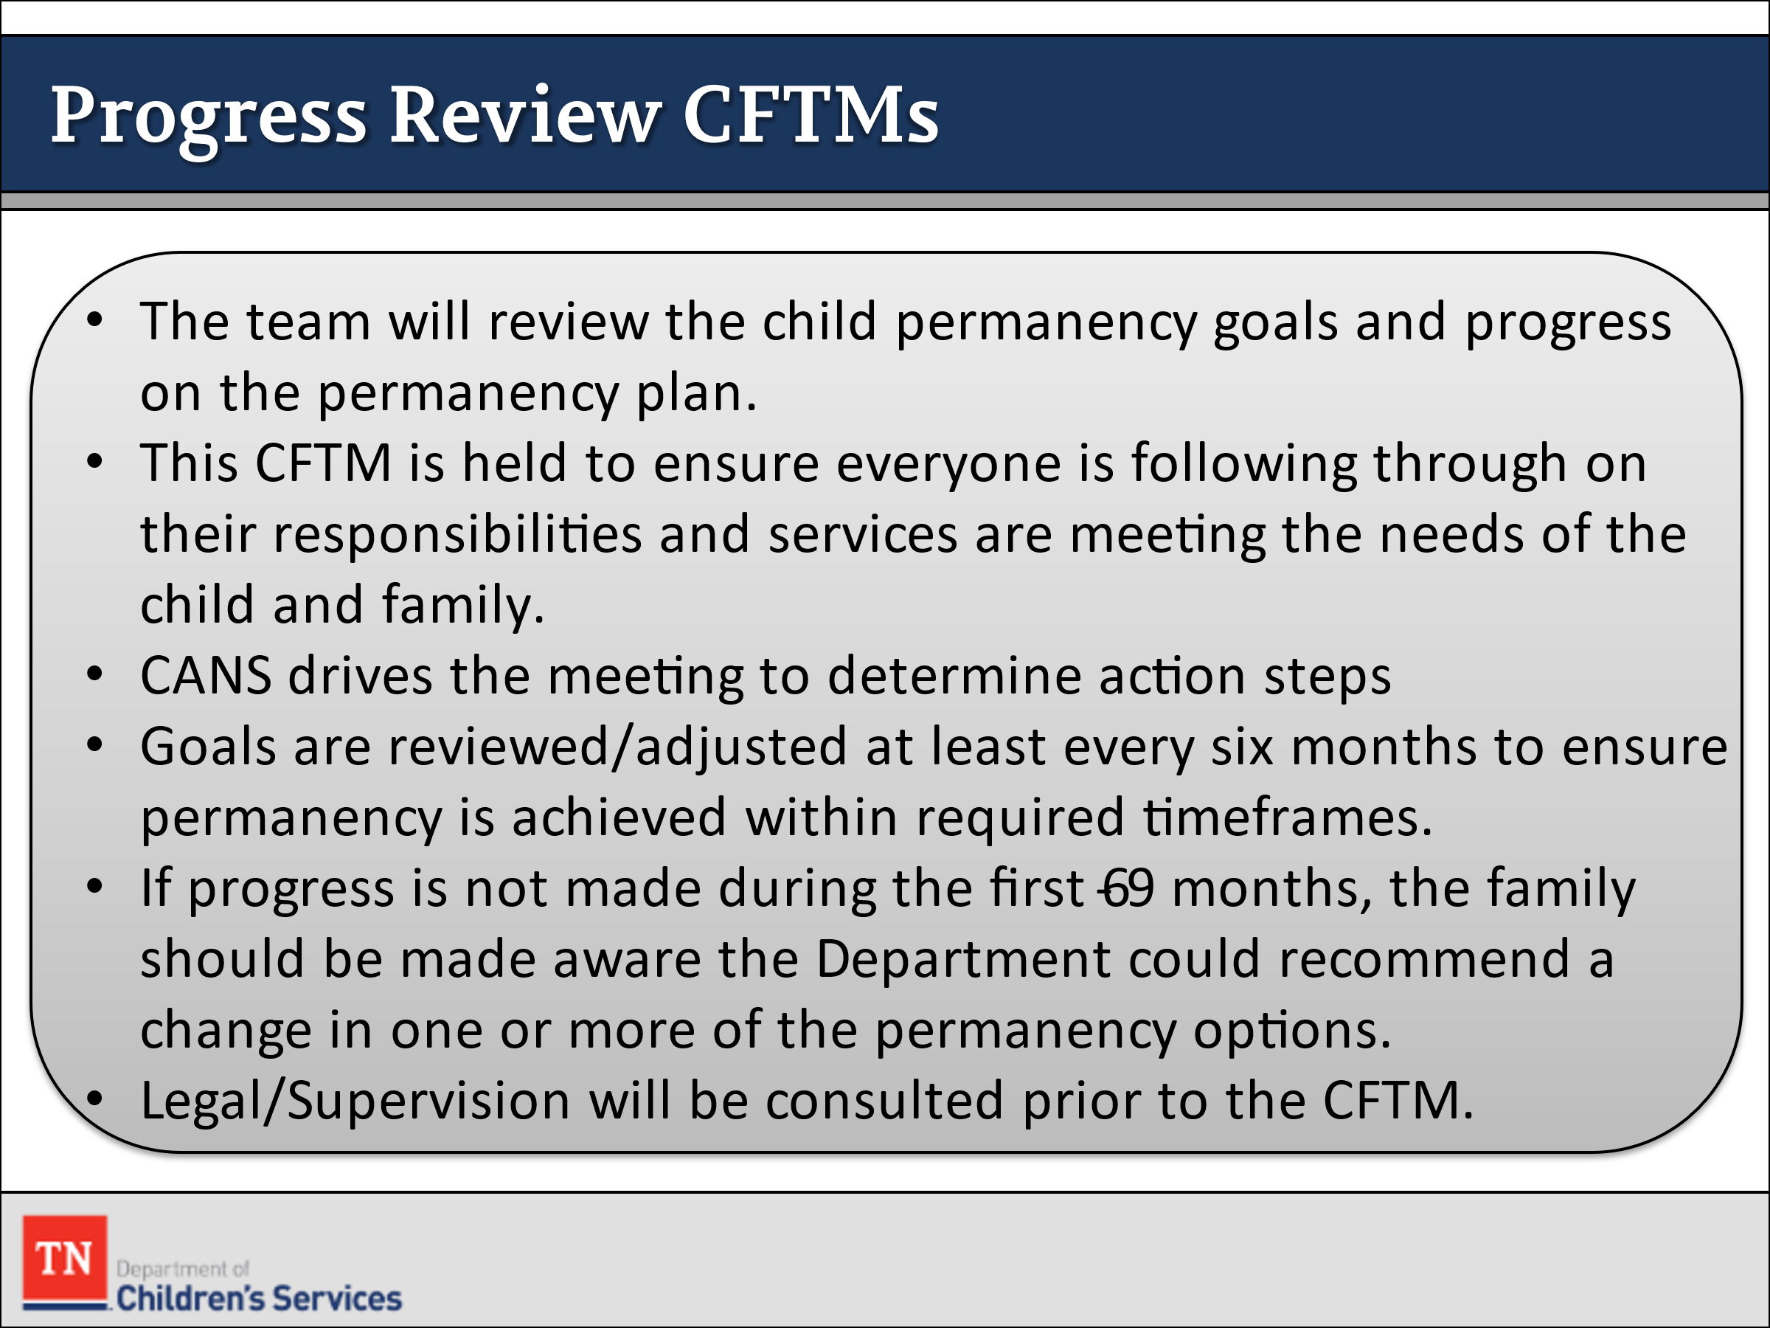
- REMIND participants the CFTM to review child permanency goals and progress on the permanency plan must take place every three months. STRESS this CFTM is held to ensure that everyone is following through on their responsibilities and the services are meeting the needs of the child and family.
- DISCUSS we use the CANS to drive the meeting to help determine action steps which then in turn informs the permanency plan.
- STATE we always consider any changes in the family situation and make adjustments as needed in order to move forward with the permanency goals. In most cases, plans with a six-month achievement date are preferred to ensure that permanency is achieved within the required timelines. If it looks like the current permanency goal(s) will not be achieved and the FSW has completed Reasonable Efforts by assisting the family during the time between reviews, then the case will be reviewed with a supervisor and legal to determine next steps and if a change in permanency goals is needed.
- EMPHASIZE if progress has not been made in the first nine months, the family should be made aware that the Department could recommend a change in one or more of their permanency options. The FSW will have a discussion with Legal prior to the CFTM to discuss the status of the case and if any changes to the plan are needed.
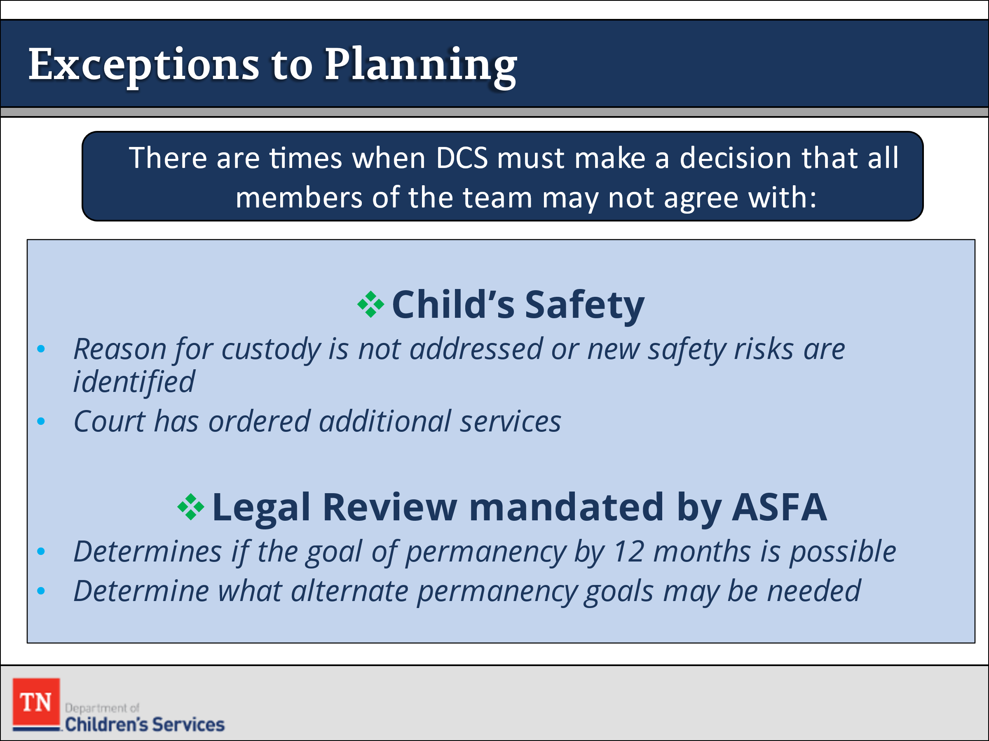
- REMIND participants that all revisions to permanency plans are developed in the context of a CFTM, however there are times when DCS must supersede that of the team. ASK the participants for examples of when DCS might have to make a decision that other members of the team might not be in agreement with. Examples could be:
- Child’s safety: the reason for the custodial episode is not being addressed or new safety risks have been presented. The court has ordered additional services during the initial Permanency Plan hearing.
- It may be necessary to bring in or consult with your TL in order to move the process along. The TL will determine if other members of leadership are needed such as TC, DRA, RA, and/or Legal.
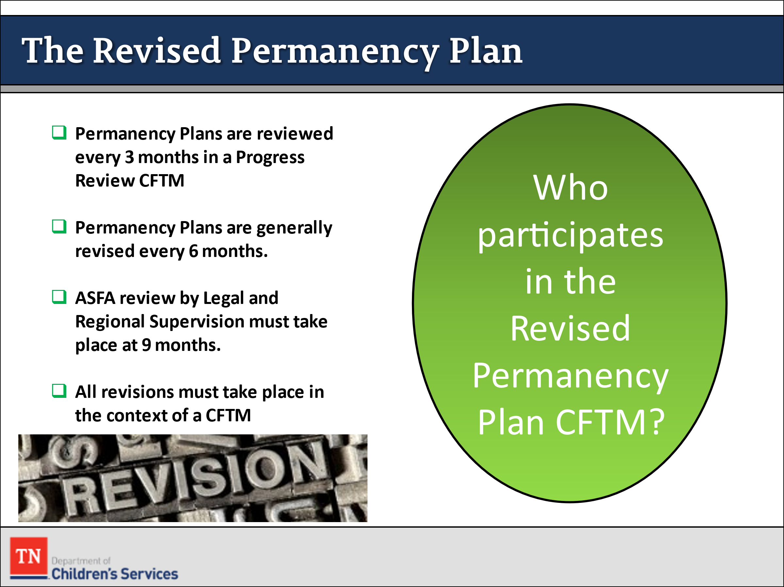
- STATE revisions can be made at any time and should be made when new issues that impact the accomplishment of the permanency goal arise or when there is a change in the goal, services, or treatment for the child/youth or family. Any time a revision is made, the FSW should consult with legal in order to present changes to the court.
- SHARE a revised permanency plan CFTM must take place at six months. At the 9 months mark a legal review is required according to ASFA. Legal, Upper Management, and others meet to review the case to assess for progress or barriers to meeting the permanency goal(s). STATE to meet the goal of 12 months we must start this process at the 9-month mark or earlier. This is why you should consult with your supervisor at the beginning of the case in order to determine timeframes for revisions. These timeframes will be set as a reference point to ensure a timely track to permanence.
- ASK: “Who participates in this revised permanency plan CFTM?”
- PROVIDE the following responses if not mentioned:
  - Child/youth 12 years of age or older and younger children as appropriate should be included for part, if not all, of the CFTM.
  - Parents, unless the parents’ rights have been terminated or surrendered, even if the parent is incarcerated. When the parents’ whereabouts are unknown, a diligent search must be conducted and documented in TFACTS
  - Informal supports, kin, or extended family the parents agree to include
  - Former legal custodians, resource parents, specialized DCS staff, therapists, CASA volunteers, community partners, and attorneys for the child, parent, and the department may also participate.
  - FSW should meet with anyone who is planning on attending the CFTM.
  - The FSW should ensure that both parents are engaged in this process. If a parent is missing, we should have already begun diligent efforts at the beginning of the case, however if for some reason (other than by court order) those efforts have not been initiated we will do so immediately.
- DISCUSS possible goals for the Williams Family at this time. ASK participants, “What questions do you think are important for Sandra to ask herself in preparation for this meeting?” After some discussion, REFER participants to “Preparing for the Revised Permanency Plan CFTM” in the Participant Guide Unit 5 and NOTE any key points that participants did not discuss.
- STATE the FSW should have a copy of the current plan as well as the CANS. The FSW should discuss the reason for the upcoming meeting. The discussion should include but is not limited to:
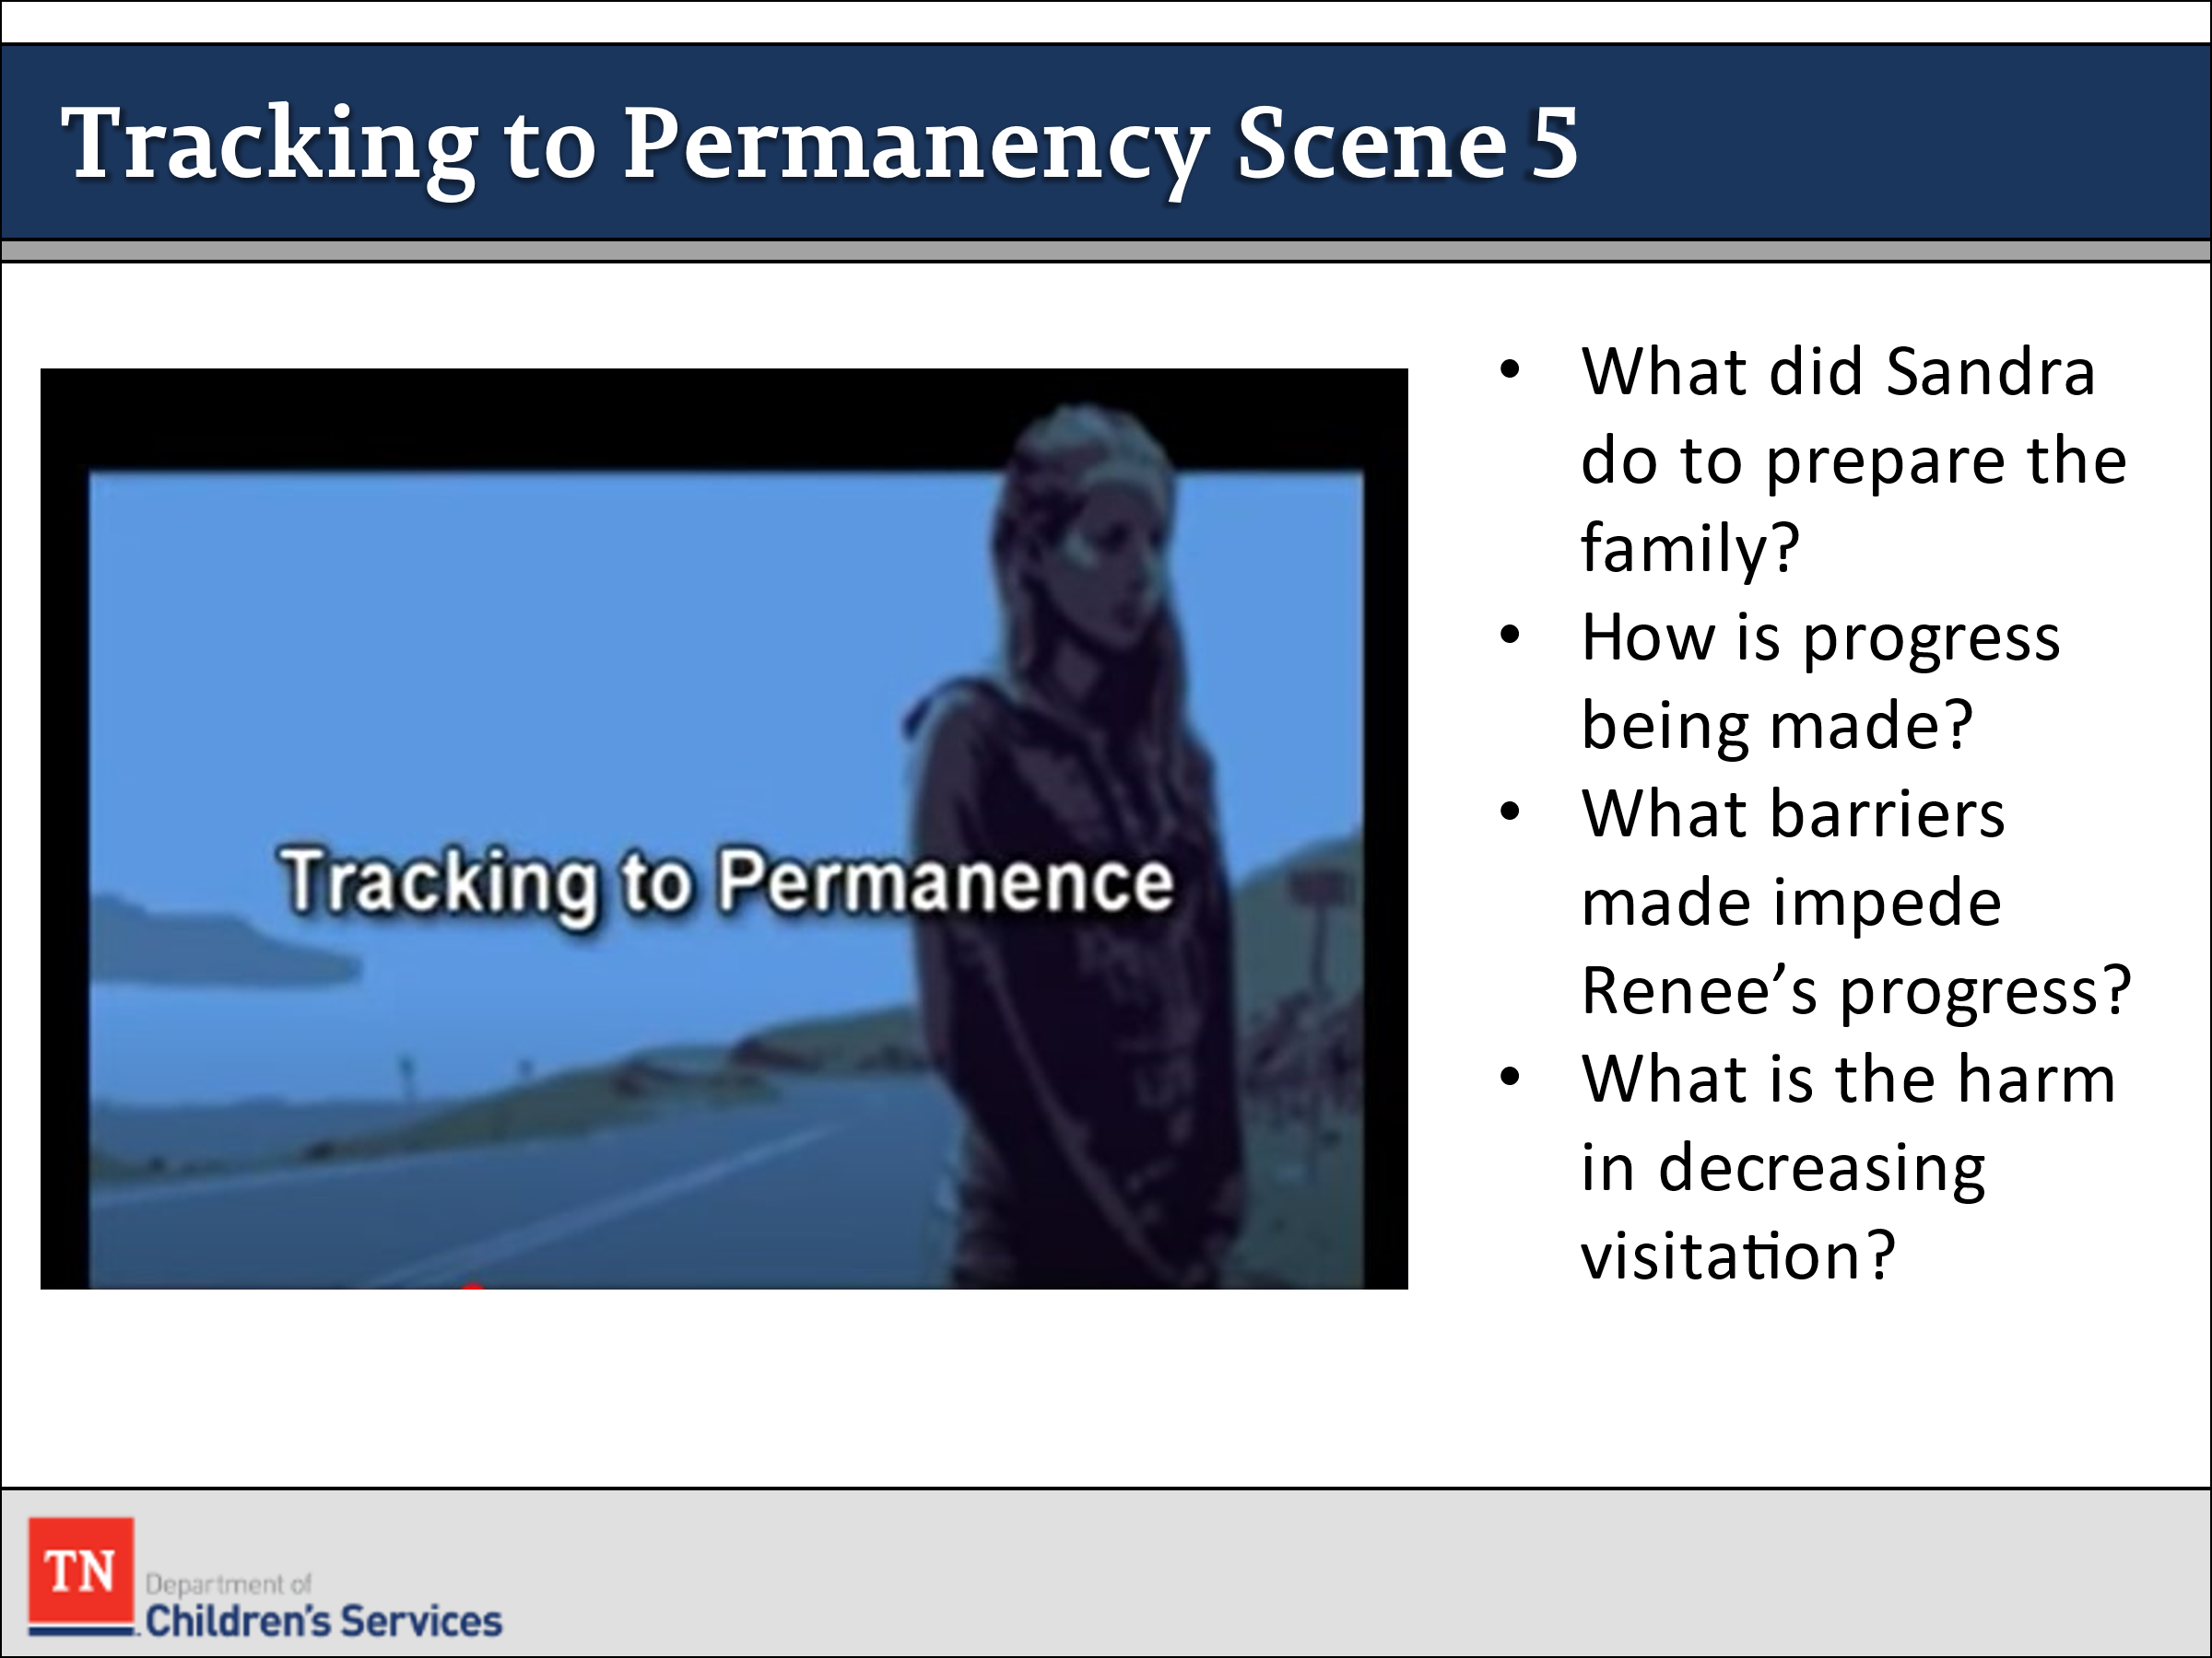
- A review of that person’s action steps on the plan, progress and/or barriers to completing the action steps and a review of strengths. A review of the CANS to see if there are any unaddressed risks or strengths that needs to be added or changed on the CANS and reflected on the plan. The FSW should ask if there are potential conflicts that might come up during the plan. The FSW should assess the team member’s willingness and ability to complete their action steps or addition of new action steps. Finally, ask if there are any additional supports that could be added to the team and assess what role they could play in helping achieve permanency.
- INFORM participants we will now view the Pathways to Permanence Scene 5 - Tracking to Permanence video. START the video at 18:45 and stop at 40:54. Time: 22:12 minutes. ASK participants to again make any notes on the Family Assessment Worksheet. https://www.youtube.com/watch?v=6Iz6NSBzFu4&feature=youtu.be&t=1122 .
- ASK participants why it is important to ensure that we engage both parents at this point in the case:
- Unless there is a specific safety risk or a court order in place stating otherwise, a child can be reunified with either parent. While there may be specific tasks for each parent depending on their individual needs, the task of ensuring the child/children’s safety is the responsibility of both parents. If the Department has to pursue TPR we will pursue both parents and will be required to show that reasonable efforts were completed with both parents not just the mother or father. There are times when we have to work harder to find and/or engage one parent over the other due to any number of reasons.
- INQUIRE with participants, “What do you think Sandra did to prepare the family for this CFTM? Did she do some of the things we talked about before you watched the video and earlier in the course?” After some discussion, EMPHASIZE the importance of preparing the family for any discussion about changing the goal from reunification. STRESS there should be no surprises during the CFTM and that emotionally charged issues need to be discussed with the family prior to the meeting. ASK the group to consider what it might feel like to share the most intimate details of a crisis in one’s life with people who are strangers.
- ASK the group about Russ, Justin and Jewel’s father, if they know where his progress is based on the information and if he has been engaged in the process. ASK what stage of change is Russ currently? ANSWER: Contemplation, Preparation, and Action. EXPLORE with the group how they might engage Russ at this point to ensure he is included in the process.
- EMPHASIZE the importance of preparing the family for any discussion about changing the goal from reunification. STRESS there should be no surprises during the CFTM and that emotionally charged issues need to be discussed with the family prior to the meeting. ASK the group to consider what it might feel like to share the most intimate details of a crisis in one’s life with people who are strangers.
- REMIND participants tracking and monitoring is an important part of their case practice and a key spoke of the practice wheel.
- DEBRIEF these questions from the video:
  - What barriers did the team identify that might impede Renee’s progress toward achieving reunification?
  - What would be the harm in decreasing visitation at this point while Renee completes substance abuse treatment?
  - How would you engage the team in a discussion to manage the conflict over visitation?
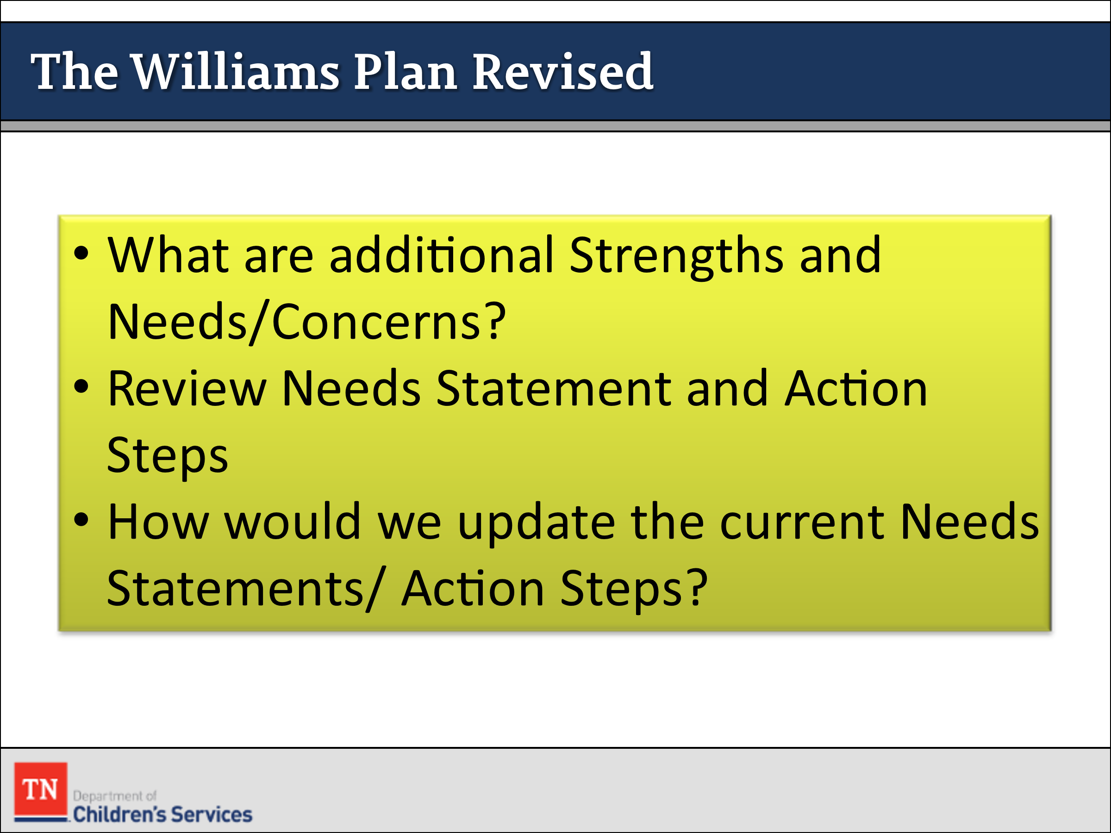
- ACTIVITY: Williams Plan Revised
- INSTRUCT participants to retrieve the Initial CANS assessment completed for Ariana. ASK participants to REVIEW the changes from the Initial CANS to the Re-Assessment CANS found in the Williams family case file. As a large group, add additional Strengths and Needs/Concerns to the list. ASK participants to review the current Needs Statements and Actions Steps. ASK how we would update the current Needs/Action Steps. Select one needs statement with action steps to revise or develop a new needs statement/action steps based on additional information learned. DEBRIEF.
TRAINER NOTE: This activity should take no longer than 15-20 minutes. Further Skill Lab will be completed next week.
- POINT OUT the move to permanence—whether it is reunification with the birth family, exit custody to live with a relative, or adoption—can trigger some of the same losses experienced at the time of separation.
- TRANSITION to Lesson 5.9 Providing Strengths-Based Feedback.

Lesson 5.9: Providing Strengths-Based Feedback

Lesson Time: 40 minutes
Key Teaching Points / Instructions
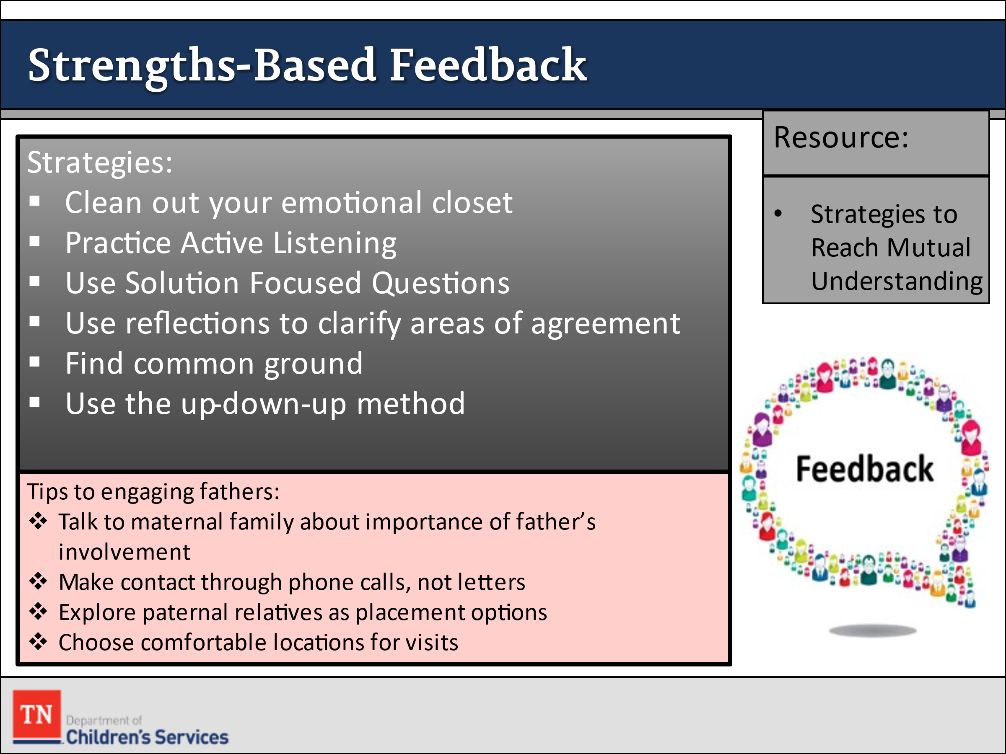
- STATE working with the family during the move to permanence involves helping them anticipate and prepare for feelings of celebration as well as the feelings of loss.
- SHARE it is important to monitor progress toward permanency goals and to provide effective strengths-based feedback to parents about their progress or lack of progress toward reunification.
- REMIND the group at this point in the case process (nearly a year after removal) the Williams family and team should be implementing and close to completing the action steps in the permanency plan.
- ASK participants to discuss their focus in working with the Williams family at this point. ASK them to describe their role in coaching and partnering with the family and team to keep them moving toward the permanency goal.
- REMIND participants that the FSW’s role is also to assist team members in assessing their progress toward achieving permanency and making revisions to the permanency plan as needed.
- ASK participants to take a minute and think about what they might do when they have a difficult message to convey to the parent including their lack of progress toward the permanency goal.
- REFER participants to the resource titled Strategies to Reach a Mutual Understanding in Google Classroom and INSTRUCT them to take a few minutes to look over these strategies.
Strategies to Reach Mutual Understanding
- Clean out your emotional closet
- Feelings of anger and fear can easily build in any conflict situation. Unless these are dealt with soon, they will likely escalate and could create even more conflict. Be a detective. Uncover and examine your emotions. Be honest with yourself in identifying your emotional state. Look at the situation as a chance to learn, grow, and transform your feelings. The situation can become something positive and productive.
- Practice active listening
- Active listening allows you to hear what is actually being said, not what you think the other person is saying. Clearly knowing what each person is saying provides the greatest potential for reducing defensiveness and respectfully resolving the problem.
- Use solution-focused questions
- Solution–focused questions move the family from problem identification to problem resolution. Solution-focused questions provide an opportunity for families to identify solutions that were effective in the past, to explore situations in which the problem could have occurred but did not, and to articulate their vision of success once the problem is resolved. These questions help family members tell their story about how they want to use their strengths to meet their needs.
- Use reflections to clarify areas of agreement
- Reflections help family members know they have been heard and also help move the family toward solving, rather than restating, the problem.
- Find common ground
- Find common ground between what the family wants to happen and what needs to happen. Finding common ground moves families from a position of “your position versus mine” to a position of “you and me versus the problem.”
- Use the up-down-up method
- UP
- Provides positive information
- Builds the family up
- Verbally acknowledges parental/caretaker/family achievements and the struggles inherent in childrearing
- DOWN
- Addresses the difficult information
- Brings the family down or into the reality of the current situation relevant to the child/youth’s risk behavior
- Defines current problems and issues and their impact on the children and introduces open, honest, reality-based discussion regarding parents’ abilities to parent effectively and to meet the goals of permanency.
- UP
- Summarizes with positive information
- Builds the family up again
- Supports self-sufficiency and self-confidence to make the right choices in the best interest of the children for safety, permanence, and well-being.
- ASK participants, “How might you use these strategies in working with Renee?” COACH participants on how they might use active listening, solution-focused questions, reflections, and other strategies effectively by asking for specific examples of each strategy.
- REMIND participants to provide strengths-based feedback after each interview. EMPHASIZE the importance of preparing for the interview with the parent, thinking beforehand how to best approach the subject, and directly addressing the issues with the parent.
- ASK the group how they feel about how the group addresses the role of Russ in the children’s lives. Though Russ has stated that he is not able to be a placement option for the children right now, he is still a part of the Permanency Plan. ASK the group how they might engage Russ more in the CFTM process.
- REVIEW some tips for engaging fathers in the CFTM process:
- Talk to the mother (maternal family) about the importance of father’s involvement.
  - Make initial contact with fathers through phone calls, not letters.
  - Talk to the father about the importance of their relationship to their child and how this impacts the child’s well-being.
  - Explore paternal relatives as placement options.
  - Choose comfortable locations for visits between fathers and children.
  - Reinforce the fact that what children want and need most from their fathers is being with them, not materials.
  - Brainstorm and implement some creative ways to build relationships between children and fathers when they are not able to visit often (for example, father’s that are incarcerated or live out of state).
- REMIND the group that although we have focused on engaging fathers, there are times we may have work toward engaging absent mothers in the CFTM process. Both parents are important and need to be engaged equally in the CFTM.
- ASK for questions or comments on facilitating feedback when the parent is showing little or no progress. The ability to assess progress and give positive feedback to parents is really the foundation of our work.
- TRANSITION by stating that the next activity will focus on explaining permanency options to a family after a child has been in care for nine months and little progress has been made toward permanency.
- ASK participants the following questions from the video:
  - What impact do you think Renee’s lack of progress at this point is having on her relationship with the children, particularly Ariana?
  - How did Sandra address the possibility of changing the permanency goal with the family?
  - What changes at this point would necessitate revisions to the permanency plan?
  - Was concurrent planning fully addressed?
- INFORM participants that soon we are going to practice reassessment so that we can update the family’s strengths, needs, and action steps.
- TRANSITION to Unit 6 Tracking and Adjusting by stating that the next activity will focus on explaining permanency options to a family after a child has been in care for nine months and little progress has been made toward permanency.

Unit 6: Tracking and Adjusting

Unit Time: 80 minutes

Learning Objectives:
- Participants will become knowledgeable in ongoing tracking and adjusting in casework.

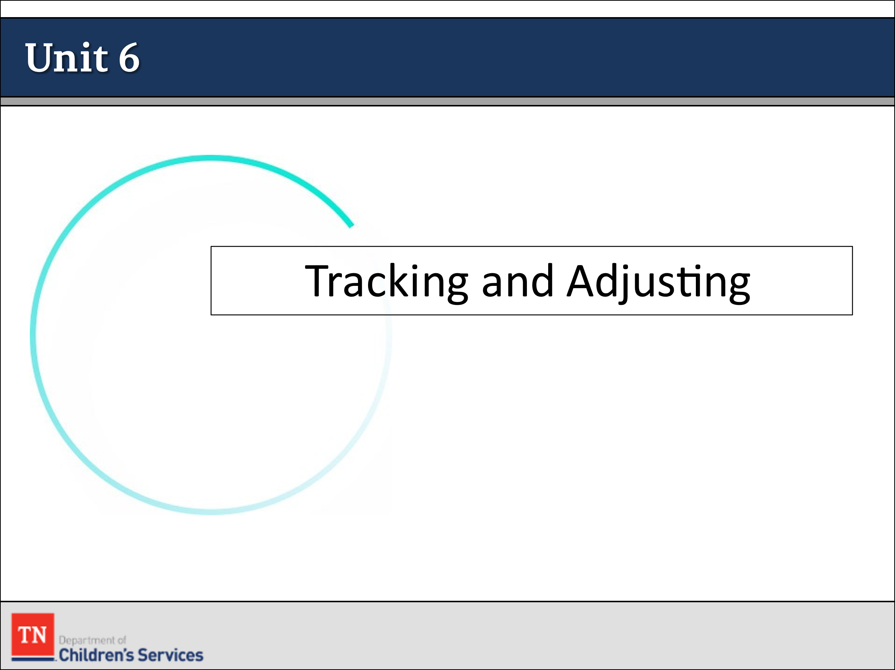
Supporting Materials:
- PowerPoint
- Policy link: https://www.tn.gov/dcs/program-areas/qi/policies-reports- manuals/policiesprocedures.html
- Child and Family Team Guide
- Visitation Guide

Lesson 6.1: Tracking and Adjusting

Lesson Time: 35 minutes
Key Teaching Points / Instructions

- TELL participants as FSWs, we are always assessing the case and tracking and adjusting action steps as necessary to reach permanency in a timely manner. Per policy, we review permanency plans quarterly in a CFTM, and we are to review progress on an ongoing basis.
- ASK participants if they can recall what is the next step in the DCS Practice Wheel. Response is implementation. ASK when does implementation happen. Now, we are going to discuss putting the plan into practice. We want to make the plan a living/breathing document.
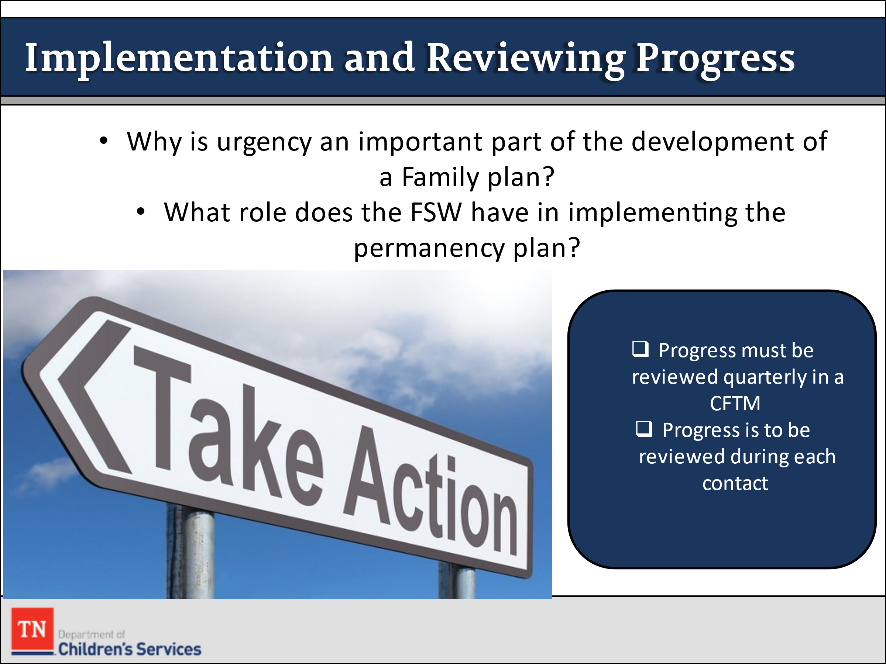
- ASK participants the following questions:
  - Why is Urgency an important part of the development of a Family plan?
  - What role does the FSW have in implementing the permanency plan? (Possible responses: advocate, broker, educator, resource developer, cheerleader, collaborator.)
- EXPLAIN permanency plans are never to be presented to the family as a list of demands, but the family is to be involved in the development of the plan. Permanency plans are more of a written partnership to gain permanency for the youth. Steps on a plan are never to be for just one person to complete. It is crucial for the team to work together to achieve the goals. The plan is also not a “to do” list for just the Worker. We do not want the family to develop a reliance on DCS to the point of when we are not in the picture they fail. We want to develop a balance of the family working to achieve the goal, and we help them with barriers that are in the way.
- INFORM participants that progress is to be reviewed during each contact with the child and family but must also be reviewed quarterly or every three months in a Progress Review CFTM.
- REFER participants back to the Child and Family Team Guide to review aspects of the Progress Review CFTM. DEBRIEF and ask if there are any questions.
- STATE the progress CFTM is a formal point in time that the team gets together and discusses the progress and barriers in the permanency plan. The team at times will need to discuss lack of progress. When discussing lack of progress, it is important that we discuss how we can address the barriers. We are to be showing reasonable efforts when addressing barriers in the plan. When these barriers come up during our progress review it is important for the team to discuss what resources or support can be offered to assist the family.
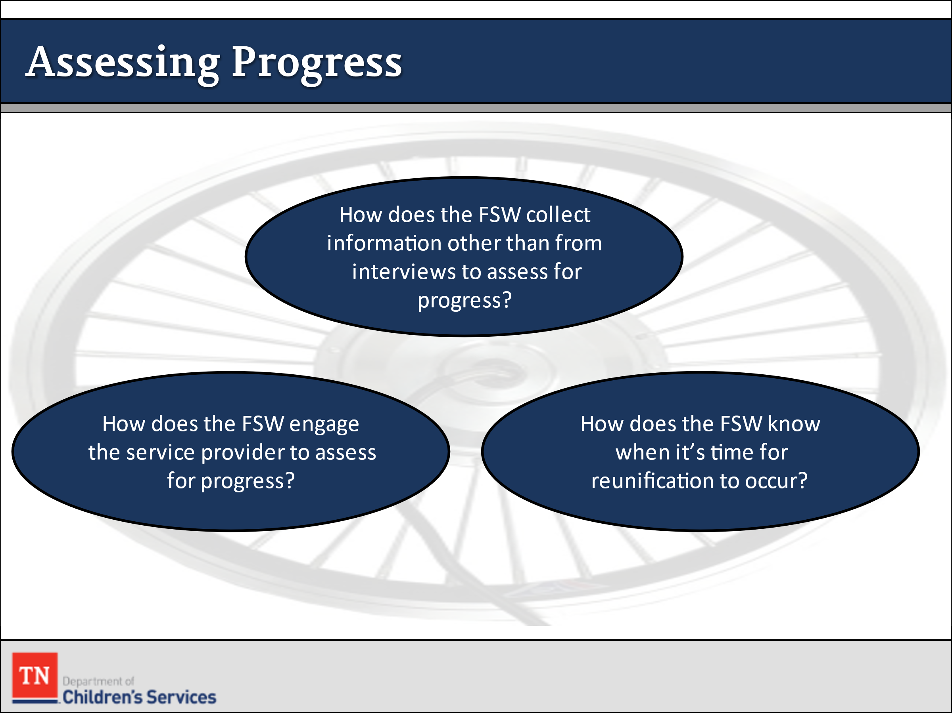
- ASK how the FSW can collect information other than from interviews to assess for progress? ASK what may be some potential barriers of progress?
- INFORM participants of the importance of beginning to build an understanding of resources available for the family. ENCOURAGE them to discuss resources available in their areas with their mentor, Supervisor, and Resource Linkage case manager.
- DISCUSS the importance of engaging the service providers to assess for progress. ASK who are possible service providers you will work with as the FSW? What is the importance of developing a relationship with providers? How can you help build the relationship with the service provider and family? What is the importance of a trusting relationship with the service provider and family?
- STATE as the FSW, it is important that we monitor the work of the Service provider and ensure the needs of the family are being met. At times, we may have to problem solve with family and provider to get the family to appointments and address other concerns. Providers should be invited to attend CFTM’s for the team to discuss progress.
- ASK as the FSW, how do you know when it is time for reunification to occur? PROMPT a group discussion about reunification as the preferred goal when parent(s) have remedied the issues that led to removal and the child can safely return home. REMIND participants that all decisions about releasing from custody are made within the context of a discharge planning CFTM.
- STATE when reunification cannot occur, the department must consider other permanency goals to assure children achieve timely permanency. EMPHASIZE the importance of the other goals should reunification not be possible.
- EXPLAIN adoption work is very specific which is why FSW’s almost always work with a Permanency Specialist when a child is in full guardianship.
- DISCUSS Permanency Specialists also assist in cases where Subsidized Permanent Guardianship (SPG) is a viable option for a child. Return to Parent and Adoption must be ruled-out before Permanent Guardianship can be approved. Policy 16.31 states:
  - Specific reasons regarding why reunification and adoption are deemed inappropriate are documented in TFACTS case recordings and/or Child and Family Team Meeting notes. Documentation should include a description of the child or family’s pre-existing relationship with the prospective permanent guardian, confirmation of the prospective guardian’s commitment to caring for the child/youth permanently, and if the youth is twelve (12) years of age or older, confirmation that the youth has been consulted regarding the SPG arrangement. Refer to DCS Policy 15.15 Subsidized Permanent Guardianship.
  - Some permanent guardians may be eligible for a subsidy. Please refer to DCS Policy 15.15, Subsidized Permanent Guardianship and the Work Aid-Subsidized Permanent Guardianship for steps to arrange this for eligible guardians and preparing the paperwork necessary for the court exit.
- SEGUE into the next activity by STATING that we will now revisit the topic of special considerations when working with youth.
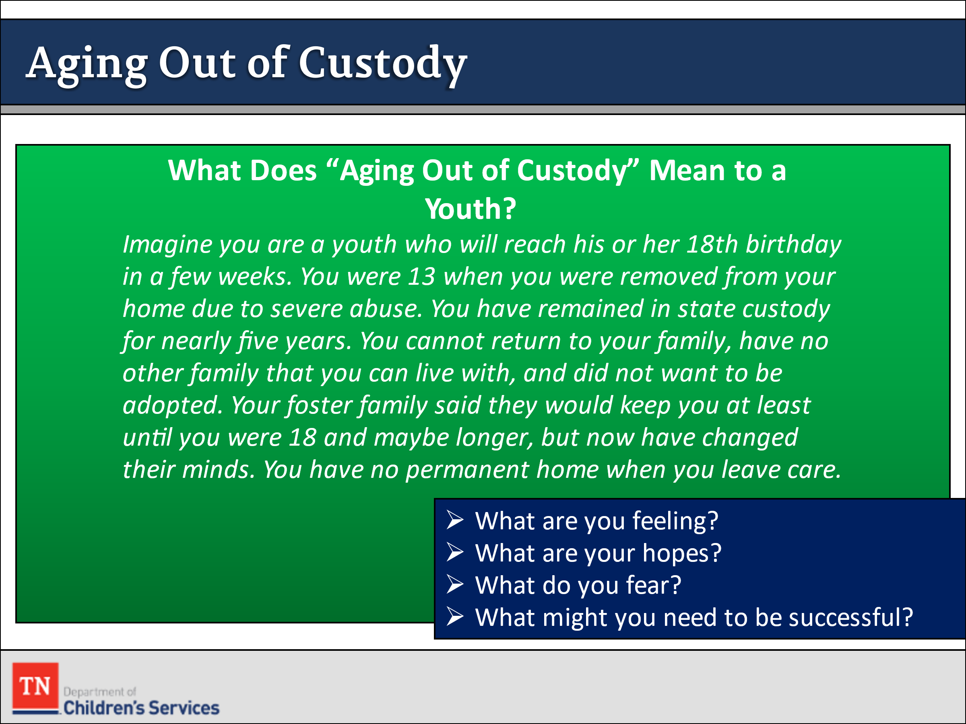
- CONDUCT ACTIVITY: What Does Aging Out of Custody Mean to a Youth?
- ASK for a volunteer to READ the scenario and answer the questions.
Imagine you are a youth who will reach his or her 18th birthday in a few weeks. You were 13 when you were removed from your home due to severe abuse. You have remained in state custody for nearly five years. You cannot return to your family, have no other family that you can live with, and did not want to be adopted. Your foster family said they would keep you at least until you were 18 and maybe longer, but now have changed their minds. You have no permanent home when you leave care. Put yourself in the child’s shoes. What does “aging out of custody” mean to this child? Record your thoughts in the space below.
- What are you feeling?
- What are your hopes?
- What do you fear?
- What might you need to be successful?
  - GIVE the participants a few minutes to complete the exercise. ASK the group to share their thoughts, feelings, hopes and fears.
  - TRANSITION to discussing Exiting Custody.

Lesson 6.2: Exiting Custody

Lesson Time: 45 minutes
Key Teaching Points / Instructions

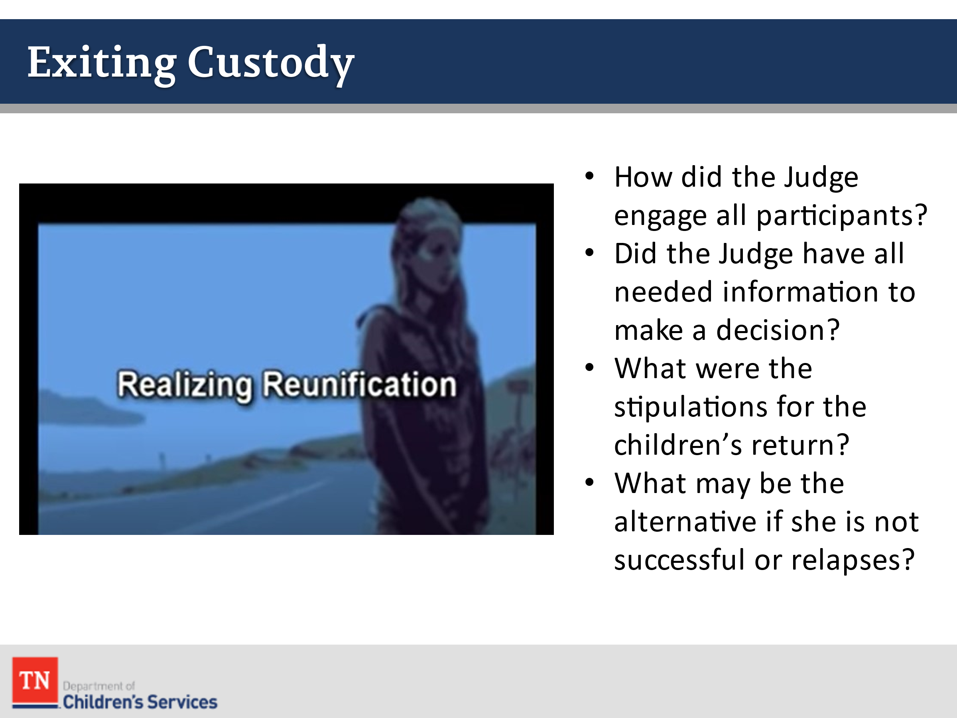
- LEAD the group in a discussion concerning the role of the court in determining whether risk to the child has been sufficiently reduced to return the child home, or if it would be in the child’s best interest to permanently place him or her in the custody of a relative or with an adoptive family.
- REMIND participants there are other advocates for the child and family who have monitored the family’s progress toward permanence and report their findings to the court (GAL, CASA).
- EXPLORE with participants whether children should be present for the hearing. ASK participants why it is important for children to be involved in the final Court Hearing. PROMPT the group to include the following points:
  - It is very important for the children to have a voice.
  - It provides reassurance that all of the adults in their lives care about them and want to listen to their concerns.
  - Even young children can participate in court if they receive the proper preparation about what to expect, who will be there, how long it will last, and what they can say or do.
  - If delicate material will be presented that may be inappropriate for children to hear, they can participate in a portion of the hearing and be escorted to a waiting room for the remaining time.
- SHARE with participants we will view Pathways to Permanence Scene 6— Realizing Reunification video where the case family appears in court to determine whether the children may be returned for a trial home visit. The scene takes place in the courtroom where the judge evaluates the progress Renee has made in drug treatment program and assesses her ability to assure permanency for the children. SHOW the following: https://www.youtube.com/watch?v=6Iz6NSBzFu4&feature=youtu.be&t=2458 . Time is 13:37 minutes. Start 40:59 – 54:30.
- DEBRIEF the scene with the large group. ASK what the court’s role in engaging participants in the permanency decision.
- EMPHASIZE that now, at this stage in the life of the case, the juvenile court plays a key role in making the permanency decision. LEAD the group in a discussion concerning the role of the court in determining whether risk to the child has been sufficiently reduced to return the child home, or if it would be in the child’s best interest to permanently place him or her in the custody of a relative or with an adoptive family.
- DEBRIEF the scene around the Court and the decision that was made by asking the following questions:
  - How did the judge engage all the participants in the hearing?
  - Think about what the judge did to recognize and build on Renee’s strengths and those of Russ. How effective do you think the judge was in using a strengths-based approach with Renee and Russ?
  - Do you think he had all the information he needed to make this important decision?
- TELL the participants there were other issues from the video that are important and continue to DEBRIEF using the following questions:
  - What were the stipulations for the children’s return?
  - Do you think these were reasonable given the circumstances?
  - What is the court’s role once the children are returned?
  - What is the agency’s role in helping Renee and her family with the transition to reunification?
  - Do you think the services provided by the department and the drug treatment program will ensure Renee’s success?
  - What is the alternative if she is not successful or relapses?
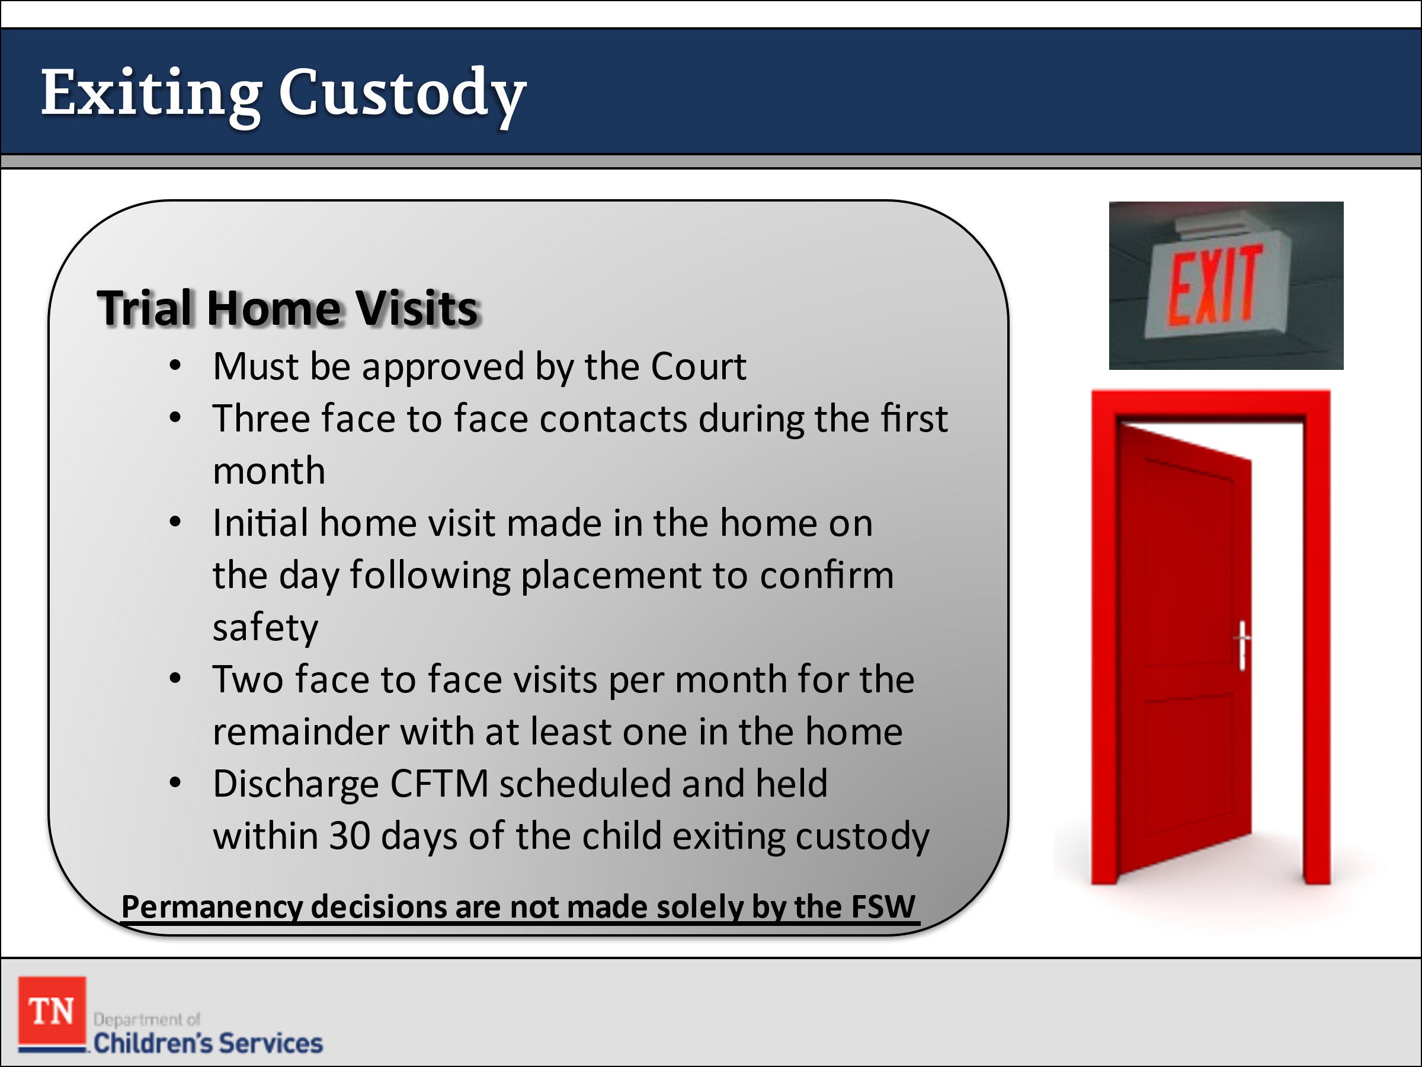
- FACILITATE a discussion around the remaining steps in the case. REFER participants to the Visitation Guide and Policy 16.31 Section F and discuss Trial Home Visits including:
  - Three (3) face to face visits during the first month of the trial home visit.
  - An initial home visit must be made in the home on the day following placement to confirm safety.
  - Two (2) face to face visits per month for the remainder of the trial home visit, with at least one of these visits occurring in the family home and with one visit occurring in the school setting.
  - One (1) face to face visit with the school each month that school is in session. The FSW will interview the child’s teacher to determine progress and if the school placement is appropriate.
  - When a child enters a trial home visit and is still being served through a Contract Agency continuum, the Contract Agency staff will be responsible for completing the required visits.
  - The DCS FSW will visit the child in their family home one time per month while the child is on a trial home visit and is being served through a Contract Agency continuum.
  - A Discharge CFTM should be scheduled and held within a sufficient timeframe to ensure the family’s needs are met and appropriate services are in place. the During this meeting the completed aftercare plan for the family should be discussed and pertinent records given to the family as outlined in policy.
- TRANSITION when children enter care, the Department has the responsibility to ensure that permanency is achieved. In the case of Renee and her family, the goal of reunification was achieved, but that is not true for every child and family.
- ASK participants at what point in the life of a case must a permanency decision be made and issues about permanency reconciled.
- STRESS that permanency decisions and issues should be reconciled by the time the child has been in DCS custody for 12 months. In the case of the Williams, family reunification was not achieved prior to the 12-month timeframe yet time was extended. Extending the goal of reunification past 12 months is called compelling reasons. The compelling reason for this family was that Renee was actively working her recovery plan and needed more time to complete the program.
- ASK the group if they can identify other circumstances that might warrant compelling reasons.
- EMPHASIZE the permanency decision is not made solely by the FSW. STRESS the involvement of the Child and Family Team is very important at this point.

Unit 7: Closing/Wrap-up

Unit Time: 60 minutes

Learning Objectives:
- Participants will apply knowledge learned from the foster care casework process.

Supporting Materials:
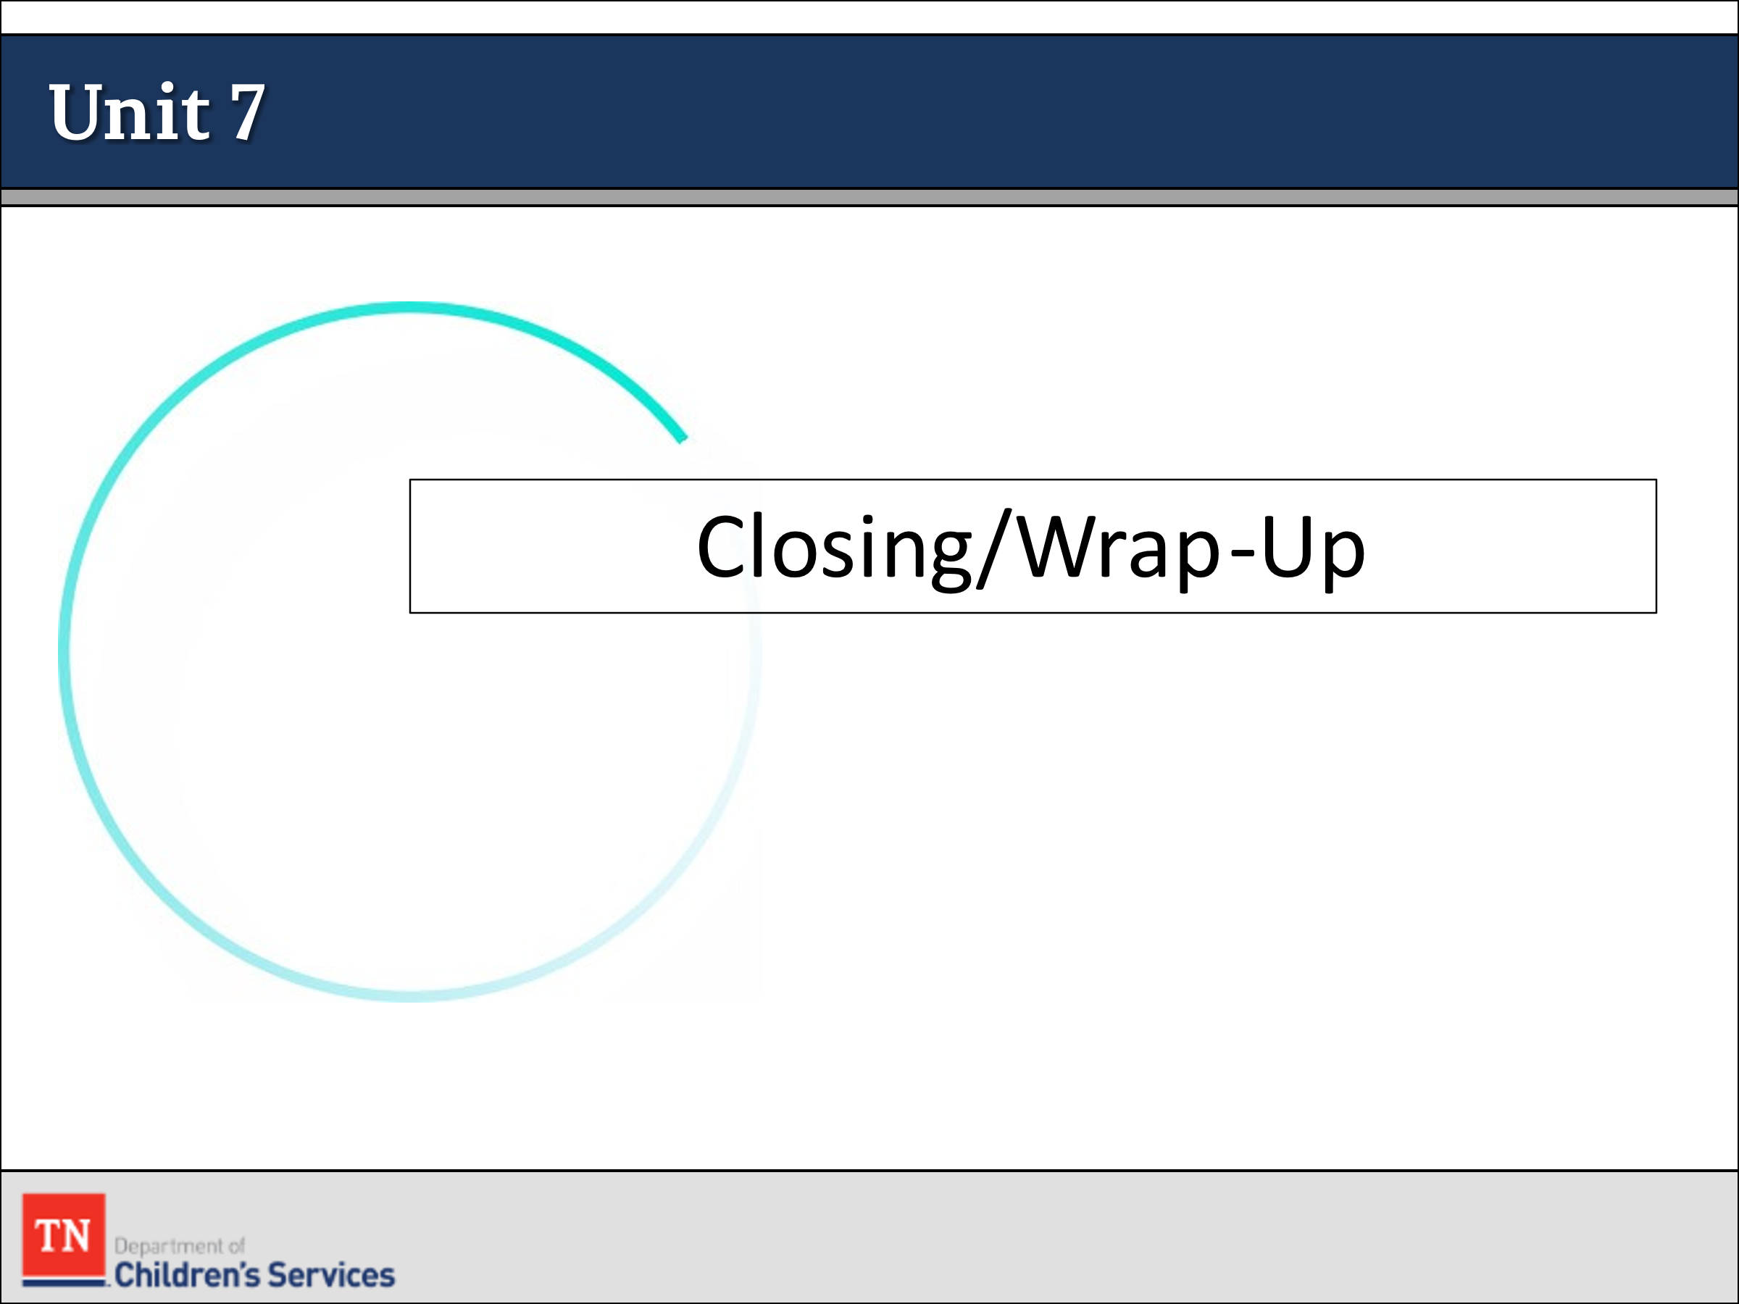
- PowerPoint
- Policies:
- New Hire Guide
- CFTM Guide
- Visitation Guide
- Case Calendar

Lesson 7.1: Content Review

Lesson Time: 45 minutes
Key Teaching Points / Instructions

- STATE we will now put all the pieces together and test our knowledge of the content and the casework process.
- CONDUCT ACTIVITY: Jeopardy Game
- Trainer: decide on how the teams will be broken down and who will keep score. It seems easiest to have 2 class teams and each team have a score keeper and select NO teams on the Jeopardy game. If the trainer is comfortable with maneuvering within the game, they can select how many teams to start the game; however, they must hit the plus sign after the participant answers correctly or incorrectly to keep score within the game at the bottom of the screen.
- Play Jeopardy. Link: https://jeopardylabs.com/play/permanency-jeopardy-4
  - Instructions: Flip a coin or have the teams select a number between 1 and 10 and whichever team is closest to the number the trainer chose, they will go first in the game.
- Hit start and have the participant on the first team chose a category and amount and select the tile. The question will pop up. The trainer will ask the question and allow a few seconds for the participant to answer. If the participant gets the answer correct, hit the spacebar to reveal the answer and congratulate the participant and move on to the next team to select their category. If the participant gets the answer wrong or is unable to answer, pose the question to their larger team to allow them to answer.
- ASK how participants feel after the content review. STATE it is normal to feel excited and overwhelmed. REMIND participants it can take a year or more to feel comfortable with the tasks and responsibilities of case management.
- EXPLAIN we will revisit all these concepts learned this week in Specialty Week 2 and apply the knowledge gained this week on the Steward case family from Intro and Core weeks.

Lesson 7.2: Closing/Wrap-Up

Lesson Time: 15 minutes
Key Teaching Points / Instructions
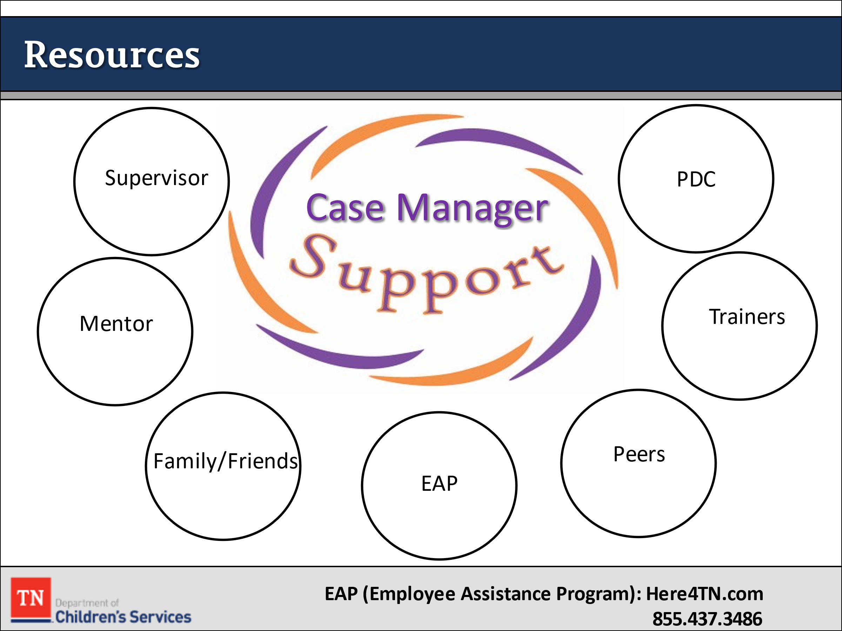
- SHARE positive outcomes for children and families involved with the Department is often due to the strong commitment of the dedicated staff. The Department is only as good as the staff who provide services to children and families and those who manage service delivery.
- STATE your well-being is important to the Department. REMIND participants we have resources at their disposal to help alleviate some of the stress and help prevent burnout.
- ADVISE participants they can utilize their DCS support system which includes their Supervisor, PDC, Mentor, Trainer, and any other DCS peers they choose if they have questions or need someone to talk to about the job or a difficult situation and/or case they may see. In addition, the state provides training opportunities that address self-care, and each region promotes varying self-care opportunities.
- Lastly, the State offers EAP (Employee Assistance Program) services. SHARE Optum contact information with the group including: 855.437.3486 or Here4TN.com to obtain your preauthorization.
- ASK participants for any final thoughts or questions from Core or Permanency Specialty Trainings. Give participants an overview of what they will be doing the remaining weeks of Pre-Service.
- SHARE the next steps in the certification process with the participants including the Individual Learning Plan (ILP), support team meetings (STMs), OJT activities, and the final certification assessment, during which they will present one of their training cases.
- THANK participants for their time and their commitment to children and families and REQUEST participants to complete the course reaction survey by utilizing the QR code.
- Training Location: Where the training is held
- Training Title: Pre-service: Permanency Specialty (CHPS1005)
- Training Completion Date: Today’s date

