Unit 3: Teaming

Unit Time: 3 hours 30 minutes

Learning Objectives:
- Participants will team with the family to identify formal and informal supports to assist the family through the custodial episode.

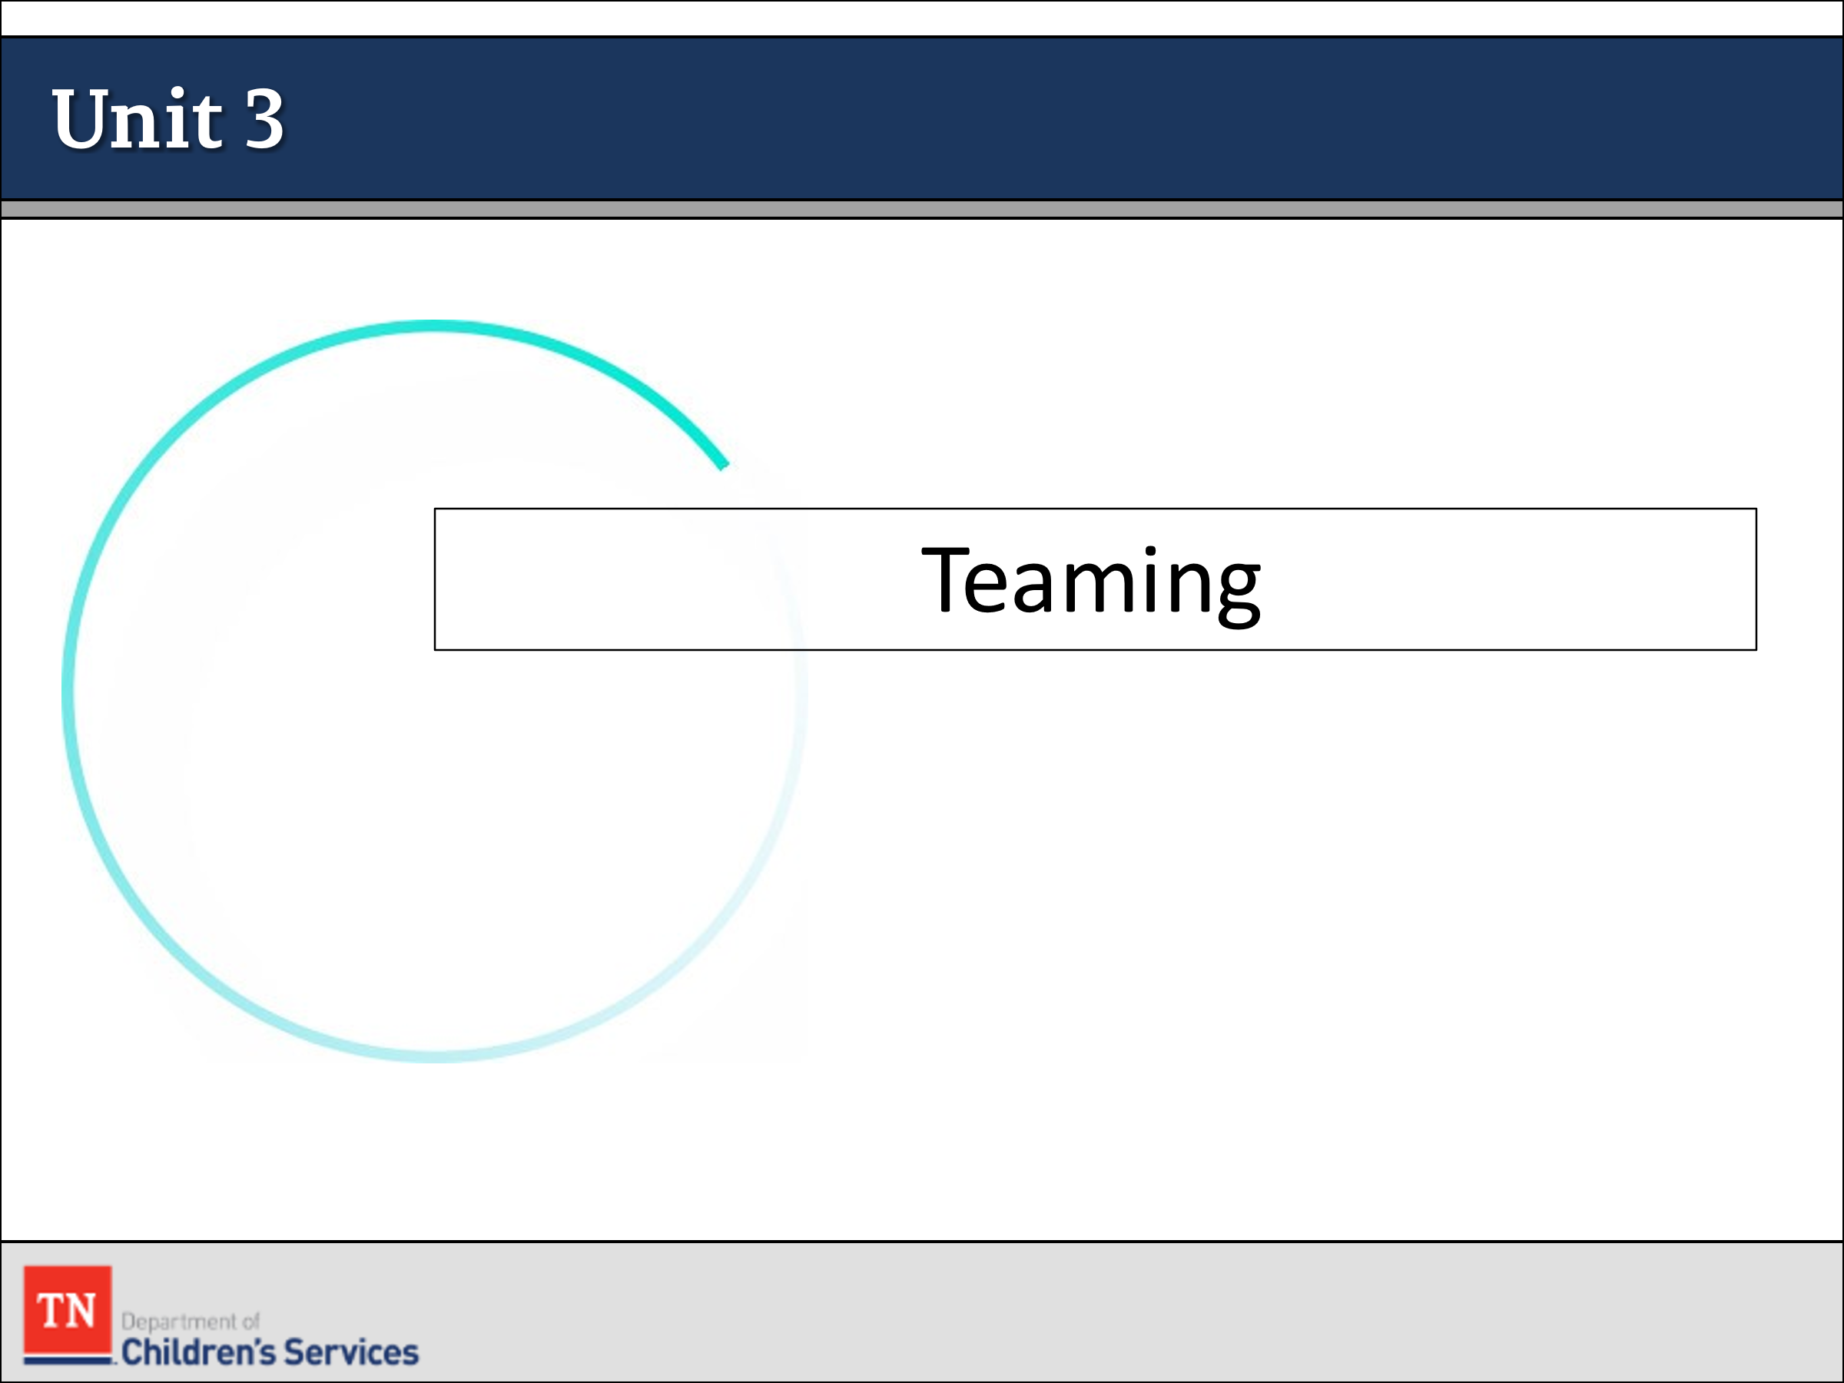
Supporting Materials:
- PowerPoint
- Family Assessment Worksheet
- Policies/Forms:
  - The Child and Family Team Meeting Guide
  - Work Aid: Child and Family Team Meeting Preparation Tool-How DCS Workers Can Help Prepare Families for the Meeting
  - Work Aid: Child and Family Team Meeting Tool-Preparing the Facilitator
  - Child and Family Team Meeting Flyer
  - What Youth Should Know About a CFTM Flyer
  - Genogram Contacts Sheets CS-0774 and Family Eco-Map CS-0782
  - DCS Policy 31.9 Conducting Diligent Searches
  - DCS Policy 16.2 Multi-Ethnic Placement Act
  - DCS Policy 16.24 Children of Native America Heritage
  - Guide to Placement Exception Categories
  - Placement Exception Request CS-0664
  - DCS Policy 16.8 Responsibilities of Approved Foster Homes
  - Assessing Potential Relative Placements Handout
  - DCS Policy 16.3 Desired Characteristics of Foster Parents
  - DCS Policy 16.4 Foster Home Selection and Approval
  - Disclosure of Legal Permanency Options for Relatives and Kin Video
  - DCS Policy 16.43 Supervised/Unsupervised Visitation between Child-Youth, Family, and Siblings
  - DCS Policy 16.46 Child/Youth Referral and Placement
  - DCS Policy 16.20 Expedited Custodial Placements
  - Visitation Guide
  - CS-0594 Visitation Observation Checklist
  - CS-4221 Visitation Working Agreement
  - Visitation Plan Work Aid
  - Developmentally Related Visitation Activities Handout
  - Guidelines for Arranging Family Visitation Handout
  - Assessing Potential Relative Placements Handout
  - Parenting a Child who has experience Trauma Handout
  - How to Prepare Families and Children for placement Handout
  - CS-0565 Daily Rate Child Placement Contract between DCS and Foster Parents Approved to Provide Temporary Care

Lesson 3.1: Building and Preparing the Team

Lesson Time: 45 minutes
Key Teaching Points / Instructions

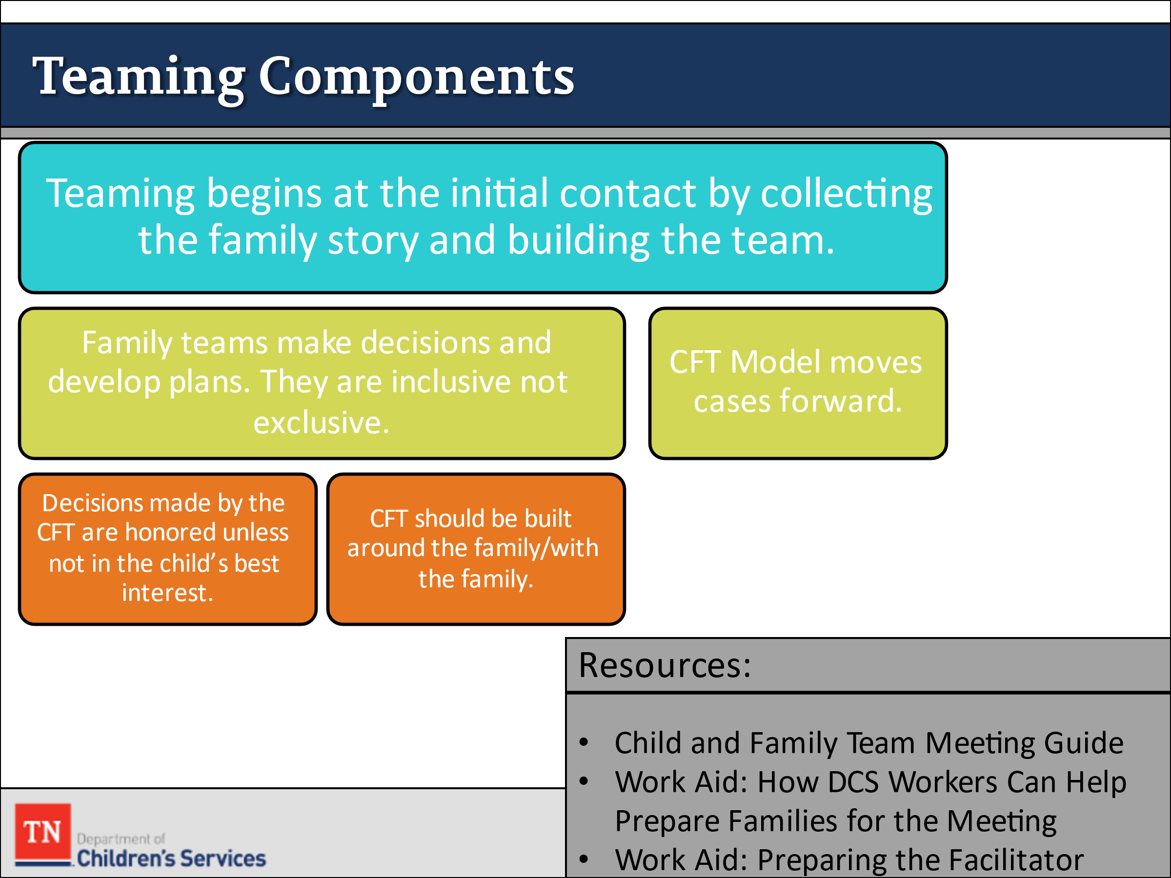
- INTRODUCE the lesson by stating the importance of teaming from the transfer of the case from CPS and how teaming begins at the initial visit and throughout the life of the case.
- REMIND participants we use teams to make decisions and develop plans with families. We are inclusive rather than exclusive. We value and respect the voice of all involved.
- REMIND participants of the CFTM Guide and POINT OUT the Work-aids for their review as they will be discussed more thoroughly shortly.
  - The Child and Family Team Meeting Guide
  - Work Aid: Child and Family Team Meeting Preparation Tool-How DCS Workers Can Help Prepare Families for the Meeting
  - Work Aid: Child and Family Team Meeting Tool-Preparing the Facilitator
- REMIND participants the purpose of the Child and Family Team model is to ensure that families and their support systems are engaged in the planning and decision-making process throughout their relationship with the Department. The Child and Family Team is built around the family and focused on working toward the child/youth and family’s goals.
- STATE the Department’s intent is to maintain the integrity, structure, and decision-making authority within the Child and Family Team. Decisions or recommendations made by the Child and Family Team are honored and followed unless those decisions or recommendations are not in the best interest of the child/youth.
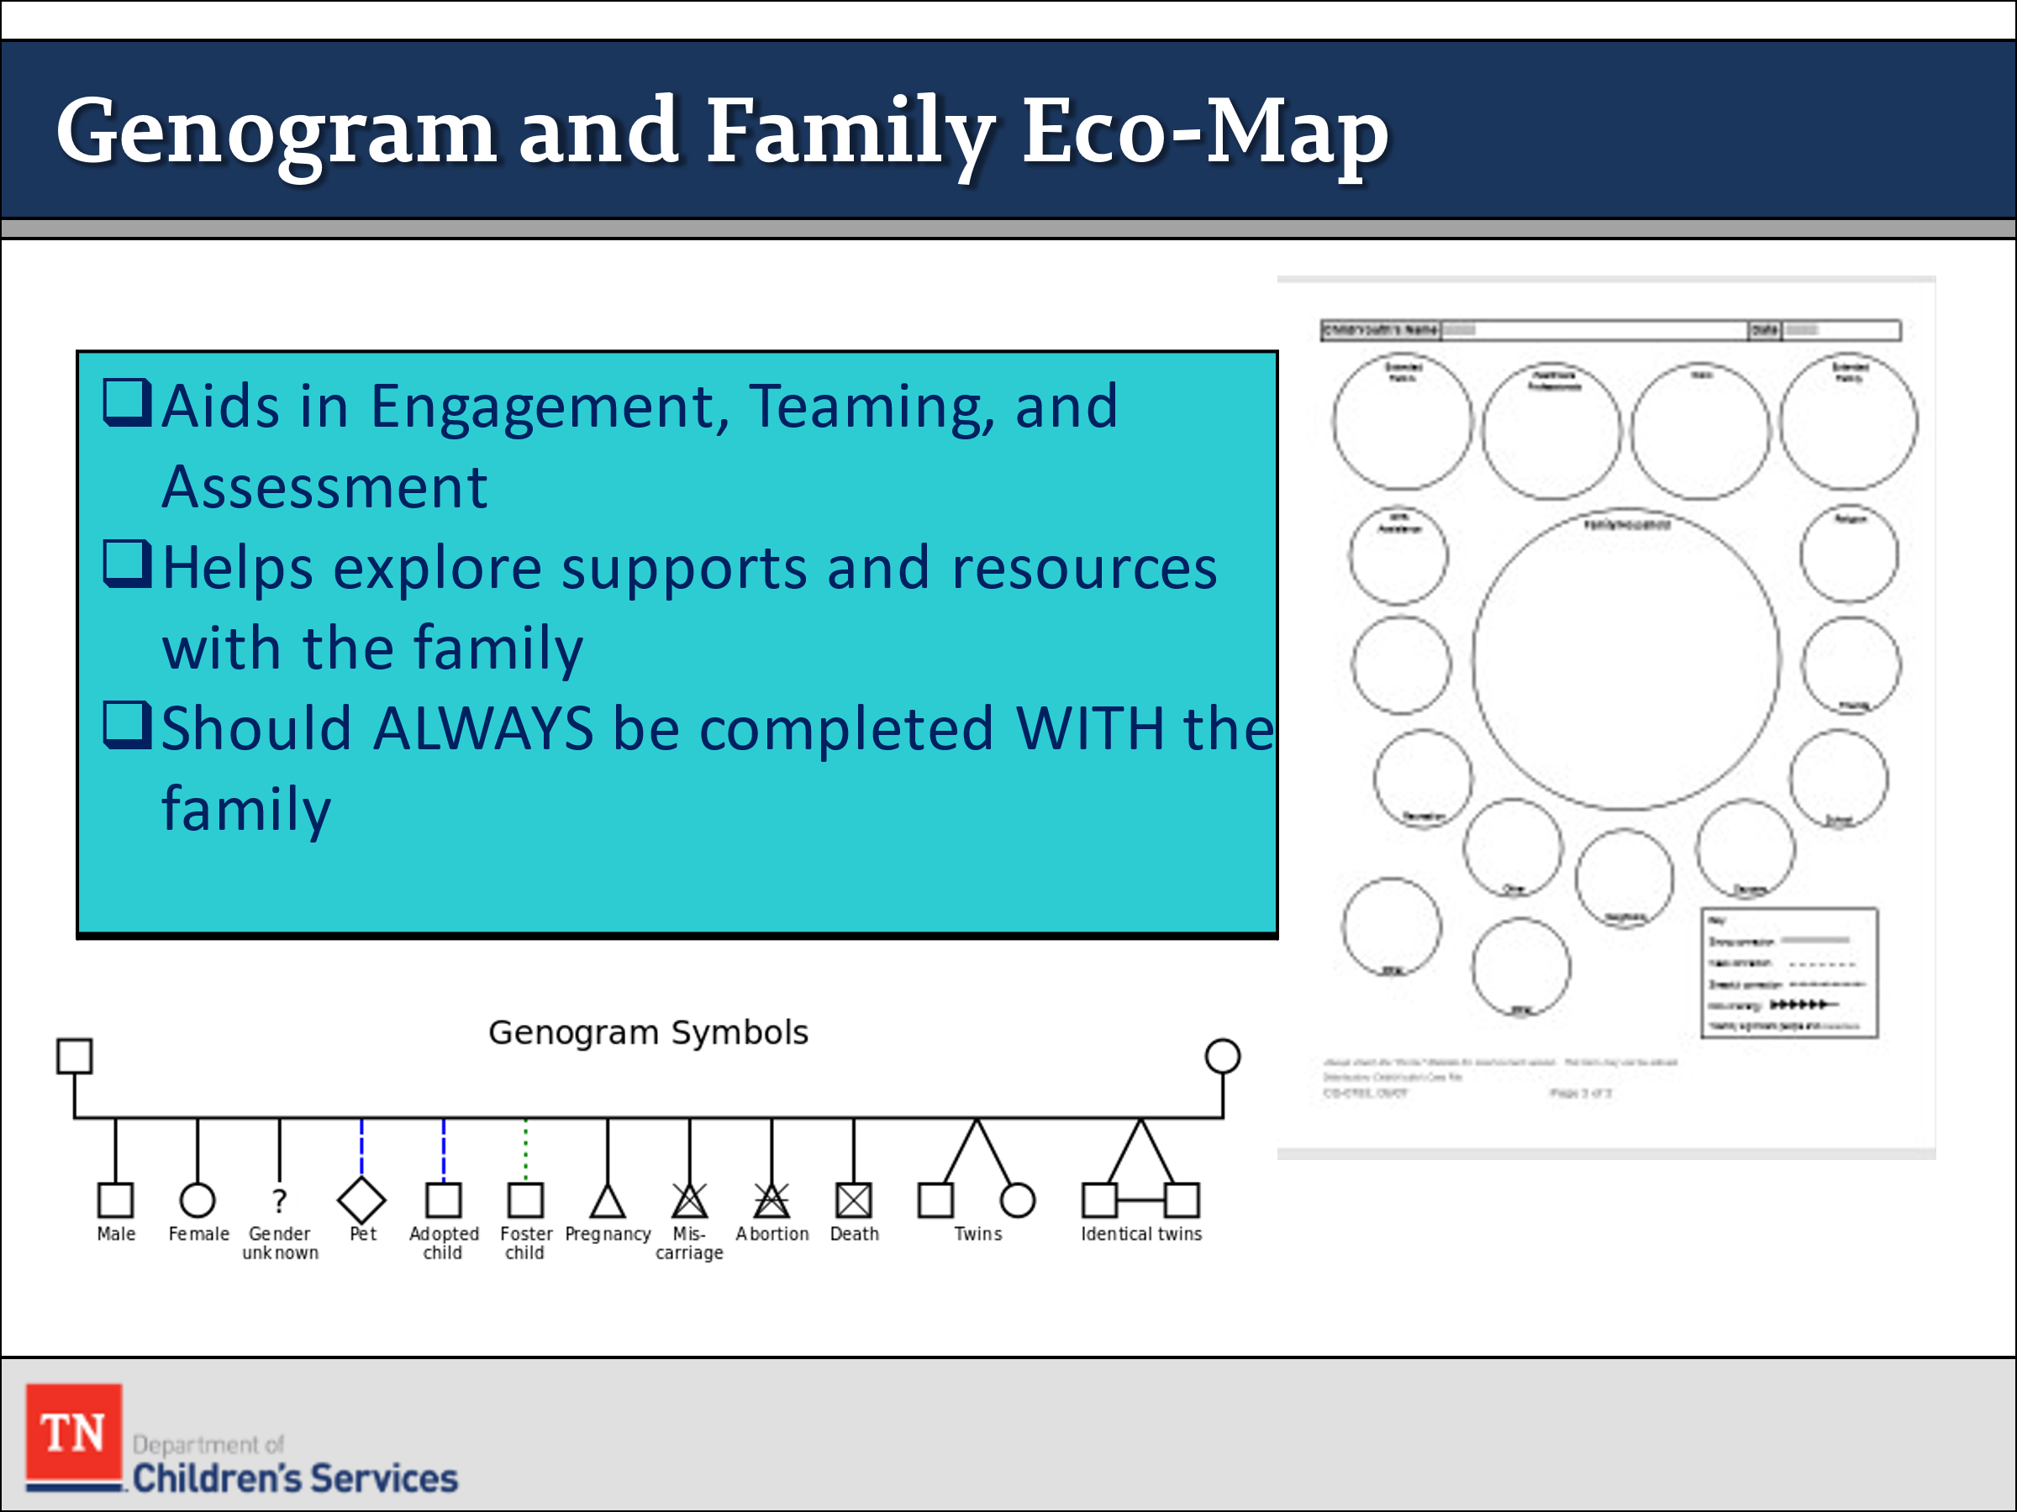
- ASK participants if they have observed the use of a Genogram or Eco-Map in the field. EXPLAIN when properly used they aid us in Teaming and Assessment. The use of the Genogram and Ecomap will allow the case worker to explore supports with the family and to begin developing the team with the family. It is the families’ team, and they have a voice in who is on their team. STRESS the Genogram and Ecomap should ALWAYS be completed with the family.
- DIRECT participants to the Genogram (CS-0774) and Family Eco-Map Contact Sheets (CS-0782) on the Forms and Documents link: https://www.teamtn.gov/dcs/forms-and documents.html
- STRESS the importance of building the right team with the family will help support them long-term and hopefully create a safety net that can help the be successful outside of the involvement of DCS.
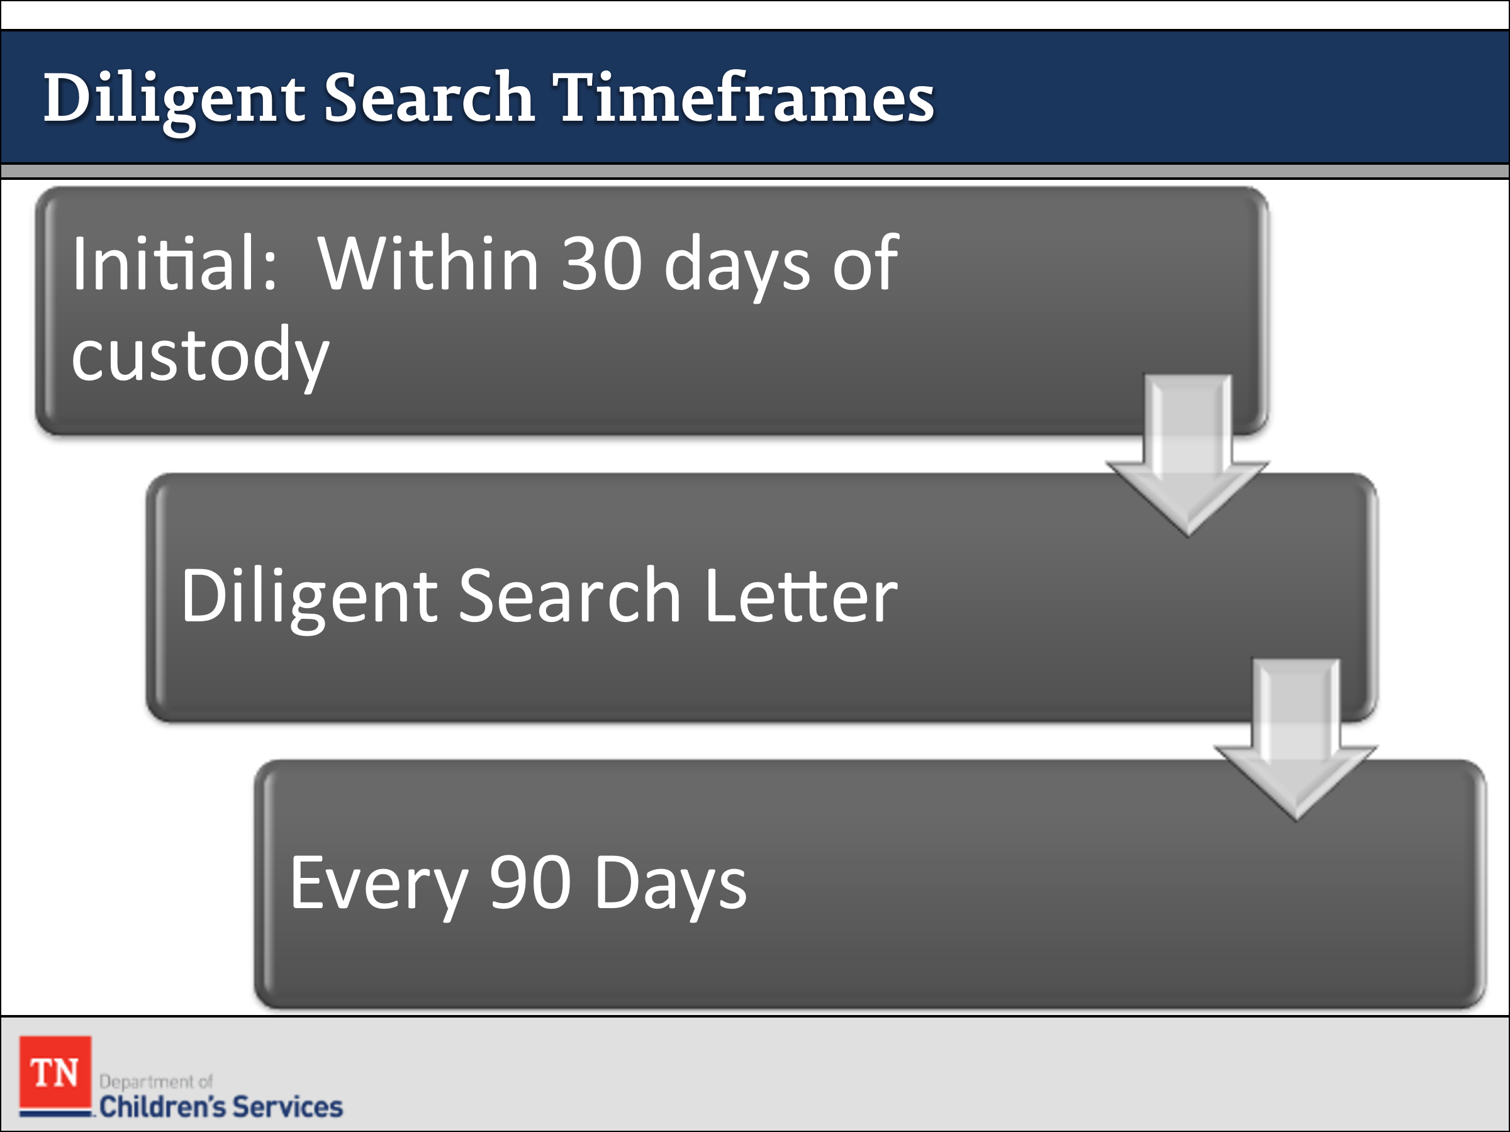
- REMIND the group of the importance of Diligent Search. STATE it is imperative to conduct diligent search efforts on an on-going basis.
  - FSWs will complete the initial diligent search within the first 30 calendar days of the custodial episode.
  - The FSW has the responsibility of notifying all identified relatives/kin from the initial diligent search. Exceptions to reporting include relatives/kin who have participated in a prevention CFTM which ended in a removal and is clearly documented in a case recording or CFTM Summary.
  - The Diligent Search Letter can be used to document the worker’s attempt to notify relatives.
  - Diligent searches are completed within ninety (90) calendar days of the last search and continue throughout the life of the case.
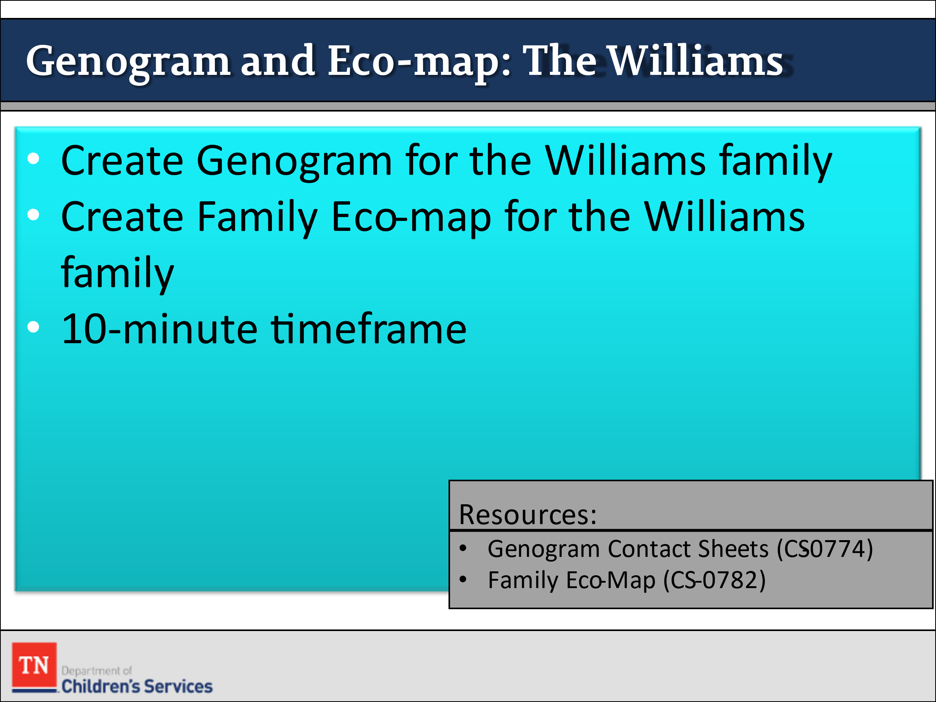
- CONDUCT ACTIVITY: Williams Genogram and Eco-map
- DIVIDE the class into two (or more) small groups. EXPLAIN that one group will complete a Genogram and the other group will create an Eco-Map of the case family based on the information available thus far. INSTRUCT the group members to elect a spokesperson to present their pictorial to the rest of the class. ALLOW 10 minutes for work. ASK each group to present their pictorial tool. BRAINSTORM with participants who would be on the Genogram and Ecomap for the Williams family if not already presented to include.
  - Genogram - Renee, Ariana, Jewel, Justin, Mr. Williams, and Paternal Grandmother Rose. EXPLORE with the group about Ariana’s father (make no assumptions, we must get a copy of the death certificate) and Frank’s inclusion on the Genogram.
  - Ecomap - Frank, Renee, Ariana, Jewel, and Justin are in the center. They may have a circle for paternal Grandmother, Pastor, School, DCS, Family Center, Neighbors, Extended Family, Friends, Landlord, etc.
- REMIND the participants these pictorials should be updated whenever new information becomes available, but they should be created early in the case process. EXPLAIN bringing these documents to Child and Family Team Meetings is important.
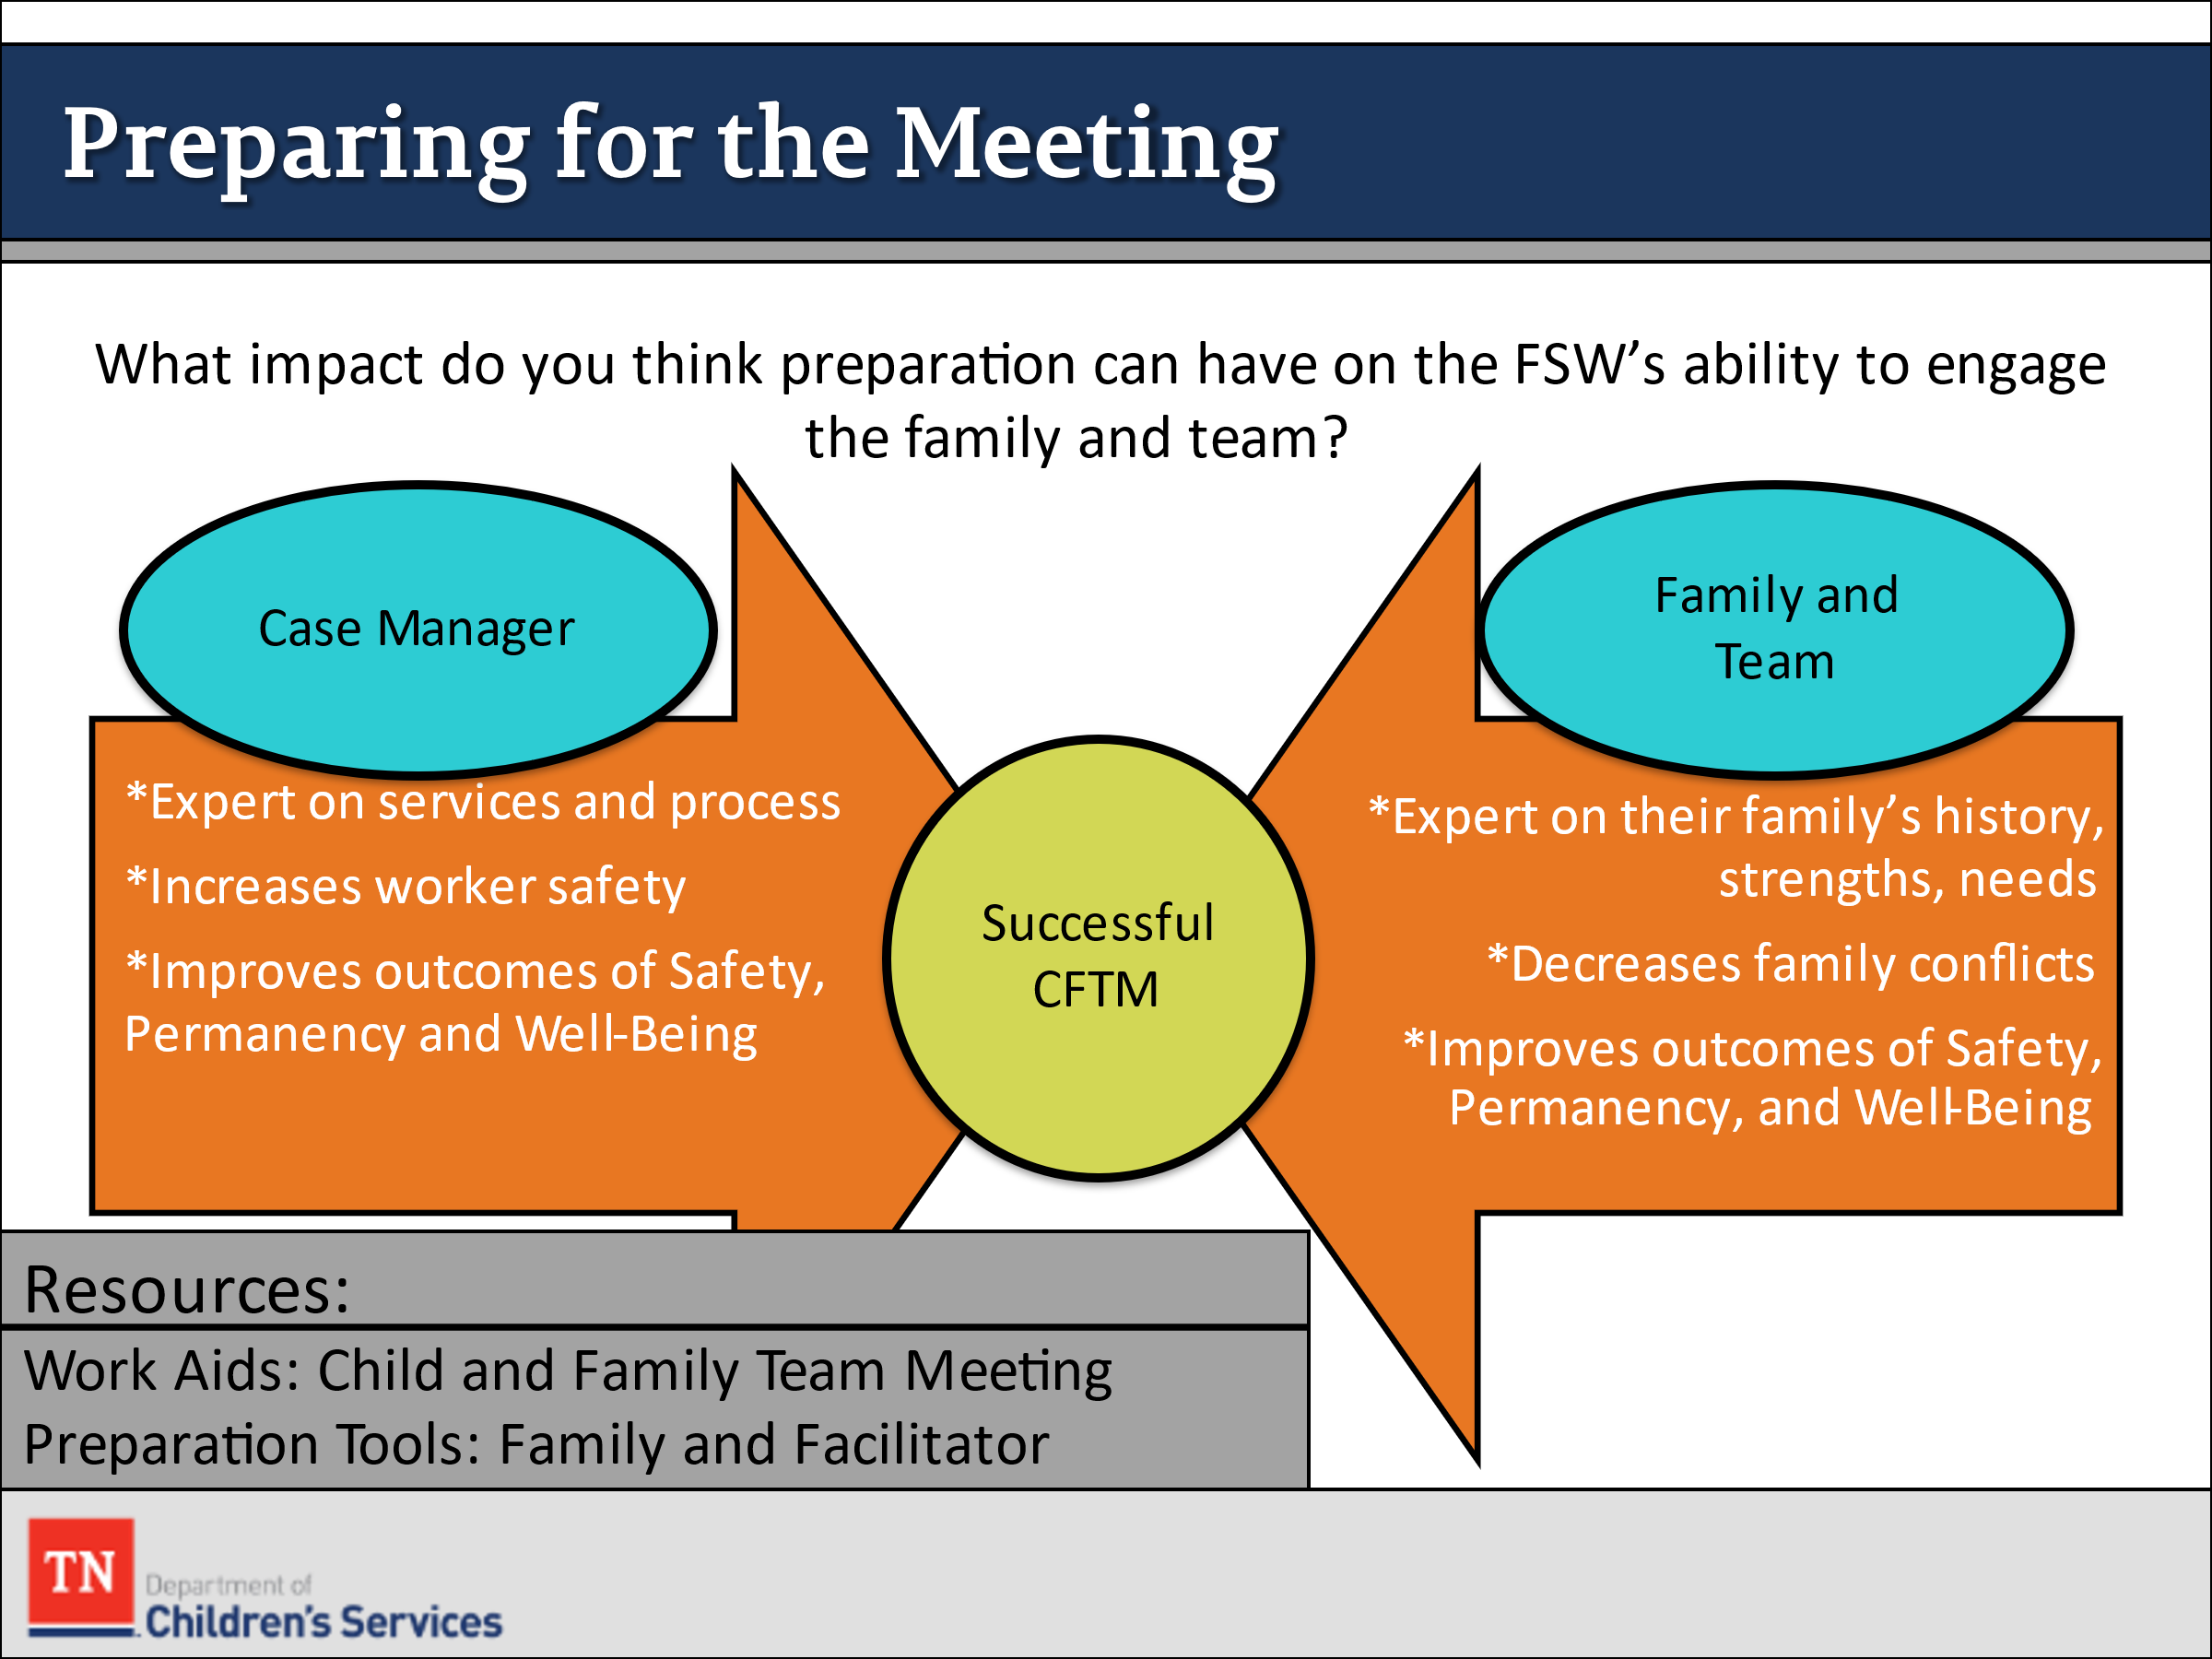
- INFORM participants once we have helped the family identify who will be on the team, we will then prepare them for what being part of the team entails.
- TRANSITION by asking “What impact do you think preparation can have on the FSW’s ability to engage a family?”
- EMPHASIZE being prepared can help build trust because the family recognizes you as a reliable source of information and thorough preparation can allow the FSW to concentrate on listening to the family.
- POINT OUT preparation can also help the FSW be aware of and plan for any issues that could potentially affect his or her safety. ALSO, in all cases, time is of the essence, the longer we take to get a case moving forward the longer a family is separated. We also want to make sure that any resources and services are discussed so there is not a gap in service.
- STRESS being prepared does not mean they are now the experts on what the family needs or “how to fix” the issue. Case Managers would be the expert in the DCS process, not on the family. For this reason, engaging and building the team with the family is crucial to work through the case and to fulfill the outcomes of Safety, Permanency, and Well-being.
- SHOW participants the Work Aid: Child and Family Team Meeting Preparation Tool-How DCS Workers Can Help Prepare Families for the Meeting and briefly DISCUSS the steps with the group. Link: https://files.dcs.tn.gov/policies/chap31/WACFTMPrepFam.pdf.
- REVIEW the Child and Family Team Meeting Flyer and What Youth Should Know about a CFTM Flyer. Inform participants these flyers can also be helpful in explaining the CFTM process to families.
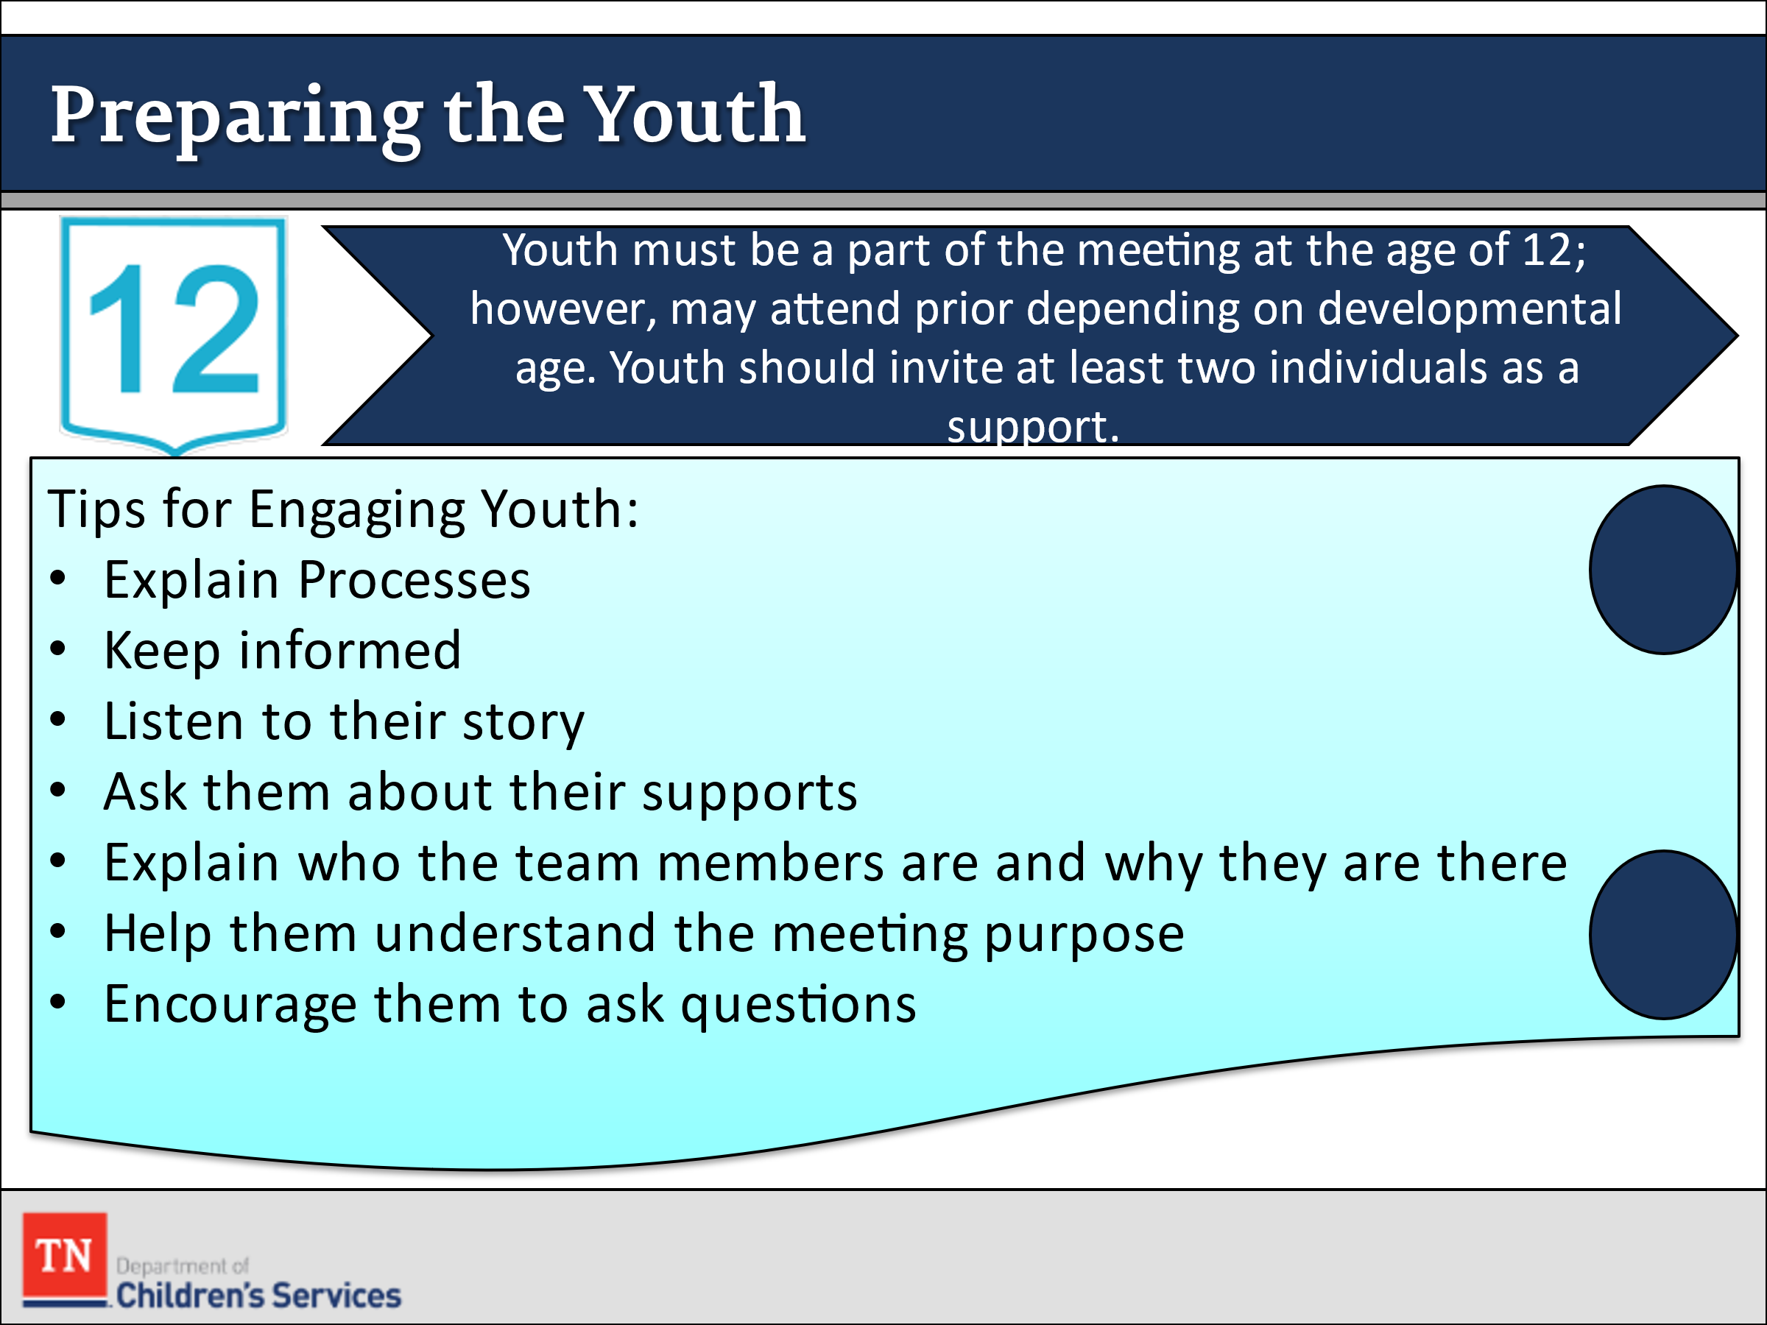
- SHARE it is important to have a script and to practice having these discussions prior to having the conversations with families. It is crucial that families understand the importance of teaming and confidence in the CFTM process. The more prepared you are to have the conversation the more trust there will be in the process.
- INFORM participants that along with engaging the family and preparing them for the CFTM it is equally important to do the same with the youth. Youth start to be part of the meetings at age 12. At times, younger children may take part in some sections of the meeting.
- SHARE we want to make sure we remain developmentally appropriate in our interactions with children and youth. SHARE some of these tips for engaging youth in the case process:
  - Make sure that you explain processes before sharing them
  - Keep youth informed of what is going on
  - Listen to their side of the story
  - Ask them who they see as a support and see if they want them to be included in meeting
  - Inform the youth of whom and why each member of the team is at the table
  - Make sure they know the purpose of each meeting
  - Encourage youth to ask questions when they are unsure
  - It is important for you to seek the youth’s understanding, of what is being said and to clarify anything they may not.
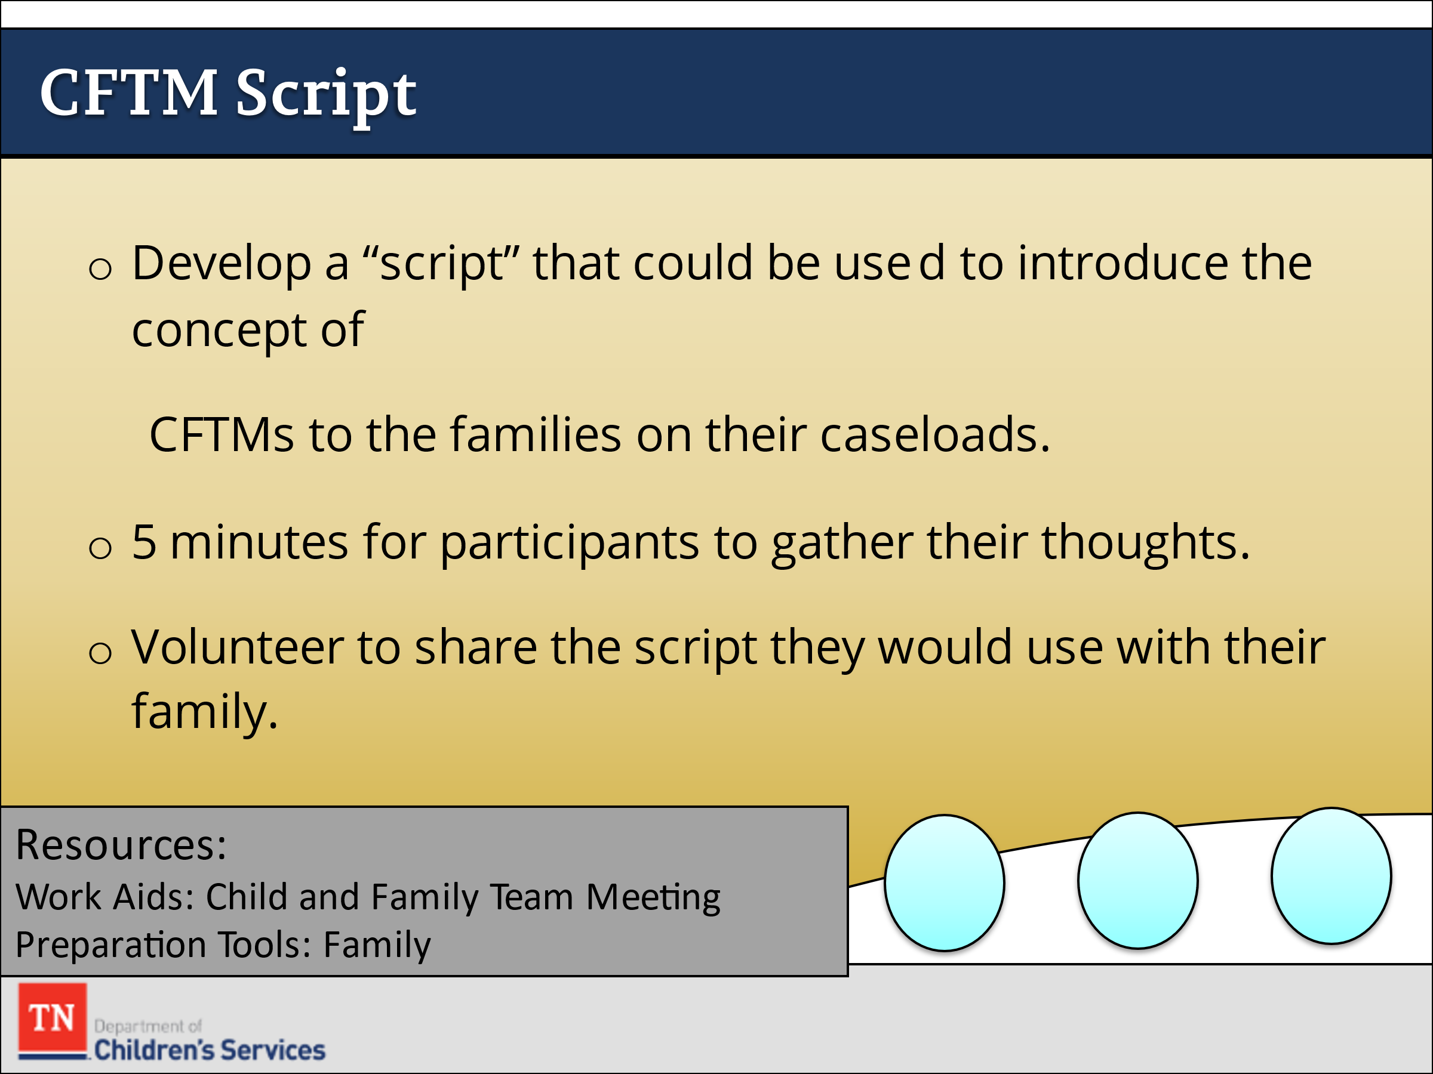
- CONDUCT ACTIVITY: CFTM Script
  - ASK participants to develop a script they could use to introduce the concept of CFTMs to the families on their caseloads.
  - ALLOW 5 minutes for participants to gather their thoughts. After the allotted time, ASK if anyone would volunteer to share the script they would use with their family.
  - THANK participants who are willing to volunteer and ask if anyone has any questions.
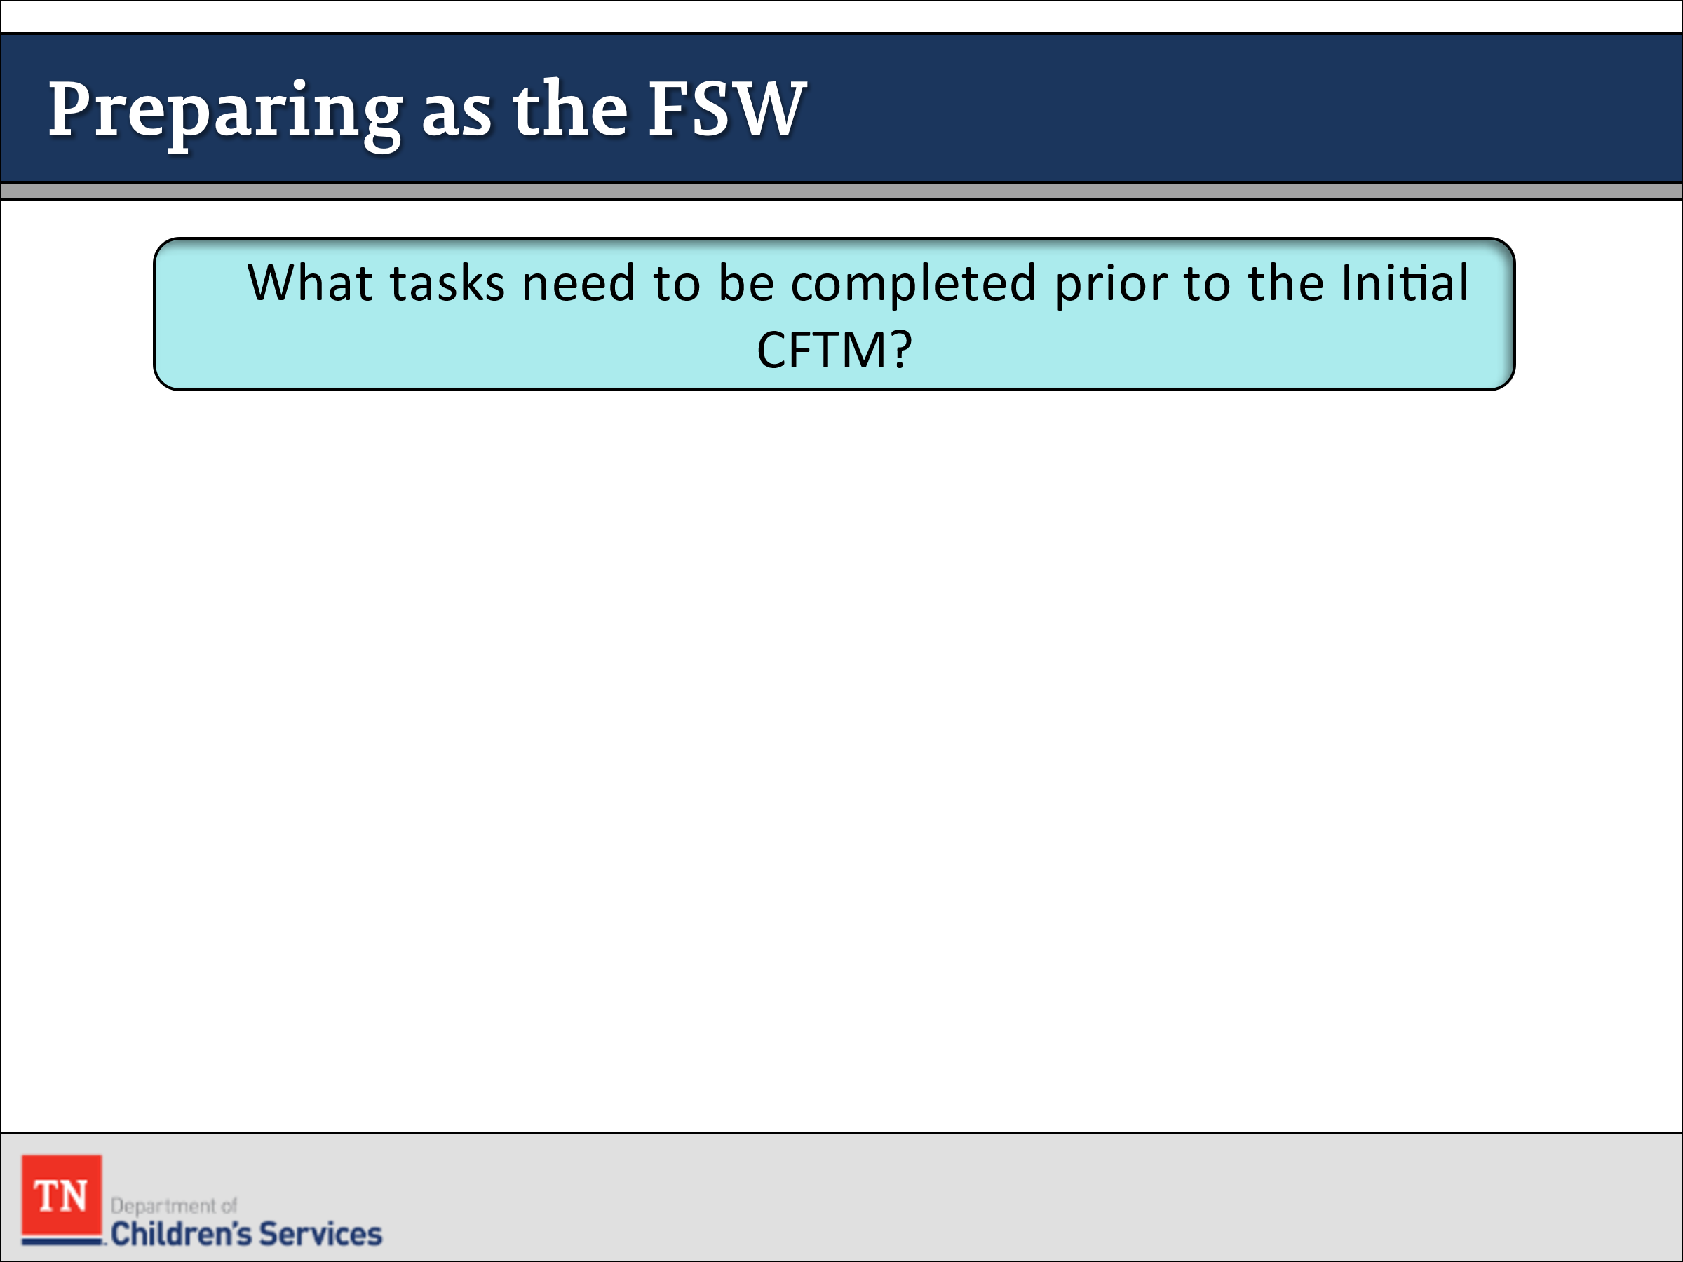
- ENGAGE participants in a discussion of the FSW tasks to be completed before the initial CFTM. Answers may include:
  - Complete diligent search if needed
  - Bring complete genogram
  - Invite parents, TL, Facilitator, CPS, foster parents, GAL, parents’ attorneys, and any other parties
  - Find a location that is comfortable for the family, but large enough for the team
  - Case conference with your supervisor
  - Brief case with Facilitator if needed
  - Review records
  - Make sure CANS is completed, and approved
  - Child and Family Team Meeting Summary (Form 0747 under Forms and Documents)
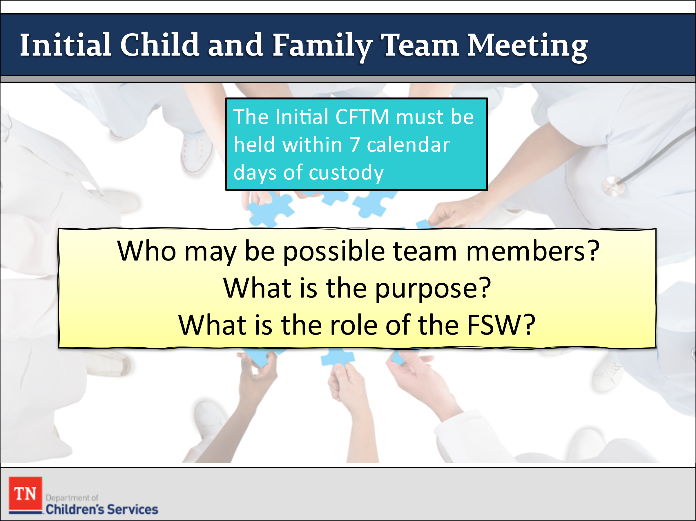
- ASK participants if anyone has observed an Initial Child and Family Team Meeting?
- SHARE the initial CFTM must be held within 7 calendar days of the child(ren) entering custody. REFER participants to the Initial Custody CFTM on page 35 in the Child and Family Team Guide and ask them to review. ASK participants who may be possible team members? What is the purpose of the Initial CFTM, and when should the meeting be held?
- ASK what is the role of the FSW in the Initial CFTM? REMIND participants of the importance of supporting the family in identifying supports.
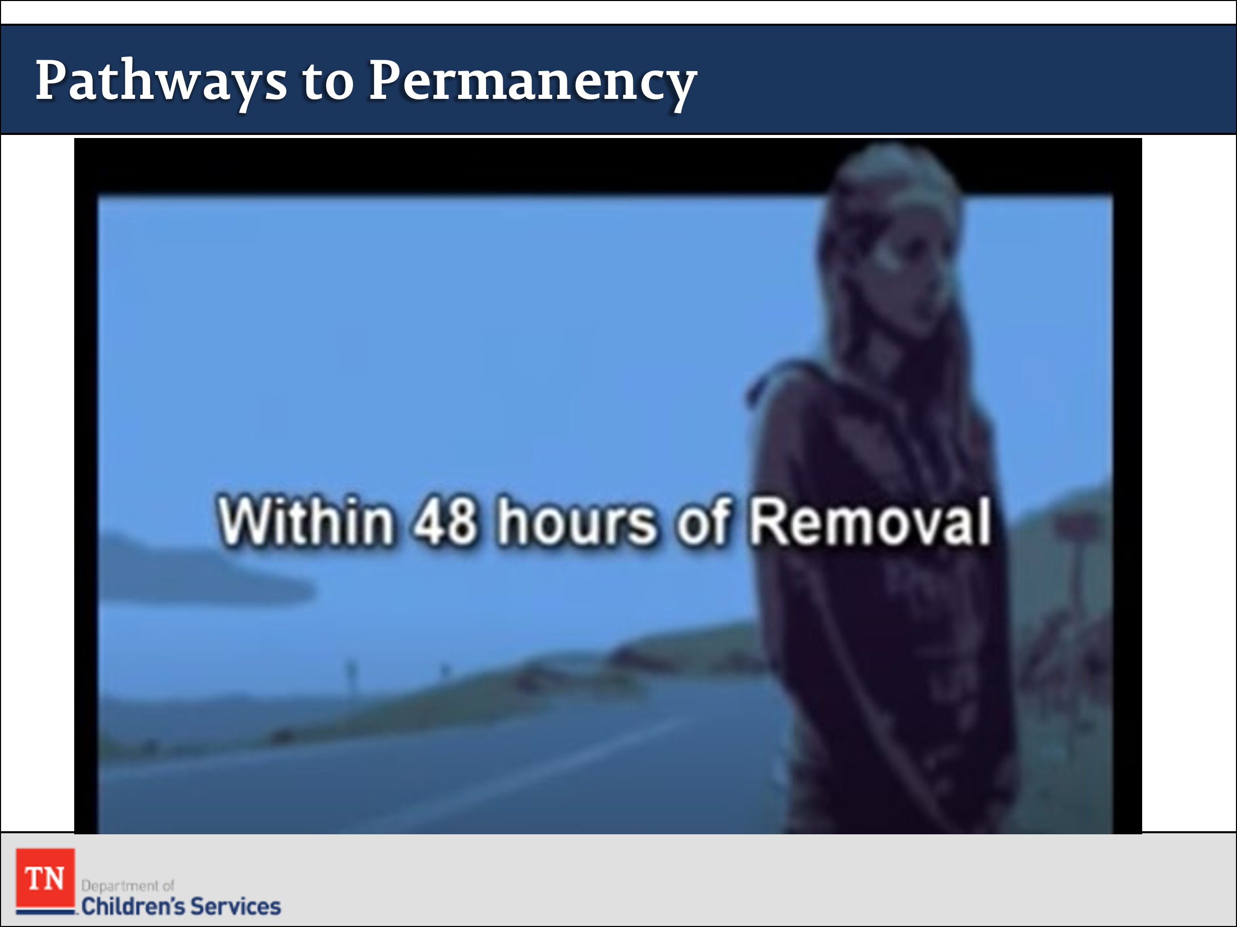
- INTRODUCE the activity by explaining that participants will now view Scene 2—Initial CFTM on the Pathways to Permanence DVD. ASK the group to summarize what has happened with Renee’s family to date. EXPLAIN that it has now been 48 hours since Renee’s children were removed. START the Pathways to Permanence DVD at Scene 2—Initial CFTM. From DVD 00:10 until 3:17 minutes or from link, 19:37-22:47 minutes (6:08 minutes total): https://www.youtube.com/watch?v=IQusnk6fN4M&feature=youtu.be&t=1374. The narrator previews the scene and explains what occurred in the initial CFTM, including the family strengths that were identified, the concerns that were raised by team members about Frank’s threatening behavior and Renee’s drug use, and the decision to contact Grandma Rose to explore whether she could provide care for all three children.
- REMIND participants of the Child and Family Team Meeting Guide introduced in Unit One. REVIEW the time frames and purpose of the initial CFTM, on page 35 of the guide.
- TRANSITION into Custodial Placements.

Lesson 3.2: Custodial Placement

Lesson Time: 60 minutes
Key Teaching Points / Instructions

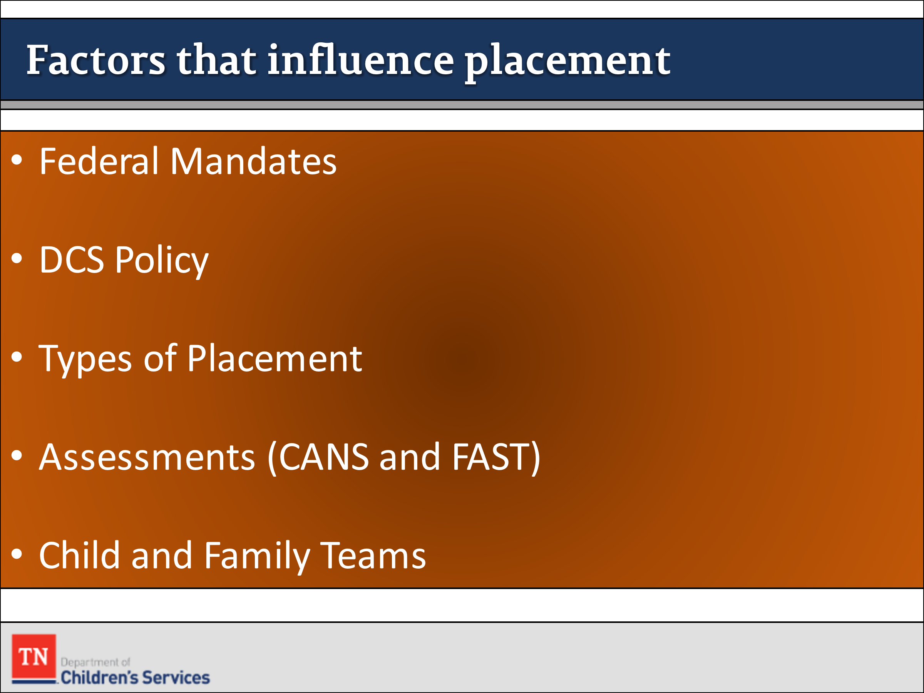
- ASK what is something, you would want others to consider if a child that you know on a personal level had to live with someone else?
- STATE there are additional factors that influence placement decisions such as:
  - Federal mandates
  - DCS policy
  - Types of placements
  - Assessments
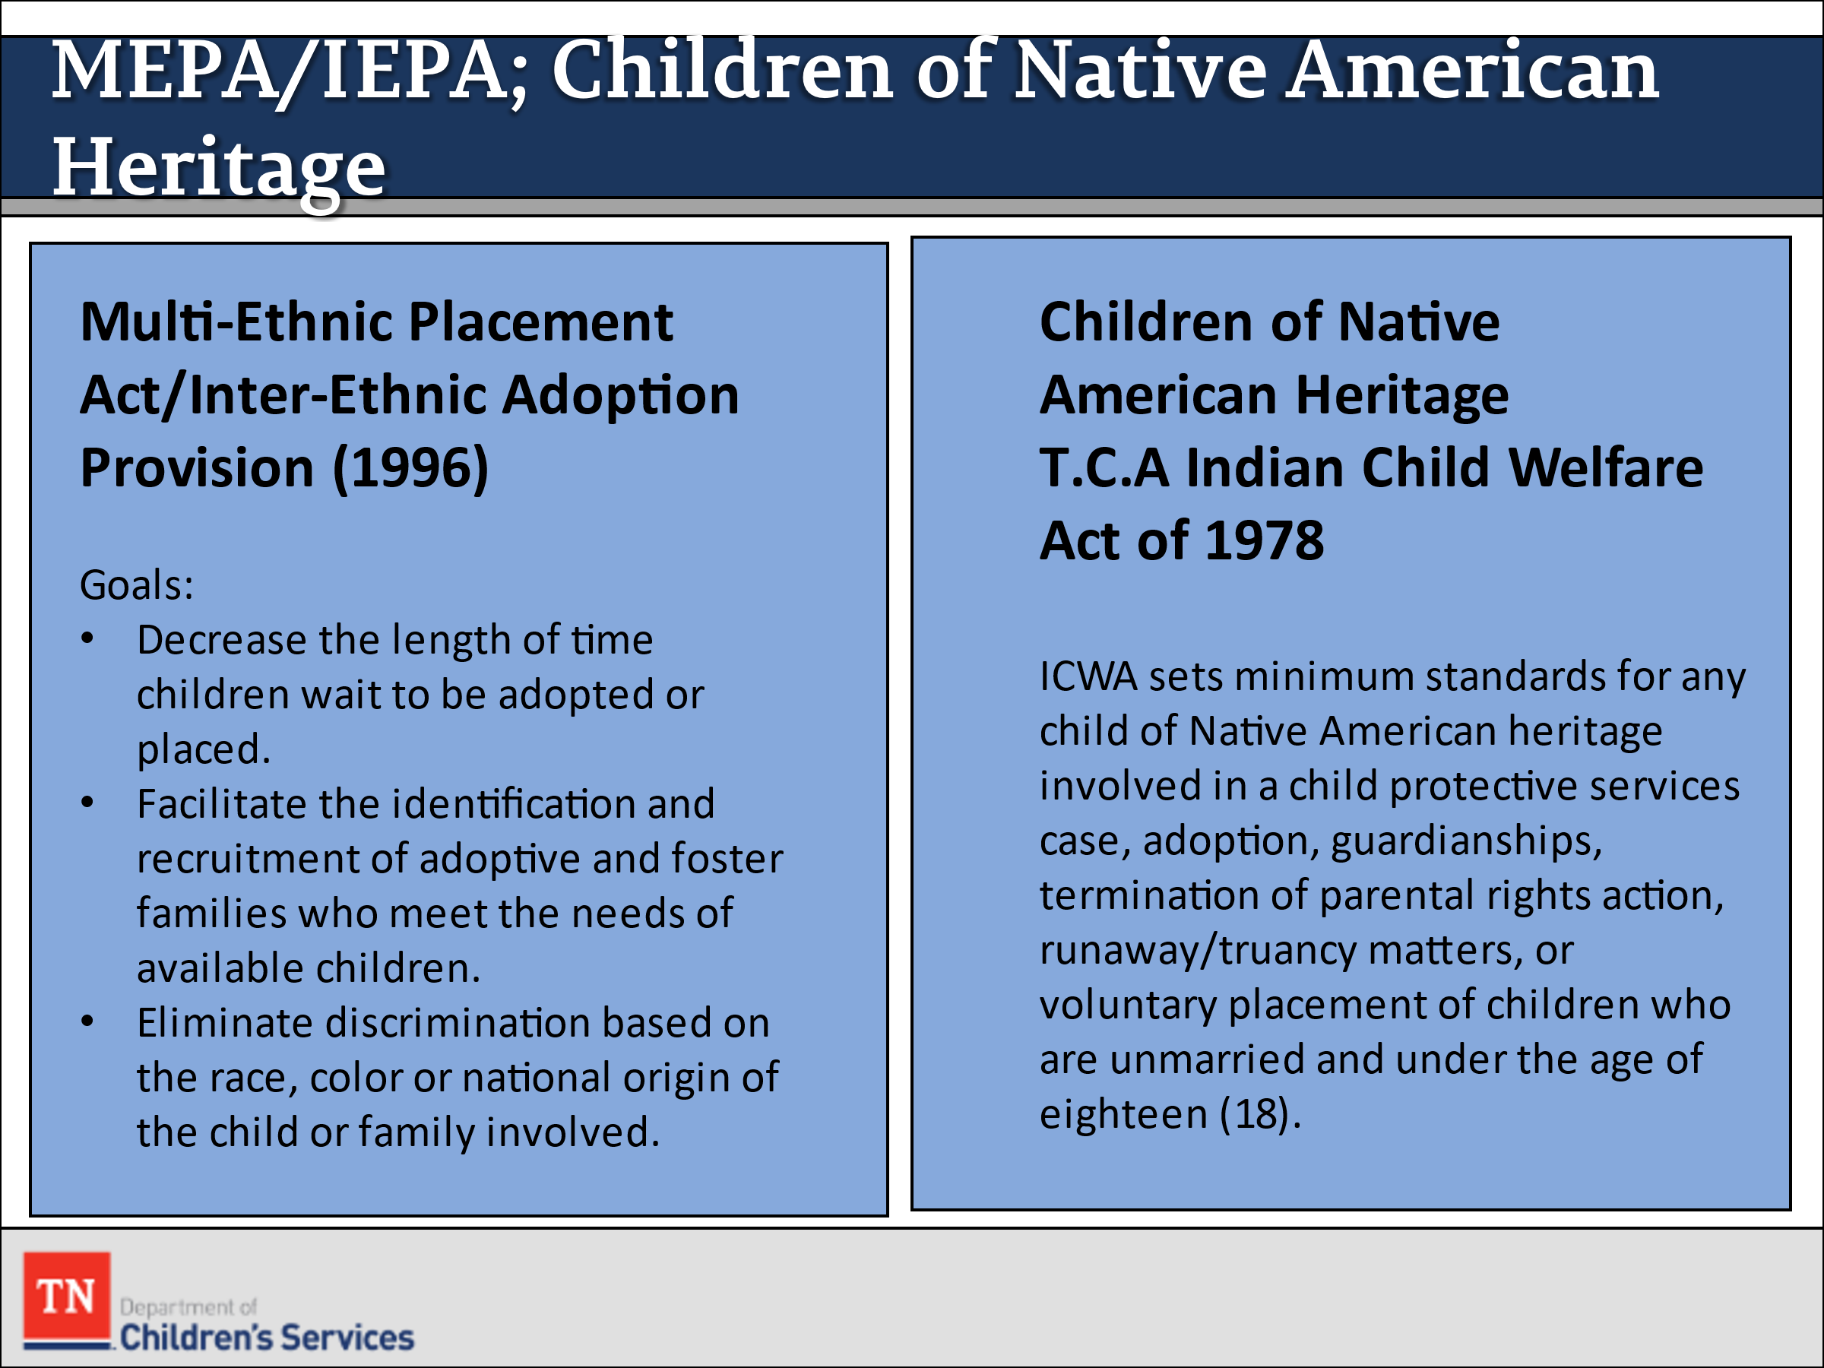
  - Child and Family Teams
- INFORM participants of the following federal laws that influence placement: Multi-Ethnic Placement Act/Inter-Ethnic Adoption Provision 1996 and Children of Native American Heritage. STATE the Bureau of Indian Affairs would be contacted to determine jurisdiction for these cases. REVIEW and ask if there are any questions.
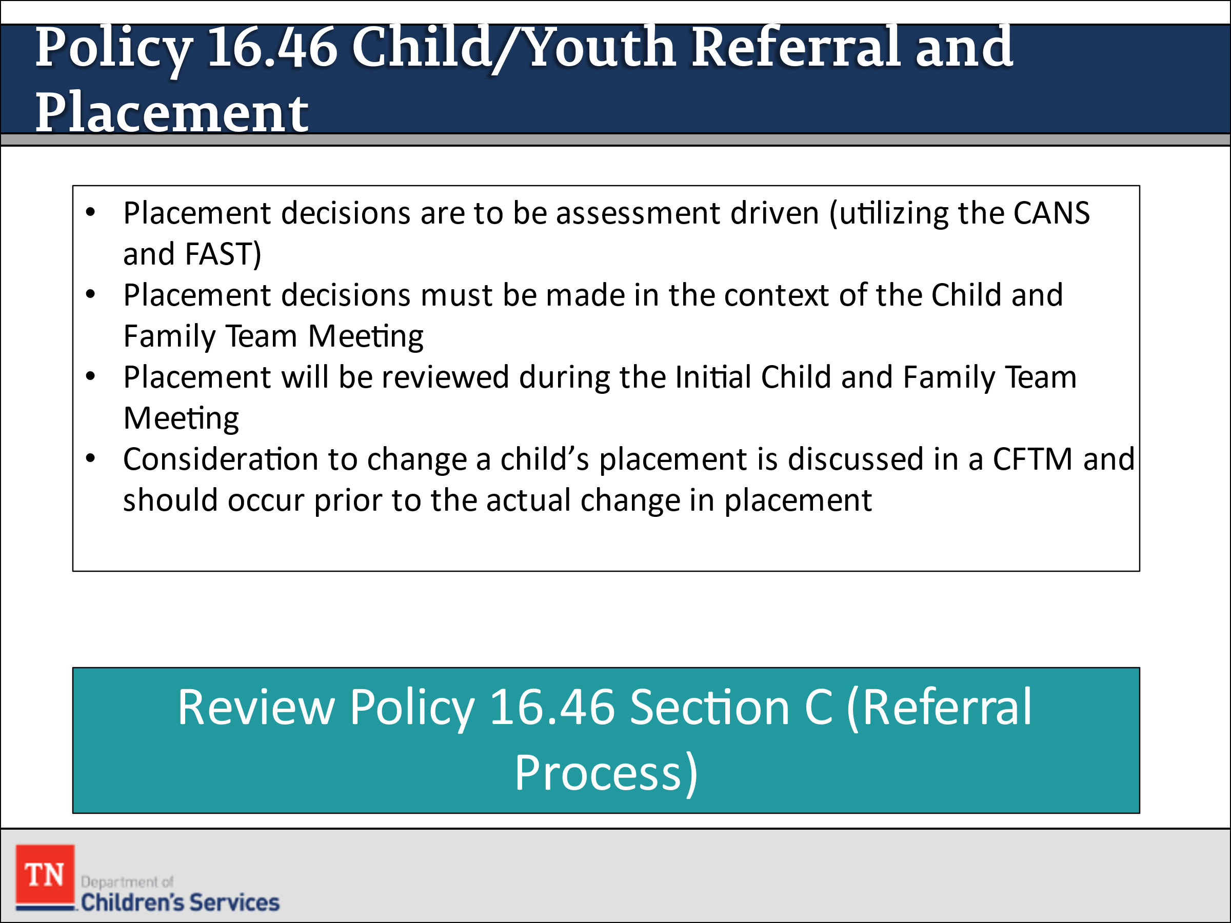
- REFER participants to Policy 16.46 Child/Youth Referral and Placement and STATE this policy along with the Contract Provider Manual gives direction to case managers and the Placement Services Division when placement is needed. SHARE DCS placements are made in a home-like, least restrictive setting that meets the unique needs of children/youth with respect to their community and school district. To the extent possible, these placements take into consideration the family, the child/youth, and the community’s safety.
- INFORM participants placement decisions are to be assessment driven (including utilizing the CANS and FAST) and made in the context of the Child and Family Team Meeting. ADVISE participants the child’s placement will be reviewed by the team during the Initial Child and Family Team Meeting. STATE consideration to change a child’s placement is also discussed in the context of a Child and Family Team Meeting and should occur prior to the actual change in placement, if possible.
- SHARE Policy 16.46 Section C also gives direction to the Referral Process. ASK participants to review Section C. DEBRIEF and ASK for questions or clarification. NOTE it is important to know who the Placement Services case managers are in the assigned region to ensure a good working relationship is cultivated.
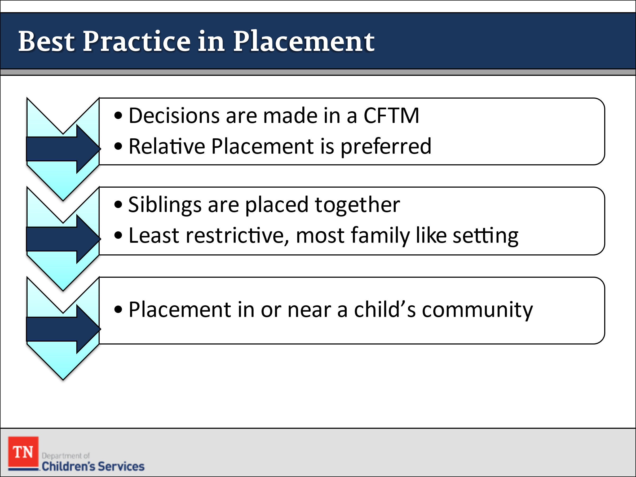
- SUMMARIZE the best practice approach to making placement decisions below:
  - Placement decisions are made within the context of the Child and Family Team Meeting
  - Relative placement is to always be considered first and is the most preferred placement option
  - Siblings are to be placed together
  - Placement is to be in the least restrictive, most family-like setting possible
  - Placement is to be in or near the children’s home community
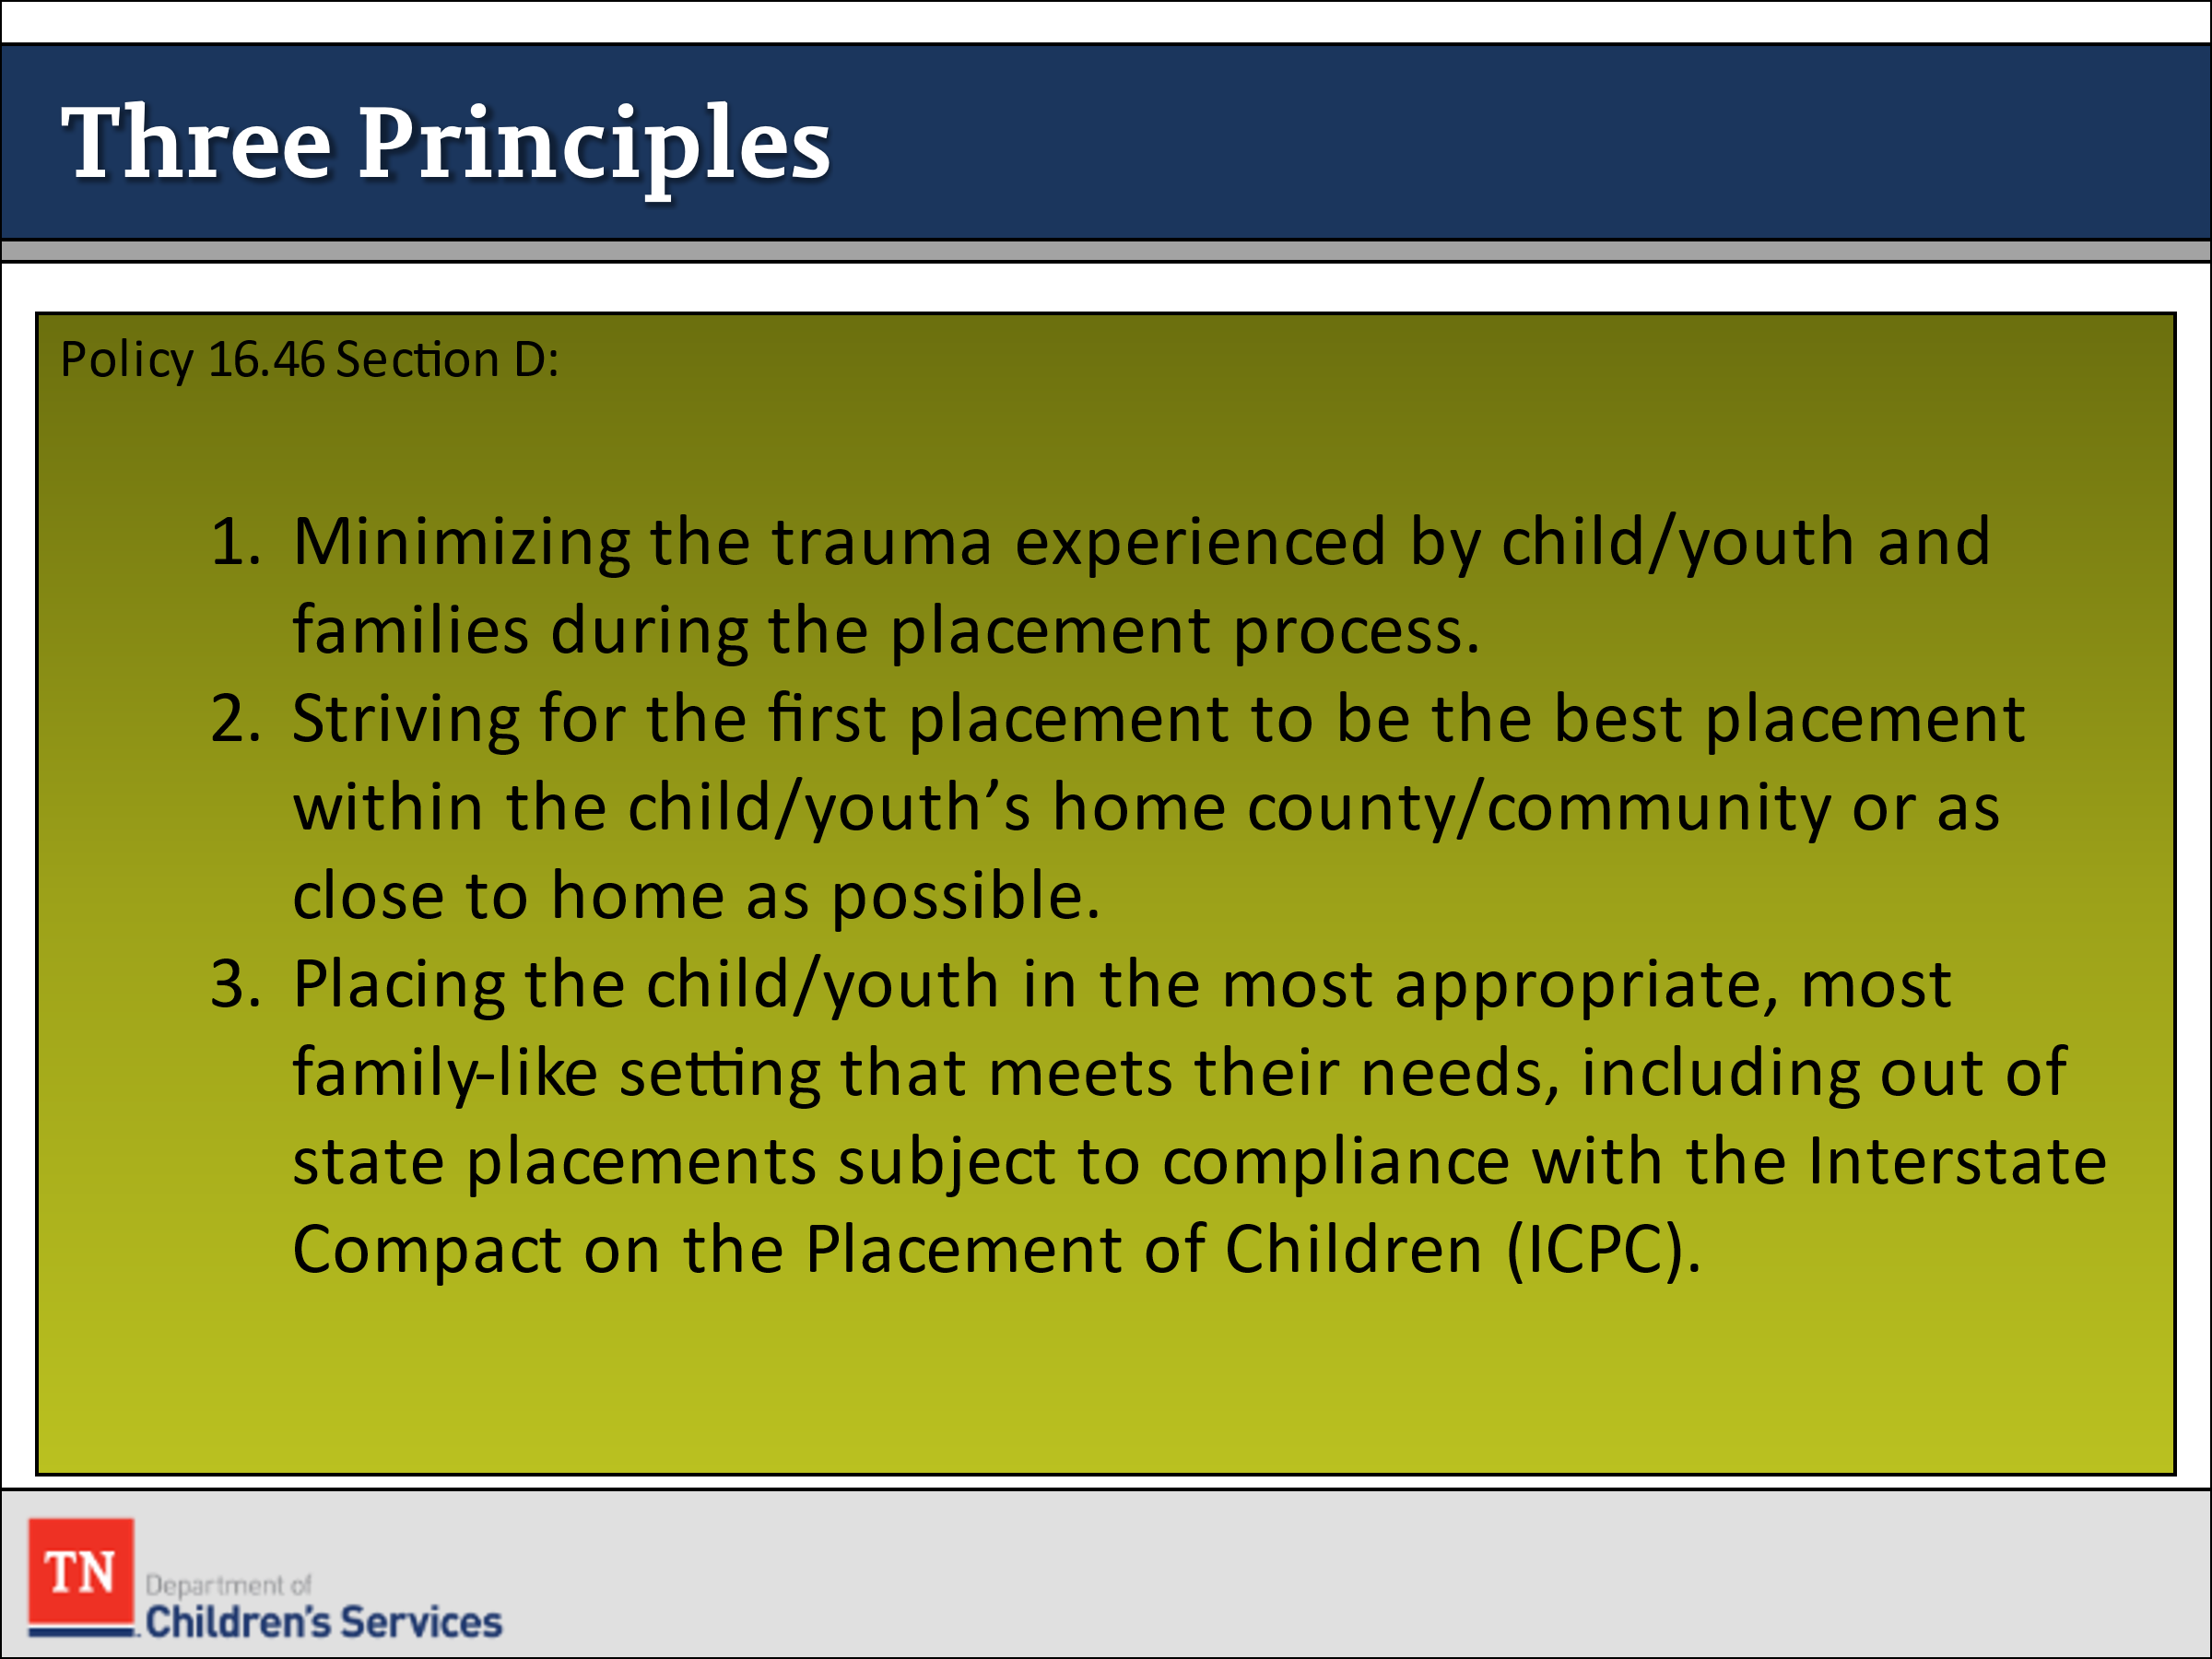
- STATE all placements on behalf of children and youth must consider the following three principles (Policy 16.46 Section D):
    - Minimizing the trauma experienced by child/youth and families during the placement process
    - Striving for the first placement to be the best placement within the child/youth’s home county/community or as close to home as possible
    - Placing the child/youth in the most appropriate, most family-like setting that meets their needs, including out of state placements subject to compliance with the ICPC (Refer to the Interstate Compact on the Placement of Children (ICPC) Practice and Procedure Manual)
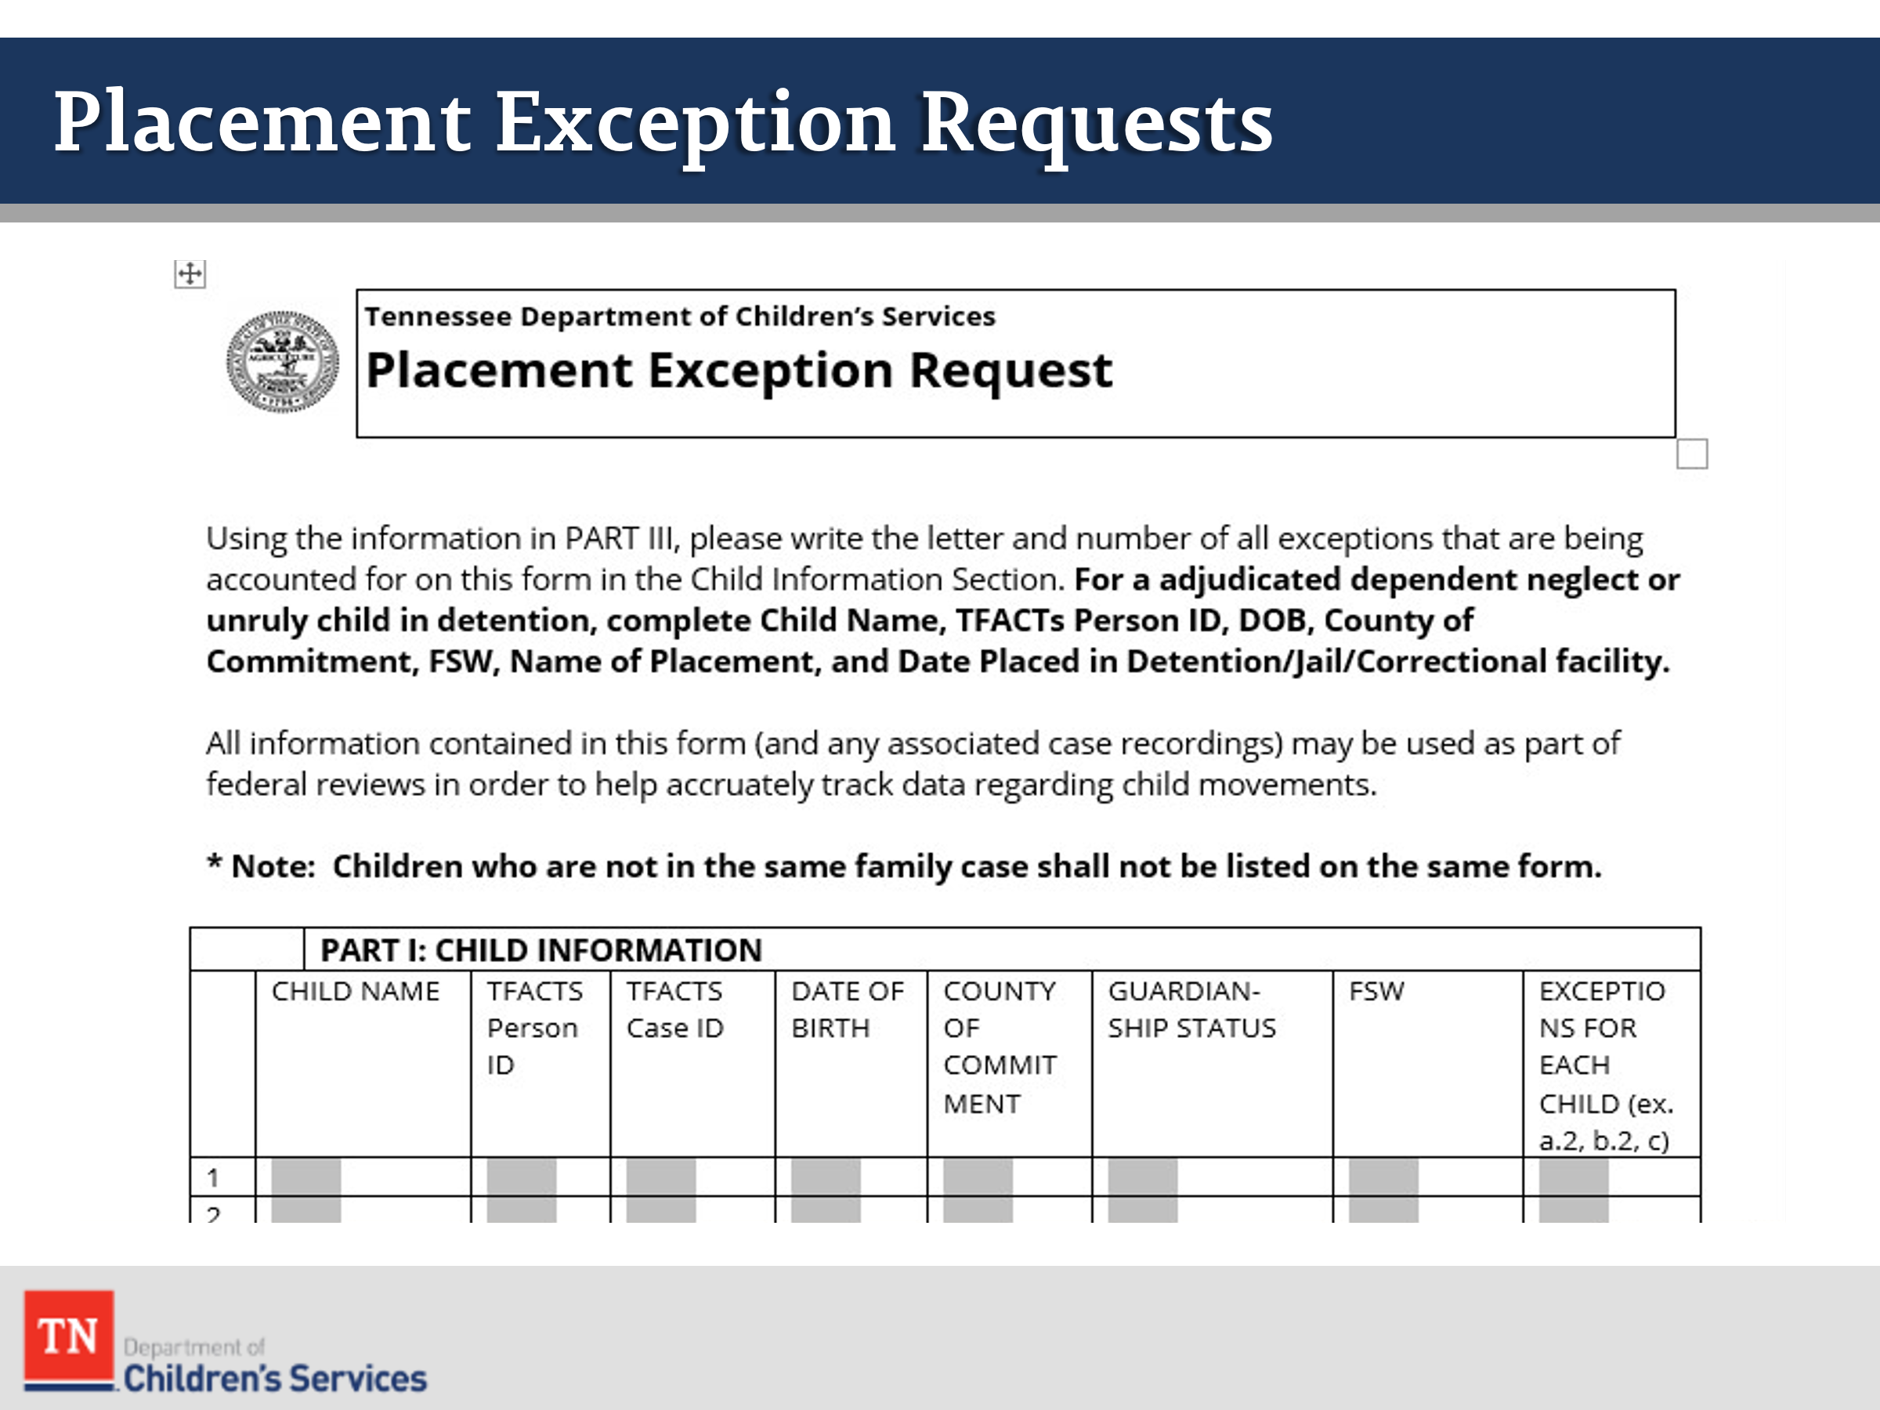
- ACKNOWLEDGE there may be times when an exception must be made to these best practice placement principles. ASK participants for examples of situations in which it might not be in the best interest of the children to place siblings together. OFFER the following examples if not stated by the group:
  - The dynamics of the relationship between the siblings is detrimental to one or all of the siblings
  - The special needs of one or more of the children would preclude any one family from meeting all the children’s needs
  - There is power/domination of one sibling over another
  - There is sexual acting out among siblings
  - There is a history of sexual abuse by one sibling with another sibling
- REFER participants to the resources which give direction to Placement Exception Requests (PERS): Policy 16.46 Section G, Guide to Placement Exception Categories, and the Placement Exception Request Form (CS-0664). HAVE participants review the Guide/Form and identify circumstances that warrant an exception request and note the justifications that are required.
- POINT OUT placement exceptions must be approved prior to the placement by the Regional Administrator/Regional Designee. The form must be completed and submitted to the Regional Administrator. SHARE in most regions placement exception requests are completed by the Placement Case Manager.
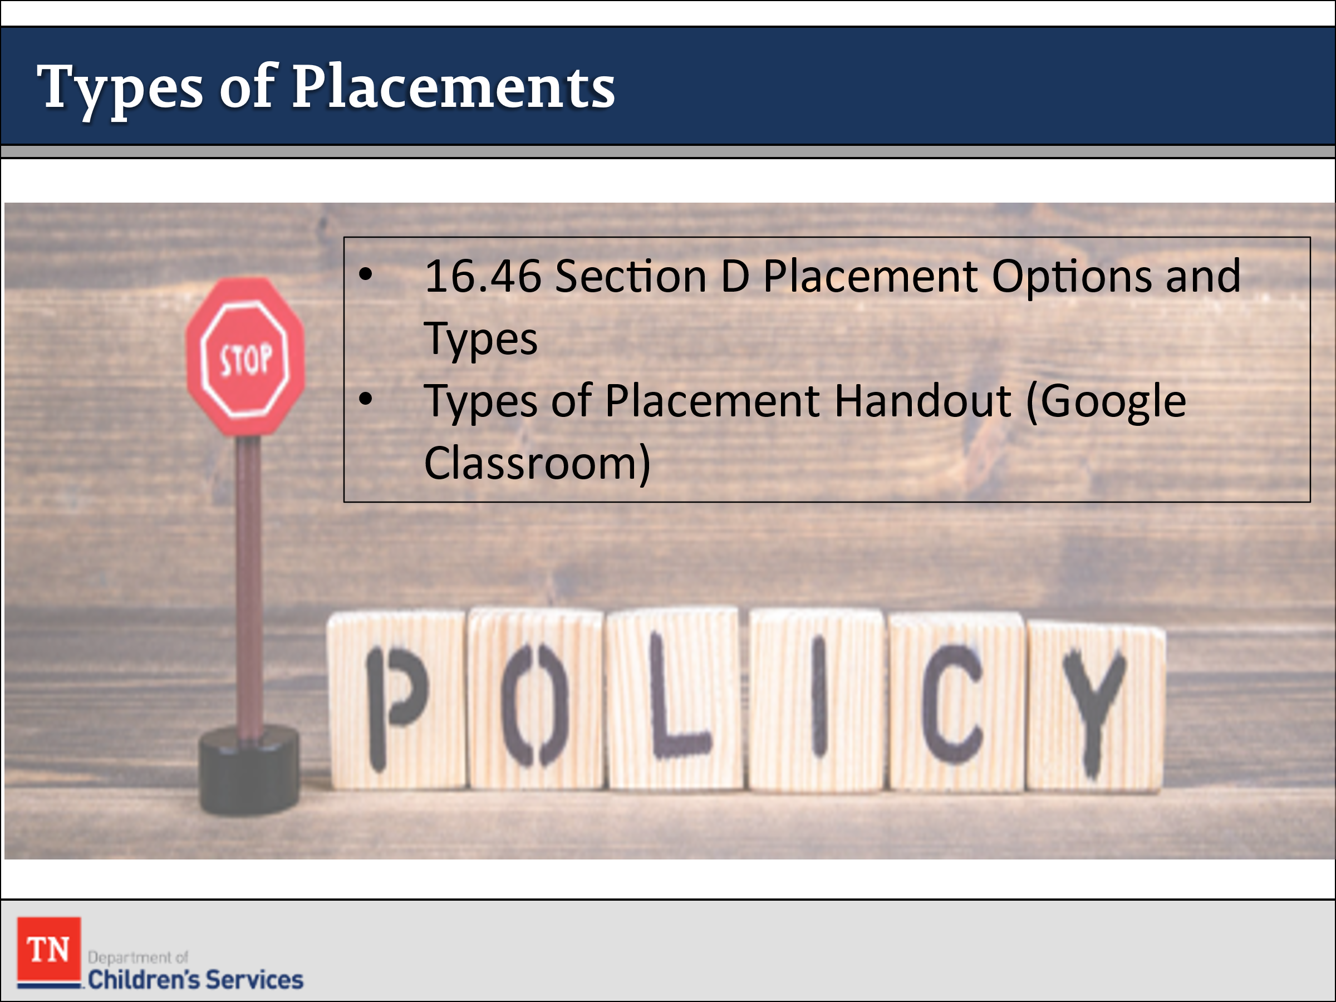
- STATE we will now discuss the Types of Placements. ADVISE this information can be found in Policy 16.46 Section D Placement Options and Types as well as the Types of Placement handout in Google Classroom. DISCUSS with the group the different types of placements. ASK the group to share what types of placements they have observed in OJT. ASK if there are questions on the types of placements. REITERATE the importance of working with the Placement Services Division when requesting placement for a child.
- HIGHLIGHT levels of care are different from types of placements. A placement such as a foster home can be more than one type of level of care. For example, there are Level 1, Level 2, and Level 3 foster homes. REFER participants to the Level of Care Handout in Google classroom.
- EMPHASIZE services the child receives is not dependent on the type of placement. SHARE service recommendations are determined by the Child and Family Team through use of the CANS and other types of formal and informal assessments.

Lesson 3.3: Foster Home Placements

Lesson Time: 30 minutes
Key Teaching Points / Instructions
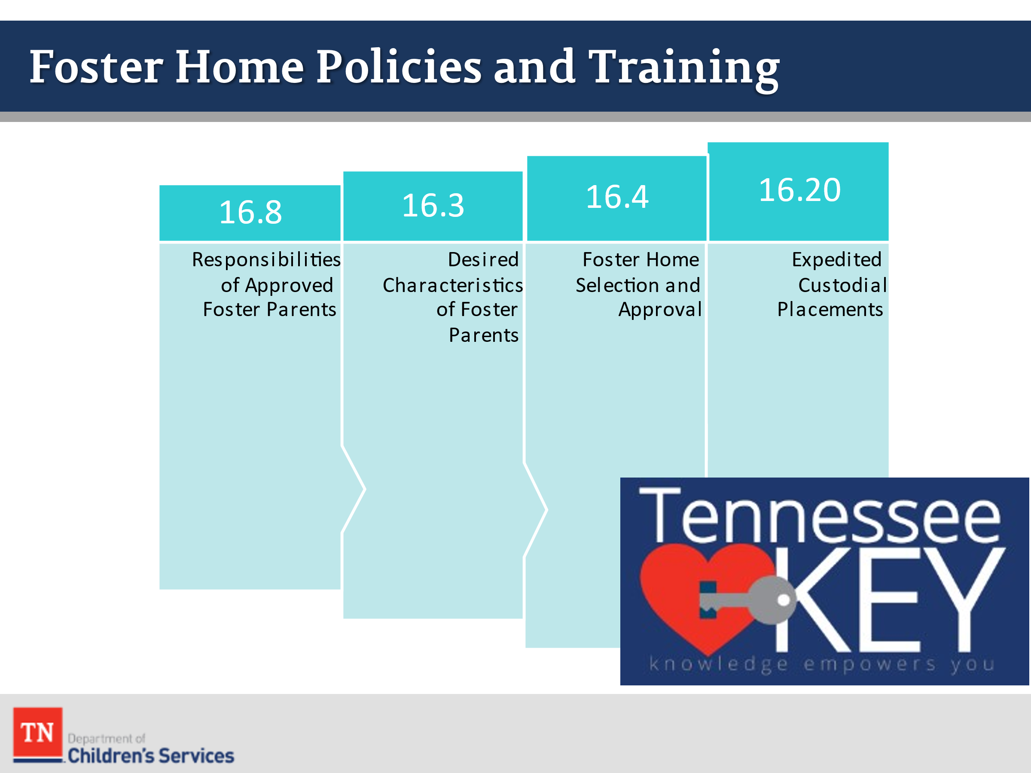
- TELL participants we are going to now look at some of the policies associated with foster homes. DCS Policy 16.8 Responsibilities of Approved Foster Parents explains the responsibilities of foster parents and the commitments they must make to ensure the safety, permanency, and well-being of the children in their care.
- SUMMARIZE the key responsibilities of foster parents. ASK participants what they view as the biggest challenge for foster parents in fulfilling these responsibilities.
TRAINER NOTE: responsibilities of foster parents include complying with policies, communicate household rules, provide proper supervision, all DCS to conduct required home visits, meet health needs of children, allowance, and clothing, follow discipline policy, transport children, and provide extra curriculars.
- REFER participants to Assessing Potential Relative Placements handout in Google Classroom and briefly REVIEW.
- ASK participants what else they would ask or discuss when assessing a potential relative caregiver? LEAD participants in a discussion about:
  - How they would explore other potential relative placements and
  - What they would do if relative placement was not an option.
- REFER participants to DCS Policy 16.3 Desired Characteristics of Foster Parents. Briefly HIGHLIGHT the key characteristics that DCS looks for in recruiting foster parents.
TRAINER NOTE: characteristics of foster parents include family composition, age and health requirements, smoking and health quality issues, quality of relationships, stability, transportation, motivation, parenting ability, reasonable and prudent parenting, ability to work with birth families, ability to work with DCS, and trauma reduction.
- POINT OUT the steps in the approval process for foster parents are described in DCS Policy 16.4 Foster Home Selection and Approval. Foster parents must attend TN-KEY training and complete the home study process to be an approved home.
TRAINER NOTE: TN-KEY includes Navigating the Child Welfare System, Exploring the Impact of Trauma, Roadmap to Resilience, and Rerouting Trauma Behaviors.
- REMIND participants that foster families must complete the TN-KEY training series to be fully approved foster parents. If they do not complete the whole process and the children were placed with an expediated home study a Placement Stability CFTM would be held to assess other placement options.
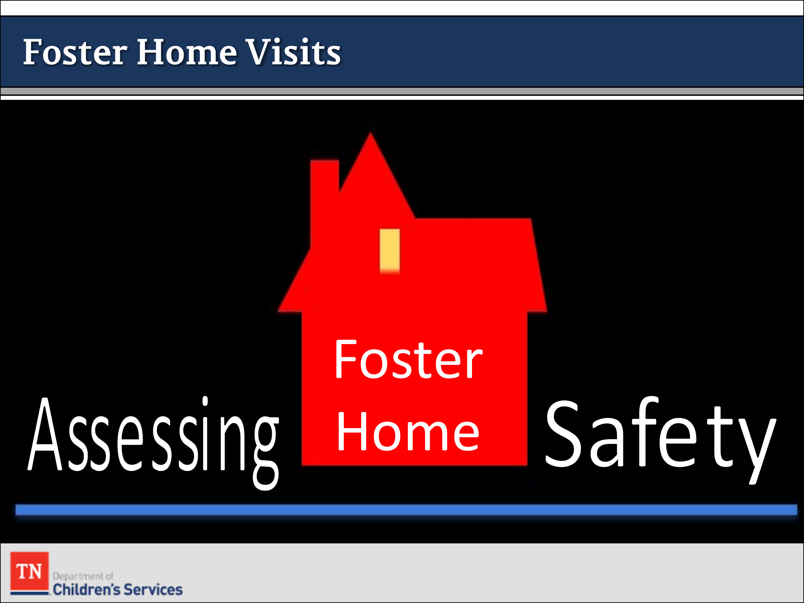
- REFER participants to DCS Policy 16.20 Expedited Custody Placements and briefly REVIEW the needed tasks to complete an expedited custodial placement.
- STATE assessment is an ongoing process and as an FSW, you are assessing safety at all times. When conducting foster home visits, it is important for the FSW to complete a walkthrough of the home and identify and address all potential safety risks. If there are additional children in the home, the FSW will do the following:
  - Engage the foster family in a discussion around the role they play with the children and how often the children are in the home.
  - Assess for EACH child’s safety by determining if there is adequate adult supervisor for the number of children in the home and identifying if there are environmental hazards in the home based on the age of the children.
  - According to the safe sleep protocol, all children under the age of 12 months, are required to have a safe sleep environment if they are in the home full or part-time.

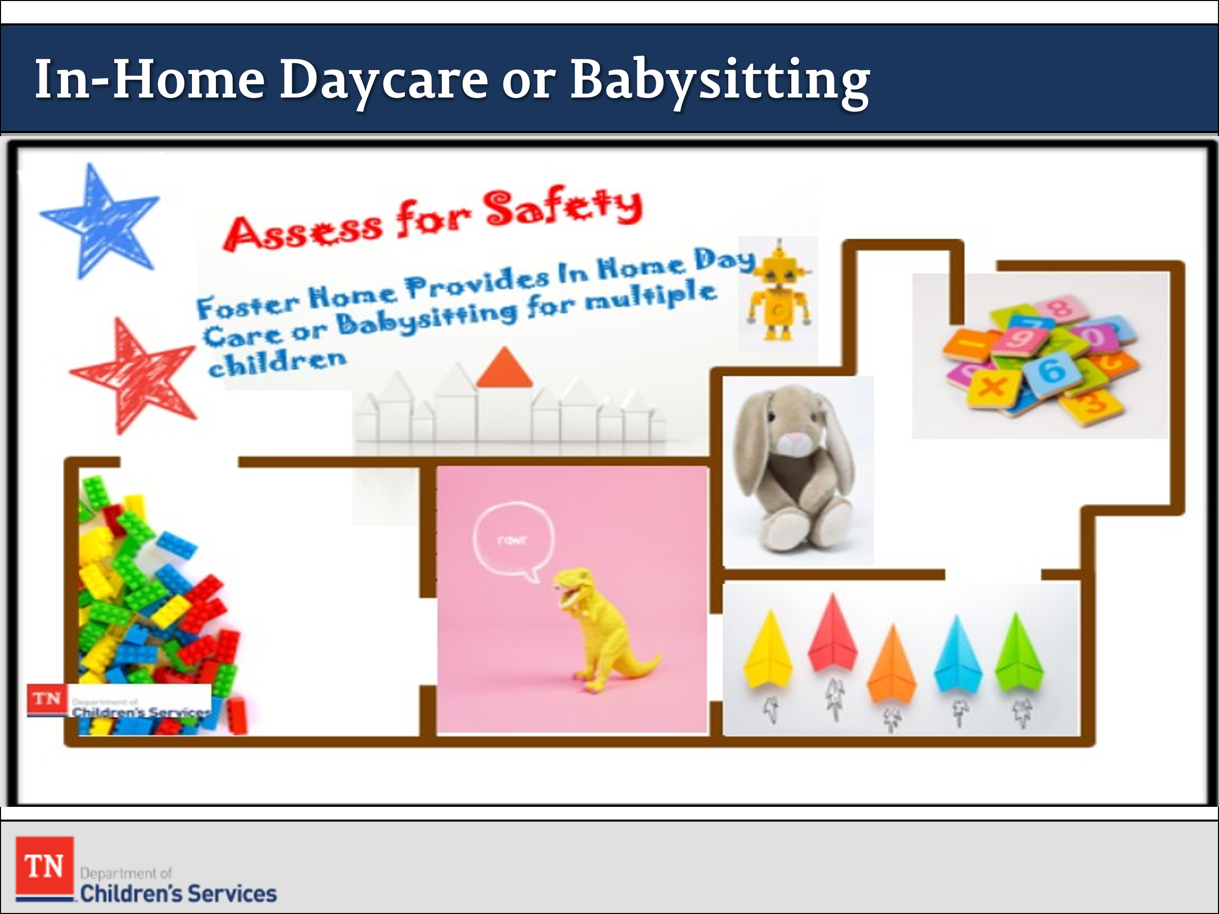
- ADVISE staff entering foster homes should assess for safety if they observe the foster parent providing an in-home daycare or babysitting for numerous children. STATE our agency has experienced near death or certain situations with children as a result of a foster parents caring for multiple children. We do not want to discourage or restrict foster families from having an in-home business. However, we encourage staff to assess for safety if multiple children are in the home. If the FSW observes an unlicensed home daycare, the FSW should discuss with Leadership/Supervision. According to the Department of Human Services, Family Child Care Homes can provide care for at least five but no more than seven unrelated children. Up to 5 additional children related to the primary caregiver may also receive care in family childcare homes. Please note assessment of safety is not contingent on the number of children in the home but the circumstances around the child’s situation and the home environment.
- STATE information regarding daycare licensing can be found at: https://www.tn.gov/humanservices/for-families/child-care-services/child-care-types-of-regulated-care.html
- ACKNOWLEDGE that caring for children/youth in custody is a tremendous responsibility whether the children are related to you or not.
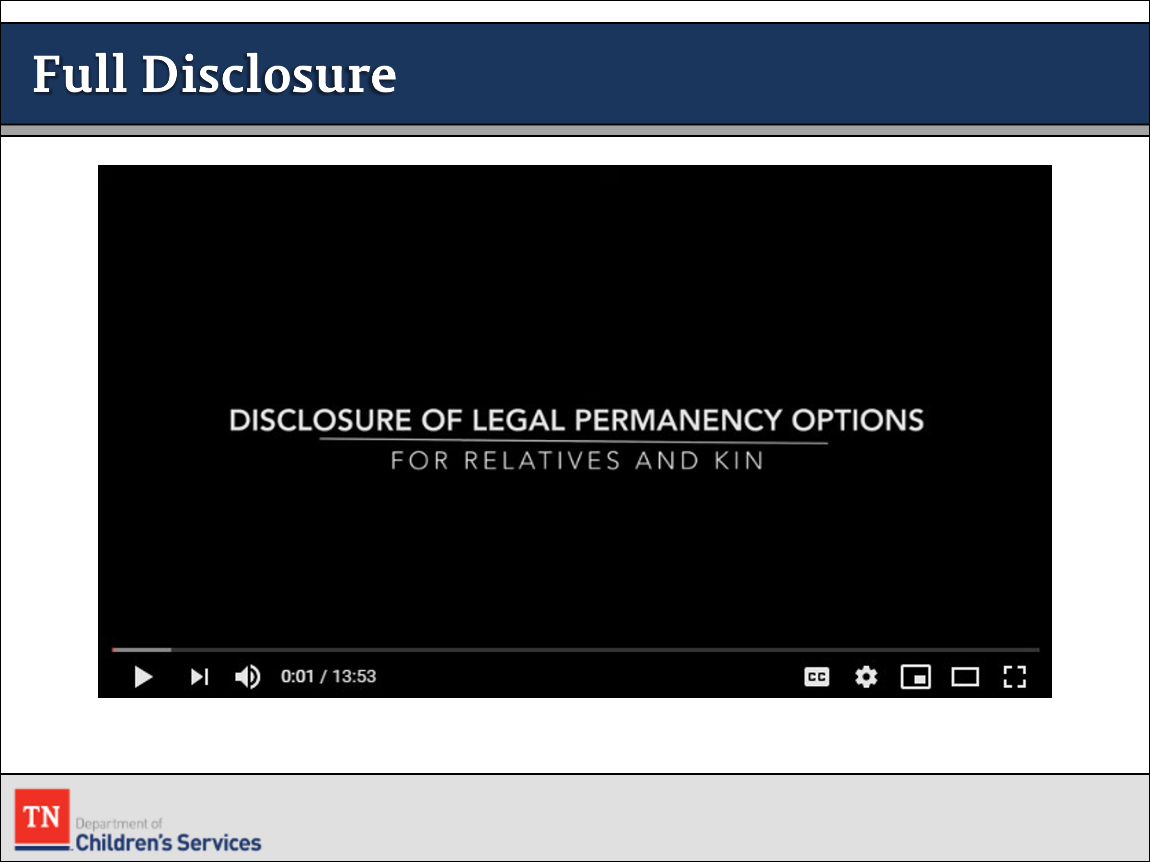
- INFORM participants they will now watch a video about the full disclosure process we must go through with our relative placements. SHOW “Disclosure of Legal Permanency Options for Relatives and Kin” (13:53 minutes): https://www.youtube.com/watch?v=C8s6KZyIKE4
- DEBRIEF and ASK if there are any questions after the video. STATE this information would need to be shared with Grandma Rose in order for her to make an informed decision about placement and potential long-term view of the case.
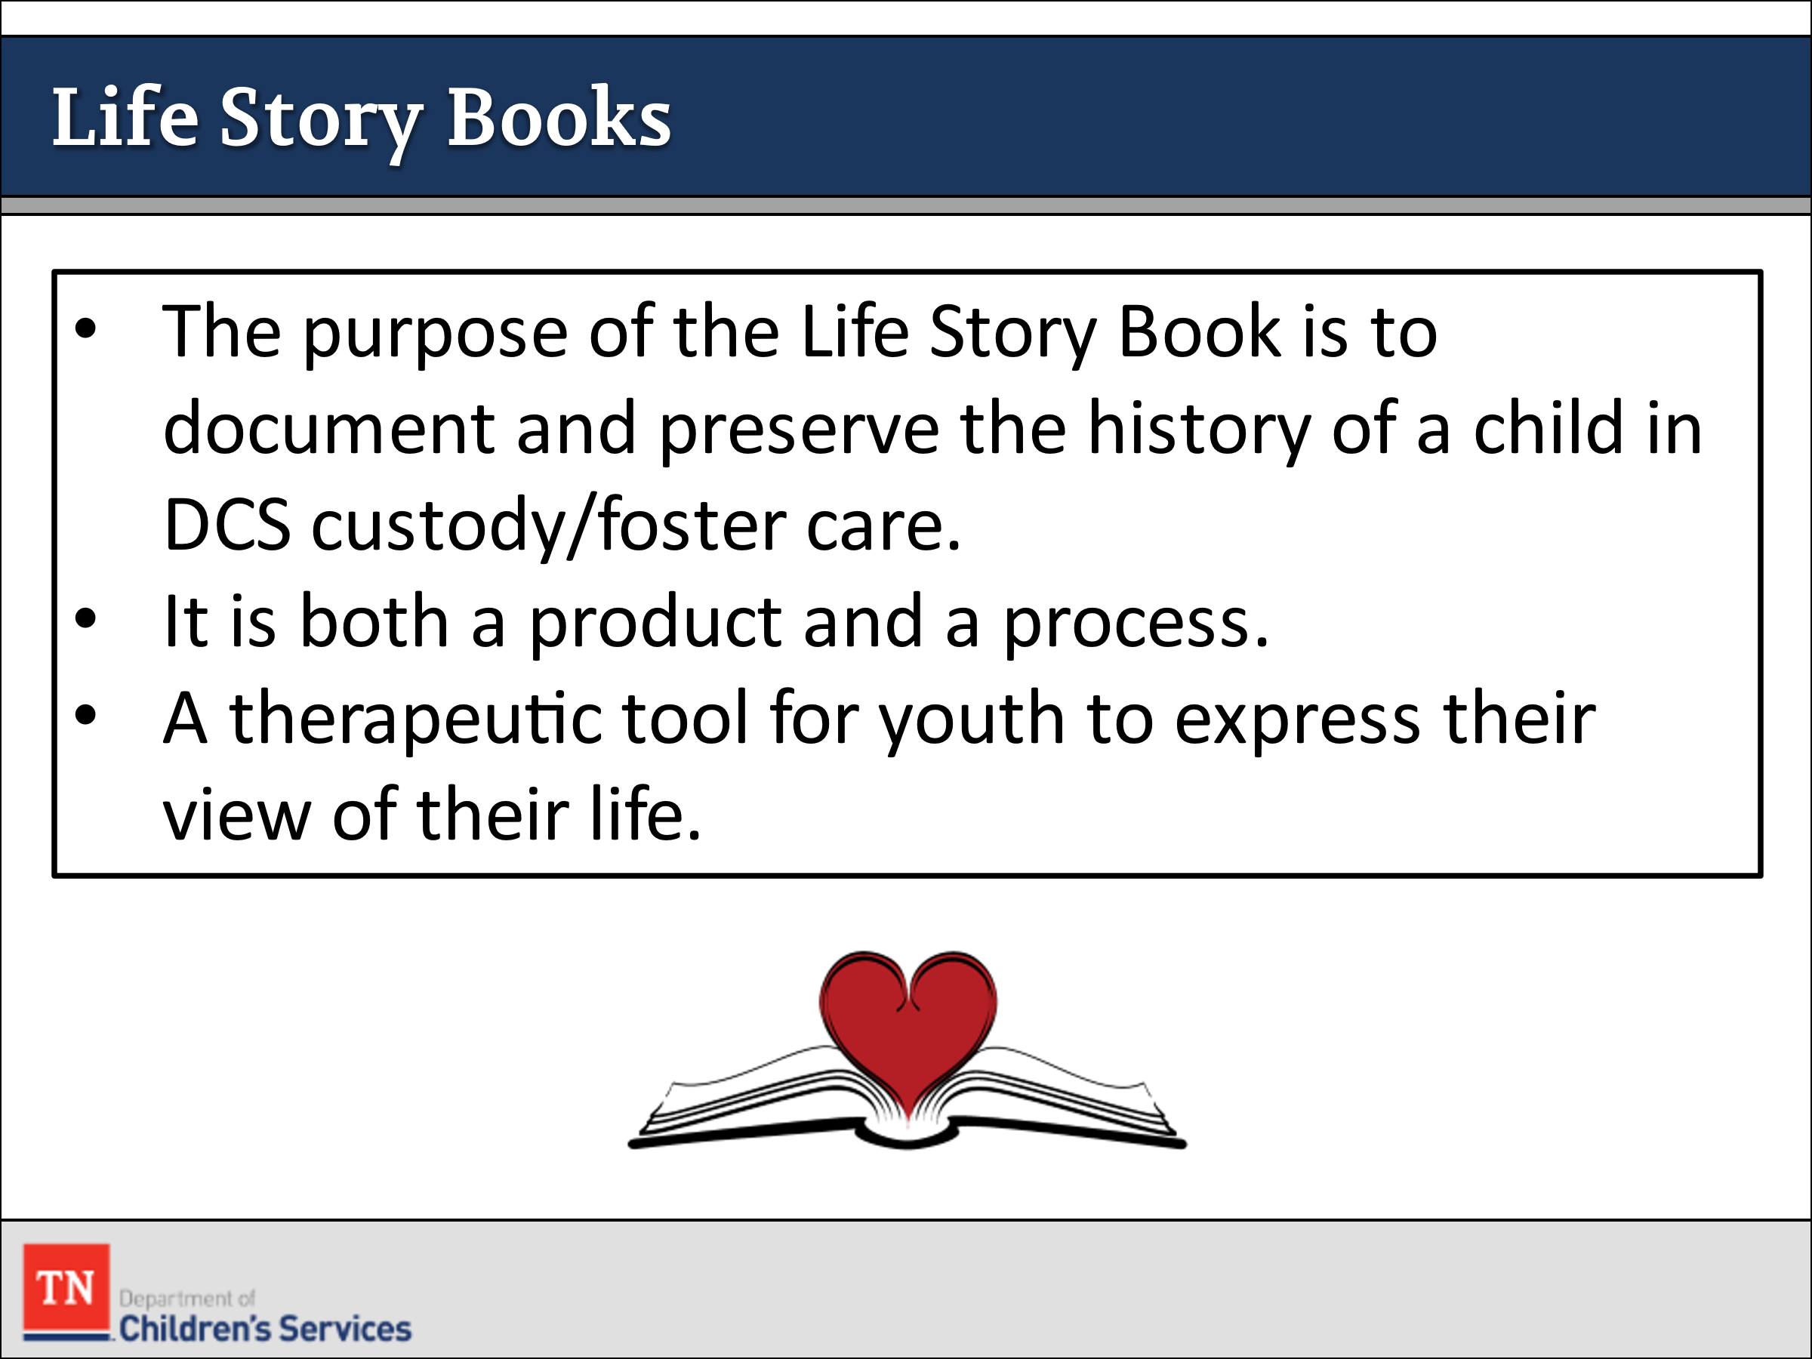
- HAVE participants to reflect on the child’s separation from parents and the losses they may experience. REMIND them that even when we are providing safety for children the impact of removal can be significant.
- DISCUSS briefly how each of them plays a critical role in helping children to cope with their negative experiences and maintain a sense of wholeness. One way to do this is to create a Life Story Book for every child in custody.
- STATE the purpose of the Life Story Book is to document and preserve the history of a child in DCS custody/foster care. SHARE a Life Story Book is both a product and a process.
- HAVE participants find and review DCS Policy 16.8 Attachment – Guidelines for Life Story Books. REVIEW the summary of the attachment as it relates to the purpose and focus of the Life Story Book. When reviewing the policy make sure to discuss the importance of the FSW working with the foster parent to ensure that the child/youth have a Life Book.
- REITERATE Life Books are not a scrap book that we put pictures and keepsakes in. They serve as a therapeutic tool for the youth to express their view of their life. A Life Book can start from the present and serve as a way to document the youth’s life.
- TRANSITION to Lesson 3.4 Visitation.

Lesson 3.4: Visitation

Lesson Time: 60 minutes
Key Teaching Points / Instructions

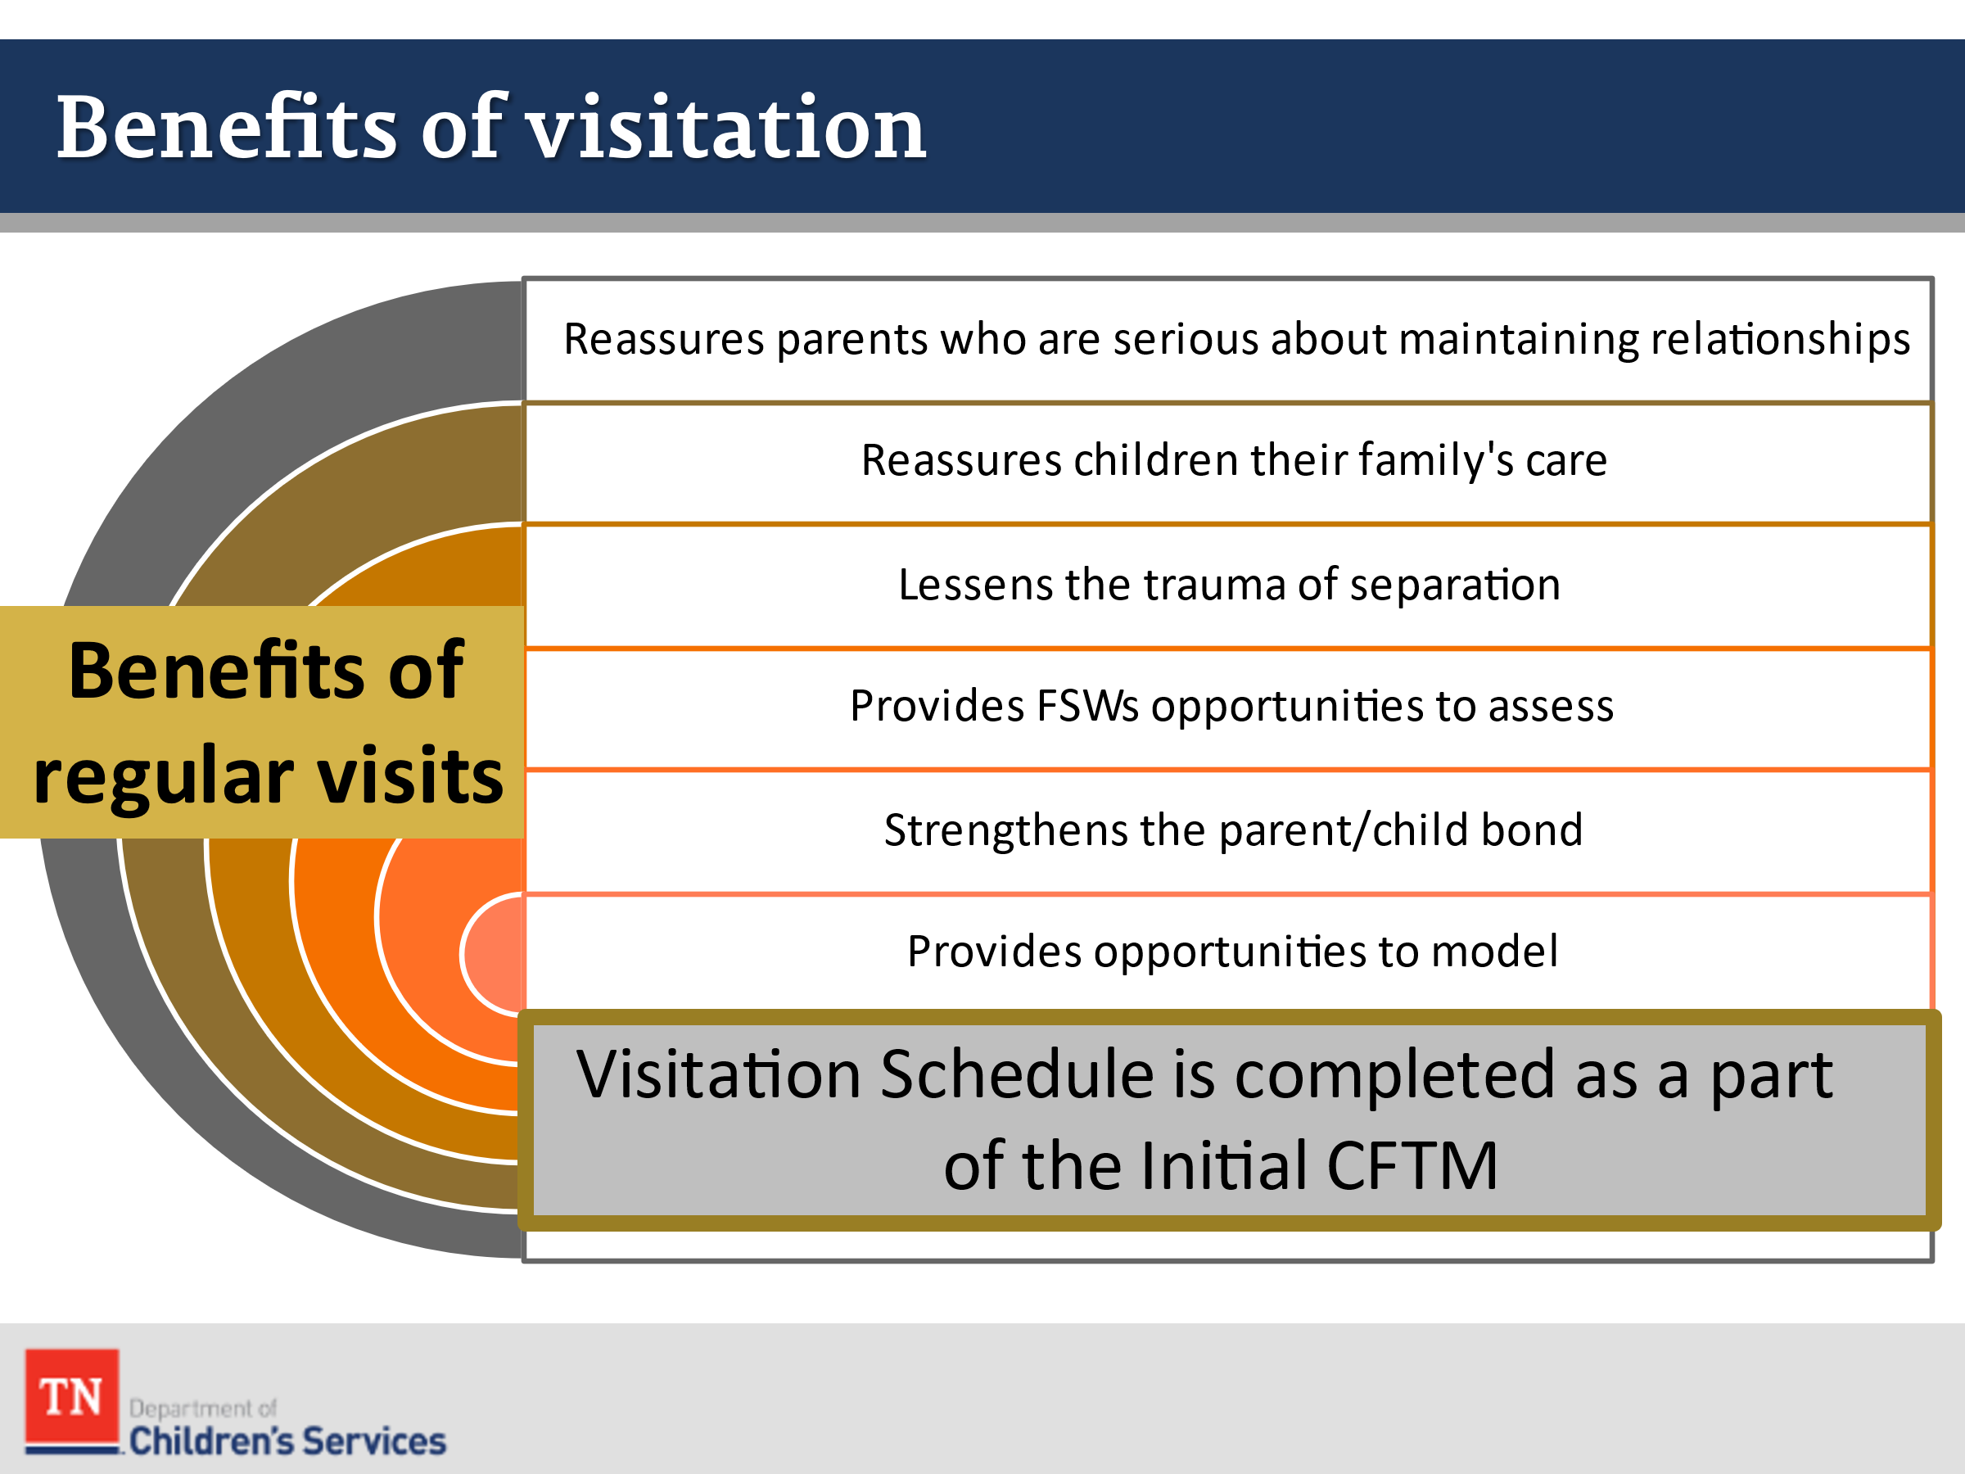
- INFORM participants one of the most important tasks they will do during the initial period of a case is to establish visitation between the children and family. STATE this task is to be accomplished as part of the Initial CFTM (within seven calendar days of entering custody).
- LEAD participants in a discussion about why visitation is so important at this stage (when the child is first removed from the home). ASK the group: “What are the benefits of regular visits between parents and children in custody?”
- ENSURE that the following points are mentioned in their discussion:
  - Reassures parents who are serious about maintaining relationships with their children
  - Reassures children that their families care about them and lessens the trauma of separation
  - Provides FSWs with opportunities to assess family interactions
  - Strengthens the bond between parents and children and helps families prepare for reunification
  - Provides opportunities for FSWs and resource parents to model and parents to practice newly acquired parenting skill
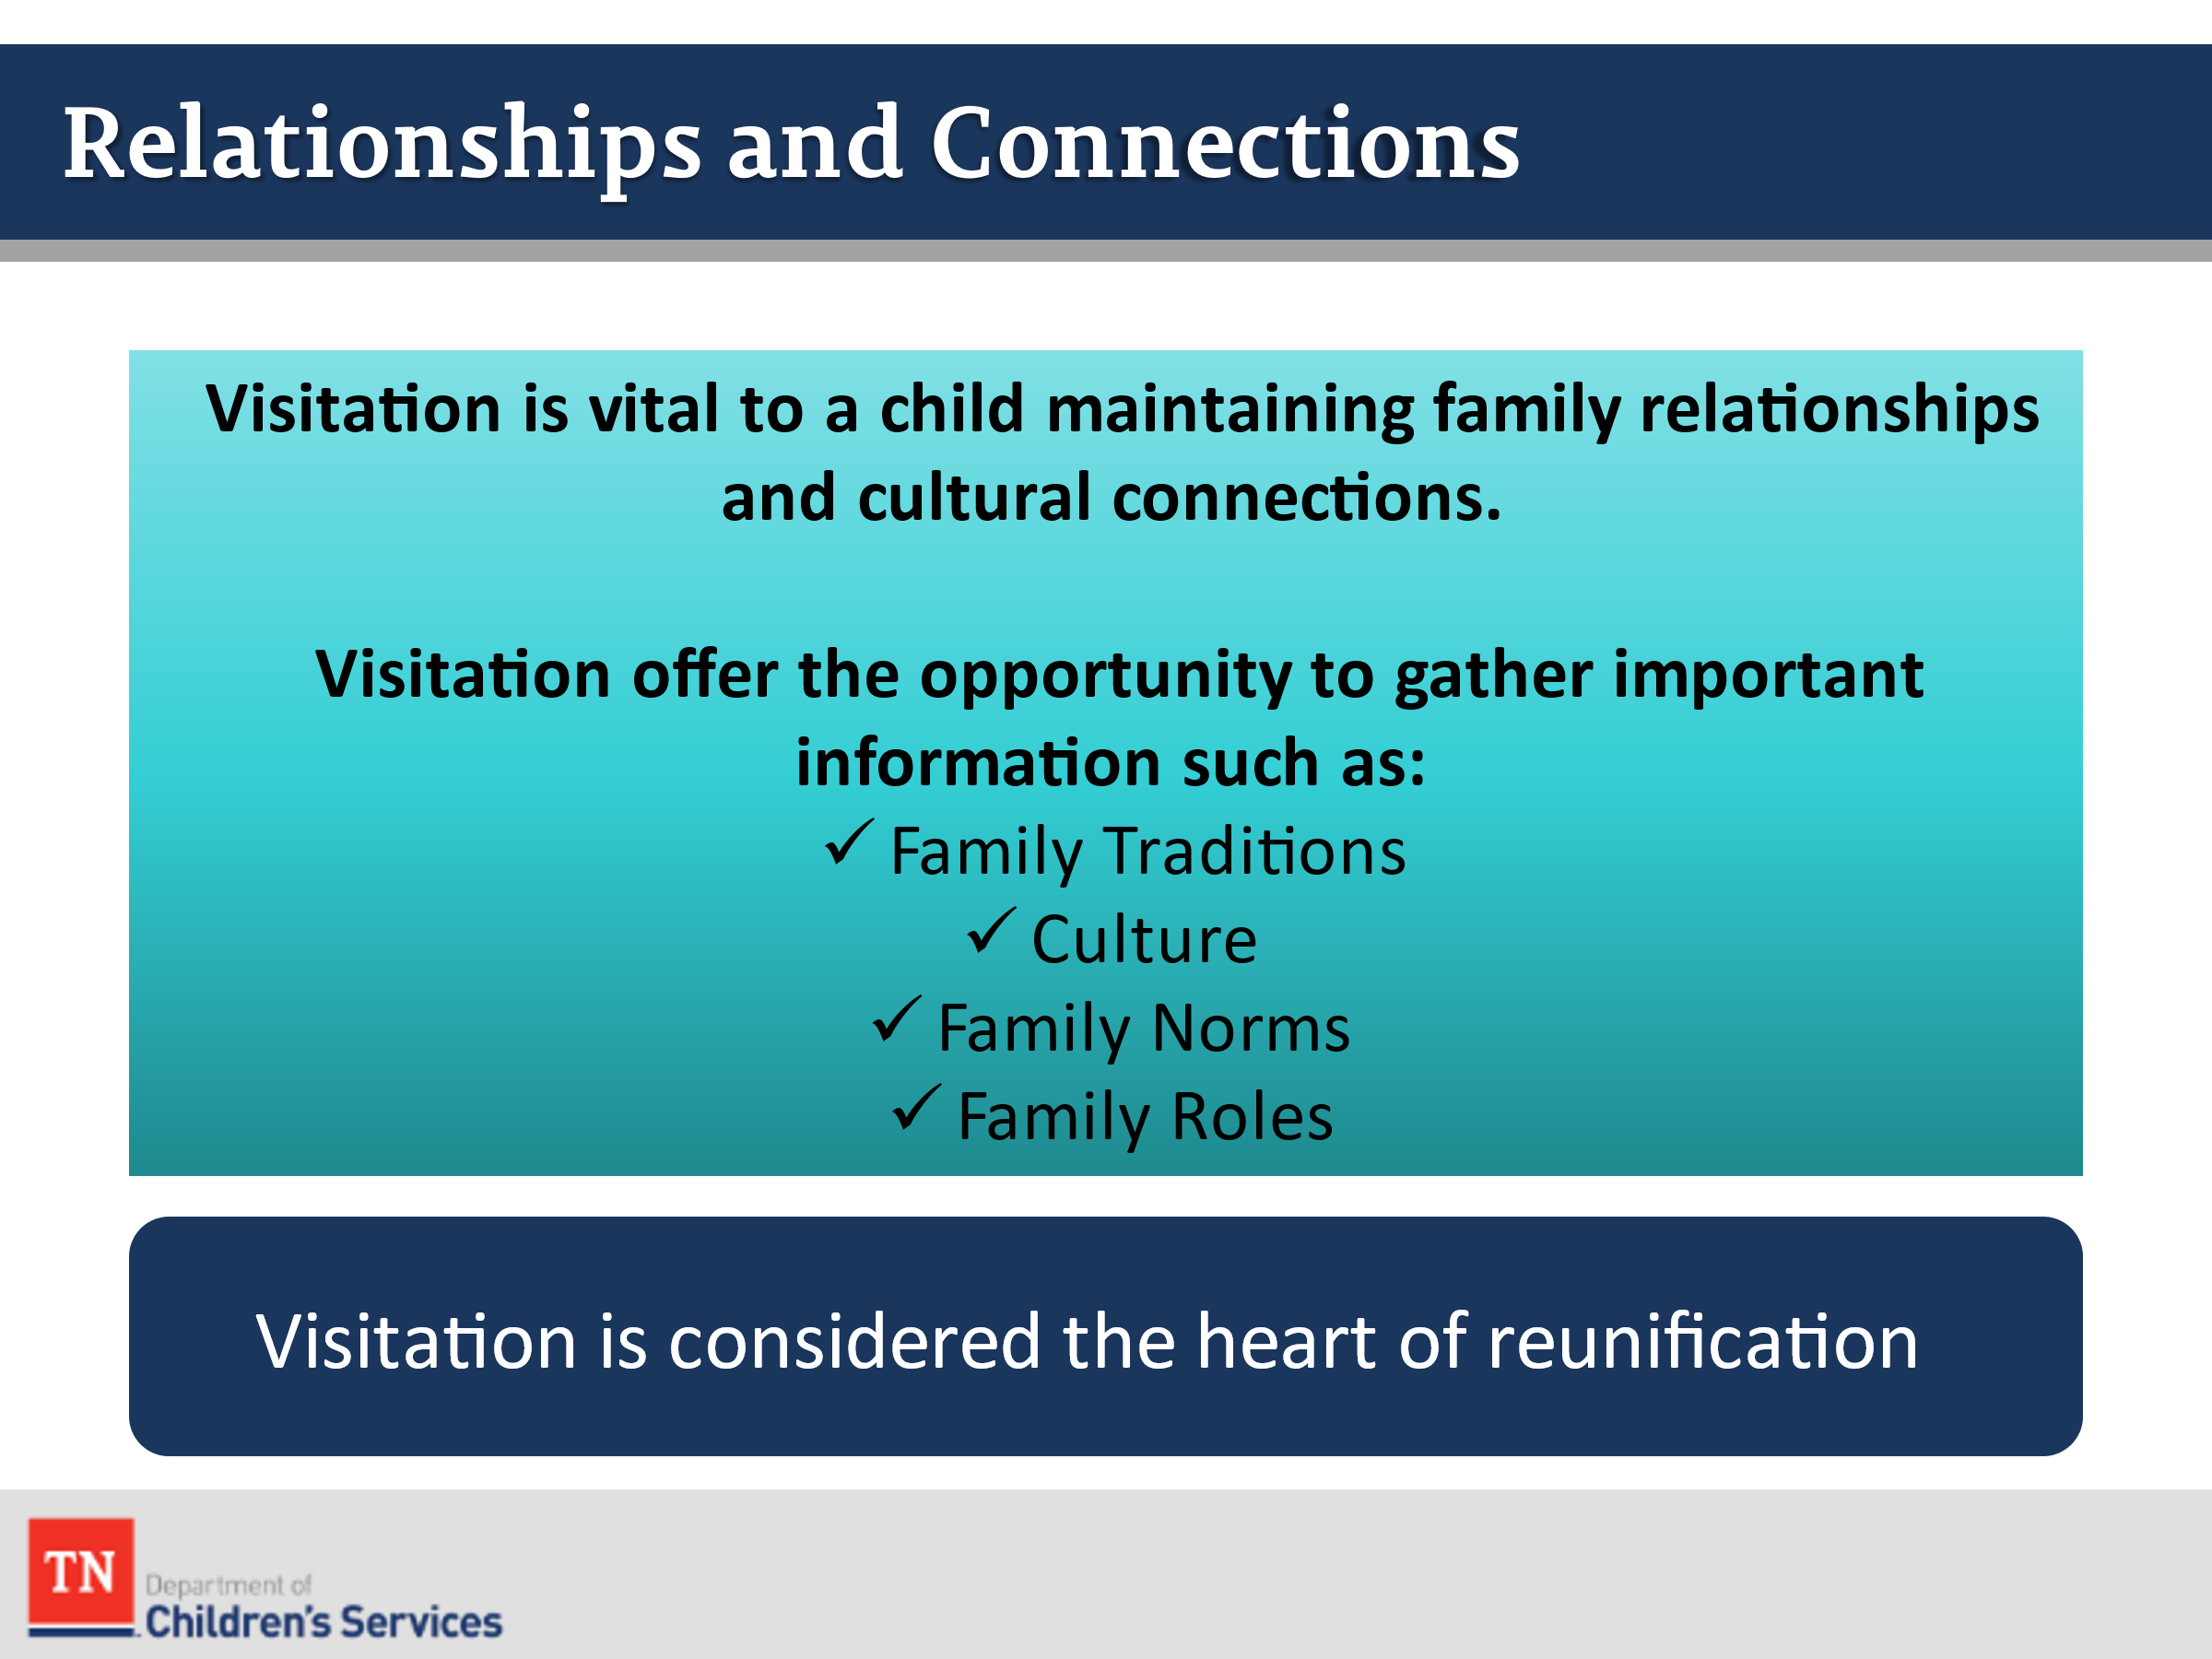
- EXPLAIN visitation is essential for a child’s well-being. The primary purpose of visitation is to maintain the parent and child attachment, reduce a child’s sense of abandonment, and preserve their sense of belonging as part of a family and community. A child needs to see and have regular contact with their parent(s) and siblings, as these relationships are the foundation of child development.
- STATE visitation is fundamental to permanency. Visitation facilitates permanency planning, promotes timely reunification, and helps in the decision-making process to establish alternative permanency plans. Visitation maintains and supports the parent and child relationship necessary for successful reunification.
- SHARE visitation is vital to a child maintaining family relationships and cultural connections. Visitation offers the opportunity to gather important information such as:
- Family traditions
- Culture
- Family norms
- Family roles
- Maintaining family connections has life-long significance for a child. Regular visitation maintains their relationships with siblings and others who have a significant role in a child’s life. When a child loses family connections, they also lose family history, medical history, and cultural information.
- Visitation is considered the heart of reunification, but even when reunification is not likely, parents, siblings and extended family continue to be important in a child's life.
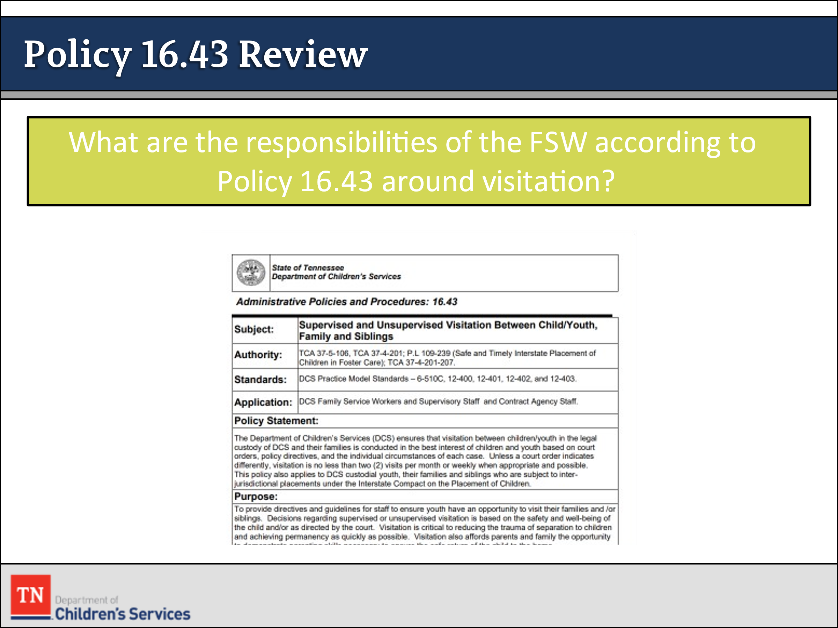
- REFER participants to DCS Policy 16.43 Supervised and Unsupervised Visitation Between Child/Youth, Family and Siblings. ALLOW time for participants to review the policy and identify the family service worker’s responsibilities related to supervised and unsupervised visitation. REFER participants back to the Visitation Guide as well.
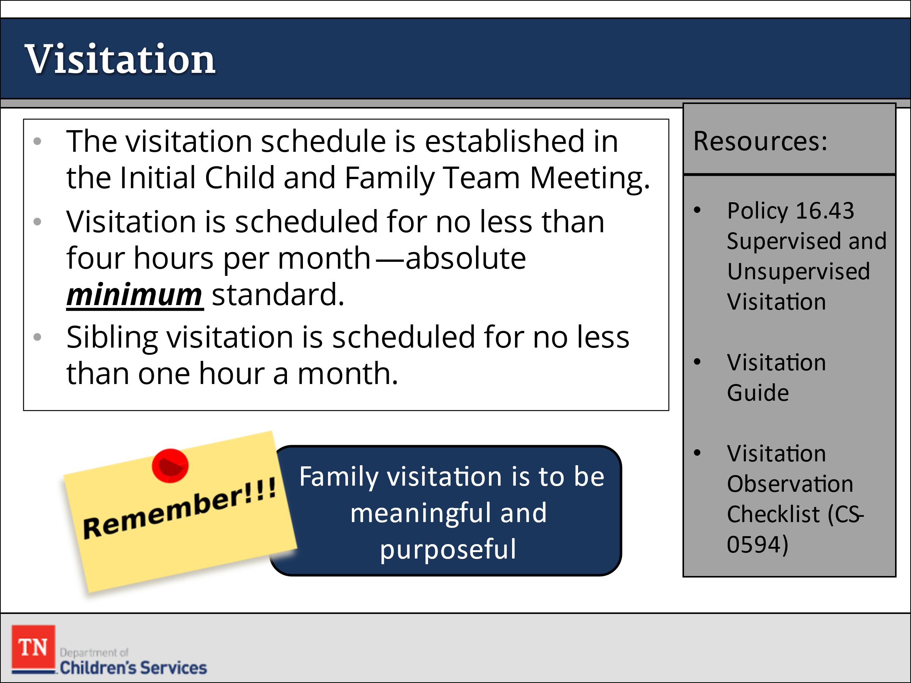
- ASK the group, “What are their responsibilities around visitation according to policy?” EMPHASIZE the following points if not mentioned by the group:
  - During the Initial CFTM that takes place within seven (7) days of a child entering care, the FSW will arrange a visitation schedule between the child and family. The first visit is to take place as soon as possible.
  - Visits occur on a regular schedule at a time and place convenient for the parents and children. They are not to occur at the DCS office.
  - Unless a court order indicates differently, visits between children and their family are to be no less than four (4) hours per month. This is the absolute minimum standard. If siblings are placed separately, sibling visitation are to occur no less than one (1) hour per month.
  - Siblings are to be included in family visits even if they remain at home.
  - Telephone contacts are encouraged.
  - If it is necessary to place a child outside his or her community for treatment, the FSW must ensure that the family has access to transportation to visit.
- STATE the birth parents, foster parents, and any provider agency must be notified of any modifications to the visitation schedule.
- EXPLAIN another purpose of visitation is to meet the child’s developmental need for maintaining and enhancing relationships with family members and to reduce their sense of loss due to removal.
- ASK participants to consider how the age and developmental level of a child might necessitate more frequent visits. PROVIDE an example such as a newborn who has not yet bonded with the birth mother. POINT OUT that, in general, the younger the child, the more often he or she will need to see his or her mother/father/caregiver.
- ASK participants to imagine they were only allowed to see their child/niece/nephew four (4) hours per month. DISCUSS the impact of this limitation on themselves as parents/aunt/uncle and the children. EMPHASIZE that more frequent contact is needed to maintain and strengthen family relationships.
- STRESS visitation and family contact should never be used as a reward or punishment but should always be considered a right of families and children. Arranging consistent and frequent visitation between caregivers and children who are placed out of home maintains and supports the parent-child relationship necessary for successful reunifications and has life-long significance for the child.
- STATE the absence of regular and frequent parent and child visitation or contact may have serious consequences for both a child and parent(s). Without visitation, the relationship can deteriorate, and both can become emotionally detached. When parent-child attachment suffers, reunification becomes more difficult.
- SHARE when used effectively, visitation can minimize some of the effects of trauma that a child experiences, because of being removed from their family.
- DISCUSS the challenges FSWs face in facilitating more frequent visits between parents and their children. BRAINSTORM strategies to address these challenges and ensure that regular frequent visitation occurs with all their cases.
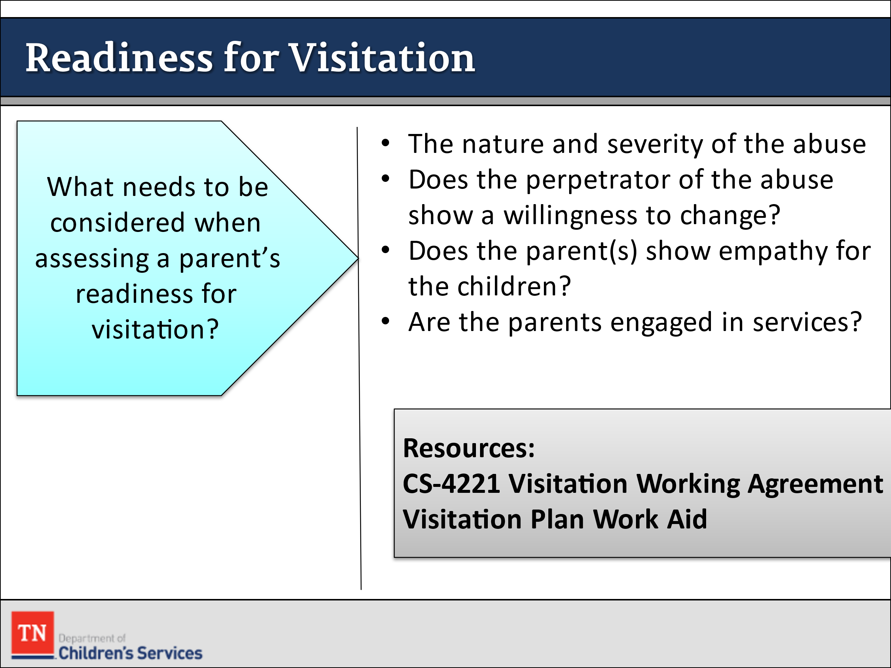
- ASK, “What are things we need to consider when assessing parents’ readiness for visitation?” ELICIT ideas from the group.
- SHARE when assessing parents’, we need to consider the following:
- The nature and severity of the abuse
- Does the perpetrator of abuse show a willingness to change?
- Does the parent(s) show empathy for the child(ren)?
- Is the parent(s) engaged in services?
- Drug and Alcohol use/abuse
- NOTE these factors are not used to determine whether visits should occur. They are used to assess the stage of supervision needed during a visit, where a visit should be held, and the level of support the child(ren) and parent(s) will need before, during, and after the visit.
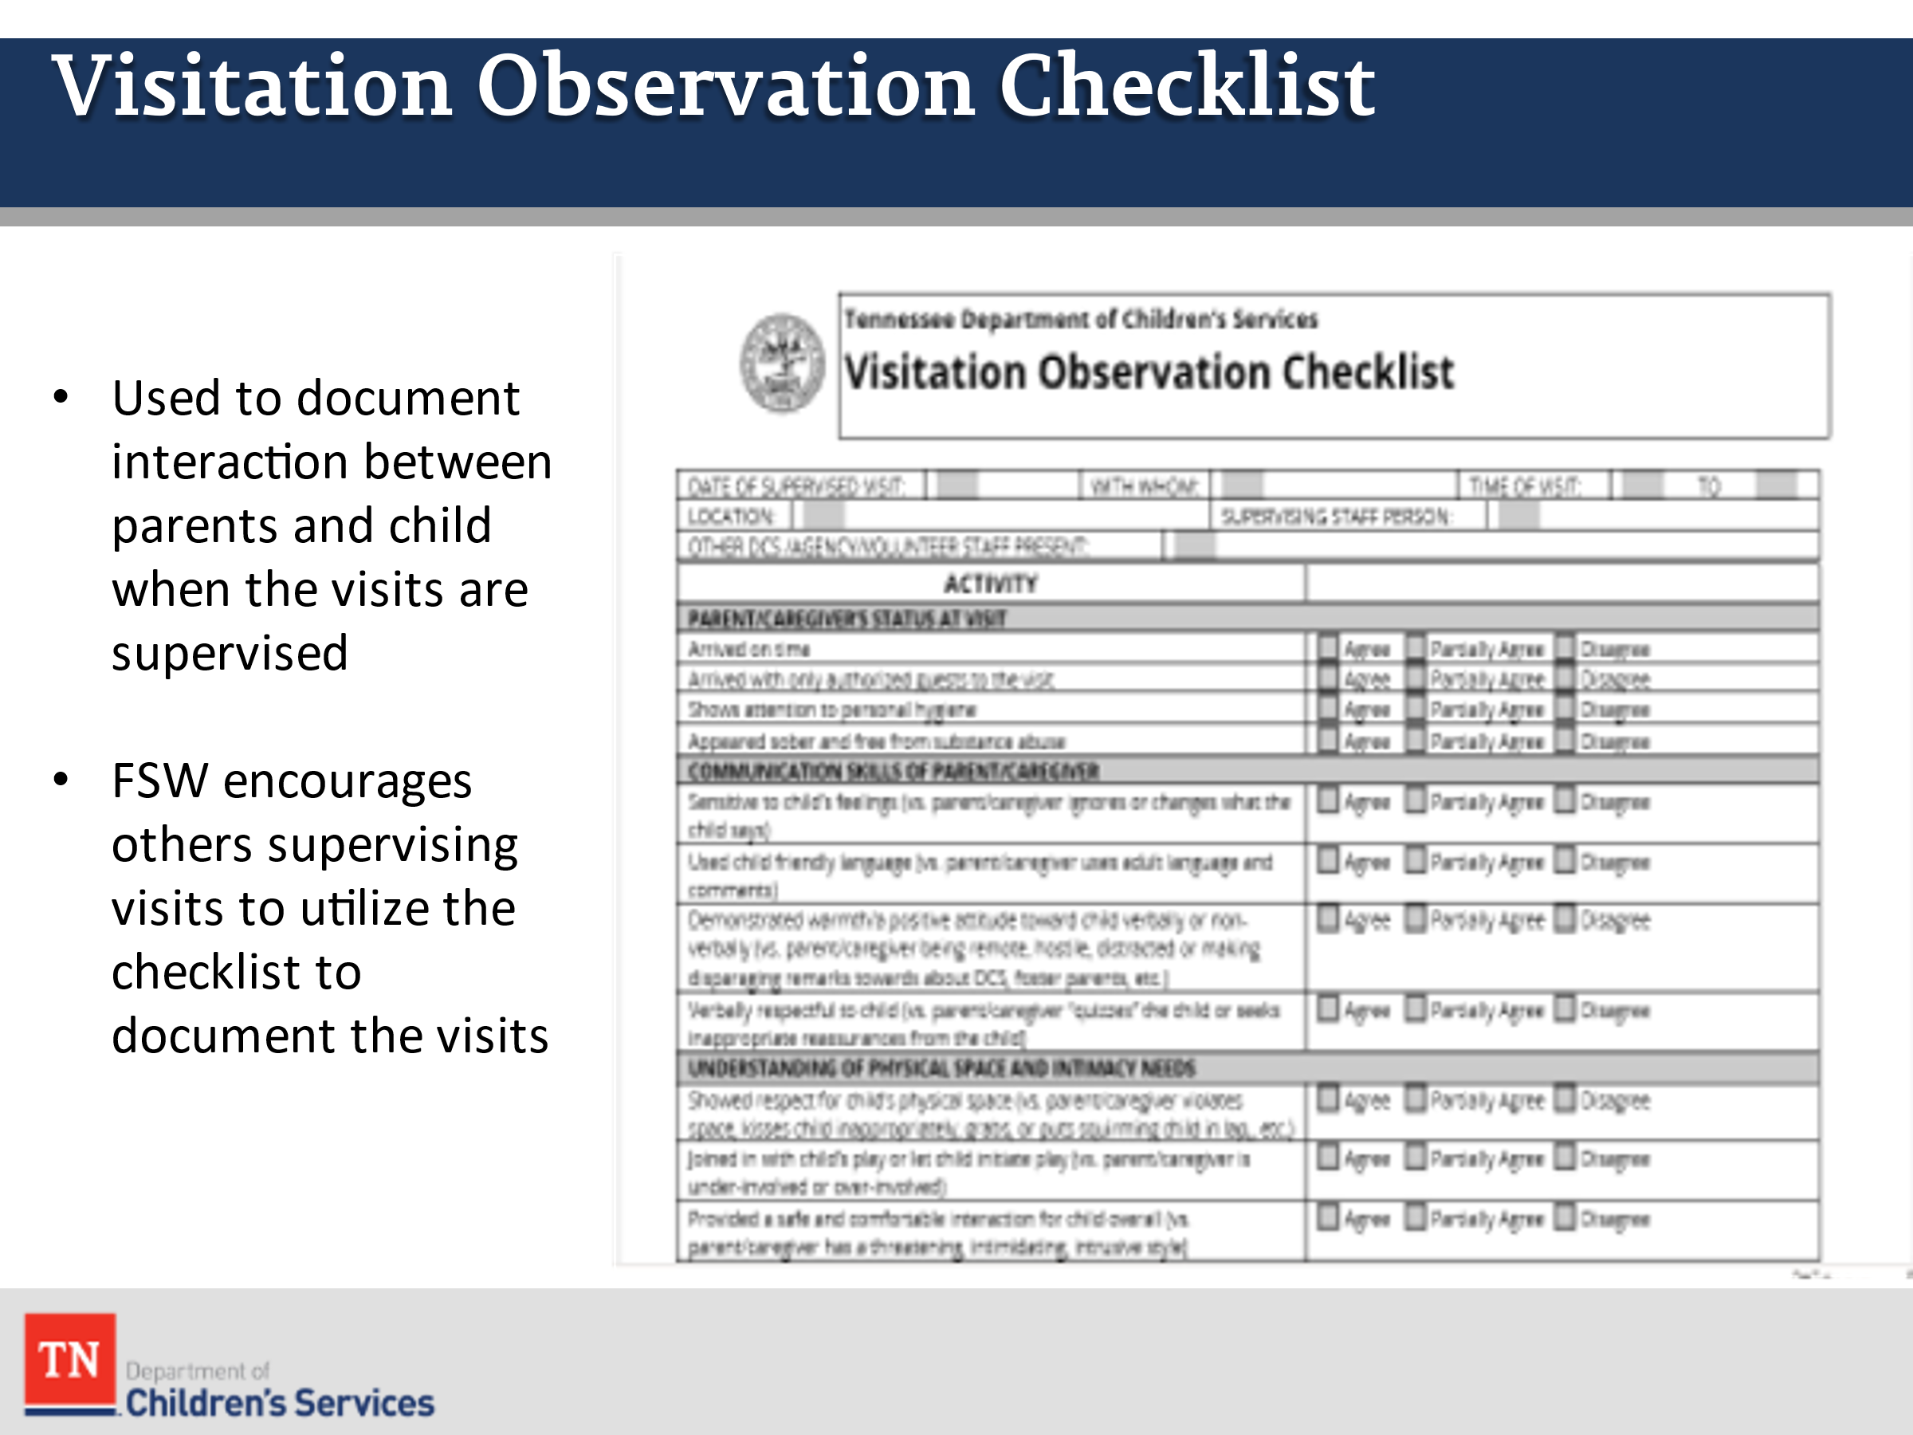
- PROVIDE information on the following resources: CS-4221 Visitation Working Agreement and Visitation Plan Work Aid. SHARE these resources should be used when developing the Visitation Plan with the family during the Initial Child and Family Team Meeting.
- INFORM Form CS-0594 Visitation Observation Checklist is used to document the interaction between parents and child when the visits are supervised. Also note the FSW will encourage others supervising visits to utilize the checklist to document the visits.
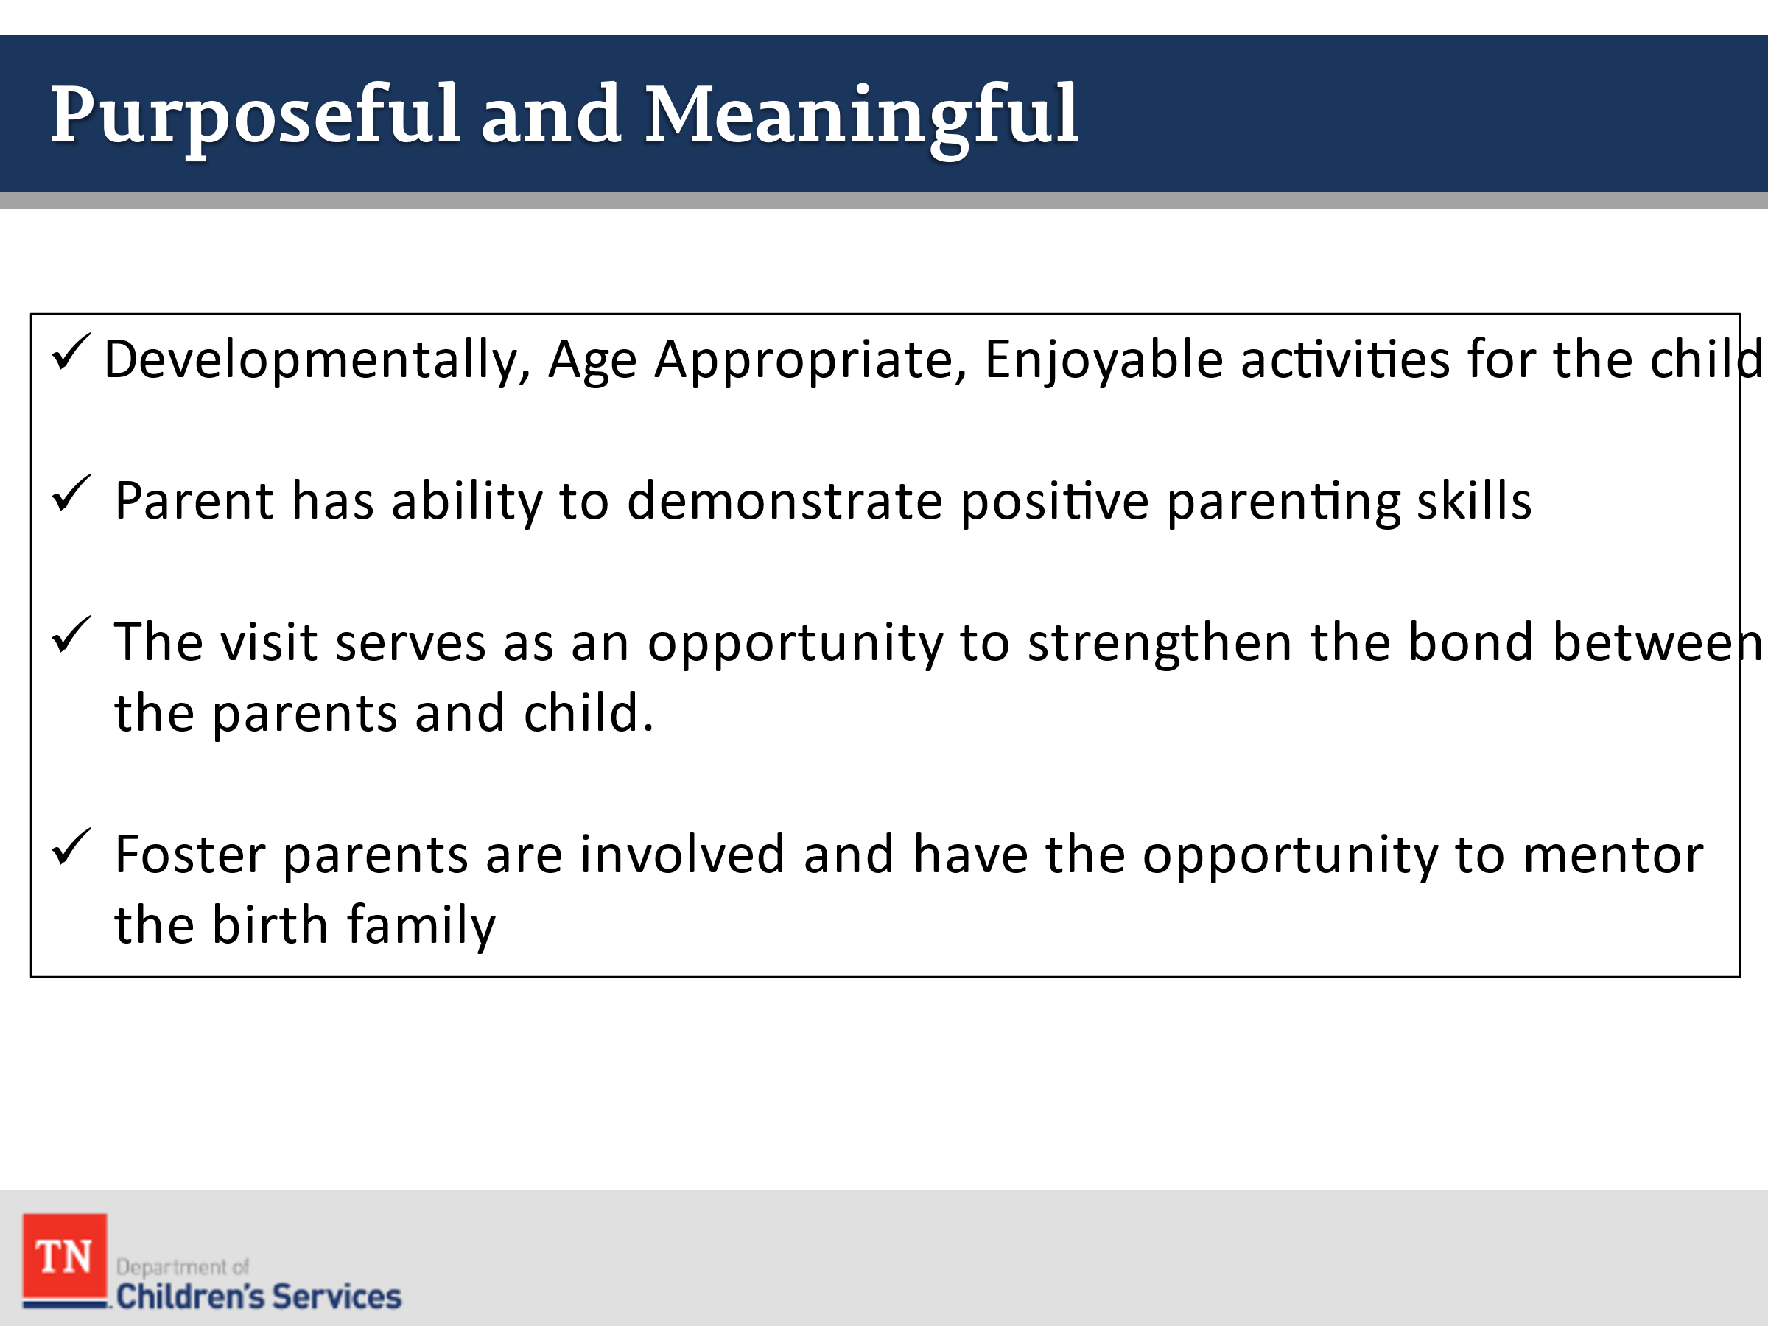
- ASK the group: “When we say family visitation is to be “purposeful and meaningful” what does that mean to you?”
- LEAD participants in a brief discussion about how FSWs can ensure that family visitation is purposeful and meaningful. ENSURE the following points are covered in the discussion:
  - Activities are developmentally and age appropriate for the child as well as enjoyable.
  - The parent has opportunities to demonstrate positive parenting skills
  - The visit provides an opportunity to strengthen the relationship between the parent and child
  - Foster parents are involved and able to demonstrate effective parenting skills and mentor the birth family
- ASK participants about visitations they have observed. SOLICIT volunteers to describe what occurred and assess whether the visits were purposeful and meaningful based on the criteria which were discussed.
- REFER the group to the resource Developmentally Related Visitation Activities handout and GIVE the group a few minutes to review. EXPLAIN many families are either unaware or uncertain of what is or isn’t appropriate during visits. The resource can be copied for parents who might want to plan activities with their children in future visits.
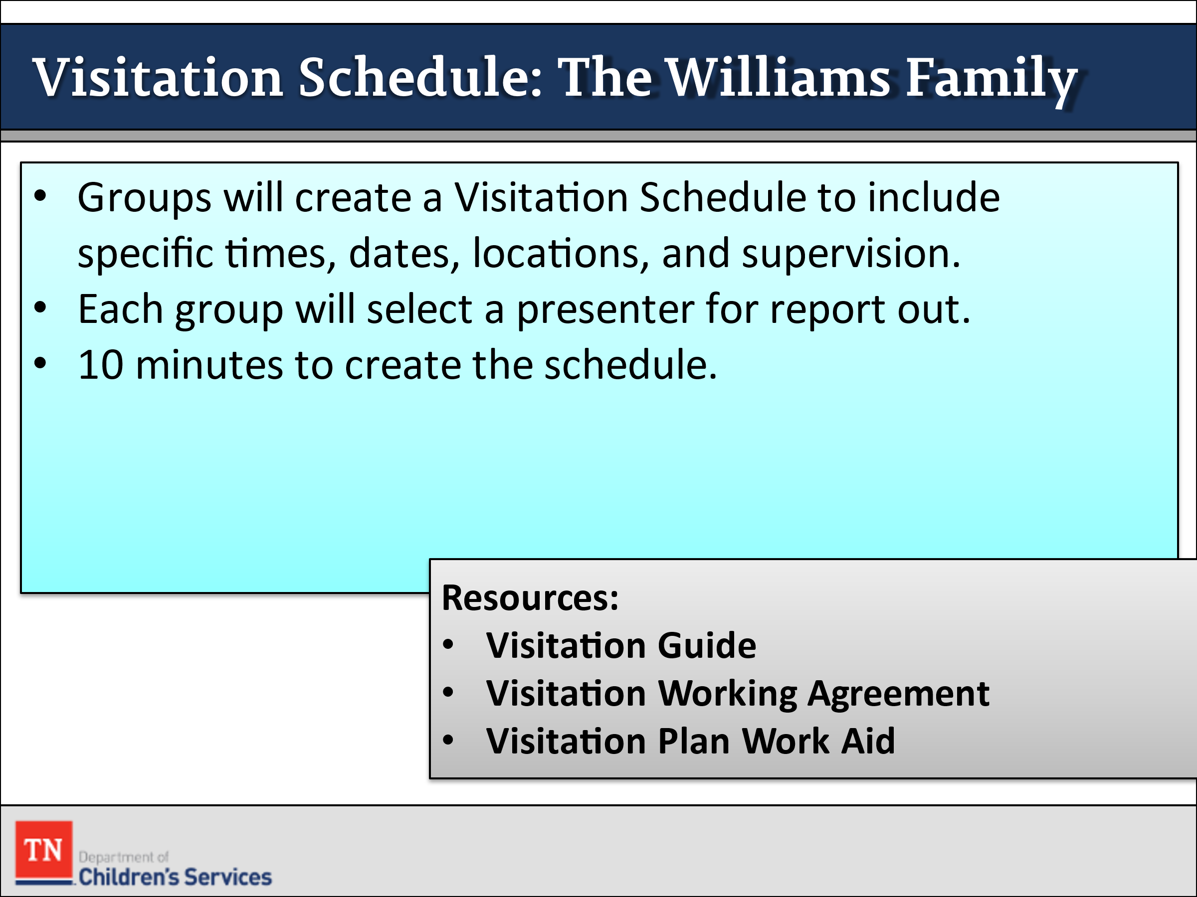
- CONDUCT ACTIVITY: Williams Visitation Schedule
  - DIVIDE the group into 3-5 participants and ASK participants to complete a visitation schedule for the Williams including: be specific about date, time, location, and who will supervise as well as visitation activities. ADVISE participants will use the following resources: Visitation Guide, CS-4221 Visitation Working Agreement, and Visitation Plan Work Aid to complete. REITERATE the importance of ensuring visitation is discussed and developed for all parents.
  - REMIND participants the schedule is always developed with the family and team during the Initial CFTM. Also NOTE visitation is included in the steps of the Family Permanency Plan.
  - Give the group 10 minutes to develop the schedule.
- DEBRIEF activity by having the groups to share their plans. ASK if there are any questions about the plans that were developed. STRESS the visitation schedule developed during the Initial CFTM may be modified/updated and then becomes a part of the Permanency Plan at the Initial Permanency Plan CFTM by day 30.
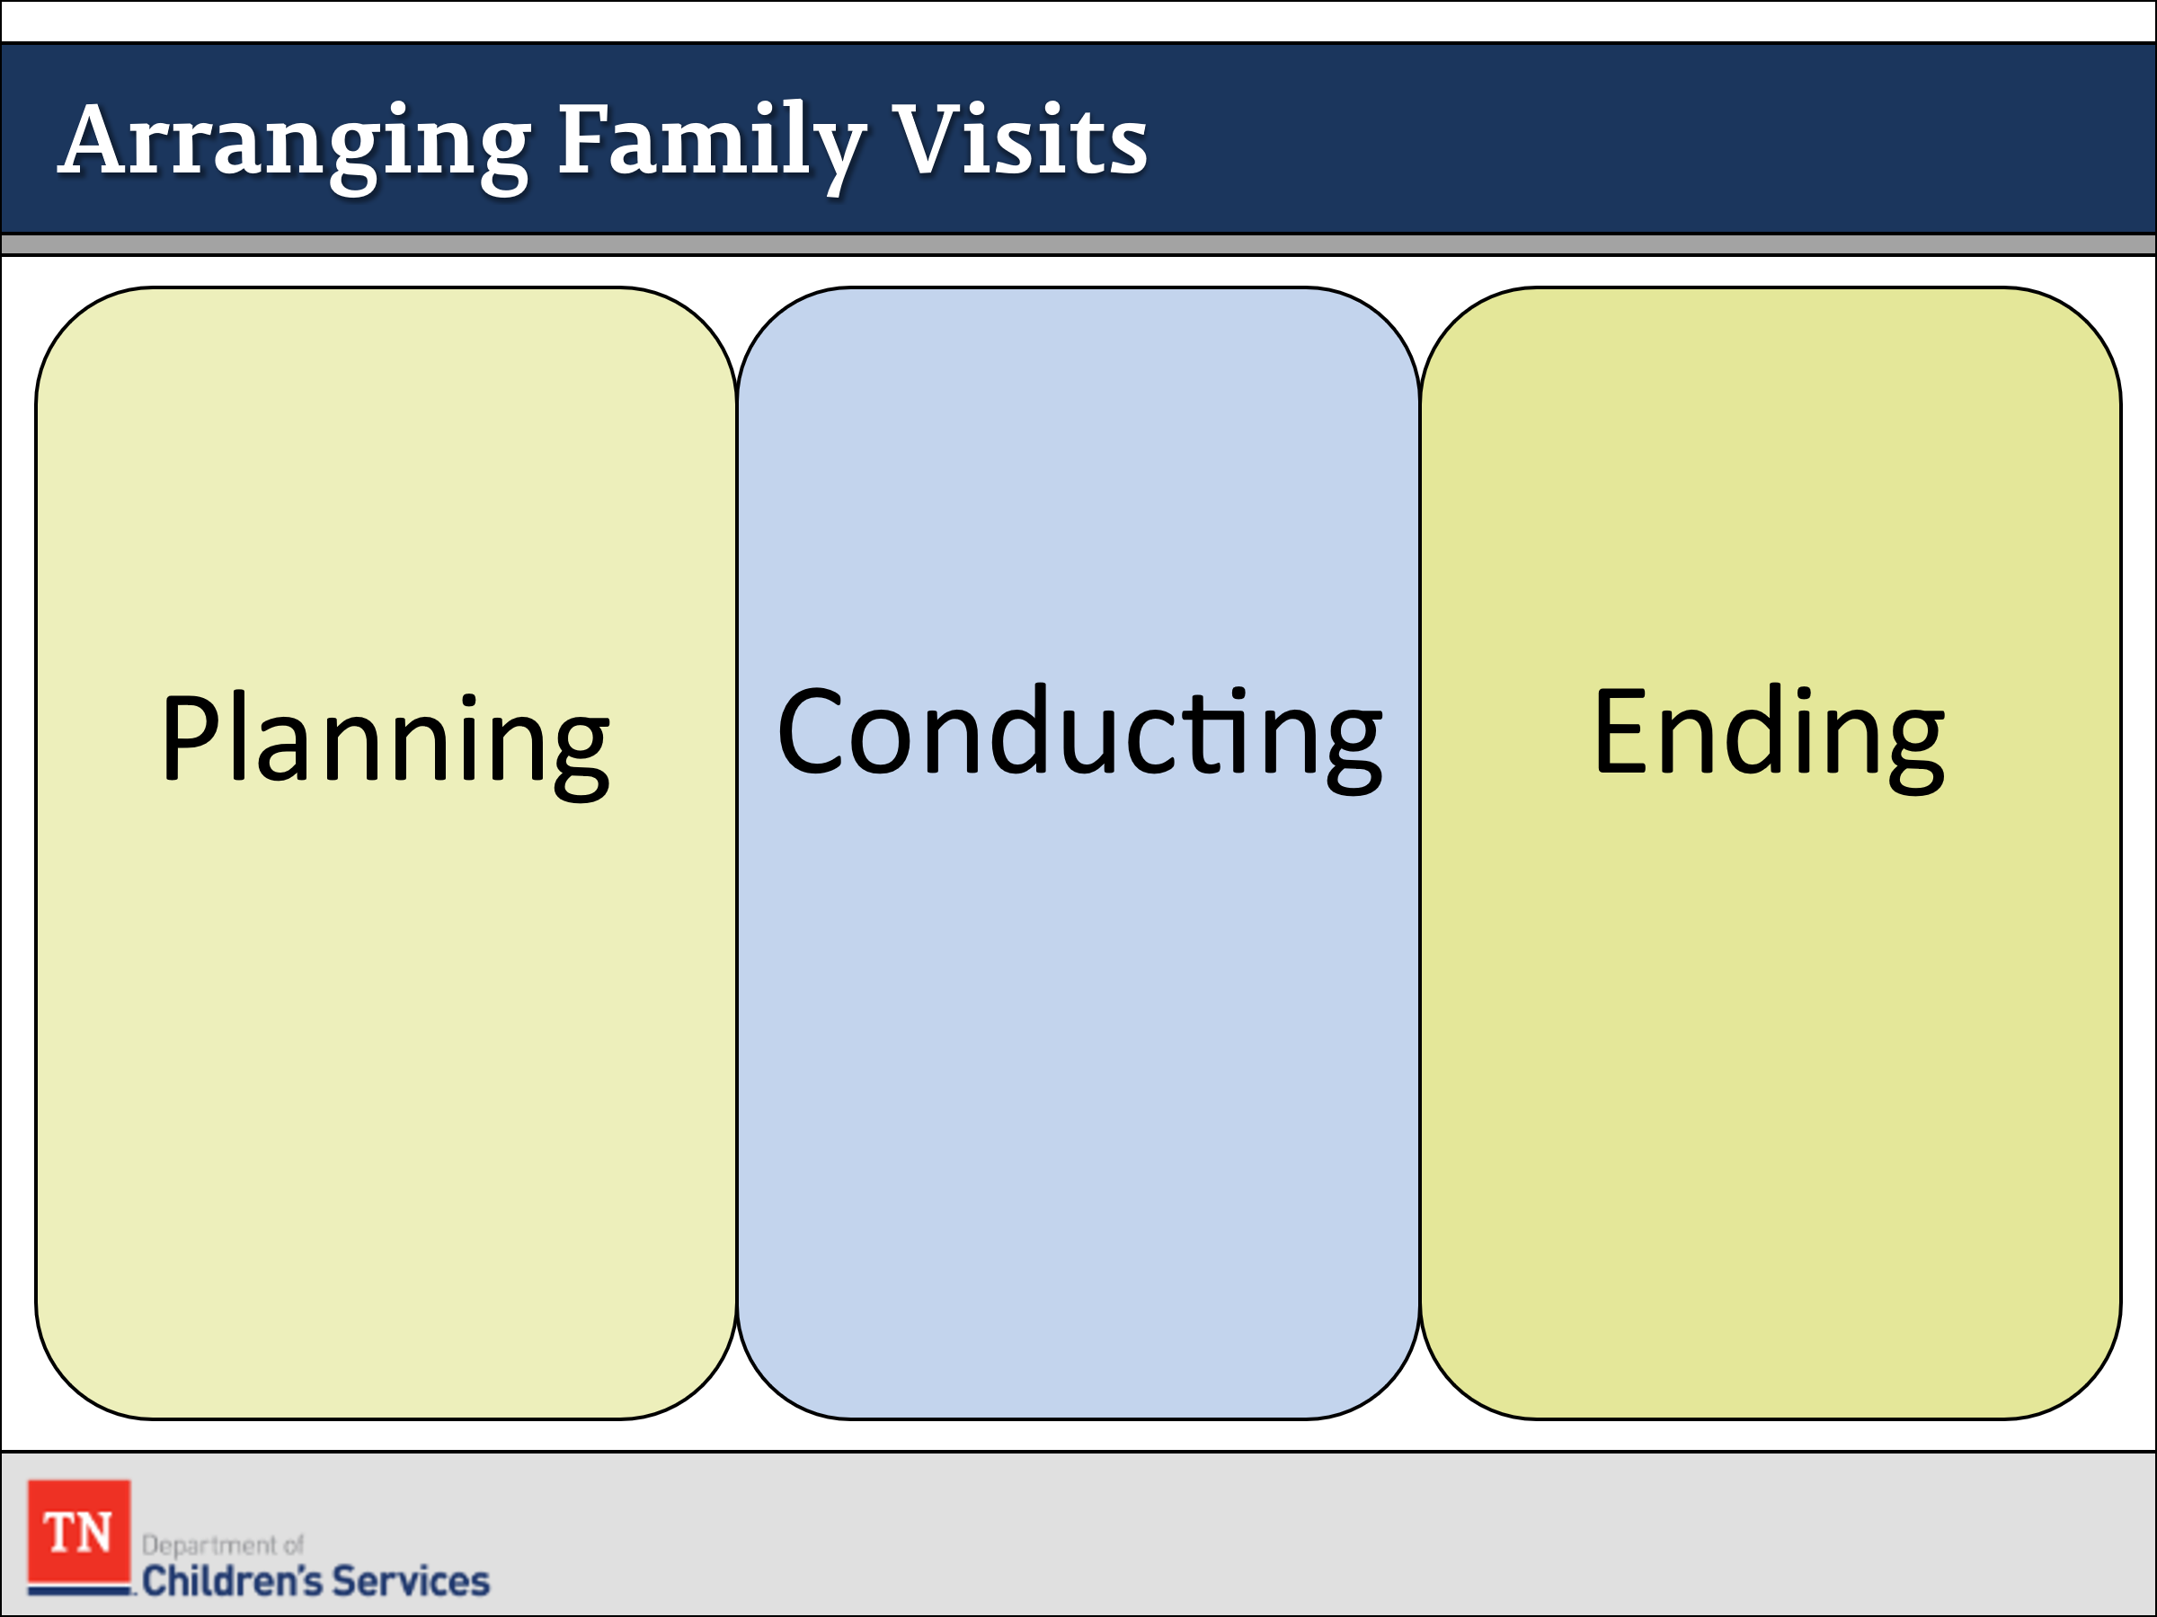
- INFORM participants visitation can affect a child’s behavior. REFER the participants to the Changes in Children’s Behavior Before and After Visits handout.
- REFERENCE Guidelines for Arranging Family Visits handout and GIVE participants a few minutes to look over this resource.
- Guidelines for Arranging Family Visits
- Planning the visit
  - Develop a regular, written visitation schedule (with the family and team in the initial CFTM).
  - Respect the birth parents’ and resource parents’ preferences for visit times and locations.
  - Keep in mind the developmental needs of the child or youth.
  - Contact the birth parent and resource parent and arrange or confirm the date, time, and location of the visit (at least 24 hours in advance).
  - Let parents know whether the visit will be supervised or unsupervised and explain why.
  - Explain the visitation procedures and activities to birth and resource parents.
  - Make sure parents understand what the child goes through if they don’t show up for a visit.
  - Identify the ways in which you expect the birth parent to interact with and parent the child.
  - Encourage parents to enjoy being with their children in a variety of ways: through play, conversation, listening, reading, or a shared activity.
  - Help the child or youth understand that visits will be times spent with his or her family.
  - Organize or confirm transportation arrangements.
- Conducting the visit (if supervised)
  - Remind birth parents why the visit is supervised.
  - Acknowledge the progress and positive connections the birth parent has made with the child or youth in previous visits.
  - Review the purpose of the visit and the planned activity.
  - Identify the ways in which you expect the birth parent to interact with and parent the child.
  - Let the child or youth and the birth parent know what is expected of them during the visit.
  - Explain the family service worker’s role in the visit.
  - Observe the parents’ interactions with the child and the use of positive parenting skills.
- Ending the visit
  - Briefly review the overall progress of the activity and its importance to the child or youth and family.
  - Acknowledge the positive connections and interactions between the child/youth and parents.
  - Make suggestions for ways to strengthen and maintain the connection.
  - Arrange or confirm the date, time, status, and location of the next visit.
  - Record the specifics of the visit
- ASK participants about if there are any questions about visitation. TRANSITION to Lesson 3.5 Facilitating Positive Placement.

Lesson 3.5: Facilitating Positive Placement

Lesson Time: 15 minutes
Key Teaching Points / Instructions
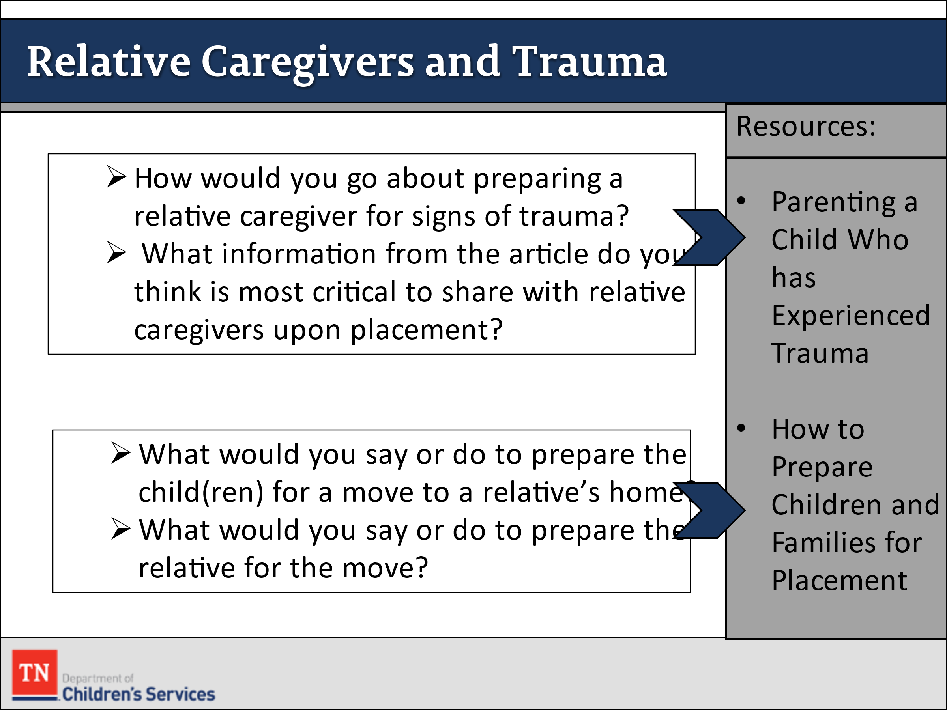
- ASK the group what potential challenges children who are placed with relative’s experience. FOCUS the discussion on the Williams family and the children’s placement with Grandma Rose. EMPHASIZE there will be changes in family roles and relationships leading to role confusion and conflicts. MENTION these examples if not discussed by the group:
  - Grandma Rose would have greater responsibility for the day- to-day care and decision making about the child(ren).
  - Ariana would not function in the role of a parent for her younger siblings. She would have to adhere to her grandmother’s rules for the family, which could be much different than what she has been used to at home.
  - The relationship between Ariana and the younger children would change with Grandma Rose taking over the parenting role from Renee and Ariana.
- REFER participants to the article Parenting a Child Who Has Experienced Trauma. ASK the group to consider the following questions:
  - How would you go about preparing Grandma Rose for signs of trauma?
  - What information from the article do you think is most critical to share with Grandma Rose upon placement?
- INSTRUCT participants to take a few minutes to REFLECT on what Renee and her children most need to successfully transition the children from living with their mother to temporary placement with Grandma Rose.
- REFER participants to How to Prepare Families and Children for Placement in Google Classroom. Give them a few minutes to review then ASK the following questions:
  - What would you say or do to prepare the Renee and the child(ren) for a move to Grandma Rose’s house?
  - What would you say or do to prepare the Grandma Rose for the move?
- TELL participants that once a child is placed with a foster family, whether that family is related to the child or not related, the FSW has certain responsibilities to ensure that the child’s needs are met. ASK the group what tasks are involved. REMIND the group of the following, if not mentioned:
  - Complete all the court documents and attend hearings
  - Enter information into TFACTS
  - Enroll the child in TennCare and Child Welfare Benefits
  - Ensure that the child’s physical, health, and educational needs are met
  - Complete a face-to-face contact with the child and foster parent as soon as possible but no later than 3 business days following removal in the foster home.
- TRANSITION to Unit 4 Assessment.
Unit 4: Assessment

Unit Time: 60 minutes

Learning Objectives:
- Participants will demonstrate assessment skills by using the CANS to assess the strengths and needs of the family.

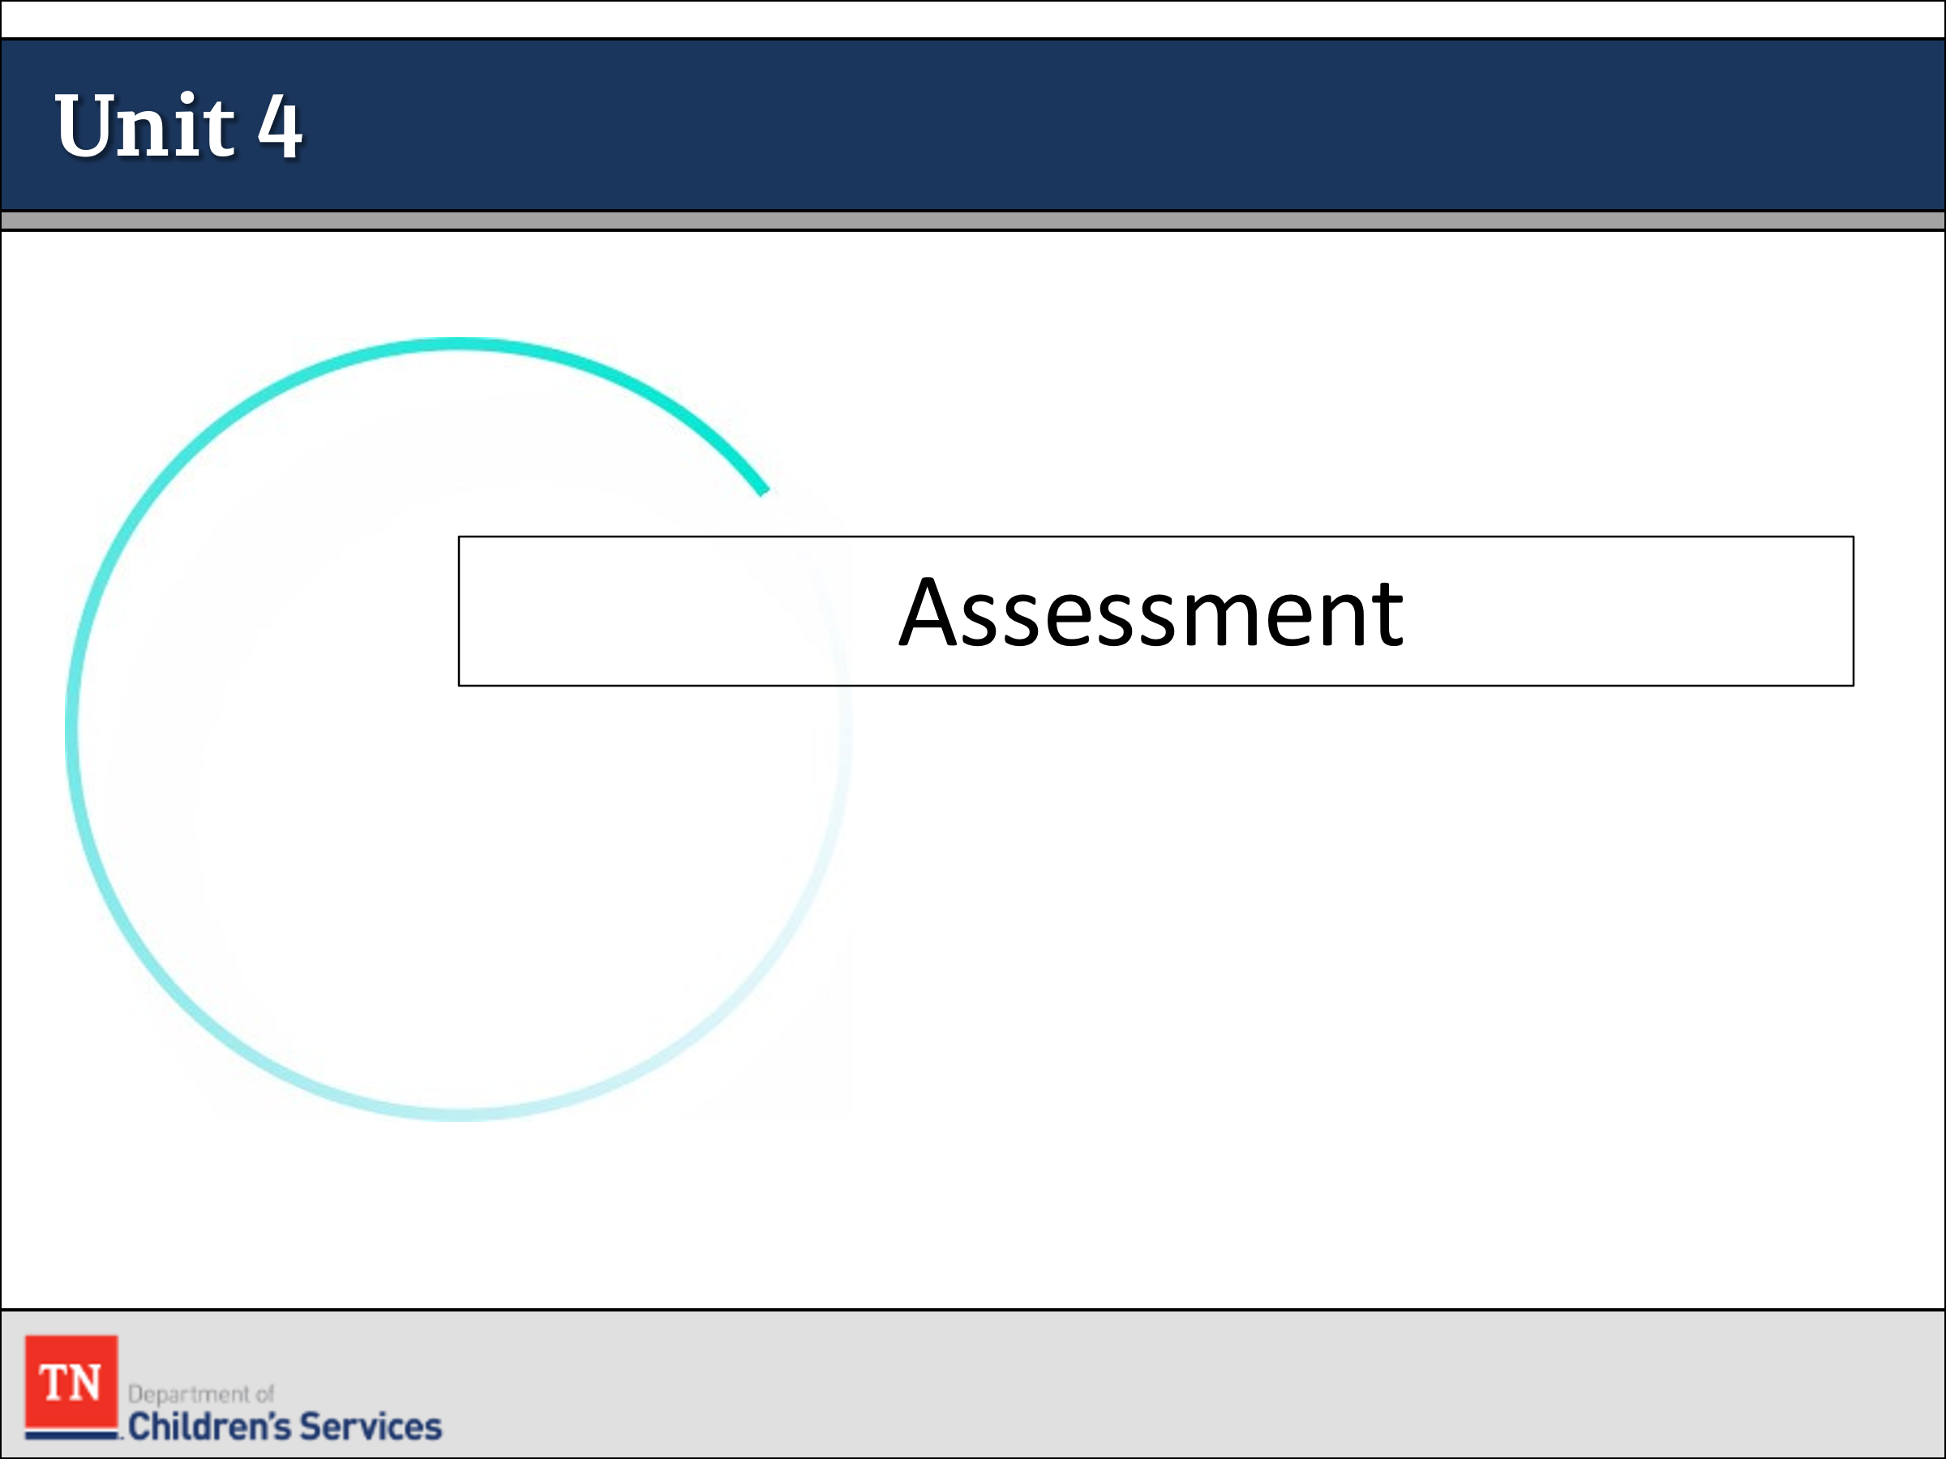
Supporting Materials:
- PowerPoint
- A Guide for Using CANS with Child, Caregivers, and their families: A Tip Sheet Handout
- CANS Protocol

Lesson 4.1: Assessment Integration

Lesson Time: 60 minutes
Key Teaching Points / Instructions

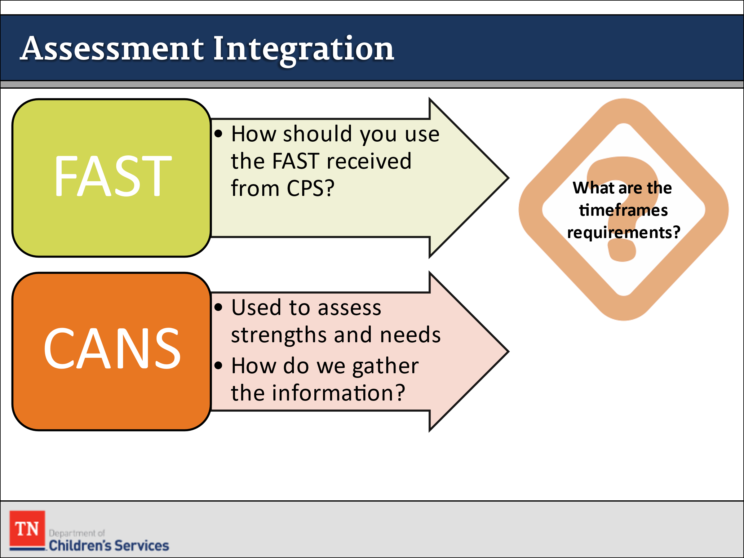
- BEGIN the lesson with a discussion about assessment integration and how we use all information gathered to inform on-going case planning.
- ASK participants how they should use assessments they obtain from CPS into their case practice. This includes the FAST (Family Advocacy Support Tool) and any other formal assessments completed during the CPS case.
- REMIND participants the CANS intervention is used to assess the strengths and needs of the child and family. ASK participants how they gather information for the CANS. Gathering this information may take place by:
  - Interviews
  - Observations
  - Records checks
  - Collateral reports
  - Evaluations
  - Pictorial tools (i.e., genogram, timeline, family map)
  - Other DCS assessment tools
- STATE the CANS is initiated on all children/youth (ages 5 and above) when entering custody. According to the CANS Protocol, the FSW initiates the CANS within the first 7 business days of custody and submits it to the Assessment Consultant within the first 10 business days of custody. It is finalized by the COE Assessment Consultant within 15 business days of the child/youth entering custody.
- SHARE the CANS is updated, reviewed, and finalized no less than every six (6) months for all CANS eligible children and youth unless there are changes in the circumstances of the case which require an update sooner.
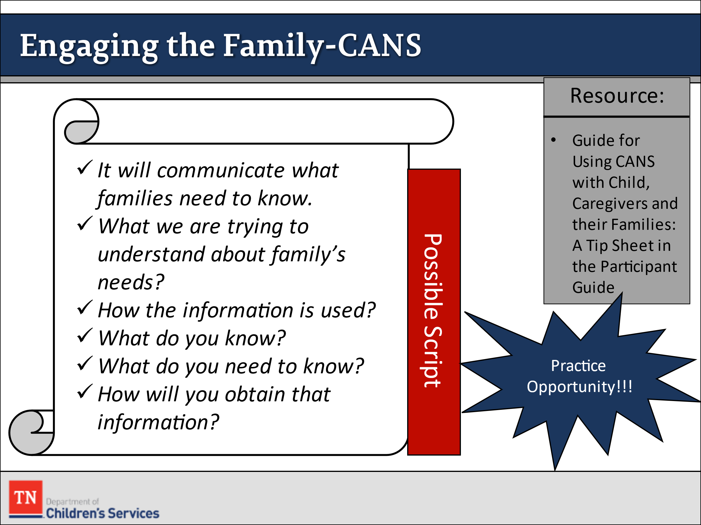
- CONDUCT ACTIVITY: Introducing the CANS to the Family
  - REFER participants to the Guide for Using CANS with Child, Caregivers, and their Families: A Tip Sheet in Google Classroom.
  - INFORM the group they will have a conversation with each family about the CANS and how it is used to inform the case plan. The script should include:
    - It will communicate what families need to know.
    - What we are trying to understand about family’s needs.
    - How the information is used.
    - What do you know?
    - What do you need to know?
    - How will you obtain that information?
  - SHARE it is important to have a script and to practice having these discussions prior to having the conversations with families. It is crucial that families understand the importance of the CANS and how it is used throughout the case process. The more prepared you are to have the conversation with the family the more trust there will be in the assessment process.
  - INSTRUCT participants to take 5-7 minutes to draft a script of how they would introduce the CANS to a family. DEBRIEF by asking participants to share any questions. ASK for volunteers to share the script and PROVIDE Strengths-Based Feedback. THANK participants who volunteer.
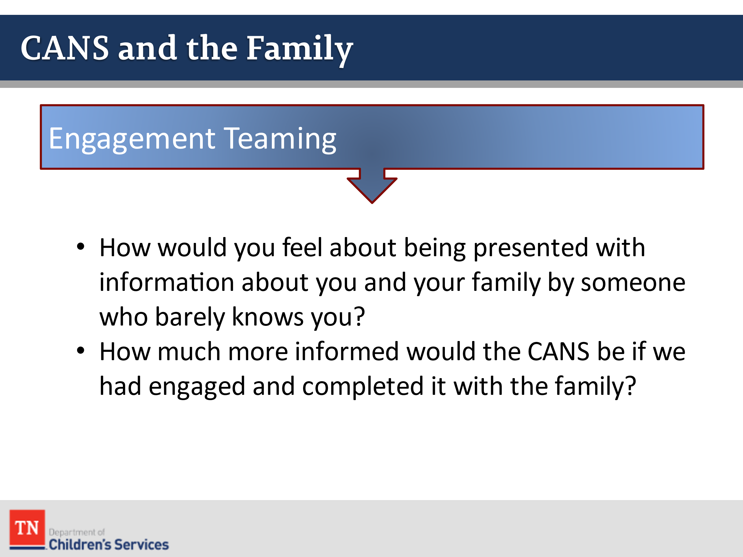
- TRANSITION into discussing the first interactions with the family, and/or child.
- EXPLAIN to the group that our first impression always leaves a lasting impression with the families.
- EXPLAIN how engaging and teaming with the family will assist us in creating a global assessment of the family.
- REFER BACK to engagement and teaming and ask the following questions:
  - How would you feel about being presented with information about you and your family by someone who barely knows you?
  - How much more informed would the CANS be if we had engaged and completed it with the family?
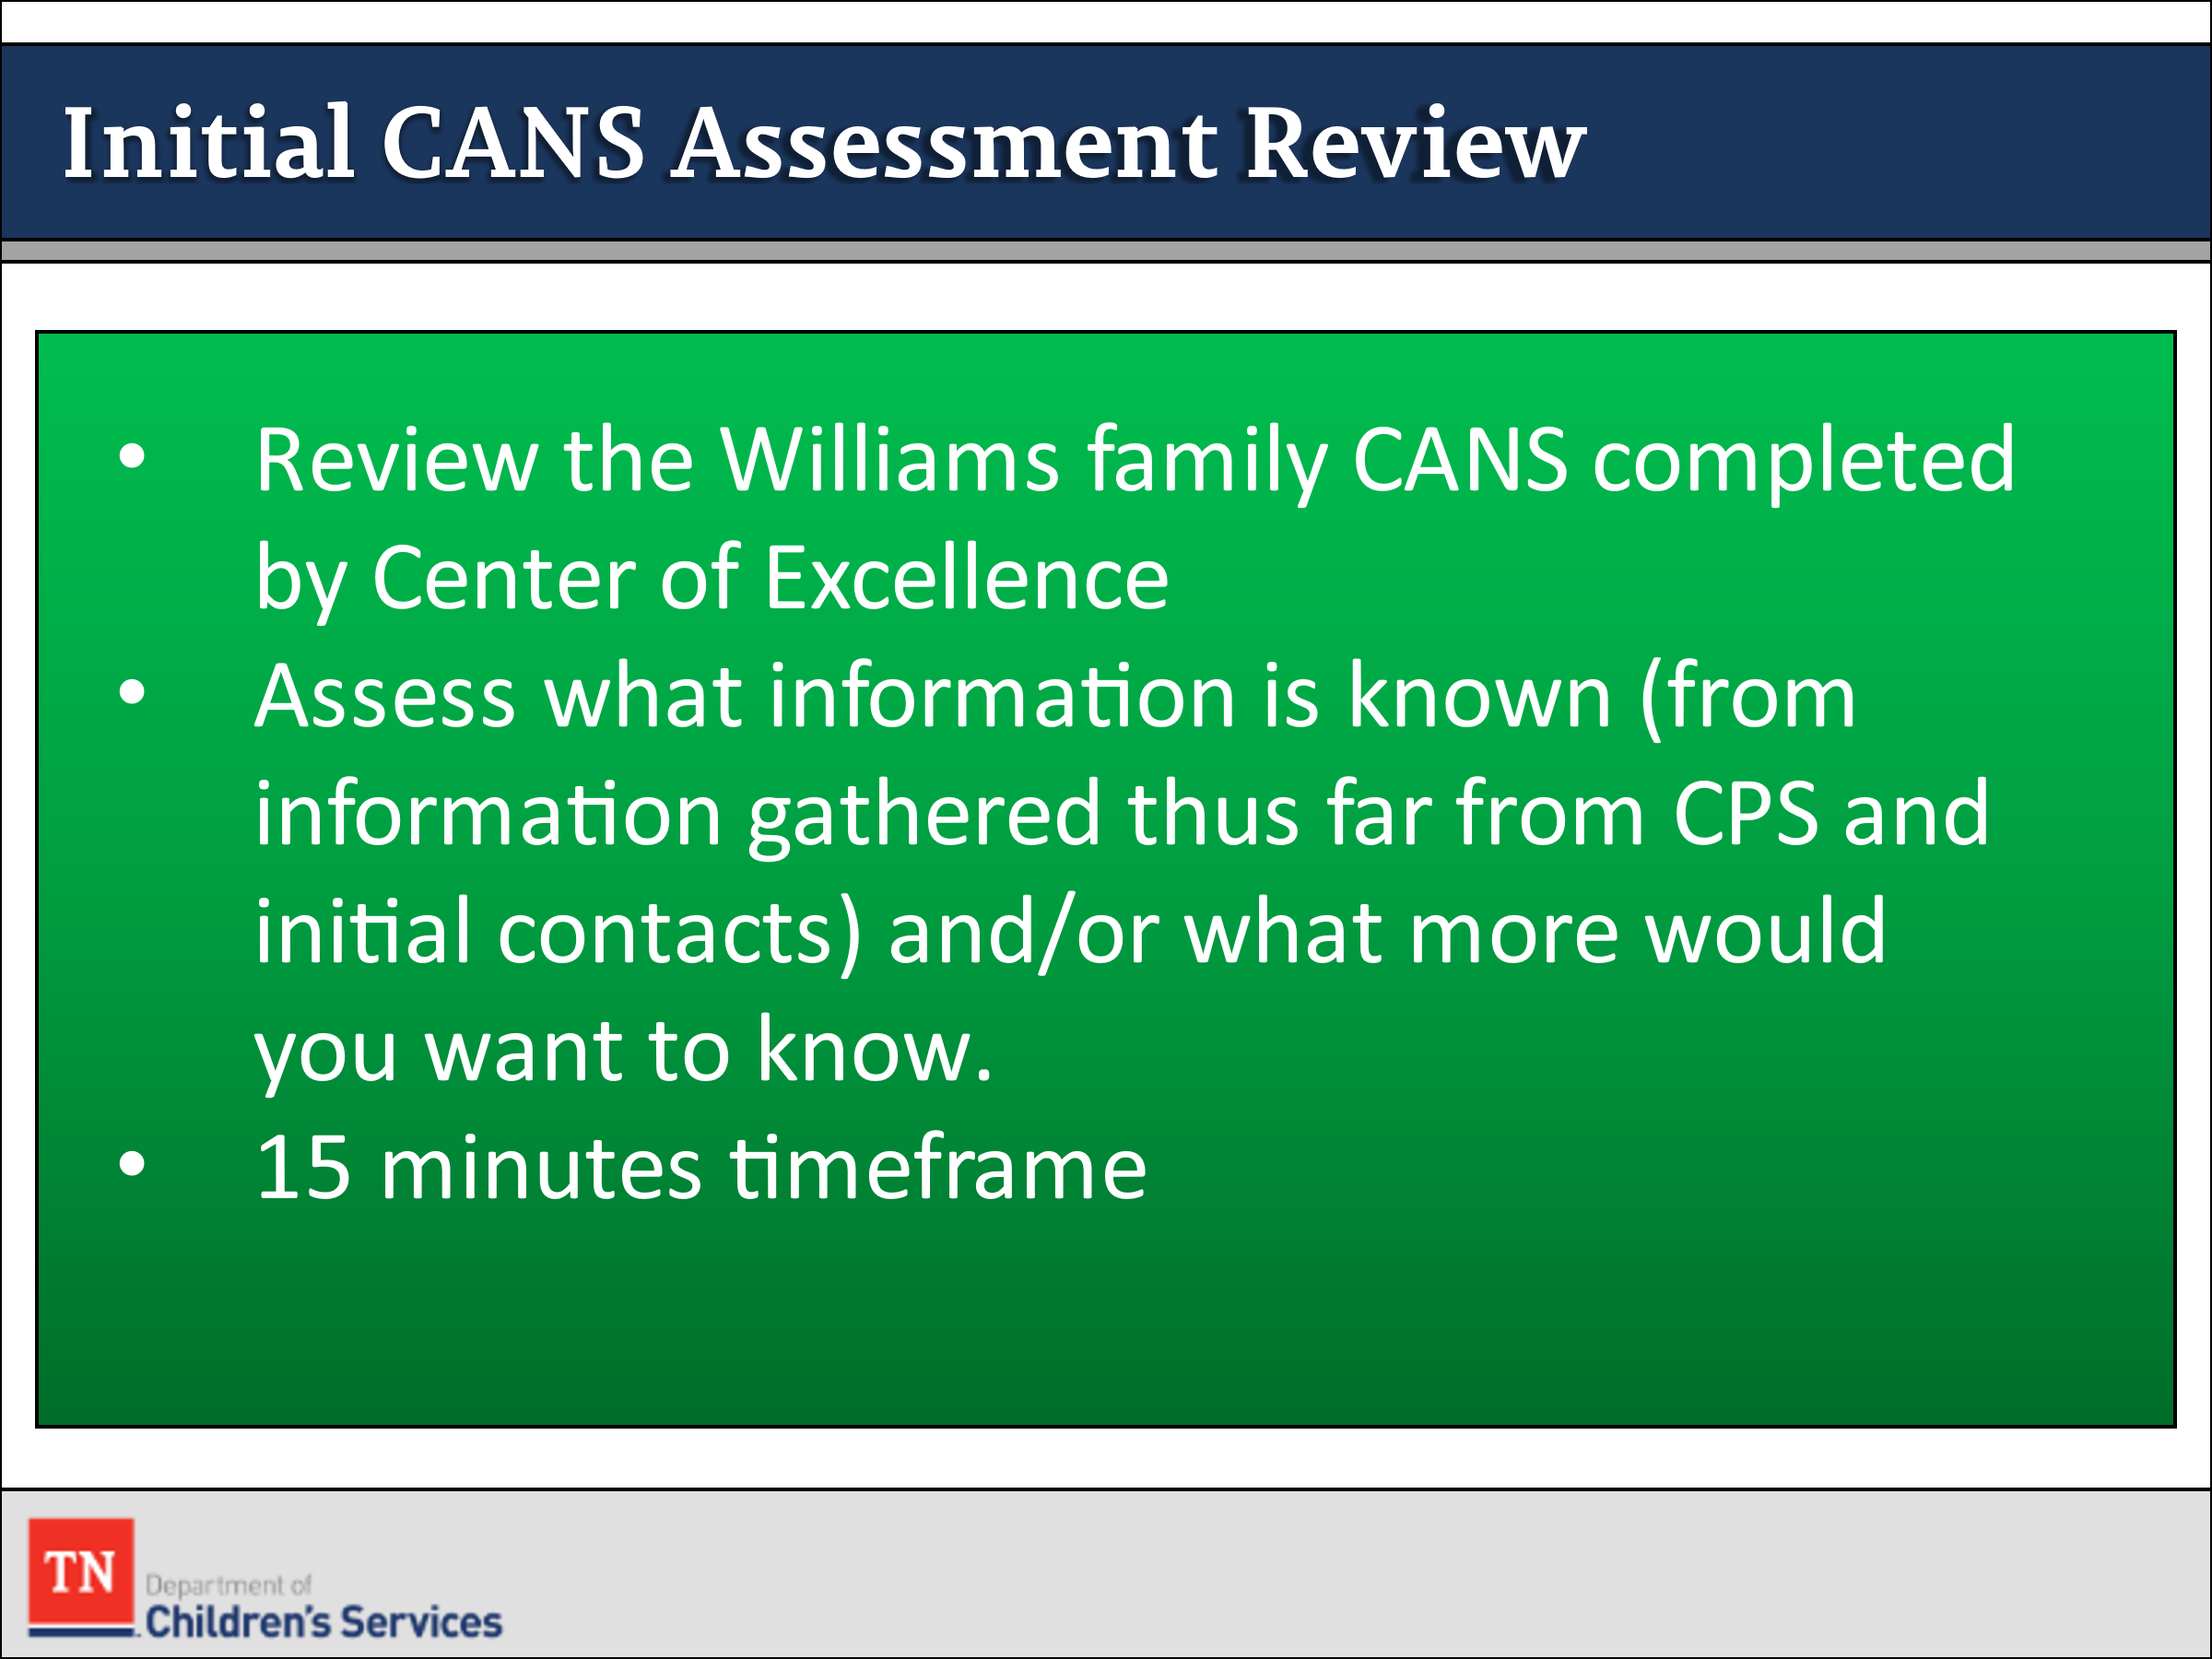
- CONDUCT ACTIVITY: Williams Initial CANS Assessment Review
- SUPPLY participants with the Williams Initial CANS Assessment completed by the Center of Excellence CANS Consultants.
- ALLOW 10-15 minutes for participants to review the Initial CANS assessment completed on Ariana. REQUEST for participants to assess what information is known (from information gathered thus far from CPS and initial contacts) and/or what more would you want to know. ASK participants to update the Family Assessment Worksheet with the additional information.
Trainer Note: We will not be focusing on the scoring at this time.
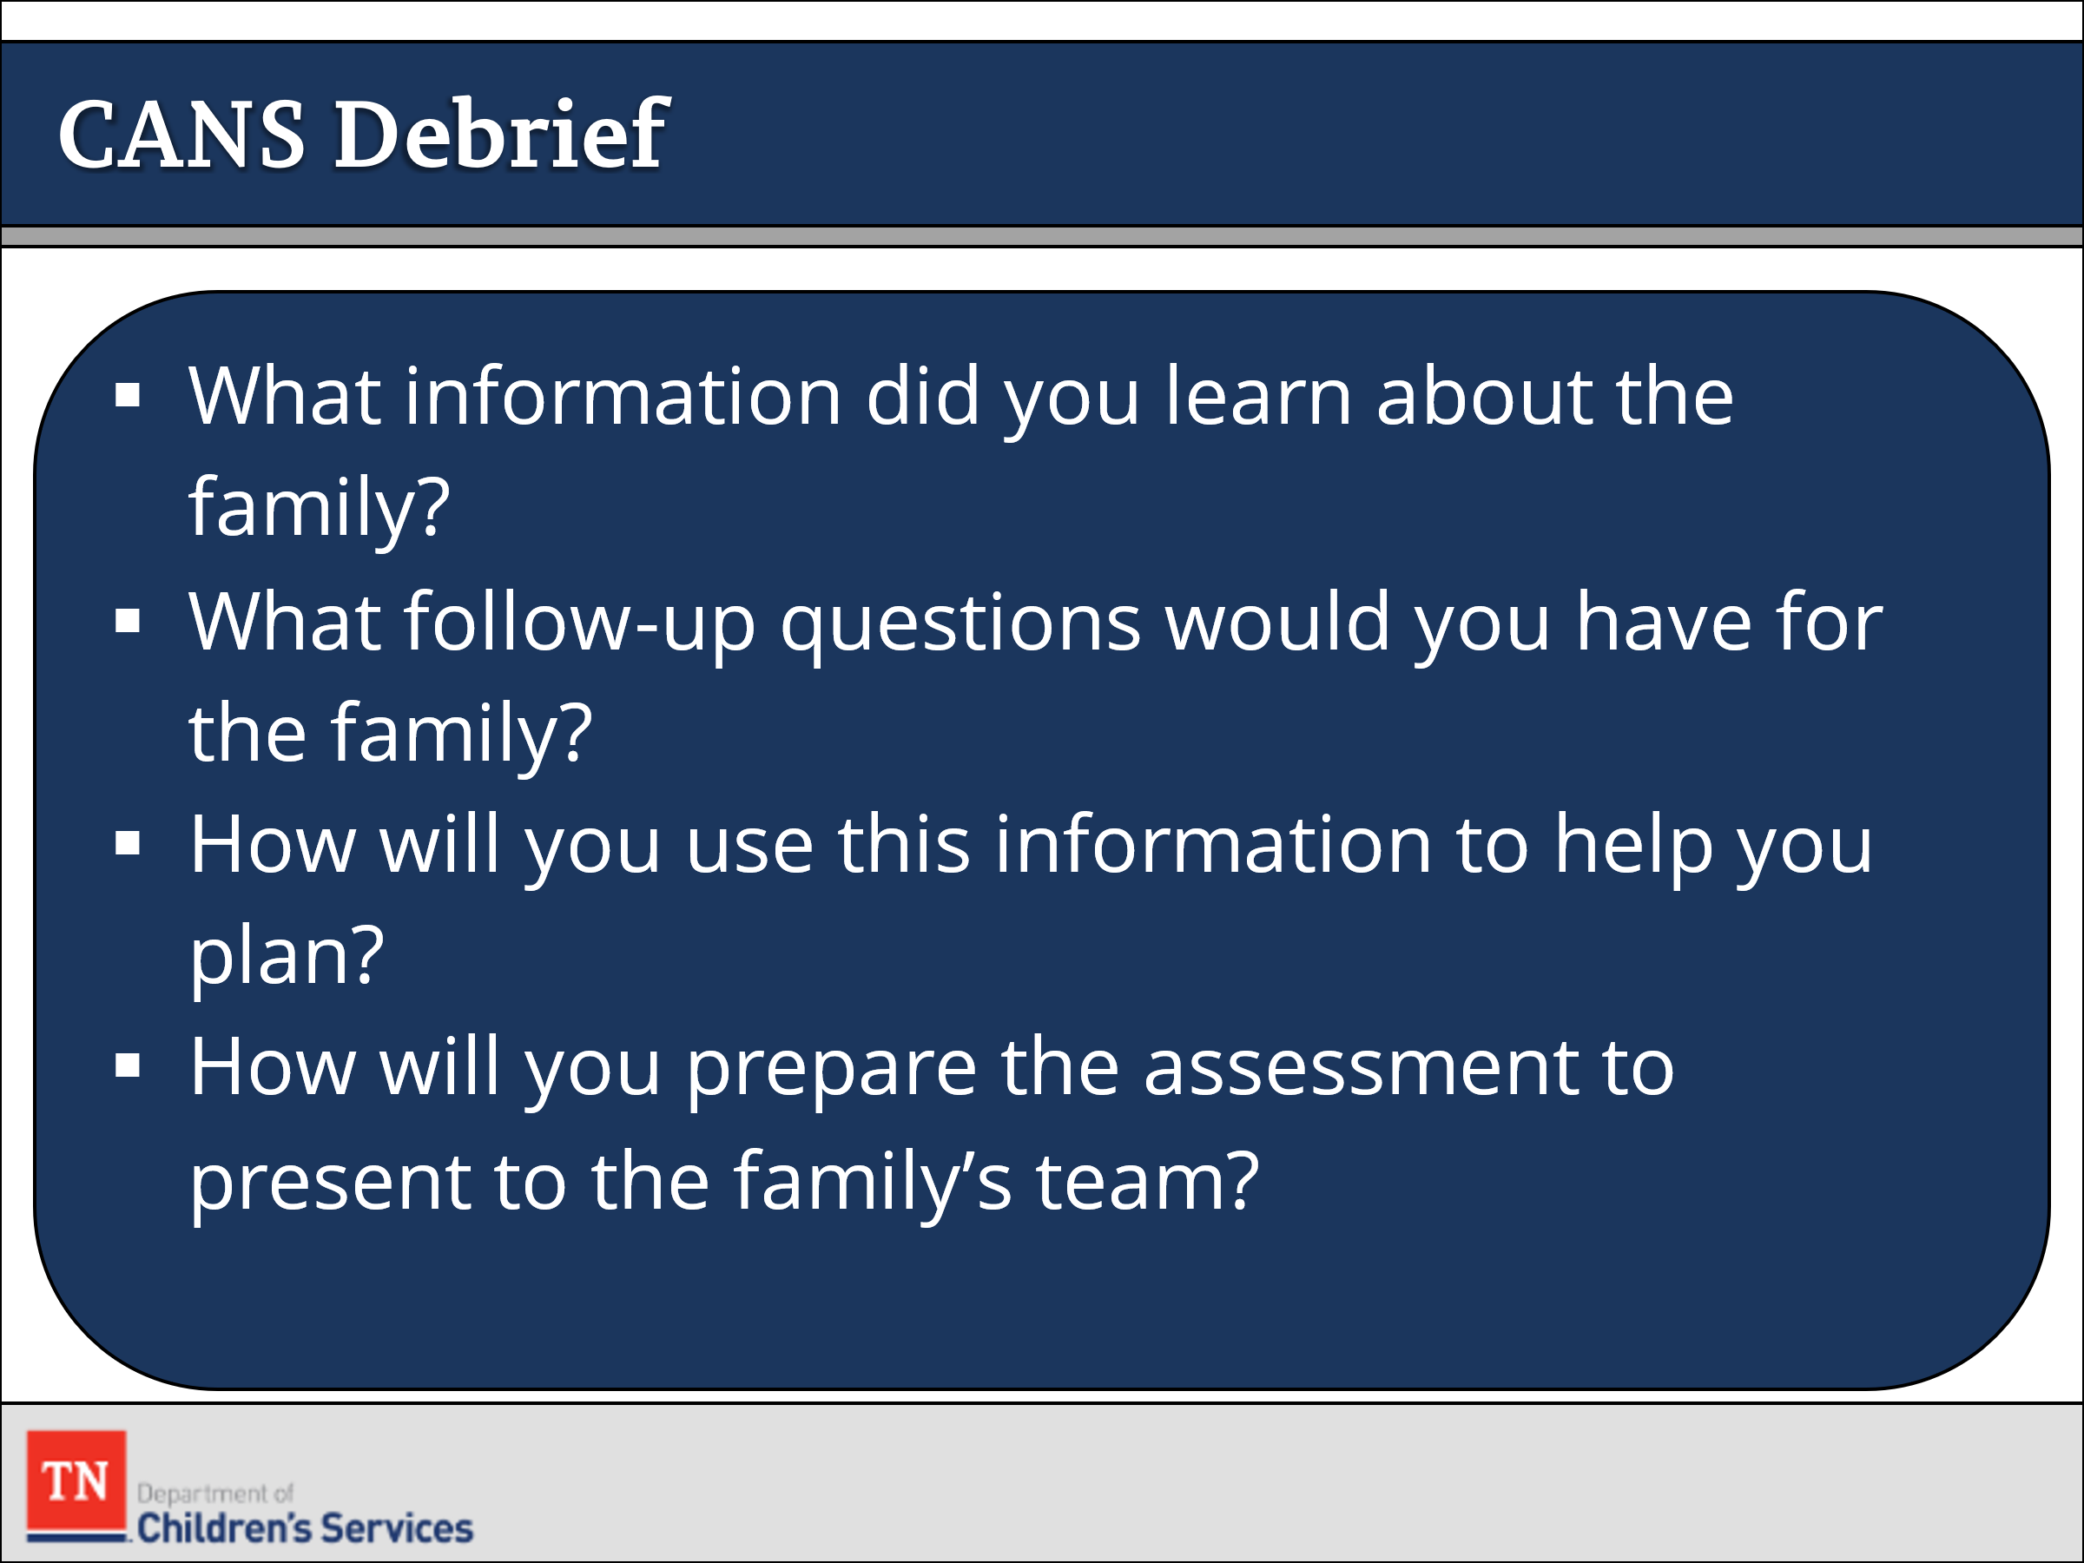
- RECONVENE the group and DEBRIEF with participants by asking the following questions:
- What information did you learn about the family?
- What follow-up questions would you have for the family?
- How will you use this information to help you plan?
- How will you prepare the assessment to present to the family’s team?
- INFORM the group the CANS is an ongoing process. There are specific times we complete a CANS reassessment throughout the life of the case. REMIND the group of the CANS Case Protocol shared during CANS training in Core week. Link: https://files.dcs.tn.gov/policies/chap31/CANSProtocol.pdf
- POINT OUT additional assessments may be needed in preparation for the upcoming Initial Permanency Plan CFTM at day 30.
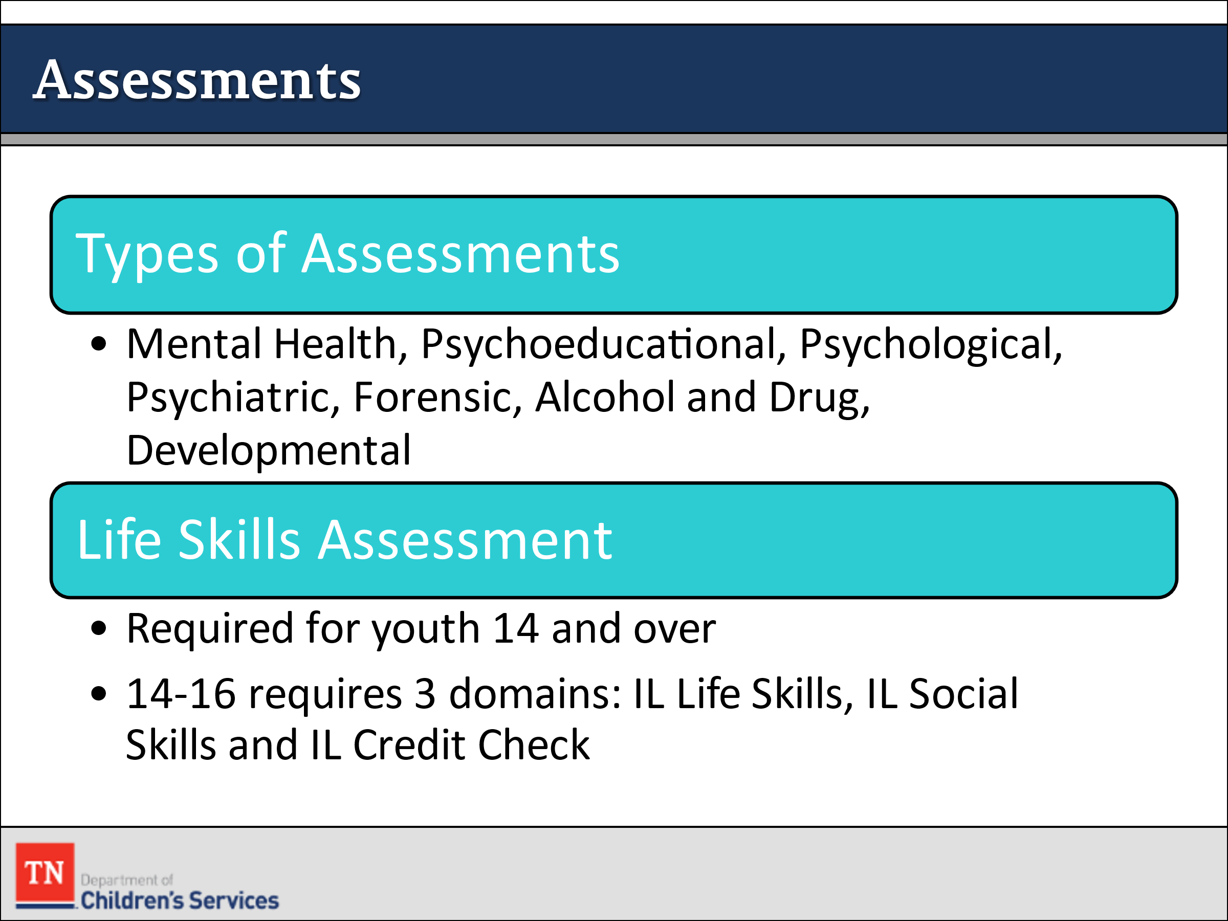
- REFER participants to Types of Assessments and briefly HIGHLIGHT the most common types. EXPLAIN some assessments are not paid for by insurance companies unless they are ordered by a doctor.
- STATE a Life Skills Assessment is required for youth aged 14 and older.
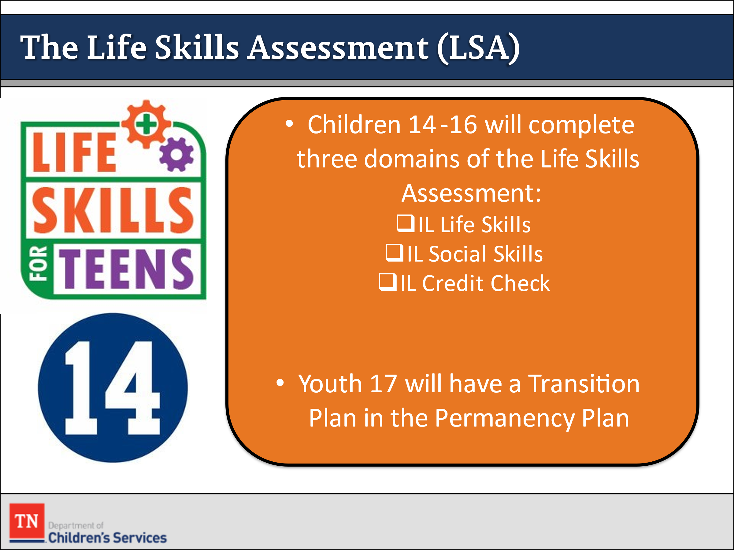
- The Life Skills Assessment in TFACTS is administered to all youth in custody fourteen (14) years of age or older prior to the initial CFTM by the FSW and then at least annually thereafter. The Life Skills Assessment is designed to evaluate the youth’s strengths and needs, and the results used to develop the Independent Living (IL) section of the permanency plan. Guidance on administration of the Life Skills Assessment is available in the Identifying and Accessing Independent Living Services Manual.
- How do you assist youth with completing the assessment accurately?
- TELL participants when we present the Life Skills Assessment to the youth it is important to inform the youth of why they are completing this assessment. The youth will complete the LSA annually to allow us to assess their progress toward developing independent living skills.
- ASK how does the CM and IL Specialist work together? SHARE FSW will review the Independent Living Handbook for youth over 14 at intake (if CPS or Court Liaison did not cover) or near their 14th birthday.
- EXPLAIN the youth’s Independent Living section is developed based on these results during the permanency planning portion of the CFTM. SHARE for youth ages 14-16 only three IL sections are required: IL Life Skills, IL Social Skills, and IL Credit Check. However, other domains may be completed for this age group as appropriate even though not mandated. Youth 16 and older are to complete all sections of the Life Skills Assessment.
- EXPLAIN for youth 17 and older, a Transition Plan is required for the Permanency Plan. REFER participants to DCS Policy 16.51: Independent Living and Transition Planning and DCS Policy 16.52: Extension or Re-Establishment of Foster Care for Young Adults.
- SHARE the following Life Skills resources
  - Identifying and Accessing Independent Living Services Manual
  - Independent Living Transition Planning Guide
  - Life Skills Assessment Storyboard
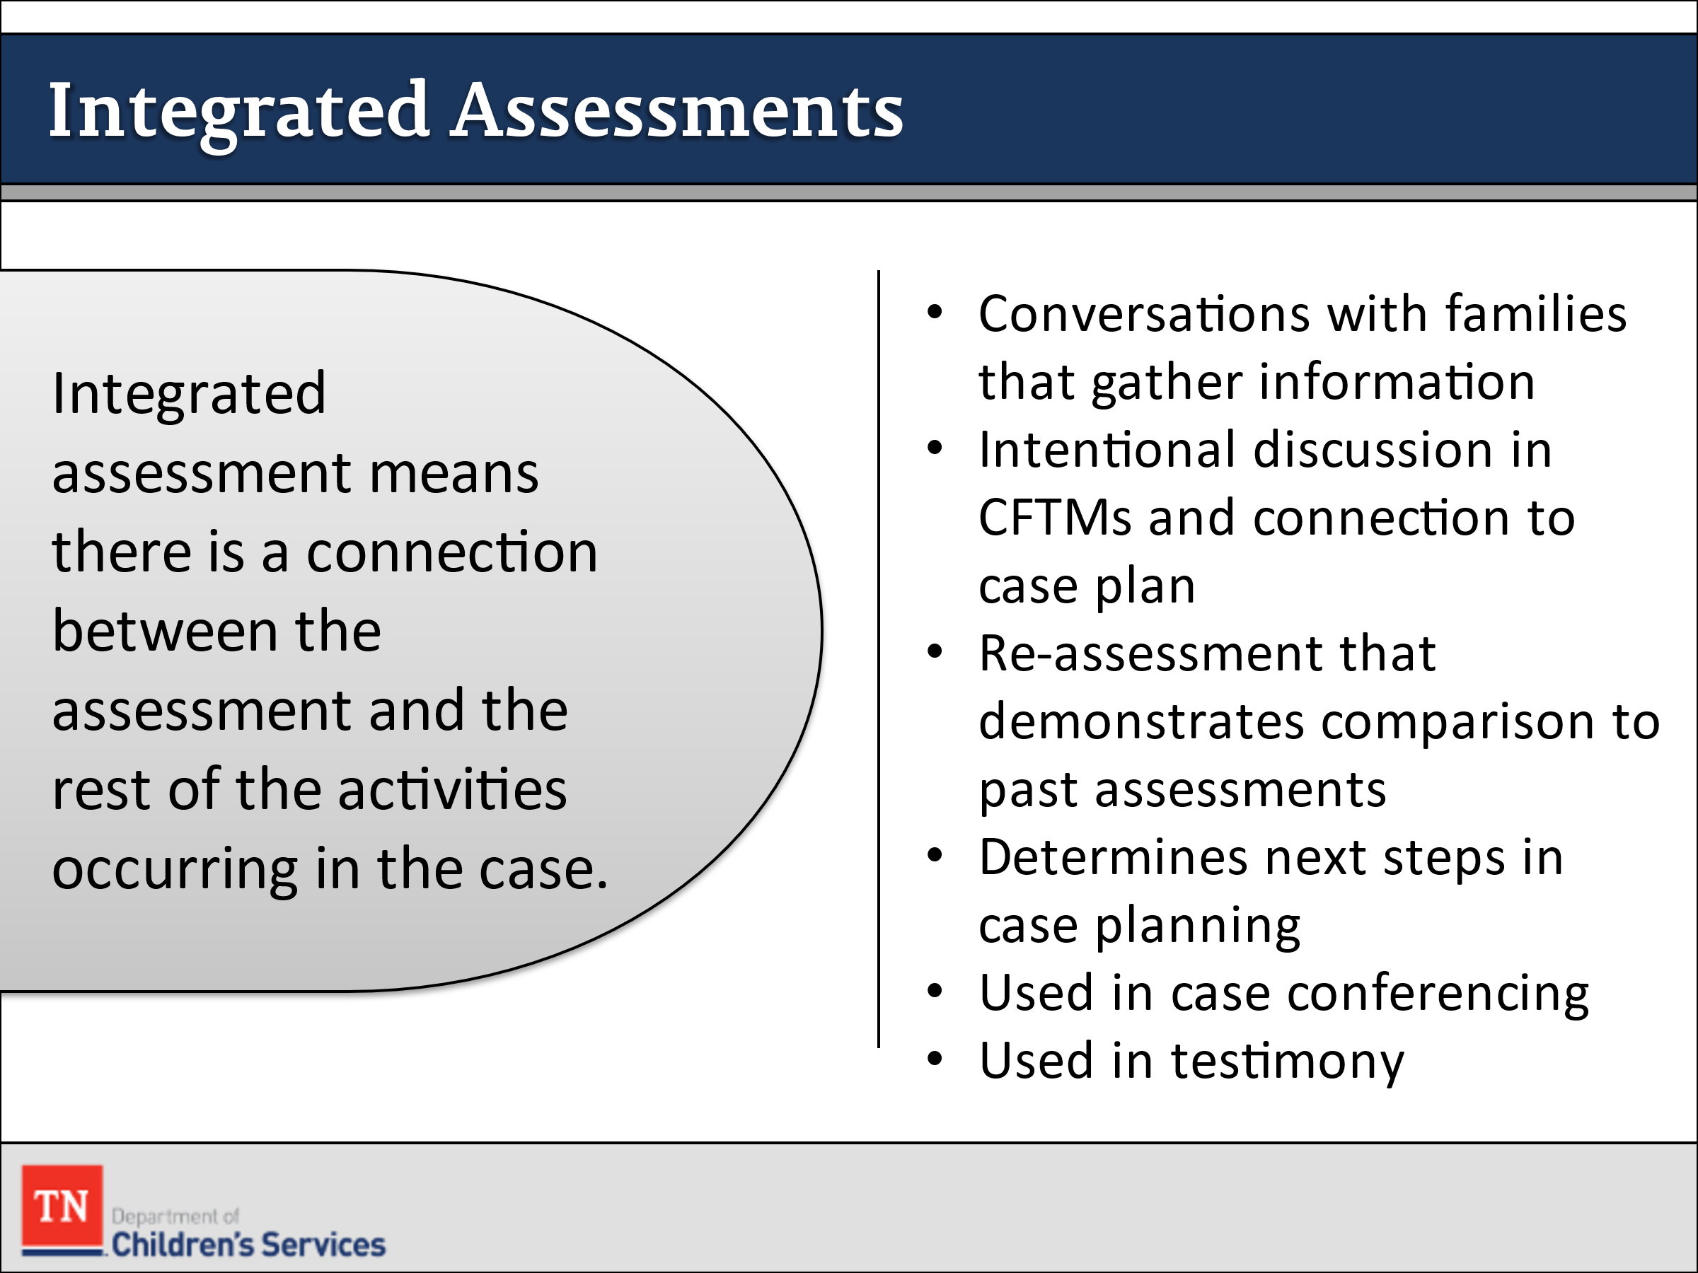
- SHARE integrated assessment means there is a connection between the assessment and the rest of the activities occurring in the case. These include:
  - Conversations with families that gather information to draw conclusions about functioning
  - Intentional discussion in CFTMs and connection to case plan (permanency plan or IPA) action steps, services selected, and decision making
  - Re-assessment that demonstrates comparison to past assessments and reflect the changes in family functioning observed
  - When things aren’t going well, assessment information is considered to determine different next steps in case planning
  - Used in case conferencing supervision meeting to guide discussion to ensure global assessment and integrated assessment throughout the case
  - Used in testimony in court to demonstrate objective assessment and structured case decision making
- ENSURE participants can understand how quality assessments lead to stronger case plans which are individualized to address the family’s strengths and concerns.
- TRANSITION to Unit 5 Planning/Implementation.

Unit 5: Planning/Implementation

Unit Time: 8 hours and 5 minutes

Learning Objectives:
- Participants will learn and demonstrate how to plan with the family to implement action steps which will help the family reach positive outcomes.

Supporting Materials:
- PowerPoint
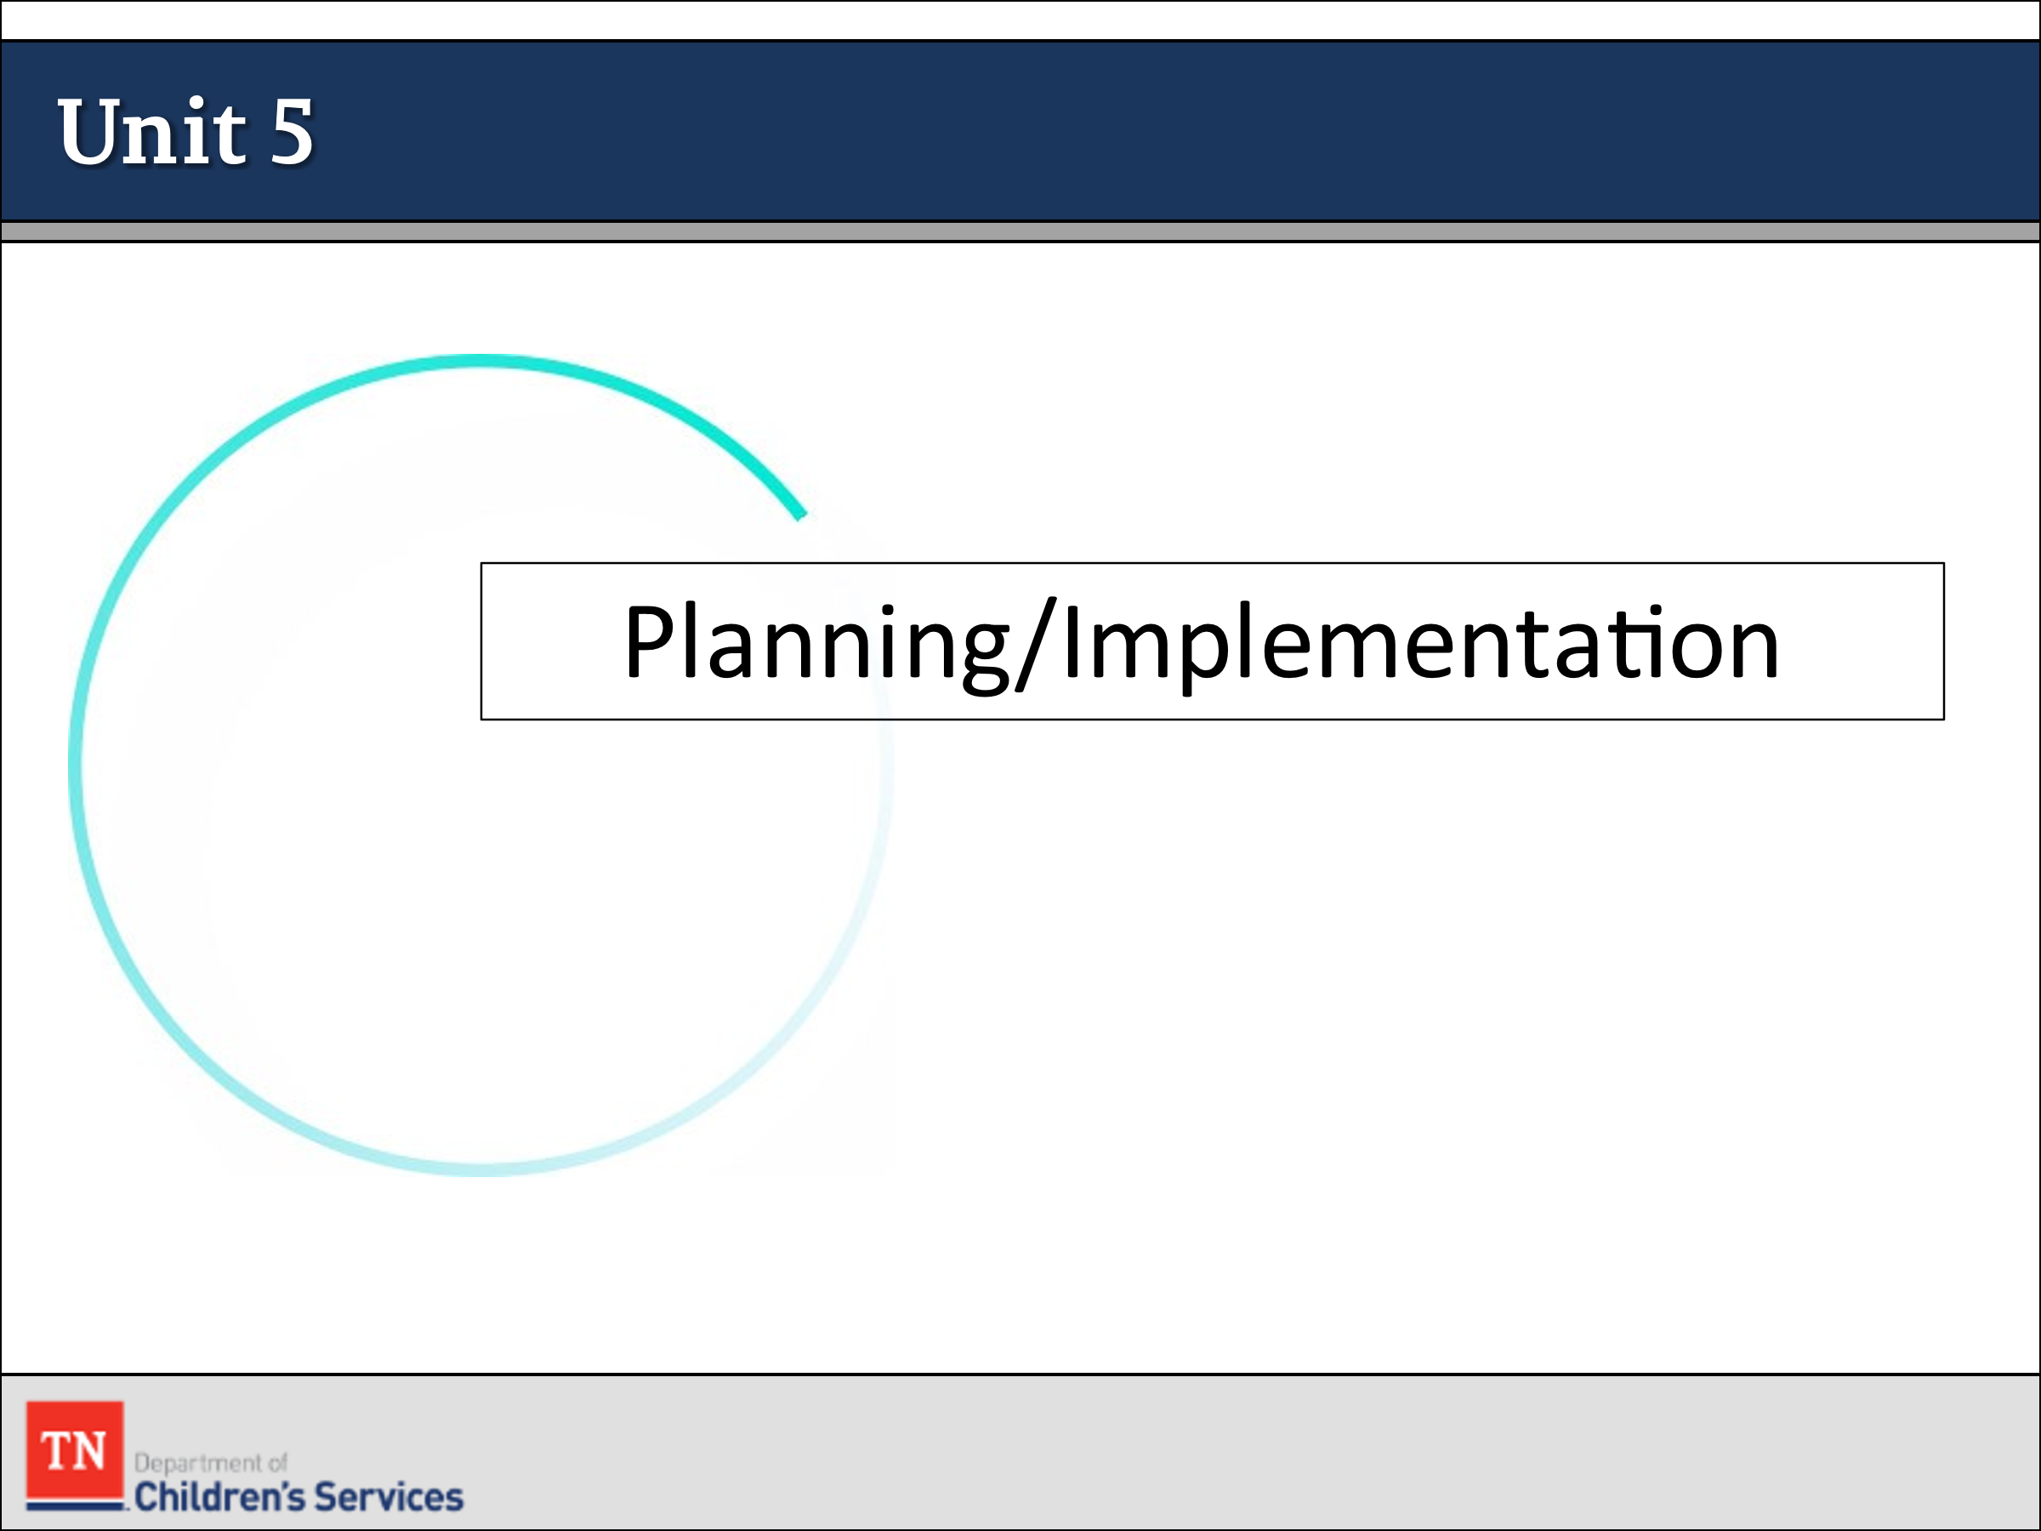
- Policies/Forms/Guides:
  - DCS Policy 16.31 Permanency Planning for Children in the Department of Children’s Services Custody
  - Policy 31.1 Family Permanency Plans
  - Permanency Plan Development Guide
  - DCS Policy 16.32 Foster Care Review and Progress Reports
  - Independent Living Handbook
  - DCS Policy 16.51: Independent Living and Transition Planning
  - DCS Policy 16.52: Extension or Re-Establishment of Foster Care for Young Adults
- How to have the Permanency Conversation with Youth and Guiding Questions for Youth Handout
- Criteria and Procedures for TPR (CS-0745)
- Strategies to Build Mutual Understanding Handout
- Protocol for Court Preparation and Attendance by Foster Care Staff

Lesson 5.1: Permanency Planning

Lesson Time: 15 minutes
Key Teaching Points / Instructions

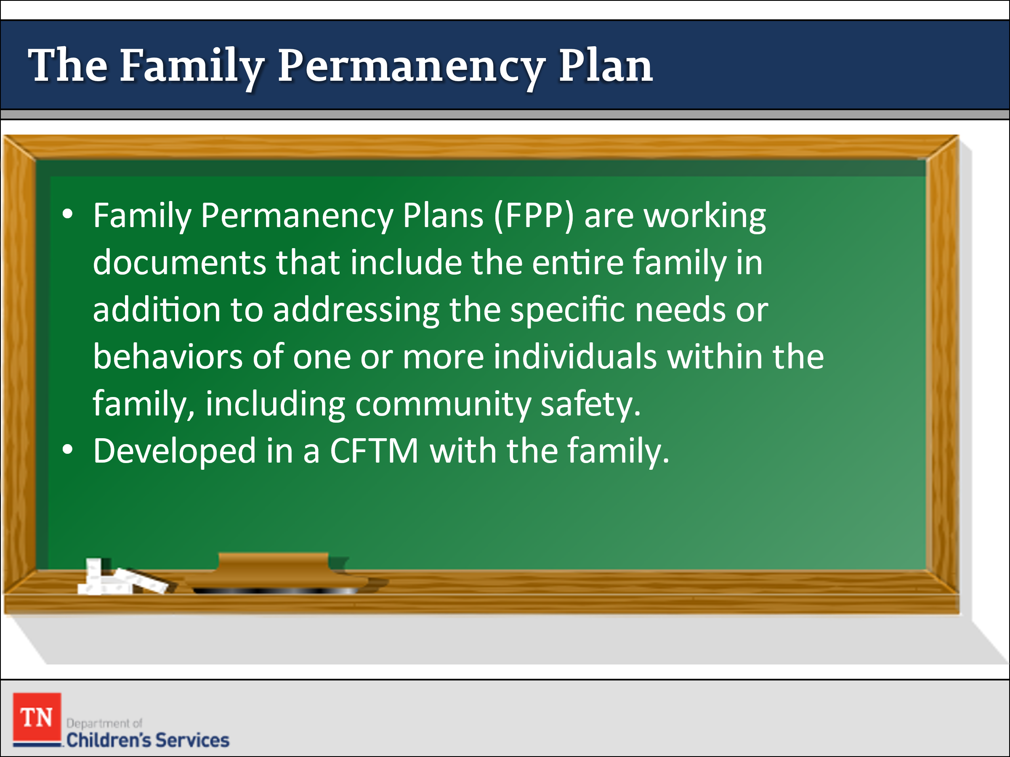
- STATE that when children enter care, the department has the responsibility to ensure that timely permanency is achieved.
- SHARE with participants that the first goal of the department is reunification. Unfortunately, it is not possible for every child and family. We should always be thinking exit at entry. Planning for discharge must begin on day one of the case.
- STATE Family Centered Permanency Planning is the process by which families, in conjunction with DCS, community partners, informal supports, specific interventions and services reinforce family strengths and meet the needs of the children/youth and their families involved with the Department of Children’s Services.
- REFER participants to Policy 31.1 Family Permanency Plans and Policy 16.31 Permanency Planning for Children/Youth in the Department of Children’s Services Custody.
- EXPLAIN the Family Permanency Plan is developed in collaboration with the child and family team in the context of the Initial Permanency Planning CFTM. REMIND the Initial Permanency Planning Child and Family Team Meeting is held within thirty (30) calendar days of the child/youth’s placement in custody.
- STATE Family Permanency Plans (FPP) are working documents that include the entire family in addition to addressing the specific needs or behaviors of one or more individuals within the family, including community safety. Children/ youth within the Family Permanency Plan may have different permanency goals and action steps based upon their specific needs.

Lesson 5.2: Permanency Goals

Lesson Time: 45 minutes
Key Teaching Points / Instructions

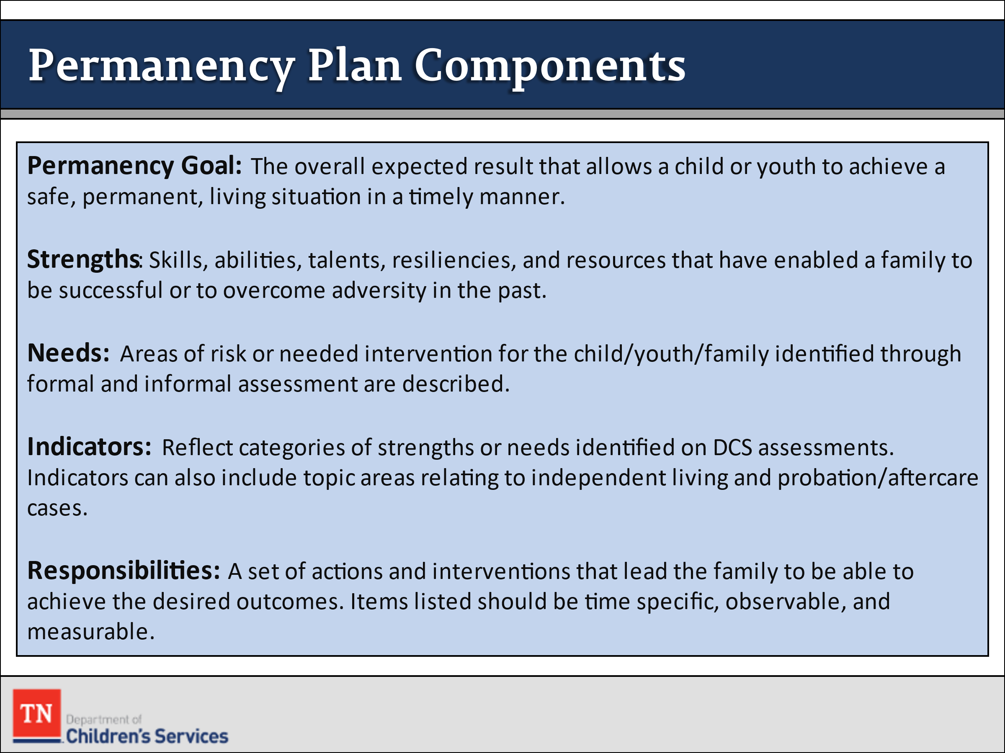
- TRANSITION and STATE the Family Permanency Plan establishes realistic goals, outcomes, and action steps necessary to achieve permanency for the family, the child/youth, and the Department. The outcomes and action steps address all the concerns that brought the child into custody as well as those needs identified by the ongoing assessment process, including health and education information and needs. Plans are designed to utilize the strengths of the family and include designated time frames for the completion of actions that help the child and family achieve permanency and stability as soon as possible. REFER to DCS Policy 31.1 Family Permanency Plans.
- STATE every Family Permanency Plan contains the following components:
  - a) Permanency Goal: The overall expected result that allows a child or youth to achieve a safe, permanent, living situation in a timely manner.
  - b) Strengths: Skills, abilities, talents, resiliencies, and resources that have enabled a family to be successful or to overcome adversity in the past.
  - c) Needs: Areas of risk or needed intervention for the child/youth/family identified through formal and informal assessment are described.
  - d) Indicators: Reflect categories of strengths or needs identified on DCS assessments. Indicators can also include topic areas relating to independent living and probation/aftercare cases
  - e) Responsibilities: A set of actions and interventions that lead the family to be able to achieve the desired outcomes. Items listed should be time specific, observable, and measurable. They should include the names of the persons responsible for each step and time frames for when the action should begin and be completed. Interventions should utilize the strengths that already exist within a family and involve informal supports when available. Whenever possible, the family should be given different options of interventions to choose from to include. Actions and responsibilities for DCS staff should also be included in the Family Permanency Plan which identifies action steps related to helping the child/youth and family receive services and move the child towards permanency.
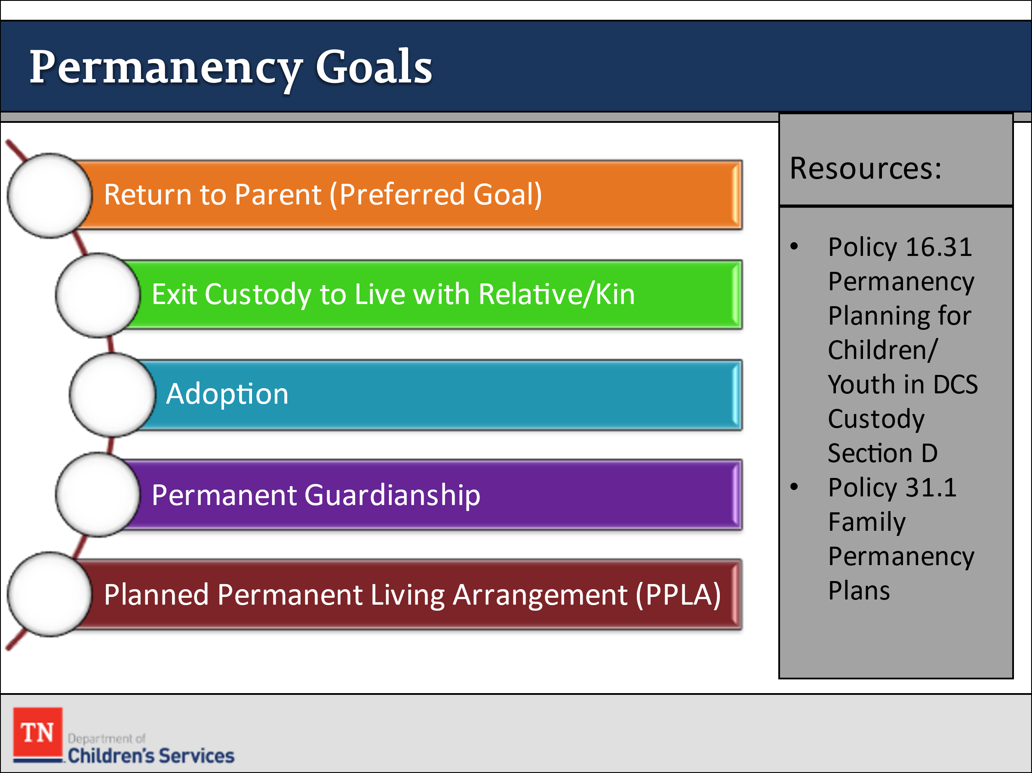
- REVIEW available permanency options including:
  - Return to Parent
  - Exit Custody to Live with Relative or Kin
  - Adoption
  - Permanent Guardianship (or SPG)
  - Planned Permanent Living Arrangement
- EXPLAIN there are times when it is uncertain if a permanency goal will be feasible. POINT OUT in such cases it is appropriate to be thinking of and planning for an alternative permanency goal; that also, will be in the best interests of the child if the primary goal cannot be realized.
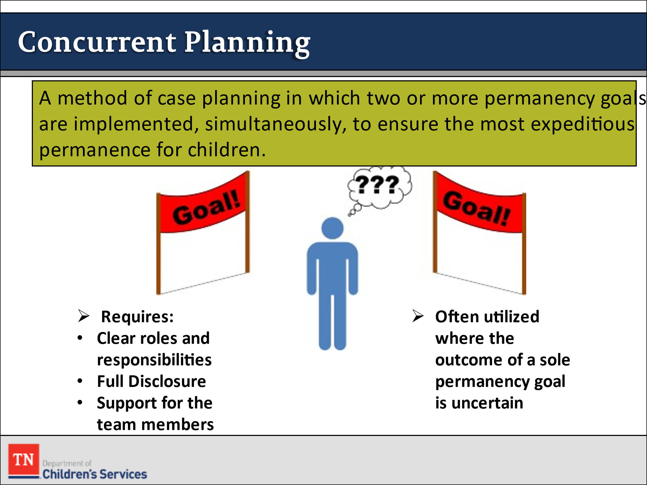
- SHARE this process is referred to as concurrent planning – a method of case planning in which two permanency plan goals are implemented simultaneously in order to ensure the most expeditious permanence for children. Successful concurrent planning requires a clear delineation of roles and responsibilities through the planning process full disclosure, and support for the child and family team members. It is often utilized in cases where the outcome of a sole permanency goal is uncertain.
- TELL participants that as FSW’s, it is crucial we are always assessing the case and tracking and adjusting action steps as needed to reach permanency in a timely manner. Per policy, we are to review permanency plans quarterly in a CFTM, additionally, we are to review progress on an ongoing basis.
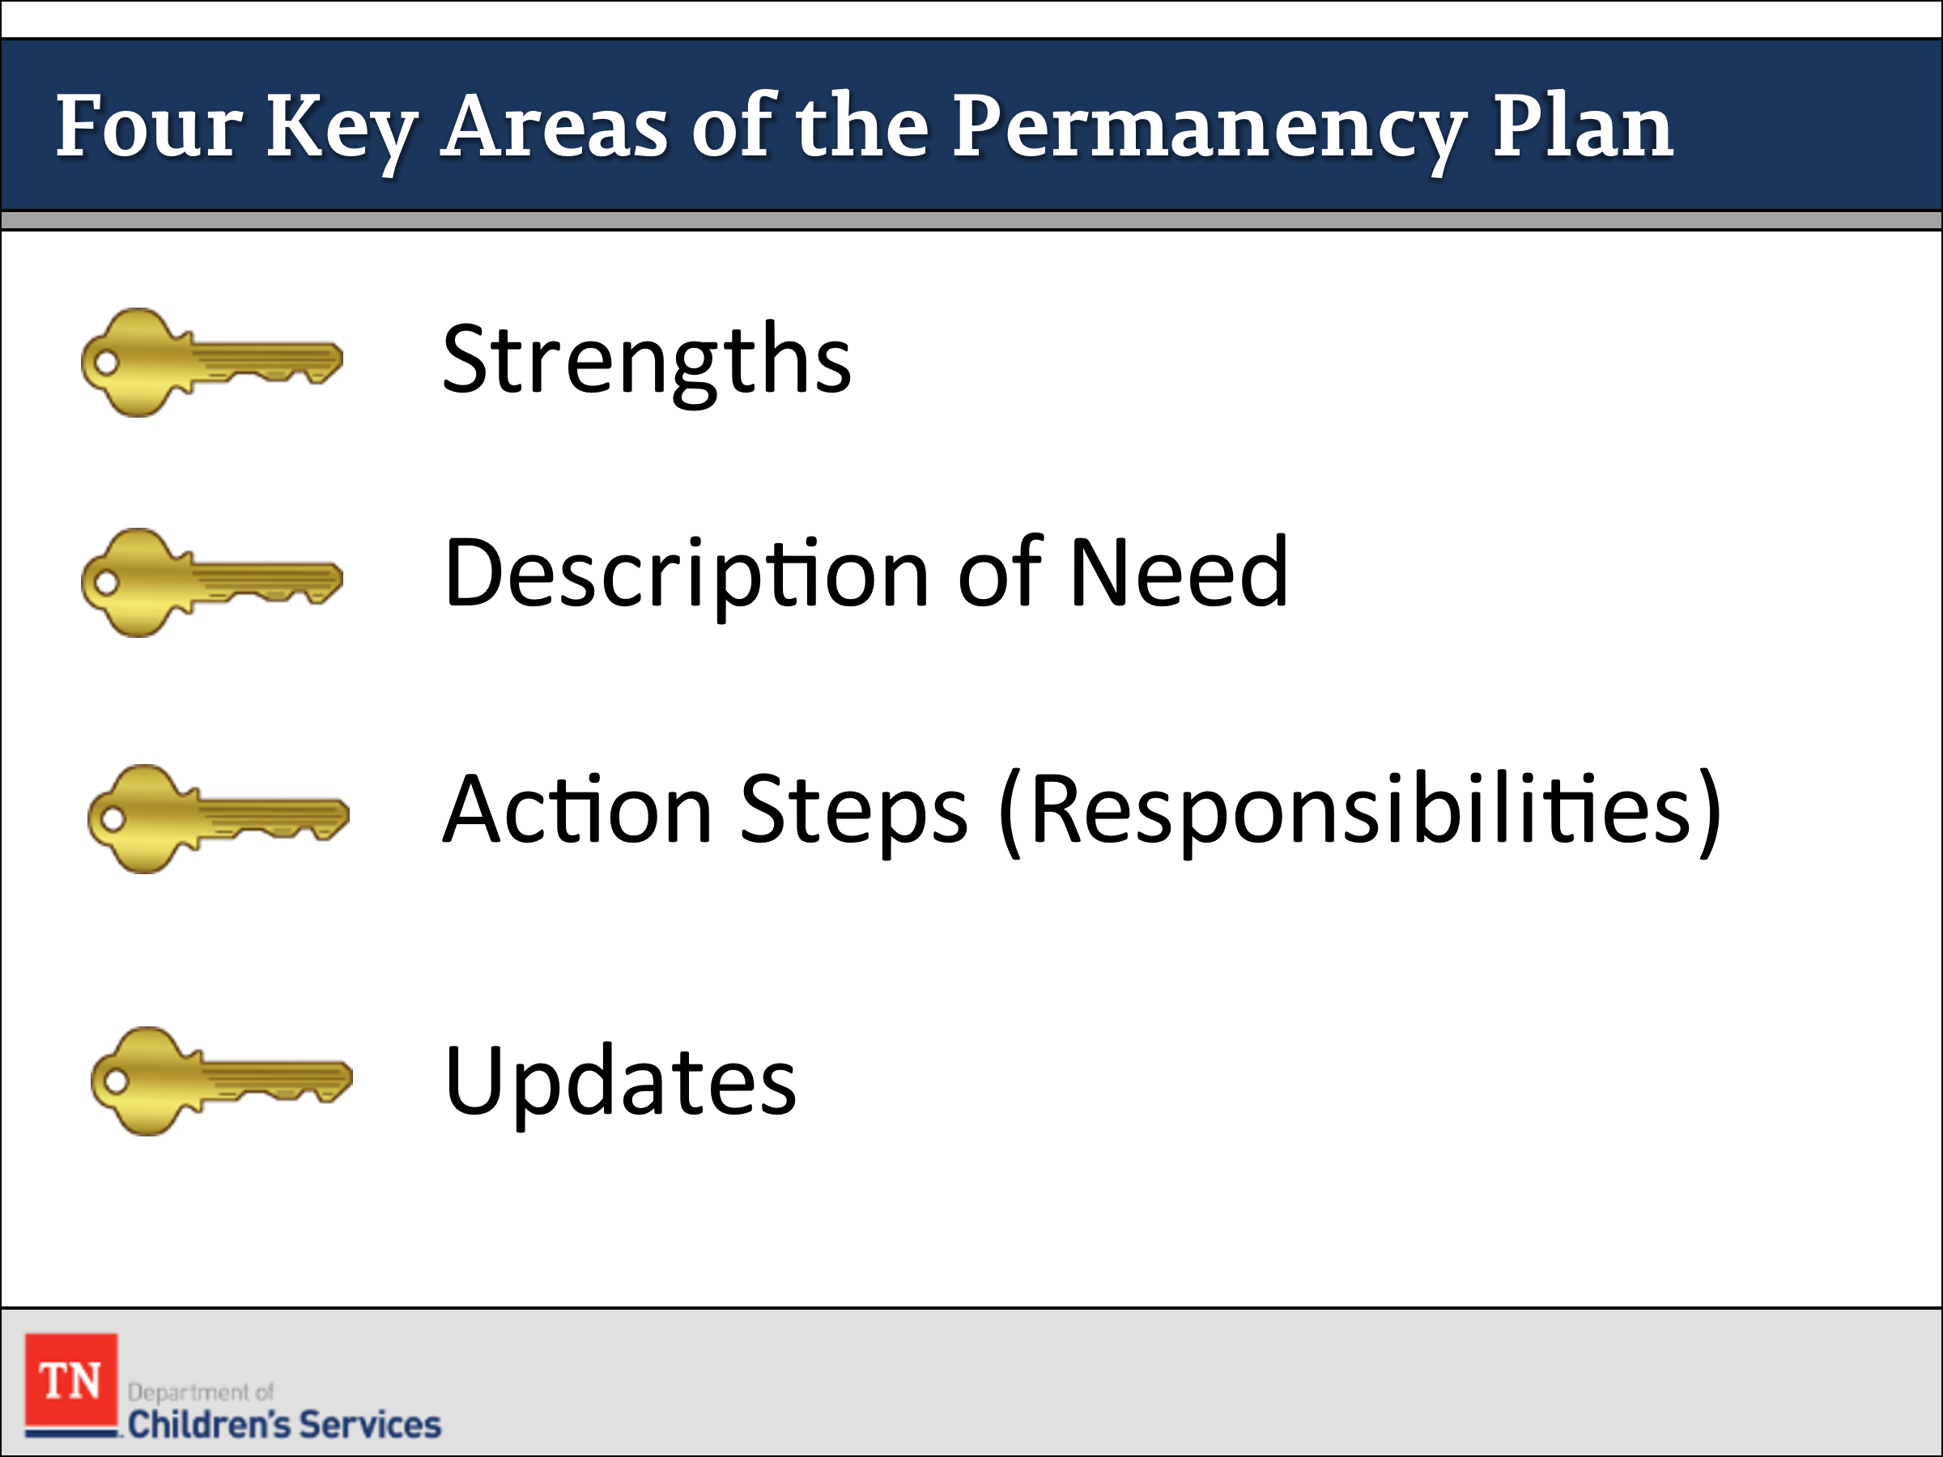
- SHARE we will now further review the four key areas of the permanency plan including:
  - Strengths
  - Initial description/description of need
  - Responsibilities
  - Updates: This allows the worker to show progress, or lack thereof, on each need and strength that has been entered.
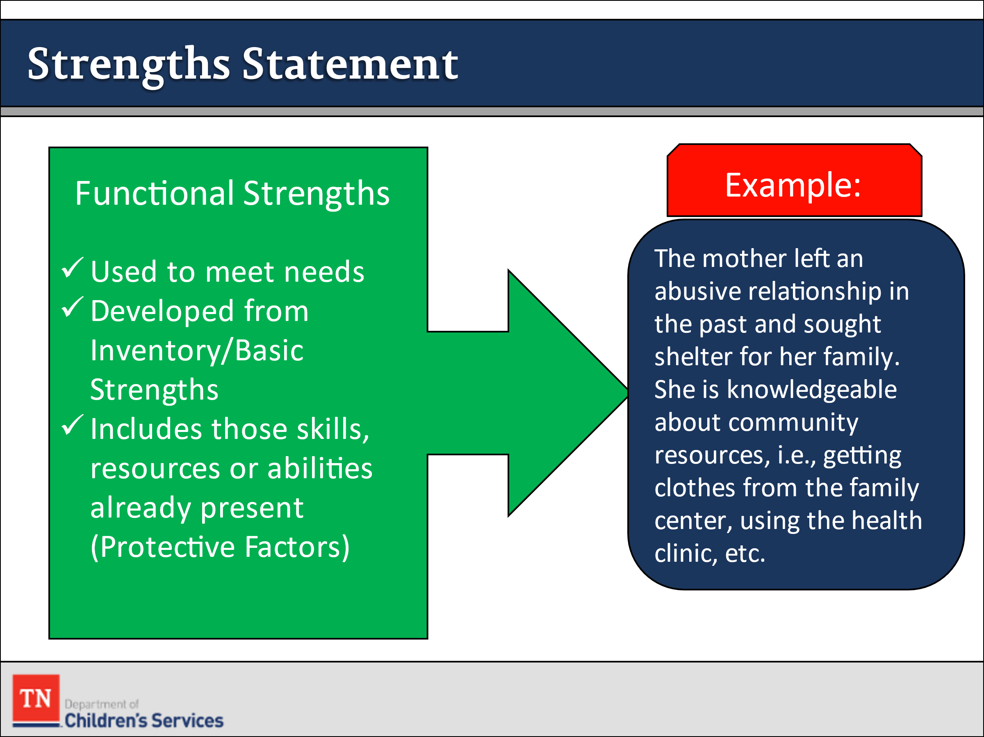
- SHARE family strengths to be explored during the assessment process relate to the parent/caregiver’s past and current efforts in protecting their children from harm, maintaining a loving parent-child relationship, accessing extended family and other support systems, and making efforts to address past and current stress conditions. STATE these types of strengths are referred to as “functional strengths” because they form the basis for addressing the needs and concerns in the family.
- STATE functional strengths can be developed from basic inventoried strengths by asking follow-up questions and exploring how it is a strength such as, “What does showing love for your children look like?” or “How is having a job important to your family?”
- EXPLAIN functional strengths are also called protective factors because they are the very skills, conditions, and resources we want families to possess to ensure safety, permanency, and well-being.
- STATE a strengths statement should include conditions in the family’s present or past that are able to be built on to strengthen the family. An example is:
  - The mother left an abusive relationship in the past and sought shelter for her family. She is knowledgeable about community resources, i.e., getting clothes from the family center, using the health clinic, etc.
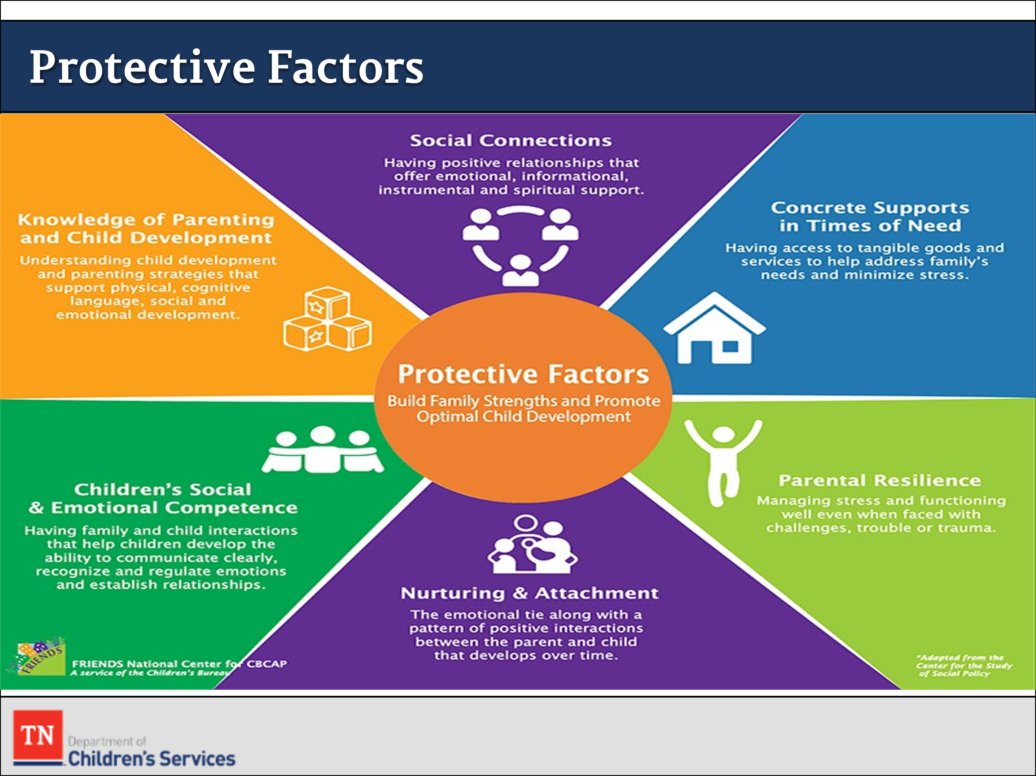
- REVIEW the following Protective Factors:
  - Concrete Support-Families who can meet their own basic needs for food, clothing, housing, and transportation - and who know how to access essential services such as childcare, health care, and mental health services to address family-specific needs and are better able to ensure the safety and well-being of their children.
  - Social and Emotional Competence-Children’s early experiences of being nurtured and developing a positive relationship with caring adults affects all aspects of behavior and development.
  - Nurturing and Attachment-Research consistently shows children who receive affection and nurturing from a consistent caregiver have the best chance of growing up to be happy, healthy, and productive. Research also shows these children do better academically, behaviorally, and have an increased ability to cope with stress.
  - Knowledge of Parenting and Child Development-Children thrive when parents provide not only affection, but also respectful communication and listening, consistent rules and expectations, and safe opportunities that promote independence.
  - Social Connections-Parents with a social network of emotionally supportive friends, family, and neighbors often find that it is easier to care for their children and themselves.
  - Resilience-Parents who can cope with the stresses of everyday life, as well as an occasional crisis, have resilience; they have the flexibility and inner strength necessary to bounce back when things are not going well.
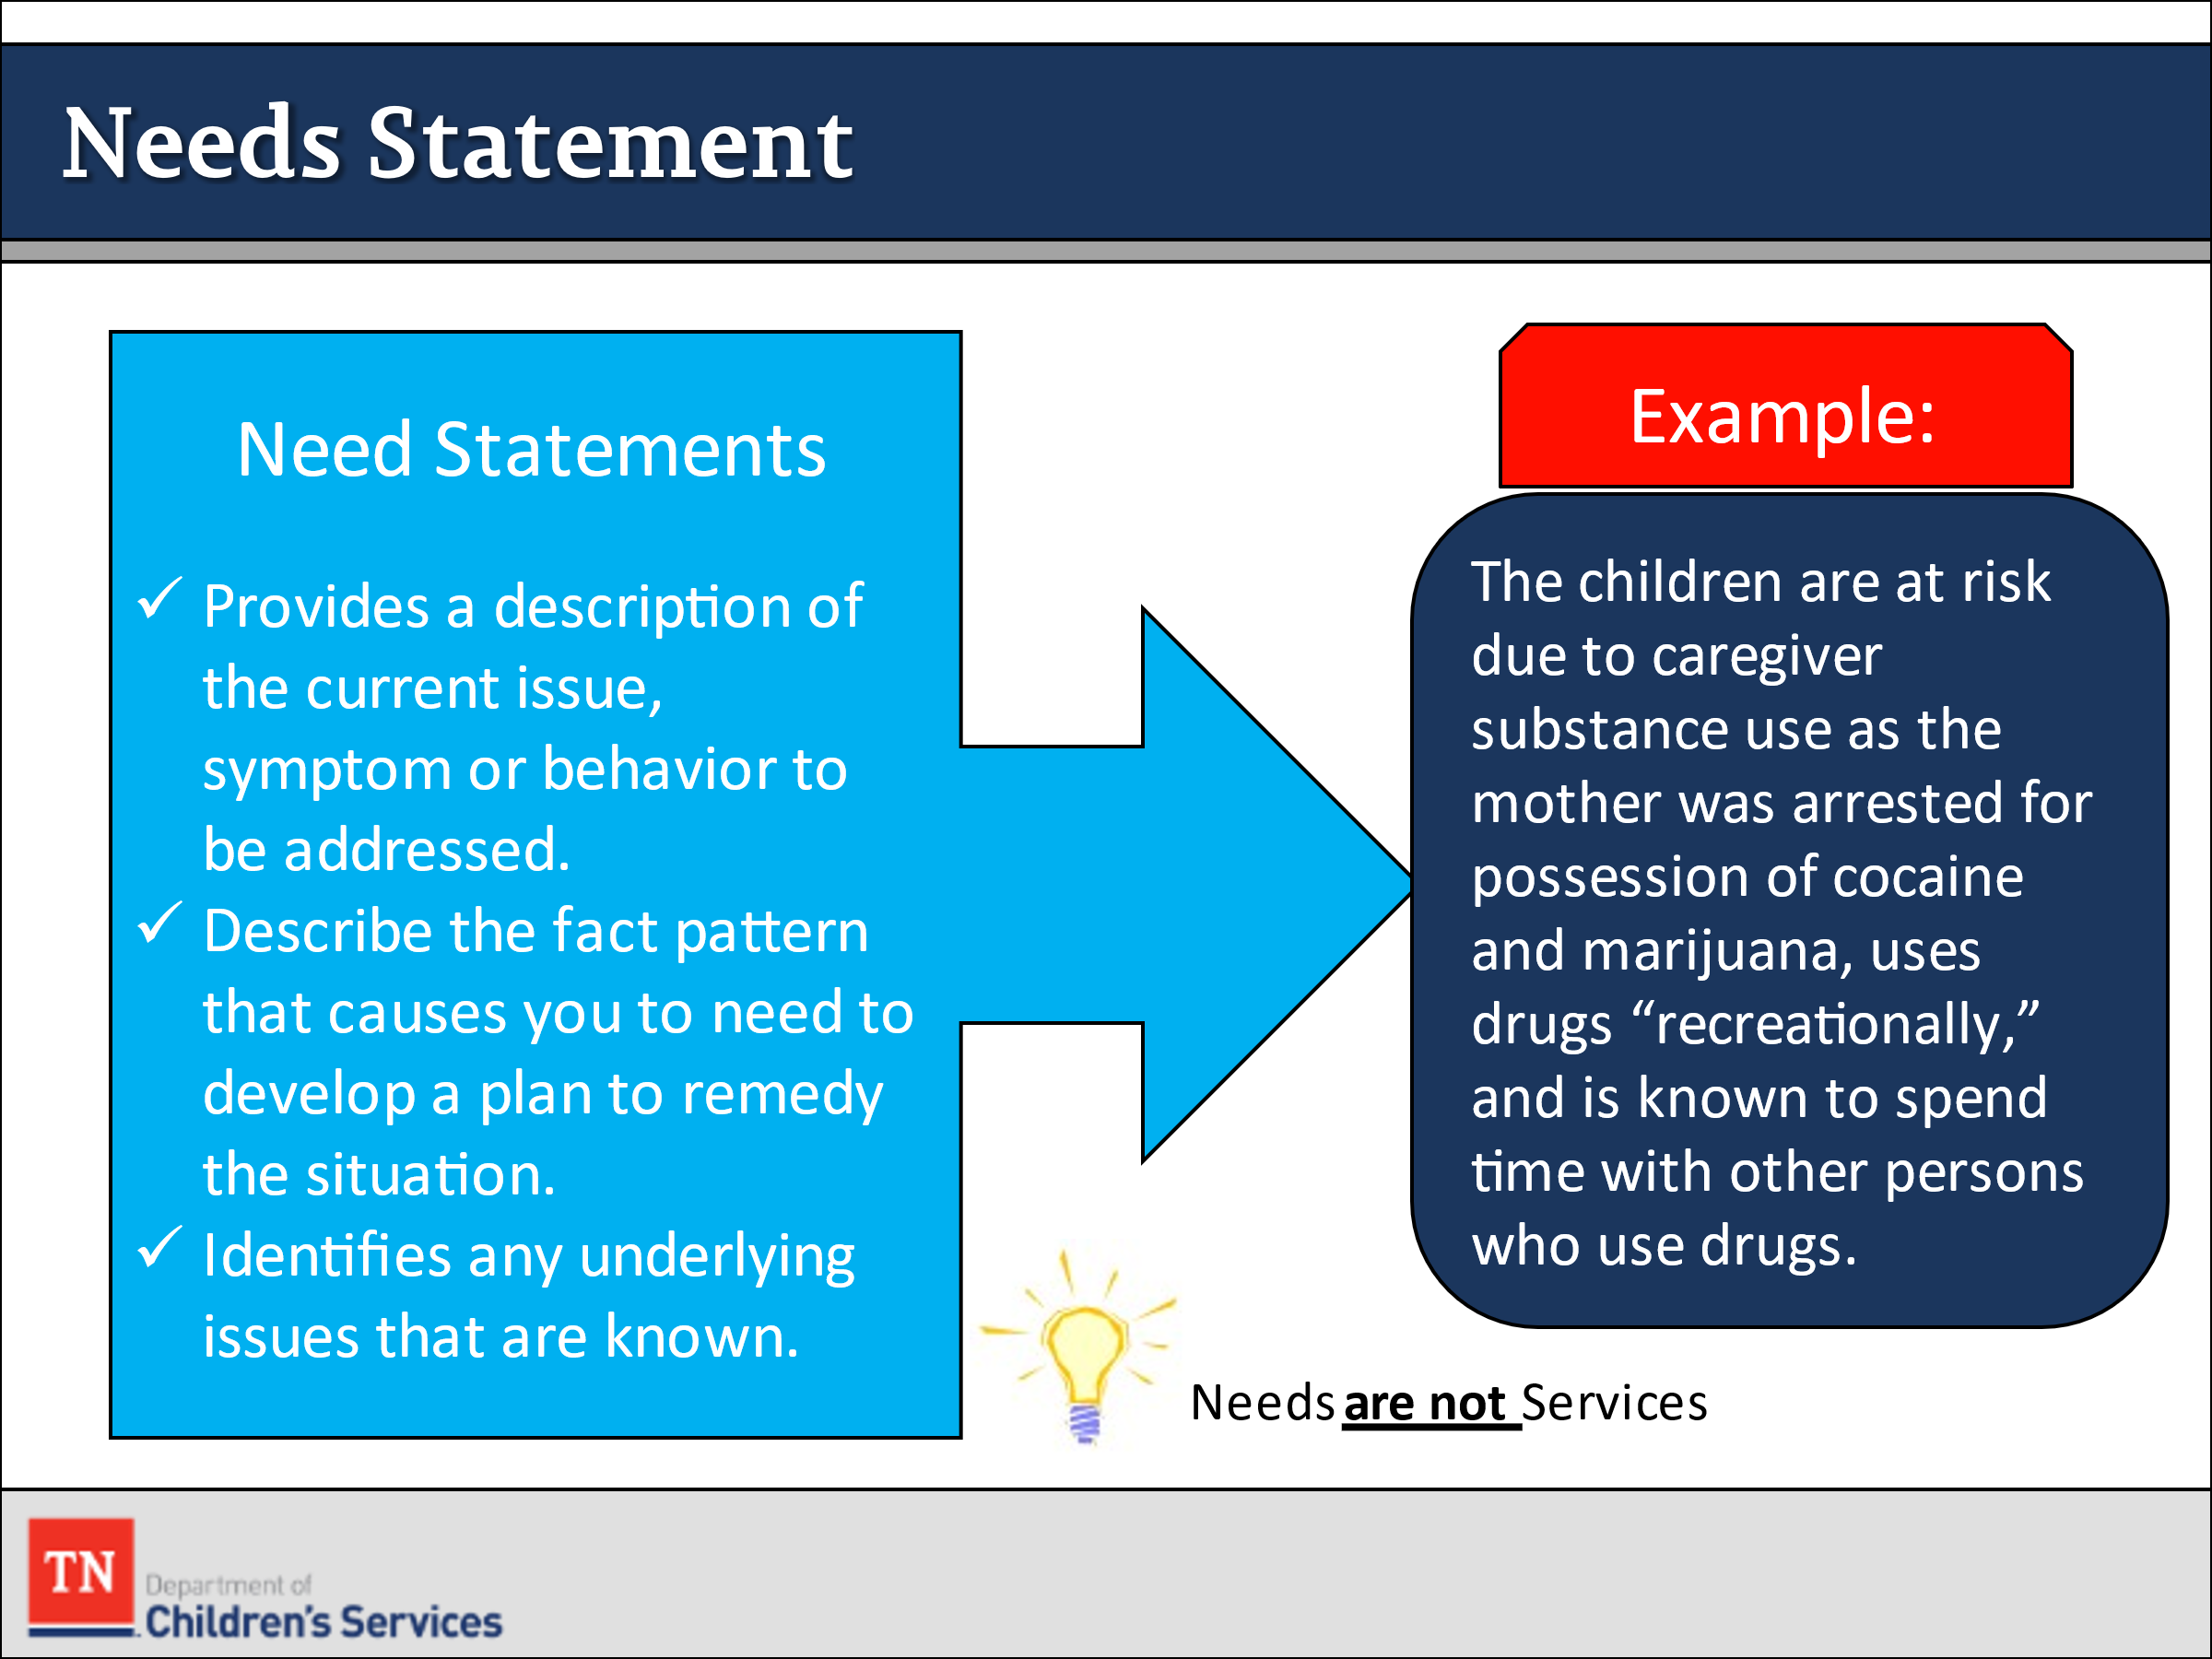
- SHARE a need statement provides a description of the current issue, symptom, or behavior to be addressed. It describes the fact pattern that causes a plan to be developed to remedy the situation. It identifies any underlying issues that are known. EMPHASIZE that needs are not services. An example is:
  - The children are at risk due to caregiver substance use as their mother was arrested for possession of cocaine and marijuana, uses drugs “recreationally,” and is known to spend time with other persons who use drugs.
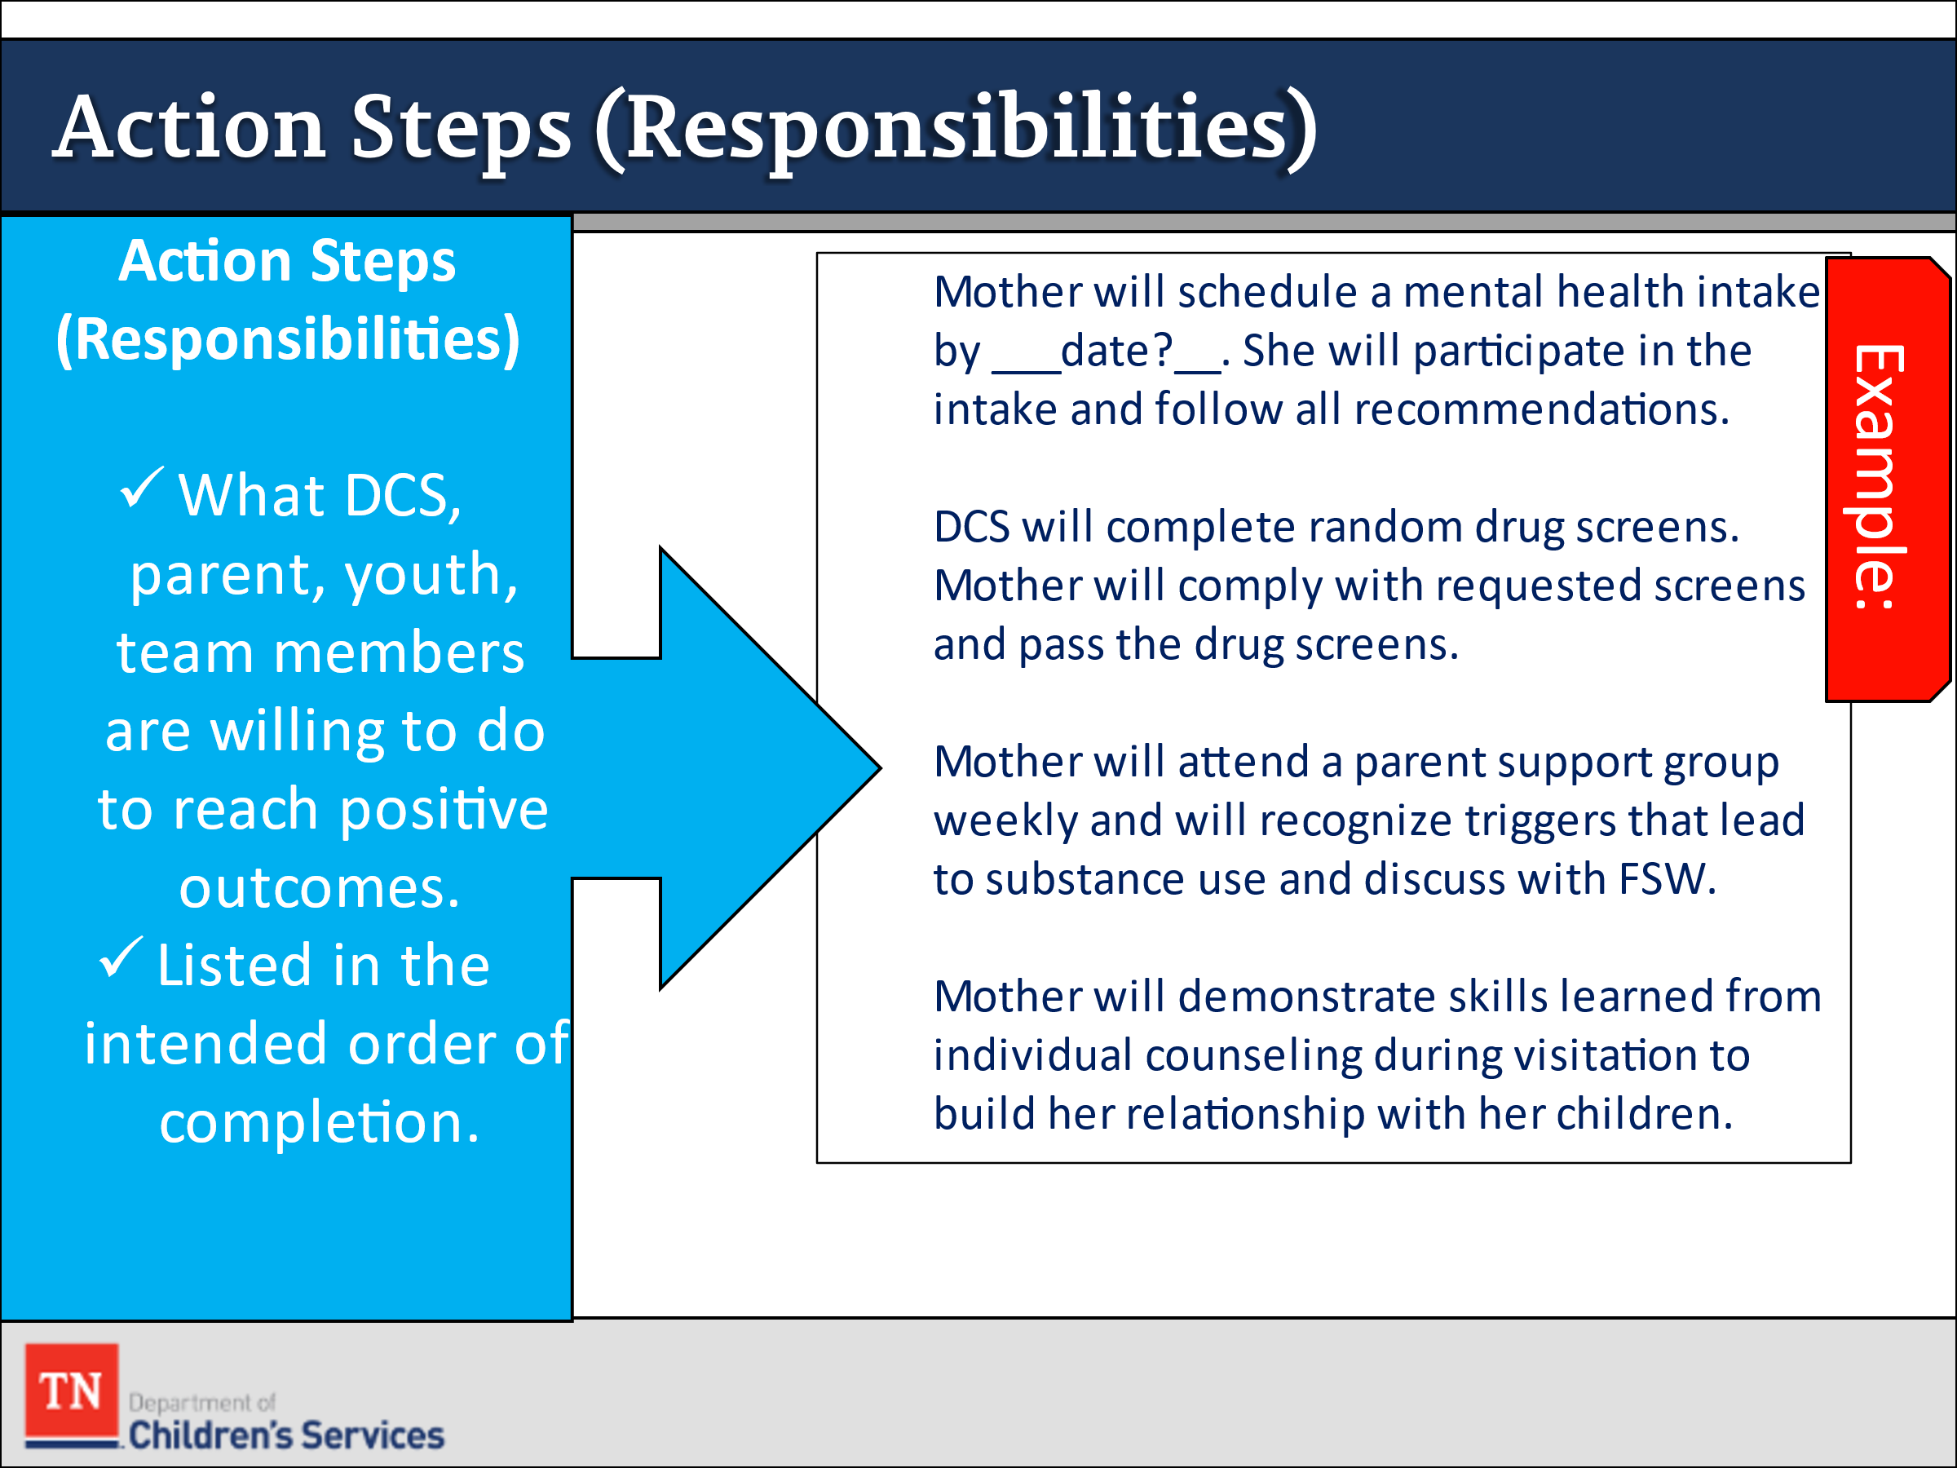
- STATE action steps (responsibilities) are what DCS, parent, youth, team members are willing to do to reach positive outcomes. Some examples are:
  - The mother will schedule a mental health intake by ______ Date. She will participate in the intake and follow all recommendations.
  - DCS will complete random drug screens. Mother will comply with requested screens and pass the drug screens.
  - Mother will demonstrate skills learned from individual counseling during visitation to build her relationship with her children.
  - Mother will attend a parent support group weekly and will recognize triggers that lead to substance use and discuss with FSW.
- EXPLAIN permanency plans should never be presented to the family as a list of demands. Action steps on a plan should never be for just one person to complete. It is crucial for the team to work together to achieve the goals. The plan should also not represent a “to do” list for just the FSW. We do not want the family to develop a reliance on DCS to the point of when we are not in the picture, they fail.
- SHARE Family Permanency Plans must be time-limited, goal-oriented, and specific about the action steps to be taken by DCS, service providers, children/youth, and families toward meeting the goal(s) on the plan. They should include responsibilities that specifically include action steps that each party should take including behavioral, assessment, service, and DCS action steps needed to address the identified concerns. To determine compliance with the plan, parents are expected to be able to demonstrate their completion of the action steps as well as demonstrate behavioral changes that decrease risk to the child(ren). The responsibilities of all team members should be clearly outlined with language that everyone can understand.
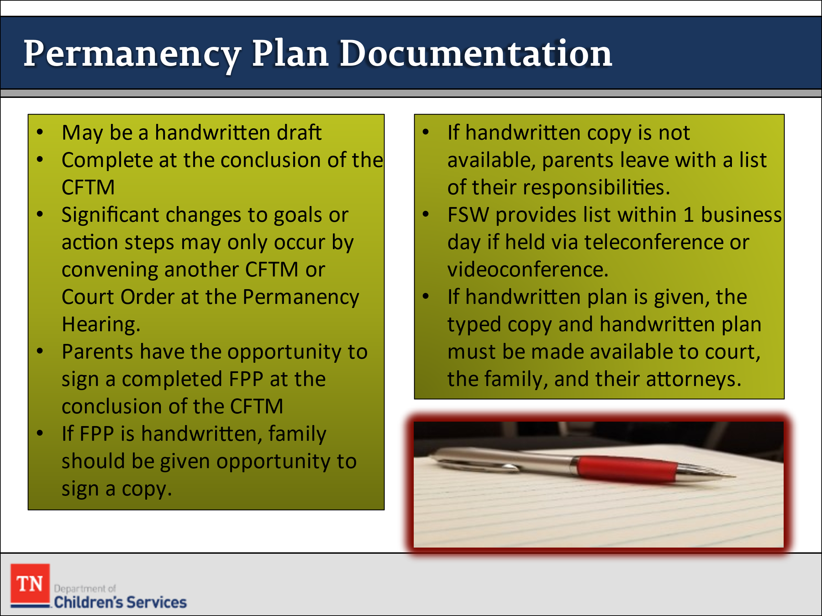
- SHARE Policy 16.31 gives guidance on documentation of the Family Permanency Plan. ADVISE participants of the following:
  - While it may be a handwritten draft, the Family Permanency Plan is considered complete at the conclusion of the CFTM. Minor changes that do not affect content, such as grammatical or spelling errors, may be made following the meeting. Significant changes to the goals or action steps on the plan are only be made by convening another CFTM or by court order at the Permanency Hearing.
  - Parents have the opportunity to sign a completed Family Permanency Plan at the conclusion of the CFTM. If the Family Permanency Plan is written by hand during the meeting, the family should be given the opportunity to sign a copy of the handwritten plan at the conclusion of the meeting. If a handwritten or typewritten plan is not available at the conclusion of the meeting, the FSW ensures that the parents leave the meeting with a list of their responsibilities. If the meeting is held via teleconference or videoconference, the FSW reviews the list of responsibilities at the close of the meeting to allow the parents an opportunity to write down/record the agreed upon responsibilities. The FSW also provides a list in writing to the parent within one (1) business day. FSWs inquire from parents at the close of the meeting which method of delivery they would prefer the FSW to use to provide the written list. Once the Family Permanency Plans is typed and completed in TFACTS, the FSW ensures the plan is presented to the team for discussion and signatures. Completed signature pages are scanned into TFACTS.
  - If parents have signed a handwritten copy at the conclusion of the CFTM and it is later typed, both copies of the Family Permanency Plan must be made available to the court, the family, and their attorneys to approve the language in the typed plan and be given the opportunity to sign it, if agreed upon.
- SHARE the last area of the permanency plan is updating. This allows the worker to show progress, or lack thereof, on each need and strength that has been entered.

Lesson 5.3: Permanency Planning and Quality Contacts

Lesson Time: 90 minutes
Key Teaching Points / Instructions

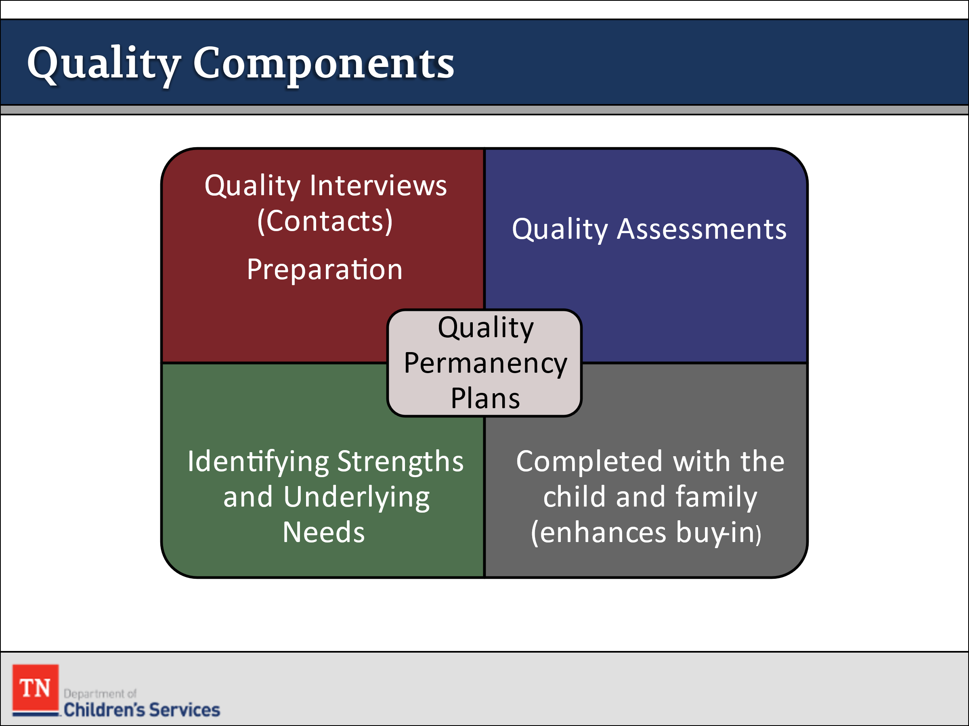
- EXPLAIN in order to write a quality Permanency Plan, we must first complete a series of tasks. We must start with having quality interviews (also called “contacts”) with case members. These quality contacts lead to quality assessments, which are the foundation of a quality permanency plan.
- STATE if we understand what the underlying issues are and the possible reasons a parent or youth might be ambivalent to make the needed changes, we can then better work with that individual to facilitate desired changes.
- REMIND participants we already know people are more likely to change if they desire the change. We call this buy-in. People are also more likely to want to change when they believe they are the ones who resolved any ambivalence in their decision to change, and when they significantly contribute to developing their own plan to solve an identified need.
- SHARE once people discover the need/reasons to change, efforts to change are more successful when they believe they are the creators of their own change plan.
- STATE effective use of Motivational Interviewing is the key to facilitating this process because it helps people who are being interviewed to feel empowered and respected. Once emotional defenses are lowered, effective assessment can begin which will uncover the needs and actions steps developed in the Permanency Plan with a family.
- CONDUCT ACTIVITY: Guided Imagery
  - INSTRUCT the participants to close their eyes read the following paragraph aloud:
“Imagine you are at the DMV to renew your license. You get your number and wait to be called. Finally, your number is called. You get up and head to the counter, before you even get all the way to the counter and say hello, the DMV staff tells you your license will not be renewed because of your poor driving abilities. The DMV staff has just decided something that severely impacts your life. How do you feel?
  - ASK participants to open their eyes and ALLOW time for responses.
  - INSTRUCT them to close their eyes again and read aloud:
“Imagine you are a client working with DCS and your worker tells you that you need A&D treatment and parenting classes to either keep or regain custody of your child.”
  - ASK participants to open their eyes. ASK them how they would the feel then? Allow time for responses.
- POINT OUT they might feel defensive, or frustrated, or curious as to what qualifies this worker to make this decision. EXPLAIN the CANS gives us a way to measure and explain the family’s strengths and needs. Using CANS in our work with families helps to guide decisions and provides a justification to the level of intervention used in the casework conducted.
- STATE we all know that better assessments lead to better Permanency Plans, which ideally leads to better outcomes for children and families. We know once a strong assessment is completed, we can then focus our efforts on using that information to guide Permanency Planning.
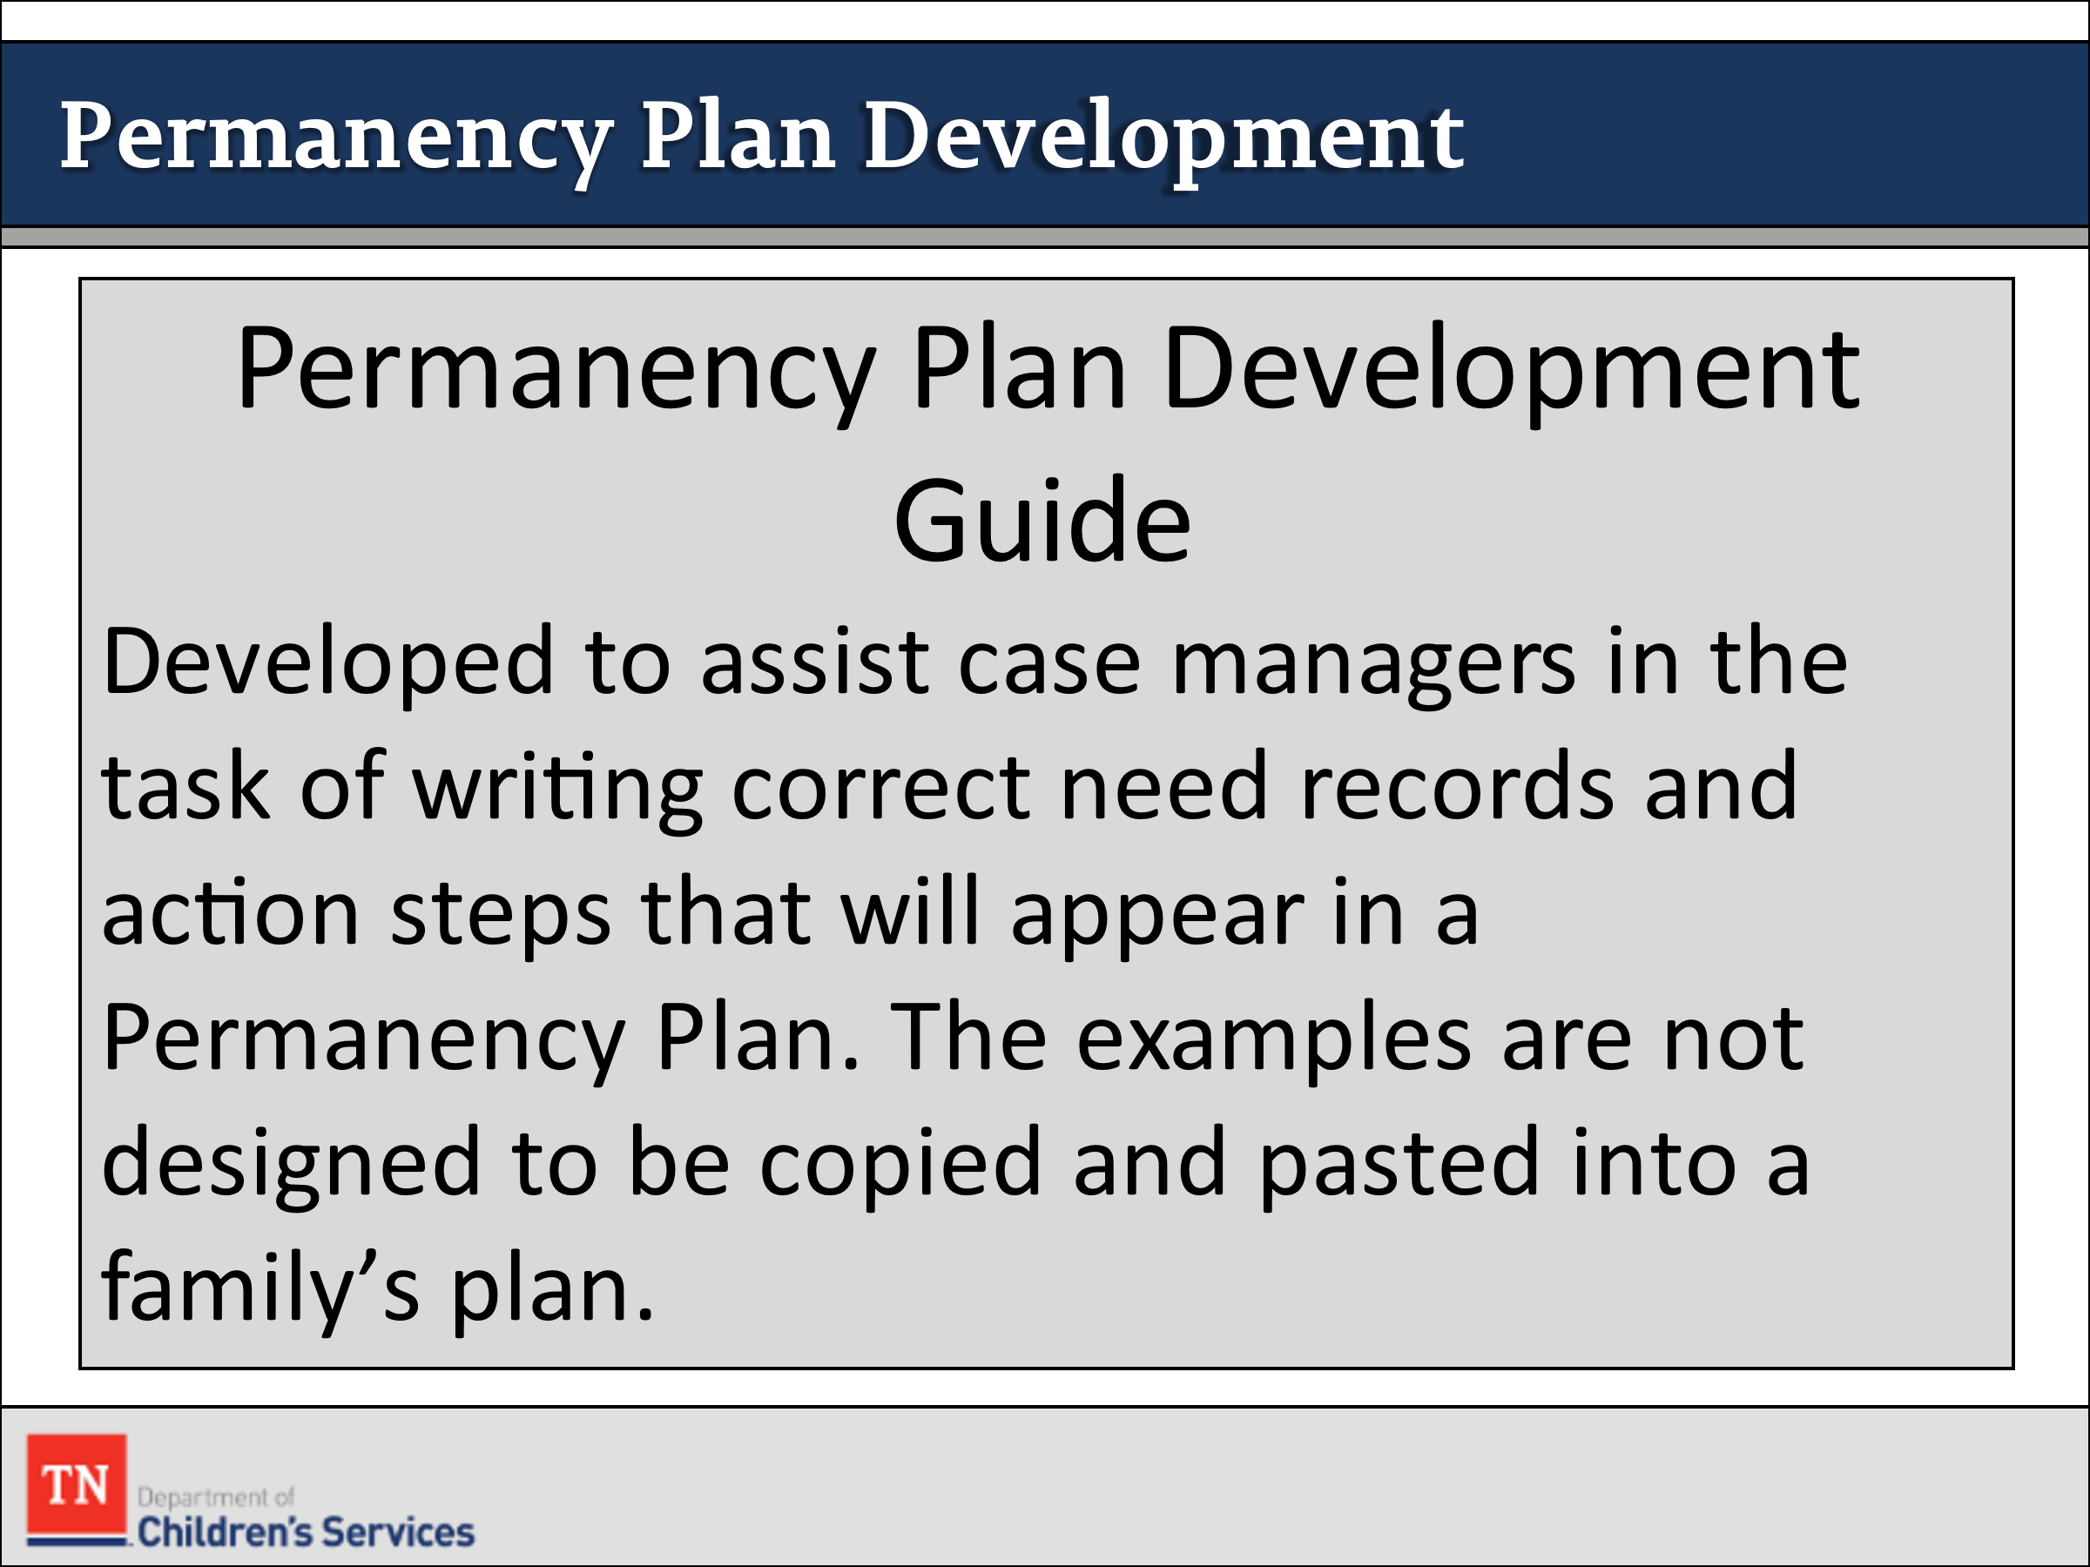
- REFER participants to the Permanency Plan Development Guide and briefly discuss how it can be used in the development of the permanency plan https://files.dcs.tn.gov/policies/chap16/PPDevGuide.pdf.
- The Permanency Plan Development Guide was developed to assist case managers in the task of writing correct need records and action steps that will appear in a Permanency Plan. The examples are not designed to be copied and pasted into a family’s plan.
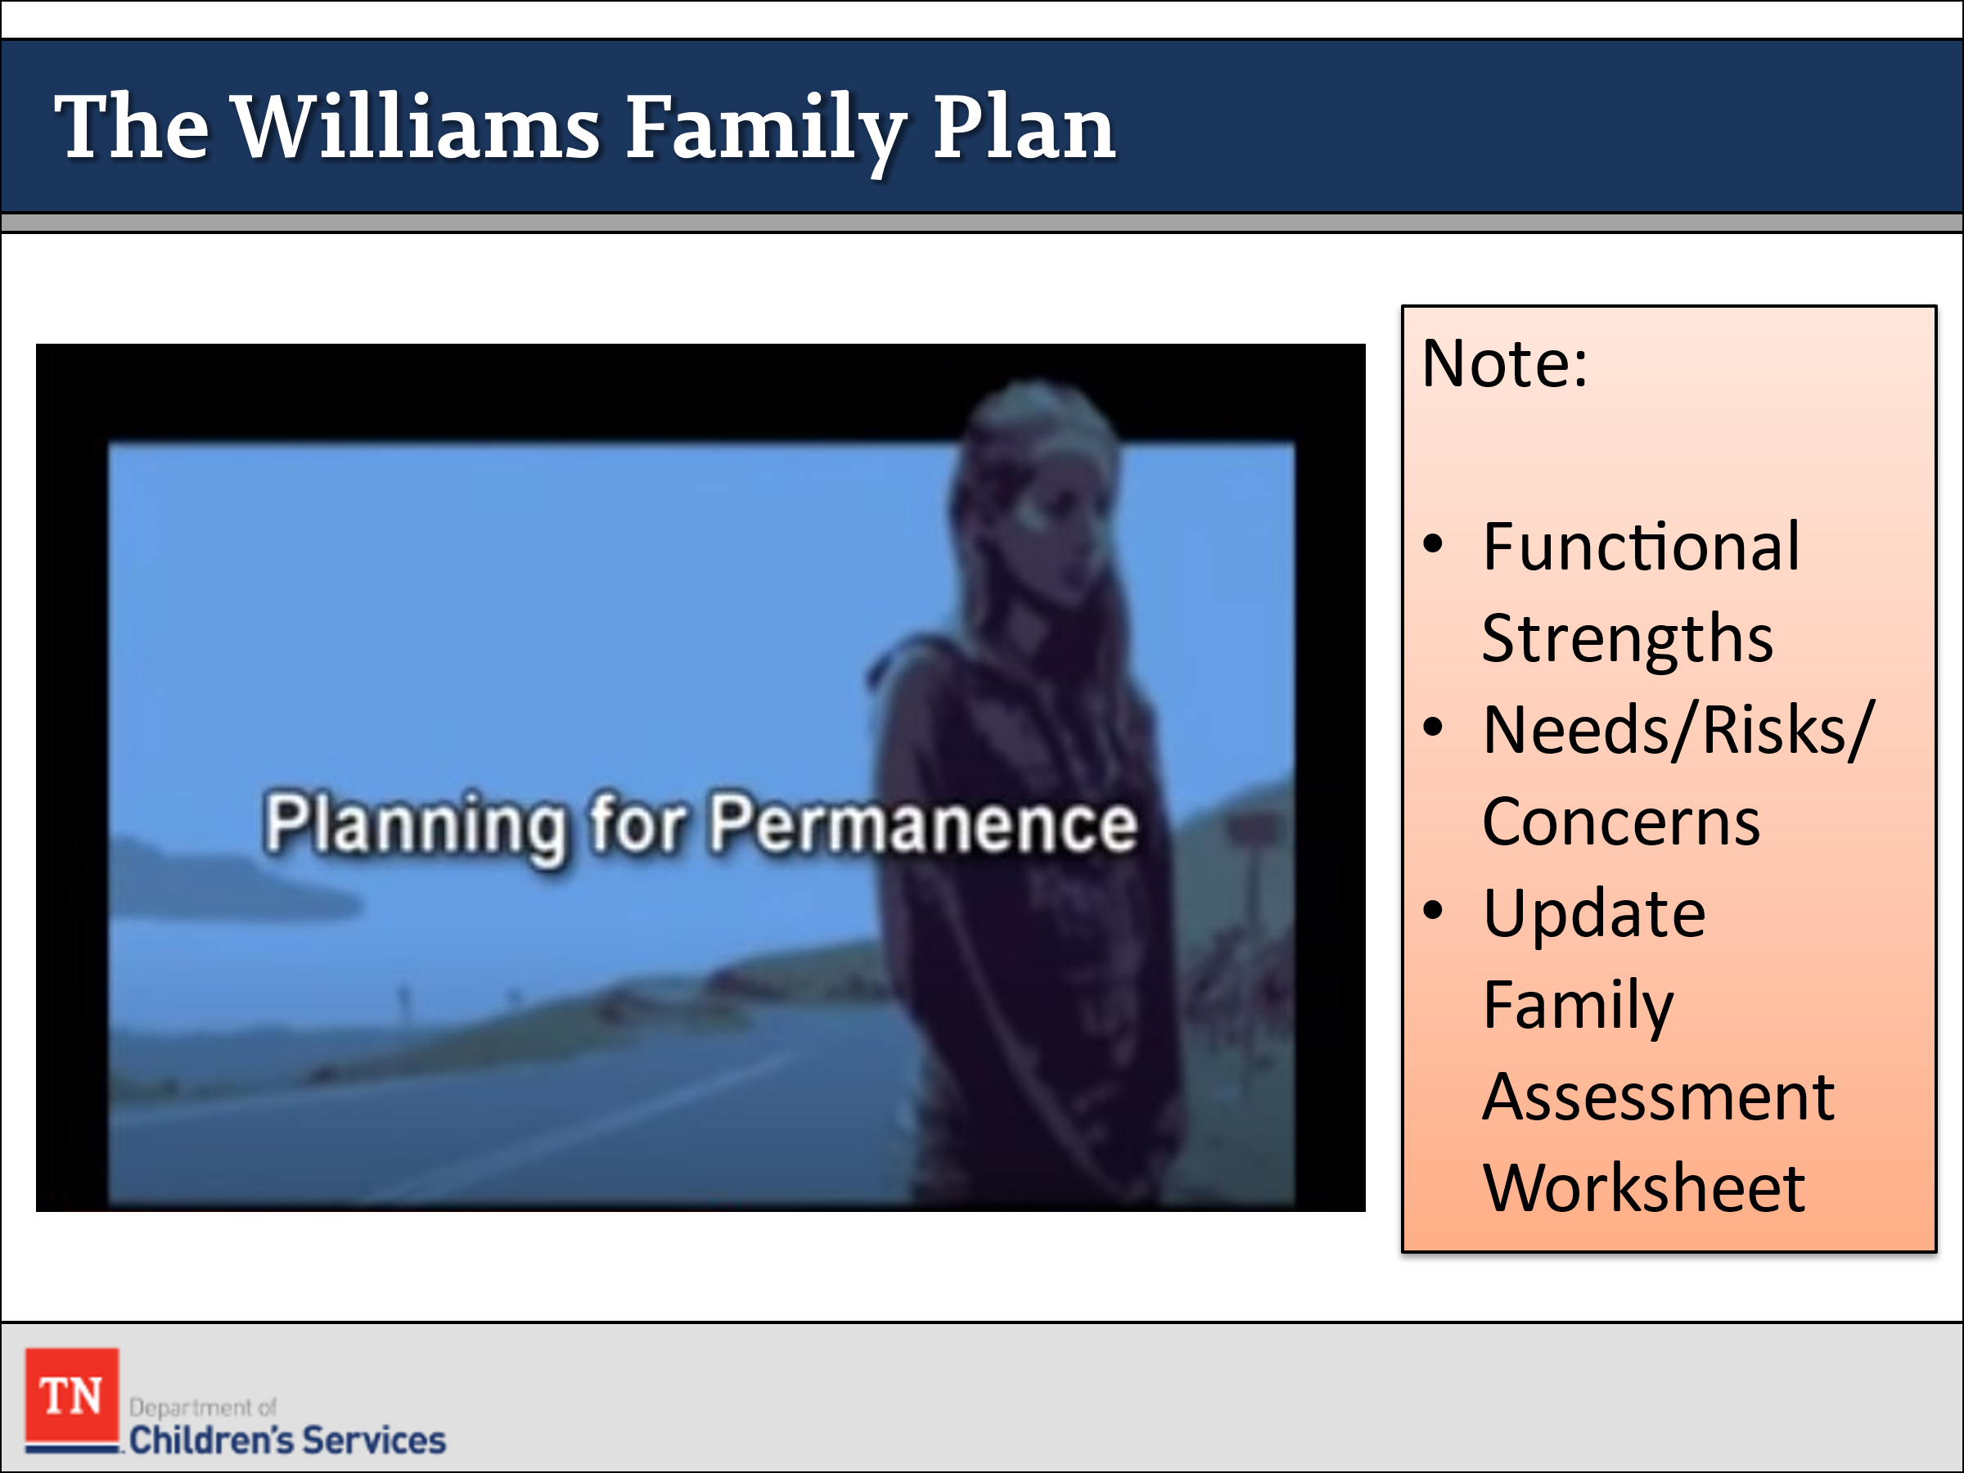
- SHARE with participants we will watch the Pathways to Permanence Scene 3 - Planning for Permanence video. Let them know they should be listening for functional strengths and concerns as they watch. The video is before we practice writing the permanency plan as families should be involved in writing the plans. ASK participants to update the Family Assessment Worksheet with new information from the video.
- SHOW Pathways to Permanence Scene 3 - Planning for Permanence video. DVD time: 39:28 or 47:10-1:26:37 on link: https://www.youtube.com/watch?v=IQusnk6fN4M
- RECONVENE and CAPTURE additional strengths/protective factors and needs/risks/concerns of the Williams family on the flipchart the group has already been developing since initial contact with the family.
- EXPLORE with participants which areas of the Williams CANS will need to be addressed in the permanency plan, i.e., scores of 2 and 3.
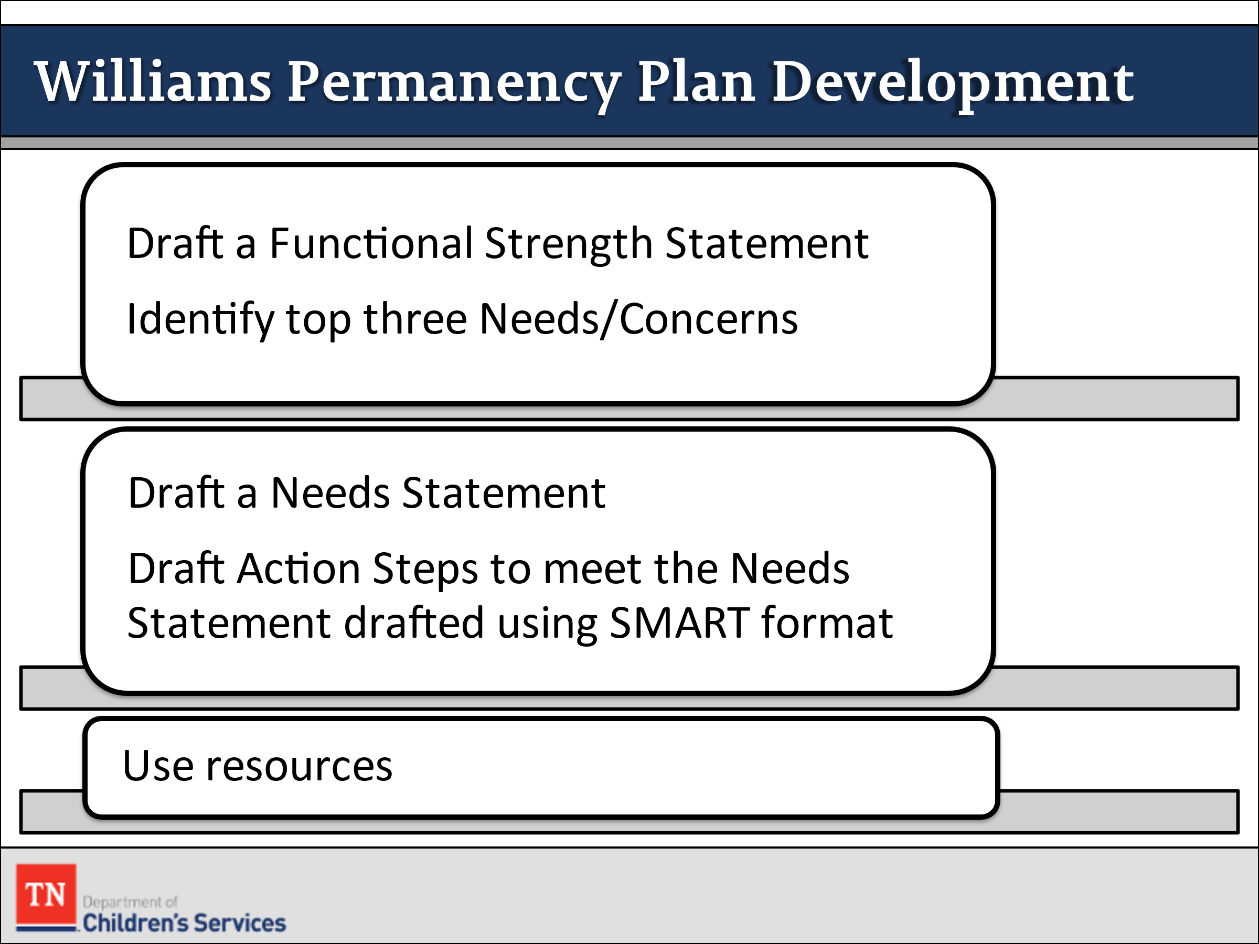
- CONDUCT ACTIVITY: Williams Family Permanency Plan Development
- TRAINER: This activity is completed with the large group as it would be completed in a CFTM setting. Group will identify top 3 concerns/needs to develop action steps. Trainer will MODEL and COACH in the construction of the Action Steps.
- REMIND the group they can use the Permanency Plan Development Guide to assist them with action steps. Also, remind them of the SMART acronym when writing action steps: Specific, Measurable, Achievable, Realistic, and Timely. Approximately 30 minutes to complete.
Trainer Note: Individual/Small Group Practice will be completed during Foster Care Week 2 Specialty with the Steward Family.
- THANK the group for their hard work. ENCOURAGE participants to review Permanency Plans in the field, attend Permanency Plan CFTMs and ask questions about the process of using the CANS to inform the plan.

Lesson 5.4: Plan Implementation

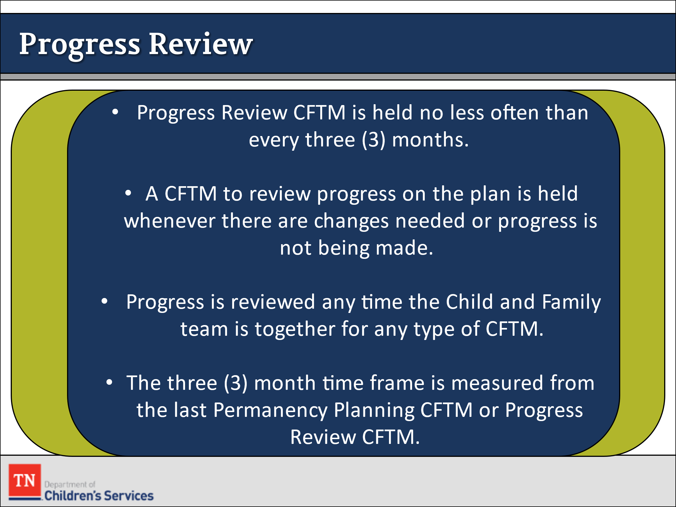
Lesson Time: 35 minutes
Key Teaching Points / Instructions

- STATE we are now going to discuss putting the plan into practice.
- SHARE the Progress Review CFTM is held no less often than every three (3) months. A CFTM to review progress on the Permanency Plan is conducted whenever there are changes needed or progress is not being made in a timely fashion. Progress is reviewed any time the Child and Family Team is together for any type of CFTM. The three (3) month time frame is measured from the last Permanency Planning CFTM or Progress Review CFTM.
- REMIND participants it is important to prepare the family and team before the meeting. Before we have the meeting to discuss the progress, we should have had several discussions with the team members on their progress and if they are having any barriers.
- When discussing lack of progress, it is important to discuss how we can address the barriers. We should be showing reasonable efforts when addressing barriers in the plan. When these barriers come up during our progress review it is important for the team to discuss what resources or support can be offered to assist the family.
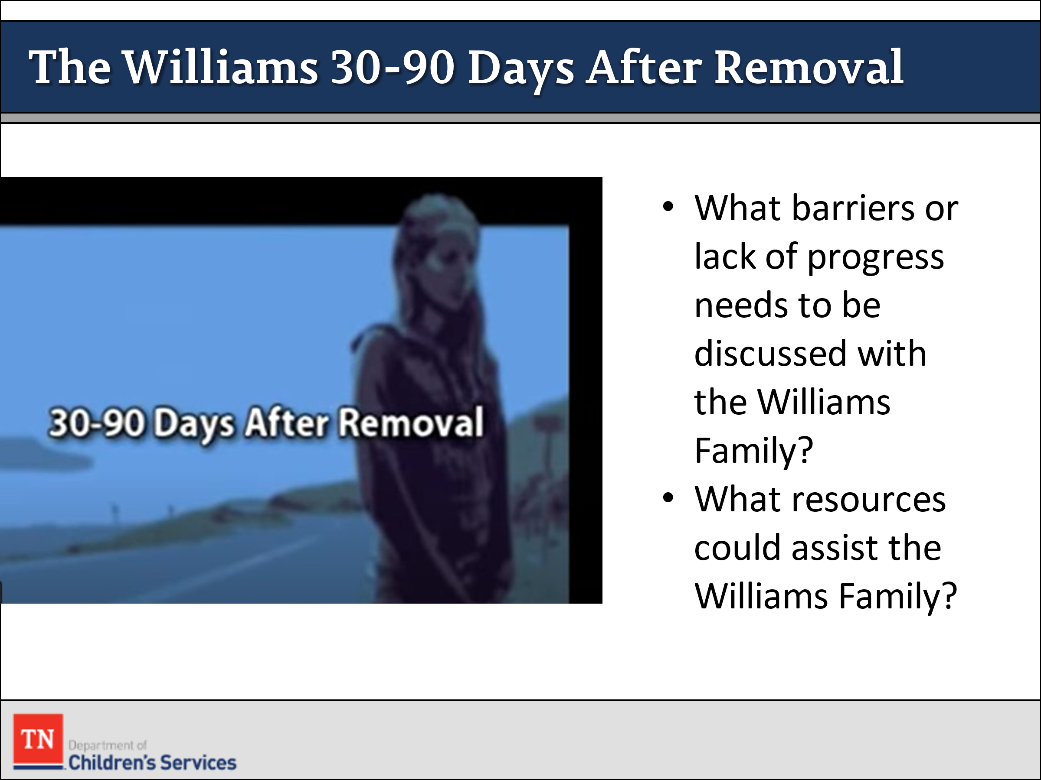
- STATE we are now going to discuss putting the plan into practice. SHARE the Pathways to Permanence Scene 4 – Connecting with Youth short video discusses what is going on with the Williams Family from day 30-90 day. ENSURE participants take notes on the family’s progress/lack of progress during this period on the Family Assessment Worksheet. SHOW the video until the 2-minute mark. https://www.youtube.com/watch?v=6Iz6NSBzFu4&feature=youtu.be&t=16
- DEBRIEF the scene with participants. REMIND participants we use Motivational Interviewing Skills of OARS when discussing progress. If we use OARS, it helps create a partnership among the team and not a “Us. Vs. Them,” mindset. INFORM participants it is also important to remember that for families, change is a process, and they may be in early stages of change.
- ASK participants, at this time, what barriers or lack of progress needs to be addressed with the Williams family. ASK participants what resources could assist the Williams family.
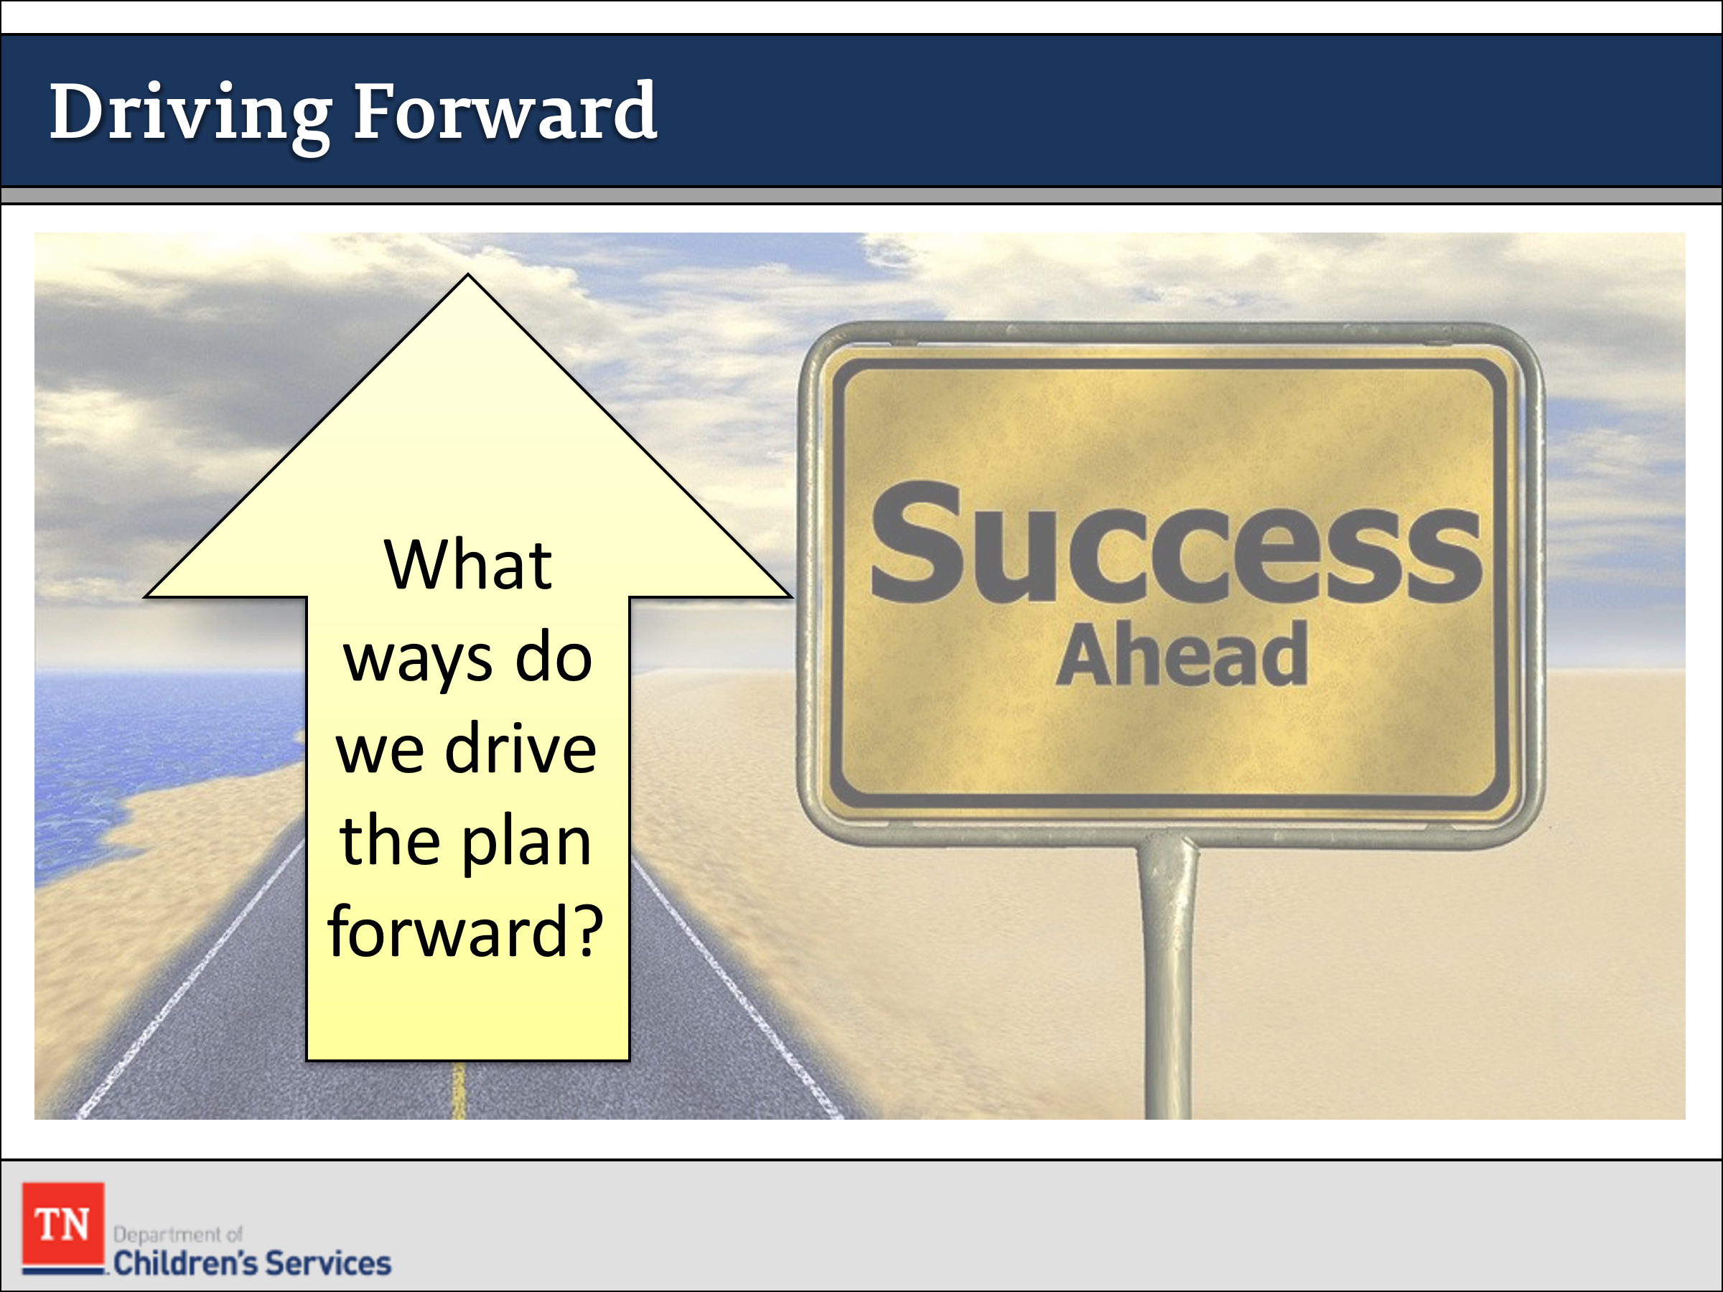
- ASK, “What are all the ways we drive the Permanency Plan forward?” ENSURE the following responses are included:
  - work with team to address issues
  - update CANS throughout the case
  - update action steps as needed
  - work with family and providers identify functional strengths
  - track progress
  - have quality contacts with the family
  - meaningful and regular visitation
  - holding Progress CFTMs
- INFORM participants while working a case there may be a time in which a placement and a youth are not successfully working together. When issues start to arise in a placement it is crucial for the FSW to work with the placement, the youth, and the family to work through issues in order to stabilize the placement.
- STRESS to participants if there is a possible placement disruption the importance of completing tasks prior to scheduling a CFTM including:
  - Staffing case with supervisor
  - Conducting interviews with children, youth, foster parents, parents, service providers
  - Scheduling a placement stability CFTM – invite placement specialist and Skilled Facilitator.
- TRANSITION to Lesson 5.5 Placement Stability.

Lesson 5.5: Placement Stability

Lesson Time: 35 minutes
Key Teaching Points / Instructions

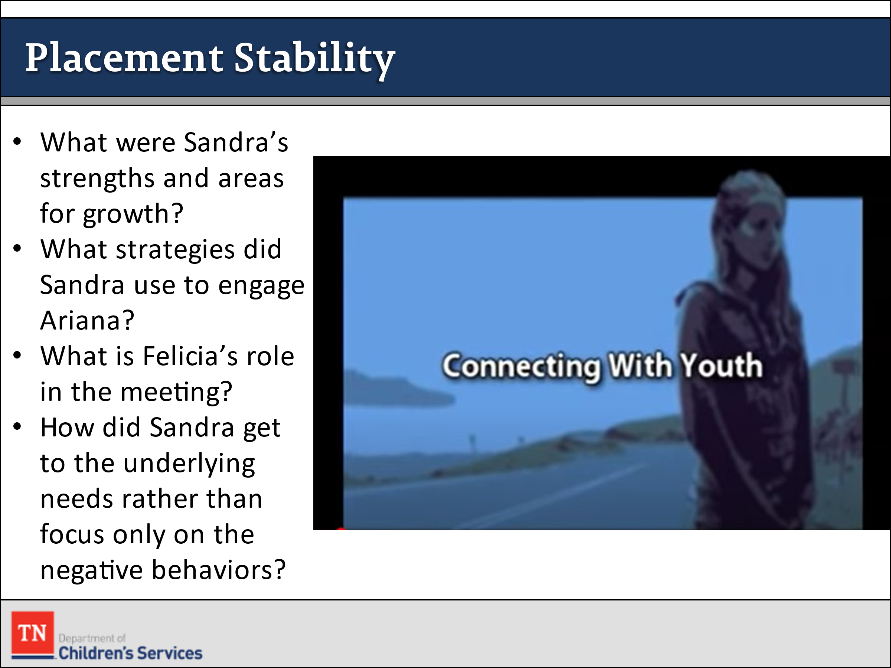
- EXPLAIN participants will now view Pathways to Permanence Scene 4—Connecting with Youth, during which the FSW meets with Ariana to discuss the difficulties Ariana has experienced since coming into care. START video at 2:08 mark and stop at 18:26. Again ask participants to note any additional information on the Family Assessment Worksheet. https://www.youtube.com/watch?v=6Iz6NSBzFu4&feature=youtu.be&t=16.
- DEBRIEF the scene in the large group by asking the following questions:
  - What were Sandra’s strengths and areas of growth in this interview?
  - What strategies did Sandra use to engage Ariana in discussing the difficult topics?
  - What is Felicia’s role in this meeting? How is Felicia’s presence helpful?
  - How did Sandra get at the underlying needs and issues rather than focus solely on the negative behaviors?
- ASK participants what is driving Ariana’s behavior at this time. ENSURE the following are identified:
  - Safety- from being bullied at school and feeling unsafe in the home environment
  - Sense of power and control—related to being bullied, increased structure at home, and her mother not working the plan
  - Need for attachment or sense of belonging—related to not feeling as though she fits in and that her mother is not working the plan
- TRANSITION into a discussion about applying the procedures for placement disruptions to the Williams case family. POSE the following “what ifs” and follow-up questions to participants and DISCUSS.
  - What if Ariana’s behavior continues to deteriorate and Grandma Rose reconsiders having Ariana live with her?
  - How would a placement disruption impact Ariana?
  - What might be the impact of a placement disruption to a younger child?
  - How might Jewel and Justin feel if Ariana moves?
- STRESS to participants if there is a possible placement disruption the importance of completing tasks prior to scheduling a CFTM including:
  - Staffing case with supervisor
  - Conducting interviews with children, youth, foster parents, parents, service providers
  - Scheduling a placement stability CFTM – invite placement specialist and skilled facilitator)
- TRANSITION to Lesson 5.6 Special Considerations When Working with Youth.

Lesson 5.6: Special Considerations when Working with Youth

Lesson Time: 35 minutes
Key Teaching Points / Instructions

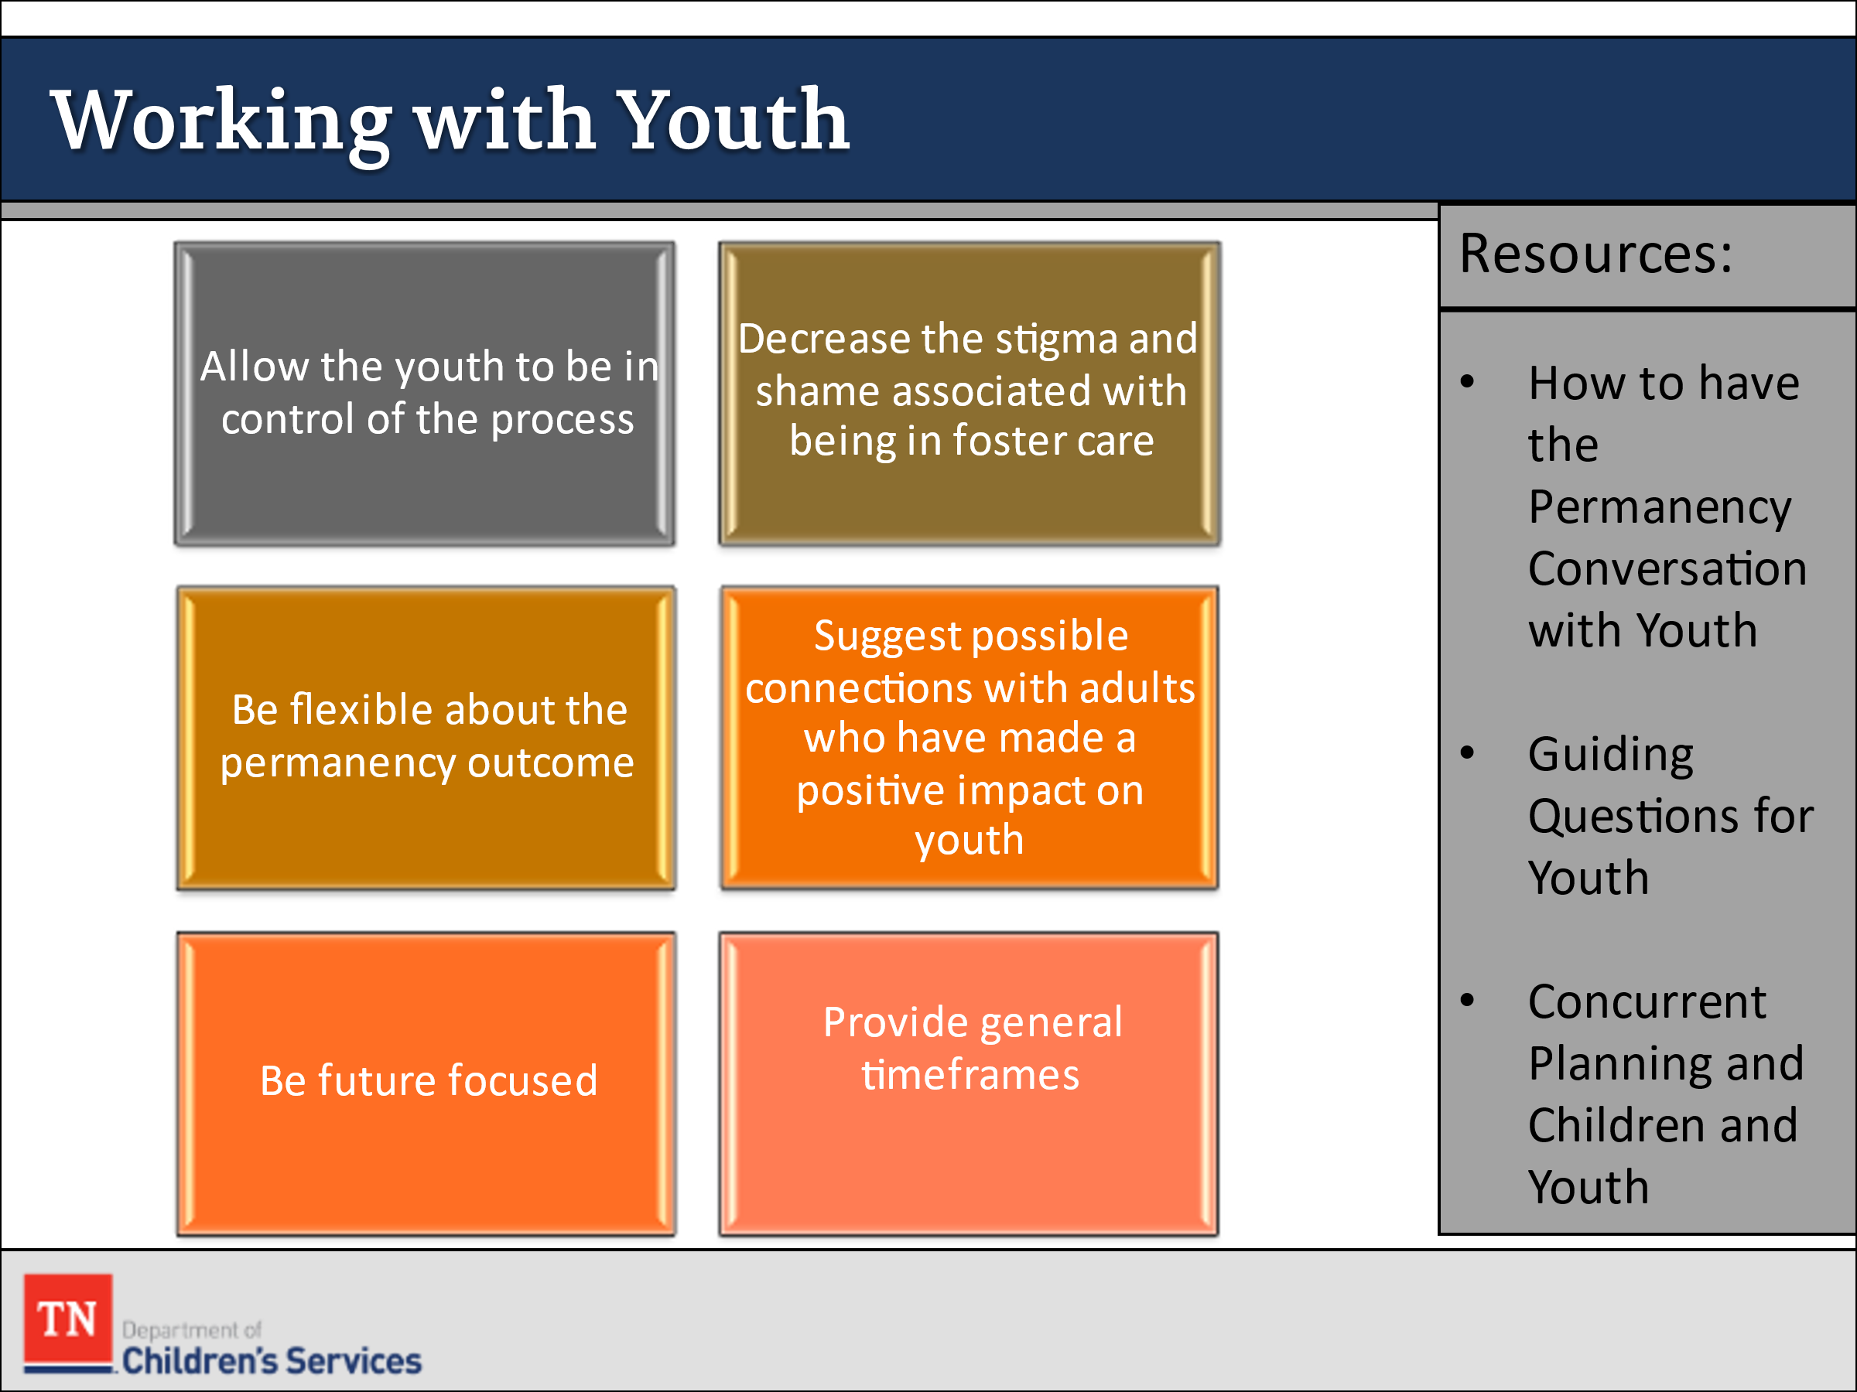
- DISCUSS the importance of initiating conversations about permanency and concurrent planning with youth. REFER participants to the resource How to Have the Permanency Conversation with Youth and Guiding Questions for Youth handout in Google Classroom and briefly discuss.
- How to have the Permanency Conversation with Youth Handout:
- Allow the youth to be in control of the process
- “I work with you to make a plan that will address your needs and wants; it’s about you and your future.”
- “It works best if you are at the planning table where we work together to find the best direction for your future.”
- “This may feel like a new way of working together.”
- Decrease the stigma and shame associated with being in foster care
- “I work with many others in similar situations.”
- “I’m working with another young man/woman who…”
- “I’m working with five other adolescents right now to help plan their futures.”
- Be flexible about the permanency outcome
- Avoid using the terms “adoption,” “guardianship,” or “family”
- Use the terms “adult connection,” “support person,” “someone you can count on,” or other words that signify permanence without implying a traditional family relationship.
- “Have you thought about who you’d like to spend time with as you get older?”
- Suggest possible connections with adults who have made a positive impact on the youth
- “I’m sure there are people in your past or present (a relative, teacher, coach, other) with whom you feel a connection.”
- “I’m here to help you reconnect or make the connection more secure.”
- Provide examples of when having these connections might be used
- Celebrating holidays and special occasions
- Getting a driver’s license
- Graduating
- Getting married
- Co-signing a loan
- Be future-focused
  - “When you think about yourself five years from now, what are your hopes?”
  - “If you could design a plan or draw a picture for your future, what would it look like and who would be in it?”
- Provide general timeframes for the process
  - “It’s not going to happen overnight.”
  - “It will take a few months to get to know you, to meet the people you’d like to have in your life, and to make a good plan.”
- Be flexible in your approach
  - You may not get to these later steps during the first conversation.
  - All that really needs to happen during the first conversation is to plant the seed and begin to establish your connection with the youth.
- Be positive and comfortable
  - This is a no-pressure, informational conversation.
  - Try to provide a warm and comfortable setting.
  - Try to meet one-on-one with the youth without program staff or foster parents.
- Be honest even if it isn’t what the youth wants to hear.
- Food is always good!
- REFER participants to the worksheet Concurrent Planning and Children/ Youth in Google Classroom and REVIEW.
- Concurrent Planning and Children/Youth Handout
  - At what age is this child functioning developmentally?
  - Does the child/youth use concrete or abstract thinking processes? Is he/she capable of logical thinking?
  - How stable is this child emotionally?
  - How can you engage the child/youth in discussing how to meet the need for permanence appropriately?
  - What, specifically, are some statements you would use to begin this conversation?
  - What guiding questions will you use with this child/youth?
- HELP the group apply this discussion to the Williams case family.
  - Would you discuss concurrent planning with Jewel (5 years old)? If so, provide an example of what you might say to her. o If Ariana was nine years old, how might you go about discussing concurrent planning with her? What, exactly, would you say?
- REFER to the video and ASK the group the following questions:
  - How did Sandra address Renee’s lack of progress with Ariana?
  - Why is it important to discuss these types of issues with youth?
  - Why is it important to discuss alternative permanency options with Ariana even though she still wants to return home to live with her mother?
- REFER participants to the worksheet Concurrent Planning and Children or Youth in the Participant Guide Unit 5 and REVIEW.
- TELL the group to use these questions to help them determine their approach so that the way they discuss concurrent planning with youth will be developmentally sound and most likely to engage the youth.
- TRANSITION to Lesson 5.7 The Role of the Court and Legal Considerations.

