Foster Care Specialty
Week Two
Tennessee Department of Children’s Services | 6.16.23

Curriculum Information

- Training Credit: 22 floor hours
- Trainers should give participants one 15-minute break during the training.
- This curriculum was developed by the State of Tennessee Office of Training and Professional Development.
- Staff may receive T4T credit for this course by:
  - Attending the course T4T offering -- OR --
  - Attending an offering of the course taught by another trainer & debriefing with that trainer.

This curriculum was developed by the Tennessee Department of Children’s Services with federal funds. It is
available to use in part or in whole free of charge. Suggested citation:
OTPD. (2023). Foster Care Specialty – Week Two. Tennessee Department of Children’s Services.

Learning Objectives

  - Participants will continue to develop an understanding of their role working at the Department of Children’s Services.
- Participants will gain additional knowledge of the foster care casework process.
- Participants will apply knowledge learned from the foster care casework process and demonstrate application in skills labs.
- Participants will have a greater understanding of how engaging families leads to quality contacts and assisting families during the custodial episode.
- Participants will team with the family to identify informal and formal supports to assist the family through the custodial episode.
- Participants will demonstrate assessment skills by using the CANS to assess the strengths and needs of the family.
- Participants will learn and demonstrate how to plan with the family to implement action steps which will help the family reach positive outcomes.
- Participants will become knowledgeable in ongoing tracking and adjusting in casework.
- Participants will understand the on-going case process throughout the life of a foster care case.
- Parents will understand the basic concepts of the reasonable and prudent parenting standard.
- Participants will recognize the importance of normalcy for foster children.
- Participants will implement the reasonable and prudent parent standard.
- Participants will encourage access to age-appropriate activities.
- Participants will promote “normalcy” with foster youth.
- Participants will eliminate barriers to prudent parenting.
- Participants will illustrate ways to prepare and support parents, children, and foster parents for/during visitation including identifying typical reactions to visitation.
- Participants will recognize the importance of assessing visits and utilizing the visitation observation checklist as an assessment tool.
- Participants will identify the importance of debriefing children, parent, and foster parents after a visit.
- Participants will articulate what needs to be documented before, during, and after the visitation.
- Participants will understand the importance of virtual visits and how they can be used as an engagement tool.
- Participants will understand the foundations of permanency plans including strength-based, family-centered, and culturally competent practice.
- Participants will understand the importance of preparation of the team in relation to successful permanency plans.
- Participants will understand the components of the Family Permanency Plan and the importance of assessment integration in creating a quality plan.
- Participants will practice developing strengths statements, needs statements, and action steps.
- Participants will gain specific knowledge on policies and protocols for the specific program areas of CPS, FSS, FCIP, Juvenile Justice, and Foster Care.
- Participants will be empowered for the next steps in the Pre-Service Process.

Materials Checklist

Materials needed for this curriculum:
- Foster Care Week Two Facilitator Guide and Power Point / Annotated Agenda
- Google Classroom Resources/Handouts
- Google Classroom: Referral Intake (680) and TFACTS History
- Base Camp: Steward Case Family Handouts Intro, Core, and Specialty
- Creating Normalcy through Prudent Parenting FG and PowerPoint
- Meaningful Parent and Child Visitation FG and PowerPoint
- Developing Quality Permanency Plans FG and PowerPoint
- Forms:
  - New Hire Guide
    - Case Calendar Timeline
- Form CS-0727 Initial Intake, Placement and Well-Being Information and History
- Form CS-0774 Genogram Contacts Sheets
- Form CS-0782 Family Eco-Map
- CFTM Tool: How DCS Workers Can Help Prepare the Family for the Meeting https://files.dcs.tn.gov/policies/chap31/WACFTMPrepFam.pdf
- CFTM Tool: Preparing the Facilitator for the Meeting https://files.dcs.tn.gov/policies/chap31/WACFTMPrepFacilitator.pdf
- Form CS-4221 Visitation Working Agreement
- A Guide for Using CANS with Child, Caregivers, and their families: A Tip Sheet
- Policies:
  - Policy Page Link: https://www.tn.gov/dcs/program-areas/qi/policies-reports- manuals/policiesprocedures.html
  - Child and Family Team Meeting Guide
  - Visitation Guide
  - CANS protocol
- Posters in the training room for the duration of the week:
  - The Practice Wheel

  - DCS Values: Strengths Based, Family Centered, Culturally Responsive
  - DCS Outcomes: Safety, Permanence, and Well-Being

  - Safety/Risk Continuum

  - Core Conditions: Empathy, Genuineness, Respect
  - DCS Vision

  - DCS Mission

  - Employee Assistance Program (EAP)

Annotated Agenda

**INSERT ANNOTATED AGENDA AFTER CONVERSION TO ADOBE**

Unit 1: Welcome

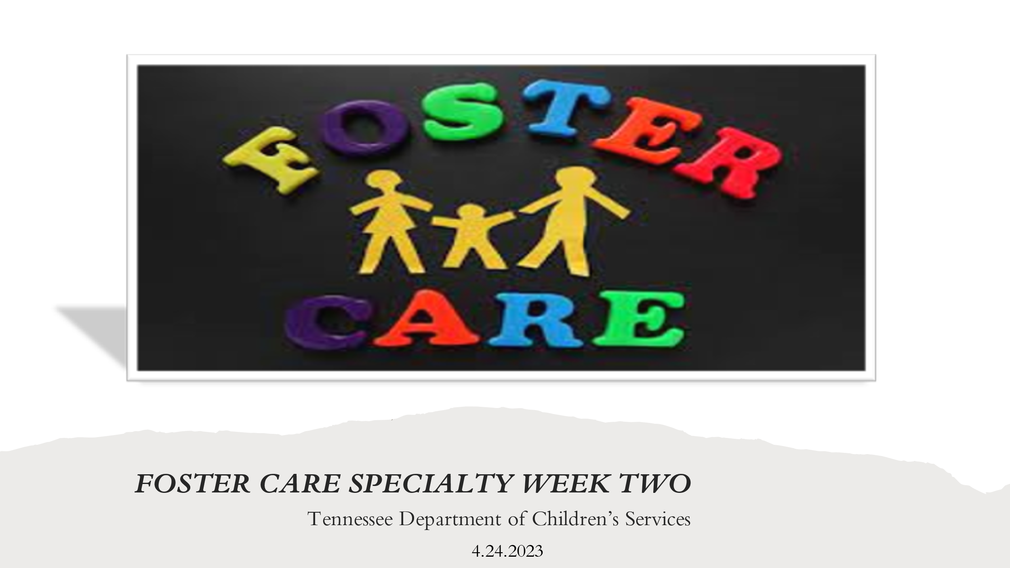
Unit Time: 25 minutes

Learning Objectives:
  - Participants will continue to develop an understanding of their role working at the Department of Children’s Services.

Supporting Materials:

- Foster Care Specialty Week Two Facilitator Guide and PowerPoint
- Comfort Rules from Intro/Core/Foster Care Specialty

Lesson 1.1 Welcome Back

Lesson Time: 25 Minutes
Key Teaching Points / Instructions

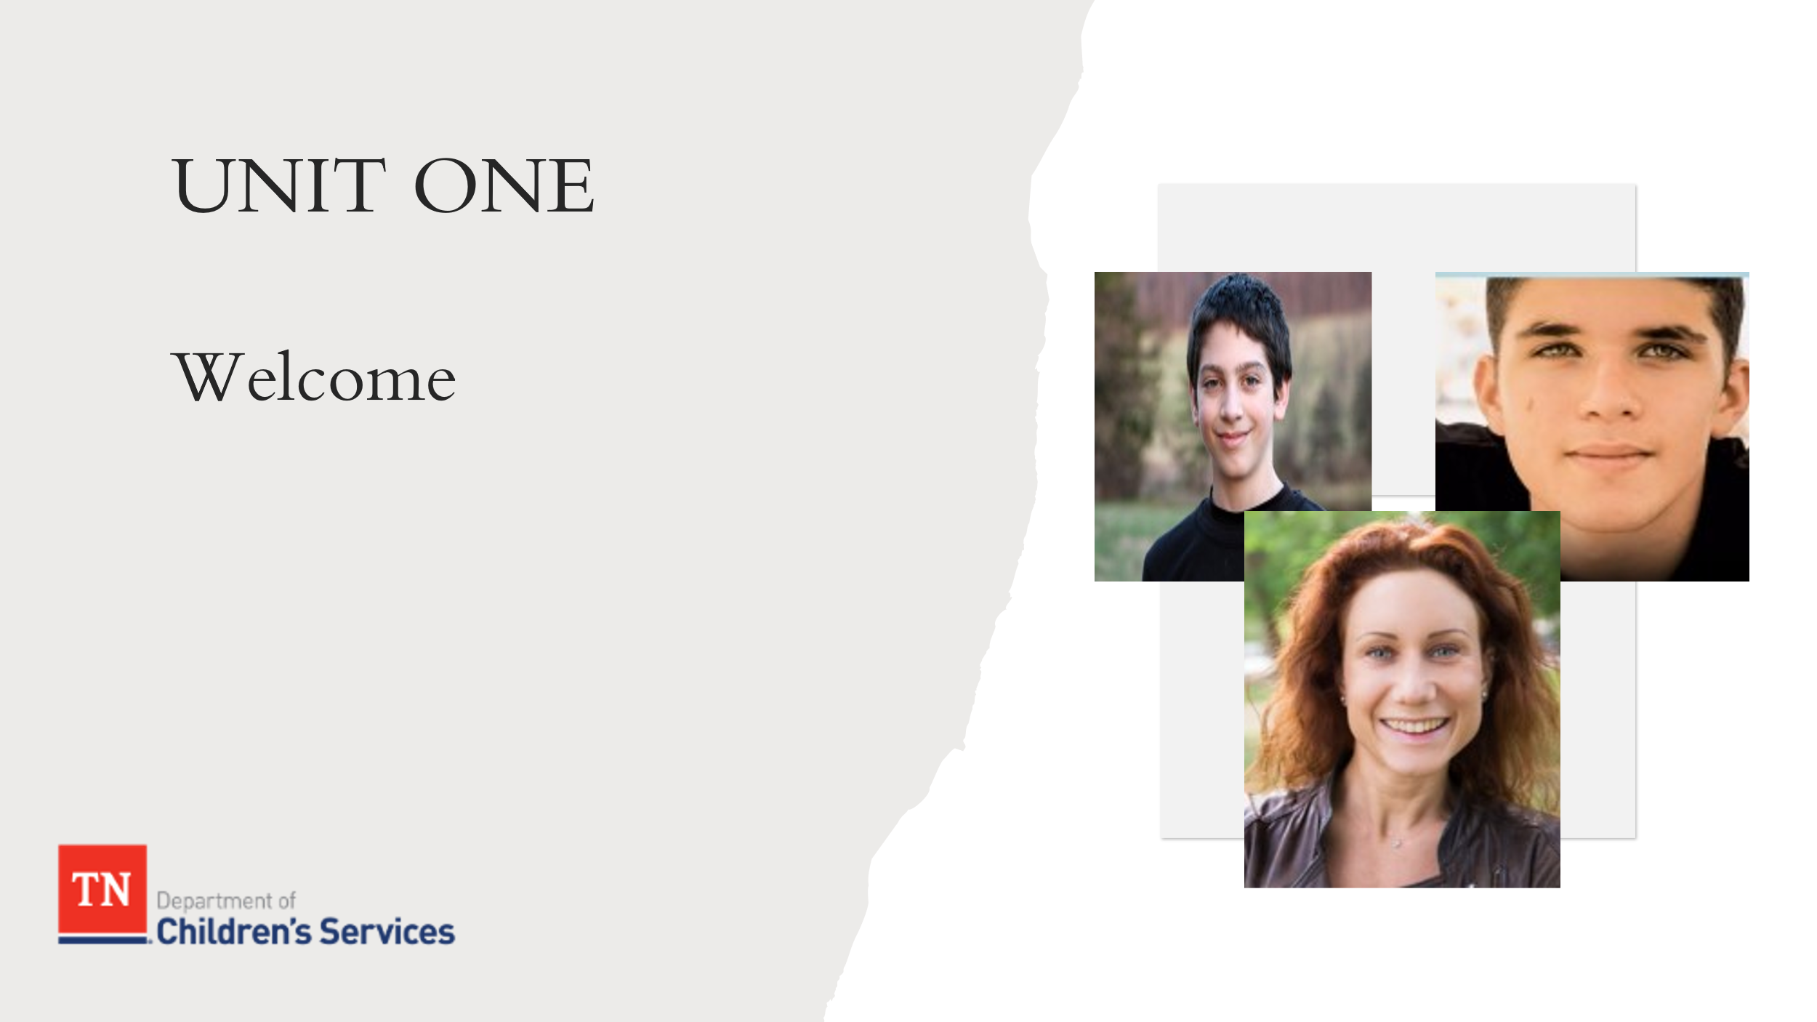
- PRIOR TO CLASS: POST the following posters in the training room for the duration of the week:
  - The Practice Wheel

  - DCS Values: Strengths Based, Family Centered, Culturally Responsive
  - DCS Outcomes: Safety, Permanence, and Well-Being

  - Safety/Risk Continuum

  - Core Conditions: Empathy, Genuineness, Respect
  - DCS Vision

  - DCS Mission

  - Employee Assistance Program (EAP)
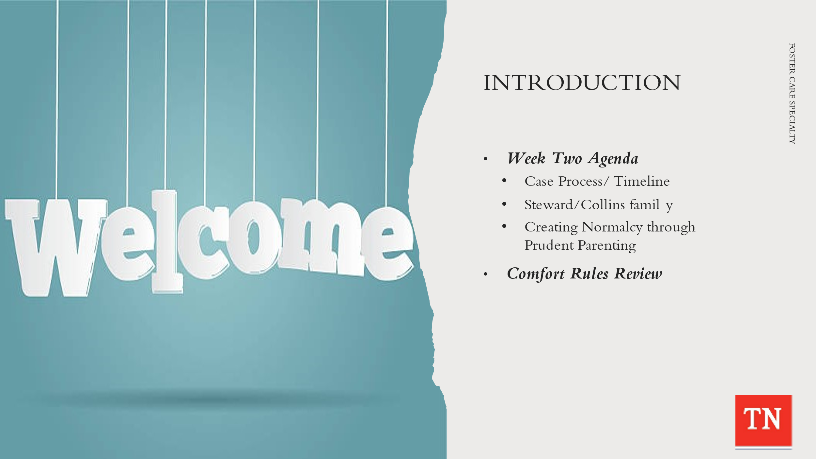
- GREET participants and WELCOME them back to class.
- INTRODUCE any new Trainers to the group and have them share information about their previous experiences working with children and families in the child welfare system.
- PROVIDE any housekeeping information for the training location i.e., restrooms, break room, safe room, closest exit, location if office emergency occurs, and smoking areas. INFORM the participants lunch and break times are flexible and may be changed if needed.
- DISTRIBUTE sign-in sheets. ALLOW time for laptop/tablet log-in and assist with any technical issues.
- INFORM the group we will begin the day by answering any questions participants have from the previous week.
- REVIEW the Foster Care Specialty Week Two Agenda:
        - Case Process/Timeline
        - Steward/Collins family
        - Creating Normalcy through Prudent Parenting
  - DISCUSS training expectations and REVIEW comfort rules developed during the INTRODUCTION and CORE and ASK if any adjustments need to be made or additional rules need to be added. REINFORCE the importance of genuineness, empathy, and respect in the training environment as well as the concept of Do No Harm. ASK participants if they can continue to agree to support the comfort rules.
  - EXPLAIN the comfort rules may be revisited or revised at any point during the training week as needed.
  - TRANSITION to Unit 2 Introduction to Custodial Episode.

Unit 2: Introduction to Custodial Episode

Unit Time: 85 minutes

Learning Objectives:
- Participants will gain additional knowledge of the foster care casework process.

Supporting Materials:

- Case Family Handout: Steward/Collins Foster Care Custodial Placement Update
- Foster Care Week Two Facilitator Guide and PowerPoint
- Form CS-0727 Initial Intake, Placement and Well-Being Information and History
- New Hire Guide: https://www.teamtn.gov/content/dam/teamtn/dcs/documents/training/preservice/fpd_fc.pdf
- CFTM Guide: https://files.dcs.tn.gov/policies/chap31/CFTMGuide.pdf
- Visitation Guide: https://files.dcs.tn.gov/policies/Chap16/VisitationGuide.pdf
- Case Calendar Timeline

Lesson 2.1 Custodial Episode
Lesson Time: 85 minutes
Key Teaching Points / Instructions
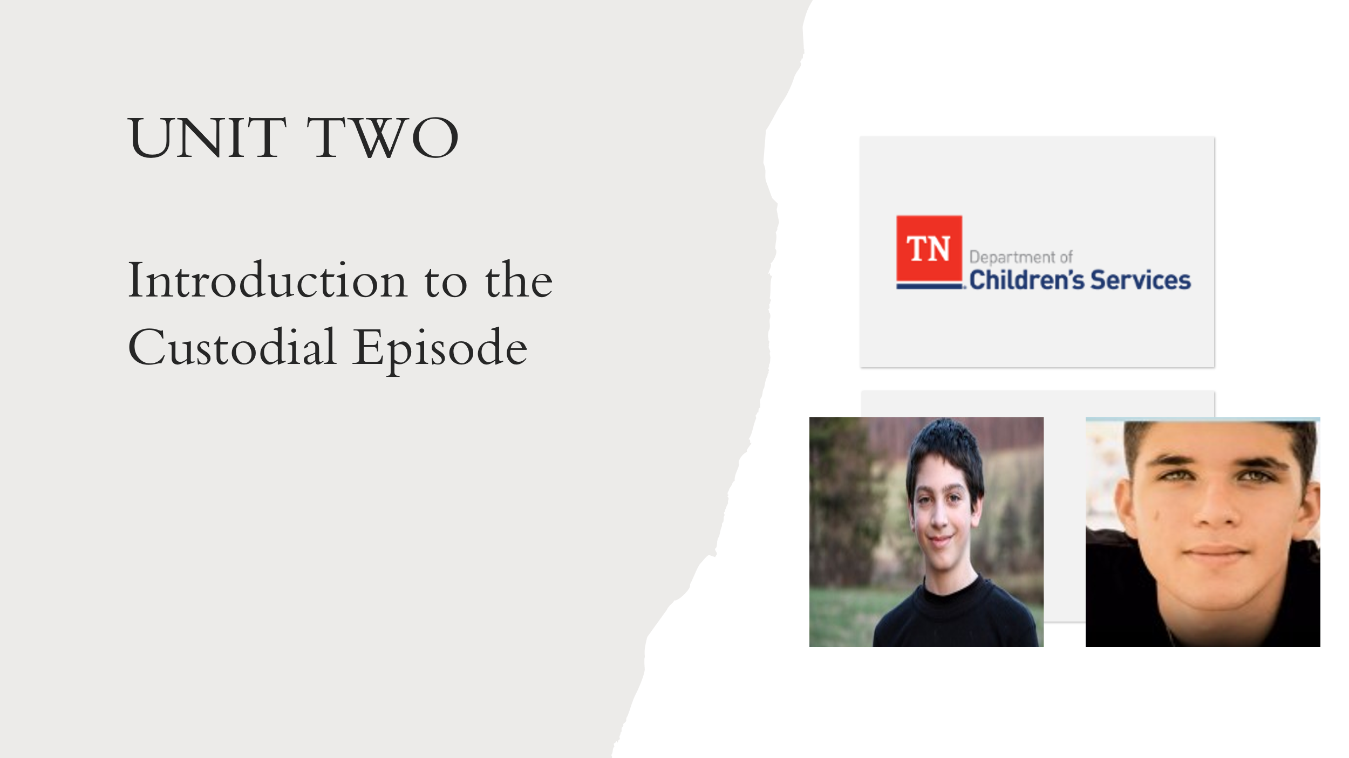
- EXPLAIN getting a new case on your caseload can be overwhelming at first. STATE preparing and planning will be key in managing the case from beginning to end.
- REMIND participants of the importance of time management and organizational skills necessary, in order to meet the needs of children/youth and families.
- SHARE each participant will have their own way of conducting case work. STATE learning skills from their Mentor, Peers, and Team Leader will allow them to begin developing their own system of tracking their casework.
- STATE we will now focus on how to ensure a smooth case transition from CPS to foster care and we will review the tasks required for family service workers to successfully prepare for the initial contact with the family after a child enters custody. EMPHASIZE the importance of internal teaming within DCS program areas.
- ASK participants to get out the Steward case file from INTRO and CORE. TRAINERS: SUPPLY materials to participants if needed. EXPLAIN this information is typically gained from the non-custodial Child Protective Services case work and information from TFACTS upon entry into care.
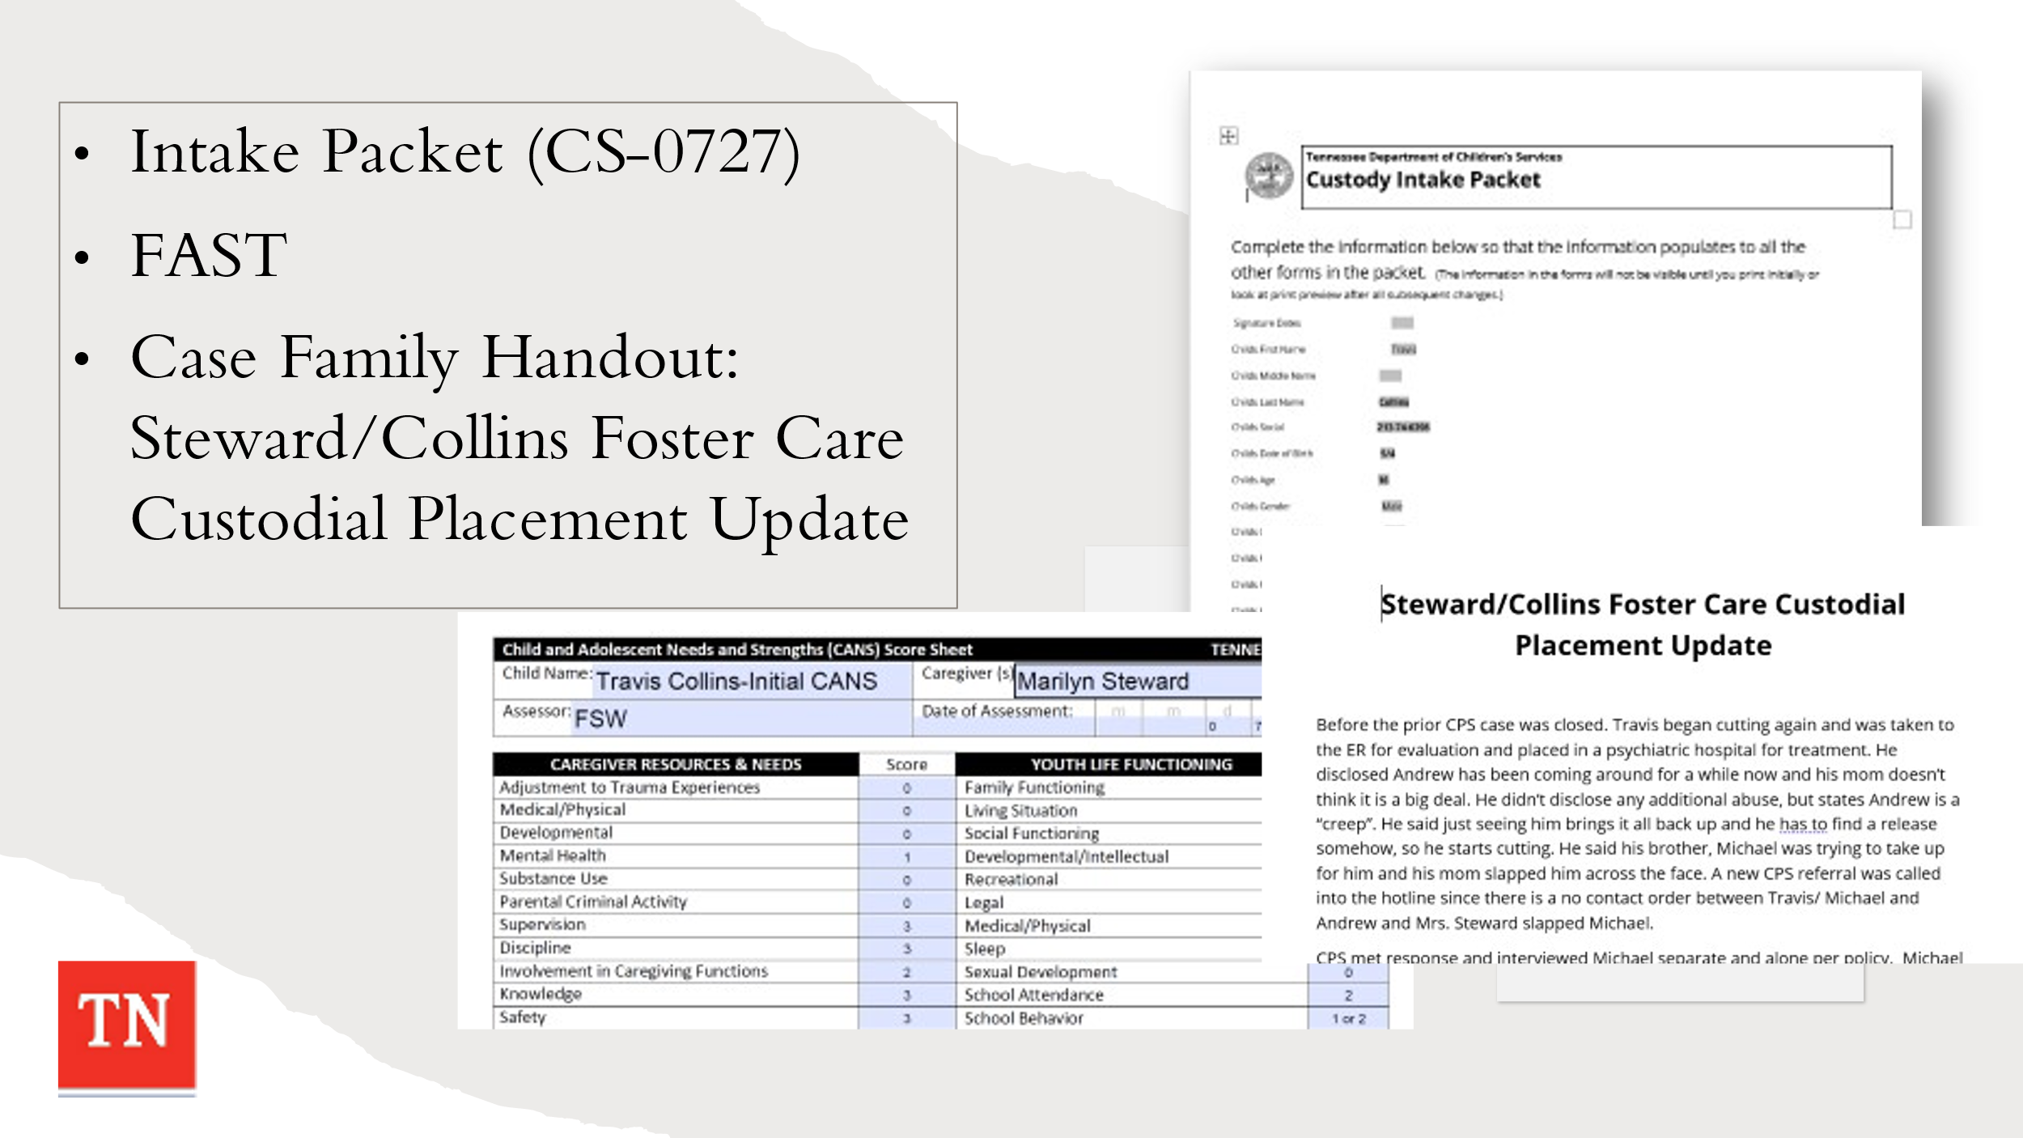
- EXPLAIN Steward Intake Packet will either come from CPS or the Court Liaison. They complete the Intake Packet with the information provided at the time of removal with the family.
- HAVE participants REVIEW Steward Intake Packet Form CS-0727 (Initial Intake, Placement and Well-Being Information and History) and the FAST (Family Advocacy Support Tool) completed by CPS at removal. ALLOW 20 minutes for the review.
- ADDITIONALLY, SUPPLY participants with the Case Family Handout: Steward/Collins Foster Care Custodial Placement Update. ALLOW participants 5 minutes to read the update and to get an understanding of what has happened with the Steward case since CORE week.
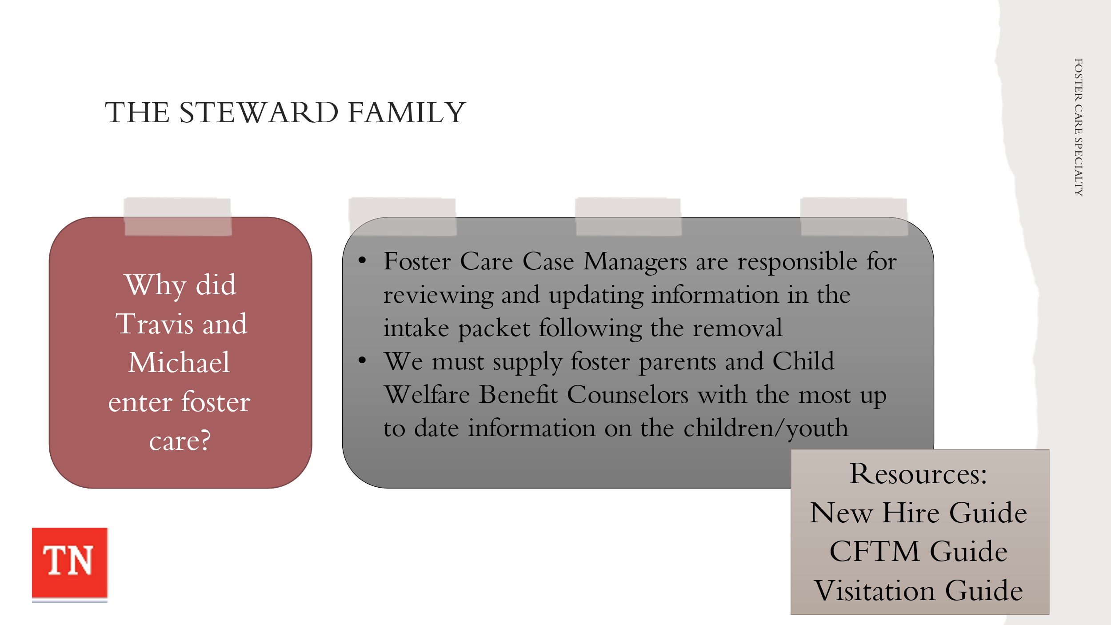
- ASK participants what is their understanding of why the youth, Travis and Michael, entered foster care/custodial placement. ANSWER: Lack of supervision by Mrs. Steward and her being unwilling to be protective of the youth from Andrew. DISCUSS additional details of what brought Travis and Michael into custody.
- STATE foster care case managers are responsible for reviewing and updating information in the intake packet following removal. EXPLAIN We want to supply foster parents and Child Welfare Benefits with the most up to date information on the children/youth.
- REMIND participants of the Foundations of Professional Development: Foster Care New Hire Guide, Child and Family Team Meeting Guide, and Visitation Guide. SHARE these documents will assist with casework practice and help with a visual timeline of responsibilities.
  - New Hire Guide: https://www.teamtn.gov/content/dam/teamtn/dcs/documents/training/preservice/fpd_fc.pdf
  - CFTM Guide: https://files.dcs.tn.gov/policies/chap31/CFTMGuide.pdf
  - Visitation Guide: https://files.dcs.tn.gov/policies/Chap16/VisitationGuide.pdf
- EXPLAIN these documents explain many of the important tasks involved in effectively working a custodial case from start to finish.
- STATE we will now put all the pieces together and map out the first month of a custodial episode for Steward/Collins family.
- REFER participants to use the New Hire Guide, Visitation Guide, and Child and Family Team Guide to assist in this activity.
- CONDUCT ACTIVITY: Timeline: Steward Entry into Custody
TRAINER NOTE: The Trainer will share their screen/desktop with participants and conduct the activity. The Trainer will drag and drop the case tasks/responsibilities to the appropriate date on the calendar by asking participants the order of tasks (the youth are removed on the first day of the month). The Trainer will allow the cursor to show on the right side of the tile in order to drag and drop onto the date on the calendar.
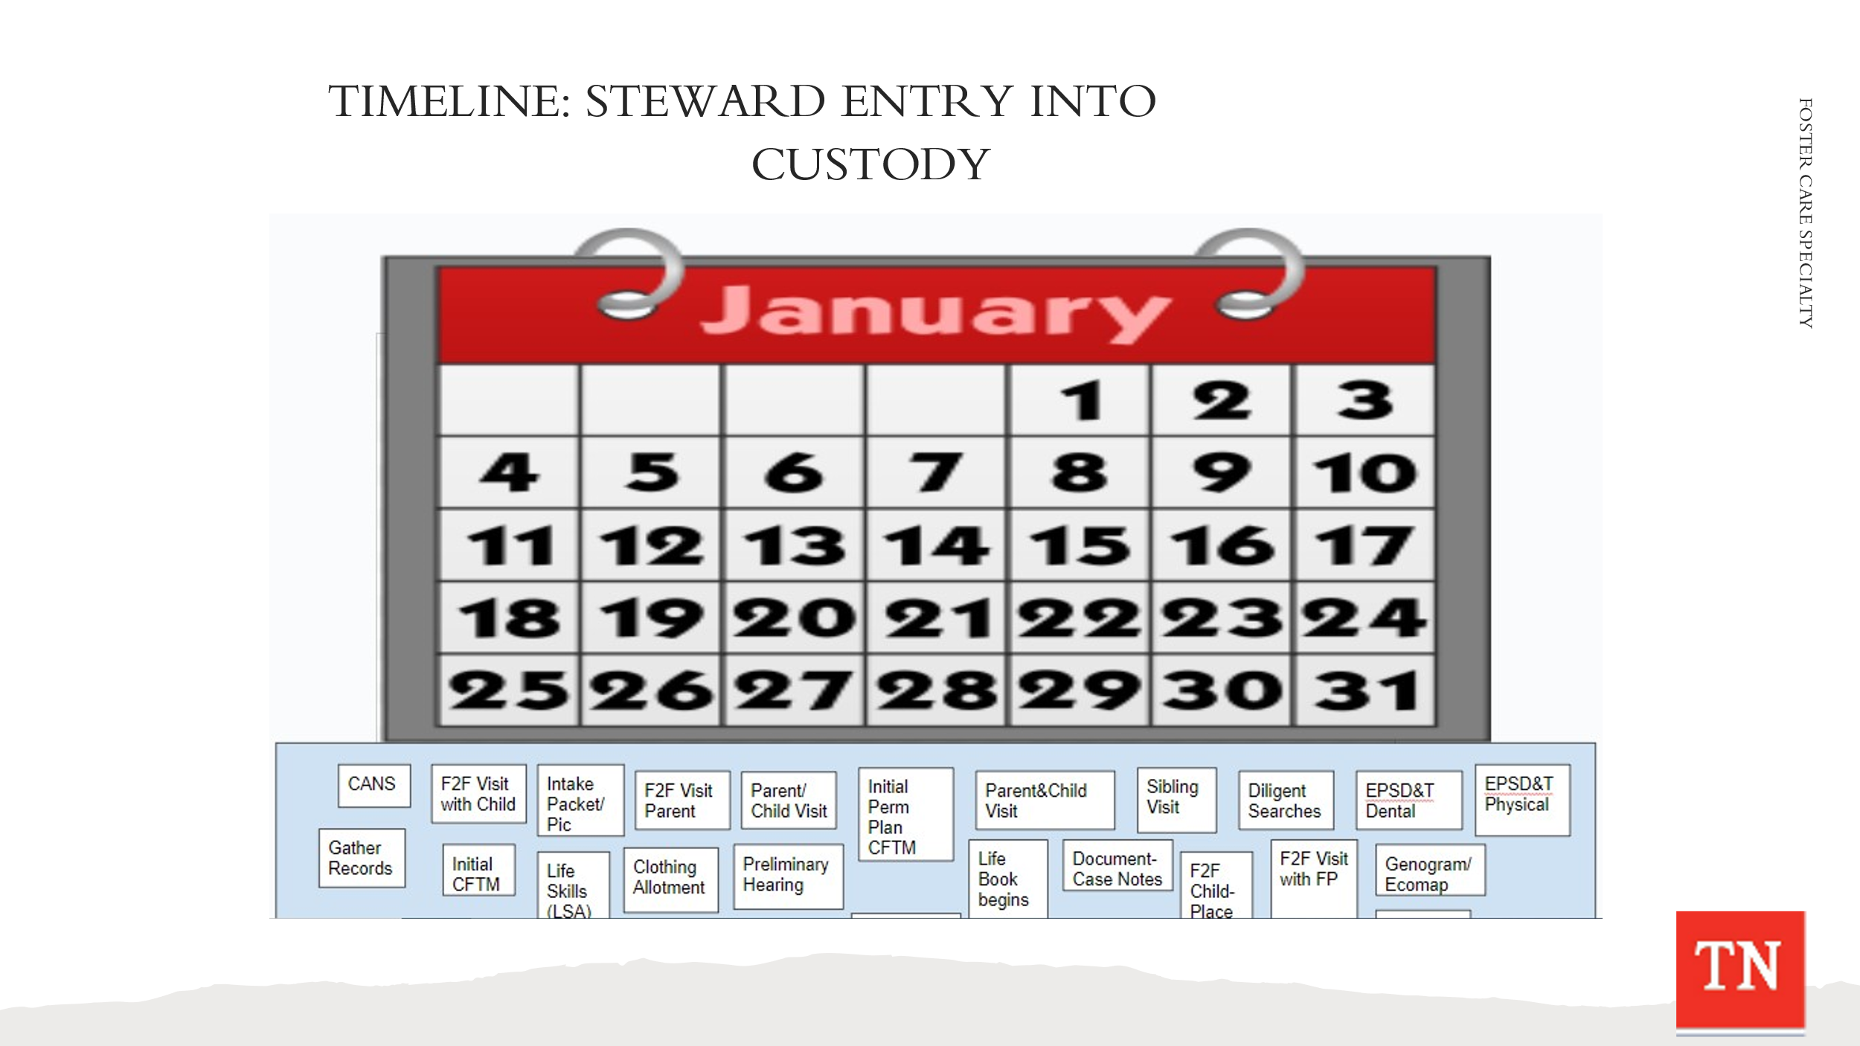
  - ASK participants what task would go first and so on until the calendar is full. There is a task for each day of the week on the calendar. LINK: https://docs.google.com/drawings/d/132rdwa9NIb1dJkl0-lzfJbAhX- g1B7e8VnnhZJ0tGD8/edit?usp=sharing. LINK number 2: https://docs.google.com/drawings/d/1ePaXCdZIAt1wKU1yPWc_lJQ7VqZkHul1P8wVt2gEKt8/edit?usp=sharing.
  - DEBRIEF the activity by sharing this activity was intended to be a guide; however, there could be slight variations in casework depending on regions/counties.
- SHARE Case Calendar Timeline Handout with the group following the activity. DISCUSS how the timeline is broken down into timeframes. STATE we will be using this timeline as a basis for our training this week. EXPLAIN this document is an addendum to the New Hire Guide for quick reference only and not meant for a check off worksheet. The New Hire guide provides custodial case process specifics, on-going case tasks, and samples along with forms and policies attached to each task.
- ASK participants if they have any questions. REITERATE the first 30 days of custody can be challenging to meet the needs of the children and families, however, there are supports in place that will assist in meeting those needs.
- REMIND participants when getting a case, self-awareness is vital to ensure bias does not creep into the work and alter case decisions. When getting a case, remember to evaluate if there are any feelings about the case and to discuss these feelings with the Team Leader and/or Mentor.
- BEGIN gathering initial strengths and needs for the Steward family from the group at this time. UTILIZE the Case Family Handout: Steward/Collins Foster Care Custodial Placement Update and Intake packet. RECORD these on flip chart paper.
  - Briefly REMIND participants of the DCS Practice Wheel and REFER participants to DCS Case Tasks that are related to the Practice Wheel. This sets the stage for the remainder of Specialty week.
  - TRANSITION to the Foster Care Unit.
Unit 3: Foster Care

Unit Time: 1 hour

Learning Objectives:
- Participants will apply knowledge learned from the foster care casework process and demonstrate application in skills labs.

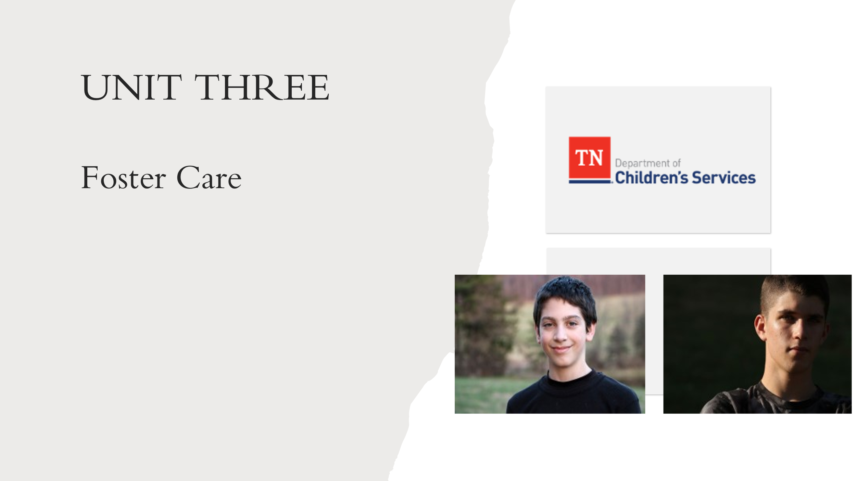
Supporting Materials:

- Foster Care Specialty Week Two Facilitator Guide and PowerPoint
- Policy 16.46 Child/Youth Referral and Placement
- Interstate Compact on the Placement of Children (ICPC) Practice and Procedure Manual
- Guide to Placement Exception Categories
- Form CS-0664 Placement Exception Request
- Policy 16.20 Expedited Custodial Placement
- Case Family Handout: Steward/Collins Foster Care Custodial Placement Update
- Case Family Handout: Initial Face to Face with Travis (in placement)
- Case Family Handout: Initial Face to Face Quality Contact with Mrs. Steward
- Forms: Genogram Contacts Sheets CS-0774 and Family Eco-Map CS-0782 CFTM Tool: How DCS Workers Can Help Prepare the Family for the Meeting https://files.dcs.tn.gov/policies/chap31/WACFTMPrepFam.pdf
- CFTM Tool: Preparing the Facilitator for the Meeting https://files.dcs.tn.gov/policies/chap31/WACFTMPrepFacilitator.pdf
- CFTM Guide https://files.dcs.tn.gov/policies/chap31/CFTMGuide.pdf
- Form CS-4221 Visitation Working Agreement
- Steward/Collins Interviews with Travis, Michael, and Marilyn
- CANS Protocol
- A Guide for Using CANS with Child, Caregivers, and their families: A Tip Sheet

Lesson 3.1: Court Involvement
Lesson Time: 25 minutes
Key Teaching Points / Instructions
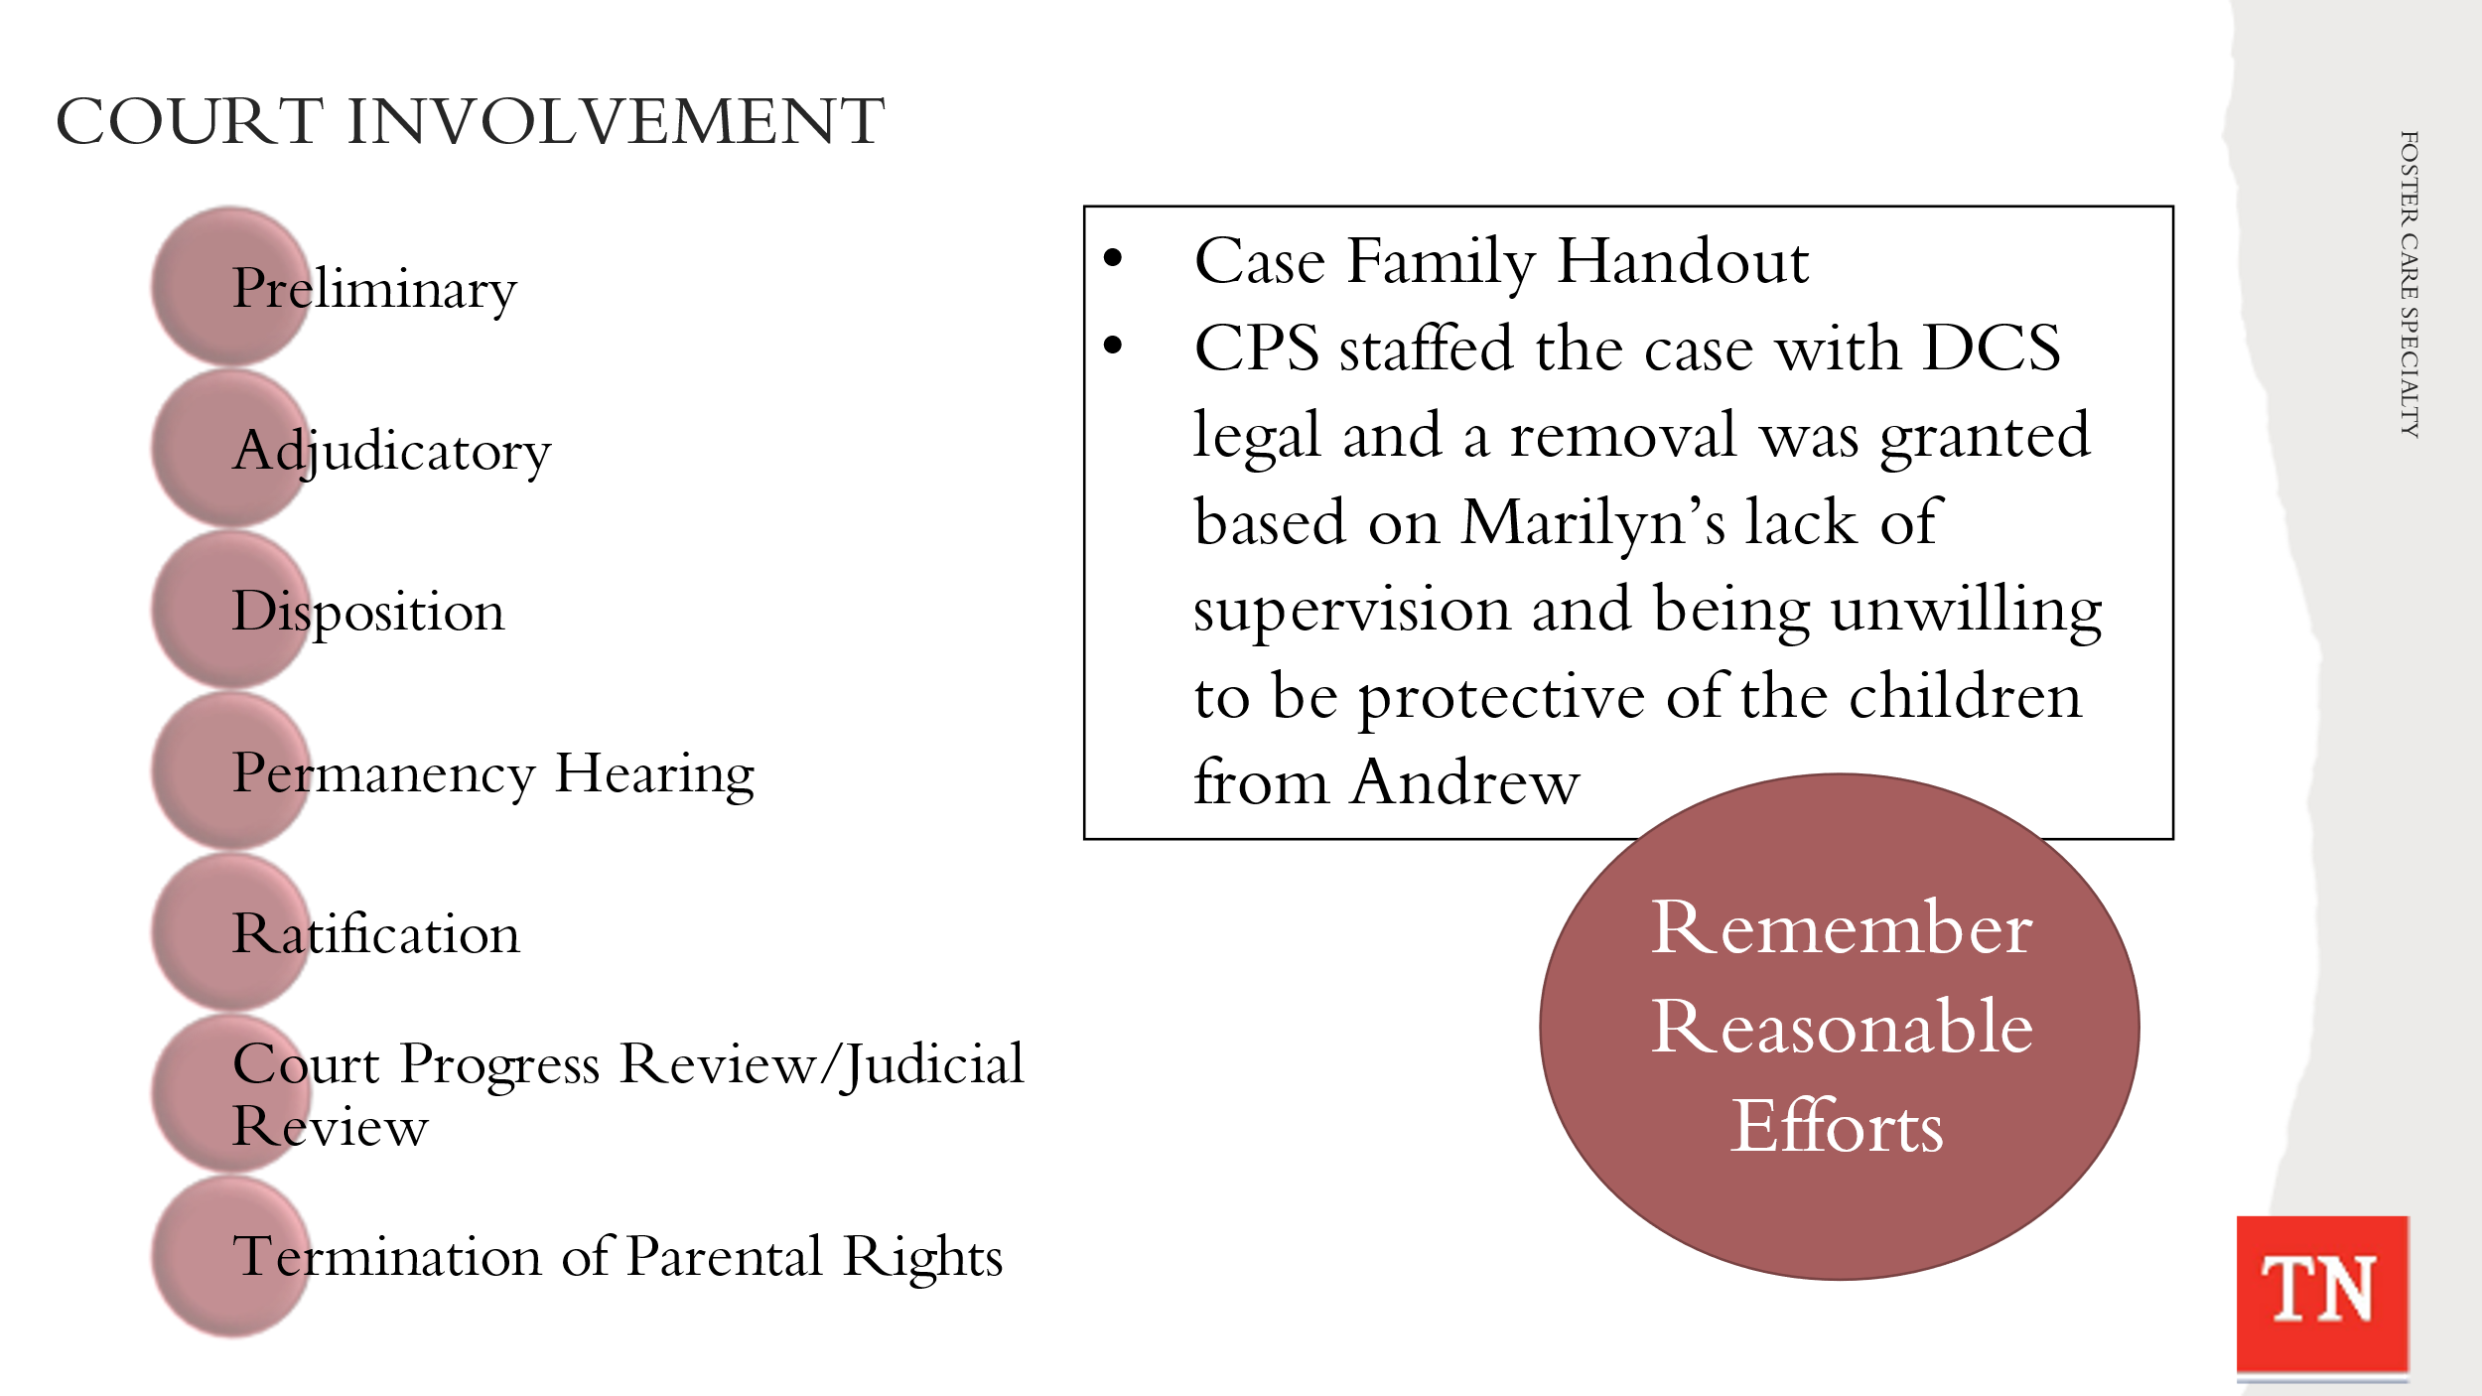
- STATE for a child/youth to enter state custody a Court made the decision that removal was in the best interest of the child/youth. REMIND participants children/youth enter care either by a bench order or the Department shared concerns with the Court and the Judge made the decision that removal was necessary. The Court makes the final decisions about safety and permanency. REMIND participants of the types of hearings in removal cases including:
  - Preliminary
    - After an emergency removal, a preliminary hearing on the removal must be held within 72 hours. The standard, or burden of proof, at a preliminary hearing is probable cause, which roughly means that there are reasonable grounds to believe that the emergency removal of the child was justified.
  - Adjudicatory
    - At the adjudicatory hearing, the court (the judge) determines whether the factual allegations of the petition are true and whether the evidence supports a finding that the child is dependent and neglected. The standard of proof for the adjudicatory hearing is clear and convincing.
  - Disposition
    - If, at the adjudication stage, the court finds dependent and neglect, it may proceed directly to the disposition, or it can conduct the disposition hearing within 15 days. The disposition hearing is supposed to design an appropriate plan to meet the needs of the child. Often, the disposition follows the adjudication directly.
  - Permanency Hearing
- REFER participants to Policy 16.31 Sections K, L, M for information on Permanency Hearing. STATE following the ratification of the Permanency Plan, the court will hold a permanency hearing within twelve (12) months of the date of a child’s placement in state custody and every twelve (12) months thereafter until permanency is achieved or until the child reaches the age of majority. Trainer Note: Per Policy 16.31 Family Permanency Plans are updated before the goal achievement date expires, so in most cases this would be at least every six (6) months.
  - Ratification
- One of the biggest responsibilities of the Juvenile court in a custodial case is presiding over permanency plans ratification hearings. This process is how we ratify the permanency plan, making them a legal document. The CFT presents the plan to the court and at that time the court decides if the plan is an efficient plan to reach permanency for the child/youth.
  - Court Progress Review/Judicial Review
- The Department submits regular progress reports to the Court and the Court should review the progress made on the permanency plan at least every six (6) months. The six (6) month review can be held by the Court or the FCRB. Court expectations can be different and staff will follow each Courts requirements for reviews.
  - Termination of Parental Rights (TPR)
- A formal proceeding usually sought by a state agency at the conclusion of dependency proceedings in which severance of all legal ties between parent and child is sought against the will of one or both parents, and in which the burden of proof must be by clear and convincing evidence. (www.tncourts.gov)
- DISCUSS the Case Family Handout: Steward/Collins Foster Care Custodial Placement Update where CPS staffed the case with DCS legal and a removal was approved based on Marilyn’s lack of supervision and being unwilling to be protective of the children from Andrew. The removal petition was submitted to the local Court and removal was granted; the removal will be discussed at the Preliminary Hearing within 3 days.
- REMIND participants Reasonable efforts are efforts made by DCS to provide the assistance and services needed to preserve and reunify families. In Tennessee, TCA 37-1-166 is the basis for determining, whether or not, DCS has exercised reasonable efforts. According to this statute, reasonable efforts mean the exercise of reasonable care and diligence by the department to provide services related to meeting the needs of the child and the family.
- EMPHASIZE the importance of consulting with DCS legal staff (and supervisors) and gaining court approval whenever it is believed that reasonable efforts might not apply. Only after the court has relieved us of these reasonable efforts, are we allowed to discontinue them.

Lesson 3.2: FSW Roles and Responsibilities
Lesson Time: 35 minutes
Key Teaching Points / Instructions

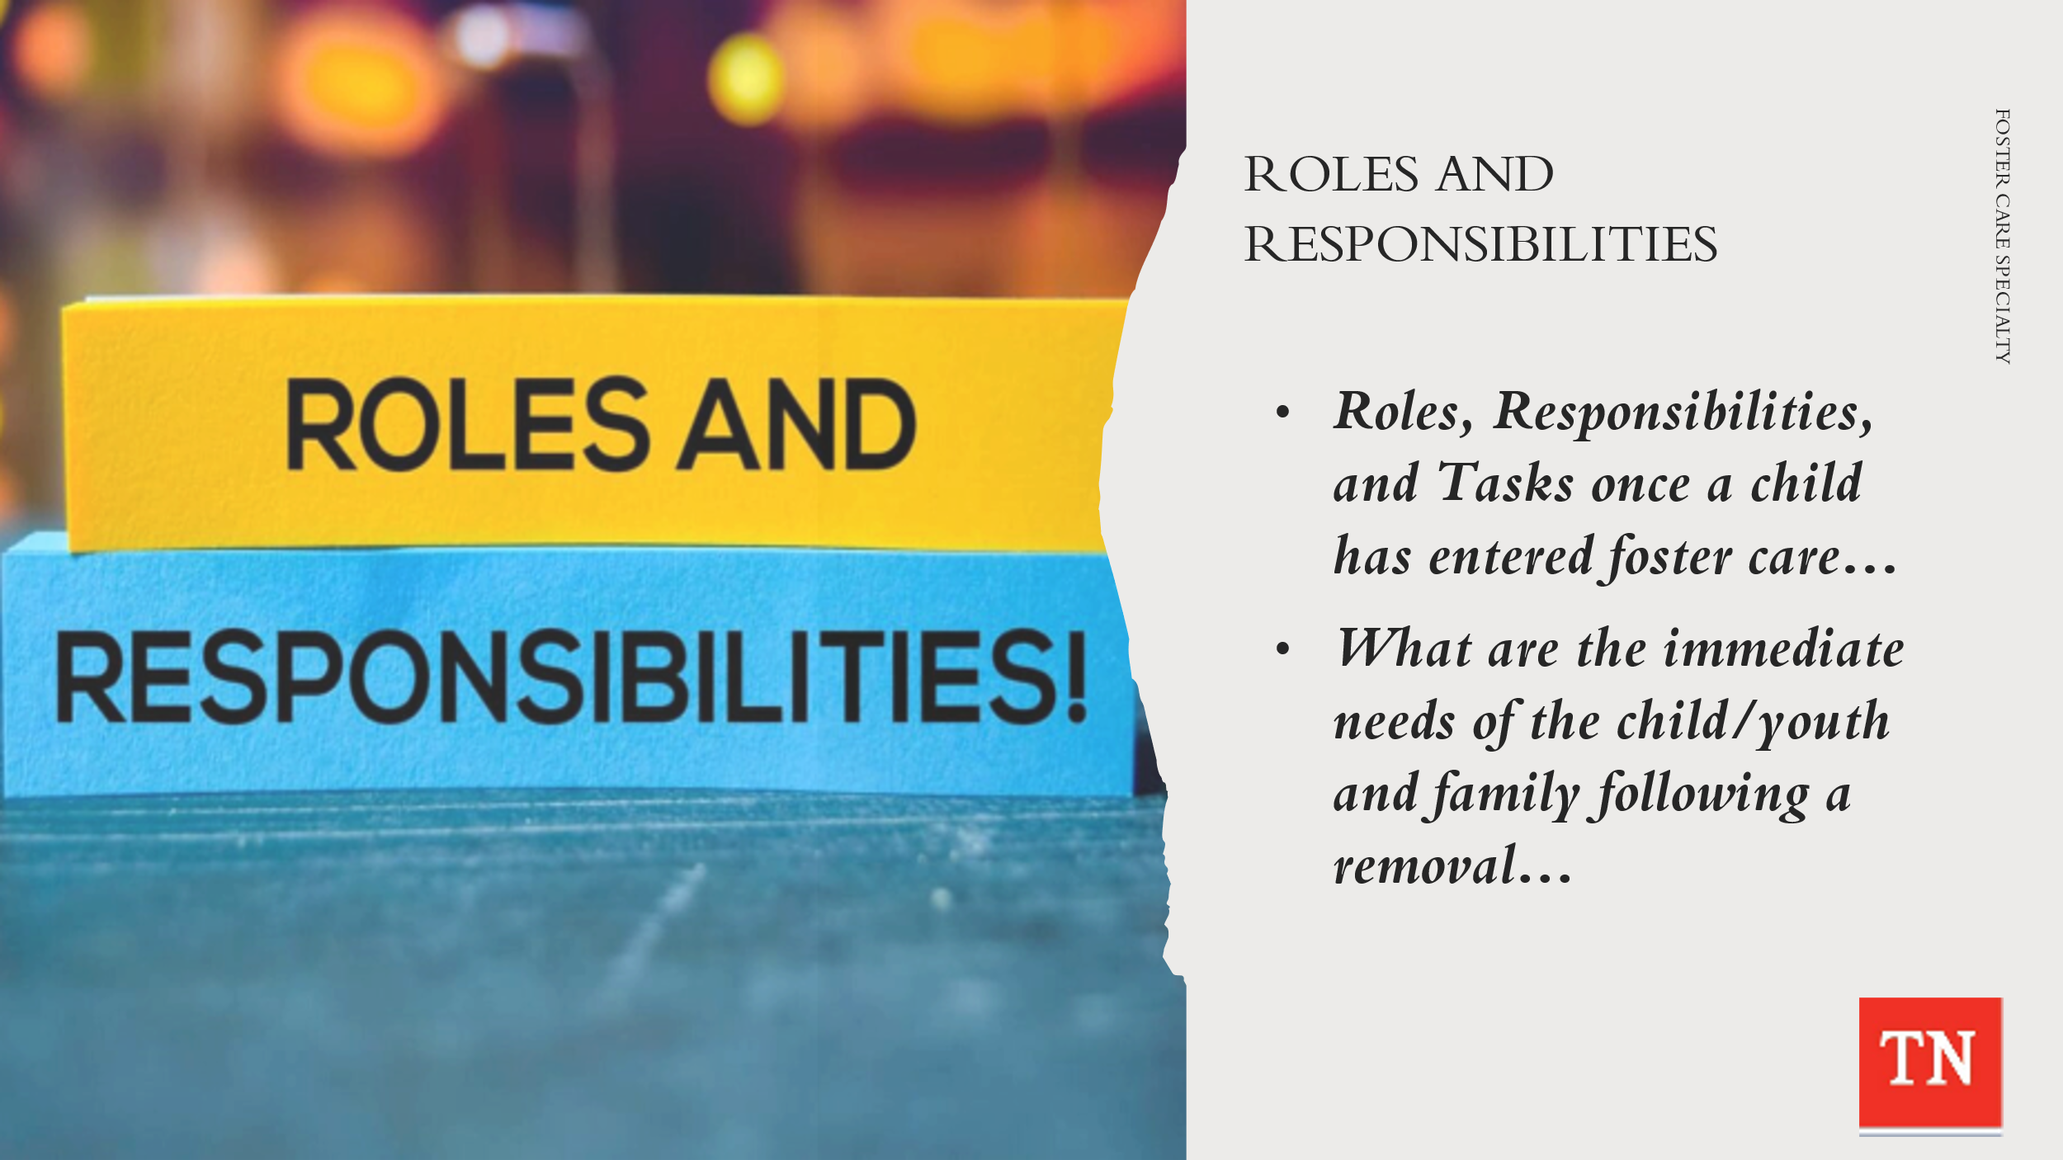
- EXPLORE with participants what are some of the roles and responsibilities (may include some tasks) they have once a child/youth has entered custody. ASK participants about the Steward/Collins family. ANSWERS may include:
  - Ensure immediate needs are met
  - Quality Contacts with Child/Youth and Family to:
  - Assessment of Safety, Permanency, and Well-Being and Resources
  - Begin gathering the family story
  - Educate the Family on Child and Family Team Process
  - Conduct Diligent Searches
  - Begin building the Child and Family Team
- ASK What are the immediate needs of the child/youth and family following removal? ELICIT ideas from the group. ENSURE the following are discussed:
- Shelter, healthy meals, health care (medical and dental), clothes
- Safe, stable environment; adult supervision; age-appropriate information about what is happening and where the parents are; connection to family: enrollment in school, if applicable
- Trauma reduction interventions
- Parents will need:
- full disclosure regarding why their child(ren) has/have been removed from the home
- a chance to tell their story
- understanding of their rights and responsibilities
- an opportunity to set up visits with the child(ren), if allowed; and
to bring the child(ren)’s special toys or other items
- Get child(ren)’s current medical needs, allergies, medications
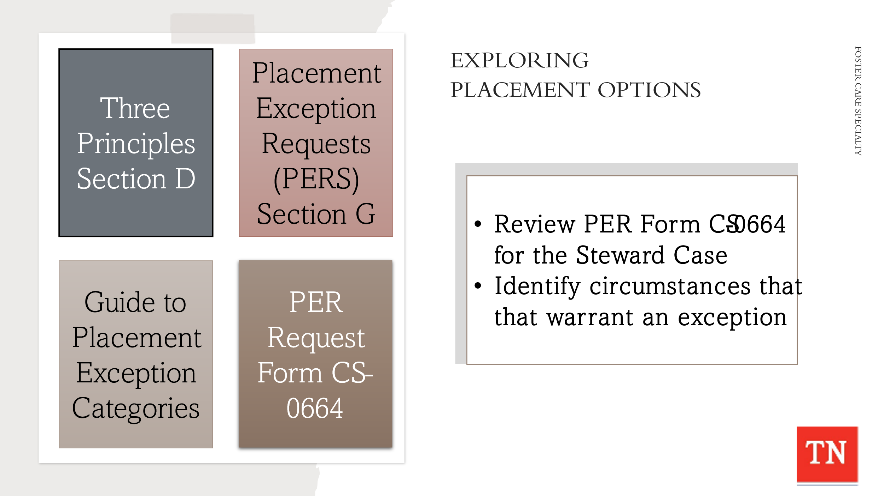
- EXPLAIN exploring placement options and making placement decisions is now a top priority, and there are several factors to consider when determining the best placement for a child/youth.
- REMIND all placements on behalf of children and youth must consider the following three principles (Policy 16.46: Child/Youth Referral and Placement, Section D):
    - Minimizing the trauma experienced by child/youth and families during the placement process
    - Striving for the first placement to be the best placement within the child/youth’s home county/community or as close to home as possible
    - Placing the child/youth in the most appropriate, most family-like setting that meets their needs, including out of state placements subject to compliance with the ICPC (REFER to Policy 1.30: Interstate Compact on the Placement of Children and the Interstate Compact on the Placement of Children (ICPC) Practice and Procedure Manual).
- ACKNOWLEDGE there may be times when an exception must be made to these best practice placement principles. REFER participants to the following resources on Placement Exception Requests (PERS): Policy 16.46 Section G, Guide to Placement Exception Categories, and the Placement Exception Request Form (CS-0664).
- HAVE participants review the PER Form CS-0664 and identify circumstances that warrant an exception request for the Steward case and note the justifications that are required. ANSWER: (D) Separation of Siblings as Travis is placed in a residential facility and Michael is placed in Kinship Foster Care with his Maternal Grandparents.
- POINT OUT placement exceptions must be approved prior to the placement by the Regional Administrator/Regional Designee. The form must be completed and submitted to the Regional Administrator. SHARE in most regions placement exception requests is completed by the Placement Case Manager.
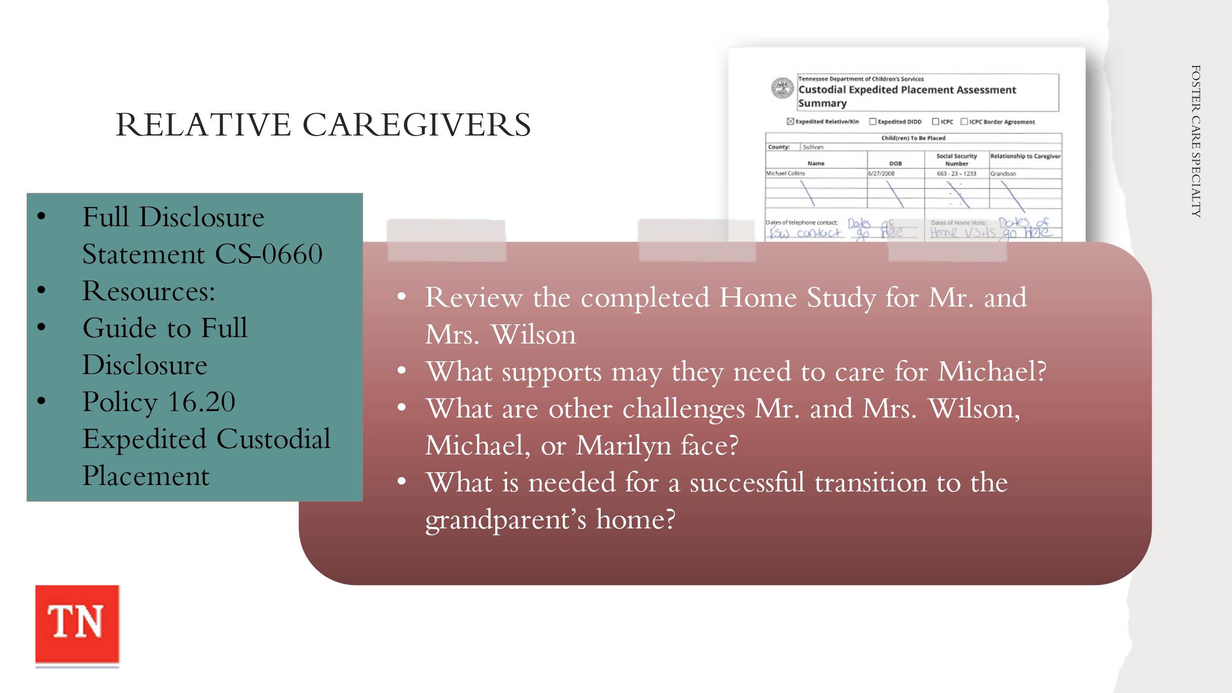
- TELL participants as family services workers they will need to explain the caregiving options to potential relative placement resources. REMIND participants they will discuss the full disclosure process if relatives are identified as a placement option.
- STATE the relative or kin caregiver and staff must sign and date Form CS-0660 Full Disclosure Statement – Permanency Options for Relative or Kin Caregivers indicating that permanency options were explained and a copy of the Guide to Full Disclosure of Permanency Options was provided. DCS Staff must provide the relative or kin a copy of Form CS-0660 and upload the document to the electronic record. DCS staff must document this discussion with the relative or kin in case recordings.
- REFER participants to the Guide to Full Disclosure of Permanency Options at https://files.dcs.tn.gov/policies/chap16/GuideFullDisPermOp.pdf. STATE this information would need to be shared with Mr. and Mrs. Wilson, maternal grandparents of Travis and Michael, in order for them to make an informed decision about placement and potential long-term view of the case.
- REFER participants to DCS Policy 16.20 Expedited Custodial Placement. SHARE the Expedited Home Study completed at removal for the Maternal Grandparents Mr. and Mrs. Wilson. ALLOW time for participants to review the completed home study.
- ACKNOWLEDGE caring for children/youth in custody is a tremendous responsibility whether the children are related to the family or not. ASK participants to identify the supports the Wilson’s might need in order to care for Michael. As noted in the Case Family Handout and the Intake, the Wilson’s felt Travis’ needs were beyond what they could handle at this time.
- EMPHASIZE to the group that separation is a traumatic event for the entire family and is especially difficult for children. EMPHASIZE placements with relatives are preferable, but they have their challenges.
- ASK the group what might be more challenging when children are placed with relatives. FOCUS the discussion on the Steward/Collins family and Michael’s placement with Mr. and Mrs. Wilson. EMPHASIZE there would be changes in family roles and relationships leading to role confusion and conflicts.
- INSTRUCT participants to take a few minutes to REFLECT on what Marilyn and her children most need to successfully transition (from living with their mother) to temporary placements with the Wilson’s and residential care. ASK participants the following questions:
- What would you say or do to prepare Marilyn for Michael’s move to Mr. and Mrs. Wilson’s house?
- What would you say or do to prepare each of the youth for the move? BRAINSTORM: What trauma reduction strategies would help with the moves?
- What would you say or do to prepare Mr. and Mrs. Wilson for the move?
- TELL participants once a child is placed, the family service worker has certain responsibilities to ensure that the child’s needs are met.
- TRANSITION to the next unit and discuss the case process for custodial episode month 1.

Unit 4: Case Process - Month 1

Unit Time: 5 hours and 5 minutes

Learning Objectives:
- Participants will have a greater understanding of how engaging families leads to quality contacts and assisting families during the custodial episode.
- Participants will team with the family to identify informal and formal supports to assist the family through the custodial episode.
- Participants will demonstrate assessment skills by using the CANS to assess the strengths and needs of the family.
- Participants will learn and demonstrate how to plan with the family to implement action steps which will help the family reach positive outcomes.
- Participants will become knowledgeable in ongoing tracking and adjusting in casework.

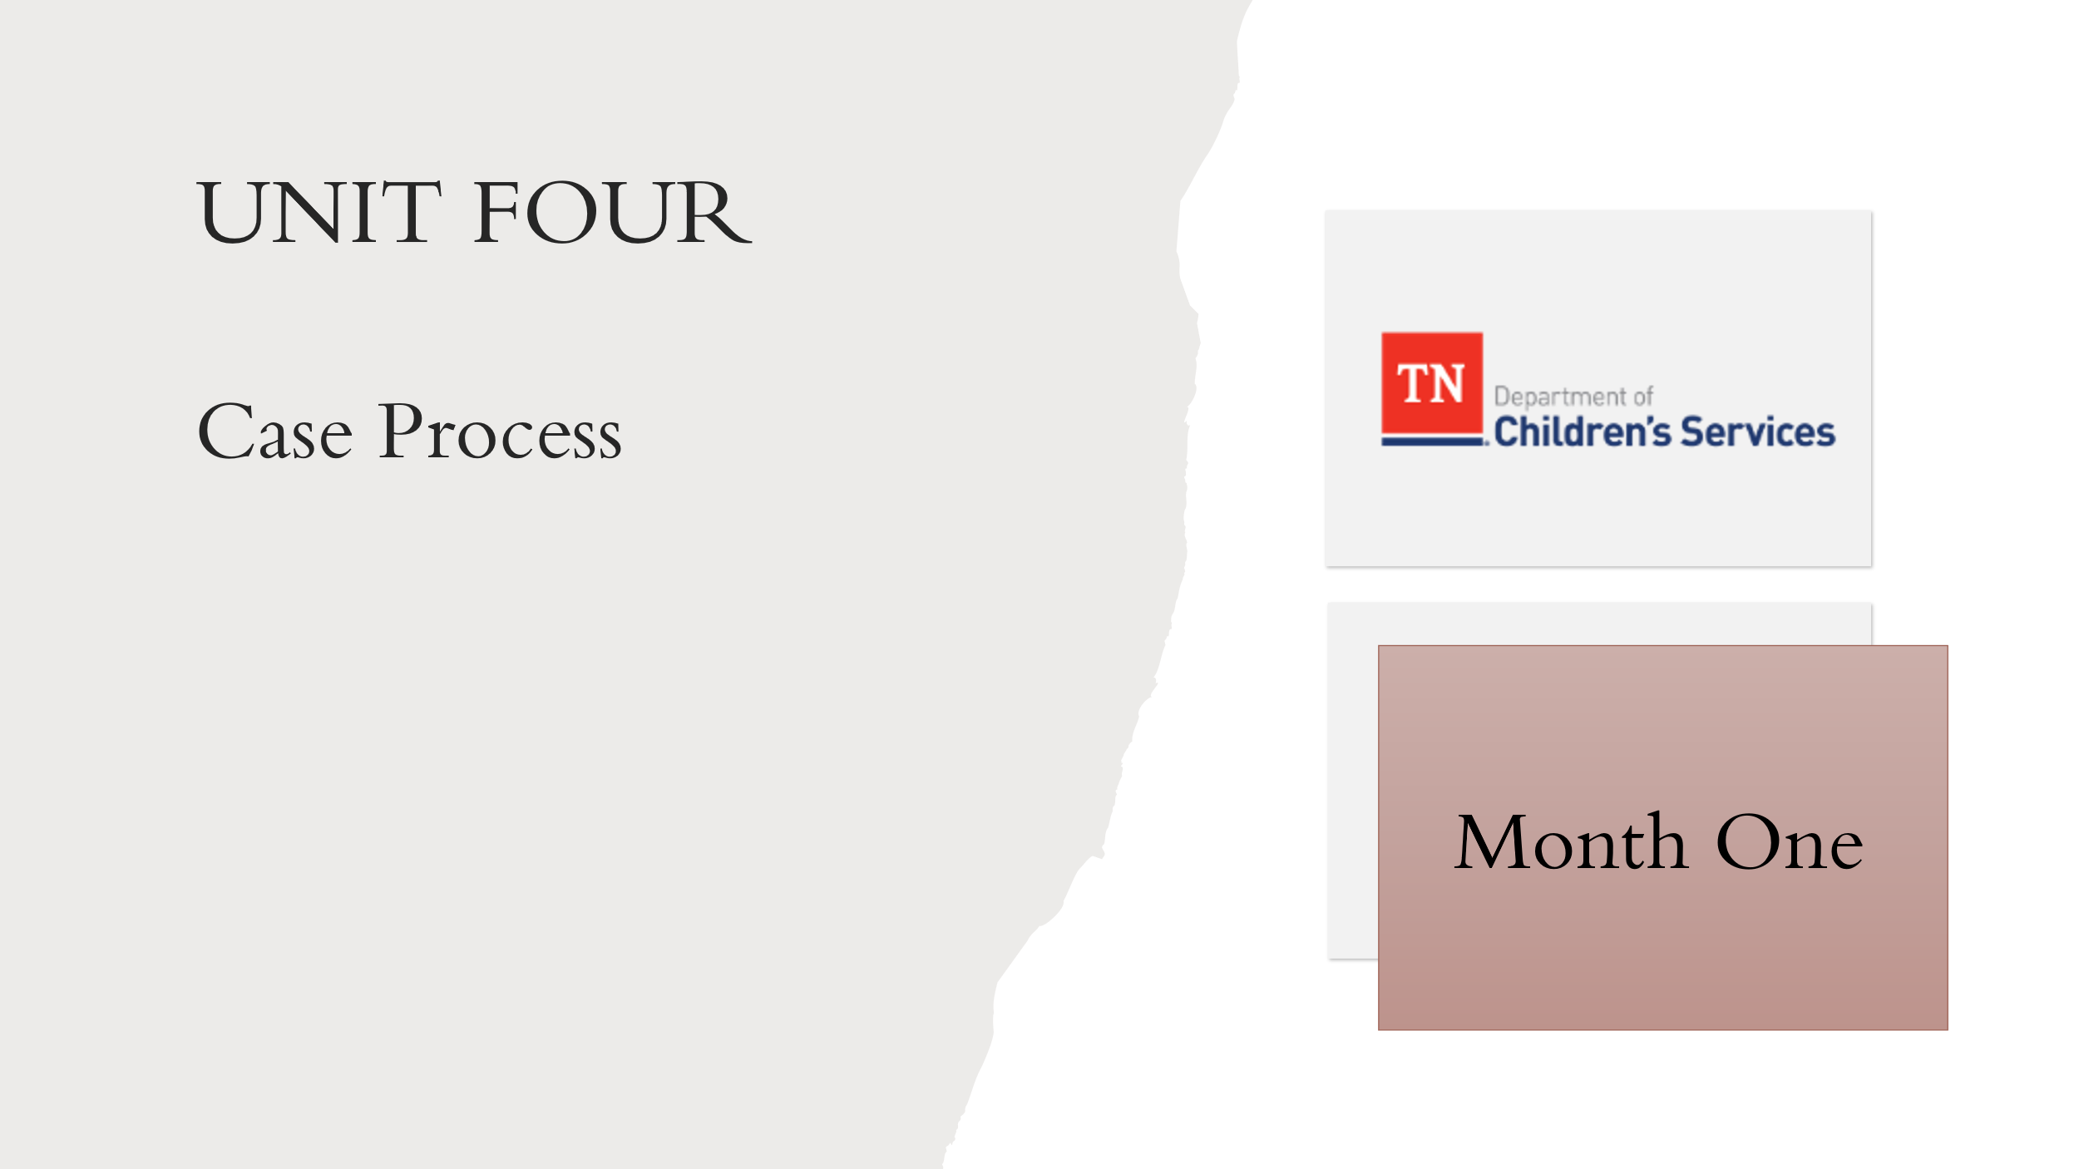
Supporting Materials:

  - Foster Care Specialty Week Two Facilitator Guide and PowerPoint
  - Case Calendar Timeline
  - Client Rights Handbook
  - Independent Living Handbook
  - Form CS-4221 Visitation Working Agreement
  - Child and Family Team Meeting Summary
  - Case Family Handouts Initial Interviews with Mrs. Steward, Travis, Michael, and Mr. and Mrs. Wilson
  - Form CS-4221 Visitation Working Agreement
  - Vyond Video: Steward Initial Child and Family Team Meeting
  - Form CS-0774 Genogram Contacts Sheets
  - Form CS-0782 Family Eco-Map
  - Steward Genogram and Ecomap
  - Work Aid: Child and Family Team Meeting Preparation Tool-How DCS Workers Can Help Prepare Families for the Meeting
  - Child and Family Team Meeting Flyer
  - What Youth Should Know about a CFTM Flyer
  - Child and Family Team Meeting Guide
  - CANS Protocol
  - Steward CANS Assessment Handout
  - Guide for Using CANS with Child, Caregivers, and their Families: A Tip Sheet
  - Steward Initial CANS Assessment
  - Permanency Plan Development Guide
  - Policy 16.51 Independent Living and Transition Planning
  - Life Skills Assessment – Casey Life Skills Assessment Travis and Michael
  - Form CS-0745 Criteria and Procedures for Termination of Parental Rights
  - Case Service Request Handout
- Policy 1.30: Interstate Compact on the Placement of Children
- Interstate Compact on the Placement of Children (ICPC) Practice and Procedure Manual.
  - ICPC Referral Packet

Lesson 4.1: Case Process-Month 1
Lesson Time: 15 minutes
Key Teaching Points / Instructions

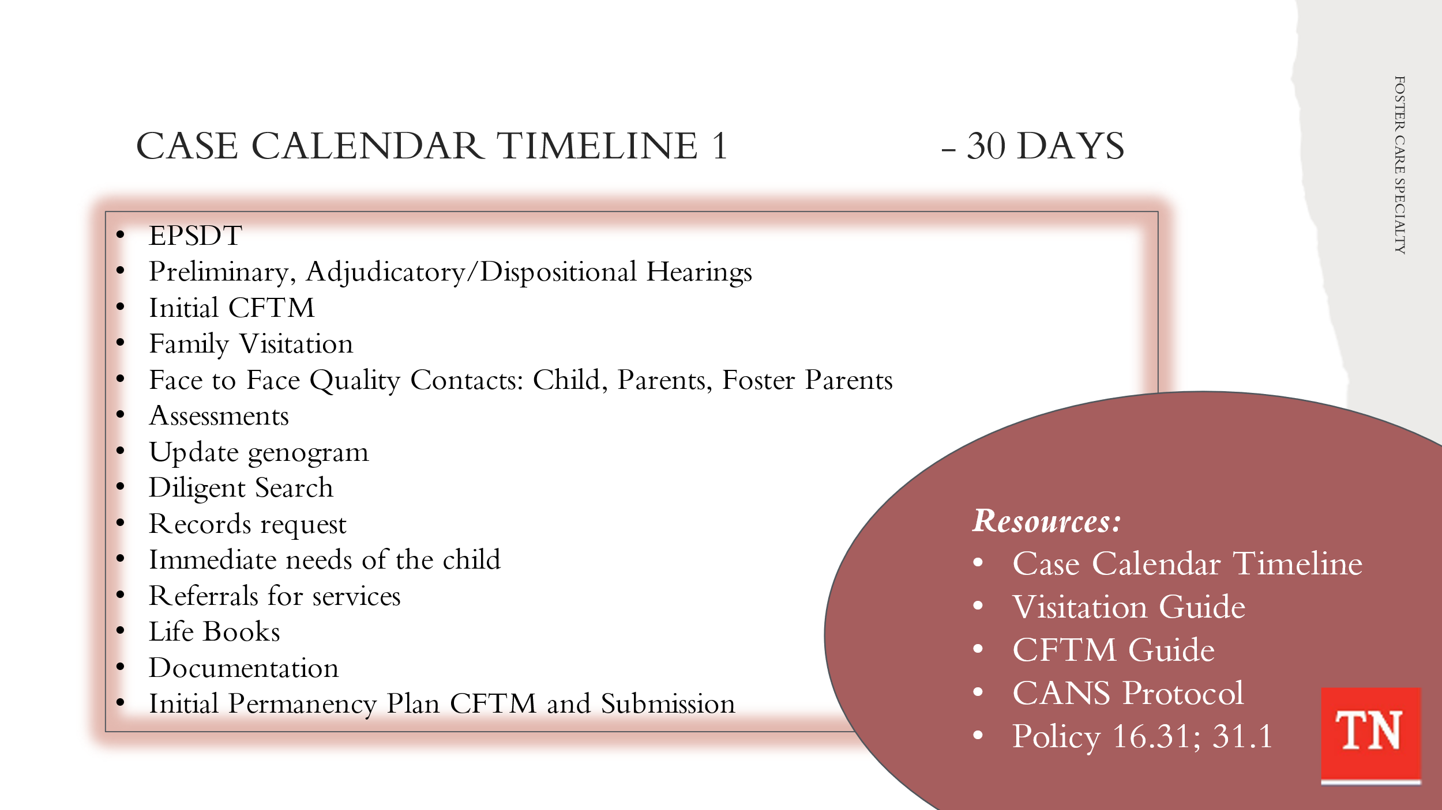
- STATE the tasks needing to be completed when receiving a case on their caseload within the first 30 days of custody is complex. TRAINER NOTE: EMPHASIZE the tasks not included in the previous Timeline: Steward Entry into Custody activity. UTILIZE Case Calendar Timeline and BRIEFLY REVIEW the tasks below. TRAINER NOTE: some tasks are applied to the Steward case and are addressed in the following lessons. Tasks for day 1-30 will include:
- EPSD&T (72 hours Health Screening or full physical to be completed/if only had Health Screening at 72 hours, then must have full physical by 30 days, EPSD&T Dental by 30 days
- Attend Preliminary Hearing by day 3/possible Adjudicatory and/or Dispositional Hearings by day 30 or when scheduled by Court
- Request Facilitator for Initial CFTM (if no pre-custodial CFTM)
- Follow up from Kinship Exception Request
- Schedule/hold Initial Custody CFTM by 7th calendar day (if no pre-custodial CFTM) (best practice is to have the Initial Custody CFTM before court hearing), send CFTM Notifications within 10 days (7 days if verbal) of meeting, develop Visitation schedule/Visitation Working Agreement during the meeting
- Schedule family visitation (if no court order) - Visitation between child and parent should occur weekly and last at least one (1) hour in duration. Opportunities for visits between children/youth and their family occur for at least four (4) hours per month.
- Sibling visitation - should visit with each other at least one (1) time per month.
- Visitation Guide – See Visitation Guide for specifics. Below is for placement in DCS foster home:
- Face to face Quality Contact - child/youth - (contact within 24 hours of custody by CPS, Court Liaison, or FSW) visit within 3 business days of custodial episode in the placement (two (2) visits per month during the first two (2) months; and one (1) visit monthly for ongoing contact; If the child/youth is in custody five (5) days or less in the calendar month, only one (1) face to face is required. First visit is in the foster home, half of the visits during the first two (2) months are in the foster home, and one (1) visit must occur in the foster home for ongoing contact.
- Face to face Quality Contact - parent - within two (2) weeks following a new placement for the child/youth, one (1) visit monthly for ongoing contact. Visits should occur in the family home quarterly.
- Face to face Quality Contact - foster parents - within 3 business days of placement and 1 x a month thereafter. The visit is in the foster home every month.
- Assessments
- Review FAST (if applicable to assist in completion of the CANS)
  - CANS – The FSW administers/initiates the initial CANS within the first seven (7) business days of custody. All CANS are reviewed by the TL and submitted to the COE Assessment Consultant within the first ten (10) business days of custody. The COE Assessment Consultant approves/finalizes the CANS within fifteen (15) business days of the child/youth entering custody and before Permanency Plan CFTM
- Life Skills Assessment – age 14 and older - within 14 days of custody and prior to Permanency Plan CFTM)
- Review Genogram and continue to update ongoing
- Conduct Diligent Search (immediately and ongoing quarterly) and send Diligent Search letters
- Educational Passport and School Notification Letter CS-0657
- Records Request:
- Criminal Background
- Birth/Social Security request
- Mental Health
- Medical
- Education
- Safe Measures History Pull
- Child Needs:
  - Clothing allotment- Complete clothing inventory and complete CSR (Case Service Request)
- TEIS referral if under 3 years old (TN Early Invention System)
- CHANT referral (Community Health Access and Navigation in TN)
- Day Care referral if needed
- Ensure Life Book begins at placement and review quarterly thereafter
- Monthly Documentation in TFACTS within 30 days. Face-to-face contacts are documented in case recordings in TFACTS within ten (10) business days.
- Schedule/hold Initial Permanency Plan CFTM within 30 days (go over Criteria for TPR and Equal Access), send CFTM Notifications, include Independent Living Plan for youth over 14 and Visitation Plan.
- Complete Notice of Action if child needs level 2, 3, or 4 placement, as determined by CFTM
- Enter Permanency Plan into TFACTS within 48 hours of CFTM
- Submit Permanency Plan to Regional Legal Counsel within 5 days of approval in TFACTS. It is then submitted by DCS to the Court and ratified within 60 calendar days.
- Schedule ratification hearing if no 30-day hearing scheduled
- Identify needed services and enter CSR (case service requests) (as applicable)
- Upload documents into TFACTS, on going

Lesson 4.2: Engagement
Lesson Time: 70 minutes
Key Teaching Points / Instructions

- TELL participants one of the most important case tasks after receiving a new custodial case is conducting the initial face to face contact with the child and parents. STATE this contact may be completed by CPS or the FSW; however, the FSW will conduct the initial visit with the child in the placement setting within 3 business days of any new placement.
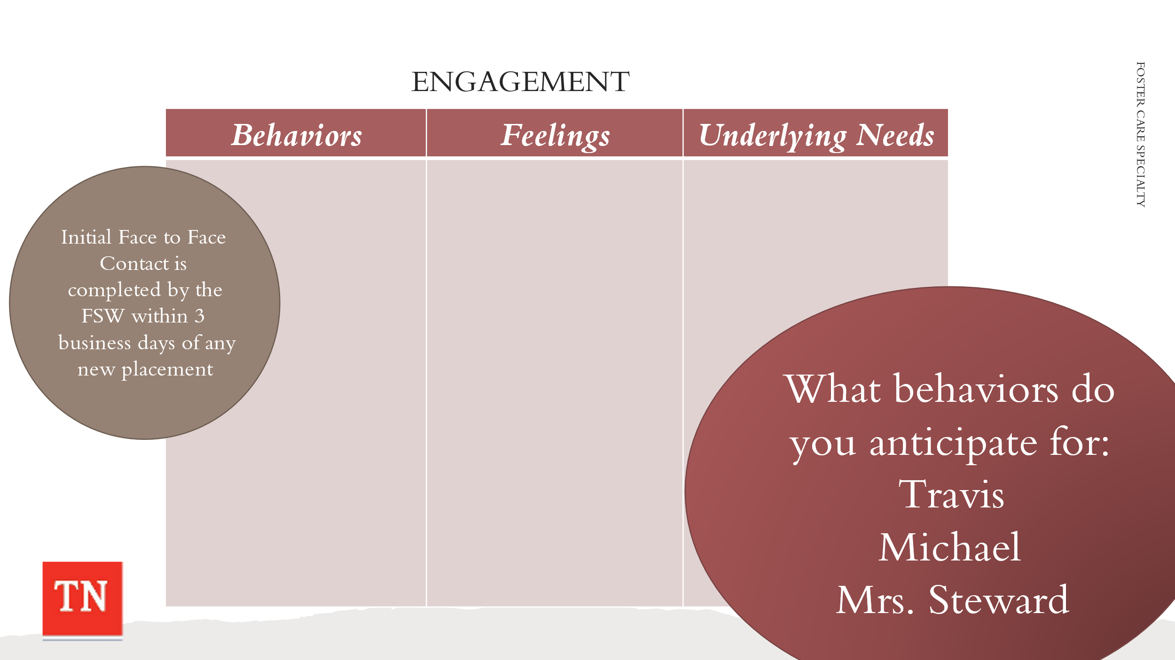
- CONDUCT ACTIVITY: Behaviors of Resistance
  - TRAINER divide the participants into three groups. Assign Michael, Travis, and Mrs. Steward to a group and have them draw three columns on flip chart paper: (Behavior, Feeling, and Underlying Needs).
  - ASK group 1 to brainstorm what behaviors would you anticipate Travis demonstrating under these circumstances? ASK participants to identify feelings which may be causing the behaviors we see. ASK participants to identify the underlying needs or what might be driving the behaviors and causing the feelings.
  - ASK group 2 to brainstorm what behaviors would you anticipate Michael demonstrating under these circumstances? ASK participants to identify feelings which may be causing the behaviors we see. ASK participants to identify the underlying needs or what might be driving the behaviors and causing the feelings.
  - ASK group 3 to brainstorm what behaviors would you anticipate Mrs. Steward demonstrating under these circumstances? ASK participants to identify feelings which may be causing the behaviors we see. ASK participants to identify the underlying needs or what might be driving the behaviors and causing the feelings.
- ALLOW 10 minutes for the group activity and ASK each group to report out on Michael, Travis, and Mrs. Steward.
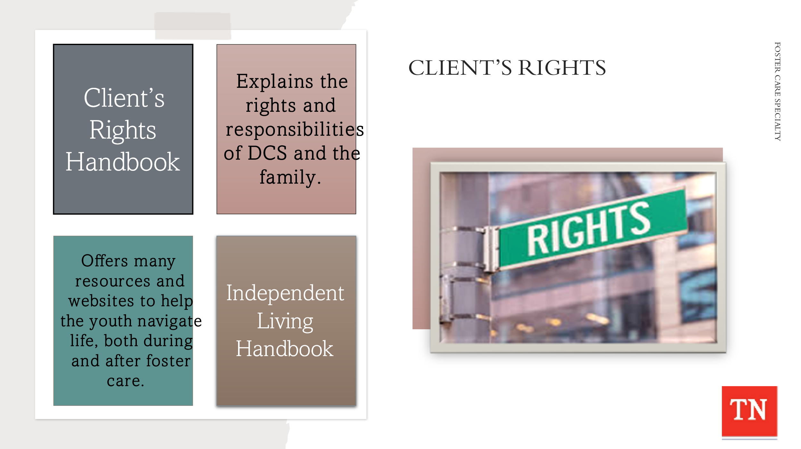
- DEBRIEF the activity and ensure participants understand the behaviors and feelings they may experience from families can be different for all family members. When hearing the family story, it is important to collect the family story from all family members to have a better understanding of their circumstances and underlying needs.
- EXPLAIN At removal, Mrs. Steward would have been explained and received a copy of the Client Rights Handbook: https://files.dcs.tn.gov/policies/chap31/ClientsRightsHandbook.pdf. This handbook explains the rights and responsibilities of DCS and the family. SHARE starting on Page 8 of the handbook it covers “if your child enters DCS state custody.” Additionally, Travis and Michael would have been explained and received a copy of the Independent Living Handbook: https://files.dcs.tn.gov/policies/chap16/ILHandbook.pdf. This handbook offers many resources and websites to help them navigate life, both during and after foster care.
- REMIND participants of interviewing skills needed to gather information including Motivational Interviewing and our Core Conditions of genuineness, empathy, and respect. Engagement is vital in obtaining the family story, teaming with the family, and to conduct a full global assessment.
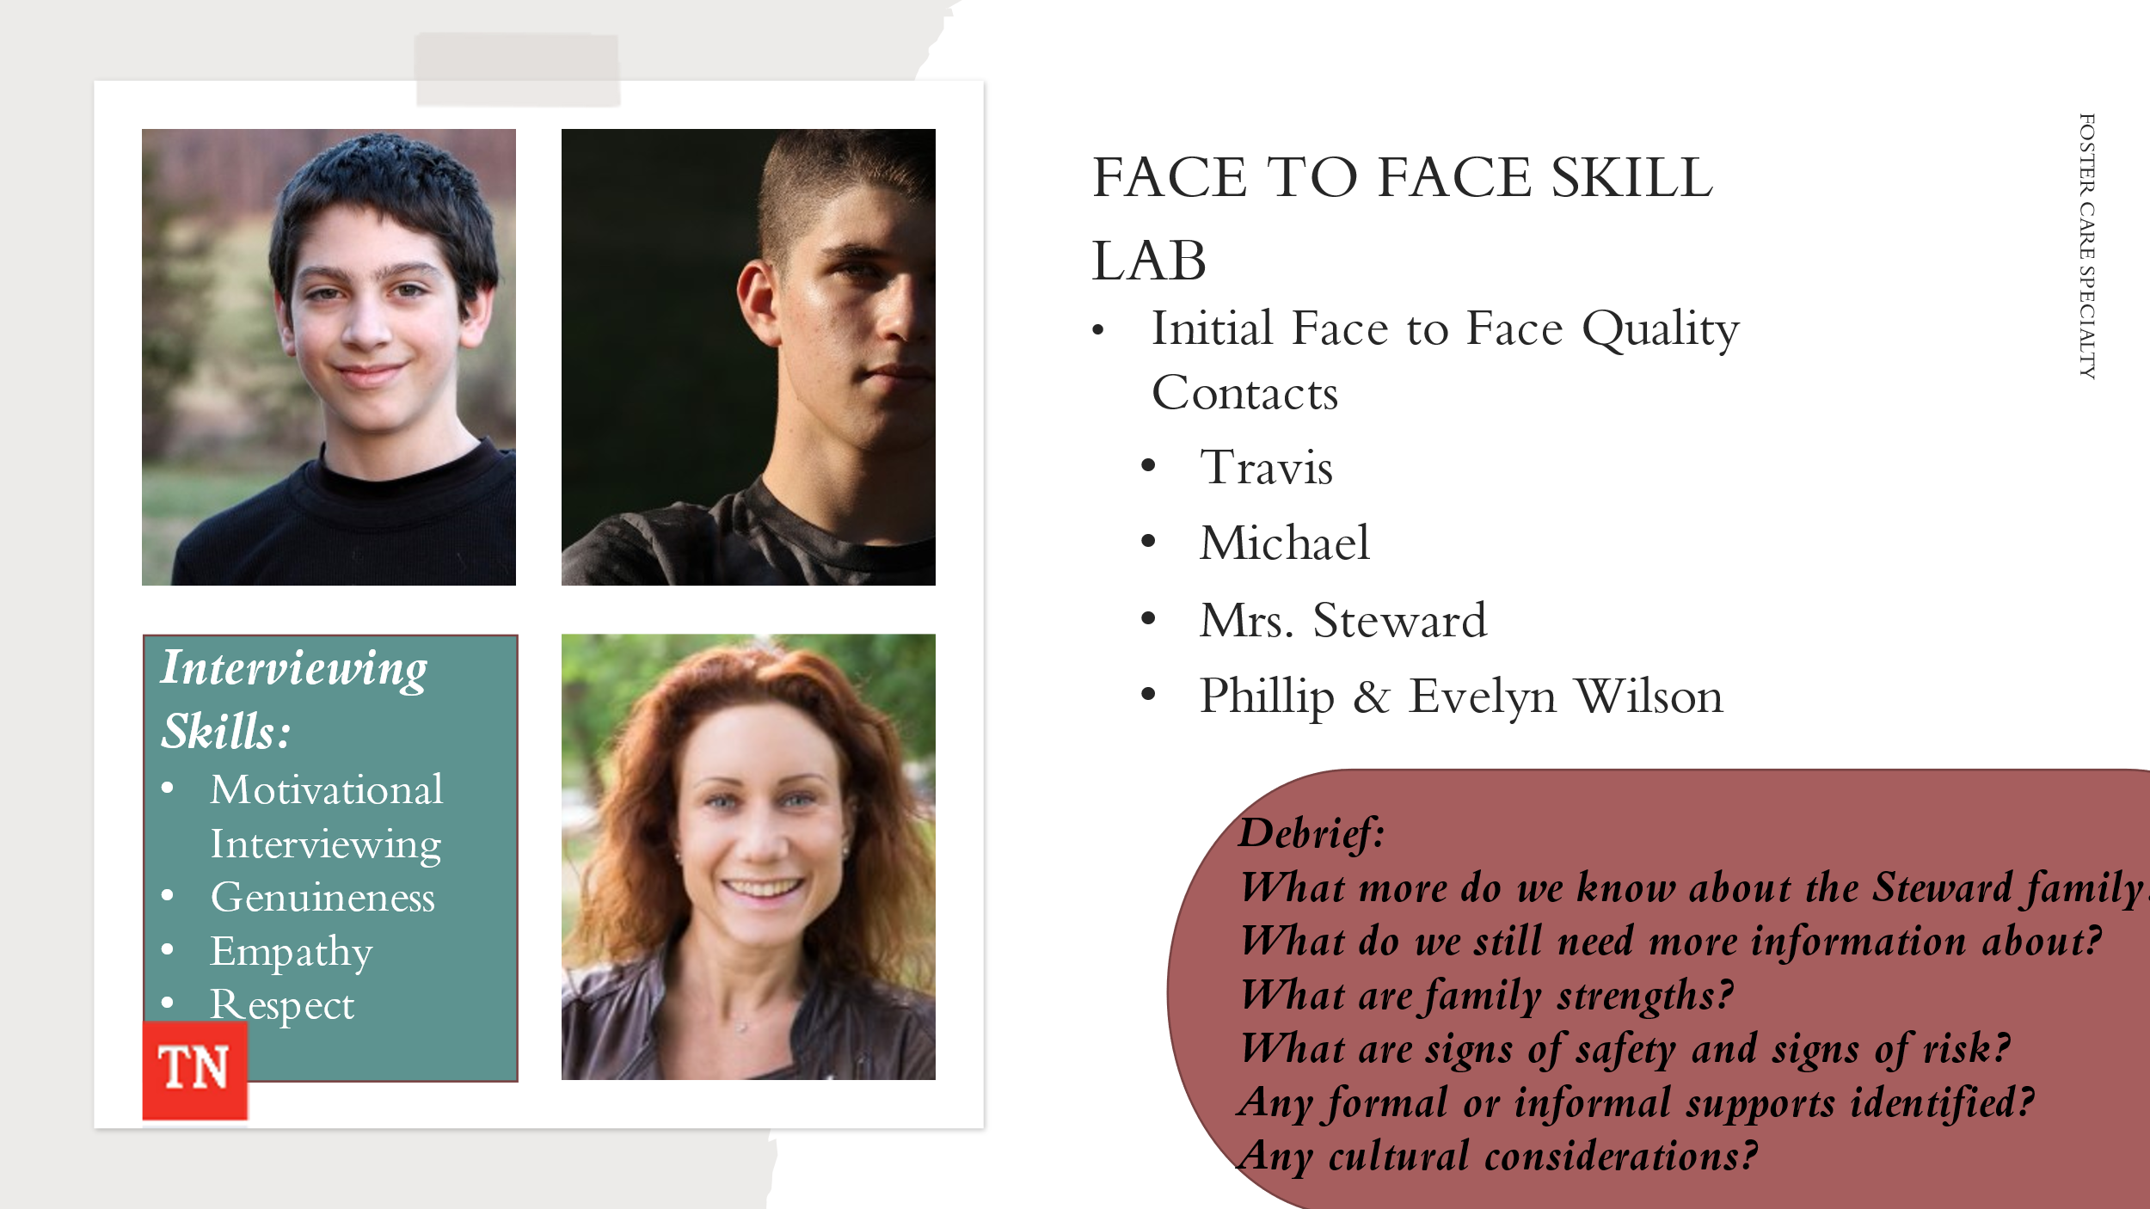
- CONDUCT ACTIVITY: Initial Face to Face Quality Contacts
  - Case Family Handout: Initial Face to Face with Travis or Michael (in placement)
- EXPLAIN Participants will break up into pairs and one participant will be the Case Manager and the other will be Travis or Michael. TRAINER: ensure both youth are interviewed amongst the groups.
- ONLY SUPPLY the participant who is Travis or Michael with additional case information/Case Family Handout: Interview with Travis or Interview with Michael.
  - CONDUCT INTERVIEW: The Case Manager will conduct an interview while attempting to assess the family situation while gathering strengths and needs/risks/concerns for the family.
- INSTRUCT Case Manager/Interviewer to take notes during the interview as these will be used later in the process.
- ALLOW 8 minutes for the interview. ENSURE feedback is given. SHOW next slide for format.
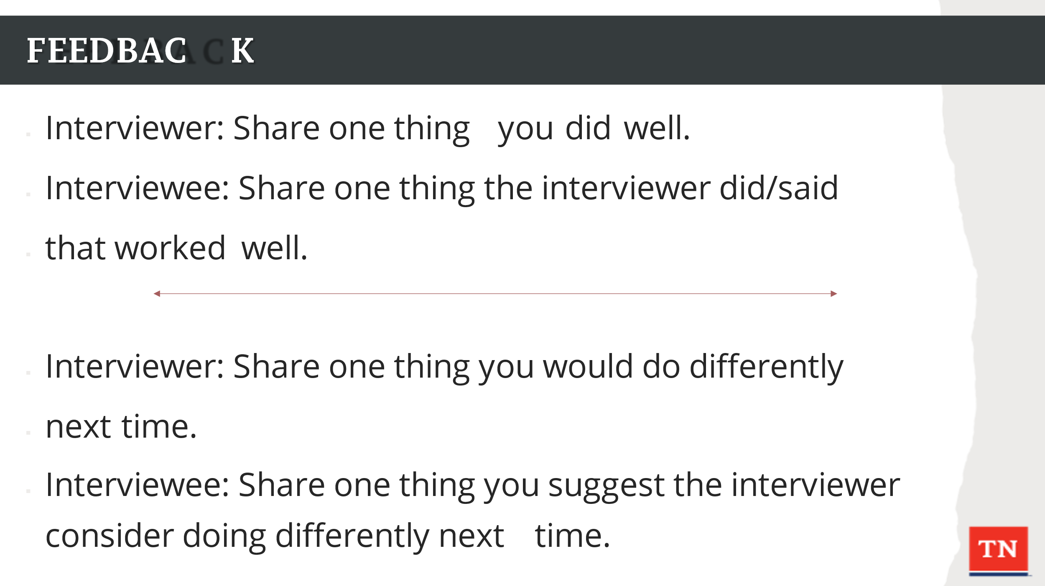
  - Provide feedback following the conclusion of the interview and before switching partners and starting the process over. Feedback should be given in the following format:
  - Interviewer: Share one thing you did well.
- Interviewee: Share one thing the interviewer did/said that worked well.
- Interviewer: Share one thing you would do differently next time.
- Interviewee: Share one thing you suggest the interviewer consider doing differently next time.
- ENSURE all participants at the end of the activity have a copy of the Steward Case Family Handouts Initial Interviews with Travis and Michael. ALLOW everyone time to read both interviews to ensure they have the most up to date information on the case and a full understanding of the current situation.
- DEBRIEF with the large group:
  - What more do we know about the Steward family? ADD these to Family Assessment Worksheet and flipchart.
  - What do we still need more information about? ADD these to the Family Assessment Worksheet and flipchart.
  - What are family strengths?
  - What are signs of safety and signs of risk?
  - Any formal or informal supports identified?
  - Any cultural considerations?
  - Emphasize we continue to cycle through the assessment process as we gather more and more information. Some analysis can take place, some initial conclusions may be drawn, and then more information is gathered, adjustments are made, and the process continues.
  - Case Family Handout: Initial Face to Face Quality Contact with Mrs. Steward or Phillip & Evelyn Wilson
- EXPLAIN Participants will swap roles and one participant will be the Case Manager and the other will be Mrs. Steward or Phillip & Evelyn Wilson. TRAINER: ensure at least one group choses to interview Phillip & Evelyn Wilson.
- ONLY SUPPLY the participant who is Mrs. Steward or Phillip & Evelyn Wilson with additional case information/Case Family Handout: Interview with Mrs. Steward or Interview with Phillip & Evelyn Wilson.
  - CONDUCT INTERVIEW: The Case Manager will conduct an interview while attempting to gather information on Travis and Michael’s safety and needs/risks/concerns for the family.
- INSTRUCT Case Manager/Interviewer to take notes during the interview as these will be used later in the process.
- ALLOW 8 minutes for the interview. ENSURE feedback is given. SHOW next slide for format.
  - Provide feedback following the conclusion of the interview and before switching partners and starting the process over. Feedback should be given in the following format:
- Interviewer: Share one thing you did well.
- Interviewee: Share one thing the interviewer did/said that worked well.
- Interviewer: Share one thing you would do differently next time.
- Interviewee: Share one thing you suggest the interviewer consider doing differently next time.
- ENSURE all participants at the end of the activity have a copy of the Steward Case Family Handouts Initial Interviews with Mrs. Steward and Phillip & Evelyn Wilson. ALLOW everyone time to read both interviews to ensure they have the most up to date information on the case and a full understanding of the current situation.
- DEBRIEF with the large group:
  - What more do we know about the Steward family? ADD these to Family Assessment Worksheet and the flipchart.
  - What do we still need more information about? ADD these to the Family Assessment Worksheet and flipchart.
  - What are family strengths?
  - What are signs of safety and signs of risk?
  - Any informal or formal supports identified?
  - Any cultural considerations?
  - Emphasize we continue to cycle through the assessment process as we gather more and more information. Some analysis can take place, some initial conclusions may be drawn, and then more information is gathered, adjustments are made, and the process continues.
  - REMIND participants of the Visitation Guide and the required face-to-face contacts for children/youth, parents, and foster parents following placement into custody. QUIZ participants on when these contacts must occur.

Lesson 4.3: Teaming
Lesson Time: 90 minutes
Key Teaching Points / Instructions

- REMIND within DCS we use teams to make decisions and develop plans with families. We use teams to get our work done. We are inclusive rather than exclusive. We value and respect the voice of all involved. Teaming also helps in fostering accountability for tasks and outcomes. In this, a balance between individual and shared responsibility for outcomes can be assumed. Teaming with families can be informal or formal. The formal avenue is teaming within the context of a Child and Family Team Meeting.
- INFORM participants DCS assists all children/youth and families in careful searches for known and unknown parents, maternal and paternal grandparents, and any other adult relatives/significant kin who may provide support to both the child and family.
- STATE it is imperative to conduct diligent search efforts on an on-going basis. The FSW will complete the initial diligent search within the first 30 calendar days of the custodial episode. The FSW has the responsibility of notifying all identified relatives/kin from the initial diligent search. STRESS diligent searches are then completed within ninety (90) calendar days of the last search and continue throughout the life of the case.
- BRAINSTORM with participants who additionally would be on the Genogram and Ecomap for the Steward/Collins family if not already presented by the group:
  - Genogram - Travis, Michael, Andrew Newel, Marilyn Steward, Jacob Steward, Richard Collins, Paula Collins, Phillip Wilson, Evelyn Wilson, Grace Wilson, Matt Newel, Maria Collins, Juan Collins, etc.
  - Ecomap - Marilyn Steward, Jacob Steward, Travis, and Michael are in the center. They may have a circle for maternal Grandparents, paternal Grandparents, Father and Stepmother, Pastor Tim Greg, School Personnel Sarah Lane, DCS, Neighbors, Extended Family, Friends, CCFT provider Courtney Shores, Counselor/Therapist, etc.
- ASK participants are there any persons we need to complete a Diligent Search for currently on the Steward/Collins case. ANSWER: Paternal Grandparents.
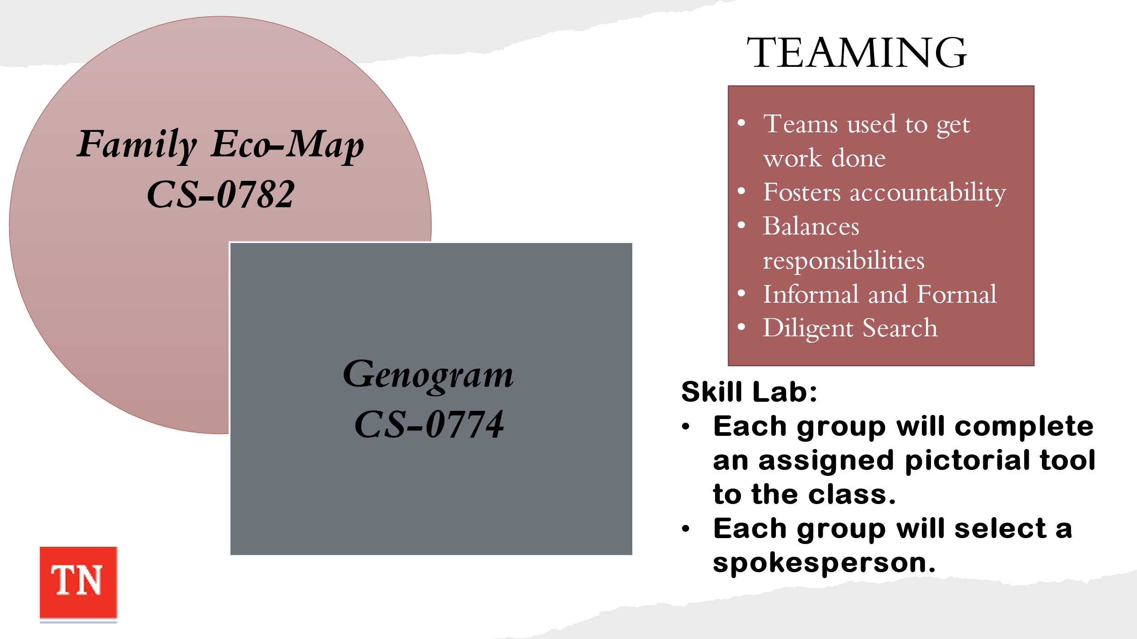
- CONDUCT ACTIVITY: Steward Genogram and Eco-map Drawing
- DIVIDE the class into two (or more) small groups. EXPLAIN one group will complete a Genogram (CS-0774) and the other group will create a Family Eco-Map (CS-0782) drawing of the Steward family on flip chart.
- HAVE participants review the Genogram Contacts Sheets CS-0774 from the Intake packet on the Steward case from their case file. STATE interviews to assess informal and formal supports would have been conducted by CPS at removal.
- INSTRUCT the group members to elect a spokesperson to present their pictorial to the rest of the class. ALLOW 10 minutes for work. ASK each group to present their pictorial tool.
- REMIND participants the Genogram and Ecomap are to ALWAYS be completed with the family. REMIND the participants these pictorials should be updated whenever new information becomes available, but they should be created early in the case process. EXPLAIN bringing these documents to Child and Family Team Meetings is important.
- INFORM participants once we have helped the family identify who will be on the team, we will then prepare them for what being part of the team entails.
- EXPLAIN preparation is the key to a successful CFTM. Preparation lays the foundation for a quality CFTM where each member of the team is able to have a voice to share their story. ASK participants:
- Why is it important to prepare the team for the meeting?
- What are the consequences when the team is not prepared?
- REMIND participants of the Work Aid: Child and Family Team Meeting Preparation Tool-How DCS Workers Can Help Prepare Families for the Meeting, the Child and Family Team Meeting Flyer and What Youth Should Know about a CFTM Flyer. INFORM participants these flyers can be helpful in explaining the CFTM process to families.
- SHARE previously in class, participants were asked to write a script and to practice having these discussions prior to having the conversations with families. It is crucial that families understand the importance of teaming and confidence in the CFTM process. The more prepared you are to have the conversation the more trust there will be in the process.
- CONDUCT ACTIVITY: CFTM Preparation Conversations
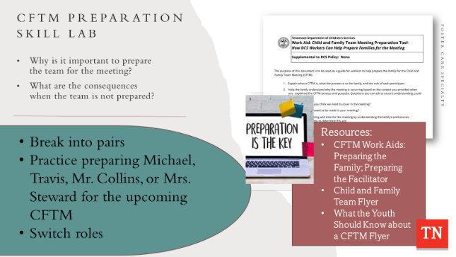
  - ASK participants to use the Work Aid: Child and Family Team Meeting Preparation Tool-How DCS Workers Can Help Prepare Families for the Meeting and have them prepare to have a prep conversation with a family member.
  - ALLOW 5 minutes for participants to gather their thoughts and prepare for the conversation.
  - After the allotted time, INSTRUCT Participants to break up into pairs and one participant will be the Case Manager and the other will be Mrs. Steward, Mr. Collins, Travis, or Michael. ALLOW 7 minutes for the prep conversation.
  - HAVE Participants swap roles and the other participant will be the Case Manager and the other will be Mrs. Steward, Mr. Collins, Travis, or Michael. ALLOW 7 minutes for the prep conversation.
  - DEBRIEF and ASK if there are any questions after the activity.
- STATE Foster Care Case Managers will be facilitating their own Child and Family Team Meetings except Initial Custody CFTM’s and Unplanned Placement Stability CFTM’s.
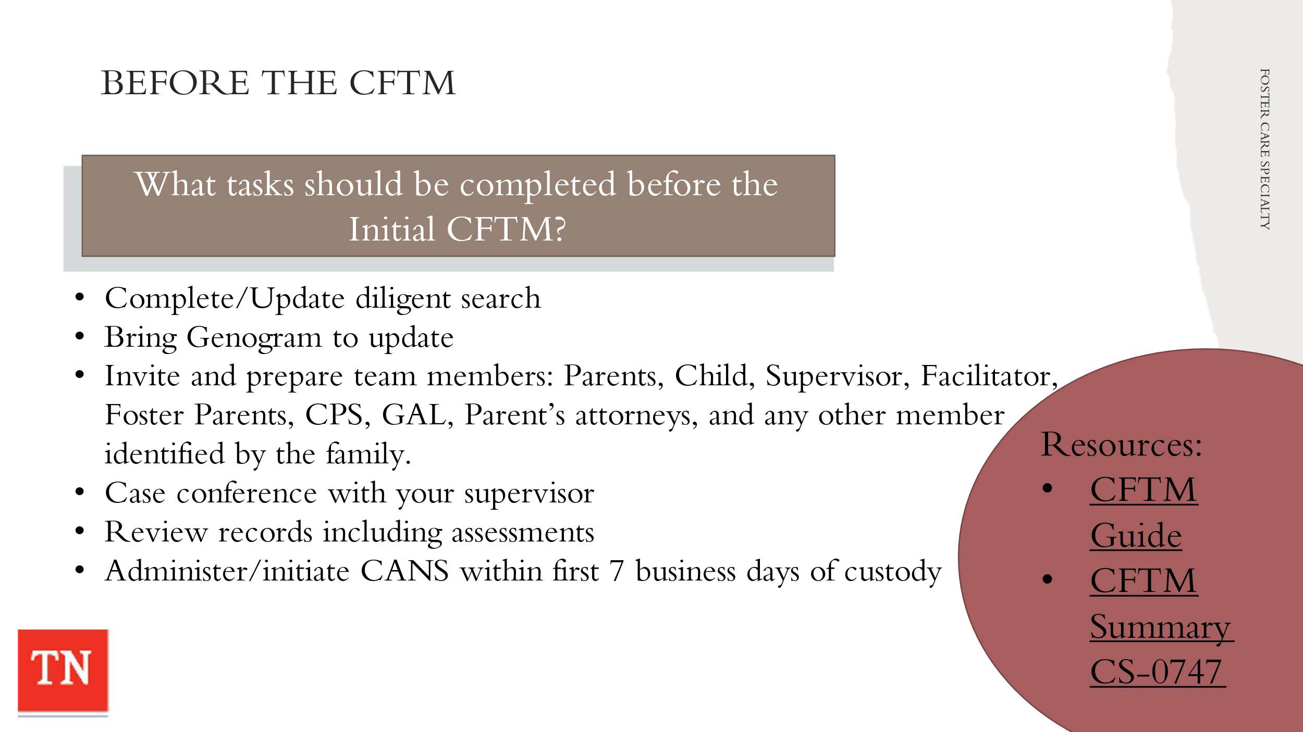
- ENGAGE participants in a discussion of the FSW tasks to be completed before the initial CFTM. Answers may include:
  - Complete diligent search if needed
  - Bring complete genogram
  - Invite parents, TL, Facilitator, CPS, foster parents, GAL, parents’ attorneys, and any other parties
  - Find a location that is comfortable for the family, but large enough for the team
  - Case conference with your supervisor
  - Brief case with Facilitator if needed
  - Review records
  - Administers/initiates CANS within the first 7 business days of custody
  - Child and Family Team Meeting Summary (Form 0747 under Forms and Documents)
- SHARE the Initial Custody CFTM must be held within 7 calendar days of the child(ren) entering custody. REFER participants to the Initial Custody CFTM on page 35 in the Child and Family Team Guide.
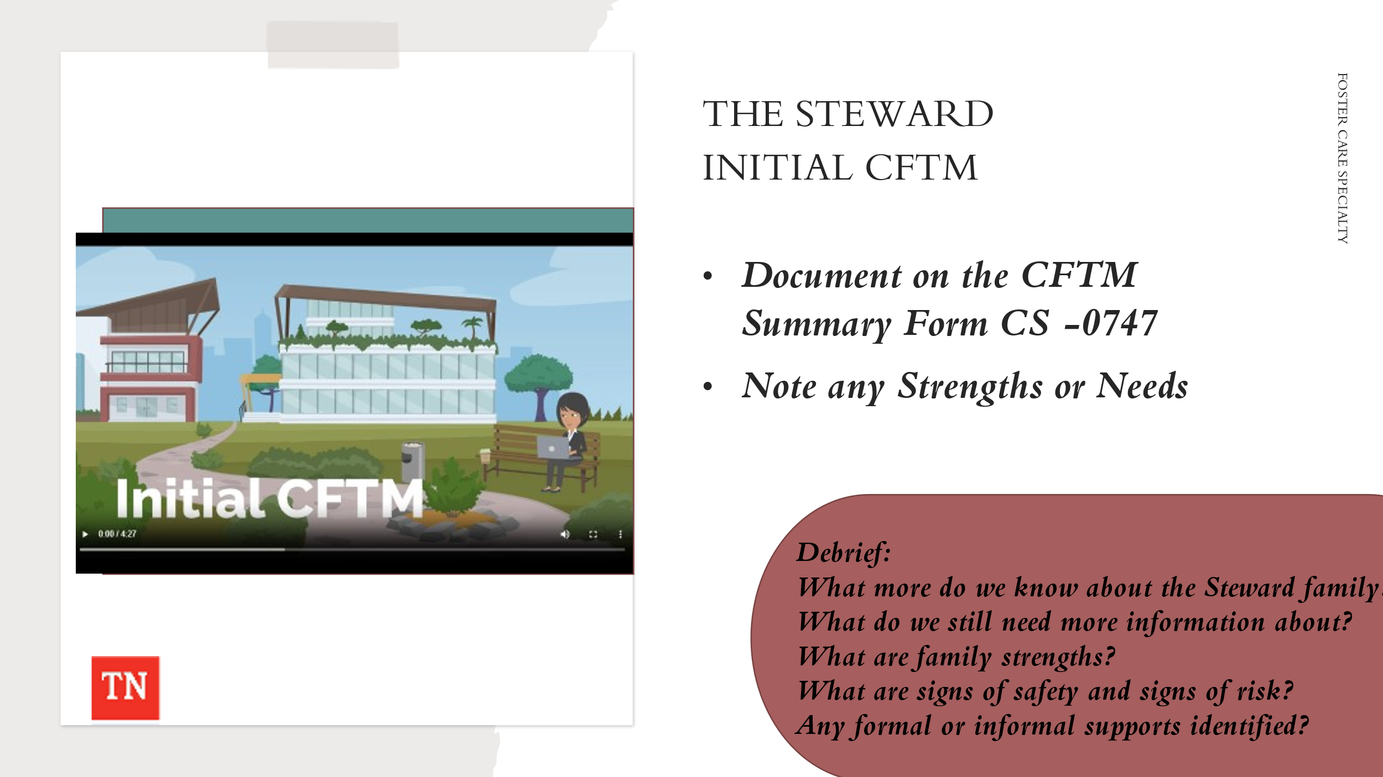
- ACTIVITY: SHOW Vyond video of the Steward Family Initial Custody Child and Family Team Meeting. Time: 4.30.
- DEBRIEF information gained from the meeting.
- UPDATE Family Assessment Worksheet and flipcharts.
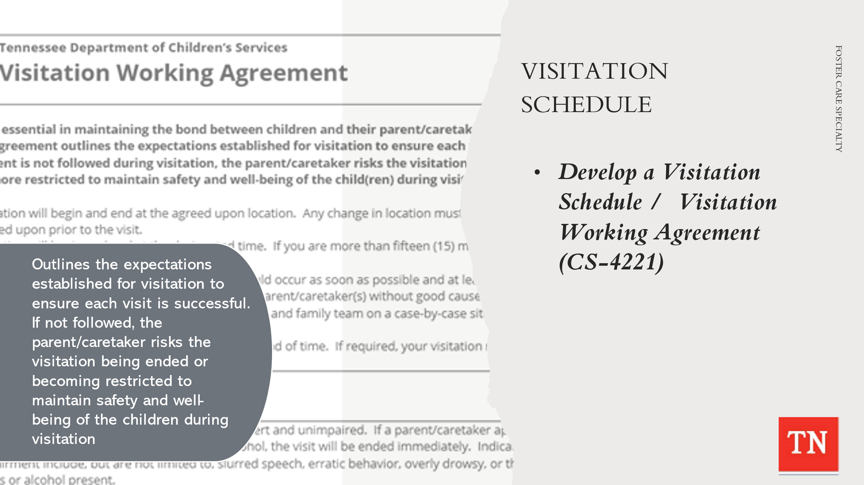
- STATE Visitation is essential in maintaining the bond between children and their parent/caretakers while in foster care and a visitation schedule must be included in the Initial Custody CFTM.
- CONDUCT ACTIVITY: Steward/Collins Visitation Schedule
  - Divide the group into 3-5 participants and ASK participants to complete a visitation schedule for the Steward/Collins including: be specific about date, time, location, and who will supervise as well as visitation activities.
  - REMIND participants the schedule is always developed with the family and team during the Initial Custody CFTM.
  - Give the group 10 minutes to develop the schedule.
- DEBRIEF activity by having the groups to share their plans. ASK if there are any questions about the plans that were developed.
- EXPLAIN participants will develop the visitation schedule with the team and will discuss and complete a Visitation Working Agreement with the parents during the Initial Custody Child and Family Team Meeting.
- REFER participants to Form CS-4221 Visitation Working Agreement. STATE This agreement outlines the expectations established for visitation to ensure each visit is successful. If the agreement is not followed during visitation, the parent/caretaker risks the visitation being ended, or becoming more restricted to maintain safety and well-being of the child(ren) during visitation.
- STRESS the visitation schedule developed during the Initial CFTM may be modified/updated and then becomes a part of the Permanency Plan at the Initial Permanency Plan CFTM by day 30.
- SHARE the Steward Family Child and Family Team Meeting Summary from the Initial Custody Child and Family Team Meeting with the participants. ALLOW time for participants to read the summary. ASK if there are any questions.

Lesson 4.4: Global Assessment
Lesson Time: 45 minutes
Key Teaching Points / Instructions

- BEGIN the lesson with a discussion about assessment integration and how we use all information gathered to inform on-going case planning.
- REMIND participants the CANS (Child Adolescent Needs and Strengths) intervention is used to assess the strengths and needs of the child and family.
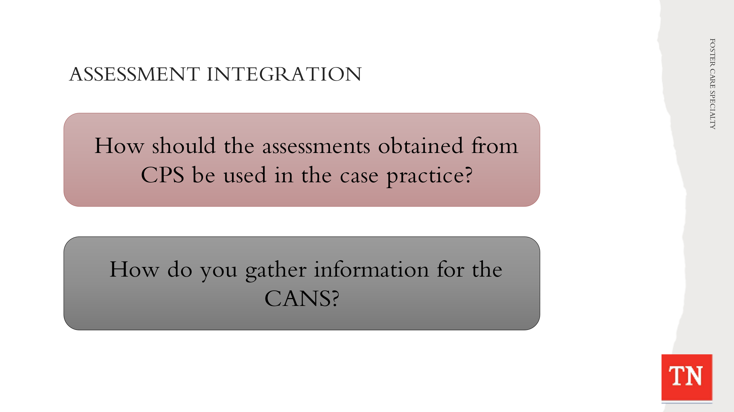
- ASK participants how they should use assessments they obtain from CPS into their case practice. This includes the FAST (Family Advocacy Support Tool) and any other formal assessments completed during the CPS case.
- ASK participants how they gather information for the CANS. Gathering this information may take place by:
  - Interviews
  - Observations
  - Records checks
  - Collateral reports
  - Evaluations
  - Pictorial tools (i.e., genogram, timeline, family map)
  - Other DCS assessment tools
- DISCUSS the importance of gathering family information from multiple sources. ASK participants what records they would want to collect in order to assess the family situation and prior to developing a plan with the family. SHARE Health Confirmations for Travis and Michael for an EPSD&T Physical and an EPSD&T dental (only 1 example for each), Stone Bridge Psychiatric Hospital Patient Safety Plan record prior to custody, Cedar Grove Assessment Report on Travis, and the Child Safety Plan Form CS-1044 for Travis once placed at residential facility.
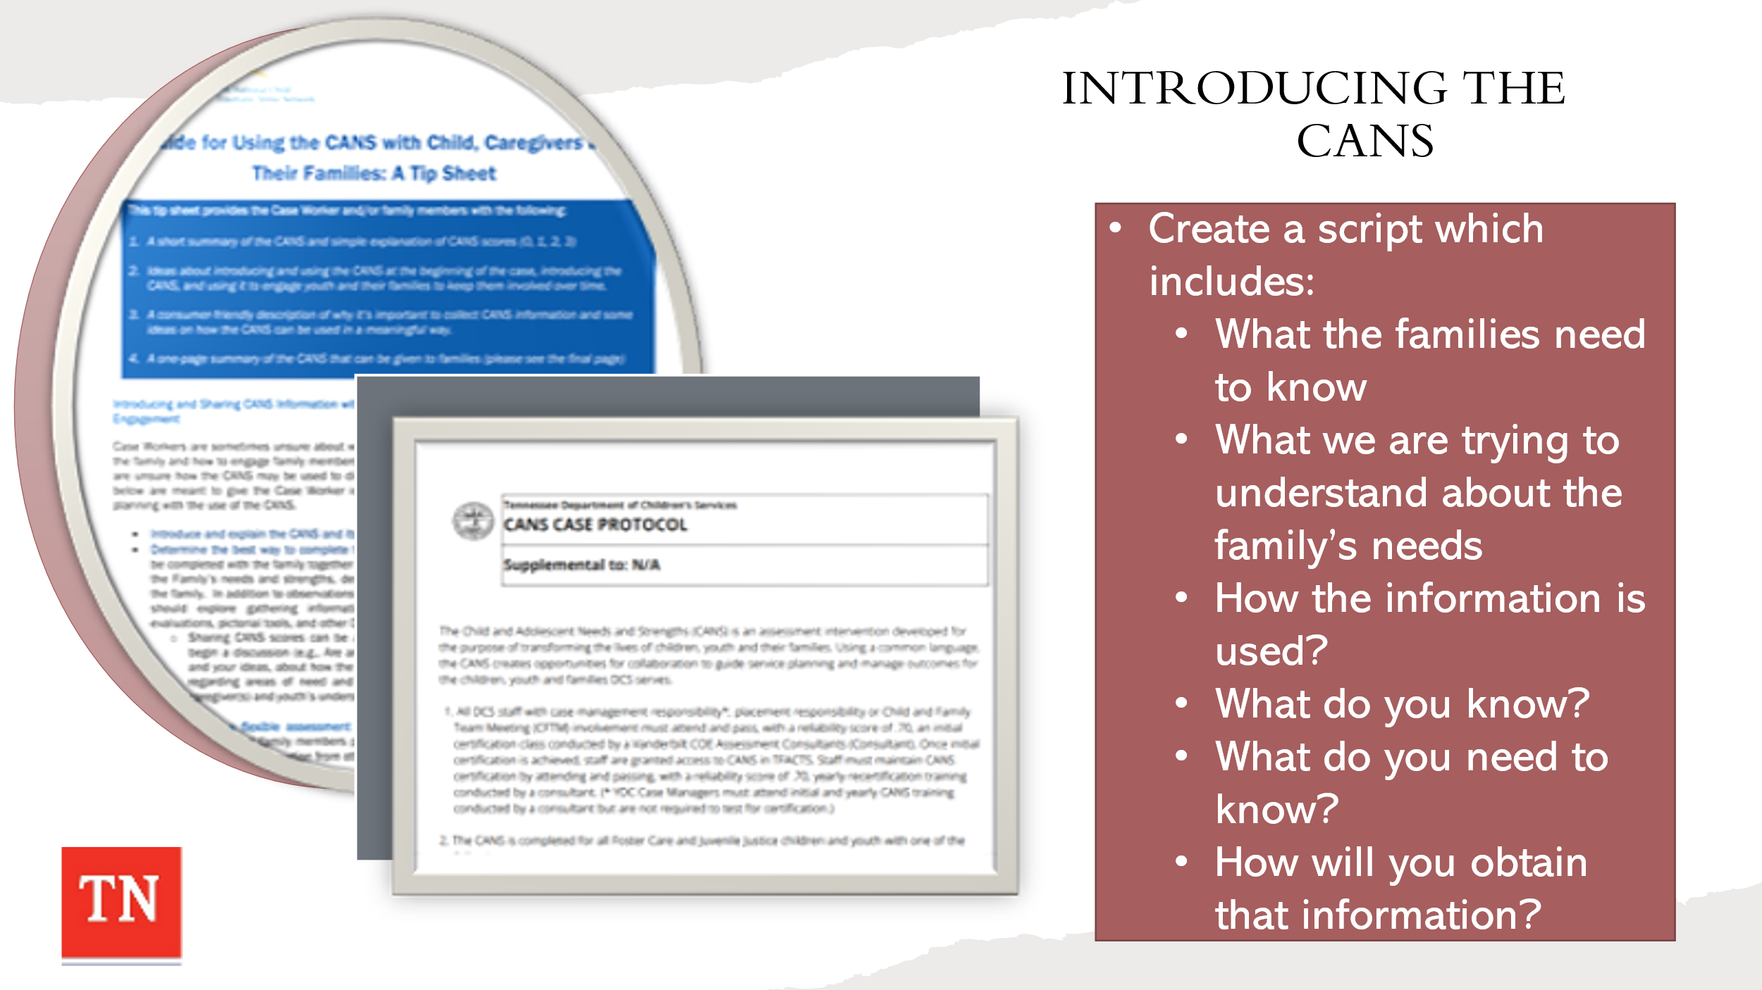
- CONDUCT ACTIVITY: Introducing the CANS to the Steward Family
  - REFER participants to the Guide for Using CANS with Child, Caregivers, and their Families: A Tip Sheet in Google Classroom.
  - INFORM the group they will have a conversation with the family about the CANS and how it is used to inform the case plan. The script should include:
    - It will communicate what families need to know.
    - What we are trying to understand about family’s needs?
    - How the information is used?
    - What do you know?
    - What do you need to know?
    - How will you obtain that information?
  - SHARE it is important to have a script and to practice having these discussions prior to having the conversations with families. It is crucial that families understand the importance of the CANS and how it is used throughout the case process. The more prepared you are to have the conversation with the family the more trust there will be in the assessment process.
  - INSTRUCT participants to take 5-7 minutes to draft a script of how they would introduce the CANS to the Steward family. DEBRIEF by asking participants to share any questions. ASK for volunteers to share the script. THANK participants who volunteer.
- REMIND the CANS is initiated on all children/youth (ages 5 and above) when entering custody. According to the CANS Protocol, the FSW initiates the CANS within the first 7 business days of custody and submits it to the Assessment Consultant within the first 10 business days of custody. It is finalized by the COE Assessment Consultant within 15 business days of the child/youth entering custody.
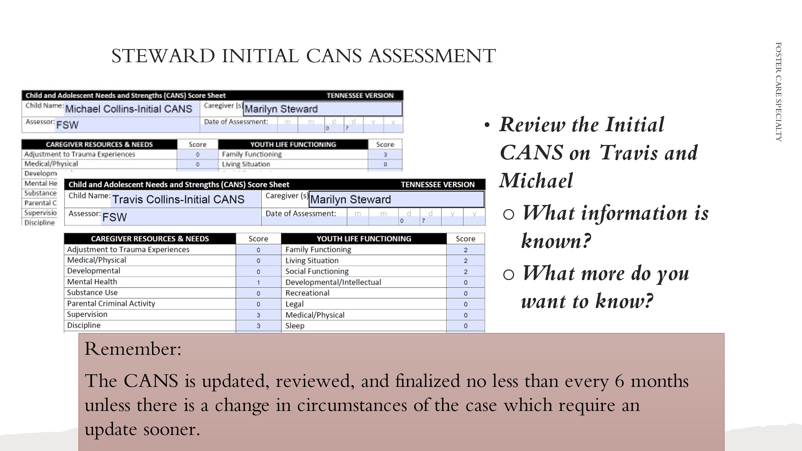
- CONDUCT ACTIVITY: Steward Initial CANS Assessment Review
- SUPPLY participants with the Steward Initial CANS Assessment completed by the Center of Excellence CANS Consultants.
- ALLOW 10-15 minutes for participants to review the Initial CANS assessment completed on Travis and Michael. REQUEST they assess what information is known (from information gathered thus far from CPS and initial contacts) and/or what more would they want to know. Trainer: We will NOT be focusing on the scoring at this time.
- RECONVENE the group and DEBRIEF with participants by asking the following questions:
- What information did you learn about the family?
- What follow-up questions would you have for the family?
- How will you use this information to help you plan?
- How will you prepare the assessment to present to the family’s team?
- INFORM the group the CANS is an ongoing process. There are specific times we complete a CANS reassessment throughout the life of the case. REMIND the group of the CANS Case Protocol shared during CANS training in Pre-service week 8. Link: https://files.dcs.tn.gov/policies/chap31/CANSProtocol.pdf
- SHARE the CANS is updated, reviewed, and finalized no less than every six (6) months for all CANS eligible children and youth unless there are changes in the circumstances of the case which require an update sooner.
- ADDITIONALLY, The Toddler and Infant Needs and Strengths (TINS) is a specialized assessment developed to lay the foundation for individualized services of children ages zero (0) through four (4). The TINS creates opportunities for collaboration to guide service planning and manage outcomes for infants and toddlers in a Safe Baby Court (SBC). REFER to the Protocol for Completions of the Toddler and Infant Needs and Strengths (TINS) in Safe Baby Court Cases.
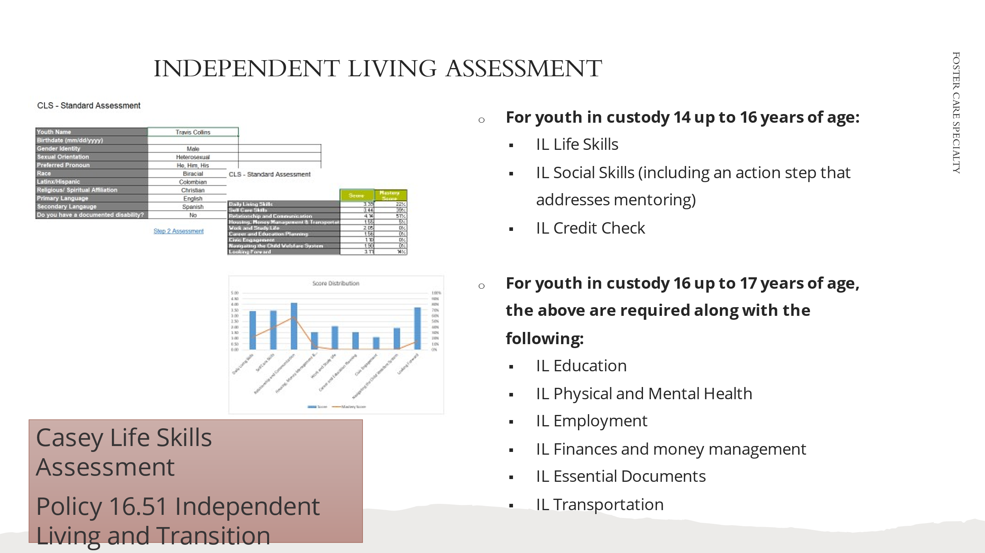
- REFER to Policy 16.51 Independent Living and Transition Planning. STRESS to participants the Life Skills Assessment must be completed for any youth age 14 and older. Currently, the Casey Life Skills Assessment can still be used but it has to be scored manually as they took down the assessment on the website. REFER participants to the Casey Life Skills Assessment handout that can be used to focus on helping youth attain life skills needed for a successful transition to adulthood.
- EXPLAIN when we present the Life Skills Assessment to the youth it is important to inform the youth of why they are completing this assessment with you.
- SHARE Life Skills Assessment and results sheet for Travis and Michael. HIGHLIGHT key areas of the life skills assessment and ALLOW time for participants to review the results.
- EXPLAIN the youth’s Independent Living section is developed based on these results during the permanency planning portion of the CFTM.
- REMIND participants the core IL strength and need categories required to complete an Independent Living Plan are as follows. Additional categories may be used in addition to those that are mandatory per age group.
- For youth in custody 14 up to 16 years of age:
- IL Life Skills
- IL Social Skills (including an action step that addresses mentoring)
- IL Credit Check
- For youth in custody 16 up to 17 years of age, the above are required along with the following:
- IL Education
- IL Physical and Mental Health
- IL Employment
- IL Finances and money management
- IL Essential Documents
- IL Transportation
- ASK participants what areas of growth would require attention in helping to enhance Travis and Michael’s independent living skills.
- REMIND participants the youth will complete a Life Skills Assessment annually to allow us to assess their progress toward developing independent living skills.

Lesson 4.5: Planning
Lesson Time: 90 minutes
Key Teaching Points / Instructions

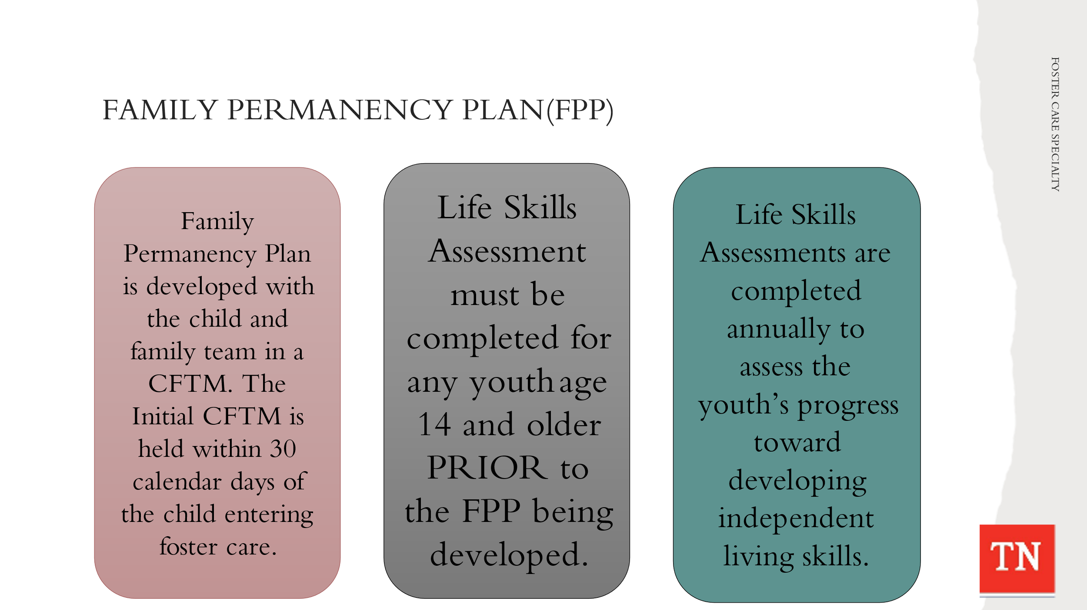
- EXPLAIN the Family Permanency Plan is developed in collaboration with the child and family team in the context of the Initial Permanency Planning CFTM. REMIND the Initial Permanency Planning Child and Family Team Meeting is held within thirty (30) calendar days of the child/youth’s placement in custody.
- STATE Family Permanency Plans (FPP) are working documents that include the entire family in addition to addressing the specific needs or behaviors of one or more individuals within the family, including community safety. Children/ youth within the Family Permanency Plan may have different permanency goals and action steps based upon their specific needs.
- STRESS to participants the Life Skills Assessment must be completed for any youth age 14 and older PRIOR to the permanency plan being developed. DISCUSS the youth’s Independent Living section in the permanency plan is developed based on the LSA results either at the Initial Permanency Plan CFTM or the Permanency Plan Revision CFTM.
- STATE if a youth turns 14 after the Initial Permanency Plan is developed, a Life Skills Assessment will be completed and incorporated into the next Permanency Plan Revision CFTM. The youth will complete the LSA annually to allow us to assess their progress toward developing independent living skills.
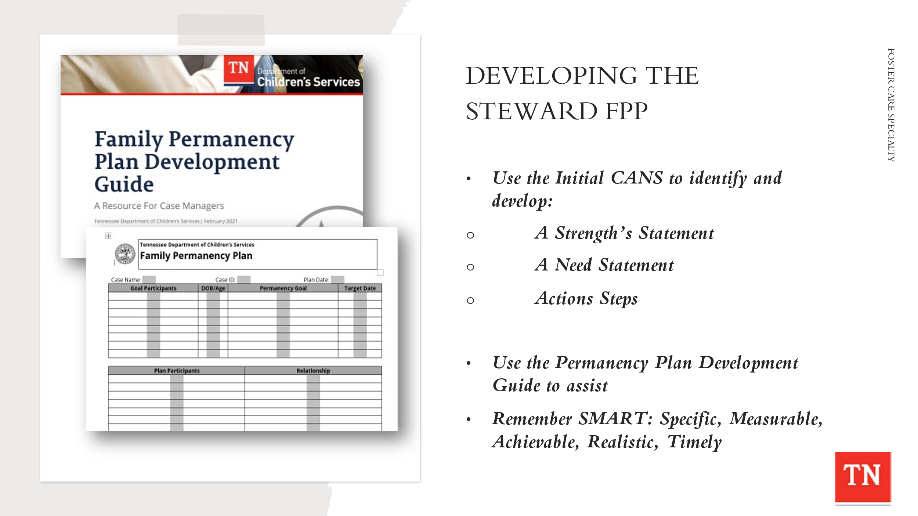
- CONDUCT ACTIVITY: Steward/Collins Family Permanency Plan Development
- TRAINER: This activity can be done as a large group or working in small teams to brainstorm ideas as would be done in a CFTM setting. Approximately 30 minutes to complete.
- INSTRUCT the group or small teams to use the Initial CANS (strengths of Steward/Collins family, needs/risk/concerns of Steward/Collins family) and identify a Strengths Statement, Need/Risk/Concern Statement, and Action Steps for Steward family (Marilyn or Travis).
- REMIND the group they can use the Permanency Plan Development Guide to assist them with action steps. Also, remind them of the SMART acronym when writing action steps: Specific, Measurable, Achievable, Realistic, and Timely.
- ALLOW report out and DEBRIEF the Strengths Statements, Need/Risk/Concern Statements, and Action Steps created by the group or small teams.
- THANK the group for their hard work. ENCOURAGE participants to review Permanency Plans in the field, attend Permanency Plan CFTMs and ask questions about the process of using the CANS to inform the plan.
- REMIND participants the Criteria and Procedures for Termination of Parental Rights are to be reviewed with the family at every CFTM in which a Permanency Plan is written or revised. This form is to be read to the parents, not summarized and if the parents have any questions they are to be directed to their attorneys.
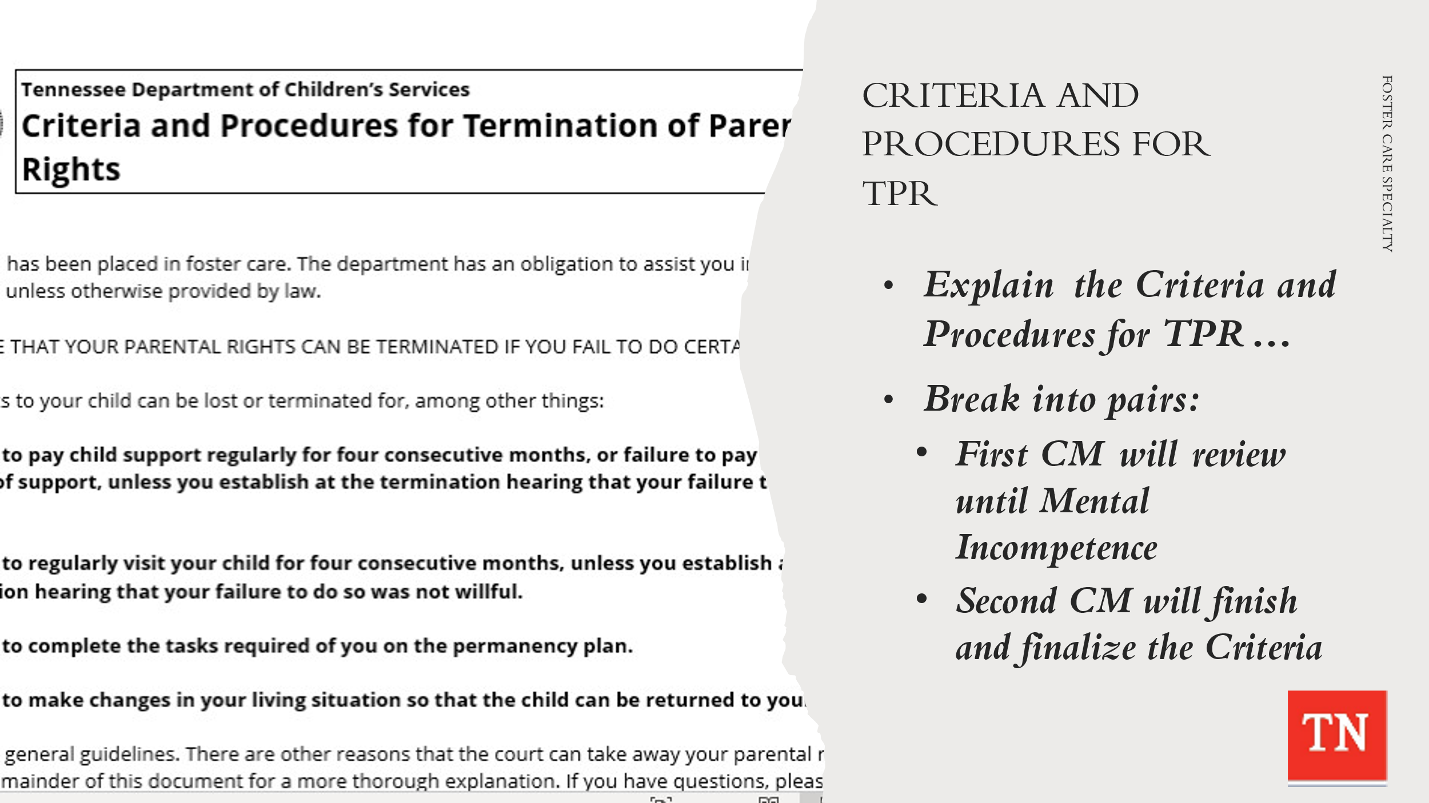
- CONDUCT ACTIVITY: How to Present Criteria and Procedures for Termination of Parental Rights
- SHARE Form CS-0745 Criteria and Procedures for Termination of Parental Rights.
- EXPLAIN Participants will break up into pairs and one participant will be the Case Manager and the other will be Mrs. Steward or Mr. Collins.
- INFORM the Case Manager will explain HALF of the TPR Criteria with the parent. The Case Manager will STOP at Mental Incompetence on page 3.
- AFTER all groups have gotten to this point (approximately 8 minutes) EXPLAIN Participants will now swap roles and one participant will be the Case Manager and the other will be Mrs. Steward or Mr. Collins.
- INFORM The Case Manager will explain the OTHER HALF of the TPR Criteria with the parent, obtain their acknowledgment they were explained the contents of the document, and obtain their signature.
- ALLOW all pairs to complete this task (approximately 8 minutes).
- DEBRIEF with participants and ASK how that felt as the Case Manager in discussing TPR Criteria with a parent. Also, ASK how it felt as the family member in having the TPR Criteria explained to them.
- EXPRESS empathy is needed during this conversation. This is a scary and confusing time for families, and we want to ensure they have all the information needed to understand this process.
- EXPLAIN following the Initial Permanency Plan CFTM, Case Managers will drive the Permanency Plan forward to help achieve permanency as quickly as possible. ENSURE the following are discussed:
  - work with team to address issues
  - complete case service requests
  - update CANS throughout the case
  - update action steps as needed
  - work with family and providers identify functional strengths
  - track progress
  - have quality contacts with the family
  - meaningful and regular visitation
  - holding Progress CFTMs
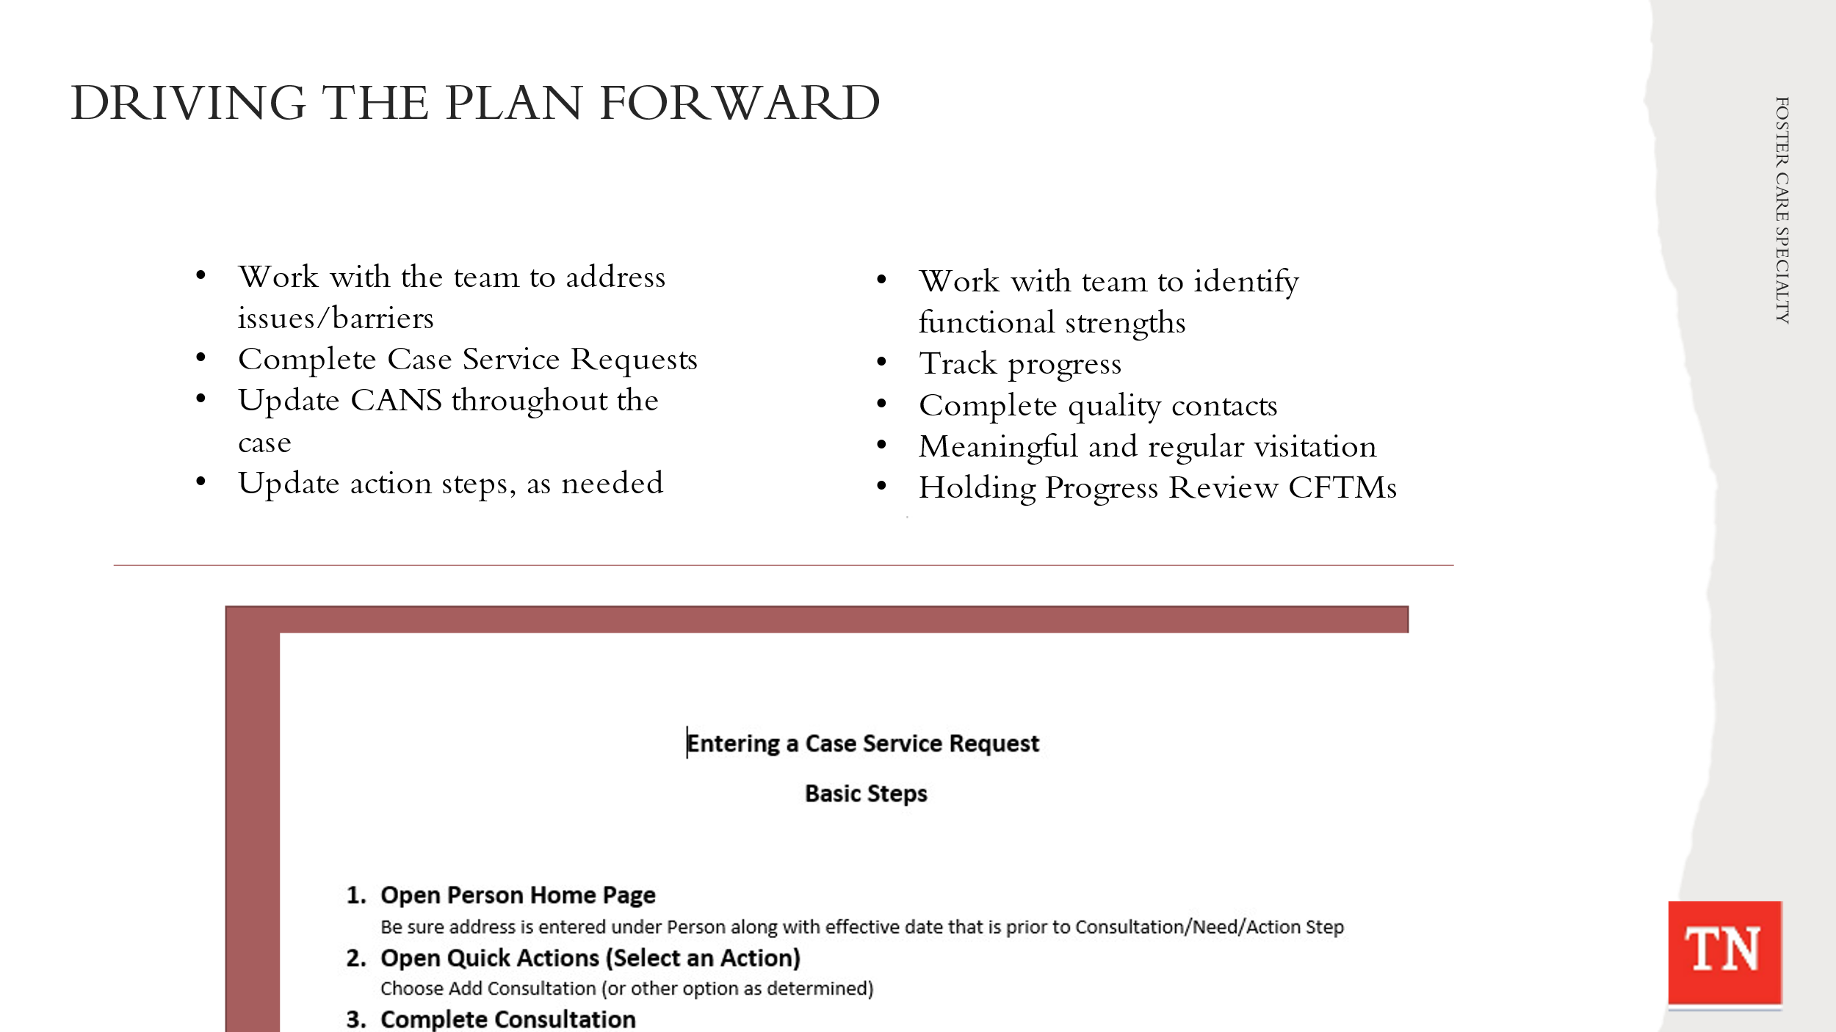
- DISCUSS Case Service Requests. The Case Service Request must be approved for the family to receive the requested service. FSW’s must provide a justification (reason) for the service and no other funds are available to pay for the service. SHARE when DCS is requesting a service and paying for the service a Case Service Request must be submitted monthly and on-going while the service is being utilized. REFER participants to Case Service Request Cheat Sheet Handout and how to enter requests into TFACTS.
- REFER participants to the TFACTS Training Calendar for specific training on Case Service Requests. Link: https://www.teamtn.gov/dcs/divisions/training/tfacts/tfacts-calendar.html.

Lesson 4.6: Interstate Compact on the Placement of Children
Lesson Time: 15 minutes
Key Teaching Points / Instructions

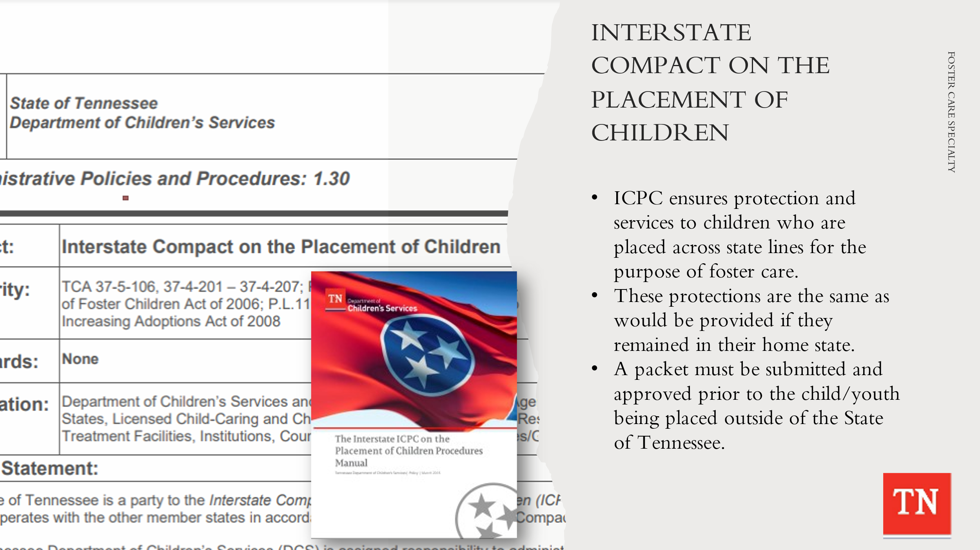
- INFORM participants at the Initial Permanency Plan CFTM the CFT’s decision to pursue an Interstate Compact on the Placement of Children (ICPC) for Michael to live with Mr. Collins in Virginia.
- REFER participants to Policy 1.30: Interstate Compact on the Placement of Children and the Interstate Compact on the Placement of Children (ICPC) Practice and Procedure Manual.
- SHARE the purpose of the ICPC is to ensure protection and services to children who are placed across state lines for the purpose of foster care. These protections and services are the same as would be provided to the child or children if they remained in their home state or jurisdiction. All relevant federal and state child welfare laws and policies that apply to a child in Tennessee apply to that child if placed across state lines.
- SHARE ICPC Referral Packet for Michael. ALLOW participants to review. INFORM an Interstate Compact on the Placement of Children (ICPC) Packet must be submitted and approved prior to a child/youth to be placed outside of the State of Tennessee.
- EXPLAIN The TN DCS Website provides a listing and contact information on persons who administer/manage the day-to-day operations of the TN Department of Children’s Services Interstate Compact on the Placement of Children. This same site provides information regarding processing of ICPC documents: https://www.tn.gov/dcs/program-areas/interstate-compact/icp/contact.html
- ASK if there are any questions.

Lesson 4.7: Implementation and Tracking & Adjusting
Lesson Time: 10 minutes
Key Teaching Points / Instructions

- TELL participants as an FSW, we are always assessing the case and tracking and adjusting action steps as necessary to reach permanency in a timely manner.
- REMIND participants CFTM’s to review child permanency goals and progress on the permanency plan must take place every three months. STRESS this CFTM is held to ensure that everyone is following through on their responsibilities and the services are meeting the needs of the child and family.
- DISCUSS we use the CANS to drive the meeting to help determine action steps which then in turn informs the permanency plan.
- STATE we always consider any changes in the family situation and make adjustments as needed in order to move forward with the permanency goals. In most cases, plans with a six-month achievement date are preferred to ensure that permanency is achieved within the required timelines. If it looks like the current permanency goal(s) will not be achieved and the FSW has completed Reasonable Efforts by assisting the family during the time between reviews, then the case will be reviewed with a supervisor and legal to determine next steps and if a change in permanency goals is needed.
- REMIND participants tracking and monitoring is an important part of their case practice and a key spoke of the practice wheel.

Unit 5: Case Process - Months 2 and 3

Unit Time: 75 minutes

Learning Objectives:
- Participants will understand the on-going case process throughout the life of a foster care case.

Supporting Materials:

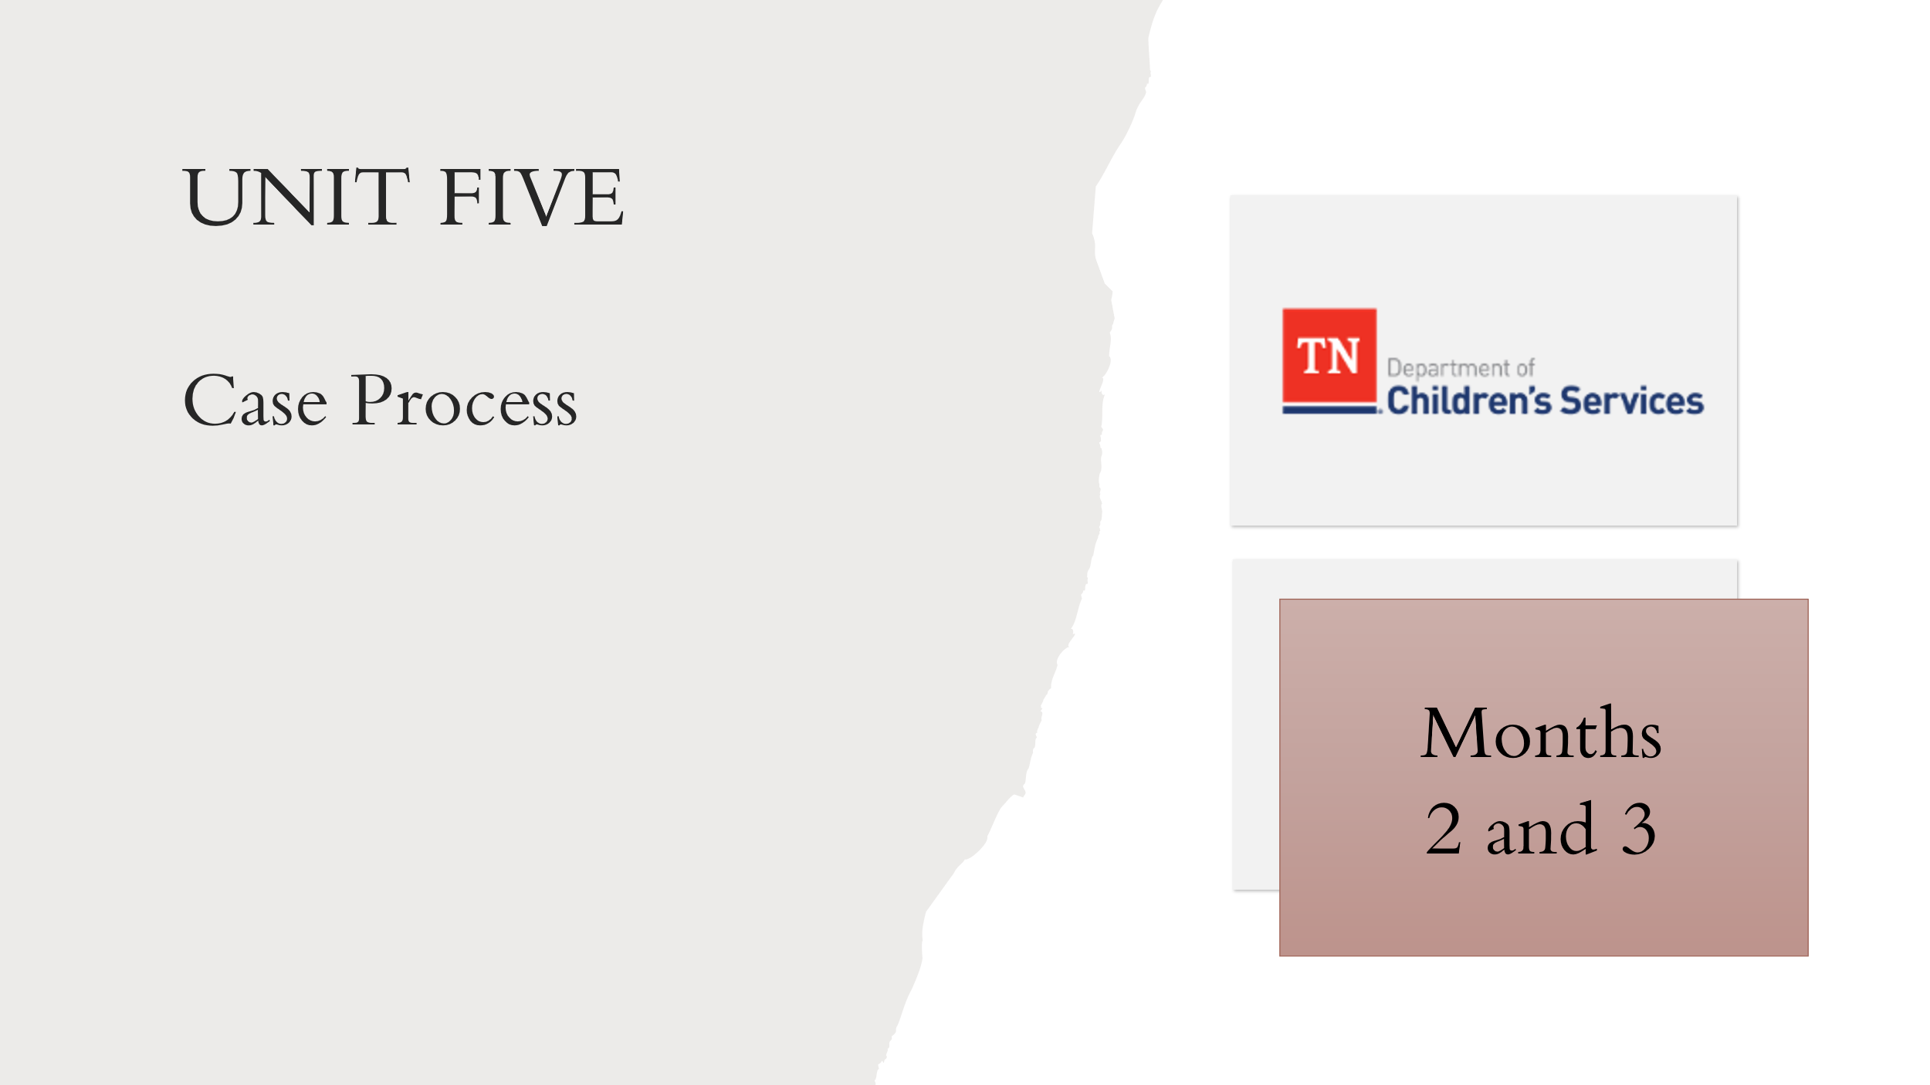
  - Foster Care Specialty Week Two Facilitator Guide and PowerPoint
  - Case Calendar Timeline
  - Policy 16.32: Foster Care Review and Progress Reports
  - Form CS-0430 Progress Report on Child in State Custody
  - Form CS-0510 Foster Care Review Summary

Lesson 5.1: Months 2 and 3
Lesson Time: 45 minutes
Key Teaching Points / Instructions

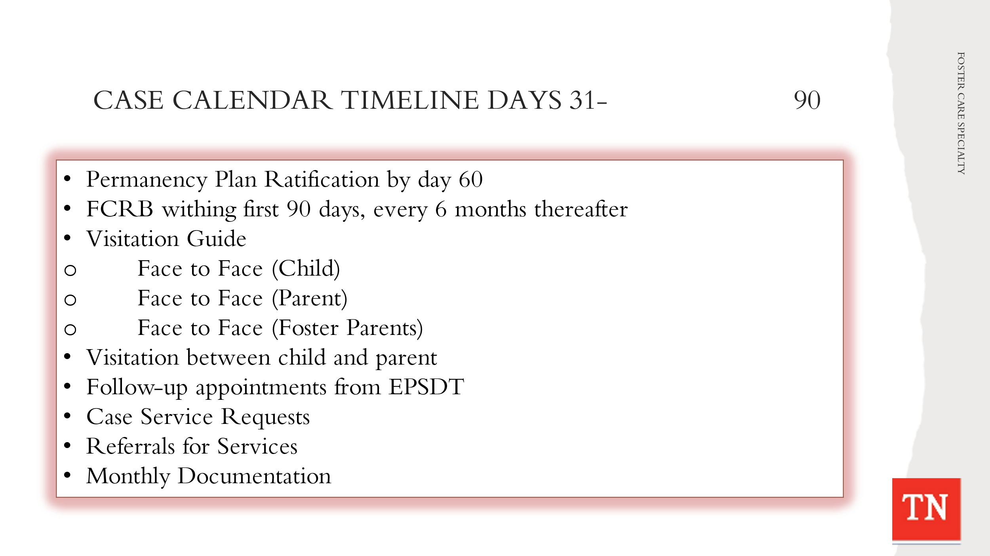
- STATE the tasks needing to be completed on a case from day 31-90 seems to slow down a little and this is where the Practice Wheel is very important. UTILIZE Case Calendar Timeline and BRIEFLY REVIEW the tasks below. TRAINER NOTE: some tasks are applied to the Steward case and are addressed in the following lessons. Tasks for day 31-90 will include:
- Permanency Plan ratification hearing by day 60
- Foster Care Review Board (if applicable) within first 90 days and every 6 months thereafter
- Visitation Guide – Quality contacts - Face to face child, Face to face parent, Face to face foster parents
- Visitation between child and parent - Visits should occur weekly and last at least one (1) hour in duration. Opportunities for visits between children/youth and their family occur for at least four (4) hours per month.
- Visitation with sibling not placed together - should visit with each other at least one (1) time per month.
- Follow up appointments from the EPSD&T and dental; mental health/ medication management appointment as needed/ongoing
- Case Service Requests - ongoing
- Referrals for services
- Monthly documentation
- STATE FSW’s will be staffing their cases with their supervisors on-going throughout the life of the case. Supervisors are included in CFTM’s, Court reviews, and FCRB’s.
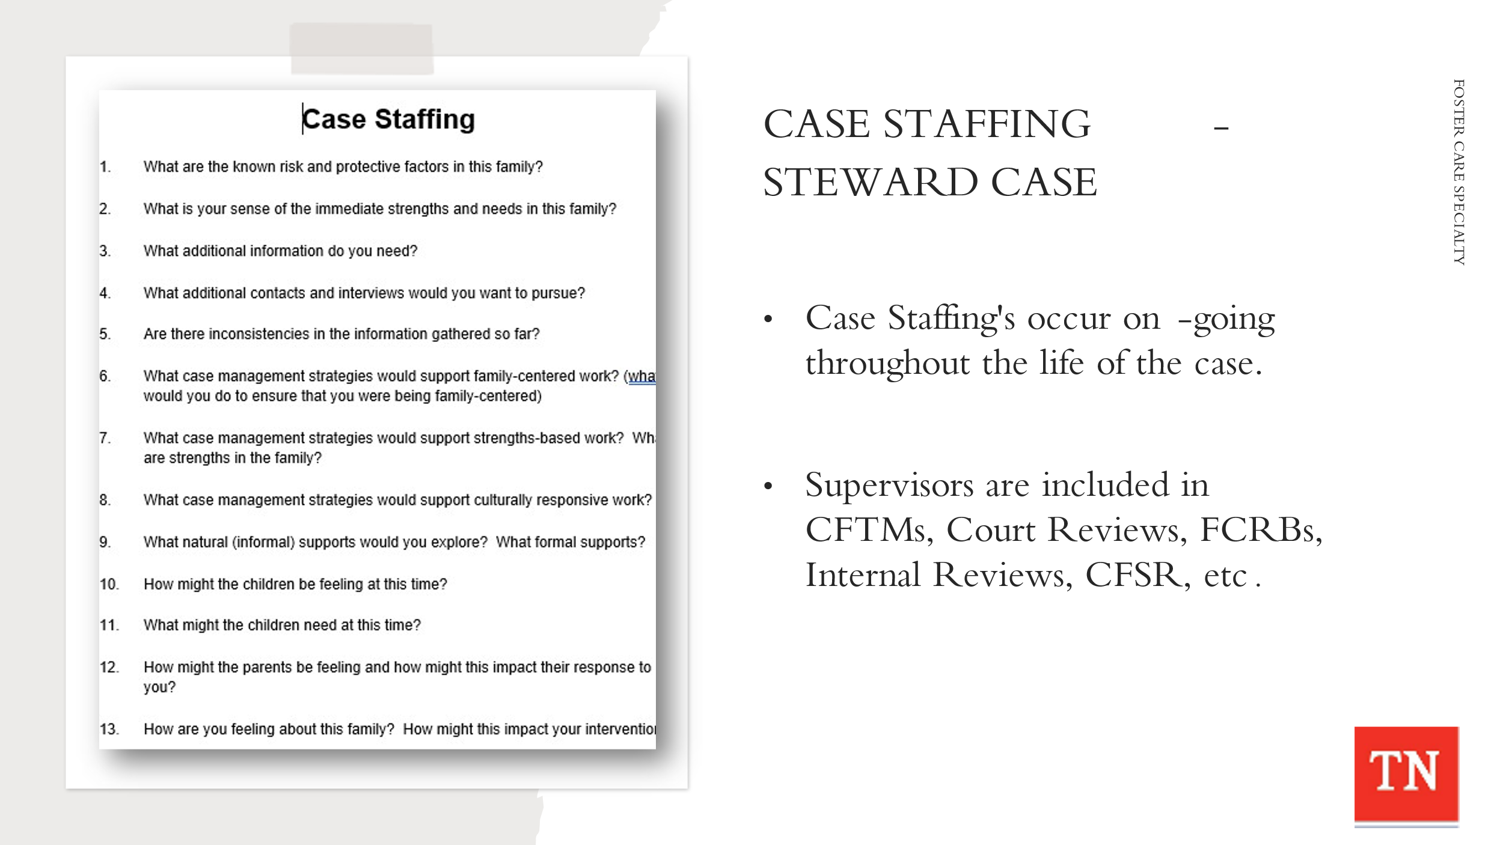
- CONDUCT ACTIVITY: Case Staffing- Steward Case
- TRAINER will ask questions of the participants as if they are staffing their case with their supervisor. Trainers will accept volunteers to answer each of the questions. Depending on class size, each participant should volunteer at least once to answer a question.
- REFER to the Case Staffing questions to conduct activity with participants.
- Optional: the group can decide to do it Round Robin style where the Trainer will go around the room asking a question of each participant until all questions have been answered.
- EXPLAIN participants are able to use all resources at their disposal in order to answer the questions if needed. COACH staff as needed through this process.
- DEBRIEF with participants. ASK how they felt about staffing their case.

Lesson 5.2: FCRB and Progress Reports
Lesson Time: 30 minutes
Key Teaching Points / Instructions

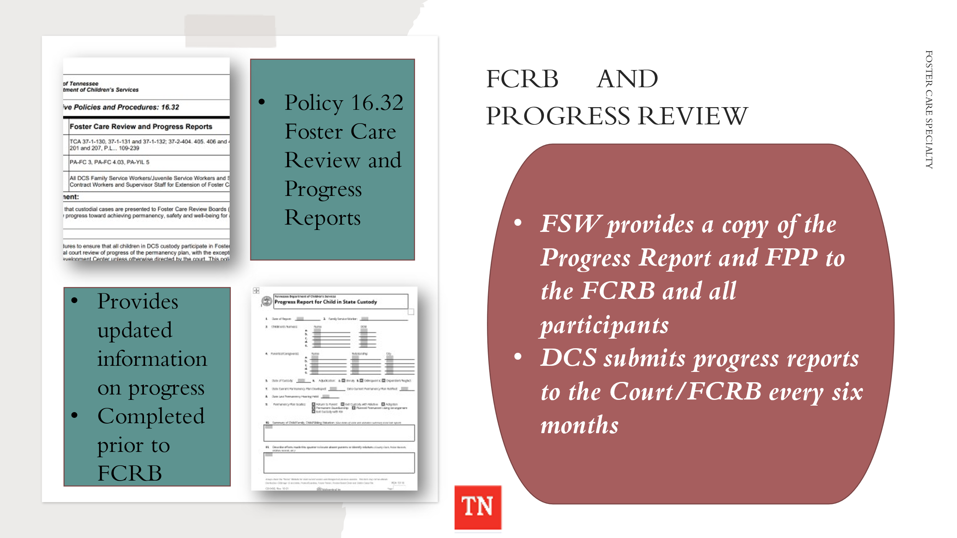
- REFER participants to DCS Policy 16.32: Foster Care Review and Progress Reports. SHARE the FSW completes Form CS-0430 Progress Report for Children in State Custody for each children/youth on their caseload. This report provides updated information on progress and should be completed prior to Foster Care Review Board or Judicial Review.
- EXPLAIN the FSW provides a copy of the Progress Report and the most recent Permanency Plan to the FCRB and all other participants. The Progress Reports for Children in State Custody (Form CS-0430) address the following:
- The current status and safety of the child/youth
- Diligent search efforts to locate parents or other family members as
outlined in DCS Policy 31.9 Conducting Diligent Searches
- Compliance with activities described in the permanency plan
- Progress made toward alleviating or mitigating the causes necessitating placement in foster care
- STATE FCRB or Judicial Review is scheduled within ninety (90) calendar days of the date of the child/youth’s placement in custody and no less than every six (6) months thereafter, for as long as the child/youth/young adult remains in state custody.
- EXPLAIN Local protocol for scheduling the reviews will be followed. Court liaisons or legal staff may secure the review dates upon request of the FSW.
- Note: Some courts maintain control of the dockets and schedule the reviews. If a board requests reviews more frequently than required by law, DCS complies with the board’s request.
- SHARE the Department submits regular progress reports to the Court and the Court should review the progress made on the permanency plan at least every six (6) months. The six (6) month review can be held by the Court or the FCRB. If neither the Court nor the FCRB is reviewing the permanency plan of the child/youth/young adult at least every six (6) months, the FSW must make a legal referral requesting that the Progress Report be filed with the Court and that a hearing be set to review the report and the child/youth/young adult’s progress.
- STATE Juvenile Court Judges may elect to personally review each case and not appoint a FCRB or they may elect to review certain cases and leave the rest to a FCRB. If the judge holds a hearing instead of the case going before the FCRB, the hearing will be entered by the FSW in TFACTS as a “Judicial Review” or as a “Foster Care Review Board” to be tracked correctly in TFACTS.
- Note: Some court hearings do not take the place of FCRB, such as a Ratification Hearing or a motion before the court. However, Permanency Plan Hearings and Termination Hearings can take the place so long as permanency is reviewed and the court makes a finding specific to permanency.
- INFORM participants unless parental rights have been terminated or the review is for a young adult receiving EFC services, the FSW notifies the parents of their right to attend and participate either by telephone or in person. The FSW also notifies other applicable parties such as: the child/youth/young adult, foster parents, Guardian ad Litem, parent’s attorney, etc. and anyone else who is a member of the Child and Family Team of the date, time and location.
- Children/youth of age six (6) or over should be encouraged and supported to attend all Foster Care Review Board hearings relating to his/her case. Some courts may require all children/youth be in attendance, regardless of age.
- When children cannot be in attendance, a medical, mental health or other good cause reason is provided to the court. Children/youth/young adults may participate by video conference or conference call when necessary. Ten days prior to any Judicial Review, the FSW notifies the child/youth/young adult and his/her placement, if applicable, and facilitates a plan to get the child transported to all hearings.
- Adequate notice must be provided to all team members, at least seven (7) calendar days in advance of the hearing if done by email, phone or in person and ten (10) calendar days in advance if notice is given by mail. Staff may use CS-0746, Meeting Notification Form to provide written notice to the team members.
- Team members can participate by video conference or conference call when their appearance is not possible. The FSW has the responsibility of setting up such arrangements prior to the FCRB review.
- The child/youth/young adult’s FSW must attend all FCRBs and present the case to the board. In the event the child/youth/young adult’s FSW is unable to attend the hearing, the FSW Team Leader or other approved designee appears to present the case.
- STATE Form CS-0510 Foster Care Review Summary is to be completed during the Foster Care Review with the participants. EXPLAIN The FSW secures a written report of the board’s findings of the review and includes it in the child/youth/young adult’s electronic case file.
- The FSW enters all FCRB and court review dates in the court section of TFACTS within three (3) business days of attending the review.
- The FSW enters documentation in case recordings including efforts to notify and assist applicable parties such as the child/youth/young adult, birth parents and resource parents to participate in the review. If there was no participation from the aforementioned parties, the documentation includes the reasons why, if known.
- STATE the FCRB recommendations are implemented within a reasonable timeframe. If recommendations are not followed, reasons for not doing so are documented in the case recordings and explained at the next FCRB or Permanency Hearing.
- BRIEFLY REVIEW Form CS-0430 Progress Report on Child in State Custody and Form CS-0510 Foster Care Review Summary to familiarize participants with the forms.
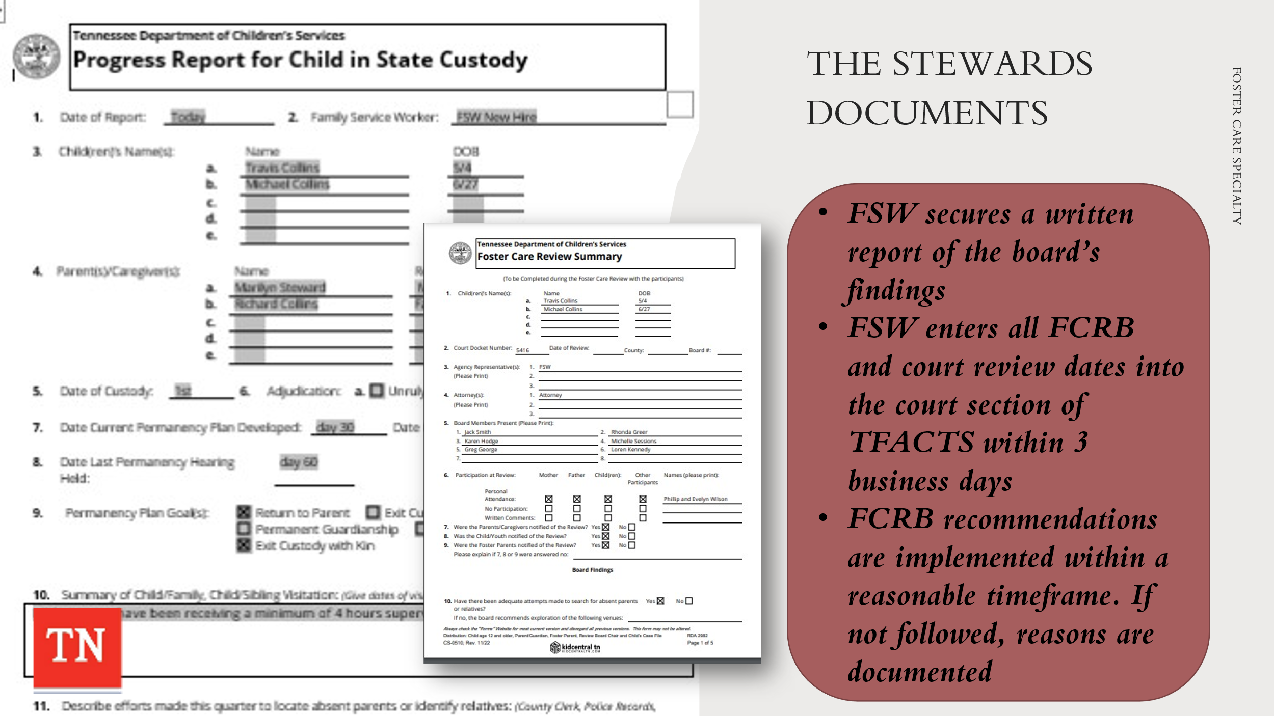
- SHARE Steward/Collins Form CS-0430 Progress Report on Child in State Custody that was submitted to the FCRB.
- REVIEW Form CS-0510 Foster Care Review Summary completed at the FCRB for the Steward/Collins family.
- DISCUSS the Steward recommendations from FCRB including:
- Continue treatment services for Marilyn and Travis
- Continue to pursue ICPC for Michael
- EXPLAIN This document will be submitted to the Court which includes recommendations from the FCRB that will need to be completed by the Team.

Unit 6: Case Process - Month 4

Unit Time: 1 hours and 45 minutes

Learning Objectives:
- Participants will understand the on-going case process throughout the life of a foster care case.

Supporting Materials:

- Foster Care Specialty Week Two Facilitator Guide and PowerPoint
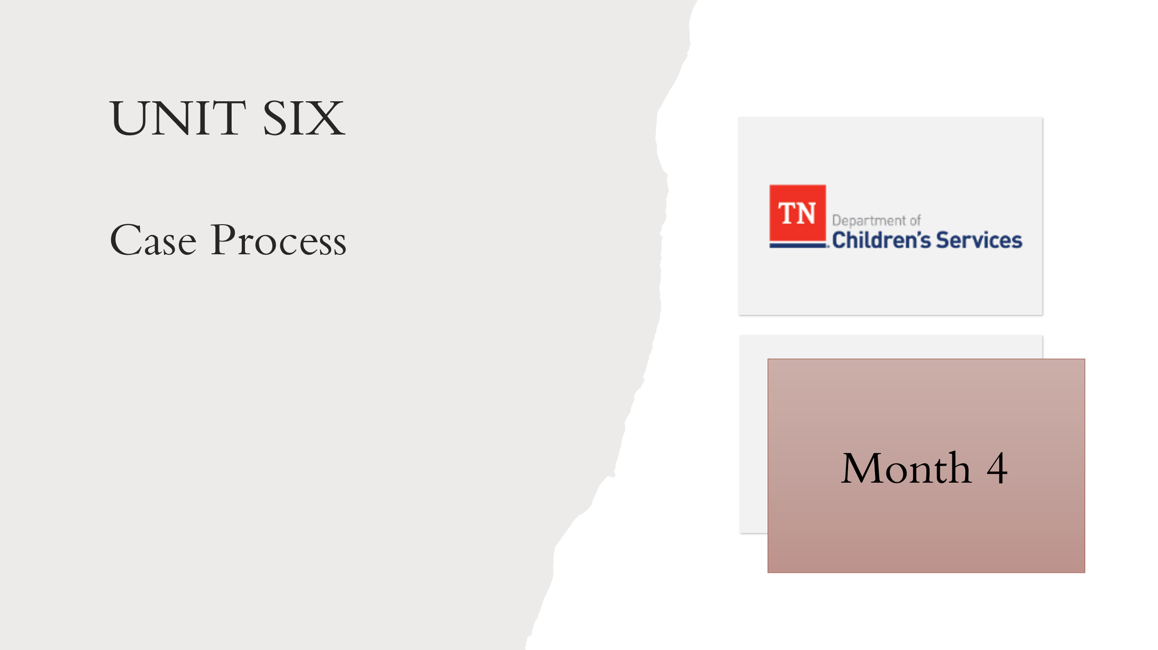
- Case Calendar Timeline
- Child and Family Team Meeting Guide
- Form CS-0747 Child and Family Team Meeting Summary
- Policy 1.30: Interstate Compact on the Placement of Children
- Interstate Compact on the Placement of Children (ICPC) Practice and Procedure Manual

Lesson 6.1: Month 4
Lesson Time: 15 minutes
Key Teaching Points / Instructions

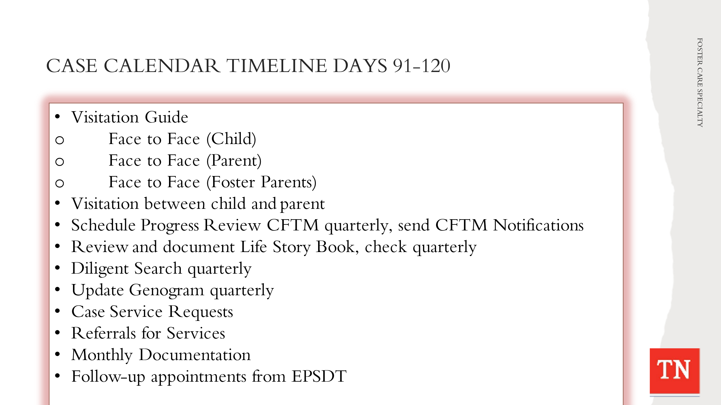
- STATE the tasks needing to be completed on a case from day 91-120 seems to slow down a little and this is where the Practice Wheel is very important. UTILIZE Case Calendar Timeline and BRIEFLY REVIEW the tasks below. TRAINER NOTE: some tasks are applied to the Steward case and are addressed in the following lessons. Tasks for day 91-120 will include:
- Visitation Guide – Quality contacts - Face to face child, Face to face parent, Face to face foster parents
- Visitation between child and parent - Visits should occur weekly and last at least one (1) hour in duration. Opportunities for visits between children/youth and their family occur for at least four (4) hours per month.
- Visitation with sibling not placed together - should visit with each other at least one (1) time per month.
- Schedule Progress Review CFTM quarterly, send CFTM Notifications
- Review and document Life Book check quarterly
- Diligent Search quarterly
- Update Genogram quarterly
- Case Service Requests – ongoing if needed
- Referrals for services – ongoing if needed
- Monthly documentation
- Follow up appointments medical, dental, mental health/medication management appointment as needed/ongoing

Lesson 6.2: Progress Reviews
Lesson Time: 90 minutes
Key Teaching Points / Instructions

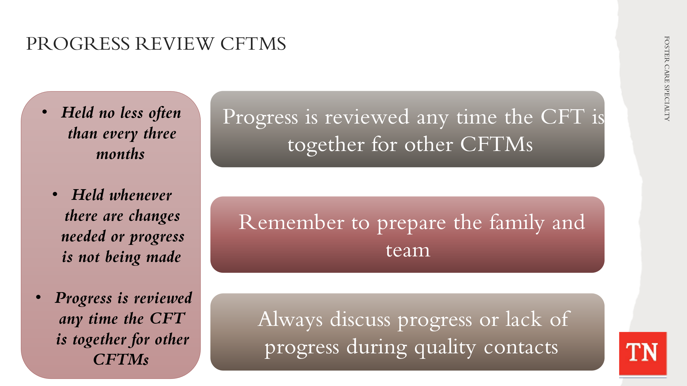
- SHARE Progress Review CFTM’s are held no less often than every three (3) months. A CFTM to review progress on the Permanency Plan is conducted whenever there are changes needed or progress is not being made in a timely fashion. Progress is reviewed any time the Child and Family Team is together for any type of CFTM. The three (3) month time frame is measured from the last Permanency Planning CFTM or Progress Review CFTM.
- REMIND participants it is important to prepare the family and team before the meeting. Before we have the meeting to discuss the progress, we should have had several discussions with the team members on their progress and if they are having any barriers.
- STATE When discussing lack of progress, it is important that we discuss how we can address the barriers. We should be showing reasonable efforts when addressing barriers in the plan. When these barriers come up during our progress review it is important for the team to discuss what resources or support can be offered to assist the family.
- REFER participants to the Child and Family Team Meeting Guide (pages 33-41). DISCUSS the CFTM’s they will be facilitating including:
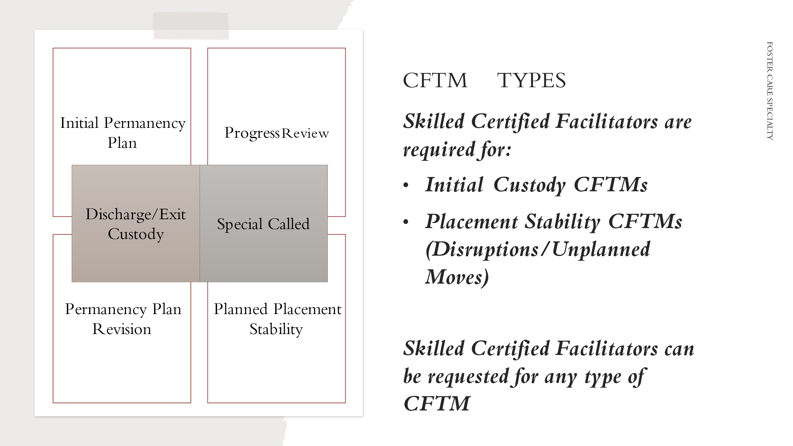
  - Initial Permanency Plan Custody
  - Progress Review Custody
  - Permanency Plan Revision
  - Planned Placement Stability
  - Discharge/Exit Custody
  - Special Called
- REMIND participants the Initial Custody Child and Family Team Meeting (by 7th calendar day) and Unplanned Placement Stability Child and Family Team Meetings require a Skilled Facilitator to facilitate. FSW’s will be required to prepare the Skilled Facilitator for the CFTM. REFER to the Quick Reference Guide on page 21 of the Child and Family Team Meeting Guide. ADDITIONALLY, reference when Supervisors are required to attend CFTM’s.
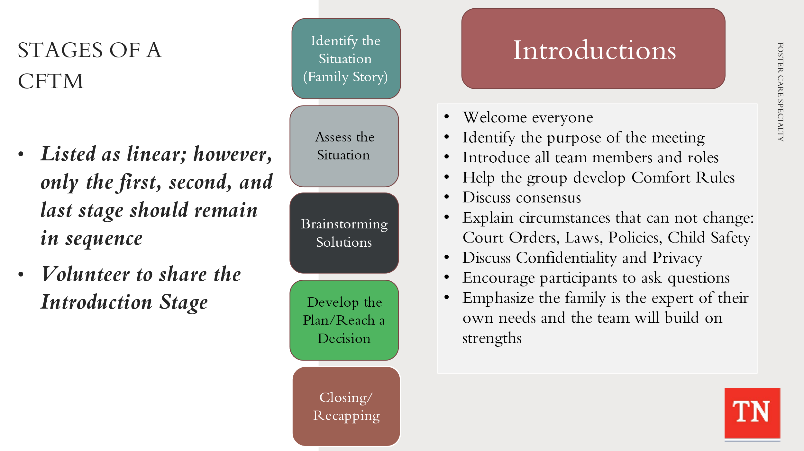
- EXPLAIN when Case Managers are conducting their own CFTM’s it will be important to follow the Stages of a CFTM. REFER participants to the CFTM Guide Pages 16-19. REMIND participants of the Stages of a CFTM:
- Introductions
- Identify the situation – Family Story
- Assess the situation – Identify Strengths and Needs/Concerns
- Brainstorming Solutions
- Develop the Plan/Reach a Decision
- Closing/Recapping the Meeting
- REMIND participants the Stages of the CFTM are listed linear; however, only the first, second, and last stage should remain in sequence. The rest of the stages may fluctuate.
- SHARE during the Introduction Stage the following are discussed:
- Welcome everyone
- Identify the purpose of the meeting
- Introduce all team members and roles
- Help the group develop Comfort Rules
- Discuss consensus
- Explain circumstances that can not change: Court Orders, Laws, Policies, Child Safety
- Discuss Confidentiality and Privacy
- Encourage participants to ask questions
- Emphasize the family is the expert of their own needs and the team will build on strengths
- ASK for a volunteer who would be willing to discuss the Introductions stage with the Steward family. INFORM participant to few moments to collect their thoughts and ASK them to share their introduction with the group. THANK the participant for sharing. TRAINER NOTE: SHARE example if needed of an Introduction to a CFTM with the group:
- EXAMPLE: “Welcome today to your family’s CFTM. We are here to discuss a variety of issues that impact you and your family. The purpose of today’s meeting is ______________. I will guide this team to create Comfort Rules. These are things that would make you feel comfortable participating today and that can assist this meeting in being productive and remain on task. Now let’s go around the table and introduce ourselves and your role with this family. I will begin. I am _____________ your case manager and will be facilitating the CFTM today. That means I will help manage the meeting to keep everyone on track and to ensure everyone gets a chance to share their thoughts and ideas. I want to encourage you to participate as you know your family best. Please feel free to ask questions as we go through this process. Thank you for joining us today.”
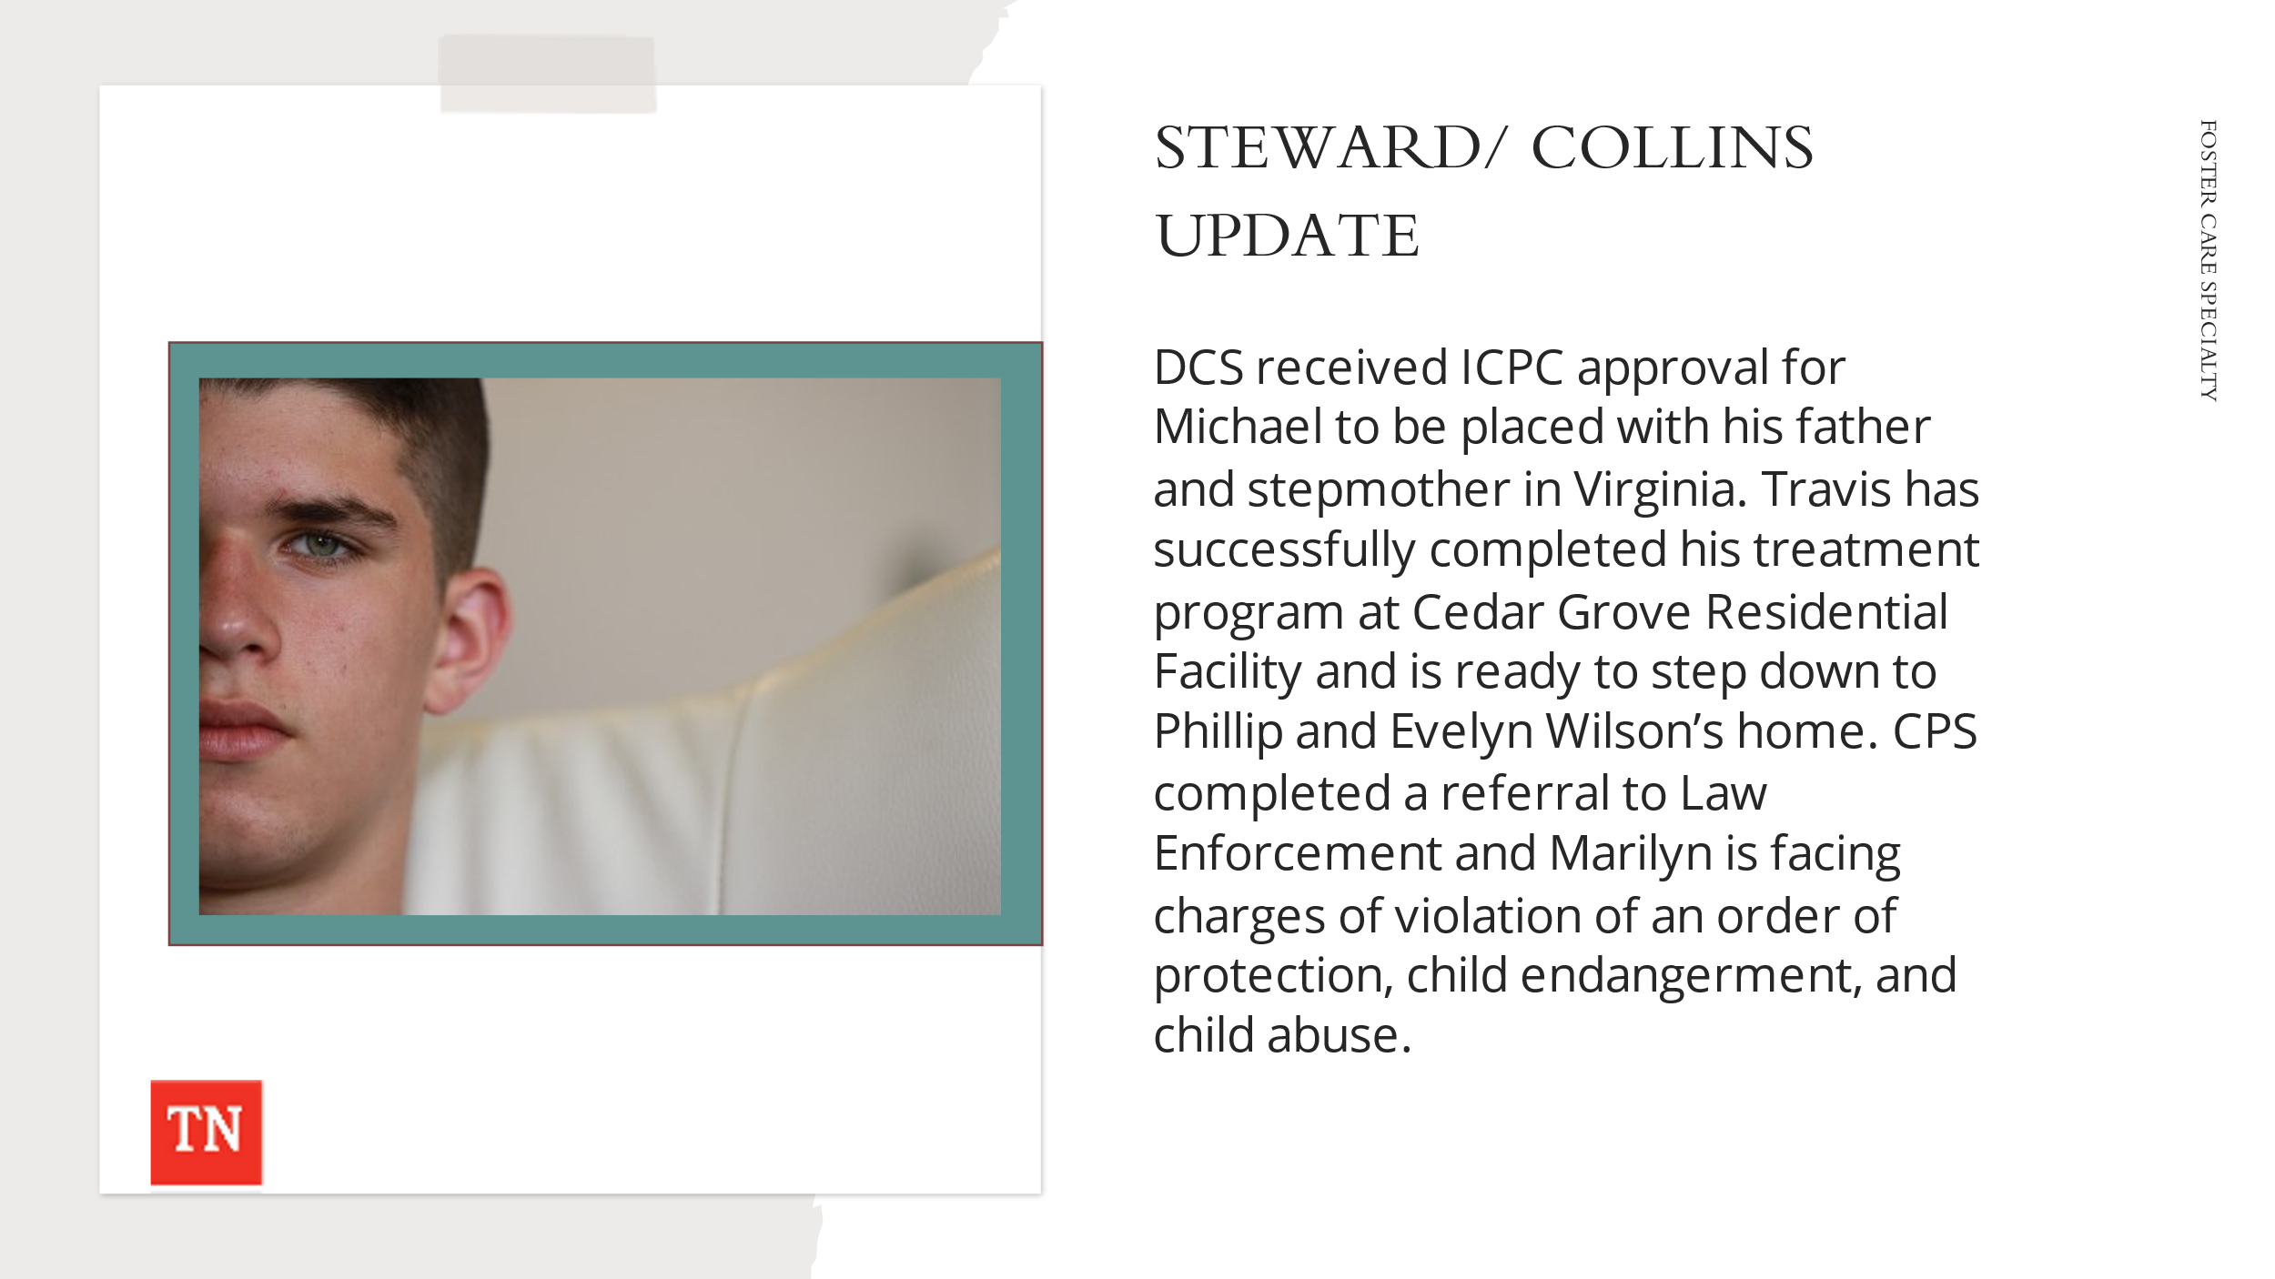
- CONDUCT ACTIVITY: Steward/Collins Progress Review CFTM Skills Lab
- TRAINER will share the Steward Case Update. EXPLAIN the ICPC was approved for Michael to move to Virginia with Mr. Collins.
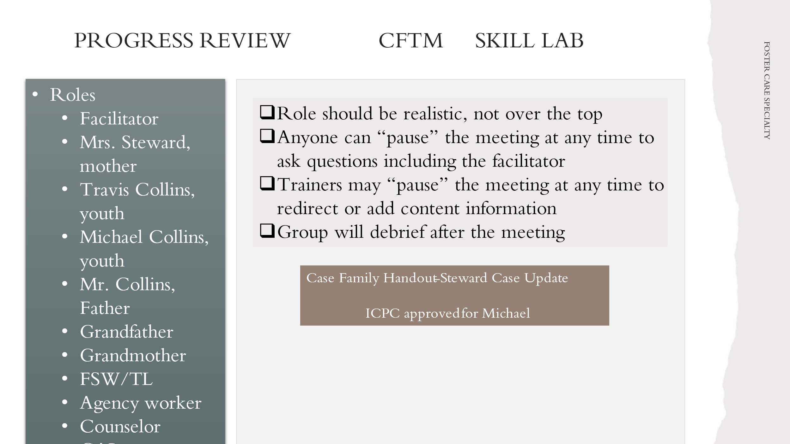
- Trainers will explore with the group who would need to attend the CFTM and assign a specific role to the participants. NOTE: If the class is not large enough, the Trainer will assign the most pertinent roles, i.e., Mother, Father, FSW, TL, Youth, Grandparents, Attorney/GAL, Counselor, etc.
- ASK for a volunteer who is willing to facilitate the Steward/Collins Progress Review CFTM. One Trainer will act as co-facilitator and document Comfort Rules/ Circumstances that cannot change, Strengths, Needs/Concerns, Brainstorm, and Action Steps on a Whiteboard or flip chart as the CFTM progresses. The participants can refer to these during the CFTM.
- EXPLAIN the “Facilitator” of the meeting should demonstrate:
- Model engagement and communication skills
- Demonstrate how to move the group through the process.
- Anyone can ask to “PAUSE” the role play to ask questions or if the facilitator is stuck on what to do next. Participants should move on from a behavior if the facilitator addresses the behavior or attempts to move the group along
- Reiterate this is about learning to manage the Stages of the CFTM.
- EXPLAIN after the CFTM, feedback will be given. The Feedback Process:
- We will honor the risk and protect the feelings of participants
- Role players will first assess how they felt it went
- The group will give positive, strengths-based feedback
- We will explore suggestions of other ways to respond for consideration
- It is very important that people feel supported, able to take risks and safe in this process.
- CONDUCT ACTIVITY: Steward/Collins Progress Review CFTM Skills Lab
- The CFTM will last 30 minutes.
- DEBRIEF the skills lab (15 minutes) using the Feedback process model from above.
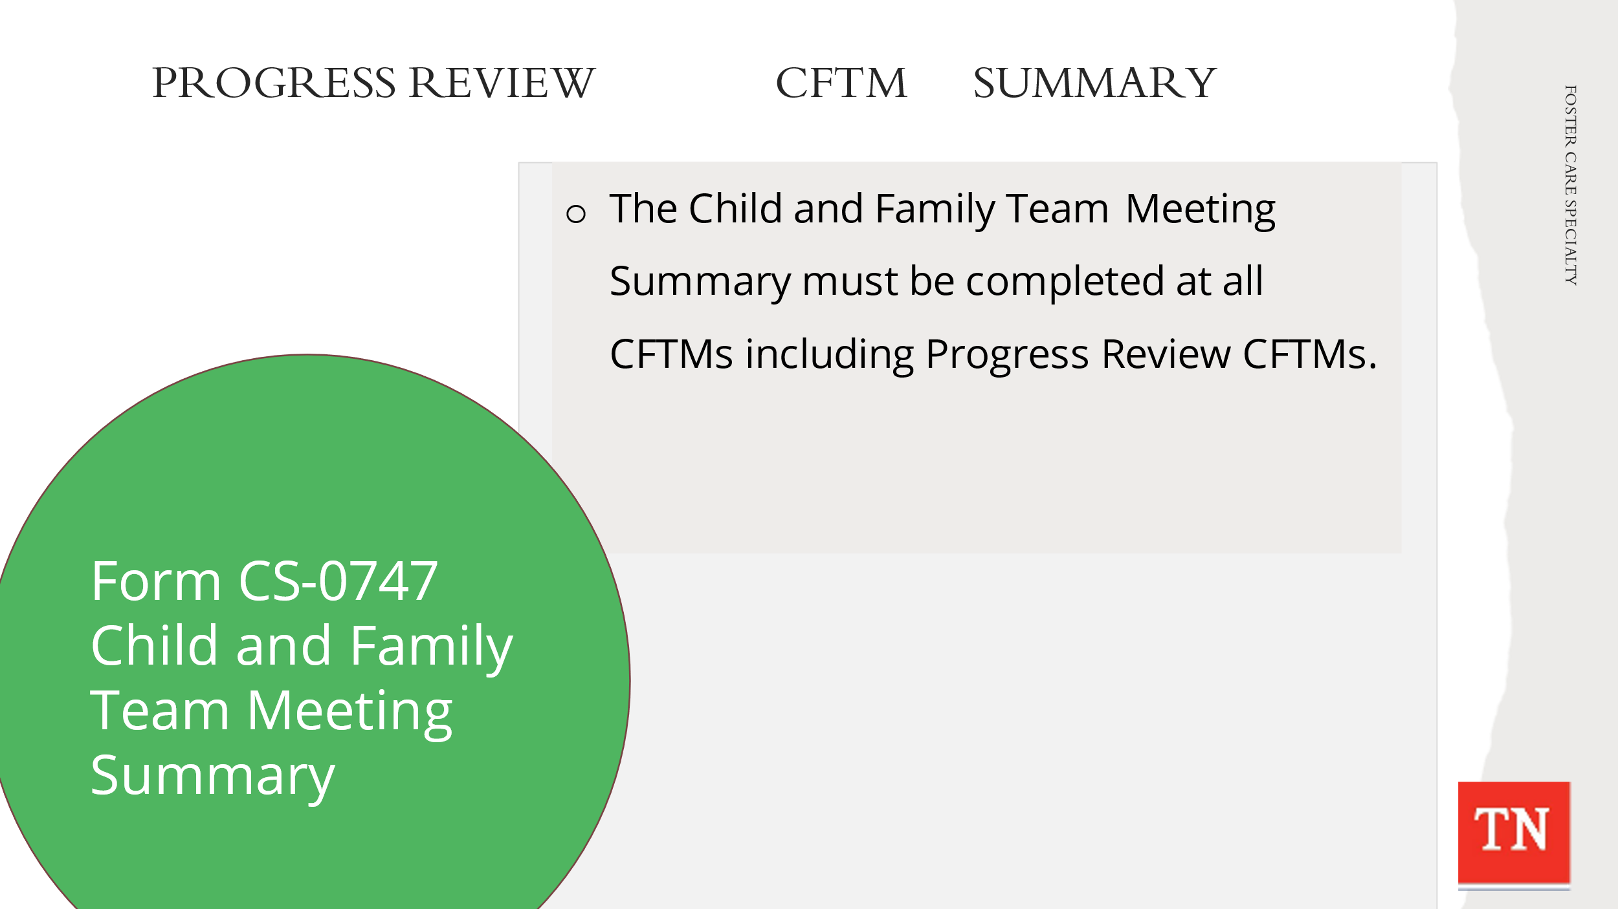
- CONDUCT ACTIVITY: Progress Review Child and Family Team Meeting Summary
- ASK participants to pull up Form CS-0747 Child and Family Team Meeting Summary. REVIEW document and the sections that require attention.
- OPTIONAL - ALLOW 15 minutes for participants to complete the Progress Review CFTM Summary.
- DEBRIEF with participants. ASK participants what would need to be captured on the CFTM Summary following the CFTM. TRAINERS ensure only accurate information would be documented on the summary (obtained from the Steward/Collins Progress Review CFTM information).
- ASK if there are questions or comments.
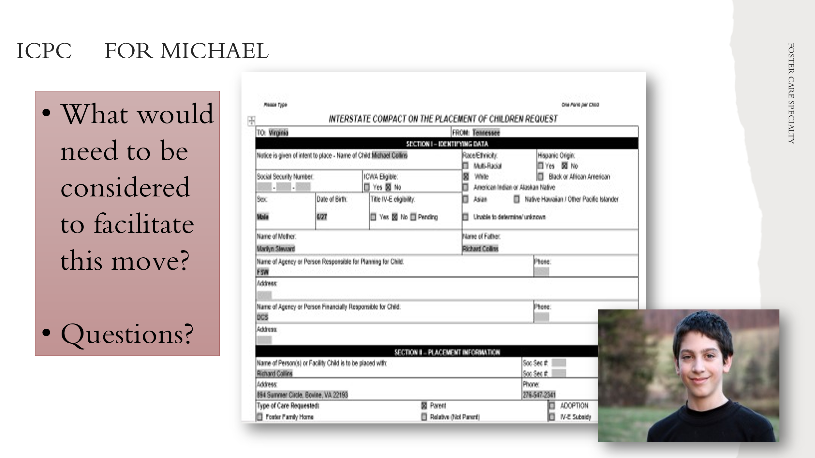
- DISCUSS Michael’s transition to Virginia with his father through the ICPC process. ASK what would need to be considered to facilitate this move. EXPLAIN the CFTM will need to make a recommendation to the Court about the monitoring of the ICPC with Virginia. The team can recommended to monitor the ICPC for 6 months or discharge custody to the father.
- IF the CFTM does not discuss the ICPC recommendation, POLL the group their recommendation on monitoring, i.e., monitor for 6 months or discharge to the father.
- STATE it will be important to staff the case with Legal and Supervision around the ICPC process and CFTM recommendations. REFER participants to Interstate Compact on the Placement of Children (ICPC) Practice and Procedure Manual for additional information.
- INFORM participants once a ICPC is approved a Court hearing must be held for final approval of the move, determination of monitoring, determine exit, etc.
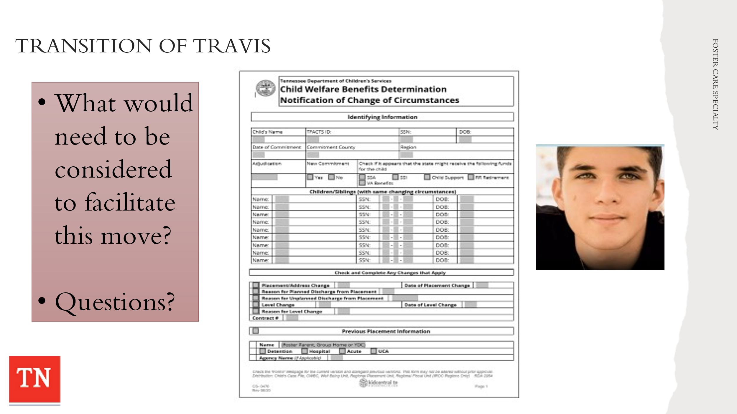
- DISCUSS the transition of Travis to Mr. and Mrs. Wilson’s home. ASK What would need to be considered in facilitating this move. INFORM The residential facility Cedar Grove will continue to provide services for Travis based on a continuum of care.
- ASK participants what tasks the FSW would be responsible in completing during Travis’ transition to the Wilson kinship home. ANSWER: See Visitation Guide for Face-to-Face contact requirements, update and provide Educational Passport and School Enrollment Letter, complete Change of Circumstance, Foster Parent Contract, Essential documents, etc.

Unit 7: Case Process - Month 5 and 6

Unit Time: 1 hour and 30 minutes

Learning Objectives:
- Participants will understand the on-going case process throughout the life of a foster care case.

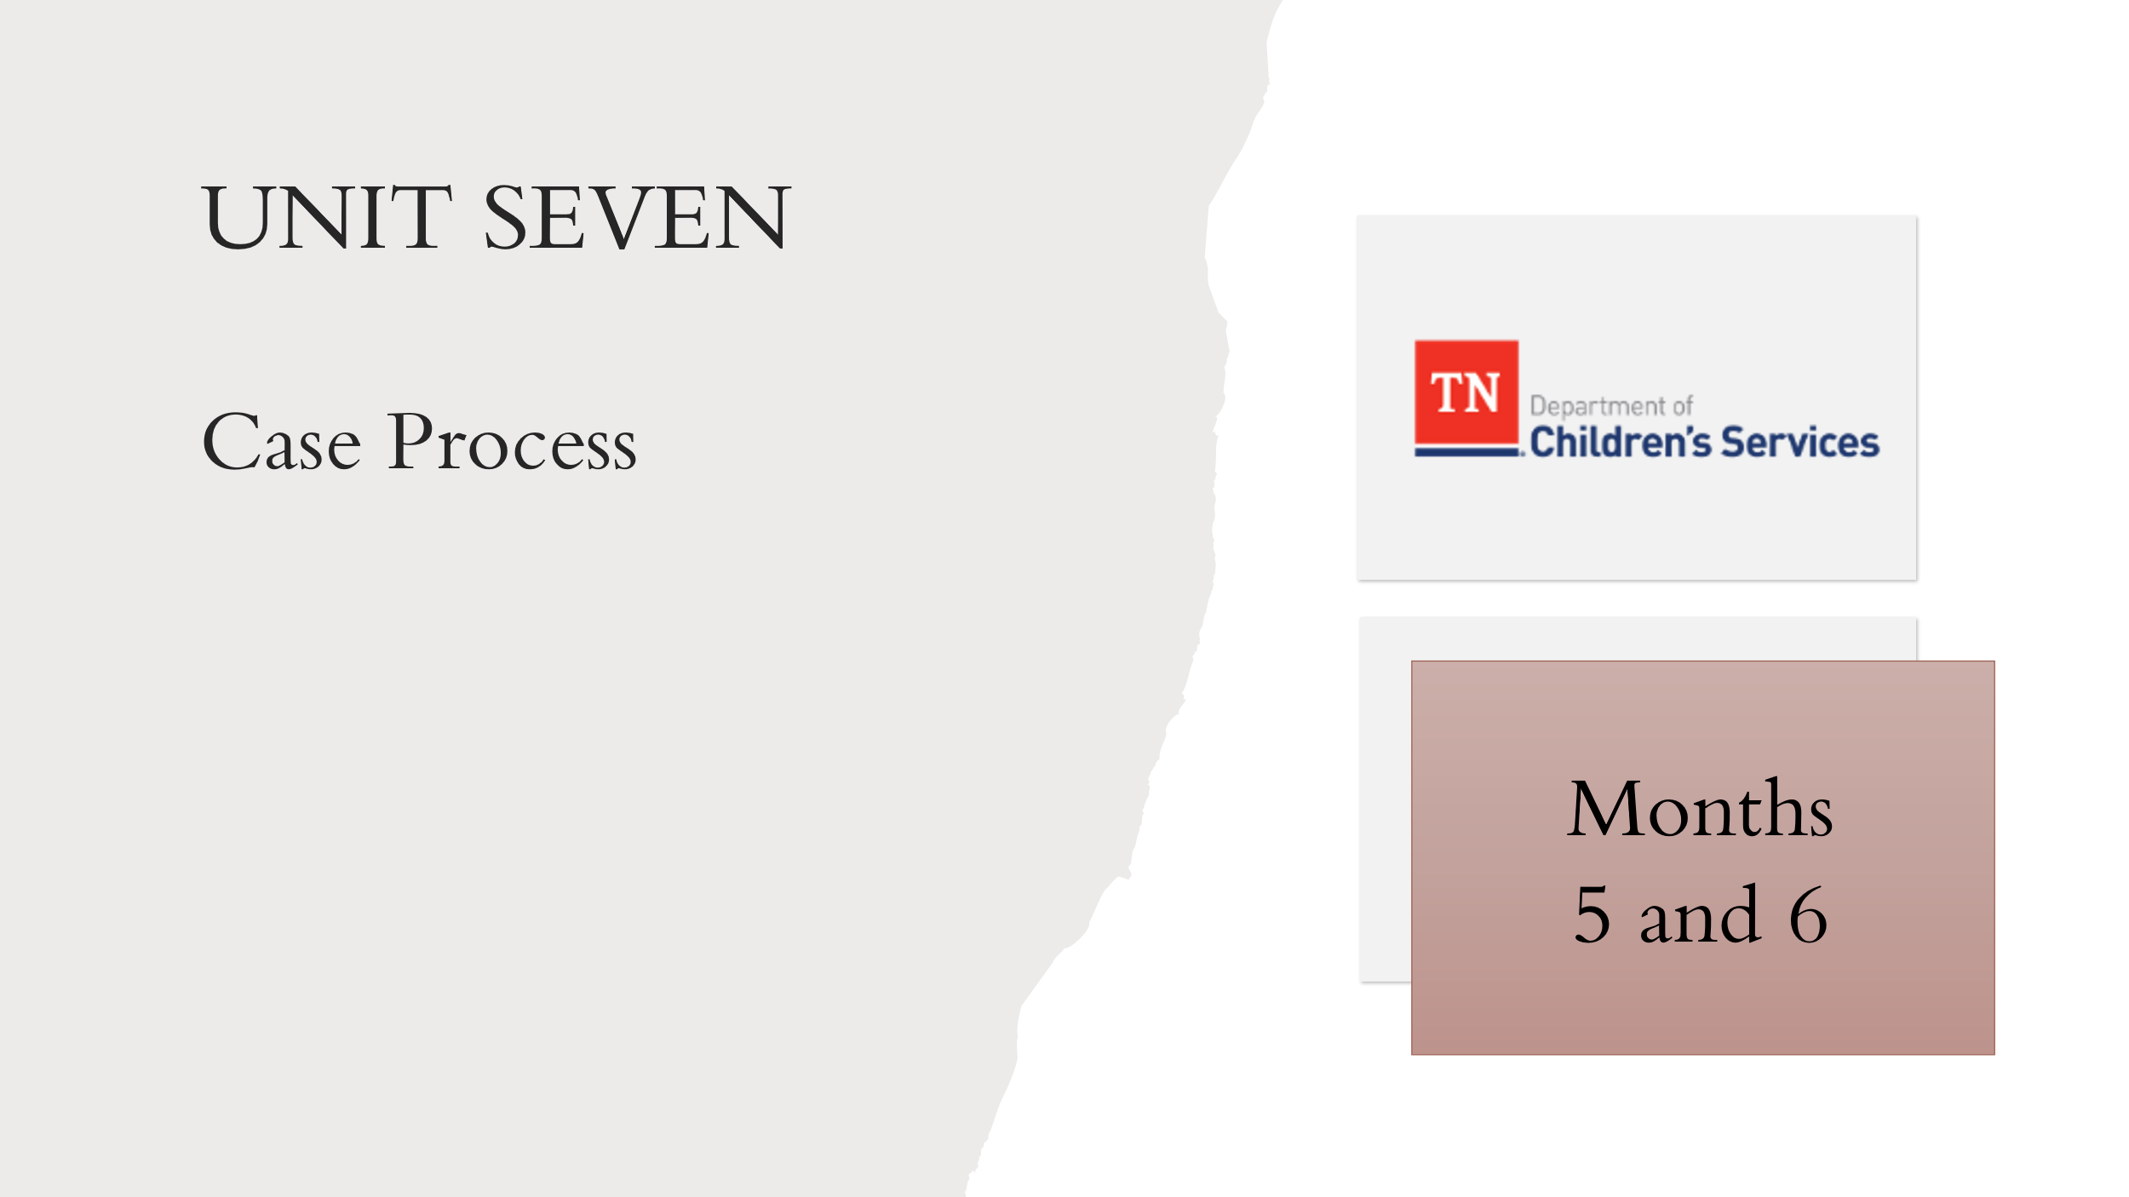
Supporting Materials:

- Foster Care Specialty Week Two Facilitator Guide and PowerPoint
- Case Calendar Timeline
- Reassessment CANS – Steward Family
- Assessing Progress of Family Permanency Plans Handout
- Permanency Plan Development Guide
- Form CS-0797 Affidavit of Reasonable Efforts

Lesson 7.1: Months 5 and 6
Lesson Time: 90 minutes
Key Teaching Points / Instructions

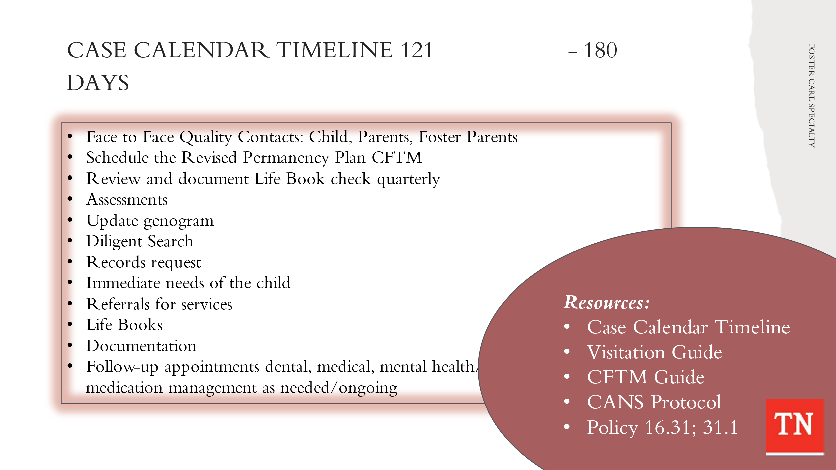
- STATE the tasks needing to be completed on a case from day 121-180 seems to slow down a little and this is where the Practice Wheel is very important. UTILIZE Case Calendar Timeline and BRIEFLY REVIEW the tasks below. TRAINER NOTE: some tasks are applied to the Steward case and are addressed in the following lessons. Tasks for day 121-180 will include:
- Visitation Guide – Quality contacts - Face to face child, Face to face parent, Face to face foster parents
- Visitation between child and parent - Visits should occur weekly and last at least one (1) hour in duration. Opportunities for visits between children/youth and their family occur for at least four (4) hours per month.
- Visitation with sibling not placed together - should visit with each other at least one (1) time per month.
- Schedule Permanency Plan Revision CFTM, send CFTM Notifications (go over Criteria for TPR and Equal Access)
- Review and document Life Book check quarterly
- Diligent Search quarterly
- Update Genogram quarterly
- Court Review of case
- Case Service Requests - ongoing if needed
- Referrals for services – ongoing if needed
- Monthly documentation
- Follow up appointments medical, dental, mental health/medication management appointment as needed/ongoing
- DISCUSS the importance of initiating conversations about permanency and concurrent planning with parents and youth.
- REMIND participants the available permanency options including:
  - Return to Parent
  - Exit Custody to Live with Relative or Kin
  - Adoption
  - Permanent Guardianship (or SPG)
  - Planned Permanent Living Arrangement
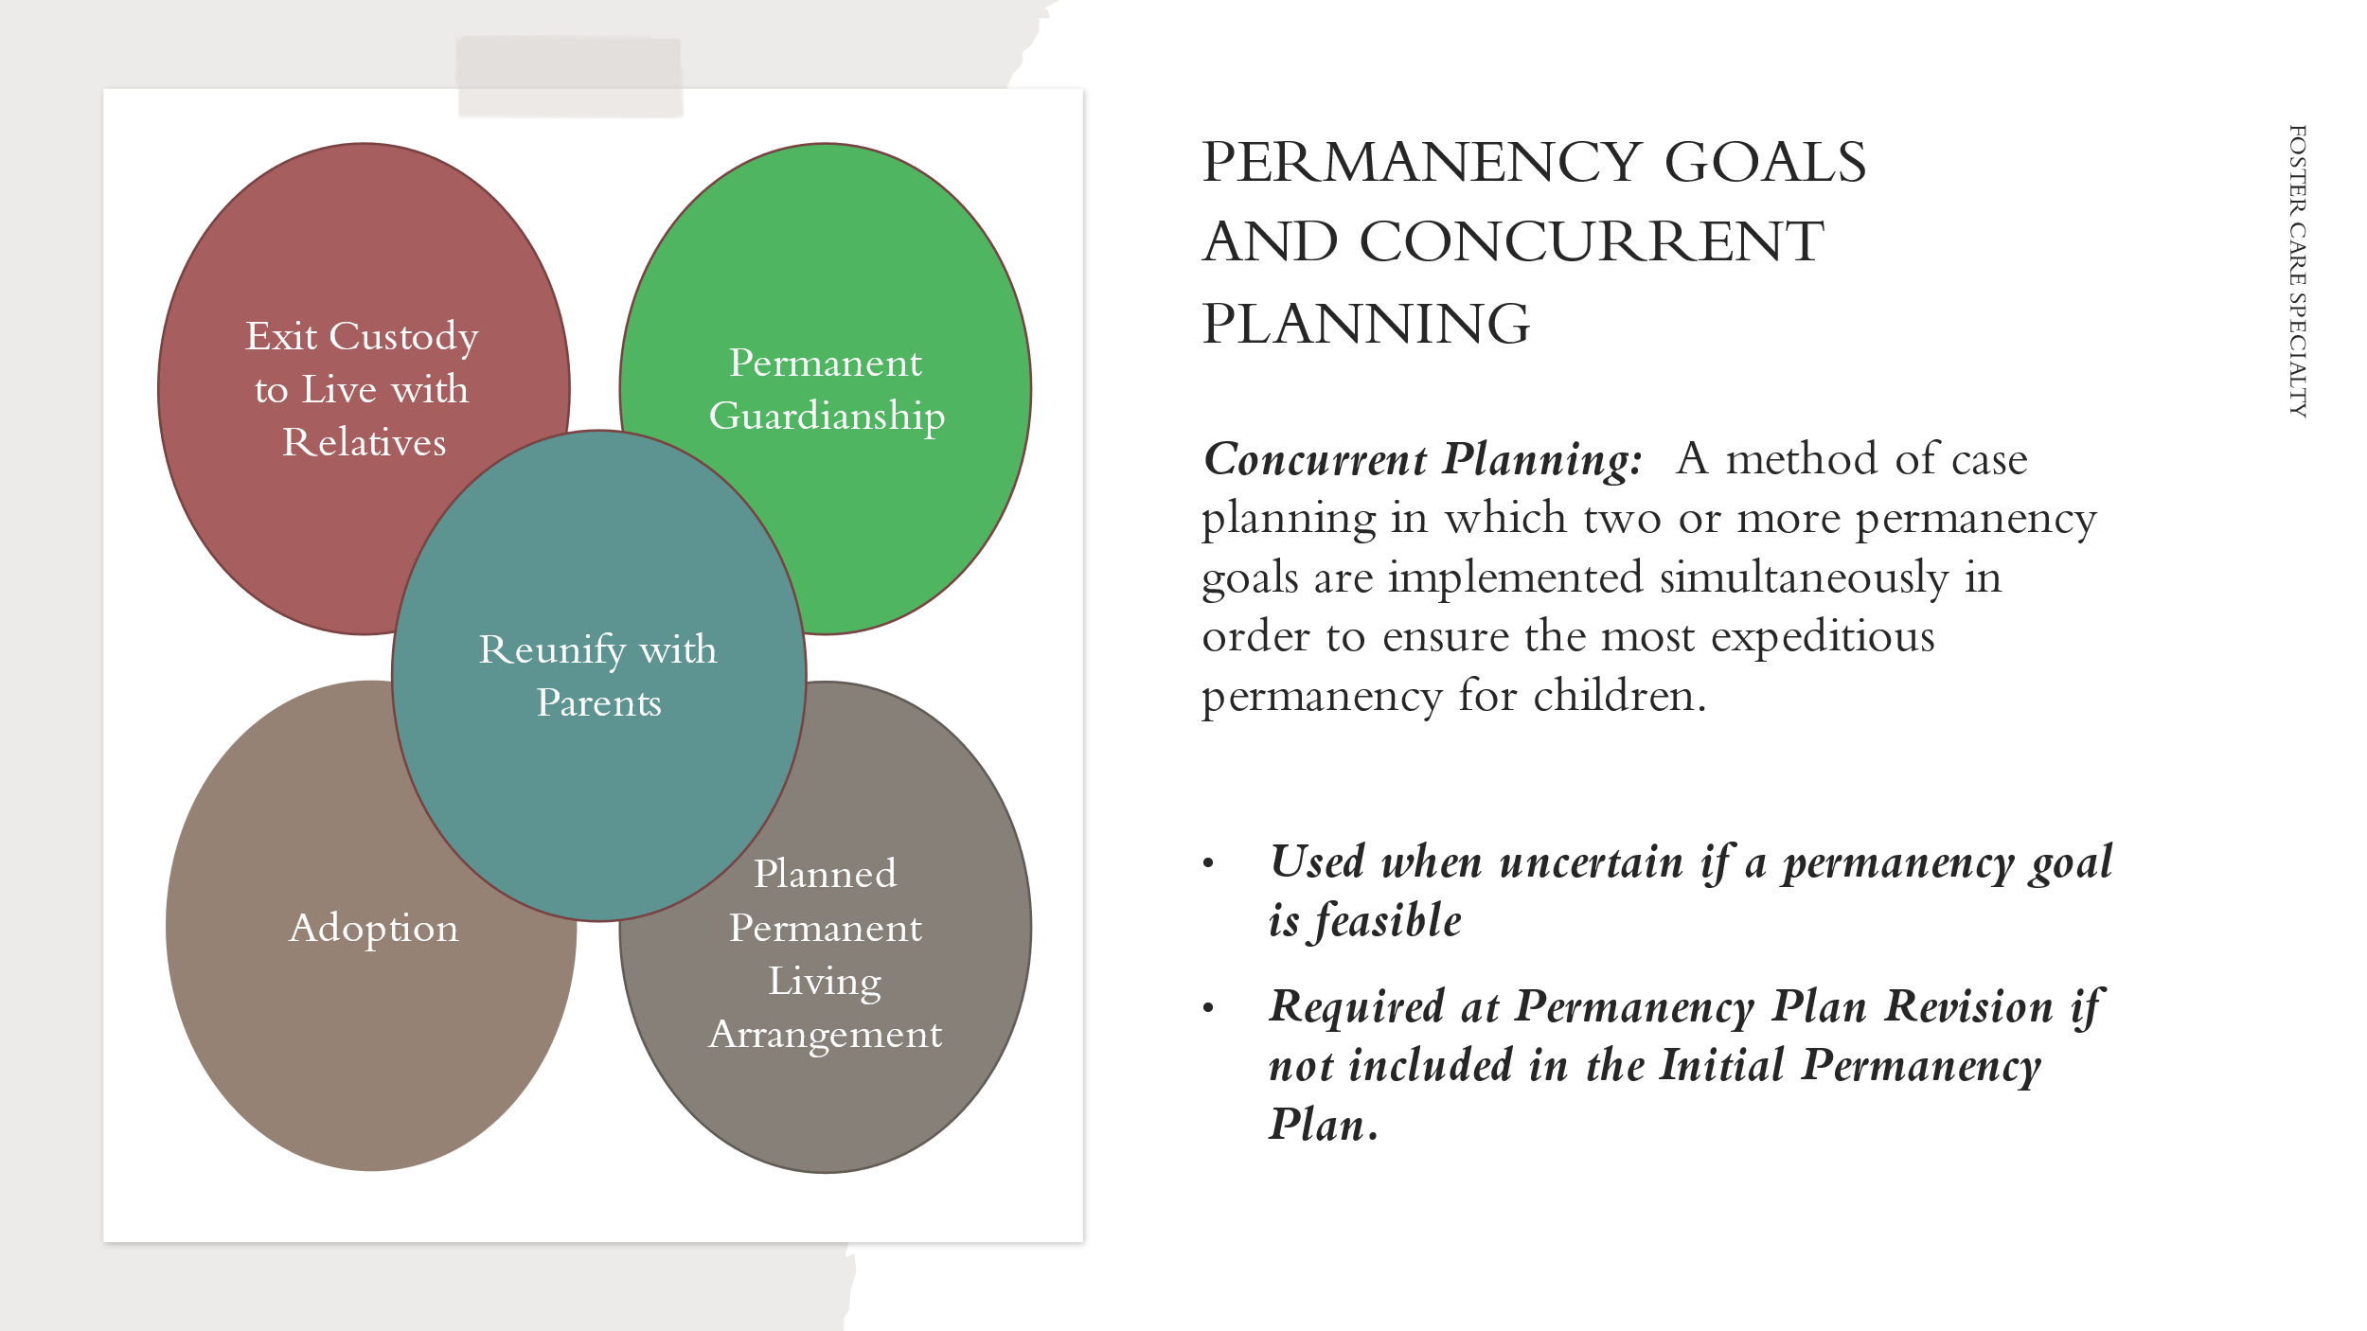
- EXPLAIN there are times when it is uncertain if a permanency goal will be feasible. POINT OUT in such cases it is appropriate to be thinking of and planning for an alternative permanency goal; that also, will be in the best interest of the child if the primary goal cannot be realized.
- REMIND concurrent planning – a method of case planning in which two permanency plan goals are implemented simultaneously in order to ensure the most expeditious permanence for children.
- STATE When reunification cannot occur, the department must consider other permanency goals to assure children achieve timely permanency. EMPHASIZE the importance of the other goals should Reunification not be possible.
- EXPLAIN concurrent planning is required at least by the Permanency Plan Revision CFTM if not already included in the Initial Permanency Plan at day 30.
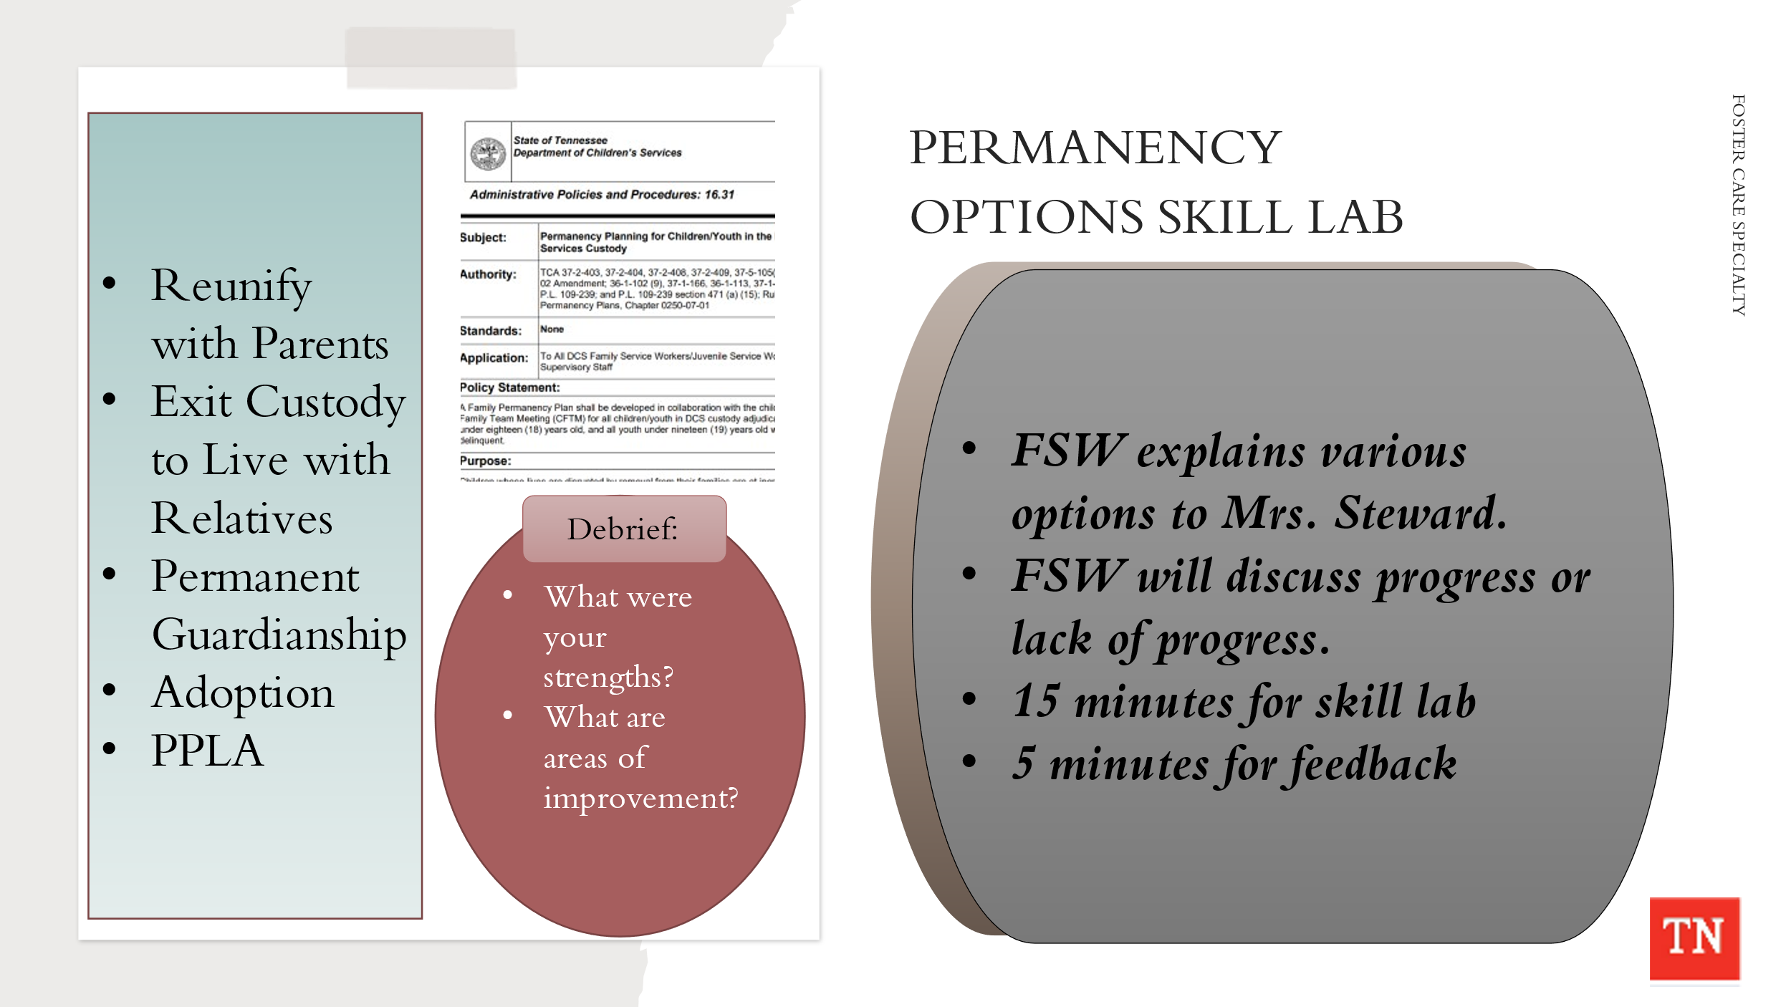
- CONDUCT ACTIVITY: Permanency Options and Concurrent Planning
- INSTRUCT the family service worker to explain the various permanency options to Marilyn and assess Marilyn’s understanding of each option. REMIND the family service worker this may be a difficult situation, but we must discuss progress or lack of progress with families. There should be no surprises when we are discussing permanency options and concurrent planning.
- ALTERNATE DELIVERY: Conduct a fishbowl with a participant as the Case Manager and another participant as Mrs. Steward.
- DIVIDE participants into small groups and INSTRUCT the groups to designate someone in each group to play the roles of Marilyn and the FSW, explaining that others in the group will be observers. EMPHASIZE for the purpose of this activity the primary interaction will be between the family service worker and Marilyn.
- ALLOW a couple of minutes for the group to decide on roles and prepare. TELL participants they will have 15 minutes to complete the skill lab and 5 minutes to conduct strengths-based feedback.
- After all interviews have been completed, DEBRIEF the exercise with the large group by asking the following questions:
- What were your strengths in discussing permanency options with a parent?
- What were some areas for improvement?
- What was it like for you to discuss permanency options with a parent who is not progressing well?
- On a scale of one to ten, where one is not comfortable at all and ten is totally comfortable, how comfortable are you with discussing permanency options with a parent not progressing well?
- ASK for questions or comments on discussing permanency options and assessing parents’ understanding.
- REFER participants to the Assessing Progress of Family Permanency Plans Handout and REVIEW.
- ASK participants for their thoughts about planning, concurrent planning and the permanency options for the Steward case family.
- EMPHASIZE the importance of preparing the family for any discussion about changing the goal from reunification. STRESS there should be no surprises during the upcoming Permanency Plan Revision CFTM and that emotionally charged issues need to be discussed with the family prior to the meeting.
- REMIND the group the CANS is an ongoing process. There are specific times we complete a CANS reassessment throughout the life of the case.
- REFER the group of the CANS Case Protocol https://files.dcs.tn.gov/policies/chap31/CANSProtocol.pdf, shared during CANS training in Pre-service week 8. There are mandatory event triggering updates and periodic updates that are required.
- STATE the CANS is updated, reviewed, and finalized no less than every six (6) months for all CANS eligible children and youth unless there are changes in the circumstances of the case which require an update sooner.
- EXPLAIN the CANS is utilized to help the CFT to discuss progress or lack of progress. The CANS will be used in the Permanency Plan Revision CFTM to ensure all strengths and need/risk/concerns are addressed on going. REMIND participants the CANS Reassessment is completed with the family.
- EXPLAIN preparing for the upcoming Permanency Plan Revision CFTM is very important. Case Managers will have the permanency options and concurrent planning discussion with families prior to the CFTM so as there will be no surprises at the meeting. ADDITIONALLY, updating the CANS is required and it helps guide the conversation in that progress and lack of progress will be discussed.
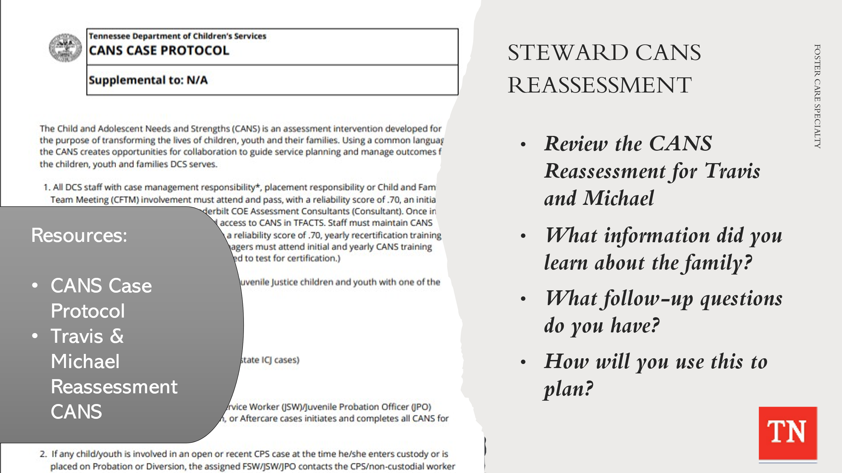
- CONDUCT ACTIVITY: Steward CANS Reassessment Review
- SUPPLY participants with the Reassessment CANS for Travis and Discharge CANS for Michael (would have been completed at discharge) completed by the Center of Excellence CANS Consultants.
- HAVE participants to compare the Initial CANS to the CANS reassessment. ALLOW 8 minutes for participants to review the CANS Reassessment completed on Travis.
- RECONVENE the group and DEBRIEF with participants. ASK participants what has changed from the initial assessment. Answer: Michael has exited to ICPC with father, Travis has stepdown to foster care with his grandparents, and charges are pending on Marilyn. ASK the following questions:
- What information did you learn about the family?
- What follow-up questions would you have for the family?
- How will you use this information to help you plan?
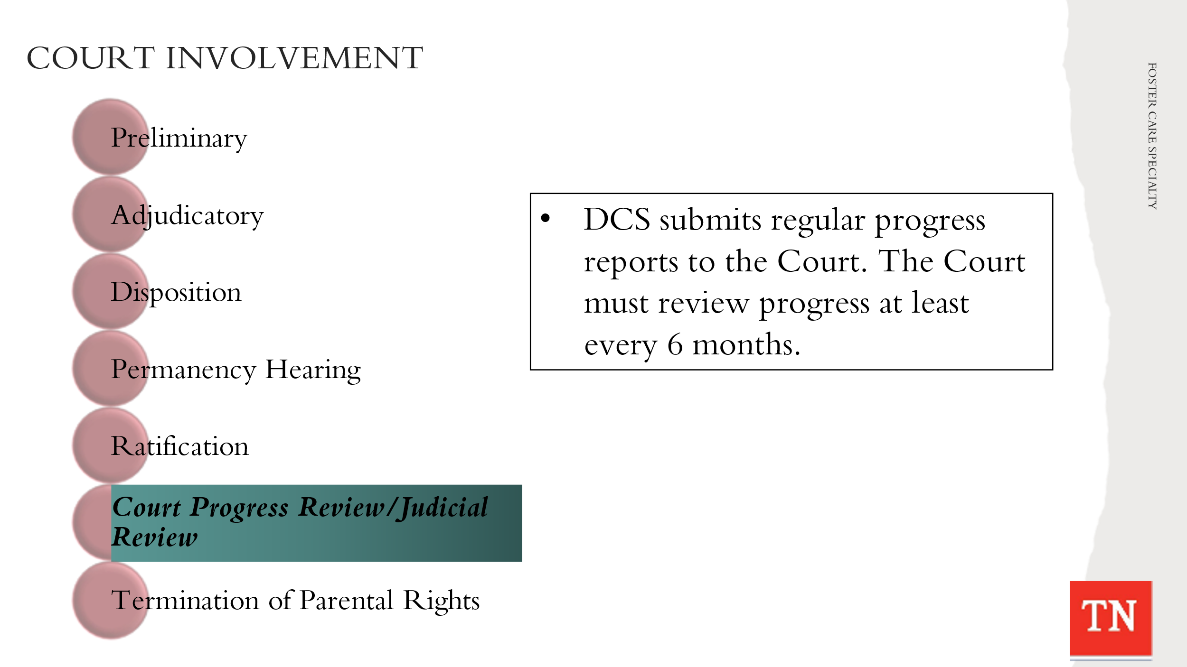
- DISCUSS with participants Court Reviews of cases. As mentioned previously, Courts conduct reviews on cases. Each Court is different, and all participants will need to consult with Regional Counsel on what Court Reviews happen in the Court jurisdictions in their areas.
  - Court Progress Review/Judicial Review
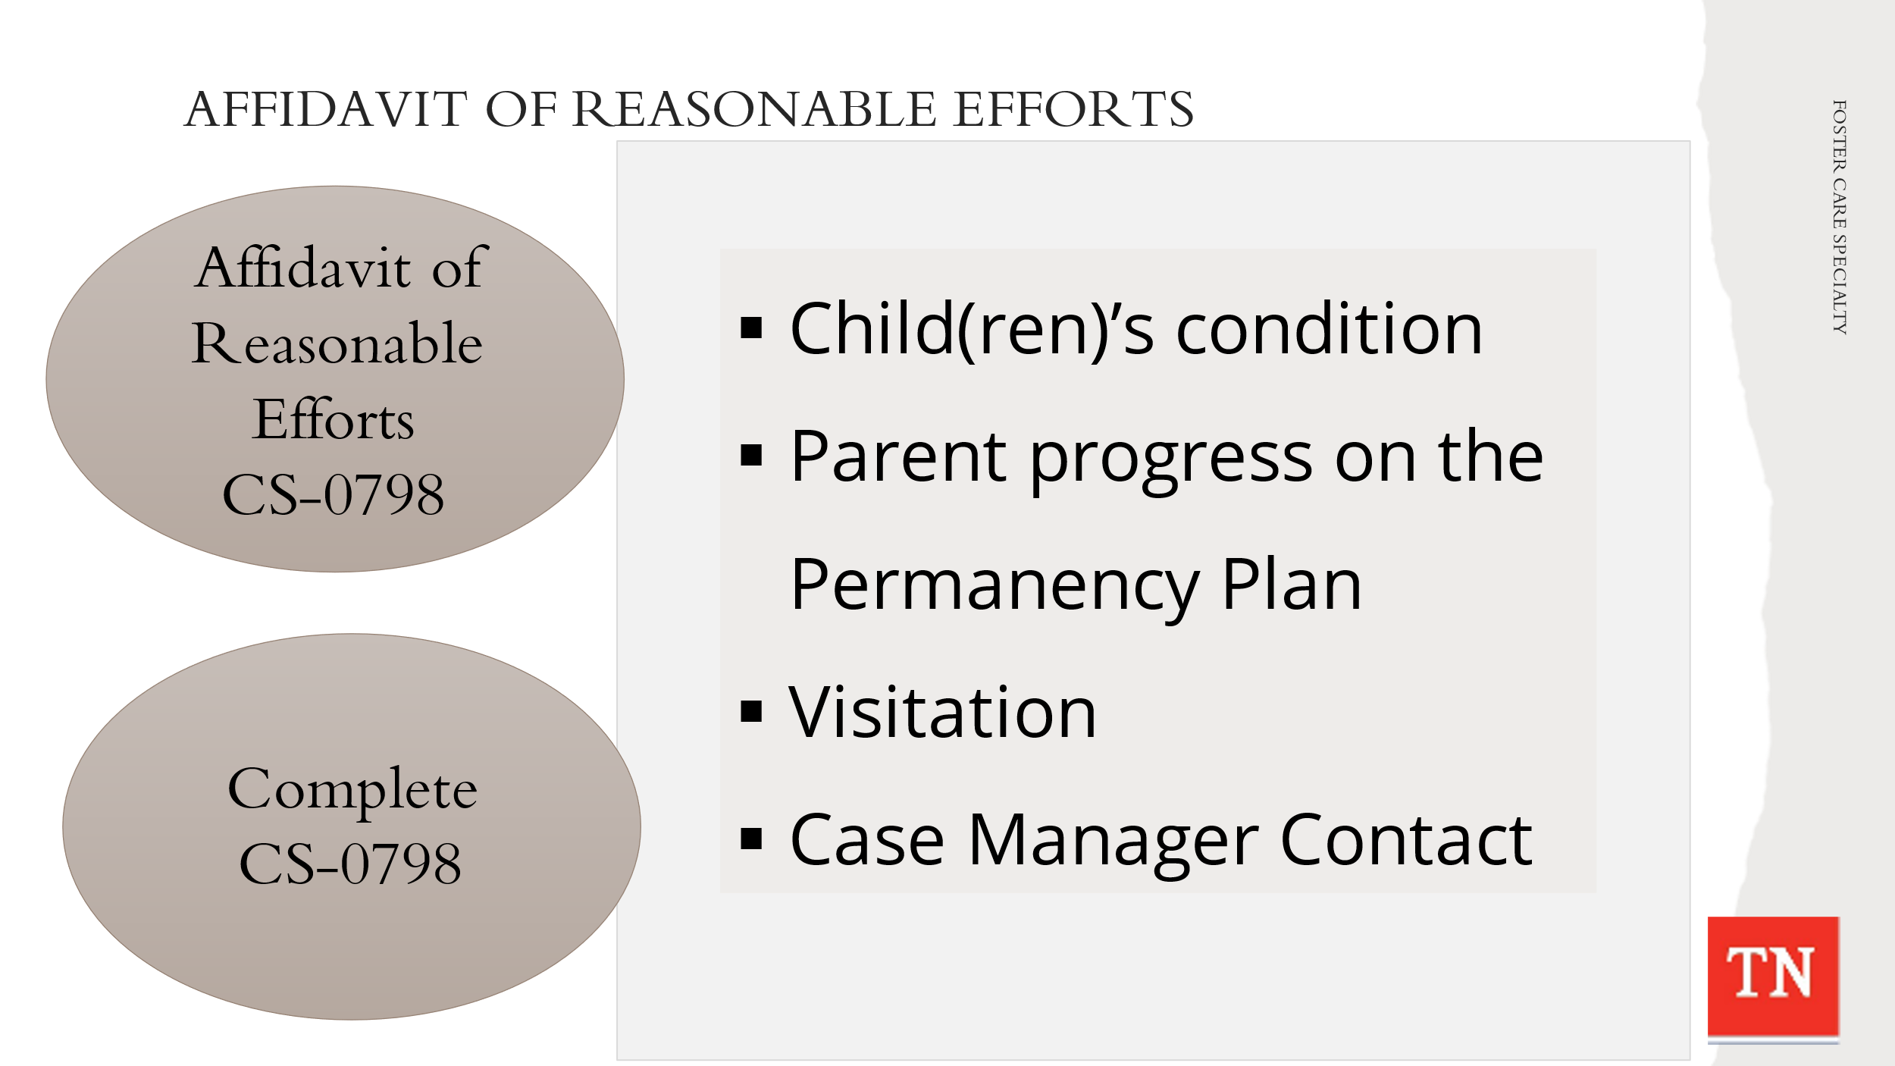
- The Department submits regular progress reports to the Court and the Court should review the progress made on the permanency plan at least every six (6) months. The six (6) month review can be held by the Court or the FCRB. Court expectations can be different, and staff will follow each Courts requirements for reviews.
- STATE Form CS-0798 Affidavit of Reasonable Efforts is used during reviews to describe the support the department has provided to help reunify the family. It asks specifically:
- What specific services are necessary to allow the child(ren) to remain in the home or to be returned to the home?
- What services have been provided to assist the family and child(ren) so as to prevent removal or to reunify the family?

- CONDUCT ACTIVITY: Affidavit of Reasonable Efforts
  - REQUEST participants to pull up Form CS-0798 Affidavit of Reasonable Efforts from the Forms and Documents drive.
  - ALLOW 10 minutes for participants to complete the document for the Steward family. EXPLAIN they can include what they think they would do on this case if needed. They will answer the following questions to complete the Affidavit:
- Child(ren)’s condition
- Parent progress on the Permanency Plan
- Visitation
- Case Manager Contact
  - ASK for a volunteer to share their Affidavit of Reasonable Efforts answers about the Steward family with the group.
- SHARE example of Steward CS-0798 Affidavit of Reasonable Efforts and ask if there are any questions.
- INFORM participants to check with your Regional Counsel to determine the forms preferred by the local courts and what must be submitted prior to the Court Reviews.

Unit 8: Case Process - Months 7, 8, & 9

Unit Time: 60 minutes

Learning Objectives:
- Participants will understand the on-going case process throughout the life of a foster care case.

Supporting Materials:
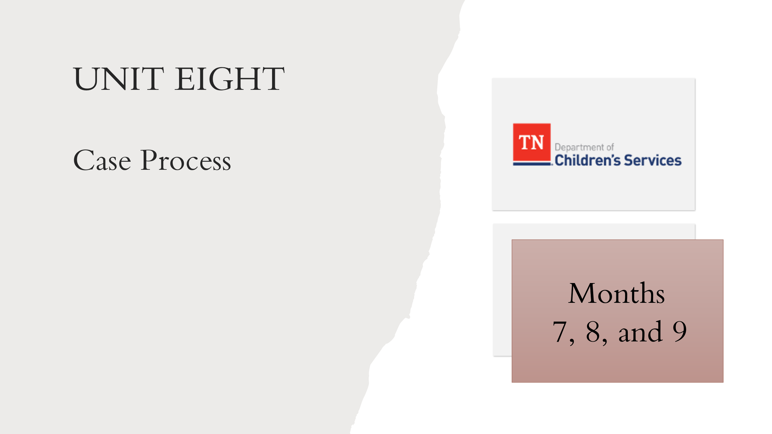
- Foster Care Specialty Week Two Facilitator Guide and PowerPoint
- Case Calendar Timeline
- CANS Case Protocol
- Form CS-1091 Termination of Parental Rights Referral

Lesson 8.1: Months 7, 8 and 9
Lesson Time: 60 minutes
Key Teaching Points / Instructions

- STATE the tasks needing to be completed on a case from day 181-270 seems to slow down a little and this is where the Practice Wheel is very important. UTILIZE Case Calendar Timeline and BRIEFLY REVIEW the tasks below. TRAINER NOTE: some tasks are applied to the Steward case and are addressed in the following lessons. Tasks for day 181-270 will include:
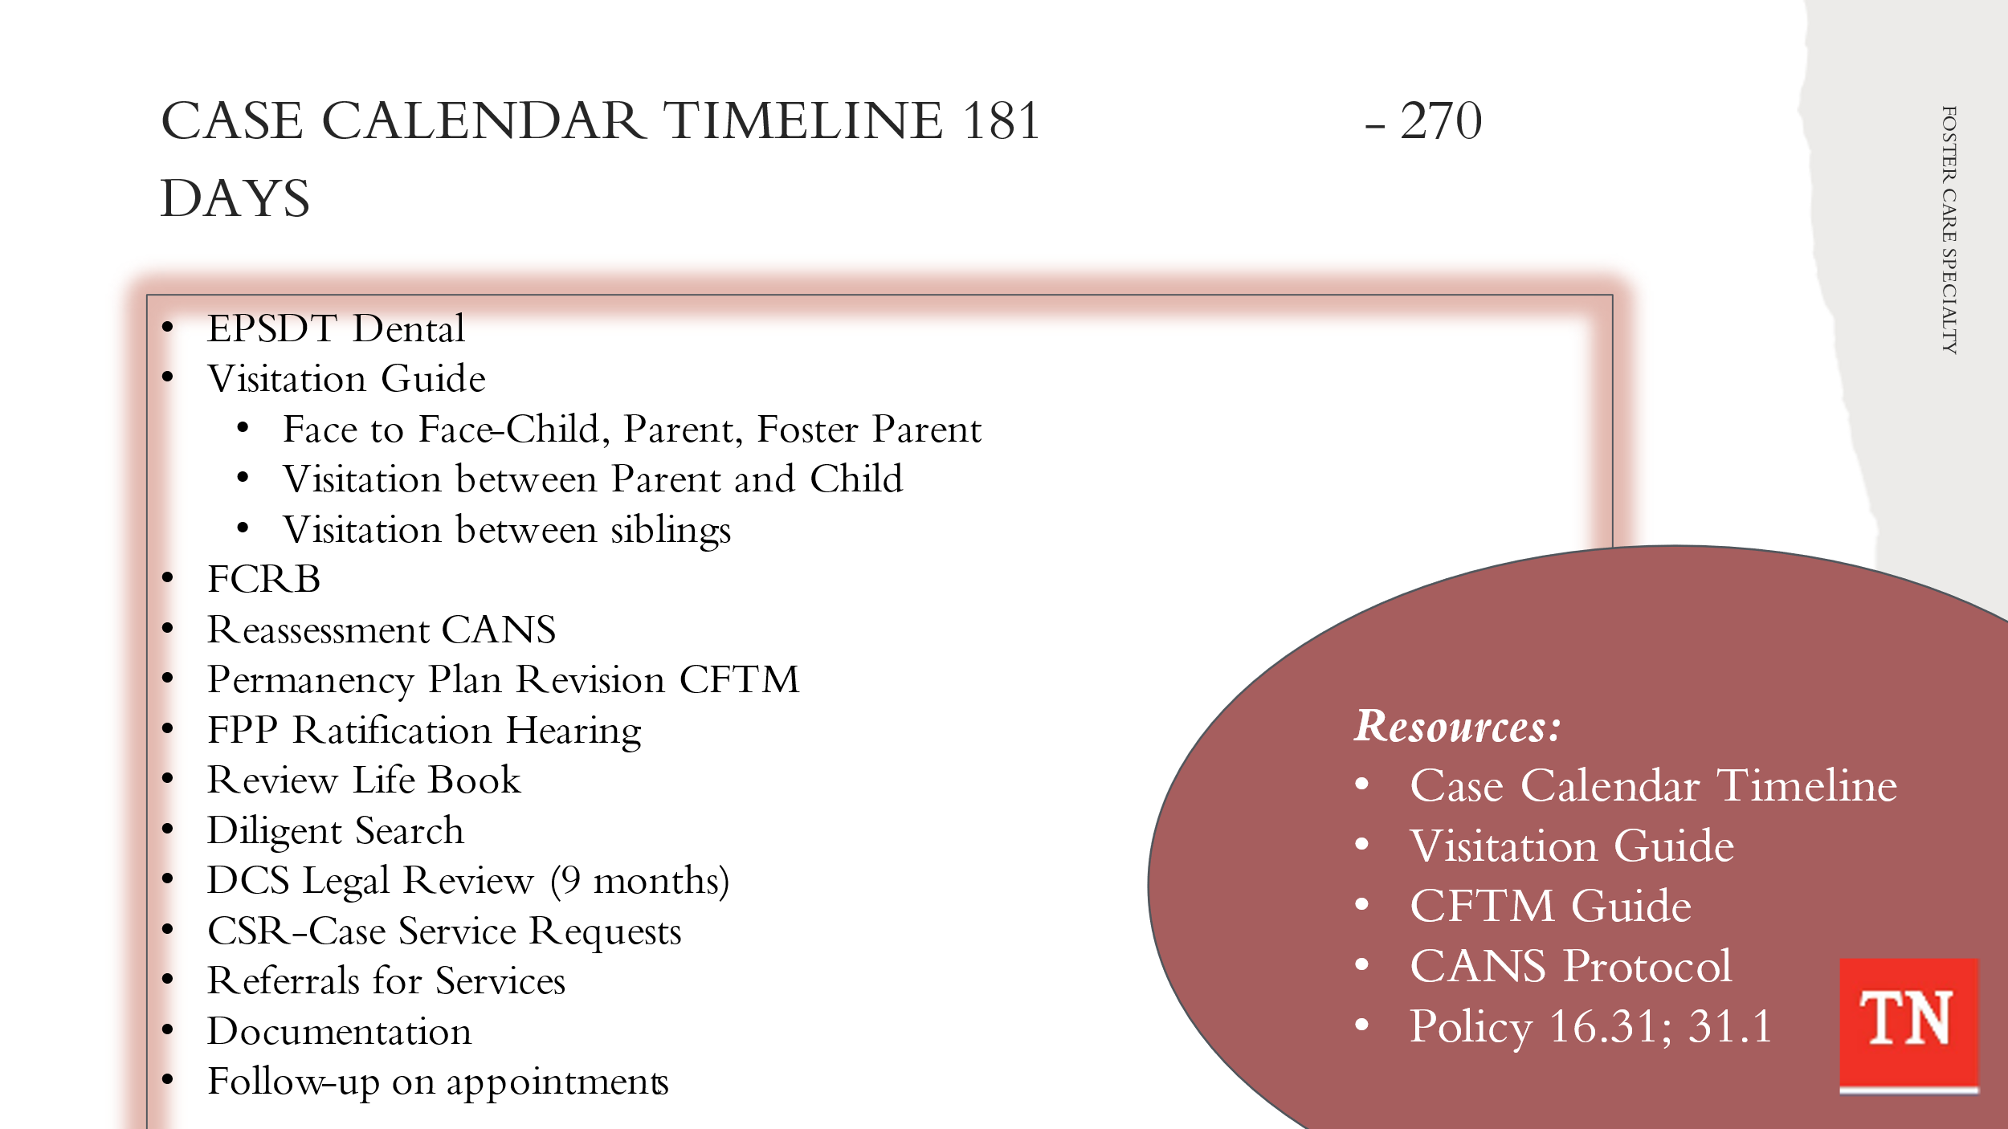
- EPSD&T Dental
- Visitation Guide – Quality contacts - Face to face child, Face to face parent, Face to face foster parents
- Visitation between child and parent - Visits should occur weekly and last at least one (1) hour in duration. Opportunities for visits between children/youth and their family occur for at least four (4) hours per month.
- Visitation with sibling not placed together - should visit with each other at least one (1) time per month.
- Foster Care Review Board (if applicable) every 6 months
- Reassessment CANS
- Permanency Plan Revision CFTM held, send CFTM Notifications, Progress Review CFTM
- Permanency Plan ratification hearing
- Review and document Life Book check quarterly
- Diligent Search quarterly
- Update Genogram quarterly
- DCS Legal Review of case due by 9-month
- Case Service Requests - ongoing if needed
- Referrals for services – ongoing if needed
- Monthly documentation
- Follow up appointments medical, dental, mental health/medication management appointment as needed/ongoing

- EMPHASIZE the Family Permanency Plans are updated before the goal achievement date expires, so in most cases this would be at least every six (6) months. Family Permanency Plans are reviewed through the quarterly progress review process, so the opportunity to update and refine activities and outcomes are revisited on a regular basis.
- TRANSITION into a group discussion about revising the Steward/Collins family permanency plan based on the updated CANS assessments and strengths and needs. ASK participants what items will be considered when revising the permanency plan for the Steward/Collins family.
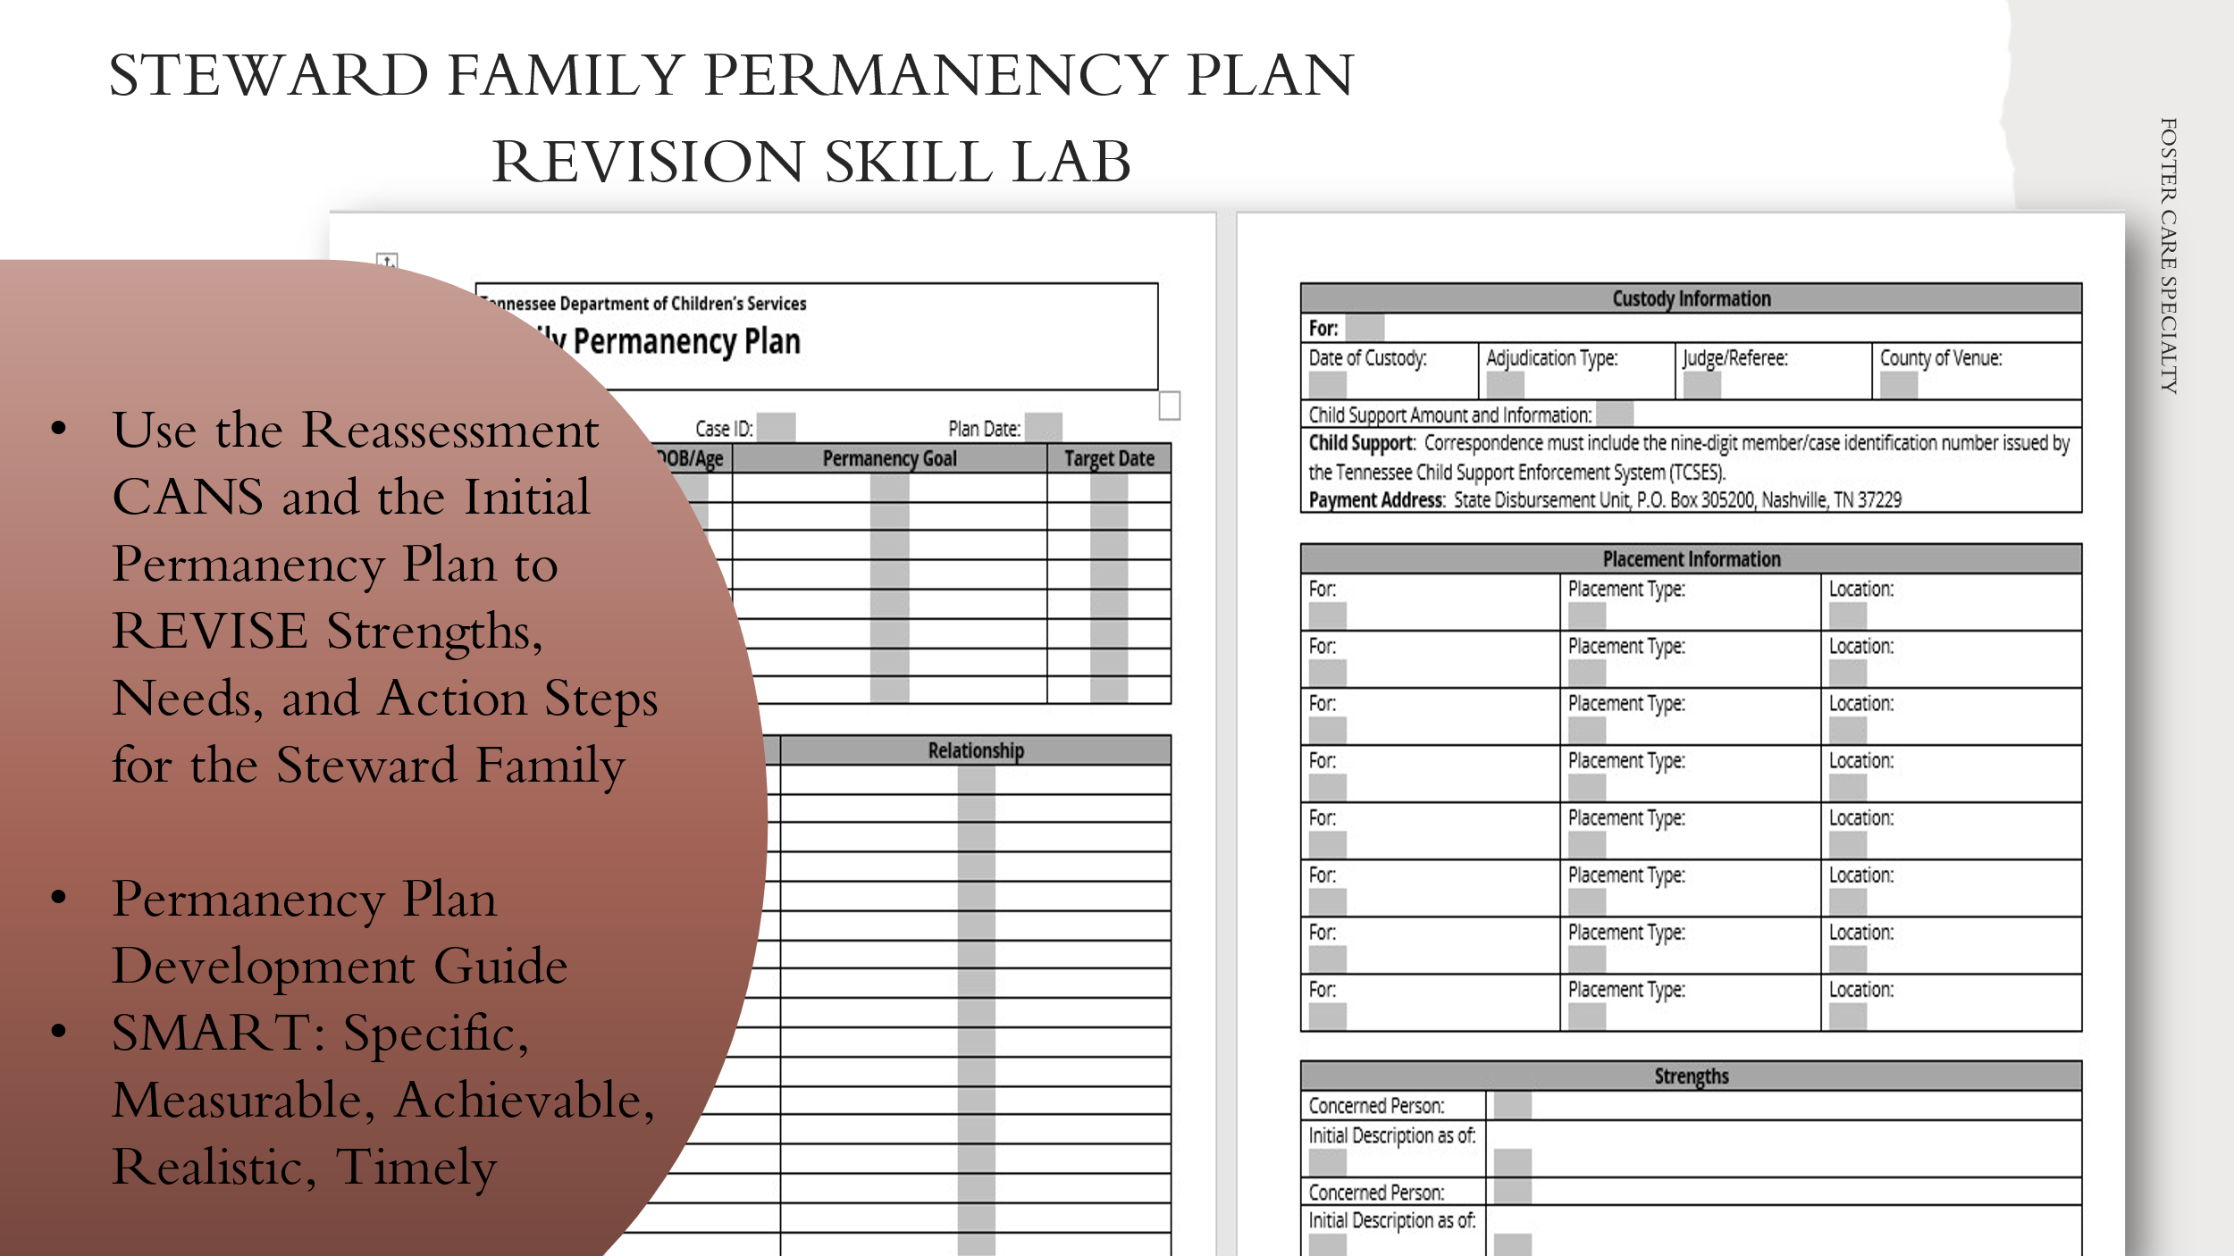
- CONDUCT ACTIVITY: Steward/Collins Family Permanency Plan Revision
- TRAINER: This activity can be done as a large group or working in small teams to brainstorm ideas as would be done in a CFTM setting. Approximately 30 minutes to complete.
- INSTRUCT the group or small teams to use the Reassessment CANS (strengths and needs/risk/concerns of Steward/Collins family) and update/revise their previous Strengths Statement, Need/Risk/Concern Statement, and Action Steps for Steward family (Marilyn or Travis).
- REMIND the group they can use the Permanency Plan Development Guide to assist them with action steps. Also, remind them of the SMART acronym when writing action steps: Specific, Measurable, Achievable, Realistic, and Timely.
- ALLOW report out and DEBRIEF the revisions to the Strengths Statements, Need/Risk/Concern Statements, and Action Steps created by the group or small teams.
- THANK the group for their hard work. ENCOURAGE participants to review Permanency Plans in the field, attend Permanency Plan Revision CFTMs and ask questions about the process of using the CANS to inform the plan.
- EMPHASIZE if progress has not been made in the first nine months, the family should be made aware that the Department could recommend a change in one or more of their permanency options. The FSW will have a discussion with Legal prior to the CFTM to discuss the status of the case and if any changes to the plan are needed.
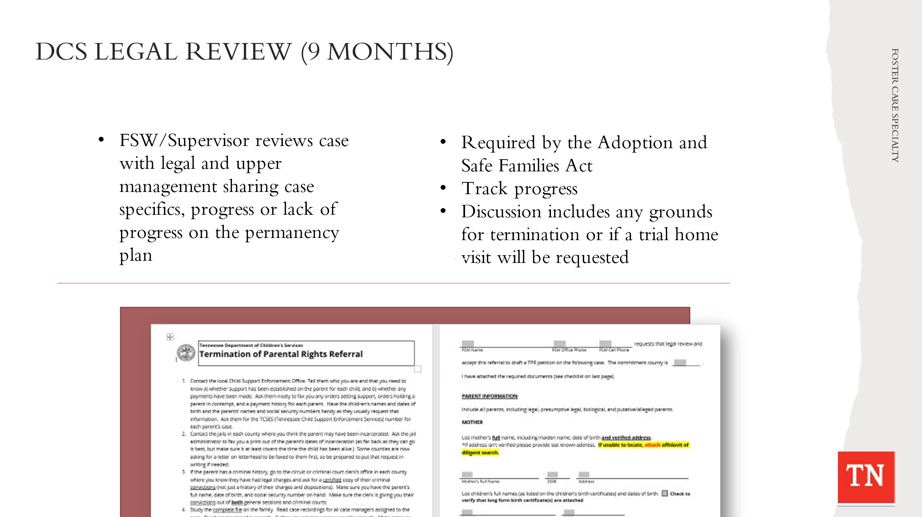
- STATE at the 9-month mark of a case a DCS Legal Review must take place. This is where the FSW has a conversation with DCS Legal sharing case specifics of progress or lack of progress on the permanency plan.
- EXPLAIN Regional Counsel will discuss any grounds of termination present and if DCS should pursue termination of parental rights.
- STATE Form CS-1091 Termination of Parental Rights Referral would be completed and submitted to legal seeking TPR.

Unit 9: Months 10 and 11

Unit Time: 20 minutes

Learning Objectives:
- Participants will understand the on-going case process throughout the life of a foster care case.

Supporting Materials:
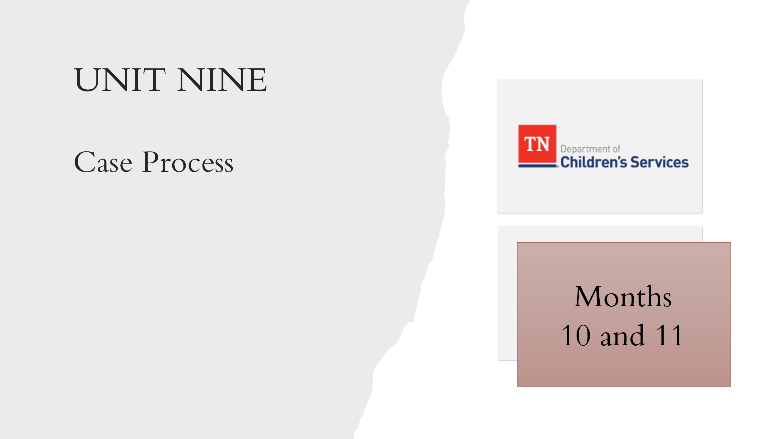
- Foster Care Specialty Week Two Facilitator Guide and PowerPoint
- Case Calendar Timeline
- Child and Family Team Meeting Guide
- Case Closure Protocol

Lesson 9.1: Months 10 and 11
Lesson Time: 20 minutes
Key Teaching Points / Instructions

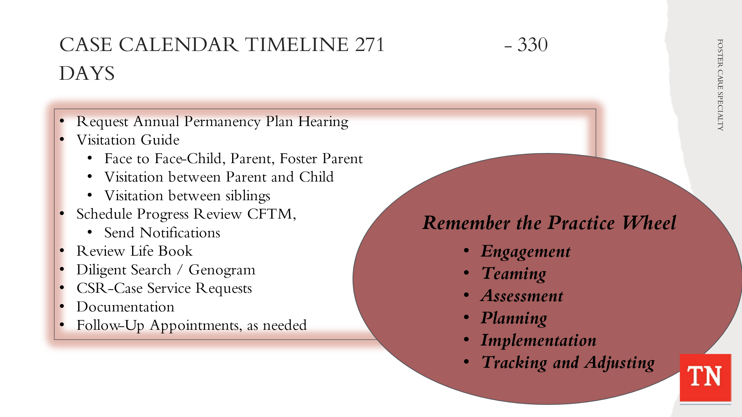
- STATE the tasks needing to be completed on a case from day 271-330. UTILIZE Case Calendar Timeline and BRIEFLY REVIEW the tasks below. TRAINER NOTE: some tasks are applied to the Steward case and are addressed in the following lessons. Tasks for day 271-330 will include:
- Request Annual Permanency Plan Hearing-must be held within year of the date of custody
- Visitation Guide – Quality contacts - Face to face child, Face to face parent, Face to face foster parents
- Visitation between child and parent - Visits should occur weekly and last at least one (1) hour in duration. Opportunities for visits between children/youth and their family occur for at least four (4) hours per month.
- Visitation with sibling not placed together - should visit with each other at least one (1) time per month.
- Schedule Progress Review CFTM quarterly, send CFTM Notifications
- Review and document Life Book check quarterly
- Diligent Search quarterly
- Update Genogram quarterly
- Case Service Requests - ongoing if needed
- Referrals for services – ongoing if needed
- Monthly documentation
- Follow up appointments medical, dental, mental health/medication management appointment as needed/ongoing

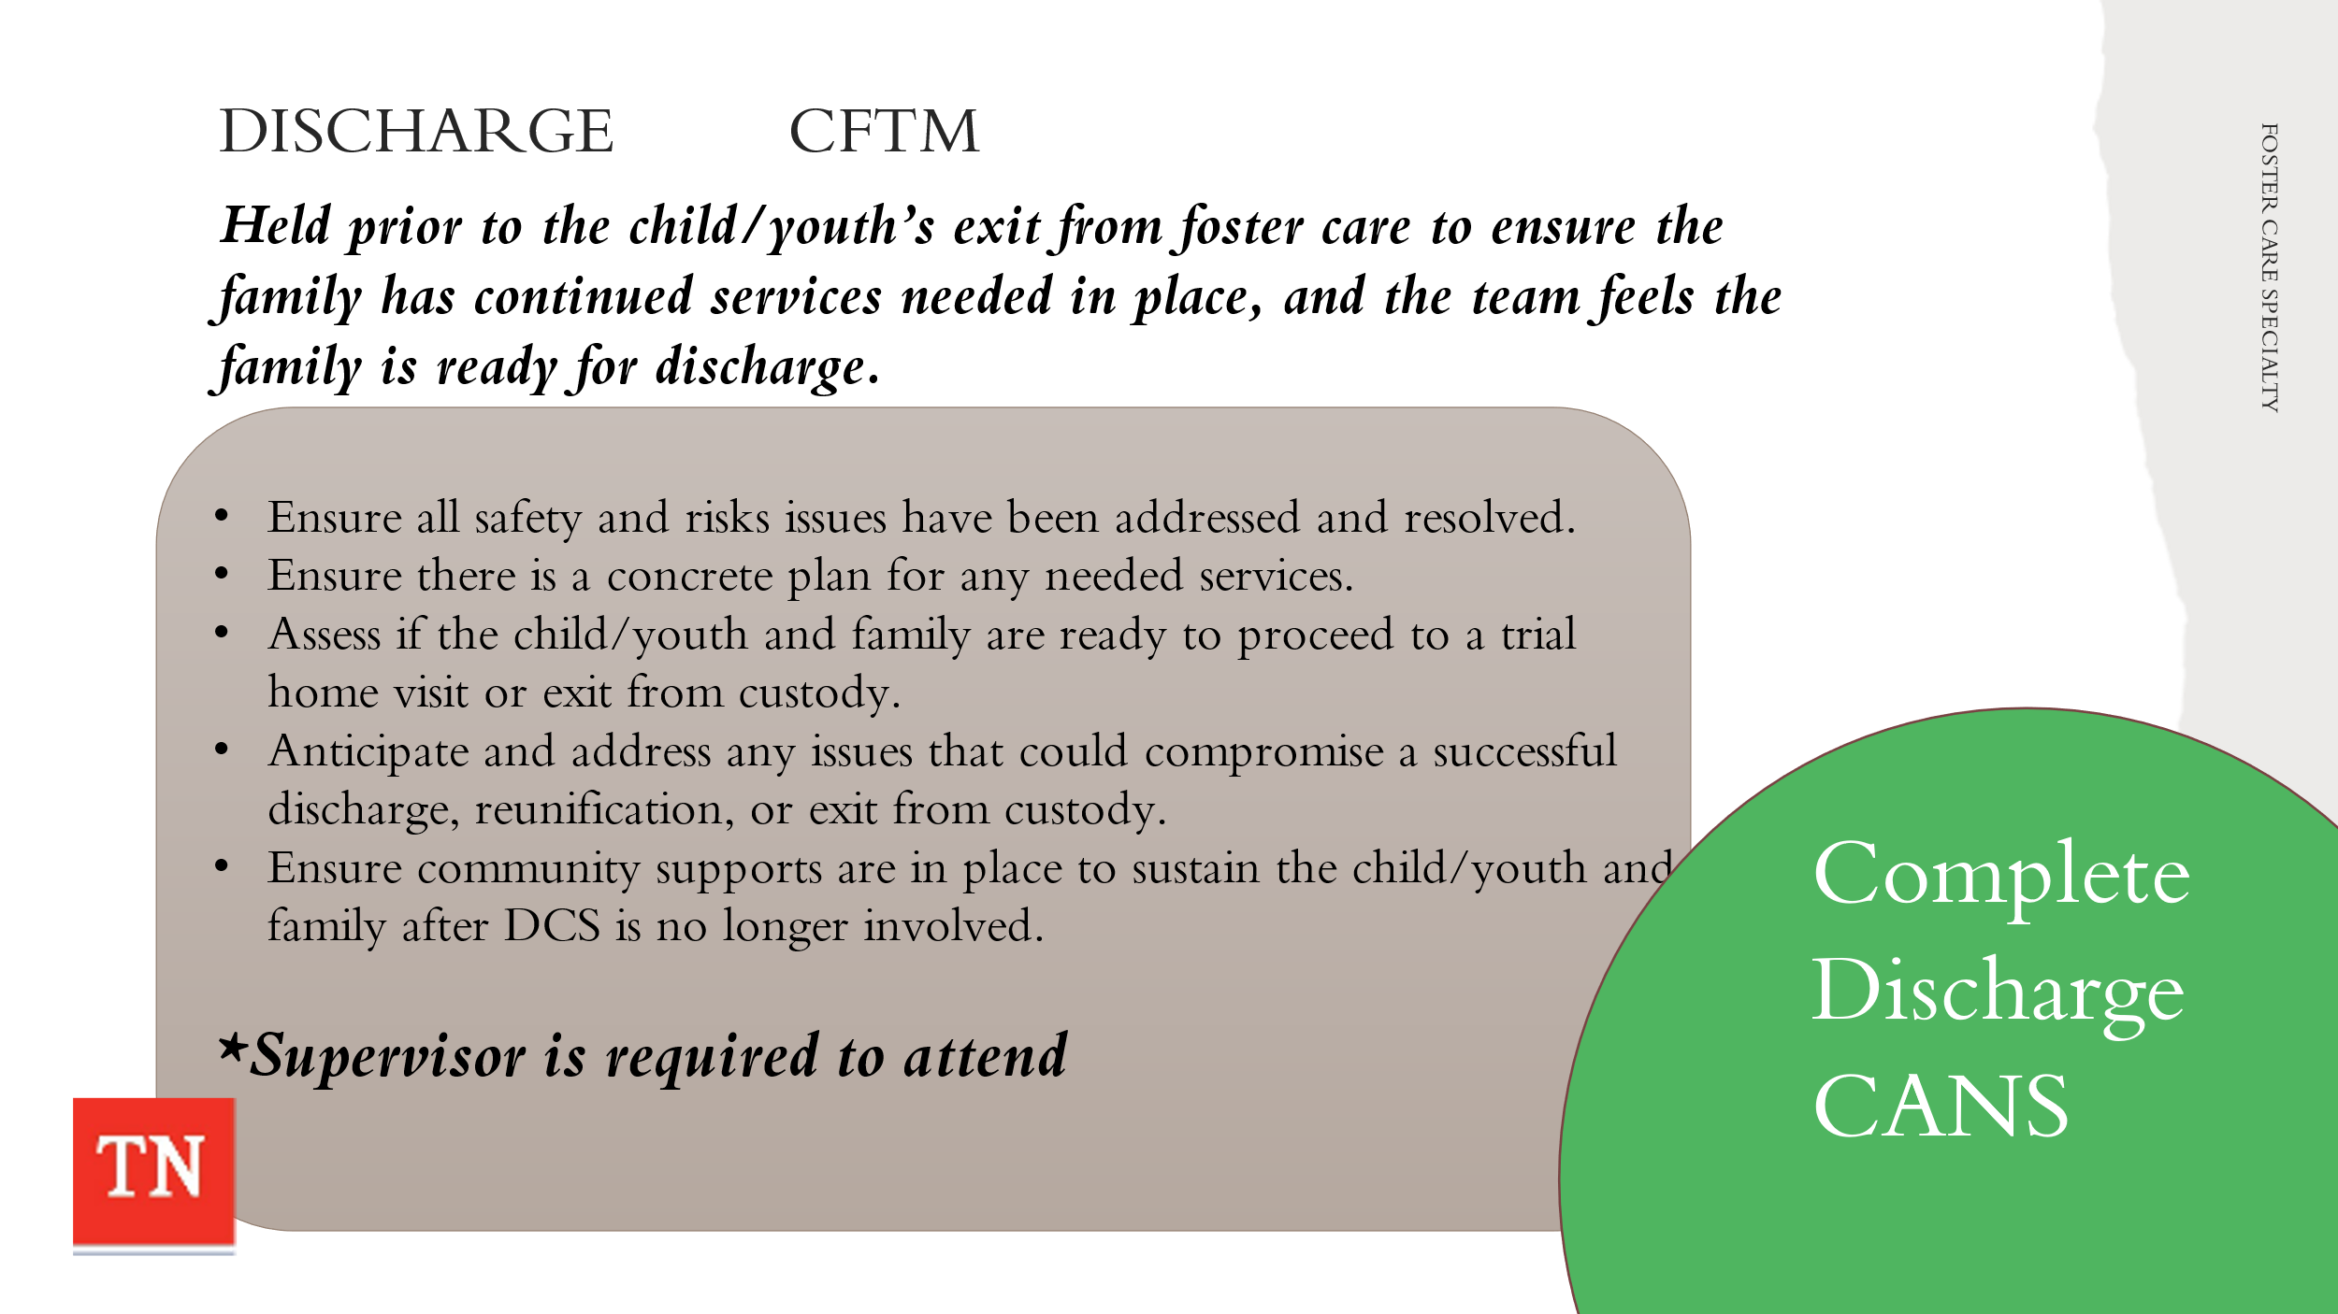
- SHARE A Discharge CFTM will be held prior to the child/youth’s exit from foster care to ensure the family has any continued services needed in place and that the team feels the family is ready for discharge.
- STATE the purpose of the Discharge/Exit CFTM is:
- To make sure that all safety and risk issues that resulted in custody have been adequately addressed and resolved.
- To ensure that there is a concrete plan for any needed services to be in place. This includes information about continued health care coverage for those receiving TennCare benefits.
- To assess if the child/youth and family are ready to proceed with a trial home visit, release or exit from custody.
- To anticipate and address any issues that could compromise a successful discharge, reunification, or exit from custody.
- To ensure that there are community supports in place to sustain the child/youth and family after DCS is no longer involved.
- EXPLAIN This meeting is critical to ensure that the services and supports are in place to make the discharge successful and prevent re-entry. A Transition CANS needs to be completed prior to this CFTM and the CANS consultant is engaged to recommend appropriate services for the needs identified by the CANS.
- SHARE Educational Stability is considered when children/youth are transitioning home. For more information on what is required in this assessment see DCS Policy 21.14, Serving the Educational Needs of the Child/Youth.
- STATE The supervisor for the case is required to attend Discharge Planning CFTMs. This ensures all safety and risk concerns are being adequately addressed and that appropriate preparation has taken place to ensure a successful discharge.
- SHARE at this time, The CFT decided Travis will exit custody to live with Mr. and Mrs. Wilson. STATE the Steward case is now ready for closure. A Trial Home Visit is not required when the youth leaves custody to live with a relative.
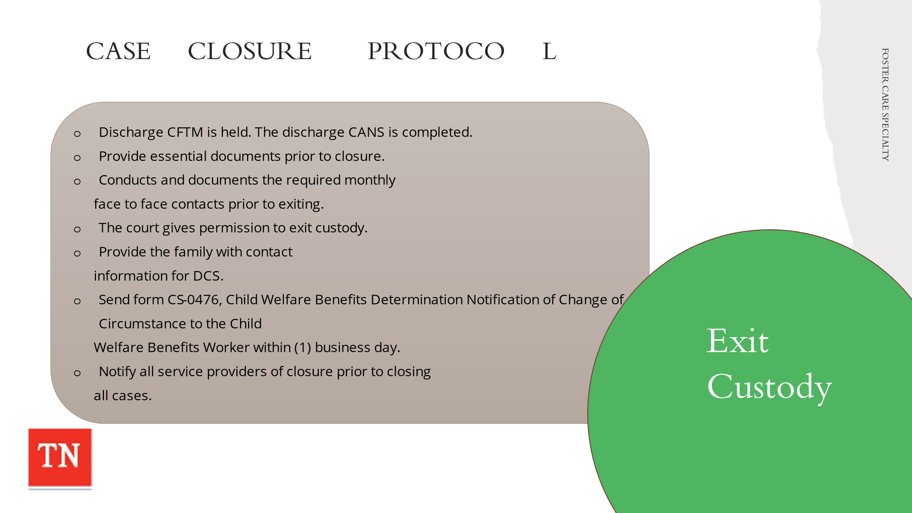
- REFER participants to the Case Closure Protocol and DISCUSS the following:
- When the Child and Family Team (CFTM) identifies a child/youth is ready to exit custody, a discharge CFTM is held. The discharge CANS is completed prior to the meeting and utilized in discharge planning. During this meeting the plan for the child to exit is developed. The DCS worker ensures that any ongoing services or necessary supports are in place for the child/youth to be successful following the custodial episode.
- The DCS Worker provides the parent/caretaker/youth with their essential documents prior to closure. Refer to Case Closure Protocol for Case Closing Essential Documents section.
- The DCS worker conducts and documents the required monthly face to face contacts with the child/youth during the calendar month of the case closure and prior to child/youth exiting custody.
- The court gives permission for the child/youth to exit custody, and this is reflected in a court order. The DCS Worker provides the parent/caretaker(s) a copy of the court order and uploads the order into the electronic case record.
- The DCS Worker provides the family with contact information for DCS should the family need assistance in the future.
- The DCS Worker sends form CS-0476, Child Welfare Benefits Determination Notification of Change of Circumstance to the Child Welfare Benefits Worker within one (1) business day, and other necessary units, as appropriate.
- The DCS Worker notifies all collaborating service providers using DCS form, CS-1126, Notification to Service Provider of a DCS Case Closure prior to closing all cases.
- EXPLAIN if a case requires a Trial Home Visit, the Visitation Guide will be followed to ensure safety, face to face quality contacts, and support required for a successful transition.

Unit 10: Year mark of custodial episode –
Month 12

Unit Time: 20 minutes

Learning Objectives:
- Participants will understand the on-going case process throughout the life of a foster care case.

Supporting Materials:

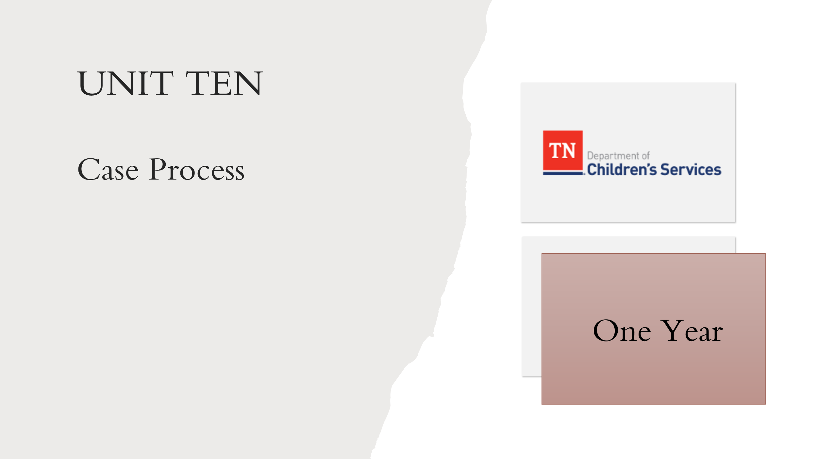
- Foster Care Specialty Week Two Facilitator Guide and PowerPoint
- Case Calendar Timeline
- Policy 16.31: Permanency Planning for Children/Youth in the Department of Children’s Custody

Lesson 10.1: Month 12
Lesson Time: 20 minutes
Key Teaching Points / Instructions
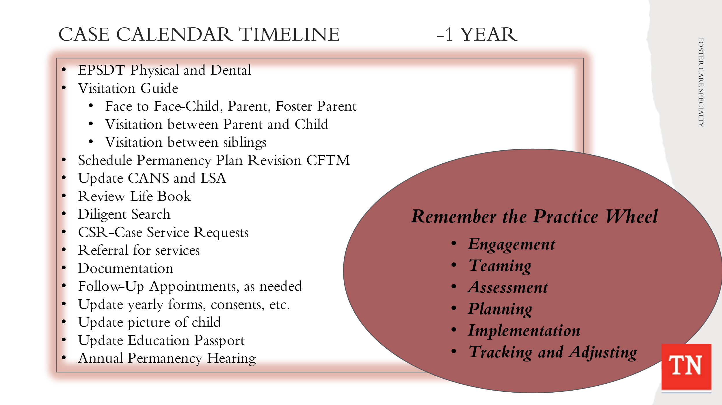
- STATE the following tasks need to be completed on a case at the year mark. UTILIZE Case Calendar Timeline and BRIEFLY REVIEW the tasks below. Tasks for the year mark will include:
- EPSD&T physical and dental (physical can be scheduled early; however, dental has to be more than 6 months from last cleaning)
- Visitation Guide – Quality contacts - Face to face child, Face to face parent, Face to face foster parents
- Visitation between child and parent - Visits should occur weekly and last at least one (1) hour in duration. Opportunities for visits between children/youth and their family occur for at least four (4) hours per month.
- Visitation with sibling not placed together - should visit with each other at least one (1) time per month.
- Update CANS and Life Skills Assessment (14+ and older)
- Schedule Permanency Plan Revision CFTM, send CFTM Notifications, Progress Review CFTM (go over Criteria for TPR and Equal Access)
- Life Book quarterly
- Diligent Search quarterly
- Update Genogram quarterly
- Case Service Requests - ongoing if needed
- Referrals for services – ongoing if needed
- Monthly documentation
- Follow up appointments medical, dental, mental health/medication management appointment as needed/ongoing
- Update yearly forms/consents/psychotropic consents/signatures
- Update picture of child
- Update Educational Passport
- Annual Permanency Plan hearing

- EXPLAIN if the Steward case extended beyond the year mark the FSW would be responsible for the yearly updates.
- DISCUSS all the tasks that are due at the year mark if a case has not achieved permanency. Many updates are required to maintain the case file yearly.
- STATE Every child in state custody has an identified permanency plan goal or concurrent permanency goals. The juvenile court uses the permanency hearing for the purpose of reviewing the appropriateness of the established goal(s) and to review progress that has been made toward achieving the permanency goal(s). Services provided to the child and/or family are also reviewed.
- STATE following the ratification of the Permanency Plan at 60 days, the court will hold a permanency hearing within twelve (12) months of the date of a child’s placement in state custody and every twelve (12) months thereafter until permanency is achieved or until the child reaches the age of majority.
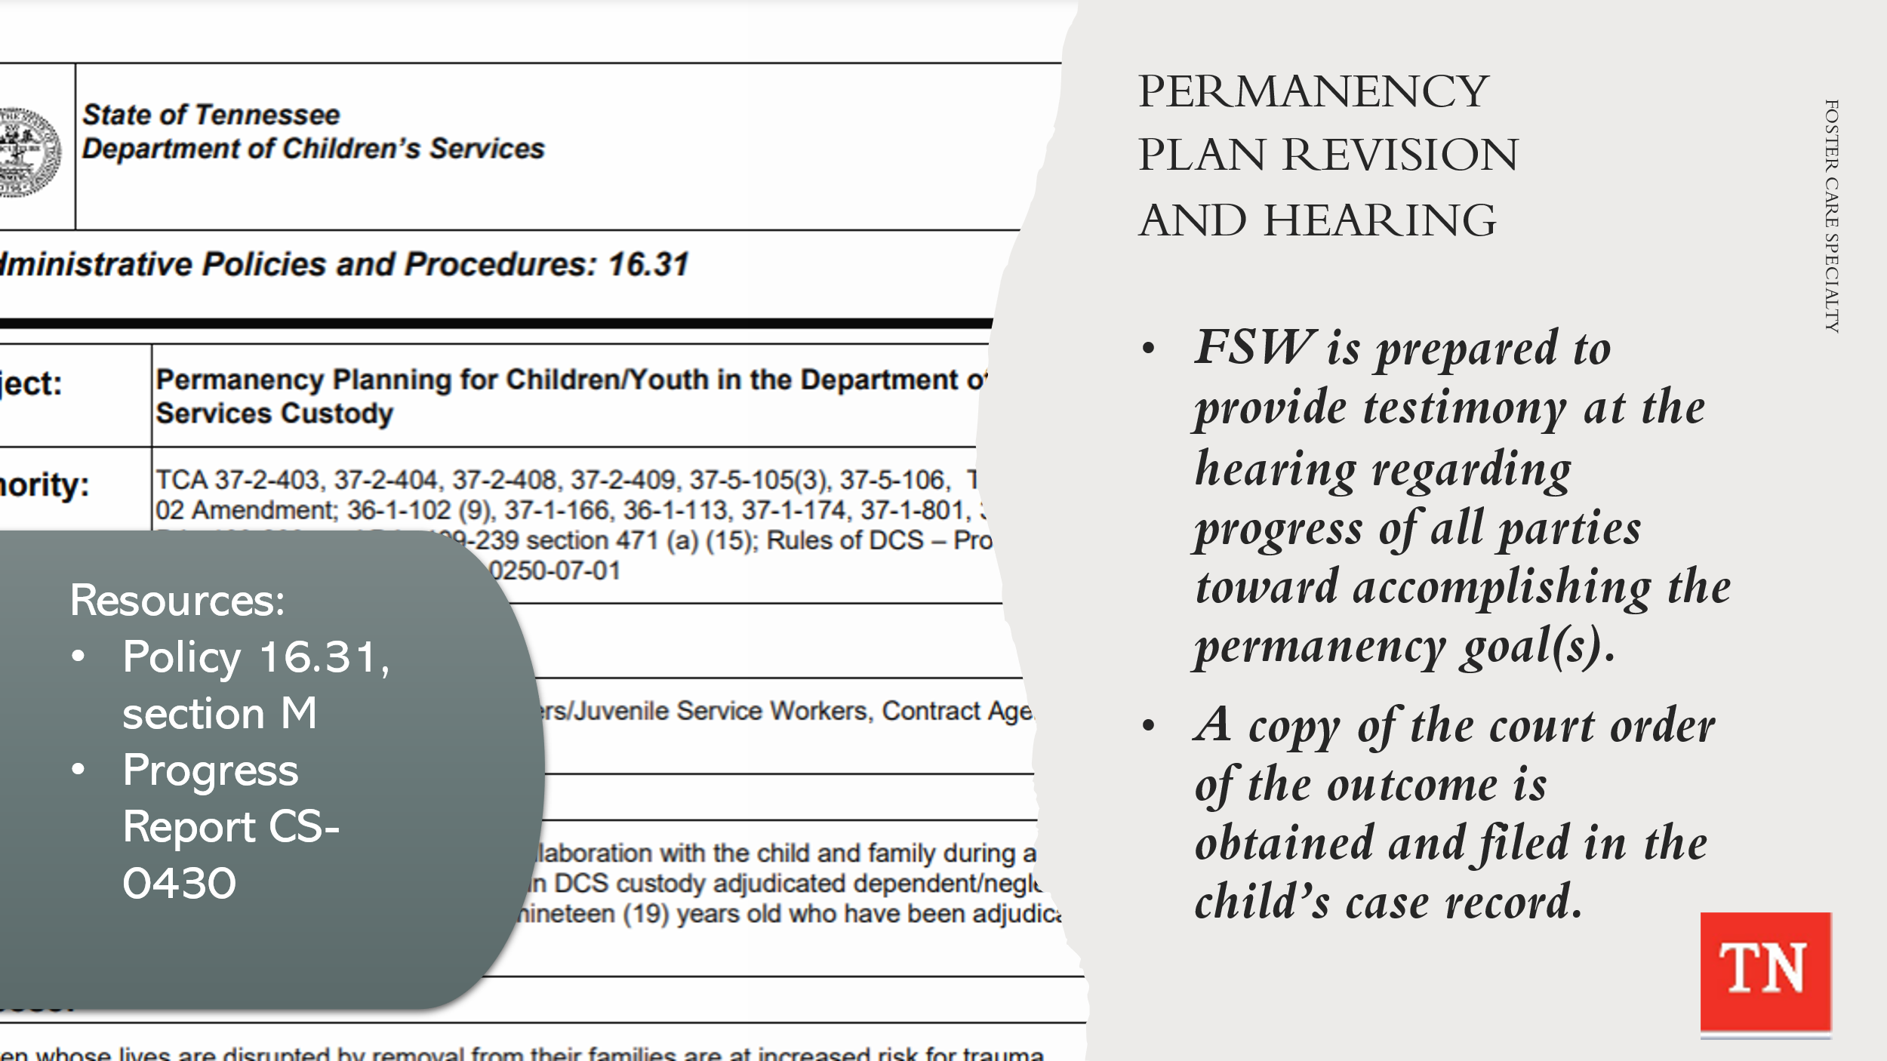
- SHARE Policy 16.31: Permanency Planning for Children/Youth in the Department of Children’s Custody Section M states at each permanency hearing DCS requests the court to determine the appropriateness of the goal, in addition to the following:
- In cases of a child/youth in an out-of-state placement, whether the placement remains appropriate and in the best interest of the child.
- In cases where the youth is sixteen (16) years or older, the services needed to assist the child in making the transition from foster care to independent living are appropriate and in the best interest of the child.
- In cases where the youth is seventeen (17), the FSW has provided and explained all available services the youth is eligible for upon turning eighteen (18) including Extension of Foster Care Services and any other opportunities available.
- The extent of compliance of all parties with the terms of the permanency plan.
- If the Department exercised reasonable efforts in assisting the family in accomplishing the tasks on the Permanency Plan.
- If the Department and resource family follow the “reasonable and prudent parent standard” in ensuring that children/ youth in their care are allowed to participate in normal childhood activities that include, but are not limited to, extracurricular, enrichment and social activities.
- The continued best interest of the use of Permanent Planned Living Arrangement (PPLA) as a sole or concurrent goal for youth where this goal is identified and the youth’s ongoing desire for this goal.
- EXPLAIN The FSW is prepared to provide testimony at the hearing regarding the progress of all parties toward accomplishing the permanency goal(s). A copy of the most recent form CS-0430, Progress Report on Child in State Custody, may be requested by the court.
- INFORM A copy of the court order reflecting the hearing’s outcome is obtained and filed in the child’s case record. DCS ensures that parents receive a copy of the court order. For children/youth who are in out-of-state placement, copies of the hearing outcome are submitted to the Tennessee Office of the Interstate Compact.
- EXPLAIN DCS will continue to work the case and offer ongoing reasonable efforts with the family toward reunification or until Permanency is achieved through other permanency options. The case will continue to be reviewed by the Court until Permanency is achieved on an annual basis.

Unit 11: Creating Normalcy through Prudent Parenting

Unit Time: 3 hours

Learning Objectives:
- Parents will understand the basic concepts of the reasonable and prudent parenting standard.
- Participants will recognize the importance of normalcy for foster children.
- Participants will implement the reasonable and prudent parent standard.
- Participants will encourage access to age-appropriate activities.
- Participants will promote “normalcy” with foster youth.
- Participants will eliminate barriers to prudent parenting.

Supporting Materials:

  - Creating Normalcy through Prudent Parenting FG and PowerPoint
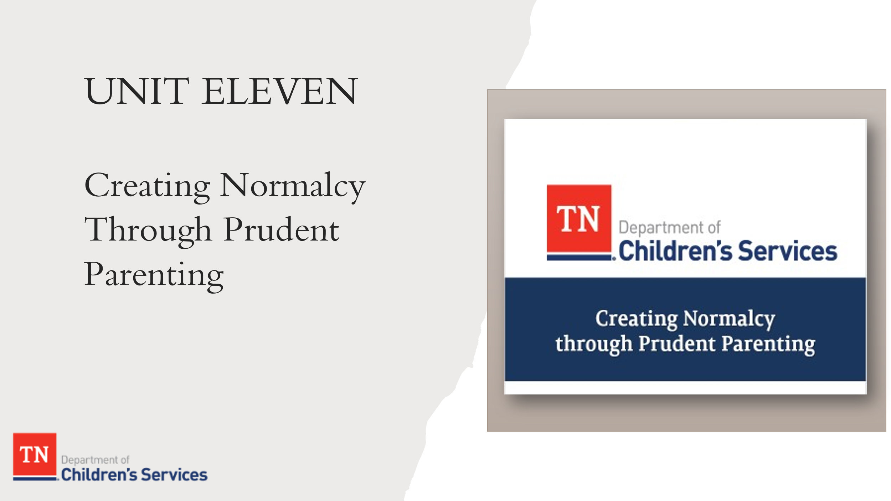

Key Teaching Points / Instructions

- TRAINER NOTE: Refer to the Creating Normalcy through Prudent Parenting Facilitator Guide and PowerPoint for the needed materials for this Unit.

Unit 12: Closing/Wrap-Up

Unit Time: 20 minutes

Learning Objectives:
- Participants will be empowered for the next steps in the Pre-Service Process.

Supporting Materials:

- Foster Care Specialty Week Two Facilitator Guide and PowerPoint
- Basic Principles to Assure Personal Safety

Lesson 12.1: Closing/Wrap-Up

Lesson Time: 20 minutes
Key Teaching Points / Instructions
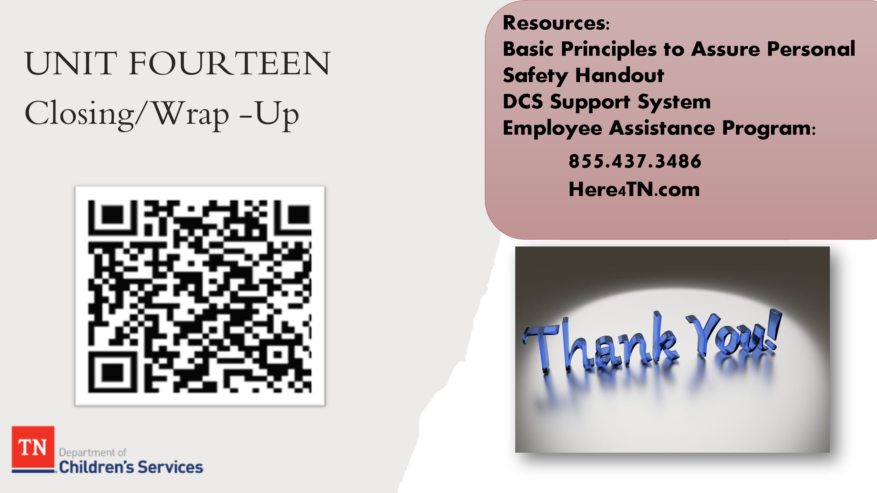
- SHARE positive outcomes for children and families involved with the Department is often due to the strong commitment of the dedicated staff. The Department is only as good as the staff who provide services to children and families and those who manage service delivery.
- STATE your well-being is important to the Department. REMIND participants we have resources at their disposal to help alleviate some of the stress and help prevent burnout.
- REFER participants to Basic Principles to Assure Personal Safety Handout and REMIND them always to be aware while working in the field.
- ADVISE participants they can utilize their DCS support system which includes their Supervisor, PDC, Mentor, Trainer, and any other DCS peers they choose if they have questions or need someone to talk to about the job or a difficult situation and/or case they may see. In addition, the state provides training opportunities that address self-care, and each region promotes varying self-care opportunities.
- Lastly, the State offers EAP (Employee Assistance Program) services. SHARE Optum contact information with the group including: 855.437.3486 or Here4TN.com to obtain your preauthorization.
- ASK participants for any final thoughts or questions from Intro, Core or Foster Care Specialty Trainings. GIVE participants an overview of what they will be doing the remaining weeks of Pre-Service.
- SHARE the next steps of the Pre-service certification process with the participants.
- THANK participants for their time and their commitment to children and families and REQUEST participants to complete the course reaction survey.

