Sharon Teebenny

steebenny@slb.com

August 2023

Version 1.0

Abstract

SEG is committed to ensuring that all HSSE policies and practices are in place to ensure a safe environment for all. This document is meant to be a guide to give direction on HSSE elements that need to be put in place to ensure a safe environment for all attendees.

SEG Events GUIDELINES

Safety First, Be Prepared

Table of Contents

**Everyday House Keeping Tips for a safer, successful Event.** 2

**SEG Conference and Meeting Guidelines** 2

**HSSE Briefing Guidelines at the start of each meeting** 2

**IMAGE event Guidelines (Annual Meeting)** 3

Hurricanes emergency guidelines 3

**Earthquakes** 4

**What to Do Before an Earthquake** 4

**What to Do During an Earthquake** 5

**Tornadoes** 5

**Extreme Heat** 6

**Reference Center for Disease, Control and Prevention https://www.cdc.gov/disasters/extremeheat/heat_guide.html** 6

**What is Extreme Heat?** 6

**What Causes Heat-Related Illness?** 6

 **Driving** 7

# **Everyday House Keeping Tips for a safer, successful Event.**

**SEG Conference and Meeting Guidelines**

1. Organizer: Identify and communicate Key points of contact for conference
2. Create an overview document/ppt based on geographical location of event (HSSE team to provide a template.
   1. This should include local safety guidelines.
   2. Dos and Don’ts in the location
   3. Highlight any health warnings in the location.
3. At the event have a graphic diagram showing the emergency exit locations
4. Key emergency response contact
5. Location of local medical emergency responders
6. Location of closest Medical Facility

**HSSE Briefing Guidelines at the start of each meeting**

* When hosting an in-person meeting, the organizer must have a safety briefing before each meeting. This should include a map.
  + Identifying Emergency exits
  + Local Emergency numbers
  + Key point of contact at the hosted location
  + Facilities in the building where the event is being held.
  + Identifying emergency response team
    - People and location
* Identification of nearest medical facility

**IMAGE event Guidelines (Annual Meeting)**

[https://www.imageevent.org/general-rules-and-regulations](https://urldefense.com/v3/__https:/www.imageevent.org/general-rules-and-regulations__;!!Kjv0uj3L4nM6H-I!j19isCgo8zDKxZc5HpvBdbe172-74ra8BVWM1tlMRE13zB2ReabZdsEyhW7JddM1GuVYOvyfWfI$)

Visitor Guidelines : Each hosting country should have specific guidelines for attendees to follow.

Please refer to the travel guidelines for US citizens and international folks

Insert link here

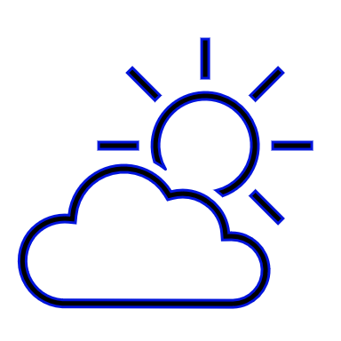 **Weather**

Natural weather occurrences can unexpectedly arise during events. It is important that everyone is aware of local country HSSE guidelines and adhere to them in event of a natural

Occurrence

[Severe Weather 101 (reference NSSL NOAA National Severe Storms Lab](https://www.nssl.noaa.gov/education/svrwx101/) )

[National Weather Service_ U.S. - Watch, Warning, Advisory Definitions](https://www.weather.gov/lwx/WarningsDefined#:~:text=The%20watch%20does%20not%20mean,that%20these%20conditions%20are%20possible.&text=A%20Hurricane%20Warning%20is%20issued,in%2036%20hours%20or%20less.)

Hurricanes emergency guidelines

Reference as extracted from the CDC (Center of Disease and Control)

**What is the best safety tip for hurricanes?**

Listen for official storm bulletins. Learn evacuation routes and prepare an evacuation plan. Assemble a disaster supply kit of dry food, safe drinking water, medical supplies, blankets, flashlights, battery-operated radios, and fire extinguishers.

**What to do during a Hurricane?**

* Stay indoors and away from windows.
* Listen to local television or radio for updates.
* Conditions may change quickly; be prepared to evacuate to a shelter or neighbor's home if necessary.

[**CDC hurricane preparedness guidelines**](https://www.cdc.gov/disasters/hurricanes/before.html)

[**Prepare for a Flood**](Prepare%20for%20a%20Flood)

[**Stay Safe After a Hurricane or Tropical Storm**](https://www.cdc.gov/disasters/hurricanes/after.html)

**Earthquakes**

**What to Do Before an Earthquake**

* Make sure you have a fire extinguisher, first aid kit, a battery-powered radio, a flashlight, and extra batteries at home.
* Learn first aid.
* Learn how to turn off the gas, water, and electricity.
* Make up a plan of where to meet your family after an earthquake.
* Don't leave heavy objects on shelves (they'll fall during a quake).
* Anchor heavy furniture, cupboards, and appliances to the walls or floor.
* Learn the earthquake plan at your school or workplace.

**What to Do During an Earthquake**

* Stay calm! ...
* If you're indoors, stand against a wall near the center of the building, stand in a doorway, or crawl under heavy furniture (a desk or table). ...
* If you're outdoors, stay in the open away from power lines or anything that might fall. ...
* Don't use matches, candles, or any flame.
* If you're in a car, stop the car and stay inside the car until the earthquake stops.
* Don't use elevators (they may shut down).

[**Earthquakes Disaster Preparedness**](https://www.cdc.gov/disasters/earthquakes/index.html)

[**FEMA’s Earthquake Safety Checklist**](https://www.fema.gov/media-library-data/1510153676317-82124ab3b0a31ea239f60acc8d46c2ba/FEMA_B-526_Earthquake_Safety_Checklist_110217_508.pdf)

**Tornadoes**

[**Tornadoe Preparedness**](https://www.cdc.gov/disasters/tornadoes/index.html)

What are 5 warning signs that a tornado may occur?

**Tornado Warning Signs List**

* The color of the sky may change to a dark greenish color.
* A strange quiet occurring within or shortly after a thunderstorm.
* A loud roar that sounds similar to a freight train.
* An approaching cloud of debris, especially at ground level.
* Debris falling from the sky.

**Extreme Heat**

**Reference Center for Disease, Control and Prevention** [**https://www.cdc.gov/disasters/extremeheat/heat_guide.html**](https://www.cdc.gov/disasters/extremeheat/heat_guide.html)

Heat-related deaths and illnesses are preventable. Despite this fact, more than 600 people in the United States are killed by extreme heat every year. This website provides helpful tips, information, and resources to help you stay safe in the extreme heat this summer. Learn more [about extreme heat](https://www.cdc.gov/disasters/extremeheat/heat_guide.html).

### **What is Extreme Heat?**

Extreme heat is defined as summertime temperatures that are much hotter and/or humid than average. Because some places are hotter than others, this depends on what’s considered average for a particular location at that time of **year**. Humid and muggy conditions can make it seem hotter than it really is.

### **What Causes Heat-Related Illness?**

[Heat-related illnesses](https://www.cdc.gov/disasters/extremeheat/warning.html), like heat exhaustion or heat stroke, happen when the body is not able to properly cool itself. While the body normally cools itself by sweating, during extreme heat, this might not be enough. In these cases, a person’s body temperature rises faster than it can cool itself down. This can cause damage to the brain and other vital organs.

Some factors that might increase your risk of developing a heat-related illness include:

* High levels of humidity
* Obesity
* Fever
* Dehydration
* Prescription drug use
* Heart disease
* Mental illness
* Poor circulation
* Sunburn
* Alcohol use

[**Extreme Heat Guidelines**](https://www.cdc.gov/disasters/extremeheat/index.html)

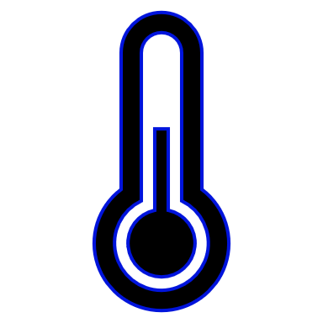**Extreme Cold**

**Weather changes can occur rapidly and in the case of extreme cold weather the following are general guidelines.**

* Minimize travel.
* Stay indoors during the worst part of the extreme cold.
* Keep a winter survival kit in your vehicle if you must travel.
* Check tire pressure, antifreeze levels, heater/defroster, etc.
* Learn how to shut off water valves for potential pipe bursts.
* Check on the elderly.
* Bring pets inside.

[**Extreme cold guidelines (National weather service US**](https://www.weather.gov/safety/cold)

 **Driving**

Driving is one of the biggest hazards worldwide. It is important to obey local rules and regulations in the local country location to ensure a safe experience.

**What are the OSHA driving safety tips?**

Use a seat belt at all times – driver and passenger(s).

Be well-rested before driving.

Avoid taking medications that make you drowsy.

Set a realistic goal for the number of miles that you can drive safely each day.

Drive to conditions, slow down when weather conditions are bad. Stop for all stop signs and red lights. Pass carefully when it's legal and safe.