CURRICULUM POLICY

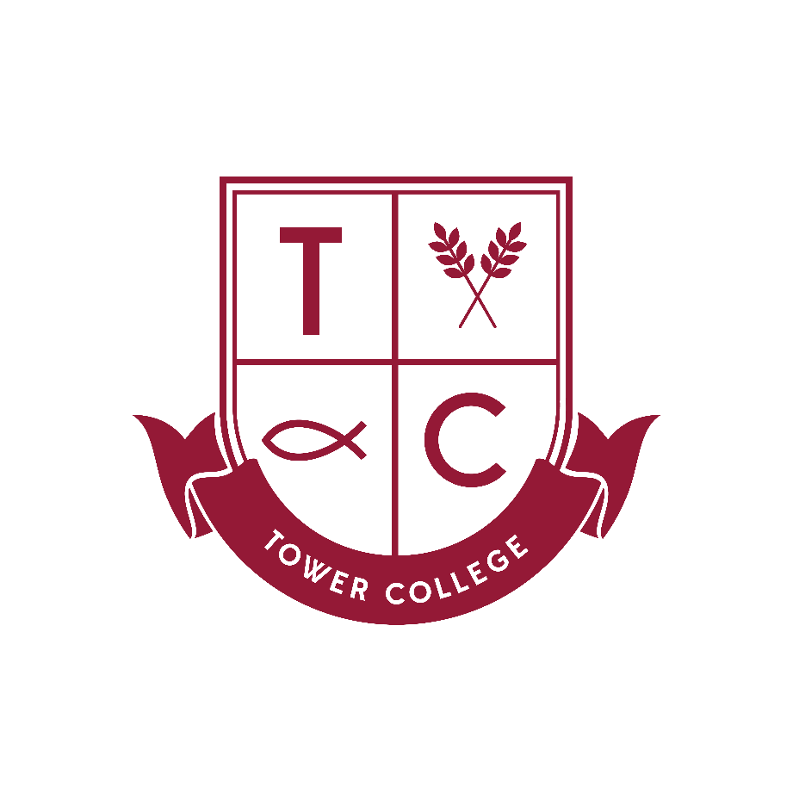

Date of Policy: February 2019
Review Date*: February 2020
Coordinator (s): Mrs A O’Grady and Mrs P Knox
Governor: Mr D Oxley
* Policy Review: Annually unless otherwise dictated by the FGB (Full Governing Body) or by changes in legislation.

Tower College Curriculum Policy
Introduction 3
Aims 4
Main Principles 4
Outcomes 5
Areas of Experience 5
Pupil Skills 6
SMSC Elements 7
Curriculum Planning 8
Assessment for Learning 9
Special Needs 10
Role of the Co-ordinator 11
Educational Visit and Visitors 12
Equal Opportunities 12
Raising Awareness of this Policy 12
Policy Review 12
EARLY YEARS FOUNDATION STAGE CURRICULUM POLICY 13
Introduction 13
Purpose of study 14
Aims 14
The Curriculum 15
Planning 15
Provision 16
Assessment, Recording and Reporting 17
Feedback to pupils 18
Recognising children’s achievements 18
Special Educational Needs (see also Policy for Special Educational Needs) 18
Equal Opportunities (see also Equal Opportunities Policy) 19
Resources 19
Links with parents 20
The role of the EYFS Leader 21

Introduction
We use both the flexibility within and without the National Curriculum to meet the needs and talents of the pupils in this school. We are aware that by drawing upon the National Curriculum in many areas as well as augmenting this with our own study programmes, we are satisfying the requirements of a broad and balanced curriculum.

We believe that we enable our pupils to achieve the highest academic and personal standards of which they are capable by providing them with challenges and the life skills that they need in order to take their place in society. We want all our children to succeed.

We provide for all children a broad and balanced curriculum that promotes their spiritual, moral, cultural, mental and physical development while preparing them for the opportunities, responsibilities and experiences in adult life in democratic Britain.

We see the development of English, Mathematics, Science and I.C.T. as central to our curriculum work, balanced with the humanities and expressive arts. Also, the experiences of the children will be enriched by a range of planned extra-curricular activities.

We strive to provide a curriculum that all pupils will find relevant and fulfilling. This can only be achieved by using the experience, enthusiasm and specialism of individual teachers who provide interesting, relevant, purposeful and differentiated lessons based on real-life experiences, wherever possible, in a structured well-ordered classroom environment.

Aims
The purpose of the curriculum is to help pupils to:
- have a broad, exciting and challenging curriculum that embraces the five outcomes set out in Every Child Matters.
- have the essential knowledge they need to be educated citizens in democratic Britain.
- have an awareness of and respect for a diversity of cultures, values, beliefs and abilities.
- acquire knowledge and skills relevant to adult life and a world of rapid and continuous technological change;
- have sound numeracy and literacy skills;
- develop personal, spiritual and moral values, respect for shared values and for other cultures, religions and ways of life;
- develop an understanding of the world in which they live;
- appreciate human achievements and aspirations, in art, music, sport, science, research, etc.
- take their place in society as informed, confident and responsible citizens
- be healthy, be safe, and enjoy making a positive contribution become successful in their endeavours and achieve economic well-being.

In line with our founders' rationales we want to develop young people who:
- are caring of others and their environment
- are honest, loyal, confident and trustworthy
- strive to stretch and challenge themselves
- have balanced views of their strengths and weaknesses
The School will endeavour to provide an environment in which young people of all abilities are able to develop the skills and attitudes which will facilitate lifelong learning and sustained personal development. At Tower College, we pay regard to the 2010 Equality Act and ensure that our curriculum reflects our respect for other people, paying particular regard to the protected characteristics set out in the Act such as sex, age, disability, gender reassignment, race, religion and belief and sexual orientation.

Main Principles
- The curriculum should be subject to planned evaluation and review.
- The curriculum should have the following characteristics: breadth, balance, relevance, differentiation; continuity and coherence;
- The curriculum should promote knowledge and understanding; mastery of intellectual, physical and interpersonal skills and personal qualities, values and attitudes;
- Equality of access for all pupils to academic experiences;
- The school should provide appropriate tasks and teaching techniques to support high expectations and appropriate challenge;
- Parents should be provided with curriculum information relevant to their child

Outcomes
The curriculum should:
- deliver the current and future statutory requirements;
- be broad, balanced, relevant and differentiated;
- enable pupils to fulfil their potential;
- meet the needs of the full range of abilities within the school;
- ensure continuity and progression within the school and between phases of education;
- foster teaching styles which will offer and encourage a variety of relevant learning opportunities;
- encourage a respect for the school and its environment so that learning is a positive and pleasurable experience for all;
- help pupils develop lively, enquiring minds, an ability to question and argue rationally and an ability to apply themselves to tasks and physical skills;
- help pupils acquire understanding, knowledge and key skills relevant to school, adult life and employment in a fast-changing world;
- help pupils to use language and number effectively;
- help pupils develop personal moral values, respect for religious values and tolerance of other races, religions and ways of life;
- help pupils understand the world in which they live;
- help pupils to appreciate human achievements and aspirations;

Areas of Experience
Tower College provides for all children access to the following areas of experience to develop their learning:
- Aesthetic and Creative
- Ethical
- Linguistic
- Mathematical
- Physical
- Scientific
- Social and Political
- Spiritual
- Technological

Pupil Skills
All Tower College teachers have a responsibility to ensure that pupils are able to:

- read fluently showing comprehension of a variety of texts. Pupils should learn to read for different purposes such as enjoyment and to gain knowledge or to research information;
- write in a legible manner with a reasonable standard of spelling, punctuation and grammar;
- communicate with clarity in speech and writing, according to the context and purpose;
- be a good listener when needing to understand information and instructions;
- learn to acquire information from a variety of sources and how to record it;
- understand what is meant by British values, the rule of law, individual liberty, mutual respect and tolerance others’ faiths and beliefs. Pupils will learn to respect equality;
- master basic scientific ideas and methods;
- observe living and inanimate things and recognise characteristics such as pattern and order.
- interpret evidence, find solutions to problems, learn about variables in experiments to deliver fair results for presentation in different ways
- apply computational skills with speed and accuracy.
- be aware of gender and multi-cultural issues. Learn to recognise prejudice, bias and superstition. Know what acceptable behaviour is.
- understand mathematical concepts and language through a process of enquiry - understand how to apply concepts and language of mathematics in a variety of situations, problems and contexts. To develop a logical thought process in relation to mathematics and its application.
- use safely changing technology, especially in respect to computers and electronic information.
- have a geographical, historical and social awareness of other times, places, cultures, religions and races. To be aware of Christian beliefs and their importance in shaping society.

SMSC Elements
Tower College wishes to assist young people in their journey of faith. The R.E. syllabus supports and helps strengthen the general ethos of the school, and the partnership between family and school.
Pupils will be able to:
- be aware of art and design in the environment both past and present. To be able to use various art forms as a means of creative expression using different types of media.
- develop physical, social and mental well-being through physical activity. To develop confidence in agility, balance, coordination, power, reaction time, speed, endurance, strength and flexibility. Have the ability to express feeling through movement, drama and dance. To be able to swim and have experience of activities in the outdoors environment. To develop an understanding of the body and its systems in relation to activity as well of the requirements of good health and nutrition.
- appreciate music through listening, performing and composing through practical means, leading to an understanding of the structure and sound of music and to learn proficiency with one or more musical instruments. To be aware of and value great music of the past and present and develop a critical sense with regard to music.
- understand the value of achieving happiness for him or herself and other people through contributing to society and the wider community.
- understand the responsibility of co-operating with those around. Where behaviour is incompatible with this, accept the Principal has a duty to discipline, suspend and ultimately exclude them from the School to protect the interests of remaining pupils in the School.
- understand what is meant by the term 'safeguarding', to help themselves adjust their behaviours in order to reduce risks and build resilience, including to bullying and radicalisation, with particular attention to the safe use of electronic equipment and the internet.

Curriculum Planning
Seven questions should be considered in this process:
- Why? - objectives/aims and policy.
- What? - guidelines, schemes of work, curriculum policies.
- Who? - the staff responsible for the key processes.
- How? - teaching and learning methods and processes.
- Resources? - what is needed in terms of equipment, time and finance.
- Whether? - evaluation.
- Review? - quality control dates.

Timetable - Class timetables provide details of time allocations to each subject.
Planning - Long, medium and short term planning is in place for all subjects.
Subject Policies - Policies are in place for all subject areas and are updated every three years.

Assessment for Learning
This should provide:
- information which teachers can use in deciding how a child's learning can be taken forward and in giving the children clear and understandable targets and feedback about their achievements.
- teachers and others with the means of identifying the need for further diagnostic assessments for particular children to help their educational development.
- overall evidence of pupil achievement and of what they know, understand and can do.
- information about children's achievements which can be used as an indicator of where there needs to be further effort, resources, changes in the curriculum etc.
- helpful communication with parents about how their child is doing.
- a basis for professional development, in that the process of carrying out systematic assessment, recording attainment and moderating the outcomes in discussion with other teachers in the school moderating groups will be a valuable basis for teachers to evaluate their own work and gain access to new thinking.
- schemes of work which take into account the continuous nature of education. Liaison with Tower Tots, Pre-Prep, Lower School, Middle School and Upper School is an important factor in curriculum design to ensure continuity.

Each area of the curriculum is allotted sufficient time to make its specific contribution, but not so much that it limits essential areas. The amount of time allocated to each subject is discussed by Heads of Departments, the Examinations Officer, Subject Leaders and Subject Co-ordinators annually. The Senior Management Team works together to ensure a smooth progression for pupils and their learning throughout EYFS, Pre-Prep, Lower School, Middle School and Upper School. The Head of Careers works closely with the Independent Schools Careers Organisation (I.S.C.O.) to give the best advice on Sixth Forms and appropriate courses for the pupils’ chosen careers.
The Upper School pupils have several consultation opportunities in Year 9 when deciding on their preferred GCSE Options. The staff endeavour to facilitate the needs of the individuals and so the ‘Options’ process can change from year to year.

Special Needs
We provide a positive and caring environment in which the children are able to feel good about themselves. The strong pupil-staff relationships enable pupil confidence and better learning.
Gifted and Talented
The more able have many successes on which to build and we want to provide for the needs of these children. We use external assessments (CATs, PIM and PIE) to test our children and identify our gifted and talented children. This information can then be used in the classroom to provide appropriate work and assessment. Lessons can be differentiated accordingly,
Learning Differences and Difficulties
We recognise that we have children whose work and behaviour is not as good as others and that we must provide support and reinforcement for these children. It is essential that learning is seen as useful and enjoyable. Every effort will be made for children to catch up if they fall behind.
As far as possible, provision is made within the school for all pupils with special needs, working closely with the parents and other relevant professionals, to ensure the pupils achieve their full potential. Appropriate additional support is provided where necessary.
Please refer to the Tower College Special Needs Policy for more detailed and specific information.

Role of the Co-ordinator
The Co-ordinator will:
- ensure there will be a subject leader for each curriculum subject who will provide curriculum reports at appropriate intervals;
- ensure compliance with the legal requirements of religious education and PE;
- work closely with the Principal and link governor;
- provide leadership and vision in respect of equality;
- provide guidance, support and training to all staff;
- monitor the effectiveness of this policy by;

- observing teaching and learning
- planning scrutinies and work trawls
- discussions with pupils and members of the school council

- annually report to the Governing Body on the success and development of this policy

The Co-ordinator will ensure that school personnel will:
- undertake careful planning the curriculum but will be encouraged to take time to react and to develop those unexpected moments which will further develop children’s experiences;
- develop pupils’ mathematical fluency, numeracy and mathematical understanding in all subjects;
- develop pupils' spoken language, reading, writing and vocabulary in all subjects;
- be encouraged to develop the curriculum by using the range of cultures within the school;
- maximize learning opportunities by encouraging and developing parental involvement;
- plan differentiated, interactive lessons which are, engaging and of a good pace;
- use a range of teaching and learning styles to address the needs of all children;
- have high expectations for all children and will provide work that will extend them;
- assess, record and report on the development, progress and attainment of pupils;
- implement the school’s equalities policy and schemes;
- report and deal with incidents of discrimination and attend training sessions on equality;

Educational Visit and Visitors
We actively encourage educational visits to link in with and enhance the experiences of the children. (see Tower College Visiting Speakers Policy)

Equal Opportunities
- We aim to promote an awareness of and respect for a diversity of cultures, values, beliefs and abilities.
- We look for ways to encourage both boys and girls in all subject areas.
- By careful monitoring we encourage those underachieving in certain areas.

Raising Awareness of this Policy
We will raise awareness of this policy via:
- the School Handbook/Prospectus
- the school website
- the Staff Handbook
- meetings with parents such as introductory, transition, parent-teacher consultations and periodic curriculum workshops
- school events
- communications with home such as weekly newsletters and of end of half term newsletters
- reports such annual report to parents and Principal reports to the Governing Body

Policy Review
The practical application of this policy will be reviewed annually or when the need arises by the coordinator, the Principal and the nominated governor.

EARLY YEARS FOUNDATION STAGE CURRICULUM POLICY

Introduction

Early childhood is the foundation on which children build the rest of their lives.

We believe that all children are entitled to a broad and balanced curriculum, relevant to their interests and needs and we strive to give the best possible provision for pupils of all abilities so that each child can aspire to the highest level of personal achievement.

The school ensures that the key outcomes of “Every Child Matters” are considered when planning and delivering the EYFS. These are:

- Being healthy,
- Staying safe,
- Enjoying and achieving,
- Making a positive contribution,
- Achieving economic wellbeing.

Every child is unique, and we value the importance of offering children a wide variety of experiences. The children experience a broad, rich, creative curriculum both indoors and outdoors, where learning is nurtured and encouraged in a happy, caring, challenging and fun environment.

Purpose of study

“Every child deserves the best possible start in life and support to fulfil their potential. A child’s experience in the early years has a major impact on their future life chances. A secure, safe and happy childhood is important in its own right and it provides the foundation for children to make the most of their abilities and talents as they grow up.” (Early years foundation stage profile – DFE)

Aims

We aim to:

- Recognise that all children are unique and special
- Use and value what children can do, assessing their individual needs and helping each child to make better than expected progress, understanding that children develop at different rates
- Provide a safe, challenging, stimulating caring and sharing environment, inside and outdoors, which is sensitive to children’s needs
- Develop each child physically, intellectually, linguistically, emotionally, socially, spiritually, morally, culturally, creatively and to their full potential
- Provide a broad, balanced, creative and exciting curriculum that will inspire children to learn and set in place firm foundations for further learning and development in Year 1 and beyond
- Enable, choice, decision making, independence and self-confidence, supporting children to learn and develop through their mistakes
- Provide inclusive experiences for all children whatever their needs
- Teach children the importance of working together, to enable our school to be a happy place where good behaviour and manners are expected and all children are able to enjoy their education
- Teach the children to express and communicate their needs
- Teach children the importance of play and good work ethics.

The Curriculum

Our Early Years Foundation Stage curriculum is carefully structured so the children are given opportunities to engage in activities planned by adults and those initiated by themselves, independently accessing both indoor and outside areas. The keyworkers, observe and respond to children, informed by the knowledge of how children develop and learn. We offer well planned, purposeful activities, with adults working closely with the children, to engage them in the learning process.

The children enjoy an exciting, rich and stimulating curriculum that follows the areas of learning identified in the Early Years Foundation Stage Guidance and leads to the development of competency and skills and achievement of the Early Learning Goals in the 3 prime areas:

- Personal, social and emotional development
- Physical development
- Language and communication

and 4 specific areas:

- Literacy
- Mathematics
- Understanding the world
- Expressive arts and design

The curriculum of the foundation stage under pins all future learning in school.

Planning

Our long term plans include termly topics through which the children learn. Each week, short term plans identify specific learning objectives, activities with success criteria and differentiation, staffing and resources. All planning is monitored by the EYFS Leader, to ensure full coverage of the curriculum. The EYFS team evaluate and plan every Wednesday lunchtime.

Provision

Our Early Years classrooms are organised to allow children to explore and learn securely and safely. The classrooms cover all areas of learning where children are able to find and locate equipment independently. Continuous provision activities may include:

- Sand (wet and dry)
- music role play
- small world play
- water construction
- malleable materials
- books/reading
- paint
- exploratory play
- maths/problem solving
- listening
- collage
- computer interactive whiteboard
- modelling
- mark making
- writing

We have our own outdoor area. The children can also access the wider grounds of the school. Being able to work and free flow outdoors, offers the children opportunities to explore and learn in different ways, whilst being physically active. Continuous provision activities may include:

- Sand
- music performance/dance ball skills
- Water construction
- role play
- paint gardening
- balancing/climbing
- books/reading
- mark making
- number recognition
- counting
- pull/push toys
- wheeled vehicles
- exploratory play

In each session, children experience 2 adult led focused work activities, as well as accessing free choice activities based around the learning objectives. These plans are flexible, allowing us to respond to the needs, achievements and interests of the children. This in turn allows for the children to develop a high level of motivation for their learning.

Assessment, Recording and Reporting

Children are assessed in the first few weeks of entry into the Bluebird (Nursery) or Reception class and baseline assessments are made in the child’s individual tracker in each of the seven areas. This is used as a baseline to track progress through the rest of the year.

Children are continuously assessed by staff in the course of their teaching, to ensure that future planning reflects identified needs. This is done through observation, questioning and analysis of work.

The children’s progress and development is recorded against the 17 Early Learning Goals.

Summative assessments are made each term and pupil’s attainment and progress is tracked and monitored using the child’s individual tracker/profile.

Parents’ Evenings are held twice a year, where class teacher can identify any children who are not meeting expectations in attainment or progress and may need further interventions. Also any children who are progressing and achieving exceptionally well and may need further challenge.

Statutory assessments are made at the end of the EYFS / Reception year and a Foundation Stage Profile is recorded. These achievements are sent to St Helens local authority and shared with parents.

At the end of the year a written report is given to parents. The Reception children’s parents receive the child’s profile at a ‘Graduation Ceremony’, this clearly shows evidence of the children’s attainment, progress and examples of their work. These are shared with parents regularly throughout the year.

Feedback to pupils

Feedback to pupils is through discussion about their work, the marking of work, and the development of individual targets, all of which are encouraging and developmental. It is important that children are involved in the assessment of their work as this helps them to understand their own strengths, needs and future targets for development. We encourage children to make judgements about how they can improve their and their peers work.

Recognising children’s achievements

Children’s achievement in the EYFS are recognised and celebrated through:

- Awarding stickers and stamps
- Star of the Week
- Tower College termly awards
- Displaying children’s work in the classroom and around the school
- Assemblies with the whole school and parents – Christmas / Easter / End of term

Special Educational Needs (see also Policy for Special Educational Needs)

It is important that children should work at an appropriate level of difficulty across the curriculum. It is the responsibility of the class teacher to monitor and assess the ability and level of understanding of individual children and to cater for their needs. When progress falls significantly outside the expected age range, the child may have special educational needs. Our assessment process looks at a range of factors –classroom organisation, teaching materials, teaching style and differentiation so that we can take some additional or different action to enable the child to learn more effectively.

Assessment against the EYFS curriculum allows us to consider each child’s attainment and progress against expected levels. This ensures our teaching is matched to the children’s needs. If it becomes evident that children do have special individual needs, they are monitored and initial concerns are discussed with parents, the Principal and SENCO. Advice may be sought from outside agencies such as the speech and language therapy service.

If we have concerns about a child they will be recorded on a ‘Concern Sheet’ in which we will note the nature of the concern and the support put in place. This will then be reviewed every term on a ‘Review Sheet’- every term. (These are usually completed every October / February and May – however a teacher can place a child on these at any point in the Year).

Children requiring specific targeted support will receive an Individual Action Plan (IEP) for children with special educational needs. The IEP may include, as appropriate, specific targets relating to the 7 areas of development.

Conversely, learners of gifted ability need to be appropriately challenged in order to extend their knowledge and understanding and maintain motivation. Differentiated work and enrichment opportunities will be planned for those children by the class teacher. Children identified as G&T will also be required to be monitored using the SEN process.

Equal Opportunities (see also Equal Opportunities Policy)

Ensuring equality of opportunity does not mean that all children are treated the same. At Tower College, in accordance with the Learner’s Act 1989, children are considered as individuals with particular needs and potentialities. Each child is given encouragement and the opportunity to develop their full potential in all areas, with appropriate support provided as necessary, whatever their gender, race, religious belief, cultural background or disability.

Resources

We plan an exciting learning environment both indoors and outdoors that encourages positive attitudes to learning and reflects the children’s interests, passions and abilities. We have a wide range of materials, resources and equipment allowing for this creative curriculum to be delivered. We encourage the children to make their own selection of the resources on offer, as we believe that this encourages independent learning. We ensure that children realise the importance of respecting our resources. Child initiated learning is recorded in the ‘Bright Ideas’ file in both the Bluebird and Reception classes.

Links with parents

We value the involvement of parents. Prior to starting school, parents and children are encouraged to visit us for a tour of the school site and grounds. The parents are greeted by a member of the SMT and then some of the older pupils will take them on a tour of all departments.

Children are then encouraged to come and do a ‘Taster Day ‘ with us to see if they would like to come and start at the school – some children sign up to do more than one taster day.

When the children start at the school we hold our first Parents’ Evening early on in the Autumn term, this enables parents to become familiar with the class/school setting, meet other parents and allows for important information to be discussed at an early stage . There are many ways that information is shared and relationships built with parents, including:

- Information about medium Term planning is shared
- Weekly information regarding what is being taught the following week is sent home every Friday, there is an allocated space on this sheet for the child’s feedback and parental feedback- the completed sheet is kept in the child’s individual tracker/ profile
- School newsletters are sent home as and when required
- families and friends are invited to assemblies, theme days, concerts and events
- Next steps for learning are shared with parents at parents’ evenings and their opinions sought
- a selection of reading books are sent home for children/families to read together
- Photographs are regularly taken and displayed, to show all children involved in learning activities/ put in tracker
- Parents are welcomed as volunteer helpers, subject to relevant safeguarding checks

At Tower College we encourage parents to come and speak to us, arrange an appointment, telephone or email should they have any concerns regarding their child. This close partnership between teachers and parents helps children to feel secure at school and to develop a sense of well-being and achievement. Parents are encouraged to support and reinforce the learning that has occurred in the classroom.

The role of the EYFS Leader

The EYFS Leader is responsible for:

- Co-ordinating all aspects of EYFS provision for learners throughout the school
- Developing the EYFS Policy, in consultation with teachers, the Principal and the Governing Body
- Modelling good practice in Early Years teaching
- advising and supporting teachers and support staff in relation to Early Years including contributing to in-service training
- Monitoring the EYFS in conjunction with the Principal , through discussion with staff and by checking the medium term planning, learning environment, lesson observations, conducting pupil interviews, and through analysis of children’s work / Trackers/ Profiles , liaising with the Local Authority during Profile Moderation visits
- Purchase and organisation of resources
- Keeping up-to-date with developments in EYFS teaching and learning, and disseminating information to colleagues as appropriate
- Completing an annual review of EYFS / action plan
- Maintaining an organised EYFS Leader file

