OpenURL/Static URL in GOBI

When OpenURL is enabled, the ISBN in each bibliographic record in GOBI will become a link. Click the link to open your library’s catalog in a new browser window. GOBI will automatically search your library's catalog for the ISBN or title of the bibliographic record.
Many libraries will use a link resolver for the OpenURL.
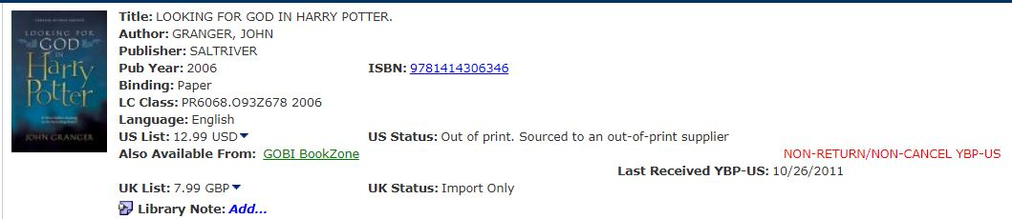

If your library does not use a link resolver, you can set up a Static URL.
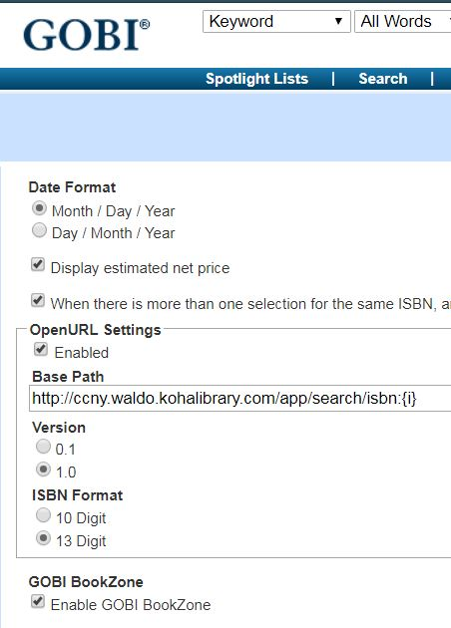
Library menu Library Preferences link
There are four options in the OpenURL section:
  - Enabled - A checkmark in this box will turn on the OpenURL service.
  - Base Path - Enter the base path URL in this field. This might be a link resolver, or a static URL.
  - Version - Click to select the version of your OpenURL link. Generally this should be 1.0.
  - ISBN Format - Select either a 10 or 13-digit ISBN setting to match your link resolver's setting.

If your library does not subscribe to a link resolver, you can create a static URL to link to the library’s OPAC or discovery layer, using either ISBN or Title.
The ISBN in the bibliographic record in GOBI will be the link to the catalog, regardless of whether the URL is designed to match on the ISBN or Title.

To build a static URL ISBN match:
- Run an ISBN search in the library’s catalog
- Copy the URL in the address bar and paste it into the GOBI OpenURL field in Library Preferences
- Replace the ISBN in the copied URL with {i}
- Save and log out of GOBI
- Log back into GOBI and test that your URL works
- Note that matching on the ISBN will look for an exact match in the library’s OPAC – this means that things like previous editions of titles will not be retrieved.

To build a static URL TITLE match:
- Run a title search in the library’s catalog
- Copy the URL in the address bar and paste it into the GOBI OpenURL field in Library Preferences
- Replace the title in the copied URL with {t}
- Save and log out of GOBI
- Log back into GOBI and test that your URL works
- Note that matching on the title will bring back results like previous editions, and alternate format editions (if they are linked in the library’s OPAC)

