Welcome to the Scouters from ODD and CBD. Glad you could join us for Program Launch and the June Roundtable!

Program Launch

(Slides available here)

- What is Program Launch
- Information and resources that can assist your Unit plan for the upcoming Scouting year. This includes:
- Program planning tips
- Dates for District events/FCPS Holiday
- Unit resources and tools
- Camping information, and
- District and Program contacts

- Pack Resources
- Annual Planning Meeting for Packs – Six step guide for your planning meeting
- Family Talent Survey – Survey tool to align parent interests/talents with needed tasks
- Pack Budget Worksheet – Fillable Spreadsheet for budget planning
- Selecting Cub Pack Leadership – How to make the “ask”
- Sample Pack Meeting Plans – How to plan your meeting (by Den)
- Additional Pack Committee Resources - various guides
- Video for new den leaders
- Cub Chat Live podcast for Cub Scout leaders on Facebook each Friday at 3:00 pm (Eastern) – can also be accessed on demand.

- Troop Resources
- Annual Program Planning for Troops - Step-by-Step guide for planning meeting
- Annual Planning Guide - Contains audio PowerPoint guide for SM, CC, and SPL
- Troop Operating Budget Worksheet PDF

- Crew Resources
- Annual Program Planning for Crews - Step-by-Step guide for planning meeting
- Other Crew Resources

Calendars and Key Dates
- NCAC Events
- 09/20/24 – NCAC Golf Tournament
- 09/21/24 – 09/22/24 – Fall Festival
- 10/11/24 – 10/14/24 – Climb-o-ree
- 10/26/24 – 10/27/24 – Hike-o-ree
- 11/02/24 – Scouting for Food (Tags)
- 11/09/24 – Scouting for Food (Pick-up)
- 02/XX/25 – Montgomery MBC
- 03/08/25 – 03/09/25 – Commissioners College
- 05/03/25 – Orienteering Meet
- 06/01/25 – Council Court of Honor
- 09/26/25 – 09/28/25 - Fall Festival
- 10/10/25 – 10/12/25 - Climb-o-ree
- 10/24/25 – 10/26/25 - Hike-o-ree
- 11/01/25 – Scouting for Food (Tags)
- 11/08/25 – Scouting for Food (Pick up)

- Goshen Scout Reservation (Goshen, VA)
- 2024 Family Camps: May 24–27 & August 30 - September 2
- 2024 Alumni Weekends: April 19-21 & October 18-20
- 2024 Volunteer Weekends: September 27-29
- 2025 Family Camps: May 24–27 & August 30 - September 2
- 2025 Alumni Weekends: April 19-21 & October 18-20
- 2025 Volunteer Weekends: September 27-29
- 2025 CAMPS
- Week 1: June 22-28
- Week 2: June 29-July 5
- Week 3: July 6-12
- Week 4: July 13-19
- Week 5: July 20-26
- Week 6: July 27-August 2

- Camp William B. Snyder (Haymarket, VA)
- 2024 Cub Day Camps: June 24-28 & July 08- 12
- 2024 Cub Resident Camps: June 20-23, June 27-30, & July 11-14
- 2024 Scout BSA Weeks: July 14-20 & July 21-27
- 2024 Family Camp: July 05-07, Oct 18-20 & 11/15-17
- 2025 - TBD

- Camp Catoctin (Thurmont, MD)
- 2024 - August 11-17
- 2025 – TBD

- National Youth Leadership Training (NYLT)
- 06/16/24 – 06/21/24: Course 24-2
- 06/23/24 – 06/28/24: Course 24-3
- 07/28/24 – 08/02/24: Course 24-4 & 24-5
- 01/17-20/25 & 02/01-02/25: Winter Course
- 06/15/25 – 06/20/25: Course 25-2
- 06/22/25 – 06/27/25: Course 25-3
- 07/27/25 – 08/01/25: Course 25-4 & Course 24-5

- Youth Training - National Advanced Youth Leadership Experience (NAYLE)
- National Advanced Youth Leadership Experience (NAYLE) is an exciting program where young men and women enhance their leadership skills through team building, ethical decision-making, problem solving and service to others.
- Philmont: https://www.philmontscoutranch.org/ptc/nayle/
- The Summit: https://www.summitbsa.org/programs/training/seven-day-conferences/nayle

- George Mason District Calendar
- 2nd Thursday of the month – Roundtable (7:30pm), Thoreau MS, Vienna, VA
- 2nd Thursday of the month – OA Meeting (7:30pm), Thoreau MS, Vienna, VA
- 07/14/24 – 07/20/24 – Camp Snyder Specialty Week (Merit Badges), Haymarket, VA
- 07/21/24 – 07/27/24 – Camp Snyder Specialty Week (Merit Badges), Haymarket, VA
- 08/04/24 – Scouts Days – Nationals vs Milwaukee Brewers, 1:35pm, Nationals Park
- 08/04/24 – 08/06/24 – Lodge Summer Ordeal, Camp Snyder, Haymarket, VA
- 08/08/24 – Join Scouting Night/Roundtable, 7:30pm, FC Pres. Church, Falls Church, VA
- 08/15/24 – 08/18/24 – Powder Horn, Camp St. Charles, Newburg, MD
- 09/07/24 – Paddle Craft Safety (Still Water), Camp Snyder, Haymarket, VA
- 09/08/24 – Paddle Craft Safety (Moving Water), Riley’s Lock, MD
- 09/12/24 – Roundtable, 7:30pm, Thoreau MS, Vienna, VA
- 09/13/24 – 09/15/24 – 2024 OA Fall Fellowship, Camp Goshen, Goshen, VA
- 09/21/24 – 09/22/24 – Fall Festival (Scout-tober Fest) , Camp Snyder, Haymarket, VA
- 09/28/24 – Life to Eagle Seminar, St James Catholic Church, Falls Church, VA
- 09/XX/24 – 10/XX/24 – Fall Ordeal, TBD
- 10/XX/24 – Aquatics Partial Merit Badge Completion Clinic, Location TBD
- 10/11/24 – 10/14/24 – Climb-o-ree
- 10/10/24 – Roundtable, 7:30pm, Thoreau MS, Vienna, VA
- 10/18/24 – 10/20/24 – Fall Camporee, Camp Rock Enon, Gore, VA
- 10/19/24 – 10/20/24 – Jamboree on the Air/Jamboree on the Internet (JOTA/JOTI)
- 10/26/24 – 10/27/24 – Hike-o-ree
- 11/02/24 – Scouting for Food (Tags)
- 11/09/24 – Scouting for Food (Collection)
- 11/10/24 – Veterans Day Flags In, National Memorial Park, Falls Church, VA
- 11/01/24 – OA Election Season Opens
- 12/06/24 – 12/07/24 – OA Trade-o-ree, Camp Snyder, Haymarket, VA
- 12/XX/24 – Peace Light distribution
- 01/XX/25 – OA Lodge Banquet, College Park, MD
- 02/22/25 – University of Scouting, Hayfield Secondary School, Alexandria, VA
- 03/08/25 – 03/09/25 – Commissioner College
- 03/28/25 – 03/30/25 – Joint Lodge Ordeal, Camp Snyder, Haymarket, VA
- 04/10/25 – District Court of Honor, Thoreau MS, Vienna, VA
- 04/25/25 – 04/27/25 – 2025 OA Spring Fellowship
- 05/03/25 – 19th NCAC Scout Orienteering Meet, PWD, Triangle, VA
- 05/XX/25 – 05/XX/25 – GMD Spring Camporee
- 05/XX/25 – 05/XX/25 – GMD Hike-O-Ree
- 05/10/24 - Jamboree on the Trail (JOTT)
- 05/26/25 – Memorial Day Flags In, National Memorial Park, Falls Church
- 05/08/25 – Program Launch, Thoreau MS, Vienna, VA
- 05/31/25 – OA Election Season Closes

- Fairfax County Public School Schedule (one Page)
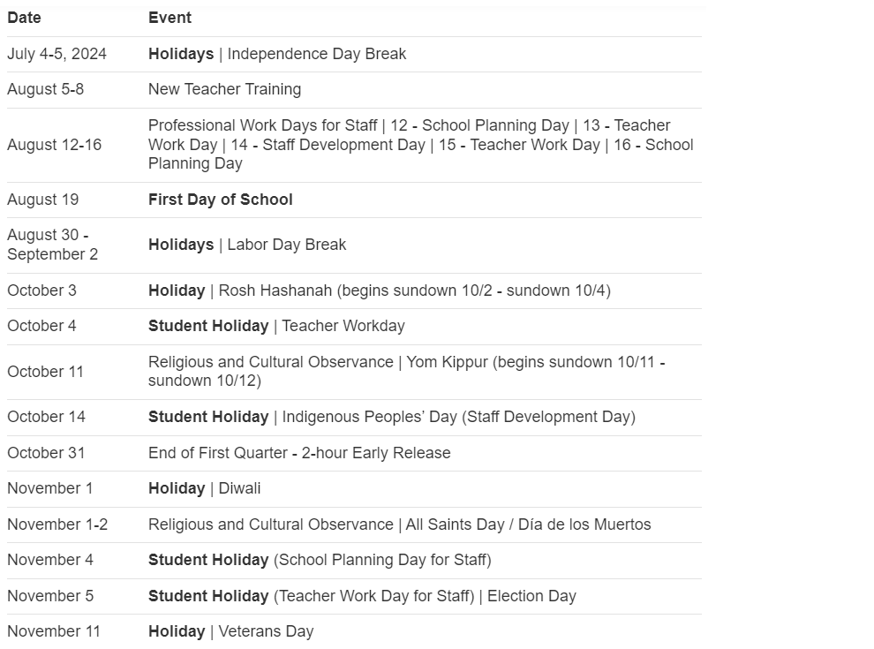
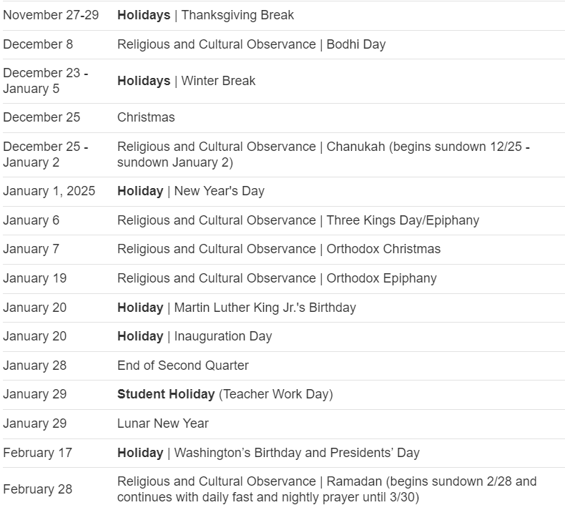

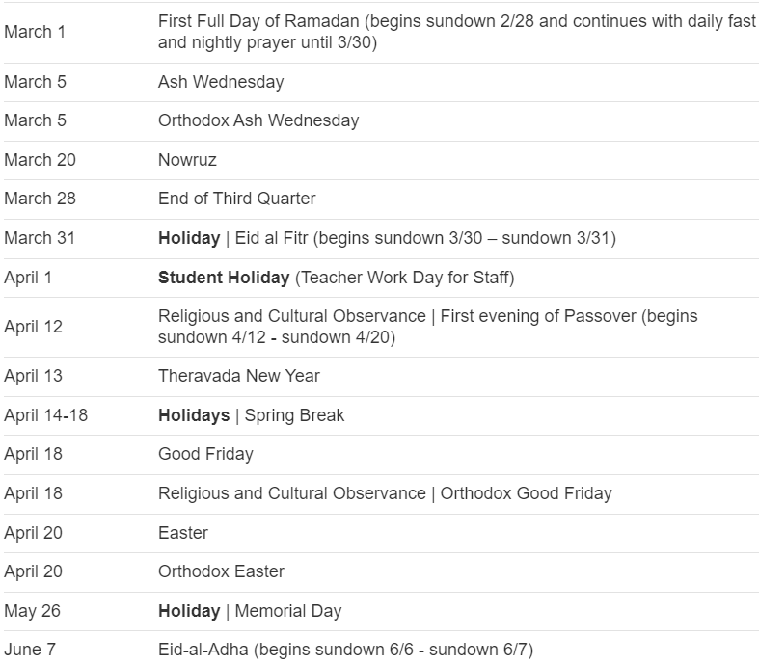
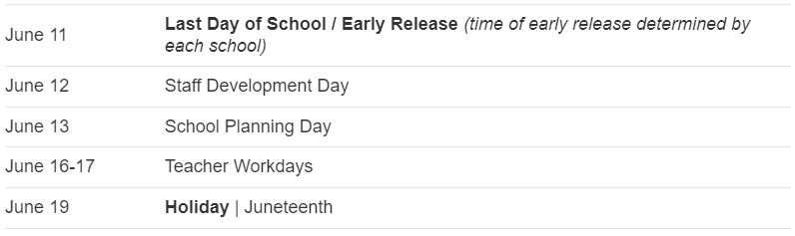

- FCPS Facilities
- The priority for community use of facilities is assigned in the following order per Regulation 8420:
- FCPS instructional and extracurricular programs.
- School-related groups such as PTA, PTO, booster club, private tutoring, and school-business Ignite Partners operating under special provisions.
- Fairfax County Department of Neighborhood and Community Services and Fairfax County Park Authority.
- Others, when space is available, including youth groups; Fairfax County employee organizations; cultural and civic groups; colleges and universities; religious organizations; state and federal agencies; private organizations and individuals; and commercial entities.
- Once you have registered and have been approved as an organization event coordinator (OEC) in the online reservation system, CommunityUse, you can request space for any FCPS facility (login top right). Please note per Regulation 8420, requests must be submitted at least fifteen (15) business days prior to the event date. Once your schedule has been approved, the OEC cannot make any adjustments to the schedule, including cancellations. Please contact the community use school contact, see below list, if changes are necessary. Please refer to the helpful user's guide provided below.

- Other Calendars
- NCAC Council Calendar: https://www.ncacbsa.org/calendar
- NCAC 2024-2025 Brochure: https://www.ncacbsa.org/wp-content/uploads/2024/06/2024-2025-NCAC-CALENDER-BOOKLET-Electronic.pdf
- BSA’s Calendar of Religious Observations
- 2024: https://www.scouting.org/resources/relationships/religious-observances/calendar-of-religious-observances-2024/
- 2025: https://www.scouting.org/resources/relationships/religious-observances/calendar-of-religious-observances-2025/
- Order of the Arrow Lodge Calendar - https://wipit470.org/calendar.html
Other Planning
- Service Projects
- Many Units put their proposed service projects in the Unit Calendar (in addition to the ones that come up throughout the year).
- Service projects can be found with your Chartering Organization, Camp Snyder, Fairfax County Park Authority, etc.
- Be sure to record the hours for your Unit in Internet Advancement - Units should log service hours via the Scoutbook redirect when they click “Activity Logs” (under either the individual or ‘Quick Entry’) or directly in Internet Advancement.
- Video Help in Recording Service Hours: LINK
- Information on Recording Service Hours: LINK

- Awards
  - Journey to Excellence
  - Cub Scout Awards – Also, don’t forget the Summertime Fun
  - Scouts BSA Awards
  - Religious Awards
  - Scouter (Adult) Awards

  - Camping Sites for Packs
  - Pack Overnighter Approve Camping Sites https://www.ncacbsa.org/approved-camp-sites/
  - OA Camping Site List
  - https://www.ncacbsa.org/wp-content/uploads/2020/12/Approved-Camp-Sites.pdf
  - Want to add a campground to the list?
  - The unit would fill out a Pack Overnight Campout Site Appraisal Form and submit to NCAC Director of Camping Services (matthew.keck@scouting.org) for review.
  - Fund Raising
  - Popcorn
    - 35% commission to units. No up-front costs. Prize program. Rank and MB opportunities.
    - www.ncacbsa.org/popcorn and 082popcorn@ncacbsa.org
  - Camp Cards – will learn in late fall if there will be Camp Cards this year.
  - Other – please fill out Unit Money-Earning Application and send to the DE.

  - 2024 Training – https://www.ncacbsa.org/george-mason/training/
  - Cub Scout Den Leader Specific (C42) - Available on-line (125 min)
  - Basic Adult Leader Outdoor Orientation (BALOO;C32) - 06/15/24 – 06/16/24 – Lorton, VA
  - Scoutmaster Position Specific Training(S24) - Available on-line (192 min)
  - Introduction to Outdoor Leadership Skills (IOLS; S11) - 06/15/24 – 06/16/24 – Lorton, VA
  - Back Country Outdoor Leadership Skills (BCOLS)
09/21/24 (Alexandria, VA) & 10/19/24 – 10/20/24 (Markham, VA)
  - Climbing Level 1 Instructor
  - June 15-16 at Great Falls Park, 7:30 AM to 5:00 PM. Logistics memo
  - Sept 7-8 at Great Falls Park, 7:30 AM to 5:00 PM. Logistics memo
  - Sept 21-22 at Sugarloaf Mountain, 8:15 AM to 5:00 PM. Logistics memo
  - Mental Health First Aid https://www.fairfaxcounty.gov/hscode/ereg/Registration.asp
  - Scouterhorn Operations Training
  - 06/18/24 – Gaithersburg, MD
  - 06/19/24 – Gaithersburg, MD
  - 06/20/24 – Gaithersburg, MD
  - 10/19/24 – Camp Snyder, Haymarket, VA
  - 11/16/24 – Camp Snyder, Haymarket, VA
  - Wood Badge (A90) https://www.ncacbsa.org/wood-badge/ - 09/13/24 – 09/15/24
  - 2025 Training
    - BCOLS:
    - Spring: 03/01/25 & 4/26-27/25
    - Fall: 09/20/25 & 10/18-19/25
    - Trainers Edge: 08/09/25 & 12/06/25
    - University of Scouting: 02/22/25
    - Wood Badge:
    - Spring: 4/4-6/25 & 5/3-4/25
    - Fall: 09/12-14/25 & 10/4-5/25
    - Outdoor Ethics - 06/29/24 (Orientation; Guide) and 10/19/24 (Orientation; Guide)
    - Orientation – After completing this course, you will have:
- Knowledge of Outdoor Ethics
- Knowledge of the Outdoor Code
- Knowledge of how Leave No Trace, Tread Lightly! And The Land Ethic / Stewardship support the Outdoor Code
- Knowledge of Outdoor Ethics Awareness and Action Awards Program
- Knowledge to locate additional Leave No Trace, Tread Lightly! and BSA Outdoor Ethics resources and opportunities for further training
After this course and completion of the online Leave No Trace Online Awareness course and Tread Lightly! online Awareness course, participants should have enough knowledge to:
- Earn the Outdoor Ethics Awareness Award
- Conduct Outdoor Ethics workshops & activities within their respective units
- Help scouts & scouters earn their Outdoor Ethics Awareness Award
Guide - Learn how to operationalize this position of responsibility to have the greatest positive impact in your unit. Join Outdoor Ethics Guides and adult advisors for an in-person session to learn best practices, meet other Outdoor Ethics Guides and adult advisors, share experiences, discuss ways to overcome challenges, and create a network of Outdoor Ethics Guides across NCAC.
    - Leave No Trace Level 1 (formerly Trainer)
    - 09/30/24 (online); 10/05/24 (in person MD – Germantown IWLA)
    - 10/21/24 (online); 10/26/24 (in person VA – Camp Snyder)
    - Course Description
This course is for BSA members 18 and older who teach outdoor skills to others.
Participants learn Leave No Trace awareness, principles, skills and ethics through a combination of presentation, discussion, and hands-on activities. They learn and practice techniques for teaching these concepts.
Each participant will prepare and present a short (10-15 minute) lesson. Topic assignments will be given to participants before the course.
At least 10 days before the Saturday outdoor session, students will be assigned approximately 6 hours of online self-study learning which must be completed prior to the outdoor session. Students who do not complete the self-study portion will not be allowed to attend the outdoor session.
Preregistration is required and class size is limited, so register soon.
The class will be held at Camp Snyder in Haymarket, VA. A suggested equipment list, driving directions, etc., will be provided to participants before the course.
We need at least 4 registered adults to hold this course. Otherwise, we will cancel it
    - Outdoor Ethics Newsletter – Sign Up for information on upcoming courses, events, Q&A about OE, Links for resources and ideas for project partners.

  - Roundtable
    - Roundtables provide unit leaders with the skill to do and the will to do what is needed to ensure that every member of every unit has a great Scouting experience. They build upon the foundation provided by position-specific basic training and each leader’s commitment to serving youth through Scouting.
    - Meets monthly on second Thursday at 7:30pm
    - Contact brian.summers@verizon.net for more information or visit the Roundtable web site (password is GMDRT)

    - Science Technology Engineering and Math (STEM)
    - STEM is an initiative the Scouting America has taken on to encourage the natural curiosity of youth members and their sense of wonder about these fields. From archery to welding, Scouts can’t help but enjoy the wide range of STEM-related activities. To support this initiative, the BSA developed the STEM Nova Awards program so that youth members have fun and receive recognition for their efforts.
    - GMD STEM Web Page:
    - https://www.ncacbsa.org/george-mason/stem-program/
    - NCAC STEM Events: https://www.ncacbsa.org/s-t-e-m/
    - 2024 STEM Trek at Philmont: https://www.philmontscoutranch.org/philmonttreks/individualprograms/stem/

    - International Scouting
    - World Scout Jamborees - https://www.scout.org/what-we-do/world-scout-events/world-scout-jamboree
    - Jamboree on the Trail (May) - https://jamboreeonthetrail.org/
    - Jamboree on the Air/Internet (October) - https://www.scouting.org/international/jota-joti/
    - International Peace Light (December) - https://peacelightnorthamerica.org/
    - [Had a question about embassy tours – There are two tour dates in May where anyone can visit. It was brought up that there used to be some scout-only tours. A member of the NCAC International Committee indicated that these tours were built on relationships that people had with individuals at the embassy and are not likely to happen unless someone has a contact to ask.]

    - Merit Badges
    - The online Merit Badge Counselor registration.
    - New Merit Badge Counselors must complete online merit badge counselor training, in addition to YPT. Be sure the counselor uses his/her legal name – no nicknames.
    - Merit Badge Counselors, or the unit Dean/Leader, also need to scan and send Margee the Merit Badge application form listing the badges the counselor is applying to teach and providing a justification of his/her qualifications.
    - Youth Protection Training is the essential first step. Don’t hit “send” on the application without it!
    - Contact Margee if you have questions at GM.MB.Dean@hotmail.com.
    - Did you know:
    - The National Council does not limit the number of merit badges a youth may earn from one counselor, though a unit leader is permitted to do so, as long as the same limit applies to all Scouts in the unit. Ideally, Scouts should work with a variety of adults. (GTA 7.0.0.3)
    - Partial Merit Badges have no expiration except the Scout’s 18th birthday. (GTA 7.0.3.3)
    - Due to the BSA policies related to Youth Protection and two-deep leadership, a merit badge counselor must have another adult present during all merit badge counseling sessions. However, the parent or legal guardian of the Scout may serve as the second adult. This parent or legal guardian does not have to be a registered leader.
    - If the requirements for a merit badge differ between the merit badge pamphlet and the current edition of Scouts BSA Requirements, the requirements in the Scouts BSA Requirements book supersede all others.

    - High Adventure - GM High Adventure Committee member is Brian Heath
    - Members of the High Adventure Committee are available to assist units in planning and training for their upcoming high adventure trips – Contact Brian Heath for more information
    - Important notes for this month
    - Registration for BSA’s high adventure bases - https://www.scouting.org/outdooradventures/open4adventure/
    - 2024 treks – Most BSA High Adventure bases still have availability
    - 2025 treks – Registration for all high adventure bases are now open
    - 2024 NCAC-Organized High Adventure Trips
    - Lenhok’sin – James River Canoeing Trek - July 7-13, 2024
    - Crew of 6-12 - $475 per participant – 6 slots remaining
    - Registration: https://scoutingevent.com/082-75664
    - For more information, e-mail highadventure@ncacbsa.org
    - Lenhok’sin Provo Backpacking Trip June 23-29, https://scoutingevent.com/082-83116
    - 3 spaces available for Scouts or adults
    - 11-12 year old Scout High Adventure Experience - Sept 28-29 Prince William Forest
    - Joshua Tree with Climbing Committee - Winter Break 2024/25 (Gathering interest)
    - Wind River Range, WY Backpacking Trip: 06/22 to 06/30/24 – Registration is Full
    - All NCAC-sponsored trips for Philmont, Northern Tier & Sea Base are already full
    - 2025 NCAC-Organized High Adventure Trips
    - Sawtooth Mountain, ID Trip - 06/21 to 06/29/2025
    - Registration begins June 1, 2024 - $1,385 per person – Ask for details
    - High Adventure Preparation Training
    - All sessions for this year are finished
    - Other Training
    - Back Country Outdoor Leadership Skills - Virginia session
    - Fall 2024: 9/21/2024 (classroom), 10/19-20 (overnight)
    - Paddle Craft Safety Training: Aug 24-25, Sept 7-8
    - National High Adventure Base Quick Links
    - Philmont: https://www.philmontscoutranch.org/register/
    - Northern Tier: https://www.ntier.org/provisional-scout-connections/
    - Sea Base: https://www.bsaseabase.org/scouts/scout-connections/
    - Summit: https://www.summitbsa.org/registration/scoutconnections/
    - Other High Adventure Bases
    - Adirondack High Adventure Area: https://public.3.basecamp.com/p/hLgsVbk7Suju6cuDzQQJaEn4
    - Maine High Adventure Area: https://www.mainehighadventure.org/
    - Montana Outdoor High Adventure Base: https://montanabsa.org/camps/high-adventure/
    - Other useful links for high adventure information and opportunities
    - NCAC High Adventure website - https://www.ncacbsa.org/high-adventure/
    - List of units with available slots in their upcoming high adventure trips - https://public.3.basecamp.com/p/xWpkdrKHKAA9pCzwmHMNdbWb

    - Range and Target Activities (formerly Shooting Sports) – GMD contact is Brian Summers
    - Requests for Shooting Events – Lead Time!
    - 50+ scouts - 6mos
    - Less than 50 scouts - 3mos
    - Shooting on private land:
    - Requirements
    - Permissions/protocols
    - R&TA web page
    - R&TA Instructor Classes: Rifle/Shotgun - 07/20/24, 08/24/24

  - Fall Camporee - Camp Rock Enon Oct. 18-20 [flyer]
    - Theme: Summer Camp in a Day
    - Join George Mason and Burke Lake Districts for SUMMER CAMP IN A DAY! We are so excited to offer Archery, Shotgun, & Rifle. There will be aquatics, rock climbing, lashings, first aid, & tomahawks!
    - Registration is now open!

    - Flags In
    - Honoring veterans by placing flags on graves at the National Memorial Park in Falls Church, VA. Events occur on Memorial Day and Veterans Day weekends. All are welcome.

    - Order of the Arrow
    - Brian Fleck is Chapter Advisor.
    - Chapter meetings are the second Thursday of the month at Thoreau Middle School in Vienna. No meeting in July. Please send your OA Reps.
    - 2024 Dues can be paid online: https://wipit470.org/dues.html
    - Registrations open online https://wipit470.org/index.html under “Events”

    - National BSA Annual Fees (Council Fees announced on or about July 1)
    - Effective May 1, 2024, BSA implemented the following national membership fees which were approved by the National Executive Committee:
    - $85 for Cub Scouts, Scouts BSA, Venturing and Sea Scouting participants ($5 increase)
    - $65 for all adult volunteers ($5 increase)
    - $0 one-time joining fee for new program participants in Cub Scouts, Scouts BSA, Venturing, and Sea Scouting ($25 decrease from 2023)
    - $30 for Scoutreach (No change)
    - $25 for Merit Badge Counselors (New Fee applies only for Merit Badge Counselors not already registered as leaders – No change)
    - $50 for Exploring participants Youth & Adult (No change)
    - $100 for a unit charter/affiliation fee (No change)
    - $15 for Scout Life magazine (No change)

    - How the District Can Support You
    - District Committee
    - Purpose - To work through chartered organizations and community groups to organize and support successful units.
    - Functions
    - Membership - The membership function strives for growth through the organization of new Scouting units, through new members and adult volunteers joining existing units, and through the retention of current members.
    - Fund Development - The fund development function sees that the district provides its share of funds to the total council operating budget.
    - Program - The program function concentrates on helping Scouting units with camp promotion, special activities including community service, training adult volunteers, and youth advancement and recognition.
    - Unit service - The unit service function provides direct coaching and consultation for unit volunteers to help ensure the success of every Scouting unit.
    - District Chair – Traci Yates (traci.yates@cox.net)

    - Commissioners
    - OUR MISSION - As commissioners, we share the BSA’s mission: To prepare youth to make ethical and moral choices over their lifetimes by instilling in them the values of the Scout Oath and Law.
    - OUR VISION - Every member of the BSA has a great Scouting experience.
    - OUR OBJECTIVES
    - Supporting unit growth and retention through the journey to excellence.
    - Contacting units and capturing in commissioner tools their strengths, needs, and a unit service plan that enables continuing improvement.
    - Linking unit needs to district operating committee and other resources.
    - Supporting timely unit, district, and council charter renewals.
    - Supporting unit leaders by collecting and distributing information, enabling program training, and providing networking opportunities.
    - Commissioners
    - District Commissioner: Rus Pittman
    - Asst. District Commissioner: Pat Berney, Justine Podolny, Mark Serfass
    - Roundtable Commissioners: Steve Banowit (Cubs), Brian Summers (Scouts)
    - Unit Commissioners: Eric Assur, Steve Banowit, Pat Burney, Jerry Driscoll, Julia Lesko, Tom McMillen, Jim Miller, Justine Podolny, Rus Pittman, Mark Serfass, Brian Summers, and Hector Uranga.

    - District Executive
      - While most paperwork and questions can be addressed by your Unit Commissioner, if there is a need, Liz’s contact information is:
Ms. Liz Kohler
District Executive
NCAC, Marriot Scout Service Center
9190 Rockville Pike, Bethesda, MD 20814
301-214-9147
elizabeth.kohler@scouting.org

      - Relationships (Pat Burney, patberney4scouts@gmail.com)
      - Builds and maintains relationships with religious organizations and service organizations to:
      - Encourage youth members to join Scouting
      - Encourage organizations to charter Scout units
      - Offer opportunities for religious and service awards

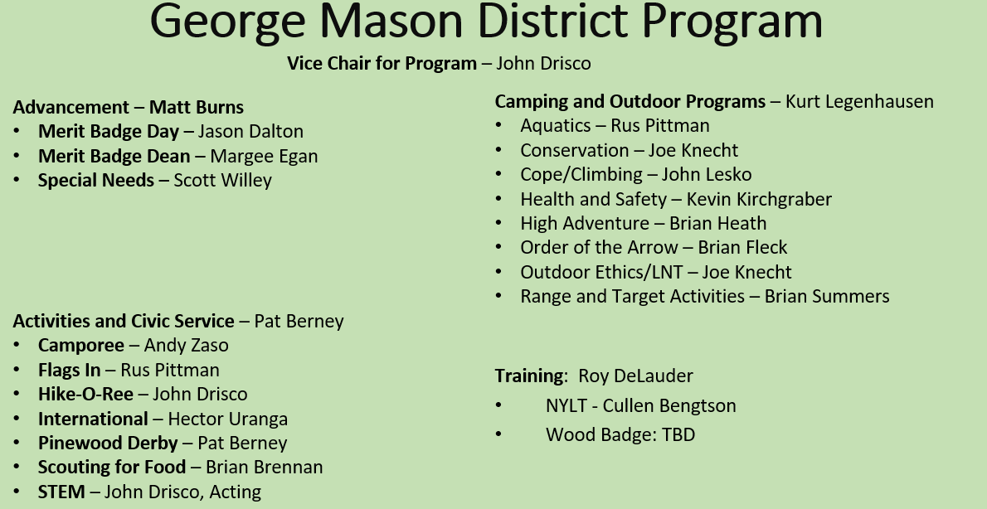
- Program Launch Closing
- How to have a successful planning effort
  - Set a date for your annual planning meeting
  - Provide materials/links listed to those that will lead the meeting
  - Be sure to include the stakeholders
    - Cubs – include the den leaders/parents
    - Scouts/Crews – Encourage youth-leadership
    - Consider inviting your Unit Commissioner and/or COR
  - Match your planned activities to your anticipated budget
  - Plan the appropriate number of Service Projects and Outings/Campouts/Adventures
  - Make it FUN!

June Roundtable Minutes

[Items added after Read-Ahead in red]

- Council Update and General Announcements
- Brand changing to “Scouting America” – We can start to use this now. Current uniforms can continue to be used after the 02/08/25 implementation date.
- Outdoor Programs 2025 Strategic Initiative – Committee is looking for your input on outdoor programs and facilities to update the strategic plan over the next 18 months.
- New Cub Program - started June 1
- Renewal notices – Will be sent out, via email, 60 days prior to registered expiring. Adults/Youth that registered last fall could see renewal notices this summer.
- Pilot Mixed-Gender Troops – National still providing information. NCAC hasn’t yet signed a MOU to participate. Researching scope.
- June 1 – New Cub Program
- July – Dec – Renewal notices, via email, to registered Adults/Youth
- Bills include both National and NCAC Fees
- Still working on Scholarships and mechanism for units to submit with one check
- Key 3 replacement error – my.scouting.org (60 days)
- Powder Horn (8/15/24 – 8/18/24), Camp St. Charles, Newburg, VA
- Adult and Youth (13 years/8th grade or 14 years)
- Program being phased out

- Shooting Sports changing to “Range and Target Activities”
- Many policy change coming later this year. Some provided so far:
- Except for law enforcement officers required to carry firearms within their jurisdiction, firearms shall not be brought on camping, hiking, backpacking, or other Scouting activities except those specifically planned for target shooting under the supervision of a currently certified BSA national shooting sports director or National Rifle Association firearms instructor.
- June 1, 2024 - Cub Scout program includes elective adventures versus awards for Cub Scouts. These elective adventures can still only be offered at an accredited camp program (day camp, short-term camp, long-term camp) or a council organized one day event. For information on delivering these new elective adventures, please visit the shooting sports website.
- Sept 1, 2024 –
- Firearm programs may only take place on a nationally authorized camp property’s range(s) or at a commercial firearm range. This does not apply to district or council programs that utilize BB devices*, but applies to pellet rifles, airsoft (any type), rifles, pistols, shotguns, and muzzle loading rifles and shotguns.
- The use of personal firearms and personal ammunition is prohibited in all Scouting programs at nationally authorized camp properties. Personal firearms and personal ammunition may be used at a commercial firearm range, subject to restrictions regarding caliber, gauge, and action as described in the National Shooting Sports Manual and herein.
- Venturing and Sea Scouting rifle use is limited to the following types (All other rifle or caliber types are prohibited.):
- .177 caliber air rifle, min 2.5 lbs. trigger pull (open, scope or dot sights);
- air, CO2, or precharged pneumatic rifle,
- .22 caliber rimfire long rifle or short rifle (breech-loading, single shot, bolt action or repeater bolt action with box magazine), min 3 lbs. trigger pull.
- Muzzle loading rifle.

- General Announcements
- Sons of the American Revolution – SAR offers several programs that support scouts. They provide American Patriot Merit Badge workshop, provide Eagle Scholarships, an provide flag ceremonies when requested. [flyer].

- Aquatics Committee – https://www.ncacbsa.org/aquatics-committee/ [Flyer]
- Paddle Craft Safety – Still water (Camp Snyder) & Moving Water (Ryan’s Lock)
- Aug 24-25: https://scoutingevent.com/082-82689
- Sept 7-8: https://scoutingevent.com/082-82690
- Partial MB Completion Day – First weekend in Oct?

- Alignment Update
  - Welcome to the units from ODD and CBD! Glad to have you join the District. No matter what District your unit is in, you are welcome at our Roundtables, trainings, district events and to ask our district leadership questions.
  - Old Dominion District (to GMD)
    - Packs – 0855, 1845, 1962
    - Troops – 0875, 1845
  - Chain Bridge District (to GMD)
- Packs – 0667, 0861, 1127, 1867
- Troops – 0652, 0667, 0869, 1130, 1916, 2119
- Crew – 0652
  - George Mason District (to Powhatan)
    - Packs – 0187, 0882, 1513
    - Troops – 0187, 0918, 1113, 1887, 1888
- District Name Change
  - The Organizational Alignment Committee’s district alignment recommended Districts composed of more or less than one county should be named after a prominent geographical feature.
  - Scouters proposed many names during the nomination period. The list has been reduced to 10 geographic names. Please vote on the George Mason web site.

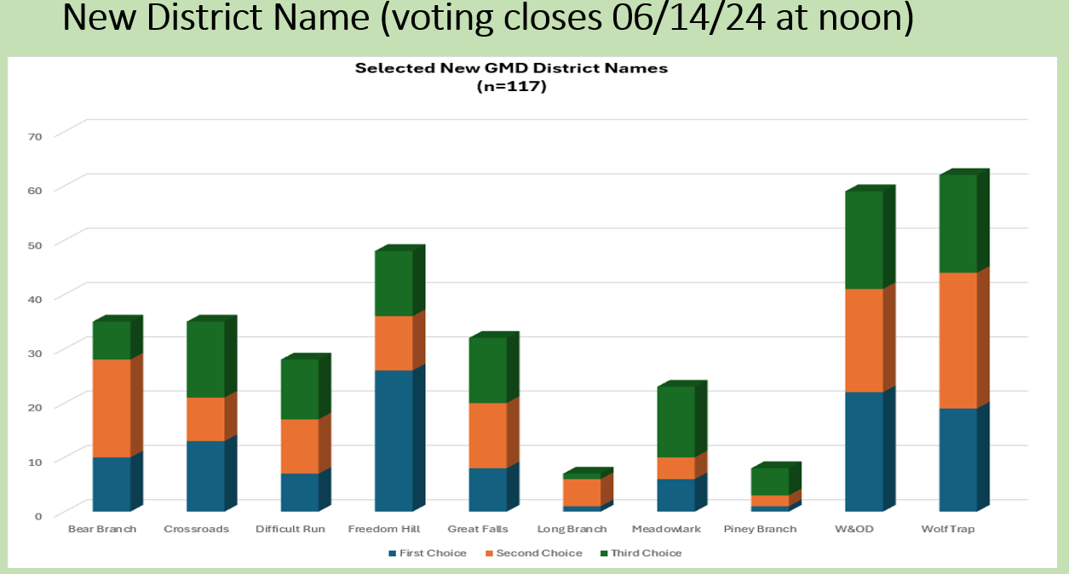

George Mason Program

- Current GM Calendar
- Sep 28, 2024 – Life to Eagle Seminar(In Person), St James Catholic Church, Falls Church, VA
- Oct 18-20, 2024 – Fall Camporee, Camp Rock Enon, Gore, VA
- Nov 02, 2024 – Scouting for Food (Tags)
- Nov 09, 2024 – Scouting for Food (Pick-up)
- Nov 10, 2024 – Flags In (Veterans Day), NMP, Falls Church, VA
- Feb 22, 2025 – University of Scouting, Alexandria, VA
- Mar 08, 2025 – GMD MB Day, St James, Falls Church, VA

- STEM /Rus P
- 07/08/24 - 07/12/24 – STEM Summer Workshop, Alexandria, VA
- 08/05/24 – 08/09/24 – STEM Summer Workshop, Alexandria, VA
- 09/07/24 – STEM MB and NOVA Workshop, Fredericksburg, VA
- Ancient Earth: Birth of the Sky (on PBS) - link
- Anytime – DC STEM Trek- Showcases 24 government agencies, private organizations and monuments related to the tenets upon which STEM is based. Two hikes - 10.57 miles, or 4.75 miles

- Goshen/Snyder Programs for 2024 –
- Camp Snyder Family Camping – July 5-7
- Camp Snyder Day Camping – June 24-28 and July 8-12.
- Camp Snyder Resident Weekends – June 20-23, June 27-30, July 11-14
- Camp Snyder Specialty Week – Two Merit Badge Weeks July 14-July 20 & July 21-July 27
- Goshen Summer Camping 2024 – Five sessions starting June 23rd. A sixth week at Camp Ross. Registration is now open.
- Goshen Provisional Camping – Camping for individual scouts (June 23-July 27).
- Goshen OA Trail Crew – June 16 – June 29
- Lenhok’sin High Adventure – Five sessions during summer 2024. Including paddling 61 miles of the historic Upper James River with 120 Class I and II rapids.

- Fall Camporee
  - 10/18-20/2024 – Summer Camp in a Day, Camp Rock Enon, Gore, VA

- Merit Badges /Margee E
- The online Merit Badge Counselor registration.
- New Merit Badge Counselors must complete online merit badge counselor training, in addition to YPT. Be sure the counselor uses his/her legal name – no nicknames.
- Merit Badge Counselors, or the unit Dean/Leader, also need to scan and send Margee the Merit Badge application form listing the badges the counselor is applying to teach and providing a justification of his/her qualifications.
- Youth Protection Training is the essential first step. Don’t hit “send” on the application without it!
- Contact Margee if you have questions at GM.MB.Dean@hotmail.com.
- Did you know:
- The National Council does not limit the number of Merit Badges a youth may earn from one counselor, though a unit leader is permitted to do so, as long as the same limit applies to all Scouts in the unit. Ideally, Scouts should work with a variety of adults. (GTA 7.0.0.3)
- Partial Merit Badges have no expiration except for the Scout’s 18th birthday. (GTA 7.0.3.3)
- Due to the BSA policies related to Youth Protection and two-deep leadership, a merit badge counselor must have another adult present during all merit badge counseling sessions. However, the parent or legal guardian of the Scout may serve as the second adult. This parent or legal guardian does not have to be a registered leader.
- If the requirements for a merit badge differ between the merit badge pamphlet and the current edition of Scouts BSA Requirements, the requirements in the Scouts BSA Requirements book supersede all others.
- Merit Badge Opportunities (https://www.ncacbsa.org/george-mason/district-resources/merit-badges/):
- 08/18/24 - Aviation and Space Exploration MBs, Lorton, VA
- 10/05/24 – 10/06/24 - DC MB Day, Catholic University, Washington, DC (opens 7/1/24)
- 03/08/25 – George Mason District MB Day, St James, Falls Church, VA
- Group – Fly Fishing
- Group - Aviation

- Training (https://www.ncacbsa.org/george-mason/training) /Roy D
- Going to Goshen this summer? They are offering Adult training most weeks.
- Cub Scout Den Leader Specific (C42)
- Available on-line (125 min)
- 06/01/24 - Alexandria, VA
- Basic Adult Leader Outdoor Orientation (BALOO; C32) -
- 06/15/24 – 06/16/24 – Lorton, VA
- Scoutmaster Position Specific Training(S24)
- Available on-line (192 min)
- 05/06/24 - Alexandria, VA
- 06/01/24 - Alexandria, VA
- Introduction to Outdoor Leadership Skills (IOLS; S11)
- 06/15/24 – 06/16/24 – Lorton, VA
- Climbing Level 1 Instructor
- June 15-16 at Great Falls Park, 7:30 AM to 5:00 PM. Logistics memo
- Sept 7-8 at Great Falls Park, 7:30 AM to 5:00 PM. Logistics memo
- Sept 21-22 at Sugarloaf Mountain, 8:15 AM to 5:00 PM. Logistics memo
- Mental Health First Aid
https://www.fairfaxcounty.gov/hscode/ereg/Registration.aspx?groupID=47
- NYLT https://www.ncacbsa.org/national-youth-leadership-training/
- 24.2: 06/16/24-06/21/24
- 24.3: 06/23/24-06/28/24
- 24.4: 07/28/24-08/02/24
- 24.5: 07/28/24-08/02/24
- Outdoor Ethics Orientation Courses (Scouts and Cubs)
- 09/30/24 & 10/5/24, Germantown, MD
- Outdoor Ethics Newsletter - Sign up here.
- Powder Horn – 08/15/24 – 08/18/24, Newburg, MD (may be last session; program discontinuing)
- Scouterhorn Operations Training
- 06/18/24 – Gaithersburg, MD
- 06/19/24 – Gaithersburg, MD
- 06/20/24 – Gaithersburg, MD
- 10/19/24 – Camp Snyder, Haymarket, VA
- 11/16/24 – Camp Snyder, Haymarket, VA
- Wood Badge (A90) https://www.ncacbsa.org/wood-badge/
- 09/13/24 – 09/15/24

- GM High Adventure / Brian H
- Members of the High Adventure Committee are available to assist units in planning and training for their upcoming high adventure trips – Contact Brian Heath for more information
- Important notes for this month
  - Registration for BSA’s high adventure bases - https://www.scouting.org/outdooradventures/open4adventure/
    - 2025 treks – Registration for all high adventure bases are now open
- 2024 NCAC-Organized High Adventure Trips
  - Lenhok’sin – James River Canoeing Trek - July 7-13, 2024
    - Crew of 6-12 - $475 per participant – 6 slots remaining
    - Registration: https://scoutingevent.com/082-75664
    - For more information, e-mail highadventure@ncacbsa.org
  - Lenhok’sin Provo Backpacking Trip June 23-29, https://scoutingevent.com/082-83116
    - 3 spaces available for Scouts or adults
  - 11-12 year old Scout High Adventure Experience - Sept 28-29 Prince William Forest
  - Joshua Tree with Climbing Committee - Winter Break 2024/25 (Gathering interest)
- 2025 NCAC-Organized High Adventure Trips
  - Sawtooth Mountain, ID Trip - 06/21 to 06/29/2025 - $1,385 per person – Ask for details
- High Adventure Preparation Training
  - All sessions for this year are finished
- Other Training
  - Back Country Outdoor Leadership Skills - Virginia session
    - Fall 2024: 9/21/2024 (classroom), 10/19-20 (overnight)
  - Paddle Craft Safety Training: Aug 24-25, Sept 7-8
- National High Adventure Base Quick Links
  - Philmont: https://www.philmontscoutranch.org/register/
  - Northern Tier: https://www.ntier.org/provisional-scout-connections/
  - Sea Base: https://www.bsaseabase.org/scouts/scout-connections/
  - Summit: https://www.summitbsa.org/registration/scoutconnections/
- Other High Adventure Bases
  - Adirondack High Adventure Area: https://public.3.basecamp.com/p/hLgsVbk7Suju6cuDzQQJaEn4
  - Maine High Adventure Area: https://www.mainehighadventure.org/
  - Montana Outdoor High Adventure Base: https://montanabsa.org/camps/high-adventure/
- Other useful links for high adventure information and opportunities
  - NCAC High Adventure website - https://www.ncacbsa.org/high-adventure/
  - List of units with available slots in their upcoming high adventure trips - https://public.3.basecamp.com/p/xWpkdrKHKAA9pCzwmHMNdbWb

- Shooting Sports /Brian S
- Requests for Shooting Events – Lead Time!
- Notice needed for SSC: 50+ scouts - 6mos; Less than 50 scouts - 3mos
- Shooting on private land:
- Requirements
- Permissions/protocols
- Shooting Sports web page
- Shooting Sports Instructor Classes:
  - Rifle/Shotgun
- Contact for finishing Shooting Sports MB Partials brian.summers@verizon.net

- Order of the Arrow / Collin L & Brian F
  - OA Representatives – Please join us at the monthly OA meetings on the 2nd Thursday of the month, Thoreau Middle School, Vienna VA. Meetings start at 7:30pm.
  - Ceremonies Team – Training at the monthly OA meetings. All are welcome!
  - 2024 Dues can be paid online: https://wipit470.org/dues.html

- Roundtable - Minutes and slides - Available on the GMD web site (District Resources, Roundtable). Password is “GMDRT”

- Next Roundtable – August 8, 2024, at Falls Church Presbyterian Church, Falls Church, VA and on Zoom. Join Scouting Night!

