Publishing Holdings to OASIS Instructions
We publish our holdings in Alma to OASIS so that bibliographers can see what we already own, making the “pre-searching” step in Alma unnecessary. Another option is to click on the ISBN in the OASIS display, which can be linked to your Discovery layer.

- Create a set. It should be an All titles search where Tag Suppressed (Title) = No, and saved as a Logical set.

(In our case, we needed to add another condition to exclude titles that are in our OASIS DDAs, so our set is called OASIS Holdings minus DDA).

- Create an ftp connection to OASIS (Configuration/General/External Systems/s/FTP definitions). You’ll need to get username and password from OASIS (should be the same as those for API).
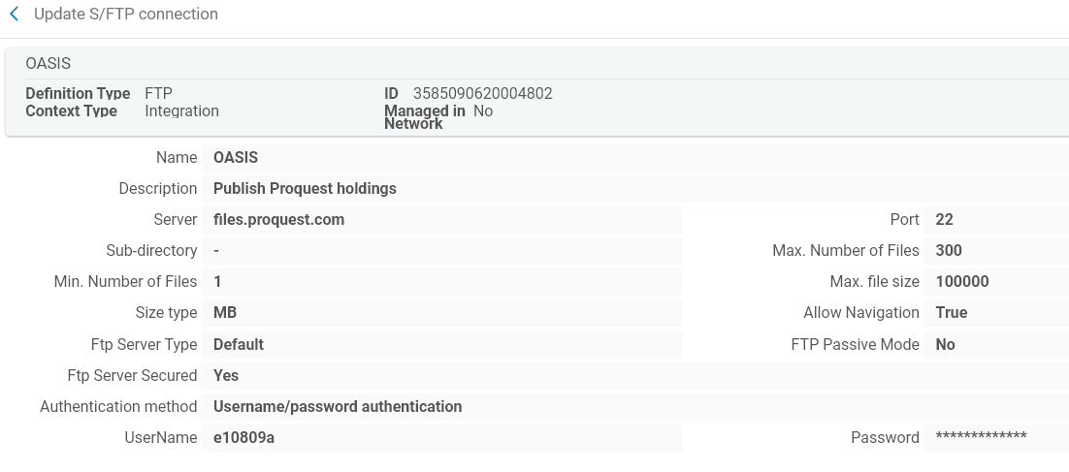

- Create publishing profile (Add profile/General). Note that you’ll need to do Data Enrichment for the 852 $b and $c data to be added to a 919 field that OASIS uses to display the holdings information.
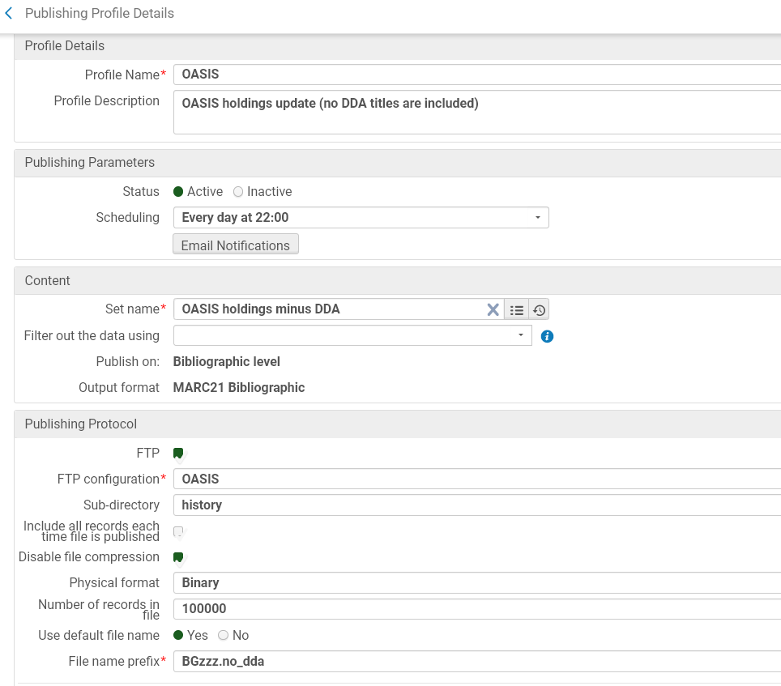

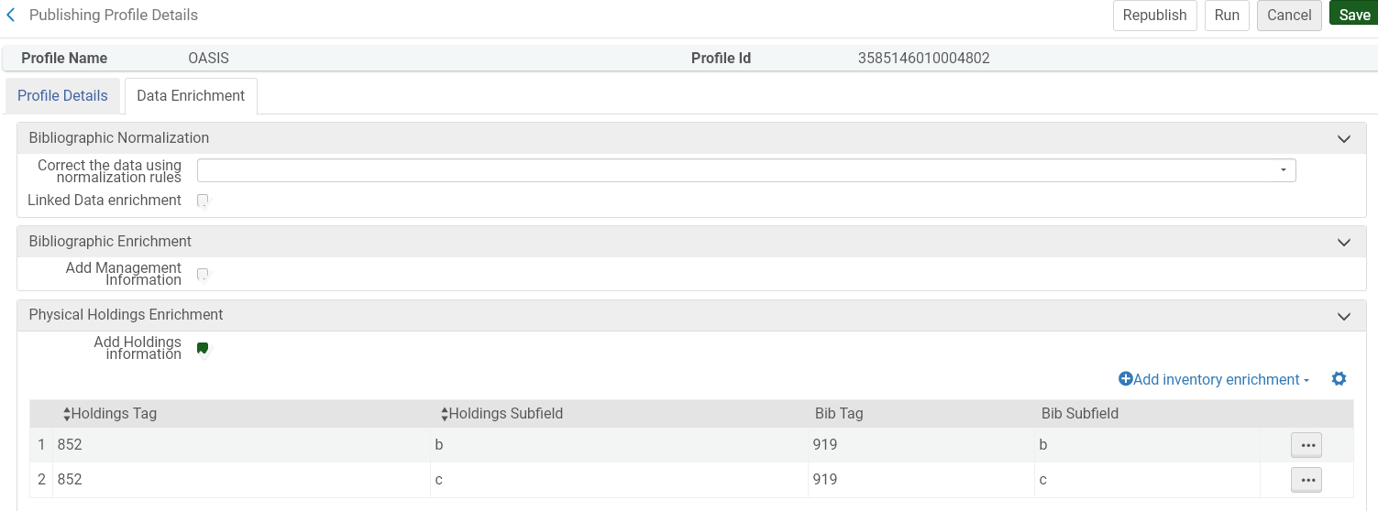

- Job will run at time scheduled in the publishing profile. The first run will be publish ALL records in the set as a baseline, but subsequent runs will be incremental and only note changes from the baseline. Check Manage Jobs history to see the report:

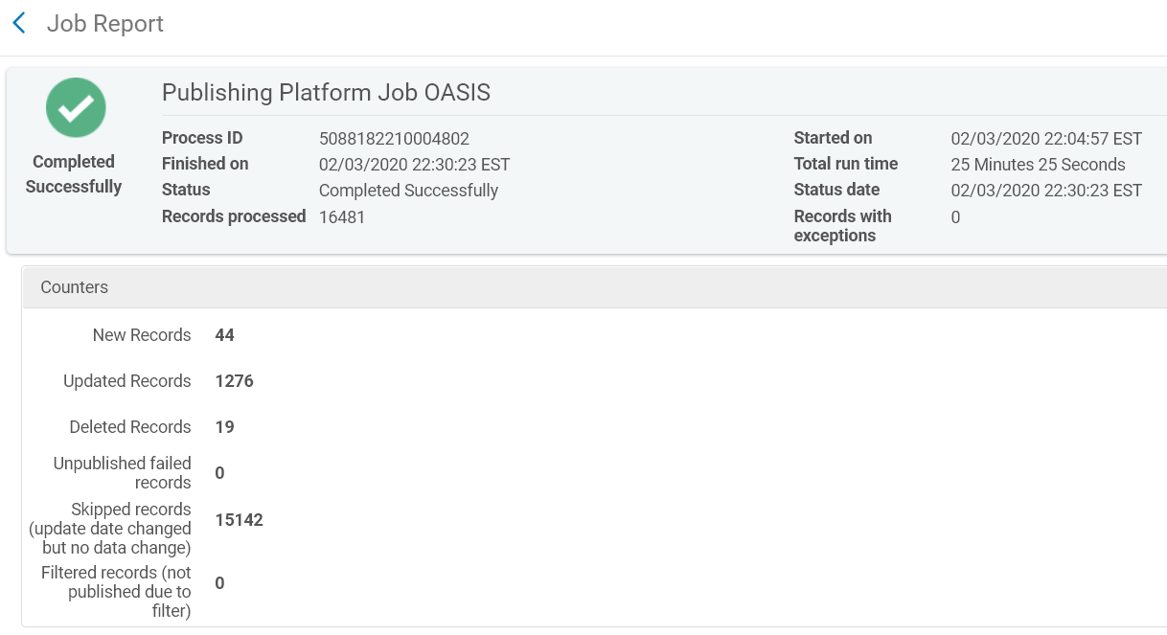
- You may also receive email notifications from OASIS if you’ve supplied your email address to them. These don’t typically match the numbers in the Alma report, not sure why.

- After the job runs, OASIS will update their display (usually overnight) to indicate the library holdings, giving bibliographers the ability to see what we already own:
