

**Think and Go Higher**

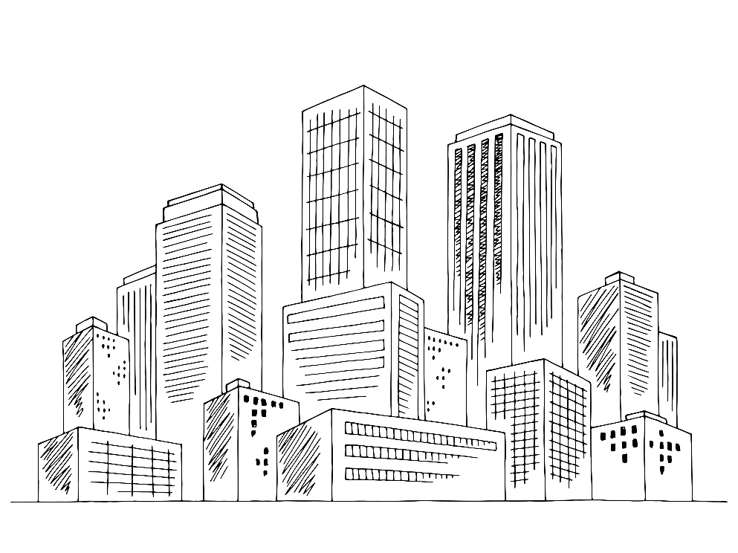

Team Name:

Building Challenge

Session 6 Go Visit!

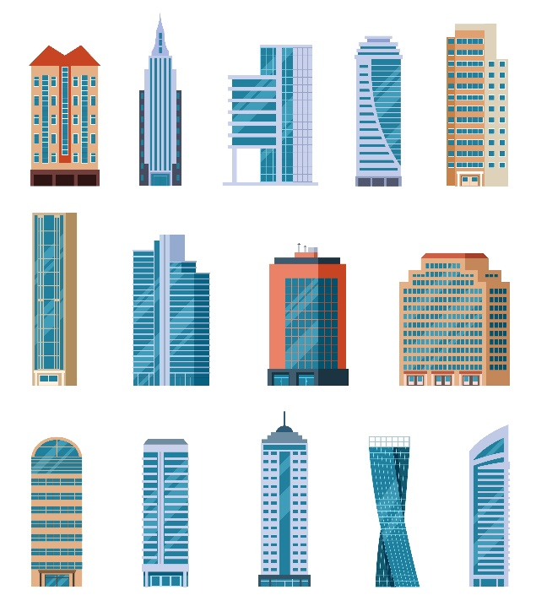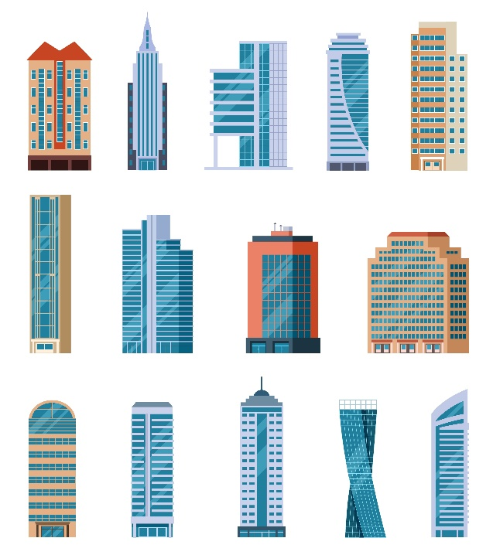**The Brief**

**In groups you need to create a building capable of surviving an earthquake.**

* As a group, you will decide on the building’s **design** and **structure** by creating a **blueprint**, and determining the **cost** of your building.
* You will then have the opportunity to **build** your building using materials **purchased** from the **supply store**.
* At the end of the session, you must be ready to **present** your idea to the **judges** who will decide on a winning building.
* You do not have long so **teamwork** is crucial!

**Group Roles**

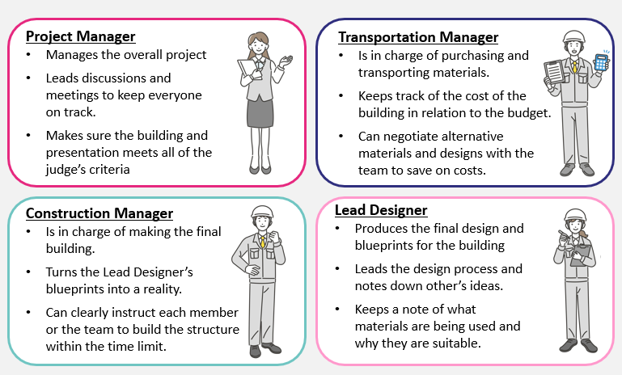

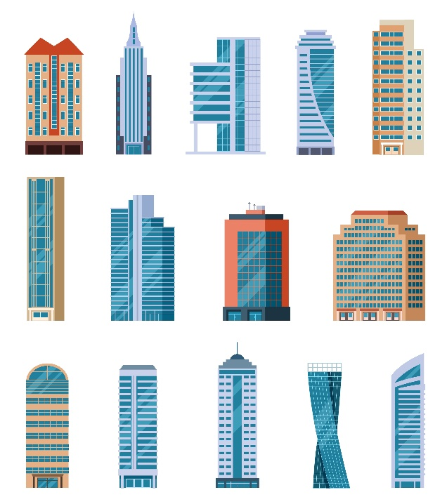

**Designing Your Building**

* Make sure you know what the building will **look like**, what **materials** it will be made from etc.
* Decide on what **features** you will include to make the building ‘**earthquake proof**’ and note these down.
* Finally, you need to create a **final design/blueprint** for your building, which is **annotated** with each **feature/material** etc.

**Below are a couple of examples which show of the level of detail your design should contain:**

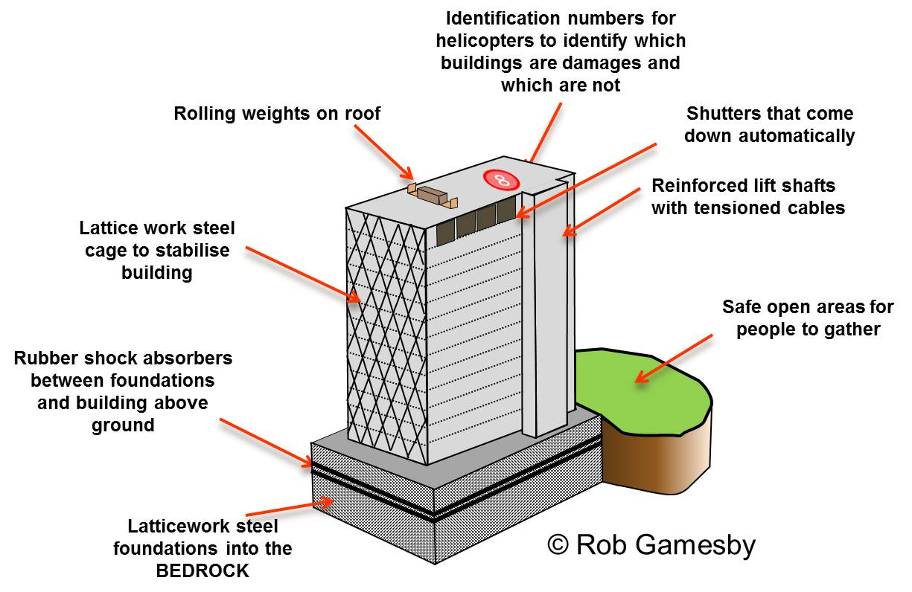

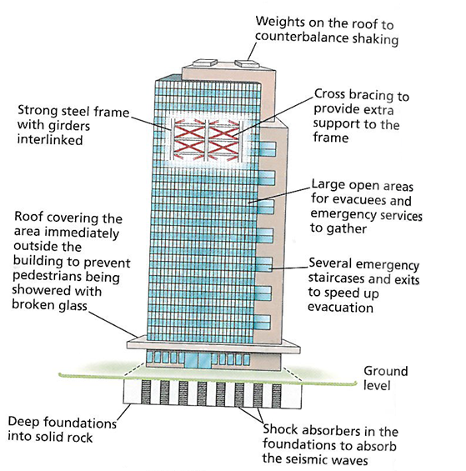

**Material Costs**

|  |  |  |  |
| --- | --- | --- | --- |
| **Material** | **Cost Per Unit** | **Units Purchased** | **Total Cost** |
| *(example)* | *£5000* | *7* | *£35,000* |
| Glue stick | £30,000 |  |  |
| 10cm Sticky Tape | £2000 |  |  |
| Sheet of A4 paper | £5,000 |  |  |
| Sheet of A4 card | £20,000 |  |  |
| 30cm string | £10,000 |  |  |
| 30cm straw | £5,000 |  |  |
| Scissors | £50,000 |  |  |
| Pipe cleaner | £10,000 |  |  |
| Pen | £20,000 |  |  |
| Wooden Stick | £5,000 |  |  |
| **Total cost for all materials** | | |  |

|  |
| --- |
| **Use this space to do any calculations:** |

**Planning Your Presentation**

**Use the information below to help you plan your presentation. Remember, you will also need to show your blueprint/design as well as your completed building.**

**Project Manager (1 minute):**

Introduce the group and your building. What is it called? What is this building used for? What challenges did your group face during the project and how did you overcome them?

________________________________________________________________________________________________________________________________________________________________________________________________________________________________________________________________________________________________________________________________________________________________________________________________________________________________________________________________________________________________________________________________________

­­­­­­­­­­­­­­­­_________________________________________________________________

**Lead Designer (1 minute):**

Show us the design/blueprints. Explain what features have you included to make it earthquake-proof and why these features are effective.

________________________________________________________________________________________________________________________________________________________________________________________________________________________________________________________________________________________________________________________________________________________________________________________________________________________________________________________________________________________________________________________________________

_________________________________________________________________





**Construction Manager (1 minute):**

Show your building. What part of the building did you build first and how did you manage the team to finish the building within the time-limit? What materials did you use for each section of the building and why?

_________________________________________________________________________________________________________________________________________________________________________________________________________________________________________________________________________________________________________________________________________________________________________________________________________________________________________________________________________________________________________________________________________________________________________________________________________

**Transportation Manager (1 minute):**

How much did your building cost to make and did you have to adapt your design/materials used to save on cost?

_________________________________________________________________________________________________________________________________________________________________________________________________________________________________________________________________________________________________________________________________________________________________________________________________________________________________________________________________________________________________________________________________________________________________________________________________________

**Good Luck!**