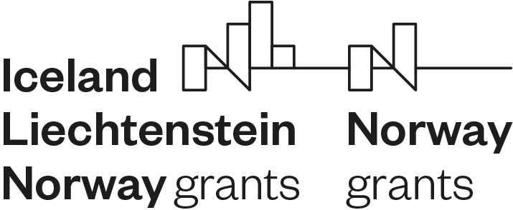

**INTERCEPT in a nutshell**

*motIvating mobiliziNg supporTing nEets gReen CarEer PaThway*

*Call: Unlocking Youth Potential*

*Project No. 2020-1-0033*

*Lead partner: Jobsplus*

*Duration: 29 months*

*Budget: € 2.18M*

*Implemented by:*

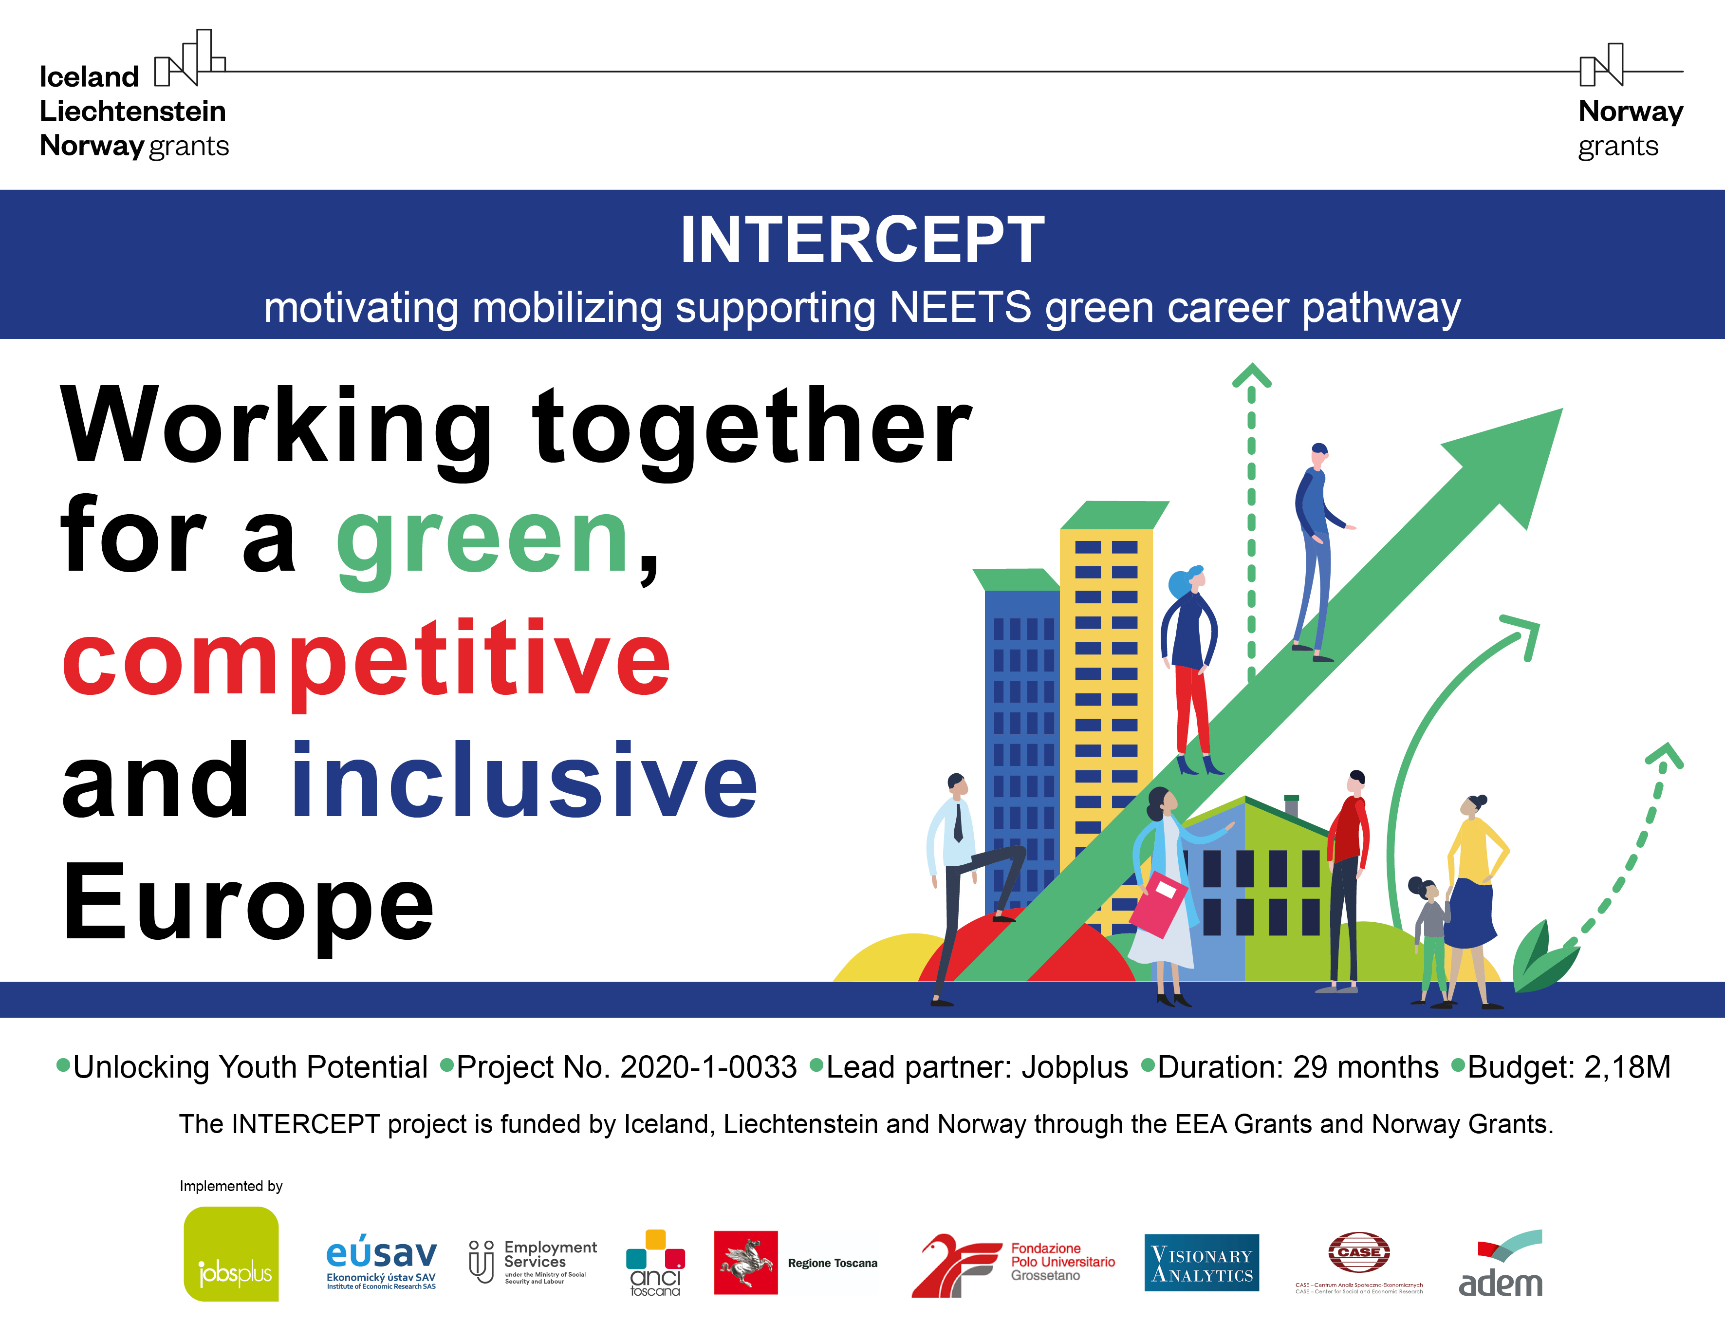

**Empowering a green and sustainable future!**

Today's **young generation** will undoubtfully be most affected by **global climate change**.

In this context, resorting to investments in a **green economy** can help secure a just and **equitable future** that improves people’s lives through the advancement of environmental and social well-being.

To ensure that such **transformation is inclusive and sustainable**, policy should create solutions which also increase the participation of vulnerable groups, like young people who are Not in Education, Employment or Training (NEETs).

Supporting **NEETs** to gain the necessary skills and work experience to **access jobs in the green sector** is an investment with high potential return and a promising tool for social inclusion.

**What is the INTERCEPT project?**

**INTERCEPT is aimed at unleashing the potential of NEETs aged 25-29** thanks to the use of innovative tools to acquire new skills and find jobs **in the green sector**. To do so, the project will create a new Green Career Pathway, featuring an outreach strategy, career counselling, tailored training and internship opportunities.

INTERCEPT benefits from a € 2.18M grant from **Iceland, Liechtenstein and Norway** through the **EEA and Norway Grants**.

**What’s in it for… ?**

**> NEETs**

**If you’re a NEET aged 25-29**, interested in building a career with a positive impact on the environment, INTERCEPT will offer you a precious chance to:

* explore your aspirations and **foster your skills** to meet the green job market demand;
* gain first-hand experience through **paid** **internships** in companies that deliver services for the protection of ecosystems, the decarbonisation of society, the reduction of energy, materials consumption, waste and pollution and so on;
* get a green job if the internship is successful.

**> Public Employment Services (PES)**

**If you’re a PES**, INTERCEPT will provide a useful **compendium of green competences** based on local labour markets, whilst upskilling youth and creating a **better equipped work force**. It will also offer up-to-date and comprehensive **data on the 25–29-year-old NEETs’ profile**, a niche segment which has its very specific needs.

**> ‘Green’ companies**

**If you’re a ‘green’ company**, INTERCEPT will find, train, pay and introduce to you the **most suitable candidates for internship opportunities**: you just need to get on board and benefit from our pilot scheme. One of your best future employees could be among them!

**Who’s already on board?**

The project is led by **Jobsplus** Malta together with 8 partners from 5 countries.

* **Visionary Analytics** from Lithuania, **CASE - Center for Social and Economic Research** from Poland and the **Institute of Economic Research - Slovak Academy of Sciences** will oversee the research aspects of the project;
* The **Region of Tuscany**, **Anci Toscana** and the **Grosseto University Hub** in Italy will focus on communications, outreach and training development;
* **Anci Toscana** with **Jobsplus** and the **Lithuanian Public Employment Service** will pilot the innovative training in green skills which will involve 300 NEETs across the three countries (Lithuania, Malta and Italy);
* As the project expert partner, **ADEM**, the **National Employment Agency of Luxembourg**, will share knowledge about labour market mechanisms and guidance of young jobseekers.

**What are the EEA and Norway Grants?**

The **EEA and Norway Grants** represent the contribution of **Iceland, Liechtenstein and Norway** towards a green, competitive and inclusive Europe. There are two overall objectives: reduction of economic and social disparities in Europe, and to strengthen bilateral relations between the donor countries and 15 EU countries in Central and Southern Europe and the Baltics. The three donor countries cooperate closely with the EU through the Agreement on the European Economic Area (EEA). The donors have provided €3.3 billion through consecutive grant schemes between 1994 and 2014. **For the period 2014-2021, the EEA and Norway Grants amount to €2.8 billion**.

The **priorities** for this period are:

#1 Innovation, Research, Education and Competitiveness

#2 Social Inclusion, Youth Employment and Poverty Reduction

#3 Environment, Energy, Climate Change and Low Carbon Economy

#4 Culture, Civil Society, Good Governance and Fundamental Rights

#5 Justice and Home Affairs

Eligibility for the Grants mirror the criteria set for the EU Cohesion Fund aimed at member countries where the Gross National Income (GNI) per inhabitant is less than 90% of the EU average. The EEA and Norway Grants scheme consists of **two financial mechanisms**: the EEA Grants and the Norway Grants. The EEA Grants are jointly financed by Iceland, Liechtenstein and Norway, whose contributions are based on their GDP. Norway Grants are financed solely by Norway.

**Working together for a green,**

**competitive and inclusive Europe**

**www.eeagrants.org**

**www.norwaygrants.org**