**Program Features for the Month:** Cycling

Related Advancement

* Tenderfoot requirements 1b
* Second Class requirements 1a and 3a
* First Class requirements 1a and 10
* Cycling merit badge
* Personal Fitness merit badge
* 50-Miler Award

**Bicycle Basics**

* Learn how to change tires and tubes.
* Learn how to adjust brakes, seat, and stem tube.
* Learn skills for short-distance street riding.
* Discuss cycling safety, traffic rules, and introduce these topics:  
  — Bike types and parts  
  — Bike clothing and helmets  
  — Bike training and nutritional needs.

**Route Planning**

* Discuss safe cycling route criteria and streets to avoid.
* Brainstorms are the most common danger for city cyclists.
* Demonstrate signals for turns and stopping.
* Discuss other defensive riding techniques.
* Introduce bicycle route maps.
* Demonstrate websites for bike riders.
* Demonstrate online route map creation.

**Riding Skills Demonstration**

* Explain skills to be demonstrated later in the meeting.
* Explain the route to be covered on evaluation rides.
* Assign riders to leaders for evaluation and assemble at the starting line.

**Bicycling Safety Training**  
The speed made possible by riding a bicycle inherently increases the risk of injury, with the head being the most vulnerable body part. However, any bicycle fall is potentially life threatening even without speed because the head is likely to strike a hard surface with enough force to cause a concussion, if not a skull fracture. Accordingly, an essential part of cycling gear is a good quality and well-fitted helmet. It is essential to understand the risk involved from head injury and the absolute necessity of wearing a helmet when biking.

The helmet, however, is no match for a collision with a motor vehicle. Youths often want to ride in vehicular traffic without an adequate respect for and

[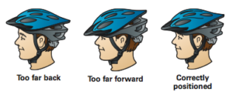](https://3rn7ez18fsfq1kf6kr1o3bpm-wpengine.netdna-ssl.com/wp-content/uploads/sites/5/2016/08/Helmet.png)

understanding of the risks related to bike and motor vehicle collision. In such a collision, the bike rider always loses.

Defensive riding practices and cycling rules of the road must be learned and practiced before riding in vehicular traffic. Practice should be conducted on bike trails or lightly traveled roads until skill levels are enough for safe riding in traffic. Special attention should be paid to staying in the bike lane and being alert for the danger of doors being flung open into the bike lane by parked cars and with drivers making a right-hand turn across bike lanes.

## Gear Carrying Options for Bikepacking

Bikepackers carry the same gear as backpackers plus spare bike tools and tubes. Fortunately, you have more places to carry it on a bike.

Unlike backpacking, you *don’t* want to carry a lot of weight on your back. Instead, most of the weight should be placed low as possible on your bike. This improves bike handling and your riding comfort.

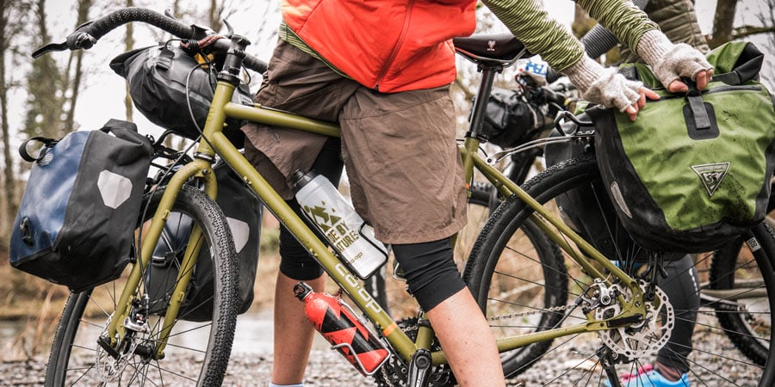

**A typical gear setup for** **beginners**:

* **Daypack:**Good for light, bulky items, or anything sensitive to vibration.
* **Dry bag secured to a rear rack:** Holds heavier items.
* **Handlebar bag (or dry bag lashed to the bars):** For light to moderate items (e.g., tent, pad, clothing).
* **Water bottle cages:**Keeps water weight low and centered.
* **Panniers:**Optional for heavy items (e.g., water, food, stove).
* **Bike trailers:** Optional for group/family gear or very heavy items.

Bikepacking enthusiasts who ride single-track trails seek a more streamlined approach. Panniers are skipped because their width makes them easily damaged on narrow trails. A rear rack is left behind to save weight and to reduce the chance of mechanical failure.

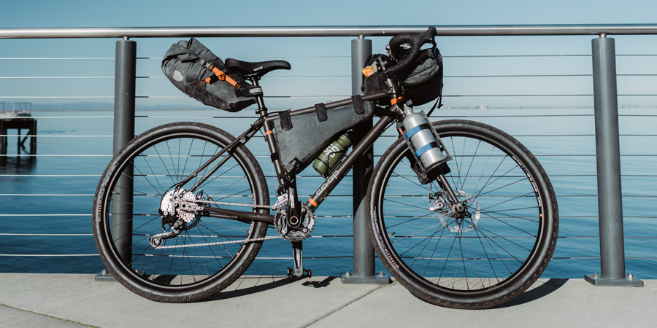

**A typical gear setup for** **enthusiasts**:

* **Large seat bag:** Good for light, bulky items.
* **Handlebar bag:**For light to moderate items (e.g., tent, pad, clothing) or gear needed quickly (e.g., map, camera, GPS).
* **Water bottle cages:**Some riders attach an extra cage under the downtube or to the fork.
* **Frame bags:** Popular for heavy items such as a hydration bladder, food, or tools.
* **Top tube/gas tank/bento box bag:** For snacks or camera.
* **Daypack:** Optional for light, bulky items, or items vulnerable to vibration.

Many riders become expert at lashing gear onto the bike with tie-down straps or repurposing items to meet their needs. A tent, for instance, can be attached to many handlebars. A bento can be placed backwards at the rear of the top tube. Nearly everyone experiments to some degree to see what gear setup works best.

**Closing/Scouting Minute**

**OUR TROOP IS LIKE A BICYCLE**  
– Have you ever thought about how a bicycle works? Most of us just hop on and let it take us where we want to go without giving it a second thought. A closer look shows it takes a lot of different pieces doing their part and working together to make transportation happen.  
– When you push the pedal with your foot, a lot happens to make the wheels turn. The pedal turns a crank that turns a gear, which pulls a chain that turns another gear, which turns a hub, which pulls the spokes, which turns the wheel, which pulls the tire that pushes against the road to make the bike go.  
– When you want to stop, you pull a lever that pulls a cable against a housing, which causes another lever to move, which pushes a pad against the wheel. Changing gears involves levers, cables, housing, springs, and pulleys working together.  
– If any one part fails to work when it is supposed to, the whole system fails to work. At best, if it still can be ridden, it doesn’t operate in top form.  
— In our troop, we are the parts, just like on the bicycle. Our patrols are like the pedaling, braking, and gear-changing systems. The senior patrol leader is like the rider. He directs a pedal or a lever (your patrol leaders) to do their part, and they in turn ask their patrol members to do theirs. If we choose not to do our part, our patrols suffer, and our troop doesn’t work well. The troop is our vehicle to adventure, fellowship, and good times. And each of us is a very important part.

Resources:

Boy Scout Handbook

Troop Program Features for Troop, Teams, and Crews A Guide for Program Planning, Volume 1

Field book

REI