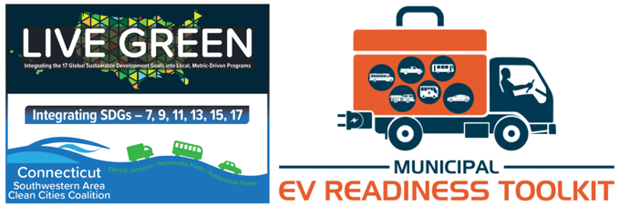
Module 1: Orientation, Economic and Community Development
Team Building Tool
 | Municipality/ Organization | First Name | Last Name | Title | Phone | Email
Orientation, Economic and Community Development
Electric School Buses
Municipal Fleet
Parking & Enforcement
Zoning & Planning
Building Codes & Permitting
Public & Destination Charging
Multi-Unit Dwelling Charging
Workplace Charging
Transit Buses
Shuttle Fleets
First Responder Fleets

Identify a person in your municipality to attend each of the 12 modules in the Municipal EV Readiness Tool series.
Registration links, dates, and times for each of the modules can be found at www.livegreenct.com.

