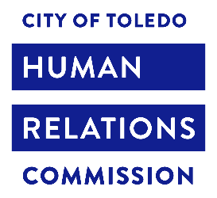 Full Meeting

Zoom Meeting Agenda February 20, 2023

6:00 PM to 7:00 PM

Location: Women of Toledo

425 Jefferson Ave., 3rd Floor

The Human Relations Commission shall endeavor to support a safe, energetic, and livable city. The Commission will support residents working to overcome prejudice and build mutual respect.

Call to Order

Minutes Approved

**Mayor’s Office Updates** (Caryn)

**Mediation** (Raina)

**Stop The Violence** (Sierra)

Committee Updates

* Community and Neighborhoods
* Social Justice
* Youth Empowerment and Engagement

**Old Business**

* Welcome TLC
* CEDAW
* Getting Healthy Zone
* Public Speaking Protocol

**New Business**

* IFTAR
* Human Library

For the Good of the Order

Next Meeting: March 18, Location TBD

Adjournment