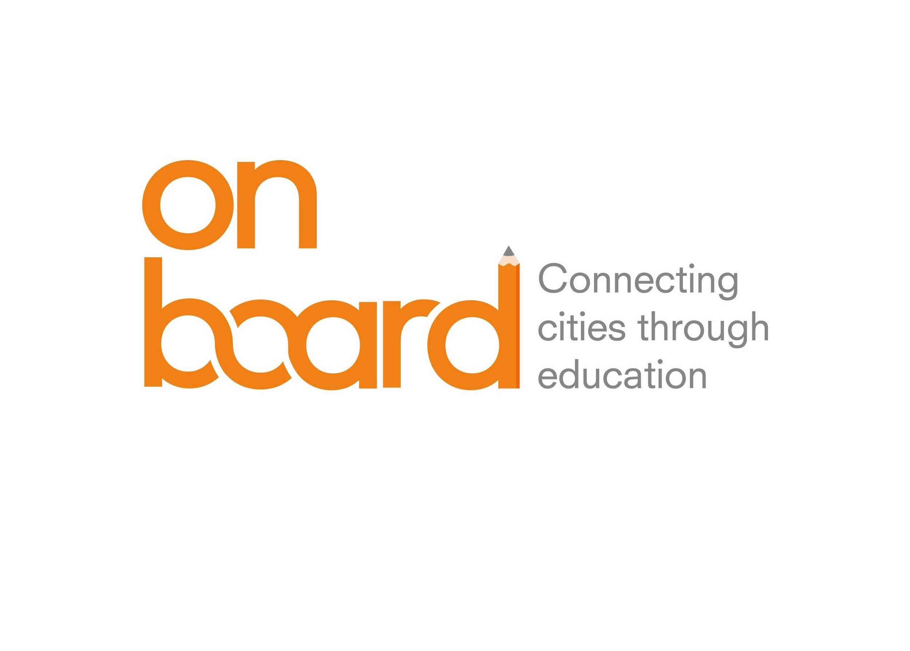

Local Entities as Educational Agents
Mid Term Review

On Board, Transfer Meeting 4 Report

Introduction

The TM4 in Tallinn addressed the educational relevance of local entities and institutions, namely, city organizations and bodies that are not formal education centres but that contribute to strengthening the capacities, skills and values of young and students in the city.

By local entities ON BOARD refers to those private community based organisations and institutions that can perform as educational agents when sharing their know how and values in subjects that complement the formal curricula and in spaces often different from the regular schools.

To address this topic, Viladecans first offered an overview of the work the city is doing to involve local entities as members of the Educational Innovation Network. Then, in turns, and with the help of graphic materials, invited stakeholders coming from local entities and non-governmental organisations of the respective cities, briefly introduced the education work they develop in their own cities.

To broaden even more the perspective on the possible interactions between schools and entities, and to inspire the debate among participants, Peter Ulholm, URBACT Ad Hoc Expert and specialist on educational collaborative processes, led a participatory session, following an initial presentation to the topics, all members contributed with their ideas and most valued proposals.

To finalise the sharing of experiences with local entities, Tallinn presented its own model of a city supported network of youth clubs and hobby centres where students go in their spare time to develop skills and learn in areas ranging from robotics and drones, arts, music, sports and other skills and personal values not often addressed at school curricula, but which complement them.

Taking advantage of the group visit to Tallinn, the URBACT team attended a presentation on the Estonian Digital Strategy and how this applies to education centres. Estonia is well known for its countrywide strategy to incorporate digital solutions to the public services and in particular to the national Education System, Kristel Rillo, from the e-Services Unit at the Estonian Ministry of Education and Research, introduced the strategy.

With regards to the Transfer Step foreseen for this 4th Network meeting, the Mid Term Reflection session allowed the group to debate and discuss on the Good Practice transfer advancement. ON BOARD Cities assessed progress so far in formalising the Educational Innovation Network, involving new stakeholders and allocating the required resources. They also discussed main difficulties in introducing the deep and systemic changes that the Educational Innovation Network requires.

The present report presents main contents and outputs of the meeting sessions as well as Policy recommendations derived thereof.

All the presentations and references can be further expanded with the help of the meeting materials annexed or referred to at URBACT ON BOARD site. Moreover, for an on going update of the project activities subscribe to the URBACT Newsletter.

The educational system in Estonia and Tallinn Education Priorities

Katrin Parve, Reet Nömmoja and Kätlin Kalde, Tallinn Education Department, presented the outline of the Estonian and Tallinn Education System Structure and competences.

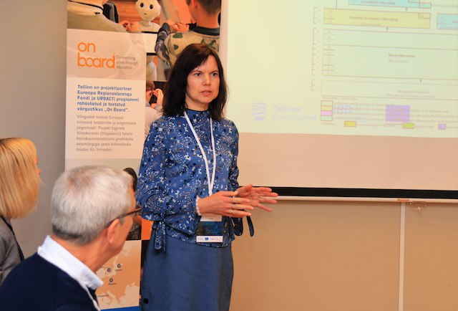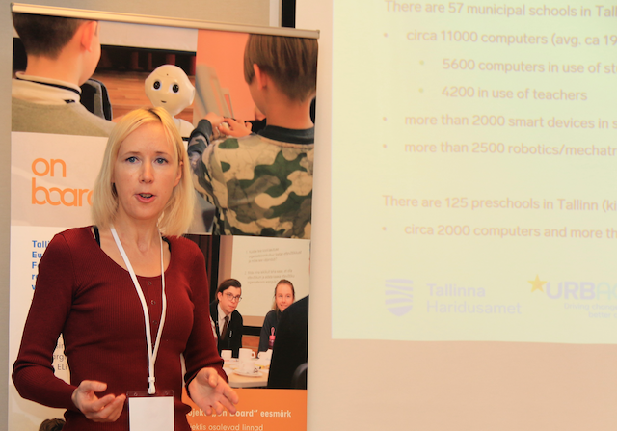
- Reet Nömmoja and Kätlin Kalde, from the Education Department of the city of Tallinn
Highlights:

Estonian education system is decentralised and the division of responsibility between the state, the local government and school is clearly defined.

The national government supervises the implementation and quality of national curricula for preschool childcare institutions, basic schools, for upper secondary schools, for vocational studies, and of higher education. On the basis of the national curricula, each education centre compiles its own curricula. The language of instruction is mainly Estonian but also other languages (Russian, English) may be used.
The expenses of secondary schools are covered from the budget of the Ministry of Education and Research while expenses of primary schools and preschools are funded by municipality’s budget. All costs of schools for extra-curricular activities and youth centres are covered by the local municipality.

Tallinn is responsible for a total of 195 municipal educational institutions comprising: preschool childcare institutions, basic and upper secondary schools, schools for extra-curricular activities, and one VET school. Expenses include infrastructure, management, maintenance, staff salary, staff development, educational projects, teaching aids and free pre-school lunch. Public transport and state museums are free for students in Tallinn.

Tallinn Education motto “We learn everywhere” means that Education is not only delivered at the schools, but it is the result of the full development of personal capabilities and opportunities. Learning and self-development is people’s own choice and responsibility, so studies should support this with modern, flexible and quality education.

Tallinn schools are digitally equipped: all public offices and schools are provided with free WiFi with fibre connection at 1Gb/s (some kindergartens too) and 1 computer per 11 students, and more than 1 computer per teacher. Education results are high within PISA rating, 95% of the population has finished compulsory education and only 7% of drop out rates concentrate in secondary education.

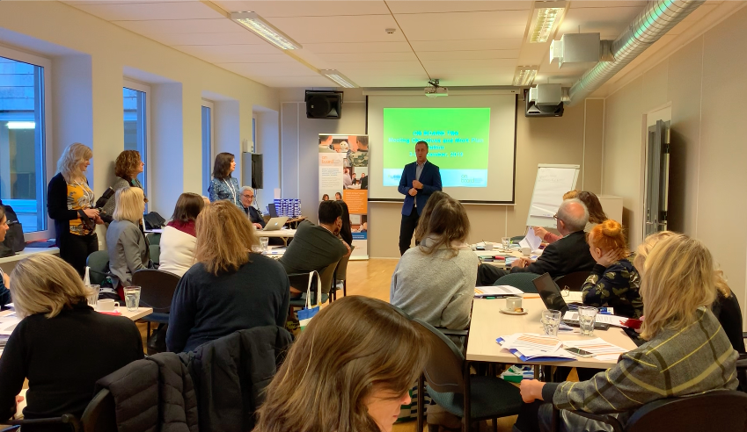

Local Entities as Education Agents

Below is a summary of the key ideas generated at the local entities’ dedicated sessions. Full contents of the presentations can be accessed through the session materials.

- Presentation

ON BOARD partners refer to local entities as a large group of local agents that contribute to educating children and young: youth and sports clubs, after-school organisations, leisure entities, environmental and cultural institutions -museum, arts, libraries…-, volunteer organisations, cooperatives and social enterprises, NGOs, civic and community organisations (neighbourhood, elderly…), training and skills-development associations, etc.

Boys and girls learn all the time and everywhere in their daily lives and their education is moulded in school and out of school time and by different mentors. Some contribute to their personal values –family, friends, leisure entities- others help develop capacities -technical, artistic, linguistic- and others contribute to shape personal and emotional abilities, communication skills and creativity. All these impact in their personal development and life and job opportunities. This is what Viladecans considers working from the basis of “360 degrees education”, i.e., “everybody educates” in the city.

ON BOARD partners believe that cities, and in particular cities’ Educational Innovation Networks, can leverage the potential of these entities’ know how to improve children educational experience and results while promoting social values and creating personal bonds with the communities they live in. In addition, by placing the child at the centre of the education process, we will get the most of their learning capacities.

To broaden the possibilities of this school-entities joint work, the participants at the TM4 in Tallinn attended a round of brief presentations from the representatives coming form the project partners’ local entities, including the Good Practice City of Viladecans, and a keynote speech from Peter Ulholm, expert in educational collaboration networks.

Key ideas are summarised below:

- Review of ON BOARD partners’ experiences

All ON BORAD partners had come with their representatives of local entities they want to involve in their Educational Innovation Network. These representatives introduced the education work they develop with the help of images, posters, etc. Find here a brief summary.

- Viladecans’ attempt to improve the Network through involving local entities

Gisela Navarro, Deputy Mayor for Social Affairs and Education, and Sonia Dominguez, International Relations Officer, introduced Viladecans’ work to strengthen the Educational Innovation Network by improving the relations with local entities.

Viladecans’ Educational Innovation Network has been mostly focused on school hours so far. However, incorporating local entities, as members of the EIN, should provide a new perspective and specific knowledge that can be applied to the classroom as well as expand the educational impact.

The situation today

- At present Viladecans has 210 active entities: sports, culture, cooperation, defence of rights, youth, elderly people and quality cultural facilities: library, museum and theatre.
- Some entities already participate with the educational centres in different activities and under different types of agreement, among them:
  - Entrepreneurial Culture in the School, where 5th grade students develop a social responsibility project consisting of a cooperative to sell products in collaboration with non-profits.
  - Local Plan for the Promotion of Sport: where some local sports entities contribute with sport sessions as part of the formal curricula subject of Physical Education and Sports.
  - Open School to the Neighbourhood: activities both in school and non-school time where different educational community agents, together with Parents Association or educational centres organise leisure activities
- The City has a Municipal Catalogue of Educational Activities provided by the local entities that create workshops on different matters to be celebrated in schools. This initiative, similar to the online catalogue that the Culture Department of Nantes offers to schools, is a way to centralise the educational offer while encouraging the educational potential of local entities, being them cultural, artistic, etc.
- Often, Parents’ Associations offer extracurricular activities in the education centres and in after-school hours.
- Finally, Viladecans has specific agreements between leisure entities and educational centres to use premises.

Good Practice Improvement

Viladecans will work towards:
- Entities being a more present educational agent, not only for specific projects
- Local entities to collaborate with the EIN must provide educational innovation projects and perspective
- The EIN will look for new ways for entities to work within the school (based on their specific knowledge), not only as after-school activities
- The EIN will facilitate entities’ learning process from this collaboration, so they find a specific interest in participating

Specific actions foreseen for this improvement area of the city Good Practice are:
- Mapping the local entities with a potential and will to be part of the EIN
- Identifying successful projects linking entities and schools for replicating and piloting in other education centres
- Develop a 2-year action plan to guide the collaboration work between schools and entities in Viladecans

- Why and How can schools open to local entities, by Peter Ulholm:

In 2014, Denmark approved a new legislation allowing schools to work together with local entities (companies, NGO´s, museums, sports clubs, craftsmen etc.). Researchers have been monitoring many of the projects developed in order to draw conclusions and recommendations.

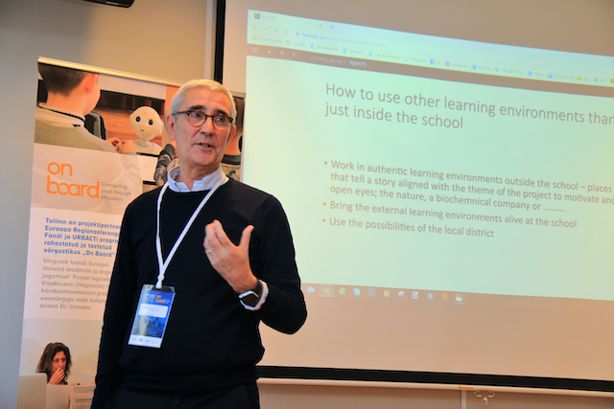
- Peter Ulholm, URBACT Ad Hoc Expert and Consulting Director of LearnLab, at the session on local entities as members of the Educational Innovation Network

Some key conclusions from the experience is summarised below (full presentation can be found here):

Why
- Students from schools developing projects with entities are more motivated. They experience different approaches to the teaching/learning process, which helps to break down walls and prejudices.
- External engagement and work in out of school spaces inspires and motivates the students and connects them with real life problems. Students can test themselves in different roles and have victories.
How
Establishing new relations between schools and local entities is a demanding process.
- There has to be a bridge between the student´s learning with the local entities and the formal teaching/learning processes at the school. This has to be analysed and prepared by teaching staff.
- The school leader and teachers must dedicate time to plan, find new partners, shape good conditions. Work needs to happen in authentic learning environments outside the school, in places that tell a story aligned with the theme of the project, i.e. the nature, a biochemnical company, a museum…
- If it has to happen within the classroom, then bring the external learning environments alive to the school. Use the possibilities of the local district.
- Appoint a co-ordinator to organize the cooperation and a working group on each school to create idea and forms of cooperation.
- School leaders should show engagement and prioritize the project in their schools
- Creating personal relations increases commitment and mutual understanding
- Use the local entities as a driving source in creating ideas and initiatives. Allow them to be propositional
- Use the network format, as the EIN, to help create a framework for dialogue and development of cooperation between school and local entities
- Enable digital portals or catalogues with an attractive offer of activities for schools and for local entities
- Use positive rewarding schemes to encourage collaboration
- Facilitate a three-party dialogue between the local administration, schools and local entities to find common interests and paths

Share
- Share knowledge an experience with colleagues by having the project on the agenda at all meetings, where pedagogical issues are discussed
- Spread the story in the medias: social, local TV, local newspaper etc.
- Make an event when a project closes down

After contents presentation, participants were asked to think of the most useful and relevant ideas for them to take home. Some of the answers here:

- Building bridges between the learning at the school and the learning with the entities
- Personal contact is important to build confidence
- Working groups within schools to create and develop ideas
- All information gathered at a digital platform to be shared
- Importance of school leaders engagement and support
- Sharing good practices

At a parallel session with only representatives from the local entities coming from the different partner cities, participants discussed relevance and interest of collaborating with schools. In cross-national groups, they debated around key questions and provided the following feedback:

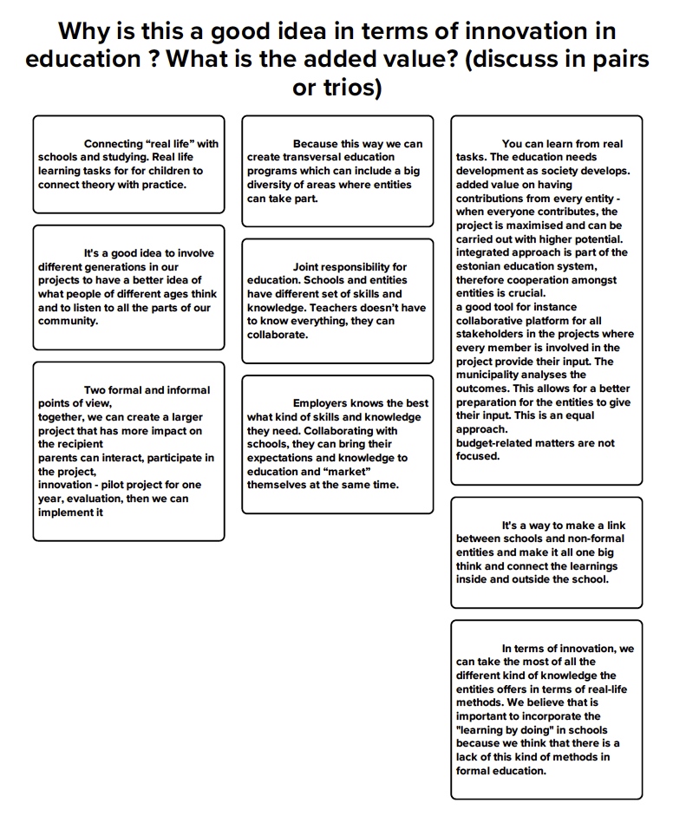

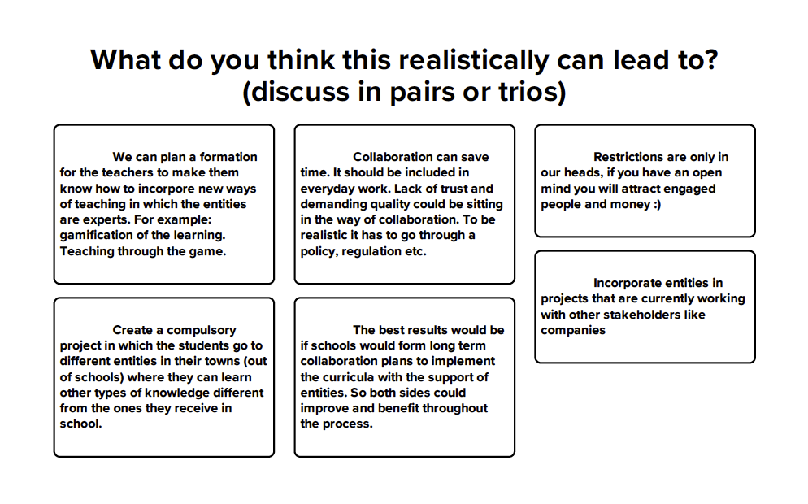

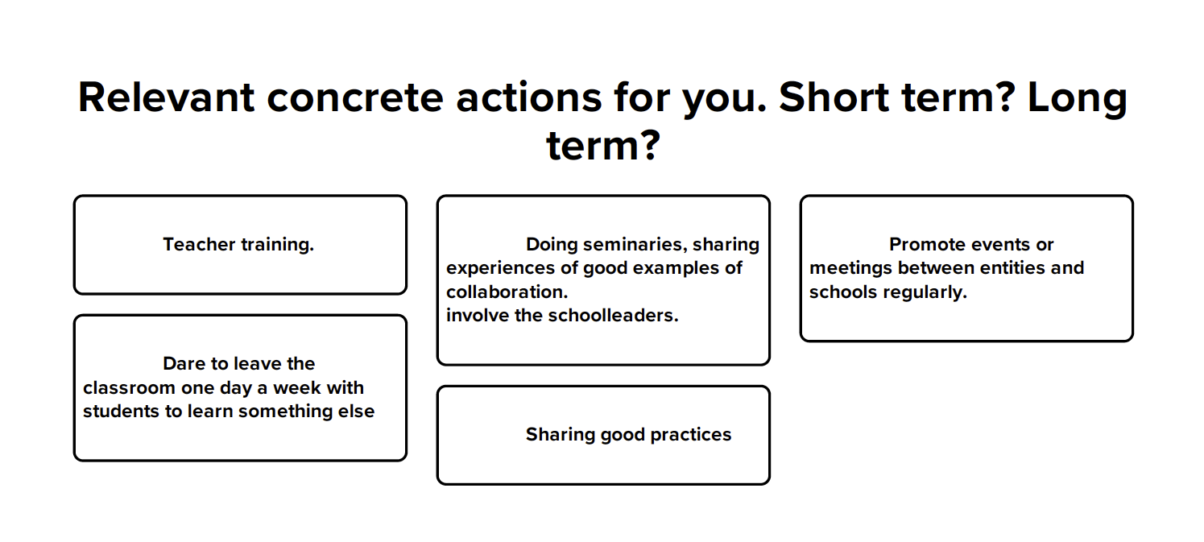

On Board Checklist

Enabling the conditions for an active role of local entities as members of the Educational Innovation Network

- Map and acknowledge the local entities with a will and capacity to perform in education projects.
- Increase the number of non-formal education agents by looking out for existing talent in the neighbourhood, city… look for organisations that can provide innovative views and contribute with their own talent and work.
- Create opportunities for schools’ teachers and headmasters and local entities to meet and interact in open and informal learning settings.
- Promote group gatherings for local entities’ self-recognition as education agents and members of the Educational Innovation Network. Invite local entities to the Network activities so they can open new channels of sharing and working together.
- Facilitate a three-party dialogue between the local administration, schools and local entities to find common interests and paths
- Coordinate and facilitate leading schools and entities to participate in pilot innovative projects in the classroom. Enable the ‘safe mode’ work by escorting those innovative projects being tested and implemented for the first time, for example, by facilitating resources and ensuring quality time to plan and implement projects in a way that collaboration effectively contributes to the curriculum.
- Involve students in projects that are relevant to them and to the local communities
- Enable reward schemes in the city to encourage and acknowledge educational innovation projects involving local entities.
- Enable digital portals or catalogues with an attractive offer of activities for schools and for local entities
- The Educational Innovation Network can help curate, protect and consolidate these new methods and relationships
- Create a public private partnership scheme to ensure the bridges between education, capacities and skills are consistent with the labour market needs and offer.

Tallinn network of after-school education centres and local entities:
Hobby centres and Youth Clubs in Tallinn

The City of Tallinn presented its local network of Youth Centres and NGOs, as well as the partnerships with technological centres that participate and support education projects for primary and secondary school students in their after-school time but also in projects delivered in school hours, in collaboration with teachers. In Tallinn the meeting participants visited:

- 2 non-formal education centres:
Kullo Hobby Centre (Tallinn school for extra-curricular activities)
Haabersti Noortekeskus

- 1 formal education school member of the EduInno Lab initiative
- Pelgulinna Gymnasium

- 2 local institutions that contribute to education in cooperation with the Municipality and the schools:
  - Energia Avastuskeskus (Energy Discovery Centre)
  - TalTech Mektory Smart Campus, at the University of Technology in Tallinn

Participants learnt about Tallinn model of public–private partnership between formal and non-formal education centres and attended practical sessions of the activities and projects that contribute to education of the children aged 5 on.

Hobby Centres

Hobby centres (also known as hobby schools or schools of extra-curricular activities) are municipal institutions. Tallinn Education Department is the administrative operator. Hobby centres to create opportunities for diverse development and hobby education for children and young people. There are a total of 10 hobby centres in Tallinn. Besides these leisure activities, hobby centres organize compulsory swimming courses for third-year students of Tallinn, sports games and extra-curricular activities such as camps, and courses. Families pay for their activities at hobby schools.

Their work is based on school curriculum and its teachers deliver the classes of music, arts, nature, technology, dance, handicraft, sports, etc. These are municipal schools with such relevant educational contents that the Municipal Department of Education is considering to include their activities as part of the formal schools curricula.

Kullo Hobby centre is the oldest (1941) and largest (2.200 students) hobby school in Estonia. Kullo offers study and educational work throughout the year at the main building, Kullo Children's Gallery. In summer activities are at Kullo Karepa Youth Camp.

Kullo hosted Day 1 of the Meeting and the participants had the opportunity to visit the facilities and have a broad explanation of the developed activities.

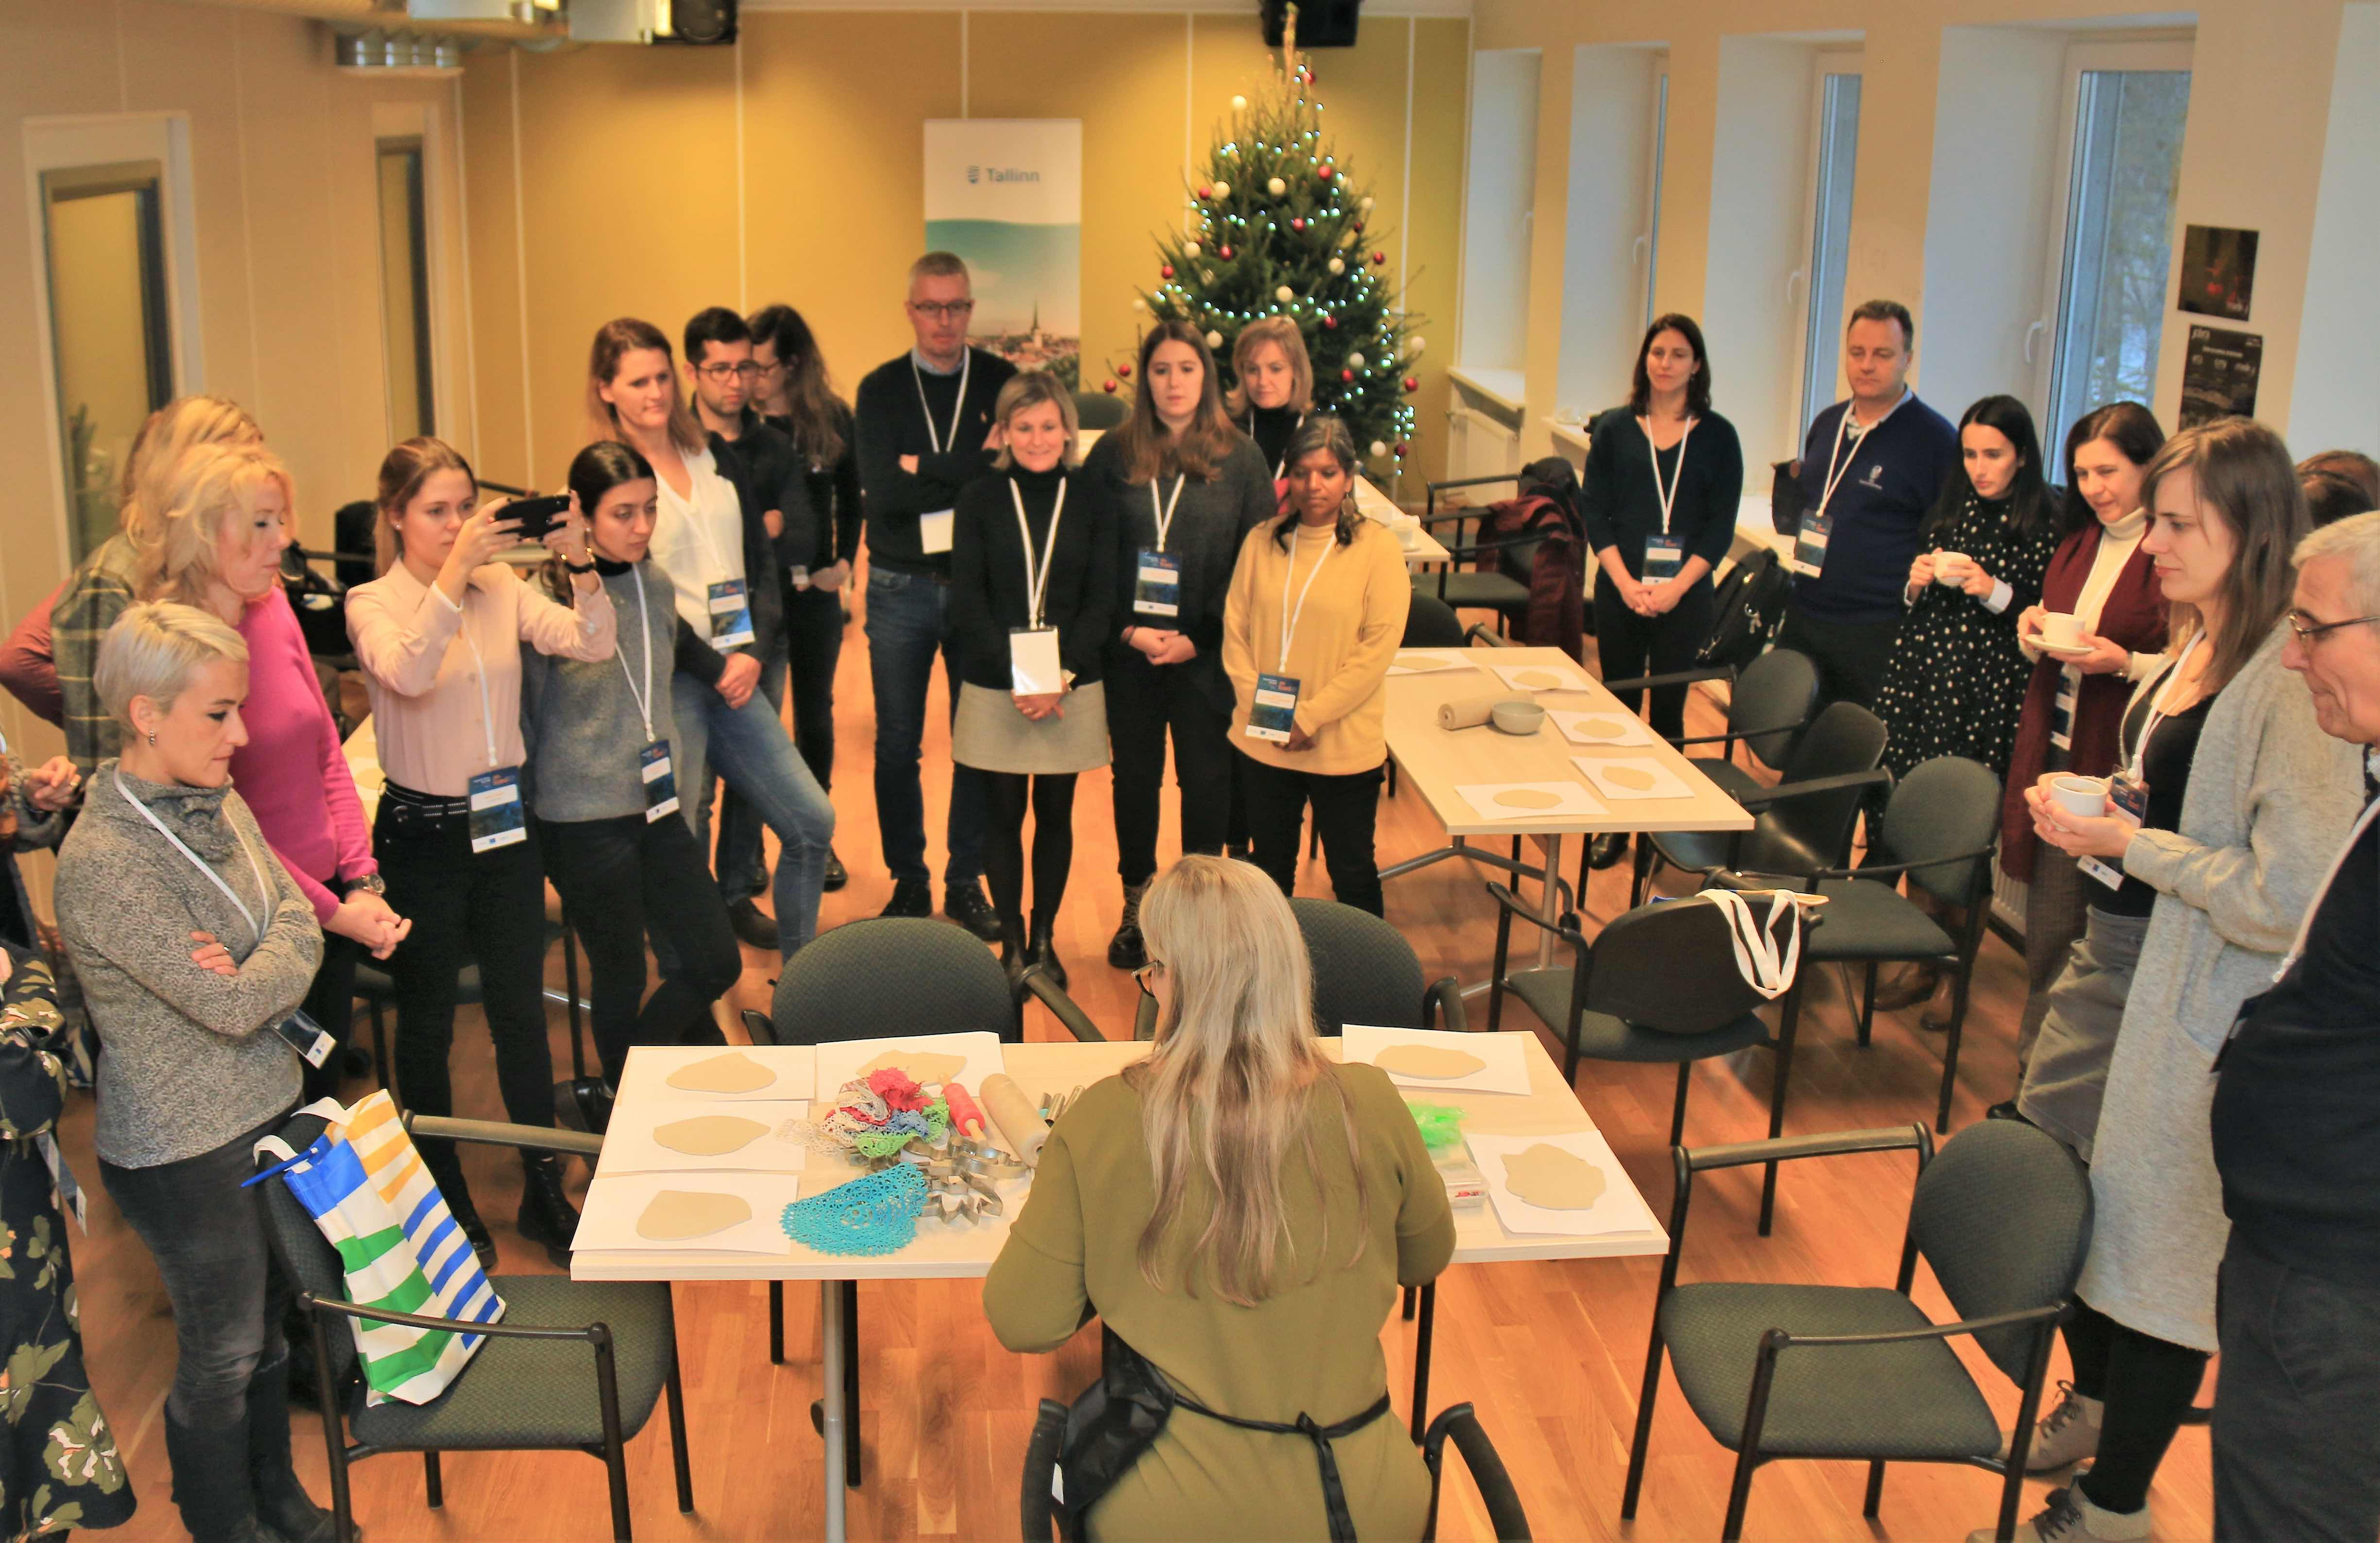
- ON BOARD participants attending a crafts classroom at Kullo Hobby Centre

Youth Centres

Youth Centres are leisure and extra-curricular organisations and have an important role in children and young education in the city. Youth Centres are coordinated by Tallinn Youth and Sports Department.

In addition to the Hobby Centres, the Youth Clubs provide with non-curricular activities to the children and young in the city. They provide adequate conditions for educational activities based on their individual interests, which keep them active near their homes but socializing out of the family with peers, and in after study program and work. The youth centres promote informal learning and are main organizers of regional youth work, executing regional and citywide youth events. They also work on integrating non-formal and formal learning offering schools 13 different workshops that classes can subscribe to for free.

The ON BOARD participants visited one of the Youth Centres from the local network, the Haabersti Youth Centre. This centre received the award to the best Estonian Youth Centre in 2018. At Haabersti, the programme of activities is decided together with the users.

- ON Board visitors attended the presentations and engaged in some of the activities that young people do at Haabersti.

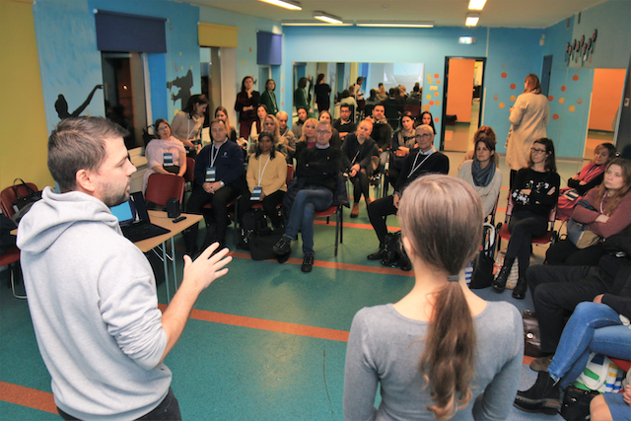

Mobile Workshops

Merkuur is a network of mobile workshops in Estonia with the purpose of introducing young people the different professions, work practices, and tools of the metal and wood sector, and offering hands-on opportunity to test the work tasks associated with these professions in order to raise young people's career awareness and competitiveness in the fields of technology and engineering.

Young people tend to not choose to study the professions in the metal and wood sector and rarely pick the career of an engineer, so the Estonian industry lacks qualified workforce. The mobile workshop has an instructor that trains young in the practical learning experience connected to entrepreneurship in the fields of technology in order to expand career awareness in choosing their future specialities.

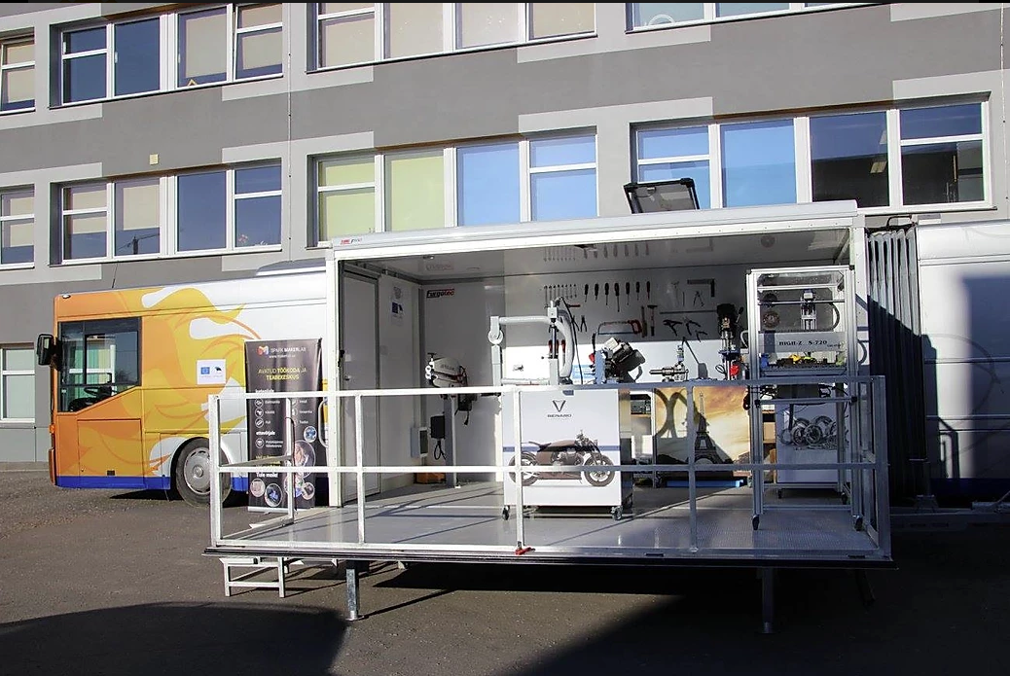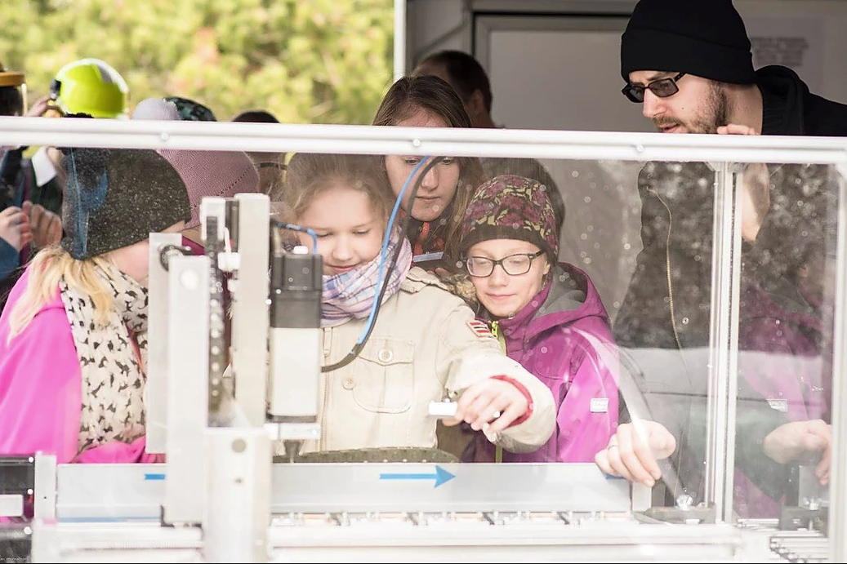
- Merkuur mobile workshop in Tallinn

Estonia Digital strategy

Estonia Digital Strategy involves health, education, e-services and electronic ID. With a population of 1,3 million people, it has been easier in Estonia than in other more populated countries to develop a nation wide strategy for schools. This is effectively implemented and permanently monitored and updated.

Education in Estonia is approached as one pack of information, with a digital focus, and not as different isolated topics. And so is IT and Digital learning. These subjects, such as robotics, are introduced as an instrument to other subjects, i.e. English or science.

- Digital Strategy in the Education system

Development and implementation phases:

2013 Development of the strategy covering some selected aspects, always prioritising digital focus:
- Change in the approach to learning and pedagogic aspects to make curricula more students’ oriented
- Competent and motivated teachers and special attention to school leadership
- Free training for teachers and in particular for school leaders for the schools to become supportive places to teach and learn
- Lifelong learning for teachers and students to adapt to new professions. In some higher studies, people from higher education go back to vocational school to have a practical experience.
- The importance of the technology in the classroom is more relevant with regards to the diversity than the number of devices per class or per student. So the government makes sure that, in addition to personal computers, there are also other tools, i.e. robots
- Estonia started looking at competences more than professions, to attend to the capacity to adapt as much as specialise.
- Access to education is general in Estonia, still the government looks for equal opportunities for all students, also in the digital aspect.

2014: Estonia initiates first digital contents and approach in the national curriculum. Key starting aspects were: what digital skills teachers and students have and which they needed to be developed? to cope with the information society, for different professions (teacher, hairdresser), to create and develop information technology.

Estonia adopted the Digital Framework of the EU as a model, which divides into 5 competences.

- Finding information
- Communication
- Content creation: writing, pictures, simple coding and copyright management
- Safety: health, data you share, environment (tech waste)
- Problem solving: figure out what is the problem when some tech issues arise.

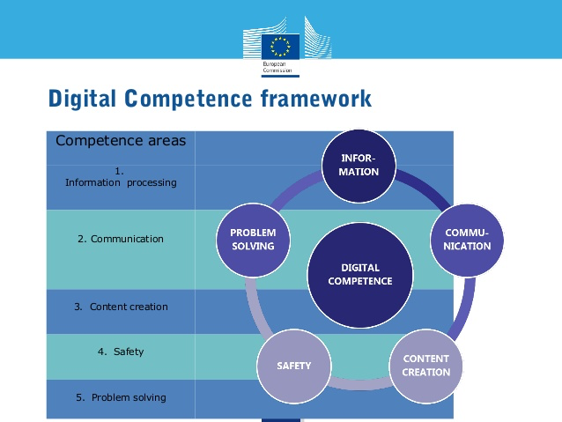

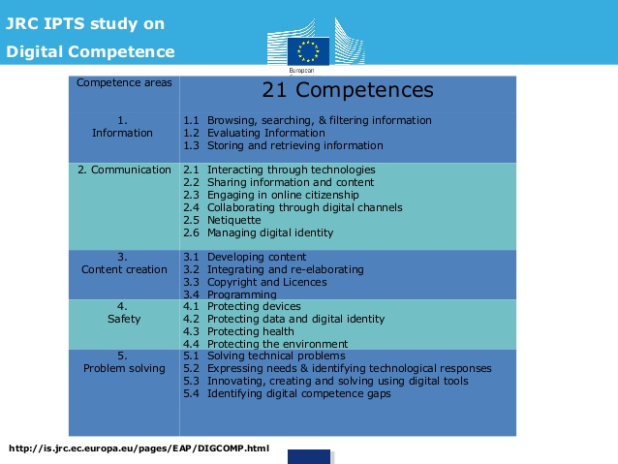

2015 Firsts tests were done in online format which facilitated that many schools were brought online for the first time

2016 Guidelines were delivered to schools on the 5 aspects of the Digital Competence Framework to be taught and for each age group

2018 84% students had achieved the set digital standards. However, because of the rapid developments of the digital sector, curricula needed to be revised and updated again. A new strategy for upgraded levels was introduced and will be reviewed in 2020.

On teachers’ training:
- Teachers do not have digital subject in their career studies, but as part and integrated to other subjects
- It is difficult to assess the Digital Competence Framework for teachers, as different from the pedagogic learning skills, which is already a full training programme.
- A key difficulty in teachers’ life long learning is time. The Government has not yet found a solution to make compatible digital training and full time working.
- The national government provides training resources for schools, while digital textbooks are generally from private publishers. In some cases, the public sector has to make available some of these materials to schools with less resources.

Effective digital transformation so far:
- Digital books of different degrees are linked per topics on the cloud. These topics are addressed at different levels/years. So, a student can access, information on volcanoes, for example, in different times of her primary and secondary school life. To access the same information and remind what was already studied in previous years, a student can go back to the link she used in previous courses to refresh and broaden the information, instead of going to the library to look at paper books.
- Estonia is progressively abandoning exams because, instead, students are being monitored digitally.

Key factor for digital maturity of schools:
In terms of skills addressed, pedagogy, infrastructure and devices in schools, there are key influence factors:
- School leaders and vision. Government supports the strong commitment of school leaders
- Support onsite educational technology for teachers for small teams in schools. One to one teaching does not work that well.

Role of youth and hobby organisations:
- National Curriculum does not make all Digital aspects compulsory but it supports it a lot through, for example, hobby education and youth clubs. These organisations get extra financing for training in arts, music, dancing sports and also STEM.
- Through these activities, it is expected to introduce IT to school curricula, first getting young familiarised with these activities. IT training is more flexible in hobby class, it is fun. Next step will be to integrate these activities into the school curricula.

On robotics:
- More and more, parents demand robotic coding in Kindergarten because other schools do.
- Robotics has many different applications to education among the youngest ones, for example to teach basic maths, colours…. Coding is not the only or main use of robots
- Today, 70% of kindergarten and 90% of schools have robotics, whether in class or in hobby schools

Some references

Food Delivery Robots within the TalTech Campus, University of Technology of Tallinn.
Computer coding taught in Estonian primary schools (BBC, January 2014)
Kristel Rillo, e-Services Unit, Estonian Ministry of Education and Research Presentation

Visit to Mektory Smart Campus, Tallinn University of Technology

The Mektory Campus at the Tallinn Technological University is the evidence of the prominent role that science, technology, engineering, ITCs and business studies have within Estonia.

TallTech is one of the most renowned Tech Universities in Europe and attracts students and visitors from all over the world. It has learning, teaching and research projects on leading technology, among them in transportation, i.e. autonomous vehicles using 5G and artificial intelligence. www.taltech.ee/en

Mektory is the Innovation and Business centre for Tallinn University of Technology. It unites cutting-edge science research with leading business organisations and innovative thinkers. Mektory fosters collaboration between academia, students, policy makers and entrepreneurs around top research projects and entrepreneurship. Mektory provides hands on workshops, courses and tech camps. Its services include co-working spaces, collaborative initiatives with different groups of students or start-up and spin-off company support in pre-incubation period, such as first office space.

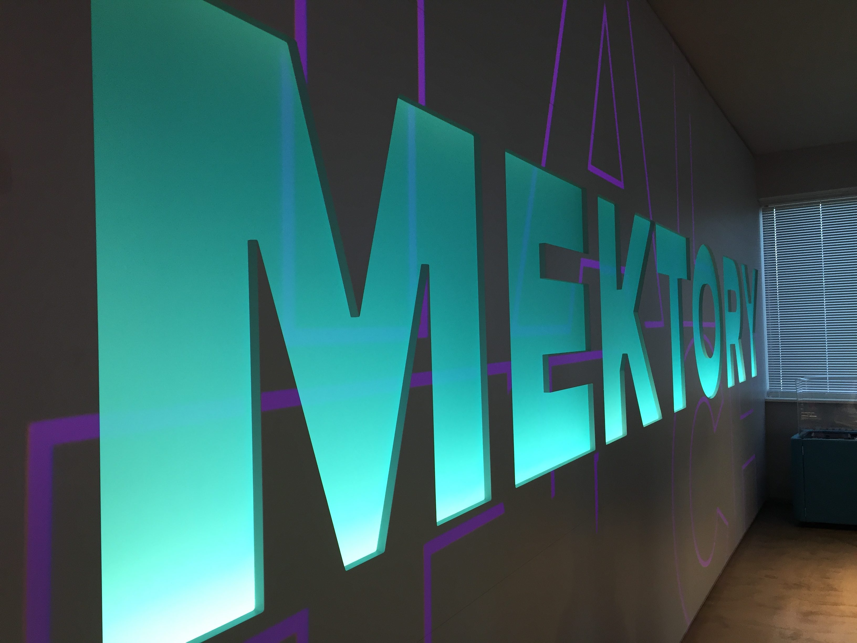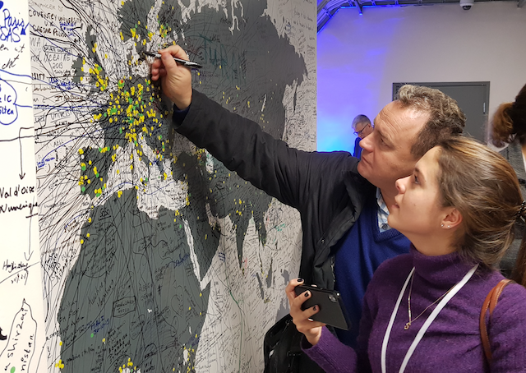
www.taltech.ee/en
- Tallinn’s TallTech hosts students from all over the world

TallTech University offers not only cutting edge technology and modern research and learning programmes, but it also provides them through a very experiential and practical teaching and learning process. For example, learning on technical, electronic and ventilation systems among engineering students is done at the very same premises of the University building, prepared and set for the training sessions.

The Energy Discovery Centre

The Energy Dicsovery Center (Energia Avastuskeskus) is a municipal supported institution that contributes to science education in cooperation with the Municipality and the schools. The group of participants visited the facilities, which offer a playful way of learning science and energy through its live shows, the planetarium and a number of devices and instruments for hands on experimentation.

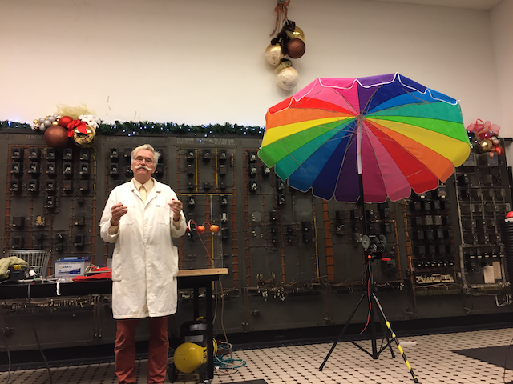
- Tallinn’s TallTech hosts students from all over the world

#EduInnoLab Innovation Project
Tallinn aims at creating an opportunity for educational institutions to experiment with forward-looking learning.
In 2018 Tallinn Education Board organised six schools and two kindergartens in the city to start the EduInnoLab Innovation Project to develop ICT and digital competences in the schools. Laboratories were set in these centres to test how innovative equipment and methods are used in teaching and find good solutions for formal curricula. The experience of innovative schools and kindergarten is expanding to other education centres in Tallinn.
At the end of 2017, the Tallinn Education Board organized a competition to participate in the #EduInnoLab project for those educational institutions that had previous experience in five specific ICT fields and had an in-depth interest in developing them.
Pelgulinna Gymnasium was one of the Education centres that participated and which had an experience in aero models and drones. ON BOARD participants visited this centre and experimented some of the initiatives related to virtual and augmented reality and drones.

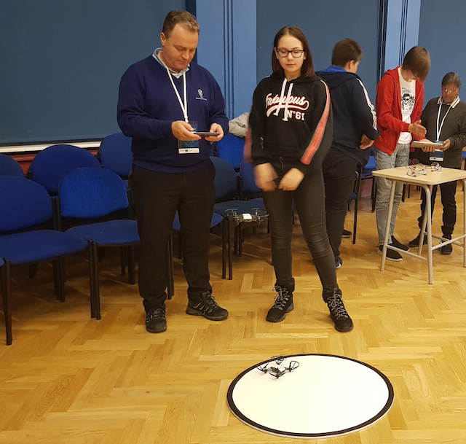
- Flying drones at Pelgulinna Gymnasium, member of EduInnolab network

Meeting with Tallinn’s URBACT Local Group

ON BOARD participants always dedicate a slot during each TM to meet with local stakeholders, ULG members of the host city. In this occasion, after considering potential interest topics to address at this gathering, the meeting focused on 2 main aspects:

- Educational Innovation concept, based on ON BOARD definition and the Open Schools for Open Society approach
- The relevance that the Educational Innovation Network Good Practice has for ON BOARD ULG members in particular in the city of Tallinn.

In addition, the participants also heard about Rotterdam Bridge Urban Innovative Action, introduced by Eddy Adams, URBACT Programme Expert and UIA Expert.

A brief summary of the above follows:

Educational Innovation

Educational innovation can have different approaches depending on the context and education agents. For the ON BOARD cities, key educational innovation principles regards the Good Practice of Viladecans’ include:

- The EIN promotes an integrative approach and co-responsibility of all education stakeholders. Broad concept of education beyond schools’ walls
- Incorporates technology and connectivity in the daily teaching-learning process using tools and methods more in line with today’s trends and skills needs
- Builds capacities of agents involved while developing education initiatives and projects
- Creates new social relationships and collaboration in education

According to the above, educational innovation more easily occurs under given conditions. Briefly summarised, these are:

- Increasing the number of educational innovators and bringing them together to exchange ideas and experiences. The isolationist structure and dispersed nature of many schools and school authorities is a barrier to educational innovation.
- Motivating teachers by providing them tools according to their educational needs. That is, listen to teachers and headmasters’ needs before proposing projects for them to adapt and reuse.
- Creating opportunities for teachers to interact with other stakeholders in the city. As suggested for the participation of local entities, open to informal learning and exchange settings. Mobilise unusual suspects – non-education local actors- to participate in educational projects and help connect learning to real issues. This makes it more meaningful for learners.

Relevance of the EIN for Educational Innovation

To better understand the relevance and thus, the effective uptake of the Good Practice among teachers and headmasters, the visitors and Tallinn ULG members, organised in mixed city groups, discussed the topic. Below are the answers provided:

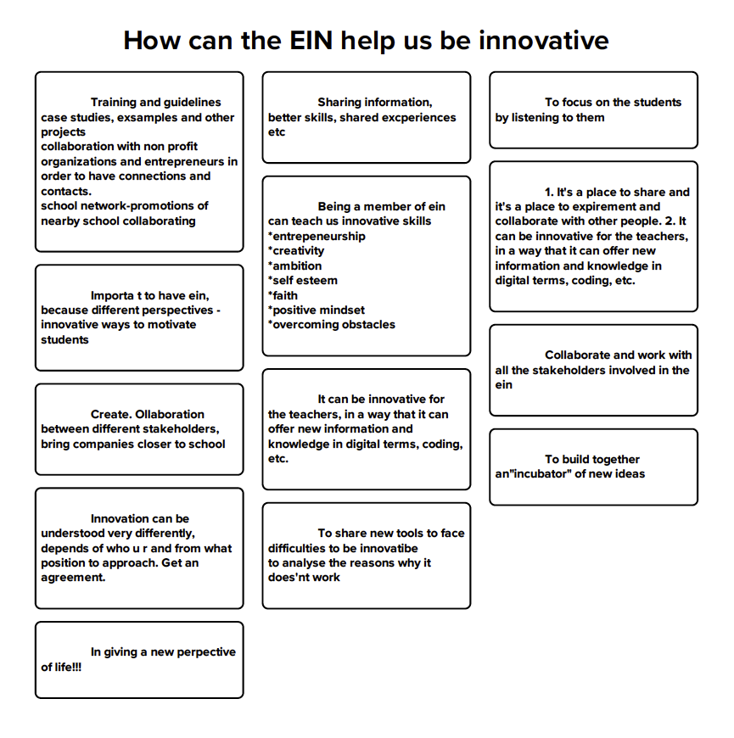

Summarized, the ways in which the EIN can promote innovation among the educational community are:

- Opening the school to new actors and to other schools
- Motivation of teachers and of students, by listening to their interests and needs
- Learning from sharing experience
- New skills, e.g. digital, creativity…
- Positive mind-set, attitude towards teaching profession, self-regard

Rotterdam BRIDGE UIA Project

Eddy Adams, URBACT Programme Expert and UIA expert, presented the Rotterdam BRIDGE Urban Innovative Action, a project that addresses the urgent urban challenge of better aligning young people’s educational choices with future labour market needs in South Rotterdam, a deprived area with high rates of immigration and youth unemployment.

The project offers innovative career guidance developed by mentors, deans, teachers and employers for the pupils on in Rotterdam South, with the support of national and local government.

Pupils follow a programme centred on the opportunities relating to the Green Digital Economy. Bringing together all 68 primary schools, 20 secondary schools and 3 vocational schools in South Rotterdam, all pupils and their parents take part in the programme. This career and talent orientation programme starts in primary school (age 9) and end when students enter the labour market.

BRIDGE Rotterdam aims at ensuring that by 2020, 50% of secondary vocational training students in South Rotterdam will have chosen a career in one of the major growth sectors.

The crucial element to achieve the goal is the Career Start Guarantee that employers offer students (for technology and healthcare sectors) at the moment they enter secondary vocational education and need to make the most crucial subject and career choices. Provided that the pupil chooses the training that the labour market needs, an employer will commit in advance to that individual with a guaranteed career start after graduation. Impact investment instruments (public subsidy based impact investing, social return on investment and social impact bonds) are an integral part of the project, supporting scaling and mainstreaming of the programme.

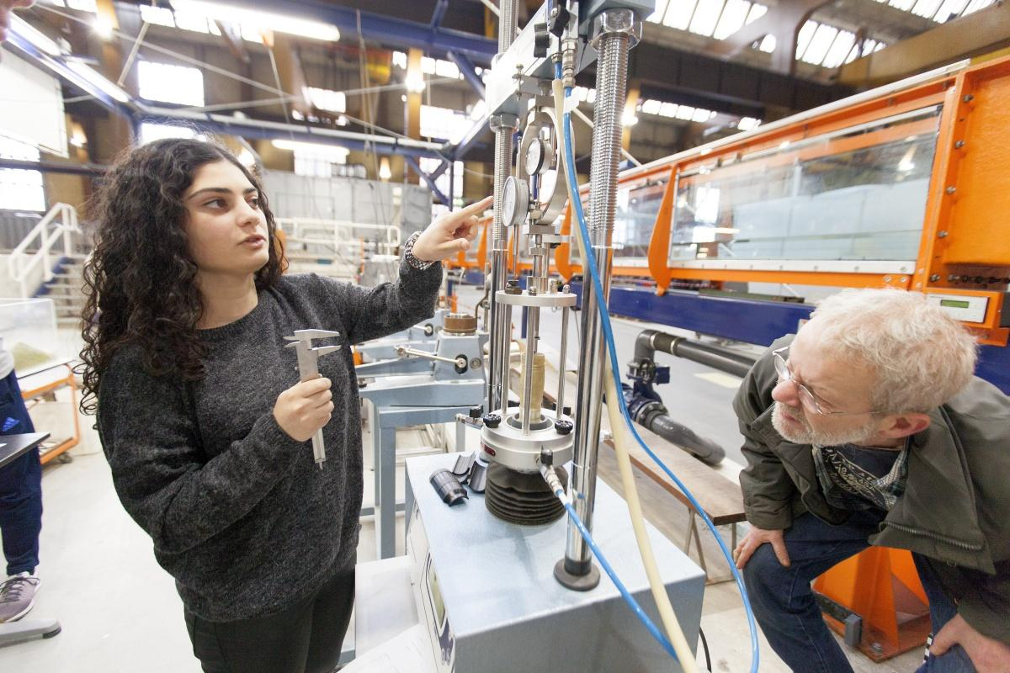
- Rotterdam BRIDGE UIA Project

On Board Checklist

S…

- Facilitate
- Open to the context, headmasters and teachers can:
- Link learners’ projects to global challenges
- Contextualize knowledge. Connect learning to real world experiences

ON BOARD Mid Term Reflection Key messages from the process

After the survey replies and feedback session, the debate on the challenges and difficulties in transferring the Educational Innovation Network has concluded with the ON BOARD State of Transfer Report. The report refers both to individual and Network progress and challenges up to date, as well as ways to overcome difficulties encountered.
One central aspect discussed, which gathered consensus among ON BAORD partners is that the Good Practice, as it exists in Viladecans, requires important structural arrangements to ensure its integrated approach and sustainability in the longer term. The transfer of the Educational Innovation Network calls for municipal readjustment processes and resources allocation to make possible the systemic change required.
In addition to this structural challenge, support and commitment from the local political authorities and financial resources to ensure staff and project activities where also identified as risks for the transfer consolidation.
Also, motivating teachers and engaging them in innovative projects was also a most commented topic and shared difficulty. The lack of innovative mind-set and leadership among teachers and headmasters, together with overstretched teaching staff, makes it difficult to be ambitions in terms of creating a wide and spread Network in the cities.

See Open Schools for Open Society Model and Roadmap, Horizon 2020 Research and Innovation Programme under Grant Agreement No. 741572. Deliverable D2.3

