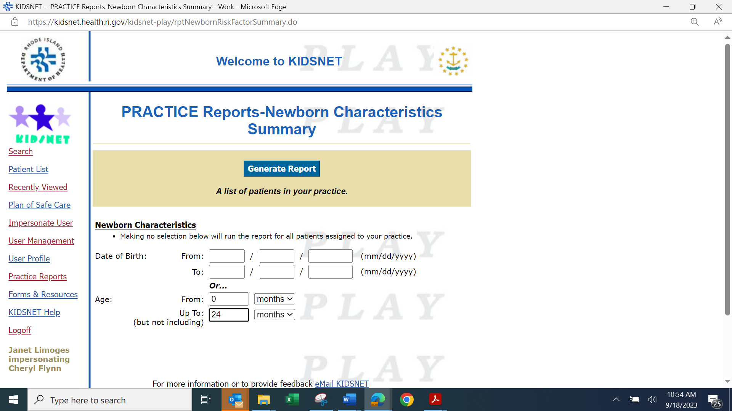
Enter the date of birth or age range to include on the report.
Click Generate Report

Newborn Characteristics Report- This report identifies children who were born in a Rhode Island birthing hospital and were determined to have certain parental and or childhood characteristics that may be cause for close follow up by a primary care provider. The report reflects the number and percent of patients in your practice with one or more of these characteristics:

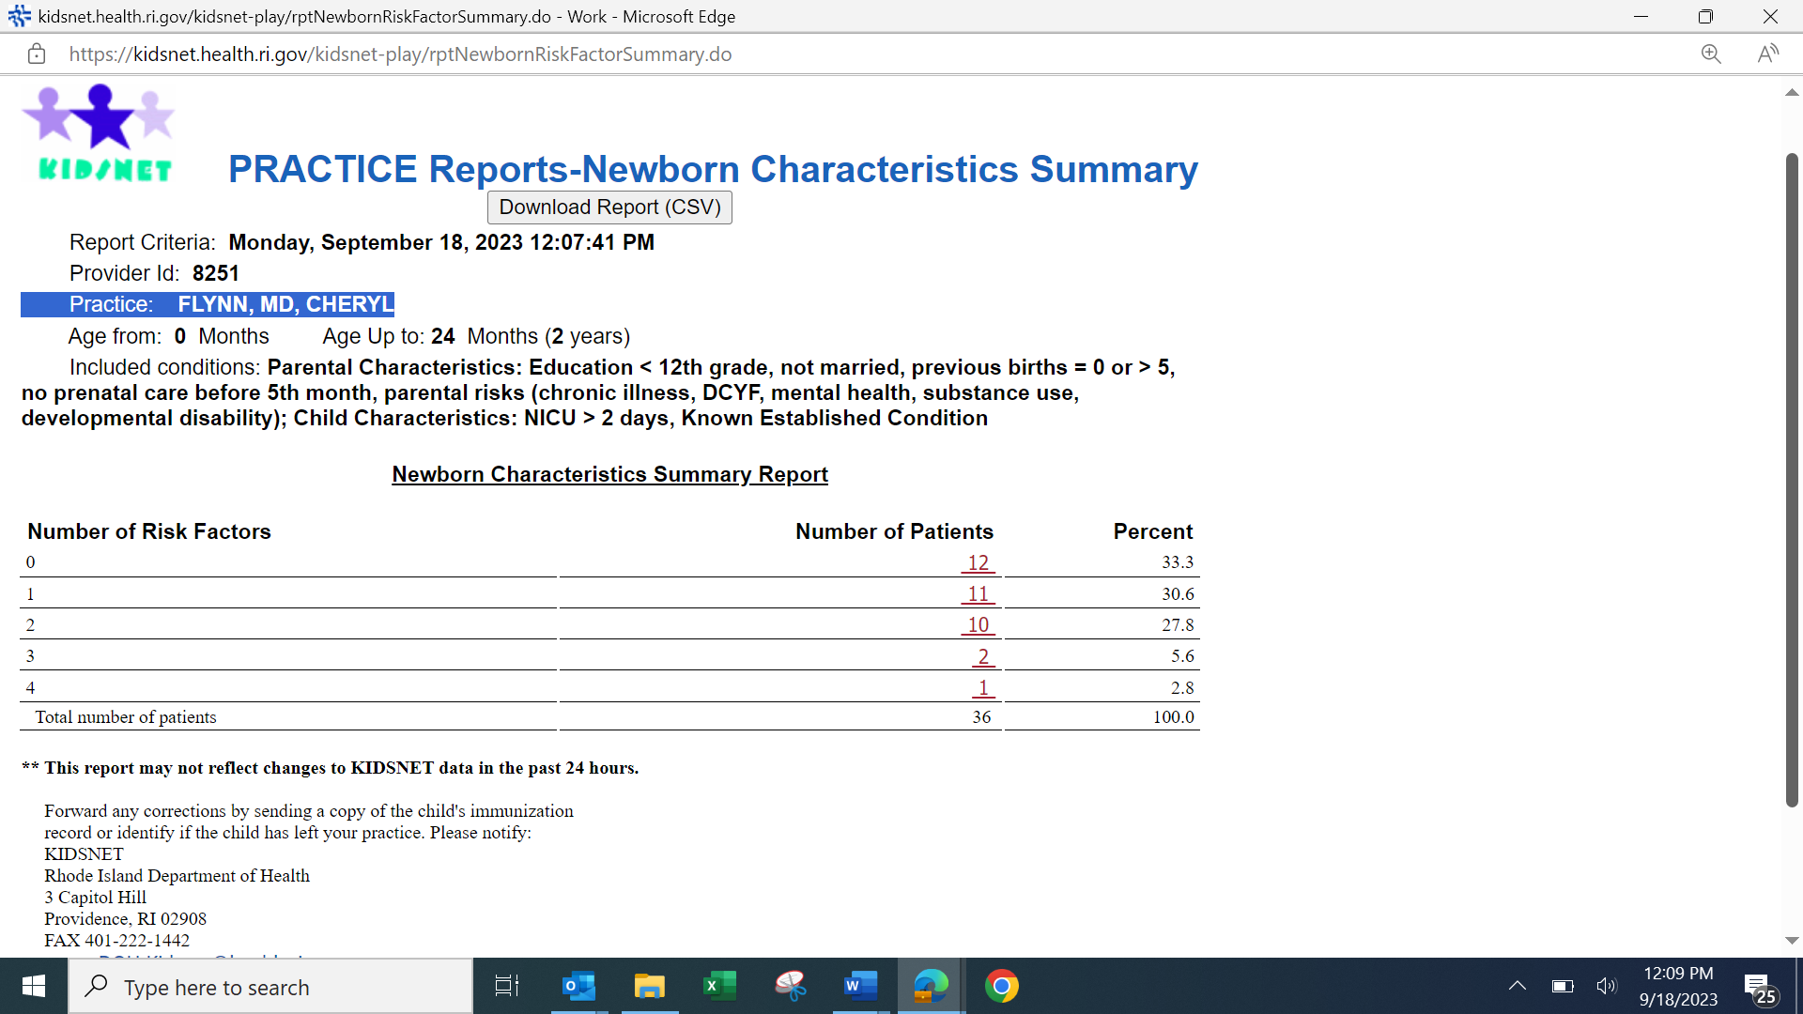
Click here to see a list of patient’s names.

Sample Summary Report
The report reflects the number and percent of patients in your practice with one or more of the characteristics listed in the report header. In the example above, there are 36 children in the age cohort selected, 1 child has 4 characteristics, 2 have 3, 10 have 2, etc. To view a report that details which children are in each category, click on the highlighted number.

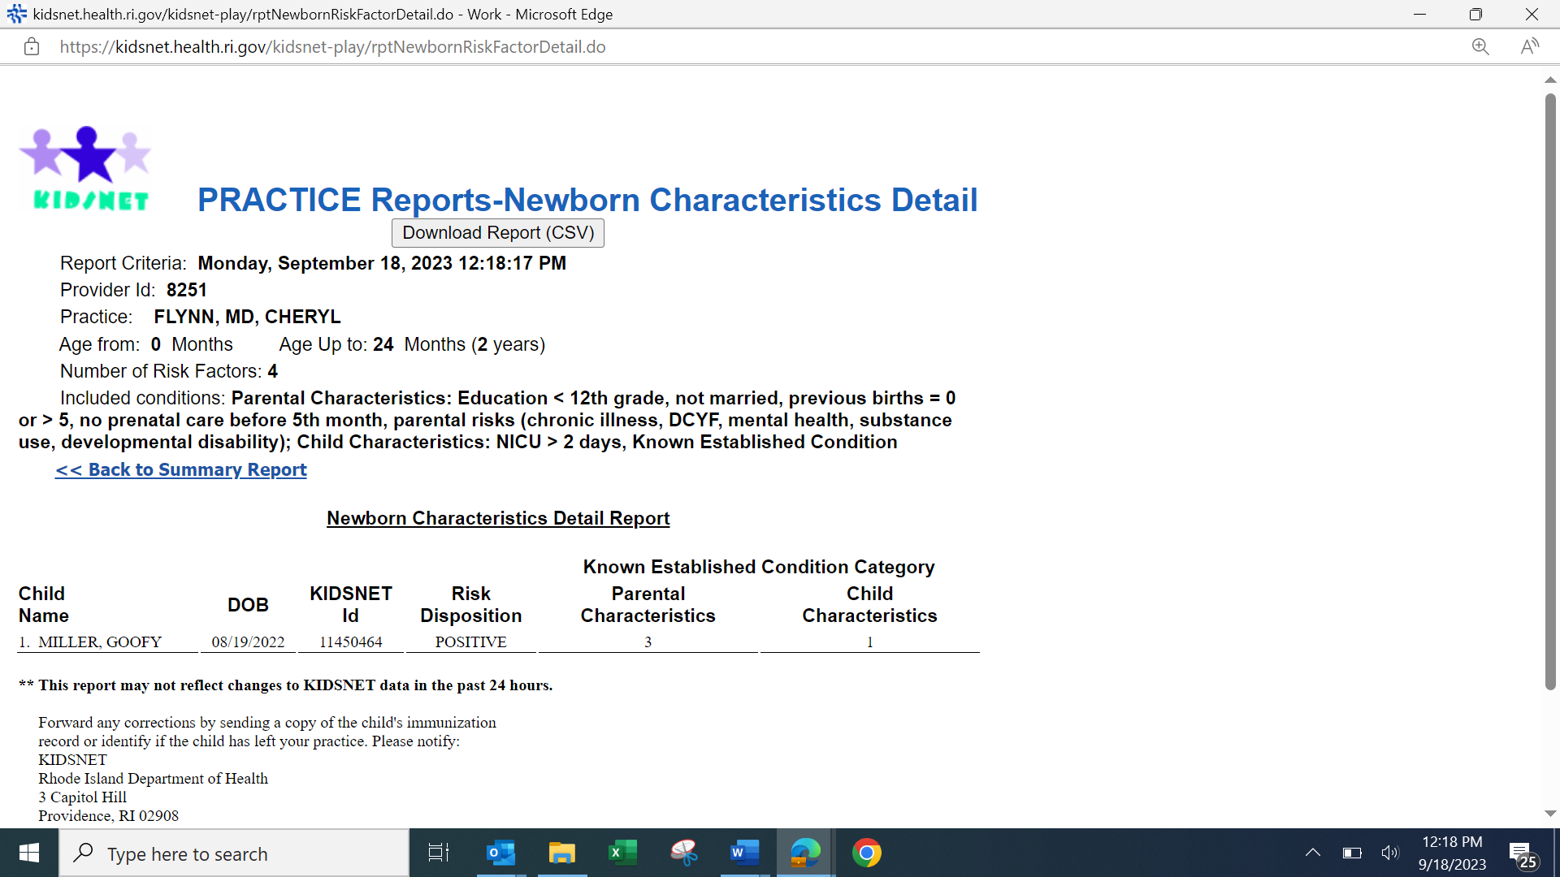

Sample Detail Report

The child listed has 3 parental characteristics and 1 child characteristic that meet the conditions listed on the report header. To view the child’s individual record in KIDSNET, return to the KIDSNET Search page and enter the KIDSNET ID number in the search option (you may want to cut and paste it from the report into the search page). A review of Family Visiting Services or other preventative care may be useful in providing necessary outreach.

