EXAMINATION POLICY
INTERNAL APPEALS
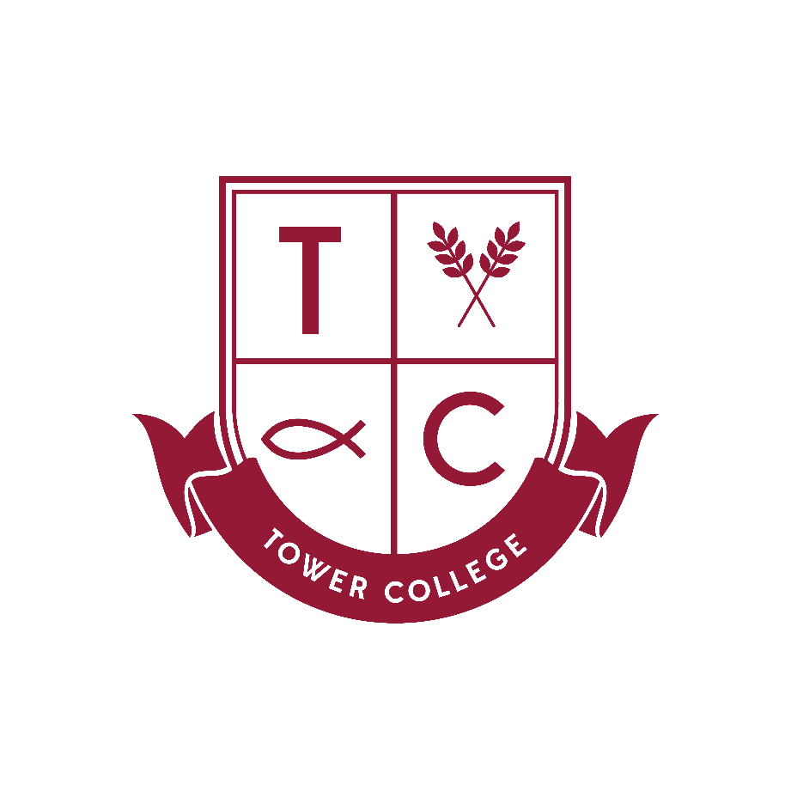

Date of Policy: October 2018
Review Date*: October 2019
Coordinator (s): Mrs P Knox
Governor: Mrs C Parr
* Policy Review: Every three years otherwise dictated by the FGB (Full Governing Body) or by changes in legislation.

In accordance with the Code of Practice for the conduct of external qualifications produced by QCDA, Tower College is committed to ensuring that:
- internal assessments are conducted by staff who have the appropriate knowledge, understanding and skills;
- assessment evidence provided by candidates has been produced and authenticated according to the requirements of the specification;
- the consistency of the internal assessment is secured through internal standardisation as necessary;
- staff responsible for internal standardisation attend any compulsory training sessions.
- Each awarding body publishes its arrangements for appeals against its decisions. In addition, an appeal can be made to the School concerning internal assessment:
- the appeal applies only to the procedures used in arriving at internal assessment decisions and does not apply to the mark or grade itself;
- the parent/carer must make the appeal in writing to the School’s Exams Officer
- the enquiry into the internal process will normally be led by the Exams Officer, the Head of Centre and the Head of Upper School, provided that they have played no part in the original internal assessment process;
- the teacher making the assessment will be able to respond to the appeal in writing, and a copy will be sent to the appellant;
- the enquiry will consider whether the procedures used for the internal assessment were in conformity with the published requirements of the Awarding Body and the ‘Code of Practice’.
The appellant will be informed in writing of the outcome of the appeal, including:
- relevant communications with the Awarding Body;
- any steps taken to further protect the interest of the candidates.
If the appellant is unhappy about the response in writing, s/he can ask for a personal hearing, where the panel will consist of two persons not previously involved, normally the Principal and a member of the Governing Body.

Enquiries About Results (Review of marking)
In cases of Enquiries About Results, the pupil may normally pay to have an enquiry carried out. On results day, pupils will find a form for the request of EAR: review of marking.
Pupils and parents must sign the form and return it to school with the appropriate payment.
If the review is unsuccessful in inflating to the next grade, the payment will be taken. If a grade does increase for the overall award, the payment will be returned.
There is a recently new service offered whereby teaching staff may see a candidate’s answered paper online. Before any staff do this, we will always seek the permission of the parent and pupil.
Note:
Each awarding body specifies detailed criteria for the internal assessment of work. In addition, the awarding body must moderate the assessment and the final judgement on marks awarded is that of the awarding body. Appeals against matters outside the School’s control will not be considered in the School’s appeals procedure.

