First follow the directions on How to Edit a Page to navigate to the page on which you want to update a photo.

**To change a photo on the page:**

Hover your mouse over the photo you want to change. You will see a blue, green, or gray box (or all3) outlining the area. To change the photo, you need to hover over the photo until the gray outline appears around the photo you want to change.

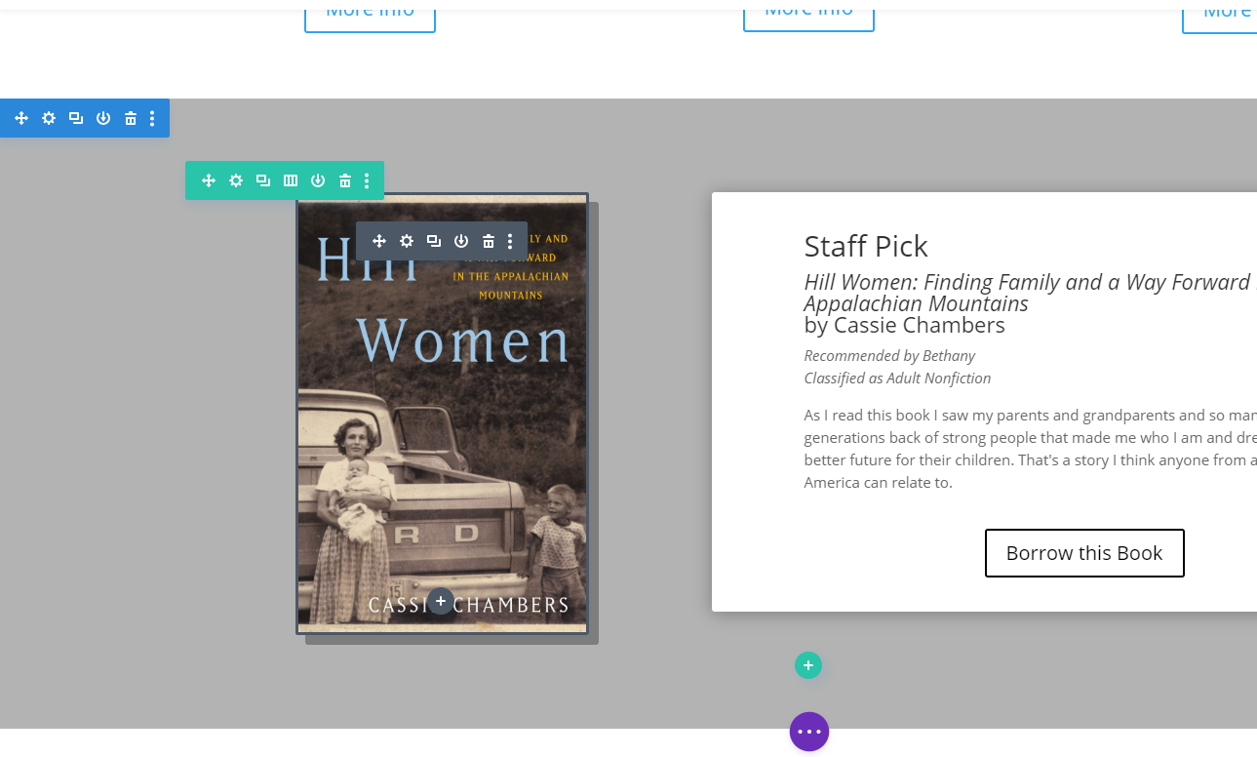

Click on the Module Settings icon on the small gray menu.

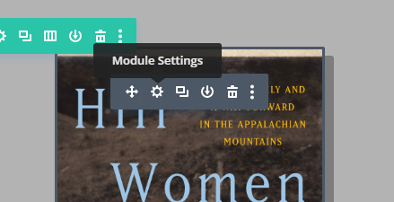

This will open an Image Settings window popup. It will, by default, open on the tab you need to change your photo. If for some reason it does not, go to the Content tab on the top of the Image Settings popup and click on the “Image” dropdown arrow.

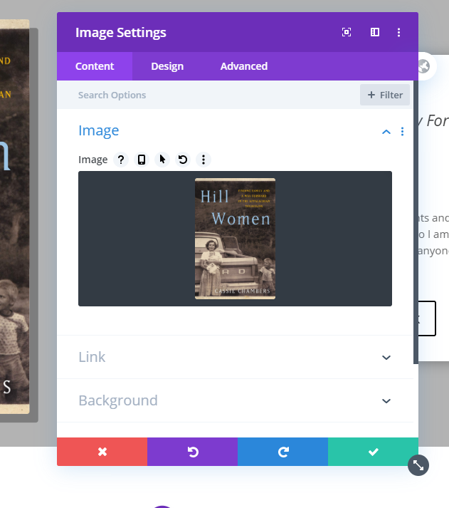

Click on the photo in the Image Settings popup. This will open the Media Library, which is where you can access all the images that have every been on your website.

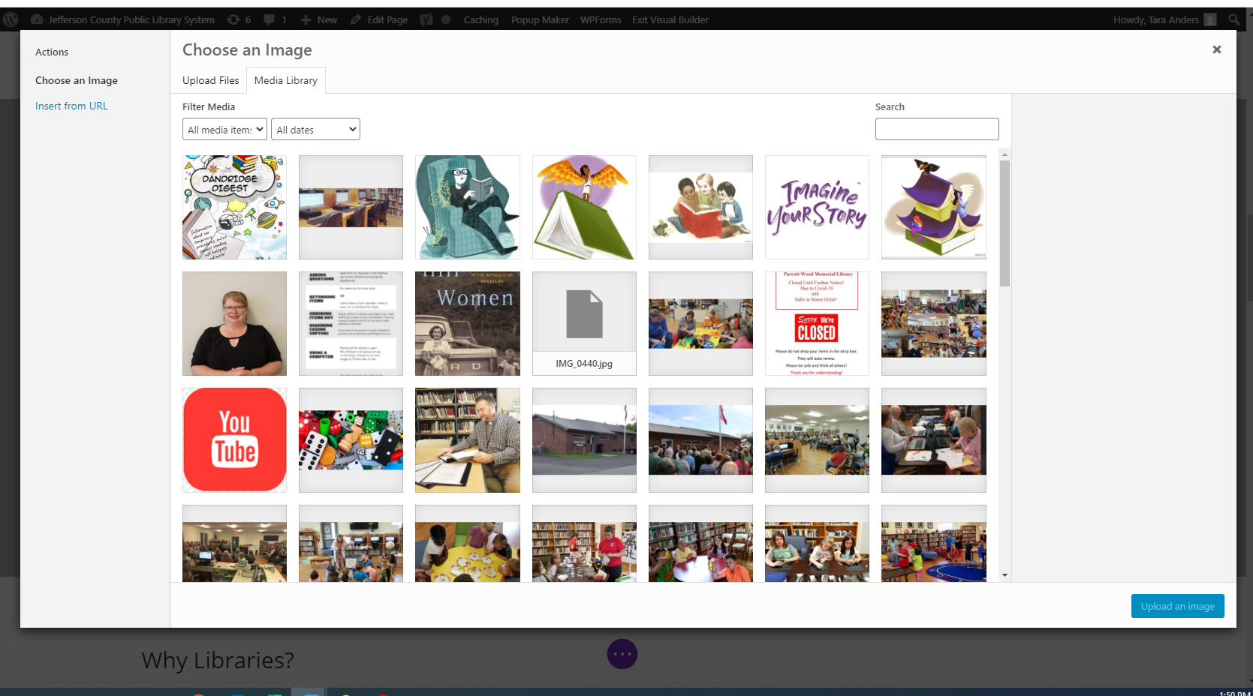

If the photo you want is already in the Media Library, click on the photo. A blue outline and checkmark will appear on the selected photo. Then click the blue “Upload an image” button on the bottom right. The Media Library will close and you will once again see the Image Settings popup, now with the new photo.

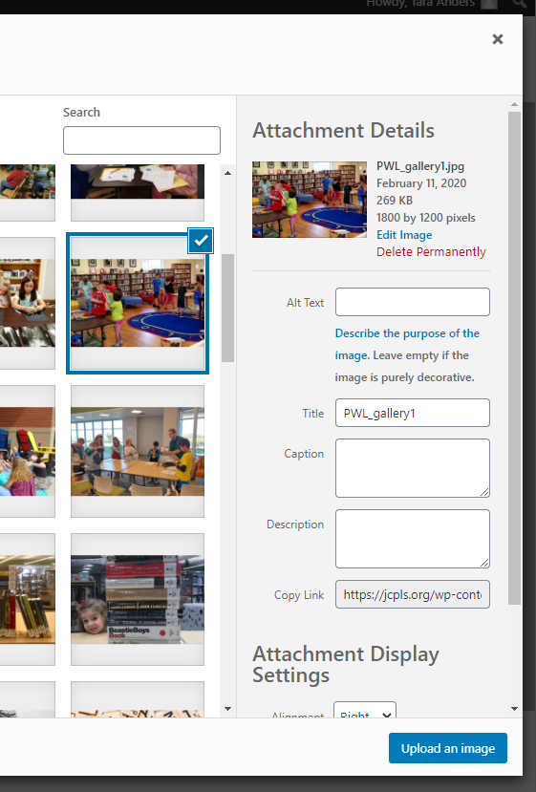

If you want to add a new photo that is not already in the Media Library, click on the Upload Files tab on the top of the window.

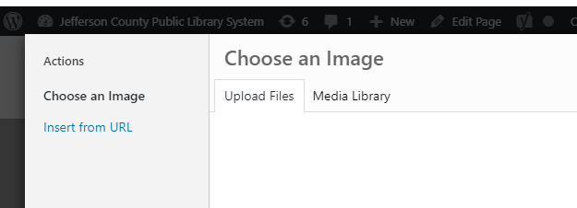

You can now drag and drop the image file(s) you want to add, or click Select Files to choose the image file from your computer.

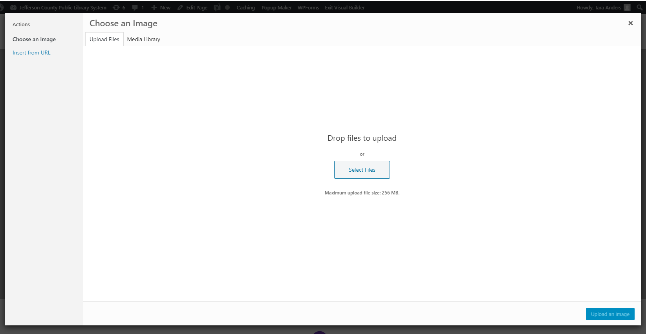

*** The size of your image file should be larger than 500 KB and smaller than 2 MB. ***

Once you have added the image file, the image will appear in the Media Library. It should already be selected with a blue outline and checkmark. Click the blue “Upload an image” button on the bottom right. The Media Library will close and you will once again see the Image Settings popup, now with the new photo.



In the Image Settings popup, click the Green button with a Checkmark to save your changes.

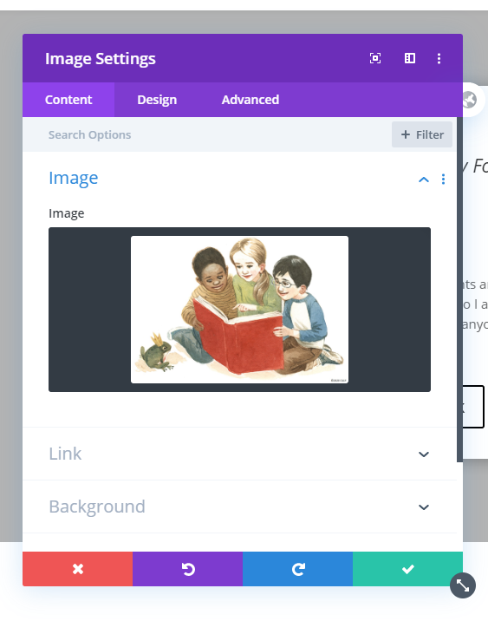

***If you do not want to save the new photo, click the Red button with an X on the bottom left of the Image Settings popup. This will undo your changes and revert back to the photo that was there before you started editing. ***

Once you have saved your changes in the Image Settings by clicking the Green Checkmark, the popup will close and you will see your new photo on the page. At the bottom of your screen you’ll see a Purple circle with 3 white dots.



Click on the Purple circle to expand the menu. Then click on the green Save button that appears on the bottom right of your screen. (The menu may already be expanded with the Save button already visible. If so, don’t worry about the purple buttons and just click the green Save button.)

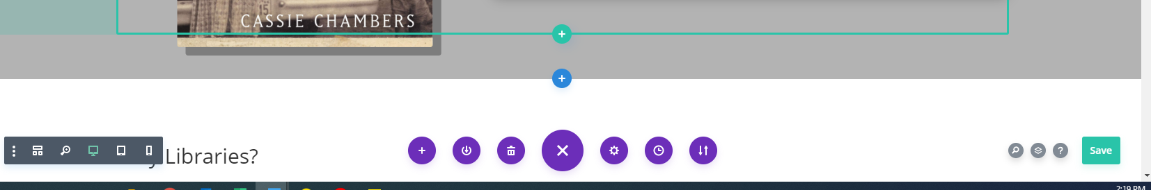

When you click the green Save button, the button will show swirling white dots while your changes are being saved.



Wait until you see a white checkmark on the green button before leaving the page.



You can now leave the page or go on to make other edits. If you are going to be making a lot of edits on the same page, click the Save button frequently so that you won’t accidentally lose your changes.

**To change the header photo at the top of a page:**

Hover your mouse over the header photo. You will see a purple or gray outline, or both, around the image. To change the header photo, you need to hover over the image until the gray outline appears around it.

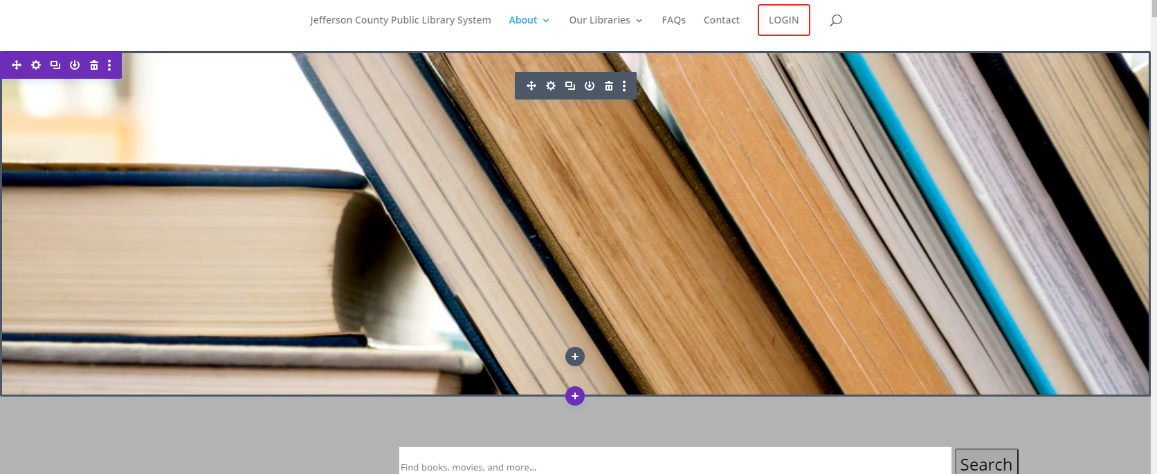

Click on the Module Settings icon on the small gray menu.

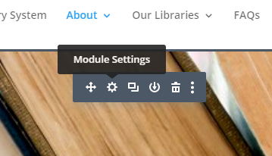

This will make a Fullwidth Slider Settings window pop up. It will, by default, open on the Content tab, which is what you need. Then click on the Settings icon on the left of the title of the slide.

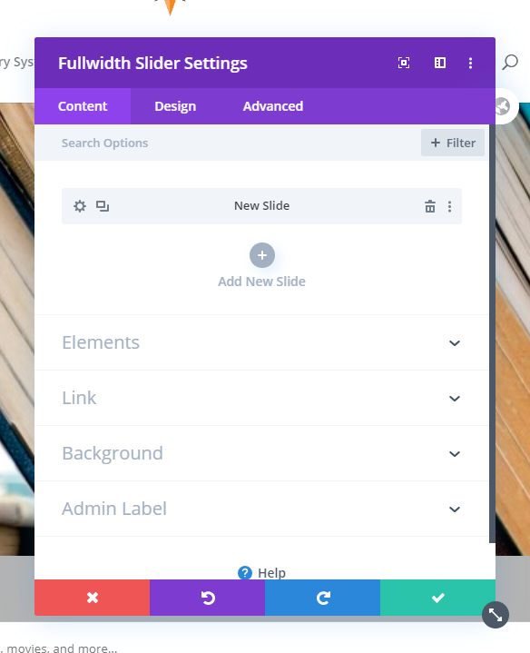

You are now in the Slide Settings popup window. By default, you should be in the Content tab, which is where you need to be. Scroll down to the bottom of the popup window. Click on the “Background” dropdown arrow.

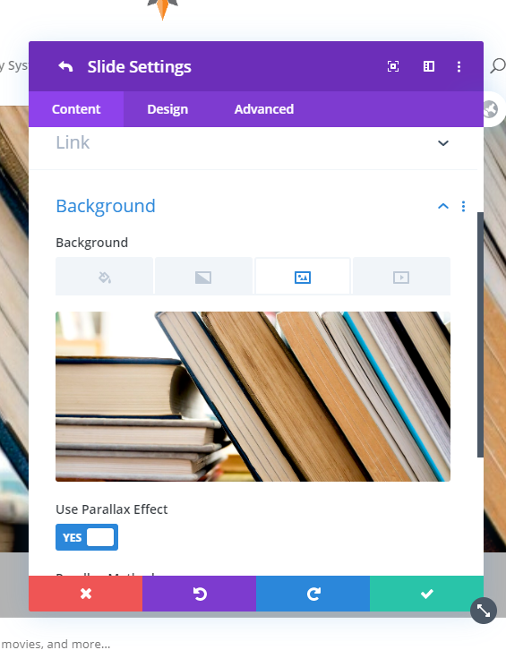

Click on the photo. This will open the Media Library, which is where you can access all the images that have every been on your website. You can update the header photo to a photo that is already in the Media Library, or you can upload a new photo.

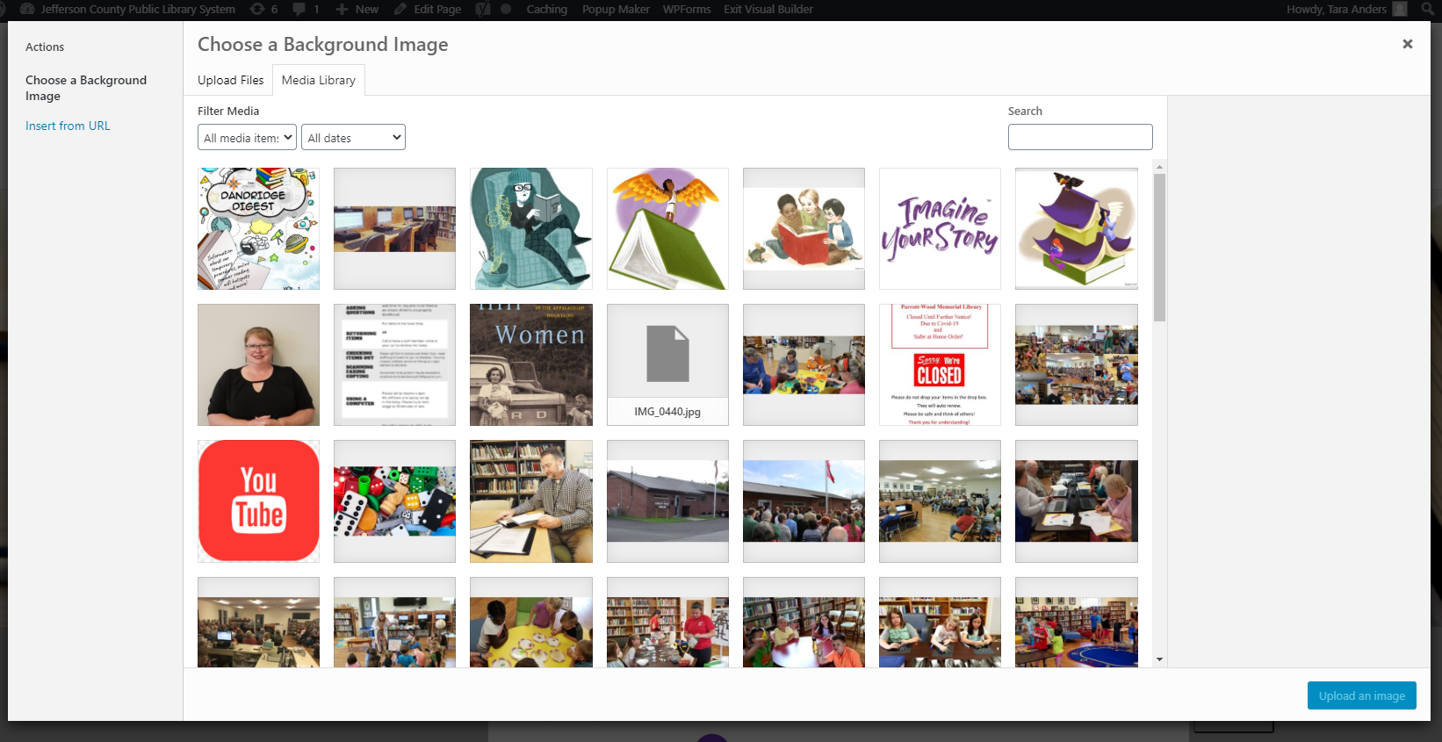

Once you have chosen a photo from the Media Library or uploaded a new photo, make sure the photo is selected with a blue outline and checkmark. Then click the blue “Upload an image” button on the bottom right.

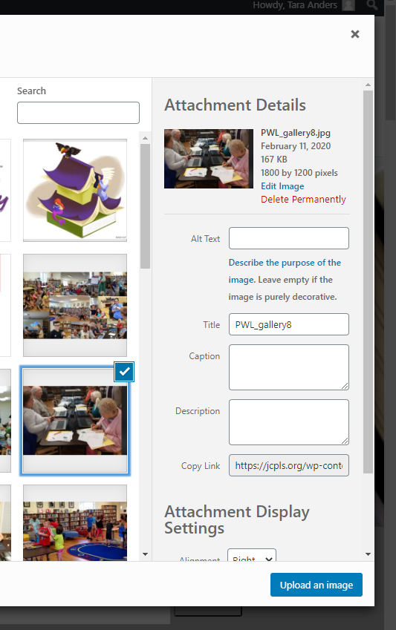

The Media Library window will close and you will once again be in the Slide Settings popup. Click the Green button with a Checkmark to save your changes.



***If you do not want to save the new photo, click the Red button with an X on the bottom left of the Slide Settings popup. This will undo your changes and revert back to the photo that was there before you started editing. ***

Once you have saved your changes in the Image Settings by clicking the Green Checkmark, the popup will close and you will see your new photo on the page. At the bottom of your screen you’ll see a Purple circle with 3 white dots.

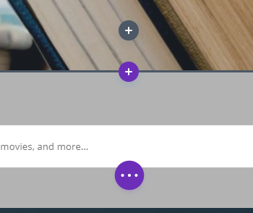

Click on the Purple circle to expand the menu. Then click on the green Save button that appears on the bottom right of your screen. (The menu may already be expanded with the Save button already visible. If so, don’t worry about the purple buttons and just click the green Save button.)

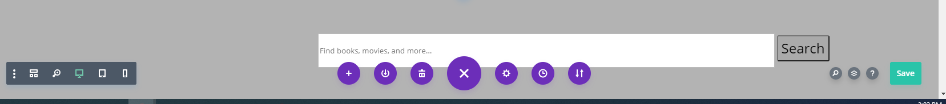

When you click the green Save button, the button will show swirling white dots while your changes are being saved.



Wait until you see a white checkmark on the green button before leaving the page.



You can now leave the page or go on to make other edits. If you are going to be making a lot of edits on the same page, click the Save button frequently so that you won’t accidentally lose your changes.