First follow the directions in How to Edit a Page to navigate to the page on which you want to change text.

Hover your mouse over the text you want to change. You will see a blue, green, or gray box (or all 3) outlining the area. To edit text, you need to hover over the text until the gray box appears around the text you want to edit.

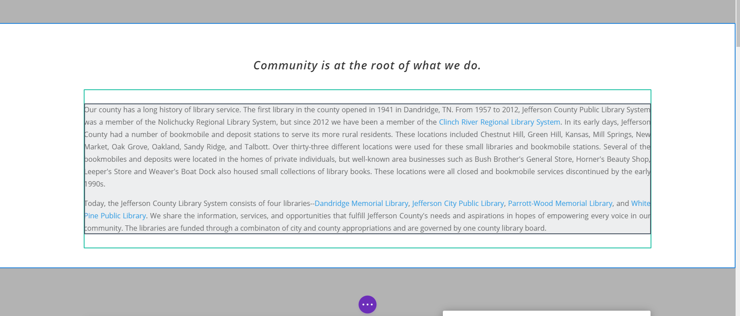

While hovering over the gray-outlined text, click on the text to make a small gray menu appear. (If the gray menu is already visible, then you do not need to click on the text.)

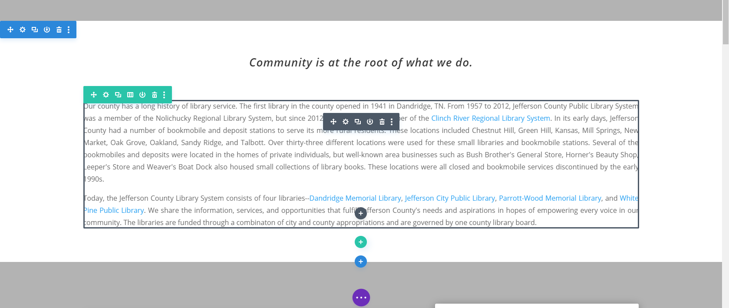

Click on the Module Settings icon on the gray menu.

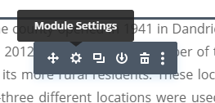

This will make a Text Settings or Blurb Settings window pop up. It will, by default, open on the tab you need to edit your text. If for some reason it does not, go to the Content tab on the top of the Text Settings popup and click on the “Text” dropdown arrow.

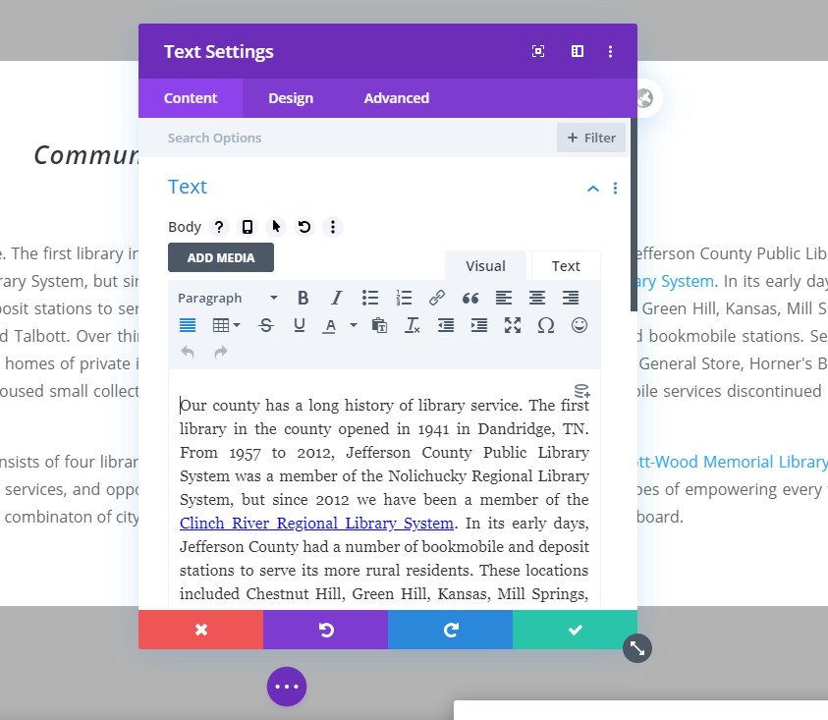

When you are changing text, you should also keep in mind that there are different sizes/styles that you can apply to your text. The default is called Paragraph and is the regular size/style of text used throughout your website. There are also Heading text options. These options make your text bigger for use as headings and subheadings. There are 6 different options for headings.

To apply a Heading style to your text, highlight the text you want to change. Click on the dropdown arrow that says either Paragraph or Heading #. Choose the Heading size you want to use for the selected text.

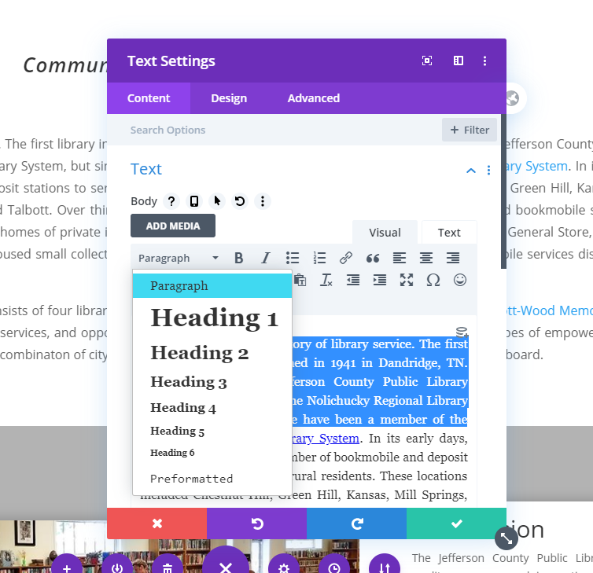

You can apply other text styles as well, including bold, italics, underline, bullet points, numbered lists, hyperlinks, and text color. Highlight the text you want to stylize, then click on the corresponding icon.

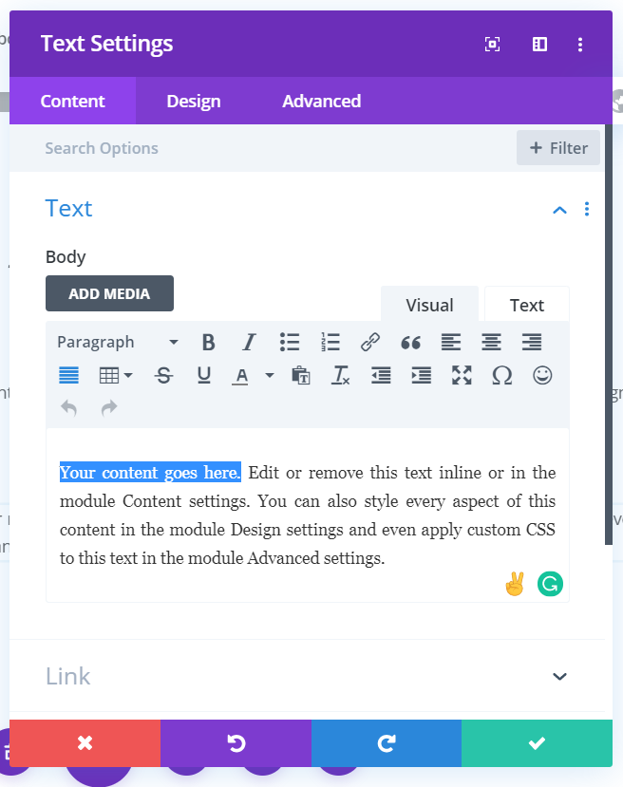

\*\*\* If at any point you want to undo the edits you have made, click on the Red button with an X on the bottom left of the Text Settings popup. This will undo your changes and revert your text back to how it was before you started editing. \*\*\*

To save your edits, click on the Green button with a Checkmark on the bottom right of the Text Settings popup.



This will close the popup, and you will see that the edits you made are now visible on the page. Then, at the bottom of your screen you’ll see a Purple circle with 3 white dots.

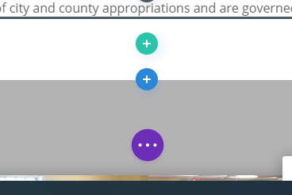

Click on the Purple circle to expand the menu. Then click on the green Save button that appears on the bottom right of your screen. (The menu may already be expanded with the Save button already visible. If so, don’t worry about the purple buttons and just click the green Save button.)

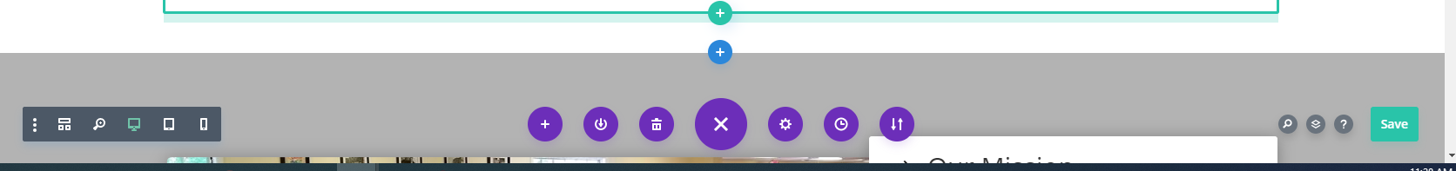

When you click the green Save button, the button will show swirling white dots while your changes are being saved.



Wait until you see a white checkmark on the green button before leaving the page.



You can now leave the page or go on to make other edits. If you are going to be making a lot of edits on the same page, click the Save button frequently so that you won’t accidentally lose your changes.