Login to your website.

When you log in, you’ll get the dashboard screen:

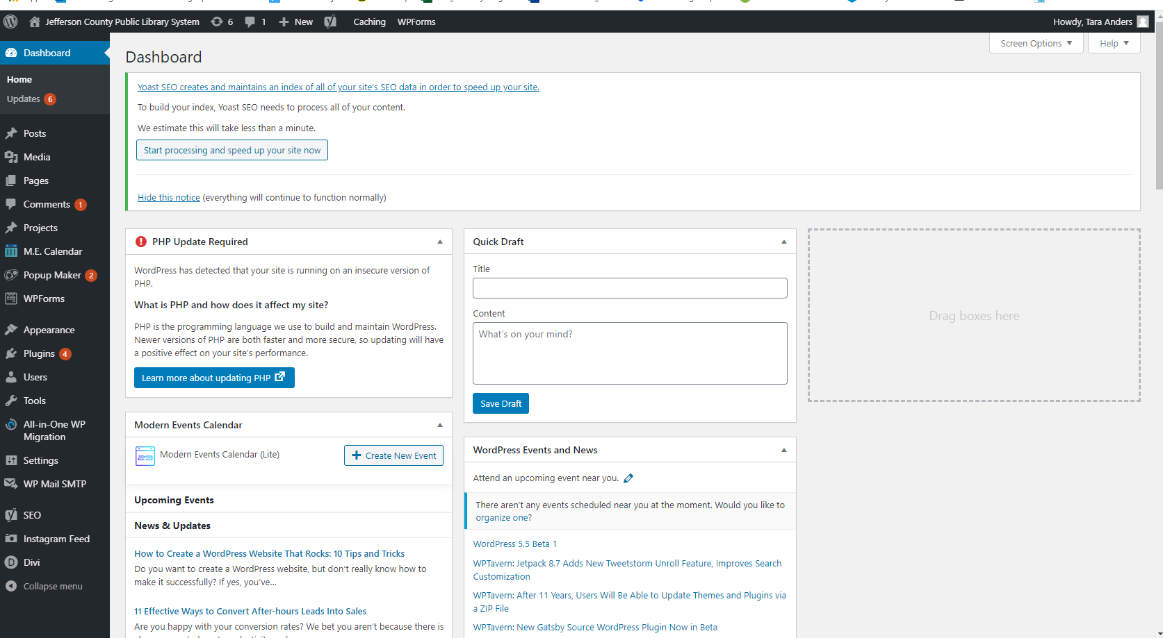

On the left-hand side of the screen, hover your mouse over Pages, then click All Pages to edit a current page.

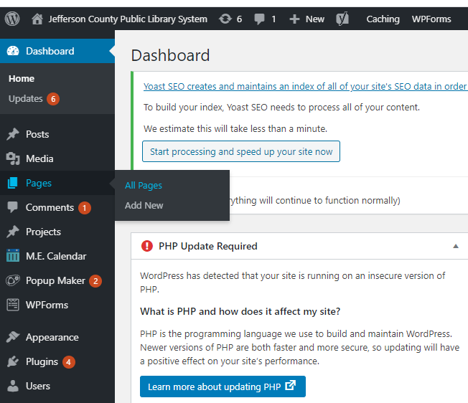

You will then see a list of all the pages on your website. Click on the name of the page you want to make changes to.

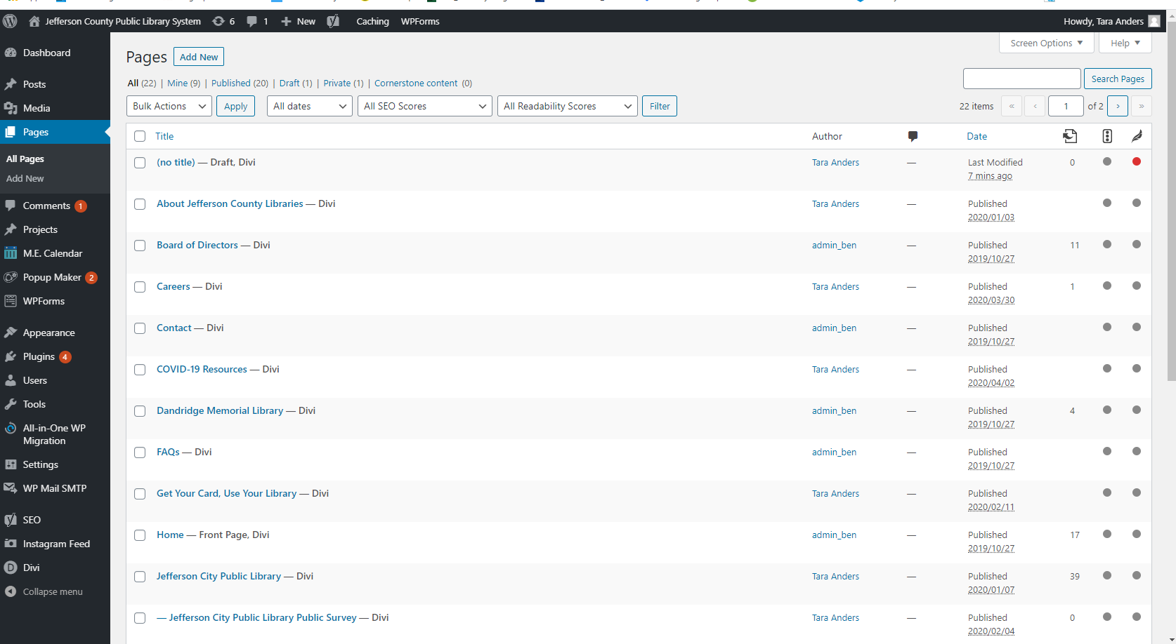

When you click on a page, you will see the following screen. Click on “Edit With The Divi Builder”:

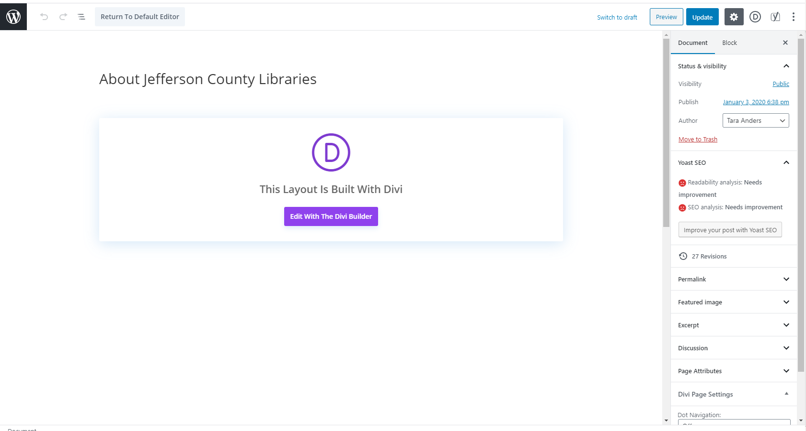

You will then see the page as it appears on the website. You are now in editor-mode, so you can hover over different areas of the site to make changes.

**Types of page elements:** There are 3 main types of elements on your page: Sections, Rows, and Modules. These elements work together to create the layout of your page.

Sections are the most basic and largest building blocks. Regular Sections are shown with a blue outline and are made up of Rows. Full Width Sections are shown with a purple outline and are made up of full-width modules (this is the type of module used for photos in the header on the pages of your site).

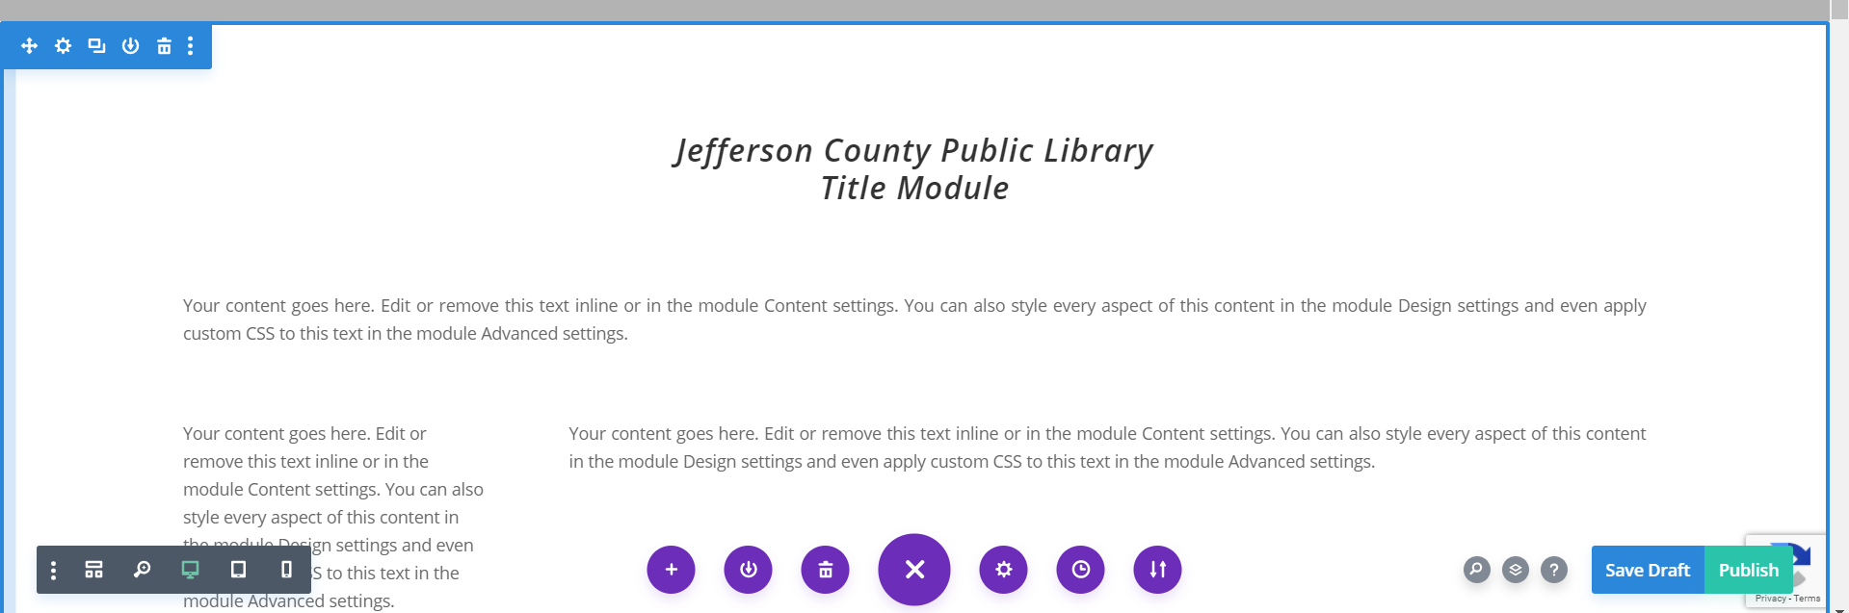

Rows are inside of Sections, and you can place as many rows as you want within a Section. They are shown with a green outline. Rows are what allow you to separate your content into columns. You can choose for your Row to have 1 full-width column, or 2-6 columns of varying widths. After you define a column structure for your Row, you can place modules into those columns.

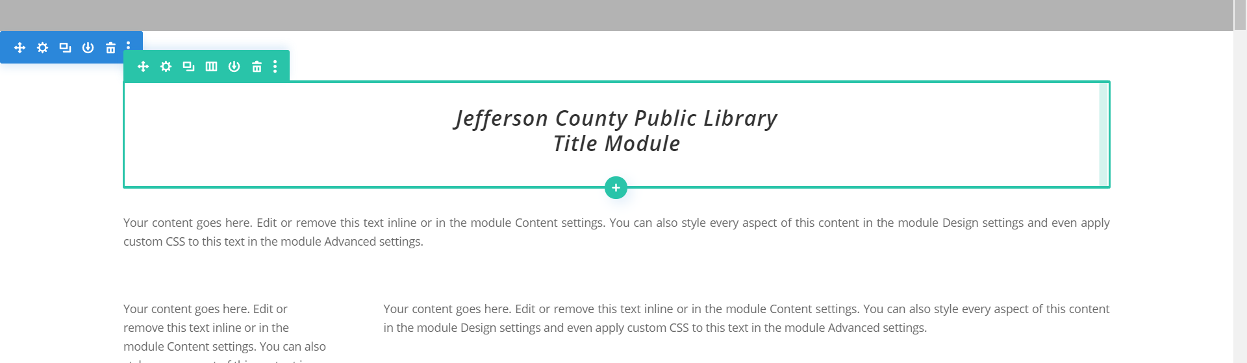

Modules are shown with a gray outline, and they are where you put the content such as text and photos. You can place as many Modules as you need in each Row.

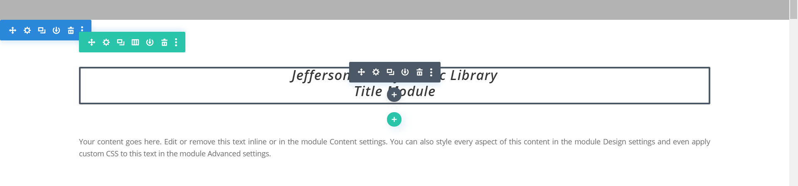

**To rearrange elements on the page:**

You can move the elements (Sections, Rows, Modules) around however you choose. Moving a Section moves all the Rows and Modules with it as well, and moving a Row moves all the Modules it contains. You can rearrange Rows in the same Section or move them to a different Section. Modules can be rearranged with the same Row or moved to Rows, even Rows in other Sections. To move a Section, Row, or Module, hover over the element until the small menu is visible (blue for Sections, green for Rows, and gray for Modules). Hover over the 4-way arrow icon. Your cursor will take on the same 4-way arrow shape. Then click, drag, and drop the element to the desired position.

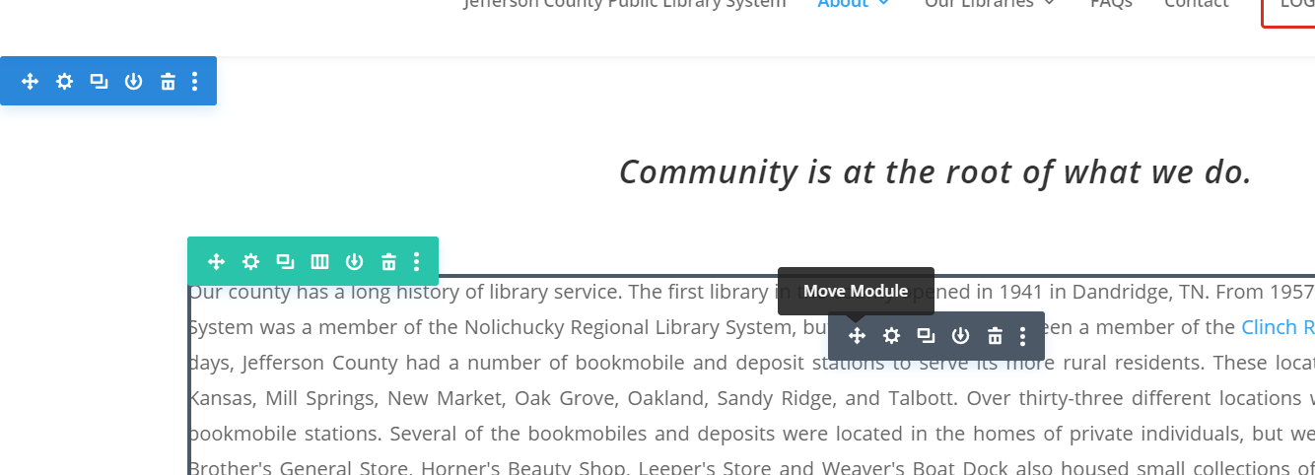

*** The Sections, Rows, and Modules on the page have default spacing. This default spacing will be appropriate for your site, so you won’t have to worry about changing the spacing of elements. ***

Please see the attached documents for instructions on how to change text or photos in Modules.