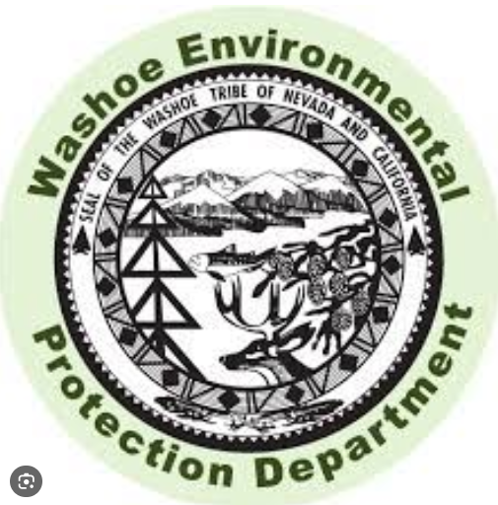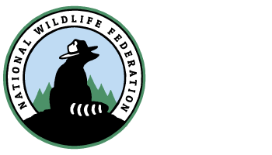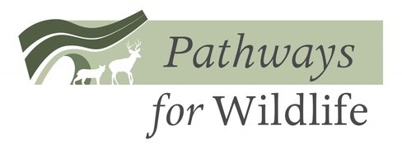

Wildlife Conservation Board

Rebecca Fris

Acting Executive Director

P.O. Box 944209

Sacramento, CA 94244-2090

(916) 212-5637

Via email: [Rebecca.Fris@wildlife.ca.gov](mailto:rebecca.fris@wildlife.ca.gov)

**RE: US-395 Wildlife Overpass Planning Project**

We are writing to express our support for the Lassen County Transportation Commission (LCTC) application for project funding through the Wildlife Conservation Board (WCB) to enhance wildlife connectivity and reduce wildlife-vehicle collisions on US 395, spanning from the California-Nevada border to Susanville. The project being proposed by the LCTC, in coordination with Caltrans D2, would investigate and plan for construction of overcrossing and/or undercrossing structures and directional fencing, to be determined based on site characteristics, such as roadway location, topography, and landscape ecology. If funded to its logical conclusion, all crossing structures would have associated fencing and escape ramps and would be designed to 65% design plans, specifications and estimates.

The section of US 395 that runs from the California-Nevada border to Susanville impedes important wildlife movement, bisects seasonal migration corridors, and experiences a high occurrence of wildlife-vehicle collisions. In fact, [a statewide analysis of deer-vehicle collisions](https://westerntransportationinstitute.org/wp-content/uploads/2019/09/4W6693_Huijser-and-Begley-FINAL-Report-Caltrans-Statewide-20190913-reduced-image-size.pdf) identified twenty-five miles within the project area as one of the top ten worst deer-vehicle collision hotspots in the State of California; consequently, facilitating safe passage for wildlife will be critical to enhancing public safety for motorists. In addition, due to the known migration routes for Doyle and Loyalton mule deer herds within the project area, CDFW’s [Restoring California’s Wildlife Connectivity 2022 Report](https://nrm.dfg.ca.gov/FileHandler.ashx?DocumentID=204648) identified two stretches of US 395 (W001 and W002) within the project area as “top priority wildlife connectivity project locations” in California. The project area is also located nearby the estimated range of the Beckwourth and Lassen wolf packs and is one of five priority locations identified in California’s 2020 Action Plan developed pursuant to DOI Secretarial Order 3362.

As your agency is no doubt aware, numerous case studies show that wildlife crossings and other mitigation efforts are effective means toward decreasing wildlife mortality and increasing habitat connectivity. If awarded, funding will also allow the LCTC, Caltrans and their partners to continue to seek additional State and Federal funding to support completion of this important project. However, funding of this planning project is the important first step. Without this funding it is unlikely that the LCTC, Caltrans, or any likely applicant will have the resources to fund a project of this magnitude.

We look forward to providing any support we can to the LCTC and its partners during the planning and implementation phases of this project, and respectfully request the Wildlife Conservation Board’s consideration of this funding request.

Sincerely,

Mari Galloway

California Program Director

Wildlands Network

Devin O’Dea

California Chapter Coordinator

Backcountry Hunters & Anglers

Kay Ogden

Executive Director/CEO

Eastern Sierra Land Trust

Beth Pratt

California Regional Executive Director

National Wildlife Federation

James Gatzke

Environmental Manager

Washoe Environmental Protection Department

Tanya Diamond

Co-Principal

Pathways for Wildlife

CC: Dave Moore, Executive Director, Caltrans D2; Don Crocker, Program Manager, WCB; John Clerici, Executive Secretary, Lassen County Transportation Commission