Francis U. and Mary F. Ritz Library
Access Services Procedure Manual
(Alma excerpt)

Contents
Part III: Procedures in Alma 3
Using This Manual 3
General Notes for Alma 3
Logging in to Alma 3
The Alma Menu Bar 3
Favorites 4
Roles 4
Location When Covering the Circulation Desk 5
Printing 5
Barcode Scanner versus Manually Entering Barcodes 5
Managing Your Homepage in Alma 6
Screen Timeout 6
Pick from Shelf List 6
Patron Hold Requests 6
Zones in Alma 8
Loaning, Renewing, and Returning Items 9
Policies 9
Loaning Items 10
Renewing Items 11
Returning Items through the Return Items Menu Option 13
Return Items in the Patron’s Account 14
Backdating Returns 14
Loaning & Returning Inter-Library Loan & SUNY Resource Sharing Items 15
Fines 16
Pay Fines 16
Waive Fines 17
Course Reserves 18
Search for Course Reserves in Primo (RitzDiscovery) 18
Search for Course Reserves in Alma 19
In-House Use Tracking 21
Patron Searches 22
Search for a Patron Without Scanning a Barcode 22
Return to a Previous Patron 22
Update a myDCC Patron’s Barcode or Contact Information 23
Update an Alumni or Community Borrower Barcode or Contact Information 24
Patron Activity Report 25
Item Searches 26
Search for an Item Barcode 26
Locate a Patron or Due Date/Time for a Specific Item that is Checked Out 26
View the Loan History of a Specific Item 27
Registering New Users in Alma 28
Add Community, Alumni, or myDCC Users 28
Add Open SUNY Patrons 29
Reset a Password for a Community or Alumni Borrower (Internal User) 30
Blocks in Alma 31
Overriding and/or Reviewing Blocks 31
Overriding External Patron (Students, Faculty, Staff) Expiration Date Blocks 32
Overriding Internal Patron (Community and Alumni) Expiration Date Blocks 33
Add a Patron Note 34
Add a Patron Block 34
Manage Patrons in Alma 35

Part III: Procedures in Alma

Using This Manual

In Alma, there are many ways to access the same screens and do the same tasks. This manual covers specific ways to complete tasks in Alma. However, as you learn more about navigating the system, you may find other ways that work better for you. Please let your supervisor know if you find additional methods that should be added to this manual.

General Notes for Alma

Logging in to Alma

Alma is a web-based system. You can log in from any computer with internet access on any browser you prefer to use (Chrome, Firefox, Edge, etc.). The Alma URL is:

https://suny-dut.alma.exlibrisgroup.com/CAS

Login using your myDCC username (without @sunydutchess.edu at the end) and password. Alma does not have a shared library account. Always use your personal myDCC login credentials.

The Alma Menu Bar

This link always brings Location menu Help
you home. These open workflow options Sign out
based on your roles. Configuration
Task List

Favorites

Alma allows you to set favorites so you can easily return to specific screens that you use frequently.

When you hover over a specific menu item, a gray star will appear to the left of the text. Click on that star to add it to your favorites (or to remove a previously added favorite). Once you have added it to your favorites, you can click on the star in the top menu to see your favorites list.

You can go back and forth between your favorites list and the full menu by clicking on the star or the menu symbol shown below.

Roles

Alma looks different to each use based on their assigned roles. For example, a user who does work in Analytics will see an Analytics tab, while a user who focuses on Fulfillment services may not see this tab.

If you are unable to perform work that is required for your position, please let your supervisor know so your roles can be adjusted.

Location When Covering the Circulation Desk
Tasks in Alma are based on your location. If you are unable to perform a certain task, you may need to change your location using the drop down arrow in the top right menu of Alma. Use the Always show current location checkbox to show your location in the top menu at all times.

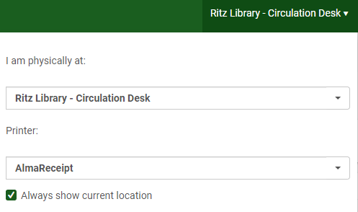

Printing

Alma printing is done through a third party software, Namtuk, that automatically prints Alma documents that are sent to our printers. In some cases, a print job may take several seconds.

In the location drop-down menu, you can also choose your printer. AlmaReceipt prints to the printer at the Circulation Desk. AlmaPrinter prints to the shared printer (H354). You can switch back and forth between printers as needed based on your work needs.

Barcode Scanner versus Manually Entering Barcodes
If you use a barcode scanner for entering item or patron barcodes, you will not have to hit enter or click on an additional box to advance to the next screen. Alma will automatically advance to the next screen.

If you manually enter item or patron barcodes, you will have to hit the enter key, or click on the appropriate button to move to the next screen.

Managing Your Homepage in Alma

Each user can set the Alma homepage to display differently based on your work needs. Click on the plus sign to add or remove widgets to your home screen.

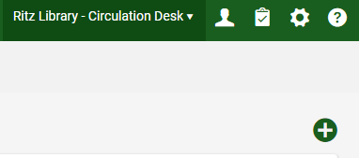

You can add or remove the widgets as needed. Please add the Discovery Search widget so you can easily access Primo (Ritz Discovery) if necessary.

Screen Timeout

After two minutes of inactivity in a patron’s account, your screen will time out and return to the patron identification screen where you can begin a transaction with your next patron.

Pick from Shelf List

The pick from shelf list will be monitored by the Technical Processing staff. This includes a list of items that have been requested (resource sharing, Interlibrary loan, holds, etc.). Please be aware of this list should a patron request a book that has not been brought to the front desk.

Patron Hold Requests

Patrons can place holds through their account in Primo (RitzDiscovery). They may not place holds for items that are available in the library. Patrons can also be referred to reference for assistance with their account or placing holds/requests.

When a returned item is on hold for another patron, the box below will appear alerting you to the hold, and a Resource Request Slip Letter will print.

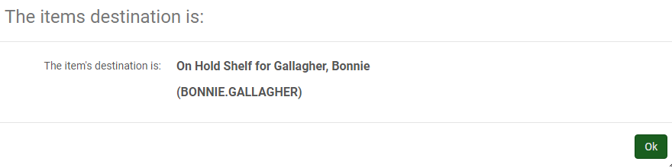

Place the slip in the item and place it on the hold shelf. The slip includes the patron’s name.

An email is automatically sent to the patron notifying them that the item is available for pick up at the circulation desk. There is no need to contact them about the hold.

Zones in Alma
Alma uses the following three “zones” for locating information and resources:
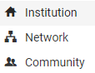

The Institution Zone (IZ) includes our local holdings print and electronic holdings only.

The Network Zone (NZ) includes print materials for all SUNY Libraries. In addition, all bibliographic records reside in the network zone (we attach our holdings and item information to bibliographic records in the network zone).

The Community Zone (CZ) is global community catalog for electronic resources. We will link our electronic resources to resources in the community zone and the information will be continuously updated by Ex Libris. Questions about e-resources can be referred to reference.

Zones and Searching

When you search for an item, you can choose the zone from the search bar zone drop-down, or you can choose the appropriate zone tab from the search results. In most instances, circulation staff will want to search for physical titles in the institution zone.

Select your zone here by choosing the icon from the drop down menu.

OR

Choose the zone tab from the top of your search results.
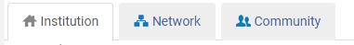

When you see results in the IZ, the NZ or CZ icon will appear next to our holdings that are linked to the NZ or CZ. When searching the NZ or CZ, the IZ icon will appear next to items we have in our library.

Please note: A physical titles (or physical items) search in the NZ will not bring up results. It will only bring up results in an IZ search because the IZ contains holdings and items, while the NZ contains bibliographic records.

Loaning, Renewing, and Returning Items

Policies
Students with a valid DCC SUNYCard for the current semester, who have less than $10.00 in fines, are permitted to borrow upon presenting the DCC SUNYCard. When a student does not have their card, please follow the guidelines below.

If the student is in Alma with a current expiration date, check their schedule or their picture ID to confirm that they are a current student.

If the student is in Alma with an expiration date that has passed, check their schedule AND a photo ID to confirm that they are a current student. Update their expiration date in Alma and proceed.

If the student is not in Alma, refer them to Security to obtain an ID card. In this case, the items can be held for the student until a card is produced.

Items that Should NOT be Renewed:
- Nooks
- Hot Topics
- Study Room Keys
- Loans from a previous semester
- Items with a hold request
- Items for students with fines of $10.00 or more
- Items for Alumni, Community Borrowers & Open Access patrons with any amount of
fines on their account
- Books that have reached the renewal limit (5 renewals)
- Reserve items that have reached the renewal limit (1 renewal)

Loaning Items

- In the Fulfillment Menu, click Manage Patron Services.

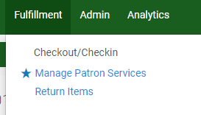

- Scan the patron barcode. This will automatically bring you to the Patron Services screen under the loans tab. Enter the item barcode(s) to check them out.

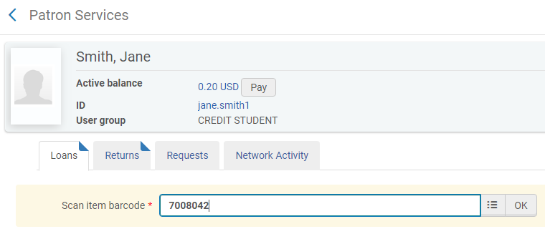

- Click Done in the top right corner of the Patron Services screen. This will automatically send the patron a loan receipt email. If you do not click done, the patron will not receive their receipt via email. We will no longer print receipts at the Circulation Desk.

Renewing Items

- In the Fulfillment Menu, click Manage Patron Services.

- Scan the patron barcode. This will automatically bring you to the Patron Services screen under the loans tab. Change the Loan Display from Loans of this session to All loans so you can see the items that are checked out to the patron.

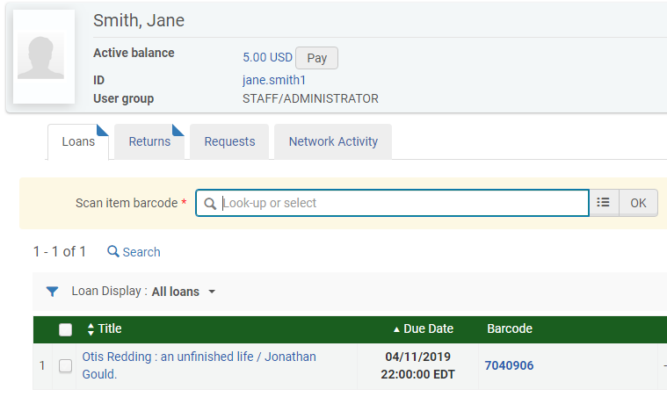

- You can renew the item in several ways.
  - Scan the item barcode. A blue box will appear on the right alerting you to the renewal.
  - Check the item(s) and select Renew Selected or Renew All.
  - Click on the ellipsis for each item and click Renew.
  - Change the due date to a new date (this option should be used rarely).

    - b. d.

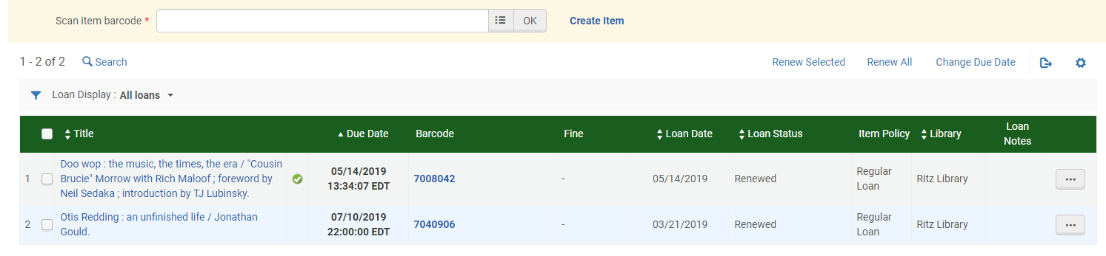

b. c.

(You can also renew items through a general user search by clicking on Manage fulfillment activities in the patron User Details screen. This is not recommended for the circulation desk as you will primarily use the Manage Patron Services screen.)

- Once you have renewed the item(s), click Done in the top right corner of the Patron Services screen. This will automatically send the patron an email with their updated due date.

Returning Items through the Return Items Menu Option

- Verify that your location is the Ritz Library – Circulation Desk. If you are set to a different location, click the drop down arrow to change your location.

- In the Fulfillment Menu, click Return Items.

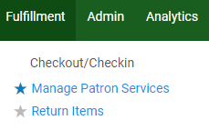

- Scan the barcode(s) in the Manage Item Returns screen.

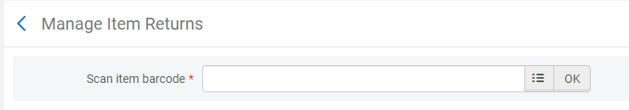

- Click Exit in the top right corner when all items are returned. If the patron has fines, a box will appear indicating the fine amount. Please see the section on fines for additional information. A return receipt will be emailed to the patron automatically.

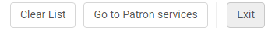

Return Items in the Patron’s Account

- Access the patron account through the Manage Patron Services option under the Fulfillment menu.

- Click the Returns tab and scan the barcode(s).

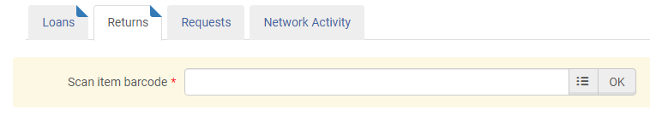

- When you are finished with the patron transaction, click Done. A return receipt will be emailed to the patron automatically.

Backdating Returns (for book drop returns, snow days, exceptions, etc.)

Navigate to Return Items from the Fulfillment menu. Select the appropriate date in the Override return date and time field. A calendar will pop-up when you click on the field. You can select the date from the calendar or manually type the date. Once the date is selected, scan the items in. The date will remain for multiple returns. Click Exit in the top right of the screen when you are finished scanning items in to clear the date.

Loaning & Returning Inter-Library Loan & SUNY Resource Sharing Items

We will no longer use the yellow inter-library loan cards. SUNY Resource Sharing and ILL items will be checked out to patron accounts in Alma.

In addition, Resource Request Slip Letters will automatically print to the circulation desk printer. Place them in the labeled basket at the desk for Technical Processing staff to pick up and retrieve requested books.

Loans: When a patron picks up an ILL or Resource Sharing book, check it out to them in Alma using the TN (transaction number) or the external ID. A transaction number is shown below. In some instances, the barcode on the label will work. In some instances, you will have to manually enter the transaction number or the external ID.

All SUNY interlibrary loan items (resource sharing items from other SUNY schools) will use an External Identifier. All ILLiad interlibrary loan items will use a Transaction Number. The number or ID will be clearly marked by Technical Processing Staff before the book is brought to the hold shelf.

Verify that the due date in Alma matches the due date on the label. Change the due date if needed.
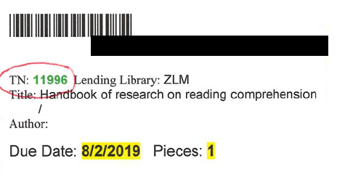

Returns: When ILL or Resource Sharing items are returned, check them into Alma using the transaction number or the external ID and place them on the ILL returns shelf.

Fines

Pay Fines

When a patron owes money, a Pay button will appear next to their name in the Manage Patron Services screen. Click on Pay.
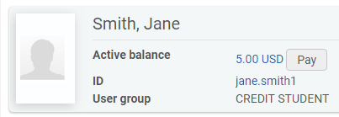

In the Payment Details screen, shown below, select the fines to be paid, the payment method, the amount, and click Send. A receipt will be sent automatically to the patron’s email address.

If you are paying less than $1.00, enter the 0 before the decimal point (0.50 for 50 cents, etc.).

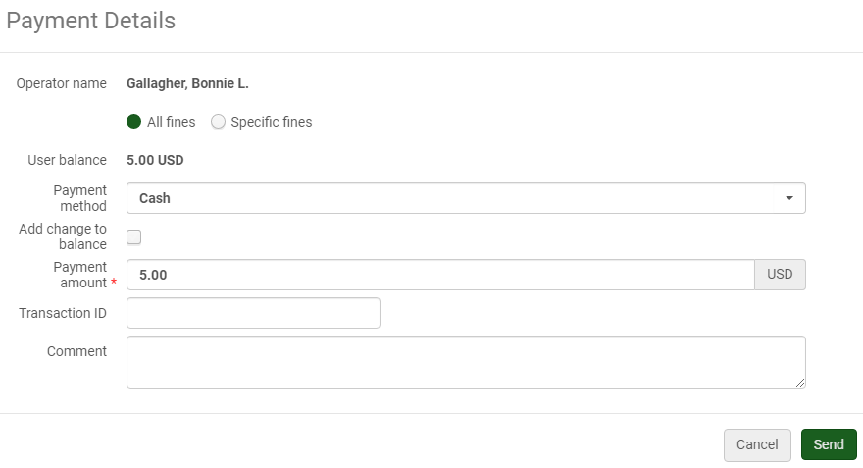

Partial fine payments: You can pay the full amount or a partial amount from this screen. If the patron gives you more money than they owe, you can enter that amount and a pop-up will appear to alert you to provide change.

Fines for specific items: To pay fines for a specific item, you can select it from the list of items after choosing the Specific fines radio button. This will update the Payment Details screen to reflect fines only for the specific items you selected.

Waive Fines

Fines can be waived by clicking on the amount that is due in the Patron Services screen.

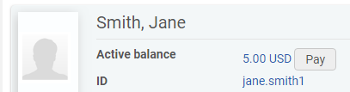

This will bring you to the User Details screen where you can select the fine, and click Waive Selected. You can also choose the Waive option from the ellipsis. Both of these options will bring you to the Waiving Fine/Fee screen.

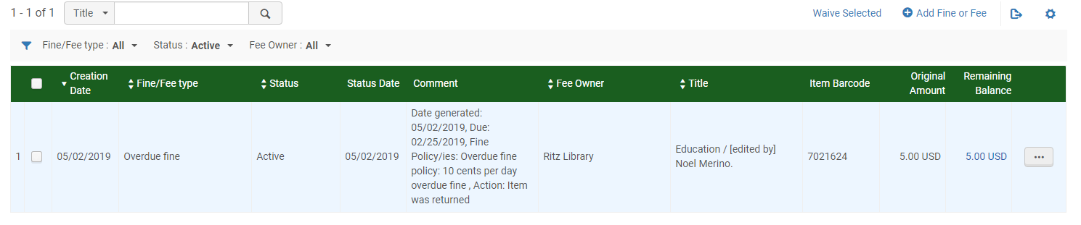

From the Waiving Fine/Fee screen, you can waive all or some of the fine amount by changing the number in the fee amount field. Select Other for the waiving reason and add a brief comment. When you are finished, click Waive in the top right corner and confirm that you want to waive the fine.

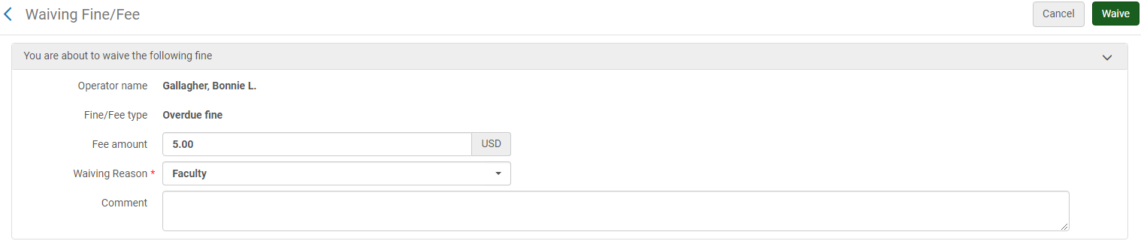

Course Reserves

Search for Course Reserves in Primo (RitzDiscovery)

From your homepage each day, you can open Primo by doing a search in the Discovery Search widget OR you can add Primo to your favorites with this link:

https://suny-dut.primo.exlibrisgroup.com/discovery/search?sortby=rank&vid=01SUNY_DUT:01SUNY_DUT&lang=en

You can sign in to Primo with your myDCC credentials, but you do not have to sign in to see search results.

Once you have Primo open, you can search for a title, course name, course number, etc.

When the drop-down of search scopes appears, choose the Course Reserves scope to see only materials that are on reserve.
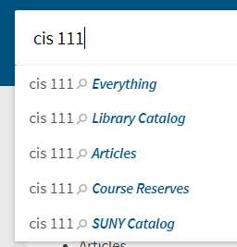

After you complete one search, the search bar will default to show the Course Reserves scope on the right side.

The screen will periodically refresh so be sure that you select Course Reserves from the drop-down or that you are already set to the Course Reserves scope each time you search for reserve materials.

Search for Course Reserves in Alma

Alma Course Reserves includes three things; courses, reading lists, and citations. Each course has at least one reading list that is compiled of citations (books, DVDs, etc.).

Search Option 1: The Main Search Bar

You can search citations and reading lists from the main search bar. For example, if a student has the course code or part of the course name, you can conduct that search to bring up all books for their course.

- Choose citations from the main search drop-down menu.
- Choose course code or course name
- Enter the course code or part of the course name.

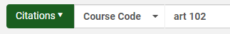

Reserve items will also appear in a physical titles or physical items search. Alma will show that they are in a reserve location. It is unlikely that you will use this search for reserves because a search is not necessary when the student know the title of the book.

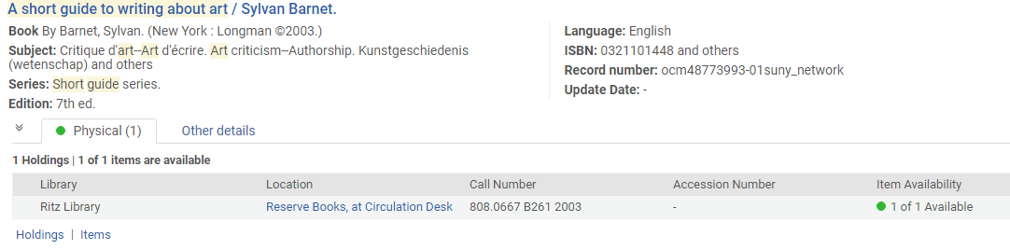

Search Option 2: Fulfillment Menu Options

Under the Fulfillment menu, you can click on Courses, Reading Lists, and/or Citations to view these items.

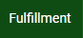
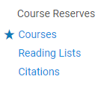

If the patron has the course number or course name, click on Courses.

From the Courses screen, you will see a list of all active and inactive courses with reserve materials. Search for the course by name, number, etc.

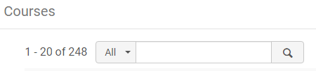

Click on the ellipsis for the desired course to view the reading list(s). Click on the reading list to see the reserve items.

Our reading lists titles will correspond to the course codes so you can also click on Reading Lists from the Fulfillment menu to see all lists in alphabetical order.

In-House Use Tracking

When books are left in the library (in the stacks, on tables, on shelving carts, etc.) follow the steps below to record the in-house use of materials.

For in-house use items, use the Scan in Items screen under the Fulfillment menu. Check the box to Register in-house use and scan the barcode(s). Click exit when you are done.

Please note that the box will remain checked when you return to this screen (it will default to the last selection you made). When you use this screen again, check to make sure the box is checked for in-house use, or unchecked for all other scan in functions (returns, etc.).

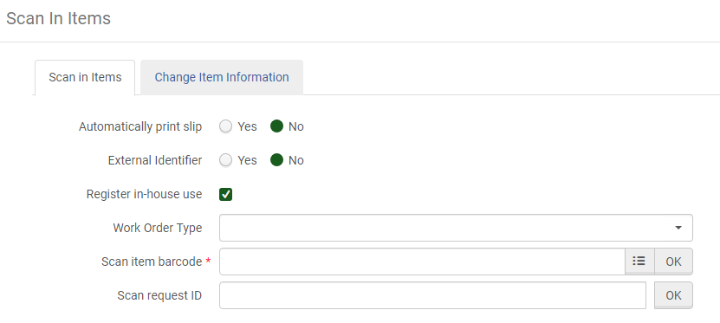

Place items on the “Needs to be Processed” cart (in the back office) in call number order when you are finished.

Patron Searches

Search for a Patron Without Scanning a Barcode

When a patron does not have their barcode present, search for them in Manage Patron Services under the Fulfillment menu.

In the search bar, you can enter the following information to locate a patron:

First name
Last name
Last name first name (no comma)
myDCC username
A number

A drop-down will appear with up to ten results based on what you typed. If your patron appears in the drop-down, click on their name and click Go. If your patron does not appear in the drop-down list, click on the ellipsis (three lines symbol) to search all patrons.

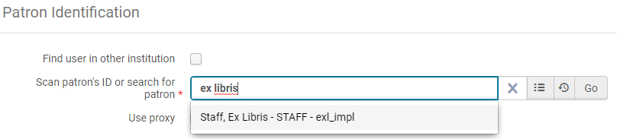

Return to a Previous Patron

You can see your recent patrons by clicking on the clock symbol when searching for a patron. If the patron still appears, click their name and click Go.

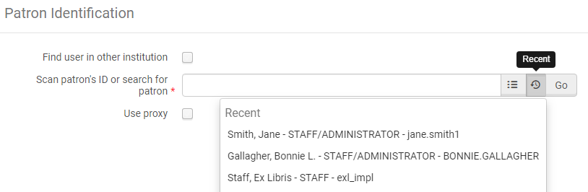

Update a myDCC Patron’s Barcode or Contact Information
Please Note: myDCC patrons must update contact information with Student Financial Services or the Registrar’s Office. If you update it in Alma, it will be overwritten by Banner.

- Search for a patron in the Manage Patron Services screen.

- Click on the patron ID to access their list of identifiers in their account.

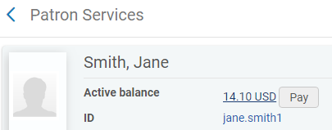

- Click Open For Update in the top right corner. Click Yes in the pop-up box about overwriting information. This will allow you to edit the barcode.

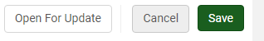

- Click the ellipsis in the right column of the Barcode row and click Edit.

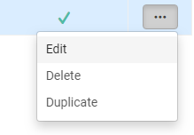

- Check the Add as an external button (for external patrons only). This will allow the information to be updated from our Banner patron loads. Scan the new barcode in the Value field. Click Update Identifier.

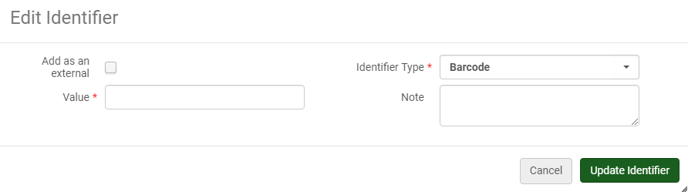

- Click Save to return to the patron services screen and proceed with your transaction.

Update an Alumni or Community Borrower Barcode or Contact Information

- Search for a patron in the Manage Patron Services screen.

- Click on the patron ID to access their list of identifiers in their account. For Community and Alumni Borrowers, their old barcode will show as the ID.

- Click on the General Information tab.

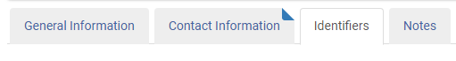

- Change the Primary identifier to the new barcode number.

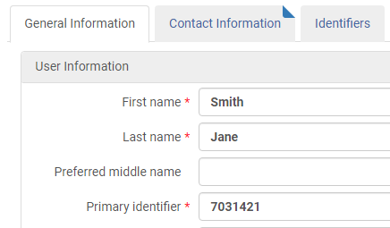

- Click Save in the top right corner to return to the patron services screen and proceed with your transaction.

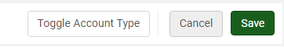

Contact information can be updated in the Contact Information tab. Use the ellipsis to edit fields and then click save in the top right corner to return to the patron services screen.

Patron Activity Report

If a patron requests a record of their current activity (outstanding loans, fines, fees, etc.), you can email them an activity report through the Manage Patron Services screen.

Access their account and click Send Activity Report.

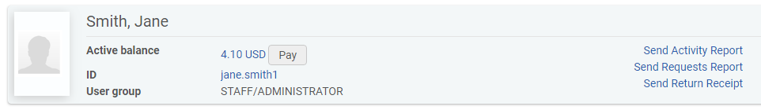

In addition, you can discuss previously borrowed items with patrons by viewing All returns under the Returns tab in the Manage Patron Services screen.

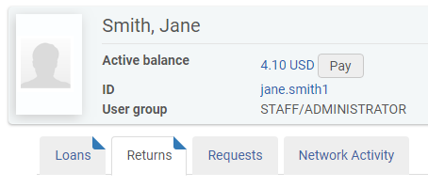

Item Searches

Search for an Item Barcode
Two ways to obtain a barcode are:

- Do a Physical Items search. The barcode will appear in the results screen.

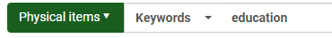

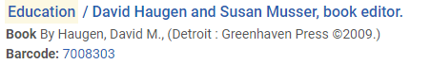

- Do a Physical Titles search. When you find the item in the list, click on Physical, then click Items to view the list of items. The barcode will be in this screen.

OR

Click on the ellipsis for the item, then click Items to access the list of items.

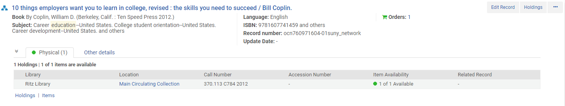

Locate a Patron or Due Date/Time for a Specific Item that is Checked Out

Follow the search steps above (for locating a barcode). From the list of items, click Loan in the Process type column. This will bring you to the patron name and the due date/time.

View the Loan History of a Specific Item

In the items screen (accessed through a physical titles or physical items search), you can click on the barcode to see additional information about that item.

The history tab will list previous loans, etc.

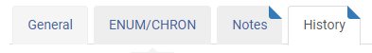

Registering New Users in Alma

Add Community, Alumni, or myDCC Users
- Click on Register New User from the top right side of the Patron Identification screen.
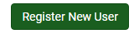

Please note: Enter new Alumni and Community Borrowers as new patrons. Do not change their previous student accounts. These duplicates will be deleted through other Alma procedures.

- In the Quick User Management screen, enter the following user information:

First name User Group
Last name Expiration date
Primary Identifier (Barcode)

Please note: Community borrower cards and barcodes are in the back of the manual.

- In the User Management Information section, select No next to Patron has institutional record for ALL new patrons.

- For myDCC users, do not fill in a password.

- For community and alumni users, enter the patron’s phone number as the password and alert them to this information. Check the Force password change on next login so they update their password upon logging in to Primo (RitzDiscovery).

Please note: Passwords must be unique and must be at least 8 characters. They cannot include the patron name or any common words. If the phone number is not accepted, create a unique password and be sure to share it with the patron so they can log in.

- Enter an email address, address, and phone number. Select the type for each item.

- When all information is entered, click Update User in the top right corner.
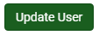

- This will return you to the Patron Services screen. Continue your patron transaction as needed.

Add Open SUNY Patrons

Open SUNY Patrons must have their ID card with their library barcode to be added to Alma.

- In the patron identification screen, click the find user in other institution box. This will add the institution drop-down to the page. Choose the patron’s institution and scan their barcode.

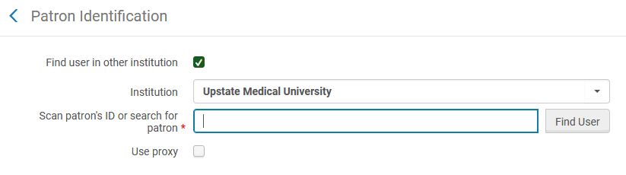

- The Quick User Management screen will appear. Enter and/or verify the following information.

First name
Last name
Primary Identifier (change this to their institution barcode)
User Group (Open SUNY)
Birth date
Expiration date (update it to the current student expiration date)
Purge date (delete the purge date that is filled in)
Contact information (email, phone, and address)

Leave the password information blank. The patron will access Primo through their
institution. Primo will show which SUNY schools they have borrowed materials from.

- Click Update User to return to the Patron Services screen. Continue your transaction as needed.

Reset a Password for a Community or Alumni Borrower (Internal User)

If a patron needs to reset their password, verify the patron contact information and birth date before changing the password. If the patron is at the desk, check their ID as well.

- From the Fulfillment menu, click on Manage Patron Services.

- Search for the patron or scan their barcode.

- Click Edit User Info in the top right corner of the Patron Services Screen.

- Update the password in the Quick User Management screen and make sure Force password change on next login is checked. Tell the patron the new password.

- This will allow the patron to log in to Primo and update their password.

Please note: The password must be a unique password that is at least 8 characters and does not include the patron name or any common words. If the phone number is not accepted, create a unique password and be sure to let the patron know what it is so they can log in.

Passwords cannot be updated for external users (students, faculty, staff) because they authenticate with their myDCC credentials.

Open SUNY students will access Primo through their home institution and will not need passwords set at DCC.

Blocks in Alma

Overriding and/or Reviewing Blocks

Alma will alert you to patron blocks with a pop-up screen when attempt to access their account through the Manage Patron Services menu option.

Please adhere to our policies in dealing with blocks. If our policies allow for an override, click override. If our policies do not allow for an override, click OK to access the account and review information with the patron. OK does not override blocks, but it does allow you to access the account and see additional block information. Cancel will return you to a blank Patron Identification screen.

A block pop-up screen will appear as shown below:

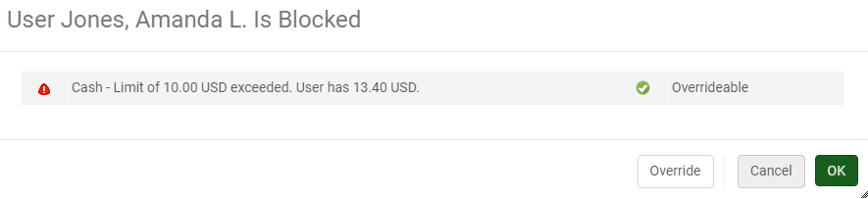

Overriding External Patron (Students, Faculty, Staff) Expiration Date Blocks

When a patron card has expired, the following block will appear.
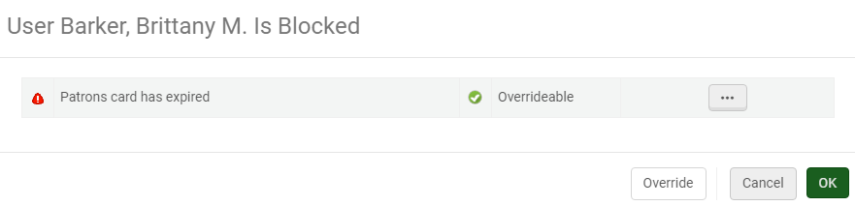

Once you have verified that the patron can be renewed (registered student, current faculty member, etc.), click the ellipsis and click Renew. This will renew the patron for 30 days. The expiration date will advance further when the patron load process updates the account.

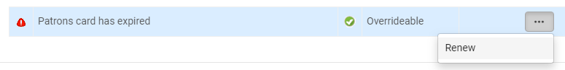

Do not use the Override button. This will not update the date and any checked out items will be due on the same day.

Overriding Internal Patron (Community and Alumni) Expiration Date Blocks

Follow the procedure above. When you have access the patron account, click on the patron ID to access the User Details.

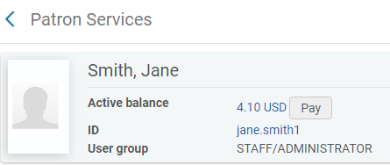

From the User Details screen, click the General Information tab. Update the Expiration date as needed. Click Save in the top right corner. This will bring you back to the Patron Services screen where you can check items out, etc.
Step 1
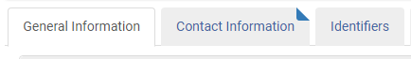

Step 2
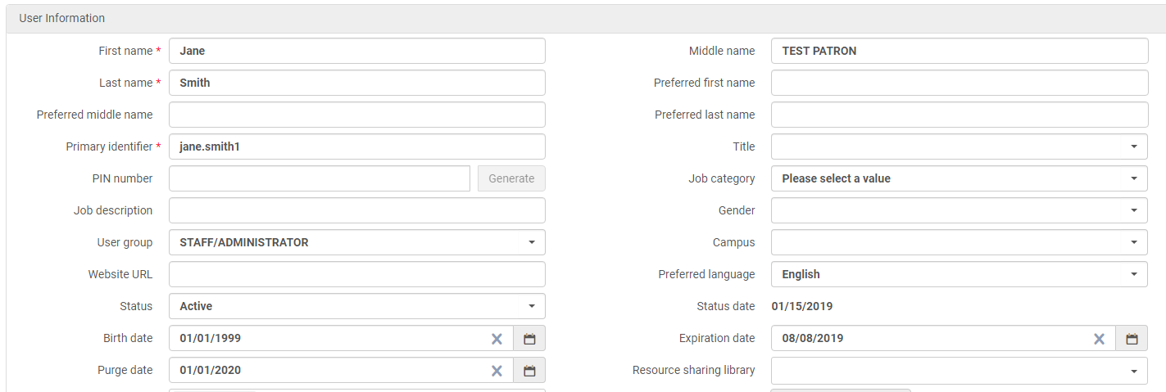

Step 3
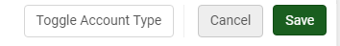

Add a Patron Note
Patron Notes will appear in the top right corner of the Patron Services screen.

From the Manage Patron Services screen, access the patron’s full account information by clicking on their ID. Click on the Notes tab.

Click Add Note and fill out the pop-up box as needed. Do NOT check Add as external or User viewable. Click Add and Close when finished.
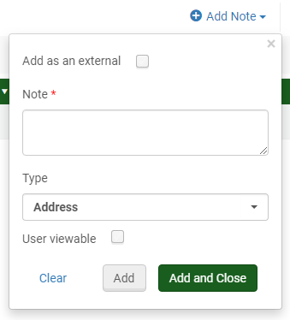

Add a Patron Block
Patron Blocks will pop-up when you access a patron’s account.

From the Manage Patron Services screen, access the patron’s full account information by clicking on their ID. Click on the Blocks tab.

- Click Add Block and fill out the pop-up box as needed. Do NOT check Add as external. Do NOT add an expiration date.
- Click Add and Close when finished.
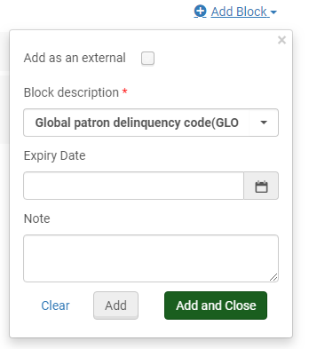

Manage Patrons in Alma
Patron Loads from Banner to Alma

Patron information is automatically loaded from Banner to Alma daily Monday through Friday. Appworx runs the Banner job at 8am, which creates an XML file that is sent to the SUNY SFTP Server. The Alma job loads the patron information from the XML file daily at 11am. SIS integration is in Alma configuration (General -> External Systems -> Integration Profiles).

Scheduled and Unscheduled Patron Loads

Before each semester, the Associate Librarian for Access Services will update the schedules for patron loads in Appworx based on the DCC registration schedule.

Fall loads can run from May 5 through October 20
Spring loads can run from October 21 through February 10
Summer loads can run from February 11 through May 4

The Associate Librarian for Access Services will run unscheduled loads for summer and winter:

- Summer: run periodically during summer months, with summer expiration date.
- Winter: run in December, prior to the start of the term, with spring expiration date.

Updating Patron Load Schedules in Appworx

- Log in to Appworx (obtain credentials from IT)
- Navigate to the process flows (Object Admin -> Development -> Process Flows OR click on process flows icon).
- Select Banner to Alma.
- Click on the schedules tab. Choose desired term(s) to update schedule. Click Edit.
- Change run dates as needed, check the active box.
- Under prompts tab, change term codes and expiration dates as needed.
- Click ok to save and exit.

Run an unscheduled Patron Load in Appworx (Banner) and Alma

- Log in to Appworx. Click the green arrow. Select Banner to Alma.
- Enter the term code, effective date (today), and expiration dates.
- Click submit and close. The job is done when you see BANNER_TO_ALMA in the history.
- In the Alma SIS integration actions configuration, click run under synchronize.

Correct Patron Load Errors

When a patron load has run in Alma, view the history tab under Admin -> Monitor jobs. Open the Users SYNCHRONIZE using profile Student Information System report to see a summary of created, rejected, and updated accounts.

Click on the ellipsis to review and correct rejected accounts. Below is a summary of error messages and solutions.

- The primary identifier is already taken by another user in this feed.
  - This error message appears for faculty/staff who are also students, thus they appear in both patron load files. These can be ignored.

- Identifier of type 01 and value 25918XXXXXXXXX is already taken AcrossInstitutio...
  - This error message appears when a new myDCC patron has been added. Go to that patron account using the barcode. Change them to an external account. Move the barcode to the identifiers tab. Add the PIDM to the identifiers tab (this is the identifier ID that shows up in the error report). Change the primary ID to the myDCC username (can be taken from the email address in their contact information). Check the account the next day to be sure errors were corrected.

For additional troubleshooting of patron information in Appworx, view the .lis files to verify information.

- Click on the completed BANNER_TO_ALMA job as shown below.

- Click on the Output Files tab.
- Click on the .lis file(s) to search for desired information and verify details.

Delete Patrons

We do not use purge dates in our patron loads. To mass delete old/inactive patrons, do the following:

- Create a set of users in Analytics.
- Run the update/notify users job to add a purge date.
- Run the purge users job based on added purge date and a limitation on patrons with fines.

