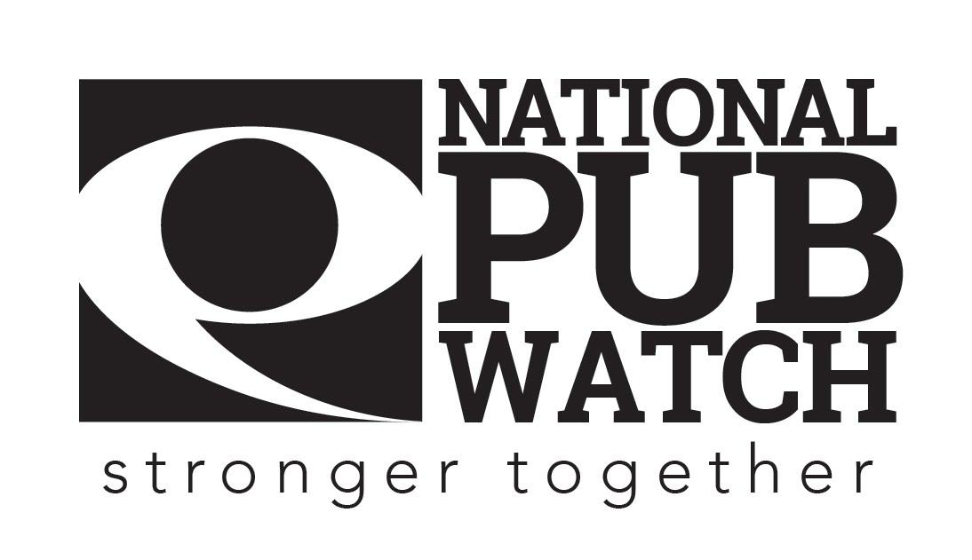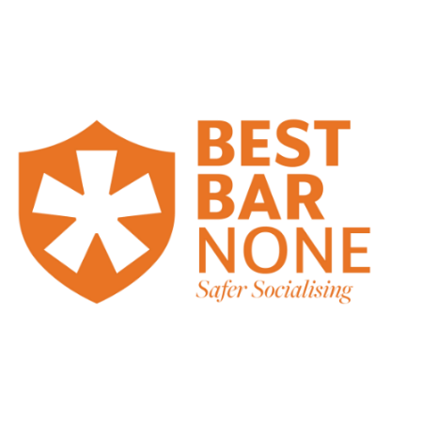

**Drunkenness and Disorderly Behaviour Policy**

**Date Created:**

**Date of last review: NB Policies should be reviewed annually.**

**Expected Standards**

There are 4 licensing objectives of equal importance:

* The prevention of crime and disorder
* Public safety
* The prevention of public nuisance
* The protection of children from harm

It is against the law to knowingly sell alcohol to someone who is drunk or appears to be drunk. It is also an offence to knowingly buy or obtain alcohol for a drunken person on licensed premises e.g. a bar, restaurant, pub or nightclub.

It is also against the law to allow people to behave in a disorderly way whilst inside our premises or on the grounds of our premises.

Section 143 Licensing Act 2003 makes it an offence for someone who is either drunk ***or*** disorderly if they fail to leave the premises when requested to do so by staff or Police.

We [insert name of premises] take our legal responsibilities to sell alcohol responsibly very seriously and we expect staff to take this very seriously too. If you do sell alcohol to someone who is drunk or disorderly or disorder breaks out on our premises due to drunkenness, you could be prosecuted and fined. There is a fixed fine of £1000 for the person who sold the alcohol to a drunk person. If you are a Personal Licence Holder, you could face a criminal prosecution and your Personal Licence is also at risk. Furthermore, your manager or owner could also face prosecution and the premises licence could be reviewed, suspended or revoked as a result of your actions.

We are in the business of selling alcohol, but we need to ensure that our customers enjoy using our facilities without behaving in a way that is offensive to others or that breaks the law.

Therefore, it is important that you know how to deal with drunkenness and disorderly behaviour if it should arise.

**What to look out for:**

* Disruptive behaviour
* Raised voices and arguments
* Customers buying drinks or shots in quick succession
* One or more people playing to a crowd
* People being held up by their friends
* Glazed eyes
* Stumbling
* Slurred words
* Vomit in the toilets

At the other extreme, intoxicated persons can often be quiet or simply asleep. Keeping an eye on each of your customers will help you to identify potential problems early before they get out of control.

**Our specific internal standards**

* We try to create a positive friendly welcoming and inclusive environment
* We train all our staff to ensure that they can serve customers as quickly and professionally as possible
* Do you try and avoid incentives to intoxication such as happy hours, 2-for-1 drinks, cocktails with more than 2 spirits, wine always sold in small glasses unless requested by the customer, shot glasses, top lines, buckets or limit the number of shots per person, or not serve spirits in anything more than doubles
* What are your specific rules for customers and how are they implemented e.g. no dancing on the tables, no caps inside, no smoking of vapes, no glassware outside.
* Devise a specific action plan so that staff know their responsibilities and who is responsible for what

**When to step in and what to do**

Service should be refused to any customer who is or appears to be:

* drunk
* or any customer who is trying to buy a drink for someone who is or appears to be drunk
* or any customer(s) who are acting in a disorderly fashion that is related to drunkenness

It is generally better to intervene too early rather than too late. The steps should be as follows:

1. A quiet word with a problem customer(s) or group can often resolve the situation before an offence is committed.

If you think someone is drunk.

* 1. politely refuse them explaining that it is company policy not to serve people who may have had too much to drink, [it is a good idea to have clear signage to this effect to de-personalise the issue] but you would happily provide them with a soft drink, tea, coffee or water [insert whether this should be free or not].
  2. If you think someone in a group of people is drunk politely refuse them explaining that it is company policy not to serve to people who may have had too much to drink, but you would happily provide them with a soft drink, tea, coffee or water. [insert whether this should be free or not]. The reason for this is because they may give the drunk person alcohol that they have bought. If they don’t listen to you or you feel uncomfortable dealing with a situation then:

1. Escalate to [door staff, duty supervisor, manager]. Be polite but firm with the problem customer.
   1. Do not serve them any more alcohol
   2. If they are in a group, advise the group of your decision, and let them know that you can’t serve them.
   3. If the customer is aggressive, do not get aggressive back or say or do anything to worsen the situation, calmly explain that it is company policy and offer them a soft drink [insert whether this should be free or not], give them a phone number and email [insert venue specific] that they can call during office hours to raise a complaint.
2. If it escalates beyond your capabilities, then you should escalate to the door security team who should ask and supervise the person or group to leave the premises.
3. Calling the police should be a last resort, but, if necessary, and appropriate and you have exhausted all other means to control the situation you must call the Police.

**Refusal logbook**

Remember to log the refusal in the refusals book. The log is kept [insert location] you must log the date and time, which product was refused, why you refused the sale plus any other details that may be useful to others in future such as a description of the person(s).

**Please sign this document to acknowledge that you have understood your responsibilities in regard to drunk and disorderly customers.**

Date: …………………………………………………………………

Trainer’s Name: ……………………………………………... Trainer’s Signature: …………………………………….

Trainee’s Name: …………………………………………….. Trainee’s Signature: ……………………………………