MN
User’s tip sheet
Create your account on MN.TRAIN
Please use Internet Explorer or Google Chrome
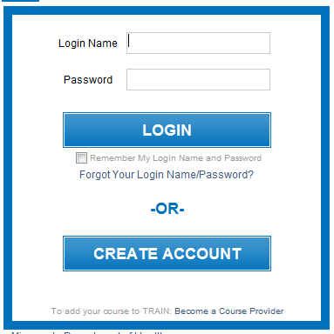
- Go to http://mn.train.org
- Click on “Create Account” on left side of screen beneath the Login button
- Review MN.TRAIN policies
- Check the “Agree” box
- Click “Next”
- Enter your profile information
      - Required fields are indicated with a red asterisk *
- Use appropriate capital and lower case letters
- You create your own Login Name and Password
- When completed, click “Next”

- To Select State Portal, click on “Select Groups” button
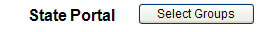

- Select Employment Category, select “Not a State Employee”
- Select Region, select which region you live
  - Color coded legend is below the map
    - Metro region is divided up into Metro East: Anoka, Dakota, Ramsey, Washington counties
    - Metro West: Carver, Hennepin, Scott counties
  - Then select the County in which you work
- Select ODP discipline (the field in which you work)
- Then hit the “Submit” button below the map

Note
- If you would like to add a CDC group to your MN.TRAIN account, you can select the CDC Portal “Select Groups” button. Here you select which area most of your work is based
- Click on the “Submit” button
- Then click on the “Next“ button

- Selecting a Professional Role: You can select up to 3 roles
- Then click “Next”
- Selecting a Work Setting: You can select up to 3
- Then click “Next”
- The next screen asks for demographic information, it is not required
  - You may skip this page, if you desire
- Answer the question: Do you hold a Professional License Number?
- This is for those working professionals that hold a licensure i.e., doctor, nurse, veterinarian, driver, contractor, etc.
  - Make the appropriate selection
- Then click “Next”
- Then you can explore MN.TRAIN by clicking on the “Continue” button

Note
please be sure to do this
- MN.TRAIN will send you an email thanking you for registering and asking that you confirm your email address by clicking on a link in the email
- Write your “Login Name” and “Password” in a secure place
- To exit MN.TRAIN, go to upper right corner of screen
- Click on “Logoff”

How do I register for “What is SHIP” course?
- If you know the Course ID, enter it in the “Keyword or Course ID” box on the Home Page

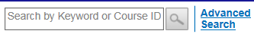
Type in: What is SHIP or
Course ID 1072933

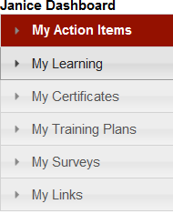
What is “the Dashboard?”
- After you login, your “Dashboard” appears on the right side
- “My Learning” contains your active course registrations
- “My Certificates” contains your course completion certificates

How do I update My Account on MN.TRAIN?
- Click on “My Account” in the upper right corner of the screen
- The screen will refresh
- Update any fields you wish
- Remember to click on the “Save and Back” button when finished

How do I change my password or update my MN.TRAIN account?
- Click on “My Account”
- Click on “Reset Password” Enter all fields (Old Password, New Password, & Confirm)
- Click on “Save”
- Update any other information
- When finished, click on “Save and Back” button at bottom of page

What if I forget my password for MN.TRAIN?
- Go to http://mn.train.org
- Click on “Forgot Your Login Name/Password?” link below the “Login” button
- Enter your email address
- Click on “Send me my password” button
- Your password will be emailed to you
- Or you can contact MN.TRAIN@state.mn.us to ask for assistance

How does a MN.TRAIN course get moved from My Learning to my TRAIN Transcript?
- You must be registered for the course through MN.TRAIN
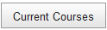
- After you complete the course, return to “My Learning”
- Open “My Learning”
- Click on the “Current Courses” button
- Locate the title of the course you want to manage
- Click the “M” button for Course Registration Management
- Click “Completed”
- Click OK
- Then click “Submit”

Where can I find my TRAIN Transcript?
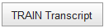
- On your Dashboard, open “My Learning”
- Click on the “TRAIN Transcript” button
- Print your certificate of attendance from the “Certificates” link in “My Learning”

What if I can’t launch a course?
- Turn off popup blockers
- Click “Help” on the TRAIN navigation taskbar
- Click “Test Your Environment” in the left hand menu
- Follow the prompts to diagnose technical problems
- Recommendation: Use “medium” or “lower” on the Privacy Tab of Internet Options
- Use Internet Explorer or Google Chrome if you are using another browser

Questions?
- Contact the MN.TRAIN State Administrator at mn.train@state.mn.us or call the Minnesota Department of Health, Center for Emergency Preparedness and Response at 651-201-5700

Center for Emergency Preparedness and Response
Minnesota Department of Health
625 N. Robert
St. Paul, MN 55164
651-201-5700
mn.train@state.mn.us
www.health.state.mn.us
11/17/2017

