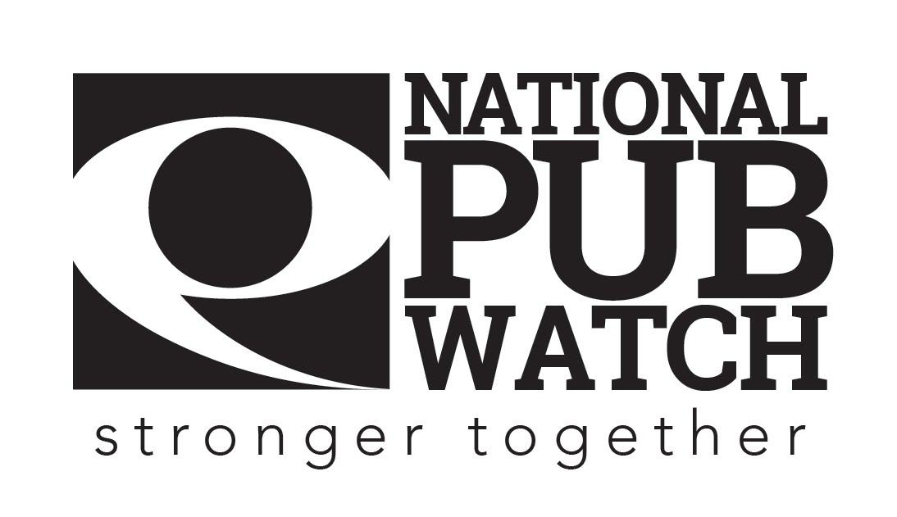

**Lost and Found Property Policy**

**Date Created:**

**Date of last review: NB Policies should be reviewed annually.**

**Expected Standards**

There are 4 licensing objectives of equal importance:

* The prevention of crime and disorder
* Public safety
* The prevention of public nuisance
* The protection of children from harm

The [insert name of venue] accepts no responsibility for private property whilst on the premises, including accepting any liability including should lost property being returned for any reason to someone who is not its owner- e.g. if someone makes a false representation to the management or staff of the [insert name of venue] of ownership of the property.

Property that is left on the premises will be kept for a period 2/3/4 months/ weeks], after which it will be disposed of. Any found passports or driving licences will not be returned to a member of the public, but will be [handed to the Police or returned to the issuing authority] (check & amend to fit arrangements in your area, some police forces will not accept lost property from venues).

Valuable property will be kept securely in a locked [specify, safe, draw]

All property will be logged in the lost/found property register and in order for it to be reclaimed; a detailed description of the item and proof of identity will be required. All returned items must be signed for by the individual making collection.

**Please sign this document to acknowledge that you have understood your responsibilities in regard to Lost and Found Property.**

Date: …………………………………………………………………

Trainer’s Name: ……………………………………………... Trainer’s Signature: …………………………………….

Trainee’s Name: …………………………………………….. Trainee’s Signature: ……………………………………