# **ASHRAE OE GOLF COMMITTEE MEETING** **AGENDA**

**Golf Tournament 2024: Tustin Ranch Country Club, October 3, 2024.**

## July 30, 2024; Teams Meeting 12:00 PM [Noon]

|  |  |  |
| --- | --- | --- |
| Event Reference | Continuing Business Description | Action Items (AI) / [STATUS] |
| Ref: 050824 – 1st meeting agenda | Subject:   * The tournament will be held 10/3/24 at Tustin Ranch CC. * Chris is the new Tournament director (in training) supporting Jeff closely for 2024, taking reins for 2025. * The ASHRAE OE Golf committee consists of the following members:   + Jeff H.: Current Director; Beverage Liaison.   + Jeff C.: BOG contact; men’s apparel design   + Jessica: Women’s apparel design.   + Emily: Women’s apparel design   + Anthony: Chapter President contact.   + Chris: New Golf Director for 2024.   + James Mansfield – not attending but interested. * 3 planning meetings planned during the summer; JH is concerned about democratic decision making; Chris will need to make a lot of decisions on his own. * JH is out of town on 05/26-29. * Target revenue generation is $30k net to Chapter. * Sponsors will buy all raffle prizes – this was a vast improvement on cash flow from the past. | **Historical Information only** |
| Ref: 052224-Liquor Service | Subject: Revised liquor serving plan for Sponsors   * Will TR have enough resources to serve properly and verify pricing? * Past sponsors: We need to explain the new layout and pricing and get commitments. * Update from JH:   + JH Sent inquiry to Air Treatment, Rheem, Sigler, Victaulic, etc. * We need to get a copy of the current insurance rider for the chapter. Likely not an issue as since the risk is transferred to TR. Note that the policy letter indicates supplement insurance is available for golf events.   History:   1. Insurance plan for chapter is uploaded on Basecamp. <https://3.basecamp.com/3106353/p/gAEwtLMr6tzuWVa8yFhc2dyw/vault/7383917666>    1. Not much information is on this insurance letter, and it is several years old.    2. Table Insurance as a separate item. 2. Basic option: everything on the course is provided by TR – we just pay for it all. 3. In the past, purchased beverage services from a sponsor; this sponsor will pay and order beverages, but TR will serve. TR has 4 bar tenders, 2 in carts, 2 else wares [6 holes max]. SB is looking for more help to hopefully expand offering to more holes. 4. JC – we should have a liaison the effort with holes sponsors. JH will be liaison. 5. When do we need to have this arrangement finalized? Needs to support flyer scheduled 05/22. **Now considering pushing to 6/3.** 6. $3500-5000 if TRCC provides bartenders. 7. 160 golfers for 2 beverage carts is an issue. 4 carts would be better. | AI-052224-JH to get verification from TR on service capacity**. [In Progress]**  AI-052224-JH will be reaching out to past sponsors. **[In Progress]** |
| Ref: 052224-Sponsor pricing change | Subject: Sponsorship pricing   1. We need to discuss and decide to lock in new sponsorship pricing, capture on flyer, and send out before the end of May (target 5/22). JH to lead discussion. 2. We may need to delay flyer publish release until 6/3 to make sure we have alignment with sponsors and TR on logistic support. 3. Discussion on various methods to preserve the $30k net profit target. JH to run a couple of scenarios and share with Committee. There will need to be some estimating as the beverage service (catered by TR) will simplify logistics, but we do not have a past event to compare as the bartenders and drinks will be provided by TR. 4. JH proposed that the Chapter pick up the drink tab for the platinum sponsors as some of this will be covered by additional fees.   History:   1. JH sent out flyer template: <https://3.basecamp.com/3106353/p/gAEwtLMr6tzuWVa8yFhc2dyw/vault/7383958914> 2. The flyer needs to be sent out before the end of May; Target 5/22. May need to be delayed until 6/3. 3. We need to figure out sponsor pricing ASAP.    1. JH Sent inquiry to Air Treatment, Rheem, Sigler, Victaulic, 4. Platinum; Gold, Siver. Last year’s pricing: $6k, $3.5k, $2k | 052224-JH to run scenarios and email results to committee for feedback. **[In Progress]** |
| Ref: 050824-Womens Apparel (WA) | Subject: Women’s clothing for sale   * Update on WA selection. * JH is sending information on what was ordered last year to EY and JC. * Currently, EY and JC are not happy with the selection available but will review past orders and try to select. * Emily and Jessica to start reviewing online catalog at WillamMurray.com | 050824 WA - EY & JC. **[In Progress]** |
| Ref: 052224-Mens Apparel (MA) | Subject: Men’s clothing for sale   * Update on MA selection. * JH selected and sent it to JC for confirmation. * Decision made 5/22/24: see below shirt.     History:   1. JH and JC to start reviewing online catalog at WillamMurray.com | 052224 MA - JH. & JC. **[In Progress]** |
| Ref: 073024 | Subject: ref: Hanzel email 7/20/2024   1. JH will order apparel “next week.” 2. JH has edited a preliminary flyer with pricing suggestions. See Attachment-1. 3. Sponsor pricing and recruitment is a **PRIORITY** at this point. Only 9-10 weeks to get this event put together. 4. Once platinum sponsors are secured, JH will order logo golf balls. 5. JH is exploring supplemental insurance. See Attachment 2. This to cover the Chapter and Individual to allow us to keep the same format as previous years. JH received significant pushback from Platinum Sponsors to pay the increased cost whilst taking away this benefit. The General Waiver [see Attachment 3] is a sample template that we would fill in yellow highlighted areas with our event to have on file with Accord. 6. JH requests a phone call with CF next week regarding insurance and Siglar participation. 7. The Tustin Ranch contract and deposit receipt is attached. See Attachment 4. |  |

| New/Future Business and Meeting Information |
| --- |
| Description: |
| 1. The next scheduled Meeting is planned for: Thursday May 30th. 4 pm at the end of year installation dinner meeting. |

**Text Legend: Bold black text is for the latest information / Assignments / Status**

**Orange text indicates Agenda publishing.**

**Blue text indicates Minutes publishing.**

**AI reference code: 102222 = October 22, 2022 [typical].**

**Incomplete or in-progress AI are highlighted.**

**Distribution List: *Attending**

|  |  |
| --- | --- |
| **Chris Mellen [CM]\*** | **Cinthya Carrillo [CC]** |
| **Jeffrey Hanzel [JH]\*** | **Chris Farrington [CF]** |
| **Anthony Zanotti [AH]\*** | **Ryan Sibley [RS]** |
| **Jessica Clark [JC]\*** | **Eric Decker [ED]** |
| **Yang, Emily [EY]\*** | **Brian Sybesma [BS]** |
| **Jeff Conrad [JC]\*** | **James Mansfield [JM]** |
| **David Lawson [DL]** | **Chris Farrington [CF]** |
| **John Sawyer [JS]** |  |

**List of Attachments**

1. ASHRAE OE - Golf 2024 Flyer (Template)
2. Application - Special Events Amateur Sports (002)
3. General Waiver-ASHRAE
4. Countersigned Contract & Initial Deposit_192

Attachment-1 ASHRAE OE - Golf 2024 Flyer (Template)

Attachment-2 Application - Special Events Amateur Sports (002)

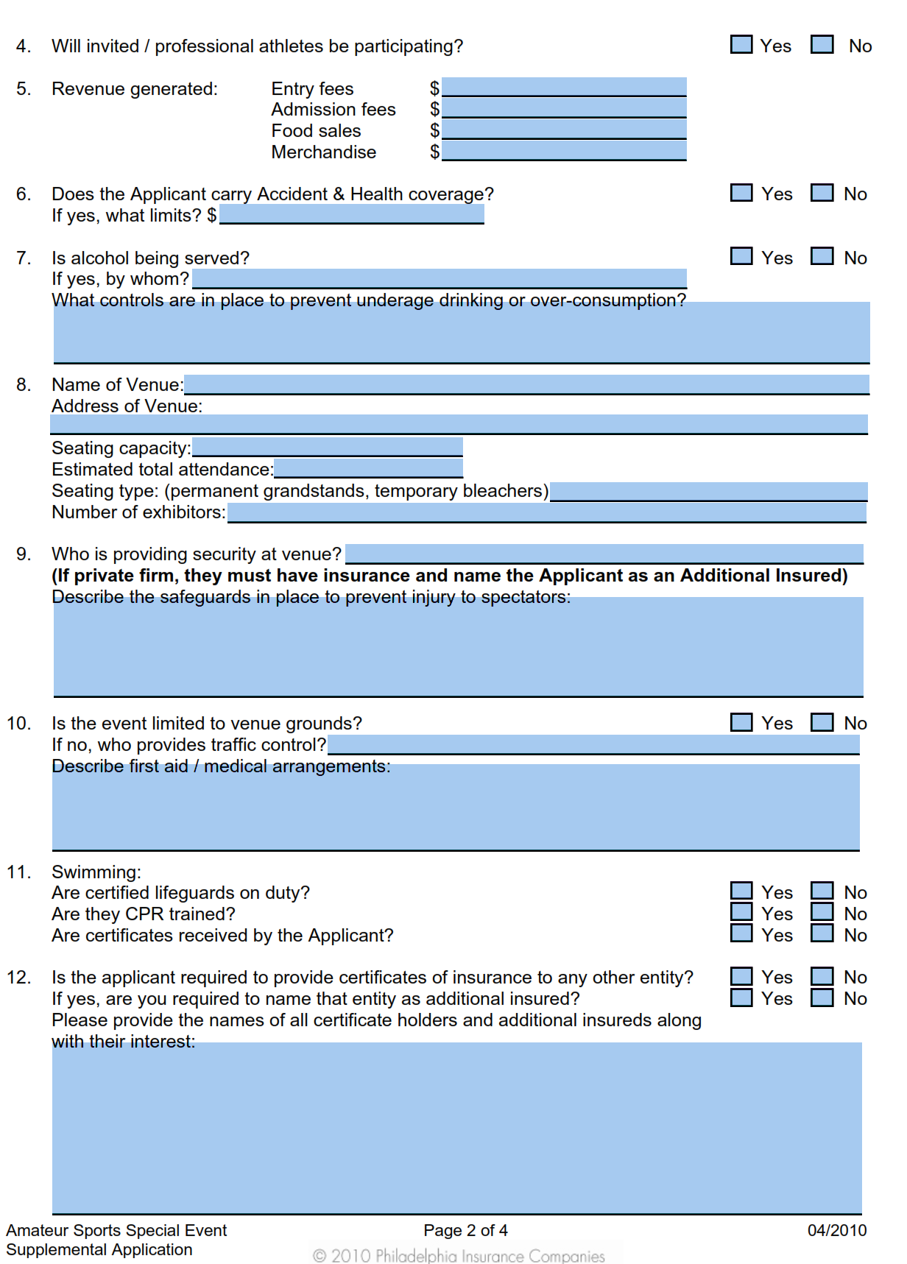

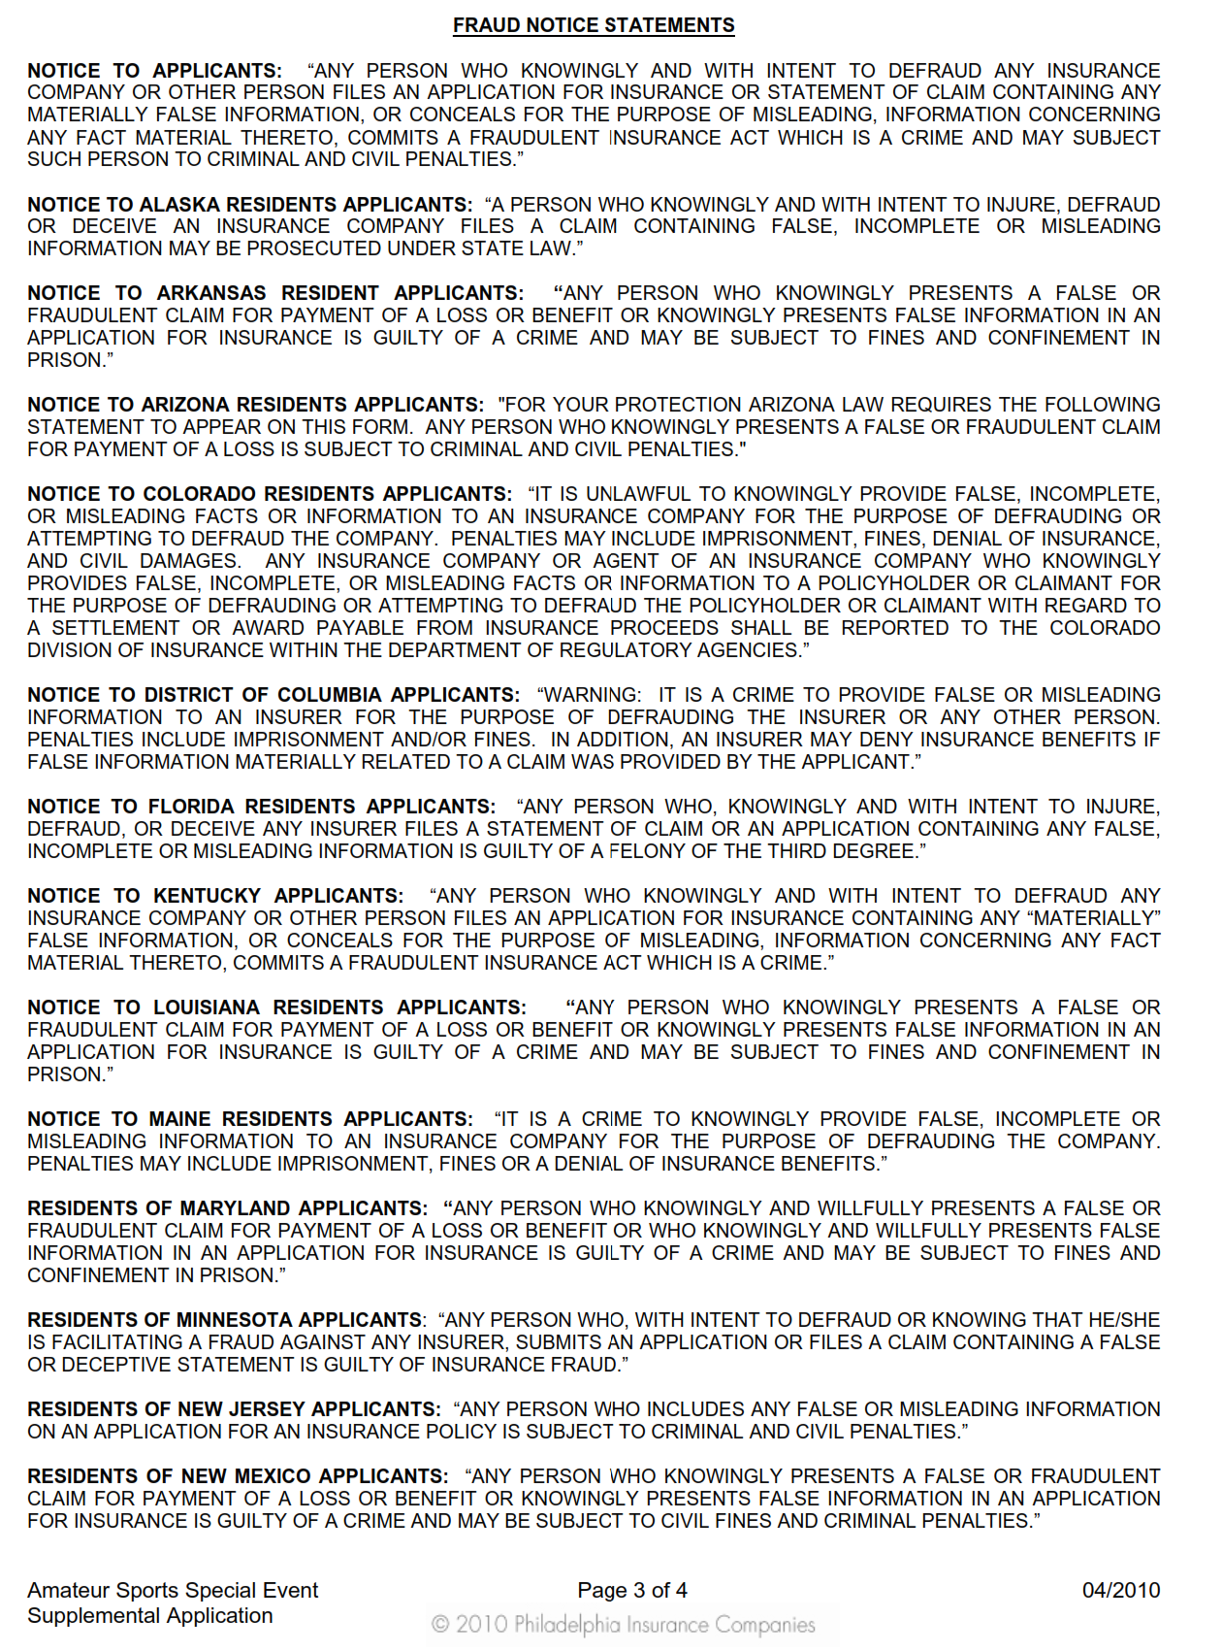

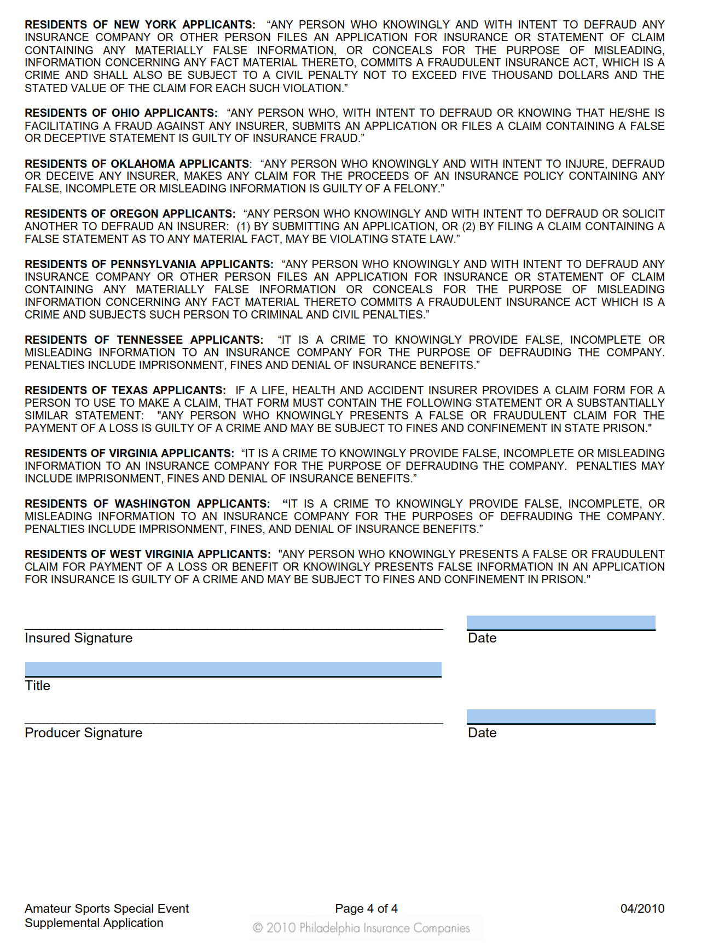

Attachment-3 General Waiver-ASHRAE

Attachment-4 Countersigned Contract & Initial Deposit_192

