ASHRAE OE GOLF COMMITTEE MEETING MINUTES
  - Golf Tournament 2024: Tustin Ranch Country Club, October 3, 2024.

September 13, 2024; Teams Meeting 12:00 PM
Event Reference | Continuing Business Description | Action Items (AI) / [STATUS]
Ref: 050824 – 1st meeting agenda | Subject:  - The tournament will be held 10/3/24 at Tustin Ranch CC.  - Chris is the new Tournament director (in training) supporting Jeff closely for 2024, taking reins for 2025.  - The ASHRAE OE Golf committee consists of the following members:  - Jeff H.: Current Director; Beverage Liaison.  - Jeff C.: BOG contact; men’s apparel design  - Jessica: Women’s apparel design.  - Emily: Women’s apparel design  - Anthony: Chapter President contact.  - Chris: New Golf Director for 2024.  - James Mansfield – not attending but interested.  - 3 planning meetings planned during the summer; JH is concerned about democratic decision making; Chris will need to make a lot of decisions on his own.  - Target revenue generation is $30k net to Chapter.  - Sponsors will not be required to buy all raffle prizes – even though this was a vast improvement in cash flow from the past. See reference below for Dinner Only raffle donation. | Historical Information only
Ref: 080124 | Update on progress of above action items:  - Decision made on liqueur format: Same as last year – sponsors will have control over serving and supply.  - The decision is made on sponsor pricing for event flyer is final.  - Decision made on dinner only guests; donation of raffle prizes of $75 or greater. The committee members are empowered to find additional raffle donations through business connections.  - JH has submitted a supplemental insurance application to cover him for liquor service. The broker is on vacation but should return the quotation shortly. [I am concerned how we will manage this process next year if JH is not available].  - Decisions made on apparel: Women’s dress selected; JH will select men’s polo from William Murray as well and solicit a quote.  - The Event flyer will be published and distributed on 8/1/24.  - Next meeting will be on 8/8 to discuss progress and current issues. | Information only
Ref: 080924 | Updates on action items above:  - 052224-Liquor Service.  - 050824-Womens Apparel. Travis Mathew selection in striped polo dress. Ordering samples for Emily and Jessica, Carmen Davis. So, they can model for the event. No embroidery. JH will order today.  - 052224-Mens Apparel; Spackler’s Shed polo is picked with embroidered sleeve logo for ASHRAE OE. JH will order Monday; last year’s numbers 160-170 units. XXL and XXXL were short last year.  - 073024-Supplemental Insurance. JH is filling out supplemental waiver with application (for liquor licensing). Going out today. Next year – need to change venue to avoid licensing (Old Ranch CC in Seal Beach). TR is managed by Troon Golf which is mandating the insurance requirement. | Information only
Ref: 080924 - Financial | Finances: Discussion on liquidity from Chapter perspective.  - $31,416 was last year’s payment to TR; need to get ready to pay in October.  - Ordering apparel on Monday; about $8000.  - Constant contact – PayPal fees are getting expensive. We need to consider the future.  - No refunds for no show within 30 days of the event.  - Rheem is not going to be a sponsor this year; opens up opportunities for others. Team to try and up sale companies into sponsorship. JH  - Raffles – JH needs prizes; only 3 prizes come from LG. JH is still getting more. The Team needs to be plugging contacts for more prizes and coordinate with JH.  - JH is still working on sponsors. The Team can help as well. | Information only
Ref: 082824 –Discussion | - Review Action Items:  - Jeff sent out insurance application; should hear back next week.  - Old sponsors: Victaulic not yet responding (ruled out at this point). 4-foursomes missing.  - JH needs to order sponsor golf balls this week, the deadline for platinum sponsors to get their logo in. Send notice to Jackson to send flyer indicating platinum sold out?  - Signage: Need to get ordered; contact in SF Valley is dependable and quick.  - Raffle Flyer: Jackson to update the 2021 raffle flyer (forwarded by CM) and send out for distribution. The Team will continue to solicit contacts for raffle.  - Progress: 2 platinum, 6 gold, 8 silver. Total of 28 foursomes: Still a little short. 2 or three individuals are interested (no less than $400).  - Potential: US Air, Fergusons, Trane, Graves Golf. DB Sales.  - New Sponsors / raffles: Reliable Controls (Casey Crown). Air Control Systems, NEBB. Reaching out to DMG. No response from ACCO. Trane not responding.
Ref: 090424 –Discussion | - Old Ranch Update: 144 golfers maximum, Mondays only for tourneys. Still waiting to receive pricing information and availability for September-November 2025. Followed up on 09/04/24.  - CM is working on a listing of courses in Orange Co.  - Flyer for raffle prizes (original) cannot be located. Design a new flyer? Sibley or Sybesma may have developed this flyer – CM will follow up.  - Current enrollment: 31 foursomes (124), estimated shortfall is 36-40 based on some sponsors wavering or not responsive. There may be some other sponsors that initially committed but are backing out.  - Here are previous sponsors that are wavering, or just non-responsive this year.  - Trane (Typically has 2-foursomes in recent years)  - DB Sales (Sponsored when James and Amir were there (now Austin), but now Enervex sponsors)  - DMG/Toro (Gold for as long as I remember, and now not thinking about sponsoring this year)  - Victaulic (Platinum for the past couple of years, and Gold for years prior. Not responsive)  - Murray tournament is on Monday prior which is causing some sponsors to withdraw support this year.  - Golf ball order: Emily has CC for authorization; JH will send invoice so order can be placed this week.  - Golf cannon – confirmed.  - Shirt delivery scheduled for 9/5.  - All members need to be soliciting raffle prizes and sponsors. CM to work with Jackson to put a distribution flyer together.  - Audit update: Pending final signatures. We need to keep good accounting maintenance this year to correctly code deposits and expenses.
Ref: 091324 –Discussion | - Raffle flyer update: who has original template?  - The Special Event liability coverage quote has been received by JH and directions to pay Philadelphia Insurance ($356) and Sterling Seacrest Pritchard ($100) have been issued.  - CM is still working on 2025 event options.  - Update on sponsors and raffle:  - Meeting was rescheduled as JH was not able to attend. | CM to develop list of potential event sites for 2025.

New/Future Busine. and Meeting Information
Description:
- The next scheduled Meeting is planned for: 09/16/24; noon.

Text Legend: Bold black text is for the latest information / Assignments / Status
Orange text indicates Agenda publishing.
Blue text indicates Minutes publishing.
AI reference code: 102222 = October 22, 2022 [typical].
Incomplete or in-progress AI are highlighted.

Distribution List: *Invited
Chris Mellen [CM]* | Cinthya Carrillo [CC]*
Jeffrey Hanzel [JH]* | Chris Farrington [CF]*
Anthony Zanotti [AH]* | Ryan Sibley [RS]*
Jessica Clark [JC]* | Eric Decker [ED]*
Yang, Emily [EY]* | Brian Sybesma [BS]*
Jeff Conrad [JC]* | James Mansfield [JM]*
David Lawson [DL]* | Chris Farrington [CF]*
John Sawyer [JS]*

List of Attachments
Attachment 1 - snapshot of current budget
Attachment 2 - Sponsor snapshot
Attachment 3 - Last Years Raffle Prizes
Attachment 4 - 2023 Sponsors
Attachment 5 – Old Ranch

Attachment 1 - snapshot of current budget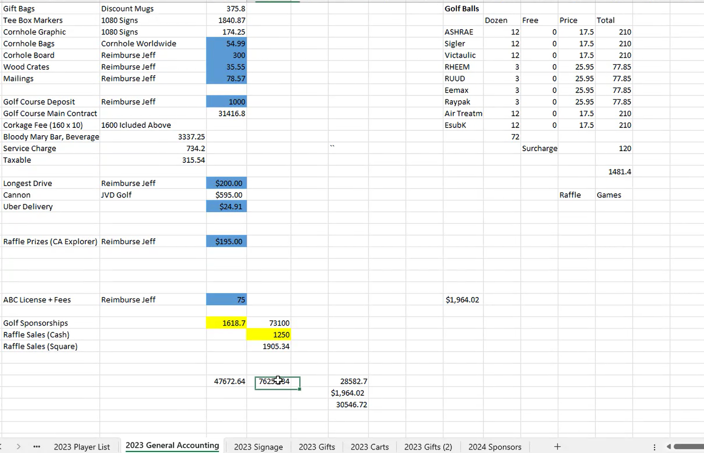

Attachment 2 - Sponsor snapshot
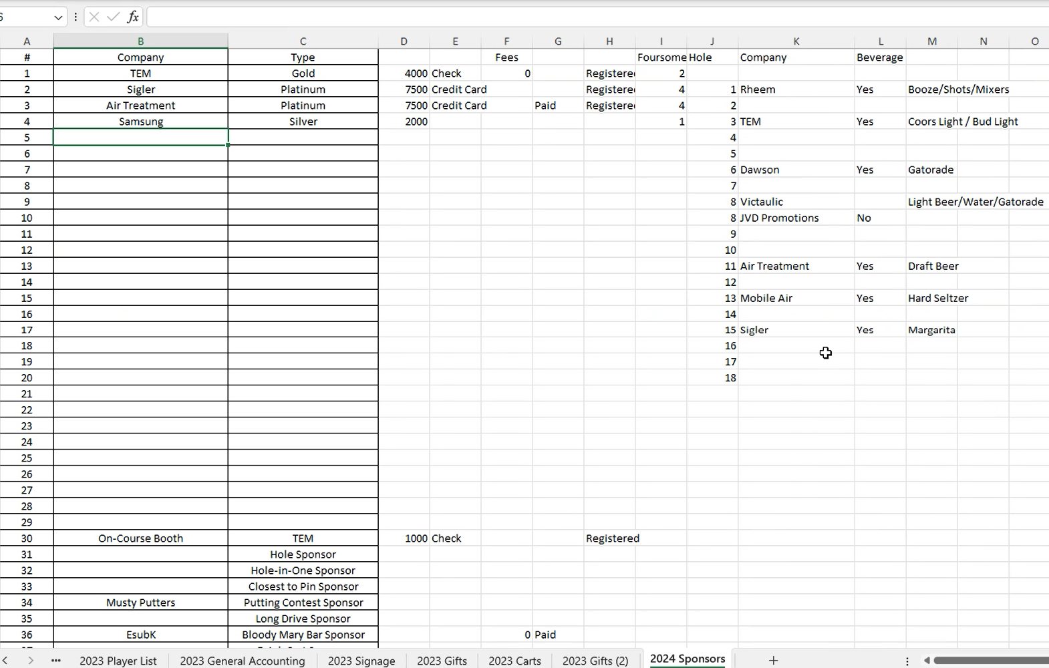

Attachment 3 - Last Years Raffle Prizes

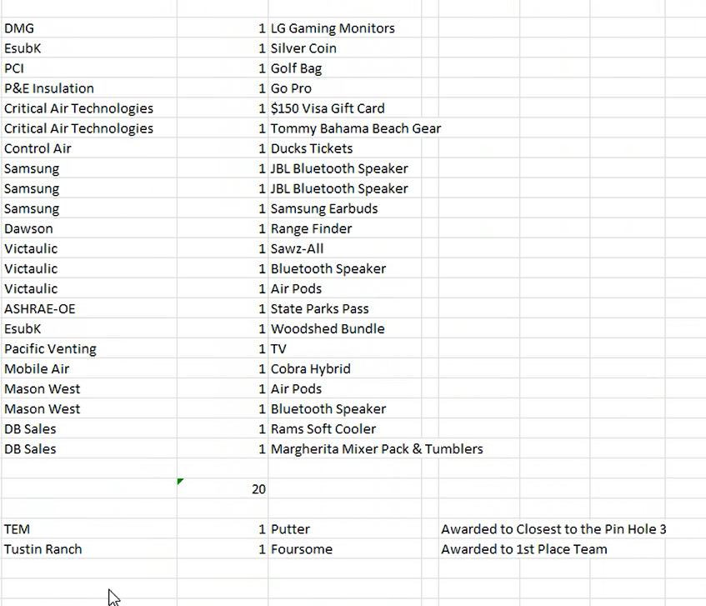

Attachment 4 - 2023 Sponsors

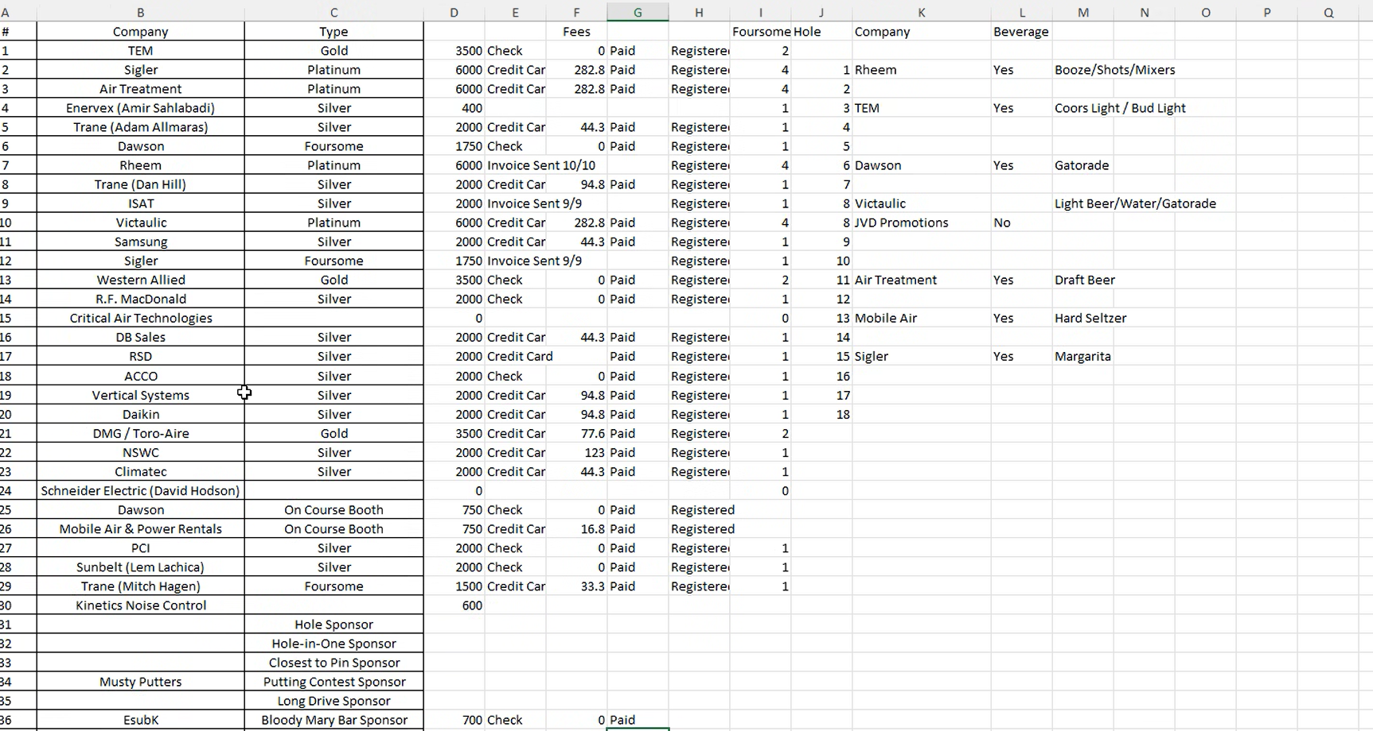

Attachment 5 – Old Ranch

