ASHRAE OE GOLF COMMITTEE MEETING MINUTES
  - Golf Tournament 2024: Tustin Ranch Country Club, October 3, 2024.

September 4, 2024; Teams Meeting 12:00 PM
Event Reference | Continuing Business Description | Action Items (AI) / [STATUS]
Ref: 050824 – 1st meeting agenda | Subject:  - The tournament will be held 10/3/24 at Tustin Ranch CC.  - Chris is the new Tournament director (in training) supporting Jeff closely for 2024, taking reins for 2025.  - The ASHRAE OE Golf committee consists of the following members:  - Jeff H.: Current Director; Beverage Liaison.  - Jeff C.: BOG contact; men’s apparel design  - Jessica: Women’s apparel design.  - Emily: Women’s apparel design  - Anthony: Chapter President contact.  - Chris: New Golf Director for 2024.  - James Mansfield – not attending but interested.  - 3 planning meetings planned during the summer; JH is concerned about democratic decision making; Chris will need to make a lot of decisions on his own.  - Target revenue generation is $30k net to Chapter.  - Sponsors will not be required to buy all raffle prizes – even though this was a vast improvement in cash flow from the past. See reference below for Dinner Only raffle donation. | Historical Information only
Ref: 052224-Liquor Service | Subject: Revised liquor serving plan for Sponsors  - Push back from some sponsors on price increase plus less service is problematic.  - Jeff is reaching out for insurance application to retain the service as what was provided in the past.  - Next week JH has to pull license / permit day use from Santa Ana (CA ABC).  History:  - JC – we should have a liaison the effort with holes sponsors. JH will be liaison.  - 160 golfers for 2 beverage carts is an issue. 4 carts would be better. | JH will send out special events’ supplemental insurance application [IN PROGRESS]
Ref: 050824-Womens Apparel (WA) | Subject: Women’s clothing.  - Would prefer Travis Mathews; EY & JC will review and make selections and send to JH. JH to send link. White dress is best choice. Order about 6 on pre-order.  - JH to check with Travis Mathews and get pricing.  - Send update to mailing list pics of apparel to be provided at a later date. | 050824 WA - EY & JC. [In Progress]
Ref: 052224-Mens Apparel (MA) | Subject: Men’s clothing.  - JH to check with Travis Mathews and get pricing.  - JH to make final selection on style; input from others is encouraged but needs to be very soon to support selection deadlines.  - 165 men’s shirts are normal order.  - We will send out an update to the event mailing list with pics of apparel to be provided at a later date. Hopefully in the next couple of weeks.  - JH and JC to start reviewing online catalog at WillamMurray.com and provide suggestion to JH. | 052224 MA - JH. & JC. [In Progress]
Ref: 073024-Supplemental Insurance | Subject: ref: Hanzel email 7/20/2024.  - Sponsor pricing and recruitment is a PRIORITY at this point.  - Once platinum sponsors are secured, JH will order logo golf balls.  - JH is applying for supplemental insurance. This to cover the Chapter and Individual to allow us to keep the same format as previous years. JH received significant pushback from Platinum Sponsors to pay the increased cost whilst taking away this benefit.  - Related to Ref: 052224-Liquor Service. | JH has sent an application for supplemental insurance; the broker is on vacation as of 8/1. JH will report the cost of insurance to the Team when received. [In Progress]
Ref: 080124 | Update on progress of above action items:  - Decision made on liqueur format: Same as last year – sponsors will have control over serving and supply.  - The decision is made on sponsor pricing for event flyer is final.  - Decision made on dinner only guests; donation of raffle prizes of $75 or greater. The committee members are empowered to find additional raffle donations through business connections.  - JH has submitted a supplemental insurance application to cover him for liquor service. The broker is on vacation but should return the quotation shortly. [I am concerned how we will manage this process next year if JH is not available].  - Decisions made on apparel: Women’s dress selected; JH will select men’s polo from William Murray as well and solicit a quote.  - The Event flyer will be published and distributed on 8/1/24.  - Next meeting will be on 8/8 to discuss progress and current issues. | Information only
Ref: 080924 | Updates on action items above:  - 052224-Liquor Service.  - 050824-Womens Apparel. Travis Mathew selection in striped polo dress. Ordering samples for Emily and Jessica, Carmen Davis. So, they can model for the event. No embroidery. JH will order today.  - 052224-Mens Apparel; Spackler’s Shed polo is picked with embroidered sleeve logo for ASHRAE OE. JH will order Monday; last year’s numbers 160-170 units. XXL and XXXL were short last year.  - 073024-Supplemental Insurance. JH is filling out supplemental waiver with application (for liquor licensing). Going out today. Next year – need to change venue to avoid licensing (Old Ranch CC in Seal Beach). TR is managed by Troon Golf which is mandating the insurance requirement. | Information only
Ref: 080924 - Financial | Finances: Discussion on liquidity from Chapter perspective.  - $31,416 was last year’s payment to TR; need to get ready to pay in October.  - Ordering apparel on Monday; about $8000.  - Constant contact – PayPal fees are getting expensive. We need to consider the future.  - No refunds for no show within 30 days of event.  - Rheem is not going to be a sponsor this year; opens up opportunities for others. Team to try and up sale companies into sponsorship. JH  - Raffles – JH needs prizes; only 3 prizes come from LG. JH is still getting more. The Team needs to be plugging contacts for more prizes and coordinate with JH.  - JH is still working on sponsors. The Team can help as well. | Information only
Ref: 080924 – Future Tourney | Jeff C will talk to Christine Alvarado at Turner to get contact information for Old Ranch so CM can follow up. Update 082824 – CM sent a request for tour and potential date of event for October 02, 2025. | JC to follow up.
Ref: 082824 –Discussion | - Review Action Items:  - Jeff sent out insurance application; should hear back next week.  - Old sponsors: Victaulic not yet responding (ruled out at this point). 4-foursomes missing.  - JH needs to order sponsor golf balls this week, the deadline for platinum sponsors to get their logo in. Send notice to Jackson to send flyer indicating platinum sold out?  - Signage: Need to get ordered; contact in SF Valley is dependable and quick.  - Raffle Flyer: Jackson to update the 2021 raffle flyer (forwarded by CM) and send out for distribution. The Team will continue to solicit contacts for raffle.  - Progress: 2 platinum, 6 gold, 8 silver. Total of 28 foursomes: Still a little short. 2 or three individuals are interested (no less than $400).  - Potential: US Air, Fergusons, Trane, Graves Golf. DB Sales.  - New Sponsors / raffles: Reliable Controls (Casey Crown). Air Control Systems, NEBB. Reaching out to DMG. No response from ACCO. Trane not responding.
Ref: 090424 –Discussion | - Old Ranch Update: 144 golfers maximum, Mondays only for tourneys. Still waiting to receive pricing information and availability for September-November 2025. Followed up on 09/04/24.  - CM is working on a listing of courses in Orange Co.  - Flyer for raffle prizes (original) cannot be located. Design a new flyer? Sibley or Sybesma may have developed this flyer – CM will follow up.  - Current enrollment: 31 foursomes (124), estimated shortfall is 36-40 based on some sponsors wavering or not responsive. There may be some other sponsors that initially committed but are backing out.  - Here are previous sponsors that are wavering, or just non-responsive this year.  - Trane (Typically has 2-foursomes in recent years)  - DB Sales (Sponsored when James and Amir were there (now Austin), but now Enervex sponsors)  - DMG/Toro (Gold for as long as I remember, and now not thinking about sponsoring this year)  - Victualic (Platinum for the past couple years, and Gold for years prior. Not responsive)  - Murray tournament is on Monday prior which is causing some sponsors to withdraw support this year.  - Golf ball order: Emily has CC for authorization; JH will send invoice so order can be placed this week.  - Golf cannon – confirmed.  - Shirt delivery scheduled for 9/5.  - All members need to be soliciting raffle prizes and sponsors. CM to work with Jackson to put a distribution flyer together.  - Audit update: Pending final signatures. We need to keep good accounting maintenance this year to correctly code deposits and expenses.

New/Future Busine. and Meeting Information
Description:
- The next scheduled Meeting is planned for: 09/04/24 Wednesday noon.

Text Legend: Bold black text is for the latest information / Assignments / Status
Orange text indicates Agenda publishing.
Blue text indicates Minutes publishing.
AI reference code: 102222 = October 22, 2022 [typical].
Incomplete or in-progress AI are highlighted.

Distribution List: *Attending
Chris Mellen [CM]* | Cinthya Carrillo [CC]
Jeffrey Hanzel [JH]* | Chris Farrington [CF]
Anthony Zanotti [AH]* | Ryan Sibley [RS]
Jessica Clark [JC]* | Eric Decker [ED]
Yang, Emily [EY]* | Brian Sybesma [BS]
Jeff Conrad [JC]* | James Mansfield [JM]
David Lawson [DL] | Chris Farrington [CF]
John Sawyer [JS]

List of Attachments
Attachment 1 - snapshot of current budget
Attachment 2 - Sponsor snapshot
Attachment 3 - Last Years Raffle Prizes
Attachment 4 - 2023 Sponsors

Attachment 1 - snapshot of current budget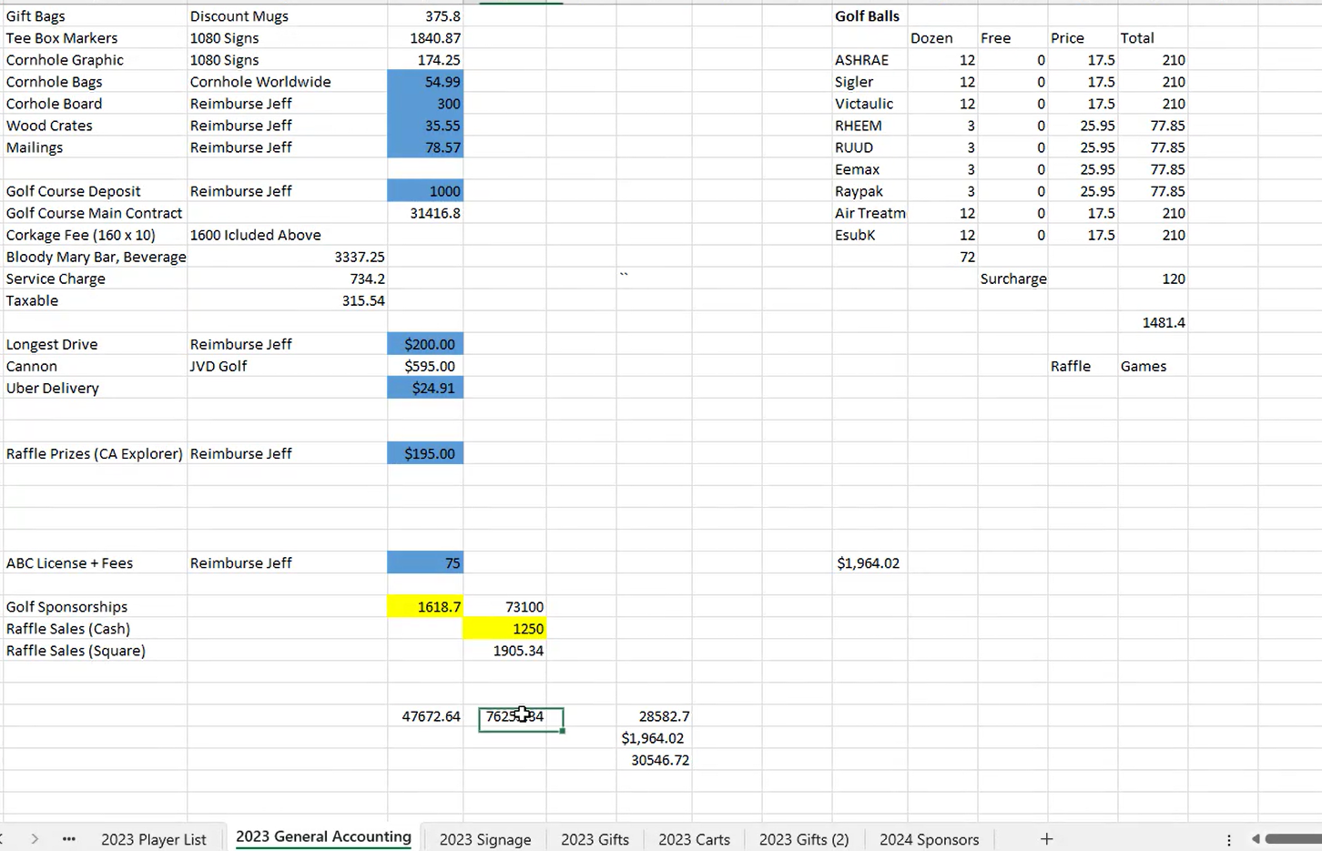

Attachment 2 - Sponsor snapshot
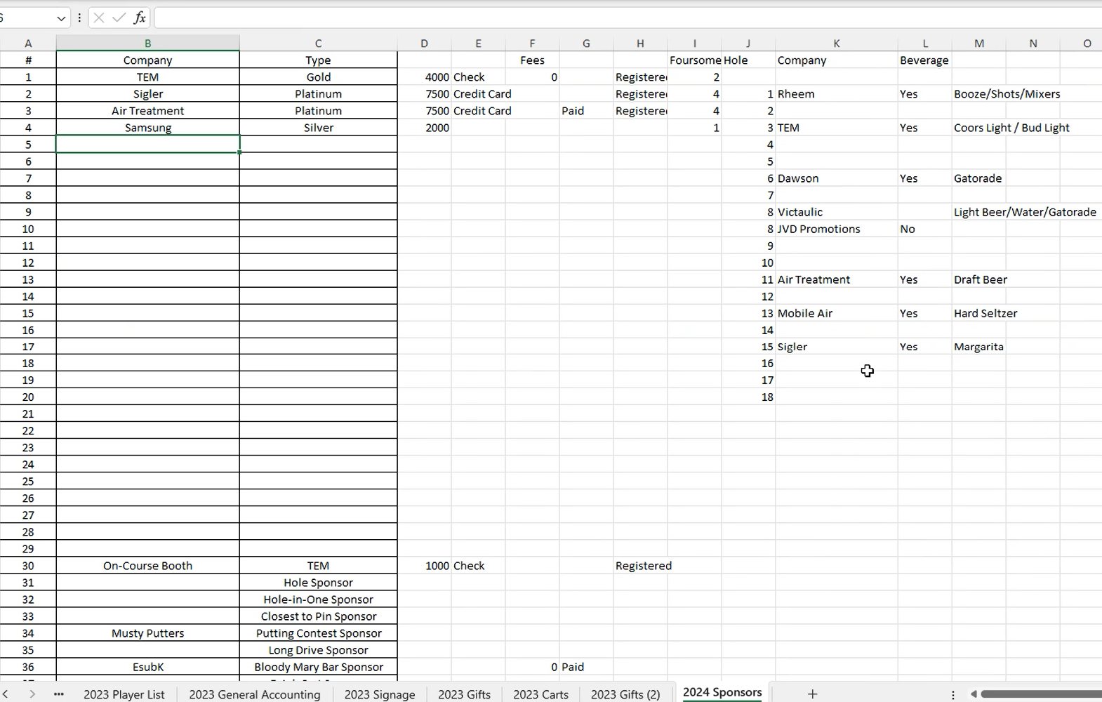

Attachment 3 - Last Years Raffle Prizes

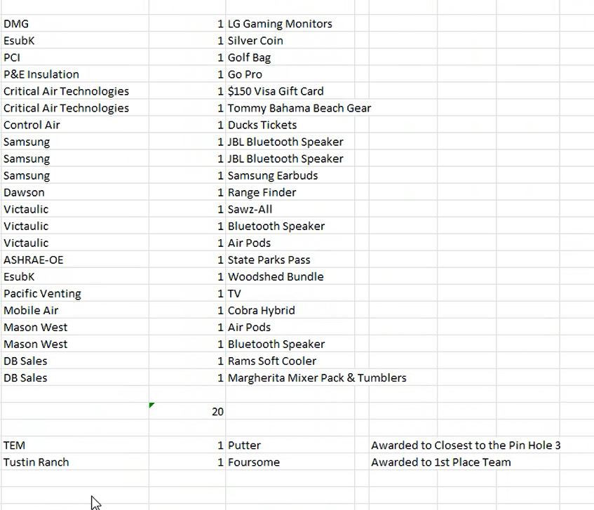

Attachment 4 - 2023 Sponsors

