**Best Practices for the Central Discovery Index (CDI)**

**Move Report:**

* Located under Resources->Advanced Tools, PC to CDI Activation Report:

A screenshot of a social media post

Description generated with very high confidence

* Will show all of your PCI activations and what they mapped to in Alma for searching
* NA packages: these are packages that didn’t have an Alma equivalent at the time of the move. They are mostly OA content, and will be automatically added at each campus as the collections are created in Alma. [Here are the collections](https://public.3.basecamp.com/p/YLyLfbjToB7ddeUA4vf7AFNB) for each PC_ID.
* Any collection in your Alma institution that has a creation date or a modification date of 11/17/2019 is a collection that was created/updated by the PC to CDI move process.
* **To-Dos:**
  + Go through your Move Report list and check each entry to make sure that it mapped correctly
  + You may see that the IZ collection that you already had active is not the version that Ex Libris activated for search in the CDI. For example, Albany had a SciELO selective package activated for full-text in Alma, but the SciELO database is what was activated for CDI search. Ex Libris is investigating this issue.
  + Do a wildcard Institution Zone e-resource collection search for * in collection name to see all of the content that you have active for full-text and for CDI searching at your campus.
  + Clean up any OA content that you don’t want available for your patrons to search in Primo VE. This content was automatically activated for you by Ex Libris in your PCI. You will need the CDI Operator Role to use the “deactivate for CDI Search” option from the collection search results list collection entry.

**Alternative Coverage for EBSCO databases:**

* There are no EBSCO index records in the PCI or in the CDI.
* You will no longer have to activate alternative coverage indexes for EBSCO content yourself. Ex Libris will automatically activate the appropriate indexes when you activate a new EBSCO collection for full-text and for CDI searching: “customers do not have to check for alternative coverage collections because the appropriate activations are done by default. This process is very similar to how activations work for Summon with the 360 client center.”
* It won’t hurt anything to say yes to search in CDI for EBSCO collections. From Ex Libris: “Turning on CDI searching for EBSCO packages is not harmful but will have any impact on records being included in the search results. We recommend to not have a different work flow for these collections, since they are only a small subset of the ‘In CDI’ collections and activation for search is not harmful at all.”
* Do not deactivate any alternative coverage packages that you had activated in the PCI. You will still need them to search EBSCO content. From Ex Libris: “The alternative coverage collections provide in addition search for items that you do not have full text for.  It is of course your decision but I would recommend to activate as many collections as possible to provide your users options to find things beyond what you have as full text.”

**Network Activations:**

* If you had chosen to inherit Network Activations in the PCI (Gale dbs, Medline, etc.), these activations will be automatically turned on for your campus for searching, but it won’t be as obvious that they are active.
* You can see that the database has been made active for search if you look for it in the Network Zone:

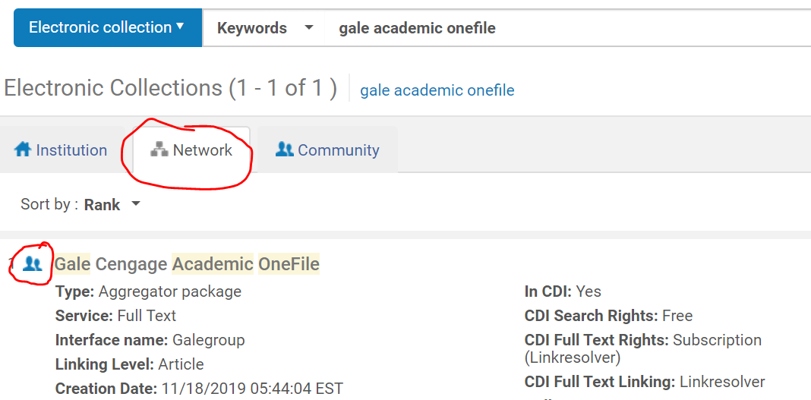

* You should see “Active for Search in CDI” on this record, but it’s not currently displaying. Ex Libris is working on fixing this problem.
* CDI Inheritance flag: this will now be stored in Configuration->Institution->Resources->General->Other Settings as [insert flag name here] but it’s currently missing and Ex Libris hopes to add it in the next Alma release. This is where you will say yes or no to inherit Network CDI activations.

**Alma Collection Search:**

* New collection search options and filters:

A screenshot of a map

Description generated with high confidence

* If you are missing the “not active for search” filter, notify Ex Libris via Salesforce and they will make sure that it’s added for you.
* Advanced searches:

A screenshot of a cell phone

Description generated with very high confidence

**Alma Collection Activation and Management:**

* Any new e-resource collection activation will automatically turn on searching for that collection in Primo VE:

A screenshot of a social media post

Description generated with very high confidence

* It takes 48 hours for any search activation changes to take effect
* If you want to wait to activate a collection for search, or temporarily turn it off, you will need the CDI Operator Role.
* To change CDI Search options, look up your collection in Alma and either choose “Deactivate for search in CDI” on the collection entry in the results list, or edit the collection and make your changes on the new CDI tab:

A screenshot of a cell phone

Description generated with very high confidence

**Searching in Primo VE:**

* Availability in brief results is not yet accurate. You may find citations for which you have full-text coming up and not available and vice versa. Ex Libris is investigating.
* Facets: Merged record may affect database source facet
* “Link in Record” collections: PCI collections that were “link in record,” are those where activation in the PCI was enough to tell Primo VE that you held the item and provide the link to that item. Alma collection activation was not necessary to provide patrons with the full-text link. These are not working correctly in the CDI. Examples are Naxos Music Library and Proquest Dissertations. Ex Libris is investigating.