

Think and Go Higher
Session 6 Go Visit!







Technology Research Challenge
Team Name:

Technology Debate
The Brief

You need to convince the local council to award your campaign a pot of money to support your side of the argument around children using technology.
Using the skills you have learned in the sessions so far, you will present your argument either for or against technology to a group of judges.

- To do this you must create the most convincing argument which is justified using the appropriate sources.
- You will present your argument to our local council representatives and they will make their decision based on who delivers the strongest argument.
- This booklet contains sources that can support your side of the debate.
- Your argument should not be scripted but you can use notes to support your structure.
- You do not have long so teamwork is crucial!
Use a lotus blossom to start generating ideas for your side of the argument


Technology
(Good or Bad?)

Structuring Your Argument
Use PEEL to help structure the arguments you are going to make for your side of the debate.
Structure | Explanation | Example
Point | State your own point | I disagree that apples are better than oranges as I actually think oranges provide more health benefits than apples.
Evidence | Give evidence to support your point | Scientists have shown that oranges contain lots of vitamin C which is important for our bodies
Explain | Explain how this evidence supports your point | Apples however, contain much less vitamin C than oranges, therefore they are less beneficial to our health.
Link | Link this back to your initial point (or the next point) | This shows that eating oranges will be better for our health overall, due to their high vitamin C content.

C.R.A.P Table
Source | Currency | Relevant | Accurate | Purpose
Critical Questions
Descriptive | Analytical | Evaluative
Asks for basic facts and information about the source/topic/event.  - Who said it?  - What did they say?  - Where did they say it?  - When was it written?  - What is the aim of the article?  - What is this problem about?  - Who does it involve or affect?  - When and where is this happening? | Asks for further detail, using logic and reasoning to understand more about the source/topic/event.  - Why did they say it?  - How was the research conducted?  - Why are these theories discussed?  - What are the alternative methods and theories?  - What are the contributing factors to the problem?  - How might one factor impact another?  - What if one factor is removed or altered? | Asks what the impact of the source/topic/event is or how it compares to something else.  - What do I think about this?  - How is this relevant to my assignment?  - How does this compare to other research I have read?  - What's next?  - What is the impact this will have? What are the next steps this research should take?  - Why is this research worth investing our time, effort, and potentially money in?

Asking Critical (Interrogating) Questions
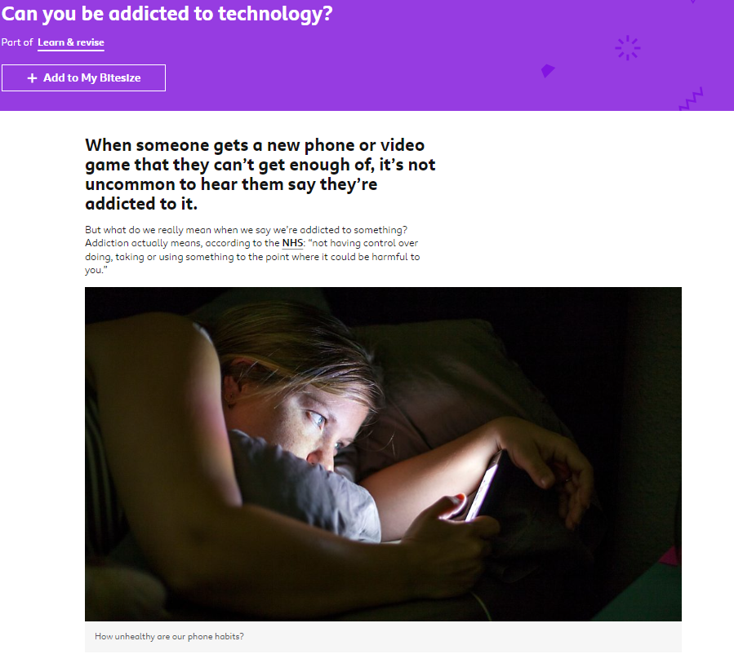
The symptoms of addictions to things such as drugs and alcohol are well documented, and are known to tear people’s lives apart. Are computers and phones in the same bracket? Is it really appropriate to use the word addiction when talking about tech?
Dr Andrew Przybylski, Director of Research at the Oxford Internet Institute argues that being addicted to something like alcohol involves negative behaviours as a result of chemicals affecting our brain. What he thinks we really mean when we say we’re addicted to tech is that it’s engaging, and we want to keep using it.
However, some psychologists argue that addiction is exactly the right word for technology that keeps a minority of people dangerously hooked.

Disorder or addiction?
Internet Gaming Disorder (IAD) is now included in the World Health Organisation’s International Classification of Diseases.
Whilst not explicitly describing it as an addiction, this means that experts acknowledge there is the potential that people can play video games to such an extent that it will negatively impact their life, and the lives of those around them.
However, there’s still a lot of debate between psychologists about whether IAD should be classified as a disorder. The American Psychiatric Association for example haven’t said it as a unique disorder in the latest Diagnostic and Statistical Manual of Mental Disorders (DSM-5), which is the other big manual of disorders used by psychologists. It was however recommended for further research.
Disorders and addictions are different. The definition of addiction is debated among psychologists, but it’s normally described as a state of dependency to something that negatively impacts our lives, with clear causes. Disorders, on the other hand, have clear symptoms, but what’s causing them isn’t as clear-cut as with addictions. So, for example, you may be as compulsive as an addict, but until more research is done into why you’re acting the way you are, experts would be wary to label it as an addiction.
However, many countries are investing in medical treatment for disorders relating to tech. Now that gaming disorder is officially classified by the WHO, the NHS has started developing a gaming treatment centre in London. China, South Korea and Japan have established treatment programmes to tackle over-excessive use of the internet. Newsround on CBBC recently went to an ‘internet addiction camp’ in South Korea, and one girl explained how she would spend 18 hours on YouTube every single day.
Professor Phil Reed, a Psychology lecturer at Swansea university who researches internet addiction, says it “doesn’t really matter in some ways” whether its a disorder or an addiction, “it’s disrupting your life and it’s terrible.”
“You can see a really complete and total disruption of a person’s life, their ability to function, their ability to form relationships, hold down jobs, the whole spectrum of their life falls apart because they’re spending too much time gaming.”

Brains hooked on technology
Prof Reed believes there are three distinct ways that tech addiction mirrors substance abuse:
- disruption - it negatively impacts your day-to-day
- withdrawal - you suffer when you’re not using it
- tolerance - you need more and more of it to get the same effect
With alcohol and drugs, things like the withdrawal effect links to chemicals that are being consumed. Nicotine for example is extremely addictive because it alters the balance of dopamine and noradrenaline in the brain, which affects mood and concentration.
Whilst a substance does this directly to your brain, Prof Reed says that using technology can also trigger the release and suppression of chemicals in the brain. This then in turn can become addictive: “So although [technologies] don’t have chemicals of their own, they’re piggybacking on the effect it has on our own neurotransmitters.”

Prof Reed says that when you’re hooked on technology, there’s a “huge range” of brain chemicals that are impacted, including:
- Dopamine - a brain chemical released when something happens that you enjoy. It can increase in response to stimuli like music, food or love. Having a bit of what you like can give you a “dopamine hit” - and technology can do this for you if you enjoy a game, interacting on social media, or watching your favourite series. Dr Reed says: “If you’re hungry and you see a cream cake pass by you, your dopamine fires off, because something good is coming and you want it.” But if you’re hooked on the dopamine hit provided by cream cakes - or your favourite app - it’s difficult to say no to one more. “If that cream cake passes by you and you’ve already eaten ten of them, it won’t fire, because although you know it’s good, you don’t want it anymore.”
- Serotonin - this is a mood regulator. Low levels of serotonin have been linked to depression, so without it you can feel pretty low, and if your tolerance levels to technology are high, it might be harder or take longer to feel good when using it.
- Cortisol - this is a stress hormone linked with the ‘flight or flight’ effect in our body. It makes you aware of stressful situations and gives you a nudge to attempt to exit it. This is usually helpful, but it’s also released when we stop using tech that makes us happy, so it makes us twitchy and anxious in withdrawal.
When we’re hooked on something, whether that’s a substance or technology, there is more going on than just the chemical effects. “We’ve got to remember that alcohol and drugs and smoking are not only used for the direct chemical effect that the substance has,” says Prof Reed. “They’re often used to overcome or escape from other problems that that individual might have in their life.”

Coming back for more
Dr Ceri Bradshaw, who researches screen addictions and, like Prof Reed, works in the psychology department at Swansea, says popular games and social media are built deliberately to keep reeling people back in, and that the companies creating them have their own reasons for doing so:
“They are extremely motivated to make sure that the games are as compelling as possible and in order to do that they implement many tricks and tactics… to make them as reinforcing as possible.”
She gave examples such as: “auditory and visual rewards for winning moves, incremental rewards that increase as you go on that reinforce correct behaviour, obviously the visual appearance of them, the movements and the colours and the attractive aesthetic properties of them.”
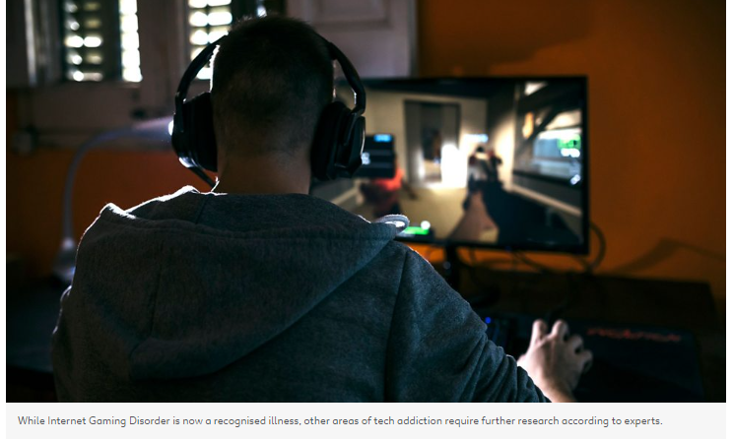
But it’s not just games that have built-in elements to keep us hooked.
Dr Bradshaw explained: “We know the reinforcers are very well worked out (with social media). They’re ingenious but they are also extremely basic. It is based on the amount of endorsement you get from other people.”
Another feature that is
employed on social media is the endless scroll. There was a time when, if you were browsing, you would actually reach the end of a page and have to click to the next one (we know, it’s hard to believe). This might then subconsciously feel like a nice cut off point for the user, and a good time to log off.
Now though, as you may have seen, you can keep scrolling almost infinitely. This is designed to make it harder to want to leave the platform.

Technology and the law
The effects of internet and technology over-use are wide ranging and in some cases, can drastically affect people’s lives. Because of this, some governments are attempting to legislate to mitigate the effects of it.
For example, the US government has brought in the Social Media Addiction Reduction Act (or SMART for short) which aims to “prohibit social media companies from using practices that exploit human psychology or brain physiology to substantially impede freedom of choice.” In other words, it means social media companies are in theory not allowed to purposefully devise methods for keeping people unhealthily hooked to their platforms.
The world is starting to become more aware of the dangers of tech addiction, and how it can be prevented or treated. According to Dr Bradshaw, the important thing is focusing on “harm reduction” - in other words, learning about the harmful effects of technology can help us to have a more healthy relationship with our favourite devices.
Sources
Use the following sources to support your side of the debate
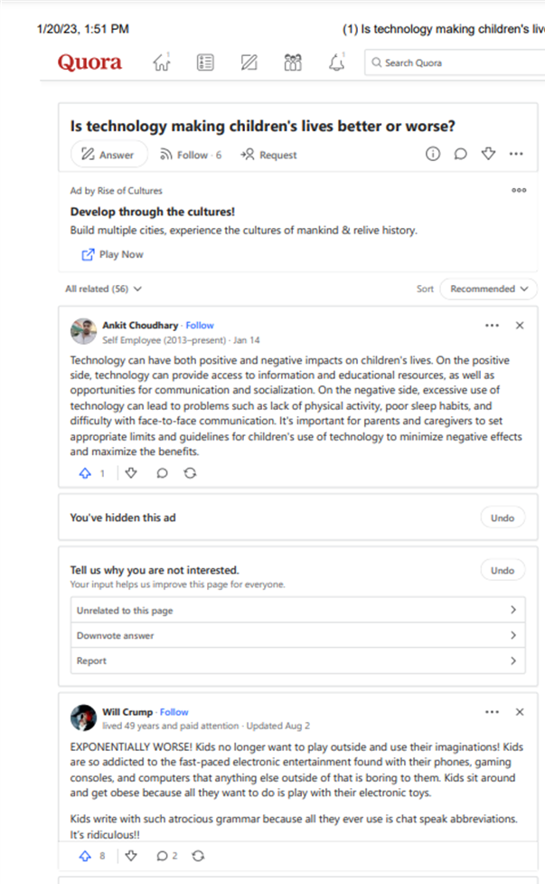
Source One- Quora ‘Is technology making children’s lives better or worse?’



Source Two- Classcraft, Casey Brown, ’12 pros and cons of technology in the classroom’
Technology is a hot topic these days in education. Some people are very supportive of integrating technology in classrooms, while others point out the negative effects that it may have on students. Parents and teachers may worry about the extra screen time, the lack of face-to-face interaction, and the distractions that the use of technology implies. Others embrace technology because they see the enthusiasm, motivation, personalized educational experiences, and collaborative opportunities that technology can provide.
Everything is good in moderation, and technology is no exception. Here are the pros and cons of technology use in the classroom.

7 pros of having technology in the classroom

1. A variety of resources
Technology provides lots of useful resources for students, parents, and teachers. For example, if a student needs help with math homework, a website such as Khan Academy provides sample problems and tutorials that can be helpful. YouTube also has many educational channels and videos that help bring learning to life. Google provides several virtual reality field trips for students and teachers through Expeditions. There are various websites such as Quizlet that allow students to review material. Students can even get personalized learning adventures on sites like Classcraft.
With modern classroom technology, there’s almost always a resource to help students with their coursework, whether at home or at school.
2. Efficiency
Technology makes learning more efficient. Nowadays, attendance, grades, and behaviour referrals are often made online and instantly shared between students and their teachers and parents. Parent-teacher communication is also much easier with email. If a student misses’ class, assignments are often already posted to a class website or on Google Classroom.
By leveraging technology to automate day-to-day tasks, teachers free up more time to work on creating course materials and giving students personalized instruction.

3. Preparation for life in the “real world”
We are living in a world that’s driven by technology in nearly every way imaginable. If students are to succeed beyond school, digital literacy and tech and systems fluency can give them a big boost. Practicing technology skills in school isn’t limited to creating digital presentations, drafting emails, and editing videos.
The valuable soft skills students gain. such as complex communication, collaboration, problem solving, and adaptability will prepare them for life in college. And since these skills are in high demand by employers, they will pay off well as students start their careers.

4. Up-to-date information
Technology allows teachers and students to have immediate access to up-to-date information. Where revisions to hard-copy materials take place over periods of months or even years, updates to online textbooks happen almost instantly.
Gone are the days of cutting out articles from a newspaper to discuss current issues in class — current events are now reported in many online formats and on many reputable news sites. And students and teachers can even collaborate back and forth in real time through email and apps like Slack.

5. Students have control
Students who want to learn more about a topic can research it online using Google or other search engines. A simple online search provides many reliable resources. If a student needs homework help, free tutorials and explanations are usually just a few clicks away. Students who are advanced in a topic can choose to find enrichment activities and work at a quicker pace. Students can choose to collaborate with each other through apps like Google Docs by sharing a document, or they can work independently. This opens up plenty of opportunities for individualized learning to thrive in the classroom.

6. Cost effective
Using technology can save districts and teachers money thanks to all of the free, quality resources that you can find online. Digital resources can also help a district cut back on printing and paper costs. Procedures like mailing report cards to students’ homes can be a thing of the past, as parents can easily check grades online (saving paper, time, and postage). Online textbooks can help eliminate some rebinding fees and storage issues.

7. Motivating and engaging
Technology is fun! Students are more motivated to learn if they are enjoying the process. They are connected to devices and enjoy using technology throughout their day-to-day lives. This level of engagement carries over when technology is offered as an option in the classroom.
Sites like Classcraft make learning fun by creating personalized learning quests where students can journey through an adventure while gathering information and practicing material. Classcraft also has Boss Battles that keep students on their toes while reviewing material.

5 cons of having technology in the classroom

1. Excessive screen time
It can often seem that students are constantly in front of a device — cell phones, tablets, computers, and gaming devices are prevalent in their lives. Adding technology to the classroom increases the overall amount of exposure to electronic devices. There are concerns that too much screen time can damage eyesight and, while disproved by science, a common misconception persists that it is associated with depression. This impact can be minimized if parents and teachers limit the number of hours students spend in front of screens.

2. Distractions
Technology can be a minefield of distractions. Ads, pop-ups, games, news, fun websites, social media, text messages, and more are constantly competing for our attention. This means teachers face the challenge of keeping students on task. How can we ensure students are doing what they’ve been assigned? By setting clear expectations and consequences, teachers can help encourage students to focus on their work. Parents and districts can also set up internet blocks to help keep students from visiting other sites when they are supposed to be working.

3. Cheating
Cheating has always existed, yet technology has made it even easier in some ways. Students can copy and paste each other’s work into their own assignments. They can even search the Internet for other people’s’ works and submit them as their own.
However, tools like Turnitin can help combat plagiarism. Teachers can require students to submit their papers and Turnitin will determine how much of the paper is similar to current or past submissions. It will also mark any anomalies it discovers for the instructor’s review.

4. Less human interaction
When students use tech devices, they have less human interaction. Teachers and parents worry that lack of face-to-face socializing will leave students unable to communicate effectively when they need to have a real-life conversation.
In reality, tech is just a tool designed to make our lives easier. Tech devices are the most advanced educational tools we have today following in the steps of other transforming classroom technology like chalkboards and pencils.
As with any tool, how you use it matters. Tech devices support complex communication. They give students a way to work together on projects, access to a vast library of information and knowledge, and connect them to the wider world, which expands their horizons.
If teachers and parents are still concerned about the time spent on a device, they can moderate screen time and provide activities that encourage more traditional interactions.

5. Unequal access to technology
Not all students have access to technology. Depending on their socioeconomic status and living environment, some students may not have access to reliable Wi-Fi or be able to afford dependable devices. These disparities can affect online learning activities, online assignments, and access to online help. There are some schools that provide technology for students, which is certainly helpful. Some educational grants can also help offset the costs of technology.

Technology can have a positive impact on learning
Technology is a powerful tool that positively impacts learning. By showing students how to use it effectively, teachers can negate the handful of negative associations to create a safe and effective learning environment. As a result, students will be more engaged and motivated when working on fun and interactive educational tasks. They will also develop the skills they need to be successful in the future.

Source Three- Maryville University ‘Children and Technology: Positive and negative Effects’
Imagine spending a year or more of your childhood almost entirely at home: no time in a classroom, no chance to join friends on the playground, and very few opportunities to enjoy favourite pastimes and experience new places, people, and activities.
The worldwide lockdowns that helped limit the spread of the coronavirus created a kind of twilight zone for children that put much of their environment off-limits and kept them separated from everyone but their immediate families. However, not all was lost. What vestiges of their pre-COVID life children were able to maintain were made possible by a range of technologies that kept them learning, interacting with friends, and entertained.
The growing presence of technology in children’s lives, from their first year through their teens, is a double-edged sword. While technologies are neutral, how they are applied and how children are exposed to them can be either positive or negative.
The impact of children and technology becomes increasingly difficult to gauge as the pace of technological innovation speeds up. This guide presents a snapshot of the many roles that technology products and services play in the lives of children. It balances the pluses and minuses of the effects of technology use by children on their development, social interactions, and prospects for the future.

Evolution of Children’s Use of Technology
From the earliest electric model trains in the early 20th century through the first home video game systems and remote-controlled toys, children’s introduction to technology has been through their toys. What were marvels of technology three, two, or even one generation ago seem almost quaint by today’s standards. However, the progress from Pong to Oculus virtual reality games occurred in a relatively brief period of time.

Early Examples of Children and Technology
Children have been interacting with digital technology since the earliest days of the PC revolution. One of the first electronic educational toys was Texas Instruments’ Speak & Spell, which was released in the late 1970s. This relatively simple device was a precursor to the first PCs designed for children in the 1980s. It also presaged the growth of computer-assisted instruction hardware and software in the pre-World Wide Web era.
- The first Speak & Spell toys debuted in 1978 to teach children ages 7 and older how to pronounce and spell 200 commonly misspelled words. It relied on electronic speech synthesis and bubble memory (a precursor to RAM) and was the first such product to use solid-state circuitry to replace all moving parts.
- While Magnavox’s Odyssey was the first gaming console upon its release in 1972, the device was soon eclipsed by the home version of Atari’s Pong arcade video game, which began shipping in 1975. This was followed by the Atari 2600 game console in 1977 and similar devices from Nintendo, Mattel, and Coleco, among other vendors. Sega and Nintendo came to dominate the home video market through the 1980s, along with Commodore, Atari, and Sony’s PlayStation, which was released in 1994.

Evolution of Technology Designed to Educate and Entertain Children
The arrival of the World Wide Web in the mid-1990s changed that nature of tech toys and education hardware and software. Smart Toy Lab, an Intel and Mattel joint venture launched in 1998, developed the first web-connected interactive toys, or “smart toys.” Among the first toys the lab developed were the QX3 Microscope, which featured a built-in video camera that sent images to a PC via a USB link, and the Me2Cam, which let children play interactive games using gestures to move “objects” on the screen.
Some early internet-connected toys and educational devices were criticized for violating children’s privacy by collecting personal information without parental consent. For example, Hello Barbie was released in 2015 and featured a built-in microphone and voice recognition software, as well as a Wi-Fi connection. The doll’s call-and-response function was a precursor to Amazon’s Alexa/Echo and Apple’s Siri voice assistants. However, hackers soon figured out how to break into the toy’s system and access users’ private information.
Today many children — from toddlers to teenagers — regularly use tablets, smartphones, and virtual environments for entertainment and educational purposes. Pandemic-related restrictions have increased children’s reliance on these and other technologies to connect with the outside world. With increased use of these products comes heightened prospects of damage and abuse:
- A recent study published in Children and Youth Services Review identified problematic smartphone use (present in 16.4% of high school students surveyed), daytime sleepiness (20.2%), and symptoms of post-traumatic stress disorder (6.9%) as spiking during pandemic lockdowns.
- A study published in the Italian Journal of Pediatrics found that 66.3% of the children and adolescents surveyed used their smartphone for more than four hours a day during the pandemic, compared with 16.3% who did so before the pandemic. In addition, 56% of the children and adolescents surveyed used their smartphone after midnight at least three times each week, compared with 30.4% before the pandemic.
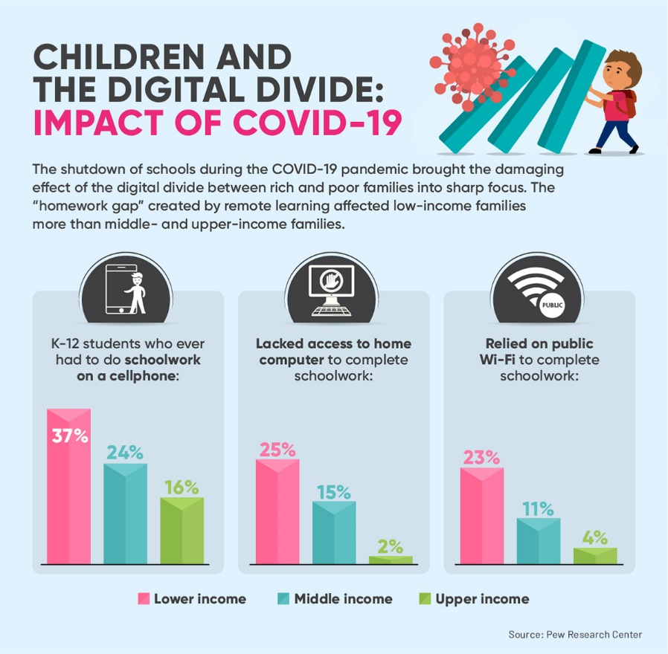

The shutdown of schools during the COVID-19 pandemic brought the damaging effect of the digital divide between rich and poor families into sharp focus. Pew Research Center data shows that the “homework gap” created by remote learning affected low-income families more than middle- and upper-income families. K-12 students who ever had to do schoolwork on a cellphone: lower income: 37%; middle income: 24%; upper income: 16%. K-12 students who ever lacked access to a home computer to complete schoolwork: lower income: 25%; middle income: 15%; upper income: 2%. K-12 students who ever relied on public Wi-Fi to complete schoolwork: lower income: 23%; middle income: 11%; upper income: 4%.

Positive and Negative Effects of Technology on Children
Children can benefit from technology by gaining new learning opportunities; it’s especially important for children who are physically or developmentally challenged. However, technology use has also been found to contribute to poor self-esteem and isolation in some children. As digital technologies become more ubiquitous, parents struggle to find the optimum amount of technology for their children’s lives.

Positive Effects of Technology on Children
All the “rules” about children’s access to computers and the internet were rewritten by the COVID-19 pandemic, according to parenting expert Anya Kamenetz. Technology provides children with easy access to information and boosts their creativity. Tech hardware and software helps children develop social skills and introduces them to various arts and sciences.
These are among the less obvious positive effects of technology on children:
- Technology allows children to connect with their family, friends, and others in ways that enrich their relationships, especially when using video chat and other real-time interactions.
- Parents and caregivers are learning to slow down and tone down the applications, games, and other content children use to avoid overloading their senses. This teaches children how to moderate their own use of technology.
- Rather than trying to eliminate all risk to children when using technology, the goal should be reducing the risk and adapting when problems arise, such as preventing children from accessing devices at specific times of the day.
Many parents hesitate to allow their preschool-age children to use technology products and services due to concerns about how it’ll impact their well-being and development. However, the children are surrounded by technology, much of which offers them significant benefits, as BSD Education explains:
- Technology helps children become independent learners more quickly. Once they learn how to access digital information sources safely, they’re able to explore the topics that interest them on their own.
- Children learn the importance of building communities and how to interact with people in social situations. When circumstances prevent children from establishing physical bonds with family members, friends, and others, they’re able to use technology to create “virtual bonds.”
- Early access to technology teaches the digital literacy skills that children will need for their future success in school and as adults.
- Many technology products promote hand-eye coordination in young children, while others focus on developing their language and problem-solving skills.

Negative Effects of Technology on Children
Children are especially susceptible to technology overuse. The American Psychological Association (APA) recommends limiting the use of technology to one hour per day of high-quality programming for children ages 2 to 5. For children ages 6 and up, it’s most important to set consistent limits on various types of media, such as gaming devices and smartphones.
APA suggests that parents focus on the content on children’s screens and how the children are interacting with it. A survey of research on the possible negative effects of technology on children establishes a connection between the level of a child’s use of technology and various developmental and behavior problems.
- Lack of attention, aggressive behaviors, obesity, physical inactivity, sleep problems
- Musculoskeletal problems related to a sedentary lifestyle
- Greater risk of lifetime obesity and cardiovascular disease
- Sleep disturbances and poor-quality sleep for children who overuse social media or keep mobile devices in their bedroom
These are among the negative effects of technology on children:
- Exposure to harmful online content and sexual exploitation: A study by Irish researchers found that children of all ages are able to bypass the age verification systems of social media apps, such as Snapchat, TikTok, Instagram, and Facebook. This can bring children into direct contact with potential predators and other dangers.
- Cyber bullying: The Cyberbullying Research Center reports that incidents of cyber bullying are most prevalent at ages 12 to 15. A recent survey by the center of 13- to 17-year-olds found that 23.7% of girls, 21.9% of boys, and 35.4% of transgender teens had experienced being bullied.
- Low self-esteem and increased anxiety: CNN reports that teens and adolescents are using image filters on Instagram to enhance their appearance even though the result looks nothing like them. “Self-esteem addiction” can make young people feel inadequate. As children spend more time on social media, they may become withdrawn or find themselves obsessively checking their social media feeds.

Resources on Ways Children Are Affected by Technology
- The Register, “Technology Does Widen the Education Divide. But Not Always in the Way You Expect” — One educator found that upon returning from online education during lockdown, children had turned away from technology, preferring real books and nontech activities because tech is no longer seen as “fun.”
- Edutopia, “Helping Parents Feel More Comfortable with Tech” — Advice for teachers about how to convince parents to support technology in the classroom.
- UNICEF, “Harnessing the Power of Technology and Digital Innovation for Children” — A report describing the initiatives and successes of the Digital UNICEF 2020 program, which is intended to extend the reach of UNICEF’s aid efforts.

Technology and Children Statistics
When it comes to children’s access to technology, the digital divide between rich and poor persists. The increased reliance of children on technology for remote schooling during the COVID-19 pandemic adds a new and dangerous dimension to the problem, which some analysts refer to as the “homework gap.”
- A survey by Common Sense Media found that 49% of 8- to 18-year-olds in the U.S. had attended classes fully or partially online since the start of the pandemic.
- Hispanic/Latinx students (48%) and Black students (39%) were much more likely than their white counterparts (20%) to attend school fully online.
- Similarly, students from low-income families (42%) were more likely to rely completely on online instruction than those from middle-income and high-income families (31% and 27%, respectively).
- While 92% of white students had a computer at home, only 87% of Hispanic/Latinx students and 78% of Black students did.
- Broadband access at home was available to 90% of students from families with high incomes, compared with 80% for middle-income families and 61% for lower-income families.
- In addition, 88% of white families had broadband access at home, while 76% of Black families and 68% of Hispanic/Latinx families had broadband access at home.
Common Sense Media estimates that closing the digital divide for K-12 public school students will cost between $6 billion and $11 billion in the first year, and between $4 billion and $8 billion annually in subsequent years. An additional $1 billion will be required to upgrade the remote access technologies that teachers use.

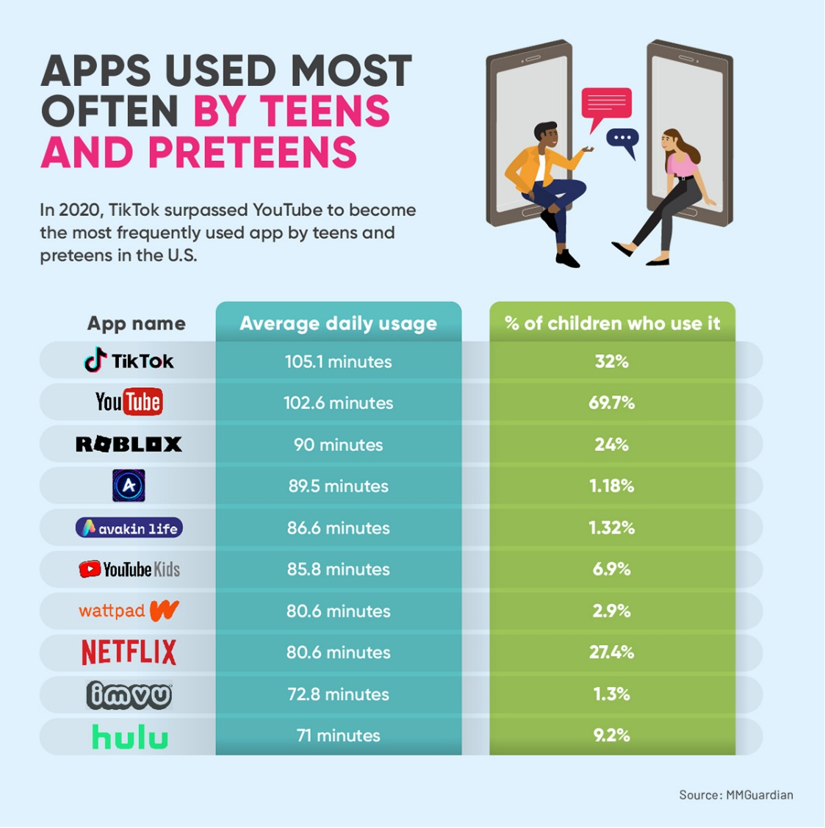

In 2020, TikTok surpassed YouTube to become the most frequently used app by teens and preteens in the U.S., according to MMGuardian. 1. TikTok: average daily usage, 105.1 minutes; % of
children who use it, 32%. 2. YouTube: average daily usage, 102.6 minutes; % of children who use it, 69.7%. 3. Roblox: average daily usage, 90 minutes; % of children who use it, 24%. 4. Amino: average daily usage, 89.5 minutes; % of children who use it, 1.18%. 5. Avakin Life: average daily usage, 86.6 minutes; % of children who use it, 1.32%. 6. YouTube Kids: average daily usage, 85.8 minutes; % of children who use it, 6.9%. 7. Wattpad: average daily usage, 80.6 minutes; % of children who use it, 2.9%. 8. Netflix: average daily usage, 80.6 minutes; % of children who use it, 27.4%. 9. IMVU: average daily usage, 72.8 minutes; % of children who use it, 1.3%. 10. Hulu: average daily usage, 71 minutes; % of children who use it, 9.2%.

Statistics on Children’s Online Activities
The most common activity for children online is accessing software, audio, and video content (44% of children had done so between March 2020 and April 2021). The next most popular activities are using internet-based communications (22%); playing video games (14%); accessing online stores, banks, or payment systems (13%); and reading news media (4%).
A study by the National Institute for Early Education Research (NIEER) on the impact of the COVID-19 pandemic on children’s learning and development determined that children lost learning opportunities at home and in preschool programs. This resulted in “unusually high” rates of socio-emotional and mental health problems in children as reported by their parents.
- Twenty-two percent of 4- to 7-year-olds had high levels of conduct problems in the fall of 2020, compared with 11% who did so in a survey conducted before the pandemic.
- Higher levels of hyperactivity (15% vs. 10%), peer problems (17% vs. 9%), lack of prosocial behavior (20% vs. 8%), and total difficulties (15% vs. 8%) were also recorded among 4- to 7-year-olds during the pandemic.

How Children’s Screen Time Correlates to Their Mental and Physical Health
A primary concern among parents about their children’s use of technology is the amount of time children spend in front of a television, computer, smartphone, or another screen. Researchers have established a link between the amount of time adolescents spend in front of a screen, their level of moderate or vigorous physical activity (MVPA), and the amount of sleep they get.
- Screen time involves sedentary activities that detract from MVPA and delay bedtime and that interrupt sleep with digital notifications.
- The result is an increased risk of children becoming overweight or obese, as well as more sleepiness during the day and lower academic achievement.
- While most of the 13- and 14-year-olds in the study met the recommendations for total screen time (less than two hours per day) and MVPA (at least one hour per day), only half met the recommendation for sleep (8.5 hours per night). Meeting the recommendation for screen time and one of the other two factors led to better academic outcomes.
Some research into the connection between children’s screen time and their psychological well-being has been brought into question because of discrepancies between actual and reported use of digital media by children. A recent meta-analysis of research on the impact of screen time on children found either no significant impact or only a moderate impact. More indicative of potential psychological or developmental problems in children than overall screen time is the type of content that children view and interact with.
However, studies have established a link between excessive screen time and children’s levels of attention deficit symptoms; impaired emotional and social intelligence; social isolation; phantom vibration syndrome; and diagnosable mental illnesses, such as depression, anxiety, and technology addiction.

Finding the Right Amount of Time Online for Children
Many activities that benefit children can become dangerous if used too much. During the pandemic, the time that adolescents spent in front of a screen nearly doubled, according to a study published in JAMA Pediatrics. Adolescents were spending an average of 7.7 hours a day in front of a screen early in the pandemic, compared with 3.8 hours per day before the pandemic. Indications are that the elevated level of screen time will persist.
Determining the optimal amount of screen time for children has become challenging for parents because of the potential problems arising related to children’s vision, posture, and other physical development concerns. While the standard recommendation of experts remains that children under the age of 8 spend less than two hours per day in front of a screen, many factors must be considered when setting a limit for children:
- Allow more screen time for positive educational activities.
- Encourage children to take breaks from the screen that involve outdoor activities.
- Avoid using screens as “babysitters” that keep children occupied. Find other nonscreen activities, such as creative toys, coloring books, and storybooks.
- Don’t let children’s use of electronics cut into their sleep time.
- Make sure that children take short breaks from the screen every 20 minutes or so to protect their vision.
- Check the area of the screen activity to ensure that the lighting is neither too dark nor too bright.

Tech Companies’ Growing Impact on Children
After pressure from government regulators, Facebook shelved its plans to develop a version of Instagram called Instagram Kids that targeted children under the age of 13, as The New York Times reports. In 2019, YouTube paid $170 million to settle claims that it targeted children under the age of 13 in its advertising and collected personal information about them.
These are just two of the many examples of giant tech companies targeting children to meet their need for continuous growth. In the absence of federal privacy laws, companies such as Google (which owns YouTube), Facebook (now known as Meta), Amazon, and TikTok are left to self-regulate their privacy and other policies.
- The Verge reports that Facebook is exploring the use of playdates to spur children to use its Messenger Kids application.
- According to Reuters, attorneys general of several states are investigating Instagram for its attempts to attract young children in violation of consumer protection laws.
- YouTube is being sued in the U.K. over alleged violations of children’s privacy and data rights, according to Tech Monitor.
- A recent survey by Accountable Tech found that 74% of parents believe that Facebook cares more about profits than about keeping their children safe on the site.
Parents, educators, and regulators are also concerned about the safety of educational technology platforms that use machine learning and other artificial intelligence technologies to harvest massive amounts of data about children. Many fear that ubiquitous surveillance will lead to behavioral control and potentially a total loss of privacy for children. They’re calling for more accountability from such platforms, as well as legislation that guarantees children’s “right to future tense.”

Resources Providing Statistics on Children and Technology
- International Central Institute for Youth and Educational Television, International Data Youth and Media 2021 — Statistics on the types of technologies that children use in countries around the world, as well as daily use of media by children in various age groups.
- Family Online Safety Institute, “Healthy Screen Time: Mobile Technology’s Relationship with Children’s Exercise” — A study reporting a sharp decrease in the amount of time children spend playing outdoors and the growing reliance on applications that entail physical activity, such as Nintendo’s Wii console.
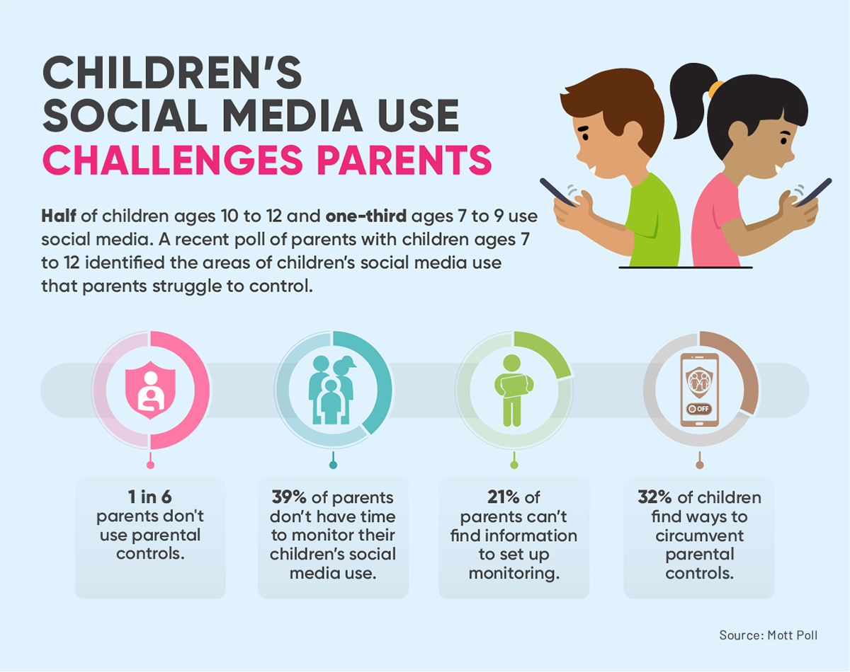
Half of children ages 10 to 12 and one-third ages 7 to 9 use social media, according to a recent Mott poll of parents with children ages 7 to 12. Parents identified the areas of children’s social media use that they struggle to control; for instance, one in six parents don’t use parental controls. Additionally, 39% of parents don’t have time to monitor their children’s social media use, 21% of parents can’t find information to set up monitoring, and 32% of children find ways to circumvent parental controls.

Technology and Social Interaction in Children
The lockdowns deprived young children of opportunities to develop social skills by interacting with other children. As a result, educators report that some children returning to school are struggling with classroom routine. However, the pandemic has disrupted the lives of many families of students and teachers.
- Some children are experiencing anxiety in the classroom that may relate to separation anxiety after spending a prolonged period with family.
- While most students readjust quickly to their school routine, those who’ve experienced trauma at home are most likely to struggle in school. This is especially true for children in kindergarten and first grade.
- Children are showing their resilience in adapting quickly to masking and social distancing requirements.
Research presented at a recent conference of the Society of Neuroscience indicates that isolation in adolescents can change the development of the brain systems related to fear, risk and reward, and social recognition. This may make it more difficult for them to distinguish friendly behavior from threatening behavior in their peers, for example.
A good way to break feelings of social isolation that developed as a result of the pandemic is to increase the amount of school time devoted to physical activities.

Child Development and Technology
Researchers are studying how the way young children play with technology compares with the way they play with real-world toys. They’ve found that all the types of play in the nondigital environment are present in the digital realm as well.
- Digital play develops a range of abilities in children, including subject knowledge and understanding; digital skills; and skills related to social, emotional, cognitive, and creative development.
- Because digital and physical play are intermixed in children’s lives, it’s more appropriate to look at play holistically.
Most research on children and technology relates to children ages 9 to 16, but interactions with technology may have a greater impact on the development of children ages 3 to 8. Digital education for young children increasingly takes the form of applications running on tablets and smartphones, language development applications, and physical coordination from manipulating game controls and videos that teach dancing and other activities.
Since the advent of Apple’s iPad in 2010, computer use by young children has skyrocketed, especially as teaching philosophies focus on play activities over traditional classes and formal teaching. Some schools now test each child’s digital skills and teach children digital competence, such as knowing when and why digital tools are used.
One approach to understanding the complexity of technology’s impact on children is the domestication theory that compares the introduction of digital tools into society to the process of taming a wild animal. The four phases of the domestication process render the tools nonthreatening and also make them useful, important, and meaningful.
- Appropriation is the reason for acquiring the digital tool.
- Objectification of the digital tool instills a personal meaning for the tool in the child using it.
- Incorporation describes how the digital tool becomes a part of the child’s life. It also explains appropriate and inappropriate uses of the tool.
- Conversion occurs when the digital tool has redefined the child’s worldview and relations with others.

Resources on the Impact of Technology on Children’s Development and Social Interactions
- Early Childhood Education Journal, “Investigating Young Children’s Interactions During Digital Play” — Research into children’s social behaviors within digital play environments found that adding a social dimension increased a child’s engagement in the activity.
- OECD iLibrary, “Children and Digital Technologies: Trends and Outcomes” — Topics include use of social robots to help treat children with chronic diseases and the impact of digital technologies on children’s physical health.

Ensuring Safe and Nurturing Digital Environments for Children
Technological advances happen so quickly that parents and educators don’t have much opportunity to consider how children’s growth and well-being may be improved or impaired by the types of technologies they interact with and the ways in which those interactions occur. However, technology continues to play a more important part of the lives of most children when they’re in school, at home, and at play. The judicious application of technology will enhance a child’s education and other aspects of life.

Source Four- Questodio, Dr. Nicole Beurkens, Child Psychologist ‘How does technology affect children’s social development’
As technology use has increased over the past decade, so have the number of concerns I receive from parents about how it impacts the development of children. From cognitive and learning concerns to social and emotional concerns, parents and professionals are right to question the impact of something that consumes the time and energy of so many children. While there are certainly social benefits to digital device use and media consumption, concerns arise when excessive time spent on devices detracts from time spent engaging in and benefitting from in-person interactions and developmentally necessary activities.
Let’s take a scientific look at how your child’s time online impacts their social skills – empathy, compassion and sensitivity to human relationships – and what parents can do to encourage healthy social development.

Pros: Technology encourages positive social connection and support

The good news is that not all technology use is bad. It can be used to bring people together, and this is certainly the case for children and teens as well. Many report that use of social media platforms, texting, and other apps allows them to stay connected to peers they know in real life. It also can foster the development of friendships with peers around the world who have shared interests and goals.
Children with social anxiety disorders, who often struggle with engaging in social interactions in person, may find that online communities and social media platforms allow them to practice social interaction skills and gain confidence with social communication in a more comfortable way. Social support groups online also allow children to share their experiences and receive encouragement and guidance that may not be available to them in their local community.

Cons: Technology can create social disconnection and development

The bad news is that the overuse of screen time displaces time spent engaging in real life social interactions. We know that children develop communication, cognitive, and social skills through their relationships with caregivers and other adults and peers. They require face-to-face engagement to understand and use verbal and non-verbal communication, develop empathy, learn turn-taking, and more. Increased technology use has the potential to create social disconnection for young and older children alike, which can negatively impact the development of social and relational skills.
Recent research has shown that screen time is negatively associated with social skills development in toddlers. Specifically, the more time they spend with devices the more their social development suffers in the areas of relating and interacting with others and compliance with directions and ability to help others. Levels of disruptive social behaviors, such as being bossy or bullying, increased with more screen time activity.
The concerns about social disconnection extend to older children and teens as well. As time spent on devices increases, time spent in-person with peers and adults decreases. This can lead to a sense of isolation and loneliness, with studies showing that teens who report the least in-person interaction and the most screen time have the highest rates of loneliness and depression.

A study involving older children showed that spending one week at summer camp without screen time led to a significant improvement in children’s ability to read and understand non-verbal emotional cues. This demonstrates the negative impact that screen time can have on the development of these critical social skills, but also highlights that these skills can improve in a relatively short amount of time (at least for older children) when device use is decreased and in-person social interaction is increased.

An additional concern regarding social development and overuse of screen time is the decrease in positive family interaction that occurs. Studies have shown that increased use of devices leads to reduced quality time among family members, and increased parent-child conflicts. Children and their use of devices play a role, but so do the device habits of parents. When parent use of devices infringes on quality engagement with children, their social development suffers. Parents need to be mindful of their own device habits, as well as the amount of time they allow their children, in order to support healthy social development.

What parents can do to encourage healthy social development

Here are the steps that I recommend parents who come to me concerned about the impact of their child’s digital device use and social development take to support healthy social development:
- Enforce time limits on devices and digital media using parental control apps like Qustodio. They help ensure your children have a balance of screen time and non-screen time activities, and enough in-person social engagement to allow for healthy development and prevent isolation and loneliness.
- Talk regularly with your children about their relationships with their peers. This can help identify concerns about a lack of real-life relationships as well as the social benefits a child perceives from their online activities. It can also help you be aware of inappropriate content or cyberbullying that may be negatively impacting your child.
- Be a role model of healthy device habits. It is critical that parents spend enough quality face-to-face time engaging with children to support healthy social and emotional development.

Source Five- Cyberwise, Brookelyn Simms ‘Positive and Negative Effects of Technology on Children’
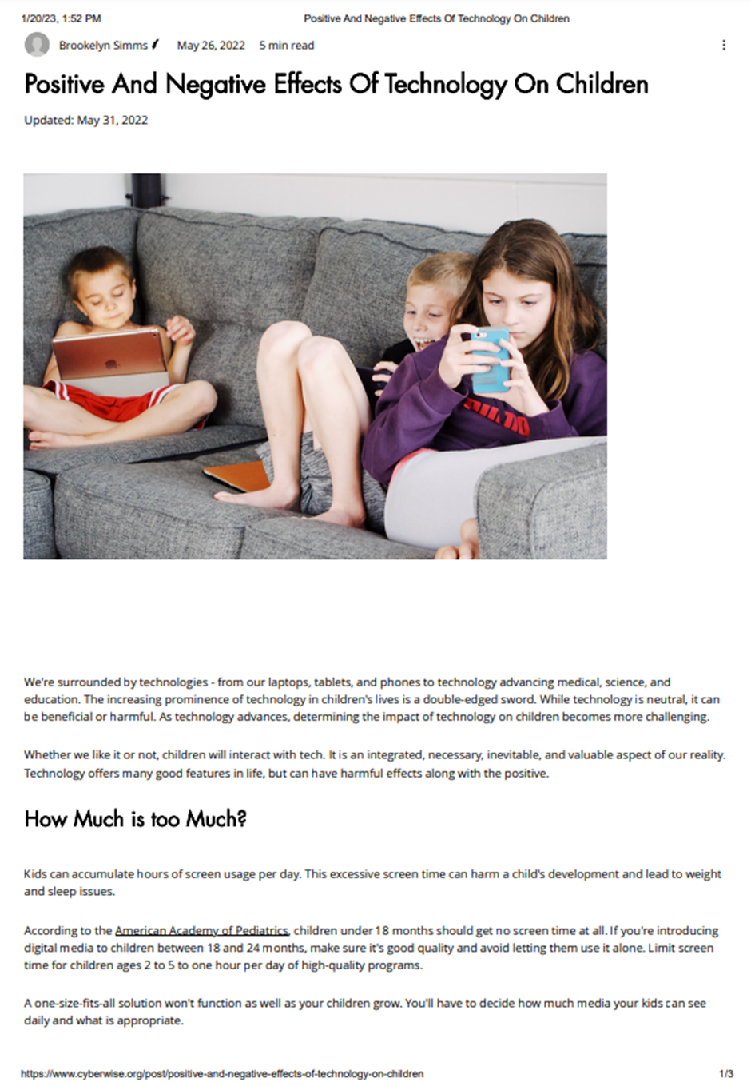

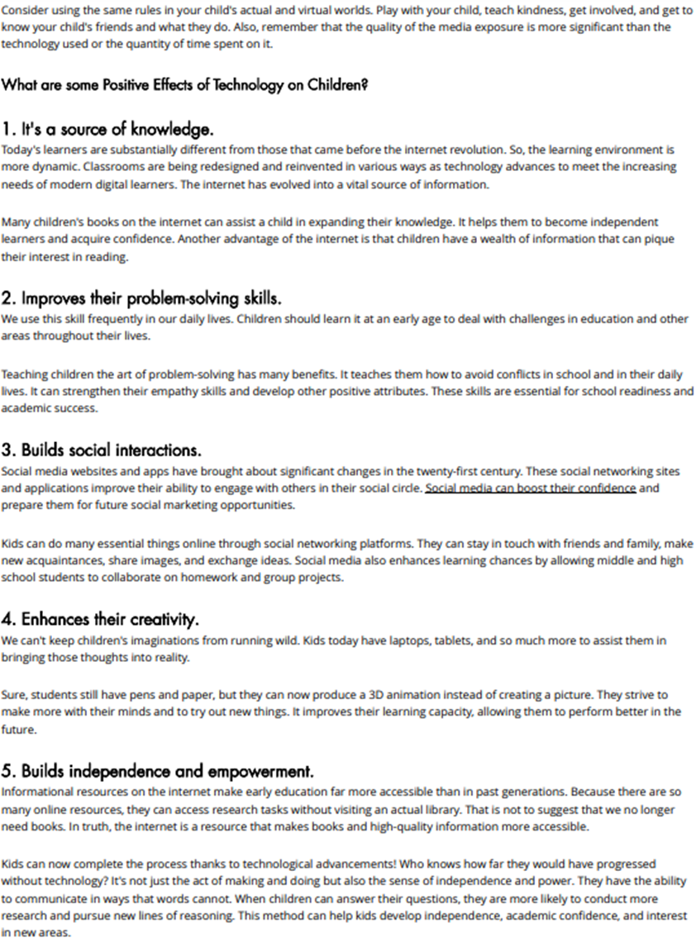
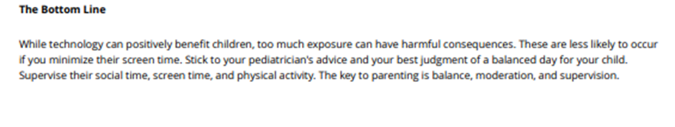
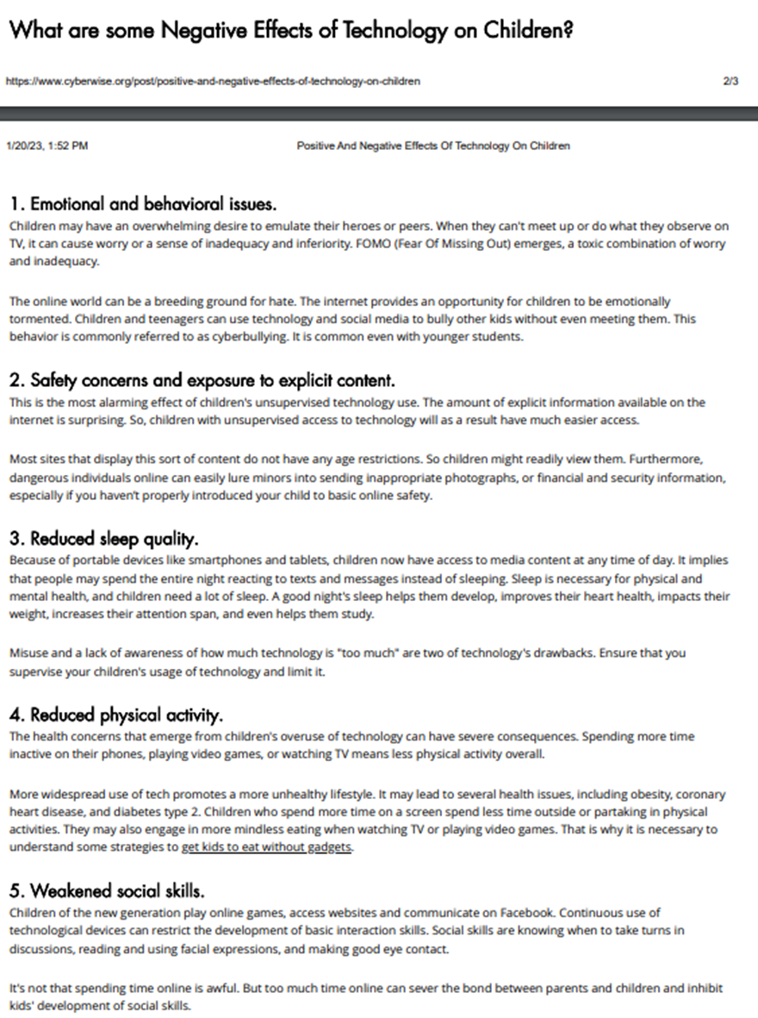

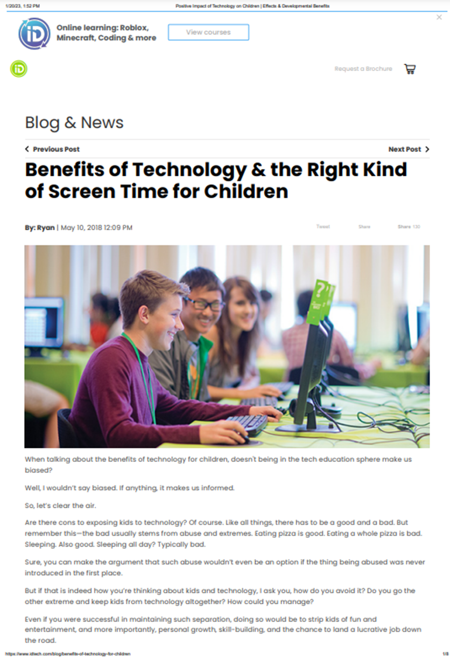
Source Six- Idtech, Ryan, ‘Benefits of technology and the right kind of screen time’
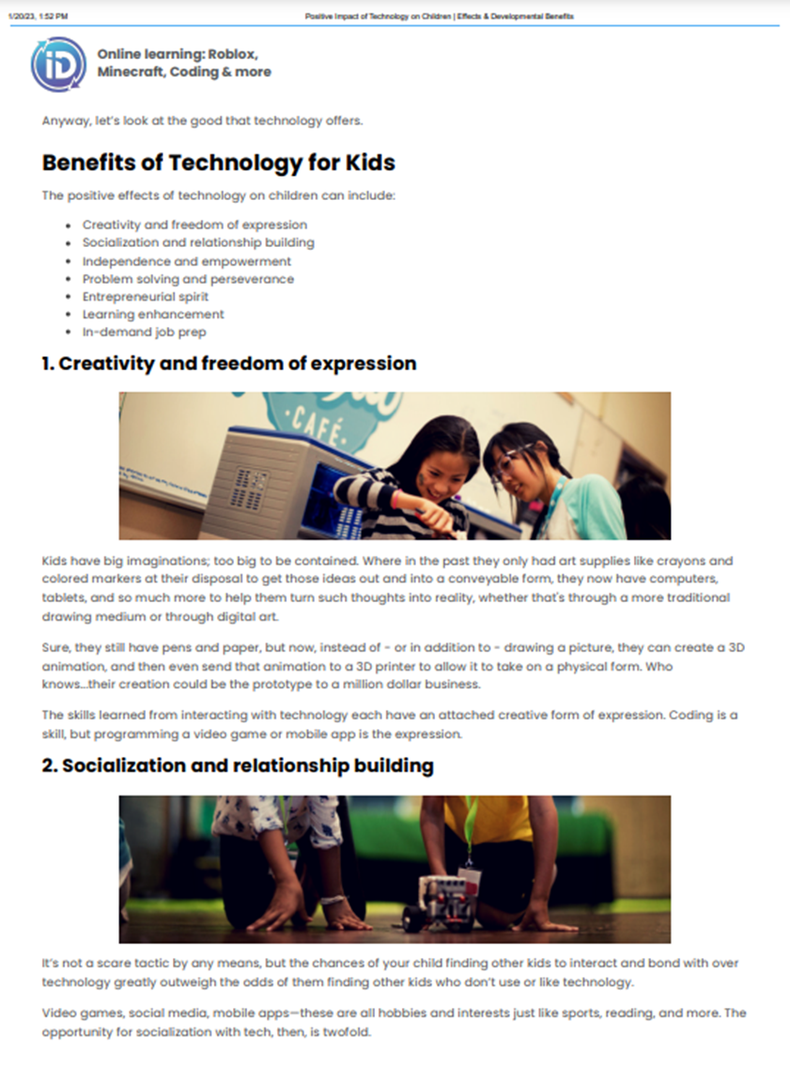
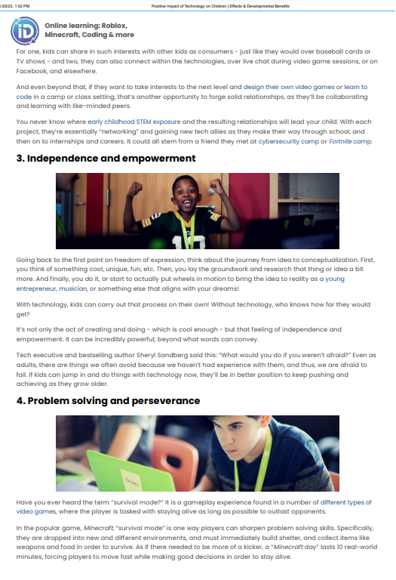
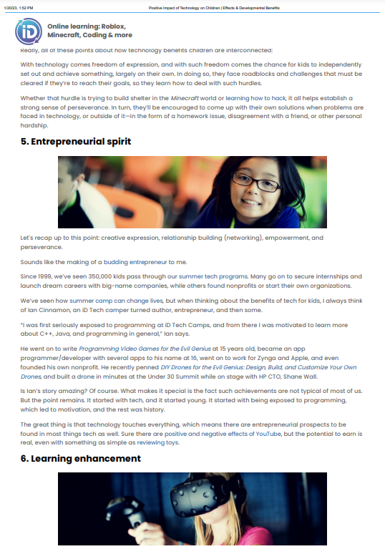
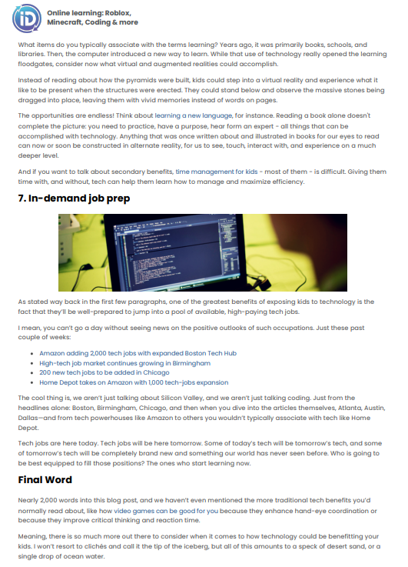



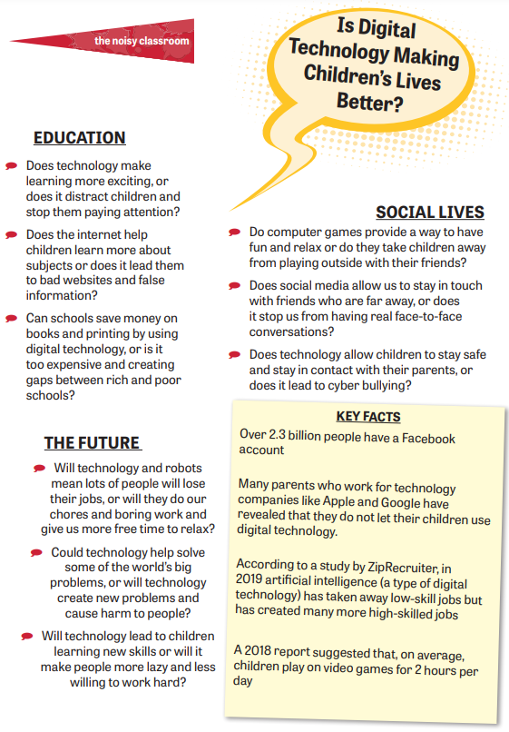
Source Seven- The Noisy Classroom ‘Is Digital Technology making children’s lives better’

Source Eight- Time for Kids ‘Is social media good for society?’







Source Nine- Time for Kids ‘Should kids have smartphones’




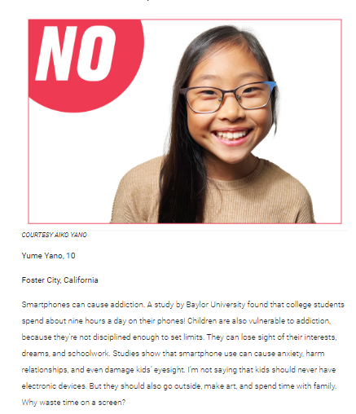









Planning Your Presentation

Use your PEEL structure to present your side of the debate to the council.
Each PEEL should last around 1 minute and you should make a minimum of 4 points.
Every member of the group should contribute to the presentation

Good Luck!

PEEL 1:
Point
Evidence
Explain
Link

PEEL 2:
Point
Evidence
Explain
Link

PEEL 3:
Point
Evidence
Explain
Link

PEEL 4:
Point
Evidence
Explain
Link

PEEL 5:
Point
Evidence
Explain
Link

PEEL 6:
Point
Evidence
Explain
Link

PEEL 7:
Point
Evidence
Explain
Link

PEEL 8:
Point
Evidence
Explain
Link

