Resources for white parents to raise anti-racist children:

Document compiled by Sarah Sophie Flicker, Alyssa Klein in May 2020
At SalesForce

- Books:
- Coretta Scott King Book Award Winners: books for children and young adults
- 31 Children's books to support conversations on race, racism and resistance
- Podcasts:
- Parenting Forward podcast episode ‘Five Pandemic Parenting Lessons with Cindy Wang Brandt’
- Fare of the Free Child podcast
- Integrated Schools podcast episode “Raising White Kids with Jennifer Harvey”
- Articles:
- PBS’s Teaching Your Child About Black History Month
- Your Kids Aren't Too Young to Talk About Race: Resource Roundup from Pretty Good
- The Conscious Kid: follow them on Instagram and consider signing up for their Patreon
Articles to read:
- “America’s Racial Contract Is Killing Us” by Adam Serwer | Atlantic (May 8, 2020)
- Ella Baker and the Black Freedom Movement (Mentoring a New Generation of Activists
- ”My Life as an Undocumented Immigrant” by Jose Antonio Vargas | NYT Mag (June 22, 2011)
- The 1619 Project (all the articles) | The New York Times Magazine
- The Combahee River Collective Statement
- “The Intersectionality Wars” by Jane Coaston | Vox (May 28, 2019)
- Tips for Creating Effective White Caucus Groups developed by Craig Elliott PhD
- “Where do I donate? Why is the uprising violent? Should I go protest?” by Courtney Martin (June 1, 2020)
- ”White Privilege: Unpacking the Invisible Knapsack” by Knapsack Peggy McIntosh
- “Who Gets to Be Afraid in America?” by Dr. Ibram X. Kendi | Atlantic (May 12, 2020)
Videos to watch:
- Black Feminism & the Movement for Black Lives: Barbara Smith, Reina Gossett, Charlene Carruthers (50:48)
- "How Studying Privilege Systems Can Strengthen Compassion" | Peggy McIntosh at TEDxTimberlaneSchools (18:26)
Podcasts to subscribe to:
- 1619 (New York Times)
- About Race
- Code Switch (NPR)
- Intersectionality Matters! hosted by Kimberlé Crenshaw
- Momentum: A Race Forward Podcast
- Pod For The Cause (from The Leadership Conference on Civil & Human Rights)
- Pod Save the People (Crooked Media)
- Seeing White
Books to read:
- Black Feminist Thought by Patricia Hill Collins
- Eloquent Rage: A Black Feminist Discovers Her Superpower by Dr. Brittney Cooper
- Heavy: An American Memoir by Kiese Laymon
- How To Be An Antiracist by Dr. Ibram X. Kendi
- I Know Why the Caged Bird Sings by Maya Angelou
- Just Mercy by Bryan Stevenson
- Me and White Supremacy by Layla F. Saad
- Raising Our Hands by Jenna Arnold
- Redefining Realness by Janet Mock
- Sister Outsider by Audre Lorde
- So You Want to Talk About Race by Ijeoma Oluo
- The Bluest Eye by Toni Morrison
- The Fire Next Time by James Baldwin
- The New Jim Crow: Mass Incarceration in the Age of Colorblindness
by Michelle Alexander
- The Next American Revolution: Sustainable Activism for the Twenty-First Century
by Grace Lee Boggs
- The Warmth of Other Suns by Isabel Wilkerson
- Their Eyes Were Watching God by Zora Neale Hurston
- This Bridge Called My Back: Writings by Radical Women of Color by Cherríe Moraga
- When Affirmative Action Was White: An Untold History of Racial Inequality in Twentieth-Century America by Ira Katznelson
- White Fragility: Why It's So Hard for White People to Talk About Racism by Robin DiAngelo, PhD
Films and TV series to watch:
- 13th (Ava DuVernay) — Netflix
- American Son (Kenny Leon) — Netflix
- Black Power Mixtape: 1967-1975 — Available to rent
- Blindspotting (Carlos López Estrada) — Hulu with Cinemax or available to rent
- Clemency (Chinonye Chukwu) — Available to rent
- Dear White People (Justin Simien) — Netflix
- Fruitvale Station (Ryan Coogler) — Available to rent
- I Am Not Your Negro (James Baldwin doc) — Available to rent or on Kanopy
- If Beale Street Could Talk (Barry Jenkins) — Hulu
- Just Mercy (Destin Daniel Cretton) — Available to rent for free in June in the U.S.
- King In The Wilderness — HBO
- See You Yesterday (Stefon Bristol) — Netflix
- Selma (Ava DuVernay) — Available to rent
- The Black Panthers: Vanguard of the Revolution — Available to rent
- The Hate U Give (George Tillman Jr.) — Hulu with Cinemax
- When They See Us (Ava DuVernay) — Netflix
Organizations to follow on social media:
- Antiracism Center: Twitter
- Audre Lorde Project: Twitter | Instagram | Facebook
- Black Women’s Blueprint: Twitter | Instagram | Facebook
- Color Of Change: Twitter | Instagram | Facebook
- Colorlines: Twitter | Instagram | Facebook
- The Conscious Kid: Twitter | Instagram | Facebook
- Equal Justice Initiative (EJI): Twitter | Instagram | Facebook
- Families Belong Together: Twitter | Instagram | Facebook
- The Leadership Conference on Civil & Human Rights: Twitter | Instagram | Facebook
- MPowerChange: Twitter | Instagram | Facebook
- Muslim Girl: Twitter | Instagram | Facebook
- NAACP: Twitter | Instagram | Facebook
- National Domestic Workers Alliance: Twitter | Instagram | Facebook
- RAICES: Twitter | Instagram | Facebook
- Showing Up for Racial Justice (SURJ): Twitter | Instagram | Facebook
- SisterSong: Twitter | Instagram | Facebook
- United We Dream: Twitter | Instagram | Facebook
More anti-racism resources to check out:
- 75 Things White People Can Do for Racial Justice
- Anti-Racism Project
- Jenna Arnold’s resources (books and people to follow)
- Rachel Ricketts’ anti-racism resources
- Resources for White People to Learn and Talk About Race and Racism
- Save the Tears: White Woman’s Guide by Tatiana Mac
- Showing Up For Racial Justice’s educational toolkits
- The [White] Shift on Instagram
- “Why is this happening?” — an introduction to police brutality from 100 Year Hoodie
- Zinn Education Project’s teaching materials

Attachments area
Preview YouTube video Black Feminism & the Movement for Black Lives: Barbara Smith, Reina Gossett, Charlene Carruthers
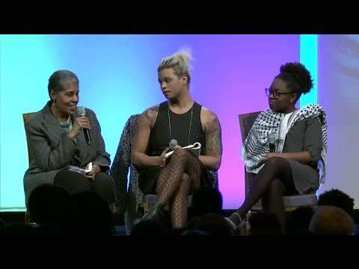
Black Feminism & the Movement for Black Lives: Barbara Smith, Reina Gossett, Charlene Carruthers
Preview YouTube video "How Studying Privilege Systems Can Strengthen Compassion": Peggy McIntosh at TEDxTimberlaneSchools
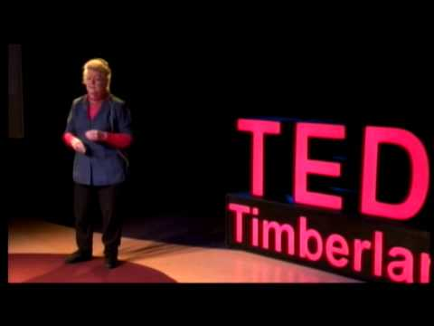
"How Studying Privilege Systems Can Strengthen Compassion": Peggy McIntosh at TEDxTimberlaneSchools

