DevOps Competences for Smart Cities
Project No.: 601015-EPP-1-2018-1-EL-EPPKA2-SSA
Erasmus+ Program,
KA2: Cooperation for innovation and the exchange of good practices-Sector Skills Alliances

The European Commission support for the production of this publication does not constitute an endorsement of the contents which reflects the views only of the authors, and the Commission cannot be held responsible for any use which may be made of the information contained therein.
WP3
T3.3 (a) Prior non formal and informal learning validation
Table of contents

1 Document Metadata 2
1.1 Document information 2
1.2 Document Change History 4
2 Procedures to validate prior, informal and non-formal learning 5

Document Metadata
Document Title: Prior non formal and informal learning validation

Keywords: instructional planning, e-learning, ADDIE model, blended learning, work-based learning

Abstract: This document describes the proposed methodology to validate prior informal and non-formal learning of the attendants of the DEVOPS curricula

Document information
Work package: | WP3
Type:
Dissemination level: | Public
Document Reference:
Version: | 1
Delivery date: | 14.12.2020
Status: | First version
Authors: | Spiros Borotis, HOU and Theodor Panagiotakopoulos, HOU
Reviewers: | Achilles Kameas, HOU
Submitted for Project QA
Approved by Project QA
Date: | Name: | Signature:
Comments

Document Change History

Version | Who | When | Action | Description
1 | S. Borotis and T. Panagiotakopoulos | 14/12/2020 | Create | Methodology to validate prior informal and non-formal learning

Procedures to validate prior, informal and non-formal learning
Beyond the formal classroom settings, people can acquire the most valuable of knowledge, skills and competences in their daily lives, being at work, at home or during leisure. Learning throughout life is a key route to personal development and acknowledging such learning can give greater value to citizen’s achievements and their potential contributions to society.
The key questions raised for the DEVOPS project were:
- How can we increase the visibility and value of learning taking place outside formal education and training systems, so that learners with different background can apply for the courses and by evidence receive exemption from one or more modules?
- What are the methods and tools for such a procedure?
- Who is involved?
- How can the social recognition and acceptance be guaranteed?
Such an idea was introduced by the European Council in 2012 with the launch of the COUNCIL RECOMMENDATION of 20 December 2012 on the validation of non-formal and informal learning (2012/C 398/01). The aforementioned Recommendation stressed the value of making prior learning visible for enhancing employability and mobility, as well as increasing motivation for lifelong learning, particularly in the case of the socio-economically disadvantaged or the low-qualified.
Accordingly, the Recommendation on the Validation of Non Formal and Informal Learning (hereof VNFIL), proposed to develop a procedure including the following components, whilst allowing each individual to take advantage of any of these, either separately or in combination, in accordance with his/her needs:
Figure 1 – The components of non-formal and informal learning process
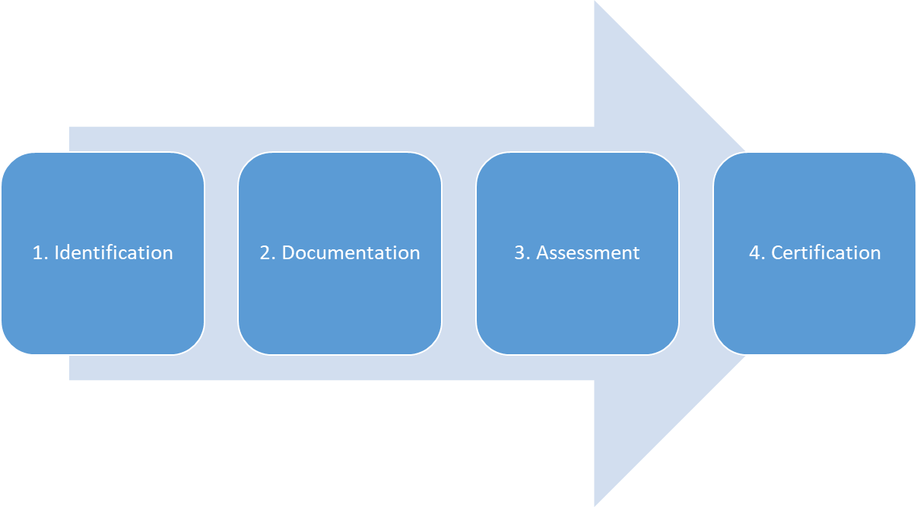

- Identification of knowledge, skills and competence acquired
This stage is crucial as learning outcomes differ from person to person and will have been acquired in various contexts: at home, during work or through voluntary activities. In some countries identification is supported by the use of standardized ICT tools allowing self-assessment. This stage will frequently require active involvement of advisors and counsellors able to enter into a dialogue with the candidate and direct him/her to appropriate options and tools.
- Documentation
Documentation involves provision of evidence of the learning outcomes acquired. This can be carried out through the ‘building’ of a portfolio that tends to include a CV and a career history of the individual, with documents and/or work samples that attest to their learning achievements. Validation needs to be open to various evidence types, ranging from written documents to work samples and demonstrations of practice. Objectivity, reliability, credibility and validity define here the qualitative criteria to ensure the acceptance of the results.
- Assessment
Individual’s learning outcomes are compared against specific reference points and/or standards. Oral, written tests, exercises, projects, observation of executing tasks, etc. Assessment methods are based on learning outcomes and refer to the competent professional standard / profile.
- Certification
Final valuing – of the learning identified, documented and assessed. This can take different forms but is commonly the award of a formal qualification (or part-qualification). Validation reaching the stage of certification requires a summative assessment officially confirming the achievement of learning outcomes against a specified standard.

The 2012 Council recommendation on validation encourages Member States to put in place national arrangements for validation by 2018. These arrangements aim to enable individuals to increase the visibility and value of their knowledge, skills and competences acquired outside formal education and training: at work, at home or in voluntary activities. To this regard CEDEFOP developed the European Guidelines to identify main challenges that policy makers and practitioners are facing and present possible responses to those challenges. The guidelines are practical, and provide advice for individuals and institutions responsible for initiating, developing, implementing and operating validation arrangements. Their impact relies exclusively on their relevance and ability to add value at national or local level.

The state of play on the adoption and implementation of the 2012 Council Recommendation on the validation of non-formal and informal learning (2012/C 398/01) is different in the three DEVOPS project countries (Italy, Greece, Germany, Cyprus). Moreover, the DEVOPS VET curricula do not currently exist as “official” occupations in the countries (at least all of them). In this regard, the VET provider should develop a procedure, “as compliant as possible” with the Council Recommendation. Thus, the VET provider should establish a procedure internally aiming to the identification, documentation, assessment and certification (thereafter mentioned as “DEVOPS VET curricula validation office”).
- Identification of knowledge, skills and competence acquired
The DEVOPS project has developed training modules / competences synthesizing the DEVOPS training offer. These modules / competences were built based on learning outcomes. The DEVOPS VET curricula validation office should invite the candidates into dialogue with counselors / advisors, possibly using particular tools, so as to identify which of each DEVOPS VET curriculum’s learning outcomes the candidate already disposes.
- Documentation
Following the establishment of the previous list, the DEVOPS VET curricula validation office asks the candidate to provide evidence, so as to synthesize his/her portfolio. Almost every evidence should be taken into account, respecting always the national legislation.
- Assessment
The DEVOPS VET curricula validation office compares the candidates existing learning outcomes with the ones included in the DEVOPS VET curricula using particular assessment methods. In this stage, the candidate becomes eligible to attend only the competences that he/she needs so as to reach the range of the learning outcomes of each DEVOPS VET curricula. No written or oral tests are foreseen so as to complete the assessment.
- Certification
Learners attain and complete the course and its partial competences and take part in the final certification procedures, e.g. assessment tests, projects, etc.

After that, the learner who completes successfully the final exams gets recognition of the achievement of particular learning outcomes and s/he is in principle able to follow the particular DEVOPS competences and eventually get the same DEVOPS Job Role Profile Certificate with the learners that followed successfully the complete DEVOPS VET Curricula training offers. The same Certifications are awarded to every learner who has successfully completed the course, regardless of his/her type of enrolling, e.g. full course learner or partial course learner deriving from prior experience.

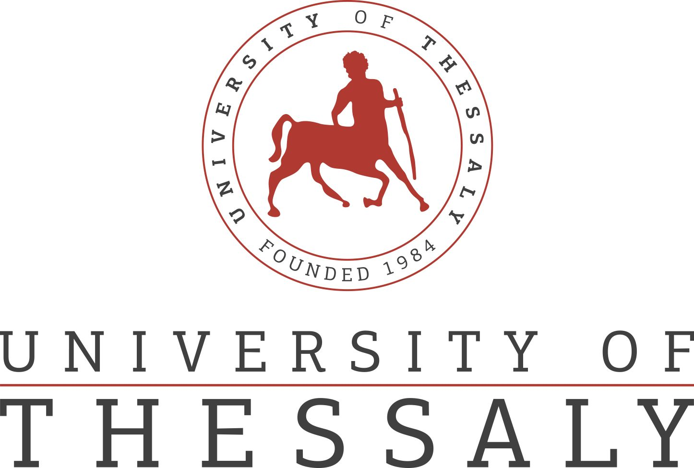
 | 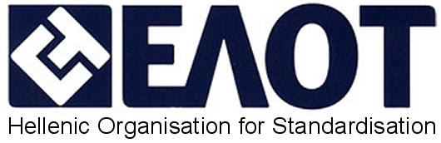
 | 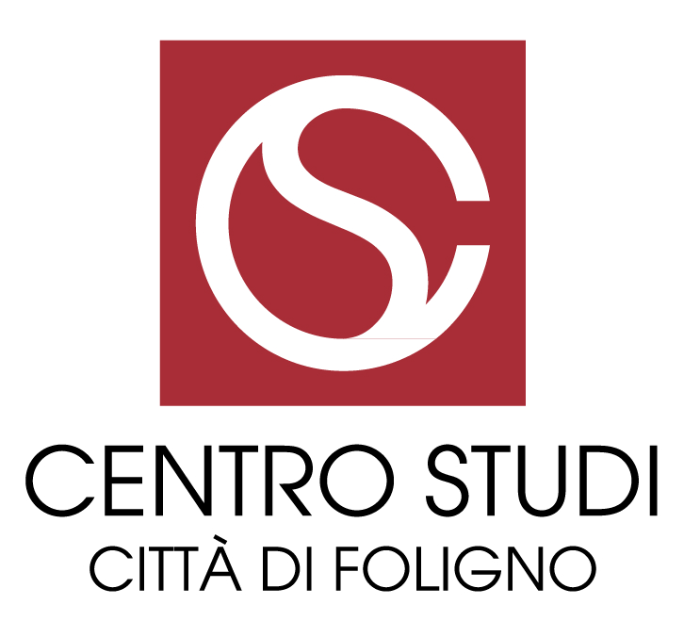 | 