Members of IFLA HBS Standing Committee as of October 2019
Last updated 30/10/2019
Photo (optional) | Name/Title/ Institution | Role | Term of office | Contact details
 | Heather Todd  Director, Learning and Research Services, University of Queensland Library, Australia | Chair ¹ | 1st Term: 2019-2021  Member:  1st Term:2015-2019  2nd Term: 2019-2023 | heather.todd@uq.edu.au  +61 421 056126
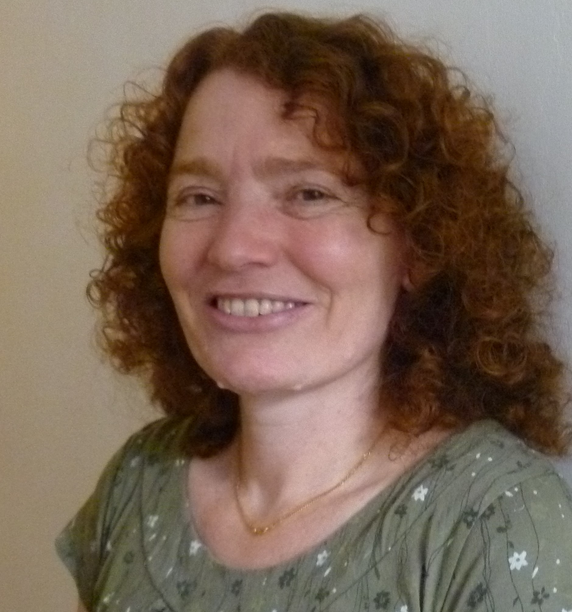 | Emma Farrow  Knowledge and Evidence Specialist, Public Health England  UK | Secretary¹  ^{E4GDH Core group} | 1st Term: 2017-2019  2nd Term: 2019-2021  Member:  1st Term: 2017- 2021 | emcolette@googlemail.com  +44 797 4851970 (+WhatsApp)
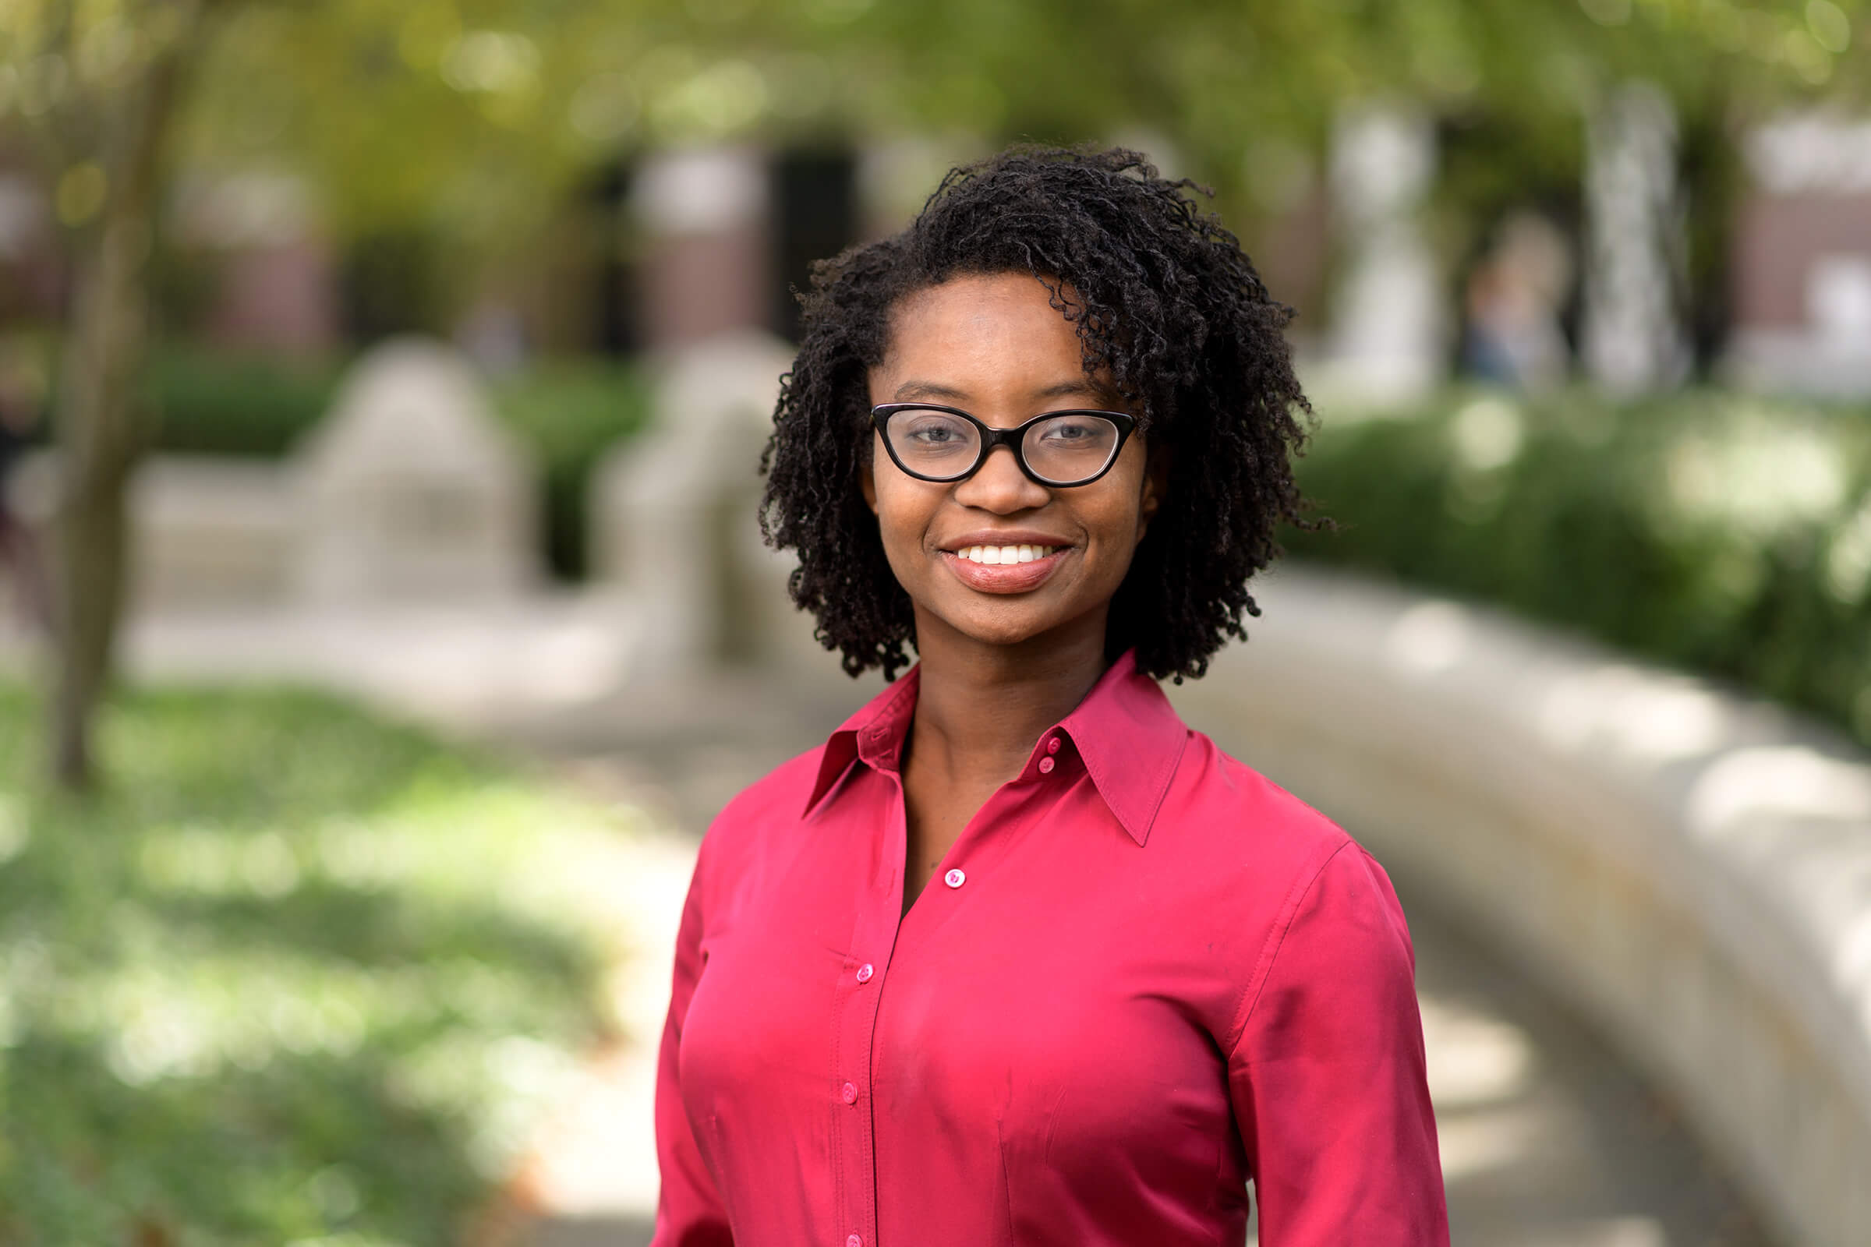 | Bethany McGowan  Health Sciences Information Specialist, Assistant Professor of Library Science, Purdue University,  United States | Information² Coordinator | Appointed 2019  Member:  1st Term: 2019- 2023 | bmcgowa@purdue  765 494 2917
 | Silvia Huaillani  Knowledge and Evidence Specialist, National Institute of Health  Peru | Member³ | 1st Term: 2019- 2023 | akizul@gmail.com  +51 985002759
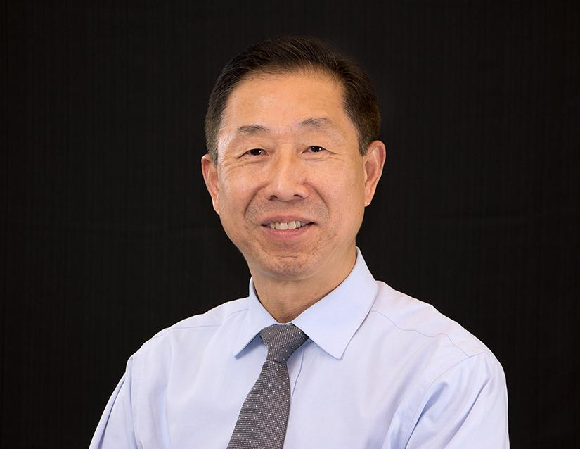 | Michael B. Huang  Director of Global Library Initiatives; Librarian, Health Sciences Library, Stony Brook University, United States | Member³ | 1st Term: 2015-2019  2nd Term: 2019-2023 | Michael.b.huang@stonybrook.edu  001 631 7867023
 | Dr Evelyn Omoluabi Idiodi  University Librarian  University of Benin  Nigeria | Member³ | 1st Term: 2017- 2021 | taiyeidiodi2@gmail.com  +234 8034284211
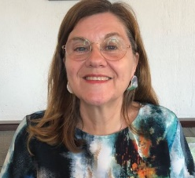 | Annelie Janred  Head of Biomedical Library, Gothenburg University Library  Sweden | Member³ | 1st Term: 2019 - 2023 | annelie.janred@ub.gu.se  +46 703088814  +46 31 786 3001
 | Hao Jiying  Head, Planning and Coordination Department  Medical Library of the Chinese People's Liberation Army, China | Member³ | 1st Term: 2013-2017  2nd Term: 2017-2021 | tanhjy@hotmail.com  86 10 13381089107
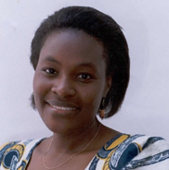 | Christine W. Kanyengo  Librarian, University of Zambia, Lusaka, Zambia | Member³ | 1st Term: 2017- 2021 | ckanyengo@yahoo.com  +260 978 448509
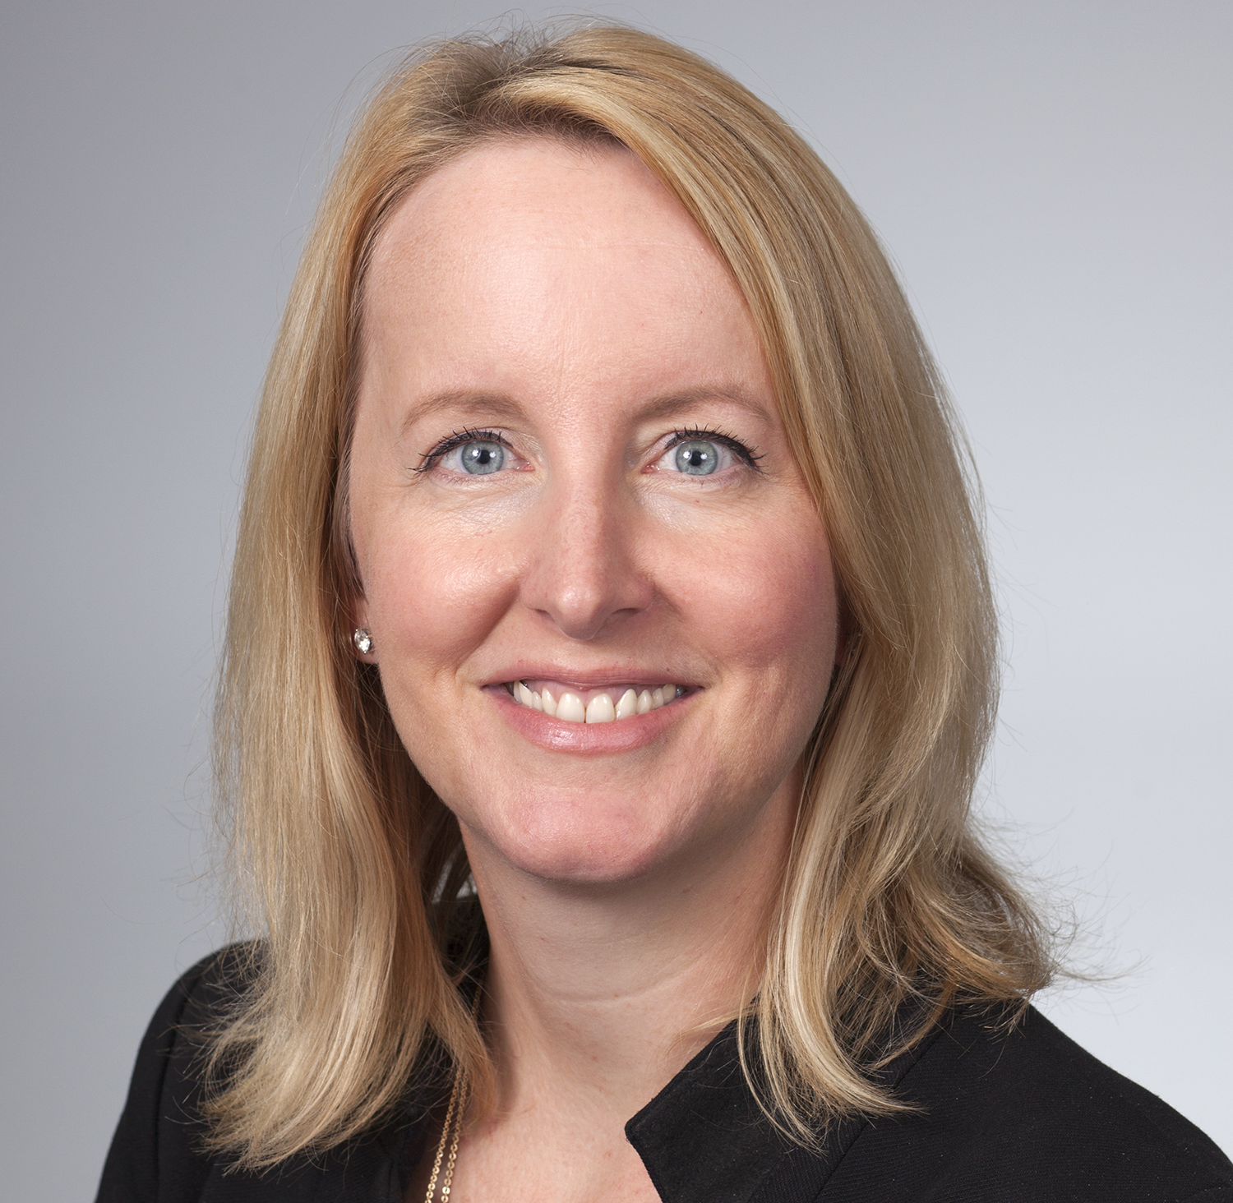 | Elizabeth Ketterman  Director, Laupus Health Sciences Library, East Carolina University  United States | Member³ | 1st Term: 2019- 2023 | kettermane@ecu.edu  1-252-744-3056 office number  WhatsApp: 1-252-258-3357
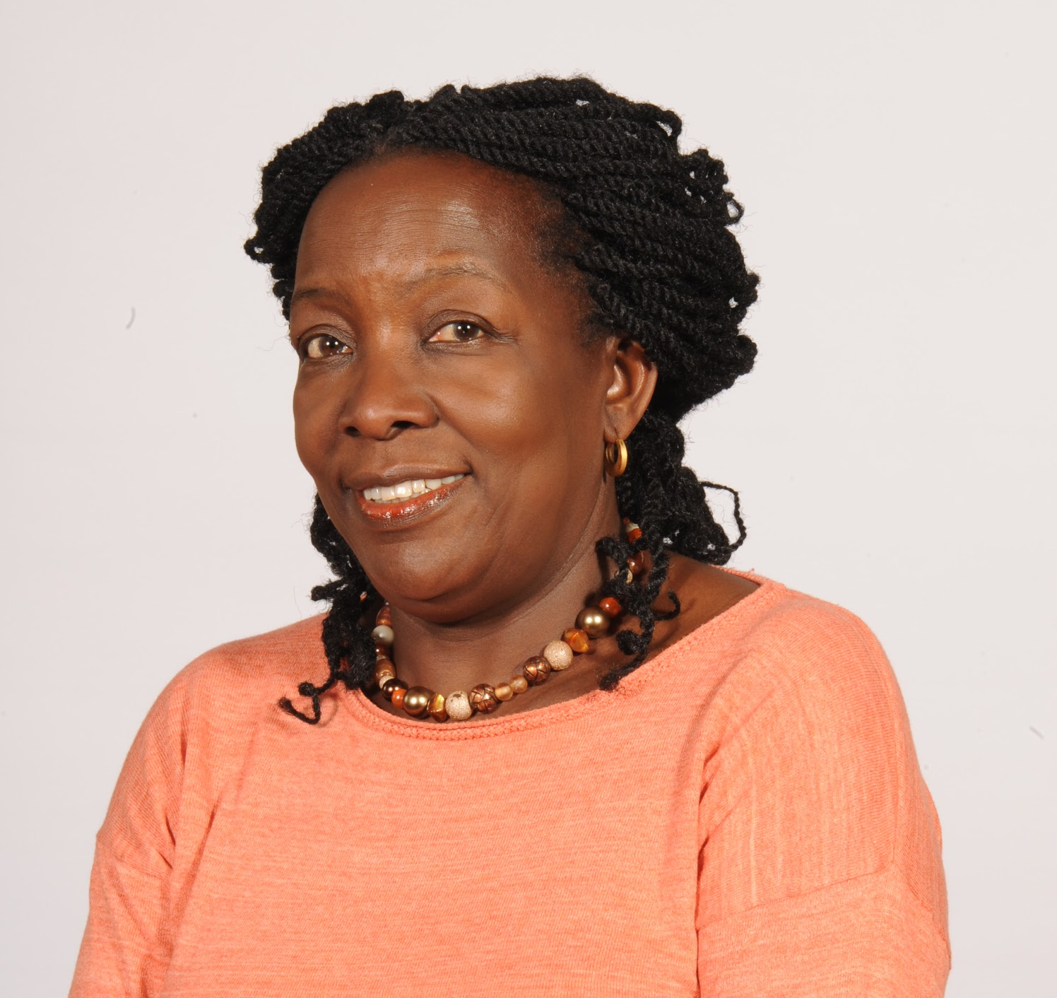 | Sarah Kibirige  Director: Library services  Sefako Makgatho Health Sciences University, South Africa | Member³ | 1st Term: 2019- 2023 | Sarah.kibirige@smu.ac.za  +27 826234979
 | Alison Kinengyere  Academic Librarian and Information Science Specialist, Sir Albert Cook Library, Makerere University  Uganda | Member³ | 1st Term: 2019 - 2023 | alison.kine@gmail.com
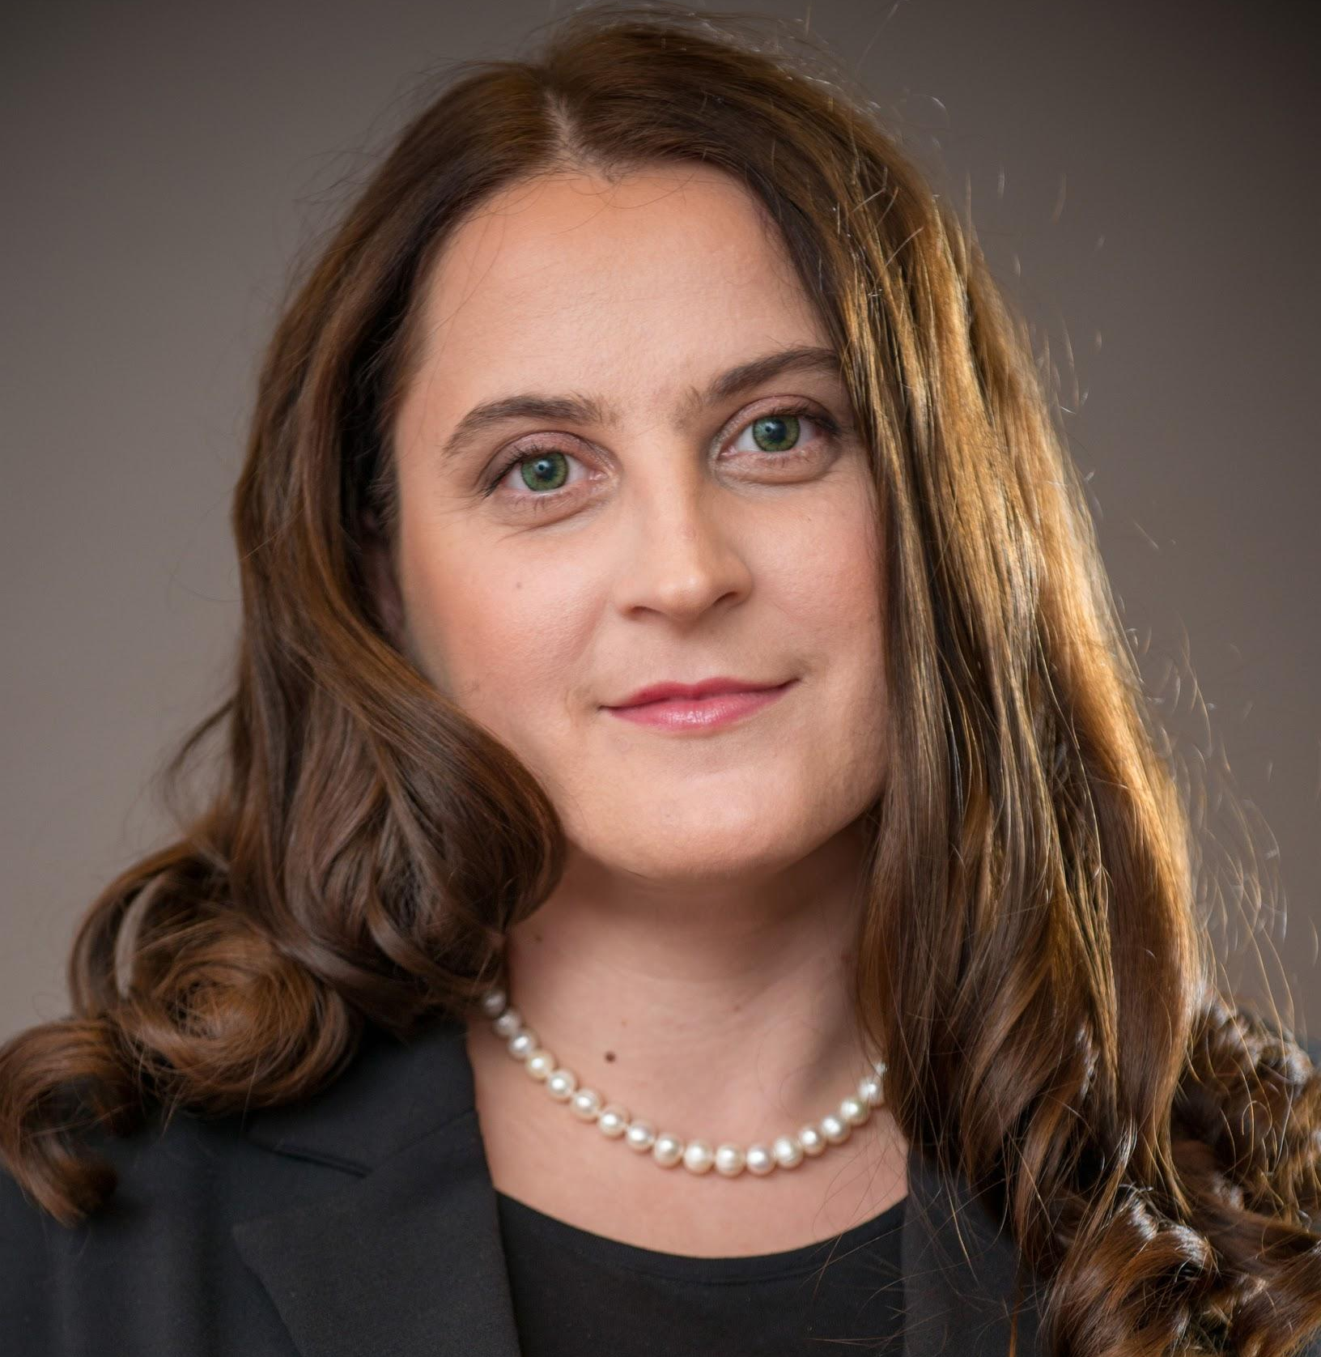 | Octavia-Luciana Madge, PhD  Associate Professor, University of Bucharest Faculty of Letters, Department of Information and Documentation Sciences, Romania | Member³  EAHIL rep | 1st Term: 2017- 2021 | octavialucianamadge@yahoo.com  + 40 744 326 137
 | Martin Morris  Liaison Librarian, Schulich Library of Physical Sciences, Life Sciences and Engineering  McGill University, Montreal, Canada | Member³ | 1st Term: 2017- 2021 | martin.morris@mcgill.ca  +1 514 834 6207
 | Robinah Namuleme  University Librarian, University of Rwanda  Rwanda | Member³ | 1st Term: 2019 - 2023 | namulemerobinah@gmail.com
 | Anne Seymour  Director, Welch Medical Library  Johns Hopkins University  United States | Member³ | 1st Term: 2015 - 2019  2nd Term: 2019 - 2023 | seymoura@jhmi.edu  +1 215 8686095
 | Feili Tu-Keefner  Associate Professor, School of Library and Information Science  University of South Carolina  United States | Member³  ^{E4GDH Advisory group} | 1st Term: 2019- 2023 | feilitu@sc.edu  +1 803-361-2795  WhatsApp: +1 803-361-2795
 | Dr Asimina N. Vlachaki  Librarian & Managing Officer, Library of the School of Health Sciences, University of Athens  Greece | Member³ | 1st Term: 2017- 2021 | avlaxaki@uoa.gr  +30 6940557200
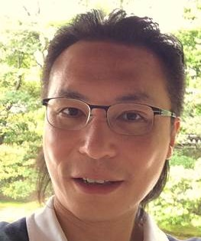 | Chun-Pong Yu PhD  Medical Librarian  Chinese University of Hong Kong  Hong Kong | Member³ | 1st Term: 2017- 2021 | cpyu@lib.cuhk.edu.hk  +852 93152625
 | Margaret Zimmerman  Assistant Professor,  The University of Iowa  United States | Member³  ^{E4GDH Advisory group} | 1st Term: 2019- 2023 | Margaret-zimmerman@uiowa.edu  +17042773465
CONVENOR [ex officio member]
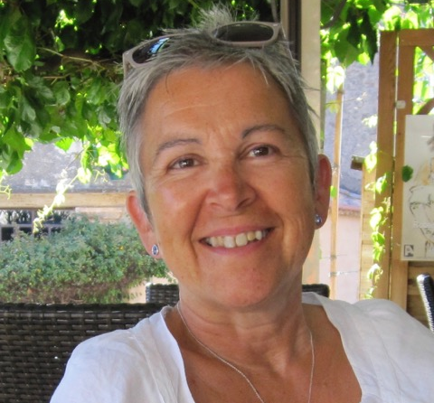 | Anne Brice  Head of Knowledge Management  Public Health England, UK | Convenor Evidence for Global and Disaster Health  SIG | 1st Term: 2018- 2020 | anne.brice@phe.gov.uk  +44 7765 256289
CORRESPONDING MEMBERS
 | Amani Saleh Alyafei  Qatar National Library  Qatar | Corresponding member⁴ | 1st Term: 2017 - 2019  2nd Term: 2019 - 2021 | ayazeedi@qf.org.qa  +974 55473023
 | Sanizan Sardzi  Senior Librarian, Universiti Sains Islam Malaysia Library  Malaysia | Corresponding member⁴ | 1st Term: 2019 - 2021 | sanizan@usim.edu.my / Libsanizan@gmail.com  +60193543005 (+WhatsApp)
 | Masae Sato  Librarian, Saiseikai  Narashino Hospital  Japan | Corresponding member⁴ | 1st Term: 2019 - 2021 | masaesato2017@gmail.com
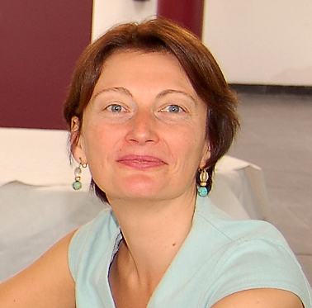 | Catherine Weill  Library manager  Université de Paris  France | Corresponding member⁴ | 1st Term: 2019 - 2021 | catherine.weill@biusante.  parisdescartes.fr  +33 6 33 07 68 90
FRIENDS
 | Judy Consales  Associate University Librarian for User Engagement, UCLA Library, United States | Friend  [Former Info  Coordinator] |  | consales@library.ucla.edu  818 535 8977
 | Prudence Dalrymple  Professor, Drexel University (Ret.)  United States | Friend |  | prudencedalrymple@gmail.com  312 519 0742
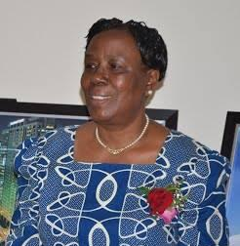 | Maria G. N. Musoke  Deputy Vice Chancellor (Academic Affairs), Kyambogo University, Uganda | Friend  [Former Chair] |  | maria.gnmusoke@yahoo.com  +256 772654960
 | Princess Nwafor-Orizu  University Librarian  Chukwuemeka Odumegwu Ojukwu University  Nigeria | Friend | 2019 | hovoa2001@yahoo.com.  eo.nwafor-orizu@coou.edu.ng  +234 8034072720
 | Lisa Travis  Clinical Informationist  Emory Saint Joseph's Hospital and Emory University, Atlanta  United States | Friend |  | kyrie72@gmail.com  865 300 3297

Notes
1. Officers (Chair & Secretary) are elected from the membership and serve 2yrs and are eligible for re-election for a further two years. Further information including Rules of procedure in connection with the election of officers are available at https://www.ifla.org/officers-corner/election-procedure
2. The Information Coordinator is appointed at the first meeting of SC and there is no set limit to their term of office as long as they remain a member of the SC
3. SC members: SC members serve four years on an SC following their election, and may be nominated and elected for a further four years, giving a maximum eight consecutive years on the same SC. While they are serving on the SC, they aim to attend all the meetings and contribute to the activities and planning of the SC as described in the roles & responsibilities of all SC members. More information on roles & responsibilities of SC members at https://www.ifla.org/officers-corner/sc-members and a fuller printable version https://www.ifla.org/files/assets/hq/officers/key-documents/standing-committee-membership-roles.pdf
4. Corresponding member: Each Section SC may also appoint up to five Corresponding Members, each with a two-year term, once renewable on decision of the Chair. Their role is to represent countries which might not otherwise be represented, or to provide expertise in a specific subject field that is missing from the SC. They do not have voting rights in SC meetings but are entitled to speak and participate. They do not contribute to the quorum.

HBS section mailing list: [SC Members, Corresponding members and friends]
Emma Farrow <emcolette@googlemail.com>, Anne Seymour <seymoura@jhmi.edu>, Michael Huang <Michael.b.huang@stonybrook.edu>, Evelyn Idiodi <taiyeidiodi2@gmail.com>, Hao Jiying <tanhjy@hotmail.com>, Christine Kanyengo <ckanyengo@yahoo.com>, Octavia-Luciana Madge <octavialucianamadge@yahoo.com>, Martin Morris <martin.morris@mcgill.ca>, Heather Todd <heather.todd@uq.edu.au>, Asimina Vlachaki <avlaxaki@uoa.gr>, Chun-Pong Yu <cpyu@lib.cuhk.edu.hk>, Bethany McGowan <bmcgowa@purdue.edu>, Lisa Travis <kyrie72@gmail.com>, Prudence Dalrymple <prudencedalrymple@gmail.com>, Amani S. Al-Yazeedi <ayazeedi@qnl.qa>, Sarah Kibirige <Sarah.kibirige@smu.ac.za>, Anne Brice <anne.brice@phe.gov.uk>, Elizabeth Ketterman <kettermane@ecu.edu>, Robinah Namuleme <namulemerobinah@gmail.com>, Annelie Janred <annelie.janred@ub.gu.se>, Alison Kinengyere <alison.kine@gmail.com>, Masae Sato <library_sato@mbr.nifty.com>, Sanizan Sardzi <sanizan@usim.edu.my>, Feili Tu-Keefner <TUF@mailbox.sc.edu>, Catherine Weill <catherine.weill@biusante.parisdescartes.fr>, Silvia Del Rosario <akizul@gmail.com>, Margaret Zimmerman <Margaret-zimmerman@uiowa.edu>, Princess Nwafor-Orizu <hovoa2001@yahoo.com>, Maria Musoke <maria.gnmusoke@yahoo.com>, Judy Consales <consales@library.ucla.edu>

