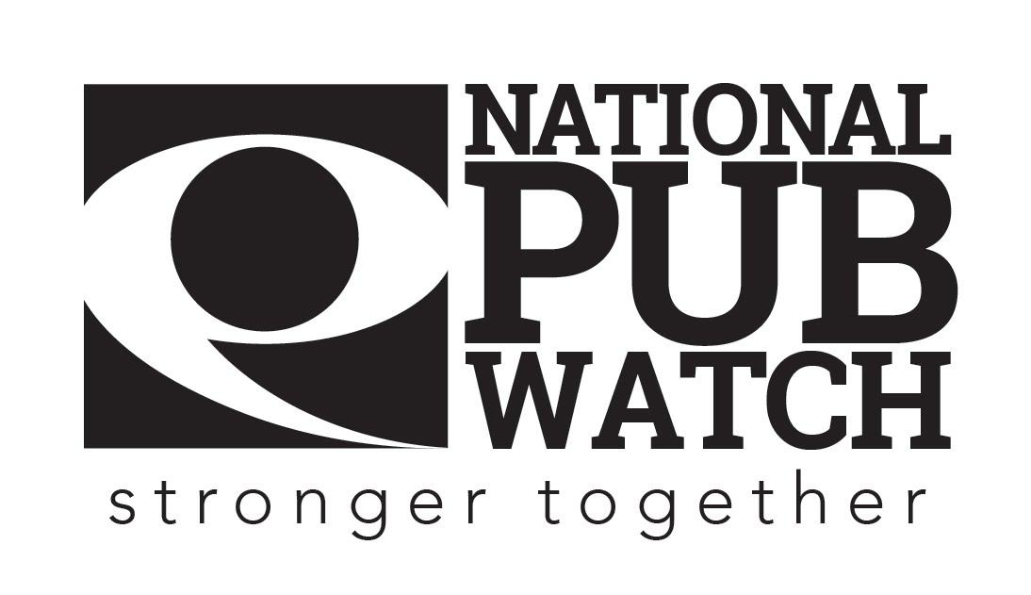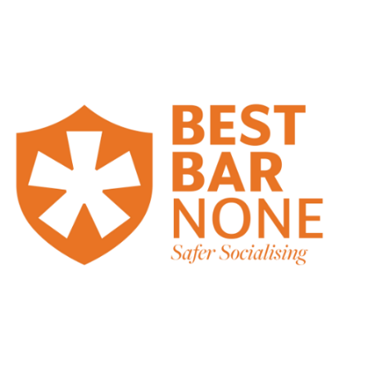

**Challenge 21 Policy**

**Date Created:**

**Date of last review: NB Policies should be reviewed annually.**

**Expected Standards**

There are 4 licensing objectives of equal importance:

* The prevention of crime and disorder
* Public safety
* The prevention of public nuisance
* The protection of children from harm

Our ***Challenge 21*** policy applies to all age-related sales that occur on our premises. You are obliged to apply our ***Challenge 21*** policy when any customer who looks to be under the age of 21 attempts to purchase alcohol, either for themselves or for somebody else, use gambling machines on the premises or any other age-related sales.

**Alcohol Sales**:

It is an offence to sell alcohol to an under 18. The consequences are very serious; a person caught making an underage sale may receive a fixed penalty notice of £90 and may lose their job. Additionally, a premises licence holder whose premises are caught selling alcohol to under 18s on two occasions in a consecutive three-month period may face an unlimited fine as well as having the licence suspended or revoked.

Our ***Challenge 21*** policy requires you to use a 3-step approach every time you see someone who appears to be under the age of 21:

1. Assess the age of every customer.
2. If you think the customer is aged under 21, ask for ID.

The following documents are acceptable for proof of age purposes and must be original documents. Photocopies, photographs or Phone Apps are not acceptable.

Edit to reflect what you will accept:

* **A valid Passport**
* **A valid photo drivers’ licence**
* **A “Pass” approved card from the national Proof of Age Standards Scheme**
* **British Military ID cards**
* **National ID cards**

1. If the **customer cannot** produce acceptable ID, refuse the sale of alcohol

**When you refuse the sale you must record this in the refusals log book/till**

There are fake proof of age cards, so if you are unhappy with the ID for any reason or it looks fake or tampered with, **refuse the sale** and bring the matter to the attention of your Duty Manager or Supervisor.

***Challenge 21*** applies at all times, even when:

* You think door staff has previously checked a customer’s ID.
* You are busy.
* You believe you have seen acceptable ID from the customer on a previous occasion.
* Customers are using gaming machines.

Remember, if you ask for ID from everyone you think looks under 21, then you will protect yourself from breaking the law.

**Practice *Challenge 21* and do not get caught out.**

**Please sign this document to acknowledge that you have understood your training and responsibilities and agree to always ask for ID from customers who appear to be under the age of 21.**

Date: …………………………………………………………………

Trainer’s Name: ……………………………………………... Trainer’s Signature: …………………………………….

Trainee’s Name: …………………………………………….. Trainee’s Signature: ……………………………………