**Packing List**

**Ordeal/Brotherhood**

Arrive at Ordeal dressed in your Scout uniform (shirt, pants, & belt). OA Member remember  
your sash.

* **All BSA Health & Medical Record Form, Parts A&B (B is 2 pages)**
* **Photocopy of Insurance Card, both sides (or state “None” on health form)**
* **Lodge Code of Conduct, signed by you, & also by parent/guardian if under 18**
* **Pre-Event Medical Screening Checklist completed and signed, stapled to your medical form. If you have any of these symptoms do not come to the ordeal:** [**https://www.scouting.org/health-and-safety/safety-moments/pre-event-medical-screening/**](https://www.scouting.org/health-and-safety/safety-moments/pre-event-medical-screening/)

**Medications need to be in the original containers with the Scouts' name, dosage requirements (containers will be returned), and with the correct amount of Medication for the weekend. This includes over the counter drugs with a signed note from Parent/ Guardian with dosage and instructions on time to be taken. Place all containers in a zip-locked bag labeled with the Scouts' name. All medications shall be turned in during check-in. If you use an inhaler or EpiPen, please bring a second one (Scout will carry one and the health center will hold the second.)**

**Ordeal Weekend Gear (ALL items should be clearly labelled with your name)**

**These items should be packed in a separate bag from the rest of your gear and be able to be easily carried:**

* Waterproof ground cloth/sheet (tarp), 2 if they are small) Different then the one that goes under your tent
* Sleeping bag
* Tent to be set up Friday night
* Clearly marked water bottle (with your name)
* Insect repellent (non-aerosol)
* Flashlight with extra batteries
* Work clothes and knit hat for the night
* Rain gear (a Scout is prepared)

**Your remaining gear should include the following:**

* **Work gloves (labeled)**, and hat
* Sunscreen (non-aerosol)
* Personal grooming supplies
* Jacket/windbreaker
* Multiple pairs of socks
* Change(s) of underwear
* Sturdy boots or work shoes (no sandals or open toed footwear)
* As our service projects develop, you will be asked to bring tools
* Camp chair (optional)  
    
  **WORK CLOTHES:** Some work projects will involve work that will potentially soil your clothing; so be sure to bring work clothes that you don’t mind getting dirt or paint on. As there is a possibility you may encounter poison ivy, please consider wearing a long-sleeved shirt and long pants for your work clothing and bring a change of work clothing in a plastic bag should you need to change during the day.

**Work gloves are a MUST – be sure to label them**

**REMEMBER:** All clothing should be appropriate for the outdoors and time of year. Remember you should pack for the season; be prepared!

**DO NOT BRING:**  
**Candidates**: Leave your cell phone, electronics, and smart watch at home (or they will be confiscated.)

**Members may bring**: Personal cell phones are to be used for event emergency communications only. Cell phone numbers must be registered with during check**-in.**

**DO NOT BRING:** any snacks or food items. All food is provided.

If you have an old tarp that could be used to haul yard waste and do not care if it is ruined or returned, it would be appreciated.

Here are some examples of what tools you might be asked to bring; be sure they are in good condition. Be sure to **label all tools**.

Leaf Rake 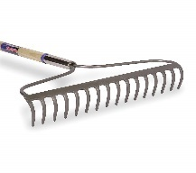Garden Rake [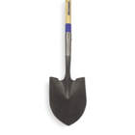](http://www.grainger.com/product/WESTWARD-Round-Point-Shovel-WP54565/_/N-ljj?redirect=Shovel&s_pp=false&picUrl=//static.grainger.com/rp/s/is/image/Grainger/1WG31_AS01?$smthumb$)Shovel

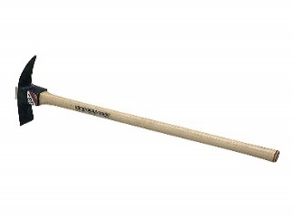Mattock 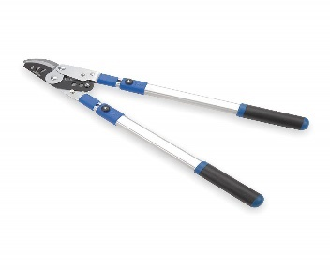Loppers 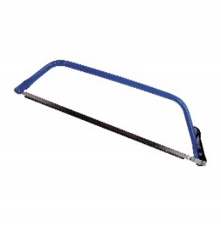 Bow Saw