Key Items from Making Care Primary Request for Application

Goals:
- Create a system of primary care that is integrated, coordinated, person-centered and accountable.
- Provide a pathway for primary care clinicians to adopt prospective, population-based payment to become more accountable for cost and quality.
- Include broad incentives to control costs that are within the control of primary care.

Lessons Learned from Other Innovation Models and Application to Making Care Primary (Investment)
- Need for an on-ramp to value-based transformation – progressive payment architecture.
- Need to design elements to attract organizations serving underserved populations.
- Primary care requires additional support and incentives to integrate with high-quality specialists.
- Improvements in quality and efficiency take time – thus a longer-term model.
- Need to prioritize partnerships at the state level and leverage existing infrastructure.

Application Process/Eligibility:
- Applications will open September 4, and close November 30 (not a binding contract).
- Online application portal with self-selected track.
- Must have at least 125 Fee For Service Beneficiaries.
- Participants will be selected in Winter 2024. Onboarding from April-July.
- Some aspects of the model may be modified as CMS considers stakeholder feedback and operational issues.
- Specialties eligible: internal medicine, general medicine, geriatrics, family medicine, pediatrics.
- Also eligible: NPs, CNS or PAs that are listed under these specialties and/or provide primary care as the majority of their services.
- Only eligible for Track 1 if you have no experience in value-based care in Medicare.
- Prior to signing a participation agreement, CMS will provide each applicant with information that may support financial modeling for the applicant based on the applicant’s attributed population at the time of application. Each practice will have to decide if it is right for them.
- Application Information mentioned in the RFA seems basic, although actual application is not yet available (see pages 59-71 of the RFA).

Payer Alignment
- Algin on quality measurement, type and format of provided data, learning priorities, and move to value.
- Designed to reduce the burden for primary care clinicians.

Care Delivery Requirements (At Practice Level)
- Track 1: Risk stratifying population, develop workflows for care management, chronic disease management, and behavioral health screenings.
- Track 2: Expand and integrate the services available to their patients. Implement chronic care management for high-risk patients.
- Track 3: Further optimize and expand care delivery and specialty care integration. Individualized care plans for all high-risk patients. Linkages to community-based supports.
- Multiple domains with steps to take in each track provide more detail:
  - Care Management:
    - Track 1: Empanel and risk stratify.
    - Track 2: Implement chronic and episodic care management and self-management.
    - Track 3. Individualized care plans.
  - Integrating Behavioral Health:
    - Track 1: Develop workflows using measurement-based care to deliver behavioral health services.
    - Track 2: Implement approach/ /systematically screen for depression and substance use disorder.
    - Track 3: Optimize behavioral health integration workflows.
PAGE TWO

Care Delivery Requirements/What a Practice Must Do (continued)
  - Specialty Care Partnerships:
    - Track 1: Use Medicare specialist performance data to inform selection of high-quality partners.
    - Track 2: ID High-quality Specialty care partners, establish Collaborative Care Arrangements (CCAs), and access new primary care e-consult codes.
    - Track 3: Enhance relationships and introduce new time-limited co-management code.
  - Community Connection Domain (relevant to our Healthy Opportunities Pilots and NCCare360):
    - Track 1: Implement universal screenings for social needs.
    - Track 2: Implement social service referral workflows and establish partnerships.
    - Track 3: Optimize workflows and strength partnerships.
  - Health Equity Strategy: Payments will be adjusted by both clinical indicators and social risk of beneficiaries. Must include a plan and report on progress annually. Must collect demographic data of patients and work to reduce disparities.

More on Specialty Care Partners
- At a minimum, must partner with a specialist in cardiology, orthopedics, or pulmonology, but can also partner with a broad range of specialists.
- Collaborative Care Arrangements (with specialty partners) must address:
  - Communication and data sharing protocols for shared MCP-patients.
  - Expectations for when a patient should be handed off back to primary care
  - Parameters for coordinating care to improve quality and prevent unnecessary utilization.
  - General expectations for co-management when specialists are billing ACM (define)
  - Annual Quality Improvement (PDSA cycles) to optimize workflows and care coordination.

Performance Assessment
- Balance clinical quality, patient-reported outcomes, utilization, and cost.
- Align with the care delivery requirements.
- Incorporate health-related social needs.
- Attribution: Prospective. If beneficiary hasn’t chose a clinician, CMS attribution depends on:
  - One or more of the eligible clinicians in a practice furnished the plurality of beneficiary’s primary care.
  - And/or Billed Chronic Care Management Services.
  - And/or Billed the most recent claim for an Annual Wellness Visit or Welcome to Medicare Visit.
- Practices will receive list of attributed beneficiaries prior to the start of the model and then quarterly thereafter.

Measures:
- Controlling high blood pressure – NCQA measure using MIPS Benchmark
- Diabetes Hemoglobin A1c Poor Control (>9%) – NCQA measure using MIPS Benchmark
- Colorectal Cancer Screening – NCQA measure using MIPS Benchmark.
- Screening for Depression and Follow Up Plan –CMS Measure using MIPS Benchmark
- Depression Remission at 12 Months – MN Community Measurement –using MIPS Benchmark
- Person-Centered Primary Care Measure – ABFM measure using Survey Instrument.
- Screening for Social Drivers -- CMS Quality Measure (Exact info. TO Be Determined).
- Total Per Capita Cost – CMS – Claims Data – Regional-Based
  - Includes all Medicare FFS Parts A and B standardized allowable charges incurred by each beneficiary in the quarter. Additional model payments do not count. Observed to expected ratio for each practice.
- Emergency Department Utilization – NCQA – Utilizing Claims Data – Regional Benchmark
- TPCC Continuous Improvement -- CMS Claims Data – Benchmark against participant level score in previous year.
- OR for FQHCs EDU Continuous Improvement -- CMS Claims Data – Benchmark against participant level score in previous year.
PAGE THREE

Other Information about Measurement
- Receive full credits for 70th percentile in Tracks 1 and 2; 80th percentile in Track 3.
- Receive a half credit for ranking at least 50th percentile.
- Using existing medical home models for incentive payments, such as MIPS (Merit-Based Incentive Payment Systems) that most practices should be knowledgeable about.

A Reminder of Payment Methodology
- Upfront Infrastructure payments (UIP) – Up to $145,000 – Track 1 Only
  - Can be used for increased staffing (case management, support staff for screening, etc.), Social Determinants Strategies, Health Care Infrastructure.
- Enhanced Services Payment for Participant Investment (ESP) – Per Beneficiary Per Month Risk Adjusted (clinical and social risks) paid quarterly (kind of care management). Goes down as you progress along tiers.
  - Must be used to support augmented services.
  - Four tiers of risk adjustment by percentile on HCC Scores. If in highest tier of HCC Codes and > 755h percentile in ADI Social Risk Tier, stays at $25 PBPM regardless.
  - Expected that a quarter of each practice’s participants will fall into each HCC tier (quartiles).
  - CMS estimates that average ESP payment will be $15 PBPM in Track 1, $10 in Track 2, and $8 in Track 3.
- Prospective Primary Care Payment (PPCP) – 50% of FFS in Tier 2; 100% in Tier 3.
  - Not all services will be included in this (Prospective Primary Care Payment Services).
  - Based on two years of historical claims data. Each participant based on unique claims history.
  - They are continuing to work on these calculations (could be revised)
  - If a practice is well above the typical Per Beneficiary Per Month spend, this payment could be adjusted downward as a recoup at a maximum of $5 PBPM, but no recoup if you are no more than $2 PBPM over.
  - Has an optional cost-sharing reduction program to allow beneficiaries with high disease burden or financial hardship to receive services without collecting coinsurance.
- Performance Incentive Payment (PIP) – Up to 3% bonus in Track 1; 45% bonus in Track 2; 60% in Track 3.
  - Upside only. Paid in two payments to provide more upfront resources (first quarter of performance year, and third quarter of following year).
  - Tracks 2 and 3 must meet or exceed a “gateway threshold” of 30% for Total Per Capita Cost (nationally) to be eligible
  - The RFA does outline what percent you can achieve for each measure.
    - Track 2 and 3: 38% of measure dependent on quality; 37% based on utilization and cost; 25% on continuous improvement.
- MCP e-Consult (MEC) -- $40 per e-consult with a specialist. Track 2 and Track 3
- Ambulatory Co-Management – Time-limited PMPM for specialty care partner. Track 3 only..
  - $50/month geographically adjusted – Can be billed for up to three months.
  - Rewarding care management shared between primary care and specialist.

Miscellaneous
- CMS Commits to support practices by providing technical assistance including a collaboration platform, a data feedback tool including analytics to help clinicians identify high-quality specialists, claim feed files monthly, etc.
- Poor performance or integrity issues can lead to termination.

PAGE FOUR

APPENDICES
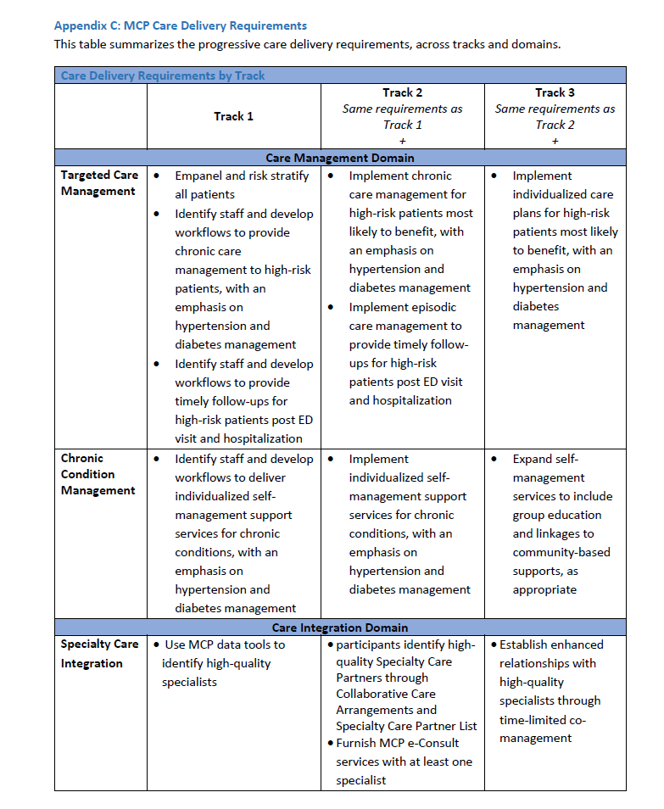
PAGE FIVE
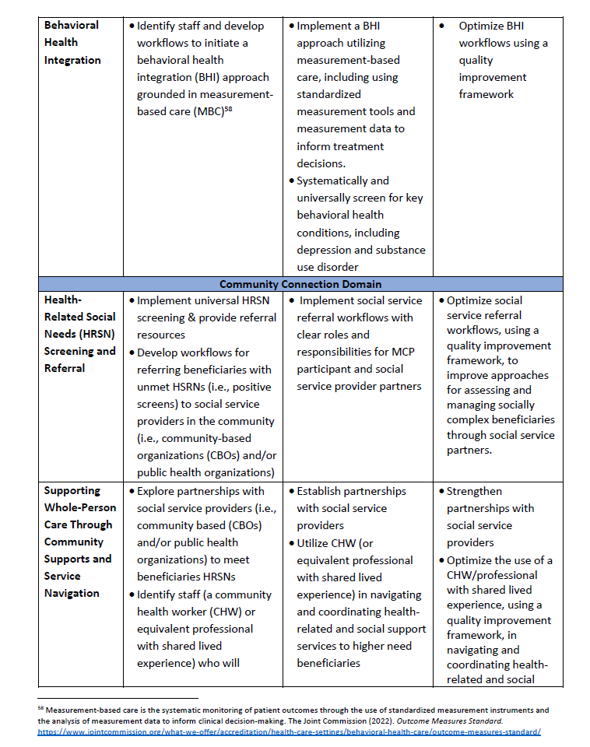
PAGE SIX
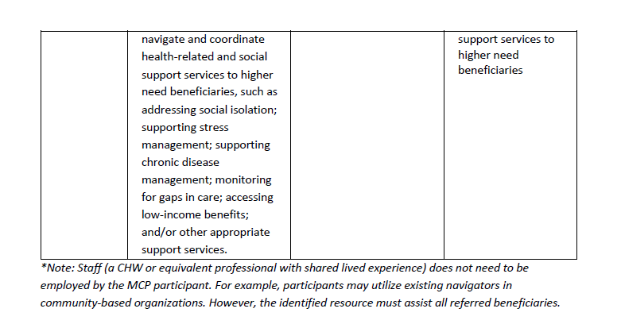

PAGE SEVEN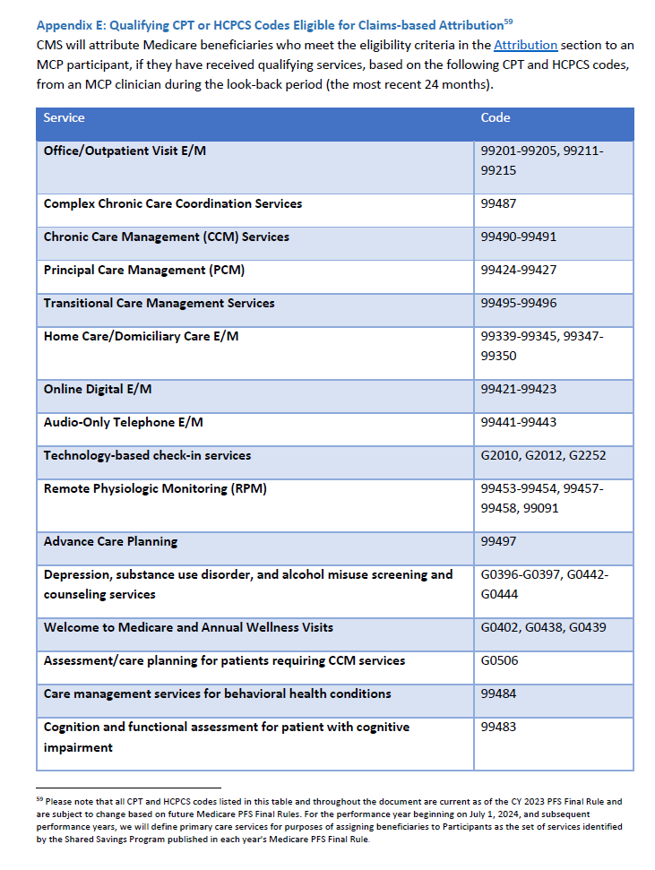
PAGE EIGHT
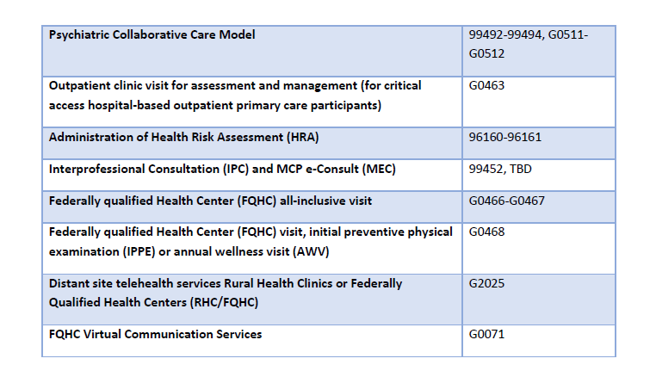

PAGE NINE

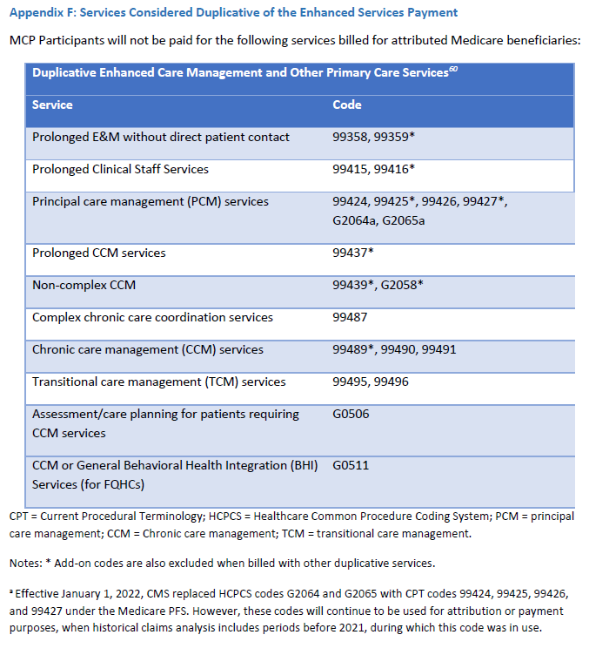

PAGE TEN
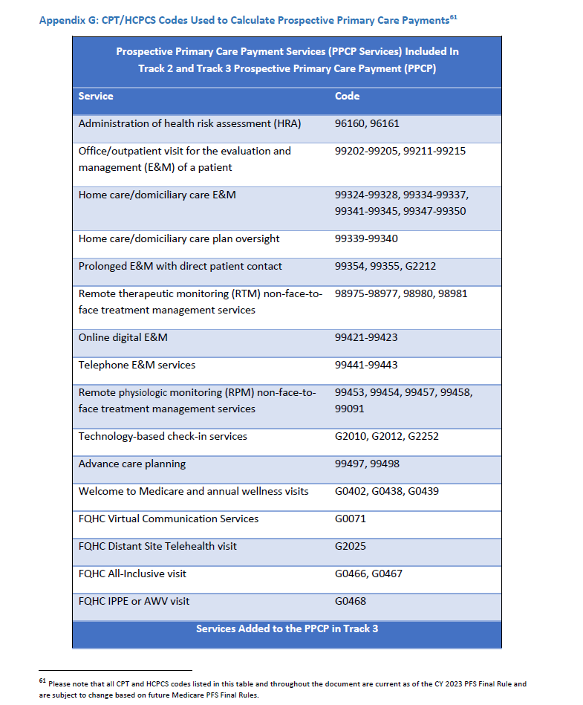
PAGE ELEVEN
