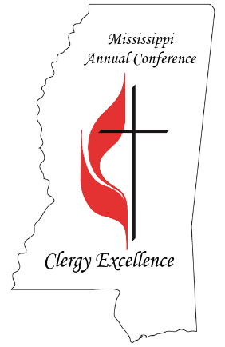
Health is defined as “the state of being free from injury or ill-health.” Health is important because we cannot be effective in ministry, if our health does not sustain all that is required of us. In order to fully live and lead, we need to take care of ourselves.

Pastor ________________________ Church/Charge _______________________
To be completed by the Pastor and Physician and submitted to the District Office during your one-on-one meeting as part of your on-going pastoral consultation.

Print this form and take it with you for your annual wellness visit for a physician’s office signature.

CONFERENCE INSURANCE: Use the Healthy You Rebate Form from the Annual Conference website. The Mississippi Conference of the United Methodist Church reward form. Please print and take this form with you to your Healthy You or Medicare annual physical appointment and have your physician’s office sign this form. Submit a copy as directed on the form for your $75.00 cash incentive reward and bring a copy to your Annual Evaluation for your file.

NON-CONFERENCE INSURANCE: USE THIS FORM. Please print and take this form with you to your annual physical appointment and have your physician’s office sign this form. Bring a copy to your Annual Evaluation for your file.

Name of Physician:____________________________________________________________________

Address:______________________________________________________________________________

City:______________________________ State:_____ ZIP:__________

Phone:____________________________

Today, ___________________________, was seen in my office for an annual physical examination. It is my intent to follow-up with the patient on any health concerns that arise from this examination.

Physician Signature:________________________________________ Date:__________________________

