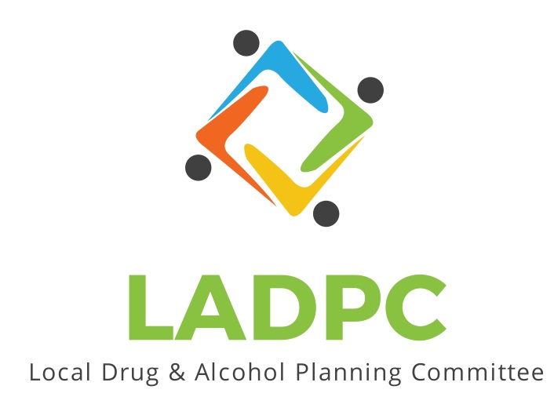

**____________________________**

**Local Alcohol and Drug Planning Committee**

**December 16, 2021**

Members Present: Ross Acker, Charlotte Carver, Alexander Baum, Deidrie Lindsey, Darrell Babb, Paul Gonzalez, Tony Angulo, Scott Cooper, Kera Hood, Tara Johnson, Katrinka McReynolds, Tracy Herning

Guests: Samuel Denny

Members Absent:

Meeting brought to order by Ross Acker

Quorum confirmed.

Agenda Approved for today

Meeting Minutes approved

* Ross Acker Provided an overview of the statewide
  + - The state plan power point will be available on basecamp
* Presentation by Samuel Denny on the opioid treatment program
  + - Power point can be added to basecamp as well, a more comprehensive format is available from Samuel Denny if requested.
  + Presentation for Prevention by Katrinka is postponed till next week.
  + Ross attended a commissioner meeting and informed them that LADPC is happening again. They requested a meeting. Bobbi Brooks will assist in scheduling a meeting with County Commissioners during the first quarter 2022

Meeting adjourned