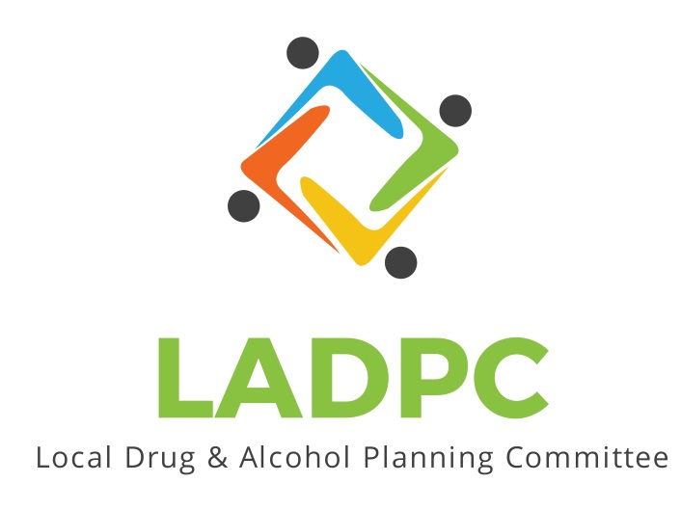

**____________________________**

**Local Alcohol and Drug Planning Committee**

**October 28th, 2021**

Members Present: Ross Acker, Charlotte Carver, Alexander Baum, Deidrie Lindsey, Darrell Babb, Paul Gonzalez, Tony Angulo, Scott Cooper, Kera Hood, Tara Johnson, Katrinka McReynolds

Guests:

Members Absent: Tracy Herning (?)

Meeting brought to order by Ross Acker

Quorum confirmed.

Agenda Approved for today

Meeting Minutes approved

* Presentation on ADAPT services by Deidre Lindsey

ADAPT has been open for 50 years and currently provides services in Coos, Douglas and Curry Counties. ADAPT has 13 CADCI or CADCII counselors, QMHP, LPC and 4 Certified recovery mentors. Adapt provides assessment screening, access to Detox and Residential services. ADAPT also provides an Opiate treatment program and drug free housing while in treatment. ADAPT has men’s and women’s DHS program, a Corrections program, a DUI program, Youth treatment programs, and also has gambling and nicotine addiction treatment available.  Curry county service will be expanding into Brookings, Gold Beach and Port Orford in 2022.

* Presentation on Bay Area First Step by Paul Gonzalez

Bay Area First Step started up in 1995 to provide peer support, alcohol and drug free housing and peer services. We serve individuals and families recovering from substance use, mental health disorders and homelessness. BAFS offers a 16 bed low barrier shelter and a 24 bed safe and supportive transitional housing. Bayview Village is drug and alcohol free short or long term housing offering a total of 41 apartments. Lakeview village has 16 permanent housing in a drug and alcohol free setting.

Our service department has contracts Coos Health& Wellness where we serve some of their people and we have a mutual clients with and we also have contracts with Coos County Corrections where we serve. We provide peer services BAFS also has another program in the service department called Prime Plus, one called Oregon Hope and also SUD outpatient treatment services. There is considerable focus on community outreach and connecting individuals with the resources that they need to be successful.

BAFS substance use disorder treatment program that started in 2019. We have currently three CADC1, a CADCII and two part time peers in treatment program also.

* New Business
  + Unable to complete review of state plan due to discussion
  + Need for deeper dive on understanding of measurer 101, methodology, outcomes, etc.
  + Discussed need for an understanding of Prevention
  + Continue to provide suggestions for additional speakers from Treatment, Prevention and recovery in Coos County to build our understanding of local services currently available.

Meeting adjourned