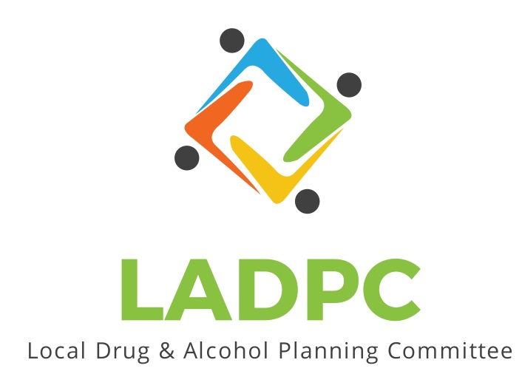

**____________________________**

**Local Alcohol and Drug Planning Committee**

**September 23, 2021**

Members Present: Ross Acker, Tara Johnson, Tracy Herning, Charlotte Carver, Alexander Baum, Deidrie Lindsey, Darrell Babb, Paul Gonzalez, Tony, Scott Cooper,

Guests: Kera Hood,

Agenda Approved

* Officer Elections:

Chair: Tara made a motion of Ross Acker for Chair, Babb second the motion, discussion term of the chair is one year, review general responsibilities according to bylaws. Passed unanimously

First Vice Chair: Tara nominated Alex for First Vice Chair, Charlotte second the motion, discussion, Passed unanimously.

Second Vice Chair: Scott Cooper Made a motion for Charlotte Carver for Second Vice Chair, Alex Baum second the motion. Passed unanimously.

Executive Committee, Member at large: Scott Cooper made a motion for Katrinka McReynolds, Tara Johnson second the motion. Passed unanimously.

* Basecamp Introduction and training by Charlotte Carver

Actions: Katrinka assist in updating Scott Coopers Email in Basecamp. Verify that Deidre receives an invitation to basecamp.

* By Laws discussion by Ross Acker
  + Review Purpose of LADPC and planning for the future.

Actions: Offer Kera Hood application to this committee,

* New Business
  + Review previous data subcommittee, this can be started up later.
  + Tableau will be available for the committee, Katrinka is seeking training on this
  + Discuss setting goals for the year, potential for supporting a sobering center, and a drug court, discussed need to support these by updating our gap analysis.
  + Discussed regular reporting to County commissioner.

Meeting adjourned